Surgical Correction of Traumatic Ingluvies Fistula in a Pigeon (Columba livia domestica): A Case Report

Abstract
A pigeon weighing 285 grams was presented with a history of recent traumatic injury caused by a ceiling fan. Physical examination revealed a wound in the crop region with leakage of feed material from the neck, suggestive of a crop fistula. Radiographic evaluation was performed to rule out any associated fractures, however no fracture was observed. Surgical intervention under general anaesthesia was carried out to repair the crop fistula. The crop wound was closed using absorbable sutures. The skin was closed with interrupted sutures using non-absorbable material. Postoperative care included oral administration of a broad-spectrum antibiotic, Cefpodoxime Proxetil (15 mg/kg body weight), and the anti-inflammatory drug, Meloxicam (0.3 mg/kg body weight) once daily for five consecutive days. Bird recovered uneventfully. Timely debridement of necrotic tissue of crop and proper suturing of crop fistula, are critical for proper recovery of crop fistula.
Keywords: Crop, Ingluvies, Fistula, Pigeon

- Introduction
The avian crop, or ingluvies, is a muscular pouch located at the base of the neck, just above the sternum. It functions as a dilation of the esophagus, serving as a temporary storage site for ingested food (Cotton et al., 2017). The morphology of the crop varies among bird species; for example, chickens typically have a single spindle-shaped pouch, while pigeons possess a bilobed crop (Sladakovic et. al., 2017). Entry into the crop is regulated by a sphincter that permits food passage only after the gizzard is filled. Within the crop, food is stored in a warm, moist environment conducive to enzymatic action, particularly amylase, which aids in pre-digestion and softening (Kierończyk and Bartosz, 2016).
Crop fistulas in birds may arise from ingestion of sharp objects, animal bites, foreign body penetration, feeding of excessively hot grains, or chronic irritation. Neonatal crops are particularly fragile and prone to injury, especially when distended with food. This case report describes the surgical management of a crop fistula in a pigeon, emphasizing the need for prompt and appropriate intervention in such cases.

- Case Presentation
A pigeon was presented to the Department of Veterinary Surgery and Radiology, College of Veterinary Science, Rampura Phul, Bathinda, Guru Angad Dev Veterinary and Animal Sciences University (GADVASU), Punjab, with a recent traumatic injury to the neck region caused by contact with a ceiling fan (Fig. 1). The bird appeared alert but had not been eating since the incident. The bird's hydration status was assessed through evaluation of the oral mucosa and a skin tent test performed over the shank region. Radiographic examination revealed no evidence of skeletal fractures (Fig. 2). Based on the clinical history, physical examination, and observation of feed leakage from the lateral aspect of the caudal neck, a diagnosis of ingluvies (crop) fistula was made. The affected area was painful on palpation, and visible discharge of feed material was noted. The bird was positioned in dorsal recumbency, and the surgical site was aseptically prepared by feather plucking and application of 5% povidone-iodine solution. Surgical correction was performed under isoflurane inhalant anaesthesia, induced at 4% and maintained at 2–3%. Necrotic edges of the crop were debrided, and the crop wound was closed using absorbable sutures (Vicryl 2-0) in an inverting pattern. The skin was closed with interrupted sutures using non-absorbable material (Nylon 1-0) (Fig. 3).
Postoperatively, the pigeon received oral administration of a broad-spectrum antibiotic syrup (Cefpet; Cefpodoxime proxetil @ 15 mg/kg body weight, an anti-inflammatory syrup (Meloxypet; Meloxicam @ 0.3 mg/kg body weight) and multivitamin syrup (Birdplus for five consecutive days.

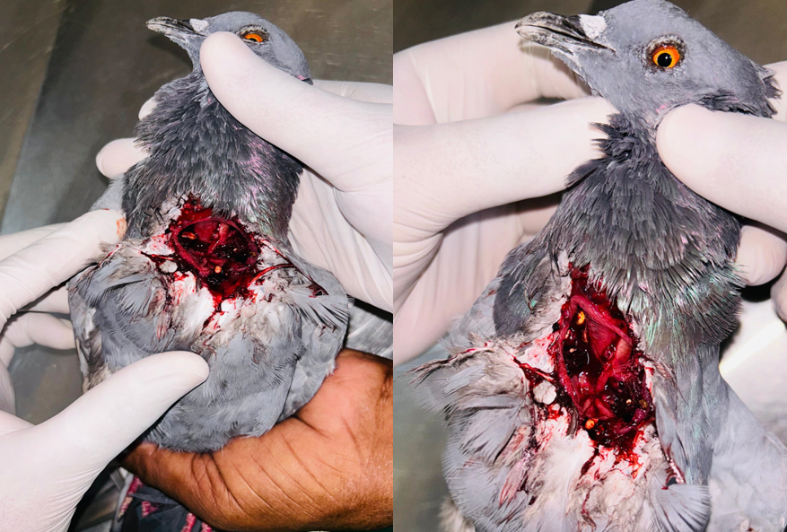
Fig. 1: Showing traumatic wound over caudal neck region along with feed material in crop region

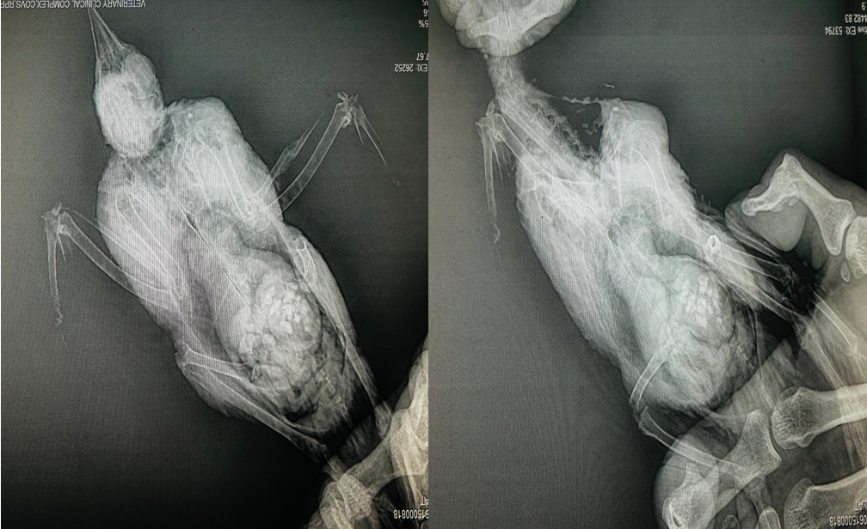

Fig. 2: Radiographs revealing no axial and appendicular fracture.
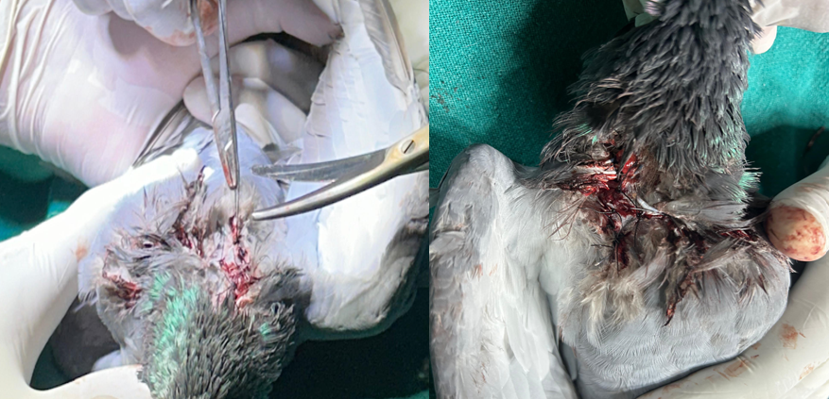]
Fig. 3: Showing suturing of crop fistula with absorbable and non-absorbable suture materials.

- Results and Discussion
Bird recovered without any complications. Surgical intervention in avian species presents unique challenges due to their small body size, high metabolic rate, limited blood volume, and overall delicate physiology. The crop serves as an essential food storage organ in birds and becomes more prominent and pendulous when distended with feed, making it more susceptible to traumatic injury (Guzman and David, 2016). In avian species, the crop is a common site for the entrapment of foreign bodies (Adamcak et al., 2000). A rupture of the crop constitutes a medical emergency, as it impairs the bird’s ability to ingest fluids, often resulting in severe dehydration (Amith, 2020). In neonates and hand-fed birds, crop rupture is frequently linked to incorrect or overly forceful gavage feeding methods (Cotton et al., 2017). Timely debridement of necrotic tissue and proper suturing are critical for successful surgical outcomes (Stocker, 2013).
The crop's rich vascular supply supports efficient healing following surgical repair (Ziswiler and Farner, 1972).

Necrotic margins were excised as recommended by Coles (2008) for crop fistulas. The pigeon recovered uneventfully without any complication.

- Conclusion
Crop rupture is a commonly encountered condition in birds, typically resulting from accidental trauma, chronic irritation, or the ingestion of excessively hot food provided by caretakers. Fortunately, the crop’s robust vascular supply facilitates rapid and reliable healing following surgical repair. In the present case, timely veterinary intervention combined with a double-layer closure technique for fistula repair contributed to a smooth and uneventful recovery, with no postoperative complications observed.

Ethical Approval
Animal Ethic committee approval has been collected and preserved by the author(s)

- References

Amith, N.G. (2020). Surgical Repair of Traumatic Crop Fistula in a Yellow Footed Green Pigeon. International Journal of Science and Research, 9(3): 762-763.
Adamcak, A., Hess, L.R. and Quesenberry, K.E. (2000). Intestinal string foreign body in an adult umbrella cockatoo (Cacatua alba). J Avian Med Surg, 14: 257-263
Coles, B. H. (2008). Surgery of the digestive system. In G. J. Harrison & T. L. Lightfoot (Eds.), Clinical Avian Medicine (pp. 317-333). W.B. Saunders.
Cotton RJ, Stephen JD (2017). Endoscopic removal of gastrointestinal foreign bodies in two african grey parrots (Psittacus erithacus) and a Hyacinth Macaw (Anodorhynchus hyacinthinus). J. Avian Med. Surg. 31(4): 335-343. https://doi.org/10.1647/2016-235
Guzman DS-M (2016). Avian soft tissue surgery. Vet. Clin. Exot. Anim. Pract. 19(1): 133-157. https://doi.org/10.1016/j. cvex.2015.08.009
Kierończyk B, Rawski M, Długosz J, Świątkiewicz S, Józefiak D (2016). Avian crop function. A review. Ann. Anim. Sci. 16(3): 653-678. https://doi.org/10.1515/aoas-2016-0032
Sladakovic I, Angela EE, Stephen JD (2017). Evaluation of gastroscopy and biopsy of the proventriculus and ventriculus in pigeons (Columba livia). Am. J. Vet. Res. 78(1): 42-49. https://doi.org/10.2460/ajvr.78.1.42
Stocker L (2013). Practical wildlife care, John Wiley and Sons.
Ziswiler V, Farner DS (1972). Digestion and the digestive system. Avian Biol., 2: 343-430. https://doi.org/10.1016/ B978-0-12-249402-4.50015-2

