Effect of Seed Priming on Growth Attributes of Buckwheat (Fagopyrum esculentum Moench.)
Abstract
Seed priming is a low cost, ecofriendly technique that involves controlled hydration of seeds to activate pre- germinative metabolic processes without initiating radical emergence. Buckwheat serves as an excellent cover crop due to its quick ground coverage, weed suppression ability, and contribution to soil fertility. The present study aimed to determines the effect of seed priming on growth attributes of buckwheat (Fagopyrum esculentum Moench.). The investigation was carried out during the Rabi Season of 2024 at Himalayan University farm, Jollang, Itanagar, to determine the response of Seed Priming on the growth of buckwheat (Fagopyrum esculentum Moench.) The experiment was outlined in a Randomized Block Design (RBD) with nine treatments and three replications. The treatment includes, T₁- Control (unprimed seeds), T₂- Gibberellic Acid (GA₃) at 200 ppm, T₃- GA₃ at 100 ppm, T₄- KH₂PO₄ @ 2%, T₅- KH₂PO₄ @3%, T₆- Tulsi leaf extract @5%, T₇- Tulsi leaf extract @75%, T₈- Neem leaf extract @5%, T₉- Neem leaf extract @75%.The study recorded significant difference among treatments in terms of plant height, leaf length, and leaf width, and dry weight at 30, 60 and 90 DAS. The result revealed that the treatment T₂ - Gibberellic acid at 200 ppm (GA₃) was found to be best treatment for obtaining maximum plant height, leaf length, leaf width , and dry weight , indicating the effect of GA₃ at 200 ppm. These superior results can be attributed to the biochemical effects of gibberellic acid in enhancing seed germination, nutrient mobilization, and enzyme activity, leading to better root and enzyme activity, leading to better root and shoot establishment. Therefore, seed priming with GA3 at 200 ppm can be considered a highly beneficial agronomic practice for improving the growth performance and dry matter accumulation in buckwheat under field condition.
Keywords: Seed Priming, Gibberellic Acid, Buckwheat, Growth Attributes, Randomized block Design (RBD).
1.Introduction
With technological advances in modern agriculture, each seed should readily germinate and produce a vigorous and healthy seedling ensuring maximum yield. The seed yield and chemical composition of buckwheat depends on a large number factors and some of them are variety of buckwheat and agro-climatic conditions of cultivation (Reddy et al., 2022). Buckwheat (fagopyrum esculentum Moench) is a fast-growing, short-duration pseudo-cereal crop valued for its nutritional and medicinal properties. It is gluten-free, rich in essential amino acids such as lysine and arginine, and contains bioactive compounds like rutin, making it suitable for health-conscious and celiac populations (Bonafaccia et al., 2003; Alvarez- Jubete et al., 2009). Additionally, buckwheat serves as an excellent cover crop due to its quick ground coverage, weed suppression ability, and contribution to soil fertility (Myers and Meinke, 1994).
Seed Priming induces a physiological state that enables effective germination, growth, and productive capacity in crops. It is a low-cost pre-sowing approach which increases and stabilizes yield, having a significant impact on the livelihoods of small-scale, marginal, and resource-poor farmers. Seed Priming has been shown to increase the yield of various field crops, such as wheat, barley, upland rice, maize, pearl millet, chickpea, and sorghum (Bhusal et al., 2024). Seed priming is a low-cost, eco-friendly technique that involves controlled hydration of seeds to activate pre-germinative metabolic processes without initiating radical emergence (Farooq et al., 2010). It enhances seed vigor, accelerates germination, and improves seedling establishment, particularly under stress-prone environments. Various priming agents, such as plant growth regulators like gibberellic acid (GA₃), nutrient solutions including monopotassium phosphate (KH₂PO₄), and botanical extracts from neem (Azardirachta indica) and Tulsi (Ocimum sanctum), have been reported to improve seedling growth and productivity in several crops (Basra et al., 2005)
2.1 MATERIALS AND METHODS
The present study, titled “Effect of Seed Priming on Growth, Yield and Quality of Buckwheat”, was conducted at the agricultural research farm located in Jollang, affiliated with the College of Agriculture, Himalayan University. The experiment was carried out during the Rabi season of October 2024. The research site is geographically positioned at 27.074684 ºN latitude and 93.652878 ºE longitude, with an average altitude of 320 meters above sea level.
The investigation aimed to evaluate the effects of various seed priming treatment on the performance of buckwheat under field conditions. The study was designed to assess growth parameters, yield attributes, and quality characteristics of the crop across different treatments during the Rabi growing season.
The treatment include, T₁- Control (unprimed seeds), T₂- Gibberellic Acid (GA₃) at 200 ppm, T₃- GA₃ at 100 ppm, T₄- KH₂PO₄ @ 2%, T₅- KH₂PO₄ @3%, T₆- Tulsi leaf extract @5%, T₇- Tulsi leaf extract @75%, T₈- Neem leaf extract @5%, T₉- Neem leaf extract @75%. The experimental design followed a Randomized Complete Block Design with three replications. Each replication consisted of plots where seeds were treated with the respective priming agents before sowing. Standard agronomic practices were followed throughout the cropping season to ensure optimal crop management.
2.1 Weather and Climate
The climatic condition of the research field was humid subtropical climate with moderate temperature ranging from 12℃ and 28℃ during the cropping season, The crop was sown in the month of October 15 and its was a season of a Rabi. The relative humidity levels remained high, averaging between 60- 85%. The site received light to moderate post-monsoon rainfall during the experimental period was light to moderate, totaling approximately 90- 120mm, The region received an average of 5 to 7 hours of bright sunshine per day, contributing to enhanced photosynthetic activity and overall crop vigor.
Figure 1. Meteorological data of weather parameters and total rainfall during the cropping season (Ravi 2024-2025)
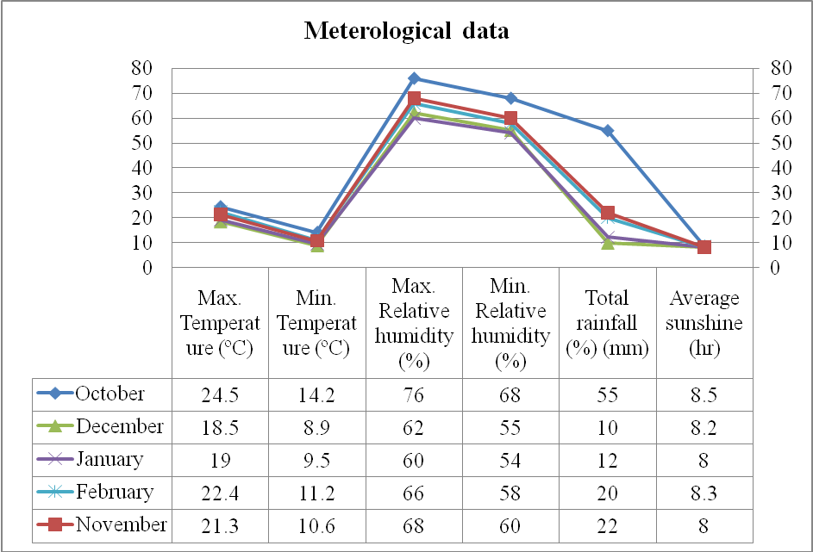
2.2 Crop Growth Parameters
Plant height was taken in cm from the growth level to the tip of the plant from randomly selected 5 (five) plants in each plot and these plants were tagged for subsequent observation. A total of 5 (five) observation 30DAS, 60DAS and 90 DAS were recorded from the same plants in each plot and the average height of plant in each treatment was worked out for each observation. The plant width was taken in cm from randomly selected 5 (five) plant in each individual plant was recorded 30DAS, 60DAS and 90 DAS and average number of leaves per plant was calculated. Leaves length was taken in cm from the growth level to the plant from randomly selected 5 (five) plants in each individual plot and these plants were tagged for subsequent observation. A total of 5 (five) observation 30DAS, 60DAS and 90 DAS were recorded from the same plants in each plot and the average height of plant in each treatment was worked out for each observation. The dry weight of a plant is the weight of the plant after all its water content has been removed. This is typically done by drying the plant material at temperatures higher than ambient temperature until all moisture is evaporated.
3. RESULTS AND DISCUSSIONS
The growth and development parameters of buckwheat were recorded following a Randomized Block Design with three replications. Observations were taken for various traits, including planth height, leaf length, leaf width and dry weight. The data were statistically analyzed to compute the general mean, standard error difference (SEd), and critical difference (CD) for each trait.
Plant height (cm) 30, 60, 90 DAS
Plant height of Buckwheat were recorded at 30, 60, and 90 DAS was statistically analyzed and presented in table.
At 30 days after sowing (DAS), the greatest plant height was observed in treatment T₂ (GA₃ 200 ppm), which showed a significant increase in plant height with an average of 18.7 cm, and then followed by T₃(GA₃ 100 ppm), with 15.6 cm, indicating the promotive effect of Gibberellic acid on early vegetative growth through enhanced cell elongation and division. The lowest plant height was observed in T₁ (Control), which recorded only 11.8 cm, due to the absence of any seed priming treatment, resulting in slower growth and lesser vigor during the early stage.
At 60 days after sowing (DAS), the greatest plant height was observed in treatment T₂(GA₃ 200 ppm), which showed a significant increase in plant height with an average of 44.8 cm and then followed by T₃(GA₃ 100 ppm), with 42.5 cm, indicating the promotive effect of gibberellic acid on early vegetative growth through enhanced cell elongation and division. The lowest plant height was observed in T₁(Control), which recorded only 23.8 cm, due to the absence of any seed priming treatment, resulting in slower growth and lesser vigor during the early stage.
At 90 days after sowing (DAS), the greatest plant height was observed in treatment T₂(GA₃ 200 ppm), which showed a significant increase in plant height with an average of 59.7 cm, and then followed by T₃(GA₃ 100 ppm) with 58.7cm, indicating the promotive effect of gibberellic acid on early vegetative growth through enhanced cell elongation and division. The lowest plant height was observed in T₁ (control), which recorded only 25.8 cm, due to the absence of any seed priming treatment, resulting in slower growth and lesser vigor during the early stage.
The maximum plant height was observed in T₂ (GA₃ at 200 ppm), where as the minimum occurred in T₁ (Control). The enhanced plant height in T₂ is largely attributed to the role of gibberellic acid in stimulating cell division and cell elongation, particularly in stem internodes. GA₃ promotes the synthesis of proteins involved in growth processes, accelerates metabolic activity, and increases intermodal length, which contribute to taller plants.
In contrast, the control treatment (T₁) recorded the lowest plant height, likely due to the absence of any seed priming agent. Seeds under this treatment experience slower germination and limited growth potential, resulting in weaker shoot development and shorter plants. The reduced height reflects lower physiological activity and suboptimal resource utilization.
Table 1: Effect of treatments on plant height (cm)
Treatments | Plant Height (cm)
Treatments | 30 DAS | 60 DAS | 90 DAS
T₁ – Control | 11.8 | 23.8 | 25.8
T₂ – GA₃ at 200 ppm | 18.7 | 44.8 | 59.7
T₃ – GA₃ at 100 ppm | 15.6 | 42.5 | 58.7
T₄ – KH₂P0₄@ 2% | 14.3 | 33 | 57.1
T₅ – KH₂P0₄ @3% | 14.8 | 28.7 | 55.5
T₆ – Tulsi extract @5% | 13.7 | 28 | 51.9
T₇ – Tulsi extract @75% | 12.5 | 27.9 | 45.3
T₈ – Neem extract @ 5% | 13.1 | 26.8 | 43.8
T₉₋ Neem extract @75% | 12.1 | 24.1 | 44.5
F- Test | S | S | S
SEd± | 1.427009 | 2.763584 | 2.186964
CD( P= 0.5) | 3.025124 | 5.858536 | 4.636157

Leaf length 30, 60, 90 DAS
Plant leaf length of Buckwheat were recorded at 30, 60, and 90 DAS was statistically analyzed and presented in table.
At 30 days after sowing (DAS), the highest plant leaf length was observed in treatment T₂ (GA₃ 200 ppm), which showed a significant increase in Leaf length with an average of 8.1 cm and then followed by T₃(GA₃ 100 ppm) with 5.2 cm, indicating the promotive effect of gibberellic acid on early vegetative growth through enhanced cell elongation and division. The lowest plant height was observed in T₁ (Control), which recorded only 2.6 cm, due to the absence of any seed priming treatment, resulting in slower growth and lesser vigor during the early stage.
At 60 days after sowing (DAS), the highest plant leaf length was observed in treatment T₂(GA₃ 200 ppm), which showed a significant increase in plant height with an average of 8.3 cm, and then followed by T₃(GA₃ 100 ppm) with 5.8 cm, indicating the promotive effect of gibberellic acid on early vegetative grow through enhanced cell elongation and division. The lowest plant height was observed in T₁ (Control), which recorded only 2.7 cm, due to the absence of any seed priming treatment, resulting in slower growth and lesser vigor during the early stage.
At 90 days after sowing (DAS), the highest plant leaf length was observed in treatment T₂(GA₃ 200 ppm), which showed a significant increase in plant height with an average of 9.5 cm, and and followed by T₃(GA₃ 100 ppm), with 8.7 cm, indicating the promotive effect of gibberellic acid on early vegetative growth through enhanced cell elongation and division. The lowest plant height was observed in T₁ (Control), which recorded only 4.8 cm, due to the absence of any seed priming treatment, resulting in slower growth and lesser vigor during the early stage.
The maximum leaf length was recorded under T₂ (GA₃ at 200 ppm), while the minimum was observed in T₁ (Control). The increased leaf length under GA₃ treatment may be attributed to its strong role in promoting cell elongation and intercellular expansion in the leaf lamina. Gibberellic acid enhances enzymatic activities and stimulates the expression of genes related to growth hormones, resulting in more vigorous leaf development. This leads to longer leaves, which contribute positively to overall leaf area and light interception capacity (Verma et al., 2020)
On the other hand, the control treatment (T₁), where no priming was applied, resulted in shorter leaves due to a lack of hormonal stimulation. Poor root development, limited nutrient uptake, and reduced turgor pressure likely contributes to restricted leaf elongation in this treatment.
Table 2: Effect of treatments on leaf length (cm)
Treatments | Leaf length (cm)
Treatments | 30 DAS | 60 DAS | 90 DAS
T₁ – Control | 2.6 | 2.7 | 4.8
T₂ – GA₃ at 200 ppm | 8.1 | 8.3 | 9.5
T₃ – GA₃ at 100 ppm | 5.2 | 5.8 | 8.7
T₄ – KH₂P0₄@ 2% | 3.7 | 3.8 | 7.6
T₅ – KH₂P0₄ @3% | 5.1 | 5.1 | 5.28
T₆ – Tulsi extract @5% | 3.3 | 4 | 6.1
T₇ – Tulsi extract @75% | 4.5 | 4.9 | 6.9
T₈ – Neem extract @ 5% | 4.6 | 4.6 | 6.1
T₉- Neem extract @75% | 2.6 | 2.7 | 5.5
F- Test | S | S | S
SEd± | 0.32388 | 0.54228 | 0.22427
CD( P= 0.5) | o.68659 | 1.14957 | 0.47543

Leaf width (cm) 30, 60, 90 DAS
Leaf width of Buckwheat was recorded at 30, 60, and 90 DAS was statistically analyzed and presented in table.
At 30 days after sowing (DAS), the greatest width leaves was observed in treatment T₂(GA₃ 200 ppm), which showed a significant increase in plant height with an average of 6.1 cm, and followed by T₃(GA₃ 100 ppm), with 6 cm, indicating the promotive effect of gibberellic acid on early vegetative growth through enhanced cell elongation and division. The lowest plant height was observed in T₁ (Control), which recorded only 3.1 cm, due to the absence of any seed priming treatment, resulting in slower growth and lesser vigor during the early stage.
At 60 days after sowing (DAS), the greatest width leaves was observed in treatment T₂(GA₃ 200 ppm), which showed a significant increase in plant height with an average of 8.9 cm. and then followed by T₃(GA₃ 200 ppm), with 8.5 cm, indicating the promotive effect of gibberellic acid on early vegetative growth through enhanced cell elongation and division. The lowest plant height was observed in T₁ (Control), which recorded only 6.6 cm, due to the absence of any seed priming treatment, resulting in slower growth and lesser vigor during the early stage.
At 90 days after sowing (DAS), the greatest width of leaves was observed in treatment T₂ (GA₃ 200 ppm), which showed a significant increase in plant height with an average of 17.6 cm, and followed by T₃(GA₃ 200 ppm), with 14.4 cm, indicating the promotive effect of gibberellic acid on early vegetative growth through enhanced cell elongation and division. The lowest plant height was observed in T₁ (control), which recorded only 11.3cm, due to the absence of any seed priming treatment, resulting in slower growth and lesser vigor during the early stage.
The widest leaves were recorded in T₂ (GA3 at 200 ppm), whereas the narrowest leaves were observed in T₁ (Control).The enhancement in leaf width under GA₃ treatment can be credited to its stimulatory effect on cell elongation and expansion, especially in meristematic regions of the leaf lamina. By promoting vigorous cell growth and improving water uptake, GA₃ leads to broader leaves with enhanced surface area for higher interception. Broder leaves are advantageous in improving photosynthetic efficiency and plant productivity.
In contrast, the control group showed restricted leaf expansion due to limited hormonal stimulation. The smaller width in T₁ may reflect lower metabolic activity and reduced cell division, which limits the capacity of leaves to expand fully.

Table 3: Effect of treatments on leaf width (cm)
Treatments | Leaf Width (cm)
Treatments | 30 DAS | 60 DAS | 90 DAS
T₁ – Control | 3.1 | 6.6 | 11.3
T₂ – GA₃ at 200 ppm | 6.1 | 8.9 | 17.6
T₃ – GA₃ at 100 ppm | 6 | 8.5 | 14.4
T₄ – KH₂P0₄ @2% | 4.5 | 8 | 13
T₅ – KH₂P0₄ @3% | 5.4 | 8.1 | 13.9
T₆ – Tulsi extract @5% | 5 | 7.4 | 11.4
T₇ – Tulsi extract @75% | 4.6 | 7.1 | 14
T₈ – Neem extract @5% | 4.1 | 7.1 | 12.9
T₉₋ Neem extract @75% | 3.8 | 6.7 | 11.6
F- Test | S | S | S
SEd± | 1.197567 | 0.581869 | 1.871413
CD( P= 0.5) | 2.568526 | 1.247985 | 3.967219

Dry Weight:
Dry weight of buckwheat crop recorded after 30, 60, 90 DAS and this was statistically analyzed and presented in table.
At 30 days after sowing (DAS), the greatest dry weight was observed in treatment T₂(GA₃ 200 ppm), which showed a significant increase in plant with an average of 5.7 kg/ha, and followed by T₃(GA₃ 100 ppm),with 5.6 kg/ha, indicating the promotive effect of gibberellic acid on early vegetative growth through enhanced cell elongation and division. The lowest plant height was observed in T₁ (Control), which recorded only 3.1, due to the absence of any seed priming treatment, resulting in slower growth and lesser vigor during the early stage.
At 60 days after sowing (DAS), the greatest dry weight was observed in treatment T₂(GA₃ 200 ppm), which showed a significant increase in plant height with an average of 9.6 kg/ha, and then followed by T₃(GA₃ 100 ppm), with 9.2 kg/ha, indicating the promotive effect of gibberellic acid on early vegetative growth through enhanced cell elongation and division. The lowest plant height was observed in T₁ (Control), which recorded only 3.5 kg/ha, due to the absence of any seed priming treatment, resulting in slower growth and lesser vigor during the early stage.
At 90 days after sowing (DAS), the greatest dry weight was observed in treatment T₂(GA₃ 200 ppm), which showed a significant increase in plant height with an average of 15.2/ha, and then followed by T3(GA₃ 100 ppm), with 13.9 kg\ha, indicating the promotive effect of gibberellic acid on early vegetative growth through enhanced cell elongation and division. The lowest plant height was observed in T1 (Control), which recorded only 5.9 kg/ha, due to the absence of any seed priming treatment, resulting in slower growth and lesser vigor during the early stage.
The highest dry weight was observed in T₂(GA₃ at 200 ppm), while the lowest was recorded I the control (T₁). GA₃ at 200 ppm enhanced dry matter accumulation by stimulating vigorous vegetative growth and improving photosynthetic efficiency. It also supports better mobilization of seed reserves during germination, which leads to improved establishment and shoot development. As a result, plants accumulate greater structural biomass over time.
On the other hand, plants grown under T₁ (Control), where no seed treatment was applied, showed reduced dry weight. This may be due to reduced dry weight. This may be due to slower germination, weaker initial growth, and suboptimal nutrient and water use efficiency. Without hormonal or nutritional stimulation, such plants often remain stunted and accumulate less dry mass.

Table 4: Effect of treatments on dry weight (kg/ha)
Treatments | Dry Weight (kg/ha)
Treatments | 30 DAS | 60 DAS | 90 DAS
T₁ – Control | 3.1 | 3.5 | 5.9
T₂ – GA₃ at 200 ppm | 5.7 | 9.6 | 15.2
T₃ – GA₃ at 100 ppm | 5.6 | 9.2 | 13.9
T₄ – KH₂P0₄@ 2% | 5.2 | 5.3 | 13.5
T₅ – KH₂P0₄ @3% | 5.1 | 7.6 | 13.1
T₆ – Tulsi extract @5% | 5 | 7.5 | 12.4
T₇ – Tulsi extract @75% | 4.9 | 7.4 | 12.1
T₈ – Neem extract @5% | 4.8 | 6.6 | 12
T₉₋ Neem extract @75% | 4.7 | 6.4 | 11
F- Test | S | S | S
SEd± | 0.318362 | 0.730796 | 2.324485
CD( P= 0.5) | 0.674897 | 1.549218 | 4.927687

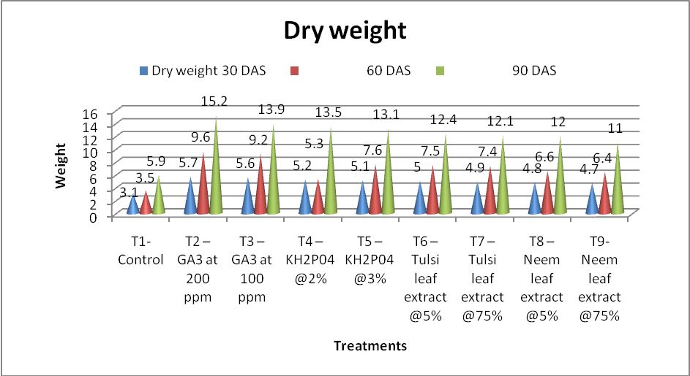
Fig 2: Effect of different treatment of Seed Priming on dry weight of Buckwheat
CONCLUSION
Based on comprehensive finding of the study, it concluded that the application of seed priming in particularly with gibberellic acid (GA₃) at 200 ppm (T₂), proved to be the most effective treatment in enhancing overall performance. Buckwheat crop shows the most favorable outcomes across growth parameters i.e. highest plant height ( 59.7 cm), highest leaf length (9.5 cm), highest leaf width (17.6 cm) and highest dry weight ( 15.2 ) at 90 DAS and moreover, it is seen that under T₂ ( Seed Priming of Gibberellic at 200 ppm ). These superior results can be attributed to the biochemical effects of gibberellic acid in enhancing seed germination, nutrient mobilization, and enzyme activity, leading to better root and enzyme activity, leading to better root and shoot establishment. Therefore, seed priming with GA₃ at 200 ppm can be considered a highly beneficial agronomic practice for improving the growth performance and dry matter accumulation in buckwheat under field condition.

Disclaimer (Artificial intelligence)
Option 1:
Author(s) hereby declare that NO generative AI technologies such as Large Language Models (ChatGPT, COPILOT, etc.) and text-to-image generators have been used during the writing or editing of this manuscript.
Option 2:
Author(s) hereby declare that generative AI technologies such as Large Language Models, etc. have been used during the writing or editing of manuscripts. This explanation will include the name, version, model, and source of the generative AI technology and as well as all input prompts provided to the generative AI technology
Details of the AI usage are given below:
1.
2.
3.

REFERENCES
Alvarez- Jubete, L., Arendt, E. K. and Gallagher, E. (2009). Nutritive value of pseudo- cereals and their increasing use as functional gluten- free ingredients. Trends in Food Science and Technology, 20(11-12), 579- 590.
Basra, S. M. A., Farooq, M., Tabassum, R. and Ahmad, N. (2005). Physiological and biochemical aspects of seed vigor enhancement treatments in fine rice (Oryza sativa L.). Seed Science and Technology,33(3), 623- 628.
Bonafaccia, G., Galli, V., Francisci, R., Mair, V., Skrabanja, V. and Kreft, I. (2003). Characteristics of spelt wheat products and nutrional value of spelt wheat- based bread. Food Chemistry, 82(4), 479- 488.
Farooq, M., Basra, S. M. A., Wahid, A., Ahmad, N. and Saleem, B. A. (2010). Priming enhances germination of spring maize ( Zea mays L.) under cool condition. Seed Science and Technology, 36(2), 497- 503.
Myers, R. L. and Meinke, L. J. (1994). Buckwheat: A multi- purpose, short- season alternative (MU Guide G4306). University of Missouri Extension.
Bhusal, D., Thakur, D. P., Yadav, L., & Ghimire, P. (2024). Influence of seed priming in the germination and yield performances of common buckwheat. Archives of Agriculture and Environmental Science, 9(2), 216-220.
Reddy, Palagulla Venkata Mahendra, Abhinav Dayal, Neha Thomas, and Narendra Reddy Ippala. 2022. “Appraisal of Buckwheat (Fagopyrum Esculentum L.) Genotypes for Growth, Yield, Yield Attributes, Seed and Seedling Characteristics under Prayagraj Agro-Climatic Conditions”. International Journal of Environment and Climate Change 12 (11):3494-3506. https://doi.org/10.9734/ijecc/2022/v12i111398.

