Threats of Climate Change in Arab Gulf Countries
.

ABSTRACT
This study aims to investigate the changes and trends in the regional climate of the Arab Gulf countries concerning temperatures, rainfall, and water lost through evapotranspiration over the last four decades, specifically for the period 1981-2020. The Climate Research Unit (CRU-TS) dataset provides essential, detailed meteorological information for researching climate change in the Gulf Countries. The CRU-TS dataset, consisting of 45 gridded stations operating at a 0.5-degree interval, was statistically analyzed to identify potential trends in mean annual temperature, rainfall, and PET using the Mann-Kendall statistical tests for confidence limits during the study period. Trend analyses indicate a significant increase in temperature and PET at a 95% confidence level, while rainfall shows an insignificant decrease over time. The findings demonstrate the spatial and temporal variations in the rate of increase in mean annual temperature between decades, with values ranging from 0.36°C for the second decade to 1.03°C for the last decade , with an overall average increase of 0.75 °C/decade during the study period. The rate of decrease in rainfall is 11.77 mm/decade, while the increase in PET is 166.31 mm/decade. The total amount of water lost by PET increased significantly from 7065348.8 m.m³ during the first decade (1981- 1990), to 7220288.6 m.m³ during the last decade (2011 – 2020), which have great effect on moisture content, vegetation growth and land degradation, The increase in the value of PET over time is due to the rise in mean annual temperature and vegetation activities, which provide more reliable water to the atmosphere.

Key Words: Air Temperature, Arab Gulf Countries, Climate Change, Evapotranspiration Rainfall
1. INTODUCTION:
The Arab Gulf countries(AGC) refer to a group of Arab countries bordering the Arabian Gulf. There are eight member states of the Arab League in the region: Bahrain, Kuwait, Iraq, Oman, Qatar, Saudi Arabia, and the United Arab Emirates. The Middle East countries, including those on the Arabian Peninsula, exhibit significant variations in their climatic conditions, which can be substantial within a single country, such as Saudi Arabia (Ragab and Prudhomme, 2000). Gulf Countries are highly vulnerable to extreme events caused by climate change, which generates multidimensional security threats regarding human habitats, public health, supply chains, food systems, and social stability. The fast-rising sea level is causing prominent threats to the habitats of GCC residents. It is estimated that more than 1,200 km² of the GCC territory will be submerged by the sea by the end of this century under the worst situation modeled by the IPCC (Herehe, 2020; IPCC,2023).
The countries of the Arab Gulf are particularly prone to climate change. The heat index, which is what the temperature ‘feels like’ when factoring in humidity, in the Middle East reached 52ºC in July 2023; this is the highest level that human beings can withstand, and the actual temperature in the Arab gulf region is expected to continue rising by 1- 2ºC by 2050(Research Report, 2023). Any change in climate produces changes in extreme weather events, such as heavy rainfall, heat and cold waves, in addition to prolonged drought occurrences (Kotwicki and Al Sulaimani, 2009).
The climate of the Arabian Gulf countries exhibits a dynamic climate that varies throughout the year. Spanning from the north to the south, the Gulf region displays a vast range of temperature variations, with daily averages spanning from 1 to 43 °C. Although the south-western area receives some rainfall, the predominant climate across the Gulf is arid with an annual rainfall of 93mm (Almazroui et al. 2020). This region is notably home to the Rub Al-Khali (Empty Quarter), the world’s largest sand desert. An increase in temperature, especially if paired with reduced precipitation, holds the potential to affect the Gulf’s agriculture and water resources severely (Almazroui et al. 2012a).
The rise in global average surface air temperature, approximately 1 °C above pre-industrial levels, represents one of the most pressing concerns in contemporary climate science (Ntoumos et al. 2020). This observed change is largely ascribed to anthropogenic influences, with the Intergovernmental Panel on Climate Change (IPCC) highlighting increased greenhouse gas concentrations as a primary driver in its Special Report on Global Warming of 1.5 °C (Allen et al. 2018). Shifts in climate patterns inevitably lead to alterations in extreme weather patterns, encompassing events like intense rainfall, heatwaves, cold spells, and extended periods of drought, with potential intensification of dust storms. The Gulf region is observing such climatic shifts, with indications that more humid areas might experience augmented rainfall, while the arid regions risk becoming even drier (Lindner 2007).
The Intergovernmental Panel on Climate Change (IPCC,2023) reports that global warming will continue to increase in the near term (2021–2040), mainly due to increased cumulative CO2 emissions in nearly all considered scenarios and modeled pathways. In the near term, global warming is more likely than not to reach 1.5°C, even under the very low GHG emission scenario, which will cause intensifying extreme weather conditions and glacier retreats, and increases in sea levels, and intensifies droughts and floods (Mitigation 2011). The effects of climate change from these disturbances affect developed and developing nations through disruptions to food security and freshwater supply, and reductions in biodiversity and economic incomes (Muluneh 2021; Dadrass et al. 2025).
Climate change is positively correlated with particulate matter (PM), as research suggests that a 1°C increase in summer corresponds to a 1.05 µg/m3 increase in PM2.5 concentrations (Shi et al,2019). PM air pollution can lead to adverse health outcomes such as heart and lung diseases (WHO,2021). In the GCC countries, such a climate-driven effect may further exacerbate high levels of PM pollution caused by natural dust and industrial, traffic, and household emissions. Moreover, the heat waves in the Gulf region can lead to more direct health risks, including heat strokes and potential fatalities. For example, studies indicate that heat stress during Hajj, an important Islamic pilgrimage, has reached dangerous levels in recent years and will continue to do so in the coming decades (Research Report,2022).
This study aims to investigate the changes and trends in the regional climate of the Arab Gulf countries regarding temperatures, Rainfall, and water lost through evapotranspiration, over the last four decades, for the period 1981-2020.
2. Materials and Methodology
2.1. Geographic Location and Climatic Conditions of AGC
Arab Gulf countries are located in the southwestern part of Asia and the northeastern part of the Arab world, lying between two latitude circles, 29 ° – 37 ° north and 38 ° – 48 ° east longitude. Consistently, its extension from east to west is approximately equal in length from north to south. The climate of the Arabian Peninsula is semi-arid to arid, with high annual temperatures and low rainfall, making it one of the most climate-vulnerable regions in the Middle East, as well as in Southwest Asia. The geographic cohesiveness of the Arabian Peninsula is reflected in a shared interior of desert and a shared exterior of coast, ports, and relatively greater opportunities for agriculture. The fact that most of the peninsula is unfavorable for settled agriculture is of enormous significance. The Arabian Peninsula can be described as a vast plateau, edged with deeply dissected escarpments on three sides and sloping gently northeastward from the Red Sea to the eastern lowlands adjoining the Arabian Gulf. The peninsula’s highest peak, Al-Nabī Shuʿayb, at 12,030 feet (3,665 meters), is located approximately 20 miles northwest of Sanaa in Yemen (Figure 2). The most prominent feature of the peninsula is the desert, but in the southwest, there are mountain ranges, which receive greater rainfall than the rest of the peninsula.
2.2. Datasets
2.2.1. Meteorological Data
A vital component for this investigation was the Climate Research Time (CRU-TS) dataset that delivered essential, detailed meteorological information to research climate change in the Gulf Countries. The CRU-TS dataset, with its 45 gridded stations were selected systematically represented the total area of the AGC, operating at a 0.5-degree interval, permitted thorough climate investigations of the Arab Gulf Countries, from 1981 through 2020(Figure 1).
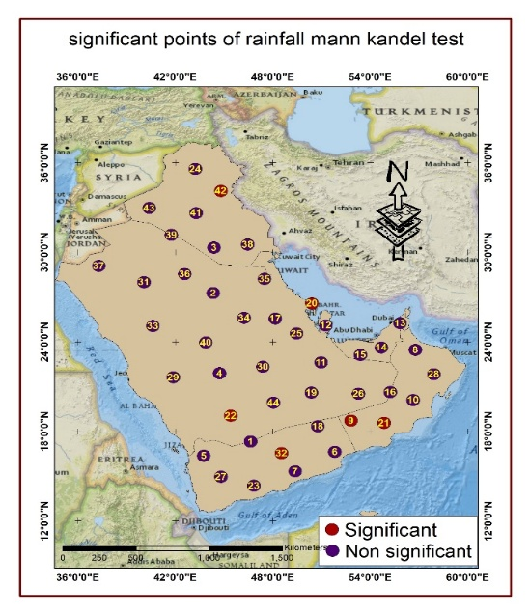
Figure 1: Location of the selected meteorological points mann Kandel test in the Arab Gulf Countries

A thorough quality control procedure was applied to this dataset, which established data reliability needed for accurate climate modeling, together with trend analysis (Awadh and Ahmad 2012; Kumar et al. 2024). The researchers obtained essential climate variables, including monthly average maximum temperature, mean rainfall, and potential evapotranspiration (PET) from the CRU-TS dataset during the specific period. The data went through ArcGIS spatial analytical processes that resulted in the creation of yearly averages for each climatic variable. Results from spatial processing showed each parameter activity, including temperature changes and rainfall patterns, and PET measurements throughout AGC over time. All analyses conducted on spatial variables (temperature, rainfall, evapotranspiration, and vegetation cover) covered AGC on pixel maps. However, several points were selected to plot the graphs, and the trend value was determined. The maps generated help scientists understand the changes climate change creates across different regions while permitting identification of zones affected by droughts and other environmental stressors. The analysis of climate data through time series evaluation revealed the identification of growing temperatures plus diminishing precipitation, combined with accelerated evapotranspiration water loss. The period from 1981 to 1990 is chosen for climatology because it serves as the reference (base) period to determine changes in climate parameters between the last three decades.
A simple linear trend approach was used to analyze potential trends in mean annual temperature, rainfall, and potential PET using the statistical tests or confidence limits of Mann-Kendall during the study period.

3. RESULTS AND DISCUSSIONS
3.1.1 Analyzing the spatial and temporal distribution of temperature in AGC from 1981 to 2020
Surface air temperature is a key component of climate variability and one of the major indicators of climate change on both regional and global scales (Kothawale et al. 2010). Temperatures in AGC exhibit substantial daily, seasonal, and long-term variations due to the geographical location. This positioning results in pronounced continental climatic conditions, ranging from extreme continental to very arid climates (Adamo et al. 2018). It was found that the mean temperature of the AGC increased significantly by 0.10 °C decade-1 for the period from 1960 to 2010(Attada et al. 2018).
Generally, the results emphasized the spatial and temporal variations of the annual mean temperature across the AGC region. It decreased from the northwestern to the southeastern part of the AGC (Figure 2 and Table 1). The mean annual temperature is low (below 12 °C) in the northwestern regions, including northern Iraq and northwestern Saudi Arabia, as well as in the southwestern coastal zone of Saudi Arabia and Yemen. In contrast, higher mean annual temperatures (more than 28 °C) occur in the southeastern regions, including the United Arab Emirates, southern Saudi Arabia, and some parts of Oman, as well as in the western coastal zone of Saudi Arabia and Yemen (along the Red Sea). These variations can be attributed to absolute geographical location and topographical influences. Almazroui et al. (2020) emphasized that the temperature in the northwest and southwest mountain areas of the AGC is lower than in the central to eastern regions. The temperature ranged from 8.57 to 28.32 °Cover the northern Peninsula, whereas the temperature ranged from 26.68 to 33.97 °C in the southern Peninsula (Almzroui et al. 2013).
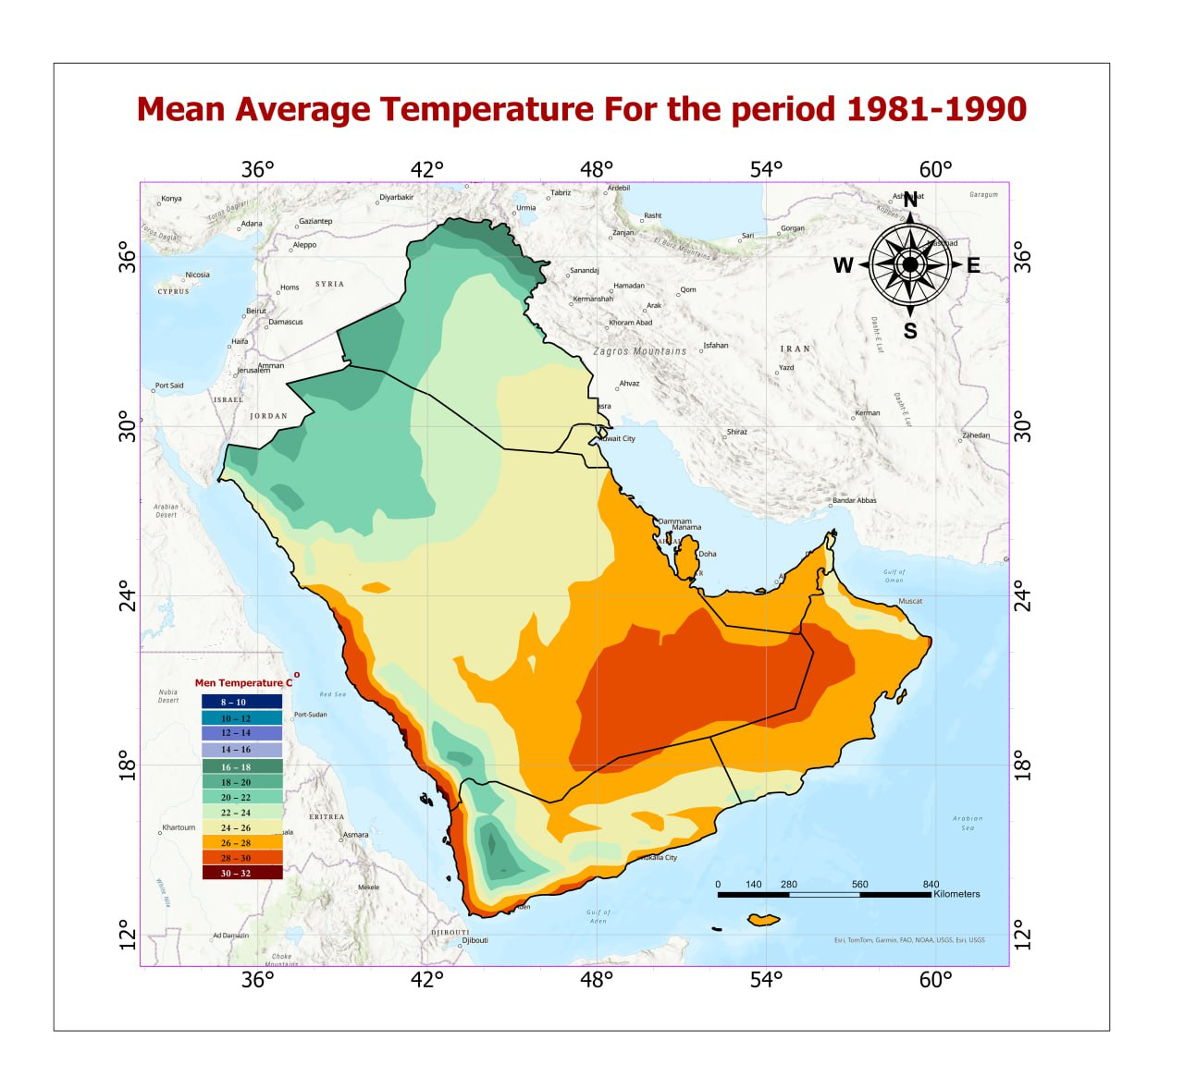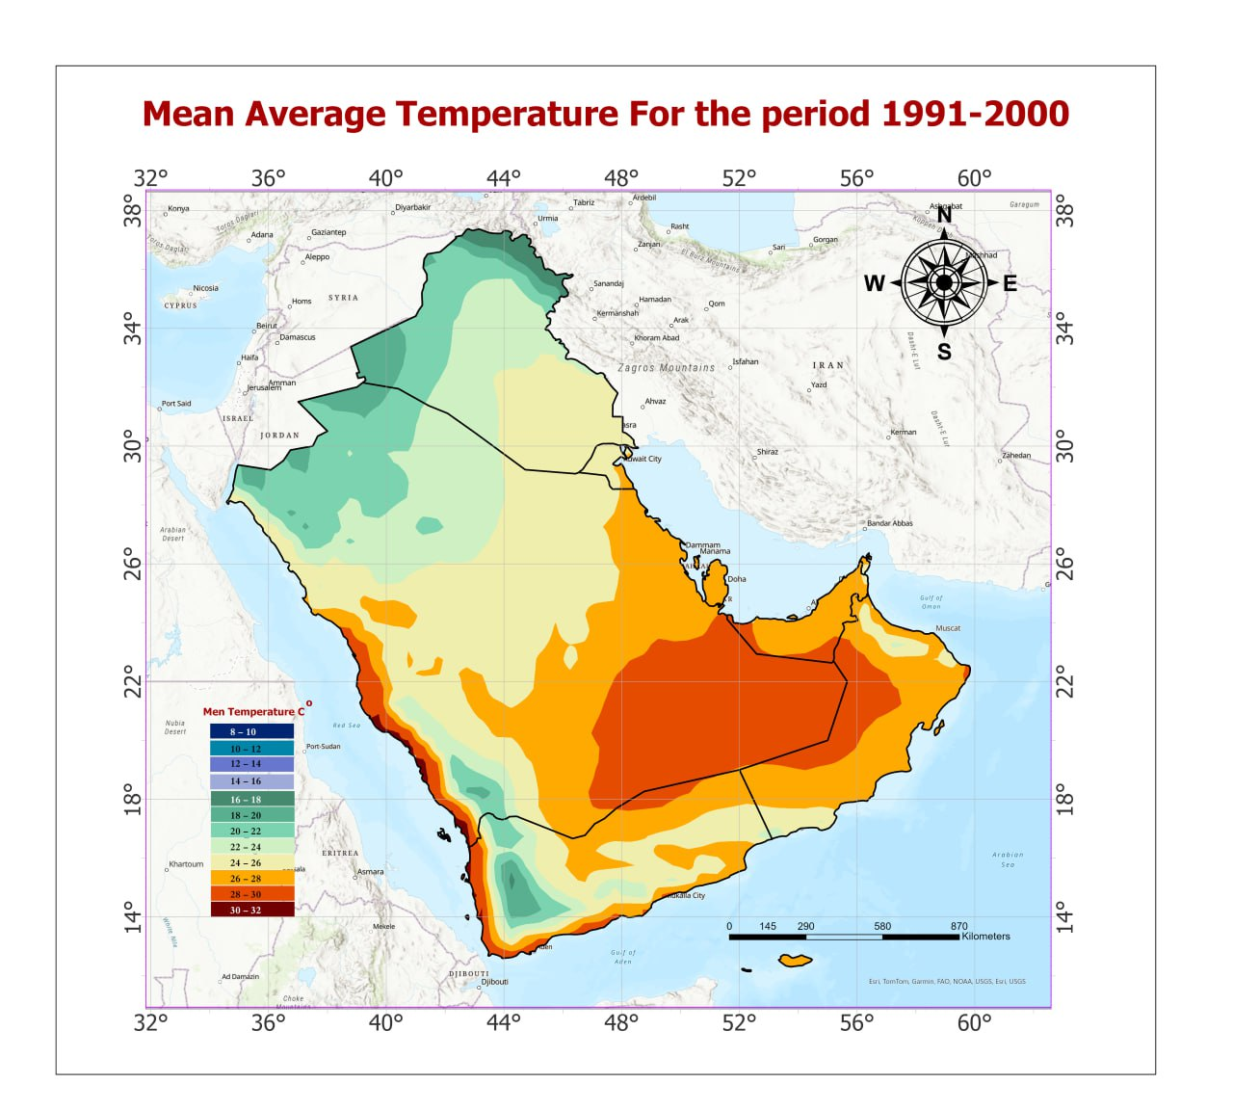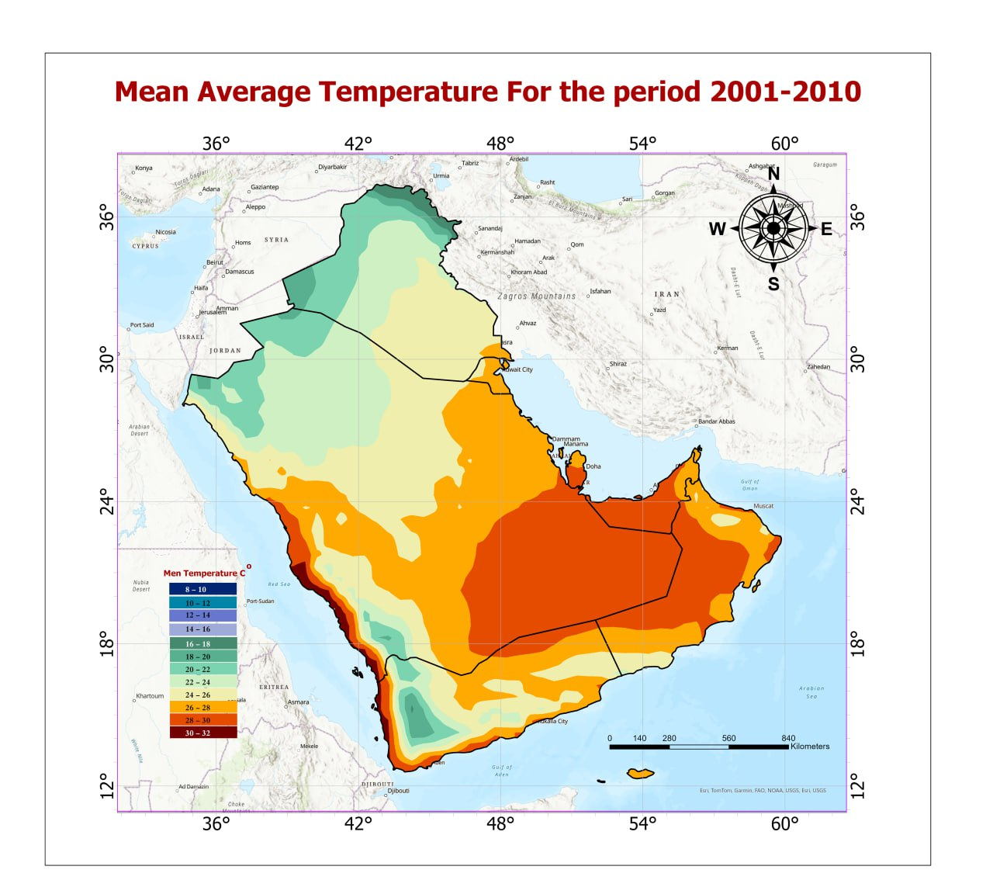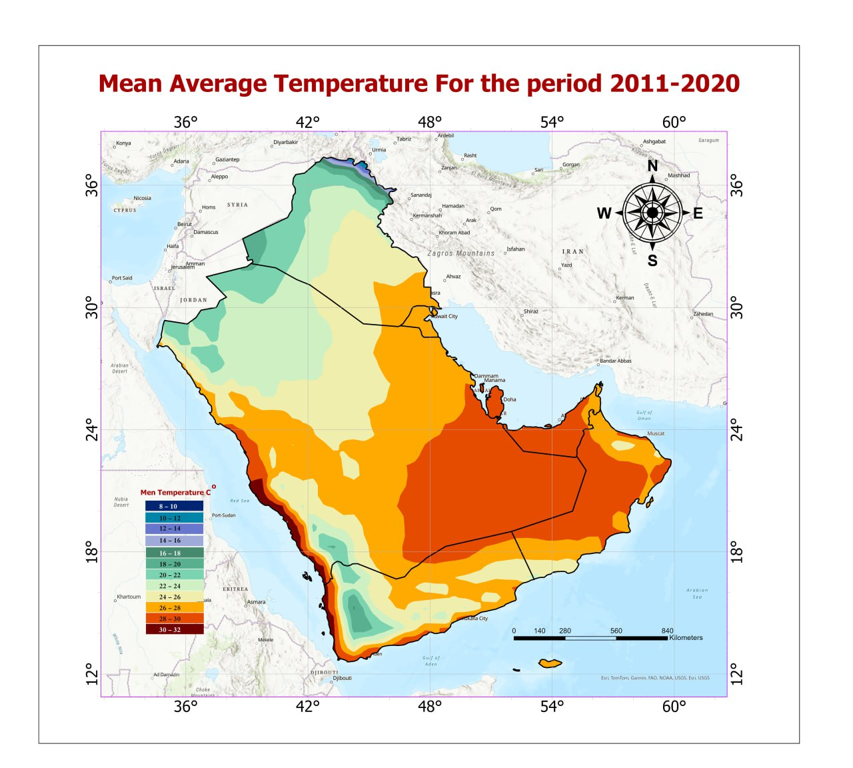
Figure 2: Spatial distribution of the Temperature averaged in the AGC over the period 1981-2020
The findings of this study (Table 2) showed an increase in the land area with a mean annual temperature higher than 22 ˚C over time, that increased from 94.66 % of the total area of AGC during the first decade(1981-1990) to 98.08% in the last decade( 2011-2020). This reflects the impact of climate change, which caused the mean temperature to rise in the Arab Gulf countries.

Table 1: Average Mean annual temperature in the AGC for the period 1981-2020
1981-1990 |  |  | 1991-2000 |  |  | 2001-2010 |  |  | 2011-2020
Tem, ˚C | Area % | Area  km² | Tem, ˚C | Area % | Area  km² | Tem, ˚C | Area  % | Area  km² | Tem, °C | Area % | Area  km²
8 | 0.00 | 0.3 | 8 | 0.00 | 70.7 | 10 | 0.005 | 149.1 | 10 | 0.003 | 107.1
10 | 0.02 | 767.4 | 9 | 0.00 | 7.6 | 12 | 0.04 | 1316.7 | 12 | 0.04 | 1232.1
12 | 0.06 | 2084.6 | 10 | 0.01 | 405.6 | 14 | 0.10 | 3228.0 | 14 | 0.09 | 2927.7
14 | 0.14 | 4445.2 | 12 | 0.05 | 1695.8 | 16 | 0.18 | 5821.7 | 16 | 0.17 | 5576.1
16 | 0.25 | 8024.5 | 14 | 0.12 | 3919.0 | 18 | 0.28 | 9001.9 | 18 | 0.27 | 8711.3
18 | 0.38 | 12263.7 | 16 | 0.21 | 6926.9 | 20 | 1.66 | 54251.6 | 20 | 1.34 | 43723.0
20 | 4.49 | 146424.5 | 18 | 0.30 | 9851.9 | 22 | 7.83 | 255267.3 | 22 | 7.00 | 228070.9
22 | 12.41 | 404401.6 | 20 | 2.95 | 95979.8 | 24 | 14.53 | 473365.9 | 24 | 13.83 | 450619.2
24 | 13.81 | 450073.1 | 22 | 10.41 | 339300.4 | 26 | 23.73 | 773169.1 | 26 | 21.65 | 705616.9
26 | 29.09 | 947777.0 | 24 | 14.30 | 466085.1 | 28 | 26.70 | 869957.6 | 28 | 29.12 | 948895.2
28 | 25.33 | 825230.3 | 26 | 28.55 | 930336.4 | 30 | 24.12 | 785845.6 | 30 | 25.52 | 831693.2
30 | 14.02 | 456975.6 | 28 | 25.24 | 822491.2 | 32 | 0.83 | 27093.2 | 32 | 0.96 | 312945.0
 |  |  | 30 | 17.52 | 570888.0
 |  |  | 32 | 0.32 | 10509.3

To calculate the average increase in mean annual temperature from 1981 to 2020, meteorological data from 1981 to 1990(First decade) were used as the baseline for comparison. This approach enabled an assessment of temperature variations over the four decades. Overall, the rate of increase in mean annual temperature indicates both temporal and spatial differences, ranging from 0.36°C for the first decade to 1.03°C for the last decade, with spatial variations observed across different decades (Table 2). The overall mean rising rate during the study period is 0.75 ºC/decade.
Table 2: Rising Rate of the mean decade temperature in the AGC during the last three decades
1991-2000 |  |  | 2001-2010 |  | 2011-2020
 | Rising Rate ˚c | Area % | Rising Rate ˚c | Area % | Ringing Rate ˚c | Area %
 | 0.20 | 19.15 | 0.20 | 1.60 | 0.10 | 9.51
 | 0.40 | 46.92 | 0.40 | 7.48 | 0.40 | 7.93
 | 0.60 | 24.96 | 0.60 | 10.46 | 0.60 | 8.41
 | 0.80 | 7.62 | 0.80 | 20.01 | 0.80 | 13.24
 | 1.00 | 1.36 | 1.00 | 26.23 | 1.00 | 13.15
 |  |  | 1.20 | 23.27 | 1.20 | 15.92
 |  |  | 1.40 | 10.51 | 1.40 | 18.31
 |  |  | 1.60 | 0.44 |  | 86.46
Mean rising rate( ˚C/decade) | 0.36 |  | 0.87 |  | 1.03

The results of regression analysis based on statistical significance tests of confidence limits of Mann-Kendall during the study period (Figure3, 4 and Table 2) revealed that the mean annual temperature increased significantly at a 95% confidence level, with variation in the rising rate between the last three decades. The increasing rates are: 0.36, 0.87, and 1.03 °C decade-1 for the last three decades, respectively. The finding confirms that the second decade has the lowest temperature rising rate, while the fourth decade shows the highest temperature rising (warmest decade).

Figure 3: Statistical trends in mean annual temperature with time in AGC from 1981 to 2020

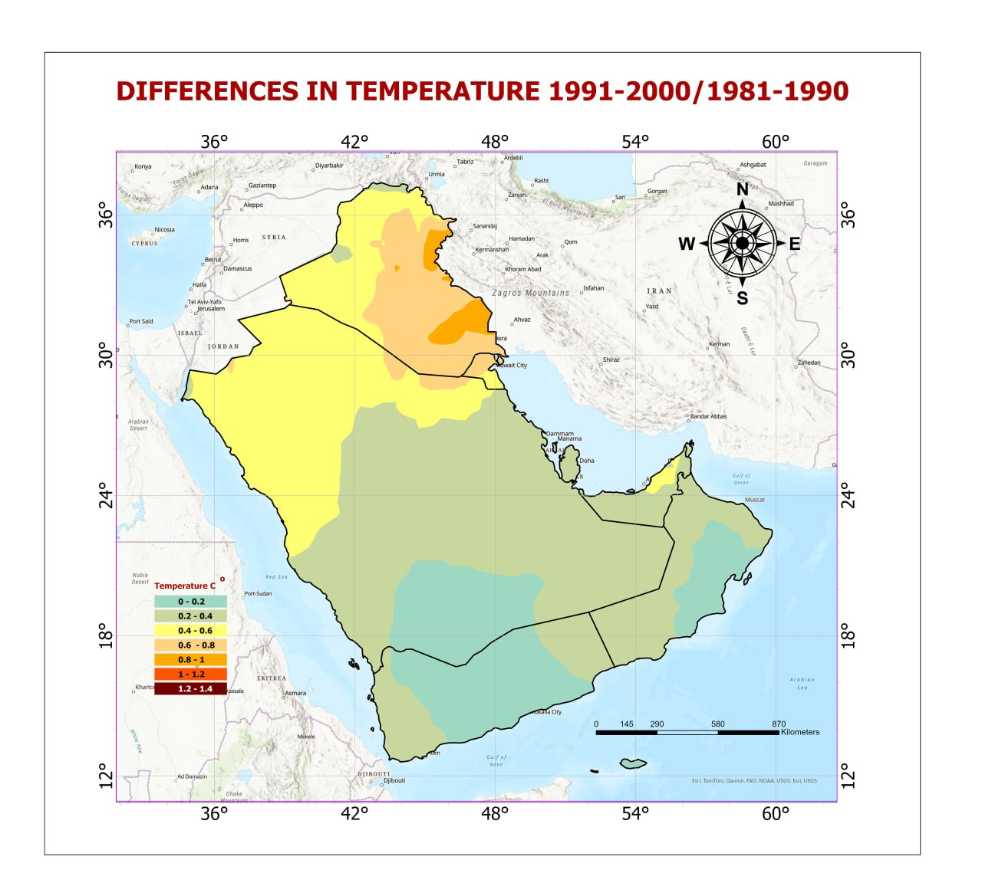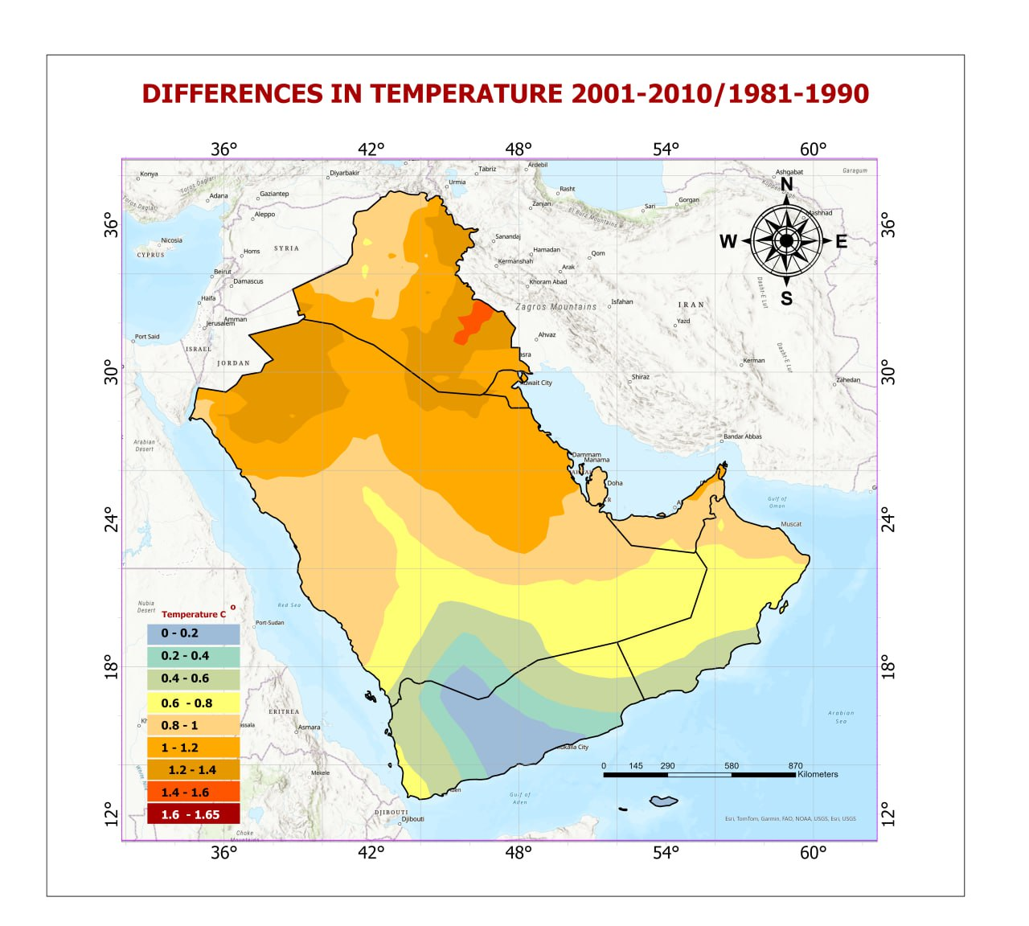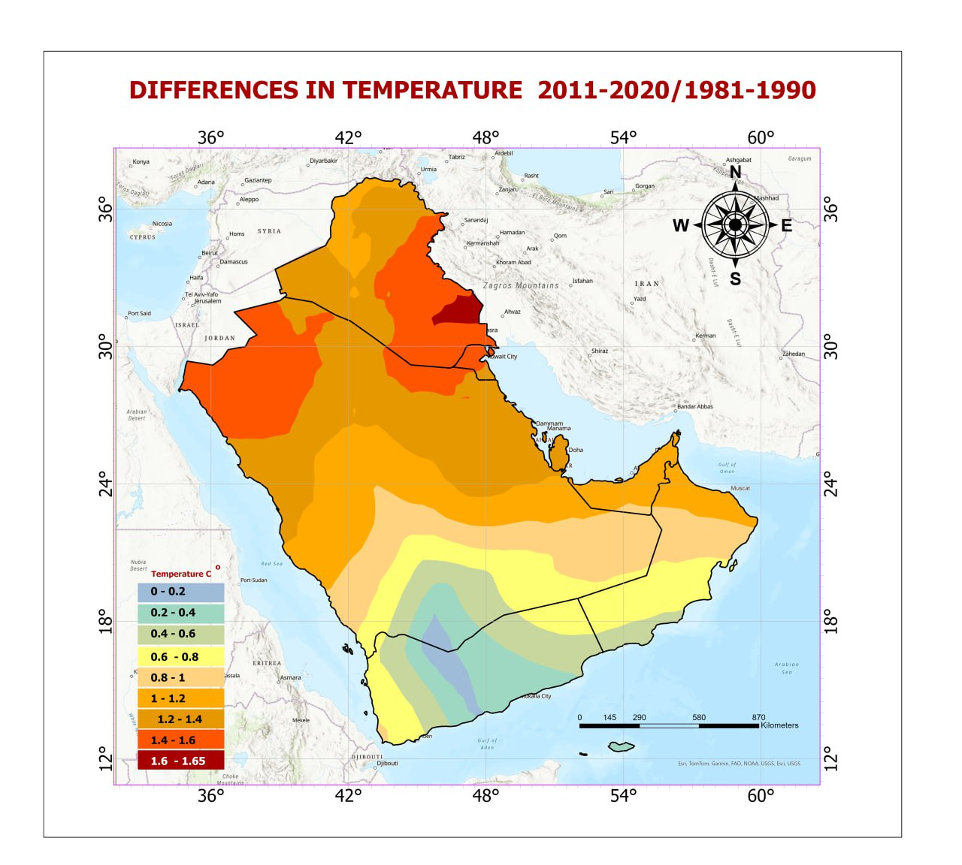
Figure 4: Spatial distribution of temperature rising rate in the AGC from 1981 to 2020

The Intergovernmental Panel on Climate Change (IPCC) fifth assessment report (AR5) highlights the increasing global mean temperature and the fact that it will continue to increase throughout the 21st century ( IPCC, 2001)According to the IPCC fourth assessment report (AR4), for the period 1956–2005, the global mean surface temperature (both land and ocean) increased by 0.13 _C/decade ( 2007) which was updated in AR5 to 0.12 ºC/decade for the period 1951–2012 ( 2001). Almazroui et al.(2012) indicated that surface temperature over the Arabian Peninsula, in particular over Saudi Arabia (covering 80% of the peninsula), increased at a rate of 0.60 °C /decade for the last three decades.
Arab Gulf countries have experienced a rising annual mean temperature pattern that aligns with global temperature increases over the past four decades (Salman et al. 2019). According to the Intergovernmental Panel on Climate Change (IPCC 2021), global warming results from the accumulation of atmospheric greenhouse gases, which triggers significant climate-related disruptions. The MENA region, along with vulnerable areas such as South Asia and sub-Saharan Africa, has exhibited similar warming trends, leading to reduced crop production, increased water loss through evapotranspiration, and serious water shortages (Alrteimei et al. 2022; Moisa et al. 2025). The rate of temperature increase in the AGC displays a distinct southern bias, reflecting broader regional trends shaped by landforms, water bodies, and atmospheric movements compared to the baseline data.
3.1.2. Spatial Distribution of the mean annual temperature in each of the AG counties
The results of the regression analysis of the mean annual temperature in AGC based on statistical significance tests of confidence limits of Mann-Kendall revealed a significant increase at 95% confidence level in the mean temperature in all of the AG countries with some variation(Table 5). Both Oman and Yemen show the lowest rate of increase over time (0.22 to 0.81˚C decade-1, and 0.21 to 0.46˚C decade-1, respectively). At the same time, Iraq and Kuwait demonstrate a higher rising rate of temperature (0.63 to 1.37˚C and 0.60 to 1.48˚C, respectively) during the study period.
The finding indicated that despite the spatial variability, the overall increasing rate in temperature across the AGC ranges from 0.18 ˚C. decade-1 to 1.48˚C. decade -1. Yemen shows the lowest mean rising rate (0. 34 ºC.decade-1), while Kuwait has the highest mean rising rate (0. 07ºC.decade-1) during the study period, due to the effect of the geographical and topographic location.
Table 3: Statistical Analysis of mean annual temperature in AGC for the period 1981-2020
Country | periods | Min ˚C | Max ˚C | Range | Mean ˚C | STD | Changing Rate( ˚C/decade) | Average changing Rate( ˚C/decade)
Bahrain | 1981-1990 | 26.64 | 27.01 | 0.37 | 26.78 | 0.08 | 0.00 | 0.89
 | 1991-2000 | 26.99 | 27.35 | 0.35 | 27.12 | 0.08 | 0.35
 | 2001-2010 | 27.63 | 28.00 | 0.37 | 27.77 | 0.09 | 0.99
 | 2011-2020 | 28.00 | 28.31 | 0.31 | 28.12 | 0.07 | 1.34
Kuwait | 1981-1990 | 24.75 | 25.96 | 1.22 | 25.18 | 0.32 | 0.00 | 1.07
 | 1991-2000 | 25.41 | 26.35 | 0.94 | 25.79 | 0.23 | 0.60
 | 2001-2010 | 25.91 | 27.13 | 1.22 | 26.31 | 0.32 | 1.13
 | 2011-2020 | 26.25 | 27.31 | 1.06 | 26.67 | 0.26 | 1.48
Oman | 1981-1990 | 23.04 | 28.69 | 5.66 | 27.05 | 1.10 | 0.00 | 0.58
 | 1991- 2000 | 23.27 | 28.90 | 5.63 | 27.27 | 1.09 | 0.22
 | 2001-2010 | 23.53 | 29.44 | 5.91 | 27.75 | 1.11 | 0.70
 | 2011-2020 | 23.57 | 29.59 | 6.03 | 27.86 | 1.12 | 0.81
Qatar | 1981-1990 | 26.76 | 27.49 | 0.73 | 27.10 | 0.19 | 0.00 | 0.85
 | 1991-2000 | 27.10 | 27.83 | 0.73 | 27.43 | 0.19 | 0.34
 | 2001-2010 | 27.74 | 28.45 | 0.71 | 28.08 | 0.19 | 0.98
 | 2011- 2020 | 28.11 | 28.72 | 0.61 | 28.38 | 0.17 | 1.28
Saudi Arabia | 1981- 1990 | 18.31 | 30.35 | 12.04 | 25.08 | 2.59 | 0.00 | 0.78
 | 1991- 2000 | 18.84 | 30.58 | 11.74 | 25.43 | 2.50 | 0.35
 | 2001- 2010 | 19.51 | 31.18 | 11.68 | 26.00 | 2.46 | 0.92
 | 2011- 2020 | 19.66 | 31.28 | 11.61 | 26.17 | 2.41 | 1.09
United Arab Emirates | 1981- 1990 | 25.22 | 28.19 | 2.98 | 27.35 | 0.50 | 0.00 | 0.78
 | 1991- 2000 | 25.57 | 28.44 | 2.87 | 27.69 | 0.48 | 0.35
 | 2001- 2010 | 26.23 | 28.99 | 2.76 | 28.25 | 0.48 | 0.91
 | 2011- 2020 | 26.34 | 29.15 | 2.81 | 28.44 | 0.48 | 1.09
Yemen | 1981- 1990 | 17.22 | 30.24 | 13.01 | 25.14 | 2.41 | 0.00 | 0.34
 | 1991- 2000 | 17.43 | 30.47 | 13.03 | 25.32 | 2.41 | 0.18
 | 2001- 2010 | 17.67 | 30.81 | 13.13 | 25.53 | 2.44 | 0.39
 | 2011- 2020 | 17.80 | 30.96 | 13.16 | 25.60 | 2.42 | 0.46
Iraq | 1981- 1990 | 8.00 | 25.31 | 17.31 | 21.81 | 2.55 | 0.00 | 1.04
 | 1991- 2000 | 8.45 | 25.92 | 17.47 | 22.44 | 2.64 | 0.63
 | 2001- 2010 | 9.05 | 26.37 | 17.32 | 22.93 | 2.62 | 1.12
 | 2011- 2020 | 9.24 | 26.76 | 17.52 | 23.18 | 2.64 | 1.37

Temperature is one of the dominant atmospheric variables having significant and direct influence on almost all hydrological variables (Sonali and Nagesh Kumar2013). The increase in temperature in recent times is mainly attributed to the rise in concentration of greenhouse gases resulting from enhanced anthropogenic activities (Feidas et al. 2004). The Intergovernmental Panel on Climate Change(IPCC 2007) reported that the mean temperature of the globe has increased by 0.74 °C over the last century, though the rates differed significantly from region to region (IPCC 2007).
Temperature, being one of the most important weather variables, not only determines the suitability of a particular crop for a zone, but it also determines the water requirements of the plants or crops through evapotranspiration. Apart from that, it also indirectly influences the metabolisms like respiration, photosynthesis, and above all, the reproduction, i.e., viability of the pollens,.. etc

3.2 Analyzing the spatial and temporal distribution of rainfall in AGC from 1981 to 2020
3.2.1: Spatial distribution of the mean annual Rainfall in AGC
Rainfall in the Arab Gulf region is characterized by low and variable precipitation, with most areas experiencing arid or semi-arid conditions. Generally, 57% of precipitation returns to the atmosphere through evapotranspiration, and this amount may reach 90 to 100% in arid and hyper-arid regions (Heidarnejad et al. 2013).
The mean annual rainfall exhibits spatial and temporal variations in the AGC. Generally, the mean annual rainfall has a wide range of variation, ranging from 50 mm to over 700 mm. More than 85% of the total area of AGC, mainly the central parts, receives less than 300 mm (Table 4). The highest amounts of rainfall (over 500 mm) occur in certain northeastern regions, including the mountainous areas in northern Iraq, while the southwestern regions comprise southern Yemen (Figure 5). These variations are due to the geographical and topographic locations. The data confirmed that the total amount of rainfall water decreases with time, except in the second decade( 1991-2000) that shows a higher total amount of water( 509130.7 m.m³) compared to the baseline data( the first decade, 1981-1990), and decreases during the third and fourth decades, -33699 m.m³and -18048.36 m.m³, at rate of decrease of 10.3 and 5.5 mm decade-1, respectively ( Table 5, and Figure 6).
Table 4: Mean annual of rainfall in AGC for the period from 1981 to 2020
1981-1990 |  |  | 1991-2000 |  |  | 2001-2010 |  |  | 2011-2020
Rainfall mm | Area (km²) | Total Water m.m³ | Rain  fall mm | Area (km²) | Total Water m.m³ | Rainfall mm | Area (km²) | Total Water m.m³ | Rainfall mm | Area( km²) | Total Water m.m³
50 | 444168.6 | 22208.5 | 50 | 433192.1 | 21659.6 | 50 | 652469.5 | 32623.5 | 50 | 547636.4 | 27381.8
100 | 920098.5 | 92009.9 | 100 | 908559.1 | 90855.9 | 100 | 1011242.6 | 101124.3 | 100 | 1012729.2 | 101272.9
150 | 1082314.3 | 162347.2 | 150 | 985054.8 | 147758.2 | 150 | 941787.7 | 141268.2 | 150 | 1000263.4 | 150039.0
200 | 465424.7 | 93084.9 | 200 | 492001.5 | 98400.3 | 200 | 319737.1 | 63947.4 | 200 | 345732.1 | 69146.4
250 | 142247.9 | 35562.0 | 250 | 204601.7 | 51150.4 | 250 | 115823.4 | 28955.8 | 250 | 126084.3 | 31521.0
300 | 58498.7 | 17549.6 | 300 | 67791.4 | 20337.4 | 300 | 62850.2 | 18855.1 | 300 | 60829.4 | 18248.8
400 | 74604.8 | 29841.9 | 400 | 84515.7 | 33806.3 | 400 | 85770.4 | 34308.2 | 400 | 80748.4 | 32299.3
500 | 55396.0 | 27698.0 | 500 | 51688.1 | 25844.1 | 500 | 44756.0 | 22378.0 | 500 | 52830.2 | 26415.1
600 | 9614.9 | 5768.9 | 600 | 25129.8 | 15077.9 | 600 | 21465.8 | 12879.5 | 600 | 25214.8 | 15128.9
700 | 4927.9 | 3449.5 | 700 | 5061.7 | 3543.2 | 700 | 2565.0 | 1795.5 | 700 | 5183.3 | 3628.3
800 | 1171.2 | 936.9 | 800 | 871.8 | 697.4 |  | 3258467.6 |  | 800 | 1216.3 | 973.0
 |  | 490457.3 |  |  | 509130.7 |  |  | 458135.34 |  |  | 476054.4

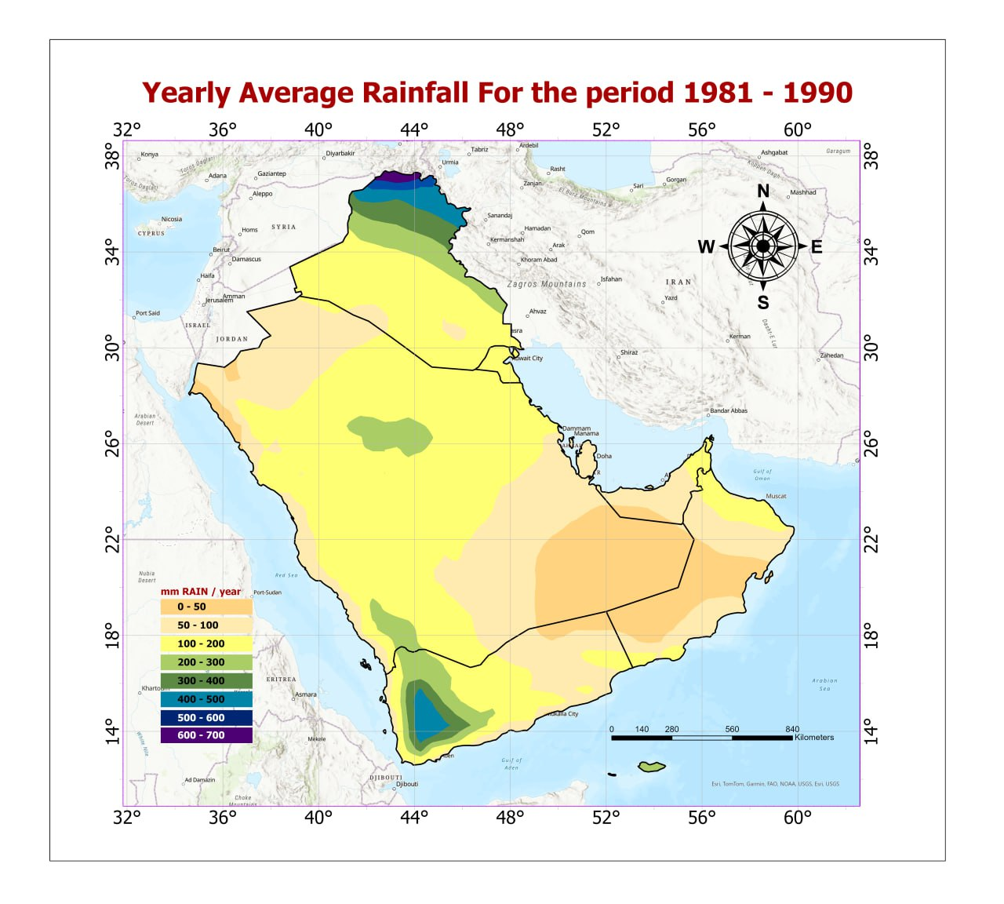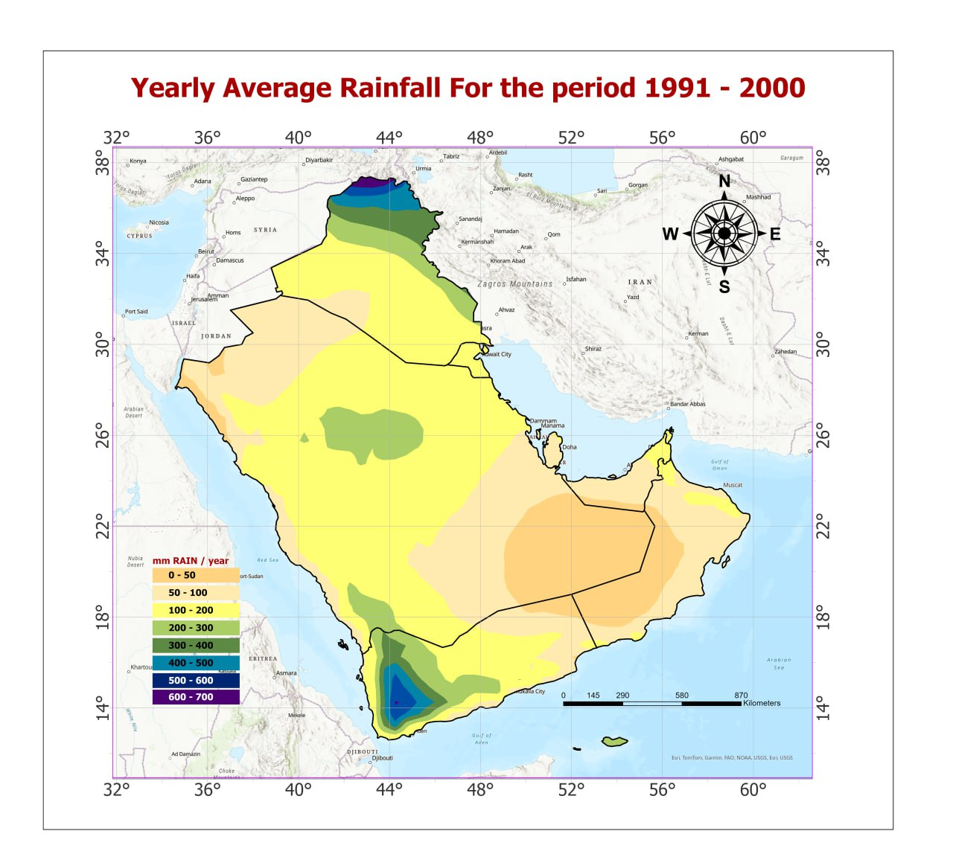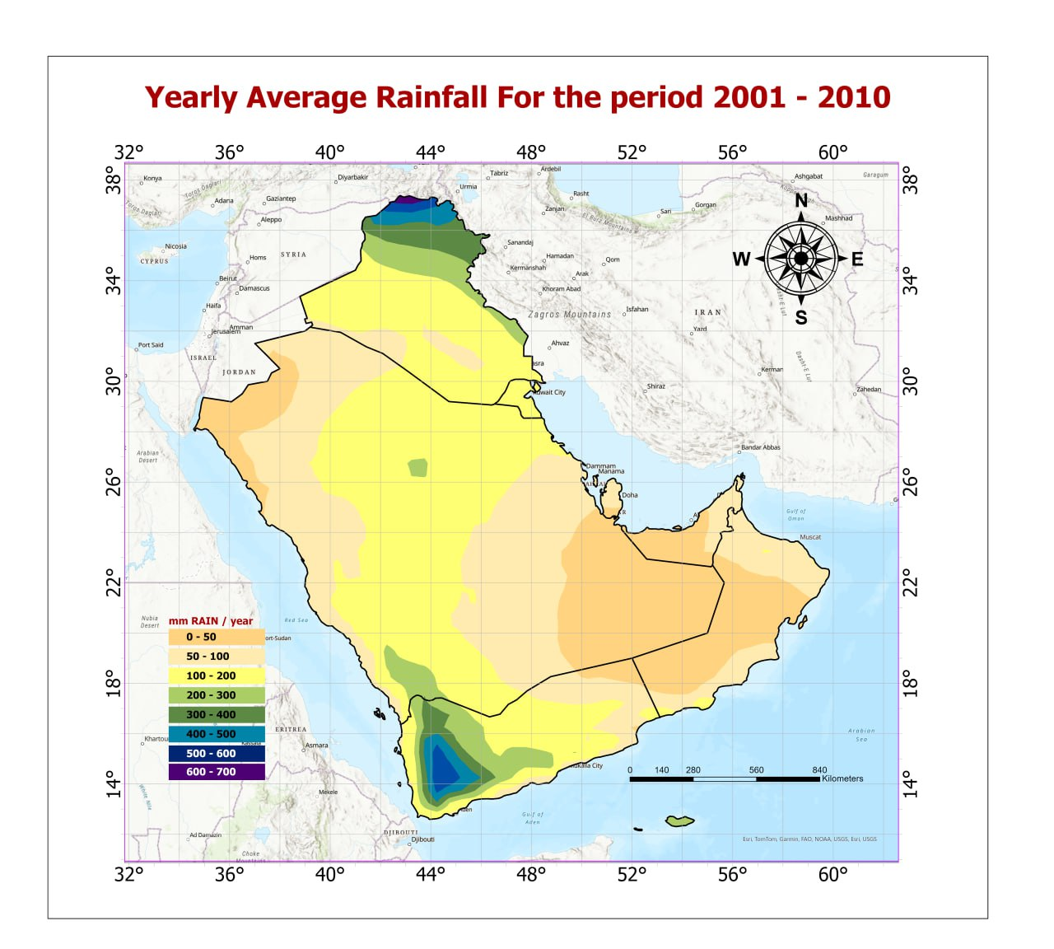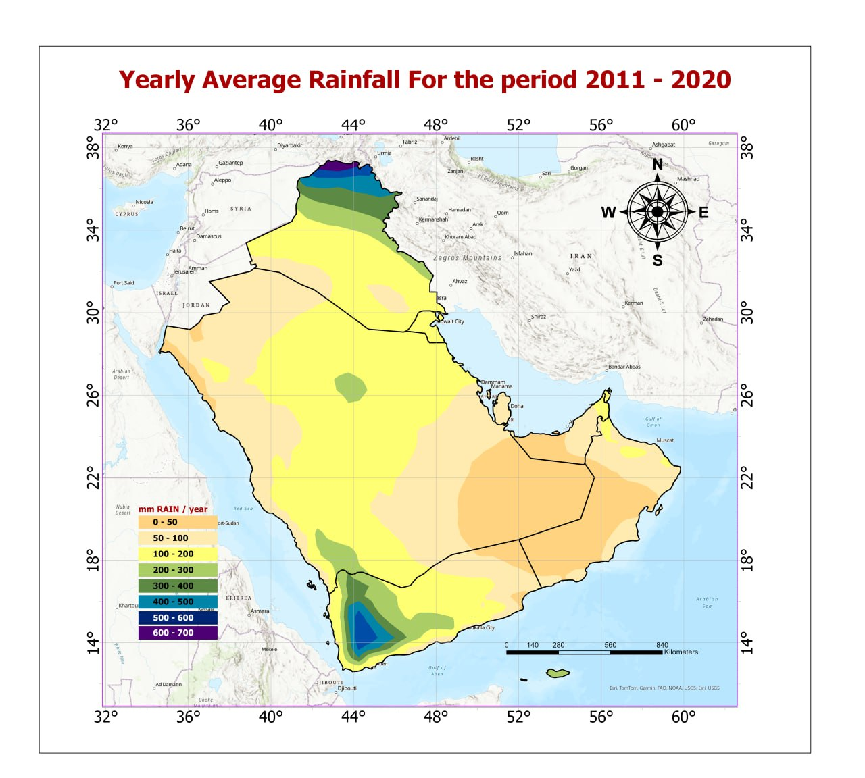
Figure 5: spatial distribution of the mean annual rainfall in the AGC for the period 1981-2020
The findings confirm that the rate of rainfall changes shows a variable trend with time, the second decade has a significant positive rate(5.6 mm.decade-1), while, the third and fourth decades have a significant negative rate( - 10.2 and – 5.5 mm.decade-1, respectively)( Table 5). These findings revealed that there is gain in water balance in the second decade (18333.9 m.m³), while there is a loss in water balance in the third and the fourth decades( -33699 m.m³, and -18048.36 m.m³, respectively) due to the decrease in the rate of rainfall with time. The total amount of rainfall follows the same trend of rainfall that decreases with time, except in the second decade( 1991-2000) which shows a higher total amount of water( 509130.7 m.m³) compared to the baseline data( the first decade, 1981-1990), and decreases during the third and fourth decades, -33699 m.m³and -18048.36 m.m³, at of -10.3 and -5.5 mm decade-1, respectively ( Table 5, and Figure 7).
Precipitation variability serves as a crucial factor in this study, which strengthens the worries regarding hydrological stability in the region. Studies from India to China and the Sahel have confirmed that rainfall patterns are now more unpredictable and produce less rainfall during each wet season and throughout the year (Zhang et al. 2011; Roy et al. 2022a; Chakrabortty et al. 2025).
Table 5: The differences in the amount of Rainfall compared to the baseline data( 1981-1991)
1991-2000 |  |  |  | 2001-2010 |  |  |  | 2011- 2020
Rain diff.  (mm) | Area  (km²) | Water balance  m.m³) | Rate  Of change mm/de. | Rain diff.  mm | Area  (km²) | Water balance( m.m³ | Rate  Of change mm/de. | Rain diff.  mm | Area  ( km²) | Water balance m.m³ | Rate  Of change mm/de.
-40 | 12106.6 | -484.3 | -0.15 | -80 | 48339 | -3867 | -1.2 | -80 | 48666.2 | -3893.3 | -1.19
-20 | 320396.2 | -6407.9 | -1.97 | -60 | 155796 | -9348 | -2.9 | -60 | 111490.9 | -6689.5 | -2.05
-5 | 1107122.3 | -5535.6 | -1.70 | -40 | 387662 | -15506 | -4.8 | -40 | 157968.7 | -6318.8 | -1.94
5 | 1003013.0 | 5015.1 | 1.54 | -20 | 861807 | -17236 | -5.3 | -20 | 553661.9 | -11073.2 | -3.40
20 | 482977.5 | 9659.6 | 2.96 | -5 | 1000345 | -5002 | -1.5 | -5 | 1536274.5 | -7681.4 | -2.36
40 | 244432.7 | 9777.3 | 3.00 | 5 | 383324 | 1917 | 0.6 | 5 | 419662.1 | 2098.3 | 0.64
60 | 57944.1 | 3476.7 | 1.07 | 20 | 174304 | 3486 | 1.1 | 20 | 185117.5 | 3702.5 | 1.14
80 | 15657.3 | 1252.6 | 0.38 | 40 | 166027 | 6641 | 2.0 | 40 | 164762.6 | 6590.5 | 2.02
100 | 10036.2 | 1003.6 | 0.31 | 60 | 62626 | 3758 | 1.1 | 60 | 62624.8 | 3757.5 | 1.15
120 | 4626.6 | 555.2 | 0.17 | 80 | 18239 | 1459 | 0.5 | 80 | 18238.6 | 1459.1 | 0.45
140 | 155.1 | 21.7 | 0.01 |  | 100.00
mean |  | 18333.9 | 5.6 |  |  | -33699 | - 10.3 |  |  | -18048.4 | -5.5

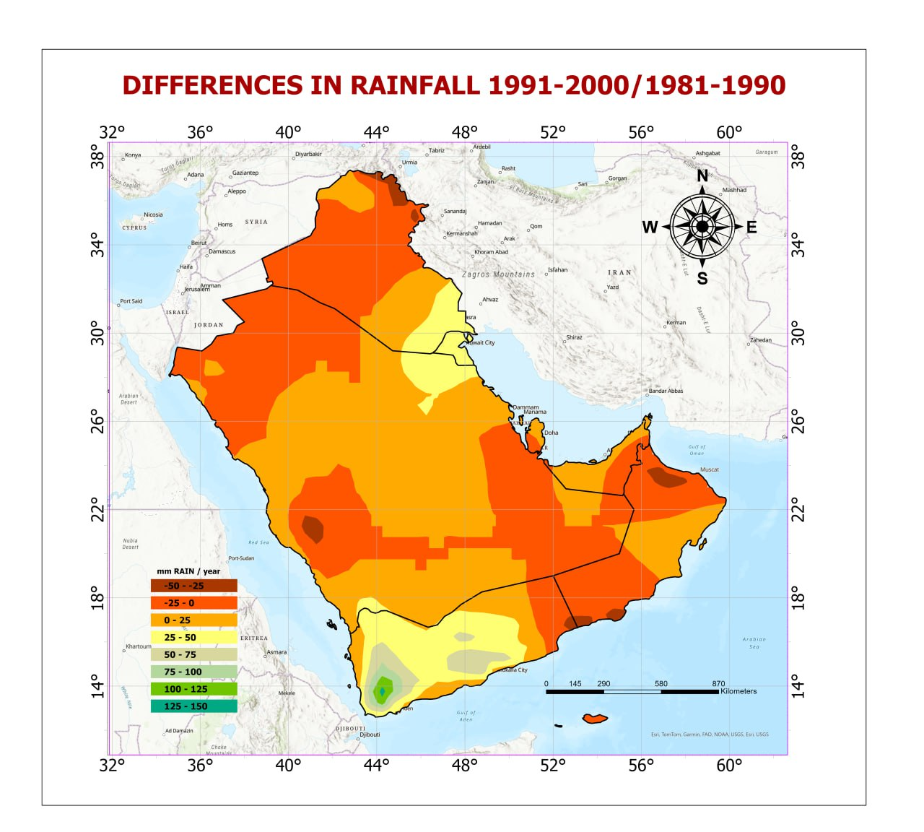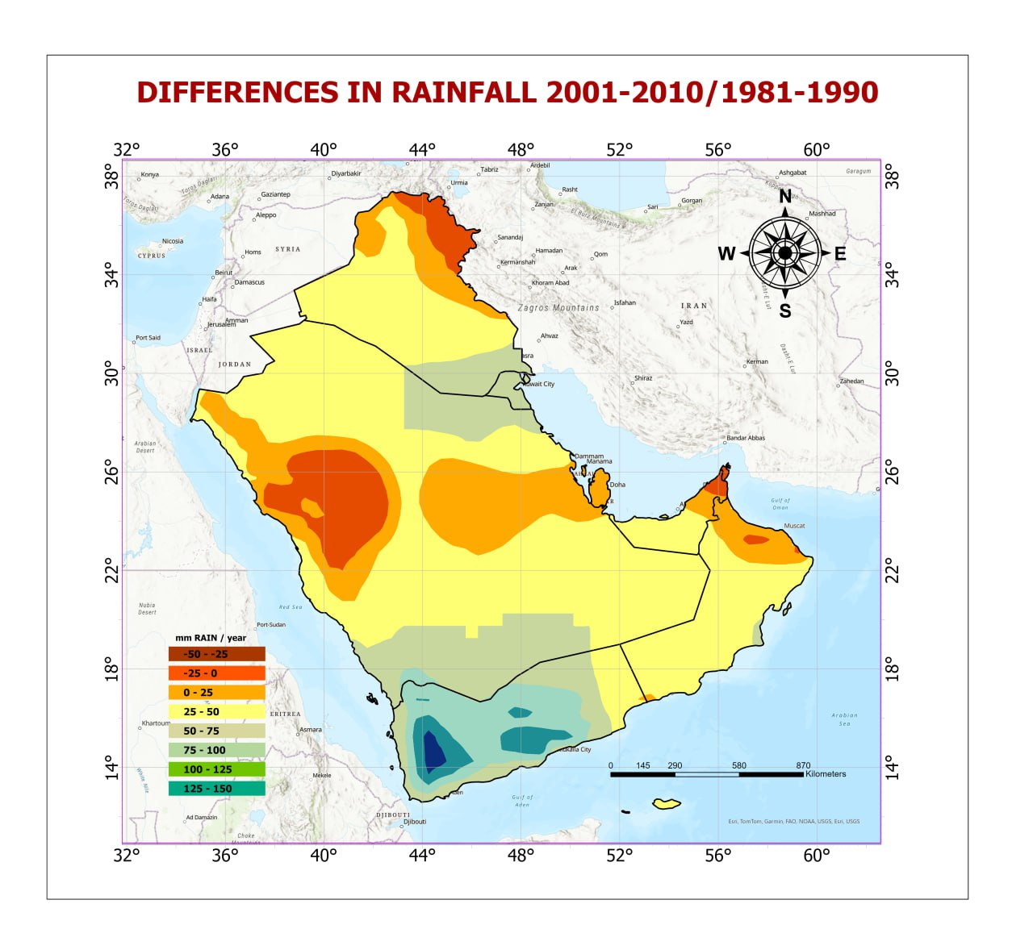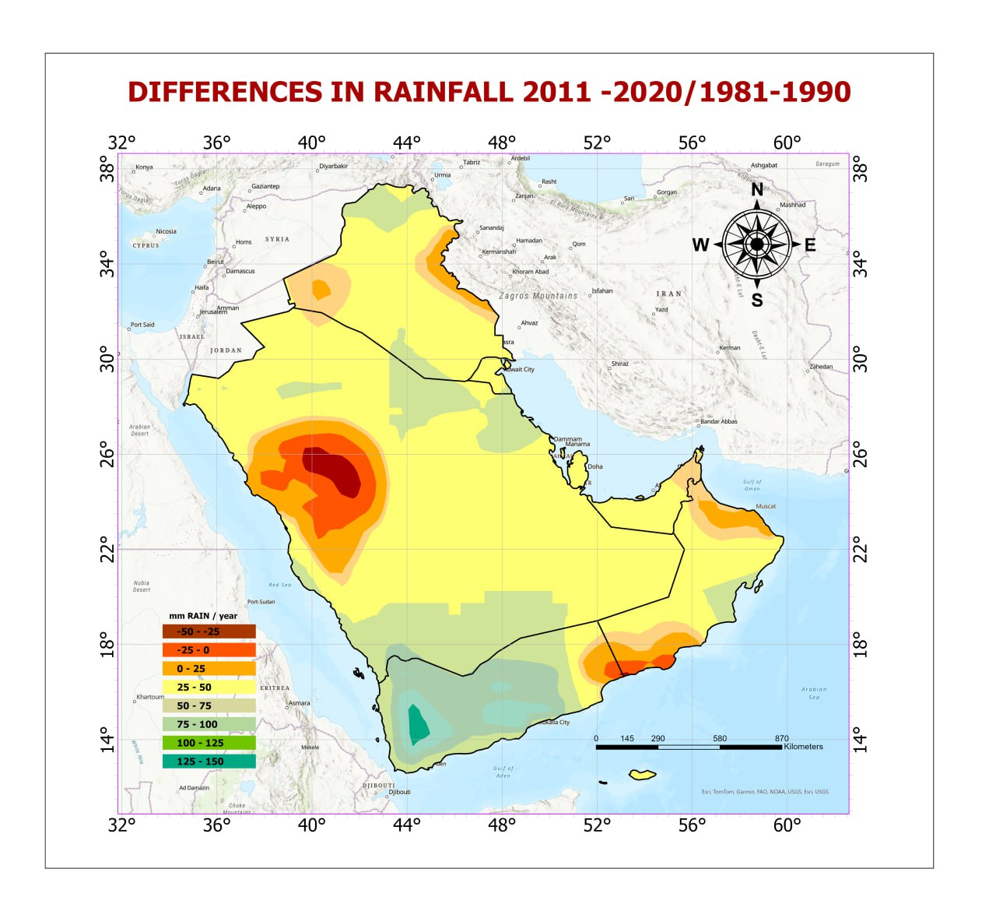
Figure 6 : Spatial distribution of mean annual Rainfall differences in the AGC from 1981-2020
The overall finding of Mann-Kendall statistical tests (Figure 7) confirms that the rainfall in the AGC insignificantly decreased at a 95% confidence level for the period from 1981 to 2020 due to the large size of the study area. AlSarmi and Washington (2013) showed that precipitation decreased over the Peninsula, and showed an insignificant trend for the time period 1986–2008. Hasanean and Almazroui (2015) also reported a downward trend in rainfall over the Arabian Peninsula for the period 1978–2009. Annual precipitation decreased significantly over northern regions of the Peninsula at a rate of 0.66% decade 1, while an increasing trend (1.67% decade -1) occurred over the southern Peninsula. However, precipitation increased at a rate of 0.86% decade–1 over the whole Arabian Peninsula (Almazroui et al. 2017b). Amazouri( 2020b) found a decreasing trend in observed annual precipitation over Saudi Arabia.
However, some testing sites (52, 36, and 14) show a significant decrease at a 95% confidence in the AGC from the same period of study( Figure 8).

Figure 7: Statistical trends in mean annual temperature with time in AGC from 1981 to 2020

Figure 8: Statistical trends in mean annual Rainfall with time in some tested sites in the AGC from 1981 to 2020

3.2.2. Spatial distribution of the mean annual Rainfall in each country of the AG

The results of the statistical analysis of the mean annual rainfall in each country of the AG (Table 6) revealed the spatial and temporal variations between them. Generally, the findings show an insignificant difference in the mean change rate at the 95% confidence level over time in all countries. However, the mean annual rainfall generally revealed insignificant differences between AG countries. Oman and AUE show the lowest mean annual rainfall during the study period( 49.8 mm to 69.3mm), while Iraq and Yemen have the highest mean annual rainfall( 160mm to 208.5mm). The findings confirmed that all countries show a negative changing rate with time, except Yemen and Kuwait show a positive change with time due to the effect of geographic location.
Table 6: Statistical Analysis of Mean Annual Rainfall Changes in AGC for the period 1981-2020
Country | periods | Min mm | Max mm | RANGE | Mean mm | STD | Changing  Rate mm/decade | Mean Change rate mm/decade
Iraq | 1981-1990 | 91.1 | 738.1 | 647.0 | 208.5 | 134.4 | 0.0
 | 1991-2000 | 88.0 | 711.8 | 623.8 | 207.1 | 130.3 | -1.4 | - 9.7
 | 2001-2010 | 89.2 | 658.7 | 569.5 | 189.4 | 118.3 | -19.1
 | 2011-2020 | 86.1 | 729.2 | 643.1 | 200.0 | 137.1 | -8.6
Kuwait | 1981-1990 | 104.6 | 116.3 | 11.7 | 108.2 | 3.4 | 0.0
 | 1991-2000 | 135.4 | 149.0 | 13.7 | 142.3 | 4.1 | 34.2 | 12.4
 | 2001-2010 | 111.5 | 124.4 | 12.8 | 114.3 | 4.0 | 6.1
 | 2011-2020 | 101.8 | 110.4 | 8.6 | 105.1 | 2.8 | -3.0
Oman | 1981-1990 | 30.5 | 167.2 | 136.7 | 67.9 | 34.0 | 0.0
 | 1991-2000 | 23.6 | 175.4 | 151.8 | 61.0 | 27.8 | -6.9 | - 12.9
 | 2001-2010 | 23.1 | 130.7 | 107.6 | 52.0 | 21.6 | -15.9
 | 2011-2020 | 14.8 | 147.9 | 133.1 | 52.3 | 26.9 | -15.7
Qatar | 1981-1990 | 74.1 | 92.2 | 18.2 | 83.4 | 7.5 | 0.0
 | 1991-2000 | 72.3 | 96.4 | 24.2 | 84.2 | 9.9 | 0.9 | -12.6
 | 2001-2010 | 46.2 | 64.6 | 18.4 | 55.3 | 7.5 | -28.1
 | 2011-2020 | 63.2 | 82.7 | 19.5 | 72.9 | 7.9 | -10.5
KS A | 1981-1990 | 17.1 | 263.7 | 246.6 | 109.2 | 50.2 | 0.0
 | 1991-2000 | 16.2 | 289.0 | 272.8 | 112.1 | 53.2 | 2.9 | - 7.5
 | 2001-2010 | 8.2 | 289.9 | 281.7 | 93.7 | 46.7 | -15.5
 | 2011-2020 | 15.3 | 289.9 | 274.6 | 99.4 | 46.6 | -9.8
U AE | 1981-1990 | 47.4 | 143.9 | 96.5 | 69.3 | 26.1 | 0.0
 | 1991-2000 | 47.3 | 141.3 | 94.0 | 68.6 | 25.0 | -0.7 | - 9.8
 | 2001-2010 | 34.4 | 88.9 | 54.5 | 49.8 | 13.4 | -19.5
 | 2011-2020 | 42.7 | 122.8 | 80.1 | 60.2 | 20.3 | -9.1
Yemen | 1981-1990 | 38.1 | 493.75 | 455.7 | 160.0 | 110.5 | 0.0
 | 1991-2000 | 33.0 | 605.8 | 572.8 | 192.2 | 132.1 | 32.2 | 29.96
 | 2001-2010 | 33.3 | 578.4 | 545.1 | 190.1 | 129.1 | 30.2
 | 2011-2020 | 27.9 | 578.4 | 550.5 | 187.5 | 131.3 | 27.5
Bahrain | 1981-1990 | 76.0 | 95.2 | 19.2 | 85.6 | 7.4 | 0.0
 | 1991-2000 | 71.3 | 96.4 | 25.2 | 83.8 | 10.0 | -1.8 | - 15.3
 | 2001-2010 | 47.2 | 65.3 | 18.1 | 56.2 | 7.5 | -29.4
 | 2011-2020 | 61.2 | 80.7 | 19.5 | 70.9 | 7.6 | -14.7

3.3. Analyzing the spatial and temporal distribution of PET in AGC from 1981 to 2020
Evapotranspiration following precipitation is a major component of the hydrological cycle that has been extensively studied, particularly in relation to hydrological balance, the design and management of irrigation systems, agricultural productivity, drainage planning, and estimating plant water requirements and environmental impacts. The rate of evapotranspiration is directly related to air temperature, a key parameter in defining and classifying regional climates (Lofti, et al.2020). Evapotranspiration results in the loss of water and moisture from surfaces of water, soil, and vegetation. It plays a crucial role in both water balance and irrigation planning in any region (Granger, 2000).
The average annual potential evapotranspiration (PET) in the AGC has shown a consistent increase over four decades, as indicated in Table 7 and Figure 9. Specifically, the average annual PET rose from 1,998.97 mm during the first decade (1981–1990) to 2,068.32 mm in the last decade (2011–2020). This increase is primarily attributed to the rise in the mean annual temperature, as previously discussed. Moreover, the rise in actual evapotranspiration (ET) is affected by the growth of vegetation cover and surface water during hotter seasons, especially summer, when elevated temperatures lead to increased water loss
The findings indicate that both the PET and the total amount of water lost increase significantly at 95% confidence over the period from 1981 to 2020( Table 6 and Figure 9). The total amount of water lost by PET increased from 7065348.8 m.m³ during the first decade (1981- 1990), to 7220288.6 m.m³ during the last decade(2011 – 2020). The increase in the value of PET over time is due to the rise in the mean annual temperature and vegetation activities, which provide more reliable water to the atmosphere.

Table 7: Spatial and Temporal Distribution of PET in AGC from 1981 to 202
1981-1990 |  |  | 1991-2000 |  |  | 2001-2010 |  |  | 2011-2020
PET  mm | Area  km² | Total water  m.m³ | PET  mm | Area  (km² | Total water m.m³ | PET  mm | Area  km² | Total water  m.m³ | PET  mm | Area  km² | Total water m.m³
1100 | 1856.58 | 2027.53 | 1100 | 1365.05 | 1498.23 | 1100 | 947.38 | 1042.12 | 1100 | 569.39 | 626.33
1200 | 5295.65 | 6354.78 | 1200 | 4275.68 | 5130.82 | 1200 | 3745.03 | 4494.04 | 1200 | 3253.06 | 3903.67
1300 | 10857.00 | 14114.10 | 1300 | 8822.71 | 11469.50 | 1300 | 7549.91 | 9814.89 | 1300 | 7158.69 | 9306.30
1400 | 13925.90 | 19496.30 | 1400 | 12827.60 | 17958.60 | 1400 | 12369.80 | 17317.70 | 1400 | 12080.30 | 16912.40
1500 | 16941.37 | 25412.05 | 1500 | 14845.70 | 22268.60 | 1500 | 14604.80 | 21907.20 | 1500 | 13907.40 | 20861.10
1600 | 43175.90 | 69081.40 | 1600 | 30335.60 | 48537.00 | 1600 | 21573.18 | 34517.11 | 1600 | 23006.23 | 36809.90
1700 | 65821.55 | 111896.66 | 1700 | 59065.25 | 100410.90 | 1700 | 50131.27 | 85223.22 | 1700 | 48434.42 | 82338.56
1800 | 138324.16 | 248983.72 | 1800 | 115598.74 | 208077.50 | 1800 | 99082.06 | 178347.66 | 1800 | 101448.55 | 182607.70
1900 | 262564.79 | 498873.34 | 1900 | 265817.04 | 505052.39 | 1900 | 224722.15 | 426971.92 | 1900 | 207780.12 | 394782.67
2000 | 372651.29 | 745302.15 | 2000 | 380859.92 | 761719.45 | 2000 | 355131.84 | 710263.69 | 2000 | 336050.58 | 672101.16
2100 | 343860.93 | 722107.72 | 2100 | 336265.89 | 706157.67 | 2100 | 314190.79 | 659800.83 | 2100 | 323019.58 | 678341.89
2200 | 491793.77 | 1081946.27 | 2200 | 465663.88 | 1024460.33 | 2200 | 431912.96 | 950208.62 | 2200 | 419477.55 | 922850.41
2300 | 849825.61 | 1954598.90 | 2300 | 864351.53 | 1988006.02 | 2300 | 776045.99 | 1784904.55 | 2300 | 749424.98 | 1723676.73
2400 | 428469.39 | 1028326.52 | 2400 | 498636.08 | 1196728.23 | 2400 | 636853.21 | 1528451.72 | 2400 | 669513.97 | 1606836.74
2500 | 170060.11 | 425150.28 | 2500 | 175217.04 | 438043.10 | 2500 | 206658.75 | 516646.91 | 2500 | 241287.25 | 603218.17
2600 | 42461.50 | 110400.00 | 2600 | 23943.04 | 62251.91 | 2600 | 102359.63 | 266134.63 | 2600 | 101467.93 | 263816.26
Total |  | 7064071.71 |  |  | 7097770.25 |  |  | 7196046.82 |  |  | 7218989.99

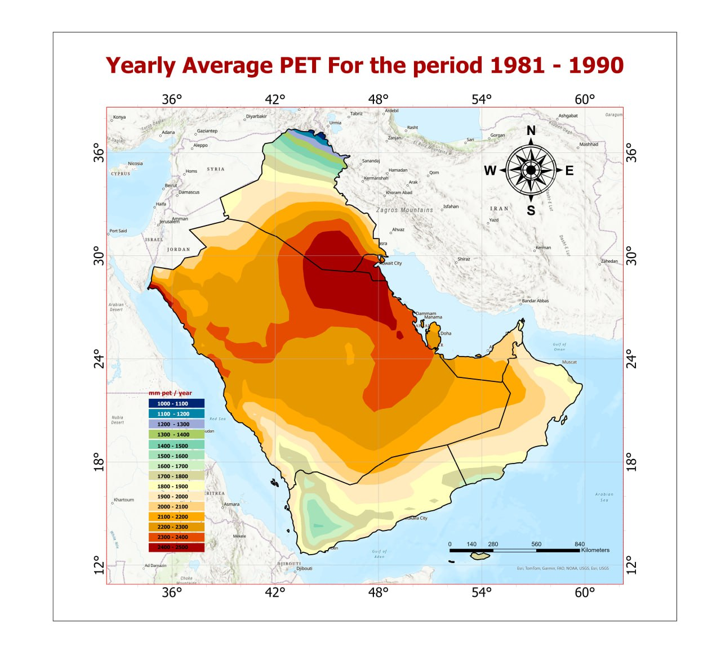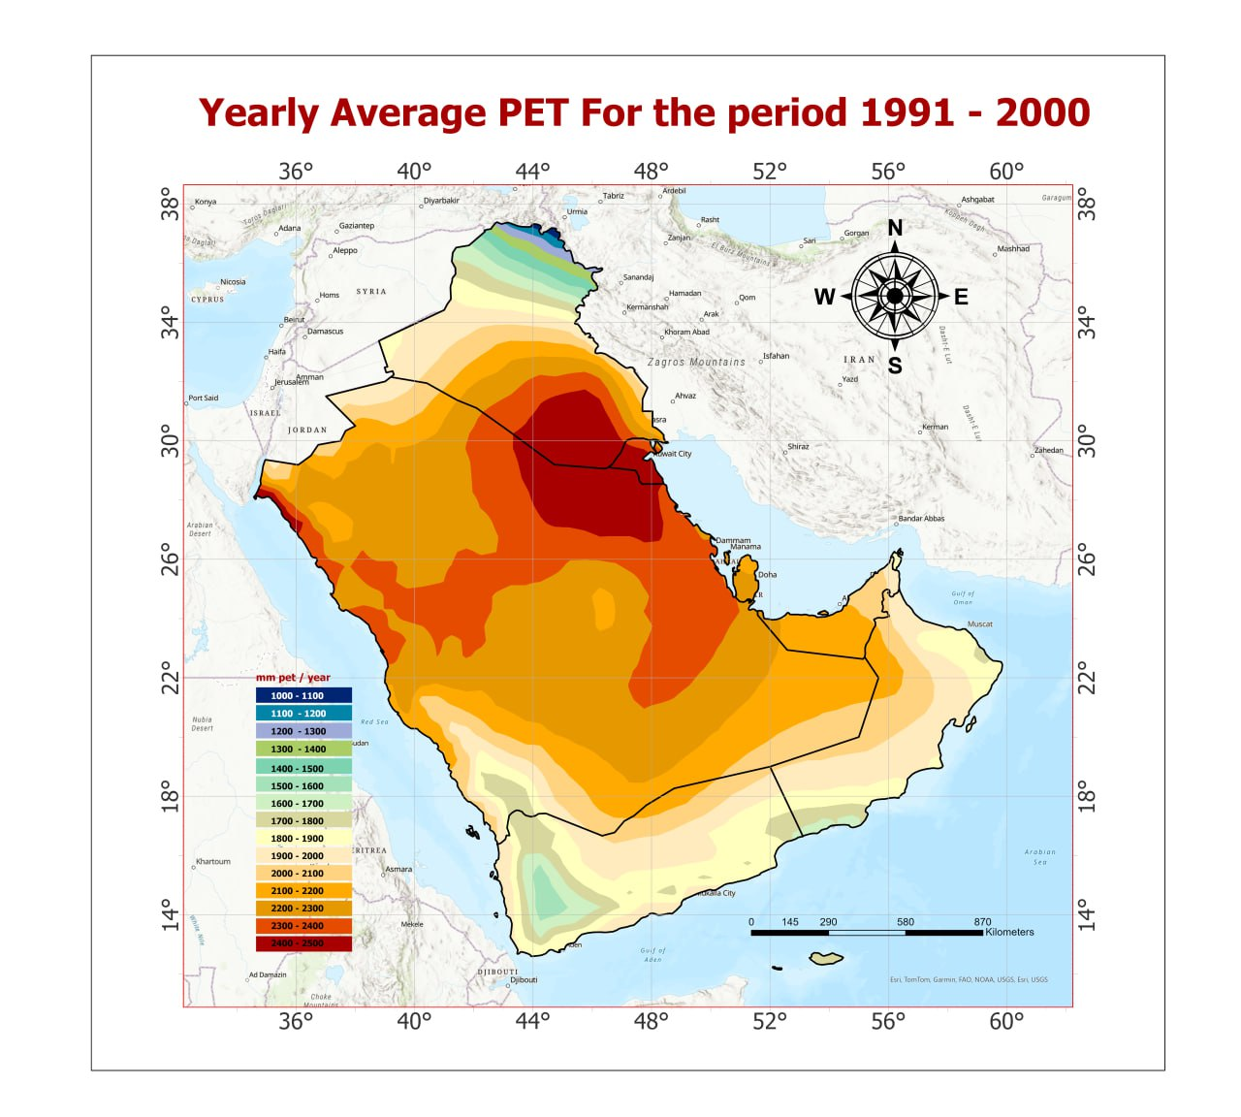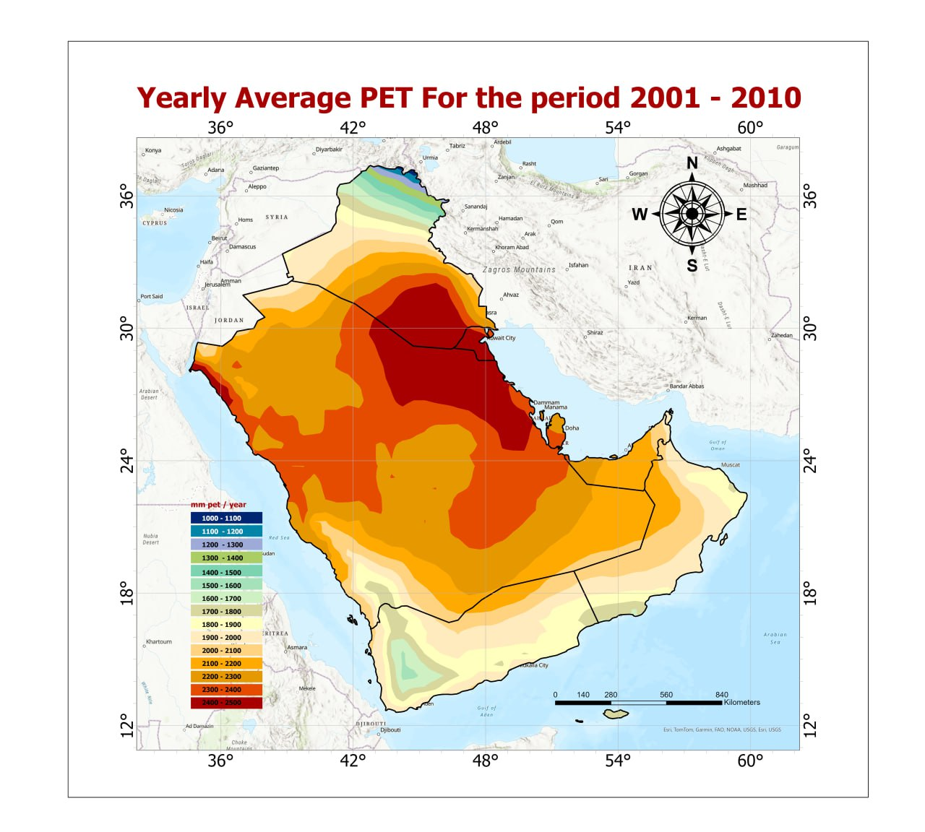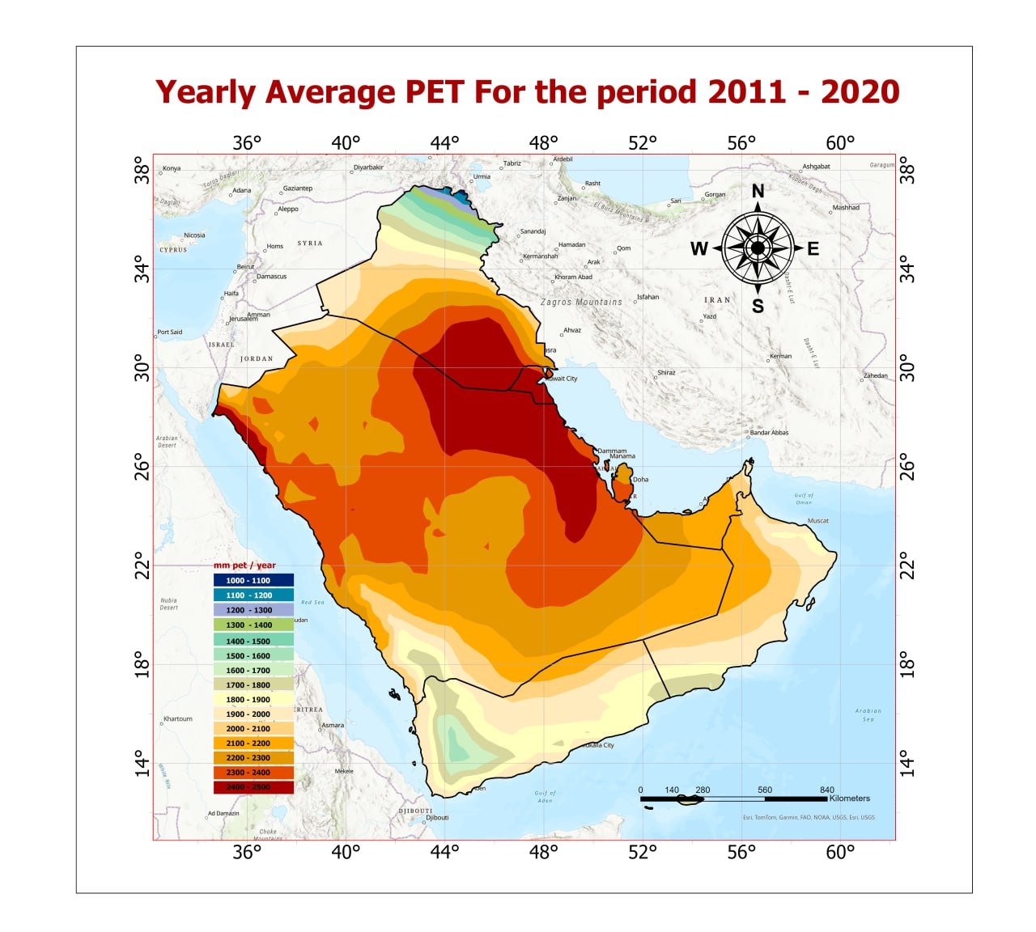
Figure 9: Spatial distribution of PET in the AGC for the period from 1981 to 2020
The data (Table 8 and Figures 10&11) confirmed that the PET and the total amount of water lost per decade increase significantly at a 95% confidence level with different rates over time, compared to the baseline data. The findings indicated that the rate of water loss by PET rose during the last three decades from 15.48 m.m³ in the second decade to 54.84 m.m³ in the fourth decade, with an overall mean decade change of 40 m.m³. These findings revealed a significant increase in the amount of water lost by PET with time.
Table 8: Differences in the mean annual PET in AGC from bass data from 1981 to 2020
1991-2000 |  |  |  | 2001-2010 |  |  |  | 2011- 2020
PET  mm | Area  ( km²) | Total amount of water  m.m³ | Change Rate  m.m³/decade | PET  mm | Area  ( km²) | Total amount of water  m.m³ | Change Rate  m.m³/decade | PET  mm | Area  (km²) | Total amount of water  m.m³ | Change Rate  m.m³/decade
-30 | 13553.20 | -406.60 | -0.12 | 0 | 3325.48 | 0.00 | 0.00 | 0 | 381.35 | 0.00 | 0.00
-20 | 99439.63 | -1988.79 | -0.61 | 10 | 32380.73 | 323.81 | 0.10 | 10 | 36921.93 | 369.22 | 0.11
-10 | 318793.62 | -3187.94 | -0.98 | 20 | 195869.41 | 3917.39 | 1.20 | 20 | 162204.32 | 3244.09 | 1.00
0 | 481863.85 | 0.00 | 0.00 | 30 | 568263.51 | 17047.91 | 5.23 | 30 | 404380.87 | 12131.43 | 3.72
10 | 745722.71 | 7457.23 | 2.29 | 40 | 684255.23 | 27370.21 | 8.40 | 40 | 434081.48 | 17363.26 | 5.33
20 | 630449.01 | 12608.98 | 3.87 | 50 | 777943.87 | 38897.15 | 11.94 | 50 | 443126.57 | 22156.33 | 6.80
30 | 507038.72 | 15211.16 | 4.67 | 60 | 554483.75 | 33269.03 | 10.21 | 60 | 704308.92 | 42258.54 | 12.97
40 | 276977.21 | 11079.09 | 3.40 | 70 | 245976.05 | 17218.31 | 5.29 | 70 | 714346.36 | 50004.25 | 15.35
50 | 136905.60 | 6845.28 | 2.10 | 80 | 128760.94 | 10300.87 | 3.16 | 80 | 179578.00 | 14366.24 | 4.41
60 | 47136.47 | 2828.19 | 0.87 | 90 | 54661.19 | 4919.50 | 1.51 | 90 | 119680.91 | 10771.28 | 3.31
 |  |  |  | 100 | 11975.90 | 1197.59 | 0.37 | 100 | 49016.71 | 4901.67 | 1.50
 |  |  |  |  |  |  |  | 110 | 9868.64 | 1085.55 | 0.33
M.D |  | 50446.60 | 15.48 |  |  | 154461.77 | 47.41 |  |  | 178651.84 | 54.84

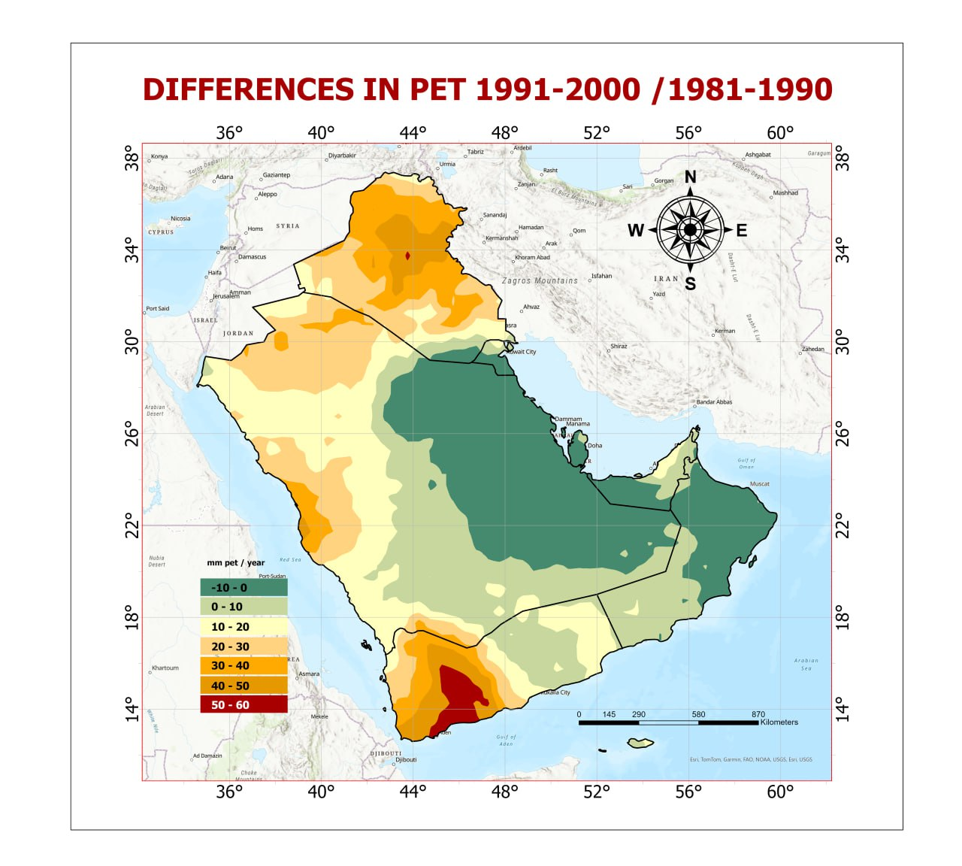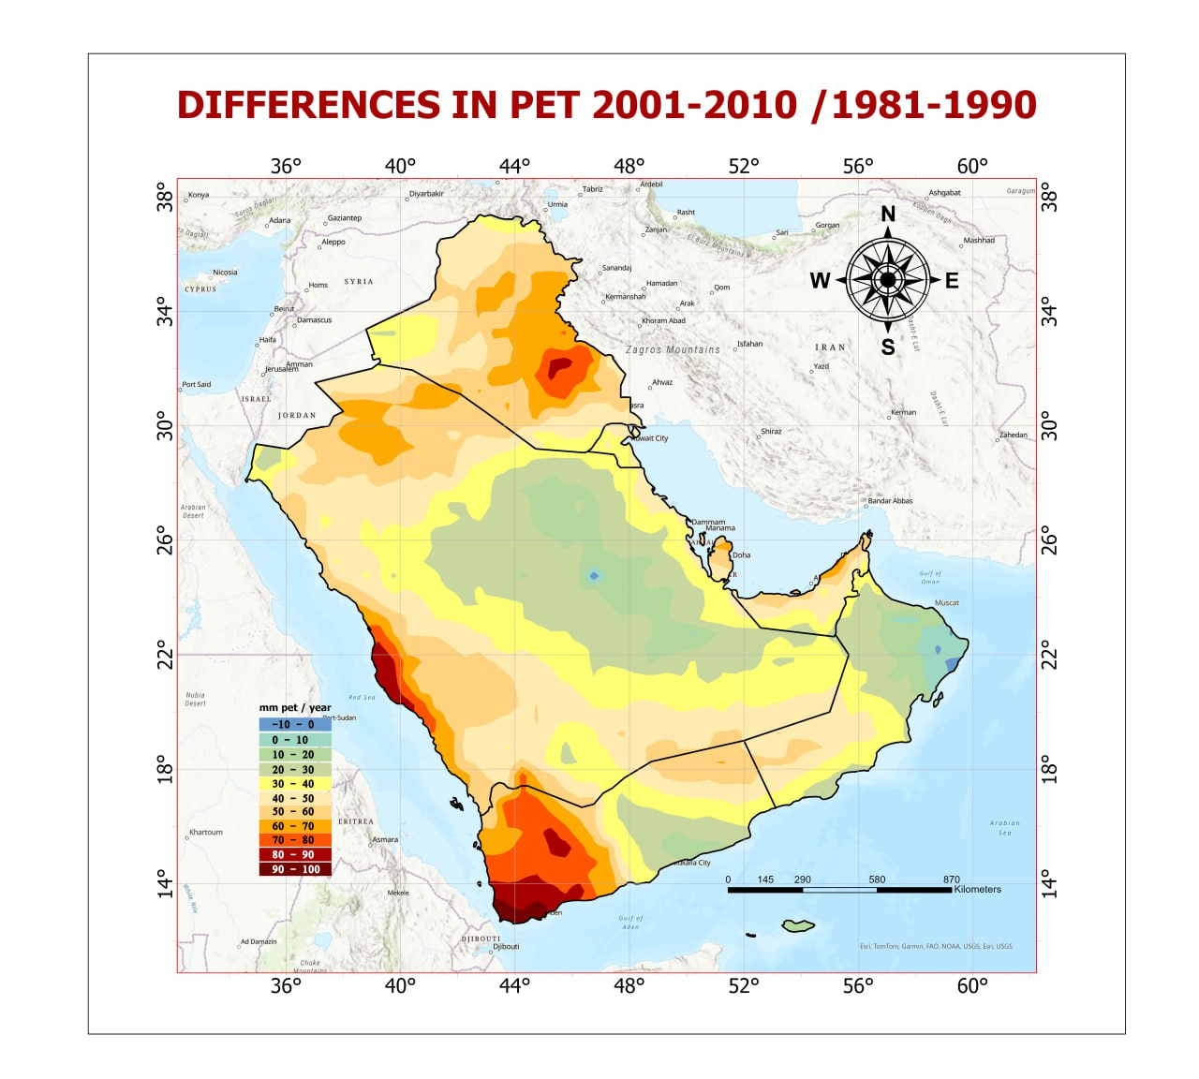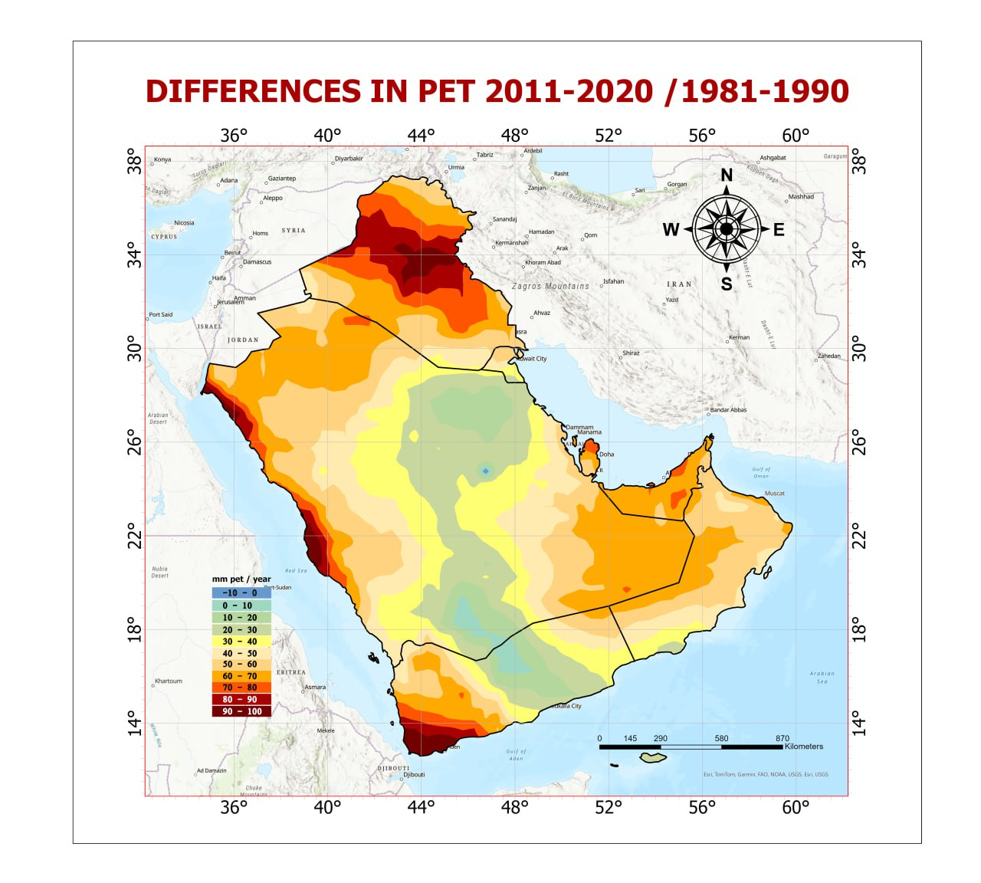
Figure 10: Spatial distribution of mean annual Rainfall differences in the AGC from 1981-2020
The overall finding of Mann-Kendall statistical tests (Figure 11) confirms that the PET in the AGC significantly increased at a 95% confidence level for the period from 1981 to 2020 due to variation in the geographic and topographic location within the countries.

Figure 11: Statistical trends in mean annual temperature with time in some tested sites in the AGC from 1981 to 2020
The results of the statistical analysis of the mean annual PET in each country of the AG (Table 9) revealed the spatial and temporal variations between them. Generally, the results show a significant difference in the mean change rate at the 95% confidence level over time in all countries. Bahrain, Kuwait, and Oman show the lowest mean annual PET during the study period(11.4mm, 26.0 mm, and 26.7mm, respectively), while Yemen and Iraq have the highest mean annual rainfall( 94mm and 56.6mm). The findings confirmed that all countries show a negative changing rate with time, except Yemen and Kuwait show a positive change with time due to the effect of geographic location.

Table 9 : Statistical Analysis of Mean Annual PET Changes in AGC for the period 1981-2020
Country | periods | Min mm | Max  mm | RANGE | Mean mm | STD | Changing Rate  mm | Mean changing Rate mm.decade-1
Iraq | 1981-1990 | 1032.6 | 2518.50 | 1485.90 | 1995.37 | 357.50 | 0.0 | 50.6
 | 1991-2000 | 1040.4 | 2511.00 | 1470.60 | 2024.15 | 353.18 | 28.8
 | 2001-2010 | 1061.1 | 2555.70 | 1494.60 | 2049.02 | 360.52 | 53.7
 | 2011-2020 | 1080.9 | 2559.90 | 1479.00 | 2064.57 | 355.36 | 69.2
Kuwait | 1981-1990 | 2293.8 | 2514.30 | 220.50 | 2440.91 | 71.16 | 0.0 | 26.0
 | 1991-2000 | 2298.0 | 2504.70 | 206.70 | 2435.06 | 64.82 | -5.9
 | 2001-2010 | 2341.8 | 2545.50 | 203.70 | 2480.74 | 67.06 | 39.8
 | 2011-2020 | 2342.7 | 2554.50 | 211.80 | 2485.09 | 66.15 | 44.2
Oman | 1981-1990 | 1661.1 | 2136.60 | 475.50 | 1948.21 | 102.42 | 0.0 | 26.7
 | 1991-2000 | 1666.5 | 2132.70 | 466.20 | 1945.24 | 102.15 | -3.0
 | 2001-2010 | 1690.8 | 2161.20 | 470.40 | 1977.63 | 104.32 | 29.4
 | 2011-2020 | 1691.4 | 2194.20 | 502.80 | 2001.78 | 109.70 | 53.6
Qatar | 1981-1990 | 2167.2 | 2284.80 | 117.60 | 2232.50 | 48.88 | 0.0 | 37.2
 | 1991-2000 | 2169.0 | 2278.80 | 109.80 | 2227.10 | 45.05 | -5.4
 | 2001-2010 | 2228.1 | 2326.80 | 98.70 | 2284.90 | 41.65 | 52.4
 | 2011-2020 | 2243.4 | 2342.70 | 99.30 | 2297.00 | 40.92 | 64.5
Saudi Arabia | 1981-1990 | 1689.9 | 2526.00 | 836.10 | 2230.46 | 130.50 | 0.0 | 30.2
 | 1991-2000 | 1708.8 | 2511.60 | 802.80 | 2236.35 | 123.84 | 5.9
 | 2001-2010 | 1737.9 | 2554.50 | 816.60 | 2269.79 | 124.32 | 39.3
 | 2011-2020 | 1725.6 | 2571.60 | 846.00 | 2275.91 | 126.93 | 45.5
United Arab Emirates | 1981-1990 | 1951.2 | 2219.70 | 268.50 | 2106.63 | 54.88 | 0.0 | 36.3
 | 1991-2000 | 1950.3 | 2209.50 | 259.20 | 2107.70 | 51.21 | 1.1
 | 2001-2010 | 1988.7 | 2269.50 | 280.80 | 2149.23 | 54.92 | 42.6
 | 2011-2020 | 2006.7 | 2282.70 | 276.00 | 2171.93 | 56.24 | 65.3
Yemen | 1981-1990 | 1491.3 | 2145.60 | 654.30 | 1847.02 | 143.47 | 0.0 | 94
 | 1991-2000 | 1531.2 | 2158.20 | 627.00 | 1872.24 | 135.36 | 25.2
 | 2001-2010 | 1571.1 | 2198.10 | 627.00 | 1900.86 | 135.07 | 53.8
 | 2011-2020 | 1563.6 | 2179.80 | 616.20 | 1892.00 | 132.61 | 45.0
Bahrain | 1981-1990 | 2164.6 | 2282.80 | 118.18 | 2223.71 | 45.05 | 0.0 | 11.4
 | 1991-2000 | 2167.0 | 2276.50 | 109.50 | 2221.75 | 45.05 | -2.0
 | 2001-2010 | 1686.8 | 2151.20 | 464.40 | 1919.00 | 44.05 | -30.5
 | 2011-2020 | 2241.4 | 2339.70 | 98.30 | 2290.55 | 44.05 | 66.8

The study reveals elevated evapotranspiration levels as the key indicator of worsening water balance deficit that scientists worldwide have started to recognize as a common pattern among affected regions. The Murray-Darling Basin of Australia and the United States share the same finding that increasing PET leads to lower soil moisture storage and causes agricultural harm through crop damage and worsening land conditions (Al-Kaisi et al. 2013; Dadzie et al. 2023).
Temperature is one of the dominant atmospheric variables having significant and
direct influence on almost all hydrological variables (Sonali and Nagesh Kumar
2013). Increase in temperature in the recent times is mainly attributed to the rise
in concentration of greenhouse gases resulting from enhanced anthropogenic
activities (Feidas et al. 2004). The Intergovernmental Panel on Climate Change
(IPCC 2007), reported that mean temperature of the globe has increased by
0.74 °C over the last century, though the rates differed significantly from region
to region (IPCC 2007).
Temperature is one of the dominant atmospheric variables having significant and
direct influence on almost all hydrological variables (Sonali and Nagesh Kumar
2013). Increase in temperature in the recent times is mainly attributed to the rise
in concentration of greenhouse gases resulting from enhanced anthropogenic
activities (Feidas et al. 2004). The Intergovernmental Panel on Climate Change
(IPCC 2007), reported that mean temperature of the globe has increased by
0.74 °C over the last century, though the rates differed significantly from region
to region (IPCC 2007).

CONCLUTIONS
The Arab Gulf countries have faced various climate change threats in recent decades, highlighting a significant increase in average annual temperature, a decreasing trend in rainfall, and a rise in potential evapotranspiration, exacerbating water scarcity, and environmental degradation. The annual temperature increases significantly at a 95% confidence level, ranging from 0.18˚C to 1.48˚C. decade -1. per decade, with an overall rising rate of 0.83 ºC, making it one of the fastest-warming regions in the world. This temperature rise, coupled with decreased rainfall and increased soil moisture loss due to rising potential evapotranspiration (PET), has caused a significant decline in water availability, severely impacting vegetation health and reducing vegetation cover density. Variability in rainfall patterns and rising temperatures have disturbed the balance between water inflow and outflow, leading to higher rates of evaporation and evapotranspiration, thereby worsening the effects of water scarcity and land degradation throughout the country.

ACKNOLDGEMENT
The authors would like to express their gratitude to the Kuwait Fund for Arab Economic Development (KFAED) for their financial contribution and their keen interest in fostering a better understanding of climate change and finding solutions to mitigate its impacts. This working paper is an output of the project titled “Improved Resilience against Transboundary Sand and Dust Storms in Kuwait and Southern Iraq.” The support provided by KFAED has been instrumental in advancing research and initiatives aimed at addressing the challenges posed by climate change in the region.

Competing interests
Authors have declared that they have no known competing financial interests OR non-financial interests OR personal relationships that could have appeared to influence the work reported in this paper.

Disclaimer (Artificial intelligence)
Author(s) hereby declare that NO generative AI technologies such as Large Language Models (ChatGPT, COPILOT, etc.) and text-to-image generators have been used during the writing or editing of this manuscript.

Authors’ Contributions:

This work was carried out in collaboration among all authors. All authors read and approved the final manuscript .

REFERENCES
Adamo N, Al-Ansari N, Sissakian V, et al (2022) Climate change: Droughts and increasing desertification in the Middle East, with special reference to Iraq. Engineering 14:235–273
Adamo N, Al-Ansari N, Sissakian VK, et al (2018) Climate change: consequences on Iraq’s environment. Journal of earth sciences and geotechnical engineering 8:43–58
Al-Kaisi MM, Elmore RW, Guzman JG, et al (2013) Drought impact on crop production and the soil environment: 2012 experiences from Iowa. Journal of Soil and Water Conservation 68:19A-24A. https://doi.org/10.2489/jswc.68.1.19A
Al-Maamary, H.M.; Kazem, H.A.; Chaichan, M.T. Climate change: The game changer in the Gulf Cooperation Council Region. Renew. Sustain. Energy Rev. 2017, 76, 555–576. [CrossRef]
Almazroui M (2012) Dynamical downscaling of rainfall and temperature over the Arabian Peninsula using regcm4. Clim Res 52:49–62.
Almazroui, M.; Islam, M.N.; Athar, H.; Jones, P.D.; Rahman, M.A.(2012a) Recent climate change in the Arabian Peninsula: Annual rainfall and temperature analysis of Saudi Arabia for 1978–2009. Int. J. Climatol. 32, 953–966. [CrossRef]
Almazroui M, Islam MN, Jones P, Athar H, Rahman MA (2012b) .Recent climate change in the Arabian Peninsula: Seasonal rainfall and temperature climatology of Saudi Arabia for 1979–2009.. Atmos Res 111:29–45
Allen M, Dube O, Solecki W, Arag´on-Durand F, Cramer W, HumphreysS, Kainuma M, Kala J, Mahowald N, Mulugetta Y (2018) An ipcc special report on the impacts of global warming of 1.5&nbsp;°C above pre-industrial levels and related global greenhouse gas emission pathways, in the context of strengthening the global response to the threat of climate change, sustainable development, and efforts to eradicate poverty. IPCC: Geneva Switzerland
Awadh SM, Ahmad LM (2012) Climatic prediction of the terrestrial and coastal areas of Iraq. Arabian Journal of Geosciences 5:465
Chakrabortty R, Pramanik M, Ali T, et al (2025) Advanced Neural Network Approaches for Optimal Check Dam Site Selection in Sub-Tropical Climates. Advances in Space Research S0273117725003734. https://doi.org/10.1016/j.asr.2025.04.037
Dadrass Javan F, Samadzadegan F, Toosi A, TousiKordkolaei H (2025) Spatial-temporal patterns of agricultural drought severity in the Lake Urmia Basin Iran: A cloud-based integration of multi-temporal and multi-sensor remote sensing data. DYSONA Appl Sci 6:. https://doi.org/10.30493/das.2025.486806
Dadzie FA, Egidi E, Stewart J, et al (2023) Agricultural Soil Degradation in Australia. In: Pereira P, Muñoz-Rojas M, Bogunovic I, Zhao W (eds) Impact of Agriculture on Soil Degradation I. Springer International Publishing, Cham, pp 49–68

Feidas H, Makrogiannis T, Bora-Senta E (2004) Trend analysis of air temperature time series in Greece and their relationship with circulation using surface and satellite data: 1955–2001. Theor Appl Climatol 79:185–200
Granger RJ (2000) Satellite-derived estimation of evapotranspiration in Gedis basin. J Hydrol 229:70–76.
Hereher, M.E.( 2020). “Assessment of Climate Change Impacts on Sea Surface Temperatures and Sea Level Rise— the Arabian Gulf,” Climate 8, no. 4 (March 30, 2020): 50, https://doi.org/10.3390/cli8040050.
Heidarnejad M, Zare Arani M, Pakparvar M (2013) Determining the accuracy of the SEBS model for evapotranspiration in Yazd. J Geographic Explorations of Desert Areas. 1:1–16
IPCC.(2007) Climate Change . The Physical Sciences Basis Contribution of Working Group 1 to the Fourth Assessment Report of the Intergovernmental Panel on Climate Change; Solomon, S., Qin, D.,Manning,M., Chen, Z.,Marquis,M., Averyt, K.B., Tignor, M., Miller, H.L., Eds.; Cambridge University Press: Cambridge, UK, 2007; p. 4.
IPCC.(2013) A Special Report of Working Groups I and II of the Intergovernmental Panel on Climate Change: Managing the Risks of Extreme Events and Disasters to Advance Climate Change Adaptation–Summary for Policymakers; Cambridge University Press: Cambridge, UK.
IPCC, (2023): Summary for Policymakers. In: Climate Change : Synthesis Report. Contribution of Working Groups I, II and III to the Sixth Assessment Report of the Intergovernmental Panel on Climate Change [Core Writing Team, H. Lee and J. Romero (eds.)]. IPCC, Geneva, Switzerland, pp. 1-34, doi: 10.59327/IPCC/AR6-9789291691647.001
Kumar A, Scaife AA, Merryfield WJ, et al (2024) World Meteorological Organization (WMO)-Accredited Infrastructure to Support Operational Climate Prediction. Bulletin of the American Meteorological Society 105:E2126–E2143
Lotfi, M.,Kamali,AG.A., Meshkatee,A.H. and V. varshavian. 2020. Study on the impact of climate change on evapotranspiration. Arabian Journal of Geosciences. 13:722
Mitigation CC (2011) IPCC special report on renewable energy sources and climate change mitigation. Renewable Energy 20.
Muluneh MG (2021) Impact of climate change on biodiversity and food security: a global perspective—a review article. Agric & Food Secur 10:36. https://doi.org/10.1186/s40066-021-00318-5
Moisa M, Karuppannan S, Wong Y, Khaddour L (2025) Urban agriculture land suitability assessment using AHP and geospatial analysis in Gondar Zuria Ethiopia. DYSONA Appl Sci 6:. https://doi.org/10.30493/das.2025.478550
Ntoumos A, Hadjinicolaou P, Zittis G, Lelieveld J (2020) Updated assessment of temperature extremes over the Middle East–north Africa (mena) region from observational and cmip5 data. Atmosphere 11
Research Report( 2023).Climate Change And Its Impact On GCC Countries (Marmore MENA Intelligence, October 25, 2023), https://www.marmoremena.com/en/reports/climate-change-and-its-impact-on-gcc-countries/.
Riegl, Bernhard; Purkis, Samuel (2011). "Persian/Arabian Gulf Coral Reefs". In Hopley, D (ed.). Encyclopedia of Modern Coral Reefs. Springer. pp. 790–798. doi:10.1007/978-90-481-2639-2_123. ISBN 978-90-481-2639-2.
Shi, L.,A. Zanobetti, I. Kloog, B.A. Coull, P. Koutrakis, S.J. Melly, S.( 2019).Low-concentration PM_{2.5} and mortality: estimating acute and chronic effects in a population-based study. Environ. Health Perspect., 124 (1) (2016),
Sonali P, Nagesh Kumar D (2013) Review of trend detection methods and their application to detect temperature changes in India. J Hydrol 476:212–227
Zhang Q, Singh VP, Sun P, et al (2011) Precipitation and streamflow changes in China: changing patterns, causes and implications. Journal of Hydrology 410:204–216

