**A decadal pattern and growth in chemical and bio-pesticide use and its intensity across Indian states – leads for policy**

**Abstract**

Globally, increasing pesticide use and its intensity (kg/ha) has become a trend since the past two decades, while India figures among top users of only insecticides. India being a key global producer and supplier of various farm commodities, use of chemical pesticides is a matter of concern. Using the annual agricultural pesticide use data from 2012 to 2021 from secondary source, this paper has analyzed the spatial and temporal pattern in chemical and bio-pesticide use in the country. The study observed the northern and western states of India to be accounting for about 62% of total use, while the northern states in addition used it most intensively (>500g/ha). States with larger arable land viz., Maharashtra, Uttar Pradesh and Andhra Pradesh, used highest chemical pesticides in total. However, Jammu & Kashmir (3.64 kg/ha) followed by Punjab, Jharkhand, Haryana, Maharashtra and Himachal Pradesh (500-650 g/ha) used chemical pesticides more intensively. Different crops in different states may be responsible for higher and intensive pesticide use. Thus, individual state governments may have to identify crops and regions responsible for higher use intensity and thus address any adversary. Fungicides, which has surpassed insecticides to become most used pesticide group, has observed promising growth of 7 percent annually. Research & policy attention may be drawn in addressing the same. On the contrary, the Indian government mandating pesticide companies to produce and sell bio-pesticides seems to have positive results with more than 5 per cent annual growth in its use across the geographic zones of the country. Sustained governance can help reduce chemical use in agriculture and thus help improving soil organic matter and health.

**Key Words: pesticide use, growth, regional pattern, per hectare pesticide use, sustainability**

**Introduction**

Indian agricultural researchers are divided in their opinion about use of chemicals in India, with a minority of them standing against the use. Though there exists a positive correlation between chemical use in agriculture and crop productivity over the years, the marginal gains have been reported to be subsiding; while the gain used to be 4-5 kgs per kg of fertilizer used in the initial years of green revolution, the gains have now come down to about a kg or so. Even in case of pesticides, farmers as well as agricultural scientists understand that getting rid of pests is not going to be easy by the use of pesticides, as the pests undergo adaptation, developing pesticide resistance, thus leading the chemical molecules ineffective. The United Nations Environment Programme (UNEP) estimated that as many as 140,000 new chemical molecules have been introduced into the market while another estimate found it to be about 350,000 molecules while America alone introduced 1500 new molecules a year (Naidu *et al.*, 2021). While chemical use in agriculture increased the food production leading to self-sufficiency, it has also escalated the production cost both due to soaring price and increased input use (Samdani, 2022). Per contra, the market prices are barely covering production cost, thus leading to indebtedness among producers (Tomko, 2021). Thus, it may be hypothesized that the chemicals, though can increase production cannot sustain farmer’s livelihood. Contrarily, as compared to local varieties (that would have adapted to climate change/pest/disease incidence over a period of time), improved varieties and hybrids are susceptible to incidence of pests and diseases, as they lack scope for evolution[1]. Thus, to save agricultural crops from pest infestation, PPC use has become inevitable and hence, the technological advancements is expected to result in increased use of PPCs.

Farmers continue to use PPCs in order to protect their crops from various pests such as fungus, bacteria, insects, weeds and so on. There are reports of farmers using it in higher concentrations (than recommended) and in incorrect combinations leading to harmful effects on crop, environment and other resources. With some parts of the country getting early exposure to technologies, the PPCs usage got more popular. Over the years, there is an increasing trend in PPC use in various parts of the country. Land area of the country being fixed and conversion of agricultural land for non-agricultural uses being quite predominant, the gross cropped area is prone to decline. Thus, per hectare usage of PPCs would be on the rise, indicating growing intensities of intoxication in agriculture.

Agriculture is increasingly becoming technology oriented. During the initial years of green revolution, high-yielding varieties and hybrids in field crops were focused in order to ensure food self-sufficiency. Breeding of horticulture crops soon gained importance, followed closely by the crop protection measures alongside mechanization, livestock breeding and food processing etc. The plant protection chemicals (PPCs) specifically, have a positive externality of increasing crop yield by reducing pest damage but a negative externality of damaging the ecosystem. The chemical residues in plant/produce, air, water, soil etc are known to damage human, animal, avian and microbial population. With the contradicting impacts of PPC use on agriculture and ecosystem health, a careful and responsible use of PPCs is highly desirable. Increasing use of these chemicals in India, further fuelled by marketing drive[2] from the MNCs is a cause of concern (Tekade, 2018). In contrast, non-synthetic, bio-pesticides form fairly good substitutes to synthetic chemicals and are available in the market (Ashraf, Hassan and Dar, 2023). Though its use is relatively low in India the consumption of such inputs also requires an inquiry.

Though there are studies covering trends in pesticide use in India at all India level and by crop groups, those at state level and per hectare analysis is generally lacking. Even those pertaining to bio-pesticides are limited. Presently, India stands at 9th position and United States stands at first position in world pesticide use (FAO, 2022). Agricultural Input Survey Report, 2016-17 identified about 37 percent of crop area in India is treated with pesticides.

**Methodology**

The present paper has analyzed pesticide use across India, disintegrating the analysis to constituent states and geographic zones and analyzes the use of major PPCs. The state level analysis depicts the scenario for only the top using states. At the country level pesticide use scenario is depicted in GIS Map to depict a comparative glimpse.

**Data and Sources**

The PPC consumption (both chemical and bio-pesticides) in India has been analyzed both in absolute and per hectare terms. Data on total consumption is sourced from the published reports of the Directorate of plant protection, quarantine and storage, Ministry of Chemicals and fertilizers, Government of India. In calculating the per hectare usage, the gross sown area of the individual states was obtained from the report, ‘Agricultural Statistics at a Glance’, published by the Ministry of Agriculture and Farmer’s Welfare, GoI. At all India level, PPC use by major chemical groups, *viz.*, insecticides, fungicides, herbicides and rodenticides is also analyzed. The spatial pattern is analyzed by considering the geographic zones/states of India. Precisely, data pertaining to the period from 2012 to 2021 is analyzed.

**Temporal time trend**

Since most of the time series evidence an exponential trend in growth, the temporal changes in total and per hectare pesticide use from 2012-13 to 2021-22 is computed using compound annual growth rate (CAGR) analysis. The multiplicative model, Y = abt is employed to estimate the annual exponential growth rate in pesticide use per annum. While Y represents pesticide use, t represents timer period (years), a & b are multiplicative constants. The term ‘b’ computes the CAGR and is computed by applying natural logarithms (‘ln’) to original model and computed as follows:

ln Y = ln a + t ln b; Growth Rate: g(r) = [anti ln (ln b)-1] x 100

The statistical significance of growth rate is estimated with the help of student t-test, and model fitness with R2. The t-values depicting significance at 1, 5 and 10 per cent are considered for growth rate interpretation while the rest could be considered a chance factor. The R2 values ranging from 0.5 and above are generally accepted in social science research.

**Spatial variations**

The present study analyzes the trends in pesticide use, both in total and per hectare terms.The 28 states of India have been segregated into six geographical zones viz., northern (Haryana, Punjab, Uttar Pradesh, Uttarakhand, Himachal Pradesh, Jammu & Kashmir), western (Gujarat, Madhya Pradesh, Chhattisgarh, Maharashtra, Rajasthan, Goa), southern (Andhra Pradesh, Telangana, Karnataka, Kerala, Tamil Nadu), eastern (Bihar, Jharkhand, Odisha, West Bengal), north eastern (Arunachal Pradesh, Assam, Tripura, Manipur, Meghalaya, Mizoram, Nagaland) and the Union Territories (UTs - Andaman & Nicobar, Pondicherry, Delhi) as per report Agricultural Statistics at a Glance -2022, released by Ministry of Agriculture and Farmers Welfare, GoI. In addition, state-wise analysis is also carried out for the major PPC using states. The per hectare pesticide use is calculated by dividing total pesticides use by the respective gross cropped area of the corresponding year and is represented in ‘g/ha’. Further, changes in total use and per hectare use of PPCs across different zones are computed using a CAGR tool.

**Results and Discussion**

**Temporal and spatial analysis of PPC use in India**

With the technological improvement over time, there are incidental causes pushing for increased PPC use. The all India chemical pesticide use rose from 45.62 to 64.23 thousand MT during 2012 to 2021 (fig.1) at an annual rate of 2.42 per cent (table 1). From a mere 2.35 thousand MT in 1950s, it rose significantly through the green revolution period from 24.31 thousand MT in 1970-71 to 75 thousand MT in 1990-91and then onwards generally exhibiting a declining trend (Devi, Thomas and Raju, 2017); it reached40 thousand MT in 2005-06 (Acharya & Agarwal, 2016). In the decade ending 2022, an annual exponential growth of 2.42 percent in PPC use at all India level is observed (table 1). The growth is driven by consistent 1.82 percent growth in its use in the North and East zone. The zone-wise trends in PPC use depicted in fig. 1 shows the intra-year variations, but an increasing trend in use of PPCs over the last decade. Mounika *et al.* (2022) observed similar positive growth trend (1.81% per annum (p.a.)) at all India level during 2011 to 2020.

It is noteworthy that major proportion of PPCs was used (fig.1) in the northern zone (37.52 to 46.47%) which account for 21 to 23% of net sown area of the country, closely followed by the western zone (ranging from 26.42 to 34.35%) comprising of the green revolution and agriculturally important states. In northern zone the PPC use increased from 21 to 25.5 million metric tone (MMT) during the last decade. The southern (ranging from 15.12 to 18.44%) and eastern (8.54 to 11.1%) zones followed the list in declining order. Northeastern zone and UTs were minor users of PPCs both due to their smaller geographic extents and also due to the relatively lower technology outreach. In general, all the zones recorded an increase (positive growth rate) in consumption of PPCs except the Union Territories[3] (table 1).

The regional distribution of PPCs consumption seems to be in alignment with their relative share of land. With 36-47 per cent of all India consumption of PPCs, its growth in the north zone stood at a rate of 1.82 per cent per annum. The west zone accounting for 26-34 per cent of total PPC use recorded the highest growth of 3.66 per cent p.a. (but low R2=0.44). The PPC use in south zone, comprising majorly of rainfed farmlands, fluctuated over the years, thus exhibiting a statistically non-significant growth. The East zone, which used only 4.9 MMT of PPCs during 2012-13, rose to 6.9 MMT by 2022-23 at an annual rate of 3.59 percent.

**Fig. 1: Zone Wise Consumption of Chemical Pesticides (‘000 MT)**

**Table 1: Trends in total and per hectare use of chemical pesticides across the geographic zones of India during 2012 to 2022**

|  |  |  |
| --- | --- | --- |
| **Zones** | **Compound Annual Growth Rate** | |
| **Total pesticide use** | **Per hectare pesticide use** |
| **South Zone** | 1.82* (0.1) | 0.42* (0.01) |
| **West Zone** | 3.66** (0.43) | 2.51* (0.25) |
| **North Zone** | 1.82*** (0.93) | 1.48** (0.89) |
| **East Zone** | 3.59*** (0.76) | 3.66** (0.76) |
| **North- East Zone** | 0.12* (0.00) | 0.07* (0.00) |
| **Union Territories** | -15.07* (0.12) | -18.70* (0.19) |
| **India** | 2.42** (0.54) | 1.58* (0.33) |

Note: *** significant at 1% level, ** significant at 5% level and *-significant at10% level; figures in parentheses indicate R-square value.

In order to make the above analysis scale neutral, the per hectare pesticide use has been computed. This measure enables a meaningful comparison of pesticide use across the zones and states. Fig. 2 denotes PPC use intensity (in g/ha) across the zones. A highest of about ½ kg/ha was witnessed in the north zone, due to the year-round cultivation supported by strong irrigation supply. Peshin *et al.* (2020) noted higher pesticide in the zone to be due to grain, fiber and horticultural crops (mainly paddy, cotton, vegetables, apple growers) cultivation supported by irrigation base. Southern (ranging from 208 to 376 g/ha) and eastern (ranging from 205 to 295 g/ha) zones recorded only half the intensity of pesticide use in the northern zone. In the west zone it was around 200 g/ha, while in the North-East zone, though the usage intensity ranged widely(100-231 g/ha), in most years it remained below 140 g/ha. Chand and Birthal (1997) observed there is an increased pesticide use intensity across the states of India from just 16 g/ha in 1958 to 380 g/ha in 1993.

**Fig. 2: Zone-wise chemical pesticide use intensity in India during 2012 to 2022**

With good model fitness, the growth rates in per hectare pesticide use in north and east zones were 1.48 and 3.66 per cent per annum respectively (table 1).The growth rates in rest of the zones were statistically significant but with low R2.Fig. 1 and 2 represents the state-wise total and per hectare PPC use in India, respectively (2021-22). The two figures being GIS maps[4], the intensity of colour depicts the extents of usage.

Fig.3 depicts total use of chemical pesticides among different states. Maharashtra is the top state (13 MMT), followed by Uttar Pradesh (11 MMT). The undivided Andhra Pradesh used PPCs to the tune of 6.85 million MT followed by Punjab (5.09 millionMT),Jammu & Kashmir (4.09 MMT) and West Bengal (3.6 MMT).Rest of the states used less than 0.2 MMT and the NE states below 0.5 MMT. It is worth noting that the only organic state in India, Sikkim as well as Ladakh did not use the pesticides at all.

The PPC use intensity across the Indian states is depicted in fig. 4. It was incomparably highest in Jammu and Kashmir (3.64 kg/ha) with any other Indian state. This has been identified to be due to white aphid infestation for control of which the chemical pesticides are heavily used (Ashraf, Hassan and Dar, 2023) despite the fact that bio-chemicals are also found equally efficient (Kacho *et al.,*2020). Peshin *et al.* (2020) observed the usage of PPC to be 9 kgs of active ingredients/ha in specific a crop, which is way above the results of this study, as the present study captures an average usage. Punjab (651 g/ha), Jharkhand (644 g/ha), Haryana (618 g/ha), Maharashtra (579 g/ha), Himachal Pradesh (501 g/ha) followed the list in that order. In other states the usage remained below half a kilo per hectare. Northeastern states generally used pesticides in least intensities exceptin Assam and Tripura. There was a varied PPC use in different states of India due to different cropping patterns and agroecological diversities in the different states (Devi *et al.,* 2017).

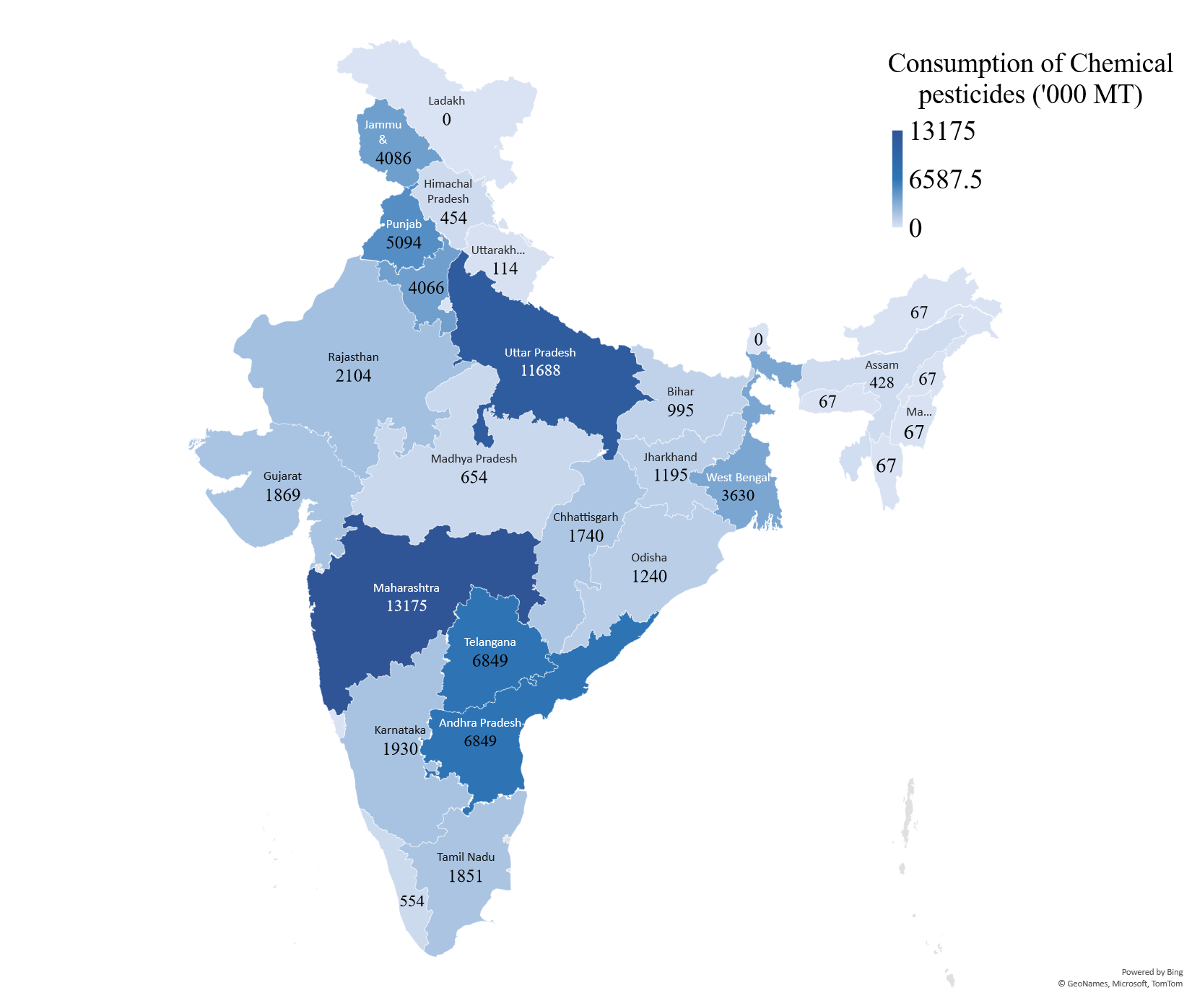**Fig. 3: PPC use (‘000MT) use map of India (2021-22)**

Source: Plotted using data from Directorate of Plant Protection, Quarantine and Storage, 2022

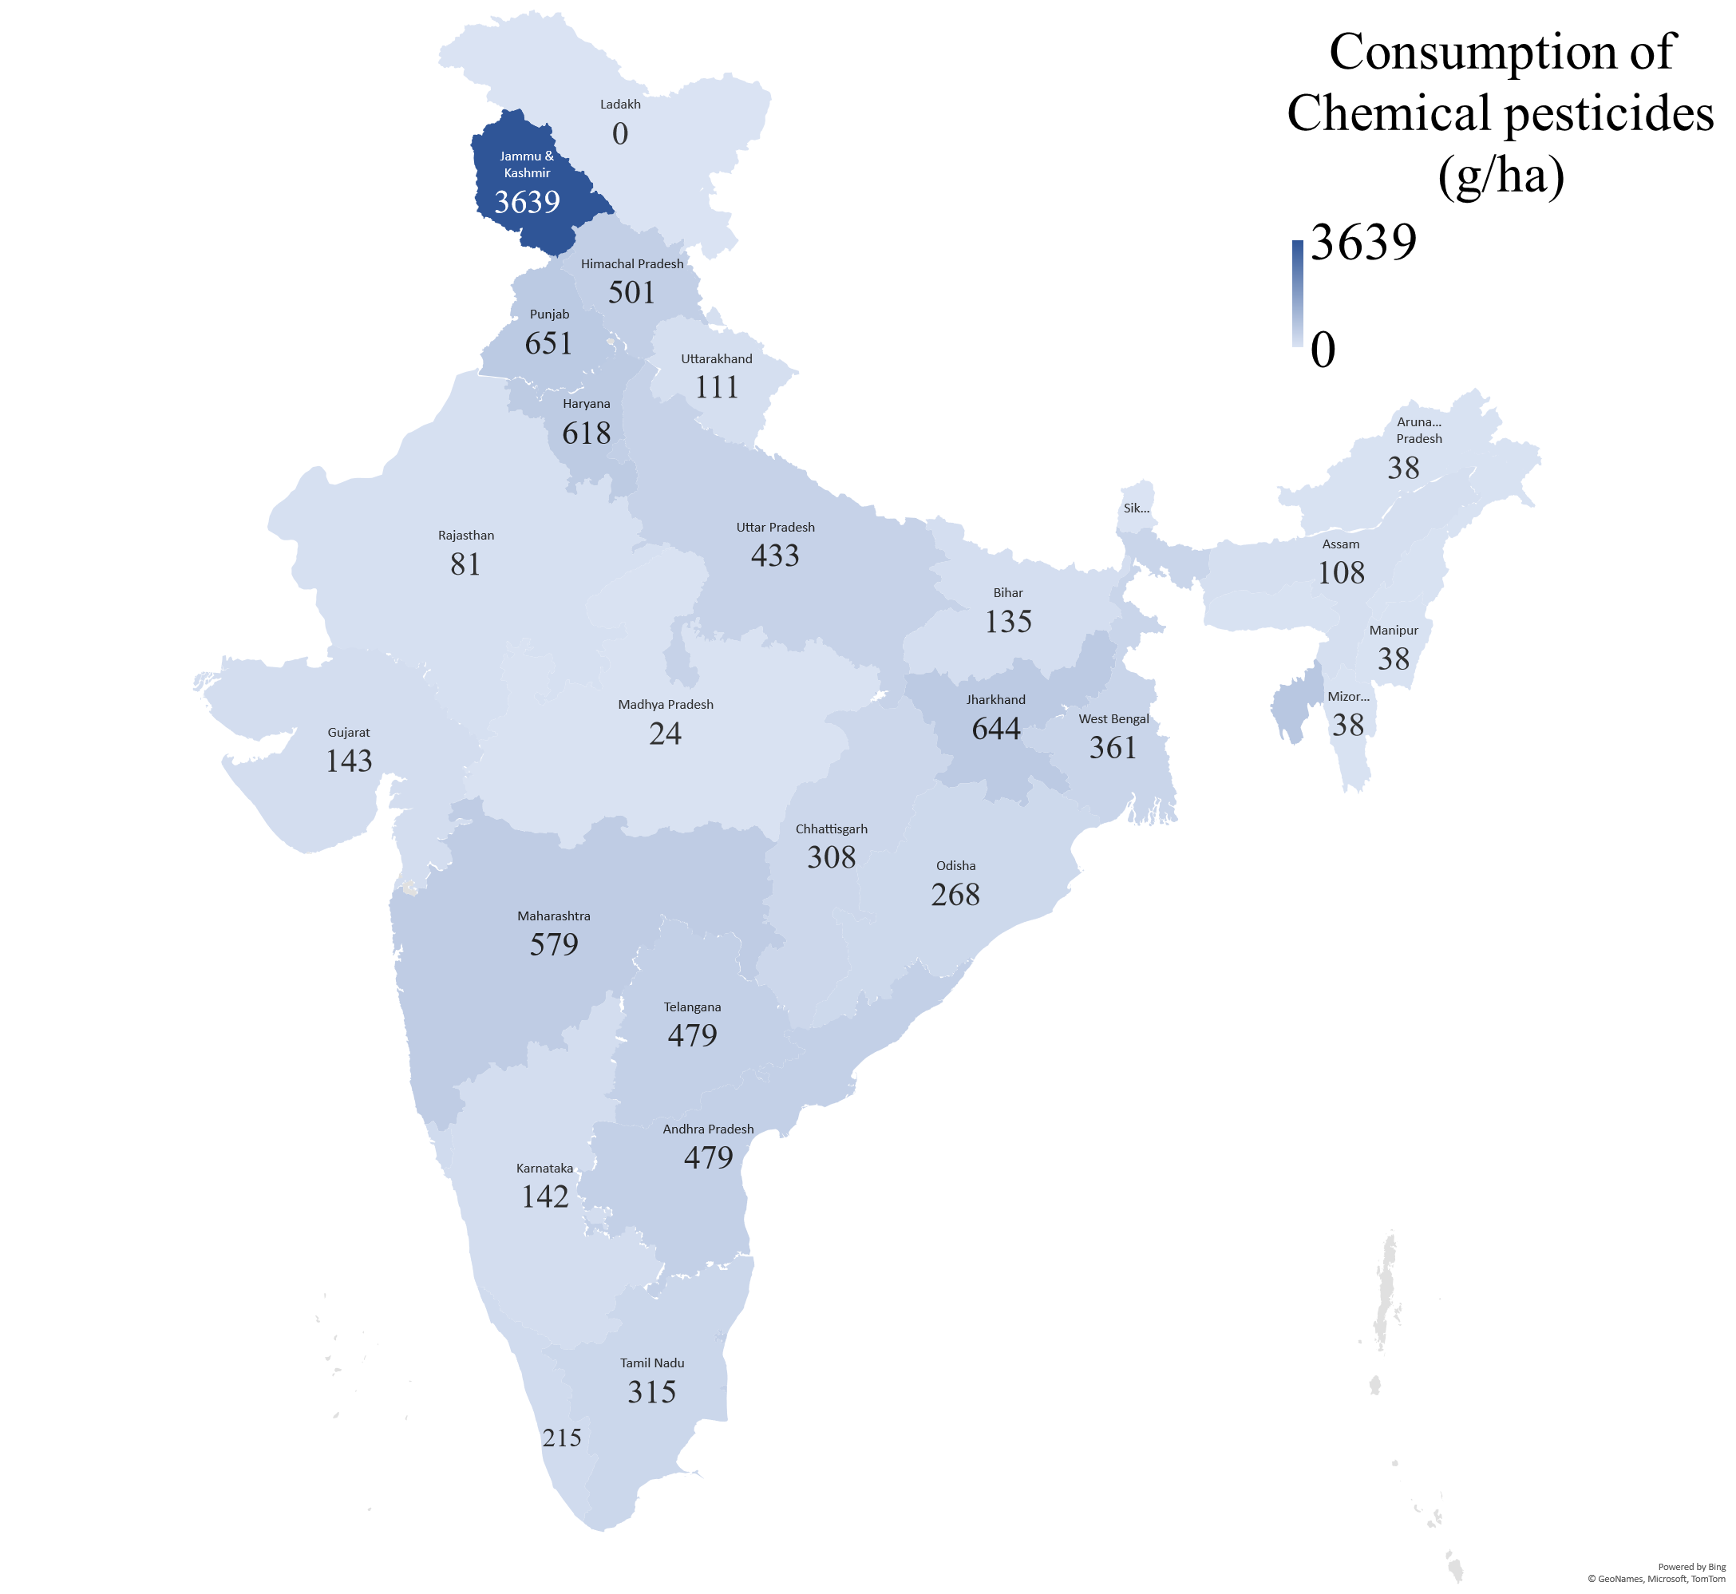

**Fig. 4: PPC use intensity (g/ha)map of India (2021-22)**

Source: Plotted using data from Directorate of Plant Protection, Quarantine and Storage, 2022

The chemical pesticide use intensity discussed above are mere averages. In case of individual crops across states could be far higher. For example, it has been reported by Peshin *et al.* (2020) that in Jammu and Kashmir (state average of 3639 g/ha) state, in case of apple, rice and vegetables 25,217, 1,191 and 1437 g/ha of active ingredient (a.i.) respectively and in Punjab (state average of 651 g/ha) among rice and cotton, about 2119 and 2660 g/ha of a.i. is reported to be used. Thus, the real intensity of chemical use in specific crops is far higher than the state averages.

Table 2 represents pattern of bio-pesticide use and its growth across the different geographical zones of India. The total bio-pesticide consumption ranged from 5 to 10 thousand tonnes over the past decade, showing an annual growth of 7.13 per cent p.a. (R2=0.78). Bio-pesticide consumption accounted for 8-14 per cent of total pesticide consumption indicating a meager share. Nayak and Solanki (2021) observed that in India, bio-pesticide consumption accounts for about 9% of overall pesticide consumption which increased during 2014 to 2020. The west zone (1.5 to 3.6 million tonnes) followed by south (1 to 2.6 million tonnes) and east zones (1.1 to 1.8 million tonnes) consumed relatively higher extents of bio-pesticide. The least consumptions were noted in the north-east zone and union territories. In stark contrast, the north zone consumed very low amounts of bio-pesticide showing stronger preference for synthetic chemicals. Even by percentage, the north zone accounted for only 2-3 percent of total pesticide use. Being a predominant consumer of bio-pesticides, the south zone recorded an exponential growth of 10.17 per cent per annum (R2=0.91), being significant at 1per cent level. On the contrary, the north zone also exhibited a significant growth of 7.82per cent p.a. (R2=0.92). The east zone recorded a fair growth of 4.65per cent p.a. (R2=0.72). Though the rest of the growth rates were also statistically significant, the lower R2 values depicted weak model fitness. Nonetheless, the highest growth rate is noted in the case of the north-east zone at 20.20 per cent p.a. (R2=0.65).

**Table 2: Trends in consumption of Bio-Pesticides across the zones of India during last decade (2012 to 2022)**

(Quantity in ‘000 MT)

|  |  |  |  |  |  |  |  |
| --- | --- | --- | --- | --- | --- | --- | --- |
| **Zones**  **Years** | **South Zone** | **West Zone** | **North Zone** | **East Zone** | **North-East Zone** | **Union Territories** | **India** |
| 2012-13 | 1044 (13.15) | 3216 (21.06) | 488 (2.25) | 1220 (19.91) | 253  (32.99) | - | 6221  (12) |
| 2013-14 | 1455 (9.92) | 2438 (11.9) | 536 (2.36) | 1122 (16.68) | 406  (26.66) | 15  (14.42) | 5972 (9.01) |
| 2014-15 | 1582 (11.9) | 1527 (9.03) | 476 (2.12) | 1202 (17.74) | 281  (16.35) | 17  (25.37) | 5085 (8.31) |
| 2015-16 | 1516 (12.81) | 2234 (10.76) | 623 (2.62) | 1514 (20.82) | 269  (31.24) | 34  (44.16) | 6191 (9.58) |
| 2016-17 | 1523 (13.54) | 3214 (13.93) | 593 (2.49) | 1473 (22.74) | 371  (35.17) | 16  (10.88) | 7190 (10.92) |
| 2017-18 | 1973 (15.09) | 2371 (9.82) | 746 (3.04) | 1619 (21.05) | 449  (42.08) | 32  (42.67) | 7190 (10.18) |
| 2018-19 | 2000 (15.38) | 2318 (11.42) | 757 (3.11) | 1698 (21.24) | 407  (38.25) | 44  (22.45) | 7224 (10.8) |
| 2019-20 | 2502 (18.64) | 3251 (14.68) | 826 (3.23) | 1801 (22.3) | 1961 (69.76) | 30  (42.86) | 10371 (14.39) |
| 2020-21 | 2685 (19.77) | 3228 (14.2) | 817 (3.25) | 1633 (19.04) | 931  (52.22) | 22  (95.65) | 9316 (12.96) |
| 2021-22 | 2627 (19.02) | 3653 (15.73) | 942 (3.56) | 1596 (18.44) | 1122  (56.93) | 4  (5.71) | 9944 (13.41) |
| CAGR | 10.17*** | 4.14* | 7.82*** | 4.65*** | 20.20*** | -6.06* | 7.13*** |
| R Square | 0.91 | 0.22 | 0.92 | 0.72 | 0.65 | 0.05 | 0.78 |

Note: 1) *** significant at 1% level and *significant at 10% level

2) Figures in parentheses indicate percent consumption of bio-pesticide to respective total pesticide use in the corresponding year

Intensity of bio-pesticide use (g/ha) across the different geographic zones of India is presented in table 3. Compared to about 300 g/ha of chemical pesticide use at the all-India level, bio-pesticide consumption is meager at 26-49 g/ha, about 1/6th of the total. Bio-pesticide consumption could be restricted to farmers inclined to traditional practices or those into organic farming. Among different zones, the Union Territories that are mostly remotely located seem to be using relatively higher bio-pesticides per unit area (31-350 g/ha). North-East (42-319 g/ha) followed by east (47-76 g/ha) and south (32-72 g/ha) zones recorded higher intensity of bio-pesticide use, north zone (11-21 g/ha) being the least.

The growth trend in bio-pesticide use across the zones seems quite promising. It was the highest in the north-east zone at 20.14 per cent p.a. though with a low R2 (0.64). The south zone (8.65% p.a.; R2=0.92) followed by the north zone (7.46% p.a.; R2=0.91) recorded impressive growth in bio-pesticide use over the last decade. Even in the east zone the growth was quite reasonable (4.72% p.a.; R2=0.71). The growth numbers at all India level (5.57% p.a.; R2=0.63) is also promising.

**Table 3: Zone wise Consumption Intensity of Bio-Pesticides in India during last decade (2012 to 2022)**

(Quantity in g/ha)

|  |  |  |  |  |  |  |  |
| --- | --- | --- | --- | --- | --- | --- | --- |
| **Year/Zones** | **South Zone** | **West Zone** | **North Zone** | **East Zone** | **North-East Zone** | **Union Territories** | **India** |
| **2012-13** | 32 | 37 | 11 | 51 | 42 | - | 36 |
| **2013-14** | 41 | 27 | 12 | 47 | 65 | 179 | 30 |
| **2014-15** | 47 | 17 | 11 | 50 | 45 | 198 | 26 |
| **2015-16** | 46 | 25 | 14 | 63 | 43 | 258 | 31 |
| **2016-17** | 46 | 35 | 13 | 61 | 58 | 126 | 36 |
| **2017-18** | 58 | 26 | 17 | 67 | 71 | 239 | 36 |
| **2018-19** | 57 | 26 | 17 | 72 | 65 | 346 | 37 |
| **2019-20** | 67 | 33 | 19 | 76 | 319 | 229 | 49 |
| **2020-21** | 68 | 32 | 18 | 68 | 151 | 176 | 43 |
| **2021-22** | 72 | 38 | 21 | 67 | 180 | 31 | 48 |
| **CAGR** | 8.65*** | 2.98* | 7.46*** | 4.72*** | 20.14*** | -10.38* | 5.57*** |
| **R Square** | 0.92 | 0.13 | 0.91 | 0.71 | 0.64 | 0.18 | 0.63 |

Note: *** significant at 1% level and *significant at10% level

Spatial difference of bio-pesticide use is depicted in fig.5and 6in both absolute (MT) and relative (g/ha) terms respectively, across the Indian states (2021-22). Bigger states *viz.,* Rajasthan (1.27 MMT), Maharashtra (0.93 MMT), Tamil Nadu (0.89 MMT), Chhattisgarh (0.48 MMT), apart from relatively smaller state, West Bengal (1.02 MMT) were top bio-pesticide using states (fig. 5). Even the states of Punjab (0.48 MMT) and Haryana (0.44 MMT) used bio-pesticides considerably. The southern states of Karnataka, Kerala and Andhra Pradesh were moderate users (< 0.5 MMT).

Interestingly, in per hectare terms, the different states did not differ widely with most of them using less than 50 g/ha. Tripura (1684 g/ha) followed by Kerala (236 g/ha), Uttarakhand (225 g/ha), Tamil Nadu (152 g/ha), Chhattisgarh (125 g/ha) and West Bengal (101 g/ha) used over 100 g/ha of bio-pesticides.

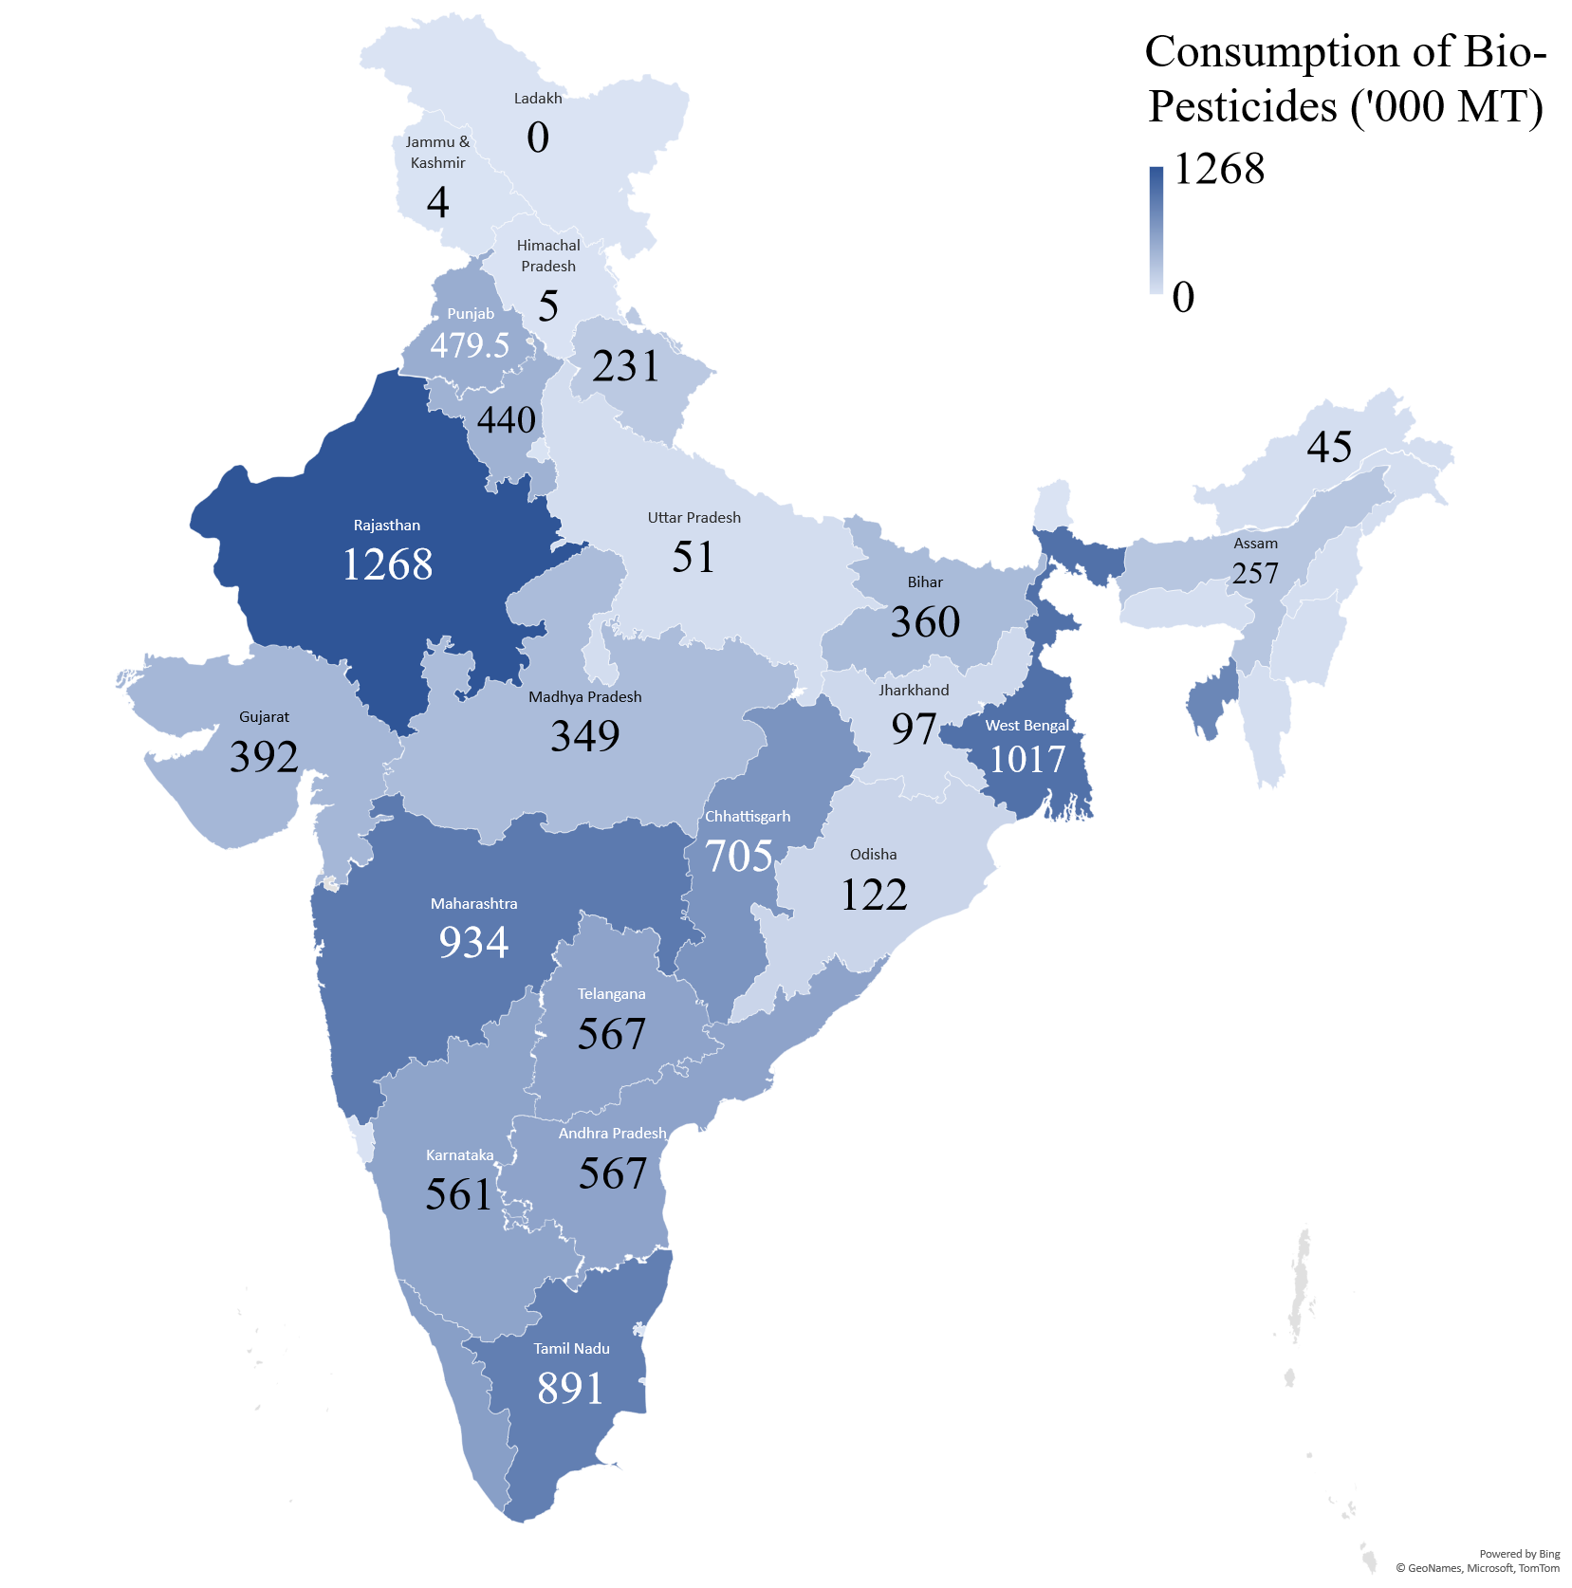

**Fig. 5: Bio-Pesticides use map of India (2021-22)**

Source: Plotted using data from Directorate of Plant Protection, Quarantine and Storage, 2022

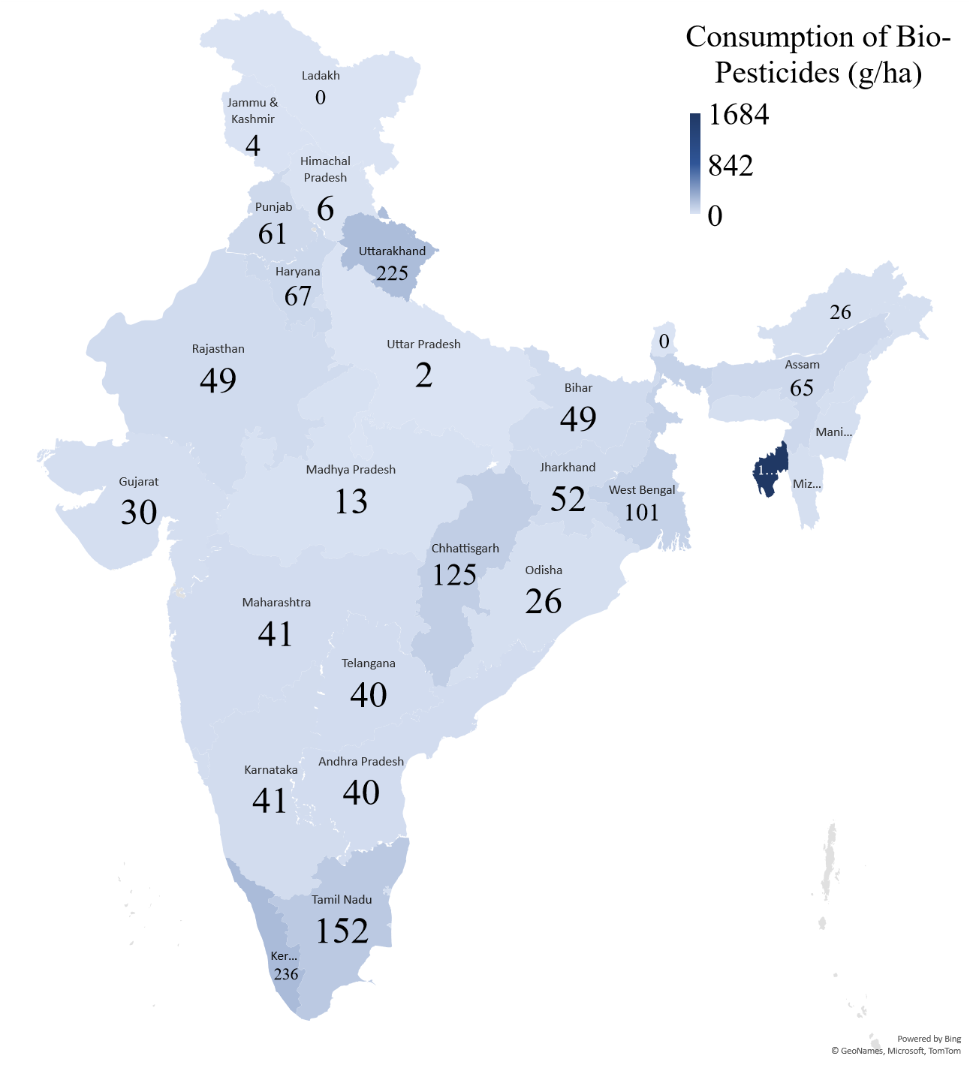**Fig. 6: Bio-Pesticides use intensity map of India (2021-22)**

Source: Plotted using data from Directorate of Plant Protection, Quarantine and Storage, 2022

A comparison of chemical and bio-pesticide use in absolute and per hectare terms is depicted in fig. 7.The total annual chemical pesticides use in India ranged from four to six-and-a-half million metric tonnes while that of bio-pesticides ranged merely from five to ten thousand metric tonnes. Simultaneously, chemical pesticide use intensity ranged from 200 to 320 g/ha and bio-pesticide use intensity was just 35 to 50 g/ha (<1/6th of chemical pesticides) with year-to-year fluctuations. Similar comparison is also given by Nayak and Solanki (2021) during the 2014 to 2020.

**Fig. 7: Comparison of Chemical and Bio-Pesticide consumption and its intensity in India**

**Consumption of different PPC groups in India**

The pesticide demand in India is met mainly from domestic production, while imports constituted a smaller share. There is a considerable bias towards the use of certain category of chemicals; some crop categories consumed more of it, either because of higher crop acreage or intensive use. Trend in use of chemical pesticides (during 2012 to 2021) in quantity terms (metric tonnes) among insecticides, fungicides, herbicides, and rodenticides for the duration is calculated. The analysis depicts both the composition (fig.8) and trends in consumption using CAGR (table 5). The total usage of all 4 categories of pesticides put together (in terms of active ingredients) ranged from 20 to 27 thousand MT during 2012 to 2021. India annually used around 20 thousand MT of active ingredients. Of the five categories analyzed, the fungicides and insecticides accounted for a major share (4/5th of total). Agnihotri (2000) reported the shares to be insecticide (80%) followed by fungicides (10%), herbicides (7%) and others (3%). Over the two decades, there seems to be a change in pesticide use in India with the fungicides being used as predominantly as insecticides. In some of the years, fungicide use exceeded those of insecticides, mostly due to their incidence reasons.

It is noteworthy that none of the chemical categories except fungicides depicted a trend in either direction (observe the negative growth rates, but with very low R2 value), probably due to inter-year fluctuations in usage. Over the last decade, fungicide use increased substantially at 7.7 per cent per annum (R2=0.79). Its consumption nearly doubled from about 5 thousand to 10 thousand MT of active ingredients during the last decade as shown in the fig. 8. The overall consumption of PPCs over the years was unstable.

**Table 4: Trends of PPCs consumption (2012-21) in India by major categories**

|  |  |  |
| --- | --- | --- |
| **Categories** | **CAGR** | **R Square** |
| Insecticides | -3.2* | 0.062 |
| Fungicides | 7.7*** | 0.786 |
| Herbicides | -2.9* | 0.180 |
| Rodenticides | -3.4* | 0.159 |
| Total | 0.8* | 0.017 |

Note: *** significant at 1% level and *significant at 10% level

**Fig. 8: Consumption of different Indigenous and Imported PPCs (a.i.)**

Note: Figures in parentheses indicate percent to total consumption of the year

Source: Computed using data from Directorate of Plant Protection, Quarantine and Storage, 2023

**Conclusions**

Pesticide use being perceived inevitable by both scientific and farming communities, its use has increased world over and India as well. The geographical and temporal changes in the use of both chemical and bio-pesticides is brought out in this paper, providing useful insights. The northern (35%, >500 g/ha) states predominated pesticide use both in total (about 70 thousand tonnes) and per hectare terms; the western (27%, 200g/ha) states accounted for a second highest total use whilesouthern states were second most intensive users (15%, 300g/ha) during the last decade. While the eastern states accounted for only 8% share in all India usage, it used about 200 g/ha. The national average was around 300 g/ha. The PPC usage increased at a faster pace in the eastern states (>3% annually), followed by the northern states, both in absolute and per hectare terms. The pattern mostly tended to be positive except for the North-eastern states and UTs. This increase is mostly led by the growing use of fungicides. Among states, Maharashtra, Uttar Pradesh and Andhra Pradesh by virtue of their vast cultivable land used highest pesticides (6-13 million MT) in India while even smaller states like Punjab, Haryana, Jammu & Kashmir and West Bengal (3.36-5 million MT) used substantially. In terms of per hectare use, it was alarming in Jammu & Kashmir (3.64 kgs/ha), way ahead of the rest of states. The high usage intensities and its increase over the years even among other states is an indication of possible trends in the future, thus cautioning the policy makers to device precautionary measures to contain their use to conserve the natural ecosystem. Its use in Punjab, Jharkhand, Haryana, Maharashtra and Himachal Pradesh fell in the range of 500-650 g/ha.

The previous literature (Peshin *et al.*, 2020) suggests per hectare usage to be very high among certain crops in individual states which are far above state averages depicted in present study. There is a strong need for individual state missionaries to keep an eye on higher chemical usage and device efforts control the same. The developed world is focusing on such issues. For instance, it is identified that over 600 pest species having developed some level of pesticide resistance[5] and hence the countries like US, Europe and Australia have initiated serious efforts in extending the longevity of pesticide resistance among pests, by evolving proper administering mechanisms in terms of dosage and timing. Specific research projects are being initiated in this direction.

Fungicide use has surpassed that of insecticide over the last decade and has witnessed a whopping 7% growth annually, while the other categories mostly evidenced inter-year fluctuation in use with a neutral growth. It is here that the scientific community need to develop/suggest/ disseminate biological and sustainable control measures for fungal diseases and the extension missionary needs to gear up to popularize the same. For example, different strains of *Beauveria bassiana* are effective against different pests. The recent dip (by about 23% between 2016-17 and 2020-21) in pesticide use in paddy production in Andhra Pradesh reported to be due to the state government natural farming initiative, is a hope in this direction (Samdani, 2022) and a possible guide for other state governments (<https://naturalfarming.niti.gov.in/andhra-pradesh/>). This does not only help in protecting the natural resources but also saves a substantial cost to the producers. Popularizing microbial formulation could have multiplicative effects in growing microbial population in soil for future and thus develop natural soil immune system.

In this direction the trends in use of bio-pesticides in India is quite encouraging. While the western states (about 3 million MT) used it to the highest, those in southern and eastern (1.5 million MT each) states is also quite encouraging. At all India level, its use increased from about 5 to 10 million MT during the decade. North-eastern states (20%) followed by southern states (10%) evidenced a highest annual growth in bio-pesticide use in India, while other zones also had impressive growth of over 4 per cent per annum. In per hectare terms, it was north eastern states (42-180g/ha) followed by eastern and southern states (30-70 kg/ha) at the top, while their decadal growth was 20.14, 7.46 and 8.65 per cent per annum respectively. However, the individual states differed widely, with West Bengal, Maharashtra, Tamil Nadu, Chhattisgarh being top using states. Kerala, Uttarakhand, Tamil Nadu, Chhattisgarh states used it relatively more intensively.

Overall, the government's regulations (the Pesticide Management Bill, 2020) mandatingthe pesticide companies to sell some minimum quantities of bio-pesticides, if they have to exist in business, seems to have reaped the benefits. The chemical pesticide companies themselves are now producing and selling bio-pesticide products as well. However, there are reports of companies mixing chemical pesticides with bio-pesticides (Liu *et al.,* 2023)and labelling and selling them to be bio-pesticides, is a risk to be addressed by the concerned enforcement agencies of the government. Though chemical pesticide use in India is considerably lower as compared to heavy users in the world, production of safer food and securing the natural and agricultural resources is the prime responsibility of scientists, planners and the whole gamut of related communities. Another fact that supports use of organic or bio-inputs in India is the smaller average land holding size in India, as larger holdings inevitably need to use chemicals.

**COMPETING INTERESTS DISCLAIMER:**

Authors have declared that they have no known competing financial interests OR non-financial interests OR personal relationships that could have appeared to influence the work reported in this paper.

Author(s) hereby declare that NO generative AI technologies such as Large Language Models (ChatGPT, COPILOT, etc.) and text-to-image generators have been used during the writing or editing of this manuscript.

**References:**

ACHARYA S.S. AND AGARWAL N.L., 2016, Agricultural Marketing in India. Sixth Edition, *Oxford & IBH Publishers, New Delhi*. (ISBN-13: 978-81-204-1792-2)

AGNIHOTRI, D.N., 2000. Pesticide consumption in agriculture in India-an update. *Pesticide Research Journal*, **12**(1):150-155.

ASHRAF MOIEZA, HASSAN SAIMA AND DAR SHAHID AHMAD, 2023, Perceptions of pesticide use and health risks among apple growers in Kashmir Himalaya. *JSFA Reports*, **3**(8): 397-404. https://doi.org/10.1002/jsf2.143

CHAND, R. AND BIRTHAL, P.S., 1997. Pesticide Use in Indian Agriculture in Relation to Growth in Area and Production and Technological Change. *Indian Journal of Agricultural Economics*, **52**(3):488-498.

DEVI, P.I., THOMAS, J. AND RAJU, R.K., 2017. Pesticide consumption in India: A spatiotemporal analysis. *Agricultural Economics Research Review*, ***30*** (1):163-172.

FAO, 2022. World food and agriculture: statistical yearbook. Report of the Food and Agriculture Organization, Rome.

GOI, 2021, Chemical and petrochemical statistics at a glance – 2021. Report of Statistics and Monitoring Division, Ministry and Department of Chemicals and Fertilizers, New Delhi.

KACHO, N.F., HUSSAIN, M., HUSSAIN, N., HUSSAIN, M. AND ASMAT, S., 2020. Comparative effect of synthetic and botanical insecticide against woolly apple aphid, Eriosoma lanigerum (Hausamann) on apple in cold arid zone of Kargil, Ladakh, India.*Journal of Entomology and Zoology Studies*, **8**(1): 1107-1109

LIU, K., QI, Z., TAN, L., YANG, C. AND HU, C., 2023. Mixed Use of Chemical Pesticides and Biopesticides among Rice–Crayfish Integrated System Farmers in China: A Multivariate Probit Approach. *Agriculture*, **13**(8): 1590.

MOUNIKA, R., SARAVANAKUMAR, V., KARUNAKARAN, K.R. AND SUGANTHI, A., 2022. Pesticide consumption trends in India. *Asian Journal of Agricultural Extension, Economics & Sociology*, **40**(10):221-226.

NAIDU RAVI, BISWAS BHABANANDA, WILLETT R. IAN, CRIBB JULIAN, SINGH KUMAR BRAJESH, NATHANAIL C. PAUL, COULON FREDERIC, SEMPLE T. KIRK, JONESI C. KEVIN, BARCLAY ADAM, AITKEN JOHN ROBERT, 2021, Chemical pollution: A growing peril and potential catastrophic risk to humanity. *Environment International*, **156**:1-12.

NAYAK, P. AND SOLANKI, H., 2021. Pesticides and Indian agriculture—a review. *International Joutnal of Research - Granthaalayah*, **9**(5):250-63.

PESHIN, R., HANSRA, B.S., NANDA, R., SINGH, K., SHARMA, R., GARG, L., BAJIYA, M.R., SHOWKAT, A., KUMAR, R. AND YANGSDON, S., 2020. Pesticides hazardous hotspots: empirical evidences from North India. *Environmental Management*, **66**(2):899-915.

SAMDANI M.N., 2022, Andhra Pradesh reports drastic decline in pesticide consumption. Time of India article dated: May 2, 2022 downloaded from: <https://timesofindia.indiatimes.com/city/amaravati/andhra-pradesh-reports-drastic-decline-in-pesticide-consumption/articleshow/91246077.cms>

Tekade B. Atul, 2018, A Study of Marketing of Pesticides and Its Effect on Agri Products in Nagpur District (2000-01 to 20005-06). *International Journal of Commerce and Management Studies,* **3**(1):1-15.

TOMKO MIKE, 2022, Production Costs Outpacing Commodity Prices. NEWS RELEASE, FB News. Downloaded from: <https://www.fb.org/news-release/production-costs-outpacing-commodity-prices>.

1. Newer varieties and hybrids are developed and released from time to time with no scope for evolution.
2. By organizing field day, method demonstration, result demonstration, supply of free samples, apart from public media advertisements etc; incentivizing pesticide dealers to increase sales is also widespread.
3. The analysis pertaining to the UTs and North-Eastern Zone may be ignored as there was no regularity in availability/reporting of data, thus resulting in poor R2 value in computation of growth rates.
4. Plotted using Microsoft Excel 2016
5. See <https://pesticidestewardship.org/resistance/#:~:text=Worldwide%2C%20more%20than%20600%20species,options%20available%20for%20pest%20management>.