**Use of SSR Markers for detection of Molecular Characterisation of Wheat (*Triticum aestivum* L.) Genotypes**

**Abstract**

Wheat is known as the ‘King of cereals’ because of its cultivated high acreage, tremendous productivity and the prominent place it holds in the international food grain market. Genetic diversity is crucial for enhancing wheat attributes and devising suitable strategies for the best possible protection of germplasm, thus to create new potential species. A study was undertaken to assess the genetic diversity of 22 wheat (*Triticum aestivum* L.) genotypes, using 13 phenotypic traits and eight simple sequence repeats (SSRs) at Acharya Narendra Dev University of Agriculture and Technology, Ayodhya (U.P.) during *Rabi* 2019-20. The polymorphic primers, which have a high PIC value, also found a higher average PIC of 0.81 per locus. For all the genotypes under analysis, the total number of alleles was reported for each microsatellite marker by giving the number of amplified alleles as 1, 2, 3 and so on. UPGMA Cluster analysis based on microsatellite allelic diversity discriminated the varieties into seven different clusters. The results of the PCOA also showed better resolution for the genetic diversity than cluster analysis. Diversity analysis through SSR markers revealed WMC 398 and WMC 335 markers giving the most diverse values; hence is a great technique to detect variation among and within genotypes and to further use them in various molecular breeding programs for wheat improvement. However, more primers should be used for saturation of different regions in further studies. In light of this, if such attempts result in the loss of diversity, the development of plants with greater uniformity may ensure the production of enough food for the growing population of the globe.

**Keywords:** SSR primers, genetic diversity, hierarchical cluster analysis, Principal Component Analysis, Wheat

**Introduction**

Wheat (*Triticum aestivum* L.) holds immense significance in ensuring global food security (FAO 2011). It is a nutritionally valuable food for human and animal consumption as it contains 67 g carbohydrate, 15.4 g protein, 612.2 g dietary fibre, 1.8 g total fat and 3.6 mg iron per 100 g seed (Chawla et al., 2023). “It is a hexaploid crop globally cultivated for its tasty seed grain, which is the most important staple food for about two billion people. Thus acts as a vital cereal crop for the greater part of the world’s countries. Worldwide, wheat offers about 55% carbohydrates and 20% of the cooking calories consumed globally” (Breiman and Graur, 1995), “having a protein content of about 13%, which is relatively high compared to other major cereals. Wheat stands out favorably in terms of its nutritional composition when compared to other cereals. It boasts an impressive nutritional profile, consisting of 12.1% protein, 1.8% lipids, 1.8%ash, 2.0% reducing sugars, 6.7% pentoses, and a substantial 59.2% starch content” (Chauhan et al., 2023). “Wheat is cultivated over a broad range of climatic conditions, and therefore the study of genetics for plant improvement purposes is of great importance. Wheat is known as the ‘King of cereals’ because of its cultivated high acreage, tremendous productivity and the prominent place it holds in the international food grain market” (Kumar et al., 2023). Molecular markers, specifically simple sequence repeats (SSRs), play an important role in the wheat improvement breeding programs (Tyagi et al., 2021).

“Grain yield is a highly polygenic trait that is influenced by the environment and integrates events throughout the life cycle of a plant. In wheat, the major grain yield components often present compensatory effects among them, which alongside the polyploid nature of wheat, makes their genetic and physiological study challenging” (Brinton & Uauy, 2019). “Grain yield is a complex polygenic character with great genetic, physico-morphological, ecological and pathological dependence” (Singh et al., 2022). For genetic manipulation of grain yield as well as quality in cereals, there is a need to examine the nature of genetic variability for the quality components and yield-related attributes. The existence of large genetic variability is a prime prerequisite for any breeding program aimed at forming new varieties with high yield potential and yield stability. This aspect needs extensive research, as most of the quality constituents of wheat have having contrary relationship with yield.

The genetic divergence analysis using techniques like non-hierarchical Euclidean Cluster analysis classifies the genotypes into homogenous groups/clusters with similarity of genotypes for different characters within clusters, while genotypes between two clusters are more divergent than the genotypes of the same clusters. Thus, suitable genotypes from diverse clusters can be used for further planning of a successful breeding program. But due to the changes in the environmental conditions during developmental stages, the real genotypic performance gets manipulated (Indraja et al., 2018).

“Assessment of genetic diversity using molecular markers has proved to be a keystone in understanding the genomic constitution, categorising the genes responsible for essential traits, classifying and conserving plant germplasm genetic variation and designing selective plant propagation approaches. Now with the development of novel technologies like microsatellite molecular markers, researchers have utilized a range of Triticeae species for genotypic identification” (Gao et al., 2023).

Keeping this in view, the study was conducted to assess the amount of genetic diversity present among different genotypes via morphological as well as molecular analysis such that the end results could help us retain the most diverse genotypes that can be implemented in future breeding programmes.

**Methods and Materials**

**Genetic Material**

The present investigation was conducted at main experimental station of Acharya Narendra Dev University of Agriculture and Technology, Ayodhya (U.P.) during *Rabi* season (2019-20), with 19 wheat germplasm lines along with 3 checks (namely Sonalika, HI-8713, HD-2967) as depicted in Table 1. The accessions were raised and followed recommended packages and practices.

|  |  |  |  |  |  |  |  |
| --- | --- | --- | --- | --- | --- | --- | --- |
| **Sl No.** | **Name** | **Sl No.** | **Name** | **Sl No.** | **Name** | **Sl No.** | **Name** |
| 1 | DBW-107 | 7 | HW-5207 | 13 | UAS-459 | 19 | HD-3237 |
| 2 | DBW-173 | 8 | KRL-283 | 14 | AKAW-3717 | 20 | HI-8713 (CH.) |
| 3 | DBW-187 | 9 | HI-8777 | 15 | WH-1080 | 21 | Sonalika (CH.) |
| 4 | GJW-463 | 10 | HS-627 | 16 | WH-1127 | 22 | HD-2967 (CH.) |
| 5 | HD-3043 | 11 | WH-1310 | 17 | DWAP-1530 |  |  |
| 6 | HI-1612 | 12 | HTW-11 | 18 | DWAP-1531 |  |  |

*CH.= Check variety

**Table 1. List of Genotypes used in the present investigation**

**Extraction of Genomic DNA**

Overall genomic DNA of 22 introduced wheat varieties was isolated based on the procedure suggested by Doyle and Doyle (1990) with minor modifications. Young leaves from four-week-old plants were harvested and packed into glassine bags and kept in ice. Pre-warmed (60°C) 500 μl CTAB buffer and 300-mercaptoethanol were added to make the leaves brittle and to avoid DNase activity. The leaves were ground using a pre-chilled pestle and mortar, and the powder was transferred to 2 ml tubes. The tubes were incubated at 60°C for half an hour in a water bath. The samples were mixed occasionally while being maintained at 60°C. Tubes were kept at room temperature, and 50 μl of chloroform: isoamyl alcohol (24:1) was added, and the tubes were swirled until a dark green emulsion was formed. At 24°C, the tubes were centrifuged for 10 minutes at 6000 rpm. 3 layers were obtained after centrifugation: Top- Aqueous phase, Middle-Debris and Proteins, Bottom-Chloroform. The tubes were treated with great care to avoid layer disruption. The supernatant was transferred to another 2 ml tube. Following this, a double volume of chilled isopropanol was added and kept overnight at 0°C, then centrifuged at 6000 rpm for 10 minutes at 4°C. Following centrifugation, the supernatant was discarded, and the pellet was air dried by opening the lid of the tube and keeping it at room temperature. After purification, the quality and quantity of DNA were checked on a 0.8% agarose gel by electrophoresis.

**Primer used**

The genotypes were screened using 25 SSR primers, which were selected based on earlier studies on molecular diversity analysis of wheat. Out of these markers, eight showed polymorphism and were used in diversity analysis (Table 2).

|  |  |  |  |
| --- | --- | --- | --- |
| **SN** | **Marker** | **Forward Sequence** | **Reverse Sequence** |
| 1 | GWM-135 | TGTCAACATCGTTTTGAAAA GG | ACACTGTCAACCTGGCAATG |
| 2 | CFD-30 | AATCGCACAACAATGGTTCA | GCCTCTCCTCTCTGCTCCTT |
| 3 | GWM-131 | AATCCCCACCGATTCTTCTC | AGTTCGTGGGCTTCTGATGG |
| 4 | GWM-498 | GGTGGTATGGACTATGGACA CT | TTTGCATGGAGGCACATACT |
| 5 | WMC-398 | GGAGATTGACCGAGTGGAT | CAAAGAACCGCTCTCACG |
| 6 | WMC-335 | TGCGGAGTAGTTCTTCCCCC | AGGGCATCTCACCAAGATGT |
| 7 | WMC-52 | TCCAATCAATCAGGGAGGAG TA | TACTTCATGCCTTGATGCGTT C |
| 8 | GWM-456 | TCTGAACATTACACAACCCT GA | TGCTCTCTCTGAACCTGAAGC |

**Table 2. Details of polymorphic microsatellite markers used in the present study**

**PCR Analysis**

DNA was amplified in vitro by means of polymerase chain reaction (PCR) using SSR primers following standard protocols derived from ICAR-NIPB, New Delhi, molecular breeding laboratory. This process was based on the reaction mixture being heated and cooled periodically. Heating induces DNA denaturation, while lower temperatures require binding of the primers and enzymatic DNA replication. The reaction was conducted using 25-30 ng of genomic DNA of each genotype in a Prima-96 Master Cycler gradient in a 96-well micro litter plate to make a final volume of 20μl per reaction. The stock and final concentration of the various components used in PCR are given in Table 3. The PCR amplification was carried out using the temperature profile provided in Table 4. With 35 polymerisation cycles, the standard PCR profile was used to obtain ample targeted amplicon yield to be visualised.

|  |  |  |  |
| --- | --- | --- | --- |
| **Components** | **Stock Conc.** | **Volume (µl)** | **Final Conc.** |
| **Water** | -- | 6.6 | --- |
| **PCR buffer+MgC12** | 10X* | 2.0 | 1X |
| **DNTPs** | 10mM | 4.0 | 200µM |
| **Primer Forward** | 5Pm | 1.0 | 0.5 µM |
| **Primer Reverse** | 5Pm | 1.0 | 0.5 µM |
| **Taq Polymerase** | 3U/µl | 0.2 | 1 Unit |
| **DNA template** | 25ng/ µl | 2 | 50 ng |
| **Total** |  | 20 |  |

*10X PCR buffer: 10mM TrisHCl, pH 8.3, 50mM KCl, 1.5mM MgCl2, 0.01 % Gelatin

**Table 3. Stocks and final volume of the different components used in PCR**

|  |  |  |  |  |  |  |  |  |  |
| --- | --- | --- | --- | --- | --- | --- | --- | --- | --- |
| **Step** | **Temperature (°C)** | | | **Time (minutes)** | | | **No. of cycles** | | |
| **SSR** | **1,2,3,4** | **5,6,7** | **8** | **1,2,3,4** | **5,6,7** | **8** | **1,2,3,4** | **5,6,7** | **8** |
| **Initial denaturation** | 94 | 94 | 94 | 4 | 4 | 4 | 1 | 1 | 1 |
| **Denaturation** | 94 | 94 | 94 | 1 | 1 | 1 | 35 | 35 | 35 |
| **Annealing** | 60 | 61 | 55 | 1 | 1 | 1 | 35 | 35 | 35 |
| **Elongation** | 72 | 72 | 72 | 2 | 1 | 2 | 35 | 35 | 35 |
| **Final Extension** | 72 | 72 | 72 | 10 | 10 | 10 | 1 | 1 | 1 |
| **Hold** | 4 | 4 | 4 | - | - | - | - | - | - |

**Table 4. The temperature profile used in PCR**

**Electrophoresis and Scoring**

Electrophoresis of the amplified sample was achieved after PCR amplification by loading it into a 3 per cent agarose gel prepared in 1X TAE buffer. 2µl of DNA extracted from the sample was loaded into each individual well with 5µl 6X loading dye. The gel was allowed to run at 60V for 40 minutes. After that gel was transferred to the Gel Documentation System to see the presence or absence of DNA bands.

The sizes of the SSR alleles were determined by band location relative to the DNA ladder. For all the genotypes under analysis, the total number of alleles was reported for each microsatellite marker by giving the number of amplified alleles as 1, 2, 3 and so on. The amplified bands were reported in a binary matrix as 1 (band present) and 0 (band absent). The amplicon scale was made by ladder with the PCR products on the gel from the 50 or 100. The allelic data of 8 polymorphic SSRs were subjected to statistical analysis using Darwin 6.0 (Liu and Muse, 2005) to calculate the total number of alleles, allele frequency, major allele frequency (MAF), gene diversity (GD), and polymorphic information content (PIC) value. The PIC value was calculated following Botstein et al., (1980) for the estimation of marker informativeness.

**PICi = 1 Σp2ij**

Where, pij is the jth allele frequency for marker ith summed up for the locus across all the alleles.

**Diversity analysis**

The PIC value provides an estimation of a microsatellite locus's discriminatory power by considering not only the number of alleles per locus, but also their relative frequencies within the studied population (Ribeiro-Carvalho et al., 2004). The 0-1 data matrix was further used to calculate pair-wise genetic similarities among all the accessions. The similarity matrix was then used to generate a dendrogram depicting the clustering pattern of cultivars using the unweighted pair group method of arithmetic average (UPGMA) (Rohlf, 1998).

Principal coordinate analysis (PCoA) was also performed based on the distance matrices, using the standardised centred data. The Darwin 6.0 software was used for constructing a genetic dissimilarity matrix using the Jaccard dissimilarity index and a neighbour-joining tree (Unweighted Neighbour Joining) (Perrier and Jacquemoud-Collet, 2006).

**Result and Discussion**

**Hierarchical Euclidean-Ward Clustering**

The Hierarchical Euclidean-Ward Clustering divided 22 wheat genotypes into Seven well characterized groups (Fig. 1). The maximum number of genotypes (04) fell in cluster VI (HS-627, HW-5207, HI-8777 and UAS-459) and cluster III (HI-8713, WH-1127, HD-2967 and SONALIKA) followed by cluster II (DWAP-1530, HTW-11 and WH-1080), IV (DBW-187, DBW-173 and DBW-107), V (AKAW-3717, WH-1310 and HD-3043) & VII (HD-3237, GW-463 and KRL-283) (03); forming larger group. Similarly, cluster I (DWAP-1531 and HI-1612) (02) comprised the minimum number of genotypes. Similar results were obtained by Kumar et al., (2017) where they discovered eight clusters in 49 genotypes of wheat.

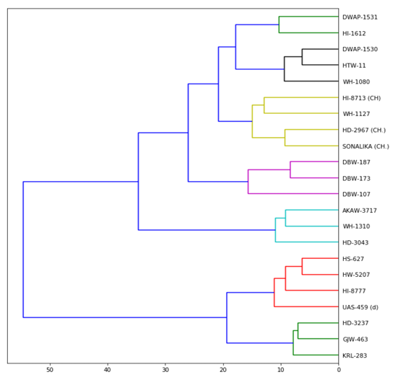

**Fig 1. Cluster for using polymorphic molecular markers**

**Molecular diversity analysis using SSR markers**

Genetic variation refers to the presence of different individuals of the same species with differing gene alleles. Analysis of diversity using molecular markers is advantageous over a traditional approach based on phenotypic evidence because molecular markers provide true information at a genetic level without the impact of environmental effects (Betsy and Siva, 2023). They also provide information about the genetic constitution of genotypes, such as genomic regions or alleles from which the population originated. The analysis of genetic variation not only presents the phylogenetic relationship but also offers a chance to find a new and useful novel allele that is found in a number of accessions (Khan, 2015).

The genetic variability among microsatellite loci was determined in terms of the major allelic frequency (MAF), number of alleles (NA), gene diversity (GD) and polymorphic information content (PIC) using eight SSR markers (Table 5). Major allelic frequency ranged from 0.23 (WMC 52) to 0.82 (WMC 358). Based on eight polymorphic loci, 57 alleles were detected among 22 wheat genotypes. The number of alleles ranged from 4 (WMC 398) to 11 (CFD 30), with an average of 7.13 alleles per locus. Gene diversityvalues ranged between 0.32 (WMC 398) to 0.88 (WMC 335), with an average of 0.72. The polymorphic information content was employed for each locus to assess the information of each marker and its discriminatory ability, and it is a reflection of allele diversity and frequency among varieties. PIC values ranged from 0.48 (WMC 398) to 0.89 (WMC 335), with the mean value of 0.73. All markers showed amplification, with four markers being highly polymorphic. The highest PIC value, 0.89, was obtained for marker WMC 335, followed by WMC 52 (0.87) and CFD 30 (0.83), whereas WMC 398 (0.48) had the least PIC value.PIC value revealed that WMC 335 was the best marker for genotypes used in the study. The polymorphic primers which have high PIC value, can be used in further molecular studies like association mapping, tagging of gene of interest, and the most commonly used approach marker marker-assisted selection (MAS). Das et al. (2014) found similar results for average PIC in the landraces of northeast India. Behera et al. (2023) also found a higher average PIC of 0.81 per locus; this may be due to the use in their analysis of a more complex range of rice accessions or the use of highly polymorphic markers.

|  |  |  |  |  |  |
| --- | --- | --- | --- | --- | --- |
| **S. No.** | **Marker Name** | **Major allelic frequency** | **Number of alleles** | **Gene diversity** | **PIC** |
| 1 | **GWM 135** | 0.6 | 9 | 0.61 | 0.59 |
| 2 | **CFD 30** | 0.3 | 11 | 0.84 | 0.83 |
| 3 | **GWM 131** | 0.26 | 8 | 0.83 | 0.81 |
| 4 | **GWM 498** | 0.47 | 7 | 0.71 | 0.68 |
| 5 | **WMC 398** | 0.82 | 4 | 0.32 | 0.48 |
| 6 | **WMC 335** | 0.24 | 6 | 0.88 | 0.89 |
| 7 | **WMC 52** | 0.23 | 5 | 0.76 | 0.87 |
| 8 | **GWM 456** | 0.25 | 7 | 0.84 | 0.72 |
|  | **Mean** | **0.39** | **7.13** | **0.72** | **0.73** |

**Table 5. Details of diversity statistics for each microsatellite marker**

**Unweighted Neighbour-Joining UPGMA analyses**

The genotypic data of SSRs were used to study the genetic diversity based on NJ-UPGMA analysis (Fig. 2). Based on the unweighted neighbour-joining clustering process, cluster analysis divided the 22 accessions into seven key groups, deciphering into three key groups along with admixture genotypes distributed through four distinct clusters. Cluster IV was the largest group, consisting of five genotypes, i.e. UAS-459, KRL-283, HS-627, DBW-187 and GJW-463. Cluster I (WH-1080, WH-1127, HI-8777 and HTW-11) and Cluster III (SONALIKA, HD-2967, HD-3237 and HI-8713) consisted of 4 genotypes each, followed by Cluster VII (WH1310, HI-1612, AKAW-3717) and Cluster V (DWAP-1531, HD-3043, HW-5207) having 3 genotypes each. This pattern of clustering confirmed the existence of a significant amount of diversity.

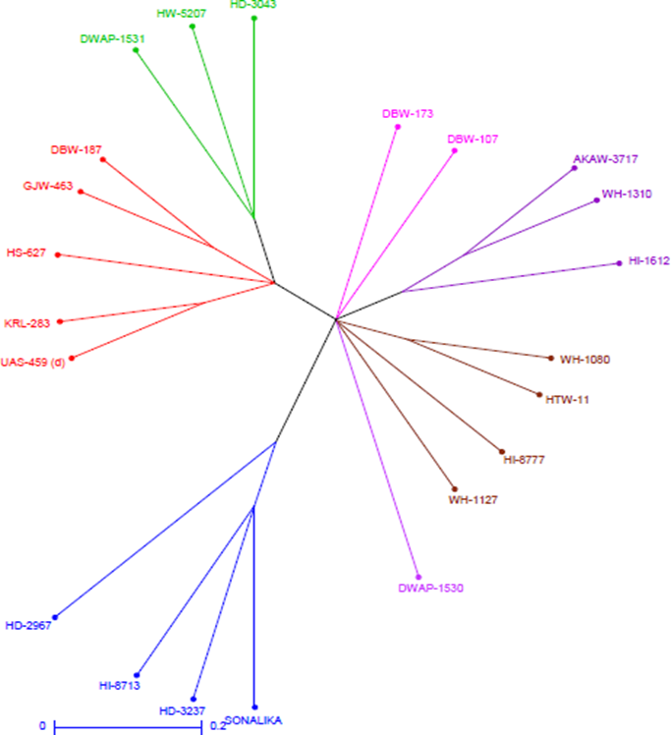

**Fig. 2 Additive tree distances Unweighted neighbour-joining tree of 22 wheat genotypes using 8 SSR markers**

**Principal Coordinate Analysis (PCoA)**

PCoA using SSR markers' allelic data determines the genetic relatedness among the genotypes. PCoA is usually used to reduce a large amount of data in groups and to obtain a new set of uncorrelated variables, which is known as principal coordinates (PCs). The first PC summarises most of the variability present in the original data relative to all remaining PCs. The second PC explains most of the variability not explained by the first PC and is uncorrelated to the first, and so on. Mohammadi and Prasanna (2003) indicated that the main component analysis (PCA) and PCoA (ordination methods) could be used in conjunction with cluster analysis for the determination of genetic diversity, particularly when the first two or three PCs account for more than 25 per cent of genetic variation.

In this analysis, 44.45 per cent of the total variability was explained by the first three axes of differentiation. The first coordinate explained the variation by 22.99 per cent, and the second coordinate explained the variation by 11.77 per cent. Coordinate analysis based on the principal coordinate analysis separated the accessions into five major groups (Table 6) along which coordinate IV constitute the largest group consisting of nine genotypes i.e. HI-1612, AKAW-3717, WH-1080, WH-1127, HI-8777, DWAP-1530, HW-5207, HTW-11 and WH1310 following coordinate I (UAS-459, KRL-283, HS-627, DBW-187, GJW-463, DWAP-1531, HD-3043, DBW-107 and DBW-173) consisted of nine genotypes whereas coordinate II (HD-3237, HI-8713) and coordinate III (Sonalika, HD-2967) each having two genotypes (Fig.3). This pattern of clustering confirmed the existence of a significant amount of diversity.

|  |  |  |  |  |  |
| --- | --- | --- | --- | --- | --- |
| **Genotype** | **PC 1** | **PC 2** | **PC 3** | **PC 4** | **PC 5** |
| Eigen value | 0.07949 | 0.0407 | 0.03352 | 0.0288 | 0.02755 |
| Percent variation | 22.99 | 11.77 | 9.69 | 8.33 | 7.97 |
| Cumulative variation | 22.99 | 34.76 | 44.45 | 52.78 | 60.75 |
| DBW-107 | 0.06 | 0.19 | -0.11 | 0.27 | 0.16 |
| DBW-173 | 0.13 | 0.11 | -0.11 | 0.31 | 0.18 |
| DBW-187 | 0.11 | 0.34 | -0.12 | -0.04 | 0.21 |
| GJW-463 | 0.17 | 0.11 | -0.26 | 0.04 | 0.33 |
| HD-3043 | 0.10 | 0.29 | 0.04 | 0.07 | -0.29 |
| HI-1612 | 0.13 | -0.06 | 0.37 | -0.03 | 0.10 |
| HW-5207 | 0.13 | -0.01 | -0.01 | 0.31 | -0.30 |
| KRL-283 | 0.16 | 0.25 | 0.14 | -0.30 | -0.09 |
| HI-8777 | 0.15 | -0.24 | -0.20 | -0.04 | 0.05 |
| HS-627 | 0.14 | 0.23 | 0.06 | -0.22 | -0.12 |
| WH1310 | 0.12 | -0.14 | 0.40 | 0.07 | 0.17 |
| UAS-459 | 0.18 | 0.23 | -0.05 | -0.32 | -0.04 |
| AKAW-3717 | 0.13 | -0.19 | 0.39 | 0.05 | 0.17 |
| HTW-11 | 0.18 | -0.27 | -0.26 | -0.17 | -0.01 |
| HI-8713 | 0.16 | -0.30 | -0.19 | 0.01 | -0.16 |
| WH-1080 | 0.15 | -0.34 | -0.05 | -0.07 | -0.02 |
| WH-1127 | 0.04 | -0.22 | -0.06 | -0.11 | -0.04 |
| DWAP-1530 | 0.11 | 0.03 | 0.06 | 0.22 | -0.31 |
| DWAP-1531 | -0.62 | 0.04 | -0.03 | -0.05 | 0.09 |
| Sonalika | -0.61 | 0.08 | -0.01 | 0.10 | -0.06 |
| HD-2967 | -0.63 | -0.10 | -0.01 | -0.08 | -0.02 |
| HD-3237 | -0.51 | -0.06 | 0.03 | -0.04 | -0.01 |

**Table 6. Principle Coordinate value for 22 wheat genotypes**

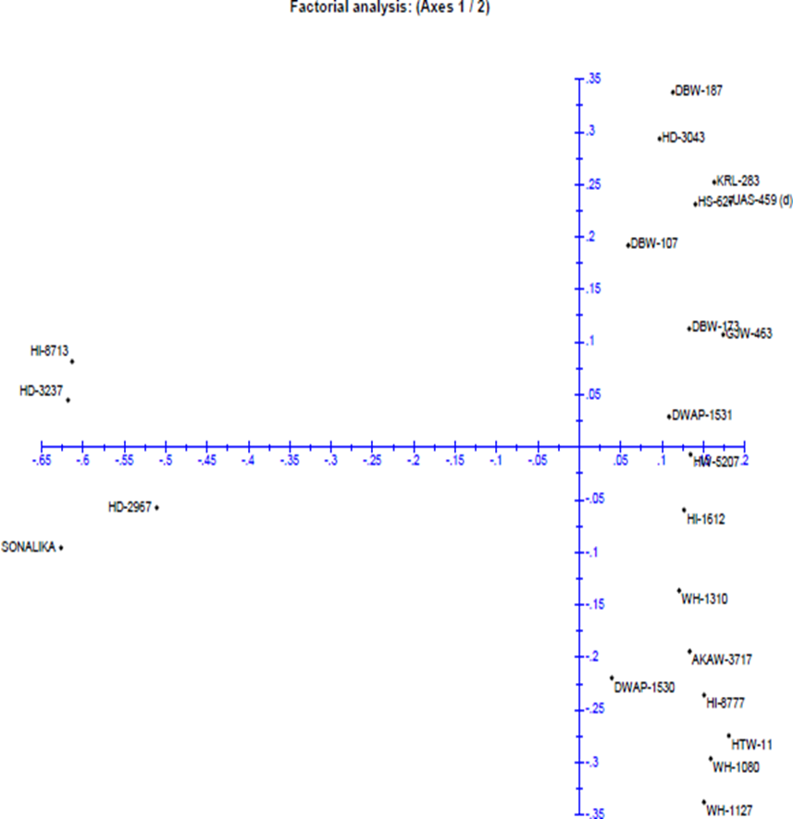

**Fig. 3. Principal Coordinate Analysis of 22 wheat genotypes using SSR markers.**

**Conclusion**

The results of Ward’s Euclidean revealed seven clusters among which HI-8713, Sonalika and HD-2967 formed same group, while unweighted neighbor-joining clustering tree generated the similar number of clusters with HI-8713, Sonalika, HD-2967 and HD-3237 in same cluster, whereas PCoA analysis were in close correspondence for the total genetic variance for SSRs and morphological analyses, respectively, where HI-8713 and HD-3237 are the most diverse than others but closely related to Sonalika and HD-2967 in PCoA, suggesting that PCoA can be used either alone or in combination with cluster analysis to discuss the genetic diversity of the wheat entries. The results of the PCoA also showed better resolution for the genetic diversity than cluster analysis. Diversity analysis through SSR markers revealed WMC 398 and WMC 335 markers giving the most diverse values, hence it is a great technique to detect variation among and within genotypes and to further use them in various molecular breeding programmes for wheat improvement. The selection of the most effective genotypes can benefit from an evaluation of genetic variety. In light of this, if such attempts result in the loss of diversity, the development of plants with greater uniformity may ensure the production of enough food for the growing population of the globe.

Disclaimer (Artificial intelligence)

Option 1:

Author(s) hereby declare that NO generative AI technologies such as Large Language Models (ChatGPT, COPILOT, etc.) and text-to-image generators have been used during the writing or editing of this manuscript.

Option 2:

Author(s) hereby declare that generative AI technologies such as Large Language Models, etc. have been used during the writing or editing of manuscripts. This explanation will include the name, version, model, and source of the generative AI technology and as well as all input prompts provided to the generative AI technology

Details of the AI usage are given below:

1.

2.

3.

**References**

Arya, V. K., Singh, J., Kumar, L., Kumar, R., Kumar, P., & Chand, P. 2017. Genetic variability and diversity analysis for yield and its components in wheat (*Triticum aestivum* L.). Indian Journal of Agricultural Research, 51(2), 128-134.

Behera, P. K., Kumar, V., Sharma, S. S., Lenka, S. K., & Panda, D. 2023. Genotypic diversity and abiotic stress response profiling of short-grain aromatic landraces of rice (*Oryza sativa* L. Indica). Current Plant Biology, 33, 100269.

Betsy, C. J., & Siva, C. 2023. *Molecular Markers* (pp. 141–151). <https://doi.org/10.1007/978-981-99-6991-3_15>

Botstein, D., White, R. L., Skolnick, M., & Davis, R. W. 1980. Construction of a genetic linkage map in man using restriction fragment length polymorphisms. American Journal of Human Genetics, 32(3), 314.

Breiman A., & Graur B. 1995. Wheat Evolution. Israel Journal of Plant Science. 43:85-98.

Das, T. K., Bhattacharyya, R., Sudhishri, S., Sharma, A. R., Saharawat, Y. S., Bandyopadhyay, K. K., Sepat, S., Bana, R.S., Aggarwal, P., Sharma, R.K., Bhatia, A., Singh, G., Datta, S.P., Kar, A., Singh, B., Singh, P., Pathak, H., Vyas, A.K., & Jat, M. L. 2014. Conservation agriculture in an irrigated cotton–wheat system of the western Indo-Gangetic Plains: Crop and water productivity and economic profitability. Field Crops Research, 158, 24-33.

Doyle J.J., Doyle J.L. 1990. Isolation of plant DNA from fresh tissue. Focus 12:13-15.

Gao, Z., Bian, J., Lu, F., Jiao, Y., & He, H. 2023. Triticeae crop genome biology: an endless frontier. Frontiers in Plant Science, 14. <https://doi.org/10.3389/fpls.2023.1222681>

Indraja, G., Syed, S., C, M., B, T. P., & M, R. S. 2018. Genetic divergence analysis in muskmelon (*Cucumis melo* L.). *International Journal of Chemical Studies*, 6(6), 2623–2626. <http://www.chemijournal.com/archives/2018/vol6issue6/PartAS/6-6-109-135.pdf>

Khan, F. 2015. Molecular Markers: An Excellent Tool for Genetic Analysis. *Journal of Molecular Biomarkers & Diagnosis*, 6(3), 1–2. <https://doi.org/10.4172/2155-9929.1000233>

Kumar, D., Rana, V., Rana, A., & Guleria, P. 2023. Genetic variability, correlation and path analysis studies for grain yield and morpho-physiological traits under moisture stress conditions in bread wheat (*Triticum aestivum* L.) under north-western Himalayan conditions. Journal of Cereal Research 15(1), 92-102. [http://doi.org/10.25174/2582- 2675/2023/124000](http://doi.org/10.25174/2582-%202675/2023/124000)

Liu K., Muse S.V. 2005. PowerMarker: an integrated analysis environment for genetic marker analysis. Bioinformatics. 21:2128-2129.

Mohammadi, S. A., & Prasanna, B. M. 2003. Analysis of genetic diversity in crop plants—salient statistical tools and considerations. Crop science, 43(4), 1235-1248.

Perrier, X., Jacquemoud-Collet, J.P., 2006. DARwin software. http://darwin.cirad.fr/dar win.

Ribeiro-Carvalho, C., Guedes-Pinto, H., Igrejas, G., Stephenson, P., Schwarzacher, T., & Heslop-Harrison, J. S. 2004. High levels of genetic diversity throughout the range of the Portuguese wheat landrace ‘Barbela’. Annals of Botany, 94(5), 699-705.

Rohlf F. J. 1998. NTSYS-PC: Numerical Taxonomy and multivariate analysis system version 2.1. Exeter Publishing Setauket, New York.

Singh, V., Poonia, M. S., Verma, A., & Tyagi, B. S. 2022. Multivariate biplot analysis for the diversity in bread wheat genotypes (*Triticum aestivum* L.). International Journal of Bio-resource and Stress Management, 13(3), 219-225.

Chawla, r., akbarzai, d. K., & chaurasia, h. (2023). Molecular characterization of bread wheat (Triticum aestivum) genotypes using SSR markers. Indian Journal of Agricultural Sciences, 93(9), 948-953.

Brinton, J., & Uauy, C. (2019). A reductionist approach to dissecting grain weight and yield in wheat. Journal of Integrative Plant Biology, 61(3), 337-358.

Chauhan , P., Kumar , V., Shrivastava , M. K., Patel , N., & Biswal , M. (2023). Stability Analysis in Wheat (Triticum aestivum L.) Genotypes under Different Environmental Conditions. International Journal of Plant & Soil Science, 35(21), 1218–1223.

Tyagi, S., Kumar, A., Gautam, T., Pandey, R., Rustgi, S., & Mir, R. R. (2021). Development and use of miRNA-derived SSR markers for the study of genetic diversity, population structure, and characterisation of genotypes for breeding heat-tolerant wheat varieties. PLOS ONE, 16(2), e0231063.