**Scientometric Analysis of the Impact of the *Journal of Research Angrau* Based on Google Scholar Metrics (1989–2024)**

**ABSTRACT**

A scientometric analysis of the Journal of Research ANGRAU was conducted from 1989 to 2024 using the Publish or Perish (PoP) software. Data was obtained over a span of 35 years for the study. The impact of the Journal of Research ANGRAU on modern academic research was evaluated by retrieving raw data from Google Scholar and utilizing eight h-Index variables for analysis. The research examined 428 scholarly publications to explore Zipf's Law concerning yearly contributions, authorship patterns, and trends in author output. The study included an analysis of ANGRAU's relative growth rate and doubling time. According to the data, the year 2022 witnessed the largest number of publications, totalling 69 articles, which represents 16.12% of the overall publications. The assessed impact rankings of ANGRAU are displayed as an average. The study employed data from many sources, including indices (h and g), h-index, g-index, publications, citations, years, citations per annum, citations per publication, citations per author, and publications per author.

**Keywords:** *ANGRAU, Impact Study, h-index, g-index, publications, citation analysis, science mapping*

**INTRODUCTION**

The *Journal of Research ANGRAU* (since 1973) serves as a significant platform for disseminating scholarly work in agriculture and allied sciences, contributing to the academic and practical advancements in these fields. Evaluating the journal's impact through widely used citation metrics like Google Scholar provides valuable insights into its visibility, academic influence, and contribution to research. Google Scholar, a freely accessible search engine, indexes a wide range of scholarly content, including journal articles, conference papers, theses, and books (Kour et al., 2024). Its citation metrics, such as the h-index and i10-index, help gauge the relevance and reach of a journal's publications (Harzing & Van Der Wal, 2008).

The visibility of research articles on Google Scholar plays a pivotal role in their accessibility to a global audience, enhancing their likelihood of being cited (Kousha & Thelwall, 2007). Citation analysis through this platform offers a measure of the journal's influence across various disciplines and regions, particularly in agriculture, where practical applications often depend on accessible research findings (Suseela, 2013). Tracking the journal’s citation data through Google Scholar not only highlights the impact of individual articles but also reflects the cumulative contribution of the journal to advancing knowledge and practices in agriculture. Such an evaluation aids in identifying trends, gaps, and opportunities for future research dissemination.

**Objectives**

Scientometric / Bibliometric / Citation studies have done earlier by different authors on the different individual journal publications and literature on specific subject areas (Rajendran et al., 2011). To analyze the impact of publications from the Journal of Research ANGRAU, citation metrics used for evaluation; To examine the annual dissemination of an author's publications, identify articles published in a single year by a solitary author, a specific group of authors or a combination of both; To ascertain the Relative Growth Rate and the median duration for article views to double within a specified timeframe and to determine the applicability of Zipf's Law to an author's research production in the Journal of Research ANGRAU. The study revealed to researchers how they can find the best field or best journal to succeed in their publication. The study would also lead to quality publications in the Journal of Research ANGRAU.

**MATERIALS AND METHODS**

The analysis conducted in the year 2025 relies on papers from the Journal of Research ANGRAU that were published between 1989 and 2024 and are archived on the Publish or Perish platform (Harzing, 2007). The PoP, developed by (Bott & Stinson, 2019), is a Microsoft Windows utility that enables the retrieval and examination of academic citations from various platforms such as OSX (Apple.Inc, 2024,Linux, 2024) when used in conjunction with a compatible emulator. The main sources for metric analysis are obtained from Google Scholar (2024). The majority of the 428 publications examined consisted of research papers, brief communications, reviews and case studies. The obtained information was collated, processed, analysed and visually depicted using tables and graphs for further examination and discussion. Table 1 displays a range of metrics for the Journal of Research ANGRAU, including the number of published papers, received citations, number of authors and other relevant statistics.

**Table 1. Metrics of the Journal of Research ANGRAU**

|  |  |  |
| --- | --- | --- |
| **S.No.** | **Query** | **The Journal of Research ANGRAU** |
| 1 | Source | Google Scholar |
| 2 | Papers | 428 |
| 3 | Citations | 483 |
| 4 | No. of years | 35 |
| 5 | Cites_Year | 13.8 |
| 6 | Cites_Paper | 1.13 |
| 7 | Cites_Author | 192.91 |
| 8 | Papers_Author | 198 |
| 9 | Authors_Paper | 2.72 |
| 10 | h_index | 8 |
| 11 | g_index | 13 |
| 12 | hc_index | 8 |
| 13 | hI_index | 2.46 |
| 14 | hI_norm | 6 |
| 15 | AWCR | 115.11 |
| 16 | AW_index | 10.73 |
| 17 | AWCRpA | 46.5 |
| 18 | e_index | 9.22 |
| 19 | hm_index | 5.83 |

**RESULTS AND DISCUSSION**

The provided bar graph illustrates (Figure 1) the percentage of publications over a series of years, highlighting trends in research output. The data reveals a gradual increase from 1989 to 2014, with notable growth observed after 2013. Starting with minimal contributions (0.47%) between 1989 and 2011, the publication rate steadily climbed, reaching 6.54% by 2015. A moderate decline occurred between 2016 (5.61%) and 2018 (3.97%), followed by a significant surge in 2019 (10.28%). The peak was recorded in 2022 at 16.12%, indicating heightened academic activity, before stabilizing in 2023 (13.79%). However, a sharp decline to 0.23% in 2024 suggests incomplete or preliminary data. This trend may reflect evolving academic priorities, funding availability, or global events influencing research output. The increase post-2018 might be tied to enhanced research collaboration or funding initiatives, while the 2024 dip could indicate pending publication indexing.

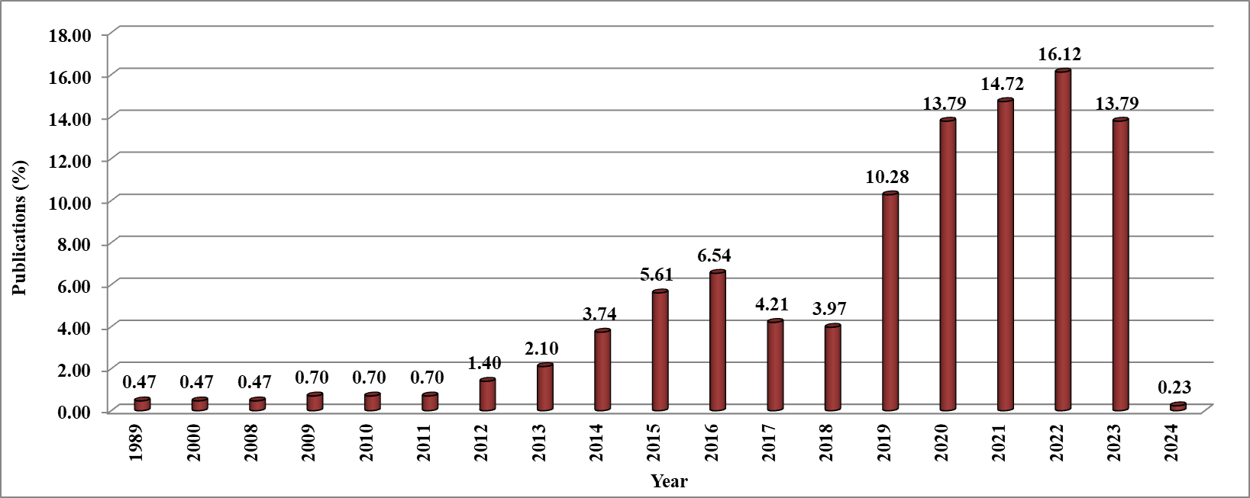

**Figure 1. Publication Growth of the Journal of Research ANGRAU**

**Table 2. Authorship Pattern in the Journal of Research ANGRAU**

|  |  |  |  |  |  |  |  |  |
| --- | --- | --- | --- | --- | --- | --- | --- | --- |
| **S.No.** | **Year** | **Single** | **Two** | **Three** | **Four** | **Five and Above** | **Total** | **Percentage** |
| 1 | 1989 | 0 | 1 | 1 | 0 | 0 | 2 | 0.47 |
| 2 | 2000 | 1 | 0 | 0 | 1 | 0 | 2 | 0.47 |
| 3 | 2008 | 0 | 1 | 1 | 0 | 0 | 2 | 0.47 |
| 4 | 2009 | 1 | 1 | 0 | 1 | 0 | 3 | 0.70 |
| 5 | 2010 | 0 | 1 | 1 | 1 | 0 | 3 | 0.70 |
| 6 | 2011 | 1 | 0 | 1 | 1 | 0 | 3 | 0.70 |
| 7 | 2012 | 1 | 1 | 1 | 3 | 0 | 6 | 1.40 |
| 8 | 2013 | 0 | 2 | 3 | 3 | 1 | 9 | 2.10 |
| 9 | 2014 | 3 | 7 | 2 | 4 | 0 | 16 | 3.74 |
| 10 | 2015 | 3 | 3 | 8 | 10 | 0 | 24 | 5.61 |
| 11 | 2016 | 12 | 1 | 8 | 7 | 0 | 28 | 6.54 |
| 12 | 2017 | 6 | 3 | 2 | 7 | 0 | 18 | 4.21 |
| 13 | 2018 | 13 | 1 | 2 | 1 | 0 | 17 | 3.97 |
| 14 | 2019 | 4 | 6 | 16 | 15 | 3 | 44 | 10.28 |
| 15 | 2020 | 14 | 22 | 11 | 12 | 0 | 59 | 13.79 |
| 16 | 2021 | 5 | 22 | 14 | 21 | 1 | 63 | 14.72 |
| 17 | 2022 | 8 | 26 | 12 | 23 | 0 | 69 | 16.12 |
| 18 | 2023 | 15 | 18 | 14 | 12 | 0 | 59 | 13.79 |
| 19 | 2024 | 0 | 0 | 1 | 0 | 0 | 1 | 0.23 |
| **20** | **Total** | **87** | **116** | **98** | **122** | **5** | **428** | **100.00** |

The table 2 corresponding bar graph detail the distribution of publications from 1989 to 2024, categorized by the number of authors involved and total output per year. The trend indicates an increasing research output over time, with a marked growth in multi-author publications (two, three, and four authors) after 2015. Initially, single and two-author publications dominated, with minimal overall contributions (0.47%) in early years like 1989, 2000, and 2008. A significant rise in publications occurred from 2014 onwards, peaking in 2022 with 69 publications (16.12%). Collaborative efforts (three- and four-author categories) notably expanded during this period, reflecting a shift toward teamwork in research. The sharp decline in 2024 (0.23%) is likely due to incomplete data or delays in publication indexing. The total contributions over 35 years (428) underscore an evolving academic landscape, emphasizing collaborative research, possibly driven by increased funding and institutional support.

**Table 3. Degree of Collaboration during the study period in The Journal of Research ANGRAU**

|  |  |  |  |  |  |
| --- | --- | --- | --- | --- | --- |
| **S.No.** | **Year** | **Single (Ns)** | **Multiple Authors (Nm)** | **Total** | **Degree of Collaboration $$(\frac{Nm}{Nm+Ns})$$** |
| 1 | 1989 | 0 | 2 | 2 | 1.00 |
| 2 | 2000 | 1 | 1 | 2 | 0.50 |
| 3 | 2008 | 0 | 2 | 2 | 1.00 |
| 4 | 2009 | 1 | 2 | 3 | 0.67 |
| 5 | 2010 | 0 | 3 | 3 | 1.00 |
| 6 | 2011 | 1 | 2 | 3 | 0.67 |
| 7 | 2012 | 1 | 5 | 6 | 0.83 |
| 8 | 2013 | 0 | 9 | 9 | 1.00 |
| 9 | 2014 | 3 | 13 | 16 | 0.81 |
| 10 | 2015 | 3 | 21 | 24 | 0.88 |
| 11 | 2016 | 12 | 16 | 28 | 0.57 |
| 12 | 2017 | 6 | 12 | 18 | 0.67 |
| 13 | 2018 | 13 | 4 | 17 | 0.24 |
| 14 | 2019 | 4 | 40 | 44 | 0.91 |
| 15 | 2020 | 14 | 45 | 59 | 0.76 |
| 16 | 2021 | 5 | 58 | 63 | 0.92 |
| 17 | 2022 | 8 | 61 | 69 | 0.88 |
| 18 | 2023 | 15 | 44 | 59 | 0.75 |
| 19 | 2024 | 0 | 1 | 1 | 1.00 |
| 20 | **Total** | **87** | **341** | **428** | **0.80** |

The data in Table 3 provides insights into the degree of collaboration (DC) in publications within the Journal of Research ANGRAU from 1989 to 2024. The degree of collaboration, calculated as $C=\frac{Nm}{Nm+Ns}$ highlights the proportion of multi-author publications in total research output.

The overall degree of collaboration during the study period is 0.80, indicating a strong preference for collaborative research. From 1989 to 2011, the degree of collaboration fluctuated between 0.50 and 1.00, reflecting a balance between single-author and multi-author works. Post-2012, there was a noticeable increase in multi-author contributions, peaking in 2021 (DC = 0.92) and 2022 (DC = 0.88). The year 2018 marks an exception with a lower DC (0.24), showing a higher share of single-author publications. In 2024, the DC was 1.00, but this is based on a single publication, limiting interpretive value.

Overall, the growing degree of collaboration aligns with global trends favouring interdisciplinary and team-based research efforts.

**Table 4. Relative Growth Rate and Doubling Time of the Journal of Research ANGRAU**

|  |  |  |  |  |  |  |  |  |
| --- | --- | --- | --- | --- | --- | --- | --- | --- |
| **Year** | **Quantum of Output** | **Cumulative total out put** | **LogXeW1** | **LogXeW2** | **RGR** | **Block Period** | **Double time** | **Block Period** |
| 1989 | 2 | 2 | 0.6931 | 0.6931 | 0 | **0.986283** | 0 | **1.262544** |
| 2000 | 2 | 4 | 0.6931 | 1.3863 | 0.0866 | 8.0000 |
| 2008 | 2 | 6 | 0.6931 | 1.7918 | 1.0986 | 0.6309 |
| 2009 | 3 | 9 | 1.0986 | 2.1972 | 1.0986 | 0.6309 |
| 2010 | 3 | 12 | 1.0986 | 2.4849 | 1.3863 | 0.5000 |
| 2011 | 3 | 15 | 1.0986 | 2.7081 | 1.6094 | 0.4307 |
| 2012 | 6 | 21 | 1.7918 | 3.0445 | 1.2528 | 0.5533 |
| 2013 | 9 | 30 | 2.1972 | 3.4012 | 1.2040 | 0.5757 |
| 2014 | 16 | 46 | 2.7726 | 3.8286 | 1.0561 | 0.6564 |
| 2015 | 24 | 70 | 3.1781 | 4.2485 | 1.0704 | 0.6475 |
| 2016 | 28 | 98 | 3.3322 | 4.5850 | 1.2528 | **2.13567** | 0.5533 | **0.398221** |
| 2017 | 18 | 116 | 2.8904 | 4.7536 | 1.8632 | 0.3720 |
| 2018 | 17 | 133 | 2.8332 | 4.8903 | 2.0571 | 0.3369 |
| 2019 | 44 | 177 | 3.7842 | 5.1761 | 1.3920 | 0.4980 |
| 2020 | 59 | 236 | 4.0775 | 5.4638 | 1.3863 | 0.5000 |
| 2021 | 63 | 299 | 4.1431 | 5.7004 | 1.5573 | 0.4451 |
| 2022 | 69 | 368 | 4.2341 | 5.9081 | 1.6740 | 0.4141 |
| 2023 | 59 | 427 | 4.0775 | 6.0568 | 1.9792 | 0.3502 |
| 2024 | 1 | 428 | 0.0000 | 6.0591 | 6.0591 | 0.1144 |
| **Total** | **428** |  | | | | | | |

The data in Table 4 provides an analysis of the relative growth rate (RGR) and doubling time (DT) of the Journal of Research ANGRAU publications over the study period. These metrics offer insights into the dynamics of research output growth.

**1. Relative Growth Rate (RGR):**

- RGR reflects the change in the quantum of publications over time. It peaked in earlier years (e.g., 1.2528 in 2012 and 2016), indicating rapid growth, but progressively declined to 0.1144 in 2024. This decline suggests a slowdown in publication growth over time, likely as the research base matured.

- High RGR in years like 2009–2012 aligns with a sharp increase in collaborative publications.

**2. Doubling Time (DT):**

- DT indicates the time required for publications to double. Lower DT reflects faster growth. For example, during the 2012–2016 block periods, DT dropped to 0.3982, signifying rapid output expansion. Conversely, the DT for 2024 was 1.2625, signalling slowed growth due to minimal output.

**3. Block Trends:**

- The cumulative output increased steadily across block periods, with significant contributions during 2019–2022. This phase corresponds to enhanced institutional focus on collaborative research, seen in other data tables. The results highlight a significant expansion in publication output during 2012–2022, driven by institutional and collaborative initiatives. However, the sharp decline in 2024 warrants further investigation, as it may be attributed to delayed indexing or reduced submission rates. Overall, the journal's growth aligns with global trends in research productivity and collaboration.

**Table 5. Number of Documents Vs Number of Citations**

|  |  |  |  |  |  |
| --- | --- | --- | --- | --- | --- |
| **S.No** | **Year** | **Documents** | **Percentage** | **Citations** | **Percentage (%)** |
| 1 | 1989 | 2 | 0.47 | 3 | 0.62 |
| 2 | 2000 | 2 | 0.47 | 1 | 0.21 |
| 3 | 2008 | 2 | 0.47 | 6 | 1.24 |
| 4 | 2009 | 3 | 0.70 | 23 | 4.76 |
| 5 | 2010 | 3 | 0.70 | 0 | 0.00 |
| 6 | 2011 | 3 | 0.70 | 10 | 2.07 |
| 7 | 2012 | 6 | 1.40 | 7 | 1.45 |
| 8 | 2013 | 9 | 2.10 | 29 | 6.00 |
| 9 | 2014 | 16 | 3.74 | 15 | 3.11 |
| 10 | 2015 | 24 | 5.61 | 69 | 14.29 |
| 11 | 2016 | 28 | 6.54 | 59 | 12.22 |
| 12 | 2017 | 18 | 4.21 | 21 | 4.35 |
| 13 | 2018 | 17 | 3.97 | 23 | 4.76 |
| 14 | 2019 | 44 | 10.28 | 32 | 6.63 |
| 15 | 2020 | 59 | 13.79 | 25 | 5.18 |
| 16 | 2021 | 63 | 14.72 | 80 | 16.56 |
| 17 | 2022 | 69 | 16.12 | 60 | 12.42 |
| 18 | 2023 | 59 | 13.79 | 20 | 4.14 |
| 19 | 2024 | 1 | 0.23 | 0 | 0.00 |
|  | **Total** | **428** | **100** | **483** | **100** |

Table 5 compares the number of documents published and their corresponding citations across years, offering insights into the journal's research impact and citation dynamics.

**1. Publication Growth:**

- The journal's document output steadily increased, peaking in 2022 with 69 publications (16.12%). This period reflects a surge in academic contributions. However, the output in 2024 dropped drastically to just 1 document (0.23%).

**2. Citation Trends:**

- Citations peaked in 2021 with 80 (16.56%), correlating with the high number of impactful publications in preceding years. This suggests a lag effect, where citations grow as earlier research gains recognition.

- Years like 2015 and 2016 also show substantial citation counts (14.29% and 12.22%), indicating significant research visibility.

**3. Notable Years:**

- 2013 had a low output (9 documents, 2.10%) but achieved a relatively high citation percentage (6.00%), reflecting quality over quantity.

- Contrastingly, 2024 had no citations, likely due to recent publication and insufficient time for academic engagement.

**4. Overall Trends:**

- The journal achieved a total of 428 documents and 483 citations, with citations slightly outpacing publications. This demonstrates the research's influence in its domain. The data highlights a consistent growth in publication output from 2015 to 2022, coupled with strong citation performance. The peak in 2021 underscores the journal's impact during this period. However, the recent decline in both documents (2024) and citations (0%) points to potential delays in recognition or indexing. These trends align with the journal's evolving focus on collaborative and impactful research. Further analysis could identify factors influencing citation growth, such as subject relevance and citation windows.

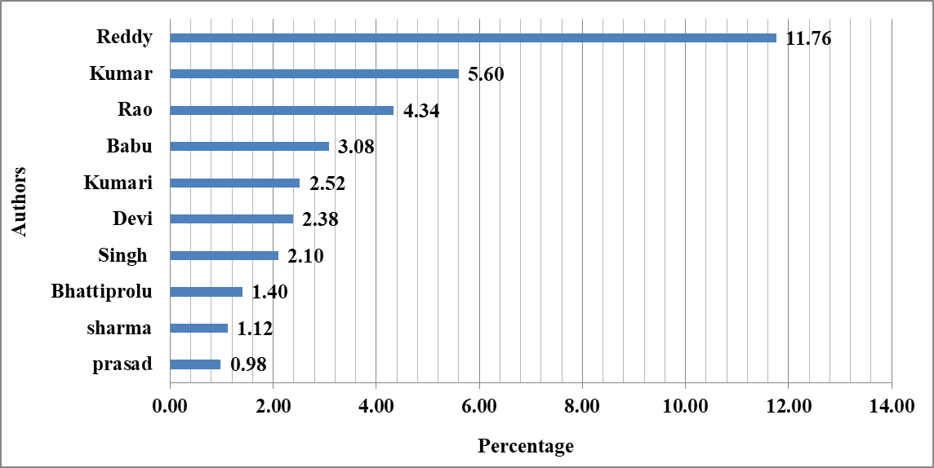

**Figure 2. Bar Chart for Ranking of Authors**

The bar graph illustrates (Figure 2) the contribution percentages of the top 10 authors to The *Journal of Research ANGRAU*. The authors' contributions are measured by their publication percentage over the study period.

Interpretation:

1. **Leading Author:**
   * "Reddy" is the most prolific contributor, accounting for 11.76% of the total publications. This indicates significant involvement in the journal's research output, likely reflecting expertise in a specific domain or active institutional participation.
2. **Other Key Contributors:**
   * "Kumar" (5.60%) and "Rao" (4.34%) follow, making notable contributions. Their combined efforts reflect over 10% of the total publications, emphasizing their consistent engagement with the journal.
   * Authors such as "Babu" (3.08%), "Kumari" (2.52%), and "Devi" (2.38%) contribute moderately, showcasing a diverse set of contributors.
3. **Lower Contributions:**
   * Authors like "Sharma" (1.12%) and "Prasad" (0.98%) contributed the least among the top 10. While their individual outputs are smaller, their inclusion highlights the collaborative nature of the journal.

The dominance of a few authors, particularly "Reddy," suggests a concentrated research output, likely due to institutional affiliations or subject-matter expertise. This trend may indicate limited diversity in author representation, as a few contributors account for a significant proportion of the publications. The presence of a broad spectrum of authors, ranging from highly prolific contributors to occasional ones, reflects a balance between expertise and inclusivity. The data emphasizes the importance of fostering a wider range of contributors to ensure diversity in perspectives and research areas. Encouraging underrepresented authors and collaborations can enhance the journal's breadth and appeal, leading to greater academic impact and community engagement.

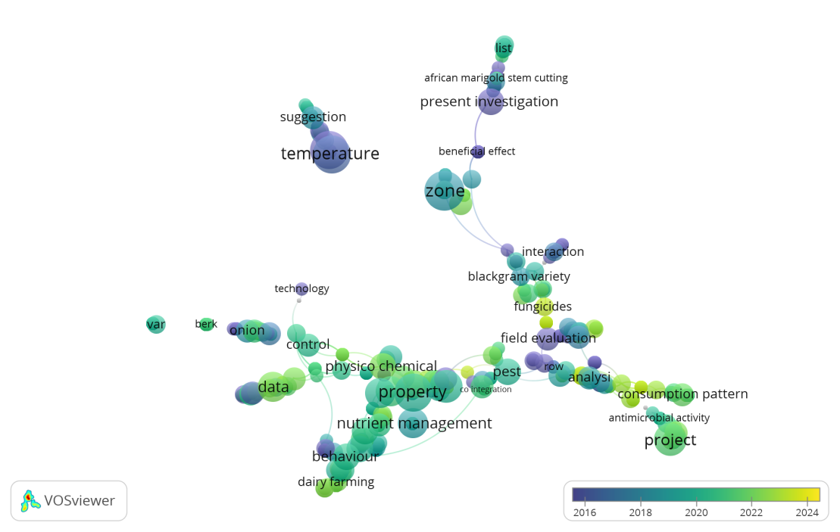

**Figure 3: Titles and Abstract of the Journal of Research ANGRAU**

This visualization (Figure 3), generated using VOS Viewer, presents a keyword analysis of a research title and abstract. The clusters represent the thematic structure of the study, highlighting significant terms and their relationships. Key concepts such as "nutrient management," "property," and "physico-chemical" suggest a focus on agricultural science, soil studies, or material properties. The presence of "temperature" and "zone" may indicate climatic or environmental influences, while "project" and "data" emphasize research methodologies. Additionally, the keywords "pest," "fungicides," and "blackgram variety" suggest a study related to crop protection and plant sciences. The colour gradient, ranging from blue (2020) to yellow (2024), shows an evolution in research trends, with newer topics like "consumption pattern" and "antimicrobial activity" gaining prominence. This network analysis provides insight into the study’s primary themes and emerging trends, aiding researchers in understanding the scope and relevance of the work.

**CONCLUSION**

The Journal of Research ANGRAU's (1989–2024) analysis shows substantial trends in authorship, publishing output, citations, and collaboration. Output of 428 articles shows constant growth, especially in recent years, with peak productivity in 2022 (16.12%). The Relative Growth Rate (RGR) fluctuated over time, but publication doubling time decreased, indicating a constant increase in research contributions. Over the study period, authorship patterns shifted toward collaborative research, with a high Degree of Collaboration (0.80). Team-based research, required for complicated transdisciplinary themes, is becoming more popular. Authors like "Reddy" (11.76%) and "Kumar" (5.60%) dominate, although others represent diversity. The journal's papers have been more influential in recent years, as 2021 had the greatest citation count (16.56%). However, 1989 and 2000 have lower citation counts, showing a progressive increase in relevance and visibility. Finally, the journal shows strong growth and teamwork. Inclusivity, multidisciplinary research, and various author contributions can boost its academic significance and global reach. This Google Scholar scientometric analysis of the Journal of Research ANGRAU reveals publishing trends, citation impact, and author contributions over time. The data demonstrate the journal's influence on agricultural research dissemination and academia. Several limitations must be noted. Without standardized author identities, bibliometric studies struggle to identify authors. Common names and author attributions can skew citation numbers and collaborative networks. ORCID (Open Researcher and Contributor ID) can solve this problem by giving each researcher a unique identification and improving scholarly production and effect tracking. Future studies could use ORCID data with other bibliometric datasets to improve author disambiguation and network analysis. Google Scholar's indexing criteria differ from Scopus and Web of Science, limiting its use as a data source. Google Scholar covers more sources; however, non-peer-reviewed sources may cause citation metrics to vary. Comparing the journal's influence across indexing platforms may be more accurate. Despite these constraints, this study offers a foundational assessment of The Journal of Research ANGRAU's agricultural research output. Continued bibliometric evaluations using standardized author identification and different data sources will improve impact assessments and research visibility. It would be worth exploring further into the decline observed in 2024 publication metrics, as this anomaly could indicate either a delay in indexing or a reduction in submission rates.

The study raises important considerations for the future of bibliometric analyses in journals, especially regarding data sources and author identification. Further longitudinal studies comparing these trends across different agricultural journals could provide deeper insights into the broader trends in the field.

Disclaimer (Artificial intelligence)

Option 1:

Author(s) hereby declare that NO generative AI technologies such as Large Language Models (ChatGPT, COPILOT, etc.) and text-to-image generators have been used during the writing or editing of this manuscript.

**REFERENCES**

Apple.Inc. (2024). *Maco s 14.4 (23E214)—Releases—Apple Developer* [Computer software]. https://developer.apple.com/news/releases/?id=03072024d

Bott, E and Stinson, C. (2019). *Windows 10 inside out* (Version Windows 10) [Computer software]. Microsoft Press. https://www.microsoft.com/en-in/software-download/

Google Scholar. (2024). *Google Scholar*. https://scholar.google.com/

Harzing, A and Van Der Wal, R. (2008). Google Scholar as a new source for citation analysis. *Ethics in Science and Environmental Politics*. *8:* 61–73. https://doi.org/10.3354/esep00076

Harzing, A.W. (2007). *Publish or Perish*. https://harzing.com/resources/publish-or-perish.

Kousha, K., & Thelwall, M. (2007). Google Scholar citations and Google Web/URL citations: A multi‐discipline exploratory analysis. *Journal of the American Society for Information Science and Technology.* *58*(7): 1055–1065. https://doi.org/10.1002/asi.20584

Linux. (2024). *Enterprise Open Source and Linux* [Computer software]. https://ubuntu.com/

Rajendran, P., Jeyshankar, R and Elango, B. (2011). Scientometric analysis of contributions to Journal of scientific and industrial research. International Journal of Digital Library Services. 1(2): 79-89.

Kour, H., Angadi, P., & Kulkarni, S. L. (2024). Journal metrics: Measuring academic impact, journal rankings, and their implications. Indian Journal of Health Sciences and Biomedical Research kleu, 17(3), 181-184.

Suseela, V. J. (2013). The relevance of usage metrics in lis research. SRELS Journal of Information Management, 50(3), 253-266.