**Short research article**

**A Stability-Indicating RP-HPLC Method for the Development and Validation of Edoxaban**

**ABSTRACT**

Anticoagulants represent a category of dosage forms utilized in the treatment of thrombotic disorders, which extend the clotting time. This study focuses on quantifying Edoxaban in solid oral dosage forms. A precise RP-HPLC method was established to ascertain the Edoxaban content using a specific stability-indicating approach. Edoxaban is effectively resolved using a C18 column with isocratic elution employing acetonitrile and Triethylamine buffer (pH 5.5) at a flow rate of 1 mL/min, with the peak appearing at a retention time of approximately 4 minutes and quantified at its λmax (290 nm). The method demonstrated accuracy and linearity across the concentration range of 14.91 µg/ml to 89.46 µg/ml of the test concentration. A forced degradation study was conducted to validate the specificity of the method, confirming degradation and establishing it as a stability-indicating method. The developed method has been validated in accordance with ICH guidelines and has been found to be satisfactory, precise, linear, and accurate. Consequently, the proposed RP-HPLC method is employed in routine quality control analysis for content determination. Edoxaban has significant role in preventing the sroke and systemic embolism in patients and availability of stability indicating method facilitate the Edoxaban medication to the patient rapidly and purest form.

**Keywords:** Anticoagulant, RP-HPLC, Method development, Validation, Forced degradation

# **INTRODUCTION**

Edoxaban: (class: Novel Oral Anti-Coagulants (NOACs) (1); IUPAC name: N- (5-Chloropyridin-2-yl)-N′-[(1S,2R,4S)-4-(N,N-dimethylcarbamoyl)-2-(5-methyl-4,5,6,7 tetrahydro[1,3]thiazolo[5,4-c]pyridine-2-carboxamido)cyclohexyl] oxamide; used to treat the people with atrial fibrillation (a heart rhythm disorder) (1) to lower the risk of stroke caused by a blood clot.) In addition, edoxaban is indicated following hip or knee replacement surgery to prevent deep vein thrombosis (DVT) (2), a specific type of blood clot, which can result in blood clots in The lungs (pulmonary embolism) During the process of development of the drug product in generic pharmaceutical industries, development of an accurate and efficient analytical method for determining the quality of the product is a key activity(3,4). Edoxaban is immediate release tablets dosage form with half life of 10-14 hrs and it reaches to its peak plasma concentration within 1-2 hrs.

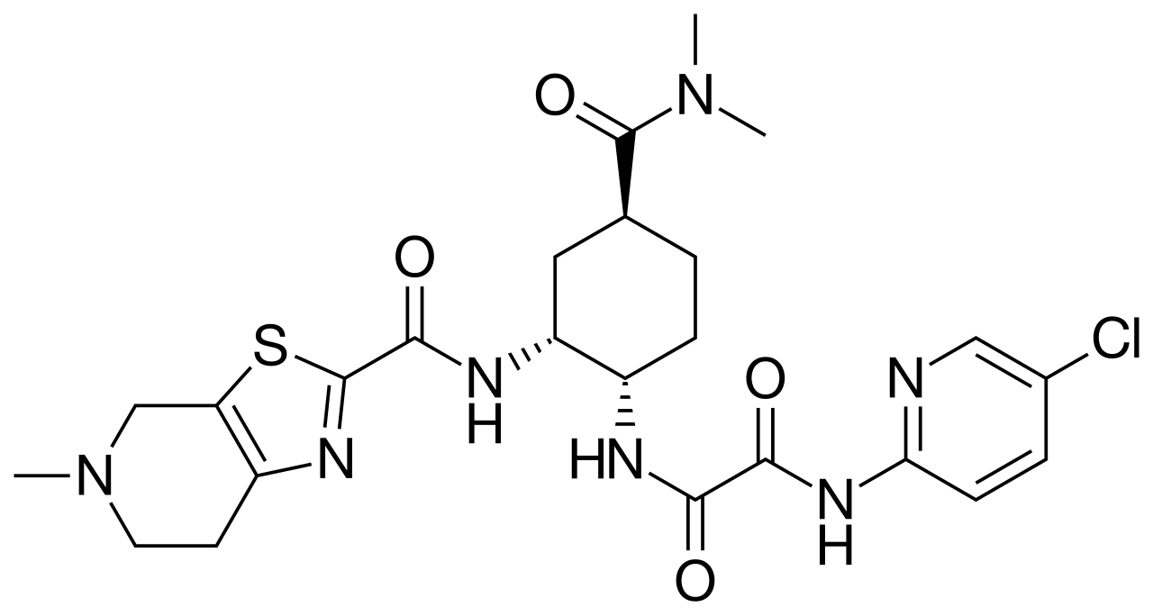

Fig. 1: The structure of Edoxaban.

Oral Anticoagulants are extensively utilized in clinical settings due to their user-friendliness, advantageous pharmacological characteristics, and the absence of monitoring requirements. Nevertheless, although they possess a superior safety profile compared to vitamin K antagonists, the risk of bleeding remains significant. Innovative anticoagulants that focus on the contact phase of coagulation are presently under development, which may enable the prevention of thrombosis risk without compromising hemostasis(5-8).

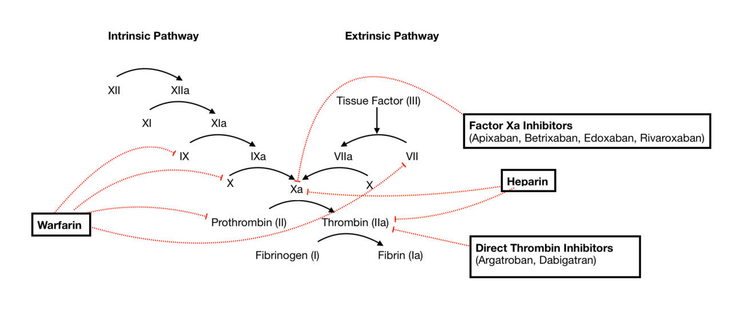

Fig. 2: Graphical representation of Coagulation mechanism

The development of analytical methods entails the design and optimization of a procedure aimed at measuring the chemical composition, concentration, or structure of substances within a sample. This process encompasses the selection of the suitable analytical technique (such as HPLC, GC, or Spectrophotometry), the determination of the optimal experimental conditions, and the preparation of the sample for analysis(9-12).

The development of analytical methods plays a crucial role in the discovery, development, and manufacturing of pharmaceuticals. These methods are employed to guarantee the purity, potency, and performance of drug products. Numerous factors must be taken into account during the method development process. Analytical method development refers to the procedure of creating a specific analytical method for drug products, spanning from the in-process stage to the finished product, with invalidation required prior to commencing the analysis of routine samples, investigation samples, and stability samples(13-14).

Regulatory bodies, including the International Council for Harmonisation (ICH), require that analytical methods be subjected to comprehensive validation to guarantee their reliability and reproducibility(15).

Essential validation parameters, such as linearity, accuracy, precision, specificity and robustness, need to be systematically assessed to verify that the method is appropriate for routine analysis.

# **METHOD DEVELOPMENT**

Chromatographic method for Edoxaban Tablets was successfully developed to determine the content of Edoxaban using RP-HPLC. Objective was to develop on suitable method with shorter runtime, reproducible, rugged and simple which can be intended for routine analysis and can be successfully validated as per ICH guideline. Below trials were taken to optimise the method:

* Various columns from different makes, different dimension were tried
* Buffers with variable pH
* Buffer and organc composition varied
* Flow rate varied
* Variable Column oven temperature tried

The screening phase done by utilizing Design Expert software. A total of 15 experimental runs incorporating 12 factorial points and 3 center points per block were employed. This design was deliberately chosen due to its reduced number of runs compared to 3 level factorial designs. Following the risk assessment, the critical method parameters or method variables were determined to be the pH of the mobile phase, the flow rate, and the temperature of the column oven. The method responses, also referred to as critical quality attributes, that were selected included the retention time of the drug, the number of theoretical plates and the asymmetry factor. The responses obtained from the execution of the 15 experimental runs were subsequently input into the DoE software.

Based on the above outcomes optimal chromatography was concluded with standard and test concentration of 60 µg/mL. Method found capable of quantify the content at the stated concentration.

## **MATERIALS AND METHODS**

Acetonitrile, hydrochloric acid, sodium hydroxide, and hydrogen peroxide, Triethylamine (all of AR grade) HPLC grade water (Millipore Inc., USA), Sonicator.

## **Analytical Condition and Instrument Methodology**

**Buffer preparation**: Added 1 mL of triethylamine in 2000 mL of millli Q water and mixed well. pH of the buffer was adjusted to 5.50.

**Mobile Phase Prepartion**: Mixed well buffer and acetonitrile in the ratio of 65:35 v/v and degassed by sonication.

**Diluent preparation:** Mixed well water and acetonitrile in the ratio of 50:50 v/v and degassed by sonication.

**Standard and test preparation**: Test and Standard were prerpared using diluent to make the concentration60 µg/mL.

**Chromatographic condition:**

The chromatographic separation was performed using Waters HPLC 2695 Alliance System, photodiode array detector, Chromeleon-software was used as CDS.

|  |  |
| --- | --- |
| Column | Inertsil ODS C18 -100 Å (100 × 4.6 mm), 3 5µm |
| Flow rate | 1mL/min |
| Column oven temperature | 35°C |
| Injection Volume | 10µL |
| Detector | UV-PDA 290 nm |
| Mode of seperation | Isocratic mode |
| Run time | 10 min |

# **RESULTS AND DISCUSSION:**

Reversed-phase high-performance liquid chromatography (RP-HPLC) is a commonly employed separation technique where a non-polar stationary phase interacts with a polar mobile phase, leading to the separation of molecules with different hydrophobic properties.

A stability-indicating HPLC method is a specialized analytical technique employed to evaluate the stability and monitoring through out lifecycle of drug substances and products.This method is specifically designed to separate and quantify the active pharmaceutical ingredient (API) from its degradation products, impurities, and excipients, thereby ensuring that the method is both specific and accurate for stability testing.

Satisfactory chromatography achieved with good peak shape of Edoxaban in isocratic elution mode. The column efficiency/theoretical plates, tailing factor %RSD for six replicate injections of standard were finalized as system suitability criteria. Method was subjected to challange its suitability by validating as per ICH guidelines(16).

# **Method Validation:**

# **Specificity**:

Specificity refers to the capability of a method to quantify the analyte response amidst degradation impurities and the matrix. Conducting stress testing on drug products can assist in recognizing degradation products that arise during stability studies. These findings can be utilized to define the degradation pathway and the intrinsic stability of the molecule, as well as to validate the stability-indicating proficiency of the analytical method employed.

The specificity of the developed RP-HPLC method for Edoxaban Tablets in the presence of its degradation impurities and placebo matrix. Forced degradation studies were conducted on Edoxaban tablets to give an insight into the stability indicating property and specificity of the proposed method. The degradation analysis includes exposing the sample to different stress conditions like heat (105˚C for 2 days), acid hydrolysis (2M HCl at 60 °C for 120 minute), base hydrolysis (5 M NaOH for 120 minutes at room temperature) and oxidation (30% v/v H2O2 for 24 hrs at room temperature). Both alkali solution and acid solution exhibited substantial degrading property. Photodiode array (PDA) detector was used to confirm the Edoxaban peak homogeneity and purity in all stressed sample solutions. These results of forced degradation studies are given in Table 1.

**Force degradation study**

The force degaradation study were tabulated below which shows stability indicating method for Edoxaban Tablets.

|  |  |  |  |
| --- | --- | --- | --- |
| **Condition** | **% Assay** | **% Degradation** | **Purity Match** |
| Control | 99.9 | NA | 1000 |
| Acid hydrolysis (2M HCl at 60 °C for 2 hrs. | 93.4 | 6.5 | 1000 |
| Base hydrolysis(5 M NaOH for 2 hrs at room temperature) | 94.8 | 5.1 | 1000 |
| Oxidation (30%v/v H2O2 for 24 hrs at room temperature) | 99.6 | 0.3 | 1000 |
| Thermal degradation (105˚C for 2 days) | 99.8 | 0.1 | 1000 |

Table 1: Forced degradation study results of Edoxaban Tablets

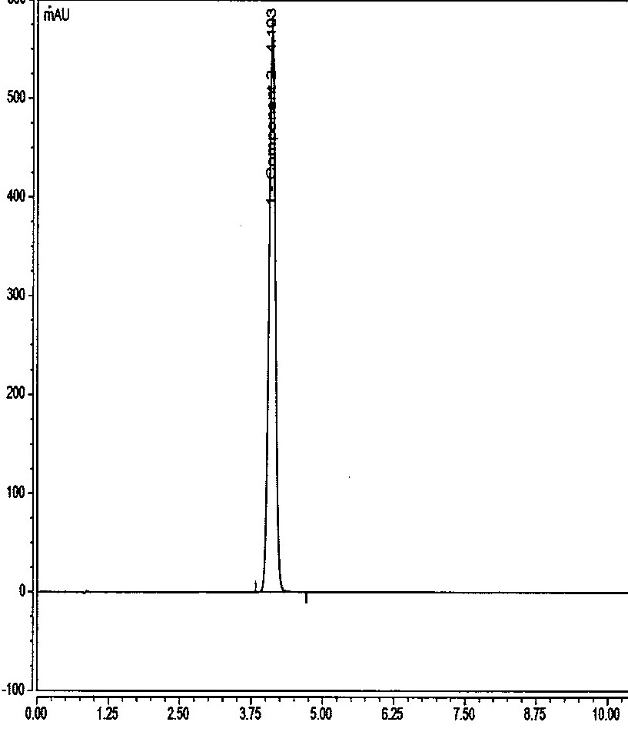

Fig. 3: The sample chromatogram

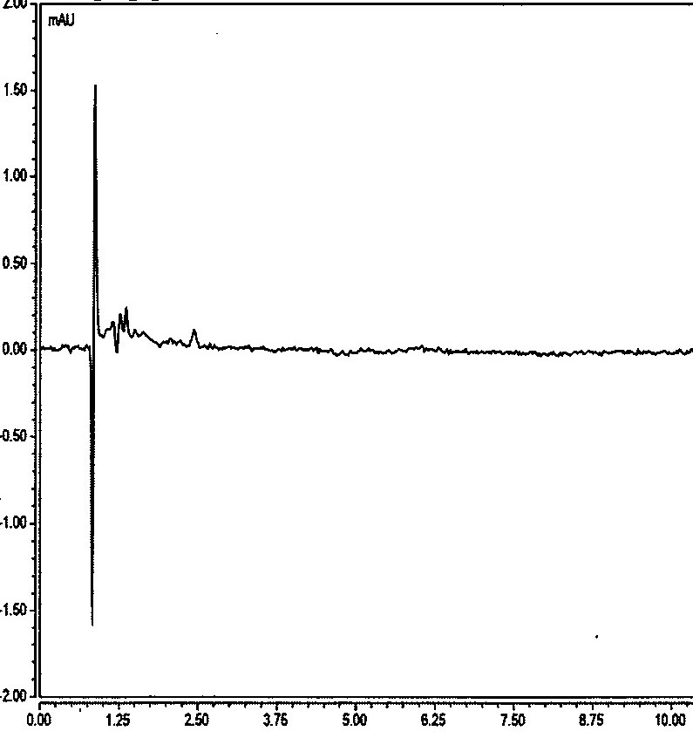.

Fig. 4: The placebo chromatogram

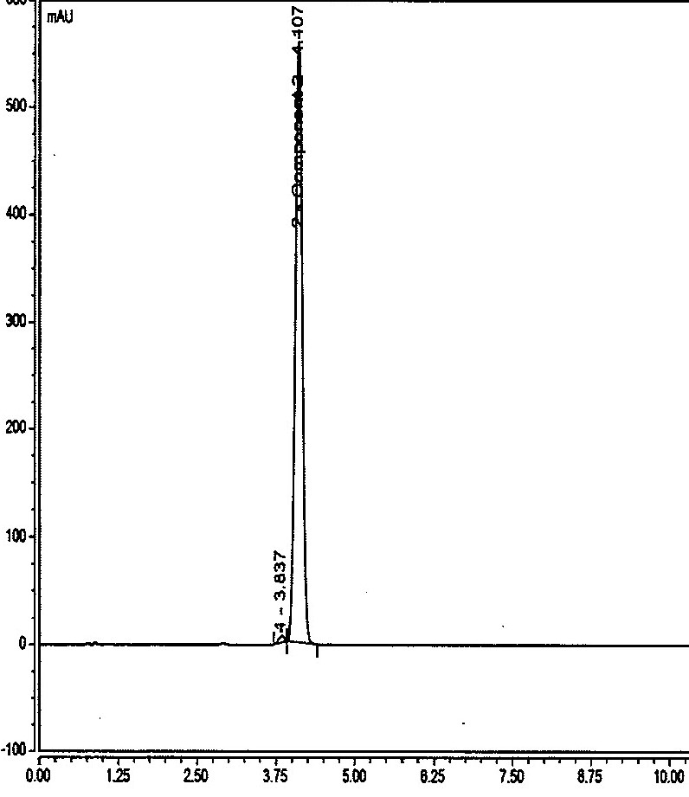

Fig. 5: The Acid hydrolysis degradation chromatogram

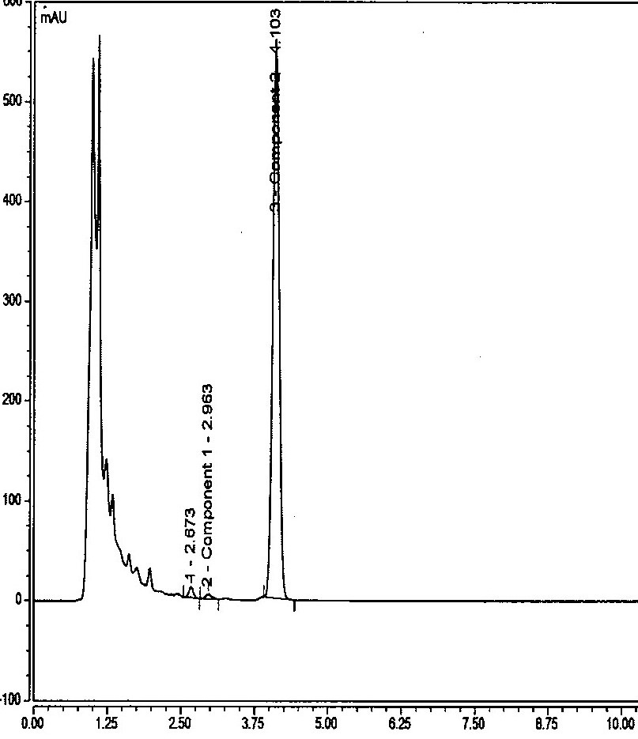

Fig.6: The Base hydrolysis degradation chromatogram

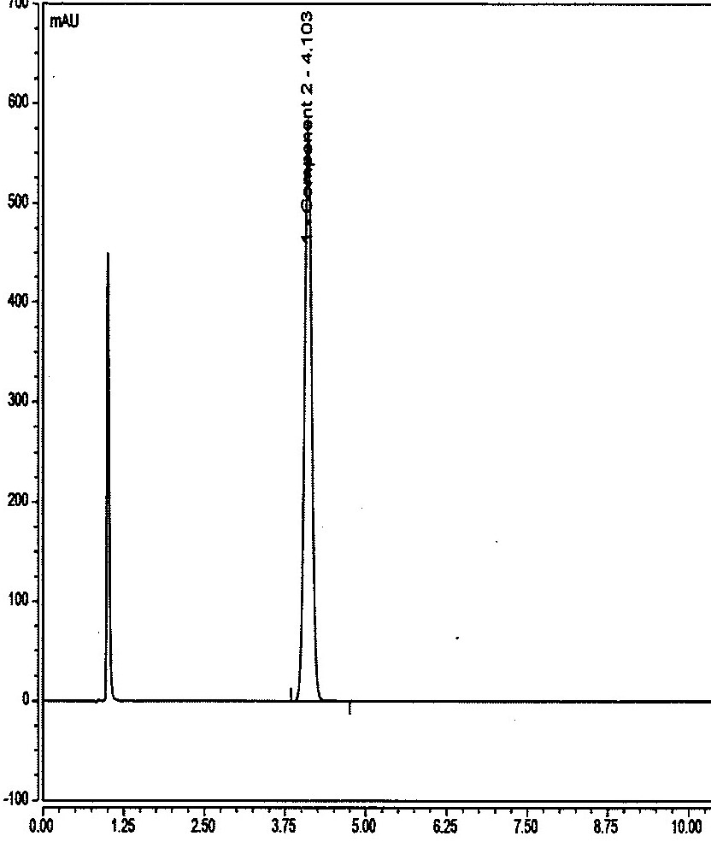

Fig.7: The Oxidation degradaation chromatogram

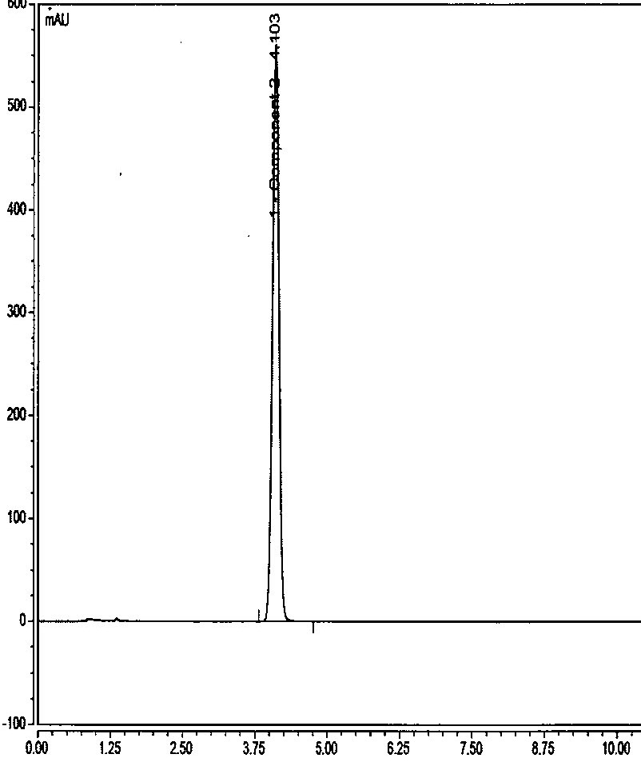

Fig.8: The Thermal degradaation chromatogram

**Results obtained for the selectivity:**

|  |  |
| --- | --- |
| **Selectivity** | **Interference** |
| Blank | No interference observed at the retention time of the Edoxaban peak |
| Placebo | No placebo interference observed for placebo at the retention time of the Edoxaban peak |
| Degradation impurities | No interference observed from the degradation impurities peak at the retention time of the Edoxaban peak |

Table. 2: Selectivity inference

# **Linearity:** The Edoxaban is linear over the range from 14.910 µg/ml to 89.460 µg/ml Correlation coefficient found for Edoxaban is 1.0000.

.

|  |  |
| --- | --- |
| **Linearity Level** | **Concentrations(µg/mL)** |
| 1 | 14.91 |
| 2 | 29.82 |
| 3 | 59.64 |
| 4 | 71.57 |
| 5 | 89.46 |
| Correlation Coefficient | 1.0000 |
| Slope | 15573.5760 |
| Intercept | -69.9832 |
| Statistical Y-Intercept | 0.0000 |

Table. 3: Linearity results

**Acceptance criteria**: Correlation Coefficient should be Not less than 0.999

Fig. 9: The Linearity graph

# **Precision:**

The precision of the method is the degree of agreement between the results. The precision of the method was studied for system precision, method precision, and intermediate precision. A standard solution of Edoxaban was injected six times to determine the system precision of the method, and %RSD was calculated for Edoxaban in table 4. Method precision study shows relative standard deviation of result for Edoxaban are 0.3% and Intermediate precision study shows relative standard deviation of result for Edoxaban are 0.5 % respectively table.

|  |  |  |
| --- | --- | --- |
| **Sl. No.** | **Method precision** | **Intermediate precision** |
|  | **Assay (%)** | |
| 1 | 99.9 | 99.2 |
| 2 | 100.1 | 99.5 |
| 3 | 99.3 | 100.2 |
| 4 | 99.9 | 99.7 |
| 5 | 99.6 | 99.0 |
| 6 | 100.2 | 100.0 |
| **Average** | 99.8 | 99.6 |
| **STD Deviation** | 0.3327 | 0.4604 |
| **% RSD** | 0.3 | 0.5 |

Table. 4: Method Precision and Intermediate Precision results

**Acceptance criteria:** % RSD should not be more than 2.0%

# **Accuracy (Recovery):**

The accuracy of the method for Edoxaban was determined by analyzing Edoxaban sample solutions at three different concentration levels of 50% to 150%. The recovery of all these was found to be in between the predefined acceptance criterion of 95.0% - 105.0%.

|  |  |  |  |  |  |  |
| --- | --- | --- | --- | --- | --- | --- |
| **Accuracy %** | **Qt. Taken (mg)** | **Amount (mg) Spiked** | **Amount (mg)**  **recovered** | **% Recovery** | **Avg % Recovery** | **% RSD** |
| 50 | 59.58 | 59.52 | 59.31 | 99.7 | 99.3 | 0.3 |
| 50 | 60.55 | 60.49 | 60.02 | 99.2 |
| 50 | 59.89 | 59.83 | 59.32 | 99.1 |
| 100 | 119.92 | 119.80 | 119.88 | 100.1 | 100.0 | 0.5 |
| 100 | 121.24 | 121.12 | 120.51 | 99.5 |
| 100 | 119.76 | 119.64 | 120.11 | 100.4 |
| 100 | 119.48 | 119.36 | 118.59 | 99.4 | 99.6 | 0.6 |
| 100 | 121.33 | 121.21 | 120.14 | 99.1 |
| 100 | 119.98 | 119.86 | 120.14 | 100.2 |
| 150 | 181.21 | 181.03 | 180.21 | 99.5 | 99.7 | 0.4 |
| 150 | 180.22 | 180.04 | 178.92 | 99.4 |
| 150 | 180.33 | 180.15 | 180.34 | 100.1 |
|  |  |  | **Overall** | | **99.6** | **0.5** |

Table. 5: Recovery results

**Acceptance criteria:**

1. Recovery at each, mean recovery and overall recovery should be in range odf 95.0% - 105.0%.
2. % RSD for the accuracy of the all levels should not be more than 2.0%

# **Stability of Analytical Solution:**

The solution stability study of Edoxaban, after 48 h at 25 °C and 2-8 °C temperature and no continuous increasing or decreasing trend was observed in the % content of Edoxaban.

The study was performed on the both standard and test solution at specific interval of time and observation are tabulated below.

|  |  |  |  |  |  |
| --- | --- | --- | --- | --- | --- |
| **Ambient Temperature (25 °C)** | | | **Refrigerated condition (2-8 °C)** | | |
| **Interval** | Similarity factor | Solution stability | **Interval** | Similarity factor | Solution stability |
| **Initial** | NA | NA | **Initial** | NA | NA |
| **48 hrs** | 0.98 | Stable | **48 hrs** | 0.98 | Stable |

Table. 6: Solution stability results of standard

|  |  |  |  |  |  |
| --- | --- | --- | --- | --- | --- |
| **Ambient Temperature (25 °C)** | | | **Refrigerated condition (2-8 °C)** | | |
| **Interval** | Similarity factor | Solution stability | **Interval** | Similarity factor | Solution stability |
| % Assay | % difference | % Assay | % difference |
| **Initial** | 99.6 | NA | **Initial** | 99.6 | NA |
| **48 hrs** | 100.2 | Stable | **48 hrs** | 99.9 | Stable |

Table. 7: Solution stability results of Test solution

**Acceptance criteria:**

1. Similarity factor for the standard and freshly prepared standard should be in range of 0.98 – 1.02.
2. % difference assay of test preparation at given interval time with respect to initial should not be more than 2.0%

# **Robustness:**

Robustness of the method was performed by making deliberate variation in the chromatographic condition. The method was found robust for ± 10% variation in flow rate of mobile phase, ± 0.2 °C variation in pH of the buffer, ± 5 °C variation in column oven temperature, ± 1% absolute organic phase variation in isocratic program variations. The effect of column temperature on the resolution was studied at 30 °C and 40 °C instead of 35 °C. Outome of the variation indicates that method was not significantly impacted by intended variation which is indicating that the robustness of the method.

# **CONCLUSION:**

Analytical method for the quantification of Edoxaban in Edoxaban Immideate Release Tablets was successfully validated as per ICH guidelines. A rapid, suitable, specific, sensitive, Linear, accurate and precise reverse-phase HPLC method for the quantitative determination of Edoxaban, an anticoagulant drug, is intended for the routine use. The developed RP-HPLC method can applied to the analysis of Edoxaban drug substances. A forced degradation study was carried out under acidic, alkaline, peroxide, and thermal conditions to demonstrate the stability-indicating nature of the developed RP HPLC method, where content determination of the dosage was carried out.

**DISCLAIMER (Artificial intelligence):** Author(s) hereby declare that NO generative AI technologies such as Large Language Models (ChatGPT, COPILOT, etc.) and text-to-image generators have been used during the writing or editing of this manuscript.

**COMPETING INTERESTS DISCLAIMER:**

Authors have declared that they have no known competing financial interests OR non-financial interests OR personal relationships that could have appeared to influence the work reported in this paper.

**REFERENCES:**

1. Lesellier E, Tchapla A. A simple subcritical chromatographic test for an extended ODS high performance liquid chromatography column classification. J Chromatogr A. 2005 Dec;1100(1):45–59.

2. Scarvelis D, Wells PS. Diagnosis and treatment of deep-vein thrombosis. Can Med Assoc J. 2006 Oct 24;175(9):1087–92.

3. Lip GYH, Agnelli G. Edoxaban: a focused review of its clinical pharmacology. Eur Heart J. 2014 Jul 2;35(28):1844–55.

4. Kuril, A. K., Elumalai, S. & Subbappa, P. K. (2024). Ion Exchange Chromatography: A Versatile Technique for Comprehensive Characterization of Therapeutic Proteins and Peptides. *Current Analytical Chemistry*, *21*. <https://doi.org/10.2174/0115734110337889240920090945>.

5. Bentounes NK, Melicine S, Martin AC, Smadja DM, Gendron N. Development of new anticoagulant in 2023: Prime time for anti-factor XI and XIa inhibitors. J Med Vasc. 2023 Apr;48(2):69-80. doi: 10.1016/j.jdmv.2023.04.002. Epub 2023 May 5. PMID: 37422330.

6. Kuril, A. K. & Saravanan, K. (2024c). Particle Matter determination in Biosimilar Parenteral Product by the Application of Dynamic Light Scattering (DLS) Followed by Statistical Evaluation. *European Journal of Parenteral and Pharmaceutical Sciences*, *29*(2), 1–13. <https://doi.org/https://doi.org/10.37521/ejpps.29201>.

7. Bentounes NK, Melicine S, Martin AC, Smadja DM, Gendron N. Les nouveaux anticoagulants en 2024 : développement des inhibiteurs du facteur XI et du XIa [New anticoagulants in 2024: Development of factor XI and XIa inhibitors]. Ann Biol Clin (Paris). 2024 Apr 19;82(1):9-23. French. doi: 10.1684/abc.2024.1865. PMID: 38638015

8. Kuril, A. K. (2024b). Exploring the versatility of mass spectrometry: Applications across diverse scientific disciplines. *European Journal of Mass Spectrometry*. <https://doi.org/10.1177/14690667241278110>.

9. Levigne S, Thomas M, Ralet MC, Quemener B, Thibault JF. Determination of the degrees of methylation and acetylation of pectins using a C18 column and internal standards. Food Hydrocoll. 2002 Nov;16(6):547–50.

10. Chaudhary H, Kohli K, Amin S, Arora S, Kumar V, Rathee S, et al. Development and validation of RP-HPLC method for simultaneous estimation of diclofenac diethylamine and curcumin in transdermal gels. J Liq Chromatogr Relat Technol. 2012 Jan 1;35(1):174–87.

11. Genovese S, Epifano F, Carlucci G, Marcotullio MC, Curini M, Locatelli M. Quantification of 4′-geranyloxyferulic acid, a new natural colon cancer chemopreventive agent, by HPLC-DAD in grapefruit skin extract. J Pharm Biomed Anal [Internet]. 2010;53(2):212–4. Available from: <http://dx.doi.org/10.1016/j.jpba.2010.01.041>

12.Yoshimura I, Kinoshita Y, Yamamoto Y, Huneck S, Yamada Y. Analysis of secondary metabolites from Lichen by high performance liquid chromatography with a photodiode array detector. Phytochemical Analysis. 1994 Jul 2;5(4):197–205.

13.Lee SH, Jeon S Il, Kim YS, Lee SK. Changes in the electrical conductivity, infrared absorption, and surface tension of partially-degassed and magnetically-treated water. J Mol Liq. 2013 Nov;187:230–7.

14. Kuril, A. K. & Saravanan, K. (2024). Method Development and Validation for the Determination of Higher Molecular Weight Species of Calcitonin Salmon in Calcitonin Salmon Injection by High-Performance Size Exclusion Chromatography. *International Journal of Pharmaceutical Sciences and Drug Research*, 1–7. <https://doi.org/10.25004/IJPSDR.2024.16021>

15. Hamdy, M. M., Korany, M. A., Ebied, S. A., & Haggag, R. S. (2022). Stability-indicating RP-HPLC assay of three novel oral anticoagulants binary mixtures with rosuvastatin calcium: Application to pharmaceutical preparations and human plasma. Journal of Chromatography B, 1193, 123160.

16. Pandey, Kailash Pati, and K Saravanan. 2025. “Establishing Standardized Procedure for the Administration of Anticoagulant Tablets via Nasogastric Tube: An In Vitro Estimation by RP-HPLC”. Journal of Pharmaceutical Research International 37 (7):121-32. <https://doi.org/10.9734/jpri/2025/v37i77728>.

17. P. Ravi Sankar et al /J. Pharm. Sci. & Res. Vol. 13(5), 2021, 232-237

18. Brückner L, Westendorf JB, Tiebel O, Pietsch J: Development and validation of an analytical method for the determination of direct oral anticoagulants (DOAC) and the direct thrombin‑inhibitor argatroban by HPLC–MS/MS. Journal of Thrombosis and Thrombolysis (2022) November 11; 53:777–787. <https://doi.org/10.1007/s11239-021-02596-z>

Sameh E. Younis, Sara A. El-Nahass, Mohammed A.W. Elkhatib, Sobhi A. Soliman, Rasha M. Youssef,

19. Gradient HPLC-DAD method for quantification of novel oral anticoagulant “Edoxaban” in plasma: Its selective determination in presence of sixteen co-administered drugs,

Journal of Chromatography B,Volume 1160, 2020, 122386, ISSN 1570-0232, <https://doi.org/10.1016/j.jchromb.2020.122386>.

20. Rahi S, Rana A. Role of ICH guidelines in registration of Pharmaceutical Products. Int J Drug Reg Affairs [Internet]. 2019Dec.18 [cited 2025Jul.25];7(4):14-7. Available from: <https://www.ijdra.com/index.php/journal/article/view/365>.

21. Ahirwar, P. ., Khare, B. ., Jain, P. K. ., Jain, A. ., Khan, R. ., & Thakur, B. . (2022). Compressive Review on Role of ICH Guidelines in Registration of Pharmaceutical Products. Asian Journal of Dental and Health Sciences, 2(3), 1–8. https://doi.org/10.22270/ajdhs.v2i3.16