Establishing Standardized Procedure for the Administration of Anticoagulant Tablets via Nasogastric Tube: An in Vitro Estimation by RP-HPLC

**ABSTRACT**

Anticoagulant therapy required administration of the oral medications via an enteral feeding tube for the patient who is unable to consume orally. Anticoagulants are class of dosage form used in [treatment](https://en.wikipedia.org/wiki/Therapy) of [thrombotic disorders](https://en.wikipedia.org/wiki/Thrombosis) and to prolong the [clotting time](https://en.wikipedia.org/wiki/Clotting_time). In the proposed study, Edoxaban Tablets was crushed uniformaly to fine powder and suspended in desired vehicle to administer to the unconscious patient or who unable to swallow. Suspension was quantified for its recovery from the enternal feeding tube. Collected suspension from the enternal feeding tube was tested by the accurate RP-HPLC method for its Edoxaban content with recovery. Edoxaban is well resolve with C18 column using isocratic elution with acetonitrile and Triethylamine buffer (pH 5.5) with a flow rate of 1 mL/min appeared at retention time about 4 min and was quantified at its λmax (290 nm). It exhibited a accuracy and linearity over the concentration range of 14.910 µg/ml to 89.460 µg/ml of the test concentration. The procedure was developed and optimized for the paasing of suspension from the feeding tube to get recovery. The current work demonstrate the suspended form of drug with suitable vehicle can be administered to the unconscious patient and suitability of the procedure can be estimated by the validated method.

**Keywords:** Anticoagulant, RP-HPLC, Method development, Enternal feeding tube.

# **INTRODUCTION**

Edoxaban: (class: Novel Oral Anti-Coagulants (NOACs) (1); IUPAC name: N- (5-Chloropyridin-2-yl)-N′-[(1S,2R,4S)-4-(N,N-dimethylcarbamoyl)-2-(5-methyl-4,5,6,7 tetrahydro[1,3]thiazolo[5,4-c]pyridine-2-carboxamido)cyclohexyl] oxamide; used to treat the people with atrial fibrillation (a heart rhythm disorder) (1) to lower the risk of stroke caused by a blood clot.) In addition, edoxaban is indicated following hip or knee replacement surgery to prevent deep vein thrombosis (DVT) (2), a specific type of blood clot, which can result in blood clots in The lungs (pulmonary embolism) During the process of development of the drug product in generic pharmaceutical industries, development of an accurate and efficient analytical method for determining the quality of the product is a key activity (3,4).

Edoxaban is immediate release tablets dosage form with half life of 10-14 hrs and it reaches to its peak plasma concentration within 1-2 hrs.

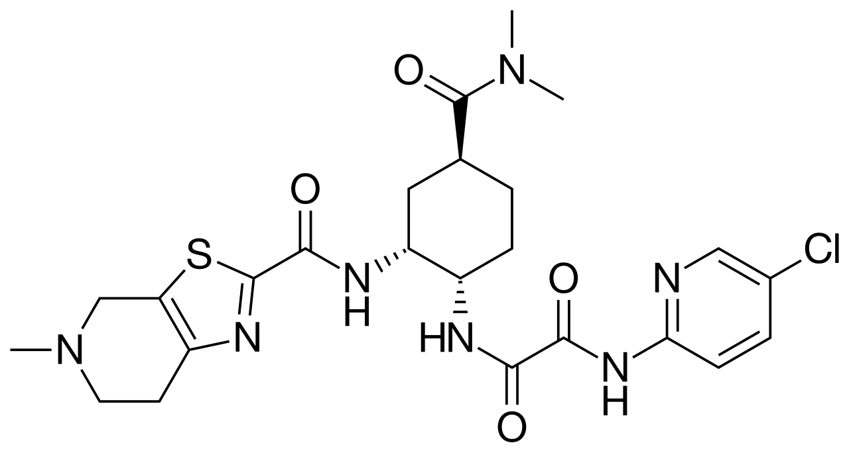

Fig. 1: The structure of Edoxaban.

In-Vitro NG Tube study involves administration of dosage form through nasal tube which is made-up of different material which involves interaction of different excipient of dosage form.

Oral anticoagulants (OACs) are consumed by numerous individuals in the form of pills or tablets, while different intravenous anticoagulant formulations are utilized in medical facilities. Certain anticoagulants are employed in medical apparatus, including sample tubes, blood transfusion bags, heart-lung machines, and dialysis devices.

Anticoagulants are intricately linked to antiplatelet and thrombolytic medications through their influence on the different pathways involved in blood coagulation. In particular, antiplatelet medications work by preventing the aggregation of platelets (their clumping together), while anticoagulants target specific pathways within the coagulation cascade, which occurs subsequent to the initial platelet aggregation but prior to the creation of fibrin and stable aggregated platelet products(5,6).

The decision to use anticoagulants is based on an assessment of the associated risks and benefits of anticoagulation. The primary risk linked to anticoagulation therapy is the heightened likelihood of bleeding. In individuals who are otherwise healthy, this increased risk of bleeding is relatively low; however, those who have undergone recent surgical procedures, have cerebral aneurysms, or suffer from other medical conditions may face an excessively high risk of bleeding. Typically, the advantage of anticoagulation lies in its ability to prevent or slow the progression of thromboembolic diseases.

A nasogastric tube (NG tube) is a slender, flexible plastic tube utilized for temporary medical applications. The term "nasogastric" refers to the pathway from the nose to the stomach. This tube is engineered to traverse your nasal cavity, extend into your throat, and proceed down your esophagus into your stomach. Various types of nasogastric tubes are employed by healthcare professionals to either administer substances to your stomach or extract substances from it(7,8).

Nasogastric tubes serve dual functions: they can both supply substances to the stomach and extract them. These tubes are frequently utilized for short-term feeding and for administering oral medications to patients in hospitals. Additionally, they can be employed to suction stomach contents, thereby alleviating pressure or eliminating toxins.

The two main functions of the nasogastric tube include short-term tube feeding (along with medication delivery) and gastric suctioning (Stomach pumping).

The NG tube is capable of providing specialized nutrition and medication directly to the stomach. Tube feeding, also known as enteral nutrition, may be necessary if you are not receiving sufficient nutrition through oral intake. This situation can arise if you have a medical condition that impacts your appetite or complicates the processes of chewing or swallowing. Additionally, certain hospital patients may require extra nutrition to aid in their recovery(9).

Conditions that might necessitate temporary tube feeding via a nasogastric tube include:

* Challenges in swallowing (dysphagia)
* Cancers of the head and neck.
* Changes in mental status/unresponsiveness.
* Nutritional deficiency.
* Inflammatory bowel disorder (IBD).
* Endotracheal tube insertion.

## Selection of NG tube:

The initial phase in choosing an NGT involves identifying its main function: enteral feeding, gastric drainage, or a combination of the two. Comprehending the intended application is essential as it significantly influences the type of tube, its lumen design, and the necessary connectors(10)**.**

## Selection of Right Tube Material:

The composition of the NGT is crucial for ensuring patient comfort and the length of time it can be utilized. The three predominant materials used are PVC, silicone, and polyurethane, each presenting unique advantages and constraints.

Polyurethane: Providing a harmonious blend of rigidity and comfort, polyurethane tubes are frequently utilized for extended feeding durations (up to 6 weeks). These tubes become more pliable when exposed to body temperature, ensuring patient comfort while preserving their durability. Additionally, they feature thinner walls, which facilitate a larger lumen without enlarging the external diameter(11,12).

## Selection of oppropriate diameter and length:

The diameter of the nasogastric tube, measured in French gauge (Fr), influences both patient comfort and clinical efficacy. Choosing the appropriate size is essential:

Smaller Bore Tubes (<12 Fr): Generally utilized for feeding, these tubes enhance patient comfort and minimize complications such as nasal irritation, esophageal reflux, and tube obstruction.

Larger Bore Tubes (>12 Fr): Primarily employed for drainage, larger bore tubes are better suited for evacuating gastric contents, as their wider diameter decreases the likelihood of clogging.

NGTs are available in various lengths, typically ranging from 90 to 165 cm for adults. The appropriate length is determined by the placement site, whether intended for gastric or jejunal feeding:

Gastric Tubes: Usually, between 90 and 120 cm, these tubes are inserted directly into the stomach. Gastric feeding is the most prevalent option for patients capable of digesting food normally.

Jejunal Tubes: Longer tubes, typically measuring 120 to 165 cm, are utilized for patients needing feeding directly into the small intestine. This is often necessary for patients with specific medical conditions such as gastric outlet obstruction or gastroparesis(13,14).

The primary aim of this study is to establish the inaugural HPLC method for the simultaneous quantification of the NOACs in pharmaceutical formulations and human plasma(15). The assay has been validated according to the standards of the International Council of Harmonization (ICH) In the future, the evaluation of NGT positioning through artificial intelligence (AI) may become more precise and prevalent; however, it is not anticipated to supplant the function of the trained observer in the near future(16).

# **Methodology:**

Development of procedure for the recovery studies of Edoxaban Tablets 60 mg after passing through the NG tube and optimisation of the procedure to perform the recovery study.

Edoxaban Tablets recovery can be successfully determined using RP-HPLC which is found to be the most sensitive and repeatable method available. Various columns from different makes were tried, but the Inertsil ODS column was found to be the most suitable in terms of a peak shape, resolution, and reproducibility. Chromatographic method was developed by considering the lower run time to make it more cost effective and Edoxaban peak observed at retention time of about 4 min.The Triethylamine used as buffer in water. The Triethylamine percentage was optimized at 0.05 %.

## **MATERIALS AND METHODS**

Acetonitrile, Trimethylamine, Orthophosphoric acid(All AR grade) pH meter, sonicator, memebrane filter. hydrochloric acid, sodium hydroxide, and hydrogen peroxide (all of AR grade). Analyses were performed using HPLC grade water (Millipore Inc., USA), 50-mL PVC oral enteral syringe, Nasogastric Polyurethane Feeding Tube, 8 French, 42 Inch Length of Tubing.

### Instrumentation and Analytical Condition

# The chromatographic separation was performed using Waters HPLC 2695 Alliance System, photodiode array detector, Chromeleon-software was used as CDS, Inertsil ODS C18 -100 Å (100 × 4.6 mm), 3 5µm, column oven temperature 35°C, ambient sample tray temperature, flow rate 1mL/min. detection wavelength 290 nm.

Buffer preparation: Added 1 mL of triethylamine in 2000 mL of millli Q water and mixed well. pH of the buffer was adjusted to 5.50 .

Mobile Phase Prepartion: Mixed well buffer and acetonitrile in the ratio of 65:35 v/v and degassed by sonication.

### Preparation of Analytical Solutions

The diluent for the preparation of the analytical solution was designed as mixture of water and 5 % dextrose and acetonitrile in the ratio of 50:10:40 (% v/v/v) as diluent-1 and water and acetonitrile in the ratio of 50:50 (% v/v) as a diluent-2. Diluent-2 as blank, and six replicates of standard and single test solutions (60µg/mL) was done separately under the optimized chromatographic conditions, linearity solution from LQC to HQC of Eoxaban and test solutions (120µg/mL) was prepared by passing through the 8 french polyurethane NG tube and analysed by the optimized chromatographic conditions.

# **RESULT AND DISCUSSION**

## Method Validation:

### Specificity:

Specificity is the method ability to quantitate the analyte response in the presence of their degradation impurities and the matrix. Stress testing of drug product can aid in identifying degradation products that form during stability studies, which can be used to establish degradation pathway and inherent stability of the molecule and validate stability-indicating capability of the analytical method used.

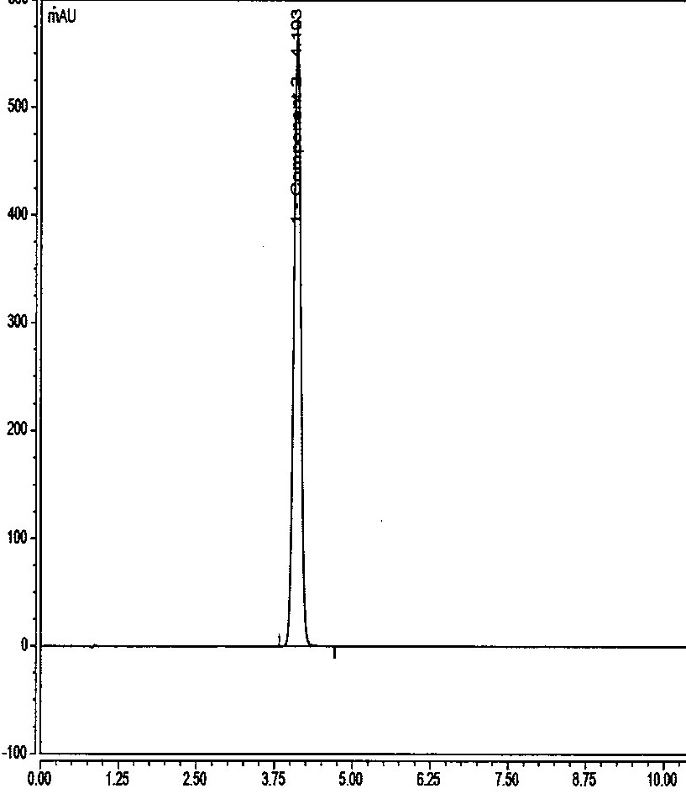

Fig. 2: The sample chromatogram

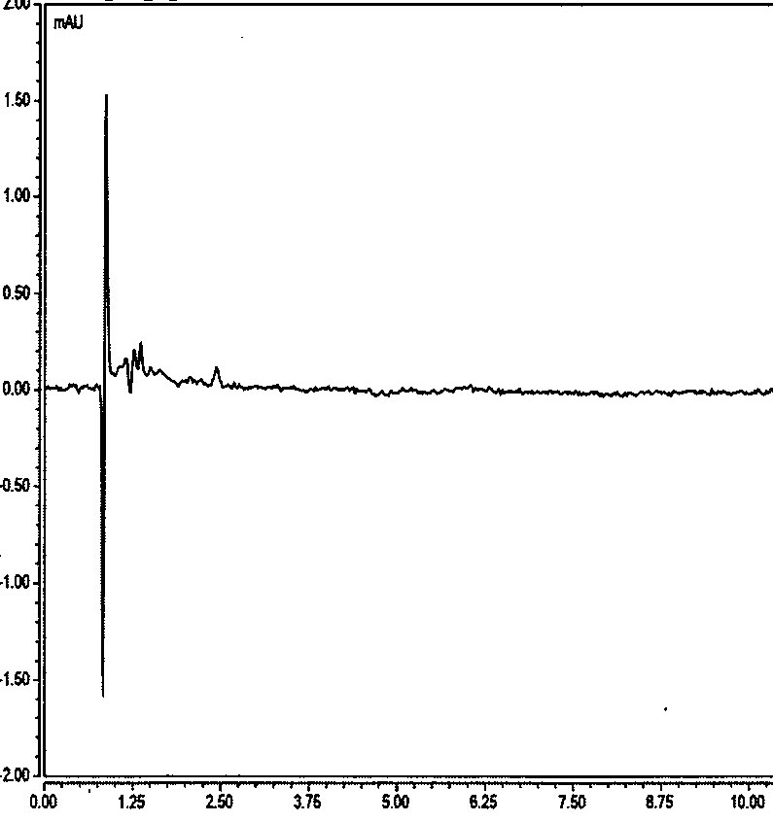

Fig. 3: The placebo chromatogram

### **LINEARITY**

The Edoxaban is linear over the range from 14.910 µg/ml to 89.460 µg/ml Correlation coefficient found for Edoxaban is 1.0000. The predefined acceptance criterion for correlation Coefficient: Not less than 0.999

|  |  |
| --- | --- |
| **Linearity Level** | **Concentrations(µg/mL)** |
| 1 | 14.91 |
| 2 | 29.82 |
| 3 | 59.64 |
| 4 | 71.57 |
| 5 | 89.46 |
| Correlation Coefficient | 1.0000 |
| Slope | 15573.5760 |
| Intercept | -69.9832 |
| Statistical Y-Intercept | 0.0000 |

Table. 1: Linearity results

Fig. 4: The Linearity graph

### **PRECISION**

The precision of the method is the degree of agreement between the results. The precision of the method was studied for system precision, method precision, and intermediate precision. The predefined acceptance criterion:% RSD Not more than 2.0%.

System precision was performed and found suitable with a precise value of 0.2 %

Method precision and intermediate precision results wrere tabulated below:

|  |  |  |
| --- | --- | --- |
| **Sl. No.** | **Method precision** | **Intermediate precision** |
|  | **Assay (%)** | |
| 1 | 99.9 | 99.2 |
| 2 | 100.1 | 99.5 |
| 3 | 99.3 | 100.2 |
| 4 | 99.9 | 99.7 |
| 5 | 99.6 | 99.0 |
| 6 | 100.2 | 100.0 |
| **Average** | 99.8 | 99.6 |
| **STD Deviation** | 0.3327 | 0.4604 |
| **% RSD** | 0.3 | 0.5 |
| **Overall %RSD** | 0.4 | |

Table. 3: Method Precision and Intermediate Precision results

### **ACCURACY (RECOVERY)**

The accuracy of the method for Edoxaban was determined by analyzing Edoxaban sample solutions at three different concentration levels of 50% to 150%. The recovery of all these was found to be in between the predefined acceptance criterion of 95.0% - 105.0%.

|  |  |  |  |  |  |  |
| --- | --- | --- | --- | --- | --- | --- |
| **Accuracy Level** | **Wt. Taken (mg)** | **mg Spiked** | **mg recovery** | **% Recovery** | **Avg % Recovery** | **% RSD** |
| 50 | 59.58 | 59.52 | 59.31 | 99.7 | 99.3 | 0.3 |
| 50 | 60.55 | 60.49 | 60.02 | 99.2 |
| 50 | 59.89 | 59.83 | 59.32 | 99.1 |
| 100 | 119.92 | 119.80 | 119.88 | 100.1 | 100.0 | 0.5 |
| 100 | 121.24 | 121.12 | 120.51 | 99.5 |
| 100 | 119.76 | 119.64 | 120.11 | 100.4 |
| 100 | 119.48 | 119.36 | 118.59 | 99.4 | 99.6 | 0.6 |
| 100 | 121.33 | 121.21 | 120.14 | 99.1 |
| 100 | 119.98 | 119.86 | 120.14 | 100.2 |
| 150 | 181.21 | 181.03 | 180.21 | 99.5 | 99.7 | 0.4 |
| 150 | 180.22 | 180.04 | 178.92 | 99.4 |
| 150 | 180.33 | 180.15 | 180.34 | 100.1 |
|  |  |  | **Overall** | | **99.6** | **0.5** |

Table. 4: Accuracy results

### **STABILITY OF ANALYTICAL SOLUTION**

The solution stability study of Edoxaban, after 48 h at 25 °C(ambient temperature) and 2-8 °C temperature and no continuous increasing or decreasing trend was observed in the % content of Edoxaban.

### **ROBUSTNESS**

The method was robust for ± 10% variation in flow rate, ± 5 °C variation in column oven temperature, ± 1% absolute organic phase variation in isocratic program variations. The effect of column temperature was studied at 30 °C and 40 °C in comparison to control column oven temperature of 35 °C. Based on the stated outcome method is found to be robust.

# **RECOVERY THROUGH NG TUBE**

The % recovery of the Edoxaban was determined by passing the suspension of Edoxaban Tablets and final solution was analysed by the optimized chromatography which is a validate method for the quantification of the Edoxaban Tablets.

Linearity stock conc: 600 µg/mL.

|  |  |  |
| --- | --- | --- |
| **Linearity stock in (mL)** | **Dilution in mL** | **Concentration in µg/mL** |
| 2.5 | 100 | 15.045 (LQC) |
| 2.5 | 50 | 30.090 |
| 5 | 50 | 60.180 |
| 6 | 50 | 72.216 |
| 7.5 | 50 | 90.270 |
| 5 | 25 | 120.360 (HQC) |

Table. 5: Lineraity solution for NG Tube Recovery

Above linearity solution prepared in diluent-2 and to established the system suitability parameter.

Fig. 5: The Linearity graph for NG Tube Recovery

## **PREPARATION OF TEST SOLUTION (120 µg/mL)**

Administration of vehicle (5% dextrose) through the combination of NG tube (8French) and catheter tip syringe as given below.

* Place single unit of Edoxaban tablet in mortar and crush for 60 seconds by sing pestle.
* Add 50 mL of vehicle in the mortar containing crushed tablet and stir the mixture for 60 sec using pestle.
* Withdraw the entire mixture into catheter tip syringe. (immediately after completion of the stirring).
* Swirl the catheter tip syringe gently to avoid powder from settling and inject the mixture through the NG tube into clean container of 500 mL volumetric flask.
* Refill the catheter tip syring with 15 mL of water two time for the flushing of mortar pestle and then pass through the NG tube sequentially.
* Again refill the catheter tip syringe with 15 mL of water two times and flush the NG tube sequentially.
* Repeat the above step twice for test product.
* Add 230 nmL of diluent -2 and sonicate for the 30 min and make up the volume up to the mark with diluent-2 and mix well. Filter the solution through 0.45µm membrane filter and Control test preparation:60 µg/mL injected into the chromatography for quantification.

Control assay was observed : 99.8 %

* The recovery of all these was found to be in between the predefined acceptance criterion of 95.0% - 105.0%.

Table. 6: Recovery results of NG Tube study

|  |  |  |  |
| --- | --- | --- | --- |
| **No. of Preparation** | **Assay in mg** | **% Assay as per label claim** | **% Recovery** |
| 1 | 59.37 | 99.0 | **99.1** |
| 2 | 58.68 | 97.8 | **98.0** |
| 3 | 59.35 | 98.9 | **99.1** |
| 4 | 58.74 | 97.9 | **98.1** |
| 5 | 60.04 | 100.1 | **100.3** |
| 6 | 58.93 | 98.2 | **98.4** |
|  |  | **Avg** | **98.8** |
|  |  | **% RSD** | **0.9** |

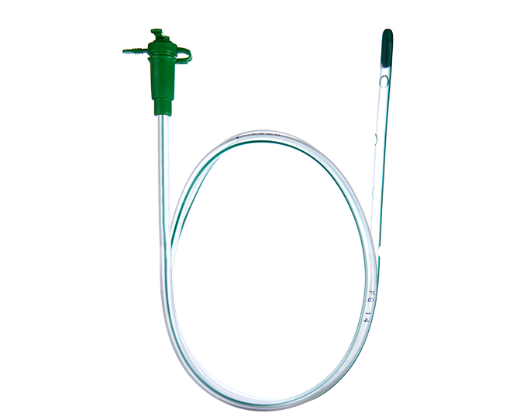

Fig. 6: NG Tube, 42 Inch Tubing lenth, 8 Fr

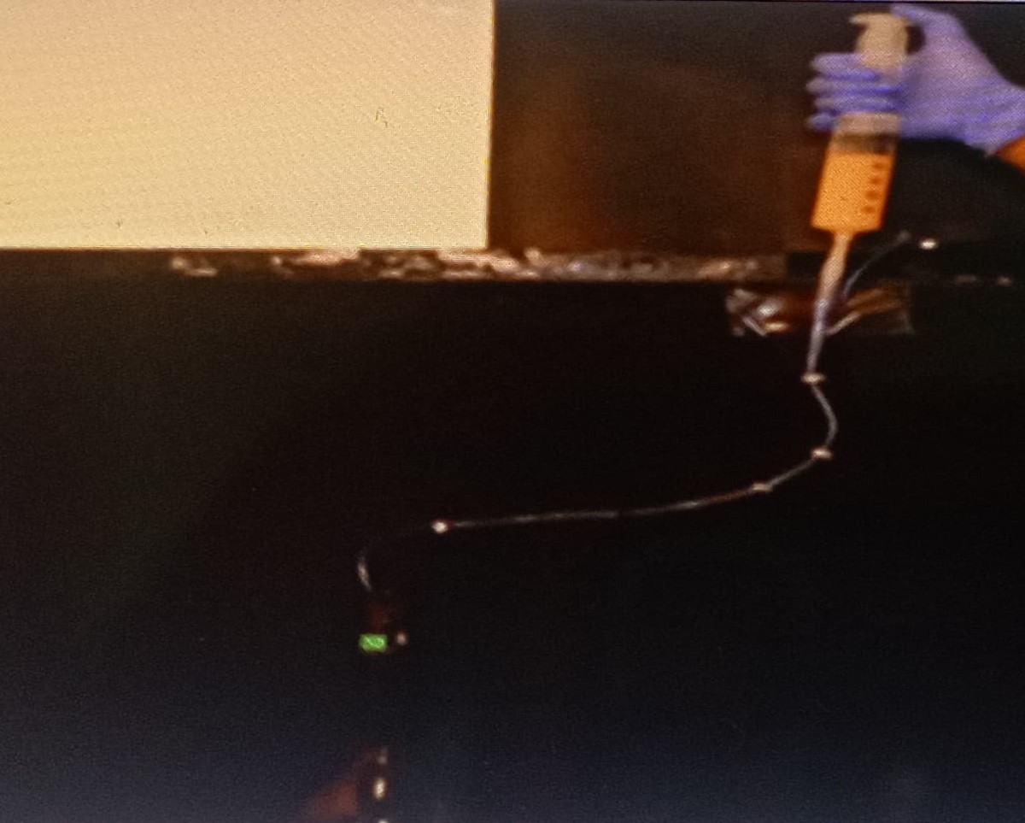

Fig. 7: In-vitro passing of crushed tablet suspension through Nasogastric Feeding Tube.

# **CONCLUSION**

A rapid, specific, sensitive and precise reverse-phase HPLC method for Edoxaban, an anticoagulant drug, is described. The developed RP-HPLC method was successfully applied for the recovery of the of Edoxaban tablets through NG tube delivery system over the range of LQC and HQC and results were precise throughout the specified range which determine its method sensitivity. The developed procedure for the recovery was robust and executed on the validated stability indicating method that can be used to analyze routine and stability samples of Edoxaban Tablets dosage form.

**Disclaimer (Artificial intelligence)**

Author(s) hereby declare that NO generative AI technologies such as Large Language Models (ChatGPT, COPILOT, etc.) and text-to-image generators have been used during the writing or editing of this manuscript.

# **REFERENCES:**

1. Lesellier E, Tchapla A. A simple subcritical chromatographic test for an extended ODS high performance liquid chromatography column classification. J Chromatogr A. 2005 Dec;1100(1):45–59.

2. Scarvelis D, Wells PS. Diagnosis and treatment of deep-vein thrombosis. Can Med Assoc J. 2006 Oct 24;175(9):1087–92.

3. Lip GYH, Agnelli G. Edoxaban: a focused review of its clinical pharmacology. Eur Heart J. 2014 Jul 2;35(28):1844–55.

4. Kuril, A. K., Elumalai, S. & Subbappa, P. K. (2024). Ion Exchange Chromatography: A Versatile Technique for Comprehensive Characterization of Therapeutic Proteins and Peptides. *Current Analytical Chemistry*, *21*. <https://doi.org/10.2174/0115734110337889240920090945>.

5. Levigne S, Thomas M, Ralet MC, Quemener B, Thibault JF. Determination of the degrees of methylation and acetylation of pectins using a C18 column and internal standards. Food Hydrocoll. 2002 Nov;16(6):547–50.

6. Chaudhary H, Kohli K, Amin S, Arora S, Kumar V, Rathee S, et al. Development and validation of RP-HPLC method for simultaneous estimation of diclofenac diethylamine and curcumin in transdermal gels. J Liq Chromatogr Relat Technol. 2012 Jan 1;35(1):174–87.

7. Genovese S, Epifano F, Carlucci G, Marcotullio MC, Curini M, Locatelli M. Quantification of 4′-geranyloxyferulic acid, a new natural colon cancer chemopreventive agent, by HPLC-DAD in grapefruit skin extract. J Pharm Biomed Anal [Internet]. 2010;53(2):212–4. Available from: <http://dx.doi.org/10.1016/j.jpba.2010.01.041>

8. Kuril, A. K. & Saravanan, K. (2024c). Particle Matter determination in Biosimilar Parenteral Product by the Application of Dynamic Light Scattering (DLS) Followed by Statistical Evaluation. *European Journal of Parenteral and Pharmaceutical Sciences*, *29*(2), 1–13. https://doi.org/https://doi.org/10.37521/ejpps.29201.

9. Yoshimura I, Kinoshita Y, Yamamoto Y, Huneck S, Yamada Y. Analysis of secondary metabolites from Lichen by high performance liquid chromatography with a photodiode array detector. Phytochemical Analysis. 1994 Jul 2;5(4):197–205.

10.Lee SH, Jeon S Il, Kim YS, Lee SK. Changes in the electrical conductivity, infrared absorption, and surface tension of partially-degassed and magnetically-treated water. J Mol Liq. 2013 Nov;187:230–7.

11.Chen ZM, Jiang LX, Chen YP, et al. Addition of clopidogrel toaspirin in 45,852 patients with acute myocardial infarction: randomised,

placebo-controlled trial. Lancet. 2005;366:1607–21.

12. Kuril, A. K. (2024b). Exploring the versatility of mass spectrometry: Applications across diverse scientific disciplines. *European Journal of Mass Spectrometry*. <https://doi.org/10.1177/14690667241278110>.

13.Peng L, Gao X, Wang L, Zhu A, Cai X, Li P, et al. Design of experiment techniques for the optimization of chromatographic analysis conditions: A review. Electrophoresis. 2022 Oct 18;43(18–19):1882–98.

14. Kuril, A. K. & Saravanan, K. (2024). Method Development and Validation for the Determination of Higher Molecular Weight Species of Calcitonin Salmon in Calcitonin Salmon Injection by High-Performance Size Exclusion Chromatography. *International Journal of Pharmaceutical Sciences and Drug Research*, 1–7. <https://doi.org/10.25004/IJPSDR.2024.16021>

15. Hamdy, M. M., Korany, M. A., Ebied, S. A., & Haggag, R. S. (2022). Stability-indicating RP-HPLC assay of three novel oral anticoagulants binary mixtures with rosuvastatin calcium: Application to pharmaceutical preparations and human plasma. Journal of Chromatography B, 1193, 123160.

16.Thieme A, Rajamohan A, Cooper B, Groombridge H, Simister R, Wong B, et al.Challenges for responsible AI design and workflow integration in healthcare: a case study of automatic feeding tube qualification in Radiology. arXiv preprint 2024. arXiv:2405.05299.