**A Case Report on Clobetasol-Induced Purpura and Cellulitis**

**ABSTRACT**

Topical corticosteroids remain a cornerstone in the management of a wide array of dermatological conditions due to their anti-inflammatory, antiproliferative, and immunosuppressive properties. This article aims to present a clinically relevant case of clobetasol-induced purpura complicated by cellulitis, highlighting the need for judicious use of high-potency topical corticosteroids and reinforcing the importance of patient education regarding duration, dosage, and application sites. Clobetasol propionate, a super-potent topical corticosteroid, is commonly prescribed for chronic inflammatory dermatoses. However, prolonged use, especially without medical supervision, may result in severe adverse cutaneous effects such as purpura and secondary infections like cellulitis. We present the case of a 75-year-old female with a history of hypertension, who developed bilateral lower limb oedema and cellulitis over the right shoulder due to chronic unsupervised clobetasol application. Dermatology evaluation confirmed clobetasol-induced purpura and cellulitis. Prompt withdrawal of the corticosteroid and appropriate medical management led to full recovery. This case underscores the need for careful monitoring of potent topical corticosteroids and patient education. Also, this case underlines the importance of rational prescribing, short-term use, and adequate patient counselling regarding application, duration, and risks of potent corticosteroids.

**KEY WORDS:** Clobetasol, Purpura, Cellulitis, Topical corticosteroids, Adverse drug reaction

**INTRODUCTION**

Topical corticosteroids are indispensable in managing a spectrum of inflammatory skin disorders, including, but not limited to, psoriasis and atopic dermatitis. They suppress inflammation primarily by inhibiting the production and release of inflammatory cytokines and dampening the activity of various cells and molecules involved in the inflammatory response. Additionally, they constrict peripheral blood vessels leading to capillaries by suppressing the secretion of vasodilating substances, thereby reducing vascular permeability and limiting the migration of blood and cells to inflamed areas (Kim et al., 2024). It remain a cornerstone in the management of a wide array of dermatological conditions due to their anti-inflammatory, antiproliferative, and immunosuppressive properties. Clobetasol propionate, classified as a class I super-potent corticosteroid, is commonly prescribed for short-term use in chronic inflammatory dermatoses such as psoriasis, lichen planus, and severe eczema. However, long-term or inappropriate use, especially without medical supervision, is associated with a spectrum of local and systemic adverse effects.[1] Among these, cutaneous side effects such as dermal atrophy, telangiectasia, striae, and purpura are frequently reported. Purpura arises due to corticosteroid-induced thinning of the dermis and increased fragility of dermal blood vessels, leading to spontaneous or trauma-induced bleeding into the skin[2].

Furthermore, the compromised integrity of the skin resulting from prolonged corticosteroid application increases susceptibility to secondary infections, particularly cellulitis. Cellulitis is an acute bacterial infection of the dermis and subcutaneous tissue, most commonly caused by Streptococcus spp. or Staphylococcus aureus. It is an infection involving the deep dermis and subcutaneous tissue, is the most common reason for skin-related hospitalisation and is seen by clinicians across various disciplines in the inpatient, outpatient, and emergency room settings, but it can present as a diagnostic and therapeutic challenge. Cellulitis is a clinical diagnosis based on the history of present illness and physical examination and lacks a gold standard for diagnosis. Clinical presentation with acute onset of redness, warmth, swelling, tenderness and pain is typical (Boettler et al., 2022). In steroid-compromised skin, even minor trauma or micro-abrasions can serve as portals of entry for pathogens, leading to rapidly spreading infections. Elderly patients and those with predisposing conditions such as diabetes or chronic venous insufficiency are at greater risk of developing these complications.[3]

Corticosteroid injections can be associated with a range of potential side effects, which may be classified as local or systemic and further stratified as immediate or delayed in onset (Kamel et al., 2024). Despite awareness of corticosteroid side effects, the progression from clobetasol-induced purpura to cellulitis remains an underreported clinical phenomenon. Early recognition and prompt management are essential to prevent systemic spread and complications. This article aims to present a clinically relevant case of clobetasol-induced purpura complicated by cellulitis, highlighting the need for judicious use of high-potency topical corticosteroids and reinforcing the importance of patient education regarding duration, dosage, and application sites. Through this case, we emphasise the importance of vigilance in monitoring adverse effects associated with potent topical therapies.[4]

**CASE PRESENTATION**

A 75-years-old female patient was admitted to the General Surgery Department with complaints of pain, oedema in both lower limbs, and redness over the skin at the right shoulder. The patient had a past medical history of Hypertension for 2+ years, and managed with T. AMLO (AMLODIPINE) 2.5mg P/O 1-0-0. 1 year ago, she had an itching all over the body; since then, she has been applying CLOBETASOL cream locally.

The patient was conscious, oriented, heart sounds were heard, chest was clear, was able to move all limbs, and GI was non-tender. During admission, she had a Pulse Rate of 94 beats/min, a Respiratory Rate of 24 breaths/min, Blood Pressure of 140/90mmHg. Her laboratory investigation showed an elevation in CRP (15.8mg/L) and a decline in Sodium (129mmol/L). Venous Doppler study showed reactive linguinal lymphadenitis, mild diffuse subcutaneous oedema in the lower leg and foot. (Image 1)

Initially Dermatology consultation was done and withheld the CLOBETASOL cream, validated the intervention and diagnosed as CLOBETASOL-induced Purpura, Cellulitis(Image 2) and advised with TAB. DAZACT (DESLORATIDINE) 5mg P/O 0-0-1, FUCIBET CREAM (FUSIDIC ACID + BETAMETHASONE) L/A BD, VENUSIA CREAM L/A BD, MUPIROCIN CREAM L/A BD. Other supportive measures were INJ. CEFTRIAXONE 1g IV BD for treating infection condition, INJ. PANTOPRAZOLE 40mg IV 1-0-0 for prevention of gastric irritation, TAB. AMLO (AMLODIPINE) 2.5mg P/O 1-0-0 for Hypertension, SODIUM CHLORIDE 3% INFUSION for first 3 days and then TAB. NATREMIA (TOLVAPTAN) 15mg P/O 1-0-0 for sodium correction. After 7 days of admission patient got symptomatically better and was discharged with TAB. DAZACT (DESLORATIDINE) 5mg P/O 0-0-1, FUCIBET CREAM (FUSIDIC ACID + BETAMETHASONE) L/A BD, VENUSIA CREAM L/A BD, MUPIROCIN CREAM L/A BD, TAB. AMLO (AMLODIPINE0 2.5mg P/O 1-0-0, TAB. CHYMORAL FORTE P/O 1-0-1 for 5 days.

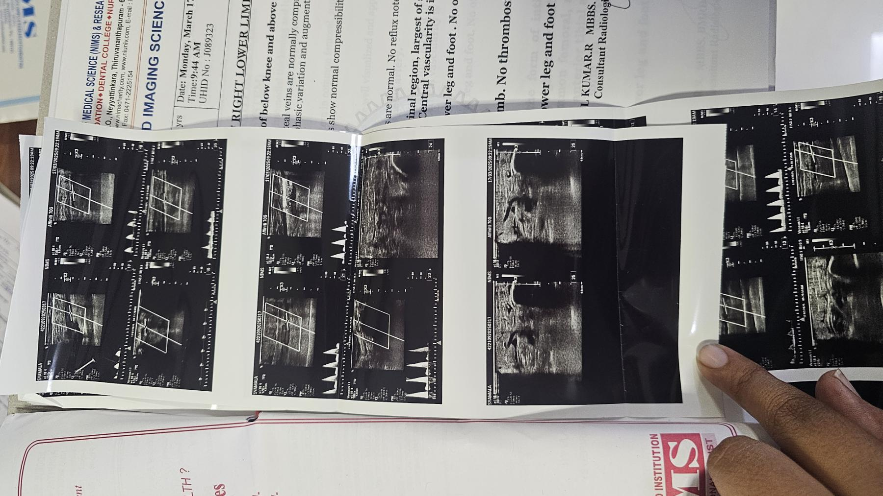

**Image 1: Doppler study**

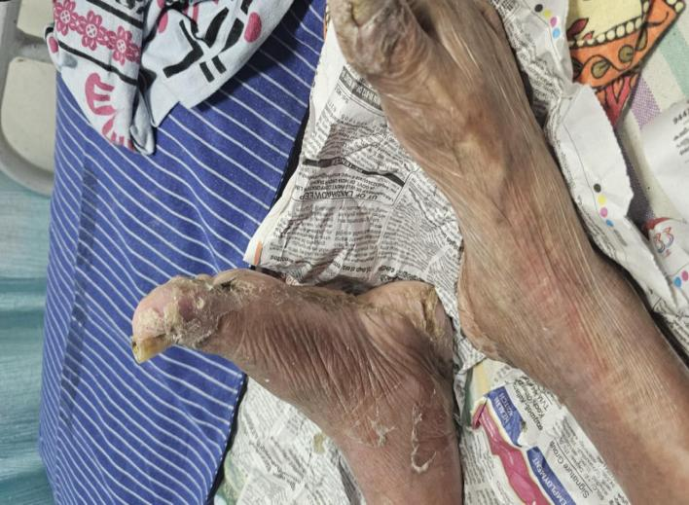 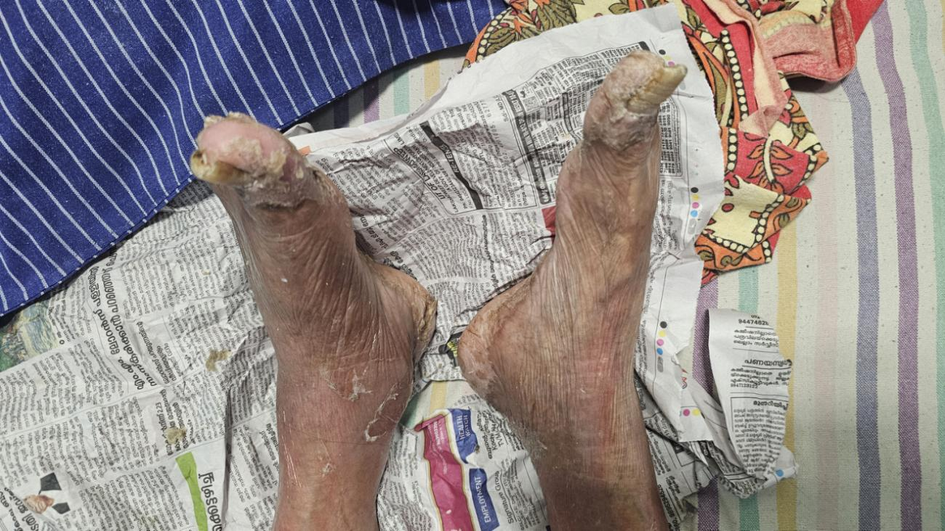

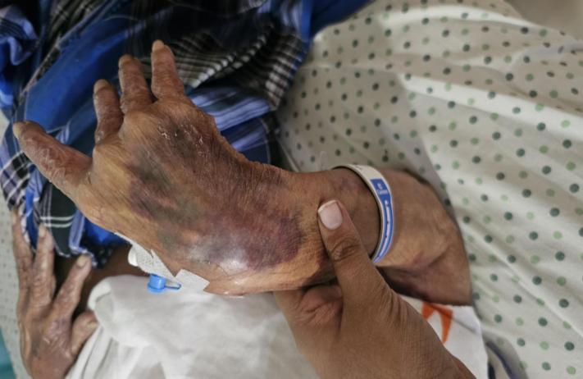 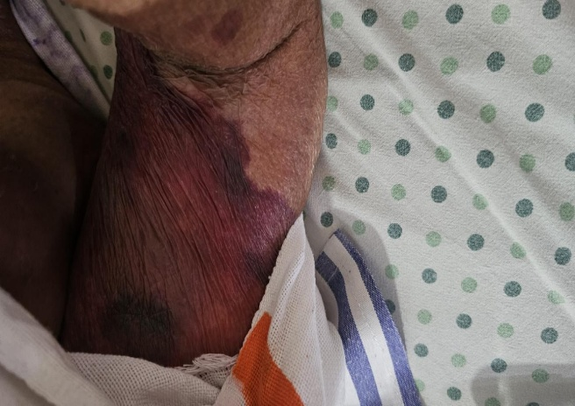

**Image 2: Image of Purpura and cellulitis in limbs**

**DISCUSSION**

The widespread use of topical corticosteroids like clobetasol propionate has significantly improved outcomes in inflammatory dermatoses. However, their misuse or unsupervised prolonged application can result in considerable local adverse effects, including purpura, skin atrophy, and secondary infections like cellulitis. In elderly patients, the skin is inherently more fragile, further increasing the risk.[5,6]

In this case, chronic clobetasol application led to corticosteroid-induced purpura and cellulitis, consistent with findings reported by Tanei and Saeki in the Journal of Dermatology, where the authors observed purpuric eruptions and skin fragility in elderly patients using long-term topical corticosteroids [7]. Likewise, Coondoo et al., in a clinical study published in the Indian Journal of Dermatology, emphasised that irrational use of potent topical steroids, including clobetasol, was associated with adverse cutaneous effects such as purpura, striae, and secondary infections [8].

The compromised skin barrier due to chronic steroid use creates a portal of entry for pathogens, commonly leading to cellulitis caused by Staphylococcus aureus or Streptococcus pyogenes. Patel and Nadkarni, in the Journal of the American Academy of Dermatology, documented cellulitis cases following inappropriate corticosteroid use, linking immunosuppression and dermal thinning to increased infection risk [9].

In this case, the adverse reaction was evaluated using the Naranjo Adverse Drug Reaction Probability Scale, which yielded a score of 7, indicating a “Probable” adverse drug reaction. This score suggests a strong temporal and clinical relationship between the drug and the reaction, especially given the absence of alternative causes and improvement upon withdrawal of the drug.[10]

**CONCLUSION**

This case highlights a significant but often under-recognised adverse effect of prolonged unsupervised use of high-potency topical corticosteroids like clobetasol. Clobetasol-induced purpura followed by secondary bacterial cellulitis in an elderly patient necessitated medical intervention and cessation of the drug. The application of the Naranjo Scale confirmed a probable ADR. This case underlines the importance of rational prescribing, short-term use, and adequate patient counselling regarding application, duration, and risks of potent corticosteroids.

**Consent**

As per international standards or university standards, patient(s) written consent has been collected and preserved by the author(s).

**Disclaimer (Artificial intelligence)**

Option 1:

Author(s) hereby declare that NO generative AI technologies such as Large Language Models (ChatGPT, COPILOT, etc.) and text-to-image generators have been used during the writing or editing of this manuscript.

Option 2:

Author(s) hereby declare that generative AI technologies such as Large Language Models, etc. have been used during the writing or editing of manuscripts. This explanation will include the name, version, model, and source of the generative AI technology and as well as all input prompts provided to the generative AI technology

Details of the AI usage are given below:

1.

2.

3.

**REFERNCE**

1. Hengge UR, Ruzicka T, Schwartz RA, Cork MJ. Adverse effects of topical glucocorticosteroids. American Journal of Clinical Dermatology. 2006;7(6):367–381.
2. Eichenfield LF, Tom WL, Chamlin SL, Feldman SR, Hanifin JM, Simpson EL, et al. Guidelines of care for the management of atopic dermatitis. Journal of the American Academy of Dermatology. 2014;71(1):116–132.
3. Carbone, M., Goss, E., Carrozzo, M., Castellano, S., Conrotto, D., Broccoletti, R., & Gandolfo, S. (2003). Systemic and topical corticosteroid treatment of oral lichen planus: a comparative study with long‐term follow‐up. Journal of oral pathology & medicine, 32(6), 323-329.
4. Harvey, J., Lax, S. J., Lowe, A., Santer, M., Lawton, S., Langan, S. M., ... & Thomas, K. S. (2023). The long-term safety of topical corticosteroids in atopic dermatitis: a systematic review. Skin Health and Disease, 3(5), ski2-268.
5. Egeberg, A., & Thyssen, J. P. (2024). Topical corticosteroids in the era of new topical therapies: Balancing efficacy and safety for long‐term use. Journal of the European Academy of Dermatology and Venereology, 38(7), 1236-1237.
6. Ratib, S., Burden-Teh, E., Leonardi-Bee, J., Harwood, C., & Bath-Hextall, F. (2018). Long-term topical corticosteroid use and risk of skin cancer: a systematic review. JBI Evidence Synthesis, 16(6), 1387-1397.
7. Stacey, S. K., & McEleney, M. (2021). Topical corticosteroids: choice and application. American family physician, 103(6), 337-343.
8. Coondoo A, Phiske M, Verma S, Lahiri K. Side-effects of topical steroids: A long overdue revisit. Indian Journal of Dermatology. 2014;59(5):455–463.
9. Siegfried, E. C., Jaworski, J. C., Kaiser, J. D., & Hebert, A. A. (2016). Systematic review of published trials: long-term safety of topical corticosteroids and topical calcineurin inhibitors in pediatric patients with atopic dermatitis. BMC pediatrics, 16(1), 75.
10. Naranjo CA, Busto U, Sellers EM, Sandor P, Ruiz I, Roberts EA, et al. A method for estimating the probability of adverse drug reactions. Clinical Pharmacology & Therapeutics. 1981;30(2):239–245.

11. Kim, D., Ahn, J., Kim, D., Kim, J. Y., Yoo, S., Lee, J. H., ... & Kim, C. (2024). Quantitative volumetric photoacoustic assessment of vasoconstriction by topical corticosteroid application in mice skin. Photoacoustics, 40, 100658. 12. Boettler, M. A., Kaffenberger, B. H., & Chung, C. G. (2022). Cellulitis: a review of current practice guidelines and differentiation from pseudocellulitis. American Journal of Clinical Dermatology, 23(2), 153-165.

13. Kamel, S. I., Rosas, H. G., & Gorbachova, T. (2024). Local and systemic side effects of corticosteroid injections for musculoskeletal indications. American Journal of Roentgenology, 222(2), e2330458.