Case report

**“Intracranial hemorrhage with ventricular exhaustion: A case report”**

**ABSTRACT:**

Intracranial hemorrhage stands as a profoundly devastating condition characterized by exceptionally high mortality rates. In the absence of clinically validated therapeutic interventions, the management of this condition is predominantly supportive. Given the unfavorable prognosis, numerous families make the difficult decision to restrict or discontinue hospital care, thereby exposing the patient to a substantial health risk. In this case report, we present a case of a 72-year-old male patient diagnosed with intracranial hemorrhage accompanied by ventricular exhaustion. Following comprehensive examination and diagnostic procedures, the patient was advised to undergo craniotomy surgery.

**KEYWORDS:**

Intracranial hemorrhage, Blood pressure, Craniotomy, Stroke, Aneurysm.

**INTRODUCTION:**

Intracranial hemorrhage is defined as any bleeding within the intracranial space, including the brain parenchyma and surrounding meningeal spaces. Generally, ICH is a life-threatening disease if prompt treatment has not been given, with an incidence of 24.6 per 100,000 people (1). ICH has four broad types, such as epidural hemorrhage, subdural hemorrhage, subarachnoid hemorrhage, and intraparenchymal hemorrhage, which may occur due to any blunt trauma in the head, skull fracture, cerebral aneurysm, hypertension, tumor, vasculitis, etc. (2). In recent decades, the incidence and mortality of ICH have increased in Asia, Europe, America, and other regions. Generally, ICH has different risk factors, such as alcoholism, smoking, previous medical problems, antithrombotic medication, and the involvement of different sites of bleeding, which may have a different impact on the general prognosis of the patient (3). Generally, there are no proven medical treatments for ICH present; therefore, the patients are frequently referred to surgery. But the roles of different surgical methods and the timings remain controversial (4). In this study, we report a case of a 72-year-old man who presented with weakness of the right side of the body, which was sudden onset and gradually progressing.

**CASE REPORT:**

A 72-year-old male was admitted to the neurosurgery department on February 2025 with the complaint of right-side hemiparesis, which was gradually increasing. On initial examination, the patient complained of mild generalized pain, which was present with weakness and an inability to sit for long durations. However, the patient had a long history of smoking for 25 years, had hypertension, and was suspected of having COPD. There were no signs of tingling or numbness of the limbs. CVS: S1 S2 positive, P/A: soft and nontender, HMF: intact, CN: intact, and GCS: E4 V4 M6. Furthermore, the patient did not have a history of falls or previous episodes of vomiting or any other comorbidities. Relevant investigations were done on the arrival of the patient. Hematology results show HB%: 12.4 g/dl, RBC count: 4.50 million/cumm, total WBC count: 10170 cells/cumm, neutrophils: 92%, lymphocytes: 05%, monocytes: 03%, eosinophils: 0%, and basophils: 0%. 2D echo shows rhythm abnormalities, mild MR, and mild concave LVH. However, there was adequate LV systolic function, which was 50%. Furthermore, a CT brain reveals hyperdensity of hemorrhagic attenuation with surrounding edema measuring 2.79x2.99x2.71 cm (APxTRxCC) in the left thalamus, corona radiata causing a mass. effect in form compression and displacement of left lateral ventricle, third ventricle, midline shift of 5.6 mm to the right, and there is an extension of bleeding into left lateral ventricle. Furthermore, there was a suspicious rounded hyperdense lesion in the anterior interhemispheric fissure along the course of the ACA with a suspected thrombosed aneurysm.

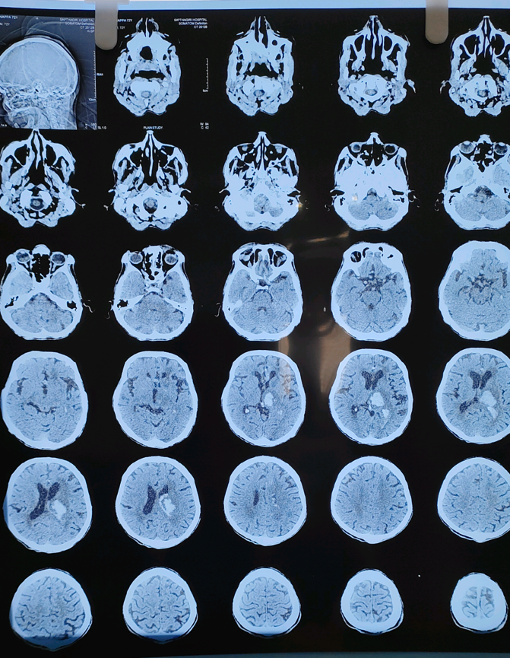 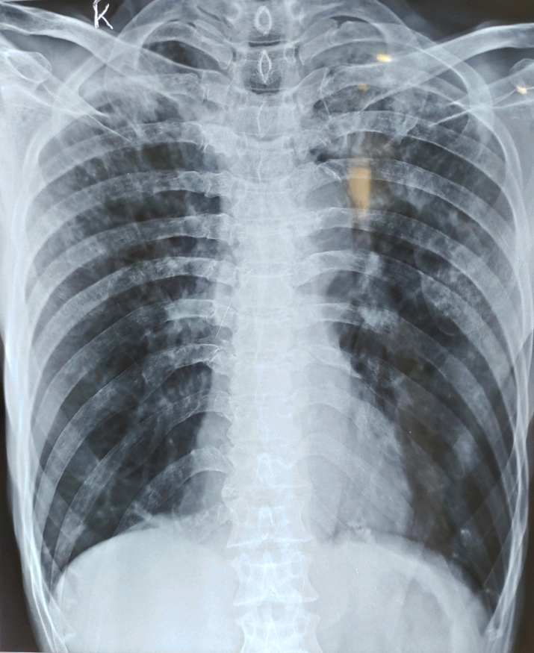

Figure 1: Intraparenchymal bleed in left Figure 2: Right lower lobe consolidation.

thalamus with mass effect

**THERAPEUTIC INTERVENTION:**

After the confirmation of intracranial hemorrhage, the patient was advised for decompression surgery, and all the pre-operative procedures were done. Furthermore, the patient was prescribed inj Xone 1g IV x BD, Inj pan 40 mg IV X OD, Inj emeset 4 mg IV X BD, Inj labetalol 20 mg IV SOS, Inj mannitol 100 ml infusion X TDS, Tab telma 40 mg x BD, Inj hydrocort 100 mg IV stat. Also, it was advised to perform intubation SOS in case of any drop in GCS score or respiratory arrest.

**DISCUSSION:**

Intracranial hemorrhage (ICH) constitutes a medical emergency that necessitates prompt and appropriate management according to the guidelines established by the American Heart Association (AHA) and the American Society of Anesthesiologists (ASA). The initial management of ICH should prioritize the restoration of airway patency, breathing, and circulation, the verification of neuroimaging findings, the utilization of standardized assessment scales such as the National Institute of Health Stroke Scale (NIHSS) and the Glasgow Coma Scale (GCS), blood pressure management, the reversal of coagulopathy, and surgical intervention. Frequent neurological examinations are conducted to monitor the signs of intracranial pressure (ICP). (5) Craniotomy is a more prevalent treatment approach for spontaneous intracranial bleeding. However, the role of open surgery has been subject to ongoing debate due to its inherent risks and complications. Consequently, alternative approaches, including minimally invasive techniques, have been tested. (6) A recent pilot randomized controlled trial demonstrated the promising safety and effectiveness of Intraoperative Computed Tomography-guided Endoscopic Surgery for Brain Hemorrhage (ICES) in managing ICH. (7) In our case, the patient presented as a chronic smoker with a history exceeding 25 years of smoking. This history strongly suggests a correlation between hypertension and cerebral hemorrhage, commonly referred to as hypertensive cerebral hemorrhage. The incidence of ICH has recently risen among younger populations, accompanied by higher mortality rates. (8) ICH can be associated with hematoma expansion, which can be effectively managed through surgical intervention, blood pressure control, and adjustments to coagulation parameters. However, it is often observed that ICH occurs prior to hospital admission, which can significantly impact the acute management and the potential for surgical intervention. (9) Nurses play a pivotal role in the intensive care unit, where they continuously monitor patients’ conscious levels, maintain vital signs, cardiac activity, and any alterations in hydroelectric balance, seizures, hygiene, and mobility. It is also crucial to inform the family members that the disability can be substantial for those who survive an intracranial hemorrhage (ICH) and may require lifelong dependence. Consequently, they will necessitate support from an occupational therapist, speech therapist, and physiotherapy team to facilitate rehabilitation and restore the patient’s maximum functional capacity. (10) In our case, the patient was recommended for surgical corrections; however, he unexpectedly experienced seizures. Nevertheless, after undergoing conservative treatment, the patient’s vital signs and all other pertinent parameters stabilized, and there was no indication of infection.

**CONCLUSION:**

Intracranial hemorrhage (ICH) significantly contributes to the global burden of disease, accounting for 10 to 15% of stroke cases in high-income countries and 20 to 50% in developing countries. Accurate diagnosis of ICH is paramount for clinicians, necessitating adherence to appropriate diagnostic criteria. Furthermore, providing patients with information regarding the most probable outcomes of their condition, in accordance with medical feasibility and patient or family preferences, can enhance clinical care.

**ACKNOWLEDGEMENTS:** We thank thepatient for allowing us to share her case.

**ETHICAL APPROVAL:** Ethical approval were taken as per international standards.

**CONFLICTS OF INTERESTS:** No potential conflicts of interest relevant to this article.

**FUNDING:** The authors receive no funding for this work.

Disclaimer (Artificial intelligence)

Option 1:

Author(s) hereby declare that NO generative AI technologies such as Large Language Models (ChatGPT, COPILOT, etc.) and text-to-image generators have been used during the writing or editing of this manuscript.

Option 2:

Author(s) hereby declare that generative AI technologies such as Large Language Models, etc. have been used during the writing or editing of manuscripts. This explanation will include the name, version, model, and source of the generative AI technology and as well as all input prompts provided to the generative AI technology

Details of the AI usage are given below:

1.

2.

3.

**REFERENCE:**

1. Caceres, J. A., & Goldstein, J. N. (2012). Intracranial hemorrhage. Emergency medicine clinics of North America, 30(3), 771–794. <https://doi.org/10.1016/j.emc.2012.06.003>

2. Tenny S, Thorell W. Intracranial Hemorrhage. [Updated 2024 Feb 17]. In: StatPearls [Internet]. Treasure Island (FL): StatPearls Publishing; 2025 Jan-. Available from: <https://www.ncbi.nlm.nih.gov/books/NBK470242/>

3. Wang, S., Zou, X., Wu, L., Zhou, H., Xiao, L., Yao, T., Zhang, Y., Ma, J., Zeng, Y., & Zhang, L. (2022). Epidemiology of intracerebral hemorrhage: A systematic review and meta-analysis. *Frontiers in Neurology*, *13*. https://doi.org/10.3389/fneur.2022.915813

**4.** McGurgan, I. J., Ziai, W. C., Werring, D. J., Salman, R. A., & Parry-Jones, A. R. (2020). Acute intracerebral haemorrhage: diagnosis and management. *Practical Neurology*, *21*(2), 128–136. https://doi.org/10.1136/practneurol-2020-002763

**5.** De Oliveira Manoel, A. L., Goffi, A., Zampieri, F. G., Turkel-Parrella, D., Duggal, A., Marotta, T. R., Macdonald, R. L., & Abrahamson, S. (2016). The critical care management of spontaneous intracranial hemorrhage: a contemporary review. *Critical Care*, *20*(1). <https://doi.org/10.1186/s13054-016-1432-0>

**6.** De Oliveira Manoel, A. L. (2020). Surgery for spontaneous intracerebral hemorrhage. *Critical Care*, *24*(1). <https://doi.org/10.1186/s13054-020-2749-2>

**7.** Vespa, P., Hanley, D., Betz, J., Hoffer, A., Engh, J., Carter, R., Nakaji, P., Ogilvy, C., Jallo, J., Selman, W., Bistran-Hall, A., Lane, K., McBee, N., Saver, J., Thompson, R. E., & Martin, N. (2016). ICES (Intraoperative Stereotactic Computed Tomography-Guided endoscopic surgery) for brain hemorrhage. *Stroke*, *47*(11), 2749–2755. <https://doi.org/10.1161/strokeaha.116.013837>

**8.** Wang, W., Zhou, N., & Wang, C. (2017). Minimally Invasive Surgery for Patients with Hypertensive Intracerebral Hemorrhage with Large Hematoma Volume: A Retrospective Study. *World Neurosurgery*, *105*, 348–358. <https://doi.org/10.1016/j.wneu.2017.05.158>

**9.** Witsch, J., Falcone, G. J., Leasure, A. C., Matouk, C., Endres, M., Sansing, L., Woo, D., & Sheth, K. N. (2021). Intracerebral Hemorrhage with Intraventricular Extension Associated with Loss of Consciousness at Symptom Onset. *Neurocritical Care*, *35*(2), 418–427. <https://doi.org/10.1007/s12028-020-01180-2>

**10.** Rajashekar D, Liang JW. Intracerebral Hemorrhage. [Updated 2023 Feb 6]. In: StatPearls [Internet]. Treasure Island (FL): StatPearls Publishing; 2025 Jan-. Available from: https://www.ncbi.nlm.nih.gov/books/NBK553103/