**Derivatization Strategies for the Analysis of Proteins Using SDS-PAGE**

**Abstract**

Sodium dodecyl sulfate-polyacrylamide gel electrophoresis (SDS-PAGE) is an essential technique in proteomics that separates proteins based on molecular weight. To enhance protein detection sensitivity and specificity, researchers use derivatization methods such as chemical modifications, fluorescent labeling, and affinity tags. These approaches improve visualization, quantification, and identification, offering deeper insights into protein structure and function. Derivatization modifies proteins chemically to boost detectability and analytical precision. Techniques like biotinylating enable sensitive detection using streptavidin probes, while isotope labeling facilitates accurate quantification in comparative studies. Chemical modifications targeting amino acids such as cysteine and lysine help investigate protein interactions and modifications. These methods are especially useful for identifying low-abundance proteins in complex mixtures—a major challenge in proteomics—and for studying post-translational modifications (PTMs) like phosphorylation and glycosylation, which are crucial for protein regulation. Advancements in photostable fluorescent dyes, efficient biotin analogs, and refined isotope labeling have improved proteomic analysis precision. Additionally, coupling SDS-PAGE with mass spectrometry has revolutionized protein characterization, providing high-resolution, comprehensive data. These developments have made it easier to study dynamic protein interactions and structural variations, aiding in biomedical research, drug development, and disease diagnostics. As proteomics continues to evolve, integrating innovative derivatization strategies with cutting-edge analytical techniques will further enhance our understanding of complex biological systems.

**KEYWORDS:** sodium dodecyl sulphate–polyacrylamide gel electrophoresis, Derivatization, Post-Translational Modifications, Protein-Protein Interactions

**INTRODUCTION:**

Recent advancements in photostable fluorescent dyes, optimized biotin analogs, and refined isotope labeling have significantly enhanced the precision of proteomic analysis. The integration of SDS-PAGE with mass spectrometry has transformed protein characterization, delivering high-resolution and comprehensive insights. These innovations have streamlined the study of dynamic protein interactions and structural variations, contributing to breakthroughs in biomedical research, pharmaceutical development, and disease diagnostics. Furthermore, improved derivatization methods have enabled researchers to study complex protein networks with greater accuracy, shedding light on intricate signaling pathways and cellular mechanisms. The refinement of affinity tags and labeling strategies has also facilitated more precise detection of low-abundance proteins, which play crucial roles in biological processes but are often challenging to analyze. As proteomics continues to progress, the fusion of novel derivatization strategies with advanced analytical technologies promises to deepen our understanding of complex biological systems and their regulatory mechanisms. These cutting-edge techniques are driving innovations in personalized medicine, allowing for the identification of disease biomarkers and the development of targeted therapies. Additionally, the integration of artificial intelligence and machine learning in proteomic data analysis is further enhancing the speed and efficiency of protein characterization, paving the way for new discoveries in systems biology and molecular diagnostics.

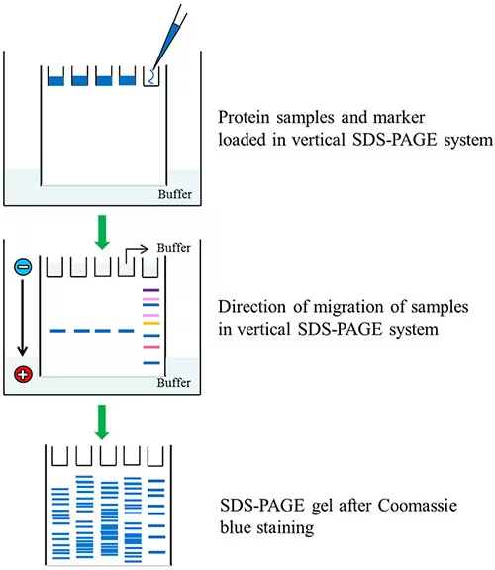

**Fig 1: Protein characterization, paving the way for new discoveries in systems biology and molecular diagnostics**

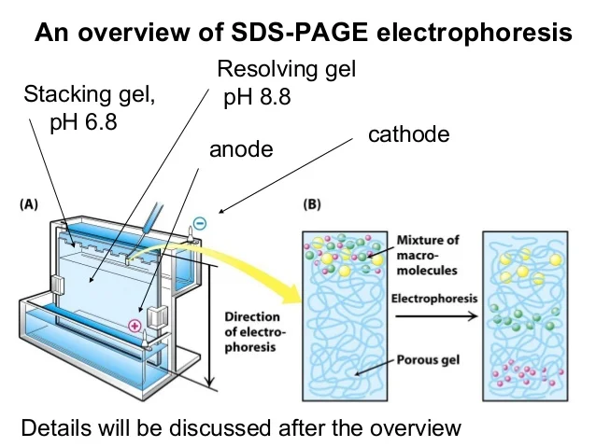

**Fig 2: An overview of SDS-PAGE electrophoresis**

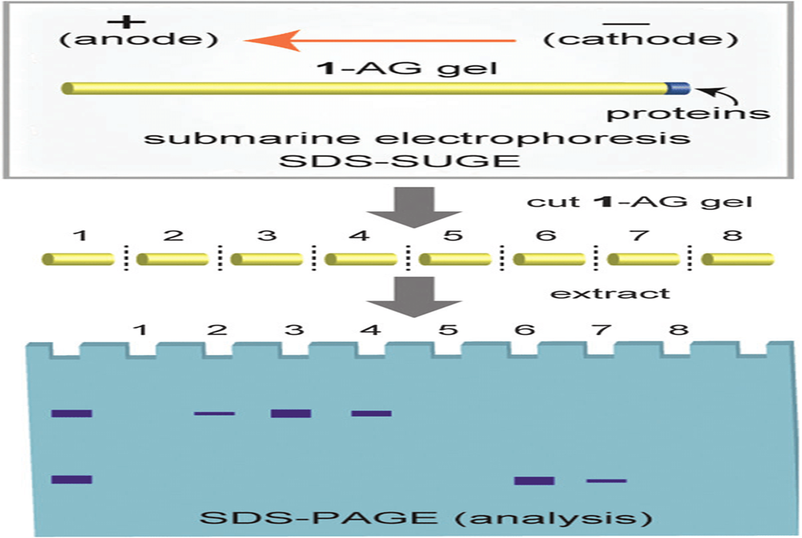

**Fig 3: Submarine electrophoresis SDS-SUGE**

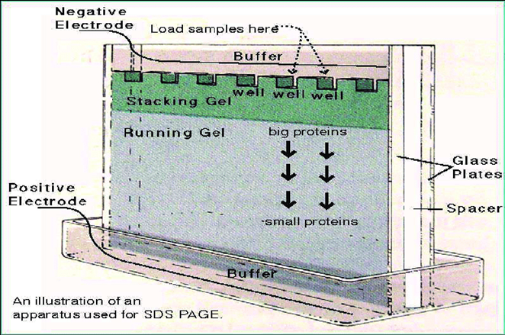

**Fig 4 : SDA-PAGE analysis**

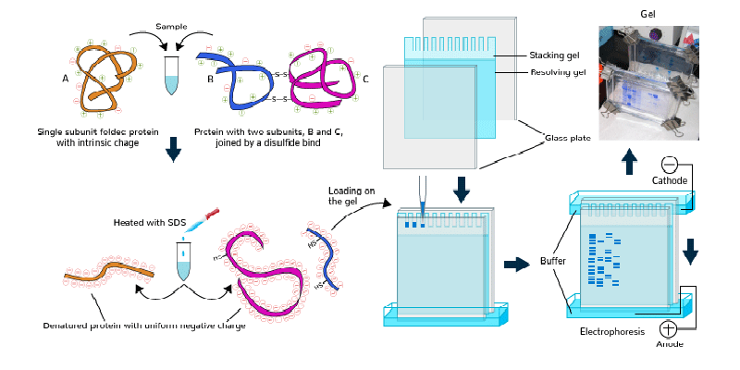

**Fig 5 : Illustration of an apparatus used for SDA PAGE**

**Importance of Derivatization**

Derivatization involves chemically modifying proteins to facilitate their detection and analysis, significantly enhancing sensitivity and specificity, particularly for low-abundance proteins or specific protein subgroups. This process is essential for improving visualization, quantification, and the accuracy of protein characterization in complex biological samples. Various derivatization strategies exist, including fluorescent labeling, which enables high-resolution imaging, and affinity tagging, which aids in immunodetection. Additionally, modifying amino acid residues such as cysteine and lysine introduces unique properties that enhance protein analysis. These modifications play a critical role in studying post-translational modifications (PTMs), such as phosphorylation and glycosylation, which regulate protein function and cellular processes. Derivatization is a pivotal process in biochemical and proteomics research, particularly when utilizing sodium dodecyl sulfate-polyacrylamide gel electrophoresis (SDS-PAGE). This technique chemically modifies proteins to improve detectability, specificity, and overall analytical performance, allowing for more precise separation and identification. The combination of SDS-PAGE with mass spectrometry further enhances characterization by providing high-resolution structural and functional insights. Moreover, advancements in derivatization technologies have led to the development of more stable fluorescent dyes, optimized biotin analogs, and refined isotope labeling methods, which significantly improve the reliability and accuracy of proteomic studies. These innovations have facilitated breakthroughs in biomedical research, drug discovery, and diagnostics by enabling the identification of disease biomarkers and the development of targeted therapies. As proteomics continues to advance, integrating sophisticated derivatization strategies with cutting-edge analytical techniques will further expand our understanding of protein networks, cellular mechanisms, and disease progression, paving the way for more personalized and effective medical treatments.

**Enhanced Sensitivity and Detection**

Proteins exist in a vast and complex biological landscape, and detecting those present in low concentrations can be incredibly challenging. That’s where derivatization steps in as a game-changer. One of its key roles is to amplify sensitivity and push the detection limits of analytical techniques, making even the faintest proteins visible. SDS-PAGE is a powerful method for protein separation, but on its own, it may struggle to reveal low-abundance proteins, which can get lost in the mix. By chemically modifying these proteins—such as tagging them with fluorescent dyes like fluorescein or rhodamine—their visibility dramatically improves. These dyes impart a strong fluorescence signal that allows proteins to glow under UV light, making them far easier to pinpoint in a complex sample. This fluorescence enhancement not only boosts detection but also enables precise quantification, giving researchers a clearer picture of protein expression levels. The ability to track proteins more effectively has profound implications in areas such as disease diagnostics, drug development, and biomarker discovery. With ongoing advancements in fluorescent tagging and imaging technologies, derivatization continues to refine protein analysis, helping scientists uncover details that were once beyond reach.

**Analysis of Post-Translational Modifications (PTMs)**

Proteins are the workhorses of biological systems, carrying out vital functions in cells. But their activity isn’t just dictated by their amino acid sequence—post-translational modifications (PTMs) such as phosphorylation, glycosylation, and acetylation fine-tune their behavior, influencing everything from signal transduction to enzyme activity and gene regulation. These modifications serve as molecular switches, determining when and how a protein interacts with other cellular components. Studying PTMs can be challenging due to their dynamic and often subtle nature, but derivatization strategies provide a powerful solution. By introducing specific chemical groups that selectively react with modified residues, researchers can highlight and analyze these modifications with greater precision. For example, phosphorylation—a critical modification involved in cell signaling—can be detected using derivatization methods that attach phosphate-specific tags. These tags make phosphorylated proteins easier to track, allowing scientists to investigate their role in processes like growth regulation, immune response, and disease mechanisms. Glycosylation, another essential PTM, affects protein stability and cell recognition, playing a major role in immune function and disease progression. Derivatization techniques enable researchers to map glycosylation patterns, uncovering insights into conditions such as cancer and neurodegenerative disorders. Similarly, acetylation influences protein interactions and gene expression, with important implications for epigenetics and cellular regulation. By combining derivatization with advanced analytical methods like mass spectrometry and SDS-PAGE, scientists can unlock a deeper understanding of PTMs, paving the way for breakthroughs in drug development and personalized medicine. As proteomics continues to evolve, refined derivatization approaches will further illuminate the intricate regulatory networks that dictate cellular function, bringing us closer to innovative treatments and disease prevention strategies.

**Quantitative Proteomics**

Understanding how protein levels fluctuate across different conditions is fundamental to unraveling biological processes, and derivatization plays a critical role in making this possible. Quantitative proteomics relies on techniques like isotope labeling to accurately measure relative protein abundance, shedding light on how cells respond to environmental changes, disease states, or drug treatments. Stable isotope labeling by amino acids in cell culture (SILAC) is one of the most powerful approaches, incorporating either heavy or light isotopes into proteins as they are synthesized. This method seamlessly integrates into cellular systems, ensuring proteins retain their natural structures while becoming uniquely traceable. When analyzed via mass spectrometry, isotope-labeled proteins can be precisely quantified, allowing researchers to compare expression levels with remarkable accuracy. This quantitative approach is essential for comparative studies, such as investigating how protein expression varies under different physiological or pathological conditions. For example, SILAC enables scientists to pinpoint proteins that are upregulated or downregulated in cancer cells compared to healthy ones, offering crucial insights into disease mechanisms. It also supports drug discovery by identifying protein targets that respond to specific treatments, helping refine therapeutic strategies. Beyond disease research, isotope labeling contributes to broader biological studies, including the monitoring of stress responses, metabolic shifts, and cellular adaptations. As proteomics continues to evolve, refining derivatization techniques will further enhance our ability to decode protein dynamics, paving the way for breakthroughs in medicine, biotechnology, and systems biology.

**Protein-Protein Interactions**

Proteins don’t operate in isolation—they form intricate networks, working together to regulate essential cellular functions. Understanding protein-protein interactions is crucial for unraveling these complex biological systems, as they dictate everything from signal transmission to metabolic pathways and gene regulation. Mapping these interactions provides deep insights into how cells respond to stimuli, adapt to changes, and even how diseases progress at the molecular level. Derivatization techniques offer powerful tools for studying these interactions by introducing specific tags or labels that help capture and analyze protein connections. One widely used approach is chemical cross-linking, which stabilizes transient protein interactions by forming covalent bonds between interacting partners. When coupled with SDS-PAGE and mass spectrometry, this method allows researchers to pinpoint which proteins bind to one another and identify key interaction sites within a protein complex. This information is invaluable for understanding functional relationships between proteins and their roles in cellular processes. By identifying interaction networks, scientists can explore mechanisms underlying diseases such as cancer and neurodegenerative disorders, revealing potential therapeutic targets. Protein-protein interaction studies also contribute to drug discovery, enabling the design of molecules that can either disrupt harmful interactions or enhance beneficial ones. With ongoing advances in derivatization strategies, including refined cross-linking reagents and improved detection techniques, researchers can achieve greater precision and resolution in studying protein networks. As proteomics continues to evolve, these developments will deepen our understanding of cellular communication, paving the way for groundbreaking discoveries in molecular biology and medicine.

**Advancements in Derivatization Techniques**

Proteins are the foundation of life, orchestrating essential processes within cells. As technology advances, derivatization techniques have become indispensable in protein analysis, helping researchers uncover the intricate details of protein structure and function with greater accuracy than ever before. Recent innovations have significantly improved these methods, making protein detection more reliable and efficient. The development of novel fluorescent dyes with enhanced photostability and brightness ensures that proteins remain visible and quantifiable over extended periods, reducing signal loss and improving imaging precision. Similarly, new biotin analogs and refined isotope labeling strategies provide greater efficiency in protein tagging, facilitating accurate quantification and comparative analysis across diverse samples. Beyond labeling improvements, the integration of mass spectrometry with SDS-PAGE has transformed proteomics by enabling high-resolution analysis of derivatized proteins. This powerful combination allows scientists to characterize proteins with remarkable detail, mapping modifications, identifying structural variations, and elucidating functional roles within complex biological systems. These insights are invaluable in fields such as disease research, drug development, and personalized medicine, where understanding protein behavior can lead to targeted therapies and improved diagnostic techniques. Derivatization plays a crucial role in expanding the possibilities of protein analysis, ensuring sensitivity, specificity, and accuracy in biochemical investigations. It enables researchers to detect low-abundance proteins that might otherwise remain hidden, study post-translational modifications (PTMs) such as phosphorylation and glycosylation, and support quantitative proteomics for comparative studies. As scientific exploration continues to push boundaries, advancements in derivatization methods will further refine proteomic analysis, opening new doors for discovery in molecular biology, biotechnology, and medical research. These breakthroughs are shaping the future of proteomics, allowing scientists to decode the molecular mechanisms that govern life with unprecedented clarity. As new technologies emerge, the ability to analyze proteins with extreme precision will undoubtedly lead to groundbreaking discoveries, driving innovation across multiple scientific disciplines.

**Common Derivatization Strategies**

**1. Chemical Labeling**

**Chemical labeling enhances protein detection by attaching specific tags or probes, improving sensitivity and enabling multiplex analysis.**

* **Fluorescent Labeling: Proteins can be tagged with fluorescent dyes like fluorescein or rhodamine, making them visible under UV light. This method significantly boosts detection sensitivity and allows for multiplexing—where multiple proteins can be simultaneously tracked using different fluorescent signals. Fluorescent labeling is widely used in imaging techniques, flow cytometry, and Western blotting for high-precision visualization.**
* **Isotope Labeling: Stable isotope incorporation using heavy or light isotopes enables accurate differentiation of proteins in comparative studies. Methods like Stable Isotope Labeling by Amino Acids in Cell Culture (SILAC) and Isobaric Tagging for Relative and Absolute Quantification (iTRAQ) allow researchers to quantify protein abundance across different conditions, making isotope labeling indispensable for quantitative proteomics and metabolic studies.**

**2. Enzymatic Labeling**

**Enzymatic approaches employ biological catalysts to attach tags, improving specificity and facilitating functional studies.**

* **Biotinylating: The attachment of biotin molecules to proteins enables high-affinity detection via streptavidin-conjugated enzymes or fluorophores. biotinylating is extensively used in pull-down assays, affinity purification, and imaging applications due to its strong and specific binding properties.**
* **Phosphorylation Detection: Protein phosphorylation is a key regulatory mechanism in cell signaling. Kinases transfer phosphate groups to specific residues, which can then be detected using phospho-specific antibodies or derivatization methods that introduce phosphate-reactive probes. This technique is crucial for studying signaling cascades, cancer biology, and drug-target interactions.**

**3. Affinity Tagging**

**Affinity tags are genetically engineered peptide sequences that facilitate purification and detection, enabling streamlined protein studies.**

* **His-tag: A polyhistidine sequence binds to nickel or cobalt ions, enabling metal affinity chromatography-based purification. His-tagging is widely used in recombinant protein production for structural and functional analyses.**
* **FLAG-tag: Recognized by anti-FLAG antibodies, this short peptide sequence aids in selective protein purification and identification, making it valuable in immunoprecipitation and affinity chromatography applications.**

**4. Glycosylation Analysis**

**Glycosylation plays a critical role in protein folding, stability, and cell-cell recognition. Specialized derivatization strategies facilitate glycan characterization.**

* **Periodate Oxidation: Oxidation of glycoproteins introduces aldehyde groups, which can be labeled with hydrazide or aminooxy compounds for selective detection. This technique is frequently applied in glycoprotein profiling and biomarker research.**
* **Lectin Blotting: Lectins selectively bind carbohydrate structures, enabling glycoprotein identification via lectin-conjugated probes. This method is essential for studying glycan diversity and its implications in diseases like cancer and inflammatory disorders.**
* **Chemical Modification: Amino acids such as cysteine and lysine can be chemically modified to enhance protein stability or reactivity. Alkylation of cysteine prevents unwanted disulfide bond formation, while lysine acetylation enables chromatin and epigenetic studies.**

**Necessity of These Techniques:**

**These derivatization strategies have far-reaching implications in proteomics, medical research, and drug discovery. Fluorescent and isotope labeling enable precise protein quantification, supporting disease biomarker identification. Enzymatic and affinity tagging streamline protein purification, making therapeutic protein production more efficient. Glycosylation studies contribute to understanding protein misfolding disorders, aiding in the development of targeted treatments. With continuous advancements in labeling technologies, proteomics is evolving into a highly accurate field capable of deciphering the complexities of biological systems with unprecedented resolution. These innovations are shaping the future of personalized medicine, enabling scientists to develop novel therapies and diagnostic tools.**

**Applications of Derivatization Strategies for SDS-PAGE Analysis**

**Derivatization techniques have transformed the way proteins are detected, quantified, and analyzed, making them indispensable tools in proteomics, biomedical research, and pharmaceutical development. These strategies improve sensitivity, enable precise quantification, and support the study of complex biological processes.**

**1. Proteome Profiling**

**Proteome profiling aims to analyze the entire set of proteins expressed by a biological system. Derivatization enhances these studies by refining protein detection and quantification.**

* **Enhanced Detection of Low-Abundance Proteins: Many regulatory proteins exist in trace amounts, making them difficult to detect using conventional SDS-PAGE. Derivatization amplifies their signal, allowing researchers to study critical biomolecules involved in gene expression, immune responses, and metabolic pathways.**
* **Differential Expression Analysis: Proteomic comparisons between healthy and diseased states rely on isotopic or fluorescent labeling to track protein expression changes. This is fundamental for understanding how cells react to environmental stress or disease progression.**
* **Multiplexing: High-throughput proteomic studies use fluorescent tags to analyze multiple samples simultaneously, accelerating biomarker discovery and streamlining experimental workflows.**

**2. Post-Translational Modification (PTM) Analysis**

**PTMs regulate protein activity, structure, and interaction networks, making their study essential for understanding cellular mechanisms.**

* **Phosphorylation Studies: As a key signaling mechanism, phosphorylation determines enzyme activation and receptor function. Derivatization techniques enable precise phospho-protein detection, critical for studying cancer biology and immune regulation.**
* **Glycosylation Analysis: Glycoproteins influence cell-cell communication, immune recognition, and protein stability. Periodate oxidation and lectin-based detection help researchers study glycosylation patterns in diseases such as neurodegeneration and cancer.**
* **Ubiquitination Detection: Protein degradation pathways heavily rely on ubiquitination. By derivatizing ubiquitinated proteins, researchers can study their role in neurodegenerative conditions like Parkinson’s disease and Alzheimer's.**

**3. Biomarker Discovery**

**The search for reliable biomarkers is a major focus in disease diagnostics and therapeutics. Derivatization enables more sensitive detection of disease-associated proteins.**

* **Disease Diagnosis: By mapping protein modifications linked to diseases, scientists can develop diagnostic assays for conditions such as cancer, cardiovascular disorders, and autoimmune diseases. Glycosylation profiling, in particular, has led to improved diagnostic markers for aggressive tumor types.**
* **Therapeutic Target Identification: Identifying proteins undergoing dysregulation in disease states helps pharmaceutical researchers develop new treatments, including targeted therapies.**
* **Early Detection: Highly sensitive derivatization methods allow researchers to detect early-stage disease biomarkers, improving intervention strategies and potentially saving lives.**

**4. Functional Proteomics**

**Beyond detecting proteins, derivatization enables the study of their roles in biological systems.**

* **Protein-Protein Interactions: Tracking protein binding events through affinity tagging enables the mapping of interaction networks essential for understanding diseases, such as cancer progression and viral infections.**
* **Protein Localization: Fluorescent labeling provides real-time visualization of protein distribution within cells, guiding research on subcellular protein organization and compartmentalization.**
* **Protein Dynamics: Isotopic labeling techniques help monitor protein stability, turnover rates, and degradation patterns—crucial for understanding drug responses and stress adaptation mechanisms.**

**5. Drug Development**

**Pharmaceutical advancements rely on precise protein characterization to validate drug targets and optimize treatment strategies.**

* **Target Validation: Studying protein modifications ensures that drug candidates effectively interact with disease-associated proteins, increasing the chances of developing successful therapeutics.**
* **Mechanism of Action Studies: Identifying how drugs influence protein activity helps refine treatments and minimize unintended effects.**
* **Biopharmaceutical Production: Ensuring the consistency and efficacy of therapeutic proteins, such as monoclonal antibodies, requires derivatization techniques for monitoring modifications during manufacturing.**

**The Future of Derivatization in Proteomics**

**As proteomics continues to advance, emerging derivatization strategies such as next-generation fluorescent probes, improved affinity tags, and AI-driven data analysis will further enhance the accuracy and efficiency of protein characterization. These innovations will shape the future of personalized medicine, disease diagnostics, and therapeutic development.**

**Examples of Derivatization Strategies for the Analysis of Proteins or Precursors Using SDS-PAGE**

These derivatization strategies play a crucial role in protein analysis using SDS-PAGE, enabling enhanced detection, quantification, and characterization of proteins in various biological and biomedical contexts. Let’s expand on these examples with additional details and real-world applications to highlight their impact:

**1. Chemical Labeling**

Chemical labeling improves protein visualization and differentiation, particularly in comparative studies.

* **Fluorescent Labeling with Cy3 and Cy5:**
* **Method:** Proteins are covalently labeled with fluorescent dyes, specifically targeting lysine residues.
* **Application:** Used in differential expression studies, where proteins from distinct conditions (e.g., cancer vs. healthy tissues) are labeled with separate dyes and run on the same SDS-PAGE gel. The fluorescent signals are scanned, providing a precise comparison of expression levels.
* **Real-World Impact:** This technique is instrumental in cancer research, allowing scientists to identify protein expression changes that contribute to tumor progression or drug resistance.
* **Isotopic Labeling with SILAC (Stable Isotope Labeling by Amino Acids in Cell Culture):**
* **Method:** Cells incorporate stable isotopes (^13C, ^15N) from the media into proteins during synthesis.
* **Application:** SILAC facilitates quantitative proteomics, enabling researchers to compare protein expression between treated and untreated samples.
* **Real-World Impact:** SILAC is widely used in drug development, helping identify proteins affected by pharmaceutical compounds, leading to insights into drug efficacy and potential side effects.

**2. Enzymatic Labeling** Enzymatic derivatization enhances protein detection and facilitates interaction studies.

* **Biotinylating:**
* **Method:** Biotin ligase (e.g., BirA) covalently attaches biotin to lysine residues.
* **Application:** Useful in protein-protein interaction studies, where biotinylated proteins act as bait to isolate their binding partners.
* **Real-World Impact:** In infectious disease research, biotinylation helps identify host-pathogen interactions, leading to improved understanding of disease mechanisms and potential therapeutic targets.
* **Phosphorylation Detection Using Kinases:**
* **Method:** Specific kinases phosphorylate target proteins, which are then detected via phospho-specific antibodies.
* **Application:** Signaling pathway studies, particularly those investigating cell responses to stimuli like growth factors or environmental stress.
* **Real-World Impact**: Neurological disease research relies on this method to examine phosphorylation changes in proteins associated with neurodegenerative disorders such as Alzheimer's and Parkinson’s.

**3. Affinity Tagging**

Affinity tags streamline protein purification and detection, improving experimental efficiency.

* **His-tagging:**
* **Method:** A polyhistidine sequence binds to nickel or cobalt ions for purification.
* **Application:** His-tagging simplifies recombinant protein production, facilitating purification for structural and functional studies.
* **Real-World Impact:** Widely used in biopharmaceutical development, ensuring efficient production of therapeutic proteins such as monoclonal antibodies.
* **FLAG-tagging:**
* **Method:** FLAG-tag sequences allow for selective detection via anti-FLAG antibodies.
* **Application:** Enables pull-down assays, identifying interaction partners in biological samples.
* **Real-World Impact:** Cancer biology benefits from FLAG-tagging in identifying proteins involved in tumor signaling networks.

**4. Glycosylation Analysis** Glycosylation influences protein stability, function, and disease progression.

* **Periodate Oxidation:**
* **Method:** Glycoproteins are oxidized, forming aldehyde groups for labeling with hydrazide compounds.
* **Application**: Supports glycoprotein profiling to study differences in glycosylation patterns across cell types or disease states.
* **Real-World Impact:** Used extensively in autoimmune disease diagnostics, as aberrant glycosylation contributes to immune system dysfunction.
* **Lectin Blotting**

These examples illustrate the diverse range of derivatization strategies that can be employed to enhance the analysis of proteins using SDS-PAGE. By incorporating chemical, enzymatic, and affinity-based modifications, researchers can achieve greater sensitivity, specificity, and resolution in their protein studies, paving the way for new discoveries in proteomics and biomedical research.

**Recent Advances in Derivatization Strategies for SDS-PAGE**

Sodium dodecyl sulfate-polyacrylamide gel electrophoresis (SDS-PAGE) has long been a fundamental method in protein biochemistry. However, recent advancements in derivatization strategies have significantly improved its ability to analyze complex proteomes and post-translational modifications (PTMs). These innovations enhance sensitivity, specificity, and throughput, broadening SDS-PAGE’s applications in proteomics, biomedical research, and clinical diagnostics.

**1. Enhanced Fluorescent Labeling Techniques**

Traditional fluorescent labeling methods have evolved with the development of novel dyes featuring greater photostability, higher brightness, and reduced background noise. New-generation fluorophores—such as Cy7 and Alexa Fluor series—have improved protein visualization, allowing for multiplex analysis and enhanced quantification in SDS-PAGE studies.

**2. Advanced Isotopic Labeling for Quantitative Proteomics**

Stable isotope labeling methods, including isobaric tagging (iTRAQ) and tandem mass tags (TMT), have expanded proteomic workflows by enabling high-throughput quantification. These labeling approaches allow researchers to measure relative protein abundances more accurately while enhancing signal resolution during mass spectrometry analysis post-SDS-PAGE.

**3. Chemical Modifications for Targeted PTM Analysis**

Recent innovations in specific amino acid-targeting reagents have facilitated PTM analysis with higher precision.

**Phosphorylation Detection:** New phosphate-specific derivatization methods utilize metal-chelating dyes that bind exclusively to phosphorylated proteins, improving detection limits.

**Glycosylation Studies**: The introduction of hydrazide-based derivatization enables more efficient labeling of glycoproteins, streamlining their identification in SDS-PAGE gels.

**Ubiquitination Tracking:** Enhanced affinity-based derivatization reagents selectively tag ubiquitin-modified proteins, improving PTM mapping and regulatory protein studies.

**4. Improved Affinity Tagging for Protein Purification and Interaction Studies**

Affinity tagging strategies have seen notable upgrades with optimized biotin analogs, cleavable tags, and dual-affinity labeling methods. These improvements have strengthened protein detection in SDS-PAGE experiments, particularly for analyzing protein-protein interactions using tandem affinity purification approaches.

**5. Integration with Mass Spectrometry for High-Resolution Proteomics**

The coupling of SDS-PAGE with next-generation mass spectrometry techniques has further refined protein characterization. Advanced derivatization techniques ensure better peptide recovery, facilitating high-resolution mapping of protein modifications in biomarker discovery studies.

**1. Advanced Chemical Labeling Techniques**

**1.1 Fluorescent Protein** **Tags:**

New fluorescent tags with enhanced stability and brightness, such as far-red and near-infrared dyes (e.g., Alexa Fluor 647 and IRDye 800CW), offer improved signal-to-noise ratios and better tissue penetration. These dyes are ideal for both in vivo and ex vivo studies, allowing for more precise and detailed protein analyses. Environment-sensitive dyes that change fluorescence based on local conditions (e.g., pH, polarity) have also been developed, enabling real-time monitoring of protein interactions and conformational changes.

**1.2 Bioorthogonal Chemistry:** Bioorthogonal reactions, which occur without interfering with native biochemical processes, are increasingly used for protein labeling. Techniques such as strain-promoted azide-alkyne cycloaddition (SPAAC) and tetrazine-trans-cyclooctene ligation offer rapid, specific, and non-toxic labeling. These methods are particularly useful for in vivo studies, where traditional chemical labeling might not be feasible due to cellular toxicity.

2**. Innovative Enzymatic Labeling Approaches**

**2.1 Proximity Labeling Enzymes**:

Proximity labeling enzymes like APEX2 (ascorbate peroxidase) and Bio ID (biotin identification) have been engineered to label proteins in close proximity, enhancing the detection of transient and weak interactions. APEX2 catalyzes the oxidation of biotin-phenol to a biotin-phenoxyl radical, which covalently attaches to nearby proteins. BioID uses a mutant biotin ligase to biotinylate proteins within a 10 nm radius, allowing for comprehensive mapping of protein interaction networks.

**2.2 Enzyme-Mediated PTM Mimics:** Engineered enzymes can introduce non-natural modifications that can be selectively labeled and detected. For example, synthetic kinases can add Biorthogonal phosphonates instead of phosphates, enabling specific detection with click chemistry. This approach allows for detailed studies of PTMs, providing insights into cellular signaling and regulatory mechanisms.

**3. Enhanced Affinity Tagging Systems**

**3.1 Multifunctional Tags**: Tags that combine multiple functionalities, such as the Halo Tag system, allow for imaging, purification, and interaction studies. The Spy Tag/Spy Catcher system provides strong and specific protein labeling through irreversible covalent bonding, facilitating the study of protein interactions in live cells.

**4. Advanced Glycosylation Analysis Techniques**

**4.1 Metabolic Labeling of Glycan:** Azido-sugar analogs, which cells incorporate into glycans, can be labeled with fluorescent dyes via click chemistry. This technique allows for the visualization and analysis of glycosylation patterns, providing important information about protein function and interactions.

**4.2 Lectin Microarrays: Lectin** microarrays enable high-throughput analysis of multiple glycan structures from a single sample, providing comprehensive glycosylation profiles. This method is particularly useful for studying glycan variations in different biological contexts, such as disease states.

**5. Integrated Analytical Platforms**

**5.1 SDS-PAGE and Mass Spectrometry Integration:** Advanced workflows that combine SDS-PAGE with mass spectrometry enhance protein and PTM identification and quantification. These integrated platforms reduce sample handling, increase throughput, and provide more detailed proteomic analyses.

**5.2 Micro fluidic SDS-PAGE Systems:** Micro fluidic platforms, or lab-on-a-chip systems, enable rapid and automated protein separation and analysis with minimal sample requirements. These systems are ideal for high-throughput screening and diagnostic applications.

**6. Computational Tools and Machine Learning**

**6.1 Automated Image Analysis:** Machine learning algorithms are being developed to automate the analysis of SDS-PAGE gels, improving accuracy and consistency in protein quantification and pattern recognition.

**6.2 Predictive Modeling of Protein Modifications:** New computational tools predict potential PTMs and their effects on protein function, guiding experimental design and interpretation of SDS-PAGE results.

**Bioinformatics Tools**: New computational tools can predict potential PTMs and their effects on protein function, guiding experimental design and interpretation of SDS-PAGE results.

**Discussion: Advances in Derivatization Strategies for SDS-PAGE**

Sodium dodecyl sulfate-polyacrylamide gel electrophoresis (SDS-PAGE) has long been a fundamental tool in protein biochemistry, providing a reliable method for separating proteins based on their molecular weight. However, the technique alone has limitations in detecting low-abundance proteins, analyzing complex proteomes, and characterizing post-translational modifications (PTMs). To overcome these challenges, derivatization strategies have been developed, significantly enhancing SDS-PAGE’s analytical capabilities.

**1. Enhanced Sensitivity and Detection of Low-Abundance Proteins**

Many biologically important proteins, such as transcription factors and signaling molecules, exist in minute quantities, making their detection difficult using standard SDS-PAGE. Chemical labeling, including fluorescent and isotopic derivatization, helps amplify signal intensity, improving visualization. Techniques such as Cy3/Cy5 fluorescent labeling and SILAC (Stable Isotope Labeling by Amino Acids in Cell Culture) enable researchers to compare protein abundance across different conditions with high accuracy and sensitivity.

**2. Post-Translational Modification (PTM) Studies**

PTMs such as phosphorylation, glycosylation, acetylation, and ubiquitination play crucial roles in regulating protein function. However, their detection requires specific derivatization techniques:

**3. Improved Protein-Protein Interaction Studies**

Protein interactions dictate numerous cellular functions, and derivatization techniques improve the study of these complex relationships. Biotinylating tagging enhances affinity-based purification for interaction studies, making it easier to isolate protein complexes. Cross-linking derivatization stabilizes transient interactions, allowing identification via SDS-PAGE and mass spectrometry.

**4. Integration with Mass Spectrometry for High-Resolution Analysis**

SDS-PAGE, when combined with advanced derivatization methods and mass spectrometry, enables high-throughput analysis of complex protein samples. Enhanced tagging techniques, such as tandem mass tags (TMT) and isobaric labeling (iTRAQ), provide quantitative proteomics capabilities, making them indispensable in biomarker discovery and clinical diagnostics.

**1. Chemical Labeling Techniques:** One of the primary advancements in SDS-PAGE derivatization strategies involves chemical labeling techniques. Fluorescent dyes, such as SYPRO Ruby and Coomassie Brilliant Blue, enhance protein visualization and quantification by emitting fluorescent signals upon binding to proteins. These dyes improve sensitivity, allowing for the detection of proteins in low nanogram quantities, which is crucial for analyzing complex biological samples and studying proteins with low expression levels. Moreover, novel fluorescent probes have been developed that offer advantages such as enhanced stability, brightness, and spectral properties. These advancements enable researchers to perform multiplexed analyses, where multiple proteins or PTMs can be simultaneously labeled and detected on the same gel, facilitating high-throughput studies and comprehensive protein profiling.

**2. Enzymatic Labeling Approaches:** Enzymatic derivatization strategies have also made significant strides in expanding the analytical capabilities of SDS-PAGE. For instance, enzymes like horseradish peroxidase (HRP) and alkaline phosphates (AP) can be conjugated to antibodies or other affinity reagents, enabling sensitive detection and quantification of specific proteins or PTMs. This approach is particularly useful in immunoblotting applications, where proteins of interest are transferred from SDS-PAGE gels onto membranes and subsequently probed with enzyme-conjugated antibodies for visualization.Enzymatic methods have also been employed for studying PTMs, such as glycosylation and phosphorylation. Glycoprotein’s can be enzymatically labeled with Lectins or glycosidase, allowing for the specific detection and characterization of glycan structures. Similarly, Kinases and phosphates can be used to investigate phosphorylation events, providing insights into signaling pathways and regulatory mechanisms.

**3. Affinity Tagging and Hybridization Strategies:** Affinity tagging strategies, such as the His-tag and GST-tag systems, facilitate the purification and analysis of recombinant proteins. These tags allow for selective binding to affinity resins or magnetic beads, enabling efficient protein purification prior to SDS-PAGE analysis. Moreover, hybridization strategies that combine chemical and enzymatic derivatization methods have emerged to enhance the specificity and versatility of protein analysis. For example, click chemistry reactions can be used to conjugate biotin or fluorescent tags to proteins of interest, followed by enzymatic detection or affinity purification steps for comprehensive characterization.

**4. Integration with Mass Spectrometry and Bioinformatics:** Recent advancements in SDS-PAGE derivatization strategies have also focused on integrating this technique with mass spectrometry (MS) and bioinformatics tools. By coupling SDS-PAGE with MS-based proteomics approaches, researchers can achieve enhanced protein identification and characterization, particularly for PTMs and low-abundance proteins. This integrated approach allows for the precise mapping of protein modifications and interactions within complex biological systems, offering insights into disease mechanisms and biomarker discovery.Bioinformatics tools play a crucial role in analyzing and interpreting SDS-PAGE data, particularly in large-scale proteomics studies. Computational algorithms for image analysis, data quantification, and statistical analysis enable researchers to extract meaningful information from complex gel images and MS spectra. Machine learning techniques are also being applied to predict protein modifications and interactions based on SDS-PAGE and MS data, further enhancing the depth and accuracy of proteomic analyses.

**Conclusion:**

In the realm of proteomics and protein analysis, recent advancements in derivatization strategies for SDS-PAGE have revolutionized the field, offering unprecedented capabilities for studying complex biological systems with enhanced sensitivity, specificity, and throughput. These innovations have not only improved the fundamental techniques of protein separation and detection but have also opened new avenues for understanding protein function, interactions, and modifications in diverse biological contexts. One of the most significant advancements lies in the realm of chemical labeling techniques. The introduction of advanced fluorescent protein tags, such as far-red and near-infrared dyes, has vastly improved the visualization and quantification of proteins in complex samples. These dyes offer superior signal-to-noise ratios and deeper tissue penetration, making them invaluable for both in vivo imaging studies and ex vivo protein analyses. Moreover, the development of environment-sensitive dyes has enabled real-time monitoring of protein dynamics and conformational changes, providing insights into protein interactions and structural alterations under physiological conditions. Bioorthogonal chemistry has emerged as a powerful tool in protein labeling, allowing for specific and non-toxic conjugation reactions that do not interfere with cellular processes. Techniques like strain-promoted azide-alkyne cycloaddition (SPAAC) and tetrazine-trans-cyclooctene ligation have facilitated rapid and precise protein labeling in live cells and organisms, enhancing the feasibility of studying protein dynamics and interactions in their native environments. Enzymatic labeling approaches have also seen significant progress, particularly with the development of proximity labeling enzymes such as APEX2 and BioID. These enzymes enable the identification of protein-protein interactions and subcellular localization by catalyzing the covalent attachment of biotin or other tags to proteins in close proximity. Such techniques have revolutionized our ability to map intricate protein networks and understand the spatial organization of proteins within cells. Split tags for protein-protein interaction studies, such as split GFP and TagRFP, have enabled real-time monitoring of protein interactions in live cells, providing dynamic insights into cellular processes. Glycosylation analysis has also benefited from recent advancements in derivatization strategies. Metabolic labeling of glycans with azido-sugar analogs and lectin microarrays have enabled high-throughput profiling of glycan structures and variations, offering critical insights into the roles of glycosylation in protein function and disease mechanisms. Integrated analytical platforms that combine SDS-PAGE with mass spectrometry (MS) have emerged as powerful tools for comprehensive proteomic analyses. These platforms allow for the identification and quantification of proteins and post-translational modifications (PTMs) with unprecedented accuracy and sensitivity, facilitating the discovery of novel biomarkers and therapeutic targets in various diseases. In parallel, computational tools and machine learning algorithms have played an increasingly important role in analyzing complex SDS-PAGE data. Automated image analysis algorithms improve the reliability and reproducibility of protein quantification and pattern recognition, while predictive modeling of protein modifications guides experimental design and interpretation of SDS-PAGE results. In conclusion, recent advances in derivatization strategies for SDS-PAGE have transformed protein analysis by enhancing our ability to study proteins in greater detail and complexity than ever before. These innovations hold promise for advancing our understanding of fundamental biological processes, discovering new biomarkers for disease diagnosis and prognosis, and developing targeted therapies for a wide range of human diseases. As these technologies continue to evolve, they will undoubtedly continue to shape the future of proteomics and biomedical research, paving the way for groundbreaking discoveries and innovations in personalized medicine and precision healthcare. Recent advances in derivatization strategies for SDS-PAGE have significantly enhanced the technique’s capabilities. These innovations enable more comprehensive proteome profiling, detailed PTM analysis, and high-throughput screening, thus expanding the applications of SDS-PAGE in research and clinical diagnostics. As these technologies continue to evolve, they promise to further deepen our understanding of protein biology and facilitate new discoveries in proteomics.

Disclaimer (Artificial intelligence)

Option 1: NO

Author(s) hereby declares that NO generative AI technologies such as Large Language Models (ChatGPT, manuscript.

Option 2: NO

Author(s) hereby declares that generative AI technologies such as Large Language Models, etc. have been used during the writing or editing of manuscripts. This explanation will include the name, version, model, and source of the generative AI technology and as well as all input prompts provided to the generative AI technology

Details of the AI usage are given below:

1.NO

2.NO

**References:**

1. Idowu, O. S., Sharma, A., & Paul, A. K. (2025). Optimizing SDS-PAGE for accurate protein characterization in nutritional research and food quality assessment. International Journal of Innovative Science and Research Technology,
2. Srivastava, Y., Tripathi, K., & Kumar, N. (2025). SDS-PAGE analysis of proteins: Principles, methodology, and applications in proteomics. In Biotechnology Lab Techniques: Culture Media, Microscopy, and Microbial Analysis (Chapter).
3. Takemori, N., & Takemori, A. (2023). In-depth structural proteomics integrating mass spectrometry and polyacrylamide gel electrophoresis. Frontiers in Analytical Science, 2, 1107183. https://doi.org/10.3389/frans.2022.1107183
4. Oh, Y., & Oh, D. (2020). Recent advances in SDS-PAGE proteomic techniques and their relevance to cancer research. *Expert Review of Proteomics, 17*(5), 349–362. doi:10.1080/14789450.2020.1769448
5. Jansson, E. T., Coombe, C. W., & O'Callaghan, C. A. (2020). Promiscuous biotinylation using a bacterial birA mutant enables enrichment and identification of organ-specific cell populations in zebrafish. *Scientific Reports, 10*(1), 7077. doi:10.1038/s41598-020-64126-3
6. Hughes, C. S., & Foehr, S. (2019). Ultrasensitive proteome analysis using paramagnetic bead technology. *Molecular Systems Biology, 15*(2), e8683. doi:10.15252/msb.20188683
7. Nishimura, T. (2018). Role of phosphoproteomics in the era of personalized medicine. Proteomics - Clinical Applications, 12*(2), 1700084. doi:10.1002/prca.201700084
8. Martinez-Hernandez, L., Solis-Sanchez, A., Alvarez-Buylla, E. R., & Cortes-Penagos, C. (2017). Protein-protein interactions: Methods and applications in systems biology. Computational and Structural Biotechnology Journal, 15*, 177–186. doi: 10.1016/j.csbj.2017.02.001
9. Hansen, K. C., & Schmitt-Ulms, G. (2016). Mass spectrometry approaches to study proteolytic events relevant to neurodegeneration. Annual Review of Pathology: Mechanisms of Disease, 11, 421–448. doi:10.1146/annurev-pathol-012615-044315
10. Wisniewski, J. R., & Gaugaz, F. Z. (2015). Fast and sensitive total protein and peptide assays for proteomic analysis. Analytical Chemistry, 87(8), 4110–4116. doi:10.1021/ac503967r
11. Wilhelm, M., & Hahne, H. (2014). Mass-spectrometry-based draft of the human proteome. Nature, 509(7502), 582–587. doi:10.1038/nature13319
12. Wilhelm, M., Schlegl, J., Hahne, H., Gholami, A. M., & Lieberenz, M. (2014). Mass-spectrometry-based draft of the human proteome. Nature, 509(7502), 582–587. doi:10.1038/nature13319
13. Vizcaíno, J. A., Deutsch, E. W., & Wang, R. (2014). ProteomeXchange provides globally coordinated proteomics data submission and dissemination. Nature Biotechnology, 32(3), 223–226. doi:10.1038/nbt.2839
14. Catherman, A. D., & Skinner, O. S. (2014). Top-down proteomics: Facts and perspectives. Biochemical and Biophysical Research Communications, 445(4), 683–693. doi: 10.1016/j.bbrc.2014.02.020
15. Zhang, Y., & Fonslow, B. R. (2013). Diverse mass spectrometry technologies provide efficient analysis of the proteome. Proteomics, 13(8), 1336–1344. doi:10.1002/pmic.201200501
16. Li, Y., & Champion, M. M. (2012). Proteomic approaches for site-specific drug delivery. Bioconjugate Chemistry, 23(6), 1307–1314. doi:10.1021/bc3000989
17. Vogel, C., & Marcotte, E. M. (2012). Insights into the regulation of protein abundance from proteomic and transcriptomic analyses. Nature Reviews Genetics, 13(4), 227–232. doi:10.1038/nrg3185
18. Elschenbroich, S., & Kislinger, T. (2011). Targeted proteomics by selected reaction monitoring mass spectrometry: Applications to systems biology and biomarker discovery. Molecular BioSystems, 7(2), 292–303. doi:10.1039/c0mb00116b
19. Domon, B., & Aebersold, R. (2010). Options and considerations when selecting a quantitative proteomics strategy. Nature Biotechnology, 28(7), 710–721. doi:10.1038/nbt.1661
20. An, H. J., & Lebrilla, C. B. (2010). Mass spectrometry-based glycomics. In G. W. Hart (Ed.), Essential of Glycobiology (2nd ed., Chapter 46). Cold Spring Harbor Laboratory Press. doi:10.1101/glycobiology.2e.046
21. Pham, T. V., Piersma, S. R., Warmoes, M., & Jimenez, C. R. (2010). On the beta-binomial model for analysis of spectral count data in label-free tandem mass spectrometry-based proteomics. Bioinformatics, 26(3), 363–369. doi:10.1093/bioinformatics/btp680
22. Yocum, A. K., & Chinnaiyan, A. M. (2009). Current affairs in quantitative targeted proteomics: Multiple reaction monitoring-mass spectrometry. *Briefings in Functional Genomics & Proteomics, 8(2), 145–157. doi:10.1093/bfgp/elp001
23. Gundry, R. L., White, M. Y., Murray, C. I., Kane, L. A., Fu, Q., Stanley, B. A., & Van Eyk, J. E. (2009). Preparation of proteins and peptides for mass spectrometry analysis in a bottom-up proteomics workflow. Current Protocols in Molecular Biology*, Chapter 10, Unit 10.25. doi:10.1002/0471142727.mb1025s88
24. Paulovich, A. G., Whiteaker, J. R., & Hoofnagle, A. N. (2008). The interface between biomarker discovery and clinical validation: The tar pit of the protein biomarker pipeline. Proteomics - Clinical Applications, 2(10–11), 1386–1402. doi:10.1002/prca.200780106
25. Tabb, D. L., & Huang, Y. (2007). A statistical characterization of peptide retention time prediction in liquid chromatography-tandem mass spectrometry. Analytical Chemistry, 79(16), 6083–6090. doi:10.1021/ac0700893
26. Zhang, B., Chambers, M. C., & Tabb, D. L. (2007). Proteomic parsimony through bipartite graph analysis improves accuracy and transparency. Journal of Proteome Research, 6(9), 3549–3557. doi:10.1021/pr070230u
27. Cravatt, B. F., Simon, G. M., & Yates, J. R. (2007). The biological impact of mass-spectrometry-based proteomics. Nature, 450(7172), 991–1000. doi:10.1038/nature06525
28. Keshishian, H., & Addona, T. (2007). Quantitative proteomics by mass spectrometry. In M. J. Dunn (Ed.), Techniques in Protein Chemistry VIII (pp. 235–254). Academic Press. doi:10.1016/B978-012164730-8/50019-5
29. Hörth, P., Miller, C. A., Preckel, T., & Wenz, C. (2006). Efficient fractionation and improved protein identification by peptide OFFGEL electrophoresis. Molecular & Cellular Proteomics, 5(10), 1968–1974. doi:10.1074/mcp.T600041-MCP200
30. Domon, B., & Aebersold, R. (2006). Mass spectrometry and protein analysis. Science, 312(5771), 212–217. doi:10.1126/science.1124619
31. Anderson, L., & Hunter, C. L. (2006). Quantitative mass spectrometric multiple reaction monitoring assays for major plasma proteins. Molecular & Cellular Proteomics, 5(4), 573–588. doi:10.1074/mcp.M500299-MCP200
32. Wang, H., Qian, W. J., & Mottaz, H. M. (2005). Development and evaluation of a micro- and nanoscale proteomic sample preparation method. Journal of Proteome Research, 4(6), 2397–2403. doi:10.1021/pr050250+
33. Apweiler, R., Bairoch, A., & Wu, C. H. (2004). UniProt: The universal protein knowledgebase. Nucleic Acids Research, 32(Database issue), D115–D119. doi:10.1093/nar/gkh131
34. Liu, H., Sadykov, R. G., & Yates, J. R. (2004). A model for random sampling and estimation of relative protein abundance in shotgun proteomics. Analytical Chemistry, 76(14), 4193–4201. doi:10.1021/ac0498563
35. Hanash, S. (2003). Disease proteomics. Nature, 422(6928), 226–232. doi:10.1038/nature01514
36. Aebersold, R., & Mann, M. (2003). Mass spectrometry-based proteomics. Nature, 422(6928), 198–207. doi:10.1038/nature01511
37. Mann, M., & Jensen, O. N. (2003). Proteomic analysis of post-translational modifications. Nature Biotechnology, 21(3), 255–261. doi:10.1038/nbt0303-255
38. Anderson, N. L., & Anderson, N. G. (2002). The human plasma proteome: History, character, and diagnostic prospects. Molecular & Cellular Proteomics, 1(11), 845–867. doi:10.1074/mcp.R200007-MCP200
39. Washburn, M. P., Wolters, D., & Yates, J. R. (2001). Large-scale analysis of the yeast proteome by multidimensional protein identification technology. Nature Biotechnology, 19(3), 242–247. doi:10.1038/85686

López, M. F., Berggren, K., Chernokalskaya, E., Lazarev, A., & Robinson, M. (2000). Advances in sample preparation technologies for proteomics. Current Opinion in Chemical Biology, 4(1), 5–11. doi:10.1016/S1367-5931(99)00047-4

1. Gygi, S. P., Rist, B., Gerber, S. A., Turecek, F., Gelb, M. H., & Aebersold, R. (1999). Quantitative analysis of complex protein mixtures using isotope-coded affinity tags. Nature Biotechnology, 17(10), 994–999. doi:10.1038/13690
2. Shevchenko, A., Wilm, M., & Vorm, O. (1996). Mass spectrometric sequencing of proteins from silver-stained polyacrylamide gels. Analytical Chemistry, 68(5), 850–858. doi:10.1021/ac950914h
3. Roepstorff, P., & Fohlman, J. (1984). Proposal for a common nomenclature for sequence ions in mass spectra of peptides. Biomedical Mass Spectrometry, 11(11), 601. doi:10.1002/bms.1200111109