***Original Research Article***

**The relationship between arm span and foot length in the prediction of stature among Imo State, Nigeria: An anthropometric study**

**Abstract**

**Background:** Stature estimation is a crucial aspect of physical anthropology, forensic science, and bioarchaeology. It involves determining or predicting an individual’s height using measurable body parameters.

**Aim:** This study aims to investigate whether arm span and foot length can be used to predict stature among individuals in Imo State, Nigeria.

**Method:** The study employed a descriptive cross-sectional design with 300 subjects (150 males and 150 females) aged 18-35 years, recruited for the study. A semi-constructive descriptive questionnaire and a personal interview were used to collect sociodemographic data from the indigenous people. The mega-size calliper was used to measure the anthropometric variables. The data analysis used an International Business Machines version of the Statistical Package for the Social Sciences (SPSS, version 23). The linear regression was used to estimate sex and stature. A probability less than 0.05 (p<0.05) was considered statistically significant, and 95% was denoted as the confidence level.

**Result:** This study’s findings show that males had a stature of 176.41±6.95 cm, an arm span of 185.80±8.50 cm, and a foot length of 26.62±1.36 cm, while females had a stature of 164.39±6.27 cm, an arm span of 170.91±8.19 cm, and a foot length of 24.26±1.45 cm. This study also indicated statistically significant differences (p<0.005) in gender. A strong positive correlation existed in all subjects between stature, arm span, and foot length (R = 0.88). The stature predictive power of males (R = 0.83) and females (R =0.76). Significant sexual dimorphism was noted in all parameters.

**Conclusion:** This study shows a strong positive correlation between the subjects. However, it was observed that arm span and foot length showed a positive correlation with stature in males, but foot length showed a weak correlation in females. These findings will be useful in forensic sciences, anthropology, medical sciences, and bioarchaeology.

**Keywords:** Anthropometry; Arm Span; Foot Length; Imo

1. **INTRODUCTION**

The term Anthropometry comes from the word "Anthropos", which means human, and "Metricos", which means size (Fitra et al.,2021; Padilla et al.,2021). It is the study of human body measurements, which plays a crucial role in various fields in forensic anthropology, archaeology, and medical sciences [1,2]. Therefore, it is a fundamental component in the identification process of human remains, when stature estimation plays a critical role in both forensic science, medical practice, and physical anthropology dealing with incomplete or skeletonized bodies, and also in cases of amputations, dismemberment, or skeletal fragmentation, direct height measurements are often impossible [3,4,5]. It provides significant insights into individual identification, population studies, and the assessment of health and nutritional status (Fawehinmi et al., 2025).

However, previous research has shown that body measurements, including arm span and foot length, exhibit strong correlations with height and can be used as reliable predictors of stature. However, a study done by Fawehinmi et al. [6] on the Hausa population indicated that arm span and foot length show a positive correlation with stature. Although Shah et al. [7] observed that foot and hand length can be used to estimate the stature of both males and females in the Gujarati population. However, the relationship between these anthropometric parameters and height varies across different populations due to genetic, environmental, and ethnic factors. This study aims to investigate whether arm span and foot length can be used to predict stature among individuals in Imo State, Nigeria. By analysing these relationships within a specific population, the study seeks to contribute valuable data to the growing field of anthropometry, enhancing its application in both clinical and forensic settings.

**2.0 MATERIALS AND METHODS**

**2.1 Study Design**

The anthropometric values of the indigenous people of Imo State, Nigeria, were measured using a cross-sectional descriptive research method. The population consisted of three hundred subjects (150 males and 150 females) between the ages of 18 and 35. The study was conducted in Owerri, Imo State, where the subjects were selected using a multi-stage random proportionate sampling approach.

**2.2 Selection Criteria**

**Inclusion Criteria**

This study included individuals whose parents and grandparents are indigenous people of Imo State. Additionally, only those aged between 18 and 35 years, with no history of body surgery, were selected.

**Exclusion Criteria**

Subjects who did not meet all these inclusion criteria were omitted from the study, and those with damage or abnormalities in hand morphology or stature were excluded.

**2.2.1 Anthropometric landmarks**

The study used some anthropometric variable measures (stature, arm span and foot length), and these variables are defined as follows;

**2.2.2. Stature**

The Goodcare ZT-160 stadiometer was used to measure this. On the level platform of the stadiometer, the subject stood upright and barefoot, contacting the bar with their heels, buttocks, shoulder blades, and back of their heads. The subjects were instructed to keep their arms by their sides and relax. To prevent sagging, care was taken.

**2.2.3. Arm Span**

This measurement is taken from the distance between the tips of the middle finger of both hands in a participant’s perpendicular upright position with both arms outstretched laterally at 900 shoulder height perpendicular to the body and parallel to the floor.

**2.2.4. Foot length**

This measurement is taken from the distance between the most prominent part of the heel and the most distal part of the longest toe.

**2.3. Method of Data Collection**

A semi-constructive descriptive questionnaire and a personal interview were used to collect sociodemographic data from the indigenous people of Imo State in Nigeria. This ensured that the subjects met the inclusion criteria and were fit to participate in the study. The arm span and foot length were measured using a mega-size calliper, adopting the appropriate anatomical landmarks. The data readings were recorded and preserved by the authors.

**2.4 Method of Data Analysis**

The data obtained were subjected to statistical analysis using the International Business Machines version of the Statistical Package for the Social Sciences (SPSS, version 23). The results obtained were presented in the table as mean ± standard deviation. The t-test was used as an inferential statistic to evaluate sexual differences. Linear regression analysis was used to estimate a stature model based on the measured variables.

**3.0 RESULT AND DISCUSSION**

In this study, Table 1 shows that the mean value of stature was 169.89±8.48cm, arm span was 178.36±11.18cm, and foot length was 25.44±1.82cm. Sexual differences were shown between the stature, arm span and foot length in Table 2. Table 3 shows the linear regression analysis for the study population with stature as the dependent variable and arm span and foot length as the independent variables, and there were statistically significant (p<0.005). The table shows the linear regression model for the stature of all subjects (R = 0.88), males (R = 0.83), and females (R = 0.76), indicating a strong positive correlation within the population.

This study’s findings show that males had a stature of 176.41±6.95 cm, an arm span of 185.80±8.50 cm, and a foot length of 26.62±1.36 cm, while females had a stature of 164.39±6.27 cm, an arm span of 170.91±8.19 cm, and a foot length of 24.26±1.45 cm. Our findings have shown that males have higher mean values than females, which verifies the gender-based variation in stature, arm span, and foot length. This is in line with Okoh et al., [8] and Oghenemavwe et al., [9]. This study also indicated statistically significant differences (p<0.005) in gender, and this aligns with previous studies done by Hsieh et al., [10] and Koşar et al., [11] but disagrees with the study done by Dorjee et al., [12] which indicated there was no significant differences in sex.

However, this study observed that the arm span and foot length estimated from the stature have shown a strong positive correlation (R = 0.88, SEE = 3.987) among the indigenous people of Imo State. The findings showed that they have predictive power for stature with no statistically significant differences. This aligns with the research of Fawehinmi et al., [6] among the Hausa population in Nigeria and Oghenemavwe et al., [13] among the Northern part of Nigeria.

Although, when compared with sexes, the findings show that males' stature is better predicted using the arm span and foot length (r=0.83, SEE= 3.767) compared to the females (r=0.76, SEE= 4.096) and this could be attributed to some factors influencing estimation such as bone length, muscle mass and fat distribution. These findings of this study align with Fawehinmi et al., [6] and Oghenemavwe et al., [13]

Moreover, arm span shows the most significant correlation in males (R =0.81) compared to females (R = 0.76), and this is consistent with Debnath et al.,[14], Chawla et al., [15], Agrawal et al., [16] and Adebajo et al., [17]. Therefore, this can be attributed to several anatomical, physiological, and developmental factors, which can also be influenced by hormonal factors, particularly the impact of testosterone during puberty, which promotes linear skeletal growth and elongation of the long bones Satoh and Hasegawa, [18].

In males, foot length shows a strong correlation (R = 0.75) compared to females (R =0.11), which is weak in correlation, indicating that females exhibit variability in foot size relative to height, influenced by earlier skeletal maturation and the role of estrogen, which accelerates epiphyseal closure Bhattacharjee et al., [19]. However, several studies have indicated that foot length shows a good correlation with stature in males by Oghenemavwe and Egwede [20], Fawehinmi et al., [6], and this is in line with the present study. On the contrary, Sen and Ghosh [21] observed that there was a moderate correlation in both sexes.

**Table 1. Descriptive Statistics of the Subjects**

|  |  |  |  |  |  |
| --- | --- | --- | --- | --- | --- |
| Parameter | N | Minimum | Maximum | Mean | Std. Deviation |
| stature | 300 | 150.00 | 194.00 | 169.8912 | 8.48765 |
| arm span | 300 | 152.50 | 211.10 | 178.3610 | 11.18089 |
| foot length | 300 | 20.40 | 32.50 | 25.4407 | 1.82889 |

**Table 2. Sexual Differences of the Subjects**

|  |  |  |  |  |  |
| --- | --- | --- | --- | --- | --- |
| Parameters | Male | Female | T-test | P-value | Inference |
| S (cm) | 176.41±6.61 | 164.39±6.27 | 14.832 | 0.000 | S |
| AS (cm) | 185.80±8.50 | 170.91±8.19 | 15.448 | 0.000 | S |
| FT (cm) | 26.62±1.36 | 24.26±1.45 | 14.535 | 0.000 | S |

*S=Stature, AS= Arm Span, FL= Foot length, S= Significant*

**Table 3. Linear Regression Analysis for the study population with Stature as the dependent variable and Arm Span and Foot Length as the independent variables.**

|  |  |  |  |  |  |
| --- | --- | --- | --- | --- | --- |
| Parameters | R | R-square | Adjusted R Square | Std. Error of the Estimate | Sig. F Change |
| **Arm Span**  Males  Females | 0.81  0.76 | 0.660  0.580 | 0.657  0.577 | 3.871  4.082 | 0.000*  0.000* |
| **Foot Length**  Males  Females | 0.62  0.11 | 0.382  0.011 | 0.378  0.004 | 5.216  6.265 | 0.000*  0.200* |

*\*=Significant*

**Table 4.** **Linear Regression Model for Stature of All Subjects**

|  |  |  |  |  |  |  |
| --- | --- | --- | --- | --- | --- | --- |
| Subjects | Regression formula | R | R Square | Adjusted R Square | Std. Error of the Estimate | Sig. F Change |
| All | S=47.53+(AS)0.617+(FL)0.484 | 0.88 | 0.781 | 0.779 | 3.987 | 0.000* |
| Males | S=50.83+(AS)0.544+(FL)0.885 | 0.83 | 0.680 | 0.675 | 3.767 | 0.000* |
| Females | S=64.51+(AS)0.584+(FL)0.001 | 0.76 | 0.580 | 0.574 | 4.096 | 0.000* |

*S=Stature, AS= Arm Span, FL= Foot Length, *= Significant, #= Not Significant*

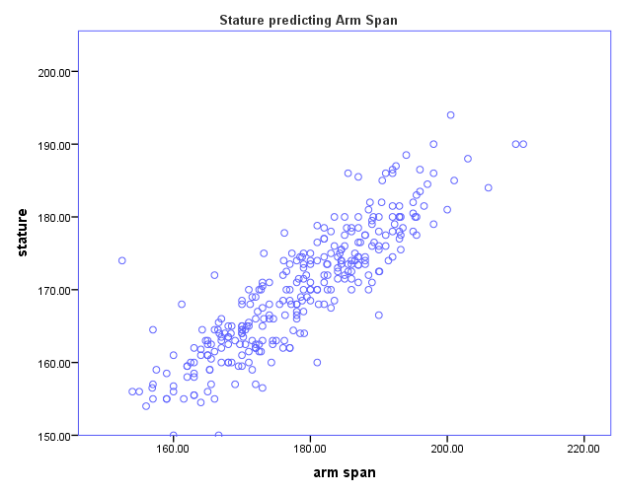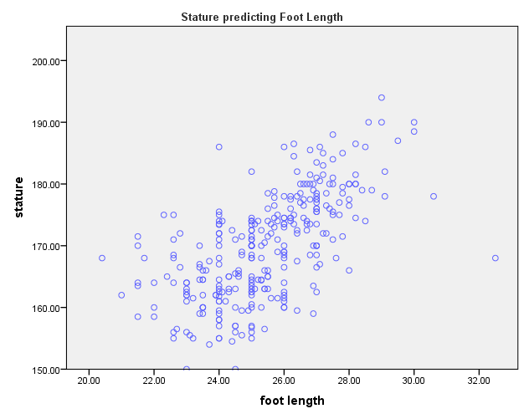

Fig 1. Showing stature, predicting arm span and foot length.

**5. CONCLUSION**

This study assesses stature estimation from arm span and foot length of the indigenous people of Imo State, Nigeria. This shows a strong positive correlation between the subjects. However, it was observed that arm span and foot length showed a positive correlation with stature in males but indicated a weak correlation in females. These findings will be useful in forensic sciences, anthropology, medical sciences and bioarchaeology.

**ETHICAL APPROVAL**

Ethical approval was obtained from the Research Ethics Committee at the University of Port Harcourt, Port Harcourt, Nigeria. (UPHCEREMAD/REC/MM/91/046). All subjects were adequately informed about the procedure of the studies, and they gave their consent in writing.

Disclaimer (Artificial intelligence)

Option 1:

Author(s) hereby declare that NO generative AI technologies such as Large Language Models (ChatGPT, COPILOT, etc.) and text-to-image generators have been used during the writing or editing of this manuscript.

Option 2:

Author(s) hereby declare that generative AI technologies such as Large Language Models, etc. have been used during the writing or editing of manuscripts. This explanation will include the name, version, model, and source of the generative AI technology and as well as all input prompts provided to the generative AI technology

Details of the AI usage are given below:

1.

2.

3.

**REFERENCES**

1. Choong CL, Alias A, Abas R, Wu YS, Shin JY, Gan QF, Thu KM, Choy KW. Application of anthropometric measurements analysis for stature in human vertebral column: a systematic review. Forensic Imaging. 2020 Mar 1;20:200360.
2. Rissech C. The importance of human anatomy in forensic anthropology. Eur J Anat. 2021;25(S2):1-8.
3. Baryah, N., Krishan, K., & Kanchan, T. (2019). The development and status of forensic anthropology in India: A review of the literature and future directions. *Medicine, Science and the Law*, *59*(1), 61-69.
4. Fawehinmi HB, Okoh PD, Oghenemavwe LE, Irozulike FC. Stature and Sex Estimation Using Anthropometric Parameters in the Yoruba Ethnic Group of Nigeria.
5. Iscan MY, Steyn M. The human skeleton in forensic medicine. Charles C Thomas Publisher; 2013 Sep 1.
6. Fawehinmi HB, Oghenemavwe LE, Okoh PD, Ebieto CE, Amadi MA, Irozulike FC. Stature Estimation Using Arm Span, Arm Length, Forearm-hand Length, and Foot Length of Hausa Ethnic Group of Nigeria. Asian Journal of Medical Principles and Clinical Practice. 2025 Feb 28;8(1):94-100.
7. Shah RK, Patel JP, Patel BG, Kanani SD, Patel MD. Estimation of Stature from Foot Length and Hand Length Measurements in Gujarat Region. National Journal of Integrated Research in Medicine. 2014 Nov 1;5(6).
8. Okoh PD, Fawehinmi HB, Oghenemavwe LE, Ebieto CE, Amadi MA, Irozulike FC. Discriminant and Multivariate Regression Analysis for Estimating Sex and Stature Model Using Upper Limb Anthropometric Measurements among the Yoruba Ethnic Group of Nigeria. Asian Journal of Advanced Research and Reports. 2025 Mar 26;19(4):41-8.
9. Oghenemavwe LE, Okoh PD, Irozulike FC, Amadi MA. Multivariate Regression Model for Stature Estimation from Arm Span, Horizontal Fingertip Reach and Foot Length of Igbo Ethnic Group of Nigeria. Journal of Complementary and Alternative Medical Research. 2024;25(8):112-7.
10. Hsieh MC, Zhu A, Lee YC. Stature estimation from various three-dimensional anthropometric foot measurements of Taiwanese female population. Legal Medicine. 2022 Feb 1;54:102000.
11. Koşar Mİ, Gençer CU, Tetiker H, Yeniçeri İÖ, Çullu N. Sex and stature estimation based on multidetector computed tomography imaging measurements of the sternum in Turkish population. Forensic Imaging. 2022 Mar 1;28:200495.
12. Dorjee B, Sen J. Estimation of stature from arm span, arm length and tibial length among Bengalee. Human Bio Review. 2016;5(2):128-45.
13. Oghenemavwe LE, Fawehinmi HB, Okoh PD, Nwofor PN, Asiwe N. Does Upper Arm Length, Arm Span, and Foot Length Serve as Good Predictors for Stature? A Cross-Sectional Study among Northern Nigerians. The foot.;5:10.
14. Debnath M, Khatun A. Estimation Of Stature Among Bengali Adolescents Using Arm Span And Arm Length: An Observational Study From North Bengal (West Bengal, India). Antrocom: Online Journal of Anthropology. 2024 Jan 1;20(1).
15. Chawla M, Tomar S, Ashoka R. The relationship between arm span and height in adult males of North Indian Punjabi population. Journal of Evolution of medical and Dental Sciences. 2013 Jan 28;2(4):332-41.
16. Agrawal V, Kumar S, Singh P, Bhardwaj K. Correlation of stature with arm span along with its significance in north Indian adult population. Indian Journal of Clinical Anatomy and Physiology. 2023 Jan 16;9(3):179-84.
17. Adebajo AO, Ojo GB, Adebajo KP, Ojo JH, Ayoade OH, Awolola AM, Uduakabong S. A model for the estimation of height and body mass index from arm span and to determine the socio-demographic characteristics cross-sectional study of Bowen University Students. Discover Psychology. 2024 Oct 7;4(1):130.
18. Satoh M, Hasegawa Y. Factors affecting prepubertal and pubertal bone age progression. Frontiers in Endocrinology. 2022 Aug 22;13:967711.
19. Bhattacharjee N, Maji S, Pal B, Goswami M. Understanding the role of ethnicity, age, sex and obesity on foot morphology: a systematic review. Papers on Anthropology. 2024 Nov 22;33(1):15-46.
20. Oghenemavwe LE, Egwede OB. Estimation of living stature from foot dimensions in uturu indigenes of Abia state, Nigeria. European Journal of Medical and Health Sciences. 2022 Feb 10;4(1):67-71.
21. Sen J, Ghosh S. Estimation of stature from foot length and foot breadth among the Rajbanshi: an indigenous population of North Bengal. Forensic Science International. 2008 Oct 25;181(1-3):55-e1.
22. Fitra, F., Azmi, A., Marbun, N. J., & Fathurrozi, N. A. (2021). Study Of Anthropometry And Ergonomics Of Desk And Chair Design For Elementary School (Case Study: Public Elementary School 008 Purnama). *Journal Of Industrial Engineering Management*, 170-175.
23. Padilla, C. J., Ferreyro, F. A., & Arnold, W. D. (2021). Anthropometry as a readily accessible health assessment of older adults. *Experimental Gerontology*, *153*, 111464.
24. Fawehinmi, H. B., Oghenemavwe, L. E., Okoh, P. D., Ebieto, C. E., Amadi, M. A., & Irozulike, F. C. (2025). Stature Estimation Using Arm Span, Arm Length, Forearm-hand Length, and Foot Length of Hausa Ethnic Group of Nigeria. *Asian Journal of Medical Principles and Clinical Practice*, *8*(1), 94-100.