Lignin-Derived Carbon Fibres: Opportunities and Challenges

## Abstract

Carbon fibre (Graphite fibre) remains an important polymer in many industries due to its high tensile strength, lightweight and its inability to rust. It is nearly five times stronger than steel, three times lighter, twice as stiff and has better yield strength. Because of this, many weight-bearing metals like steel and aluminium can be replaced by carbon fibre. This paper explores the opportunities and challenges of using lignin as a precursor for carbon fibre production. This review revealed that lignin is considered waste in paper mills as it does not create desirable paper qualities, so most paper mills burn the excess lignin for fuel. Because lignin is considered waste to the paper and biofuel industries, these industries would be willing to sell the lignin to a carbon fibre plant as long as there is a greater profit rather than burning the lignin to save some money on energy costs. Furthermore, it was found that blending lignin from a different species can improve the fibre spinning, stabilisation rates, and properties of lignin-based carbon fibres. Again, being able to synthesise carbon fiber from lignin could be a possible solution to help make carbon fiber less expensive and simultaneously be produced from renewable resources. The review also revealed that the latest technologies, such as electrospinning, melt-spinning, dry-spinning and wet-spinning, are used in the production of carbon fibre. In summary, using lignin as a precursor for carbon fiber production offers opportunities to lower costs, utilise a renewable resource, and address recycling challenges. This promotes more sustainable and economical manufacturing of carbon fibre.

***Keywords****: carbon-fibre production, lignin, polymers, electrospinning process*

INTRODUCTION

## Background On Carbon Fibre

Carbon fibre (CF) was first synthesised by the English scientist Joseph Swan in the 18th century (1860). Later, in 1879, the American scientist Thomas Edison showed a high-temperature cotton/bamboo CF produced by a carbonisation method. Typically, carbon fiber is defined as a fiber composed by long chains of carbon atoms, which consists of about 90 percent or more carbon such that the C-atoms are bonded with each other and have diameters in the range of 5 to 10 micrometers (Ali et al., 2021; Almushaikeh et al., 2023). CF, also known as Graphite fibre, remains an important polymer in many industries due to its high tensile strength, lightweight and its inability to rust. It is nearly five times stronger than steel, three times lighter, twice as stiff and has better yield strength [[1]](https://www.zotero.org/google-docs/?mPWDoX). Because of this, many weight-bearing metals like steel and aluminium can be replaced by carbon fibre. About 90% of carbon fibres are based on [polyacrylonitrile](https://www.sciencedirect.com/topics/chemical-engineering/polyacrylonitrile), while a small amount is based on rayon or petroleum pitch, notably some higher modulus grades. The cost of producing carbon fibres is highly determined by the cost of producing the precursor [PAN fibre](https://www.sciencedirect.com/topics/materials-science/polyacrylonitrile-fiber), about 50% (Peijs et al., 2022). As the price has been dropping steadily over the last couple of years, the demand has steadily grown as well. The global demand for carbon fibre has grown from 46,000 tons in 2011 to 140,000 tons in 2020 [[2]](https://www.zotero.org/google-docs/?mHDRFN). That being said, the price of carbon fibre is still significantly more expensive than steel and aluminium. This has led to the trend where products made with carbon fibre are significantly more expensive than the same items made with other materials. A good example of this is seen in the bicycle industry. Most bike frames are made out of either aluminium or steel. These bikes are in the $50-3,000 range. But if you were to buy a bike over $3,500, you would mostly find the frames to be made of carbon fibre, and these bikes can go up way higher, sometimes up to 10,000 to 15,000 dollars. The average person does not require a carbon fibre bike, but the people that do buy them are usually people who need the performance boost. This can be seen in many industries as well, including the automotive, fishing, sporting goods, and aerospace industries.

|  |  |  |  |  |
| --- | --- | --- | --- | --- |
| Material | Price per lb ($) | Tensile Strength (mPa) | Density (g/cc) | Modulus of Elasticity (Gpa) |
| Carbon Fiber | 12.00-15.00 | 2550 | 1.57 | 120 |
| Aluminum | 1.40-2.00 | 570 | 2.81 | 70.1 |
| Steel Alloy | .40-.80 | 1275 | 7.85 | 205 |

**Table 1.** Comparison of carbon fibre to its material competitors [[3]](https://www.zotero.org/google-docs/?vtjTya)

In the aerospace industry, carbon fibre and composites make up about 50% of the total number of parts, where a plane takes about 6 million parts to complete. Carbon fibre materials make up the fuselage, or main body, of the plane, as well as parts of the wings and tail. In addition to fuel efficiency, using carbon and other composite materials allows for less maintenance as they do not corrode or fatigue like metals do. Less maintenance means more flight time, making carbon fibre planes more profitable [[4]](https://www.zotero.org/google-docs/?fgXYXS). Carbon fibre is more aerodynamic than other metal composites used today in the industry. Replacing these composite parts with carbon fibre will reduce the total drag on the aircraft. The composite fabrication processes can produce very smooth geometries. And because of the stiffness of the composite, new commercial designs can be introduced that would be more aerodynamic and, in turn, reduce fuel usage. For example, swept wing designs (where the fuselage and wings blend together) in commercial aircraft would reduce fuel consumption by 5% by reducing aerodynamic drag and improving the lift-to-drag ratio. A carbon fibre plane can save up to 20% in the weight of a traditional aluminium plane [[5]](https://www.zotero.org/google-docs/?RM2wE8). This creates profound savings over the lifetime of the plane. For each kilogram of weight reduction, experts at NASA estimate a savings of about 1 million dollars over the total lifetime [[6]](https://www.zotero.org/google-docs/?dUvXaM).

The commercial use of carbon fibre in the aerospace industry would also contribute to lower manufacturing costs as carbon fibre is normally moulded, many parts can be combined on each mould, which means the sheer number of parts would significantly decrease, as well as manufacturing time. And because these parts will weigh less, fewer workers would be needed to assemble them.

## Why lignin?

Lignin is the second most abundant natural polymer found on Earth (Behind cellulose). Lignin is considered waste in paper mills as it does not create desirable paper qualities, so most paper mills burn the excess lignin for fuel. It is also considered a waste product in the ethanol industry. These two industries create about 100-120 million tons of lignin alone, which is all regarded as trash [[7]](https://www.zotero.org/google-docs/?bQ62nk). Although these industries consider them trash, there are still many potential applications that include lignin that could be converted to valuable products. Some applications include fuel additives, filler in cement, adhesives, surfactants and even could have a role in paper coatings as lignin is notoriously hydrophobic. There are plenty of potential uses which make lignin an incredibly diverse polymer. There are some companies already utilising this polymer, including Borregaard Lignotech and Rayonier, where they sell binding agents, dispersing agents, emulsion stabilisers, and complexing agents, all made from lignin [[8]](https://www.zotero.org/google-docs/?O1SuTs).

Because lignin is considered waste to the paper and biofuel industries, these industries would be willing to sell the lignin to a carbon fibre plant as long as there is a greater profit rather than burning the lignin to save some money on energy costs. Another solution would be to build a carbon fibre plant directly connected to the paper mill, which would allow the company to make more profits as it would be selling two materials: paper and carbon fibre.

There are four types of lignin, which come from what type of pulping the paper mill uses. There are Kraft lignin, Organosolv lignin, soda lignin, and lignosulfonates. These types of lignin are only relatively slightly different structurally from each other, but could lead to interesting outcomes during synthesis processes, especially for high-purity/quality products like carbon fibre.

**Fig 1. Comparison of common lignins** [**[9]**](https://www.zotero.org/google-docs/?hEQbYI)

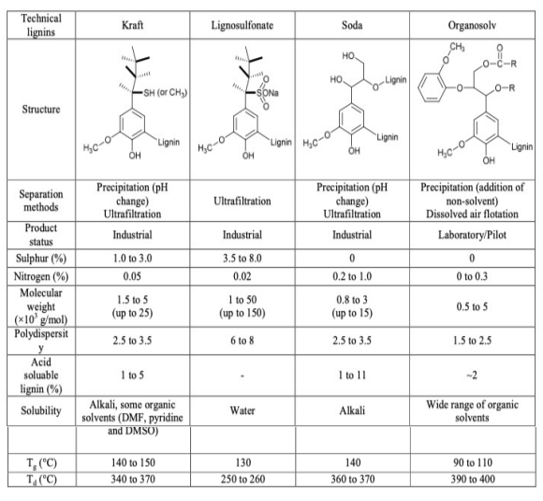

**Fig. 2. Mapping of lignin value vs. lignin-based product value by lignin type**

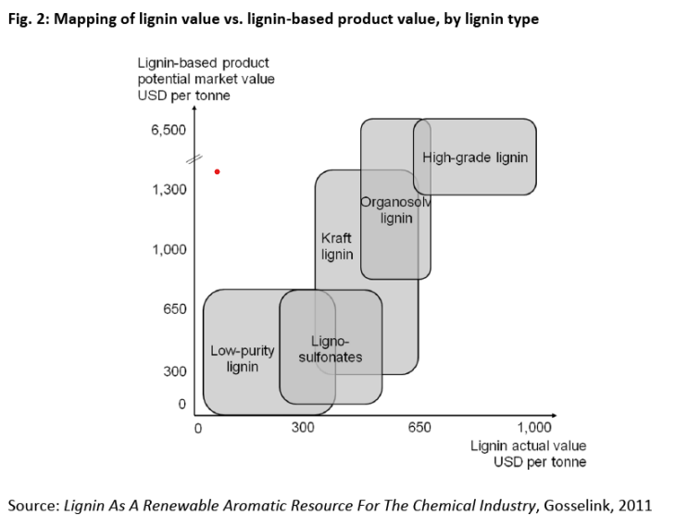

There are also slight differences inside lignin structures when they come from hardwood vs. softwood trees. Hardwood lignin is less condensed, more soluble and less stable than softwoods. This is due to softwoods' higher -OH count, a lower amount of β-O-4’ bonding, and higher molecular mass. It is important to note that β-O-4’ bonding contributes to roughly 50% of the total bonds in softwood lignin and 60% in hardwood lignin. β-O-4’ bonding is the most common bond inside lignin. The rest of the bonding can contribute 0.5-15% of its total bonds, although more research is required because these percentages are highly debated [[10]](https://www.zotero.org/google-docs/?2KrNf8). These bonds can be seen in Figure 4.

## Potential Issues with Lignin

Lignin is made up primarily of H, G, and S units.

**Fig 3.** Monomer units that make up lignin [[11]](https://www.zotero.org/google-docs/?Rv86FC) **Fig. 4.** Bonds between monomer units [[12]](https://www.zotero.org/google-docs/?GiiJG5)

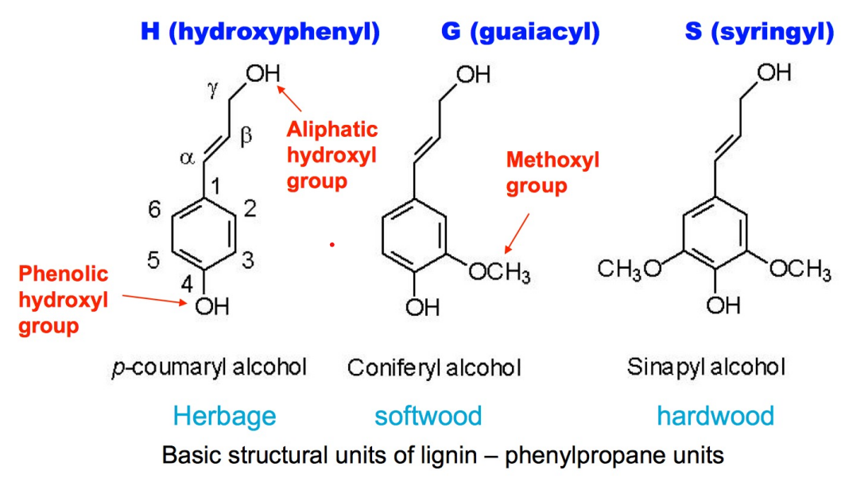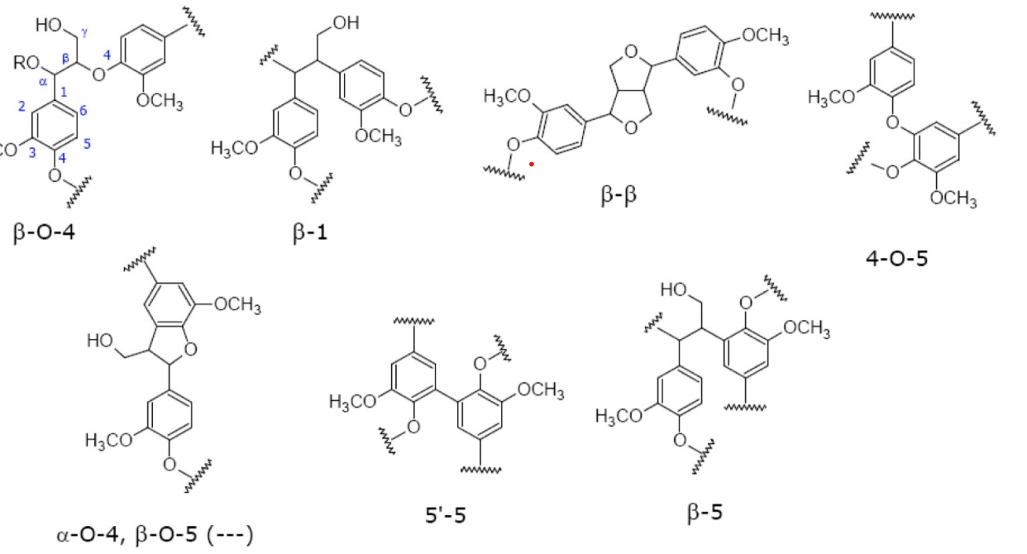

|  |  |  |  |
| --- | --- | --- | --- |
| Lignin Units | Herbaceous | Softwoods | Hardwoods |
| H Unit | 10-25% | .5-3.5% | Trace |
| G Unit | 25-50% | 90-95% | 25-50% |
| S Unit | 25-50% | 0-1% | 50-75% |

**Table 2.** Percentages of the monomer units that make up lignin [[13]](https://www.zotero.org/google-docs/?sT7mux)

There are also many different types of bonds between each of these units, which can be seen in the figure above. Lignin usually has at least one per cent composition of all of the bonds seen in the above figure in each polymer, no matter which plant the lignin came from. This creates a heterogeneous polymer that has a complex structure and linkages, multiple monomers, and multiple linkages. This could lead to impurities when trying to synthesise lignin into carbon fibre. The way carbon fibre is made normally is from the synthetic, homogeneous polymer polyacrylonitrile (PAN) and only requires heat to synthesise into carbon fibres. But because of the homogeneity of the polymer, it allows for very little amounts of impurities as long as the PAN has time to complete the reaction [[14]](https://www.zotero.org/google-docs/?8z73Mx).

Lignin may contain units which are not produced from lignin precursors known as cinnamyl alcohols. These include dihydroconiferyl alcohol, vanillin, and coniferaldehyde. These units have their own usage in various industries when isolated, but increase the number of impurities that could introduce issues during the synthesis of carbon fibre. These impurities will most likely negatively affect many of the desirable properties. Impurities can prevent fusion and flow during melt-spinning, cause defects on the surface of carbon fibres, and decrease fibre carbon yield. It was found that blending lignin from a different species can improve the fibre spinning, stabilisation rates, and properties of lignin-based carbon fibres [[15]](https://www.zotero.org/google-docs/?5sW9vi).

## Recycling Carbon Fibre

Being able to synthesise carbon fiber from lignin could be a possible solution to help make carbon fiber less expensive and, simultaneously, be produced from renewable resources. Lignin is the second most common polymer found in nature. Still, current technologies require 14 times the energy to create carbon fibre than steel. But carbon fibre typically has a much longer life cycle, meaning it has to be replaced less often than counterpart steel counterparts. Steel does have the advantage of being recyclable indefinitely [[16]](https://www.zotero.org/google-docs/?jgH2j7). Carbon fibre is harder to recycle as it is usually made into composites, creating an issue where it is difficult to separate the initial materials without damaging the fibres. Currently, carbon fibre is recycled either through the process of pyrolysis or solvolysis. Pyrolysis is the process of thermochemically decomposing the organic part of the composite material between 450-700 degrees Celsius with little to no oxygen. Solvolysis is the use of a chemical treatment to degrade the organic part of the composite. The recycled fibres do change their properties, which would change the usage of recycled fibres vs virgin fibres. With current technology, pyrolysis and solvolysis maintain 50-85% of the tensile strength from the original fibres [[17]](https://www.zotero.org/google-docs/?2VXIll).

## How is carbon fibre made?

There are two ways that carbon fibre is currently produced in the market. The process where about 90% of the total carbon fibre is created comes from the synthetic polymer polyacrylonitrile (PAN), which is a synthetic thermoplastic polymer. It is unclear what happens in the process, but it is thought that the heat causes the cyano repeat units to form cycles. PAN is converted to carbon fibre in 3 main stages of heating. Once from about 200°C to 700°C. And once more at 400-600°C. In this stage, a double bond between 2 carbon atoms is added, which makes each pyridine ring contain 2 double bonds. And another time from 600 to up to 1300°C. Each cycle allows the polymer to form a sheet rather than a single chain. When the individual fibres form sheets, the nitrogens get replaced by carbon atoms and are released as N2 gas. When this happens, we are left with pure carbon in the graphite form, except for the outsides of the sheet where a single nitrogen atom is left over [[18]](https://www.zotero.org/google-docs/?M622qV). This can be seen in Figure 5.

**Fig 5.** Derivation of carbon fibre from PAN [[19]](https://www.zotero.org/google-docs/?YyKrWl)

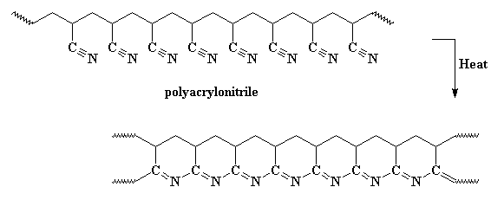

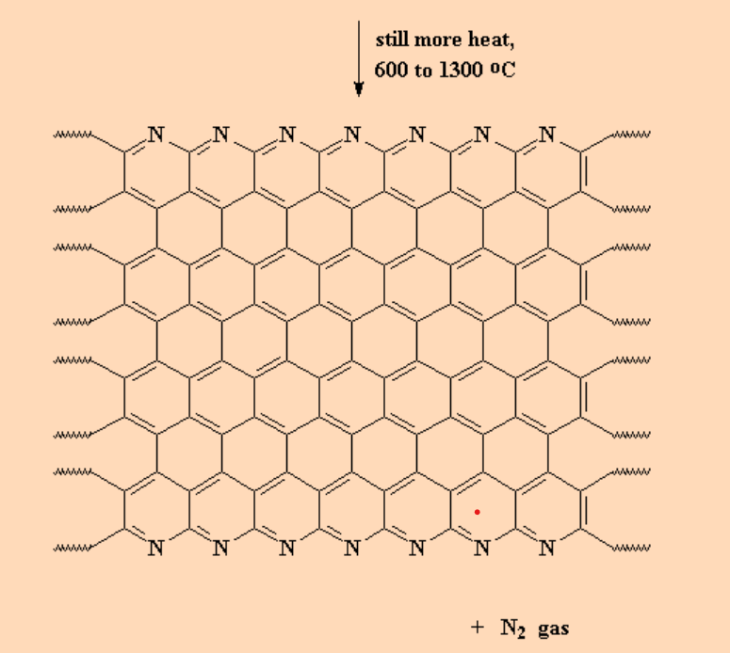

The other 10% comes from rayon or petroleum pitch. Pitch is known to have more benzene-like carbon structures than PAN, which causes the carbon fibre formed from these processes to form better sheets than carbon fibre formed from PAN, where these carbon fibres are more granular. Pitch fibres are generally more crystalline than PAN fibres, which allows Carbon fibre derived from pitch to be generally stiffer but more brittle, more expensive to produce, and contain a higher electrical/thermal conductivity. There are fewer makers of pitch fibres as most companies do not have access to an oil refinery. It is also important to note that carbon fibre from pitch requires much higher heat than PAN fibres. PAN fibres require a temperature of 1300°C, whereas pitch fibres require 2500-3000°C [[20]](https://www.zotero.org/google-docs/?Sa4nc6). It is commonly seen that these two different carbon fibres are mixed together to form a composite to influence the stiffness and strength.

**Figure 6.** Summary of the petroleum pitch process [[21]](https://www.zotero.org/google-docs/?9GlPmt)

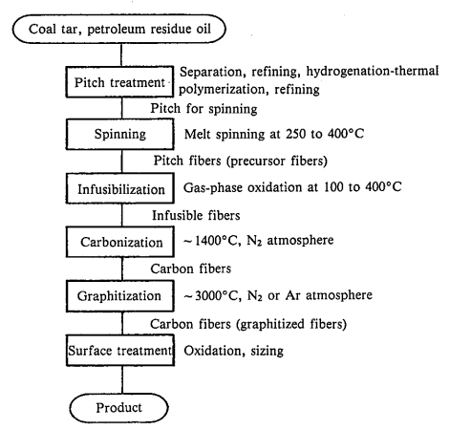

The current technology used that yields the best results is called electrospinning. This process only requires a syringe, a pump, a high-voltage power source, and a collector. In our case, the lignin would be pumped out at a constant rate from the syringe. The added voltage changes the shape of the fibre and creates a Taylor cone. The fibre will eject sporadically, forming no shape, which would just leave a non-woven fibre mat. The fibre would then need to be woven in another process to form a carbon fibre sheet. The fibres would then need to be coated to protect them from damage and unravelling. The coatings that are typically used with regular carbon fibre are epoxy, polyester, nylon, and urethane [[22]](https://www.zotero.org/google-docs/?KfmwSg).

**Fig. 7.** Basics of the Electrospinning Process [[23]](https://www.zotero.org/google-docs/?Zywz6o)

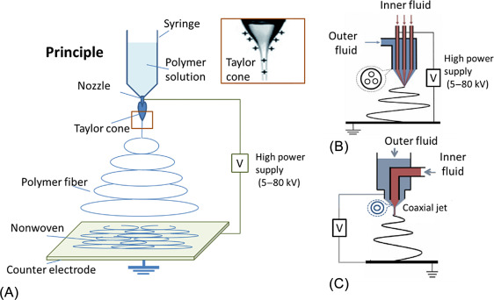

Melt-spinning is another alternative to electrospinning. This method is commonly used to manufacture fibreglass. Melt-spinning requires lignin to be fusible and without undergoing extensive thermal-induced depolymerisation. Depolymerisation would lead to pores on the surface of the fibres. Hardwood lignin, especially Organosolv lignin, has been shown to exhibit greater thermal mobility and better spinnability, while lignin from softwoods and herbaceous plants has better performance during thermostabilization and conversion processes. Organosolv lignin, because of its lower number of hydroxyl groups and phenolic acid chains, presented better spinnability. It was found that lignin with a higher concentration of G units limited the thermal mobility and caused issues during spinning. But the thermal stabilisation was faster, which reduced the carbon fibre production time.

Melt-spinning is a relatively simple process where the molten polymer is forced through a die at high pressure and elongated to form thin fibres. Fibres can be extruded in parallel to make the process take less time and therefore become more energy efficient. When the fibres hit the cool air, they will solidify. The basic requirement to be able to use the melt-spinning process is for the polymer/s being used to be easily meltable. Melt-spinning emits polymer at a speed anywhere between 825- 4500 ft/min [[24]](https://www.zotero.org/google-docs/?TTi9Gd).

**Fig 8.** Outline of the melt-spinning process [[25]](https://www.zotero.org/google-docs/?sVFVhh)

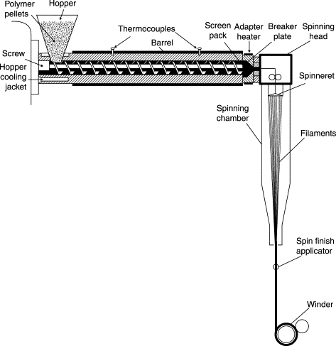

Dry-spinning and wet-spinning are used for polymers that need to be dissolved in a solvent. Both methods could be useful in laboratory settings, but because they only emit polymer at a speed of 210-1200 feet per minute and require the use of solvents that would most likely be flammable and require extra washing, these processes would not be useful in a scale-up operation[[26]](https://www.zotero.org/google-docs/?9WcqbQ),[[27]](https://www.zotero.org/google-docs/?1im6nm).

**Conclusion**

In summary, using lignin as a precursor for carbon fibre production offers opportunities to lower costs, utilise a renewable resource, and address recycling challenges. This promotes more sustainable and economical manufacturing of carbon fibre.

Disclaimer (Artificial intelligence)

Option 1:

Author(s) hereby declare that NO generative AI technologies such as Large Language Models (ChatGPT, COPILOT, etc.) and text-to-image generators have been used during the writing or editing of this manuscript.

Option 2:

Author(s) hereby declare that generative AI technologies such as Large Language Models, etc. have been used during the writing or editing of manuscripts. This explanation will include the name, version, model, and source of the generative AI technology and as well as all input prompts provided to the generative AI technology

Details of the AI usage are given below:

1.

2.

3.

References

[[1] F. Yin, “Can Carbon Fiber replace Steel in Automotive &Aerospace machining | LinkedIn.” Accessed: Dec. 18, 2023. [Online]. Available: https://www.linkedin.com/pulse/can-carbon-fiber-replace-steel-automotive-aerospace-machining-yin/](https://www.zotero.org/google-docs/?5KpYIF)

[[2] “Future of Carbon Fiber | ZOLTEK Corporation.” Accessed: Dec. 18, 2023. [Online]. Available: https://zoltek.com/carbon-fiber/the-future-of-carbon-fiber/](https://www.zotero.org/google-docs/?5KpYIF)

[[3] “Online Materials Information Resource - MatWeb.” Accessed: Apr. 28, 2025. [Online]. Available: https://www.matweb.com/](https://www.zotero.org/google-docs/?5KpYIF)

[[4] McCaw, Billy, “Carbon FIber in Aerospace Applications,” *PCMI MFG*, [Online]. Available: https://www.pcmi-mfg.com/blog/carbon-fiber-in-aerospace-applications#:~:text=Carbon%20fiber%20materials%20make%20up,or%20fatigue%20like%20metals%20do](https://www.zotero.org/google-docs/?5KpYIF)

[[5] “(PDF) Advanced Composite Materials for Aerospace Applications.” Accessed: Apr. 28, 2025. [Online]. Available: https://www.researchgate.net/publication/383874153_Advanced_Composite_Materials_for_Aerospace_Applications](https://www.zotero.org/google-docs/?5KpYIF)

[[6] “NASA.” Accessed: Apr. 28, 2025. [Online]. Available: https://www.nasa.gov/](https://www.zotero.org/google-docs/?5KpYIF)

[[7] “Lignin Valorization: Improving Lignin Processing in the Biorefinery | Science.” Accessed: Apr. 28, 2025. [Online]. Available: https://www.science.org/doi/10.1126/science.1246843](https://www.zotero.org/google-docs/?5KpYIF)

[[8] “Borregaard and rayonier invest in new lignin operation.” Accessed: Apr. 28, 2025. [Online]. Available: https://www.borregaard.com/company/news-archive/borregaard-and-rayonier-invest-in-new-lignin-operation](https://www.zotero.org/google-docs/?5KpYIF)

[[9] W. Yang, Y. Zhu, Q. Wang, R. Ou, and P. Ma, “Chapter 14 - Biopolymer/nanolignin films with enhanced toughness,” in *Micro and Nanolignin in Aqueous Dispersions and Polymers*, D. Puglia, C. Santulli, and F. Sarasini, Eds., Elsevier, 2022, pp. 433–458. doi: 10.1016/B978-0-12-823702-1.00008-6.](https://www.zotero.org/google-docs/?5KpYIF)

[[10] “Lignin, the Lignification Process, and Advanced, Lignin-Based Materials.” Accessed: Apr. 28, 2025. [Online]. Available: https://www.mdpi.com/1422-0067/24/14/11668](https://www.zotero.org/google-docs/?5KpYIF)

[[11] madshansen, “BIOFUELS AND THE PROSPECT OF CONVERTING PLANT FIBRES INTO GASOLINE USING ENZYMES | SCQ.” Accessed: Apr. 28, 2025. [Online]. Available: https://www.scq.ubc.ca/biofuels-and-the-prospect-of-converting-plant-fibres-into-gasoline-using-enzymes/](https://www.zotero.org/google-docs/?5KpYIF)

[[12] A. T. Ogunbiyi, W. Li, and B. Zhang, “6 - Chemo-catalytic conversion of lignin,” in *Biomass, Biofuels, Biochemicals*, T. Bhaskar and A. Pandey, Eds., Elsevier, 2021, pp. 109–128. doi: 10.1016/B978-0-12-820294-4.00003-X.](https://www.zotero.org/google-docs/?5KpYIF)

[[13] “1 Lignocellulose and lignin composition for softwoods, hardwoods, and... | Download Table.” Accessed: Apr. 28, 2025. [Online]. Available: https://www.researchgate.net/figure/Lignocellulose-and-lignin-composition-for-softwoods-hardwoods-and-grasses-21-33_tbl1_318158851](https://www.zotero.org/google-docs/?5KpYIF)

[[14] “Carbon Fibers: Formation, Structure, and Properties.” Accessed: Apr. 28, 2025. [Online]. Available: https://www.researchgate.net/publication/327529967_Carbon_Fibers_Formation_Structure_and_Properties](https://www.zotero.org/google-docs/?5KpYIF)

[[15] “Lignin-based carbon fiber: A current overview | Request PDF.” Accessed: Apr. 28, 2025. [Online]. Available: https://www.researchgate.net/publication/324044589_Lignin-based_carbon_fiber_A_current_overview](https://www.zotero.org/google-docs/?5KpYIF)

[[16] “Comparative life cycle assessment of carbon fiber reinforced compositecomponents for automotive industry | Request PDF,” ResearchGate. Accessed: Apr. 28, 2025. [Online]. Available: https://www.researchgate.net/publication/350862535_Comparative_life_cycle_assessment_of_carbon_fiber_reinforced_compositecomponents_for_automotive_industry](https://www.zotero.org/google-docs/?5KpYIF)

[[17] S. Pimenta and S. T. Pinho, “Recycling carbon fibre reinforced polymers for structural applications: Technology review and market outlook,” *Waste Manag.*, vol. 31, no. 2, pp. 378–392, Feb. 2011, doi: 10.1016/j.wasman.2010.09.019.](https://www.zotero.org/google-docs/?5KpYIF)

[[18] “(PDF) Structural Evolution of Polyacrylonitrile Fibers in Stabilization and Carbonization,” *ResearchGate*, doi: 10.4236/aces.2012.22032.](https://www.zotero.org/google-docs/?5KpYIF)

[[19] “ISTF2006: Carbon Fiber.” Accessed: Apr. 28, 2025. [Online]. Available: http://mainland.cctt.org/istf2006/Carbon_Fiber.asp](https://www.zotero.org/google-docs/?5KpYIF)

[[20] “Carbon Fibers From Pan and Pitch,” ResearchGate. Accessed: Apr. 28, 2025. [Online]. Available: https://www.researchgate.net/publication/251160400_Carbon_Fibers_From_Pan_and_Pitch](https://www.zotero.org/google-docs/?5KpYIF)

[[21] “The main processes in the production of carbon fibers from coal and /... | Download Scientific Diagram.” Accessed: Apr. 28, 2025. [Online]. Available: https://www.researchgate.net/figure/The-main-processes-in-the-production-of-carbon-fibers-from-coal-and-or-petroleum-pitch_fig2_356635895](https://www.zotero.org/google-docs/?5KpYIF)

[[22] “Electrospun Carbon Nanofibers and Their Applications in Several Areas | ACS Omega.” Accessed: Apr. 28, 2025. [Online]. Available: https://pubs.acs.org/doi/10.1021/acsomega.3c01114](https://www.zotero.org/google-docs/?5KpYIF)

[[23] B. Joshi, E. Samuel, Y. Kim, A. L. Yarin, M. T. Swihart, and S. S. Yoon, “Progress and potential of electrospinning-derived substrate-free and binder-free lithium-ion battery electrodes,” *Chem. Eng. J.*, vol. 430, p. 132876, Feb. 2022, doi: 10.1016/j.cej.2021.132876.](https://www.zotero.org/google-docs/?5KpYIF)

[[24] “A Review on Melt-Spun Biodegradable Fibers.” Accessed: Apr. 28, 2025. [Online]. Available: https://www.mdpi.com/2071-1050/15/19/14474](https://www.zotero.org/google-docs/?5KpYIF)

[[25] A. Rawal and S. Mukhopadhyay, “4 - Melt spinning of synthetic polymeric filaments,” in *Advances in Filament Yarn Spinning of Textiles and Polymers*, D. Zhang, Ed., Woodhead Publishing, 2014, pp. 75–99. doi: 10.1533/9780857099174.2.75.](https://www.zotero.org/google-docs/?5KpYIF)

[[26] Y. Imura, R. M. C. Hogan, and M. Jaffe, “10 - Dry spinning of synthetic polymer fibers,” in *Advances in Filament Yarn Spinning of Textiles and Polymers*, D. Zhang, Ed., Woodhead Publishing, 2014, pp. 187–202. doi: 10.1533/9780857099174.2.187.](https://www.zotero.org/google-docs/?5KpYIF)

[[27] A. Rohani Shirvan, A. Nouri, and A. Sutti, “A perspective on the wet spinning process and its advancements in biomedical sciences,” *Eur. Polym. J.*, vol. 181, p. 111681, Dec. 2022, doi: 10.1016/j.eurpolymj.2022.111681.](https://www.zotero.org/google-docs/?5KpYIF)

[28] Peijs, T., Kirschbaum, R., & Lemstra, P. J. (2022). A critical review of carbon fiber and related products from an industrial perspective. *Advanced Industrial and Engineering Polymer Research*, *5*(2), 90-106.

[29] Ali, Z., Gao, Y., Tang, B., Wu, X., Wang, Y., Li, M., ... & Yu, J. (2021). Preparation, properties and mechanisms of carbon fiber/polymer composites for thermal management applications. *Polymers*, *13*(1), 169.

[30] Almushaikeh, A. M., Alaswad, S. O., Alsuhybani, M. S., AlOtaibi, B. M., Alarifi, I. M., Alqahtani, N. B., ... & Alshammari, B. A. (2023). Manufacturing of carbon fiber reinforced thermoplastics and its recovery of carbon fiber: A review. *Polymer Testing*, *122*, 108029.