Lignin Derived Chemicals and Aromatics

# Abstract

Cellulose makes up roughly 45% of a tree, which also puts it in first place for the most widely abundant natural polymer on Earth. For this reason, lignin will be removed from the biomass before processing. Lignin is the second most abundant natural polymer on Earth, making up 18-30% of woody biomass. The two processes that create the most desirable properties for lignin valorization projects are the Sulfite Process and the Organosolv Process as they lead to the least amount of lignin degradation although Kraft Process is the most popular method, with 85% of pulp mills going through with this process. Bio-based polyols are important because these are the precursors to polyurethane. Polyurethane is one of the most versatile plastics in the world, with uses in the automobile, coatings, adhesives, sealants, paints, textile, wood composites, and more. Looking at the applications, adhesives and binding were by far the largest use case for this class of resins and is projected to grow more than other applications with the electrical and electronics industry being the most lucrative market for their usage in photoresists and circuit boards, closely followed by the automotive industry.Keywords: Cellulose, Organosolv Process, automotive industry, Polyurethane

# Introduction

Environmental concerns are steadily rising and new technologies and alternatives have been gradually developing, although we oftentimes see a conflicting issue where the environmental alternative is oftentimes more expensive and resource intensive to produce than the original product. Although there can be a significant environmental benefit for switching from the original products, consumers are oftentimes shunned away from the significant price increase that comes with the environmentally friendly alternative. One of the longest surviving industries that use renewable resources is the paper industry. Although in most virgin paper mills, only the cellulose is desirable for paper products. Cellulose makes up roughly 45% of a tree, which also puts it in first place for the most widely abundant natural polymer on Earth. For this reason, lignin will be removed from the biomass before processing. Lignin is the second most abundant natural polymer on Earth, making up 18-30% of woody biomass [[1]](https://www.zotero.org/google-docs/?0UusnE).

***Table 1.*** *Composition of lignocellulosic biomass in various feedstocks* [*[2]*](https://www.zotero.org/google-docs/?Sa9fpS)

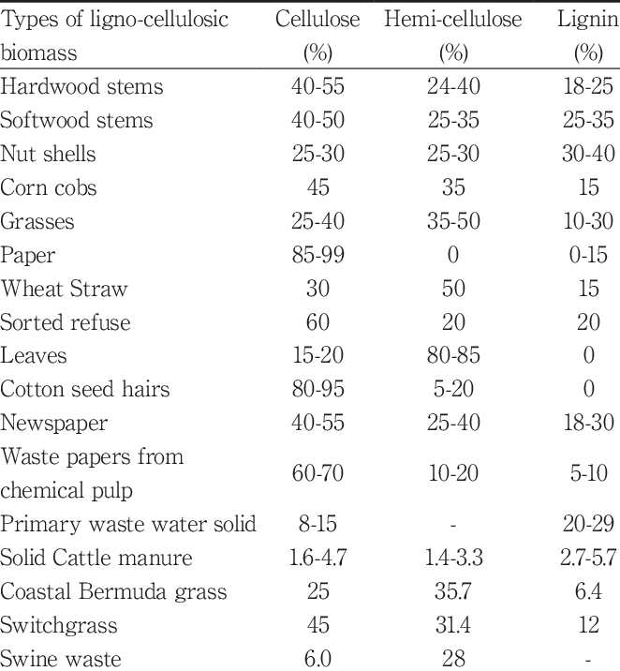

This lignin is almost always burned as a fuel source for the paper mill to save money on electricity. The exact savings is kept secret by each company. Nevertheless, we know that it only makes up a tiny fraction of what paper mills use each year. Although this is beneficial to the mill to use lignin as a fuel source, it only makes up for a fraction of the electricity they use. Another alternative that many large paper companies have been researching is to utilize lignin to create alternatives to products like carbon fiber, plastics, biochar, and many chemicals and aromatics like phenolic compounds, polyols, vanillin, fuel additives, and aromatics in fragrances.

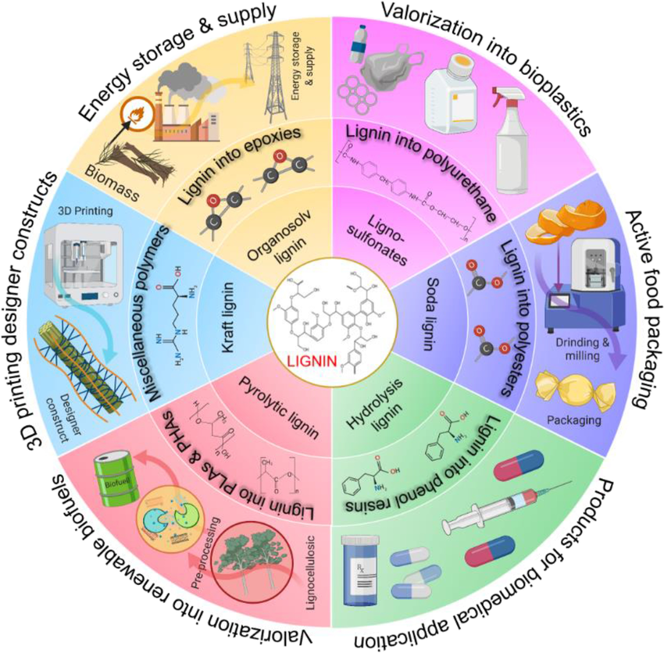

***Fig 1.*** *Comprehensive utilization pathways of lignin* [*[3]*](https://www.zotero.org/google-docs/?DytWLP)

These compounds can all be created although there are some potential issues that need to be explored. Lignin is a great way to produce aromatic compounds although most lignin depolymerization techniques create a mixture of impurities that hinder the full production of the necessary aromatic compound or hinder its attainment of the desired properties. The current methods also lead to the lignin becoming degraded [[4]](https://www.zotero.org/google-docs/?O1ybQM). The two processes that create the most desirable properties for lignin valorization projects are the Sulfite Process and the Organosolv Process as they lead to the least amount of lignin degradation although Kraft Process is the most popular method, with 85% of pulp mills going through with this process. This method has a more efficient chemical recovery process than other methods, which tells of its popularity [[5]](https://www.zotero.org/google-docs/?Irw0SE). There has been a big push in the US to discover better ways to separate and recover lignin for the purposes of utilization for aromatic compounds. Lignin can be utilized more effectively than ever before and we can see startups have been beginning to pop up and large corporations funding a large variety of lignin research and development projects.

# Vanillin

It was stated that lignin can be used as a precursor to make molecules such as phenolic compounds, polyols, fuel additives, and aromatics in fragrances.

The most popular phenolic compound produced from trees is vanillin (C8H8O3). Regardless, only 15% of vanillin is produced from wood sources with the rest being artificial vanillin from fossil fuels [[6]](https://www.zotero.org/google-docs/?dqcSGD). Less than 1% of all the vanillin is produced from natural vanilla plants [[7]](https://www.zotero.org/google-docs/?DiKE7K). The problem with producing vanillin from natural sources, is that the price of vanilla is high and has a high number of price fluctuations. Vanillin costs 10-20 $/kg to produce artificially whereas natural vanillin can be bought for 1500-2000 $/kg. Synthetic vanillin is also more concentrated which makes synthetic vanillin a very good choice for considerable cost savings [[8]](https://www.zotero.org/google-docs/?akZPLu).

Vanillin is usually used as a sweetener/flavoring and can be used as a precursor to others as well including ginger flavoring (zingerone) and jasmine oil. It is also sometimes used as an aromatic in deodorants, cologne, etc [[7]](https://www.zotero.org/google-docs/?680J7z).

Artificial vanillin is produced through a chemical synthesis reaction from guaiacol or lignin. It is said that vanillin produced from lignin has a richer overall taste from the other natural molecules that come from trees. A major problem with all of these processes regardless is that they are artificial processes, which means many food safety organizations restrict its use in many food products. Lignin produced vanillin is currently the most practical way to circumvent this issue [[9]](https://www.zotero.org/google-docs/?lDtfDf).

In the Guaiacol reaction, benzene is converted to guaiacol, and then is reacted with glyoxylic acid which will form vanillin. There are many reaction steps involved which makes the process fossil fuel intensive and is known to generate toxic byproducts [[9]](https://www.zotero.org/google-docs/?HH9Mt7). This is currently how 95% of the vanillin is produced globally [[10]](https://www.zotero.org/google-docs/?6lpOcC). It is also important to note that because Guaiacol is a petrochemical, vanillin produced with this method will be subject to price fluctuations that follow the trends of global oil prices.

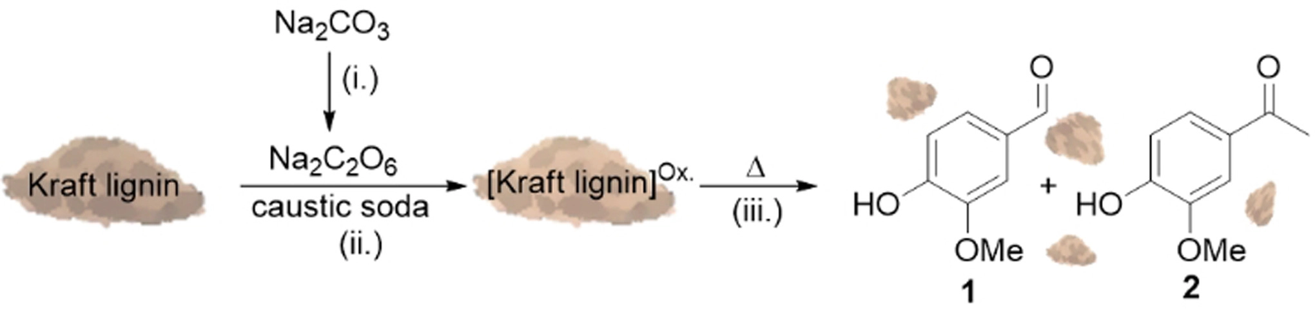

***Fig 2.*** *Schematic of the chemical process of Kraft lignin into vanillin* [*[11]*](https://www.zotero.org/google-docs/?CfGY9b)

There is currently just one company, Borregaard, that produces vanillin from lignin. Nevertheless Borregaard is the second largest producer of vanillin. They produce all of it from Norway Spruce wood and is used after the Sulfite pulping process from paper mills. From the Guaiacol process, we see there is a 90% reduction in CO2 emissions [[12]](https://www.zotero.org/google-docs/?2z2vzB). In this process they produce the vanillin through a lignin oxidation reaction however the reaction is complex and is not fully understood yet.

More research is being done on trying to complete a reaction that is more successful than Borregaards’ with Kraft pulp as kraft pulp is the majority of what paper mills use today at roughly 90%. There are many ways that this can be completed although the pressing issue that Kraft lignin has is that the water consumption to get our finished product is much higher than the Sulfite lignin [[13]](https://www.zotero.org/google-docs/?hWZnC0). Kraft pulp is associated with “Black Liquor” which is a mixture of chemicals that are required for the Kraft Pulping Process to separate the lignin from the celluloses and hemicelluloses. It is harder to fully separate the lignin from these chemicals and Kraft lignin tends to be slightly more degraded from these chemicals than the sulfite pulp. Researchers are on the move to figure out how to fractionate kraft lignin more effectively in turn to reduce water consumption for more efficient lignin valorization processes [[14]](https://www.zotero.org/google-docs/?V5sIa7).

## 3.1 Vanillin Market

The global market is estimated to be somewhere between $400-700 million and growing with a calculated annual growth rate (CAGR) of 8.4%. From this entire market, 65% is held by two corporations, Givaudan and Solvay. This market exhibits an oligopoly as only a small number of competitors saturate the entire market.

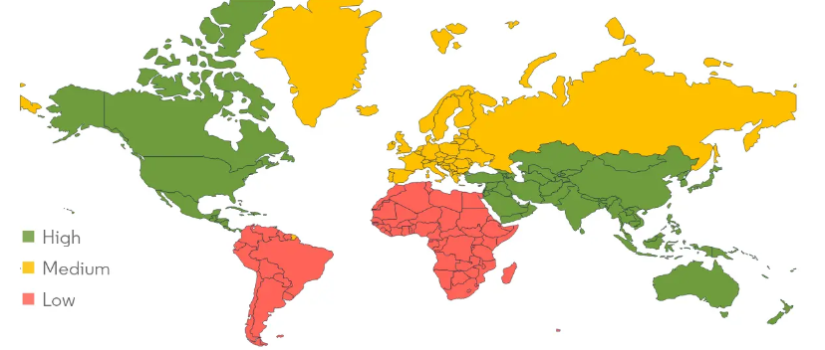

***Fig 3.*** *Heat map of the bio-based vanillin market size by region in 2022* [*[15]*](https://www.zotero.org/google-docs/?jxrIyR)

Borregaard, being the only supplier of lignin derived vanillin, holds a complete monopoly over that market. 60% of all industrial vanillin is used in the food industry, 33% in fragrances, and 7% are used in pharmaceuticals. It is important to note that although North America and Europe have a larger demand for vanillin, the growth rate of China’s demand of 10% annually is opening up new niche markets that were not normally attainable before. With this growth rate, roughly 100 million new consumers per year are coming into play [[16]](https://www.zotero.org/google-docs/?bwb1eQ).

# Polyols

Polyols ((CHOH)nH₂) or more specifically Lignin-Based Polyols (LBPs) are used to make a couple things like sealant, binders, resins, but most importantly; bio-based polyurethane and polyurethane foams. Polyols can be split into two categories; High molecular weight and low molecular weight. High molecular weight polyols will create a more flexible plastic as the degree of crosslinking is lessened [[17]](https://www.zotero.org/google-docs/?3Ub7aY). Current technology allows a 30% replacement of the petro polyol in polyurethane foams. It was also found that overall the most desired properties were lignins from Organosolv Hardwood lignins [[18]](https://www.zotero.org/google-docs/?AVucDH).

Bio-based polyols are important because these are the precursors to polyurethane. Polyurethane is one of the most versatile plastics in the world, with uses in the automobile, coatings, adhesives, sealants, paints, textile, wood composites, and more [[19]](https://www.zotero.org/google-docs/?5igfUA). Globally, it is estimated that 25.78 million metric tons of polyurethane are produced annually [[20]](https://www.zotero.org/google-docs/?E85iS5). To put this in perspective a mere 104,000 metric tons of carbon fiber are produced annually [[21]](https://www.zotero.org/google-docs/?A4yIf9). Regularly produced polyurethane has two primary ingredients; isocyanate and polyol. These two molecules will then be mixed with a catalyst or blowing agent to complete the reaction for polyurethane that requires crosslinking between each other [[22]](https://www.zotero.org/google-docs/?BwjXEe). More polyols in the mixture means that the plastic will be softer, more flexible, and more hydrophilic [[17]](https://www.zotero.org/google-docs/?3G8ow2).

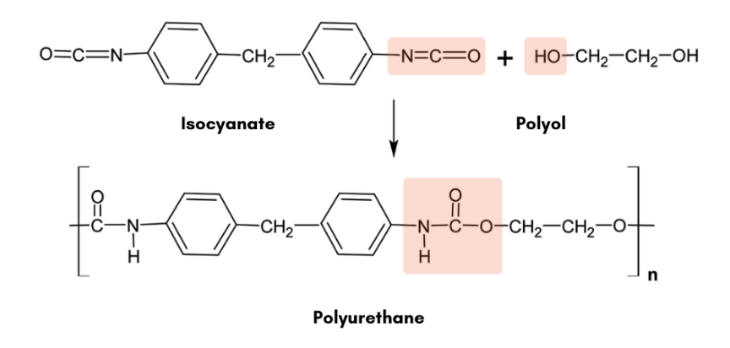

***Fig 4.*** *Synthesis of polyurethane from Isocyanate and Polyol* [*[23]*](https://www.zotero.org/google-docs/?pChc8j)

They have a unique problem for why there is not as much widespread use. They emit a nasty odor that makes people extremely uninterested. The smell comes from the process used to remove the lignin from the celluloses in the paper mills where lignin containing sulfur will have a less pleasurable smell. Kraft lignin has a more burnt smell to it while soda pulp smells more like hay. These smells come from the impurities left over even after the industrial grade washing. Improvements to the fractionation of lignins will surely begin to solve this issue [[24]](https://www.zotero.org/google-docs/?JQmXFd). There is an extra issue with lignins containing sulfur like Kraft lignin and Sulfite lignin where yellowing is more likely to occur, notably in coating applications particularly. Removing the sulfur will not be economical so for many applications, sulfur free lignin (Organosolv) will most likely produce a more desirable product. Furthermore, lignin is notoriously brown in color, which in turn will make the polyols slightly brown, which may not be desirable in certain applications where color is an important component [[25]](https://www.zotero.org/google-docs/?blrOKN).

There are some other unique issues that come up that are prevalent with lignin derived polyols. The ability of the hydroxyl groups in lignin to react with isocyanate may be limited because of the crowded structure caused by the arrangement of molecules and the possible sticking together of lignin. This makes it challenging for isocyanates to reach and interact with the hydroxyl groups in lignin [[26]](https://www.zotero.org/google-docs/?4Jxc8p). Additionally, depending on the different types of alcohol hydroxyl functionalities, (primary (1°), secondary (2°), and phenolic (Ph), the alcohol will react differently to the isocyanate group. The reaction rate shows that primary alcohols react the fastest while phenolic alcohols are the slowest. The phenolic alcohols can react up to 1000 times slower than primary alcohols [[25]](https://www.zotero.org/google-docs/?HKYrRu).

## 4.1 Polyols Market

The global polyols market was estimated at $35.73 billion in 2022 and an estimated compound annual growth rate of 7.3% from 2023 to 2032. The primary driver that is driving this growth rate is the demand for polyols for building materials in the construction industry maining for insulating and sealant materials [[27]](https://www.zotero.org/google-docs/?UxchnZ). It is estimated that roughly 33% of polyurethane is consumed through speciality applications (elastomers, sealants, adhesives, coatings), 31% through flexible polyurethane foams, 25% through rigid polyurethane foams, and 11% through molded polyurethane foams [[28]](https://www.zotero.org/google-docs/?0mgwxp). In other words, two thirds of the market is dominated by polyurethane foams. The global polyol market as a whole is well established, with many different companies producing polyols for many niche applications. This market resembles a competitive market, unlike the vanillin industry that resembles an oligopoly.

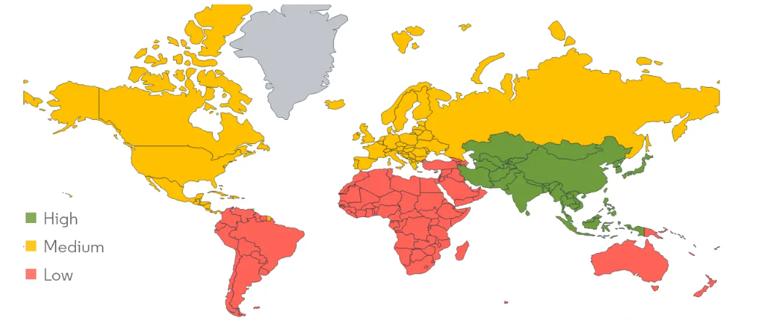

***Fig 5.*** *Heat map of the bio-based polyol growth rate by region in 2022* [*[29]*](https://www.zotero.org/google-docs/?kIff1s)

Unlike the vanillin industry, there are no commercial players in the lignin derived polyols market. Although there is more research that needs to be done before a company takes up the task to sell lignin based polyols, other bio-based polyols are being sold today. Large chemical corporations such as BASF SE, Bayer, Dow Chemical, Huntsman, Covestro, and Cargill all produce vegetable oil based polyol [[30]](https://www.zotero.org/google-docs/?elG2ul). Of the entire polyol market, an estimated $4.48 billion is dedicated to the bio-based polyols market. This means from the entire global market of polyols, 12.5% of it is made up of bio-based products. This niche market is expected to have a compound annual growth rate of 9%, which puts the 2032 estimate to be at $10.61 billion. This market’s primary driver is the construction industry as well. North America is the largest consumer of green polyols, and fast growth is expected in the Asia Pacific [[31]](https://www.zotero.org/google-docs/?rhIxN1). The bio-based market may exhibit some oligopoly tendencies especially compared to the whole market, although there are still many players in this niche market, displaying a medium level of competition.

# Phenolic Resins

A material is considered phenolic when it is reacted in a condensation reaction with phenol and aldehyde; typically formaldehyde. This reaction was discovered by Adolph Baeyer who created the first resin although these resins were made mainstream by Leo Baekeland by his invention of the first synthetic plastic,Bakelite, in 1908 [[32]](https://www.zotero.org/google-docs/?w32kvL). These plastics took over the world and had an extraordinary amount of uses, but in the current day the main uses for phenolic resins are molding powders, laminating resins,adhesives, binders, and coatings.

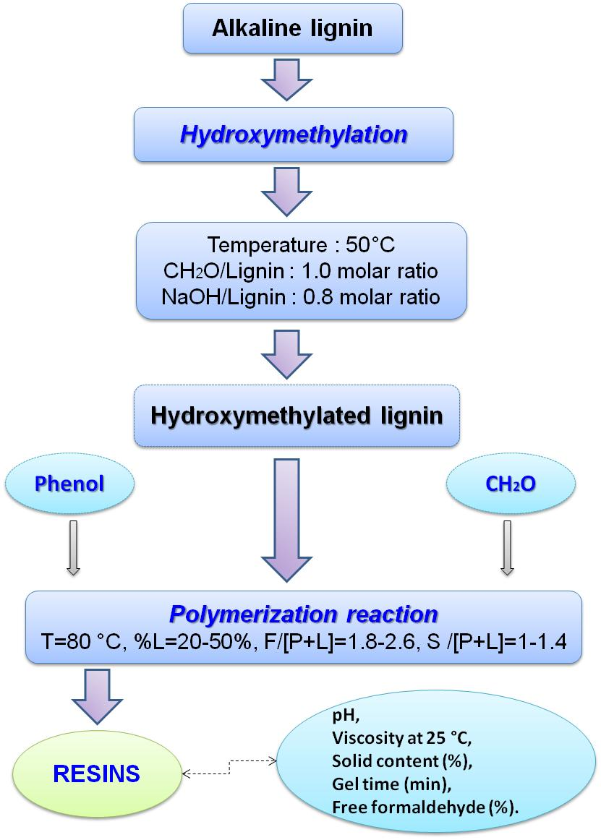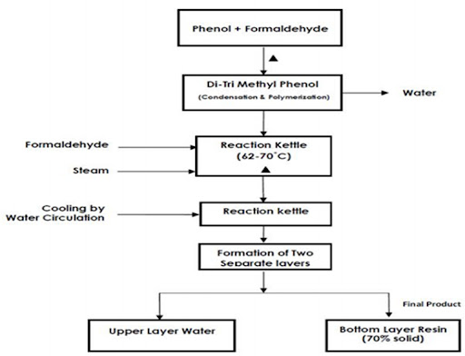

***Fig 6.*** *Phenol-Formaldehyde resin*  ***Fig 7.*** *Flowchart of the hydroxymethylation*

*synthesis process* [*[33]*](https://www.zotero.org/google-docs/?ywiley) *polymerization process of alkaline lignin* [*[34]*](https://www.zotero.org/google-docs/?ww0JEm)

There are two general classes of phenol resins. Resole resins are formed by using a surplus of formaldehyde in relation to phenol under basic conditions and novolac resins are formed using a surplus of phenol in relation to formaldehyde under acidic conditions. Resole resins are most usually seen in bonding and casting applications whereas the novolac resins can be seen most often for molding applications [[34]](https://www.zotero.org/google-docs/?BOoHCu). Resoles are usually in liquid form while the novolacs are solids. A big consequence coming from this, is that the resoles will always have some type of shelf life usually estimated at about a year while novolacs tend to not have any shelf life [[35]](https://www.zotero.org/google-docs/?ts8tHl).

Phenol is derived from petroleum which means that the prices fluctuate as well as are on the serious rise in the next couple years. This makes phenol a non-renewable resource which makes it absolutely critical to find a bio-based alternative. Lignin can at least partially replace the phenol in the phenol and formaldehyde condensation reaction. As you add more lignin in place of phenol, there is an increase in the viscosity of the resin. This is very important as the increase in viscosity also has an effect on the gelification time. Adding lignin will surely retard the time gelification takes and can even alter the temperature the gelification occurs [[34]](https://www.zotero.org/google-docs/?6mjtpc). One prominent method to be able to replace petroleum-derived phenols for lignin is to figure out how to depolymerize lignin even further in an inexpensive manner [[36]](https://www.zotero.org/google-docs/?Di0CCL). This in turn being a common theme for many lignin derived products.

## 5.1 Phenolic Resins Market

In 2021, the global phenolic resin market was estimated at $8.1 billion with a compound annual growth rate of 4.8%. Using this CAGR, in 2031 the global market is projected to reach $12.8 billion. Novolac resin accounted for approximately 55% of the total market and is expected to maintain its position for at least the next ten years and likely longer. Looking at the applications, adhesives and binding were by far the largest use case for this class of resins and is projected to grow more than other applications with the electrical and electronics industry being the most lucrative market for their usage in photoresists and circuit boards, closely followed by the automotive industry [[37]](https://www.zotero.org/google-docs/?6MlU2O). Although this plastic is still in very high demand, the growth rate has not been as strong for other plastics like polyethylene and polystyrene. Production today is only one-tenth of polyethylene and one-third of polystyrene. North America dominates the manufacturing, where Europe, especially Western Europe follows behind, and Japan in third [[38]](https://www.zotero.org/google-docs/?GQDFjM). But an interesting find is that Asia-Pacific holds the largest market share at an estimated 30% although North America is currently the fastest growing market [[39]](https://www.zotero.org/google-docs/?xccpSX).

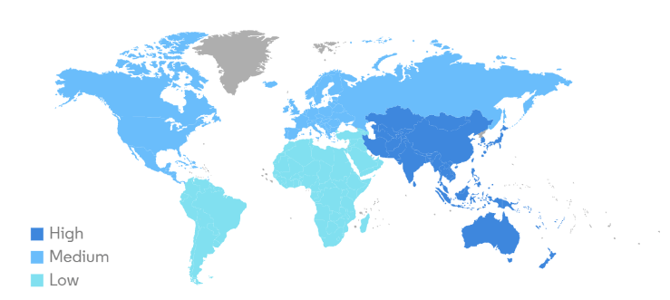

***Fig 8.*** *Heat map of the phenolic resins market size by region in 2022* [*[40]*](https://www.zotero.org/google-docs/?IrGvhT)

**Conclusion**

The phenolic resin market is fragmented, characterized by high levels of competition among the market participants [[38]](https://www.zotero.org/google-docs/?YXIfuz). The biobased market however is not very established yet, although there are companies competing in this niche with the market leader being Bitrez Ltd based in the United Kingdom. UPM Biochemicals in Leuna, Germany is dominating for delivering lignin-derived phenol resin solutions although not directly making them. They have partnered up with some big name corporations like Selenis to work on developing better solutions to bring to the mainstream [[41]](https://www.zotero.org/google-docs/?WbZuea).

# References

[[1] Md. S. Hasan, Md. R. Sardar, A. Shafin, Md. S. Rahman, Md. Mahmud, and Md. M. Hossen, “A Brief Review on Applications of Lignin,” *J. Chem. Rev.*, no. Online First, Nov. 2022, doi: 10.22034/jcr.2023.359861.1186.](https://www.zotero.org/google-docs/?UgVkyy)

[[2] K. A. Khalid, A. A. Ahmad, and T. L.-K. Yong, “Lignin Extraction from Lignocellulosic Biomass Using Sub- and Supercritical Fluid Technology as Precursor for Carbon Fiber Production,” *J. Jpn. Inst. Energy*, vol. 96, no. 8, pp. 255–260, 2017, doi: 10.3775/jie.96.255.](https://www.zotero.org/google-docs/?UgVkyy)

[[3] M. Bilal *et al.*, “Bioprospecting lignin biomass into environmentally friendly polymers—Applied perspective to reconcile sustainable circular bioeconomy,” *Biomass Convers. Biorefinery*, Mar. 2022, doi: 10.1007/s13399-022-02600-3.](https://www.zotero.org/google-docs/?UgVkyy)

[[4] M. Alherech, S. Omolabake, C. M. Holland, G. E. Klinger, E. L. Hegg, and S. S. Stahl, “From Lignin to Valuable Aromatic Chemicals: Lignin Depolymerization and Monomer Separation via Centrifugal Partition Chromatography,” *ACS Cent. Sci.*, vol. 7, no. 11, pp. 1831–1837, Nov. 2021, doi: 10.1021/acscentsci.1c00729.](https://www.zotero.org/google-docs/?UgVkyy)

[[5] “Understanding the Chemical Recovery Processes in Pulp & Paper Mills.” Accessed: Jan. 19, 2024. [Online]. Available:](https://www.zotero.org/google-docs/?UgVkyy) <https://blog.teco-inc.com/2017/09/understanding-chemical-recovery.html>

[[6] L. Martínková, M. Grulich, M. Pátek, B. Křístková, and M. Winkler, “Bio-Based Valorization of Lignin-Derived Phenolic Compounds: A Review,” *Biomolecules*, vol. 13, no. 5, p. 717, Apr. 2023, doi: 10.3390/biom13050717.](https://www.zotero.org/google-docs/?UgVkyy)

[[7] A. Converti, B. Aliakbarian, J. M. Domínguez, G. B. Vázquez, and P. Perego, “Microbial production of biovanillin,” *Braz. J. Microbiol.*, vol. 41, no. 3, pp. 519–530, Oct. 2010, doi: 10.1590/S1517-83822010000300001.](https://www.zotero.org/google-docs/?UgVkyy)

[[8] A. Kumar Eswaran, “Fermentation-derived vanillin could be a sustainable natural alternative to synthetic vanillin.” Accessed: Jan. 15, 2024. [Online]. Available:](https://www.zotero.org/google-docs/?UgVkyy) <https://www.beroeinc.com/article/fermentation-derived-vanillin/>

[[9] M. Breiner, J. Strugatchi, and S. Waldvogel, “Vanillin from lignin,” Analytical Science Article DO Series. Accessed: Jan. 15, 2024. [Online]. Available:](https://www.zotero.org/google-docs/?UgVkyy) <https://analyticalscience.wiley.com/do/10.1002/was.00170197/>

[[10] Y. Liu, L. Sun, Y.-X. Huo, and S. Guo, “Strategies for improving the production of bio-based vanillin,” *Microb. Cell Factories*, vol. 22, no. 1, p. 147, Aug. 2023, doi: 10.1186/s12934-023-02144-9.](https://www.zotero.org/google-docs/?UgVkyy)

[[11] V. Koester, “Vanillin from Kraft Lignin,” ChemistryViews. Accessed: Jan. 19, 2024. [Online]. Available:](https://www.zotero.org/google-docs/?UgVkyy) <https://www.chemistryviews.org/vanillin-from-kraft-lignin/>

[[12] “Biovanillin.” Accessed: Jan. 15, 2024. [Online]. Available:](https://www.zotero.org/google-docs/?UgVkyy) <https://www.borregaard.com/product-areas/biovanillin/>

[[13] N. Wongtanyawat *et al.*, “Comparison of different kraft lignin-based vanillin production processes,” *Comput. Chem. Eng.*, vol. 117, pp. 159–170, Sep. 2018, doi: 10.1016/j.compchemeng.2018.05.020.](https://www.zotero.org/google-docs/?UgVkyy)

[[14] T. Li and S. Takkellapati, “The current and emerging sources of technical lignins and their applications,” *Biofuels Bioprod. Biorefining*, vol. 12, no. 5, pp. 756–787, Sep. 2018, doi: 10.1002/bbb.1913.](https://www.zotero.org/google-docs/?UgVkyy)

[[15] “Analyse der Marktgröße und des Anteils von Vanille - Branchenforschungsbericht - Wachstumstrends.” Accessed: Jan. 19, 2024. [Online]. Available:](https://www.zotero.org/google-docs/?UgVkyy) <https://www.mordorintelligence.com/de/industry-reports/global-vanilla-industry>

[[16] T. Wong, “Technological, commercial, organizational, and social uncertainties of a novel process for vanillin production from lignin,” Simon Fraser University, Burnaby, Canada, 2012. [Online]. Available: chrome-extension://efaidnbmnnnibpcajpcglclefindmkaj/](https://www.zotero.org/google-docs/?UgVkyy)<https://core.ac.uk/download/pdf/56377175.pdf>

[[17] F. M. De Souza, P. K. Kahol, and R. K. Gupta, “Introduction to Polyurethane Chemistry,” in *ACS Symposium Series*, vol. 1380, R. K. Gupta and P. K. Kahol, Eds., Washington, DC: American Chemical Society, 2021, pp. 1–24. doi: 10.1021/bk-2021-1380.ch001.](https://www.zotero.org/google-docs/?UgVkyy)

[[18] C. Henry, A. Gondaliya, M. Thies, and M. Nejad, “Studying the Suitability of Nineteen Lignins as Partial Polyol Replacement in Rigid Polyurethane/Polyisocyanurate Foam,” *Molecules*, vol. 27, no. 8, p. 2535, Apr. 2022, doi: 10.3390/molecules27082535.](https://www.zotero.org/google-docs/?UgVkyy)

[[19] A. Das and P. Mahanwar, “A brief discussion on advances in polyurethane applications,” *Adv. Ind. Eng. Polym. Res.*, vol. 3, no. 3, pp. 93–101, Jul. 2020, doi: 10.1016/j.aiepr.2020.07.002.](https://www.zotero.org/google-docs/?UgVkyy)

[[20] “Polyurethane global market volume 2030,” Statista. Accessed: Jan. 15, 2024. [Online]. Available:](https://www.zotero.org/google-docs/?UgVkyy) <https://www.statista.com/statistics/720341/global-polyurethane-market-size-forecast/>

[[21] “Carbon Fiber Market Size, Share & Growth Analysis [2031].” Accessed: Jan. 15, 2024. [Online]. Available:](https://www.zotero.org/google-docs/?UgVkyy) <https://www.astuteanalytica.com/industry-report/carbon-fiber-market>

[[22] B. International, “How is Polyurethane Manufactured,” Bisley International LLC. Accessed: Jan. 15, 2024. [Online]. Available:](https://www.zotero.org/google-docs/?UgVkyy) <https://bisleyinternational.com/how-is-polyurethane-manufactured/>

[[23] “The chemistry of polyurethanes.” Accessed: Jan. 19, 2024. [Online]. Available:](https://www.zotero.org/google-docs/?UgVkyy) <https://www.l-i.co.uk/knowledge-centre/the-chemistry-of-polyurethanes/>

[[24] B. Lok, G. Mueller, J. Ganster, J. Erdmann, A. Buettner, and P. Denk, “Odor and Constituent Odorants of HDPE–Lignin Blends of Different Lignin Origin,” *Polymers*, vol. 14, no. 1, p. 206, Jan. 2022, doi: 10.3390/polym14010206.](https://www.zotero.org/google-docs/?UgVkyy)

[[25] M. Alinejad *et al.*, “Lignin-Based Polyurethanes: Opportunities for Bio-Based Foams, Elastomers, Coatings and Adhesives,” *Polymers*, vol. 11, no. 7, p. 1202, Jul. 2019, doi: 10.3390/polym11071202.](https://www.zotero.org/google-docs/?UgVkyy)

[[26] M. Zieglowski *et al.*, “Reactivity of Isocyanate-Functionalized Lignins: A Key Factor for the Preparation of Lignin-Based Polyurethanes,” *Front. Chem.*, vol. 7, p. 562, Aug. 2019, doi: 10.3389/fchem.2019.00562.](https://www.zotero.org/google-docs/?UgVkyy)

[[27] E. R. https://www.emergenresearch.com, “Polyols Market Size, Share, Industry Forecast by 2032.” Accessed: Jan. 17, 2024. [Online]. Available: https://www.emergenresearch.com/industry-report/polyols-market](https://www.zotero.org/google-docs/?UgVkyy)

[[28] D. S. Kaikade and A. S. Sabnis, “Polyurethane foams from vegetable oil-based polyols: a review,” *Polym. Bull.*, vol. 80, no. 3, pp. 2239–2261, Mar. 2023, doi: 10.1007/s00289-022-04155-9.](https://www.zotero.org/google-docs/?UgVkyy)

[[29] “Green & Bio Polyols Market Size & Share Analysis - Industry Research Report - Growth Trends.” Accessed: Jan. 19, 2024. [Online]. Available:](https://www.zotero.org/google-docs/?UgVkyy) <https://www.mordorintelligence.com/industry-reports/green-and-bio-polyols-market>

[[30] F. R. Vieira, S. Magina, D. V. Evtuguin, and A. Barros-Timmons, “Lignin as a Renewable Building Block for Sustainable Polyurethanes,” *Materials*, vol. 15, no. 17, p. 6182, Sep. 2022, doi: 10.3390/ma15176182.](https://www.zotero.org/google-docs/?UgVkyy)

[[31] “Bio Polyol and Green Polyol Market.” Accessed: Jan. 17, 2024. [Online]. Available:](https://www.zotero.org/google-docs/?UgVkyy) <https://www.futuremarketinsights.com/reports/bio-polyol-green-polyol-market>

[[32] F. L. Tobiason, “Phenolic Resin Adhesives,” in *Handbook of Adhesives*, I. Skeist, Ed., Boston, MA: Springer US, 1990, pp. 316–340. doi: 10.1007/978-1-4613-0671-9_17.](https://www.zotero.org/google-docs/?UgVkyy)

[[33] “ATEC.” Accessed: Jan. 19, 2024. [Online]. Available:](https://www.zotero.org/google-docs/?UgVkyy) <http://atec.co.in/ProcessTechnologies_sub75d2.html?val=12>

[[34] E. Melro, F. E. Antunes, A. J. M. Valente, H. Duarte, A. Romano, and B. Medronho, “On the Development of Phenol-Formaldehyde Resins Using a New Type of Lignin Extracted from Pine Wood with a Levulinic-Acid Based Solvent,” *Molecules*, vol. 27, no. 9, p. 2825, Apr. 2022, doi: 10.3390/molecules27092825.](https://www.zotero.org/google-docs/?UgVkyy)

[[35] A. Pizzi and C. C. Ibeh, “Phenol–Formaldehydes,” in *Handbook of Thermoset Plastics*, Elsevier, 2014, pp. 13–44. doi: 10.1016/B978-1-4557-3107-7.00002-6.](https://www.zotero.org/google-docs/?UgVkyy)

[[36] Y. Ren, J. Xie, X. He, R. Shi, and C. Liu, “Preparation of Lignin-Based High-Ortho Thermoplastic Phenolic Resins and Fibers,” *Molecules*, vol. 26, no. 13, p. 3993, Jun. 2021, doi: 10.3390/molecules26133993.](https://www.zotero.org/google-docs/?UgVkyy)

[[37] A. M. R. https://www.alliedmarketresearch.com, “Phenolic Resin Market Size, Share | Industry Forecast, 2031,” Allied Market Research. Accessed: Jan. 18, 2024. [Online]. Available:](https://www.zotero.org/google-docs/?UgVkyy) <https://www.alliedmarketresearch.com/phenolic-resin-market-A14853>

[[38] “Phenolic Resin - an overview | ScienceDirect Topics.” Accessed: Jan. 18, 2024. [Online]. Available:](https://www.zotero.org/google-docs/?UgVkyy) <https://www.sciencedirect.com/topics/engineering/phenolic-resin>

[[39] “Phenolic Resins Market Size & Share Analysis Report, 2030.” Accessed: Jan. 18, 2024. [Online]. Available:](https://www.zotero.org/google-docs/?UgVkyy) <https://www.grandviewresearch.com/industry-analysis/phenolic-resins-market>

[[40] “Phenolic Resin Market Trends.” Accessed: Jan. 19, 2024. [Online]. Available:](https://www.zotero.org/google-docs/?UgVkyy) <https://www.mordorintelligence.com/industry-reports/phenolic-resin-market/market-trends>

[[41] 1 June 2023, “UPM Biochemicals and Selenis work towards production of renewable thermoplastic polyester resin in strategic partnership,” Packaging Europe. Accessed: Jan. 18, 2024. [Online]. Available: https://packagingeurope.com/news/upm-biochemicals-and-selenis-work-towards-production-of-renewable-thermoplastic-polyester-resin-in-strategic-partnership/9879.article](https://www.zotero.org/google-docs/?UgVkyy)