Landslide risk assessment of settlements using gis and remote sensing in Kashar, Albania

ABSTRACT

|  |
| --- |
| Landslides are complex situations that derive from a variety of interconnected processes, which include both causative and triggering factors. In residential areas, this phenomenon causes significant loss of life and infrastructural damage. Therefore, it is crucial for local and national decision makers to have up-to-date, suitable, and detailed information based on a complete landslide vulnerability assessment of the target area. In this context, the use of Geographic Information Systems (GIS) and Remote Sensing (RS) plays a key role in identifying and analyzing infrastructure at risk from landslides. Both these technologies offer the opportunity to integrate data on various contributing factors, such as geology, terrain slope, hydrography, and land use, to create maps that indicate the level of spatially distributed areas at risk and develop prevention strategies. This study focuses on identifying spatial distribution patterns of landslides occurring in the Kashar administrative unit, Tirana, Albania. This is done using the Multicriteria Decision Making (MCDA) technique in ArcGIS Desktop 10.8/ArcGIS Pro 3.2 by analyzing four main contributing factors: land cover, slope, distance from water flows, and soil texture. Their relation to the Kashar unit’s settlements has been examined, and hot spots of high risk of landslides have been identified. The study successfully identifies areas within the Kashar administrative unit that are most at risk of landslides. The results of this study can be highly valuable for urban planners and decision-makers. By identifying spatial patterns and hotspots of landslide risk in the Kashar administrative unit, authorities can prioritize areas for intervention, infrastructure reinforcement, or land-use restrictions. The integration of GIS and Remote Sensing provides a scientific basis for informed urban development, disaster preparedness, and zoning policies. These insights allow for targeted investment in resilient infrastructure and guide sustainable planning efforts to minimize future loss of life and property. |

*Keywords: landslide, GIS, Remote Sensing, MCDA, satellite images, socioeconomic*

1. INTRODUCTION

Landslides are generated by a combination of both natural causes and human activities. Cruden et al [6] define a landslide as the movement of a mass of rock or soil down a slope due to gravitational forces. They classify landslides by type of movement, including falls, overturns, slides, spreads, and mudflows. Generally, this phenomenon can occur due to various factors like heavy rainfall, melting snow, sudden changes in temperature or human activities, mainly infrastructural constructions. It can have serious consequences for settlements, especially those located in suburban areas, where sometimes rapid construction and changes in land use make this phenomenon very dangerous. The academic field of landslides is broad, where some researchers have made efforts to understand their structure, addressing literature reviews and their classification, as well as the bibliometric analysis of various landslide concepts through the Science Citation Index-Expanded (SCIE) and Social Sciences Citation Index (SSCI) databases (1991–2014)[1] Landslides have caused costly damage and loss of life worldwide, yet the most devastating disasters occur in developing countries [2]. Therefore, the implementation of techniques to reduce geological risks and natural vulnerability is essential for developing disaster prevention and mitigation strategies on various scales [3]. Geographic Information Systems (GIS) and Remote Sensing (RS) play a very important role in identifying, monitoring, and predicting landslides. The combination of GIS and RS offers a powerful approach to proactive landslide risk management, contributing to better territorial planning, mitigation of consequences, and saving human lives. These are achieved through the usage of digital data in several approaches, such as: a) identifying areas at risk - RS uses satellite imagery and aerial photography to identify changes in the land surface and slope of the terrain that indicate the potential areas for landslides. GIS integrates data from different sources, includes imagery and allows the analysis of factors such as slope, geological structure, soil type, and land use to identify areas at high risk; b) monitoring existing landslides – RS especially through techniques such as InSAR (Interferometric Synthetic Aperture Radar), can measure small ground movements with very high accuracy. Afterwards, GIS manages and updates the collected data and creates dynamic landslide maps in real time; c) generate predictive models and hazard maps by using spatial algorithms in GIS and Remote Sensing data, statistical or mechanics-based models can be created that predict the probability of future landslides. These models can be visualized as hazard maps in a GIS environment hence helping decision makers in urban planning and emergency interventions; d) assessing damage after a landslide occurrence - RS helps in analyzing images before and after the event to assess the size and impact of the landslide, while GIS assist in collecting and analyzing socio-economic data for damage assessment.

2. Materials and methods

**2.1 Study area**

TThe administrative unit of Kashar is the study area. Its territory is part of the Municipality of Tirana, capital of Albania since 2015 and it is located 6 km from the city. This unit covers a total area of 39.1km² and includes 6 settlements under its jurisdiction: Kashar, Mëzez, Yrshek, Katundi i Ri, Kus and Mazrek. In this unit reside 37.373 inhabitants distributed in 11.285 families (2024) [4].

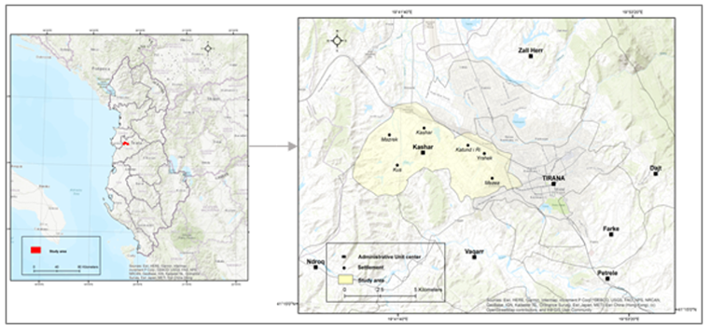

Figure 1: Study area Source: ESRI World Topographic Basemap, Author’s design

The territory of Kashar lies on both sides of the motorway Tirana-Durres. In this axis operates the most important businesses for the Albanian economy. Kashar is the industrial hub of Tirana with many large companies located there. Kashar's economy also relies on agriculture and housing due to a huge influx of people coming to Tirana. The relief is hilly - flat with the domination of fields which have a low altitude above the sea level. The area is rich with artificial lakes: Purez Lake, Kashar Lake, Gjokaj and Mezez Lake and the hilly relief creates an attractive panorama increasing the interest of the local visitors and of the foreign tourists for horse riding, biking, etc. Due to its very favorable position, Kashar has become urbanized with fast rhythms [4]. This has created social and economic benefits but also has triggered conditions for landslides development. One of the main contributing factors in this regard is the fact that this unit is located near watercourses and in a hilly terrain, which makes it sensitive to erosion and landslide occurrence. The studies undertaken so far in this unit indicates presence of landslides, which are of the type of flow landslides, rotational landslides and collapses. They have occurred in the hilly morphological unit on slopes with a slope of over 10°.The body of these landslides is made up of eluvial-deluvial soils, which are placed on clay-silty littoral rocks [5].

**2.2 Database**

The interpretation of the relationship between landslides and their causative factors is significant in understanding the impact of the landslides [10]. In this study, landslide risk assessment is conducted through a multicriteria analysis using GIS and RS technology. It is based on four factors as illustrated in Table 1.

|  |  |  |
| --- | --- | --- |
| Environmental factors | Anthropogenic factors | Elements at risk |
| 1. Soil texture | 4. Land cover/use | Buildings/settlements |
| 2. Slope |
| 3. Water flow |

Table 1. Selected factors used for landslide risk assessment. Source: Author’s design

**2.3 Methodology**

In Figure 2 the main pillars of the study methodology are illustrated. The four gray elements in the schema represent the four data inputs. Each green element represents functions executed in vector and raster in ArcGIS environment.

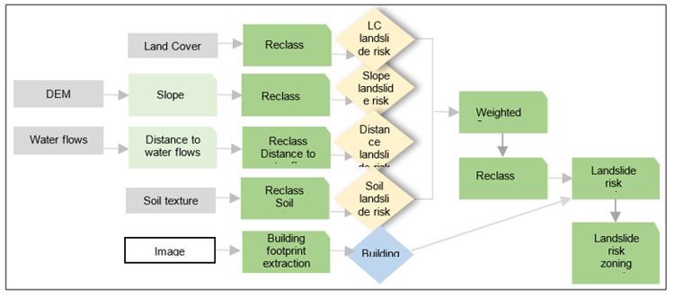

Figure 2: Schematic representation of methodo.logy Source: Author’s design

The generated rasters are then reclassified so that the original value of each cell is transformed into a 1-to-5 value in a common scale (Table 2) with 5 representing the highest landslide risk and 1 representing the lowest. The four result layers are then combined in a Weighted Sum functionality and transformed into an output raster in which each cell contains a 1-to-5 value representing the overall landslide susceptibility score. Finally, labels are attached to the numeric values of a common scale to represent 5 classes of landslide risk, ranging from 1- Very Low,2- Low,3- Moderate, 4- High, and 5-Very High.

|  |  |  |  |  |
| --- | --- | --- | --- | --- |
| **Common scale of risk levels to landslides** | **Environmental factors** | | | **Anthropogenic factors** |
| Soil texture | Distance from water flows (m) | Slope (degrees) | Land cover/use |
| 1- very low | Sandy Loam | >800 | 0 – 5 | forest, shrubs |
| 2 - low | Sandy Loam | 600 – 800 | 5 – 10 | grassland, pastures |
| 3 - moderate | Clay Loam | 400 – 600 | 10 – 15 | mix cultivated |
| 4 – high | Clay, Silty clay | 200 – 400 | 15 – 20 | sparse vegetation |
| 5 – very high | Clay | 0 – 200 | 20 – 35 | discontinuous urban area |

Table 2: Correlation of landslide risk factors and common scale values

**2.4 Environmental factors**

2**.4.1 Soil texture**

Concerning landslides, the texture of soil plays a significant role because it affects water retention, drainage, and shear strength. Therefore, soil texture was selected as one of the environmental factors that contribute to the landslide occurrence, as presented in Table 3. Hence, based on the soil texture characteristics areas with predominant clay structure are most prone to landslides, followed by clay loam with a moderate rate and sandy loam with the least prone rate to landslide risk.

|  |  |  |  |  |
| --- | --- | --- | --- | --- |
| Soil Texture | Water Retention | Drainage | Cohesion | Landslide Risk |
| Clay | High | Poor | High | Very High |
| Clay Loam | Moderate | Moderate | Moderate | High |
| Sandy Loam | Low | Good | Low | Low |

Table 3. Solid texture and its relation to landslide risk

Knowing the importance of this environmental factor concerning landslides susceptibility the map of soil texture is designed (Figure 3). It illustrates how soil texture patterns influence landslide risk. As it can be noticed, areas around central and northern Kashar (e.g., near Kashar and Mucaj) show high to very high risk, indicating soil textures prone to erosion or low cohesion, such as clayey or silty soils. The southern and southeastern regions show low to medium risk, likely due to more stable or coarse-textured soils (e.g., sandy or well-drained).

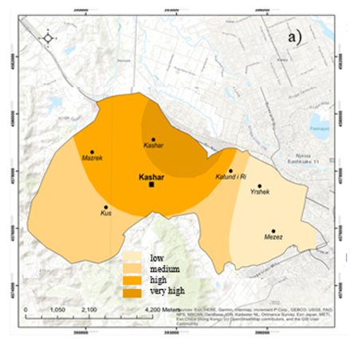

Figure 3. Spatial patterns of soil texture concerning the risk level of landslide

Source:https://esdac.jrc.ec.europa.eu/content/european-soil-database

**2.4.2 Slope**

Slope instability is the result of a complex combination of several predisposing and causal factors. Due to the heterogeneous spatial distribution and temporal variability of physical features, such as land use, climate, soil properties, and groundwater regimes, slope failures are tough to model and predict [9]. The prepared maps in Figure 4 below illustrate the terrain of the study area based on slope steepness. It can be noticed that the flatter areas (green shades) dominate the northern and central zones. Steeper slopes (orange to red) appear mainly in the south and southeast, suggesting elevated or hilly terrain. These two maps complement each other since slope (a) is a key factor influencing landslide risk (b). The central and northern areas of Kashar unit are safer for construction and development, while southern and eastern areas may require mitigation or avoidance due to higher landslide risk.

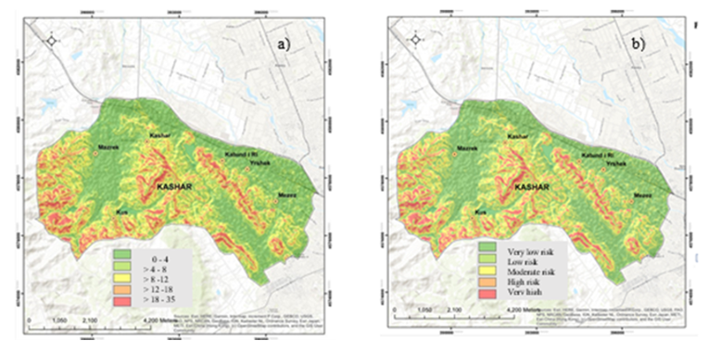

Figure 4. a) Slope (degrees) b) Slope and relation to the risk level of landslide

Data source: DEM provided by <https://earthexplorer.usgs.go>

**2.4.3. Water flows**

The hydrography of the administrative unit Kashar is quite rich. Its territory is crossed by a series of streams that flow through the hills' slopes, often causing problems related to slope erosion. These water flows, through erosive activity, manage to form the products of alienated materials along the surface of the slopes. Some of the most important streams are: Purezit Stream, Limuthit Stream, Madh Stream, Kusit Stream, Mazrekut Stream, and Geges Stream. Kashar is crossed almost entirely by the Lana River. Likewise, there are 4 artificial reservoirs in its territory. The Lana River passes through the territory of the unit, which serves as another natural element connecting with the city of Tirana, as well as these lakes, which constitute 2% of the territory. Since proximity to water flows acts as an external triggering factor for landslide susceptibility, a map that shows proximity to watercourses and their influence on landslide risk is prepared in this regard (Figure 5). From the corresponding map there can be identified areas closer to water flows (rivers and streams), especially those in red, can be at very high risk due to increased soil saturation, slope undercutting, and superficial erosion processes. Risk decreases with distance from water flows, as seen in the outer blue and light blue zones.

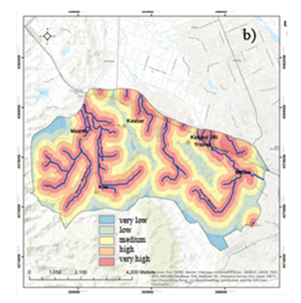

Figure 5. The distance from water flow in relation to the risk level of landslide

Data source: Topographic map, 1:50.000

**2.5 Anthropogenic factors**

**2.5.1 Land cover/use**

To address the land cover/change impact on landslide data provided by the Copernicus Land Monitoring Service (CLMS) is utilized. These data are in raster format and their classification is based on CORINE land cover/use nomenclature [11]. In the study, 16 classes are identified as illustrated in the corresponding map in Figure 6. Those are: 1) pastures,2) meadows,3) forest,4) water,5) olives,6) vineyards,7) agriculture land,8) complex cultivation patterns,9) mines,10) industrial commercial areas,11) sparse vegetation, 12) shrubs,13) discontinuous urban areas,14) grassland. Using reclassification technique in GIS environment these categories of land use are grouped into five levels of landslide risk from very low to very high (Figure 6/b). Very high risk zones are found in the eastern and southeastern areas, where terrain and vulnerable land use (e.g., agriculture, sparse vegetation) combine. Moderate to high risk areas overlap with arable lands and disturbed terrain. Low to very low risk areas correspond with the urbanized flat terrain in the north and northwest.

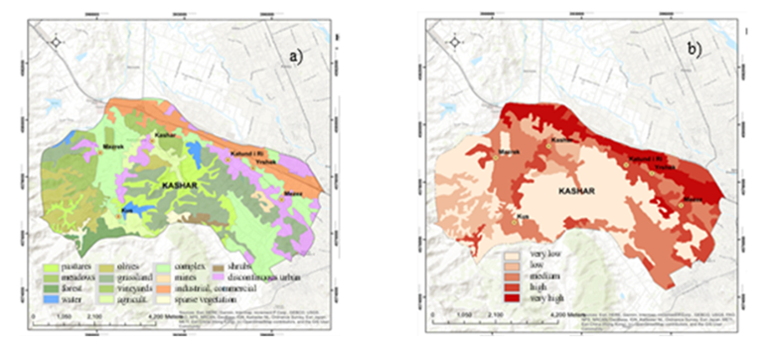

Figure 6 a) Land cover/use, b) Land cover/use related to landslide risk

Data source: https://land.copernicus.eu

There is a clear spatial relationship between land use types and landslide risk. Vegetated and forested areas tend to reduce risk, while bare, agricultural, or disturbed lands on slopes increase vulnerability.

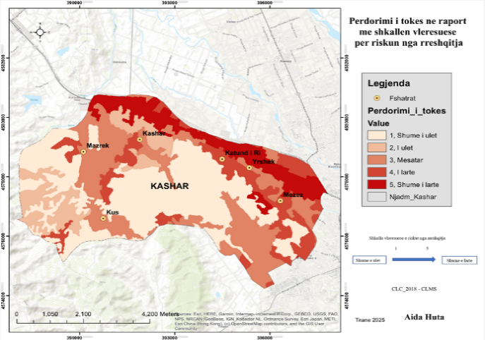

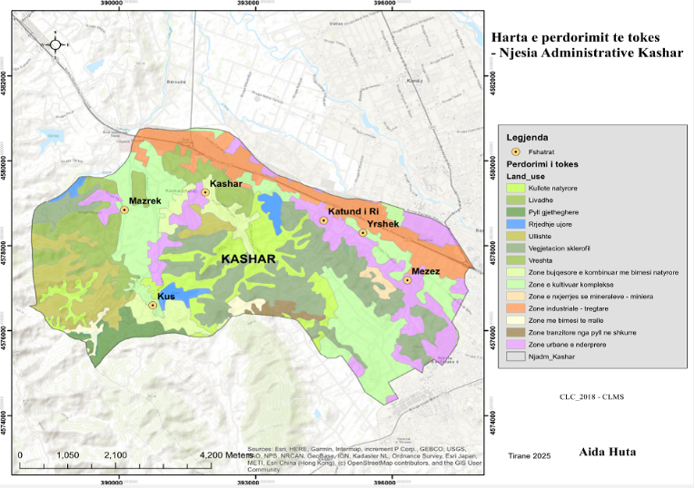

a)

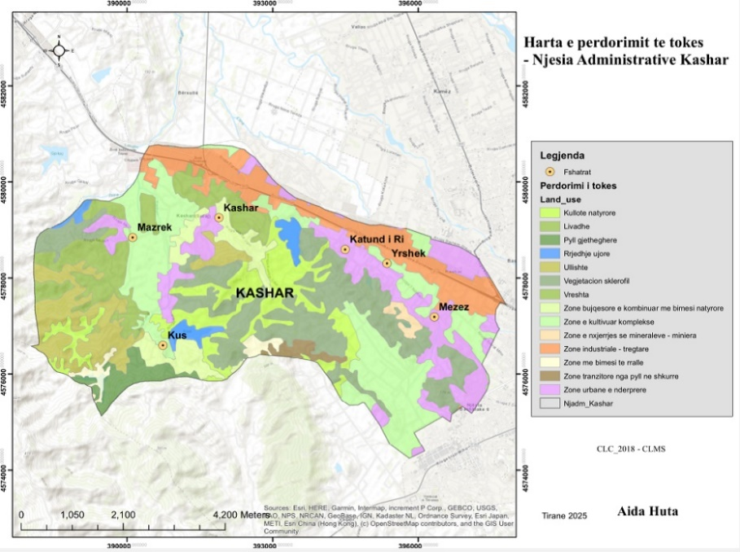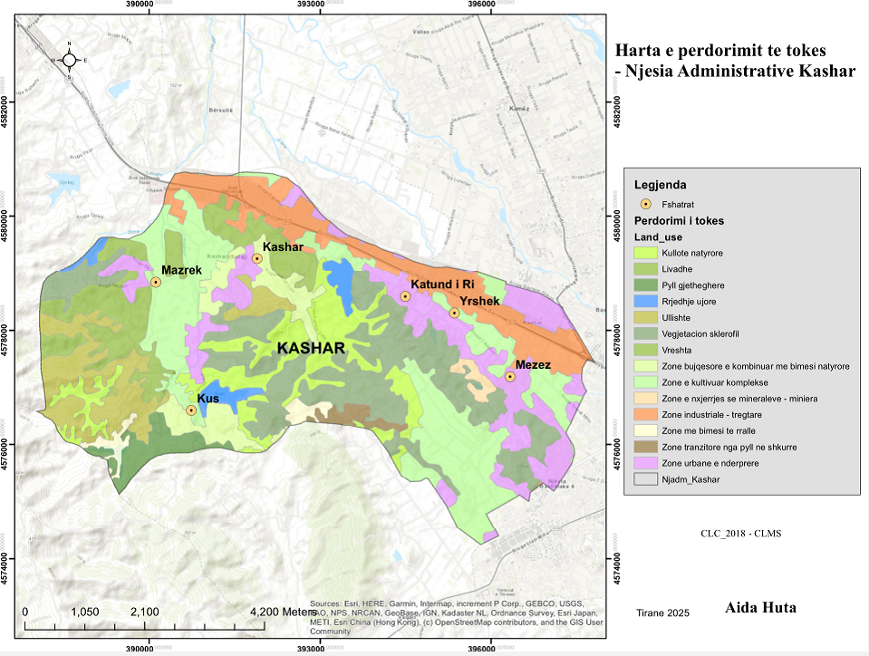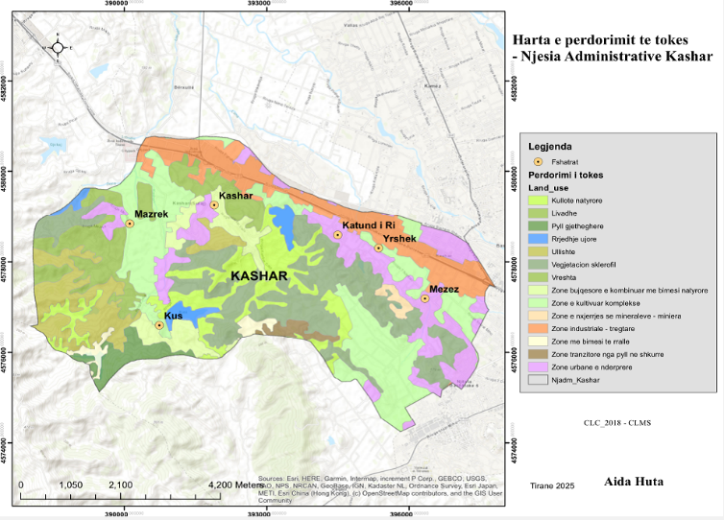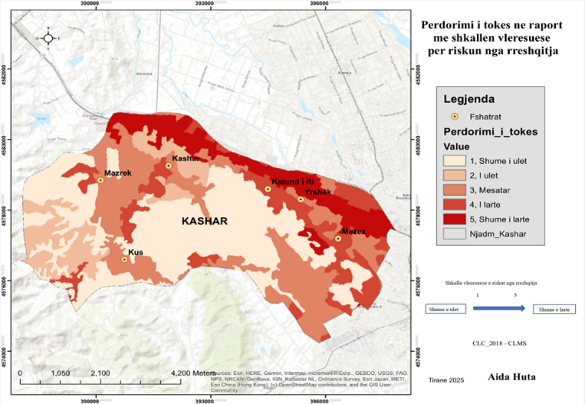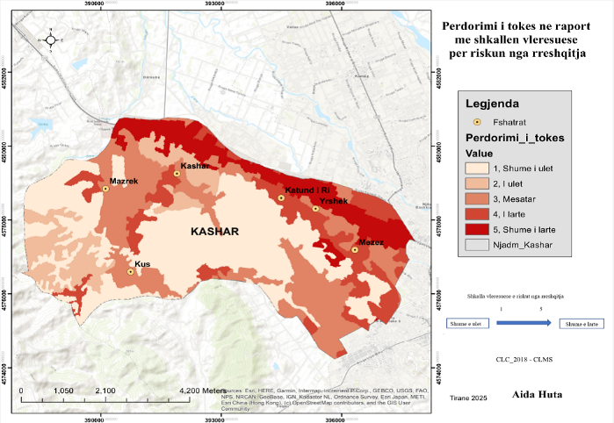

b)

pastures

meadows

forest

water

olives

grassland

vineyards

agricult.

complex

mines

industrial, commercial

sparse vegetation

shrubs

discontinuous urban

very low

low

medium

high

very high

very low

low

medium

high

very high

very low

low

medium

high

very high

**3. RESULTS AND DISCUSSION**

**3.1 Landslide risk zoning of Kashar unit**

On the resulting map (Figure 7) five main classes related to the risk level of landslides can be distinguished in Kashar unit. Areas classified as “very low” and “low” can be considered a “not landslide-prone area”. Meanwhile, “medium”, “high”, and “very-high” areas can be considered “landslide-prone areas”. However, it Is important to note that landslides can occur even in “not landslide-prone areas”, but they are not expected to be as frequent and with devastating consequences as in “landslide-prone areas”.

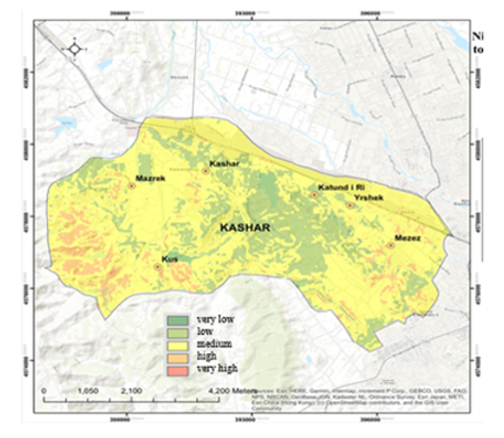

Figure 7. Landslide risk zoning of the Kashar unit

Source: Author’s calculation

**3.2 Assessment of vulnerability**

The consequences of landslides are hazardous to human life, and thus, they are treated as natural disasters [10]. In this perspective, vulnerability assessment involves the understanding of the interaction between a given landslide and the affected elements [7]. In this study, this is done by assessing the spatial relation of areas at risk of landslides and settlements located in the Kashar unit. Deep learning technique in ArcGIS Pro is utilized for this purpose. A mosaic of imagery data set from the Sentinel hub was created for the area of interest, and a pre-trained deep learning model provided by the ArcGIS Living Atlas of the World was implemented to automatically extract the building footprints [8] (Figure 8).

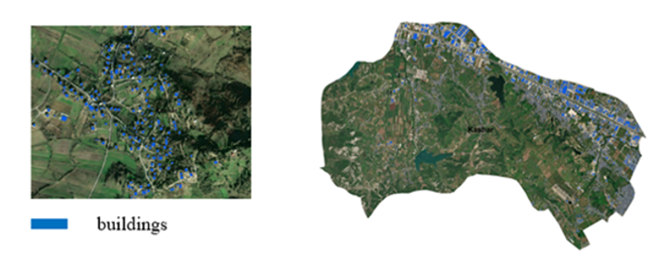

Figure 8. Spatial distribution of buildings/settlements

Data source: Imagery accessed at Sentinel Hub/ Sentinel 2 L2A

https://www.esa.int/Applications/Observing_the_Earth/Copernicus/Sentinel-2

Visualizing both buildings' footprints and zones of landslide risk in a final map provides insight on their spatial correlation (Figure 9). There can be identified three settlements located in areas ranging from medium to high levels of landslide risk, namely the villages of Mazrek, Mëzez and Kus; one village, Kashar is partly inside a medium to low risk zone; two other settlements, Yrshek and Katund i Ri reside on zones with low to very low risk of landslides

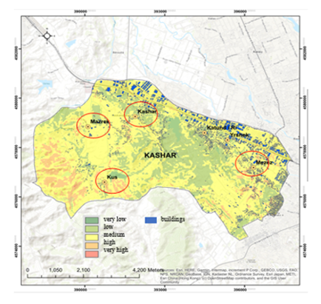

Figure 9 Landslide risk zoning of Kashar unit and its relation to spatial distribution of

buildings/settlements Source: Author’s calculation

**4. CONCLUSIONS AND RECOMMENDATIONS**

Landslides are processes influenced by a combination of natural and anthropogenic factors. They represent a natural phenomenon that has major consequences on the environment, economy, and people's lives. The study concludes that the Kashar administrative unit is significantly prone to landslide risks due to both natural factors (e.g., steep slopes, clay-rich soils, proximity to water flows) and human-induced pressures (e.g., rapid urban expansion, unregulated land use). High-risk areas are concentrated particularly in the villages of Mëzez, Kashar, and Kus. GIS and Remote Sensing (RS) technologies have proven to be effective tools in spatially identifying and analyzing landslide-prone zones, enabling a comprehensive understanding of vulnerabilities. The natural conditions (geographical position, terrain slope, hydrography, soils, climate) of the Kashar Administrative Unit are favorable towards the development of landslides in this peripheral area of the Municipality of Tirana. The impact of human activity on the development of landslides is observed in the expansion of the urbanized area, or the use of land for recreational purposes. In all settlements, there are buildings located in areas with a high level of landslide risk, but the most noticeable are in the villages of Mëzez, Kashar and Kus. The information derived from multifactor analysis and geovizualized through thematic maps indicates that buildings at risk of landslides have a significant spatial distribution throughout the study area in the northern, northeastern, and southern/southwestern parts of the territory. Therefore, this study underlines the importance of conducting landslide risk assessment and vulnerability in suburban areas. It also emphasizes the values of geospatial databases and GIS/RS technology in this regard. The collected data helps authorities to react more quickly during a landslide and to plan urban infrastructure sustainably. Vulnerability and hazard maps enable planners to develop urban areas more effectively while minimizing the risk of natural disasters like landslides.

To address the identified vulnerabilities and ensure the long-term safety and resilience of this rapidly urbanizing area, several strategic recommendations are proposed. First and foremost, urban planning and land-use zoning in Kashar must be revised to reflect the geospatial evidence presented in this assessment. The risk maps generated through GIS and Remote Sensing delineate zones of very high, high, and moderate susceptibility to landslides. These maps should serve as core reference documents for planners, guiding future development away from high-risk slopes and promoting the use of safer, lower-risk terrain. Enforcing strict zoning regulations can prevent the construction of new buildings in unstable areas and reduce the exposure of residents and infrastructure to potential disasters. In addition to regulatory measures, enhancing disaster risk reduction efforts is imperative. The implementation of early warning systems in areas with high vulnerability—such as the villages of Mëzez, Kashar, and Kus—could significantly reduce casualties and damage in the event of a landslide. These systems should be coupled with regular monitoring of slope movement and rainfall thresholds, supported by geospatial technologies, to provide timely alerts to residents and authorities. A key aspect of reducing landslide damage involves improving infrastructure resilience. Existing roads, utilities, and buildings in susceptible areas should undergo risk assessments and, where necessary, structural reinforcement. Mitigation measures such as retaining walls, proper drainage systems, and slope stabilization techniques can play a crucial role in limiting the destructive effects of landslides on critical infrastructure. Equally important is the need for sustainable land management. Human activities, especially deforestation and inappropriate agricultural practices, can exacerbate soil erosion and slope instability. Promoting reforestation and the restoration of natural vegetation cover in erosion-prone areas would contribute to stabilizing the soil and reducing landslide risks. These ecological interventions should be integrated into local environmental planning and incentivized through government support. On a broader policy level, it is recommended that local and national institutions establish frameworks for regularly updating spatial data related to topography, soil, hydrology, and land use. Strengthening institutional capacity in GIS and RS applications will ensure that municipalities can continuously monitor risk patterns and adapt planning strategies accordingly. In this regard, training programs and knowledge-sharing platforms should be developed for local authorities and urban planners. Lastly, fostering public awareness and community involvement is essential. Educating residents about the causes and signs of landslides, as well as response measures, empowers them to participate in risk reduction. Community engagement also enhances the effectiveness of monitoring systems and ensures that interventions are grounded in local realities.

Disclaimer (Artificial intelligence)

Author(s) hereby declare that NO generative AI technologies such as Large Language Models (ChatGPT, manuscript.

5.References

1. Paúl Carrión-Mero et.al, (2021). Worldwide Research Trends in Landslide Science. International Journal of Environmental Research and Public Health.
2. Alcántara-Ayala, I. Geomorphology, natural hazards, vulnerability and prevention of natural disasters in developing countries.Geomorphology 2002, 47, 107–124
3. Gokceoglu, C.; Sezer, E. A statistical assessment on international landslide literature (1945–2008). Landslides 2009, 6, 345–35
4. https://tirana.al/en/administrative-area/kashar/info
5. Muceku Y. (2006). Vlerësimi i kushteve gjeomorfologjike të zonës Tiranë - Vorë për qëllime të planifikimit dhe zhvillimit urban. *Buletini i Shkencave Gjeologjike,* 39-40.

<https://gsa.gov.al/Artikujt/buletinet/2000/1_2006.pdf>

1. Cruden, D. M., & Varnes, D. J. (1996). Landslide types and processes. *Transportation Research Board Special Report*, 247, 36–75
2. Dai, F. C., Lee, C. F., & Ngai, Y. Y. (2002). Landslide risk assessment and management: an overview. *Engineering Geology*, 64, 65–87
3. <https://learn.arcgis.com/en/projects/identify-infrastructure-at-risk-of-landslides/arcgis-pro/>
4. Luino,F. et.al (2022).The Role of Soil Type in Triggering Shallow Landslides in the Alps (Lombardy, Northern Italy) Journal Land,Volume 11,Issue 8
5. Bathrelos.D,G et al. Landslide causative factors evaluation using GIS in the tectonically active Glafkos River area, northwestern Peloponnese, Greece, Geomorphology, Volume 461, 15 September 2024, 109285
6. https://land.copernicus.eu/en/products/corine-land-cover