**Assessment of Sediment Deposition Rates in Orashi River, Nigeria**

***Abstract***

*The dynamic nature of rivers as a result of natural and anthropogenic factors such as hydrology, geology, climate, land use, deforestation, urbanization, dam construction, dredging, pollution etc is of monumental consequences to its inhabitants and its surroundings. These dynamic natural and anthropogenic factors are observed in Orashi Rivers in the form of fluctuations in the volume of water, changes in depth due to sediment, and changes in geometry. These vagaries have remained unpredicted and hence the focus of this study. The aim of this research is to assess the rates of sediment deposition in Orashi river. The objectives are to determine the depth of some sections (catchments) of Orashi river bed for 2012, 2018 and 2024; determine the hydrodynamics parameters of some sections of Orashi river for 2018 and 2024, determine the surface runoff water of some sections (catchments) to the river, determine the volume of sediment deposition of some sections of Orashi river in two epochs, determine the most contributing factor to the sedimentation of the river using* linear regression *analysis. This study employed mixed methods of research using classical survey methods such as river current measurement, river cross-sectional area evaluation, river water discharge rate estimation, bathymetric operation, runoff water computation, sediment computation and multiple regression analysis. The* linear regression by Least Squares Method (LSM) *was carried out using data obtained for 2018 and 2024. Runoff water peak discharge (Qp) and River water discharge rate (Q) were used as the independent variables while the rate of sediment deposition was used as the dependent variable. The result shows the average velocity of the catchments in Orashi river for dry and wet season as 0.61m/sand 0.76m/s and the average discharge flow rate of each catchment in Orashi for dry and wet season as 711.75m3/s and 1594.54m3/s. The result shows the average sediment deposition ranges from* ***0.3****m to* ***0.6m*** *(****3cm*** *to* ***6cm****) in Orashi river between 2012 to 2024. The linear regression analysis showed 46% by river water discharge and 54% by run-off water peak discharge. The research recommends, among other things, the dredging of Orashi river so as to avoid the overflow of river which causes flooding of their farmlands and residence.*

***Keywords:*** *Catchment, Discharge rate, Linear regression, Peak discharge, Sediment*

**1.1 Introduction**

The increased activities of oil and gas companies, sand mining and their operations within and around river and river shorelines, requires a proper, adequate and updated riverbed mapping necessary for scientific analysis and design purposes, this is to match rapid changes on the riverbed topography due to change in river conditions as a result of storm surges, river current, river discharge, runoff water, sea level rise, sediment transport, erosion and accretion (Gerald et’al, 2021).

The river is a dynamic system that is influenced by hydraulic processes and sediment transport (Gunawan, 2018). The process of erosion of the river body and erosion of the catchment area in the upper reaches of the river along the earth surface flows into the river bodies thereby contributing to the sedimentation of the riverbed (Gunawan, 2018). Sediment deposits in river channels most times cause the water levels of the river to rise above its banks. On the other hand, the erosion of the riverbed due to strong river currents can cause water levels to fall upstream and transport sediment particles downstream as reported by (Gunawan, 2018). Sediments in the river also have a negative effect on the water quality of the river. Gunawan (2018) opined that sediment and scouring generally occur in the riverbed due to differences in sediment load and sediment transport capacity in the stream. Mishra et’al, 2021, reported that reservoir sedimentation estimated from river sediment flow and reservoir surveys by using the trap efficiency and sediment distribution either by manual survey or by web-based technologies.

A number of researchers have developed various analytical procedures and theories to predict sediment load, but the implementation of most existing theories is only suitable for certain types of rivers. From various tests on sediment measurement data through laboratory experiments and data measurements on the river by various researchers, there are limitations in the application of existing theories (Felix et’al, 2018).

Sedimentation rates are poorly monitored due to inadequate data and modeling challenges. The most direct measurement is through periodic river bathymetry surveys. For example, surveys at two different times are often used to estimate the volume of sediment accumulation during the period. Owing to time-consuming and expensive, bathymetry survey data is spatially sparse and often not publicly available (Foteh et’al, 2018). Sedimentation rates can also be estimated through process-based models (Doten et’al, 2006; Minear and Kondolf, 2009). However, the lack of sedimentation and auxiliary data for model calibration and parameterization often lead to high uncertainties in modeled estimates (Trimble, 1999).

Moreover, an accurate estimate of the amount of sediment carried in rivers is very important in terms of engineering and water structures planning and projecting of structures built on rivers (Ünes et’al, 2022). The amount of sediment in the rivers reduces the life of the facilities built on the river and also damages the river transport and agricultural areas. Particularly, the sediment accumulated in water storage facilities such as dam reservoirs reduces the reservoir capacity and causes the reservoir to become unable to function over time (Üneş et’al, 2022). In addition, estimation of the amount of sediment transport is very important in determining the amount of scour or accumulation that may occur on the feet of other structures such as viaducts and bridges in the river for flood control, and in terms of taking the necessary precautions.

Sediment particles are most times transported through river system as a result of runoff from rainfall through the processes of sheet, rill and gully erosion. The eroded sediment particles are eventually deposited in a flood plain, reservoir or rivers (Akrasi, 2011). Many activities related to the conservation, development and utilization of land, to mineral and water resources either increase or decrease the rate of sediment movement, thereby, causing a variety of sediment related problems (Akrasi, 2011). A change in runoff regime from a drainage basin, for example, may concentrate or disperse sediments in the stream channel and, in turn, affect the flow capacity of the stream. Because of the complex interrelationship that affects erosion, transport and deposition, knowledge of climate, physical attributes of drainage basins, hydraulic and hydrologic characteristics of stream flow, and quantitative and qualitative aspects of sediment are all required to solve sediment problems (Amisigo and Akrasi, 2000).

Sedimentation rates are poorly monitored due to inadequate data and modeling challenges. The most direct measurement is through periodic river bathymetry surveys. For example, surveys at two different times are often used to estimate the volume of sediment accumulation during the period. Owing to time-consuming and expensive, bathymetry survey data is spatially sparse and often not publicly available (Foteh, *et al.,* 2018). Sedimentation rates can also be estimated through process-based models (Doten et’al., 2006; Minear and Kondolf, 2009). However, the lack of sedimentation and auxiliary data for model calibration and parameterization often lead to high uncertainties in modeled estimates (Trimble, 1999).

Sediment particles are most times transported through river system as a result of runoff from rainfall through the processes of sheet, rill and gully erosion. The eroded sediment particles are eventually deposited in a flood plain, reservoir or rivers (Akrasi, 2011). Many activities related to the conservation, development and utilization of land, to mineral and water resources either increase or decrease the rate of sediment movement, thereby, causing a variety of sediment related problems (Akrasi, 2011). A change in runoff regime from a drainage basin, for example, may concentrate or disperse sediments in the stream channel and, in turn, affect the flow capacity of the stream. In addition, the complex interrelationship that affects erosion, transport and deposition, knowledge of climate, physical attributes of drainage basins, hydraulic and hydrologic characteristics of stream flow, and quantitative and qualitative aspects of sediment are all required to solve sediment problems (Amisigo and Akrasi, 2000).

Rivers are the major receptors and transporters of sediment from soil erosion, however, in most watercourses of the globe, sediment information is not readily available due to lack of monitoring (Syvitski et’al., 2000), which becomes more critical in regions where rivers are intermittent and the annual sediment load is conveyed in a short period of time (Mano et’al., 2009; Medeiros et’al., 2014). Generally, the monitoring of sediment processes involves in-situ observations at specific cross-sections, which cannot provide a broader spatial view of the processes in locations other than the monitoring spot. This limitation can result in inaccurate sediment-dynamic characterization (Liu, He, Des Walling, and Wang, 2013).

River sedimentation primarily is a continuous process that can be unnoticed for a significant portion of the life of a river as silts and other earth materials are transported from the upstream river system to downstream of the river with a relatively high sediment transport velocity (Radwan, 2016). The volume of sediment deposition is dependent on water velocities, discharge rates of the river and runoff components receive by the river within its surroundings (Radwan, 2016). Most often the river capacity tends to reduce with increased deposit of sediment over time (Radwan, 2016). The frequent accumulation of silts and sediments may end up producing an abnormal distribution trend in the river which in most cases affects the river management during peak flood event (Sedlacek et’al., 2016).

The countless benefits offered humanity by river makes the study of water bodies a vital field of research to man (FIG Commission 4, 2010; Chukwu and Badejo, 2015). Ranging from easing and ensuring safe navigation of vessels on waterways (FIG Commission 4, 2010;), simple reconnaissance (at project formulation) to payment for work carried out underwater, such as dredging or reclamation, mineral exploration and other such benefits derivable from the water bodies, a concise study of the sedimentation of the river body is highly relevant (Sciortino, 2010), this is usually made possible through bathymetric operations. A bathymetric survey is required whenever a detailed survey of the bed level is to be carried out. It is defined as the measurement of water depth e.g. lakes, oceans, dams, seas and rivers. Bathymetry is the measurement of the depths of water bodies from the water surface (Samaila-Ija et’al., 2014).

Sediment accumulation in Orashi river catchment includes soil erosion from agricultural fields, hill slopes and settlements. Consequently, factors that influence fluvial sediment loads would, therefore, include the various land uses and cultural practices that take place in these areas. Since it is not practicable to undertake field measurements of the effects of these practices on sediment accumulation, predictive models are used. Good sediment yield models could provide good estimates of the rates at which some variable factors are contributing sediment to the Orashi river. These could also be used to predict the effects of various combinations of land use activities and cultural practices on erosion and sediment yield on drainage basins.

The study area covers an extensive area (almost 300 km²) as shown in Fig. 1 and 2, and the water supply relies strongly on surface runoff water and overflow from Niger river, which are vulnerable to sediment dynamics. The lack of in-situ spatially and temporally varied data on sediment routing reduces the effectiveness of the river and environmental policies of the study area. Hence, the use of accurate, spatially-extensive and affordable techniques, such as classical survey methods, remote sensing and some hydrodynamics computation is expected to be of great value for the improvement of sediment-dynamic knowledge and, therefore, of the water policy, since, unlike traditional monitoring methods, satellite remote sensing allows to collect data for large areas on a frequent and regular basis.

Sedimentation amongst other factors disrupts river stability and the impact caused by excessive sedimentation can influence an increase in riverbed elevation (siltation) and at the same time can cause an increase in water level of a river which can cause increase losses when it overflows to the surrounding environment of the river (Radwan, 2016). Sediment, normally understood to comprise of sand, silts and clays dominates the material flux of Orashi river. Understanding the sediment dynamic process, the routing of sediment through the Orashi river channels, the erosional and depositional history of sediments to the catchments of Orashi river remains a challenge to surveyors, scientists and hydrographers.

More so, the Orashi river in recent times witnessed inundated changes which resulted in the frequent rise in volume of water of that river, consequently resulting in the overflow of the river through its bank. These changes are the form changes in the cross-sectional area, riverbed topography, accretion and erosion of the shorelines. These changes and the associated dynamics of the river have not been properly understood. This situation has persisted in this study area over a period of time until date, thereby causing frequent flooding of the Orashi river and its environment, and also distorting the navigational channels of the river, hence it becomes imperative to assess the rate of sediment accumulation and its associated hydrodynamics of Orashi river to provide adequate sediment information of the river.

**1.2 Aim and Objectives of the Study**

The main thrust of this research work is to assess the rates of sediment deposit in Orashi River.

The objectives of this study are:

i) Determine the depth of some sections (catchments) of Orashi riverbed for 2012, 2018 and 2024.

ii) Determine the Hydrodynamics parameters of some sections of Orashi River for 2018 and 2024.

iii) Compute the surface runoff water of some sections (catchments) to the river for 2018 and 2024.

iv) Calculate the average sediment accumulation of some sections of Orashi River in two epochs.

v) Determine the most contributing factor to the sedimentation of the river using linear regression analysis.

**1.3**  **Study Area**

This study area is located in Ogba/Egbema/Ndoni local Government Area of Rivers State. The local Government Area is rich in crude oil deposits and natural gas and the activities of oil mining firms within and around the LGA contribute immensely to the economy of the local Government Area and Rivers State. Fishing is another popular enterprise amongst the people of Ogba/Egbema/Ndoni local Government Area with the area’s rivers and tributaries being rich in seafood.

Fig. 1: Map of the Study Area Showing Orashi River (Sources: Authors Field Work 2024)

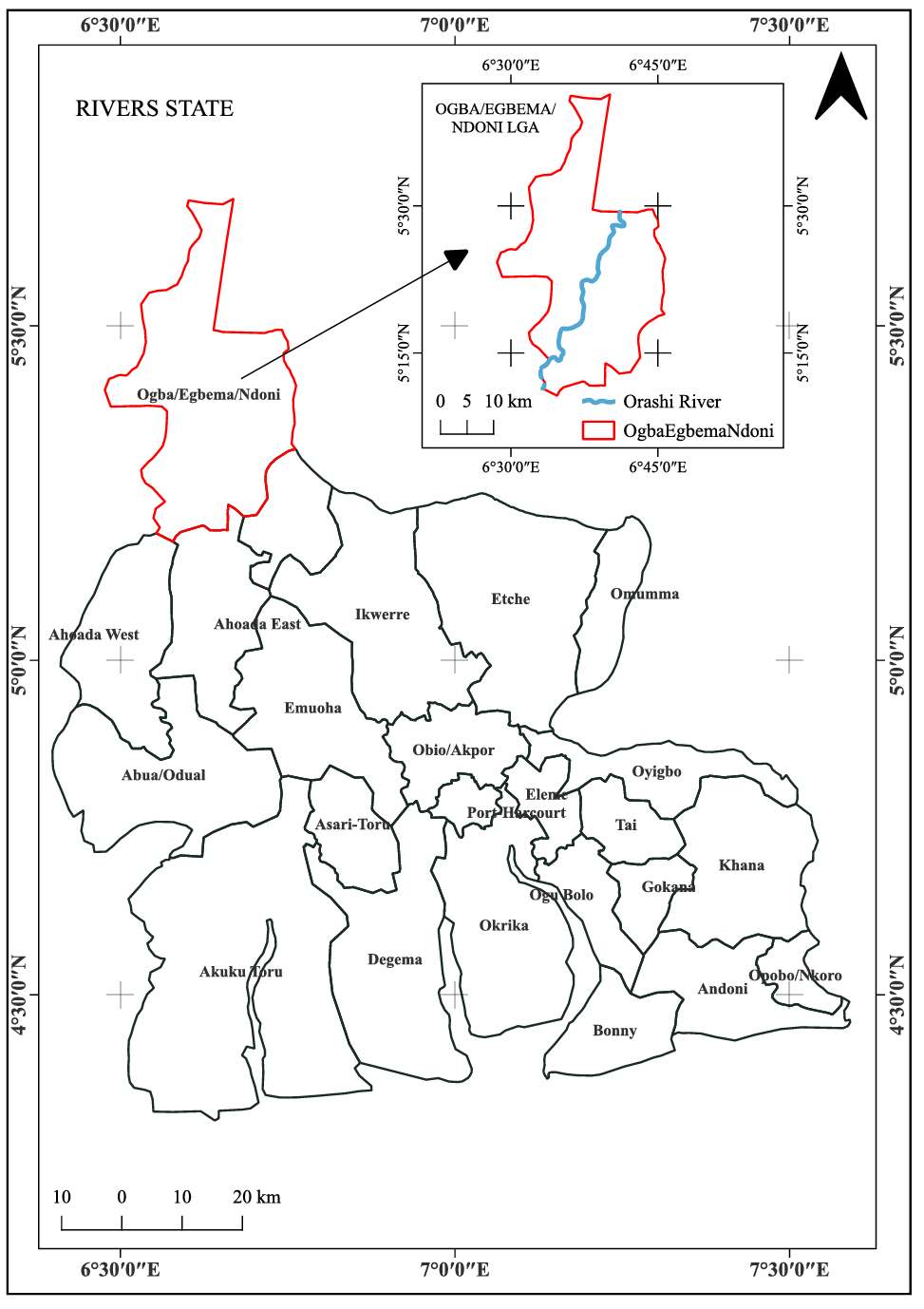

Other important economic activities in the local Government Area include trade and lumbering (Francis, 1995). The study extends about 26km along the Orashi River and stretches through some major communities are Obirikom, Omoku, Aligu, Krigani, Ohali-Osomini, Ohali-Elu, Idu-Obusokwu, and Idu-Osobile as shown in figure 2. The companies and the inhabitants of these communities are the victims of frequent changes in the dynamics of the Orashi river.

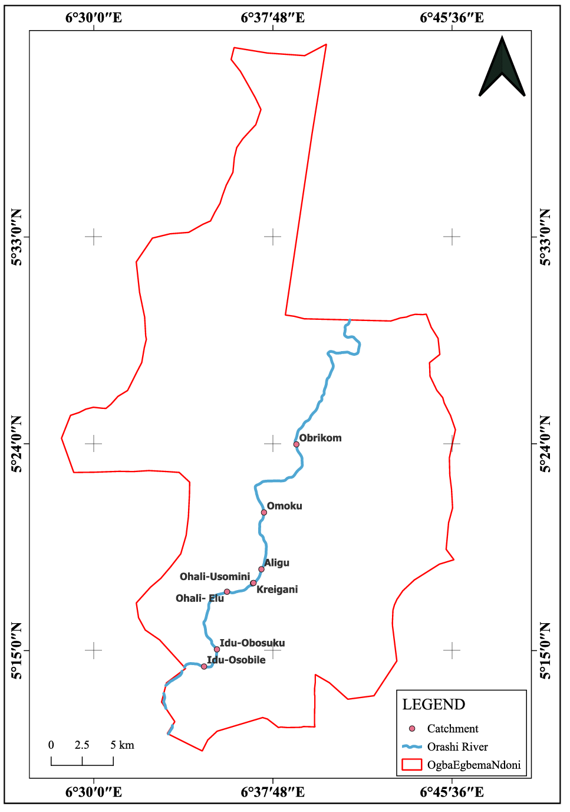

Fig. 2: Map of the Study Area Showing Catchments (Sources: Authors Field Work 2024)

The study area is located on latitude 633902mN – 572127mN and longitude 219601mE – 255551mE, in the WGS84 UTM Zone 32N with a population size of 283,294 as reported by the National Population Commission (NPC, 2006) and a land mass of 1,621 square kilometers respectively. The climatic condition of the study area is close to that of Port Harcourt with mean temperature ranges from 30.0 - 33.0°C and annual rainfall ranges between 2100 – 4600mm as predicted by (NIMET, 2011).

**2.0 Materials and Methods**

The mixed method of research was employed based on the principle of classical survey methods in its data acquisition and linear regression by Least Squares Method (LSM) in its data analysis.

**2.1 River Current (U) Measurement**

The current of the river was obtained using electromagnetic current meter measurement. This was done in eight (8) catchments along the river. The principle behind electromagnetic current meter is as follows: $Voltage-induced current \left(V\right)=K*B*L*v$ 1.0

Where:

K = Constant

B = Magnetic field strength

L = Conductor length

v = Sound speed in Water

$Current \left(I\right)= \frac{V}{R}$ 2.0

Where:

I = Current or Velocity of the river

V = Voltage-induced current

R = Resistance

**2.2 Cross-Sectional Area (A) Computations**

The cross-sectional area was computed by measuring the depth of the river at equal interval of 10m along the width of the eight catchments (sections) as discussed above and multiply each depth by the interval and sum up together. This was achieved using trapezoidal rule of continuity equation.

**2.3** **Discharge Rate (Q)**

The Discharge or Flow Rate of a river is a function of the river current and the cross-sectional area of the river. It was obtained using equation 3.0.

$Q=UA$ 3.0

Where:

Q is the discharge rate (m3/s).

U is the average velocity which was obtained during the river current measurement (m/s).

A is the cross-sectional area (m2)

**2.4** **Bathymetric Data**

The bathymetric data of some section of Orashi River was obtained in order to have the knowledge of the depth variations of the riverbed. This was achieved with the use of a single beam echo sounder. The principle behind the use of echo sounder equipment is given in equations 4.0 and 5.0.

$h=\frac{vt}{2}$ 4.0

Where:

h is the expected depth (m)

v is the speed of the sound in water (m)

t is the time interval between the transmission and reception of the signal (s).

Since it is a non-tidal River, the raw depth will be corrected as:

Depth corrected to referenced water surface  5.0

Where:

d = corrected depth from reference water surface (m).

v = average velocity of sound in the water column (m).

t = measured elapsed time from transducer to bottom and back to transducer (s).

k = system index constant

dr = distance from reference water surface to transducer (draft) (m)

**2.5 Runoff Water Computation**

The runoff water of the different catchment along Orashi River in the study area was computed to ascertain the volume of water that is being discharged to the river during the rainy season. This computation was done using the rational equation of runoff water peak discharge stated in equation 6.0.

 6.0

Where:

Qp = Volume of runoff water (m3/s)

0.278 = Runoff constant

C = Runoff coefficient obtained from Runoff rational formula table.

I = Rainfall intensity obtained from NiMet (mm).

A = Catchment area (m2).

**2.6**  **River Sediment Deposition**

The sediment deposit in Orashi river was estimated using the bathymetric data of the river for 2012 as a baseline and the bathymetric data of the river for 2018 and 2024 as a quality check. The following equation was used for the estimation of the sediment deposition of the river.

$RDL=IDR-PDR$ 7.0

Where:

RDL is the river depth lost due to sediment deposit in kg/m3

IDR is the initial depth of the river in kg/m3 for 2012

PDR is the present depth of the river in kg/m3 for 2018and 2024.

**2.7 Meteorological Data**

The rainfall intensity data for 2018 and 2024 of the study area used in the computation of the runoff water was obtained from Nigeria Meteorological Agency (NiMet, 2024).

**3.0 Data Analysis**

The linear regression by Least Squares Method (LSM) was adopted in this research in the data analysis. This research adopted linear regression by Least Squares Method (LSM) among other methods of data analysis as its methodology for data analysis because of the variability of the data sets. The linearity equation was adopted for this research work and is given as follows:

$Y=k+a_{1}*x_{1}+a_{2}*x_{2}$ 8.0

Where:

Y is the dependent variable, representing the River Sediment deposit variables (m3).

k is the intercept or constant of the variables.

a1, a2 are the regression slope or regression coefficients of the independent variables.

x1, x2 are the redundant observation of the explanatory or independent variables which represent the Discharge Rate of the River (Q) and the Volume of runoff water (Qp).

**4.0 Results and Discussions**

**4.1 Current Data**

The average velocity or current of the eight catchments of Orashi River design for this research for 2018 and 2024 is presented in table 1.

Table 1: Average River Current 2018 and 2024

|  |  |  |
| --- | --- | --- |
| Catchments (m2) | (V) m/s 2018 | (V) m/s 2024 |
| Catchment-1 | 0.61 | 0.73 |
| Catchment-2 | 0.73 | 0.76 |
| Catchment-3 | 0.69 | 0.75 |
| Catchment-4 | 0.72 | 0.74 |
| Catchment-5 | 0.73 | 0.73 |
| Catchment-6 | 0.73 | 0.73 |
| Catchment-7 | 0.72 | 0.74 |
| Catchment-8 | 0.71 | 0.72 |
| Average | **0.70** | **0.74** |

Source: Author 2025

**4.2 Cross-Sectional Area (A) and Discharge Rate (Q)**

The cross-sectional area and the Discharge rate of the eight catchments of the river are presented in table 2 and 3 for the different catchments in 2018 and 2024 respectively.

Table 2: Cross-Sectional Area and Discharge Rate for 2018

|  |  |  |
| --- | --- | --- |
| Catchments (m2) | (A)m2 | (Q)m3/s |
| Catchment-1 | 1166.88 | 711.75 |
| Catchment-2 | 2194.80 | 1602.20 |
| Catchment-3 | 1628.29 | 1123.52 |
| Catchment-4 | 1656.53 | 1192.70 |
| Catchment-5 | 1316.20 | 960.83 |
| Catchment-6 | 1331.28 | 865.33 |
| Catchment-7 | 1304.70 | 939.38 |
| Catchment-8 | 1305.32 | 926.78 |

Source: Author 2025

Table 3: Cross-Sectional Area and Discharge Rate for 2024

|  |  |  |
| --- | --- | --- |
| Catchment | Area A(m2) | (Q) m3/s |
| Catchment-1 | 1617.95 | 1181.10 |
| Catchment-2 | 2196.23 | 2125.13 |
| Cathment-3 | 1897.06 | 1422.80 |
| Catchment-4 | 1964.52 | 1427.74 |
| Catchment-5 | 1919.09 | 1400.94 |
| Catchment-6 | 1984.30 | 1594.54 |
| Catchment-7 | 1785.61 | 1321.35 |
| Catchment-8 | 1650.48 | 1476.34 |

Source: Author 2025

**4.3 Average Bathymetric Data for Each Catchments**

The average bathymetric data obtained from each catchment of Orashi River as design by this research methodology is presented in table 4.

Table 4: Average Bathymetric Data

|  |  |  |  |
| --- | --- | --- | --- |
| **Catchments (m2)** | **September 2012 (m)** | **September 2018 (m)** | **September 2024 (m)** |
| Catchment-1 | 474.012 | 473.95 | 473.932 |
| Catchment-2 | 599.227 | 599.16 | 599.137 |
| Catchment-3 | 609.914 | 609.861 | 609.857 |
| Catchment-4 | 608.777 | 608.758 | 608.748 |
| Catchment-5 | 559.138 | 559.094 | 559.089 |
| Catchment-6 | 558.988 | 558.96 | 558.963 |
| Catchment-7 | 569.135 | 569.123 | 569.115 |
| Catchment-8 | 574.479 | 574.458 | 574.446 |

Source: Ecotech Digital Nigeria Limited 2025

**4.4 Runoff Water Peak Discharge**

The area of the eight catchments and the average runoff water peak discharge (Qp) of the various catchments along Orashi river were computed for, 2017 and 2024 using equation 6.0 and are presented in tables 5 and 6.

Table 5: Catchment Area and Runoff Coefficient

|  |  |  |  |  |  |
| --- | --- | --- | --- | --- | --- |
| **S/N** | **Catchments**  **(m2)** | **Area (A)**  **Sq.m** | **Runoff Coefficient**  **(C)** | **A*C** | **A*C * 0.278** |
| 1 | Idu-Osobile | 12,767.06 | 0.3 (R) | 3,830.118 | 1,064.773 |
| 2 | Idu-Obosuku | 14,545.74 | 0.3 (R) | 4,363.722 | 1,213.115 |
| 3 | Ohali-Elu | 13,426.98 | 0.4 (A) | 5,250.792 | 1,459.720 |
| 4 | Ohali-Usomini | 11,245.24 | 0.4 (A) | 4,498.096 | 1,250.471 |
| 5 | Kreigani | 14,044.76 | 0.3 (R) | 4,213.428 | 1,171.333 |
| 6 | Aligu | 13,426.54 | 0.3 (R) | 4,027.962 | 1,119.773 |
| 7 | Omoku | 11,541.62 | 0.3 (R) | 3,462.486 | 962.571 |
| 8 | Obrikom | 12,763.10 | 0.4 (A) | 5,105.240 | 1,419.257 |

Source: Author 2025

Table 6: Runoff water Peak Discharge of some catchments in Orashi River (2018 & 2024)

|  |  |  |  |  |
| --- | --- | --- | --- | --- |
| S/N | Catchments (m2) | A*C*0.278 | A*C*0.278*I = Qp | A*C*0.278*I = Qp |
| 1 | Idu-Osobile | 1,064.773 | 2,786.511 | 2,522.447 |
| 2 | Idu-Obosuku | 1,213.115 | 3,174.722 | 2,873.869 |
| 3 | Ohali-Elu | 1,459.720 | 3,820.087 | 3,458.077 |
| 4 | Ohali-Usomini | 1,250.471 | 3,272.483 | 2,962.366 |
| 5 | Kreigani | 1,171.333 | 3,065.378 | 2,774.888 |
| 6 | Aligu | 1,119.773 | 2,930.446 | 2,652.742 |
| 7 | Omoku | 962.571 | 2,519.048 | 2,280.331 |
| 8 | Obrikom | 1,419.257 | 3,714.196 | 3,362.219 |
| (I =2617mm for 2018), (I =2639mm for 2024) | | | | |

Source: Author 2025

**4.5 Sediment Computation**

The rate of sediment accumulation in Orashi River for the two epochs is presented in table 7.

Table 7: Rate of Sediment Accumulation

|  |  |  |  |  |  |
| --- | --- | --- | --- | --- | --- |
| **Catchments Areas(m2)** | **H1av.**  **2012** | **H2av. 2018** | **H3av.**  **2024** | **S1(m) =**  **H1av. - H2av.** | **S2 (m)=**  **H1av.  - H3av.** |
| Idu-Osobile | 474.012 | 473.980 | 473.972 | 0.03 | 0.04 |
| Idu-Obosuku | 599.247 | 574.438 | 574.436 | 0.04 | 0.04 |
| Ohali-Elu | 609.914 | 609.861 | 609.857 | 0.05 | 0.06 |
| Ohali-Usomini | 608.777 | 608.728 | 608.718 | 0.05 | 0.06 |
| Kreigani | 559.138 | 559.094 | 559.089 | 0.04 | 0.05 |
| Aligu | 558.988 | 558.94 | 558.933 | 0.05 | 0.06 |
| Omoku | 574.479 | 574.458 | 574.446 | 0.02 | 0.03 |
| Obrikom | 569.135 | 569.093 | 569.075 | 0.04 | 0.06 |

Source: Author 2025

**4.6 Average Dependent and Independent Data**

The average of the runoff peak discharge, the river peak flow and the sediment deposit of the river for the two epochs are presented in table 8. The linear regression analysis was based on the average data of the dependent and independent variables.

Table 8: Average Dependent and Independent Data

|  |  |  |  |
| --- | --- | --- | --- |
| **Catchments**  **Areas (m2)** | **Average Sediment Deposit (m)** | **Average River**  **Discharge (m-3s-1)** | **Average Runoff Water (m-3s-1)** |
| Idu-Osobile | 0.04 | 1,053.895 | 2,654.478 |
| Idu-Obosuku | 0.04 | 2,062.940 | 3,024.296 |
| Ohali-Elu | 0.06 | 1,414.985 | 3,639.082 |
| Ohali-Usomini | 0.06 | 1,379.385 | 3,117.425 |
| Kreigani | 0.05 | 1,263.845 | 2,920.133 |
| Aligu | 0.06 | 1,361.880 | 2,791.594 |
| Omoku | 0.03 | 1,233.145 | 2,399.690 |
| Obrikom | 0.05 | 1,338.415 | 3,538.208 |

Source: Author 2025

**4.7 Data Analysis**

**4.7.1 Least Squares Analysis**

Least Squares Analysis was used in the analysis of the dependent variable (Y) which is the average sediment deposit in Orashi River obtained from the difference in bathymetric data of the study area for 2012, 2018 and 2024 and the independent variables (X1 and X2) which are the average River water Discharge (Q) and the Runoff Peak Discharge (Qp). The data were analysed statistically as follows:

Table 9: Least Squares Analysis

|  |  |  |  |  |
| --- | --- | --- | --- | --- |
| **Y** | $$X_{1}$$ | $$X_{2}$$ |  |  |
| 0.04 | 1053.895 | 2654.478 |  |  |
| 0.04 | 2062.940 | 3024.296 |  |  |
| 0.06 | 1414.985 | 3639.082 |  |  |
| 0.06 | 1379.385 | 3117.425 |  |  |
| 0.05 | 1263.845 | 2920.133 |  |  |
| 0.06 | 1361.880 | 2791.594 |  |  |
| 0.03 | 1233.145 | 2399.690 |  |  |
| 0.05 | 1338.415 | 3538.208 |  |  |

Source: Author 2025

$y=f(x_{1},x_{2})$ 9.0

Where:

y is the dependent variable,

$x_{1},x_{2}$ are the independent variables.

This can be expressed as:

$y=a_{0}+a_{1}x_{1}+a_{2}x_{2}$ 10.0

Where:

y is the dependent variable,

$a_{0}$ is a constant, the intercept,

$a_{1},a_{2}$ are the coefficients of $x_{1},x_{2}$.

The matrix approach was used in deriving the quantities $a_{0},a_{1},a_{2}$ as shown below:

$\hat{a}=\left({\left(A^{T}A\right)}^{-1}A^{T}\right)*Y$ = $\left[\begin{matrix}{\hat{a}}_{0} \\ {\hat{a}}_{1} \\ {\hat{a}}_{2}\end{matrix}\right]$ 11.0

$A=\left[\begin{aligned}\begin{aligned}\begin{matrix}1 & 1053.895 & 2654.478 \\ 1 & 2062.940 & 3024.296 \\ 1 & 1414.985 & 3639.082\end{matrix} \\ \begin{matrix}1 & 1379.385 & 3117.425 \\ 1 & 1263.845 & 2920.133 \\ 1 & 1361.880 & 2791.594\end{matrix}\end{aligned} \\ \begin{matrix}1 & 1233.145 & 2399.690 \\ 1 & 1338.415 & 3538.208\end{matrix}\end{aligned}\right]$

$A^{T}=\left[\begin{matrix}1 & 1 & 1 \\ 1053.895 & 2062.940 & 1414.985 \\ 2654.478 & 3024.296 & 3639.082\end{matrix} \begin{matrix}1 & 1 & 1 \\ 1379.385 & 1263.845 & 1361.880 \\ 3117.425 & 2920.133 & 2791.594\end{matrix} \begin{matrix}1 & 1 \\ 1233.145 & 1338.415 \\ 2399.690 & 3538.208\end{matrix}\right]$

$${(A^{T}A)}^{-1}=\left[\begin{matrix}2.2000548 & -0.0001502 & -0.0003925 \\ -0.0001502 & 0.0000004 & 0.0000001 \\ -0.0003925 & -0.0000001 & 0.0000002\end{matrix} \right]$$

$Y=\left[\begin{aligned}\begin{aligned}\begin{aligned}0.04 \\ 0.04\end{aligned} \\ 0.06\end{aligned} \\ 0.06 \\ 0.05 \\ 0.06 \\ 0.03 \\ 0.03\end{aligned}\right]$ $\left({\left(A^{T}A\right)}^{-1}A^{T}\right)*Y$ = $\left[\begin{matrix}0.088 \\ -0.006 \\ -0.063\end{matrix}\right]$ = $\left[\begin{matrix}{\hat{a}}_{0} \\ {\hat{a}}_{1} \\ {\hat{a}}_{2}\end{matrix}\right]$

$K=\overline{Y}-a_{1}{\overline{X}}_{1}-a_{2}{\overline{X}}_{2}$ 12.0

Finally, the linear model for the analysis Y = $k-a_{1}{\overline{X}}_{1}-a_{2}{\overline{X}}_{2}$ is given as:

Y = 0.088 $-$ 0.006 ${\overline{X}}_{1}$- 0.063 ${\overline{X}}_{2}$ 13.0

Where:

Y is the average sediment deposit in Orashi River,

The intercept or constant of the independent variables is 0.088,

And, -0.006 and -0.063 are the regression coefficients of the independent variables.

**4.7.2**  **Test of the Model**

The model test was done collectively and independently as follows:

Collective test:

0.39 = 0.088 – 0.006(1388.436) - 0.063(3010.613)

0.39 = 0.088 – 8.330616 -189.668619

0.39 = – 197.911

0.39 = -197.911

**4.7.3 Independent Test**

An independent test of the variables to ascertain the most contributing factor to the sedimentation of the river was done as follows:

0.39 – 0.006 = 0.384: River Discharge (Q)

0.39 - 0.063 = 0.327: Runoff Water Peak Discharge (Qp)

**4.7.4 Percentage Contribution**

The percentage of contribution of the independent variables to the sedimentation of Orashi River is computed as below:

For River Discharge (Q) $\frac{0.384}{0.711}$ $×$ $\frac{100}{1}$ = 54.01%

For Runoff Water Peak Discharge (Qp) = 45.99%

**4.7.5 Pie Chart Representation**

The percentage contributions of each of the independent variables are represented in a pie chart format in figure 3

**Figure 3: Percentage Contributions of Q and Qp**

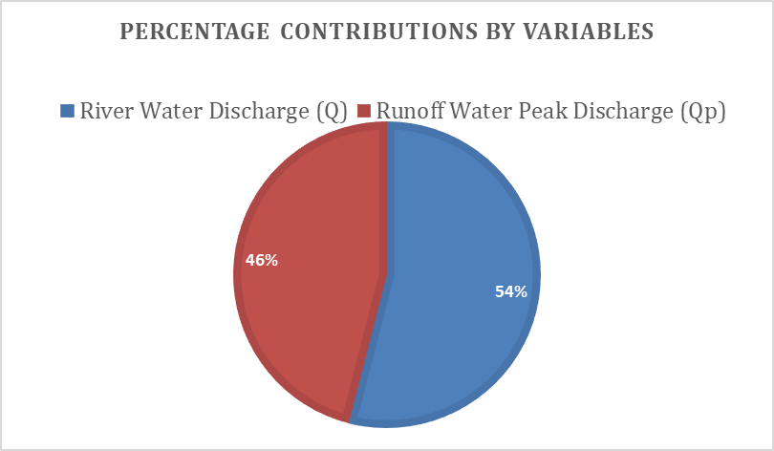

The result of this research is discussed based on the objectives of the research as follows:

Table 1 showed the average Current or Velocity (V) of the river for 2018 and 2024. The table shows that the average velocity of the river for 2018 and 2024 is between 0.61m/s and 0.76m/s. Table 2 and 3 represents the values for cross-sectional area (A) and the Discharge flow rate (Q) of each of the catchments of the river for 2018 and 2024.

Table 4 showed average bathymetry data of the catchment areas of Orashi River for 2012, 2018 and 2024. The bathymetry data showed a depth difference between 2012 used as baseline and 2018, 2024. The difference in average depths ranges from 0.3m to 0.6m (3cm to 6cm) in each of the catchments as identified in this research. These results show a deposition of sediment of 0.3m to 0.6m in Orashi River between 2012 to 2024.

Table 4 showed the catchment areas of Orashi River with their various runoff water peak discharge (Qp) for 2018 and 2024 based on their various cross-sectional areas (A), runoff coefficient (C) and rainfall intensity (I) of the catchment areas. Table 7 showed the rate of sediment accumulation in Orashi River. It shows a maximum rate of sediment accumulation of 0.06m in catchment 3, 4, 6 and 8 while a minimum accumulation occurred in catchment 7.

Table 8 represents the average dependent and independent data used in the linear regression analysis of this research. The linear regression analysis shows a good correlation between the dependent variable and the independent variables based on the correlation error of 0.2cm obtained from the collective test of the dependent and independent variables. The linear regression analysis showed 46% contributions by Discharge Flow Rate (Q) to the rate of sediment accumulation of the river and Runoff water peak discharge (Qp) contributed about 54% in the study area.

**Conclusion**

The study thus far has shown the dynamic state of part of Orashi River, the riverbed has been found to be undergoing changes due to sedimentation occasioned by the River Discharge Flow Rate (Q) and the Runoff Water Peak Discharge (Qp).The study has shown the usefulness of multiple regression analysis in establishing a relationship between river sediment, river discharge flow rate and runoff water peak discharge with minimum design error. It is evident in this research that the increase in volume of water of Orashi River that overtops its bank to the environment is as a result of increase in sedimentation of the riverbed. The results of this study will help individuals, Government, rivers authorities and corporate bodies around the study area to understand rate at which sediment is been deposited in Orashi river and other rivers. The following recommendations were made with respect to the research results and findings:

1. This research recommends among other things the dredging of Orashi river to enable it to retain more volume of water.
2. The relocation of individuals living within 50meters from the shore of the river owing to the impact of the flooding when the river overflows its banks.

**Disclaimer (Artificial intelligence)**

Author(s) hereby declare that NO generative AI technologies such as Large Language Models (ChatGPT, manuscript.

Competing Interest

The authors declare no competing Interest.

Acknowledgment

The Authors acknowledge NiMet and EcoTech. for the supplies of the rainfall data and bathymetric data.

**References**

Akrasi S.A. (2011). Sediment Discharges from Ghanaian Rivers into the Sea. CSIR-Water Research Institute, P. O. Box M.32, Accra, Ghana Corresponding author; E-mail: [xxxxxx@yahoo.com](mailto:xxxxxx@yahoo.com). *West African Journal of Applied Ecology,* 18. ISSN: 0855-4307: <https://doi.org/10.4314/wajae.v18i1.70320>.

Amisigo, B. A. & Akrasi, S. A. (2000). A suspended sediment yield predictive equation for river basins in the southwestern river basin system of Ghana. *Journal of Applied Science and Technology,* *5*(1 & 2), 108-113. ISSN: 0855-2215; <https://doi.org/10.4314/wajae.v18i1.70320>.

Chukwu, F.N. & Badejo, O.T, (2015). Bathymetric survey investigation for Lagos lagoon seabed topographical changes. *Journal of Geosciences and Geomatics,* 3(2):37-43. ISSN: 2373-6704. <https://doi.org/10.12691/jgg-3-2-2>.

Doten, C.O., Bowling, L.C., Lanini, J.S., Maurer, E.P., & Lettenmaier, D.P. (2006). A spatially distributed model for the dynamic prediction of sediment erosion and transport in mountainous forested watersheds. *Water Resources Research, 42*(4), 21-27. ISSN: 2166-5982; <https://doi.org/10.1029/2004WR003829>

Felix, D., Albayrak, I. & Boes, R.M. (2018). In-situ investigation on real-time suspended sediment measurement techniques: Turbidimetry, acoustic attenuation, laser diffraction (LISST) and vibrating tube densimetry. *International Journal of Sediment Research,* *33:*3-17. ISSN:1001-6279. <https://doi.org/10.1016/j.ijsrc.2017.11.003>.

FIG Commission 4 (2010). *Working group on hydrographic surveys in practice.* Guidelines for the planning, execution and management of hydrographic surveys in ports and harbours. FIG Publication, 56. www.fig.net.

Foteh, R., Garg, V., Nikam, B.R., Khadatare, M.Y., Aggarwal, S.P. & Kumar, A.S. (2018). Reservoir sedimentation assessment through remote sensing and hydrological modelling. *Journal of the Indian Society of Remote Sensing, 46*(11), 1893-1905. ISSN: 0974-3006. <https://doi.org/10.1007/s12524-018-0843-6>.

Gerald, I.U., Lawrence, H. & KuroTamuno, P.J. (2021). Comparison of classical and sentinel 2a satellite derived Bathymetry of a section of Nun River in Bayelsa State. *International Journal of Scientific & Engineering Research, 12*(8), 664. ISSN: 2347-3878.

Gunawan, T. A., Daud, A., Haki, H. & Sarino, K. (2018). *The estimation of total sediments load in river tributary for sustainable resources management.* International Conference on SMART CITY Innovation 2018 IOP Conf. Series: Earth and Environmental Science 248.

Liu, C., He, Y., Des Walling, E. & Wang, J.J. (2013). Changes in the sediment load of the Lancang-Mekong River over the period 1965–2003. *Science China Technology Science 56*(4), 843-852. ISSN: 1869-1900. <https://doi.org/10.1007/s11431-013-5162-0>.

Mano, V., Némery, J., Belleudy, P. & Poirel, A. (2009). Assessment of suspended sediment transport in four alpine watersheds (France): influence of the climatic regime. *Hydrology Process. 23:*777-792. ISSN: 1099-1085.

Medeiros, P.H.A., de Araújo, J.C., Mamede, G.L., Creutzfeldt, B., Güntner, A. & Bronstert, A. (2014). Connectivity of sediment transport in a semiarid environment: a synthesis for the Upper Jaguaribe Basin, Brazil. *Journal of Soils Sediments 14*(12), 1938-1948. ISSN: 1614-7480. <https://doi.org/10.1002/esp.5001>.

Minear, J.T. & Kondolf, G.M. (2009). Estimating reservoir sedimentation rates at large spatial and temporal scales: A case study of California. *Water Resources Research, 45*(12), 31-38. ISSN: 2166-5982. <https://doi.org/10.1029/2007WR006703>

Mishra, S. P., Kumar, C., Mishra, A., Mishra, S., & Patel, A. (2021). Estimation of Sediments in Rengali Reservoir, Odisha (India) Using Remote Sensing. International Journal of Environment and Climate Change, 11(12), 205–225. <https://doi.org/10.9734/ijecc/2021/v11i1230572>

NIMET (2024). Nigeria Meteorological Agency, website-info@nimet.gov.ng

Radwan, A.E. & Tarek, E. (2016). Bathymetric Study of some Khors in Lake Nasser, Egypt. *Lakes, Reservoirs and Ponds,* 10(2): 139-158. ISSN: 1844-6477.

Samaila-Ija, H.A., Ajayi, O.G., Zitta, N., Odumosu, J.O., Kuta, A., Adesina, E.A. & Ibrahim, P. (2014). Bathymetric survey and volumetric analysis for sustainable management: Case study of Suleja Dam, Niger State, Nigeria. *Journal of Environment and Earth Science, 4*(18), ISSN: 2224-3216. <https://doi.org/10.30564/jees.v7i7.9923>.

Sciortino, J.A. (2010). *Fishing harbour planning, construction and management.* Published by Food and Agriculture Organization of the United Nations. ISBN: 978-92-5-106696-6.

Sedlacek, J., Bábek, O. & Kielar, O. (2016). Sediment accumulation rates and high-resolution stratigraphy of recent fluvial suspension deposits in various fluvial settings, Morava River catchment area, Czech Republic. *Geomorphology, 254:*73-87. ISSN: 1872-695X. <https://doi.org/10.1038/srep34250>.

Syvitski, J.P., Morehead, M.D., Bahr, D.B. & Mulder, T. (2000). Estimating fluvial sediment transport: the rating parameters. *Water Resources Research 36*(9), 2747-2760. ISSN: 2166-5982. <https://doi.org/10.1029/2000WR900133>.

Trimble, S.W. (1999). Decreased rates of alluvial sediment storage in the Coon Creek Basin, Wisconsin, 1975-93. Journal of *Science, 285*(5431), 1244-1246. <https://doi.org/10.1126/science.285.5431.1244>

Üneş, F., Taşar, B., Varçin, H. & Gemici, E. (2022). River sediment amounts prediction with regression and support vector machine methods. *Air and Water - Components of the Environment” Conference Proceedings, Cluj-Napoca, Romania,* 98-107.