Spatial Analysis of Gully Erosion Patterns and Community Impact in Kaduna South, Kaduna State, Nigeria
Abstract
This study assessed the spatial patterns and socio-economic factors influencing gully formation in Kaduna South Local Government Area of Kaduna State. Gully erosion sites numbering eighty eight (88) were identified in planned and unplanned areas, coordinates of all the spatial locations of gullies are collected using hand held GPS Garmin 78s and the area was mapped using ArcGIS 10.5. Shape files were used to generate Base Map for the period of 20 years (2001-2020) at 5 years interval. Data on gullied areas were obtained from places where gullies are more prevalent like Kurmin Mashi, Kakuri Gwari, Tudun Nupawa and Kabala West through survey, interviews, measurements and ground trothing exercise. The highest number of gullies identified was 21, Kabala West having the most of the gullies and Makera having the lowest. Several roads identified to be affected by gully erosion like Kajuru road and Alagbado Street in Kabala West as well as Birnin Kudu Road in Tudun Nupawa were investigated, While building infrastructures were also affected by gully development at Tudun Nupawa LEA, River close in Kurmin Mashi, Lungu (pipeline) in Kakuri Gwari which eventually became a criminal hiding points. Base Map of Kaduna South LGA for the years 2005, 2010, 2015 and 2020 was obtained with the coordinate of the gully locations superimposed. From the Base Map, the year 2005, 2010, 2015 and 2020 had 33, 18, 20 and 16 gullied points respectively. Mean length, Width, Depth and year of formation for each gullied site was obtained and the rate of advancement per annum was calculated. Kajuru and Alagbado roads in Kabala have the highest rate of advancement of 6.6m per annum which is due to slope and inadequate drainage. Captain Road in Kurmin Mashi has the lowest rate of advancement of 0.2m per annum which is due to community effort put in place by using sacks of sand as a way to mitigate and reduce the effects of the gully. There was community participation in different areas in trying to mitigate the effect of gully in their communities, as evidenced at Abuja road, Kurmin Mashi and Kajuru Road at Kabala West, where residents use old car tires and sacks filled with sand across the gullied region to stop further advancement of the gully on the road side. An action that helped in ameliorating the advancement of gully overtaking the available access roads. From the results obtained it can be concluded that gully formation can occur in any area whether planned or unplanned. Factors discovered to be responsible for the development of gullies in the study areas clearly shows that the socio economic status of the residents contributed in their formation where residents were found to have abandoned their houses because they cannot remediate the effect of gully presence. However, relevant government authorities need to enlighten the communities about the dangers of gullies in the society and finding lasting solutions to gully effects. Also, state and local government authorities need to provide required engineering solutions to the places affected by the gully(s) like retaining walls, embankments and proper drainages.

Keywords: Gully Erosion, Spatial Analysis, Environmental Degradation, Geospatial Techniques, Land Degradation

INTRODUCTION
The impacts of gully erosion in Nigeria are significant and comparable to those experienced in other parts of the world. Gully erosion occurs due to a combination of various factors that act individually or concurrently to detach, transport, and deposit soil particles in different locations from where they originated. This phenomenon leads to the formation of deep cuttings and bulges that dissect the entire land surface. Earth scientists have established that both environmental and human-related factors, known as anthropogenic factors, influence the extent of soil erosion worldwide (Mbaya, 2013).
While humanity has contributed positively to reshaping and conserving the earth's surface, it has also played a role in causing ecological instability and the rapid proliferation of environmental issues like soil erosion. Anthropogenic factors primarily include technical elements such as land use and tillage methods, the choice and distribution of crops, and the nature of agro-technology. Activities like vegetation clearance, intensive harvesting, and over-grazing leave the soil bare and promote soil erosion. Moreover, soil compaction resulting from heavy machinery reduces the soil's capacity to absorb water, leading to excessive water runoff and erosion (Simpson, 2020).
Classical modeling works on soil erosion prediction and estimation by various researchers have identified topography/relief, rainfall, and soil factors as the main agents determining the extent of gully erosion hazard. The soil factor represents soil erodibility, which is a product of geological and soil characteristics (Poeson, 2011). .
In Nigeria, erosion is an active and widespread geomorphic process, particularly in the south-eastern and some parts of the guinea savanna. These areas experience phases of intense rainfall combined with non-cohesive soil structure, making erosion a severe environmental hazard. The savanna region, in particular, is affected by erosion in a broad east-west belt stretching from the eastern highland of Taraba state to the Sokoto basin. Headwaters of major drainage systems have been extensively eroded in these regions.
Every state in Nigeria suffers from some form of erosion, with the southern states experiencing higher incidences. As a response to the severity of the issue, the Kaduna state government approved construction works for soil erosion control projects in various locations across the state. These projects aim to combat erosion and prevent further damage to the environment. For instance, the construction of the Rigasa Erosion Control project in Igabi Local Government was funded by the Ecological Fund and overseen by the Kaduna state government in 2015.
The significance of understanding gully erosion and its impacts on primiparous mothers lies in the potential to develop targeted interventions and support systems. By recognizing the factors that contribute to erosion and its implications on environmental stability, healthcare providers can address the health and well-being of primiparous mothers more effectively. Moreover, awareness of the social and informational support available to these mothers can help healthcare providers offer tailored guidance, resources, and assistance during the postpartum period. Ultimately, improving the support systems for primiparous mothers can lead to better maternal and infant health outcomes, fostering a positive start to motherhood and nurturing the well-being of both mothers and their newborns (Mbaya, 2013). .
Gullies are evident signs of physical land loss, and for a long time, efforts have been directed towards controlling them. As early as the 1930s, the colonial government in Nigeria initiated a tree-planting campaign to combat erosion, especially on steep slopes in the South Eastern region. Over the years, researchers have extensively studied the causes of these catastrophic erosions, attributing them to environmental factors such as vegetation, geology, geomorphology, aggressive rainfall patterns in the region, and soil characteristics. The consequences of soil erosion are severe, leading to the loss of arable land and inhabitable areas (Simpson, 2001).
The critical state of gully erosion problems in Nigeria necessitates a comprehensive soil conservation program to mitigate the hazards posed by these erosions. Soil conservation measures should focus on sustainable soil productivity while striking a balance between the ecosystem and human-induced influences. Gully occurrences have resulted in the destruction of several properties, particularly houses, with some areas losing multiple buildings in a single event of gully erosion. For instance, in the Auchi area of Edo State, about ten houses were lost to gully erosion (Poeson, 2011). In another incident, over 450 buildings were reported to be lost in Edo State due to erosion. The problem of gully development poses a significant threat to land use, sustainable agriculture, and infrastructural development in the Kaduna South Local Government Area. In light of this situation, this study aims to assess the extent of gully development in both planned and unplanned communities within the Kaduna South Local Government Area. By understanding the severity of gully erosion and its impact on the region, this study seeks to inform effective strategies for mitigating the erosional hazards and preserving the environmental and socio-economic stability of the area.
Gully erosion represents a significant component of land degradation that requires careful consideration in the planning of urban centers. It occurs when water flows through unprotected land, washing away soil along drainage lines (Ibrahim, 2014). In the Kaduna South Local Government Area, gully erosion has emerged as a serious problem affecting both planned and unplanned localities. Examples of its impact include the washing away of toilet blocks at Tudun Nupawa Primary School and the encroachment on access roads in Kurmin Mashi due to gully development. Similar situations are observed in areas like Kabala west, Barnawa, Television, and Tudun Wada.
Various measures have been implemented to address gully occurrences in these affected areas. Communal efforts during the rainy season aim to mitigate the effects of gullies, while the Local Government Authority works on de-silting drainages to allow for the free flow of water and prevent further gully development. The State Ministry of Environment also takes action to tackle gully erosion in the region. Additionally, the Federal Government has partially addressed one gully site in Tudun Wada through the ecological funds. Despite these efforts, the problem of gully development persists.
Gully erosion poses several problems, including the threat of displacement, destruction of road and communication infrastructure, loss of lives and properties, and the disruption of existing drainage systems, among others. To address these challenges, the research in question investigates the spatial distribution of gully erosion in planned and unplanned areas of Kaduna South Local Government Area. Utilizing ArcGIS 10.5, the study aims to identify and map out areas affected by gully erosion, analyze potential causes, and propose solutions to mitigate its effects.
In conclusion, gully erosion represents a pressing issue in the studied region, impacting both planned and unplanned areas. Despite various efforts by different authorities, the problem persists, causing significant disruptions and risks to the community. The research endeavors to shed light on the extent and characteristics of gully erosion, offering valuable insights to develop more effective strategies for its prevention and mitigation.
The aim of this study is on the assessment of the extent of gully erosion in both planned and unplanned areas of Kaduna South Local Government Area. This aim was achieved via the following actions:
- Identification of the planned and unplanned areas within the study area.
- Identifying the gully erosion sites and the level of their development.
- Examining the causes of gully erosion in the study sites.
- The determination of the effects of gully erosion on available infrastructure.
Literature Review
Gully erosion brings forth a plethora of problems, including social, material, human, physical, psychological, and economic issues. It has become epidemic in Nigeria, particularly in the southeastern part of the country (Egboka, 2005).
Gully erosion is considered one of the most destructive soil and land erosion processes. Within a short period, topsoil and the underlying unconsolidated rock substrate are removed by runoff leading to the formation of steep-sided channels deeper than 1 meter, characterized by abrupt gully head cuts and numerous thresholds in the channel. This landform is commonly referred to as a ravine (gully), although it may bear different names in different parts of the world, such as arroyo or coulee in the USA, uvrag in Russia, burone or fosco in Italy, ravin in France, donga in South Africa, lavaka in Madagascar, and nullah in India.
Gully erosion is considered an indicator of desertification (WHO, 2004), with its main causes attributed to global climate changes and anthropogenic pressure. However, experimental studies on gully erosion have often been less extensive compared to those dedicated to surface sheet erosion, even in Europe (Pearson, 2011). Gully erosion rate estimates show that gullying is responsible for a significant extent of topsoil loss in small catchments, ranging as high as 90% or more in numerous cases.
In the context of geographic information systems (GIS), various types of gully models are employed for spatial modeling of gully development. GIS has been a well-established tool for spatial analysis for over four decades. It serves as a platform to create, store, organize, manage, display, and model spatial phenomena, such as erosion factors, rainfall, runoff, topography, land use, soil type, and agricultural practice patterns. All these relevant factors can be converted into different GIS data formats as spatial information (Simpson, 2020).
The dynamic model takes into account topographical, hydrological, and lithological data as input. Topography is described by elevation and distances from the gully mouth at N points along the longitudinal profile of each flow line, including existing gullies. The water discharge changes over time, and the hydrograph needs to be calculated for all these points using a hydrological model that must be linked with the gully erosion model. The model also utilizes multi-layer soil properties, requiring input for each layer's elevation at the same N point, soil density, cohesion, angle of internal friction, stable aggregate diameter, water content, and thin vegetation root content.
The longitudinal profile of transformation in space and time and the widening of the gully bottom are computed using the Lax-Wendroff predator-corrector scheme. A stability criterion is determined for each calculation step, and numerical scheme stability is achieved by adjusting the duration of the time step. At each step, the flow width, depth, velocity, and critical shear stress for the soil at the bottom and banks are calculated. After each flood event, the rectangular bottom trench is transformed into a trapezoidal shape using a straight slope model, and the longitudinal distribution of the gully's width (top and bottom), depth, and bottom elevation are estimated.
Soil erosion is typically the result of various factors working either independently or in combination to detach, transport, and relocate soil particles from their original location. This phenomenon leads to the formation of deep cuttings and ravines that carve into the land surface, a sight commonly observed across the southeastern region of Nigeria. It is well acknowledged within the field of earth sciences that a range of environmental factors, along with pedagogical parameters, play a role in influencing the extent of soil erosion on a global scale. These factors are often influenced by human activities, known as anthropogenic factors. While human actions have contributed to both shaping and preserving the Earth's surface, they have also disrupted the natural ecological balance, leading to the rapid propagation of environmental issues such as soil erosion. Anthropogenic factors primarily encompass technical aspects like land use and tillage methods, the selection and distribution of crops, and the nature of agricultural technology, as noted by Igwe (1994).
In the Northern hemisphere, including many European countries, Giordano, Bonfils, & Briggs (1991) demonstrated that factors promoting soil erosion include activities like
vegetation clearance, extensive harvesting, and overgrazing, which leave the soil exposed. Additionally, soil compaction caused by heavy machinery reduces the soil's capacity to absorb water, leading to increased runoff and soil erosion. Renard, Foster, Weesies, Mc Cool, & Yoder (1997) emphasized topography and relief, rainfall, and soil characteristics as primary determinants of soil erosion hazards in classical modeling approaches for soil erosion prediction. The soil factor, which signifies soil erodibility, is influenced by both geology and soil properties. Exploring how these factors impact the extent of soil erosion and gully formation in southeastern Nigeria involves an examination of how these parameters contribute to gully erosion in other geographical regions.
Hudson (2011) asserts that steep lands are more susceptible to water erosion compared to flat land due to the increased impact of erosive forces like splash, scour, and transport on such slopes. Soil erosion is generally influenced by slope characteristics, with the length of the slope and the extent of soil erosion being directly proportional to the steepness of the slope. Additionally, the shape of hillside slopes, whether convex or concave, often plays a significant role in soil loss and the formation of gullies. In a study conducted in southeastern Nigeria by Ofomata and Phil-Eze (2007), a positive relationship between relief and soil erosion was found. Similarly, in southwestern Nigeria, an increase in soil erosion severity was observed as the slope changed from 5 to 15%. For instance, on a 15% slope, a total soil loss of 230 t/ha/yr was recorded from bare plots, whereas a 1% slope resulted in a soil loss of 11.2 t/ha/yr.
The topography of southeastern Nigeria, as described by Ofomata (1975), can be categorized into three relief units: plains and lowlands, which include all river valleys, cuesta landscapes, and highlands. It has been observed that the uplands, composed of highly friable sandstones, are prone to erosion and can induce gully formation even on slopes of about 5%. On the other hand, the cuesta and other highlands with more stable lithology resist gully formation but contribute to aggressive runoff, leading to devastation in lowland areas, especially at toe slopes and river headwaters. Notably, the infamous Agulu-Nanka gully erosion sites in the southeastern region of the country originated from the headwaters of streams and slopes in the Awka-Orlu Upland region.
Rainfall in Nigeria is characterized by its heaviness and aggressiveness, particularly in the southern region. The nature of the rainfall regime significantly contributes to its erosivity, which refers to its potential to cause erosion. Rainfall erosivity is influenced by the physical characteristics of rainfall
The lithology, or the type and characteristics of bedrock and geological materials, directly influences soil erosion processes. This influence is evident in how denuded bedrocks exposed to water flow can resist erosion, and how the properties of parent materials, determined by the bedrock, condition the soil's main properties. Some geological materials are more vulnerable to the aggressive energy of rainfall and runoff than others. Areas with weak unconsolidated geological formations, especially when coinciding with medium to long slopes with marked gradients, are at higher risk of erosion.
In Nigeria, Ofomata (1981) classified areas with potential erosion susceptibility based on underlying geology. He found that areas with weak unconsolidated sandy formations are highly susceptible to erosion, while areas with consolidated tertiary to recent sediments are less susceptible. In southeastern Nigeria, the sites known for classical gully erosion are located in formations such as False-bedded sandstone, Coastal Plain sands, Nanka Sands, and the Bende-Ameki Formations, all of which are sandy formations and have more gullies compared to their shale formation counterparts. These sandy formations are associated with the worst catastrophic soil erosion sites in sub-Saharan Africa. Therefore, geology directly and indirectly influences gully formation, with the indirect effect being on soil formation and its contribution to erosion processes (Igwe, 2005).
Soil erodibility refers to the susceptibility or vulnerability of the soil to erosion, which is determined by its ability to detach and be carried away by erosive agents. Igwe (2003) noted that several factors, including the chemical and physical properties of the soil, influence its erodibility. In southeastern Nigeria, the nature and long weathering history of the soil parent material, characterized by a dominance of non-expanding clay minerals and low soil organic matter concentration due to high mineralization rates and excessive nutrient leaching, contribute to the worsening erosion situation. Improper land use and soil management practices in agriculture also weaken the soil, leading to severe gullies. These soils are loose and prone to slumping under intense rainfall, making them easily detachable. Some soils may slake and form seals under heavy rainstorms, resulting in significant runoff and erosion (Lal, 2016).
The role of soil erodibility as a contributing factor to soil erosion hazards has been recognized. Various soil indices that predict or promote soil erosion will be discussed in terms of soil erodibility. Studies in Nigeria have shown that factors such as soil clay content, soil organic matter (SOM) level, and sesquioxides like Al and Fe oxides, as well as indicators like Clay Dispersion Ratio (CDR), Mean-Weight Diameter (MWD), and Geometric-Mean Weight Diameter (GMWD) of soil aggregates, influence soil erosion hazards in southeastern Nigeria (Igwe, 2005, 2003). SOM, Al, and Fe oxides control soil dispersion and flocculation. During aggressive rainfall, the soil's inherent properties combine with the physical forces of rainfall to cause soil erosion. Erodibility varies with soil texture, aggregate stability, SOM content, and hydraulic properties of the soil. The soil Dispersion Ratio (DR) and clay dispersion ratio are considered good indicators of erodibility. Soils with high Water-Dispersible Clay (WDC) in southeastern Nigeria pose problems, as mud flow and soil loss from runoff alter stream flow within watersheds and lead to environmental challenges. Soil crusting and sealing resulting from aggregate breakdown are secondary issues arising from deposited sediments (Poesen, 2011). Soil properties related to aggregate stability have been identified as efficient predictors of the extent of soil erosion.
In various regions worldwide, the use of aggregate stability indices to predict soil erodibility has provided reliable information about the extent and degree of soil erosion (Bajracharya, Elliot, & Lal, 1992). In Western Europe, Le Bissonnais (1990) found that the Mean-Weight Diameter (MWD) of soil aggregates was a highly dependable soil property to assess the erosion potential of the soil. Therefore, aggregate stability and MWD are reliable indicators in explaining, quantifying, or predicting soil erosion and other soil issues such as crusting and sealing.
Certain soil properties also contribute to structural failure, sliding, and mass movement of soils. These factors include the mineralogy of the clay and soil chemical properties. The stability of the soil mass is dependent on the presence of specific clay minerals. Illite and smectite readily form aggregates, but their open lattice structure and swelling and shrinking during wetting and drying make the aggregates less stable than those formed from kaolinite. Soils with predominant kaolinite or illite clay but containing small amounts of smectite are easily dispersive. Smectitic soils are more erodible than soils with only a small amount of smectite. In contrast, soils without smectite are more stable, less erodible, and less prone to seal formation.
The presence of sodium dithionite extractable Fe oxide, a soil chemical property, significantly relates to soil erodibility. This property affects soil structure and fabric, often leading to the formation of soil aggregates and cementation with other major soil components (Igwe & Stahr, 2009). In southeastern Nigeria, the aggregation mechanism of soils in the presence of Fe (Hydr) oxide has been demonstrated (Igwe, Zarei, & Stahr, 2009). The presence of OH-Al polymers may reduce the swelling and expansion of clay particles by bonding adjacent silica sheets and displacing interlayer cat ions with high hydration power, thus promoting aggregation. Although well-crystallized aluminum hydroxide may act as a cementing agent in acid soils like those in southeastern Nigeria, its impact might be less significant compared to non-crystalline materials. Therefore, iron oxides are generally more effective than aluminum hydroxide in cement effectiveness, except for soils undergoing frequent oxidation-reduction processes.
The continuous clearing of the former rainforest due to population growth and increased agricultural activities exposes the bare soils to the influence of weather, leading to a significant escalation in soil erosion problems. Consequently, the soils are frequently subjected to various degrees of erosion, including accelerated erosion. Vegetation and land use play a crucial role in the soil erosion process in southeastern Nigeria. Vegetation acts in multiple ways, such as intercepting raindrops, promoting greater water infiltration, and increasing surface soil organic matter, which reduces soil erodibility (Stocking, 1975). Proper land use selection, as noted by Lal (1983), can substantially mitigate soil erosion. In Nigeria, soil erosion, especially gully development, is most severe on soils where the original vegetation has been disturbed, as is the case in the southeast. This is particularly evident in agricultural soils stripped of vegetation for infrastructural developments like road and housing construction. Ofomata (1985) demonstrated that soil erosion in the region is mainly linked to agricultural activities and other related land use practices, including mining, road construction, urbanization, industrialization, and general infrastructural development. These activities result in the degradation of the soil surface, loss of vegetation cover, and direct contributions to slumping, sliding, rill erosion, and gully formation.
A significant contributing factor to soil erosion issues in southern Nigeria is the anthropogenic impact resulting from land misuse (Igwe, 2005). Inadequate farming practices have led to the breakdown of soil structure, promoting increased runoff and soil loss due to erosion. Uncontrolled grazing by nomads has led to deforestation, and the creation of indiscriminate footpaths on the landscape has facilitated the formation of rudimentary channels, which can evolve into gullies if left unchecked from their early stages. The construction of roads and other unchecked infrastructure development has played a substantial role in the formation of gullies. Gully development has also been exacerbated by the abandonment of road networks, buildings, and other infrastructure projects due to the emergence of gullies.
Materials and Methods
Study Area: The study area is cited in the central part of Kaduna State Nigeria, covering a total land area of 1152km² and estimated to be inhabited by 588,766.8 people. The study is limited to Kaduna South Local Government situated within the Kaduna Metropolis and falls in the ecological zone of Northern Guinea Savannah.. The area is geographically located between Latitude 10⁰ 24' 00''and 10⁰ 28' 00'' North and Longitude 70⁰ 20' 00'' and 70⁰ 28' 00'' East as shown in figure 1.
The terrain is predominantly flat, with gentle undulations found in the northern part. The soils in Kaduna South Local Government Area primarily consists of Sandy and laomy soils. Sandy soils are composed of medium, coarse and particle, promoting good drainage and lacking organic matter. The prevalent soil type I of Kaduna South Local Government Area is sandy loam, which combines soil texture with varying promotions of silt, clay and organic materials, sandy laomy generally offers excellent water holding capacity and fertility compared to pure sandy soils ensuring favorable conditions for crop cultivation due to their effective drainage conditions.
The elevation of Kaduna South varies between 575 to 650 meters above sea level. Kaduna South experiences a typical tropical continental climate with distinct seasonal patterns, alternating between hot dry and humid wet season. This variations are influenced by the presence of tropical continental and equatorial maritime air masses that sweep over the entire country. The climate is characterized by a pronounced seasonality, with cool and dry season.

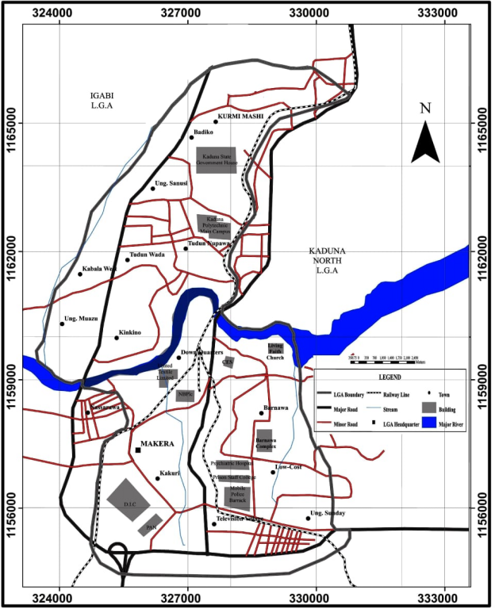
Figure 1: The Study Area
Source: Cartography Department, Kaduna Polytechnic (2021)
The localities surrounding Kaduna South are characterized by a peneplain that has developed under Precambrian basement complex, consisting of igneous and metamorphic rocks with varying compositions, including quartzite. Overtime, weathering, erosion, transportation and deposition processes have shaped the land forms. Some areas in Kaduna South have protruding hard and resistant granite rocks that have resulted from the weathering process. (Dantudu 2015). Moving on the relief of Kaduna South, the land primarily comprises of rolling hills with elevation ranging from as low as 600m.
River Kaduna serves as the main river in the study area, originating from the Jos Plateau highland and flowing into the river Niger. It receives contributions from its tributaries, including River Galma and River Romi. The volume of water in the Kaduna River varies with the changing patterns of rainfall, experiencing fluctuations from season to season. The drainage pattern of the study area, depicted in Fig 2, shows the network of major and minor tributaries that feed into River Kaduna. This network spans from Kurmin Mashi at an elevation of 575 meters above sea level to Anguwan Muazu at 650 meters above sea level, as well as from Tudun Nufawa to Tudun Wada, all the way down to River Kaduna through Bashama Road.
Regarding population, Kaduna South Local Government Area has witnessed a steady and rapid increase over the years. The population recorded during the 2006 census was 402,390 (Ndabula, 2006), and it further rose to 474,820 in 2012. Utilizing the 3.0% growth rate sanctioned by the National Population Commission, the projected population of Kaduna South in 2020 is estimated to be 588,776.8. The growing population implies an increasing demand for ecological intervention to manage the existing effects of gully erosion and implement mitigation measures to prevent its further spread. Over the years, efforts have been made by communities to combat
gully erosion, with some areas being filled up using sand and used vehicle tires to reduce the formation of new gullies.
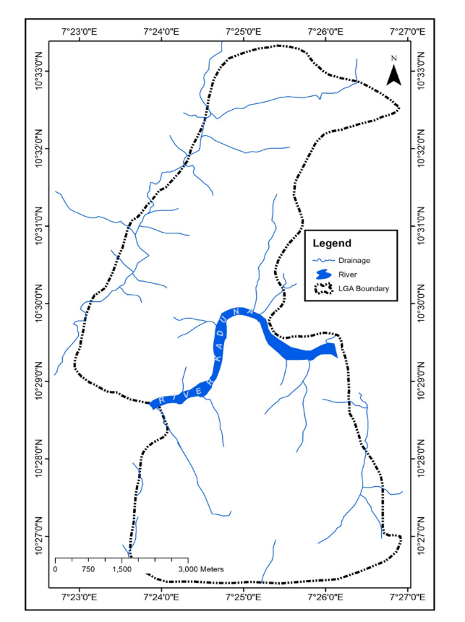

Figure 2: Drainage pattern of the study area
Source: Cartography Department, Kaduna Polytechnic (2021).
Data Collection
The study employed a descriptive survey method, which involves collecting data to describe and interpret existing conditions, prevailing practices, attitudes, and procedures related to the research objectives. The data were presented using maps, plates, and tables, and subsequently analyzed and presented using graphs, tables, figures, and charts.
Before initiating the main study, a reconnaissance survey was conducted to gain a better understanding of the gully locations and to identify the planned and unplanned areas. This preliminary survey laid the groundwork for scoping the study and setting its boundaries.
Gully locations were obtained through ground truthing, where researchers physically visited the sites and used a hand-held GPS device to accurately record the exact locations of the gullies in the study area. Additional attribute data, such as the gully's proximity to infrastructures like roads and buildings, and specific characteristics of each gully, were also recorded.
A base map of the study area was obtained, covering the period from 2000 to 2020, with intervals of 5 years. This base map served as a reference for understanding the spatial changes over time. Topographic maps and land use maps of the study area were also acquired, providing valuable information about the terrain and how the land is being utilized.
Oral interviews were conducted with individuals directly affected by gullies, gathering valuable insights and experiences from the local community. Additionally, a field survey was conducted to gather on-site information.
The following software’s are used for the studies: -
i ArcGIS 10.5 software for mapping, vectorization and analysis purposes,
ii Microsoft words for data storage and processing,
iii Microsoft Excel for data entry and graphic display.
The following hardware’s are used for data collection and analysis: -
i GPS (hand held Garmin 78s) for the collection of coordinates of gully locations.
ii HP Laptop for typing, data analysis and storage of soft copy.
iii Coloured printer for conversion of soft to hard copies
iv Digital camera for capturing photographs of the affected locations
v Measuring tape for measurements of the gully length and width
The sample used in this study was determined based on the desired level of research. The entire relevant field data was gathered through a series of steps, including Reconnaissance Survey, field Observation, Measurements, oral interviews, Ground Truthing, and Inventory Survey, to ensure comprehensive and validated data.
Observation played a crucial role in conducting this research; areas affected by gullies were carefully observed and recorded for analysis. All geographic data collected underwent meticulous scrutiny and were converted into compatible formats for computer systems. The following processes were undertaken: Geo-referencing, Digitizing, Creation of layers, and Data Base Creation.
The analysis was conducted to achieve the research objectives. Descriptive statistics were utilized to summarize the data gathered from field observation, measurements, and interviews. The relevant data were presented using tables, plates, figures, and maps. Furthermore, GIS Analysis involved overlaying the gullies' locations on the base map generated for the period 2000-2020.
Data Analysis and Discussion
The designated planned areas under the Kaduna State Geographic Information System (KADGIS) is presented in Table 1. Investigation reveals that communities in Kaduna South Local Government were planned during the period from 1976 to 2014. Among these planned settlements, Barnawa Residential Layout stands as the oldest, while Makama Road Low Density Residential Layout represents the most recent planned area, as the result presented in table 1.
Table 1: List of Planned Areas under the State Planning Authority
S/No. | Planned Areas | TPO’s | Year of Approval
1 | Barnawa residential layout GRA B | 463 | 1976
2 | Bye Pass Light Industrial Estate K/Mashi A,B and C | 460 | 1985/1998
3 | College Road Residential Layout (Governor Road) | 428 | 1985
4 | Bus Terminus, Residential and Commercial Layout, Badikko | 630 | 1991
5 | Kakuri Industrial Layout | 451 | 1994
6 | Tudun Wada Lodge Layout | 640 | 1991
7 | Challawa Crescent residential lay out | 635 | 1996
8 | Unguwan Muazu old market site Development  Layout extension | 668 | 1997
9 | AliyuMakama road redevelopment scheme | 655 | 1996
10 | Low density residential lay out at Barnawa North | 1064 | 2014
11 | Unguwan Television high density residential layout | 5598 | 2000
12 | Tudun Wada and Kinkinau medium density residential layout | 996 | 1996
13 | Makama road, Barnawa GRA, Low density residential layout Barnawa north | 636 | 2014
*TPO Town planning ordinance
Source: KADGIS, KASUPDA 2021
Table 2 provides evidence of the existence of planned areas in Kaduna South Local Government under the native authority before the establishment of the Local Government system in Nigeria. The oral interview with the deputy director of lands in Kaduna South Local Government reveals that people applied for lands and were allocated them under the native authority as far back as the 1950s, as clearly indicated in Table 2 above

Table 2: Planned Areas under the Local Government and Colonial Authority
S/No. | Area | L.G.A. Planning Authority | Native Authority | Years of Establishment
1 | T/Wada | - | Native | 1930s-1963
2 | Sabon/Gari | - | Native | 1963
3 | Makera | - | Native | 1950s-1962
4 | Kakuri | - | Native | 1950s-1962
5 | T/Nupawa | Kaduna L.G.A Authority | - | 1962
6 | K/Barchi | Kaduna L.G.A Authority | - | 1972
7 | Barnawa | Kaduna L.G.A Authority | - | 1972
8 | K/Mashi | Kaduna L.G.A Authority | - | 1974
9 | Badikko | Kaduna L.G.A Authority | - | 1974
10 | Kabala West | Kaduna L.G.A Authority | - | 1976
11 | U/Sanusi | Kaduna L.G.A Authority | - | 1976
12 | Shagari Low-cost Barnawa | Federal Ministry of Works | - | 1979
Source: Kaduna South L.G.A, 2021
Results obtained in Table 3 showcases the unplanned areas within the Kaduna South Local Government area, encompassing 12 different localities. Oral interviews with village heads and residents revealed this outcome. The earlier settlers were permitted to continue residing in their respective areas while planning initiatives were being implemented. According to the research findings, Kakuri Gwari stands as the oldest settlement, with a history of over 200 years of existence.

. Table 3: Unplanned Areas (Old Settlements) Presentation
S/No. | Area | L.G.A. Planning Authority | Customary Authority | Year of Establishment
1 | T/Wada | Nil | Nil | Over 120
2 | U/Sanusi | Nil | Nil | Over 100
3 | Kabala West | Nil | Nil | Over 150
4 | Barnawa | Nil | Nil | Over 100
5 | K/Mashi | Nil | Nil | Over 150
6 | Badikko | Nil | Nil | Over 150
7 | K/Barchi | Nil | Nil | Nil
8 | T/Nupawa | Nil | Nil | Over 120
9 | Kakuri-Gwari | Nil | Nil | Over 200yrs
10 | Makera | Nil | Nil | Over 150
11 | Barnawa | Nil | Nil | Over 120
12 | Kakuri | Nil | Nil | Over 150
Source: Author’s Field Work, 2021
The identified gully locations and their developments over a period of twenty (20) years is presented in Table 4 with their respective location as shown by Figure 3.
Table 4: Identified Gully Locations and Development over a 20-Year Period
S/No | IDENTIFIED AREAS | Ref No. | 2005 |  | 2010 |  | 2015 |  | 2020
 |  |  | N^{O} | E^{O} | N^{O} | E^{O} | N^{O} | E^{O} | N^{O} | E^{O}
1 | Kurmin Mashi | 1 | 327294 | 1166426 | 327447 | 1166524 | 326218 | 1166144 | 326831 | 1166358
 |  | 2 | 327241 | 1166451 | - | - | 326147 | 1166080 | 326856 | 1166370
 |  | 3 | 327126 | 1166217 | - | - | 327399 | 1166496 | 326880 | 1166384
 |  | 4 | 327121 | 1166241 | - | - | 327324 | 1166464 | - | -
 |  | 5 | - | - | - | - | 327156 | 1166478 | - | -
2 | Badikko | 6 | 326137 | 1165429 | 325576 | 1164841 | 326635 | 1165372 | - | -
 |  | 7 | 324163 | 1161620 | - | - | - | - | - | -
3 | Unguwan Sanusi | 8 | 325839 | 1164559 | 325789 | 1164630 | - | - | 326150 | 1163396
 |  | 9 | 325855 | 1164528 | 325876 | 1164463 | - | - | - | -
 |  | 10 | 325816 | 1164577 | 325713 | 1164529 | - | - | - | -
 |  | 11 | 325711 | 1164647 | - | - | - | - | - | -
4 | Kabala West | 12 | 325576 | 1164841 | 324163 | 1161620 | 324231 | 1161409 | 323591 | 1161452
 |  | 13 | 323579 | 1161376 | 324212 | 1161409 | 323604 | 1161478 | 323413 | 1161356
 |  | 14 | 323463 | 1161146 | 323583 | 1161527 | 323611 | 1161193 | - | -
 |  | 15 | 323423 | 1161120 | 323593 | 1161064 | 323528 | 1161322 | - | -
 |  | 16 | 323495 | 1161166 | 323175 | 1161165 | 323181 | 1161152 | - | -
 |  | 17 | - | - | 323206 | 1161084 | 323206 | 1161084 | - | -
 |  | 18 | - | - | 323305 | 1161130 | 323305 | 1161130 | - | -
5 | Unguwan Mu’azu | 19 | - | - | 323522 | 1160809 | 323209 | 1160790 | 323321 | 1160495
 |  | 20 | - | - | - | - | - | - | 323582 | 1160779

 |  | 21 | - | - | - | - | - | - |  | 323782 | 1159947
 |  | 22 | - | - | - | - | - | - |  | 323815 | 1160016
 |  | 23 | - | - | - | - | - | - |  | 323802 | 1159751
6 | Tudun Nupawa | 24 | 327248 | 1163026 | 326840 | 1163048 | - | - |  | 327348 | 1162938
 |  | 25 | 327240 | 1162784 | - | - | - | - |  | - | -
 |  | 26 | 327223 | 1162936 | - | - | - | - |  | - | -
 |  | 27 | 327505 | 1163039 | - | - | - | - |  | - | -
7 | Tudun Wada | 28 | 326075 | 1161586 | - | - | - | - |  | - | -
 |  | 29 | 326441 | 1161824 | - | - | - | - |  | - | -
 |  | 30 | 327310 | 1163140 | - | - | - | - |  | - | -
8 | Television | 31 | 328226 | 1154977 | 328406 | 1154992 | 328517 | 1155373 |  | 327824 | 1155542
9 | Barnawa | 32 | 328114 | 1159610 | 329208 | 1157305 | - | - |  | - | -
 |  | 33 | 328077 | 1159671 | 329217 | 1157305 | - | - |  | - | -
10 | Kakuri Gwari | 34 | 326365 | 1156731 | 326223 | 1156647 | 325493 | 1156952 |  | 326547 | 1156548
 |  | 35 | 326402 | 1156748 | - | - | 325516 | 1156991 |  | 326478 | 1156783
 |  | 36 | 325847 | 1157280 | - | - | 326457 | 1157223 |  | 326519 | 1156779
 |  | 37 | 325897 | 1157304 | - | - | 326289 | 1156847 |  | - | -
 |  | 38 | 325932 | 1157321 | - | - | 325700 | 1157786 |  | - | -
 |  | 39 | 326349 | 1156784 | - | - |  |  |  | - | -
11 | Kakuri Hausa | 40 | 326349 | 1156838 | - | - | - | - |  | - | -
 |  | 41 | 325672 | 1157732 | - | - | - |  | - | - | -
12 | Makera | 42 | 326912 | 1159074 | - | - | - |  | - | - | -

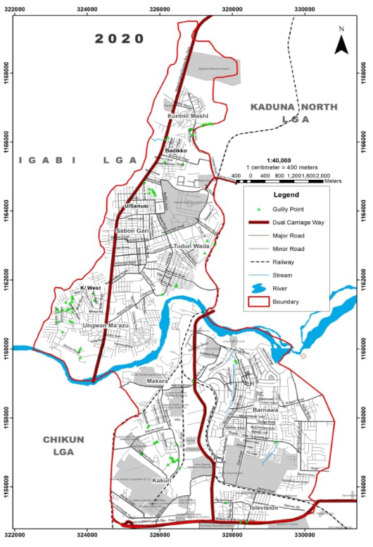

Figure 3: Gully Locations in the Study Area
Authors Field Work, 2021
The outcomes of gullies and their impact on houses in regions of high gully prevalence particularly in Kurmin Mashi area is observed in Plates I, II and III. In this areas, numerous residents have been compelled to evacuate their homes and relinquish their possessions to allow the gully to persist in its development. Notably, River Close has experienced such effects. Additionally, Plates III and IV depict the alarming situation at the Local Education Authority Primary School in Tudun Nupawa, where the gully's advancement poses a severe threat, encroaching closely upon the classrooms and fully engulfing two blocks of toilet facilities used by the students. In these areas, numerous houses have been destroyed, leading to the area becoming a hub for criminal activity involving the sale and consumption of various sedative drugs during daylight hours. This perilous situation has also resulted in the recruitment of many unsuspecting young individuals into these illicit activities. The gullies in these regions have become conspicuous symbols of land degradation, necessitating an immediate response to salvage the affected environment.
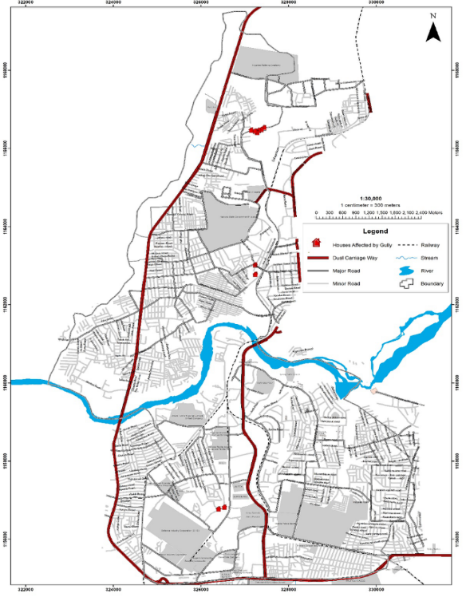
Figure 4.: Houses affected by gully developments
Source: Author’s Field Work, 2021
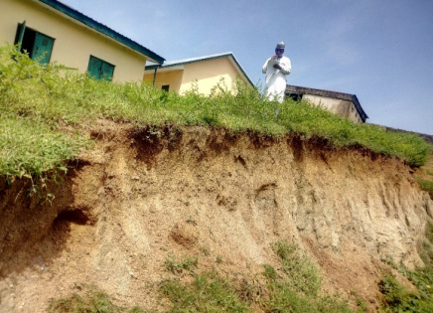

Plate I: Gully development approaching a classroom in LEA, Primary school, T/Nupawa
Source: Authors Field Work, 2021
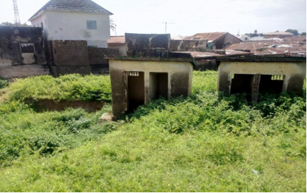
Plate II: Gully development that consumed 2 Toilet facilities in LEA, T/Nupawa
Source: Authors Field Work, 2021
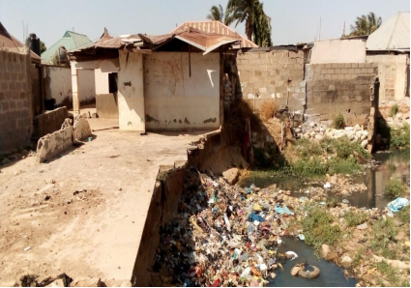
Plate III: Houses at River Close Kurmin Mashi, where residents forfeited and evacuated their belongings because of gully development.
Source: Authors Field Work, 2021

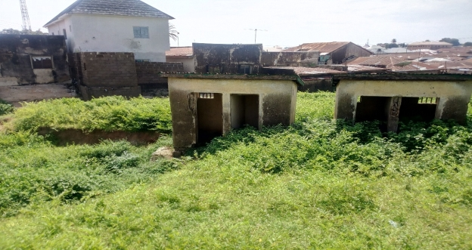
Plate IV: Gully development that consumed 2 Toilet facilities in LEA, T/Nupawa
Source: Authors Field Work, 2021

SUMMARY
Gullies represent visible signs of land degradation, and the research findings provide evident support for gully erosion occurring due to various factors. It is crucial to implement mitigation and remediation measures to address gully development and ensure a sustainable and healthy environment. Thus, this study focused on conducting a comparative analysis of gully development in the planned and unplanned areas of Kaduna South Local Government Area. The study identified the locations of planned and unplanned areas, with Table 1 displaying the planned areas approved by the Kaduna Urban Planning Development Authority (KASUPDA) and Table 1 presenting the planned areas under the Kaduna Local Government and Customary (Native) authority. Additionally, Table 2 illustrates the unplanned areas (old settlements).
During the assessment of the existing planned and unplanned areas, it was discovered that certain parts of Kaduna South Local Government area were planned before Nigerian independence, as evidenced by records from Kaduna Geographic Information Systems (KADGIS) and Kaduna State Urban Planning Development Authority (KASUPDA) in Table 1. This table indicates the names of the areas, Town Planning Orders (TPOs), and the years of establishment, which vary across different locations. These planned areas are spread across the study area and feature diverse land uses such as residential, industrial, and commercial. According to the records, Barnawa Residential Layout and G.R.A. B 1976 stand as the oldest and low-density residential layouts, while Barnawa North 2014 represents the most recent layout established by KADGIS in the study area. Table 4 also reveals planned areas under the Local Government and Customary (Native) authorities, with certain areas like Tudun Wada, Makera, Kakuri, and S/Garin Tudun Wada planned and approved by customary authorities between the 1930s and 1960s. Moreover, Table 4 provides clear information about areas that were not planned by State, Local government, or customary authorities, and they are regarded as old settlements. The planning authorities adopted the integration concept to incorporate these areas instead of the resettlement concept, which involves demolishing all existing structures to create new settlements.
Locations of eighty-eight (88) gullies were identified, and their coordinates were recorded using GPS Garmin78s as displayed in Figure 5. 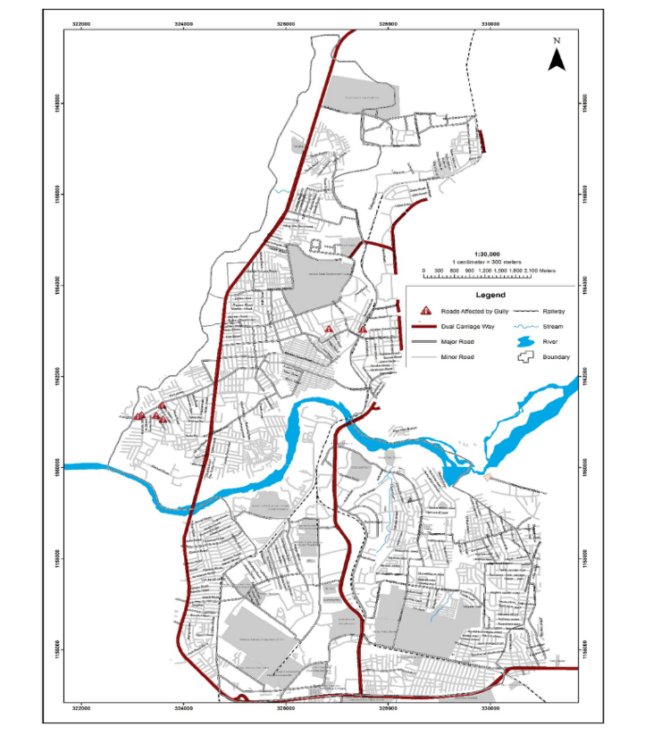
Figure 5: Gully Locations of the Study Area
Source: Author’s Field Work, 2021

Gully points were then superimposed on Figure 5., revealing areas with a high prevalence of gullies, namely Kabala West, Kakuri Gwari, Kakuri Hausa, and Kurmin /Mashi.
Investigating the causes of gully erosion in the study area, it was found that in Kurmin Mashi, gullies primarily form due to water channels or streams that pass through the area, carrying a large volume of rainwater as evident in Plate V.
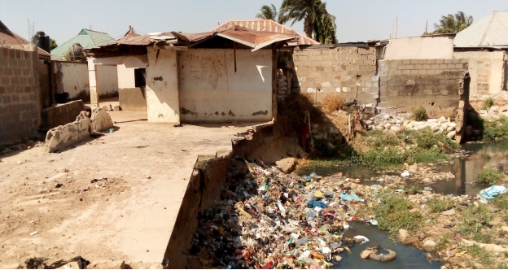Plate V: Houses at River Close Kurmin Mashi, that Residence Forfeited and Evacuates their Belongings Because of Gully Development
Source: Authors Field Work, 2021
This situation is also prevalent in Tudun Nupawa where two blocks of toilet facilities were washed away at LEA Tudun Nupawa Primary School as was observed in Plate II. This finding aligns with Stocking (1987) and Lal (2016), which suggest that the kinetic energy of the storm and the highest intensity of rainfall during the first 30 minutes significantly contribute to soil loss and gully erosion on field plots. Rainfall distribution, intensity, and quantity, along with other environmental factors, play a role in accelerating the rate of inter-rill and gully erosion development.
The level of gully development significantly impacting many roads in Kabala was found to be a result of steep slopes. According to the relief of the study area, Kabala West and Unguwan Muazu have the lowest relief at 565 meters above sea level. This aligns with Hudson, N.W. (2011), as steep lands are more vulnerable to water erosion due to increased erosive forces such as splash, scour, and transport.
The study also revealed that the level of government intervention in tackling gully development is inadequate. However, community efforts in some areas play a vital role in addressing the ongoing development of gullies, as demonstrated in Plate VI.
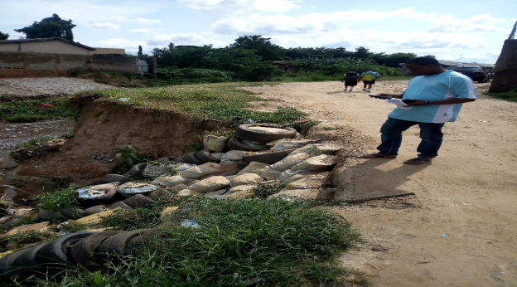
Plate VI: Community Participation to Curtail the Effects of Gully in Abuja Road, K/Mashi
Source: Author’s Field Work, 2021
Conclusion
The findings of this study indicate that various factors contribute concurrently to the development of gullies in the study area, including socio-economic status, poor development control, slope size and inclination, inadequate drainage systems, soil type, and rainfall.
The research emphasizes that gullies can form in both planned and unplanned areas, with socio-economic status being a major contributing factor, as evidenced in high gully prevalence areas like Kurmin Mashi, Kabala West, Kakuri Gwari, and Tudun Nupawa. Residents from disadvantaged socio-economic backgrounds often remain in such areas due to their struggle for daily survival, vacating their homes only when it becomes unavoidable for the gully to continue its development, as seen in Kurmin Mashi.
Furthermore, slope influences the quantity of runoff, with long slopes collecting more water and generating larger volumes of runoff. Steep and long slopes tend to cause the most erosion due to high velocity and mass of runoff, as observed in Kurmin Mashi and Kabala West, which are part of the high-prevalence gully occurrence areas.
Recommendations
Based on the field findings and obtained results, the following recommendations are proposed to effectively address and control the development of gullies in the study area:
i Implementation of drainage and culvert construction: Constructing proper drainage systems and culverts will assist in mitigating and preventing the concentration of water before it flows down steep slopes, ultimately halting gully formation.
ii Utilization of lateritic soil for backfilling gullies: In areas where gullies have already formed, backfilling with lateritic soil should be employed. Additionally, for deeper cuts, permanent engineering gully remediation techniques, such as constructing channels, embankments, and retaining walls, should be utilized.
iii Strict adherence to development control measures: It is essential to comply strictly with development control regulations to avoid building developments in close proximity to water channels, especially at the tributaries of River Kaduna. Adequate provisions for water channels where necessary must also be addressed by the Local and State governments.
iv Public awareness and education: The government should collaborate with relevant authorities to raise awareness among gully-affected communities about the detrimental effects of gullies. This will help discourage building development in gully-prone areas and encourage residents to take preventive measures

Disclaimer (Artificial intelligence)
Option 1:
Author(s) hereby declare that NO generative AI technologies such as Large Language Models (ChatGPT, COPILOT, etc.) and text-to-image generators have been used during the writing or editing of this manuscript.
Option 2:
Author(s) hereby declare that generative AI technologies such as Large Language Models, etc. have been used during the writing or editing of manuscripts. This explanation will include the name, version, model, and source of the generative AI technology and as well as all input prompts provided to the generative AI technology
Details of the AI usage are given below:
1.
2.
3.

REFERENCES
Adara O. A (2000). Water erosion, causes effects and prevention in strategies for technical erosion and acid rain. Science teachers association of Nigeria. Environmental Education series.
Adewuyi, T. O. (2005). Analysis of Changes in Land Use and Land Cover of some parts of Kaduna Metropolis, BEST Journal, 2(1): 9-14
Aremu,J,K. (2020): The Language of Meteorology.Cee Kay Bee Publisher, Kaduna.
Bajracharya, R. M., Elliot, W. J., and Lal, R. (1992). Interrillerodibility of some Ohio soils based on field rainfall simulation. Soil Science Society of America Journal [56], 267-272.
Egboke, B.C.E. (2004). Distress call and plea to the senate committee for urgent Action against floods, soil/gully erosion/land slide disasters in the south east Nigeria. Paper presented to the committee on environment road/erosion senate Delegation foro the south east. Pp 30- 36.
Giordano, A., Bonfils, P., and Briggs, D. J. (1991). Menezes de Sequeira E., Roquero D.L.C., Yassoglou A. the methodological approach to soil erosion and important land resources evaluation of the European community. Soil Technology [4], 65-77.
Hudson, N.W. (2011). Soil conservation, Cornell University Press, New York.
Ibrahim, M. (2014). Assessment of soil erosion hazard in some part of Kaduna state. Unpublished PhD thesis submitted to the Department of Geography Ahmadu Bello university Zaria.
Igwe, C. A. (1999). Land use and soil conservation strategies for potentially highly erodible soils of central-eastern Nigeria. Land Degradation Development [10], 425-434.
Igwe, C. A., &Stahr, K. (2014) Water-stable aggregates of flooded inceptisols from southeastern Nigeria in relation to mineralogy and chemical properties. Australian Journal of Soil Research (2004). (42), 171-179.
Igwe, C. A., Akamigbo, F. O. R., and Mbagwu, J. S. C. (2009). The use of some soil aggregate indices to assess potential soil loss in soils of Southeastern Nigeria. International Agrophysics [9], 95-100.
Igwe, C.A. (1994). The applicability of SLEMSA and USLE erosion models on soils of Igwe, C.
Igwe, C.A. (2003). Erodibility of soils of the upper rainforest zone, southeastern Nigeria. Land Degradation and Development [14], 323-334.
Igwe, C.A. (2005) Erodibility in relation to water-dispersible clay for some soils of eastern Nigeria. Land Degradation and Development (2005). , 2005(16), 87-96.
Jeje, L.K. and Agu, S,N. (1982). Runoff and soil loss form erosion plots in Ife area in South western Nigeria. Geo. Eco. Trop 16 (3) Pp 161-181.
Kaduna State Government (2015). Kaduna-to-invest more-in soil erosion-control project available at http:/www.consturtionreviewonline.come retrieve on 14/08/2022.Kaduna
Kasimu S. (2018) Soil erosion Hazards assessment in Chikun Local Government Kaduna State. Unpublished MSc theses submitted to the Department of Geography Ahmadu Bello University Zaria.
Lal, R. (2016). Soil erosion in the humid tropics with particular reference to agricultural land development and soil management. Proceedings of the Hamburg Symposium. IAHS Publication 140, August, 221-239.
Le Bissonnais, Y. Experimental study and modelling of soil surface crusting processes. Catena Suppl., 1990(17), 13-28.
Mahdi, A.K. Wet soils vulnerable to compaction. Integrated Crop Management. Iowa State University. Grassed waterways. (2022, June 22). Government of Ontario, Canada
Mbaya L.A (2014). A study of inter-relations among gully variables in Gombe, Gombe state Nigeria. Wud pecker j Geogr. Regional plan 1 (1): Pp 001-006.
NEST (1999) Nigeria’s threatened Environment; A National Profile. Ibadan. Nigerian Environment Study/Action Team.
Niger Techno &Technital Spa. (1979) Pre-feasibility study of soil erosion in East Central State of Nigeria (1979). pp., 1
Obi, M. E., and Ngwu, O. E. (1988). Characterization of the rainfall regime for the prediction of surface runoff and soilloss in south eastern Nigeria. Beitrage Fur Tropicalische Land wirtschaften und Vetrinarimedizin [26], 39-46.
Obi, M.E. (1982). Runoff and soil loss from an oxisol in southeastern Nigeria under various agricultural management practices.
Obi, M.E., & Salako, F.K. (1995). Rainfall parameters influencing erosivity in south eastern Nigeria. Catena. 24, 275-287.
Ofomata, G. E. K. (1975). Soil erosion. Nigeria in maps, Eastern States, Ethiope Publishing House, Benin City Nigeria.
Ofomata, G. E. K. Soil erosion. Southeastern Nigeria: the view of a geomorphologies, southeastern Nigeria, unpulished PhD Thesis, University of Nigeria, Nsukka.
Ofomata, G.E.K, Phil-Eze P, O. (2007). Geographical perspective on environmental problems and management in Nigeria. Pp 1-10. Enugu; jamoe publishers. In Kasimu S. (2018) Soil erosion Hazards assessment in Chikun Local Government Kaduna, state. Unpublished MSc theses submitted to the Department of Geography Ahmadu Bello university Zaria.
Ofomata, G.E.K. (1981). Actual and Potential erosion in Nigeria and measures for control. Soil Science Society of Nigeria Special Monograph 1, 151-165.
Pierzynski, G., Brajendra (Ed.). (2017, September). Threats To Soils: Global Trends And Perspectives. A Contribution from the Intergovernmental Technical Panel on Soils, Global Soil Partnership Food and Agriculture Organization of the United Nations.
Poeson, (2011). Soil erosion on alfisols in Western Nigeria. I. Effects of slope, crop rotation and residue management. Geoderma, 16, 363-373.
Reganold, J. P. et al. (1987, November 26). Long-term effects of organic and conventional farming on soil erosion. Nature, 330, 370-372. https://doi.org/10.1038/330370a0.
Renard, K. G., Foster, G. R., Weesies, G. A., Mc Cool, D. K., and Yoder, D. C. (1997). Predicting Soil Erosion by Water: A Guide to Conservation Planning with the Revised Universal Soil Loss Equation. U.S. Department of Agriculture, Agriculture Handbook, 703, 384pp.
Renschler, C.S. and Harbor, J. (2002). Soil erosion assessment tools from point to regional scales on the role of geomorphologists in land management research and implementation. Geomorphology, 47, Pp 189-209.
Roose, E.J. (1977). Application of universal soil loss equation of Wischmeier and Smith in west Africa. Greenland D.J. and Lal R (eds), Soil conservation and management in the humid tropics, 177-188.
Salako, F. K., Obi, M. E., and Lal, R. (1991). Comparative assessment of several rainfall erosivity indices in southern Nigeria. Soil Technology [4], 93-97.
Simpson, F. (2001). Preventing Gully erosion in Nigeria. International Development Reserch Centre Reports (IDRC).
Simpson, F. (2020). Preventing Gully erosion in Nigeria. International Development Reserch Centre Reports (IDRC).
southeastern Nigeria,. unpublished PhD Thesis, University of Nigeria, Nsukka.
Disclaimer (Artificial intelligence)
Option 1:
Author(s) hereby declare that NO generative AI technologies such as Large Language Models (ChatGPT, COPILOT, etc.) and text-to-image generators have been used during the writing or editing of this manuscript.

