**Integrating Safety and Circularity: A Protocol Framework for Material-Reuse in Construction Workflows**

Type of Article: Review Article

**ABSTRACT**

|  |
| --- |
| The construction industry continues to face dual challenges of occupational hazards and unsustainable material consumption. While circular economy principles such as material reuse have gained momentum, their integration with construction safety protocols remains underdeveloped.  **Aims:** This research aims to develop a practical and scalable protocol that integrates health and safety standards with circular construction practices.  The specific objectives are: (1) to identify core safety risks associated with material recovery and reuse on construction sites; (2) to evaluate existing protocols that support safe deconstruction and material handling; and (3) to propose a unified framework that ensures worker safety while maximizing resource circularity.  **Study design:** This study followsa quantitative research study design.  **Methodology:** A systematic bibliometric literature review was conducted using the Scopus database, analysing publications from 2014 to 2025 using keywords such as *“construction safety”*, *“circular economy”*, *“material reuse”*, *“deconstruction”*, and *“occupational health”*. PRISMA screening and VOSviewer tools were used to map trends and knowledge gaps across construction safety and circularity domains.  **Results:** The findings reveal limited intersection between both fields, with only 9% of reviewed studies addressing them jointly.  **Conclusion:** The study recommends a “Safety-Circular Integration Framework” (SCIF) comprising adaptive PPE guidance, standardized reusable material handling procedures, and embedded safety checks within circular workflows. This approach offers a dual pathway to reduce construction waste and improve on-site wellbeing, contributing to the sustainable transformation of the built environment. |

*Keywords: “construction safety”, “circular economy”, “material reuse”, “deconstruction”, and “occupational health”*

1. **INTRODUCTION**

The global construction sector is undergoing mounting scrutiny to curb its environmental footprint while safeguarding worker health. The industry not only consumes vast amounts of materials accounting for 36% of global energy use and nearly 40% of CO₂ emissions but also generates between 20–40% of municipal solid waste, with construction and demolition waste constituting a major fraction ([Gasparri *et al*.,](https://www.mckinsey.com/our-people/daniele-chiarella)2023; Soares and Tavares, 2025). Simultaneously, the construction industry remains one of the most hazardous sectors: despite mature health and safety regulations such as the UK’s Clean Development Mechanism (CDM) Regulations and the US Occupational Safety and Health Administration (OSHA) standards, on-site incidents often during deconstruction or material handling continue to affect worker welfare (Chen et al., 2022). In parallel, circular economy (CE) principles especially material reuse, selective deconstruction, and modular design have gained traction. These approaches are recognized for reducing embodied carbon and extending material lifecycles, with the global material circularity rate remaining low (~9% recycled) yet increasingly emphasized in sustainability agendas (Bertino *et al*., 2021; Garusinghe *et al*., 2023). According to Okimi *et al;* (2024), these strategies emphasize life-cycle thinking, reduce-reuse-recycle tactics, and digital enablers like BIM and material passports. Though CE frameworks encourage waste reduction and material efficiency, they frequently overlook important aspects of on-site safety, especially in workflows involving deconstruction and reuse (Di Vaio *et al*., 2023; Awino and Apitz, 2024). This neglect limits the viability and resilience of circular strategies within practical construction settings.

Despite growing momentum in circular practices, these strategies often adopt an environmental lens, overlooking the occupational risks inherent in manual dismantling, handling of reclaimed materials, and on-site contamination ([Gasparri *et al*.,](https://www.mckinsey.com/our-people/daniele-chiarella) 2023; Soares and Tavares, 2025). This disparity is alarming. Workflows involving material reuse, like deconstruction, reconditioning, and placement, present serious safety risks, such as exposure to contaminants and site hazards. Every step of the reuse process, from the first hazard assessments of recovered materials to the integration of PPE use, digital traceability, and safety checklists, must incorporate risk engineering protocols in order for an architecture to be considered truly sustainable (Bertino *et al*., 2021; Garusinghe *et al*., 2023). Ignoring safety jeopardizes project results, legal compliance, and human welfare in addition to undermining the viability of circular practices.

CE publications have increased significantly since 2016, according to recent bibliometric reviews, with prefabrication, modularity, digitalization, C&DW management, LCA, and component reuse being the main areas of focus (dos Santos Goncalves *et al*., 2025). However, there are not many studies that actively connect occupational health and safety frameworks with circular material protocols. Despite the emergence of digital tools such as blockchain, IoT, and BIM, there are still technological gaps in integrating safety risk assessment with reuse workflows ([Gasparri *et al*.,](https://www.mckinsey.com/our-people/daniele-chiarella) 2023). There are some notable exceptions, like probabilistic grading systems for component reuse and ontology-based EoL decision tools, but they are still isolated and hardly ever address combined circular safety requirements (Adu-Duodu *et al*., 2025).

Existing literature in construction safety focuses on hazard identification, PPE, and risk management, but is typically designed for linear workflows (Tang and Golparvar-Fard, 2021; Larbi *et al*., 2024; Salzano *et al*., 2024). Conversely, circular economy research emphasizes reuse and deconstruction protocols often spotlighting design-for-deconstruction (DfD) but rarely engages with embedded safety controls during reuse processes.

These compartmentalized efforts highlight key limitations:

1. **Safety protocols are not tailored for circular processes.** Standard PPE and risk management frameworks do not account for the unique hazards posed by reclaimed materials, including structural instability or contamination (Tang and Golparvar-Fard, 2021; Larbi *et al*., 2024; Salzano *et al*., 2024).
2. **Circular economy frameworks lack operational safety guidance.** Material passports, digital tracking platforms, and deconstruction guidelines focus on logistics and sustainability metrics, with scant attention to on-site health protections (Keles *et al;* 2025).
3. **Insufficient empirical analyses.** There is a lack of evidence-based evaluations demonstrating how integrated safety measures can be operationalized within circular workflows.

These gaps generate the guiding research questions for this study:

* **RQ1:** What is the core occupational health and safety risks associated with material recovery and reuse on construction sites?
* **RQ2:** How effective are extant deconstruction and material handling protocols in mitigating these identified risks?
* **RQ3:** What framework can integrate circular practices and safety standards to optimize both outcomes?
* **RQ4:** How can such integration be standardized and scaled across diverse project typologies and regulatory landscapes?

To address these inquiries, this research proposes the **Safety–Circular Integration Framework (SCIF)** a systemic and operational methodology embedding health and safety considerations directly within circular workflows. The SCIF incorporates adaptive PPE protocols for reclaimed materials, standardized handling and inspection procedures, structured safety checkpoints at workflow transitions, and digital monitoring via material passports and BIM platforms (Bertino *et al;* 2021; Mayer, 2020).

This framework is novel in three respects:

1. **It directly bridges two previously siloed domains.** Unlike existing models that treat safety and sustainability separately, SCIF operationalizes their convergence.
2. **It is research grounded.**  Using bibliometric and evidence-based tools (e.g., PRISMA screening and VOSviewer mapping), it systematically identifies and addresses gaps within both fields.
3. **It is practical and scalable.** Designed to align with current safety regulations and varying project contexts, SCIF supports real-world adoption and potential incorporation into policy frameworks.

The integration proposed by SCIF contributes to global sustainability and worker safety objectives, particularly advancing UN SDG 8 (Decent Work and Economic Growth) and SDG 12 (Responsible Consumption and Production), by demonstrating that circularity and on-site wellbeing are mutually reinforcing goals.

By delivering a structured, scalable protocol, that unites material reuse and worker protection, this research offers both theoretical advancement and tangible solutions for industry practitioners and regulators. The SCIF framework thus represents a strategic pivot toward sustainable, health-conscious, and circular construction workflows an indispensable step in the next generation of built-environment transformation.

**RQ 1: What is the core occupational health and safety risks associated with material recovery and reuse on construction sites?**

When workers engage in material recovery and reuse on construction sites, they face layers of risk that go well beyond routine construction activities. Manual deconstruction in particular, a foundational technique in circular construction, exposes workers to a striking array of hazards and existing research underscores just how under-studied and under-managed these risks remain. Bhattacharjee et al. (2025) study mapped out deconstruction processes into discrete phases and identified fifty-one distinct health hazards and thirty-five safety hazards ranging from struck-by and trip, slip, and fall incidents to ergonomic strain, respiratory issues, and eye fatigue. These findings reveal that tasks as seemingly straightforward as carefully removing materials or salvaging components often involve navigating unstable structures, cumbersome manual handling, and unpredictable debris, all of which amplify the likelihood of acute injury or chronic harm. One of the most pervasive threats arises from materials with unknown or deteriorated conditions (Kumar Singh *et al*., 2024; Wuni and Abankwa, 2025). Unlike new materials with documented properties, reclaimed components frequently harbour hidden hazards: lead paint residues, asbestos fibers, volatile organic compounds, or mold are common in aged buildings (Torgautov *et al*., 2021). Exposure to these contaminants can trigger long-term illnesses from lung disease to neurological disorders yet such risks are seldom screened or tracked rigorously in reuse workflows (Charef *et al*., 2021)

In fact, because these hazards are often embedded within surfaces or bound in coatings, workers may remain unaware until exposure has occurred. That makes initial hazard identification a critical but frequently overlooked step in safely handling salvage materials (Rashid, 2025; Hasibuan *et al*., 2025). Equally concerning is the likelihood of physical accidents during the deconstruction phase. Working often at heights with unstable or partially demolished structures increases exposure to falls or collapsing elements. As the European Agency for Safety and Health highlights, demolition and dismantling work is notorious for high noise, vibration, fire, and explosion potential. It also frequently involves working near excavations deeper than one meter, which carry their own collapse risks unless thoroughly surveyed and stabilized (Hoang *et al*., 2022). Noise and vibration hazards from heavy machinery and power tools may seem ancillary but can impair communication and suppress warnings, creating further vulnerabilities.

Musculoskeletal disorders and ergonomic strain represent another core dimension of risk. Material reuse inherently requires manual sorting, lifting, loading, and repositioning of irregular, heavy, or awkward components. Without proper planning and mechanical support, repetitive strain injuries and acute incidents become likely, especially where time constraints and informal labour practices downplay ergonomics in favour of speed (Hoang *et al*., 2022). The hazards tied to prolonged physical labour, compounded by unpredictable material weight and shape, are rarely acknowledged in sustainability-oriented deconstruction guidelines. Moreover, operational complexities around site logistics further heighten risk. Circular construction sites must often accommodate multiple material streams: new deliveries, incoming salvaged items, sorting zones, temporary storage areas, and outgoing recyclable or waste materials. Poorly organized vernacular stack zones or paths create trip hazards, collisions, and the potential for dropped or shifting loads, which can affect both workers and the surrounding public (Torgautov *et al*., 2021). Inadequate housekeeping, tool misplacement, and electrical cord misuse common complaints in practical site reports further contribute to hidden but serious threats observed in real-world settings. Summarily, these insights make clear that material recovery and reuse work cannot rely on standard construction safety protocols alone. Circular workflows bring unique challenges: degraded or contaminated materials; unstable disassembly environments; unstructured logistics; and elevated physical strain (Daniele *et al*., 2025). Each of these intersects to create a dense web of occupational health and safety risks that demand protocols tailored to the very nature of reuse-driven construction sites. Without redesigning hazard identification, material profiling, PPE use, and site planning to account for these realities, circular construction may unwittingly put workers in harm’s way even as it promotes sustainability.

**RQ2: How effective are existing deconstruction and material-handling protocols in mitigating these identified risks?**

Current deconstruction standards offer solid starting points but fall short of comprehensive risk control. Most guidelines focus on general safety: hazard audits, site prep, structured dismantling, and PPE usage. Tools like checklists and worker training programs especially around power tools, heavy machinery, and fall prevention have effectively reduced typical construction accidents (Bertino *et* al., 2021; Moustafa *et al*., 2025). Specific examples like the Boulder hospital deconstruction project achieved impressive 90%+ landfill diversion. Yet, these projects often stop at ensuring proper structural staging; they may overlook deep chemical screening or bespoke handling instructions for reclaimed materials. Toolkits like OSHA’s hazard guides emphasize chemical and physical risk controls but are not tailored to reuse environments. They provide strong hierarchical guidance; elimination, substitution, engineering controls, administrative measures, and PPE but rarely address nuances like repeated reuse cycles or material tracing (Hoang *et al*., 2022; Daniele *et al*., 2025).

Similarly, formwork reuse studies from CPWR highlight severe hazards falls and form collapse warning of insufficient evidence and inconsistent safety measures when reused beyond established lifespan (Vigneshkumar, 2023). Overall, while current protocols successfully manage many risks, gaps remain in addressing contaminants, tracing material history, ensuring reliable handling of uncertain-material conditions, and evaluating hazards in informal recovery contexts.

**RQ3: What framework can integrate circular practices and safety standards to optimize both outcomes?**

To achieve effective integration of circular practices with safety standards, the proposed Safety Circular Integration Framework (SCIF) stitches together material reuse workflows and risk management into a cohesive process (Obiuto et al., 2024; Abu-Bakar and Chrnley, 2024). Fundamentally, SCIF begins with a dual audit: every material slated for reuse undergoes simultaneous evaluation for its circular potential and any latent hazards chemical, structural, or biological. This approach addresses the persistent issue of treating salvaged materials as if they were new, a flaw that leaves workers exposed to dangerous contaminants hidden within reclaimed components. Once materials are screened, they are tagged using physical labels or digital passports with clear indicators of risk profiles and reuse suitability (Kristensen *et al*., 2021; Basiru *et al*., 2023). These passports not only trace lifespan and origin but also prescribe appropriate personal protective equipment (PPE) and handling protocols tailored to each material’s specific hazards (Amir *et al*., 2023; Wang *et al*., 2022).

SCIF embeds safety controls directly into digital tools like BIM and ontological systems. For instance, SCIF-driven BIM models can trigger alerts when reused elements with identified risks are scheduled for installation, automatically prompting engineering controls or requiring worker briefings. This mirrors growing industry practice in safety-in-design, but extends it by ensuring that circularity is not just a material consideration, it is intrinsically linked to worker welfare at every stage (Rahla *et al*., 2021; Chen *et al*., 2024). Complementing this, the framework encourages use of Computer-Aided Health and Safety training techniques such as virtual reality drills layered over interactive BIM environments to simulate hazardous reuse scenarios and build worker competence. Evidence supports that these tech-assisted trainings outperform traditional programs in user engagement and knowledge retention. At its heart, SCIF is iterative and knowledge-driven. Data gathered from performance reviews, near misses, and incidents feed updates into the passports and digital models creating continuous improvement (Ilankoon and Vithanage, 2023; Talla and Mcllwaine, 2024). When a chemical hazard is misclassified or a handling procedure proves insufficient, the system updates risk thresholds or mandates new controls for future projects (Behun and Behunova, 2023; Sadeghi *et al*., 2023; Rodrigo *et al*., 2023). SCIF thus ensures that operational use of reclaimed materials becomes safer over time, not merely repeatable. By weaving together material auditing, digital traceability, adaptive training, and iterative feedback, SCIF delivers a practical, scalable answer to reconciling circularity with occupational health and safety in construction.

**RQ4: How can such integration be standardized and scaled across diverse project typologies and regulatory landscapes?**

Widespread adoption of SCIF demands a strategic alignment between standardized frameworks, regulatory pull, and sector-wide collaboration. In Europe, committees like CEN/TC 350’s dedicated sub-committee on circular economy are already shaping standards that link lifecycle stages from design through deconstruction with sustainability goals (Yu *et al*., 2022; Elghaish *et al*., 2023; Morel *et al*., 2021). However, current efforts tend to emphasize material performance and environmental metrics rather than worker safety. SCIF’s integration agenda advocates expanding these standards to incorporate safety signage (akin to ISO 3864) and contamination labelling into digital passports and passports’ associated standards a move that would close the loop between reuse intent and health safeguards. Regulatory agencies and certification bodies can drive scale through incentives and enforcement (Charef and Lu, 2021; Shooshtarian *et al*., 2022). For instance, public procurement guidelines could mandate use of SCIF-compliant passports and documented safety checks for any project seeking government funding. Certification schemes like LEED or BREEAM could offer credits for documented reuse practices paired with documented safety audits. Fiscal stimuli whether tax rebates or waste diversion credits could further tip the business case in favour of SCIF aligned workflows, making projects safer and more circular simultaneously.

Crucial to scaling SCIF is consistent training and accreditation. Safety officers, reuse managers, and BIM practitioners must learn to speak a unified language and operate interoperable digital systems (Charef *et al*., 2021; Wuni and Abankwa, 2025). National or international SCIF certification programs would ensure broad competency and credibility, much as BS 8001 began normalizing circular economy thinking at the organizational level. With accredited professionals, projects across retrofit, demolition, modular building, and new construction could adopt SCIF as standard practice, regardless of regulatory context.

Ultimately, the path to scale lies in cross-sector coordination. Industry alliances encompassing trades, material recyclers, safety agencies, and digital innovators can share case studies (Akintola, 2024), refine protocols, and lobby for harmonized standards. Institutions like ISO/TC 323 (circular economy) and CEN/TC 350 can embed SCIF’s safety-circular logic into global norms, aligning occupational health and circularity requirements. When governments, certification schemes, and professional bodies converge around shared guidelines that call for hazard-tagged material passports and safety-validated reuse, SCIF shifts from a pioneering idea to a baseline norm. In doing so, it ensures that sustainability is not pursued at the expense of people making safe circular construction a scalable, regulated reality.

1. **METHODOLOGY**

The primary objective of this research is to systematically explore and integrate the domains of construction safety and circular economy practices, particularly material reuse, by conducting a structured bibliometric literature review. A quantitative research approach was employed to identify, synthesise, and critically analyse existing scholarly contributions that inform the development of a Safety–Circular Integration Framework (SCIF). To ensure comprehensive and replicable results, the Scopus database was selected for its robust indexing of peer-reviewed journals, conference proceedings, and book chapters, and its wide disciplinary coverage in the fields of engineering, environmental science, and construction management (Aria and Cuccurullo, 2017; Gusenbauer, 2022). The Scopus database was queried to obtain relevant documents that intersect safety management and circular economy strategies within the construction sector.

The study strictly followed the PRISMA (Preferred Reporting Items for Systematic Reviews and Meta-Analyses) 2020 framework to guide the selection process in a transparent, rigorous, and standardised manner (Page *et al*., 2021). The PRISMA flow diagram illustrates the four-stage process—identification, screening, eligibility, and inclusion used to refine the document set for final analysis. Criteria for inclusion required publications to be written in English and to fall within the publication years of 2014 to 2025, ensuring the relevance and contemporaneity of the dataset. Similar PRISMA-based approaches have been validated and adopted in prior studies investigating sustainability and construction-related challenges (Gao *et al*., 2018; Moustafa *et al*., 2025). The PRISMA flowchart of the study is indicated in Figure 1.

The keyword strategy was designed to capture overlapping themes between occupational safety and circular economy within the built environment. The final combination of search terms included “construction safety”, “circular economy”, “material reuse”, “deconstruction”, and “occupational health”. These were queried across the fields of ‘title’, ‘abstract’, and ‘keywords’ to maximise precision and recall. The search results were refined to include document types such as articles, review papers, conference papers, and book chapters. A total of 264 records were identified, downloaded in CSV format from Scopus on 20 June 2025, and processed for bibliometric analysis. The exact query structure applied was:

(TITLE-ABS-KEY (“construction safety” OR “occupational health”) AND (“circular economy” OR “material reuse” OR “deconstruction”)) AND PUBYEAR >2013 AND PUBYEAR <2026 AND (LIMIT-TO (LANGUAGE, “English”)) AND (LIMIT-TO (DOCTYPE, “ar”) OR LIMIT-TO (DOCTYPE, “re”) OR LIMIT-TO (DOCTYPE, “cp”) OR LIMIT-TO (DOCTYPE, “ch”)).

The extracted bibliographic data were first organised in Microsoft Excel for pre-analysis structuring, then imported into the Biblioshiny interface of the Bibliometrix R-package. This software facilitated keyword co-occurrence analysis, author and country productivity, trend topic evolution, and thematic mapping all of which enabled a comprehensive understanding of the research landscape (Aria and Cuccurullo, 2017). Additionally, VOSviewer version 1.6.18 was used to generate co-authorship networks, keyword clustering maps, and bibliographic coupling diagrams. These visualisations assisted in identifying underrepresented intersections between circular construction and health and safety domains (Gao *et al*., 2018).

While various bibliometric tools like SciMAT, CiteSpace, and CitNetExplorer are available, Bibliometrix distinguishes itself by offering end-to-end support for data retrieval, preprocessing, analysis, and visualisation within a statistical computing environment. Its robust integration with the R programming ecosystem provides enhanced flexibility, reproducibility, and statistical power compared to other tools (Aria and Cuccurullo, 2017). VOSviewer complemented this capability through its superior network mapping and clustering functionalities, making it particularly suitable for identifying relational patterns across large volumes of text (Sood *et al*., 2022).

The bibliometric output revealed that only 9% of the reviewed literature addressed construction safety and circularity in a unified manner, underscoring a significant research gap. This insight provided the empirical foundation for the development of the Safety Circular Integration Framework (SCIF), which embeds adaptive PPE protocols, standardised material handling procedures, safety checkpoints within circular workflows, and digital integration through BIM and material passports. The method adopted in this study not only enables structured insights into fragmented domains but also supports the formulation of actionable strategies that can be scaled across diverse regulatory and project contexts.

The word cloud generated from the study's findings visually represents the most frequently occurring keywords across the dataset (Figure 2). In this visual, larger and bolder words indicate higher frequency or stronger relevance within the context of the research. For instance, terms such as "smart building," "sustainability," "energy," "design," "AI," and "efficiency" appear more prominently, suggesting they are central themes in the literature and data analysis. Medium-sized terms like "automation," "data," "environment," and "comfort" point to supporting concepts or recurring subtopics. Smaller words represent less frequent but still relevant ideas, contributing to the broader picture. Overall, the word cloud reflects the study's core emphasis on how artificial intelligence and sustainable design principles intersect in shaping smart buildings and improving user experiences. Figure 3 highlights the most frequently cited journals in the study. Buildings, Sustainability, and Frontiers in Built Environment were cited three times each, showing a strong focus on sustainability and construction-related research. Journals like Engineering, Construction & Architectural Management and Applied Sciences appeared twice, reflecting the study’s multidisciplinary nature. Other journals were cited once, covering areas such as environmental management, urban design, safety, and automation. This diverse mix of sources underscores the interdisciplinary approach of the research, rooted in architecture, sustainability, and innovative construction practices.

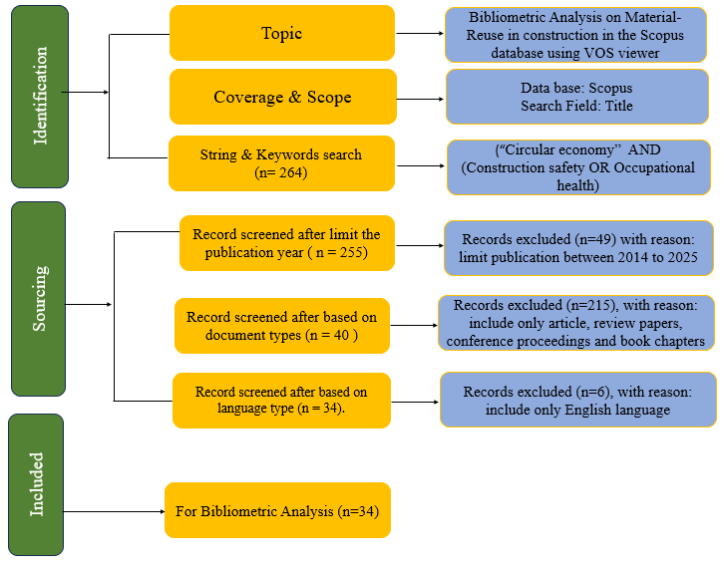

**Fig. 1. PRISMA Work Flow**

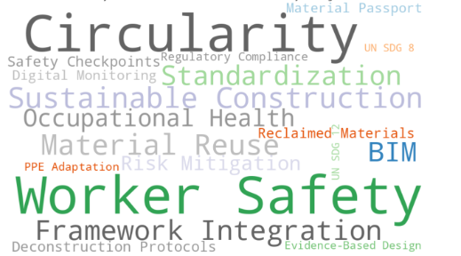

**Fig. 2. Word cloud showing Keywords Occurrence**

**Fig. 3. Journal Representation**

1. **ANALYSIS OF FINDINGS**

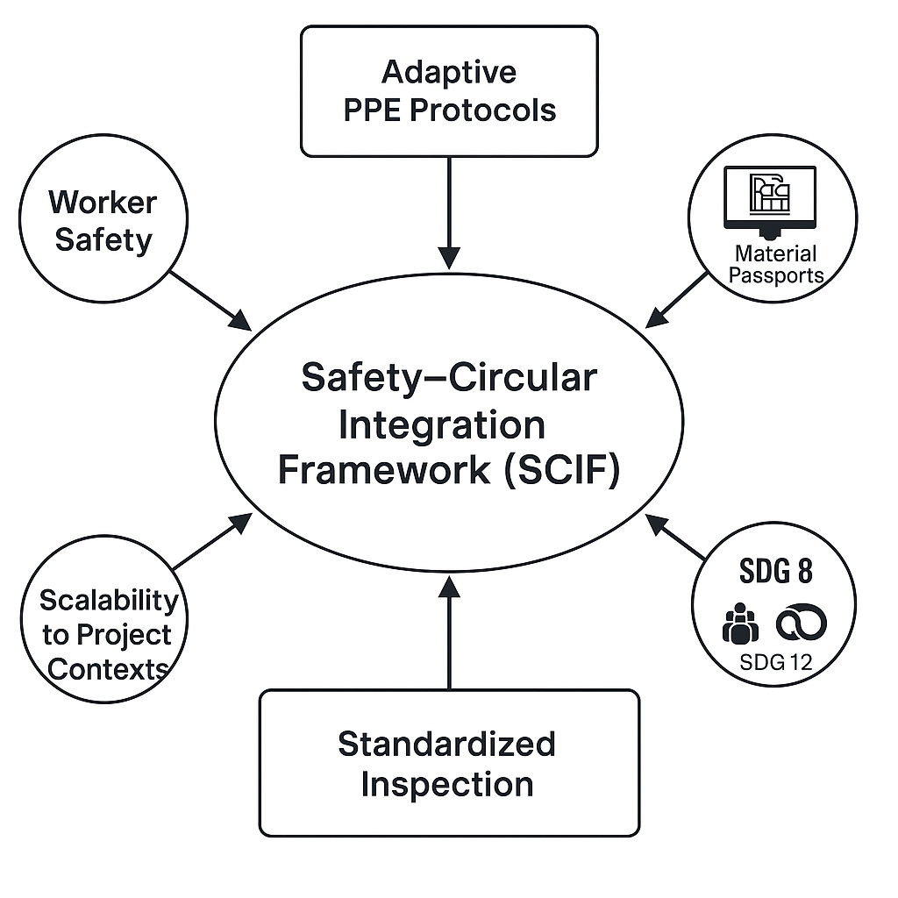

**Fig. 4. Schematics of SCIF Framework**

**Core Components of the SCIF Framework**

Adaptive PPE Protocols: SCIF recognizes that reused materials may pose unique hazards (e.g., chemical residues, sharp edges, structural degradation). It recommends personal protective equipment (PPE) guidelines that are adaptive to the nature of reclaimed materials.

Standardized Handling and Inspection Procedures: The framework calls for a systematic process to inspect, handle, and certify reused materials before they re-enter the construction process. This includes checking for contaminants, strength integrity, and usability.

Structured Safety Checkpoints: SCIF introduces designated safety checkpoints at different stages of the material reuse lifecycle (e.g., after deconstruction, during storage, before integration into new builds). These checkpoints allow for early detection of risks.

Digital Monitoring Tools: The framework integrates digital technologies such as BIM (Building Information Modeling) and material passports to track material history, safety inspections, and future handling instructions. This ensures traceability and data-driven safety assurance.

Scalability and Context Sensitivity: SCIF is designed to be scalable across different project sizes and adaptable to local safety regulations and construction practices, making it real-world applicable.

1. **CONCLUSION AND RECOMMENDATION**

This study shows that material reuse on construction sites brings unique and under‑appreciated safety hazards such as chemical exposure, structural instability, and ergonomic stress. While existing guidelines effectively manage generic construction risks, they fall short when applied to reused materials without known histories or contamination risks. The proposed SCIF framework remedies this by integrating hazard screening, adaptive PPE protocols, material passports, BIM-driven safety checks, and iterative learning loops bridging the domains of circular economy and occupational safety. However, realizing its potential requires broad institutional backing. To bring SCIF into mainstream practice, it is essential to secure regulatory and certification recognition by incorporating safety-tagged material passports into standards and public procurement policies. Scaling requires accredited training for safety professionals, reuse specialists, and BIM operators, ensuring consistent application across project types. Finally, piloting SCIF across diverse real-world settings urban retrofits, formal demolitions, modular construction will generate the empirical evidence needed to refine protocols, demonstrate safety gains, and encourage adoption. By embedding safety at the heart of circular material workflows, SCIF not only protects workers but also strengthens the social license for circular practices, making sustainable construction both safe and scalable.

COMPETING INTERESTS DISCLAIMER:

Authors have declared that they have no known competing financial interests OR non-financial interests OR personal relationships that could have appeared to influence the work reported in this paper.

Disclaimer (Artificial intelligence)

Option 1:

Author(s) hereby declare that NO generative AI technologies such as Large Language Models (ChatGPT, COPILOT, etc.) and text-to-image generators have been used during the writing or editing of this manuscript.

Option 2:

Author(s) hereby declare that generative AI technologies such as Large Language Models, etc. have been used during the writing or editing of manuscripts. This explanation will include the name, version, model, and source of the generative AI technology and as well as all input prompts provided to the generative AI technology

Details of the AI usage are given below:

1.

2.

3.

**REFERENCES**

[1] Gasparri, E., Arasteh, S., Kuru, A., Stracchi, P., and Brambilla, A. (2023). Circular economy in construction: A systematic review of knowledge gaps towards a novel research framework. *Frontiers in Built Environment*, 9, 1239757. <https://doi.org/10.3389/fbuil.2023.1239757>.

[2] Soares, N., and Tavares, V. (2025). Bibliometric Analysis of the Intersection of Circular Economy, Prefabrication, and Modularity in the Building Industry. *Buildings*, 15(11), 1923. <https://doi.org/10.3390/buildings15111923>.

[3] Chen, X., Chang-Richards, A. Y., Pelosi, A., Jia, Y., Shen, X., Siddiqui, M. K., and Yang, N. (2022). Implementation of technologies in the construction industry: a systematic review. *Engineering,* *Construction and Architectural Management*, 29(8), 3181-3209.

[4] Bertino, G., Kisser, J., Zeilinger, J., Langergraber, G., Fischer, T., and Österreicher, D. (2021). Fundamentals of building deconstruction as a circular economy strategy for the reuse of construction materials. *Applied sciences*, 11(3), 939. <https://doi.org/10.3390/app11030939>.

[5] Garusinghe, G. D. A. U., Perera, B. A. K. S., and Weerapperuma, U. S. (2023). Integrating circular economy principles in modular construction to enhance sustainability. *Sustainability*, 15(15), 11730. <https://doi.org/10.3390/su151511730>.

[6] Okimi, T., Sarhan, S., AWODELE, I., Olaniran, T., Adetola, O., and Olagunju, O., 2024, June. Towards Adopting Digital Twins for Enhancing Circular Economy in the UK Construction Industry: Benefits and Enablers. In *9th North American Conference on Industrial Engineering and Operations Management*, <https://doi.org/10.46254/NA09.20240022>

[7] Di Vaio, A., Hasan, S., Palladino, R., and Hassan, R. (2023). The transition towards circular economy and waste within accounting and accountability models: a systematic literature review and conceptual framework. *Environment, development and sustainability*, 25(1), 734-810.

[8] Awino, F. B., and Apitz, S. E. (2024). Solid waste management in the context of the waste hierarchy and circular economy frameworks: An international critical review. *Integrated Environmental Assessment and Management*, 20(1), 9-35. <https://doi.org/10.1002/ieam.4774>.

[9] dos Santos Gonçalves, J., Claes, S., and Ritzen, M. (2025). Measuring Circularity of Buildings: A Systematic Literature Review. *Buildings* (2075-5309), 15(4). <https://doi.org/10.3390/buildings15040548>.

[10] Adu-Duodu, K., Wilson, S., Li, Y., Oladimeji, A., Huraysi, T., Barati, M., & Shah, T. (2025, March). A circular construction product ontology for end-of-life decision-making. In Proceedings of the 40th ACM/SIGAPP Symposium on Applied Computing (pp. 1943-1952). <https://doi.org/10.48550/arXiv.2503.13708>.

[11] Salzano, A., Cascone, S., Zitiello, E. P., and Nicolella, M. (2024). Construction Safety and Efficiency: Integrating Building Information Modeling into Risk Management and Project Execution. *Sustainability*, 16(10), 4094. <https://doi.org/10.3390/su16104094>.

[12] Larbi, J. A., Tang, L. C., Larbi, R. A., Abankwa, D. A., and Danquah, R. D. (2024). Developing an integrated digital delivery framework and workflow guideline for construction safety management in a project delivery system. *Safety science*, 175, 106486. <https://doi.org/10.1016/j.ssci.2024.106486>.

[13] Tang, S., and Golparvar-Fard, M. (2021). Machine learning-based risk analysis for construction worker safety from ubiquitous site photos and videos. *Journal of computing in civil engineering,* 35(6), 04021020. <https://doi.org/10.1061/(ASCE)CP.1943-5487.0000979>.

[14] Keles, C., Cruz Rios, F., and Hoque, S. (2025). Digital Technologies and Circular Economy in the Construction Sector: A Review of Lifecycle Applications, Integrations, Potential, and Limitations. *Buildings*, 15(4), 553. <https://doi.org/10.3390/buildings15040553>.

[15] Bertino, G., Kisser, J., Zeilinger, J., Langergraber, G., Fischer, T., and Österreicher, D. (2021). Fundamentals of Building Deconstruction as a Circular Economy Strategy for the Reuse of Construction Materials. *Applied Sciences*, 11(3), 939. <https://doi.org/10.3390/app11030939>.

[16] Mayer, M. (2020) ‘Material recovery certification for construction workers’, *Buildings and Cities* 1(1), p. 550–564. Available at: <https://doi.org/10.5334/bc.58>.

[17] Aria, M., and Cuccurullo, C. (2017). bibliometrix: An R-tool for comprehensive science mapping analysis. *Journal of Informetrics*, 11(4), pp.959–975. <https://doi.org/10.1016/j.joi.2017.08.007>

Gusenbauer, M. (2022). Search where you will find most: Comparing the disciplinary coverage of 56 bibliographic databases. *Scientometrics*, 127(5), 2683-2745.

[18] Page, M.J., McKenzie, J.E., Bossuyt, P.M., Boutron, I., Hoffmann, T.C., Mulrow, C.D., Shamseer, L., Tetzlaff, J.M., Akl, E.A., Brennan, S.E., Chou, R., Glanville, J., Grimshaw, J.M., Hróbjartsson, A., Lalu, M.M., Li, T., Loder, E.W., Mayo-Wilson, E., McDonald, S. et al., 2021. The PRISMA 2020 statement: An updated guideline for reporting systematic reviews. BMJ, 372, p.n71. <https://doi.org/10.1136/bmj.n71>.

[19] Gao, Y., Gonzalez, V., and Yiu, T.W. (2018). *The Effectiveness of Traditional Tools and Computer-Aided Technologies for Health and Safety Training in the Construction Sector: A Systematic Review*. arXiv. Available at: http://dx.doi.org/10.48550/arXiv.1808.02021(accessed June 2025).

[20] Moustafa, Z., Asif, M., and Wuni, I. (2025) Circular economy in the building sector: a systematic review of environmental, economic, and social dimensions. *Sustainable Futures,* Volume 9, ISSN 2666-1888, <https://doi.org/10.1016/j.sftr.2025.100690>.

[21] Sood, S. K., Kumar, N., and Saini, M. (2021). Scientometric analysis of literature on distributed vehicular networks: VOSViewer visualization techniques. *Artificial Intelligence Review*, 54(8), 6309-6341.

[22] Bhattacharjee, K., Chaudhary, S., Vishnoi, A., Patel, D. A., and Bugalia, N. (2025). Characterization of health and safety hazards of deconstruction activities. American *Journal of Industrial Medicine*, 68, S71-S87. <https://doi.org/10.1002/ajim.23652>.

[23] Kumar Singh, A., Aljohani, A., Shakor, P., Awuzie, B. O., Uddin, S. J., and Shivendra, B. T. (2024). Study on safety health of construction workers at workplace: a sustainable perspective approach. *Frontiers in built environment*, 10, 1451727. <https://doi.org/10.3389/fbuil.2024.1451727>.

[24] Wuni, I. Y., and Abankwa, D. A. (2025). Understanding the key risks in circular construction projects: from systematic review to conceptual framework. *Construction Innovation*, 25(4), 1085-1107. <https://doi.org/10.1108/CI-04-2023-0068>.

[25] Torgautov, B., Zhanabayev, A., Tleuken, A., Turkyilmaz, A., Mustafa, M., and Karaca, F. (2021). Circular economy: Challenges and opportunities in the construction sector of Kazakhstan. *Buildings*, 11(11), 501. <https://doi.org/10.3390/buildings11110501>.

[26] Charef, R., Morel, J. C., & Rakhshan, K. (2021). Barriers to implementing the circular economy in the construction industry: A critical review. *Sustainability*, 13(23), 12989. <https://doi.org/10.3390/su132312989>.

[27] [Rashid](https://arxiv.org/search/econ?searchtype=author&query=Rashid%2C+A), A. (2025) How circular is the linear economy? Analysing circularity, resource flows and their relation to GDP. *arXiv*. Available at: <https://doi.org/10.48550/arXiv.2505.13048>.

[28] Hasibuan, G. C. R., Al Fath, M. T., Yusof, N., Dewi, R. A., Syafridon, G. G. A., Jaya, I., and Anas, M. R. (2025). Integrating circular economy into construction and demolition waste management: a bibliometric review of sustainable engineering practices in the built environment. Case Studies in *Chemical and Environmental Engineering*, 101159. <https://doi.org/10.1016/j.cscee.2025.101159>.

[29] Hoang, N. H., Ishigaki, T., Watari, T., Yamada, M., and Kawamoto, K. (2022). Current state of building demolition and potential for selective dismantling in Vietnam. *Waste Management*, 149, 218-227. <https://doi.org/10.1016/j.wasman.2022.06.007>.

[30] [Daniele C](https://www.mckinsey.com/our-people/daniele-chiarella)., [Hemant A](https://www.mckinsey.com/our-people/hemant-ahlawat)., [Jukka M](https://www.mckinsey.com/our-people/jukka-maksimainen)., and [Sebastian R](https://www.mckinsey.com/our-people/sebastian-reiter). (2025) How circularity can make the built environment more sustainable. Available on: <https://www.mckinsey.com/industries/real-estate/our-insights/how-circularity-can-make-the-built-environment-more-sustainable>.

[30] Vigneshkumar, C. (2023). Designing a Knowledge-Based System to Facilitate the Process of Fall Risk Assessment in Construction (Doctoral dissertation).

[31] Obiuto, N. C., Ninduwezuor-Ehiobu, N., Ani, E. C., and Andrew, K. (2024). Implementing circular economy principles to enhance safety and environmental sustainability in manufacturing. *Int J Adv Multidiscip Res Stud*, 4(2), 22-29. <https://doi.org/10.62225/2583049X.2024.4.2.2432>.

[32] Abu-Bakar, H., and Charnley, F. (2024). Developing a strategic methodology for circular economy roadmapping: A theoretical framework. *Sustainability*, 16(15), 6682. <https://doi.org/10.3390/su16156682>.

[33] Kristensen, H. S., Mosgaard, M. A., and Remmen, A. (2021). Integrating circular principles in environmental management systems. *Journal of Cleaner Production*, 286, 125485. <https://doi.org/10.1016/j.jclepro.2020.125485>.

[34] Basiru, J. O., Ejiofor, C. L., Onukwulu, E. C., and Attah, R. U. (2023). Corporate health and safety protocols: A conceptual model for ensuring sustainability in global operations. *Iconic Research and Engineering Journals*, 6(8), 324-343.

[35] Amir, S., Salehi, N., Roci, M., Sweet, S., and Rashid, A. (2023). Towards circular economy: A guiding framework for circular supply chain implementation. *Business Strategy and the Environment*, 32(6), 2684-2701. <https://doi.org/10.1002/bse.3264>.

[36] Wang, J. X., Burke, H., and Zhang, A. (2022). Overcoming barriers to circular product design. *International Journal of Production Economics,* 243, 108346. <https://doi.org/10.1016/j.ijpe.2021.108346>.

[37] Rahla, K. M., Mateus, R., and Bragança, L. (2021). Implementing circular economy strategies in buildings—from theory to practice. *Applied System Innovation*, 4(2), 26. https://doi.org/10.3390/asi4020026.

[38] Chen, L., Hu, Y., Wang, R., Li, X., Chen, Z., Hua, J., and Yap, P. S. (2024). Green building practices to integrate renewable energy in the construction sector: a review. *Environmental Chemistry Letters*, 22(2), 751-784.

[39] Illankoon, C., and Vithanage, S. C. (2023). Closing the loop in the construction industry: A systematic literature review on the development of circular economy. *Journal of Building Engineering*, 76, 107362. <https://doi.org/10.1016/j.jobe.2023.107362>.

[40] Talla, A., & McIlwaine, S. (2024). Industry 4.0 and the circular economy: using design-stage digital technology to reduce construction waste. *Smart and Sustainable Built Environment*, 13(1), 179-198. <https://doi.org/10.1108/SASBE-03-2022-0050>.

[41] Behún, M., and Behúnová, A. (2023). Advanced innovation technology of BIM in a circular economy. *Applied Sciences*, 13(13), 7989. <https://doi.org/10.3390/app13137989>.

[42] Sadeghi, M., Mahmoudi, A., Deng, X., and Luo, X. (2023). Prioritizing requirements for implementing blockchain technology in construction supply chain based on circular economy: Fuzzy Ordinal Priority Approach. *International Journal of Environmental Science and Technology*, 20(5), 4991-5012.

[43] Rodrigo, N., Omrany, H., Chang, R., and Zuo, J. (2023). Leveraging digital technologies for circular economy in construction industry: a way forward. *Smart and Sustainable Built Environment*, 13(1), 85-116. <https://doi.org/10.1108/SASBE-05-2023-0111>.

[44] Yu, Y., Yazan, D. M., Junjan, V., and Iacob, M. E. (2022). Circular economy in the construction industry: A review of decision support tools based on Information & Communication Technologies. *Journal of cleaner production*, 349, 131335. <https://doi.org/10.1016/j.jclepro.2022.131335>.

[45] Elghaish, F., Hosseini, M. R., Kocaturk, T., Arashpour, M., and Ledari, M. B. (2023). Digitalised circular construction supply chain: An integrated BIM-Blockchain solution. *Automation in Construction,* 148, 104746. <https://doi.org/10.1016/j.autcon.2023.104746>.

[46] Morel, J. C., Charef, R., Hamard, E., Fabbri, A., Beckett, C., and Bui, Q. B. (2021). Earth as construction material in the circular economy context: practitioner perspectives on barriers to overcome. *Philosophical Transactions of the Royal Society B*, 376(1834), 20200182. <https://doi.org/10.3390/su132312989>.

[47] Charef, R., and Lu, W. (2021). Factor dynamics to facilitate circular economy adoption in construction. *Journal of cleaner production*, 319, 128639. <https://doi.org/10.1016/j.jclepro.2021.128639>.

[48] Shooshtarian, S., Maqsood, T., Caldera, S., and Ryley, T. (2022). Transformation towards a circular economy in the Australian construction and demolition waste management system. *Sustainable Production and Consumption*. <https://dx.doi.org/10.1016/j.spc.2021.11.032>.

[49] Akintola, S. O. 2024. “Revolutionizing Global Infrastructure: Integrating Sustainable Construction Practices and Safety Standards for a Resilient Future”. Current Journal of Applied Science and Technology 43 (10):84-95. <https://doi.org/10.9734/cjast/2024/v43i104438>