Comparative Batch Adsorption Study of Crude Oil Removal from Simulated Oil Spill Using Quail Egg Shell and Snail Shell Biosorbents

**Abstract**

Oil spill incidents in petroleum-producing regions present major ecological threats. Although various commercial adsorbents have demonstrated effective pollutant removal capabilities, their high cost, toxicity, and non-biodegradable nature restrict their large-scale application. This study explores the use of quail eggshells (QES) and snail shells (SS) as eco-friendly and low-cost alternatives for mitigating oil pollution. A total of 300 g of each shell type was collected, crushed, and oven-dried at 120 °C for 48 hours. The dried samples were then pulverized and sieved into two particle sizes: 106 µm and 425 µm. To maximize surface area and potential adsorption capacity, the finer 106 µm fraction was selected for all subsequent analyses. Characterization via Fourier Transform Infrared (FTIR) spectroscopy identified key functional groups: metal carbonyl peaks appeared at 1789.17 cm⁻¹ for QES and 1642.5 cm⁻¹ for SS, indicating the presence of active adsorption sites. Batch adsorption experiments were carried out to investigate the impact of several operational parameters namely, temperature, agitation speed, adsorbent dose, oil concentration, and contact time on crude oil removal efficiency. To describe the adsorption equilibrium, four classical isotherm models; Freundlich, Langmuir, Temkin, and Dubinin–Radushkevich were applied. Additionally, adsorption kinetics were evaluated using pseudo-first-order and pseudo-second-order models. The kinetic results revealed that the pseudo-second-order model provided the best fit to the experimental data, suggesting that the dominant mechanism was chemisorption involving electron exchange or sharing between adsorbent and adsorbate. Oil removal efficiencies ranged between 25.0% and 77.5% for QES, and between 40.0% and 95.0% for SS, with maximum performance observed at an adsorbent dosage of 5 g. Across all tested conditions, SS consistently outperformed QES, demonstrating up to 35% higher efficiency. The Langmuir isotherm provided the best fit for QES data, reflecting monolayer adsorption on a homogeneous surface, while the Temkin model was more suitable for SS, indicating a heterogeneous surface with variable adsorption energies. Both QES and SS exhibited significant potential as efficient, sustainable, and cost-effective alternatives to conventional synthetic adsorbents in oil spill remediation applications.

**Keywords:** biosorbents, crude oil remediation, snail shell, quail egg shell, adsorption isotherms.

**1.0 Introduction:**

Since the advent of crude oil exploitation, oil spills have continued to present formidable environmental and economic challenges globally. These incidents may arise from natural catastrophes such as earthquakes, as well as from human-induced factors like sabotage, warfare, operational negligence, and technical failures. A significant proportion of oil spills occur during routine oil handling and transportation, posing severe threats to ecosystems and leading to substantial energy losses (Omole & Falode, 1998; Beyer et al., 2016; Lin & Mendelssohn, 2012). Transportation, in particular, remains a high-risk phase, where prompt response is essential to minimize environmental harm. Effective spill response necessitates the rapid containment and recovery of spilled oil to prevent extensive contamination (Annunciado et al., 2005).

Oil pollution has caused profound ecological degradation in aquatic environments and has negatively impacted economic sectors such as agriculture, tourism, and energy (Ayotamuno et al., 2006; Alaa El-Din et al., 2018). Contamination pathways often include leaks from pipelines and refineries, as well as effluents and runoff from petroleum and petrochemical operations, which severely affect freshwater systems. Common remediation techniques—such as the use of dispersants, booms, skimmers, and in situ burning—are widely practiced. However, these methods typically do not incorporate sorbents and may be limited in efficiency. When adsorbents are employed, many are commercially synthesized materials that tend to be expensive, potentially hazardous, and inaccessible for large-scale or emergency use, particularly in resource-constrained settings (Hussein et al., 2009). Moreover, some dispersants are flammable and present health risks to cleanup personnel while simultaneously harming aquatic life, degrading vegetation, and contaminating shorelines and water sources.

Adsorption-based techniques have emerged as a cost-effective and practical approach to mitigating oil spill impacts (Bhatnagar et al., 2010; Ahmad et al., 2015). Adsorbents are favored for their low water absorption, high oil uptake, ease of recovery, buoyancy, reusability, and affordability (Ifelebuegu & Momoh, 2015; Bailey et al., 1999). These characteristics make them one of the most promising options for efficient oil spill control.

Oil sorbents are generally categorized into three groups: inorganic mineral-based materials, natural organic substances, and synthetic organic polymers. Synthetic adsorbents such as polypropylene and polyurethane dominate the commercial market. However, inorganic materials like zeolites, exfoliated graphite, and vermiculite are also used for oil adsorption (Bandura, 2017; Tryba, 2003). Despite their effectiveness, many of these materials exhibit powdery textures, which reduce their oil sorption capacity, oil recovery efficiency, and buoyancy, while limiting their field applicability. Furthermore, materials such as silica gel and exfoliated graphite, although highly effective, are costly and derived from non-renewable sources. These limitations have spurred interest in sustainable alternatives, especially agro-waste-based adsorbents that are biodegradable and locally abundant.

Qasem et al. (2021) provided a comprehensive review of wastewater treatment methods, highlighting the growing preference for adsorption techniques due to their simplicity and effectiveness. The review identified important gaps to inform future research. Similarly, Wang et al. (2024) conducted a bibliometric study covering 2,673 publications from 2011 to 2022 on biochar-based adsorption, using tools like CiteSpace and ArcGIS to visualize research trends and global collaboration. Their findings serve as a strategic framework for advancing adsorption research. In another study, Satyam and Patra (2024) underscored the transformative potential of advanced adsorbents in water purification and advocated for interdisciplinary approaches to scale up sustainable technologies. Mohammad et al. (2021) proposed the use of solid waste from reject brine in multistage desalination as low-cost oil adsorbents, promoting sustainability and waste reuse. Likewise, Akhtar et al. (2024) reviewed breakthroughs in nanocellulose, metal-organic frameworks (MOFs), graphene composites, and biochar, examining their structures, performance, and environmental applications. Askari et al. (2025) created a hybrid sorbent composed of goat hair, palm fiber, and polyurethane, which demonstrated improved oil adsorption, durability, and reusability. Baruah and Neog (2025) highlighted the effectiveness of biodegradable agricultural waste materials in treating oil-contaminated environments, positioning them as viable, eco-friendly solutions.

Agricultural waste is widely available, inexpensive, and often underutilized, making it an attractive feedstock for developing sustainable adsorbents. Over the years, researchers have explored the use of such materials for oil and water purification, with a focus on improving reusability, minimizing disposal costs, and enhancing environmental outcomes. In light of these developments, there is increasing collaboration between researchers and policymakers globally to support the development of more eco-conscious oil spill mitigation strategies (Akinsanoye, 2022; Akinsanoye et al., 2025). This study specifically investigates the feasibility of snail shell (SS) and quail eggshell (QES) as low-cost, sustainable alternatives to conventional adsorbents commonly used in oil remediation.

In a related study, Falode et al. (2016) assessed the performance of a biosurfactant derived from pineapple waste for enhanced oil recovery. The biosurfactant was produced using hydrocarbon-degrading bacteria isolated from contaminated soil, and its efficiency was evaluated through surface tension reduction and adsorption metrics.

This research contributes a novel, sustainable approach to environmental remediation by utilizing QES and SS as effective, natural adsorbents for crude oil cleanup. The study supports ongoing efforts to promote waste-to-resource innovation and demonstrates the practical application of agricultural byproducts in pollution control. Through the characterization of these biosorbents and detailed analysis of their adsorption efficiency, the work provides valuable insight into adsorption mechanisms and the feasibility of large-scale deployment. These findings hold particular promise for advancing green technologies in water purification, especially in oil-impacted or resource-limited regions.

**2.0 Materials and Methods**

The study's experimental framework effectively explores how various operational factors including adsorbent mass, solution temperature, pH level, contact duration, crude oil concentration, and stirring rate affect the adsorption efficiency of quail eggshell (QES) and snail shell (SS). Due to limited access to laboratory facilities, each trial was performed in duplicate rather than the conventional triplicate format commonly used to enhance data reproducibility. Nevertheless, the findings consistently demonstrated reliable patterns across all evaluated parameters. Figure 1 illustrates the step-by-step procedure employed for crude oil adsorption using QES and SS.

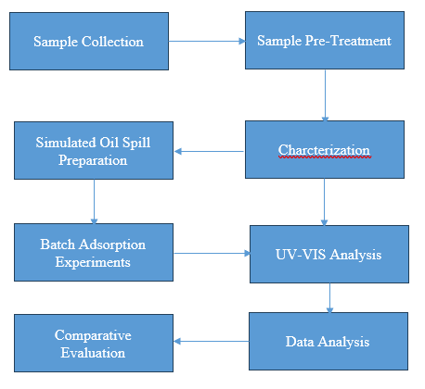

Figure 1: Schematic Representation of the Adsorption Experiment Using QES and SS

**2.1 Sample Collection and Preparation**

Quail egg shells and snail shells were sourced from local markets including Bodija and Lalupon, located in Ibadan, Oyo State, Nigeria. The materials were thoroughly cleaned using tap water followed by a rinse with distilled water to eliminate surface impurities. After drying in direct sunlight, the shells were manually crushed into smaller fragments. These fragments were subsequently oven-dried at 120 °C for 48 hours to remove residual moisture. The dried shells were then ground and sieved to obtain particle sizes of 106 µm and 425 µm. For the adsorption experiments, the finer 106 µm fraction was selected due to its larger surface area. The processed materials were sealed in airtight containers and labeled as PQES (Pulverized Quail Eggshell) and PSS (Pulverized Snail Shell) for storage and further use.

**2.2 Adsorbent Characterization**

The structural and functional characteristics of the prepared adsorbents were determined using Fourier Transform Infrared (FTIR) spectroscopy. The FTIR analysis, conducted using a Perkin Elmer instrument, was performed in the wavenumber range of 500–4000 cm⁻¹ to identify key functional groups contributing to adsorption potential.

**2.3 Simulated Oil Spill Preparation**

A crude oil-in-water emulsion was formulated to simulate an oil spill. Specifically, 20 grams of crude oil were introduced into 1 liter of distilled water in a beaker, yielding a homogeneous mixture with an initial oil concentration of 0.020 g/L.

**2.4 Batch Adsorption Experiments**

Each experiment was conducted using 100 mL of the prepared simulated crude oil solution. The mixture was treated with a pre-weighed amount of the adsorbent under controlled laboratory conditions. The equilibrium concentration of crude oil in water for each measured sample was determined using UV-VIS spectrophotometer. The weight (m) of the adsorbents, the corresponding equilibrium concentration (Ce) and volume (V) of the simulated oil spill were recorded. For each batch run, the amount of crude oil adsorbed per unit weight of adsorbent denoted as (qe) was determined, denoted with equation (1) expressed by (Uzojie et al. 2011). The mean values were calculated and utilised after double runs.

$q_{c}=\frac{V\left(C_{o}-C_{c}\right)}{m}$ (1) `

The percentage removal is expressed as:

$\% Removal= \frac{100\left(C_{o}-C_{c}\right)}{C_{o}}$ (2)

**2.5 Effect of Adsorbent Dosage**

A fixed volume (50 mL) of 0.020 g/L oil solution was mixed with varying amounts (1.0 g to 5.0 g) of the 106 µm QES and SS adsorbents in separate 100 mL beakers. The mixtures were agitated at 200 rpm using an orbital shaker at 25 °C for 60 minutes. Post-treatment, the mixtures were filtered, and the filtrates were analyzed using a UV-VIS spectrophotometer at 450 nm to assess residual oil content.

**2.6 Influence of Temperature**

To evaluate the impact of thermal conditions, adsorption experiments were conducted at 15, 30, 45, 60, and 75 °C. Each test involved adding 2.0 g of either QES or SS to 100 mL of 0.020 g/L crude oil solution. The mixtures were stirred at 200 rpm for 1 hour. After filtration through Whatman filter paper (150 mm diameter), the filtrates were analyzed spectrophotometrically at 450 nm.

**2.7 Effect of Contact Time**

Time-dependent adsorption behavior was studied by mixing 2.0 g of the shell adsorbent with 50 mL of crude oil solution (0.020 g/L). The mixture was stirred at 200 rpm for varying durations: 15, 30, 45, 60, and 75 minutes. After each interval, the mixture was filtered, and absorbance of the remaining oil was measured using a UV-VIS spectrophotometer.

**2.8 pH Effect on Adsorption**

To examine the role of pH, 2.0 g of each adsorbent was added to 200 mL of the simulated oil solution. The pH was adjusted across the range of 5 to 13 using 0.1 M HCl or NaOH, depending on the target pH. The mixtures were stirred for 1 hour at ambient temperature. After filtration, the remaining oil concentration in each sample was determined at 450 nm.

**2.9 Effect of Crude Oil Concentration (Adsorbate Dose)**

The influence of varying crude oil concentrations was assessed by mixing 2.0 g of adsorbent with increasing oil doses (2–10 g) in 100 mL of water. The mixtures were agitated at 200 rpm for 60 minutes under room temperature conditions. The solutions were filtered and analyzed using UV-VIS spectrophotometry.

**2.10 Effect of Rotational Speed**

To assess the impact of mixing speed, 2.0 g of shell powder was added to 50 mL of crude oil solution (0.020 g/L) and stirred at varying rotational speeds 100, 200, 300, 400, and 500 rpm for 60 minutes. Following filtration, the concentration of residual oil was determined at 450 nm for each test.

**3.0 RESULTS AND DISCUSSION**

**3.1 Morphological Assessment of Shell Adsorbents**

Figures 1a and 1b illustrate the physical transformation of quail eggshells before and after pulverization, while Figures 2a and 2b display similar observations for snail shells. Pulverizing the shells significantly increased their surface area, a critical factor in enhancing adsorption efficiency. The finer texture of the processed materials indicates greater potential for interacting with oil molecules in aqueous systems.

 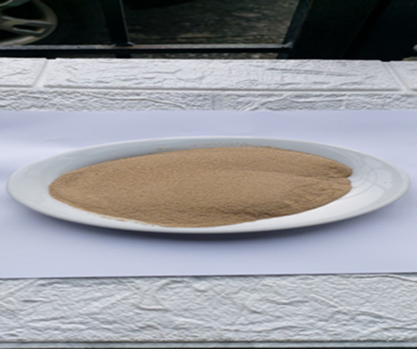

**Figure 1a:** Quail eggs shells **Figure 1b:** Pulverised quail eggs shell

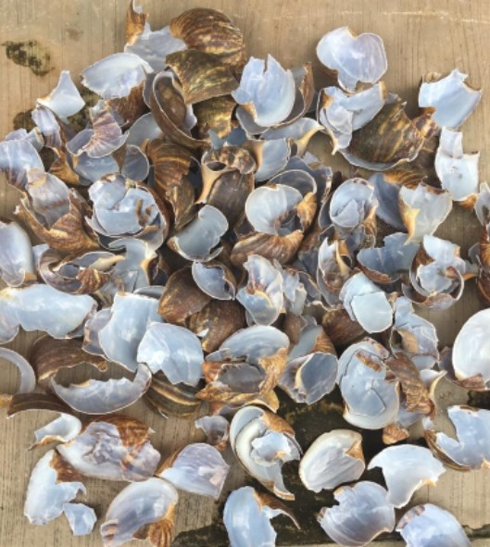 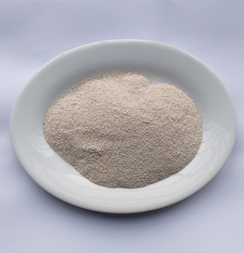

**Figure 2a:** Snail egg shell  **Figure 2b:** Pulverised snail shell

**3.2 FTIR Spectroscopy of Adsorbents**

The FTIR spectrum of quail egg shell and snail shell are presented in Figure 3 below.



Quail egg shell (A)

**Figure 3 (a):** FTIR spectra for Quail egg shell



Snail shell (B)

**Figure 3 (b):** FTIR spectra for snail shell

Figure 3(a) displays the FTIR spectrum of pulverized quail eggshell (QES). A strong and broad absorption band observed at 2969.08 cm⁻¹ corresponds to C–H stretching vibrations and is indicative of metal–oxide bonding within the shell matrix. The sharpness and intensity of this peak suggest a substantial concentration of free metal oxides in the QES structure. Previous studies have reported the effectiveness of metal oxides as adsorbents (Somaia et al., 2015; Kudaibergenov et al., 2013). A distinct band at 1424.16 cm⁻¹ is attributed to C=C bending vibrations, likely associated with the partial interaction of metal oxides with carbonate groups. This interaction may be due to the polarizing power of the central cation in the metal–oxide complex, resulting in a partially stable metal–carbonate structure.

Additional peaks observed at 874.83 cm⁻¹ and 712.68 cm⁻¹ are characteristic of M–C–O stretching vibrations. The minor peak at 1642.5 cm⁻¹ is likely due to the presence of a carbonyl (C=O) group within the carbonate framework of the eggshell. Overall, the FTIR analysis confirms that QES is rich in metal oxide carbonates—compounds widely recognized for their adsorption potential. The successful application of QES in this study further supports its suitability as a promising biosorbent material.

Figure 3(b) presents the FTIR spectrum of pulverized snail shell (SS). Prominent bands at 2917.41 cm⁻¹ and 2848.60 cm⁻¹ suggest C–H stretching, consistent with metal–oxide bonds observed in QES. A distinct peak at 1789.17 cm⁻¹ confirms the presence of carbonyl (C=O) stretching within carbonate (CO₃²⁻) groups, indicating a high carbonate content in the snail shell matrix. Additional bands at 1159.30 cm⁻¹ and 1082.96 cm⁻¹ correspond to M–C–O stretching, providing further evidence of metal–carbonate structures. Moreover, the peaks at 861.31 cm⁻¹, 712.51 cm⁻¹, 700.07 cm⁻¹, and 658.11 cm⁻¹ reflect typical C–H bending vibrations associated with carbonate compounds. These results are consistent with prior literature, affirming that both quail eggshells and snail shells are naturally abundant in metal carbonates, which are essential for effective adsorption processes. Omotosho and Akinsanoye (2015) highlighted the potential of shell-based materials as adsorbents in heterogeneous catalysis for biodiesel production. In the present study, FTIR analysis confirmed that the examined shells are abundant in metal oxide carbonates. This finding supports their viability as cost-effective and eco-friendly alternatives to conventional petroleum-derived adsorbents, while also complementing existing biomass-based options.

**3.3 Batch Adsorption Performance**

**3.3.1 Influence of Adsorbent Dosage on oil adsorption**

The impact of adsorbent dosage on crude oil removal was assessed at 25 °C over a 1-hour contact period using a simulated oil solution with a concentration of 0.020 g/L. The experimental data, presented in Table 1, demonstrate a direct correlation between increased adsorbent mass and enhanced adsorption efficiency (Figures 4a and 4b). At an initial dose of 1.0 g, snail shell (SS) exhibited a higher oil recovery rate than quail eggshell (QES), a trend that persisted across all dosage levels examined. This indicates that SS possesses superior adsorption potential compared to QES.

The enhanced performance of SS is likely attributed to its greater abundance of metal carbonate and metal oxide components, as evidenced by FTIR analysis. These components, particularly metal oxides with unpaired d-electrons, are known to contribute significantly to adsorption via electrostatic and chemisorptive interactions. As a result, SS provides more active binding sites and stronger interactions with crude oil molecules than QES.

The results are consistent with adsorption behavior predicted by isotherm models. Langmuir, Freundlich, Dubinin–Radushkevich, and Temkin models all demonstrated strong fits to the experimental data, with R² values ranging from 0.80 to 1.00 (Figures 5a–b, 6a–b, 7a–b, and 8a–b). These findings further validate the observed dose-dependent increase in adsorption capacity.

QES also demonstrated significant adsorption potential, achieving a maximum recovery of 77.5% at 5.0 g dosage. However, SS achieved even higher performance, removing up to 95% of crude oil at the same dosage (Table 1). This suggests that SS can serve as a viable, cost-effective substitute for commercial synthetic adsorbents, many of which are petroleum-based and environmentally detrimental.

The progressive increase in removal efficiency with increasing adsorbent dose can be attributed to the corresponding increase in available surface area and active sites, which facilitate better interaction and penetration of crude oil molecules into the adsorbent matrix (Figure 4a). Overall, while both biosorbents demonstrated strong oil-removal capabilities, snail shell consistently outperformed quail eggshell, establishing it as a more efficient and sustainable candidate for crude oil spill remediation.

**Table 1:** Effect of a quail eggs shell and snail shell adsorbents doses on rates of adsorption.

|  |  |  |  |  |  |  |
| --- | --- | --- | --- | --- | --- | --- |
| **S/N** | **M(g)** | **Co(g/L)** | **Ce (g/L)** | **Co - Ce (g/L)** | **qe** | **% Removal** |
| 1QES  SS |  | 0.020  0.020 | 0.0150  0.0120 | 0.0050  0.0080 | 0.5000  0.8000 | 25  40 |
| 2QES  SS |  | 0.020  0.020 | 0.0120  0.0120 | 0.0080  0.0080 | 0.4000  0.6000 | 40  60 |
| 3QES  SS |  | 0.020  0.020 | 0.0080  0.0040 | 0.0120  0.0160 | 0.4000  0.5333 | 60  80 |
| 4QES  SS |  | 0.020  0.020 | 0.0050  0.0020 | 0.0150  0.0180 | 0.3750  0.4500 | 75  90 |
| 5QES  SS |  | 0.020  0.020 | 0.0045  0.0010 | 0.0155  0.0190 | 0.3100  0.3800 | 77.5  95 |

**3.3.2 Temperature Effects**

The influence of temperature on the adsorption performance of the shell biosorbents is summarized in Table 2. Results indicate that both quail eggshell (QES) and snail shell (SS) are more effective at lower temperatures, with SS achieving the highest recovery efficiency at 15 °C. This suggests that the carbonate groups within the shell matrices exhibit thermal instability at elevated temperatures. The likely cause is the polarizing effect of the central metal cations involved in the formation of metal carbonates; at higher temperatures, this effect may lead to the breakdown or destabilization of the carbonate structure.

At 15 °C, QES recorded a 60% removal efficiency, further confirming that SS contains a higher concentration of active metal oxides and carbonate groups conducive to adsorption. This temperature-dependent trend persisted across subsequent evaluations at 30 °C, 45 °C, 60 °C, and 75 °C, reinforcing the observation that both shell types perform optimally under ambient or sub-ambient conditions. Notably, the performance curve suggests the potential for near-complete (approaching 100%) oil recovery at even lower temperatures (Figure 4b).

These findings underscore the economic and operational advantages of using SS and QES in oil spill remediation, as effective adsorption can be achieved without the need for external heating, thereby reducing energy costs. The observed temperature dependence aligns well with the adsorption equilibrium models presented and is consistent with previous literature on the thermal sensitivity of metal carbonates (Reller, 1991).

**Table 2:** Effect of temperature on the rate of adsorption of quail egg shell and snail shell

|  |  |  |  |  |  |  |
| --- | --- | --- | --- | --- | --- | --- |
| **S/N** | **Temp (oC)** | **Co(g/L)** | **Ce (g/L)** | **Co - Ce (g/L)** | **qe** | **% Recovery** |
| 1QES  SS | 15 | 0.020  0.020 | 0.0080  0.0030 | 0.0120  0.0170 | 0.6000  0.8500 | 60  85 |
| 2QES  SS | 30 | 0.020  0.020 | 0.0085  0.0050 | 0.0115  0.0150 | 0.5750  0.7500 | 57.5  75 |
| 3QES  SS | 45 | 0.020  0.020 | 0.0090  0.0070 | 0.0110  0.0130 | 0.5500  0.6500 | 55  65 |
| 4QES  SS | 60 | 0.020  0.020 | 0.0100  0.0100 | 0.0100  0.0100 | 0.5000  0.5000 | 50  50 |
| 5QES  SS | 75 | 0.020  0.020 | 0.0120  0.0125 | 0.0080  0.0075 | 0.4000  0.3750 | 40  37.5 |

**3.3.3 Contact Time Dependency**

Oil adsorption efficiency increased with longer contact times, as reported in Table 3 and illustrated in Figure 4c. SS again outperformed QES at all time intervals. At 75 minutes, SS removed 92.5% of the crude oil, while QES achieved 85%. This suggests that both materials reach near-saturation over time, but SS achieves equilibrium faster and more efficiently due to its favorable surface characteristics.

**Table 3:** Effect of contact time on adsorption of quail eggs shell and snail shell

|  |  |  |  |  |  |  |
| --- | --- | --- | --- | --- | --- | --- |
| **S/N** | **Time(mins)** | **Co(g/L)** | **Ce (g/L)** | **Co - Ce (g/L)** | **qe** | **% Removal** |
| 1QES  SS | 15 | 0.020  0.020 | 0.0150  0.0080 | 0.0050  0.0120 | 0.2500  0.6000 | 25  60 |
| 2QES  SS | 30 | 0.020  0.020 | 0.0100  0.0065 | 0.0100  0.0135 | 0.5000  0.6750 | 50  67.5 |
| 3QES  SS | 45 | 0.020  0.020 | 0.0070  0.0050 | 0.0130  0.0150 | 0.6500  0.7500 | 65  75 |
| 4QES  SS | 60 | 0.020  0.020 | 0.0050  0.0020 | 0.0150  0.0180 | 0.8000  0.9000 | 75  90 |
| 5QES  SS | 75 | 0.020  0.020 | 0.0030  0.0015 | 0.0170  0.0185 | 0.9000  0.9250 | 85  92.5 |

**3.3.4 pH Influence**

The effect of pH on adsorption was evaluated across a range from 5 to 13 (Table 4, Figure 4d). Both adsorbents showed better performance under alkaline conditions. At pH 13, SS exhibited an 85% removal efficiency, while QES reached 52.5%. The lower efficiency in acidic conditions may be due to protonation of active sites, which reduces their affinity for oil molecules. The improved performance under basic conditions is consistent with the stability of carbonate-based adsorbents in alkaline media.

**Table 4:** Effect of pH on adsorption of quail eggs shell and snail shell

|  |  |  |  |  |  |  |
| --- | --- | --- | --- | --- | --- | --- |
| **S/N** | **pH** | **Co(g/L)** | **Ce (g/L)** | **Co - Ce (g/L)** | **qe** | **% Removal** |
| 1QES  SS | 5 | 0.020  0.020 | 0.0150  0.0100 | 0.0050  0.0100 | 0.2500  0.5000 | 25  50 |
| 2QES  SS | 7 | 0.020  0.020 | 0.0130  0.0080 | 0.0070  0.0120 | 0.3500  0.6000 | 35  60 |
| 3QES  SS | 9 | 0.020  0.020 | 0.0120  0.0070 | 0.0080  0.0130 | 0.4000  0.6500 | 40  65 |
| 4QES  SS | 11 | 0.020  0.020 | 0.0100  0.0050 | 0.0100  0.0150 | 0.5000  0.7500 | 50  75 |
| 5QES  SS | 13 | 0.020  0.020 | 0.0095  0.0030 | 0.0105  0.0170 | 0.5250  0.8500 | 52.5  85 |

**3.3.5 Adsorbate Concentration**

Increasing the concentration of crude oil led to a decline in adsorption efficiency for both biosorbents (Table 5, Figure 4e). At the lowest tested concentration (2 g of oil), SS achieved 80% removal and QES 70%. However, efficiency dropped to 45% for SS and 40% for QES at 10 g oil loading. This inverse relationship is due to the saturation of active sites on the adsorbent surface, which limits further uptake at higher adsorbate concentrations.

**Table 5:** Effect of adsorbate concentration on adsorption of quail eggs shell and snail shell

|  |  |  |  |  |  |  |
| --- | --- | --- | --- | --- | --- | --- |
| **S/N** | **W(g)** | **Co(g/L)** | **Ce (g/L)** | **Co - Ce (g/L)** | **qe** | **% Removal** |
| 1QES  SS | 2 | 0.020  0.020 | 0.0060  0.0040 | 0.0140  0.0160 | 0.7000  0.8000 | 70  80 |
| 2QES  SS | 4 | 0.020  0.020 | 0.0180  0.0060 | 0.0120  0.0140 | 0.6000  0.7000 | 60  70 |
| 3QES  SS | 6 | 0.020  0.020 | 0.0090  0.0080 | 0.0110  0.0120 | 0.5500  0.6000 | 55  60 |
| 4QES  SS | 8 | 0.020  0.020 | 0.0100  0.0100 | 0.0100  0.0100 | 0.5000  0.5000 | 50  50 |
| 5QES  SS | 10 | 0.020  0.020 | 0.0120  0.0110 | 0.0080  0.0090 | 0.4000  0.4500 | 40  45 |

**3.3.6 Effect of rotational speed**

The batch adsorption experiments at different rotational speed were studied. The result showed that the adsorption of oil onto the adsorbents increases with increased speed (Table 6). This was observed to be higher in SS than QES. This is in tandem with the other results obtained. Increase in rotational speed resulted in a reduction in surface film resistance, thereby allowing residual oil to reach the particle surface more easily (Figure 4f). Surface film resistance hinders rate of adsorption. The results showed that the rate of adsorption increased with speed.

**Table 6:** Effect of rotational speed on adsorption (quail egg shell)

|  |  |  |  |  |  |  |
| --- | --- | --- | --- | --- | --- | --- |
| **S/N** | **R(rpm)** | **Co(g/L)** | **Ce (g/L)** | **Co - Ce (g/L)** | **qe** | **% Removal** |
| 1QES  SS | 100 | 0.020  0.020 | 0.0140  0.0100 | 0.0060  0.0100 | 0.3000  0.5000 | 30  50 |
| 2QES  SS | 200 | 0.020  0.020 | 0.0120  0.0080 | 0.0080  0.0120 | 0.4000  0.6000 | 40  60 |
| 3QES  SS | 300 | 0.020  0.020 | 0.0100  0.0075 | 0.0100  0.0125 | 0.5000  0.6250 | 50  62.5 |
| 4QES  SS | 400 | 0.020  0.020 | 0.0080  0.0060 | 0.0120  0.0140 | 0.6000  0.7000 | 60  70 |
| 5QES  SS | 500 | 0.020  0.020 | 0.0060  0.0030 | 0.0140  0.0170 | 0.7000  0.8500 | 70  85 |

**Figures 4a & 4b**: Effect of adsorbent doses and temperature on % removal of crude oil.

Figure 4a shows the effect of adsorbent doses on the % removal of crude oil using 106µm snail shell and quail eggs shell at 0.020g/L initial oil concentration, pH of 7.6, 200rpm and 25o C for 1 hour each. Figure 4b shows the effect of temperature on the % removal of crude oil using 2g of 106µm snail shell and quail eggs shell at 0.020g/L initial oil concentration, pH of 7.6, 200rpm speed at 1 hour each.

**Figures 4c & 4d**: Effects of contact time and pH on % removal of crude oil

Figure 4c shows the effect of contact time on the % removal of crude oil using 2g of 106µm snail shell and quail egg shell at 0.020g/L initial oil concentration, pH of 7.6, 200rpm speed and 25oC at 1 hour each. Figure 4d shows the effect of pH on the % removal of crude oil using 2g of 106µm snail shell and quail egg shell at 0.020g/L initial oil concentration, 200rpm speed and 25oC temperature at 1 hour each.

**Figures 4e & 4f:** Effects of adsorbate concentration and rotational speed on % removal of crude oil.

Figure 4e shows the effect of adsorbate concentration on % removal of crude oil using 2g of 106µm snail shell and quail eggs shell at 200rpm and 25o C temperature at 1 hour each.

Figure 4f shows the effect of rotational speed on the % removal of crude oil using 2g of 106µm snail shell and quail eggs shell at 0.020g/L initial oil concentration and 100-500rpm rotational speed.

**3.4 Adsorption Isotherm Analysis**

Adsorption isotherms helps in optimizing sorption processes and elucidating the underlying adsorption mechanisms. In this study, four isotherm models—Langmuir, Freundlich, Temkin, and Dubinin–Radushkevich—were employed to analyze the equilibrium data, each expressed through its respective mathematical formulation as described by Foo et al. (2010). To complement the equilibrium modeling, adsorption kinetics were also evaluated using both pseudo-first-order and pseudo-second-order models.

The experimental data were fitted to both kinetic models, and their correlation coefficients (R²) were compared to determine the most suitable description of the adsorption process. The superior fit observed with the pseudo-second-order model indicates that chemisorption is the dominant mechanism, involving electron sharing or exchange between the adsorbent and crude oil molecules. This finding is consistent with the monolayer adsorption behavior described by the Langmuir model for QES and the heterogeneous energy distribution inferred by the Temkin model for SS.

**3.4.1 Langmuir Isotherm**

The Langmuir model assumes monolayer adsorption on a homogeneous surface with finite adsorption sites. Its linearized form provides insights into adsorption capacity and affinity between the adsorbent and adsorbate. The correlation coefficients (R²) obtained for QES and SS indicate that this model effectively described the adsorption behavior of QES across most variables, such as adsorbent dosage, temperature, and pH. This suggests that oil molecules formed a single layer on QES surfaces, pointing to uniform energy distribution and localized adsorption.

**3.4.2 Freundlich Isotherm**

In contrast to Langmuir, the Freundlich model is empirical and applicable to heterogeneous surfaces with varied adsorption energies. It accounts for multilayer adsorption and is especially suitable for complex natural materials. The model fitted SS data more consistently, reflecting the complex surface characteristics of snail shells. The values of the Freundlich constant (n > 1) for both biosorbents confirmed favorable adsorption, with SS showing stronger affinity under all experimental conditions.

The Freundlich is an empirical equation used to describe heterogeneous systems, and which can be expressed in its logarithmic form as:

$ogq_{c}=logk_{f}+\frac{1}{nlogC_{e}}$ (4)

Values of kf and n may be obtained by plotting log (qe) versus log (Ce), and the slope is equal to 1/n while the intercept is equal to log(kf). But the Freundlich model is based on an exponential distribution of sorption sites and energies, as an empirical model not limited to monolayer coverage alone but also describes multilayer (i.e. heterogeneous systems) adsorption (Freundlich and Heller, 1939).

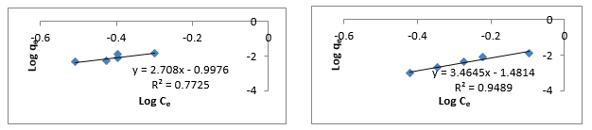

**Figures 6a & 6b:**

Freundlich Adsorption Isotherm of Quail Eggshell and Snail Shell at Different Adsorbent doses.

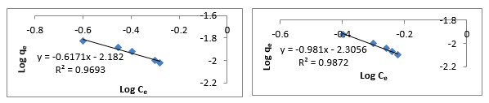

**Figures 6c & 6d:** Freundlich Adsorption Isotherm of Quail Eggshell and Snail Shell at Different Temperatures

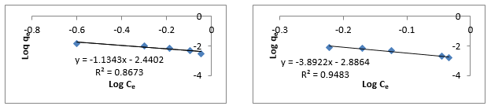

**Figures 6e & 6f:** Freundlich Adsorption Isotherm of Quail Eggshell and Snail Shell at Different contact times

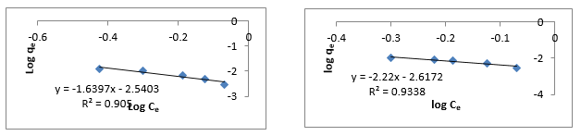

**Figures 6g & 6h:** Freundlich Adsorption Isotherm of Quail Eggshell and Snail Shell at Different pH

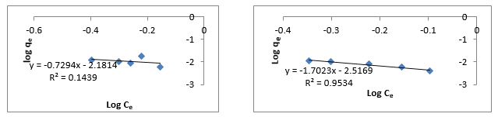

**Figures 6i & 6j:** Freundlich Adsorption Isotherm of Quail Eggshell and Snail Shell at Different Adsorbate Concentrations

.

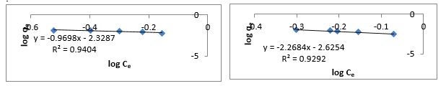

**Figures 6k & 6l:** Freundlich Adsorption Isotherm of Quail Eggshell and Snail Shell at Different Rotational Speeds.

**3.4.3 Dubinin–Radushkevich (D–R) Isotherm**

The Dubinin – Radushkevich isotherm was chosen to evaluate the energy and porosity of adsorbent materials. It helps distinguish between physical and chemical adsorption mechanisms. The data revealed that both biosorbents followed this model fairly well, with higher R² values observed for SS. The mean free energy values suggested that chemisorption predominated, particularly in SS, which aligns with the pseudo-second-order kinetic model discussed previously.

The Dubinin – Radushkevich isotherm was chosen to estimate the characteristics porosity of the biomass and the apparent energy of adsorption. The model can be expressed as:

$q_{c}= \frac{RT}{b\left(lnA\right)}+\frac{RT}{blnC_{e}}$ (5)

Where, BD is related to the free energy of sorption per mole of the sorbate as it migrates to the surface of the adsorbent from infinite distance in the solution and qD is the Dubinin-Radushkevich isotherm constant related to the degree of sorbate sorption by the biosorbent surface (Demirbas et al., 2009). The Linear form of equation (5) is given as:

$lnq_{c}=lnq_{D}-2B_{D}RTln\left(1+\frac{1}{C_{e}}\right)$ (6)

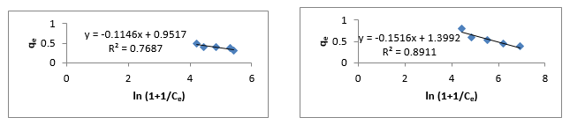

**Figures 7a & 7b:** Dubinin- Radushkevich Adsorption Isotherm of Quail Eggshell and Snail Shell at Different Adsorbent Doses.

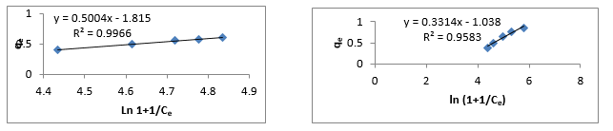

**Figures 7c & 7d:** Dubinin- Radushkevich Adsorption Isotherm of Quail Eggshell and Snail Shell at Different Temperatures.

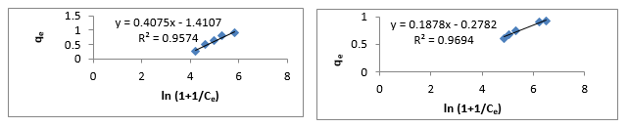

**Figures 7e & 7f:** Dubinin- Radushkevich Adsorption Isotherm of Quail Eggshell and Snail Shell at Different Contact Times.

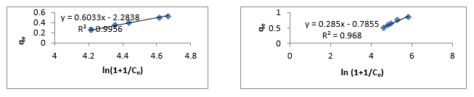

**Figures 7g & 7h:** Dubinin- Radushkevich Adsorption Isotherm of Quail Eggshell and Snail Shell at Different pH.

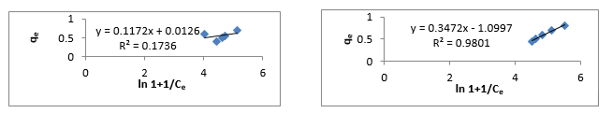

**Figures 7i & 7j:** Dubinin- Radushkevich Adsorption Isotherm of Quail Eggshell and Snail Shell at Different Adsorbate Concentrations.

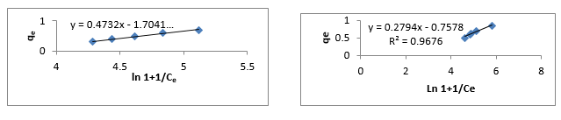

**Figures 7k & 7l:** Dubinin- Radushkevich Adsorption Isotherm of Quail Eggshell and Snail Shell at Different Rotational Speeds.

**3.4.4 Temkin Isotherm**

The Temkin model incorporates adsorbent–adsorbate interactions and assumes that the heat of adsorption decreases linearly with coverage due to indirect effects. This model provided the best fit for SS, suggesting that the adsorption process was influenced by interactions between adjacent adsorbed molecules and a gradual energy decline across the adsorbent surface. The Temkin constants support the idea of energy-distributed adsorption sites, particularly in SS, which complements its carbonate-rich composition.

This assumes that the fall in the heat of sorption is linear rather than logarithmic as implied in the Frendluich equation. The Temkin isotherm has generally been applied to the following form (Ho et al., 1999: Półka et al., 2015).

$q_{c}=\frac{RT}{b\left(\ln{A}\right)}+\frac{RT}{blnC_{e}}$ (7)

Where, R is the universal gas constant, T is the absolute temperature, A and b are constants based on the biosorbent.

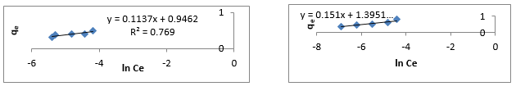

**Figures 8a & 8b:** Temkin Adsorption Isotherm of Quail Eggshell and Snail Shell at Different Adsorbent Doses.

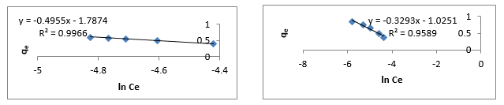

**Figures 8c & 8d:** Temkin Adsorption Isotherm of Quail Eggshell and Snail Shell at Different Temperatures.

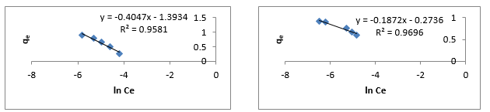

**Figures 8e & 8f**: Temkin Adsorption Isotherm of Quail Eggshell and Snail Shell at Different Contact Times

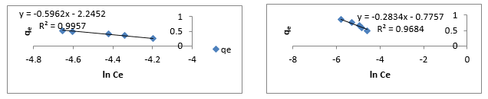

**Figures 8g & 8h:** Temkin Adsorption Isotherm of Quail Eggshell and Snail Shell at Different pH.

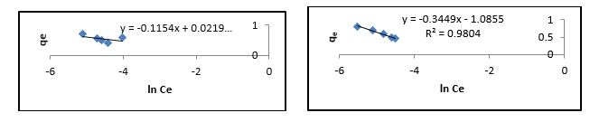

**Figures 8i & 8j:** Temkin Adsorption Isotherm of Quail Eggshell and Snail Shell at Different Adsorbate Concentrations.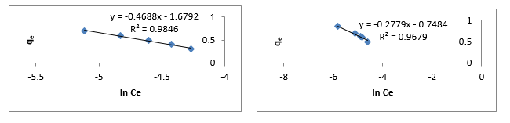

**Figures 8k & 8l:**Temkin Adsorption Isotherm of Quail Eggshell and Snail Shell at Different Rotational Speeds

**Table 7:** Coefficient of Determination (R2) forQuail Egg Shell and Snail Shell

|  |  |  |  |  |  |
| --- | --- | --- | --- | --- | --- |
| **S/N** | **Varied Parameters** | **langmuir** | **Freundlich** | **Temkin** | **Dubinin -Radushkevich** |
| 1QES  SS | Adsorbent dose(g) | 0.9373  0.9524 | 0.7725  0.9489 | 0.7690  0.8918 | 0.7681  0.8911 |
| 2QES  SS | Temperature (oC) | 0.9883  0.9497 | 0.9872  0.9050 | 0.9966  0.9589 | 0.9966  0.9583 |
| 3QES  SS | Contact time (mins) | 0.9042  0.9869 | 0.8673  0.9483 | 0.9581  0.9696 | 0.9574  0.9694 |
| 4QES  SS | pH | 0.9514  0.9722 | 0.9693  0.9338 | 0.9957  0.9684 | 0.9956  0.9680 |
| 5QES  SS | Adsorbate-concentration(g/L) | 0.7691  0.9759 | 0.1439  0.9534 | 0.1722  0.9804 | 0.1736  0.9801 |
| 6QES  SS | Speed (rpm) | 0.9401  0.9671 | 0.9404  0.9292 | 0.9846  0.9679 | 0.9843  0.9676 |

The correlation coefficients (R² values) obtained for the Freundlich isotherm model fall within the acceptable range of 0.1 to 0.99 (Figures 5a–f), with values for snail shell (SS) particularly close to 1.0. This suggests that oil molecules were rapidly and effectively adsorbed onto the heterogeneous surface of the biosorbents, particularly in the case of SS. The data confirm that SS possesses a higher adsorption capacity compared to quail eggshell (QES), likely due to its richer composition of active surface sites. Similar patterns were observed in the Langmuir isotherm analysis (Figures 6a–f), which supports the notion of monolayer adsorption on a uniform surface. The high R² values for both biosorbents imply that crude oil molecules were strongly attracted and bound to the central metal oxides present in the adsorbents. The Langmuir results further indicate that both physisorption and chemisorption contributed to the adsorption process, with the oil being effectively anchored to the adsorbent surfaces through both physical forces and chemical interactions. The Temkin isotherm model (Figures 7a–f) provided additional insights, indicating that adsorption occurred with a uniform distribution of binding energies across the surface. This suggests that the metal oxides and carbonate groups in both QES and SS offered energetically stable and reactive sites, capable of facilitating substantial oil uptake even at higher binding energy levels. These findings are consistent with the high removal efficiencies observed and confirm the thermodynamically favorable nature of the process. Moreover, the Dubinin–Radushkevich (D–R) isotherm model yielded high R² values for both biosorbents (Figures 8a–f), reinforcing the conclusion that chemisorption plays a dominant role in the adsorption mechanism. The model implies that adsorption occurred through energy-driven interactions at the central metal atoms embedded in the adsorbents, characteristic of surface-mediated processes common in heterogeneous catalysts. Collectively, the isotherm analyses reveal that the adsorption of crude oil by QES and SS is governed by a combination of physisorption and chemisorption mechanisms. These processes involve enthalpy-driven reactions, desorption events, and molecular diffusion across the active surfaces of metal oxide-rich biosorbents. The central metal atoms in the biosorbents provide the crucial reactive surfaces upon which these mechanisms operate, making both materials viable candidates for oil spill remediation technologies.

The findings of this study confirm that both quail eggshell (QES) and snail shell (SS) are effective biosorbents for removing crude oil from aqueous systems, achieving maximum removal efficiencies of 77.5% and 95.0%, respectively, at an adsorbent dosage of 5 g. These results are consistent with prior research by Uzoije et al. (2011), who observed comparable performance using plantain peels and groundnut husks under similar batch adsorption conditions. More recent investigations by Askari et al. (2025) demonstrated that hybrid composites combining natural fibers such as goat hair and palm fiber with synthetic polymers can enhance oil sorption capacity and mechanical resilience. In contrast, the present study offers a simpler, biodegradable, and low-cost approach utilizing single-source agricultural waste materials. Additionally, this research complements the work of Mohammad et al. (2021), who focused on resource recovery using reject brine-derived adsorbents for oil remediation. By employing waste shells, our study contributes to waste valorization while simultaneously addressing environmental contamination. When compared to advanced biosorbents reviewed by Akhtar et al. (2024) including nanocellulose, graphene-based materials, and metal-organic frameworks (MOFs) QES and SS stand out for their ease of preparation, nontoxicity, and local availability, even though their adsorption capacities are moderate by comparison. Importantly, this study advances the field by providing a side-by-side evaluation of two calcium-rich biogenic waste adsorbents under controlled batch conditions. Variables such as adsorbent dosage, pH, temperature, agitation rate, and contact time were systematically varied to characterize adsorption behavior. Kinetic modeling revealed that adsorption follows a pseudo-second-order model, indicative of a chemisorption mechanism. Furthermore, isotherm analysis showed that QES adsorption aligns with the Langmuir model—suggesting monolayer coverage while SS conforms more closely to the Temkin model, which accounts for variable adsorption energies. This comparative analysis offers novel insights into how the structural and compositional properties of natural biosorbents influence their adsorption mechanisms—an area that remains under-investigated in the literature. Future research may build on these findings by examining the reusability of these materials, assessing regeneration techniques, or applying surface modifications to further enhance their adsorption efficiency and practical applicability.

**4.0 CONCLUSION**

This study successfully evaluated the potential of quail eggshell (QES) and snail shell (SS) as low-cost, eco-friendly biosorbents for the remediation of crude oil-contaminated water. The adsorbents were prepared from readily available agricultural waste, processed into fine powders, and tested across multiple experimental parameters, including temperature, contact time, pH, adsorbate and adsorbent concentrations, and agitation speed. The results revealed that SS consistently outperformed QES, achieving a maximum oil removal efficiency of 95%, compared to 77.5% for QES under similar conditions. FTIR analysis confirmed the presence of key functional groups—primarily metal oxides and carbonates—that contributed to their adsorption capabilities. The superior performance of SS was attributed to its higher carbonate content and more favourable surface chemistry. Adsorption isotherm modelling further substantiated these findings. The Langmuir model fitted QES data best, indicating monolayer adsorption, while SS data aligned more closely with the Temkin model, suggesting heterogeneity in binding energy. Additionally, kinetic modeling showed that the pseudo-second-order model best described both adsorbents, signifying chemisorption as the primary removal mechanism.

**5.0 RECOMMENDATIONS**

The Quail egg shell and Snail shell should also be pulverised to other sizes aside the one used for this research, to compare the adsorption capacities. A blend of these samples can also be studied at the same and different mesh sizes. Other agricultural waste products should also be encouraged to open up opportunity for local materials at no cost. Government and industries should take advantage of adsorption technologies by developing these natural adsorbents for household and industrial purposes. While this study has demonstrated the adsorption efficacy of quail eggshells and snail shells, their natural abundance, biodegradability, and minimal cost position them as highly promising candidates for sustainable large-scale deployment.

Quantifying these environmental and economic benefits would significantly enhance their practical appeal and promote wider adoption in environmental remediation efforts. Therefore, future studies should incorporate comprehensive cost–benefit analyses and environmental impact assessments to better evaluate the industrial viability and long-term value of using these biosorbents in real-world applications.

Disclaimer (Artificial intelligence)

Option 1:

Author(s) hereby declare that NO generative AI technologies such as Large Language Models (ChatGPT, COPILOT, etc.) and text-to-image generators have been used during the writing or editing of this manuscript.

Option 2:

Author(s) hereby declare that generative AI technologies such as Large Language Models, etc. have been used during the writing or editing of manuscripts. This explanation will include the name, version, model, and source of the generative AI technology and as well as all input prompts provided to the generative AI technology

Details of the AI usage are given below:

1.

2.

3.

COMPETING INTERESTS

Authors have declared that they have no known competing financial interests OR non-financial interests OR personal relationships that could have appeared to influence the work reported in this paper.

References

Ahmad, M. A., Ahmad, N., & Bello, O. S. (2015). Removal of Remazol Brilliant Blue reactive dye from aqueous solutions using watermelon rinds as adsorbent. *Journal of Dispersion Science and Technology, 36*(6), 845–858. https://doi.org/10.1080/01932691.2014.925400

Akinsanoye, O. A. (2022). Laterite as a binder for remediation of polluted landsites. *Global Scientific Journal, 10*(5), 1660–1671.

Akinsanoye, O. A., Omotoso, M. A., & Falode, O. A. (2025, June). Industrial precursors from agricultural wastes. In *Proceedings of the 4th International Conference of the Turkish Journal of Agriculture – Food Science and Technology (TURJAF 2025), Turkey*.

Akhtar, M. S., Ali, S., & Zaman, W. (2024). Innovative adsorbents for pollutant removal: Exploring the latest research and applications. *Molecules, 29*(18), 4317. https://doi.org/10.3390/molecules29184317

Alaa El-Din, G., Amer, A. A., Malsh, G., & Hussein, M. (2018). Study on the use of banana peels for oil spill removal. *Alexandria Engineering Journal, 57*(3), 2061–2068. https://doi.org/10.1016/j.aej.2017.05.020

Alawode, A. J., & Falode, O. A. (2019). Development of a new Type-I isotherm for correction of Langmuir isotherm’s over-estimation of adsorption at higher pressures. *Physical Science International Journal, 23*(3), 1–26. https://doi.org/10.9734/psij/2019/v23i330157

Aljeboree, A. M., Alshirifi, A. N., & Alkaim, A. F. (2017). Kinetics and equilibrium study for the adsorption of textile dyes on coconut shell activated carbon. *Arabian Journal of Chemistry, 10*(Suppl. 2), S3381–S3393. https://doi.org/10.1016/j.arabjc.2014.01.020

Annunciado, T. R., Sydenstricker, T. H. D., & Amico, S. C. (2005). Experimental investigation of various vegetable fibers as sorbent materials for oil spills. *Marine Pollution Bulletin, 50*(11), 1340–1346. https://doi.org/10.1016/j.marpolbul.2005.04.043

Askari, E., Alipour, V., & Rahmanian, O. (2025). Synthesis and application of adsorbent pads for removal of oil pollutants from water. *Heliyon, 11*(4), e42885. https://doi.org/10.1016/j.heliyon.2025.e42885

Ayotamuno, M. J., Kogbara, R. B., Ogaji, S. O. T., & Probert, S. D. (2006). Bioremediation of a crude-oil polluted agricultural soil at Port Harcourt, Nigeria. *Applied Energy, 83*(11), 1249–1257. https://doi.org/10.1016/j.apenergy.2006.01.003

Bailey, S. E., Olin, T. J., Bricka, R. M., & Adrian, D. D. (1999). A review of potentially low-cost sorbents for heavy metals. *Water Research, 33*(11), 2469–2479. https://doi.org/10.1016/S0043-1354(98)00475-8

Bandura, L., Woszuk, A., Kołodyńska, D., & Franus, W. (2017). Application of mineral sorbents for removal of petroleum substances: A review. *Minerals, 7*(3), 37. https://doi.org/10.3390/min7030037

Baruah, S., & Neog, D. (2025). Adsorption analysis of organic and chemical sorbents for oil spill management on land. *Results in Engineering, 26*, 105167. https://doi.org/10.1016/j.rineng.2025.105167

Beyer, J., Trannum, H. C., Bakke, T., Hodson, P. V., & Collier, T. K. (2016). Environmental effects of the Deepwater Horizon oil spill: A review. *Marine Pollution Bulletin, 110*(1), 28–51. https://doi.org/10.1016/j.marpolbul.2016.06.027

Bhatnagar, A., & Sillanpää, M. (2010). Utilization of agro-industrial and municipal waste materials as potential adsorbents for water treatment – A review. *Chemical Engineering Journal, 157*(2–3), 277–296. https://doi.org/10.1016/j.cej.2010.01.007

Darlington, B. N., & Uchenna, A. (2010). Adsorption of crude oil using meshed groundnut husk. *Chemical Product and Process Modeling, 5*(1), Article 1. https://doi.org/10.2202/1934-2659.1433

Demirbas, E., Dizge, N., Sulak, M. T., & Kobya, M. (2009). Adsorption kinetics and equilibrium of copper from aqueous solutions using hazelnut shell activated carbon. *Chemical Engineering Journal, 148*(2–3), 480–487. https://doi.org/10.1016/j.cej.2008.09.027

Falode, O. A., Oluwadero, T. A., Nwadike, B., & Fagade, O. E. (2016). Performance of biosurfactant produced from pineapple waste for improving oil recovery. *Chemical Science International Journal, 15*(4), 1–14. https://doi.org/10.9734/ACSJ/2016/27205

Foo, K. Y., & Hameed, B. H. (2010). Insights into the modeling of adsorption isotherm systems. *Chemical Engineering Journal, 156*(1), 2–10. https://doi.org/10.1016/j.cej.2009.09.013

Freundlich, H., & Heller, W. (1939). The adsorption of cis- and trans-azobenzene. *Journal of the American Chemical Society, 61*(8), 2228–2230. https://doi.org/10.1021/ja01877a071

Ho, Y. S., & McKay, G. (1999). Pseudo-second order model for sorption processes. *Process Biochemistry, 34*(5), 451–465. https://doi.org/10.1016/S0032-9592(98)00112-5