Factors Affecting Passenger Satisfaction on The Depok-Bkn Transjakarta Bus

.

ABSTRACT

|  |
| --- |
| The Transakarta Bus (TJ) makes a significant contribution to the growth and development of urban areas, particularly in Jakarta's capital city. One aspect is to help reduce traffic congestion, which has been a problematic issue in Jakarta. The main objective of this study is to investigate the relationship between service quality dimensions and passenger satisfaction with TJ. The method in this study uses data based on field surveys and questionnaire instruments distributed to 100 TJ user respondents, then the data is processed and analyzed using the Partial Least Squares (PLS) technique. The study concluded that the service quality dimensions of assurance and empathy have a significant positive relationship with passenger satisfaction. In addition, these dimensions describe 53.9% of the variance in passengers' perceived satisfaction towards BTJ's performance on the Depok-BKN route. Based on the results of the study, it is recommended to improve connectivity with other modes of transport in order to increase user satisfaction and influence passenger decisions to use public transport. |

*Keywords: Public transport, ﻿Passenger satisfaction, Service quality, Bus Transjakarta*

1. INTRODUCTION

Public transportation is an important component of the nation's economic and social development. Switching from private vehicles to public transport such as buses, trains, taxis, and boats has many benefits, including improved air quality, reduced traffic congestion, and reduced noise pollution [1]. Indonesia is a developing country where public transport plays an important role in the growth and development of urban areas, especially in the capital city of Jakarta [2]. One important aspect of public transport is that it contributes to reducing traffic congestion in Jakarta, especially during peak hours [3], [4]. This reduces stop-start driving and fuel consumption, saving passengers time and energy, locals and visitors to the city both use public transport. [5], [6].

The most popular mode of transport is land, which has issues like congestion [7]. According to data from the Central Bureau of Statistics, the number of motorized vehicles registered in Jakarta in 2022 was 21,865,081 units, and in the last 5 years, there has been growth of 5.35 percent per year, leading to problems such as congestion because the existing infrastructure cannot accommodate existing vehicles. Therefore, to attract private vehicle users to switch to public transport, the DKI Jakarta Provincial government built a BRT (Bus Rapid Transit) transportation system, known as Transjakarta, which began operating on 15 January 2004 [8].

Based on data from the Central Bureau of Statistics, passengers were carried by the Transjakarta fleet on a total of more than 155 routes with 14 corridors. as many as 188.77 million people in 2018, an increase from the previous years of 144.86 million in 2017, and 123.70 million in 2016. In 2024, the number of passengers on Transjakarta reached 1.3 million per day[9].

Cibubur is an area in the east of Jakarta that borders Bekasi and Depok. Many people who work in Jakarta live around the area and use different types of transport [10]. The quality of public transport services is becoming an important issue to realize a better and more comfortable environment [11]. Public transport service quality appears to be unsatisfactory and at an average level, particularly in terms of physical facilities such as cleanliness, comfort, punctuality, frequency, and staff responsiveness. Therefore, this study will also investigate staff responsiveness [12].

Transjakarta bus operators are facing a problem as the number of passengers increases: the quality of services they provide has not been able to provide maximum satisfaction to passengers [13]. Many passengers continue to express dissatisfaction with the service provided, as evidenced by the presence of uncomfortable bus and bus stop facilities, as well as unsterile lanes that disrupt the comfort of Transjakarta users [14].

The significance of this research is intended to provide assistance to Trans Jakarta Bus on the Depok-BKN route in establishing the services offered and identifying important aspects of service quality that affect passenger satisfaction. The main objective of this study is to determine the relationship between the dimensions of service quality and passenger satisfaction with Transjakarta Bus.

2. methods AND DATA COLLECTION

Every research generally employs a "research method" to ensure consistent execution of each step, leading to the completion of the research at the decision-making stage [15]. Data collection techniques are carried out by direct observation, interviews, and distributing questionnaires to obtain primary data, while secondary data is obtained from Transjakarta bus operators.

This data processing and analysis uses questionnaire data as well as direct observations obtained in the field [16]. The goal of this work is to gather insights from the performance analysis and maintenance of Transjakarta buses, ensuring they meet the Department of Land Transportation Standards for bus fleet services. Direct data collection such as load factor, journey speed, time headway, travel time, service time, vehicle frequency, and number of vehicles operating[17]. To conduct this research at the Depok-BKN bus stop over two days in a week to gather comparative data, specifically on Monday and Wednesday. Figure 1 below illustrates the research location:

**Fig. 1. Study location**

To investigate the relationship between service quality and passenger satisfaction, a survey was conducted, where questionnaires were distributed to a valid sample of 100 respondents representing passengers using the Transjakarta Bus on the Depok-BKN route. The convenience sampling technique was chosen because it is easy to use and cost-effective, where the questionnaire will be easily distributed to passengers, and it is also a very easy way to produce the required sample [13].

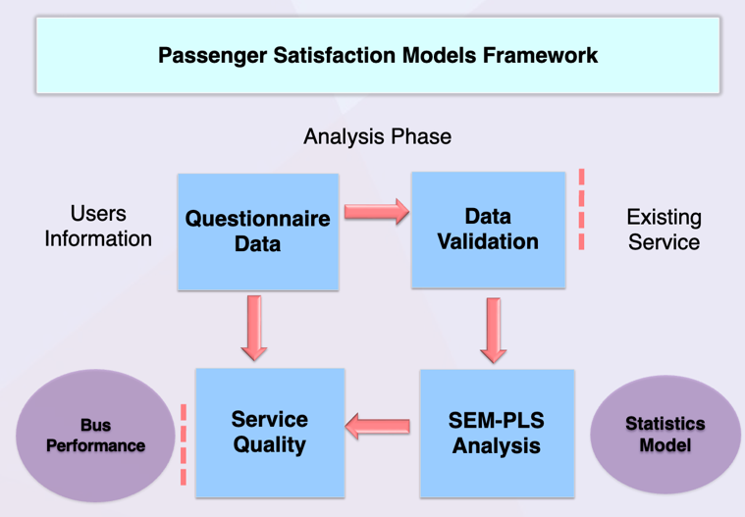

**Fig. 2. Research flow**

The completed respondent questionnaires were checked and entered into the Smart PLS 3.0 software as a structural equation modeling approach [18]. This research also includes various statistical tools and techniques to analyze the data. The Smart PLS 3.0 program was mainly used for all types of results except for calculating the demographic profile of the respondents [19].

3. ANALYSIS AND DISCUSSION

* 1. Analysis of respondent characteristics

The total of 100 respondents in this study were Transjakarta Bus users on the Depok-BBKN route. There were 39 female respondents (39%) and 61 male respondents (61%). In addition, the results showed that most respondents were aged between 45 years and over as many as 1 person (1%), followed by respondents between 35-44 years as many as 12 people (12%), ages between 25-34 years as many as 35 (35%), young ages between 17-24 years as many as 51 people (51%), and ages less than 16 years as many as 1 (1%).

* 1. Transjakarta bus performance analysis

Based on the data that has been obtained, it can be seen in table 1 as follows:

**Table 1. Trans Jakarta Bus operational performance**

| **No.** | **Indicators** | **Category** | **Weight** |
| --- | --- | --- | --- |
| 1 | Load Factor | B | 2 |
| 2 | Headway | A | 3 |
| 3 | Frequency of vehicle | A | 3 |
| 4 | Travel time | A | 3 |
| 5 | Service time | A | 3 |
| 6 | Travel speed | A | 3 |
| 7 | Number of Operating Buses | A | 3 |
| Total | | | 20 |
| Operational Performance Assessment | | | Good |

Based on the table above, it can be determined that:

* **Load** **factor**, Transjakarta buses have an average value of 83.1% in category B (80-100%).
* **Headway**, the analysis of all routes yields results with an average value of 7.3 minutes in category A (6 vehicles/hour).
* **Frequency of vehicle**, the analysis of all routes yielded an average value of 7.56 vehicles per hour in category A, which is greater than 6 vehicles per hour
* **Travel time**, the analysis results for all routes have an average value of 2.38 minutes/kilometer in category A (15 hours/day).
* **Service time**, the Transjakarta bus route Cibubur-BBKN Cawang operates for 16 hours, falling under category A (>15 hours / day).
* **Travel speed**, The analysis results for all routes have an average value of 31.6 kilometers per hour in category A (>10 kilometers per hour).

The total number of vehicles operating is 100%, so it falls into category A (>100%). The Standard Decree of the Director General of Land Transportation, all categories related to load factor, headway, vehicle frequency, travel time, service time, travel speed, and number of vehicles.

* 1. Common-Method Variance Bias Test

Common method bias refers to measurement error from a methodological perspective. For example, having the same measurement scale (e.g., 5-point Likert scale) for all survey questions may lead to common method bias [20]. This entails incorporating all measurement scale items into the principal component analysis. The total variance explained by the single factor was only 42.5%, which is below the recommended limit of 50%. Based on these results, the study did not encounter common method bias, and the collected data was deemed suitable for further analysis.

**Table 2. ﻿Factor Loading for Multiple Items**

| **Indicators** | **Items** | **Factor Loading** |
| --- | --- | --- |
| Ass.1 (Latent Variable 3) | The officers at Transjakarta are friendly when responding to passengers | 0,862 |
| Ass.2 (Latent Variable 3) | Safe inside the Transjakarta bus stop | 0,837 |
| Ass.3 (Latent Variable 3) | Safe on board a Transjakarta bus | 0,782 |
| Emp.1 (Latent Variable 4) | The attendant says an opening greeting at the start of the journey | 0,930 |
| Emp.2 (Latent Variable 4) | The number of passengers on the bus corresponds to the available space | 0,859 |
| Emp.3 (Latent Variable 4) | The attendant says a closing greeting at the end of the journey | 0,781 |
| Rea.1 (Latent Variable 1) | Timing and arrival of Transjakarta buses | 0,912 |
| Rea.2 (Latent Variable 1) | The facilities at the bus stop are functioning properly | 0,881 |
| Rea.3 (Latent Variable 1) | The facilities on board the bus are functional | 0,842 |
| Res.1 (Latent Variable 2) | Officers who are willing to help passengers when experiencing difficulties | 0,893 |
| Res.2 (Latent Variable 2) | It is easy to get information about bus routes and departure times | 0,840 |
| Res.3 (Latent Variable 2) | A Transjakarta officer tells passengers about giving priority seating | 0,939 |
| Res.4 (Latent Variable 2) | Transjakarta buses always on time | 0,919 |
| Sat.1 (Latent Variable 6) | ﻿I am satisfied with the BTJ services | 0,883 |
| Sat.2 (Latent Variable 6) | ﻿I am satisfied with the fares | 0,708 |
| Sat.3 <(Latent Variable 6) | ﻿It is easy to take the BTJ to go anywhere I want | 0,832 |
| Sat.4 (Latent Variable 6) | ﻿The services provided by transporters need my satisfaction I | 0,836 |
| Sat.5 (Latent Variable 6) | Cleanliness of public facilities | 0,832 |
| Tan.1 (Latent Variable 5) | There are clear information boards in the passenger lounge | 0,742 |
| Tan.2 (Latent Variable 5) | Existence of facilities inside the bus stop | 0,806 |
| Tan.3 (Latent Variable 5) | Existence of facilities in the bus | 0,940 |
| Tan.4 (Latent Variable 5) | ﻿The dress of staff is neat | 0,939 |

Based on Table 2 above, it is found that the indicators used represent the constructs measured so that it can be used for structural analysis.

* 1. Convergent Validity

In addition to convergent validity, the loading must be higher than 0.7 to be considered as having high internal consistency reliability [21]. If the loading is lower than the threshold value, then the item should be removed from the construct to obtain an average variance extracted with a minimum value of 0.50 and higher than 0.7. The study revealed that the composite reliability (CR) and average variance extracted (AVE) values for assurance (CR = 0,867; AVE = 0,685), empathy (CR = 0,893; AVE = 0,737), reliability (CR = 0,910; AVE = 0,772), responsiveness (CR = 0.943, AVE = 0.807), satisfaction (CR = 0,911; AVE = 0,672), and tangible (CR = 0,919; AVE = 0,742) exceed the threshold value, confirming the validity of all items for analysis. According to [22], if the composite reliability value is 0.6 or higher, the scale has reasonable internal consistency. Furthermore, according to the results shown in Table 3, all indicators have good composite reliabilities. Consequently, these results confirm that the variables in this study are highly reliable, as they are highly consistent in explaining the variance contained in them.

﻿**Table 3. Composite Reliability and Average (CR) Variance Extracted (AVE)**

|  |  |  |
| --- | --- | --- |
| **Constructs** | **Composite Reliability** | **Average Variance Extracted (AVE)** |
| Assurance | 0,867 | 0,685 |
| Empathy | 0,893 | 0,737 |
| Reability | 0,910 | 0,772 |
| Responsiveness | 0,943 | 0,807 |
| Satisfaction | 0,911 | 0,672 |
| Tangible | 0,919 | 0,742 |

* 1. ﻿Full model structural equation modeling

﻿The purpose of this test is to determine the relationship between constructs that have been modeled. The designed theoretical model framework establishes a structural connection, specifically the correlation between factors, as demonstrated in Figure 2 below:

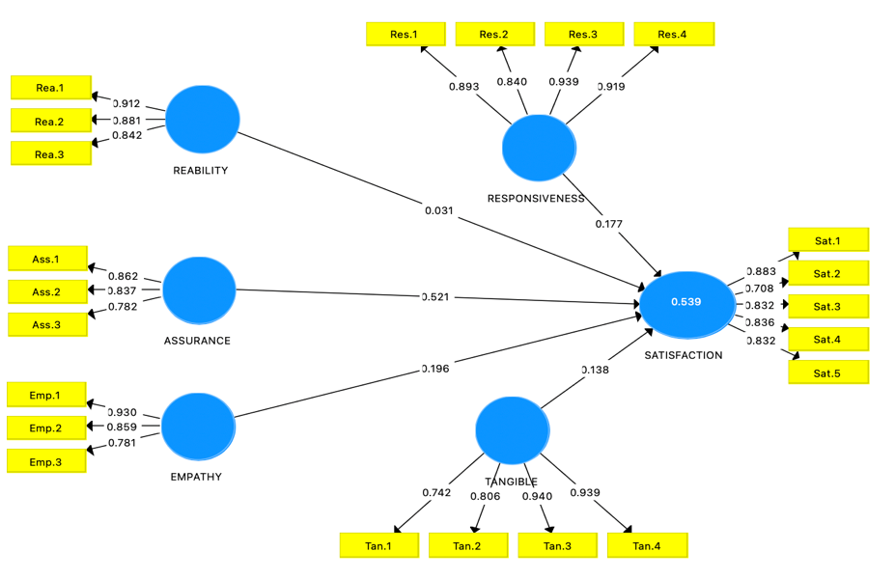

**Fig. 3. Measurement model**

The structural relationship modeling, illustrated in Figure 3 above, shows a very complex relationship between constructs with a large number of indicators. Items should have a higher load on their own constructs and the AVE share between each construct and its measure should be higher than the variation shared between the construct and other constructs [23]. This is to make sure that there are no problems with discriminant validity. In order to test discriminant validity, the criterion has been performed to compare the correlations between constructs and AVE values [24]. Table 4 presents bolded values on the diagonal, which are greater than the corresponding row and column values, indicating that the measures are discriminant.

**Table 4. Discriminant Validity**

|  |  |  |  |  |  |  |
| --- | --- | --- | --- | --- | --- | --- |
| **Construct** | **Assurance** | **Empathy** | **Reability** | **Responsiveness** | **Satisfaction** | **Tangible** |
| **Assurance** | **0,575** |  |  |  |  |  |
| **Empathy** | 0,085 | **0,597** |  |  |  |  |
| **Reability** | 0,150 | 0.093 | **0,610** |  |  |  |
| **Responsiveness** | 0,311 | 0,130 | 0,183 | **0,624** |  |  |
| **Satisfaction** | 0,460 | 0,213 | 0,163 | 0,332 | **0,569** |  |
| **Tangible** | 0,155 | 0.084 | 0,126 | 0,115 | 0,213 | **0,598** |

* 1. Structural model

The analysis of path coefficients reveals a positive impact of assurance, empathy, reliability, responsiveness, and tangible on satisfaction, as illustrated in Figure 4 below:

**Fig. 4. Model partisanshio**

The results for construct assurance as in table 5, obtained (OS = 0.362; PV =p0.000) and empathy (OS = 0.136; PV = 0.002) in Table 5 below demonstrate a significant positive impact on satisfaction. The results for construct reliability (OS = 0.031; PV = 0.498), responsiveness (OS = 0.123; PV = 0.074), and tangible (OS = 0.096; PV = 0.056) demonstrate that the PV value exceeds 0.005, indicating that construct reliability, responsiveness, and tangible do not significantly affect satisfaction. Therefore, the regression equation can be formulated as follows:

Satisfaction = 0,362 x assurance + 0,136 x emphaty +

0,031 x reability + 0,123 x responsuveness

+ 0,096 x tangible + e

Where: e is the error value

**Table 5. Path coofecients**

| **Construct** | **Original Sample (O)** | **Sample Mean (M)** | **Standard Deviation (STDEV)** | **T Statistics (|O/STDEV|)** | **P Values** |
| --- | --- | --- | --- | --- | --- |
| Assurance -> Satisfaction | 0,362 | 0,366 | 0,076 | 4.791 | 0.000 |
| Empathy -> Satisfaction | 0,136 | 0,136 | 0.064 | 3.041 | 0.002 |
| Reability -> Satisfaction | 0.031 | 0.041 | 0.086 | 0,252 | 0,498 |
| Responsiveness -> Satisfaction | 0,123 | 0,121 | 0,076 | 1.619 | 0,074 |
| Tangible -> Satisfaction | 0,096 | 0,096 | 0.072 | 1.918 | 0.056 |

* 1. Hypothesis Result

From the results of the analysis, it is concluded that all hypotheses tested, as illustrated in Table 6, obtained that the service quality dimensions of the assurance and empathy constructs have a significant positive relationship to passenger satisfaction, while the constructs of reliability, responsiveness, and tangibility have an insignificant positive relationship to passenger satisfaction.

**Table 6. Results of the tested hypothesis**

| **Path coefficient** | **Hypotesis statement** | **Result** |
| --- | --- | --- |
| Assurance -> Satisfaction | ﻿H1: There is a significant relationship between assurance and  passenger satisfaction | Supported |
| Empathy -> Satisfaction | H1: There is a significant relationship between emphaty and  passenger satisfaction | Supported |
| Reability -> Satisfaction | H1: There is no significant correlation between reability and  passenger satisfaction. | Supported |
| Responsiveness -> Satisfaction | H1: There is no significant correlation between reesponsiveness  and passenger satisfaction. | Supported |
| Tangible -> Satisfaction | H1: There is no significant correlation between tangible and  passenger satisfaction | Supported |

4. Conclusion

From the results of the analysis, it can be concluded that the Depok-BKN Transjakarta Bus route must be evaluated and assessed in a broader context, focusing on the dimensions of service quality used in this study as well as paying attention to other dimensions of service quality. This study found that the service quality dimensions of assurance and empathy have a significantly positive relationship with passenger satisfaction. Furthermore, these dimensions account for 53.9% of the variance in perceived passenger satisfaction with the Depok-BKN Trans Jakarta Bus's performance. This implies that other determinants account for 46.1% of the variance. By paying attention to and improving the dimensions of reliability, responsiveness, and tangibility to increase user satisfaction, a safe, comfortable, and sustainable transportation system will be established.

More research is required, such as identifying the mode of transport that passengers use to connect with other modes of transport, as this will also influence their decision to use public transportation.

**DISCLAIMER (ARTIFICIAL INTELLIGENCE)**

Author(s) hereby declare that NO generative AI technologies such as Large Language Models (ChatGPT, COPILOT, etc) and text-to-image generators have been used during writing or editing of this manuscript.

**COMPETING INTERESTS**

Authors have declared that no competing interests exist.

References

[1] M. Isradi, J. Prasetijo, A. Irfan, H. Andraiko, and G. Zhang, “The Prediction of Road Condition Value during Maintenance Based on Markov Process,” *International Journal on Advanced Science, Engineering and Information Technology (IJASEIT)*, vol. 14, no. 3, pp. 1083–1090, 2024, doi: https://doi.org/10.18517/ijaseit.14.3.19475.

[2] M. Isradi, J. Prasetijo, Y. D. Prasetyo, N. Hartatik, and A. I. Rifai, “Prediction of Service Life Base on Relationship between PSI and IRI for Flexible Pavement,” *Proceedings on Engineering*, vol. 5, no. 2, pp. 267–274, 2023.

[3] N. Hartatik, J. Prasetijo, and M. Isradi, “Characteristics of traffic accidents in jalan tol surabaya-porong, Jawa Timur,” *International Journal of Advanced Trends in Computer Science and Engineering*, vol. 9, no. 1 Special Issue 4, 2020, doi: 10.30534/ijatcse/2020/4991.42020.

[4] M. Isradi, J. Prasetijo, T. S. Aden, and A. I. Rifai, “Relationship of Present Serviceability Index for Flexible and Rigid Pavement in Urban Road Damage Assessment using Pavement Condition Index and International Roughness Index,” in *E3S Web of Conferences ICCIM*, 2023.

[5] R. K. Kinasih, J. Prasetijo, S. Indriany, M. Isradi, and A. W. Biantoro, “Analyzing Toll Road as a Solution to The Existing Highway Problem,” *Res Militaris*, vol. 12, no. route 1, p. 6, 2022.

[6] H. Y. Firdaus, M. Isradi, J. Prasetijo, and M. Rifqi, “Performance Analysis and Passenger Satisfaction on Trans Jakarta Bus Services ( Cibubur Route – BKN ),” *Journal of Science, Technology, and Engineering (JSTE)*, vol. 1, no. 2, pp. 73–81, 2021.

[7] M. Isradi, Z. Arifin, M. I. Setiawan, R. D. Nasihien, and J. Prasetijo, “Traffic Performance Analysis of Unsignalized Intersection Using the Traffic Conflict Parameter Technique,” *Sinergi*, vol. 26, no. 3, p. 397, 2022, doi: 10.22441/sinergi.2022.3.015.

[8] BPS Kota Bekasi, “Badan Pusat Kota Bekasi.”

[9] A. I. Rifai, Lista, M. Isradi, and A. Mufhidin, “How did the COVID-19 Pandemic Impact Passenger Choice toward Public Transport ? The Case of Jakarta , Indonesia,” *Design Engineering*, vol. 2, no. 8, pp. 6816–6824, 2021.

[10] H. Y. Firdaus, M. Isradi, J. Prasetijo, M. Rifqi, and H. Halim, “Analysis of Transjakarta Service Performance on the Cibubur-BKN by Servqual Method,” *European Journal of Science, Innovation and Technology*, vol. 2, no. 1, pp. 113–123, 2022.

[11] C. Zhang, Y. Liu, W. Lu, and G. Xiao, “Evaluating Passenger Satisfaction Index Based on PLS-SEM Model: Evidence from Chinese Public Transport Service,” *Transp Res Part A Policy Pract*, vol. 120, no. December 2017, pp. 149–164, 2019, doi: 10.1016/j.tra.2018.12.013.

[12] K. Ismael and S. Duleba, “Investigation of the Relationship Between the Perceived Public Transport Service Quality and Satisfaction: A PLS-SEM Technique,” *Sustainability (Switzerland)*, vol. 13, no. 23, 2021, doi: 10.3390/su132313018.

[13] A. Mat, N. S. Bahry, N. L. Kori, Z. A. Munir, and N. M. Daud, “The Influence of Service Quality and Passenger Satisfaction Towards Electric Train Services (ETS): A PLS-SEM Approach,” *Foundations of Management*, vol. 11, no. 1, pp. 57–64, 2019, doi: 10.2478/fman-2019-0005.

[14] Y. Rachmadina, M. Isradi, J. Prasetijo, A. K. Negara Dalimunte, and A. Mufhidin, “Analysis of the Choice of Commuter Line Electric Rail Train (Krl) Modes and Transjakarta Buses for the Bekasi City - East Jakarta Route,” *Engineering and Technology Journal*, vol. 8, no. 08, pp. 2655–2664, 2023, doi: 10.47191/etj/v8i8.23.

[15] A. Ibraeva, G. H. de Almeida Correia, C. Silva, and A. P. Antunes, “Transit-Oriented Development: A Review of Research Achievements and Challenges,” *Transp Res Part A Policy Pract*, vol. 132, pp. 110–130, 2020.

[16] C. Shen and Y. Yahya, “The Impact of Service Quality and Price on Passengers’ Loyalty Towards Low-Cost Airlines: The Southeast Asia Perspective,” *J Air Transp Manag*, vol. 91, p. 101966, 2021.

[17] S. T. Ha, W. H. W. Ibrahim, M. C. Lo, and Y. S. Mah, “Factors Affecting Satisfaction and Loyalty in Public Transport using Partial Least Squares Structural Equation Modeling (PLS-SEM),” *International Journal of Innovative Technology and Exploring Engineering*, vol. 8, no. 12, pp. 569–575, 2019, doi: 10.35940/ijitee.L3453.1081219.

[18] J. Mandhani, J. K. Nayak, and M. Parida, “Interrelationships Among Service Quality Factors of Metro Rail Transit System: An integrated Bayesian Networks and PLS-SEM Approach,” *Transp Res Part A Policy Pract*, vol. 140, no. August, pp. 320–336, 2020, doi: 10.1016/j.tra.2020.08.014.

[19] M. S. Farooq, M. Salam, A. Fayolle, N. Jaafar, and K. Ayupp, “Impact of Service Quality on Customer Satisfaction in Malaysia Airlines: A PLS-SEM Approach,” *J Air Transp Manag*, vol. 67, pp. 169–180, 2018.

[20] W. Shen, W. Xiao, and X. Wang, “Passenger Satisfaction Evaluation Model for Urban Rail Transit: A Structural Equation Modeling Based on Partial Least Squares,” *Transp Policy (Oxf)*, vol. 46, pp. 20–31, 2016, doi: 10.1016/j.tranpol.2015.10.006.

[21] R. P. Bagozzi and Y. Yi, “Specification, Evaluation, and Interpretation of Structural Equation Models,” *J Acad Mark Sci*, vol. 40, pp. 8–34, 2012.

[22] A. Lawson-Body and M. Limayem, “The Impact of Customer Relationship Management on Customer Loyalty: The Moderating Role of Web SiteCharacteristics,” *Journal of Computer-Mediated Communication*, vol. 9, no. 4, p. JCMC944, 2004.

[23] D. Barclay, C. Higgins, and R. Thompson, *The Partial Least Squares (PLS) Approach to Casual Modeling: Personal Computer Adoption ans Use as an Illustration*. 1995.

[24] J. De Carvalho and F. O. Chima, “Applications of structural equation modeling in social sciences research,” *Am Int J Contemp Res*, vol. 4, no. 1, pp. 6–11, 2014.