Original Research Article
Molecular Dynamics Study of Interfacial Behavior Between Crude Oil and Injected CO₂ in a Niger Delta Reservoir
Abstract
As global oil reservoirs mature and conventional recovery methods become less effective, there is growing interest in CO₂-enhanced oil recovery (EOR), especially in regions like the Niger Delta. This study employed molecular dynamics (MD) simulations to investigate the interfacial interactions between injected CO₂ and crude oil under typical reservoir conditions. Octane was selected as a model compound for crude oil and represented using the TraPPE-UA force field, while CO₂ molecules were modeled with the all-atom TraPPE-AA force field to accurately capture electrostatic interactions. The system was simulated at 344 K, reflecting deep reservoir temperatures in the Niger Delta. Results revealed that CO₂ solubility and oil swelling increased with pressure, enhancing oil mobility. Interfacial tension (IFT) declined linearly as pressure rose, with the minimum miscibility pressure (MMP) estimated at approximately 18 MPa. These outcomes underscore the need to operate above the MMP for effective miscible displacement. The study highlights the potential of CO₂ injection for improving oil recovery and demonstrates the value of MD simulations as predictive tools for optimizing EOR strategies in complex reservoir environments.

Keywords: Molecular dynamics simulation, Crude Oil–CO₂ interactions, Interfacial tension,
Minimum miscibility pressure
- Introduction
Crude oil exploitation in the Niger Delta has a rich history spanning over five decades. During the early phases of production, natural reservoir energy was the primary mechanism for hydrocarbon recovery. As depletion progressed, operators shifted to secondary recovery methods, typically involving water flooding. However, as these methods reach their efficiency limits, the focus has increasingly turned to Enhanced Oil Recovery (EOR) techniques to sustain and boost oil output (Ogolo et al., 2019; Hemmati-Sarapardeh & Hajirezaie, 2020).
A growing body of literature has explored various EOR strategies applicable to Nigerian reservoirs. Adeyemi et al. (2013) utilized data mining frameworks to assess the feasibility of EOR deployment across Africa’s oil-producing basins. Foam-based injection techniques, examined by Falode and Ojuomola (2015), showed promise in improving oil displacement efficiency in unconsolidated sandstone formations, typical of many Niger Delta fields. More recently, researchers have intensified their efforts toward evaluating CO₂ injection as a viable EOR strategy due to its dual benefit of enhanced recovery and potential for carbon sequestration (Ehibor et al., 2024; Alawode & Nekwaya, 2025).
Nanotechnology has also gained traction in EOR research, with studies investigating the effect of nanoparticles and smart fluids on interfacial tension and oil displacement. For example, Anuka et al. (2020) reviewed microbial EOR in Nigeria and emphasized the urgent need for pilot-scale validation. Moreover, the work by Ehibor et al. (2024) employed a hybrid three-phase simulation model to evaluate chemical EOR processes involving alkali, polymer, and surfactant injections, reporting significant gains in oil recovery and fluid interaction mechanisms.
Despite these advances, a critical knowledge gap persists in understanding the molecular-level interactions that govern CO₂–oil systems, particularly under reservoir-specific conditions. Conventional laboratory techniques often fall short in capturing nanoscale behaviors such as gas dissolution dynamics, oil swelling, and interfacial modifications. To address this, molecular dynamics (MD) simulations have emerged as a cost-effective and insightful approach. They enable the computation of thermophysical and transport properties with atomic-scale resolution, aiding in EOR screening and design (Li et al., 2020; Zhang et al., 2020).
Although numerous MD studies have examined CO₂ interactions in other global reservoirs, few have focused specifically on the unique thermodynamic conditions of the Niger Delta. This study fills that gap by developing a reservoir-specific MD model to assess CO₂ solubility, oil swelling, interfacial tension, and minimum miscibility pressure (MMP), thereby offering actionable insights for field-level EOR implementation.

METHODOLOGY
2.0 Molecular Simulation Techniques
Molecular simulation offers a powerful means of analysing systems at the atomic scale by explicitly modelling the position, velocity, and interactions of particles over time. These techniques are instrumental in predicting thermophysical and transport properties that are often difficult or expensive to obtain experimentally. Among the most widely used methods are Molecular Dynamics (MD) and Monte Carlo (MC) simulations, each serving distinct purposes in the exploration of fluid behaviour.
MD simulations focus on solving Newton’s equations of motion to track the temporal evolution of atomic trajectories. This allows researchers to study dynamic properties such as diffusion, viscosity, and energy exchange across phases. In contrast, MC simulations rely on stochastic sampling of configurations to calculate equilibrium properties based on statistical thermodynamics. Both approaches have proven valuable in petroleum research, particularly for understanding fluid–fluid and fluid–rock interactions under reservoir-like conditions (Hemmati-Sarapardeh & Hajirezaie, 2020; Li et al., 2020).
In the context of CO₂-based Enhanced Oil Recovery (EOR), MD simulations provide key insights into how injected gas molecules interact with crude oil components, facilitating oil swelling, reducing interfacial tension, and altering miscibility behavior at the molecular level. These simulations help bridge the gap between laboratory observations and field-scale implementations.

2.1 Model Development
The simulation system was composed of a binary mixture of CO₂ and crude oil modelled at the molecular level. Crude oil is a complex mixture of straight and branched chain hydrocarbons and simulating it at the molecular level will be difficult and computationally expensive. To mimic crude oil for simplicity and computational efficiency, a single component that reduces the complexity of simulating a diverse hydrocarbon mixture alike and make simulations more tractable, hence n-octane (C₈H₁₈) molecules were chosen because it is a medium dense straight chain hydrocarbon and has been widely used in molecular simulations. The TraPPE-UA (Transferable Potentials for Phase Equilibria – United Atom) force field was utilized for modeling octane, because it treats every atom separately, and groups are treated as united atoms, thus reducing the number of interaction centers and lowering computational cost, while preserving the important physics of molecular interactions. Additionally, force field parameters are transferable across similar molecules, allowing for reliable modeling of various hydrocarbons without reparameterization making the simulation more accurate and efficient.
In this approach, methyl (-CH₃) and methylene (-CH₂-) are treated as single interaction centres, reducing the computational complexity without significantly sacrificing accuracy.
To model CO₂, the TraPPE-AA (All-Atom) force field was employed, which treats each atom in the molecule as a separate interaction site. This all-atom representation is particularly important for capturing electrostatic interactions and quadrupole effects in CO₂ molecules, which can influence solubility and interfacial dynamics (Li et al., 2020).

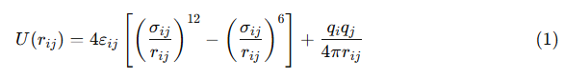
The parameter ε_{ij}​ denotes the depth of the potential energy well, while σ_{ij}​ indicates the interatomic separation at which the potential energy between two particles reaches its minimum. The term rij is the distance between particles i and j, while qi and qj are their partial charges.
The entire system was maintained at a temperature of 344 K, reflecting typical reservoir conditions observed in deep offshore Niger Delta fields. Atomic interactions were defined using a combination of Lennard-Jones (LJ) potentials and Coulombic forces, providing a robust framework for evaluating both van der Waals and electrostatic contributions.

To model interactions between dissimilar atoms, modified Lorentz–Berthelot combining rules were applied, as adapted in the work of Wang et al. (2018). These combining rules account for cross-interaction parameters that differ from simple arithmetic or geometric means, especially in systems involving polar and non-polar molecules.
For CO₂–octane cross interactions, a combining factor of a = 0.9 was adopted, modifying the depth and range of interaction potentials between the components.
The construction of the simulation cell followed methodologies adapted from recent studies (Chang, 2019), with all three spatial boundaries defined under periodic boundary conditions (PBC) to eliminate edge effects and mimic an infinite bulk system.
The number of CO₂ molecules was varied to simulate different pressures, while octane molecules were kept constant. Given that CO₂ behaves as a supercritical fluid under the chosen reservoir conditions, the canonical ensemble (NVT) was applied to preserve constant particle number, volume, and temperature throughout the simulation. This ensured the system stayed in a thermodynamic state similar to reservoir conditions (Nakagawa et al., 2013).
The simulation workflow involved a two-step approach:
- Equilibration Phase – A 2-nanosecond MD run under NVT conditions was used to stabilize the system and eliminate non-physical artifacts.
- Production Phase – A 10-nanosecond simulation followed, during which thermodynamic averages such as pressure tensors, densities, and interfacial energies were computed.
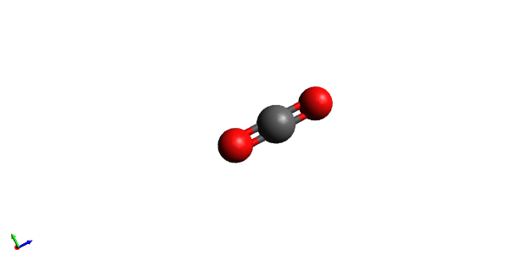
Figure 1: MD Model of CO₂ (AA Style)
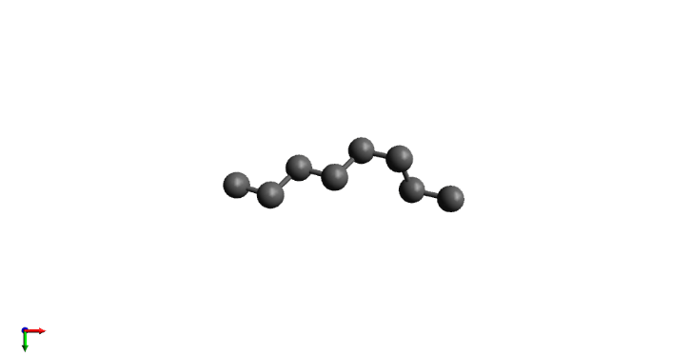
Figure 2: MD model of C₈H₁₈ (UA style)
Figure 3: MD model of Oil/CO₂ System
Temperature control was implemented using the Nosé–Hoover thermostat, with a relaxation time constant of 200 femtoseconds, ensuring precise temperature regulation without excessive damping (Nosé, 1984; Hoover et al., 1982).
For long-range electrostatic interactions, the Particle–Particle Particle–Mesh (PPPM) technique was applied, offering computational efficiency and high accuracy (10⁻⁵ precision). A cutoff distance of 20 Å was used for both LJ and electrostatic interactions.
Simulations were carried out using GROMACS, a widely used open-source MD package. Electrostatic calculations employed the Particle Mesh Ewald (PME) method with a grid spacing of 0.1 nm, and a fourth-order spline interpolation to achieve high-resolution force calculations. The integration time step was set at 2 femtoseconds, which ensured numerical stability and adequate sampling of atomic motions.
Figures 1-5 show the molecular structures of CO₂ (all-atom) and octane (united atom), as well as the initial and equilibrated states of the CO₂–oil system.

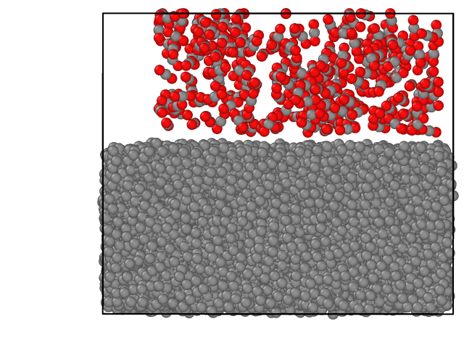
Figure 4: Construction of the initial simulation system for CO₂/Oil System
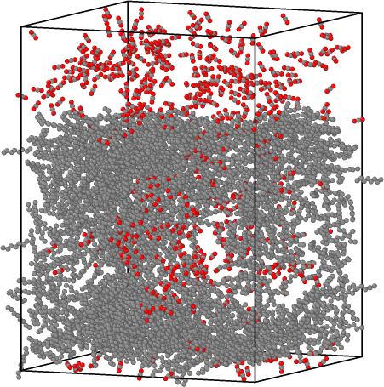
Figure 5: State of MD Simulation of CO₂/Oil System at 10ns

3.0 Results and Discussion
Molecular dynamics (MD) simulations offer detailed insights into thermophysical changes occurring at the interface between injected CO₂ and reservoir oil. In this study, three key parameters were examined: CO₂ solubility, oil swelling factor, and interfacial tension (IFT). These are critical indicators for evaluating the performance of miscible gas injection, particularly in offshore Niger Delta fields where deep and high-pressure reservoirs dominate.

3.1 CO₂ Solubility and Oil Swelling Behaviour
The solubility of CO₂ in crude oil and the corresponding expansion of the oil phase quantified through the swelling factor are presented as a function of pressure at 344 K in Figures 6 and 7. These properties were extracted from equilibrium molecular configurations after the production phase of the simulation.

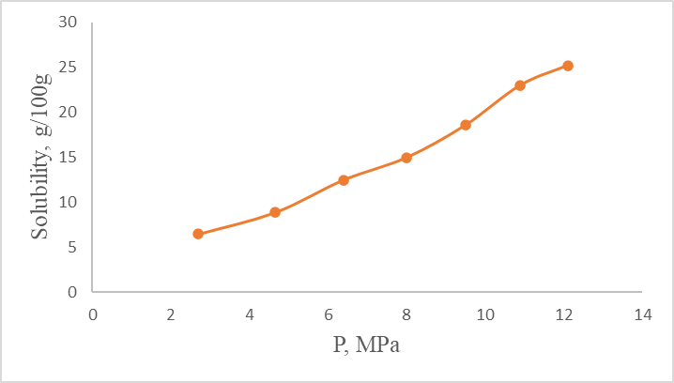
Figure 6. Pressure-dependent solubility profile of CO₂ in modelled Niger Delta crude oil at 344 K.
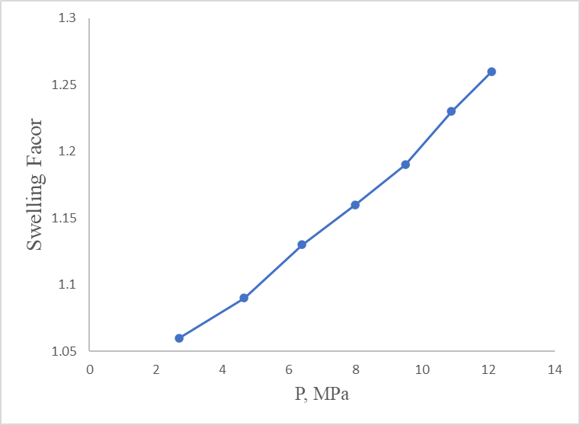
Figure 7. Variation in oil swelling factor as a function of pressure for the CO₂–crude oil system at 344 K.
As shown, both CO₂ solubility and the swelling factor exhibit a strong positive correlation with pressure. This outcome is consistent with previous findings by Zekri et al. (2006) which demonstrate that under supercritical conditions, CO₂ possesses enhanced molecular diffusivity and compressibility, facilitating deeper penetration into hydrocarbon chains.
The increased solubility expands the oil phase and lowers viscosity and capillary retention within the porous media. This swelling behaviour translates into greater mobility and improved displacement efficiency, making miscible CO₂ injection an attractive EOR method in deep reservoirs (Jarrell et al., 2002).
Quantitatively, swelling can account for up to 20–30% enhancement in oil recovery under favourable conditions. This is particularly beneficial for mature Niger Delta fields where reservoir pressure has declined significantly over decades of production. The introduction of CO₂ offers not only pressure maintenance but also enhanced recovery through physicochemical interactions.

3.2 Interfacial Tension and Minimum Miscibility Pressure (MMP)
The effectiveness of gas injection in displacing oil is heavily influenced by the interfacial tension between the two phases. Lower IFT creates continuous flow pathways and reduces capillary forces, facilitating the movement of oil from micropores to the production well.
In this study, the interfacial tension between the CO₂ and oil phases was computed using pressure tensor components from MD simulations, based on the framework proposed by Zhang (1995).
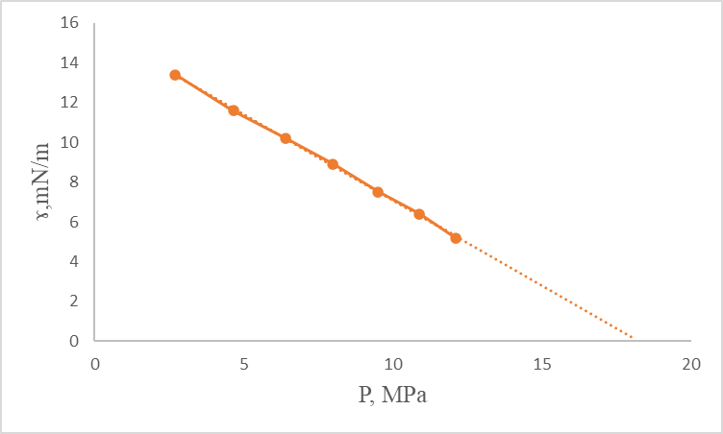
Figure 8. Computed interfacial tension of the CO₂–oil system as a function of pressure at 344 K, highlighting the extrapolated MMP threshold.


where:
- L_{z}​ represents the length of the simulation box in the z-direction,
- P_{xx}, P_{yy}, and P_{zz}​ are the diagonal components of the pressure tensor, and
- The angled brackets denote the ensemble average over the simulation time.

The IFT values showed a clear decreasing trend with increasing pressure. Extrapolation of the IFT–pressure curve to the point of zero tension enabled the estimation of the Minimum Miscibility Pressure (MMP) at approximately 18 MPa. This is in agreement with prior research by Martin and Taber (1992) and Abedini & Torabi. (2014), which emphasized the role of supercritical CO₂ in achieving miscibility at relatively moderate pressures under suitable reservoir conditions.
Establishing the MMP is critical for EOR design, as it marks the threshold beyond which CO₂ and crude oil form a single phase, eliminating interfacial resistance. Operating below the MMP results in immiscible displacement, which is less efficient due to the persistence of capillary forces and interfacial drag.
From a practical standpoint, these findings suggest that pressurizing the reservoir to at least 18 MPa is essential for realizing the full benefits of miscible CO₂ injection in the Niger Delta context.

4.0 Summary, Conclusions, and Recommendations
4.1 Summary of Key Findings
(i) The simulation results indicate a clear pressure-dependent increase in CO₂ solubility within the crude oil phase. This behavior promotes oil swelling, which reduces viscosity and enhances fluid mobility, ultimately improving recovery efficiency.
(ii) A consistent decline in interfacial tension (IFT) was observed as pressure increased, with the IFT extrapolating to zero at an estimated minimum miscibility pressure (MMP) of 18 MPa. This threshold pressure marks the transition to complete miscibility, crucial for maximizing the effectiveness of gas injection strategies.
(iii) These findings validate the potential of CO₂-enhanced oil recovery (CO₂-EOR) as a practical, efficient method for revitalizing mature fields in the Niger Delta. The results also highlight the power of molecular dynamics simulations in uncovering fundamental interactions that govern oil displacement at the microscopic level.
4.2 Conclusion
This study shows that CO₂ injection creates favorable molecular interactions with crude oil, manifesting as increased solubility, volumetric expansion, and reduced interfacial resistance. As pressure increases, these effects become more pronounced, resulting in full miscibility at about 18 MPa under Niger Delta conditions.

From an industrial perspective, these results suggest that CO₂-EOR can be optimized for deep, depleted reservoirs across the region. The use of predictive MD modeling enhances reservoir engineers’ ability to design injection strategies, forecast recovery performance, and tailor EOR projects to specific field conditions.
In terms of environmental impact, CO₂-EOR offers dual benefits: enhanced hydrocarbon production and long-term carbon storage potential, contributing to greenhouse gas mitigation. By capturing anthropogenic CO₂ from industrial sources and injecting it into subsurface formations, the oil and gas sector can align with global decarbonization goals.
Nonetheless, several limitations inherent to MD simulations should be acknowledged. These include:
- The use of simplified molecular surrogates (e.g., n-octane instead of full crude oil blends).
- Constraints on system size and simulation timescales.
- Idealized assumptions (e.g., homogeneous reservoirs, fixed temperature).
These factors may limit direct extrapolation to field conditions, underscoring the need for experimental calibration and field pilot validation.

4.3 Recommendations
To strengthen the integration of molecular simulation into field development planning, the following are recommended:
(i) Experimental Validation: Future research should couple MD results with experimental laboratory measurements of interfacial tension, swelling factor, and solubility under representative reservoir conditions. This will improve the reliability of simulation-based predictions.
(ii) Field-Scale Pilot Testing: Design and implement pilot CO₂-EOR projects in selected Niger Delta fields. These pilots should incorporate geological heterogeneities, multi-component fluids, and real-time monitoring to assess operational feasibility, economic viability, and recovery efficiency.
(iii) Environmental Risk Assessment: The long-term sequestration potential of CO₂ and possible leakage pathways should be evaluated through coupled reservoir-geomechanical modeling and life cycle assessments (LCAs) to ensure safe and sustainable implementation.
(iv) Early-Stage Screening Tool: Incorporate MD simulations into the early phases of reservoir screening to guide EOR method selection. Their cost-effectiveness, high resolution, and ability to evaluate fluid compatibility make them valuable tools for reducing technical uncertainty in EOR planning.
(v) Advanced Modeling Approaches: Explore hybrid simulation frameworks that combine coarse-grained MD, machine learning, and reactive transport modeling to address limitations in scale and computational cost. These integrated methods can further enhance the decision-making pipeline for EOR deployment.

COMPETING INTERESTS DISCLAIMER:
Authors have declared that they have no known competing financial interests OR non-financial interests OR personal relationships that could have appeared to influence the work reported in this paper.

DISCLAIMER (ARTIFICIAL INTELLIGENCE)
Author(s) hereby declares that NO generative AI technologies such as Large Language Models (ChatGPT, COPILOT, etc.) and text-to-image generators have been used during the writing or editing of this manuscript.

REFERENCES
- Abedini, A., & Torabi, F. (2014). On the CO₂ storage potential of cyclic CO2 injection process for enhanced oil recovery. Fuel, 124, 14–27. https://doi.org/10.1016/j.fuel.2014.01.084
- Adeyemi, B. J., Ajilo, V. I., Falode, O. A., & Falobi, E. O. (2013, April). Enhancing oil recovery through high level data mining technology (Paper No. SPE-164761-MS). Paper presented at the North Africa Technical Conference and Exhibition, Cairo, Egypt. https://doi.org/10.2118/164761-MS
- Alawode, A. J., & Nekwaya, T. T. (2025). Evaluation of alkaline-nanofluid flooding for enhanced oil recovery in a Niger Delta core sample. Progress in Engineering Science, 2(1), 100054. https://doi.org/10.1016/j.pes.2025.100054
- Anuka, A., Falode, O., Ogunshe, A., & Udie, C. (2020, August). An overview of microbial enhanced oil recovery in Nigeria (Paper No. SPE-203765-MS). Paper presented at the SPE Nigeria Annual International Conference and Exhibition, Virtual. https://doi.org/10.2118/203765-MS
- Chang, Q. (2019). Using molecular dynamics simulation to study behavior of hydrocarbon fluid (Master’s thesis, University of Oklahoma). University of Oklahoma Graduate College.https://shareok.org/server/api/core/bitstreams/e6d7d01d-c3ab-4bb8-a24f-5aa0babd2ffe/content
- Ehibor, I. O., Ibe, A., Maku, G., et al. (2024). Numerical simulation studies on heavy oil recovery in a Niger Delta reservoir. In SPE Nigeria Annual International Conference and Exhibition. https://doi.org/10.2118/221801-MS
- Falode, O. A., & Ojuomola, O. (2015). Evaluating the application of foam injection as an enhanced oil recovery in unconsolidated sand. Journal of Petroleum and Gas Engineering, 6(2), 22–37. https://doi.org/10.5897/JPGE2014.0204
- Hemmati-Sarapardeh, A., Larestani, A., Nait Amar, M., & Hajirezaie, S. (2020). Applications of artificial intelligence techniques in the petroleum industry. Gulf Professional Publishing. https://doi.org/10.1016/C2018-0-04421-7
- Hoover, W. G., Ladd, A. J. C., & Moran, B. (1982). High-strain-rate plastic flow studied via nonequilibrium molecular dynamics. Physical Review Letters, 48(25), 1818–1820. https://doi.org/10.1103/PhysRevLett.48.1818
- Jarrell, P. M., Fox, C. E., Stein, M. H., & Webb, S. L. (2002). Practical aspects of CO₂ flooding. Society of Petroleum Engineers. https://doi.org/10.2118/9781555630966
- Li, X., Wang, S., Feng, Q., & Xue, Q. (2020). The miscible behaviors of C₁₀H₂₂(C₇H₁₇N)/C₃H₈ system: Insights from molecular dynamics simulations. Fuel, 279, 118445. https://doi.org/10.1016/j.fuel.2020.118445
- Martin, D. F., & Taber, J. J. (1992). Carbon dioxide flooding. Journal of Petroleum Technology, 44(4), 396–400. https://doi.org/10.2118/23564-PA
- Nakagawa, S., Kneafsey, T. J., Daley, T. M., Freifeld, B. M., & Rees, E. V. (2013). Laboratory seismic monitoring of supercritical CO₂ flooding in sandstone cores using the Split Hopkinson Resonant Bar technique with concurrent x-ray computed tomography imaging. Geophysical Prospecting, 61(2), 287–302. https://escholarship.org/uc/item/90d3449d
- Nosé, S. (1984). A unified formulation of the constant temperature molecular dynamics methods. The Journal of Chemical Physics, 81(1), 511–519. https://doi.org/10.1063/1.447334
- Ogolo, N. A., Olafuyi, O. A., & Onyekonwu, M. O. (2012, April). Enhanced oil recovery using nanoparticles (Paper No. SPE-160847-MS). Paper presented at the SPE Saudi Arabia Section Technical Symposium and Exhibition, Al-Khobar, Saudi Arabia. https://doi.org/10.2118/160847-MS
- Wang, R., Peng, F., Song, K., Feng, G., & Guo, Z. (2018). Molecular dynamics study of interfacial properties in CO₂ enhanced oil recovery. Fluid Phase Equilibria, 467, 25–32. https://doi.org/10.1016/j.fluid.2018.03.022
- Zekri, A. Y., & Jerbi, K. K. (2006). Economic assessment of enhanced oil recovery methods. Oil & Gas Science and Technology – Revue d’IFP Energies Nouvelles, 61(3), 259–267. https://doi.org/10.2516/ogst:2006013
- Zhang, S. F. (1995). Computer simulation of liquid/liquid interfaces. I. Theory and application to octane/water. The Journal of Chemical Physics, 103(23), 10252–10266. https://doi.org/10.1063/1.469927
- Zhang, Z., Liu, H., & Wang, J. (2020). Energetics of interfacial interactions of hydrocarbon fluids with kerogen and calcite using molecular modeling. Energy & Fuels, 34(4), 4251–4259. https://doi.org/10.1021/acs.energyfuels.0c00053

