**Original Research Article**

**Experimental Study and Numerical Modeling of the Lap Strength of Reinforcing Steel Bars Milled From Recycled Scrap Metals**

ABSTRACT

The study aimed to assess the lap strength of reinforcing steel bars milled from scrap metals in beams. Lapping of reinforcing bars is generally inevitable in concrete members such as beams, slabs and columns due to construction dictates and such bars are required to effectively transfer stresses between them. The study explored the influence of different lap lengths on structural performance, considering variables such as rebar diameter and spliced length. Experimental work was carried out involving both four-point load bending (4PB) and three-point load bending (3PB) on twelve (12) reinforced concrete beams with varying lap lengths. The reinforcing steel bars ranged from 10mm to 20mm in diameter. The experimental setup included measurements and testing of the bars' yield and ultimate stresses, as well as the preparation and curing of concrete specimens. Findings indicated that larger reinforcing bars and longer lap lengths had enhanced load-carrying capacity and stiffness, and also longer lap lengths reduced deflections. The research contributes insights into suitable lap strength, crack behavior, and failure modes in reinforced concrete beams, offering valuable recommendations for improved design practices. Finite Element Analysis of the beams was conducted by modeling them into ABACUS and validated with the experimental results. The findings from FEM confirm that longer lap lengths enhance load transfer and stiffness, and larger diameter bars improve load-carrying capacity and stiffness. The study concludes with recommendations for good design option, highlighting on longer lap lengths and the use of larger diameter bars for lapping. Additional recommendations include ensuring adequate shear reinforcement (stirrups) to prevent premature shear failure.

Keywords: Concrete, lap strength, steel bar, scrap metals, beam, splice strength, load-deflection, cracks

1. INTRODUCTION

Reinforced concrete is a widely used construction material and is a composite of reinforcing bars, embedded in a matrix of hardened concrete, which is highly strong in compression. Thus, concrete’s low tensile capacity necessitates the use of steel, which is globally recognized as the most effective reinforcing material in structural concrete. The lapping of reinforcing bars is typically unavoidable in concrete members like beams, slabs, and columns due to construction requirements. These lapped bars must efficiently transfer stresses between them to maintain structural integrity.

Reinforcing steel bars are critical components of concrete structures, enhancing their tensile strength and durability [1]. Additionally, reinforcing steel bars have high tensile strength, similar thermal coefficient, and Poisson’s ratio to concrete [2]. Commercially available conventional reinforcing steel bars are widely used as reinforcement in concrete, however, locally manufactured reinforcing bars milled from recycled metals have been gaining attention due to their potential cost-effectiveness and sustainability [3, 4] . The structural integrity of reinforced concrete elements can be significantly affected by various factors, including the presence of openings created by elements such as PVC pipes, as demonstrated in prior research [5].

In many developing countries, the high cost of imported steel has led to the production of reinforcing steel bars from recycled scrap metal from obsolete vehicles and machinery. For instance, in Ghana, about 80% of the estimated 80,000 tonnes of steel scrap produced annually is recycled [6, 7]. While modern codes such as Eurocodes and ACI typically require high-yield deformed bars (≥ 500 MPa)[8], the current study focuses on assessing the lap strength performance of these locally manufactured mild to medium strength steel bars under various conditions to provide practical guidelines for their effective use in regions where they are commonly employed [3,9] . Steel bars made from scrapped metal were commonly categorized as mild steel by manufacturers. For example, Connor [10] found steel reinforcing bar produced from local scrapped metals with yield strength of 250MPa, which is classified as mild steel. They usually possess surface grooves, much like regular high-strength deformed bars, to boost their ability to resist cracking when mixed with concrete [11]. Kankam and Adom-Asamoah [3] found the yield strength steel bars milled from scrap metals in Ghana to be in excess of 400 MPa and classified them as medium strength reinforcing steel bars. It was observed that the chemical profile of these bars, produced locally, did not align with the typical requirements for mild steel, leading to a greater risk of brittle failures [3,6]

Previous studies have shown the potential of the use of recycled steel materials that are locally milled into reinforcing steel bars for use as structural reinforcement. These studies have considered varying properties of these locally milled reinforcing steel bars, which include their physical and chemical properties [3,12], strength and ductility characteristics [3], and their bonding behavior with concrete materials [5, 11, 13]. For effective stress distribution from one bar to another, lapping of reinforcing bars is necessitated, and the lap may be provided by various means which include, lap splices, welded splices and mechanical couplers [6,13]. To ensure the structural integrity of the use of these locally milled steel reinforcing bars when lapped in concrete members, their lap strength is of great importance [13]. Where lap splices are used, proper splicing provides continuity and strength in the reinforcement [14]. Interestingly, where the lap splice length is adequately given, the quantity of steel bars may be reduced and still meet the strength requirements of the reinforcement [13]. Lap splice’s influence on the lap strength also varies under different loading conditions, which in turn influences the performance of steel reinforced concrete elements [12,15]. Therefore, a wide range of factors which influence the lap strength have been explored in the past by researchers. These factors include geometry of reinforcing bars [5, 13], lap length [11, 13], compressive strength of concrete [5, 13], and confinement effect of concrete and steel stirrups [13].

The specific gap that this study seeks to fill is to explore the lap strength of locally milled reinforcing steel bars. The influence of different loading orientations, diameter of reinforcing bars and lap length and on the lap strength is considered. Reinforcing bar diameters (D) of 12 mm, 16 mm and 20 mm were considered, and the lap length of multiples of the reinforcing diameters of 10, 15 and 20 times the reinforcing bar diameters (10D, 15D and 20D) were investigated. By focusing on the deformation and load-carrying capacity of lap splices of the reinforced concrete beams, this study determines the viability of the locally milled reinforcing bars in maintaining the structural integrity. Ultimately, this research study was aimed at sustainable construction practices.

**2. MATERIALS AND METHODS**

**2.1 Description of beams**

A total of 12 concrete beams reinforced with steel bars milled from scrap metals were cast. The variables studied were the influence of the bar size, lap splice length and loading orientation on the structural behaviour of the beam. The reinforcing bar diameters (D) were 12 mm. 16 mm and 20 mm. The lap splice lengths were 10D, 15D and 20D. All the beams were reinforced in the compression zone with two 12 mm mild steel reinforcing bars. The longitudinal tension reinforcement bars were lapped at the midspan with the reinforcing bar of variable diameters and their respective lap splice lengths. The control beam on the other hand was designed without lapping of the longitudinal tension reinforcement. Each beam had constant dimensions of 150 mm wide, 300 mm deep and 2100 mm total length. A clear concrete cover of 25 mm was provided in all the beams. To ensure no shear failure, all beams were reinforced with transverse steel stirrups of diameter 10mm mild steel at 200mm spacing (2R10 @ 200mm c/c). The beam details are illustrated in **Figure 1**. The beams were identified with numbers, symbols and letters, the first two numbers followed with the symbol D represented the lap length. The numbers following the symbol also represented the reinforcing bar diameter. For example, C25/15D/16 represented the beam with concrete grade 25, lap length of 15 times bar diameter and reinforcing bar diameter of 16mm. The beams with their respective characteristics are presented in **Table 1.**

|  |  |  |
| --- | --- | --- |
| 10mm dia. @200mm c/c |  |  |
|  | 2 nos. 10mm dia. as hanger bars |
| A | B |
| C |

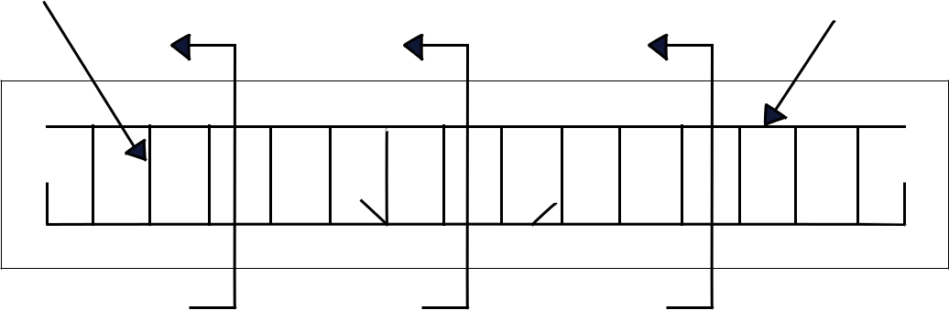

300mm

,

A B  C 

1a. Side View

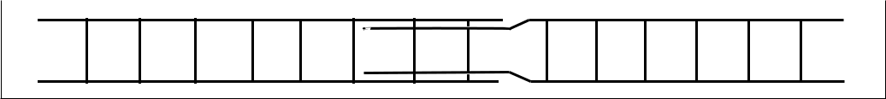

150mm



2100mm

1b. Plan View

150mm 150mm 150mm

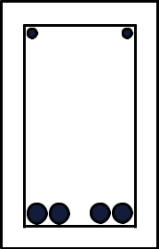

300mm 300mm 300mm

**Section A-A Section B-B Section C-**

Figure 1: Schematic representation of the beam

Table 1: Beam characteristics

|  |  |  |  |  |
| --- | --- | --- | --- | --- |
| Beam ID | Cross section  b x h  (mm x mm) | Span length  (mm) | Effective depth  (mm) | Lap length  (mm) |
| C25/B1/D12 | 150 x 300 | 2100 | 259 | 0 |
| C25/10D/12* | 150 x 300 | 2100 | 259 | 120 |
| C25/15D/12* | 150 x 300 | 2100 | 259 | 180 |
| C25/20D/12 | 150 x 300 | 2100 | 256 | 240 |
| C25/B1/D16 | 150 x 300 | 2100 | 257 | 0 |
| C25/10D/16 | 150 x 300 | 2100 | 257 | 160 |
| C25/15D/16 | 150 x 300 | 2100 | 257 | 240 |
| C25/20D/16 | 150 x 300 | 2100 | 257 | 320 |
| C25/B1/D20 | 150 x 300 | 2100 | 255 | 0 |
| C25/10D/20* | 150 x 300 | 2100 | 255 | 200 |
| C25/15D/20* | 150 x 300 | 2100 | 255 | 300 |
| C25/20D/20* | 150 x 300 | 2100 | 255 | 400 |

* Indicates beams tested under three-point loading.

**2.2 Materials**

**2.2.1 Reinforcements**

All the reinforcing steel bars used in this study were mild steel produced from locally milled recycled metals. The characteristics of the steel bars used in the experimental work are presented in **Table 2**. These characteristics include the actual bar diameter, yield strength and tensile strength of the steel.

Table 2 Reinforcement details

|  |  |  |  |  |  |  |
| --- | --- | --- | --- | --- | --- | --- |
| Specimen ID | Actual diameter (mm) | Minimum Yield load  (kN) | Maximum Yield load  (kN) | Ultimate load  (kN) | Yeild strength  (N/mm2) | Ultimate strength  (N/mm2) |
| 10 mm | 9.81 | 48.07 | 48.46 | 53.82 | 636.0 | 712.1 |
| 10 mm | 9.81 | 48.78 | 49.06 | 54.51 | 645.4 | 721.2 |
| 12 mm | 11.36 | 38.23 | 38.74 | 52.07 | 430.0 | 585.6 |
| 12 mm | 11.36 | 38.58 | 39.47 | 52.82 | 430.7 | 589.6 |
| 16 mm | 15.96 | 61.67 | 62.66 | 87.74 | 398.9 | 567.5 |
| 16 mm | 15.96 | 60.49 | 62.19 | 85.59 | 389.6 | 551.3 |
| 20 mm | 19.68 | 101.3 | 104.06 | 130.2 | 415.1 | 533.4 |
| 20 mm | 19.68 | 102.57 | 104.43 | 130.66 | 417.8 | 532.2 |

**2.2.2 Concrete**

The same concrete mix ratio of 1:1.5:3 (cement: sand: aggregates) with a water-cement ratio of 0.55 was used for all beams. This was designed for concrete with target grade of C25 [16]. The fresh concrete mix was evaluated for workability using the slump test as per BS EN 12350-[8]. The concrete cubes and 150mm x 300mm cylinders concrete specimens were prepared to evaluate the compressive strength and the split tensile strength of the concrete respectively. The compressive and splitting tensile strength of the concrete were evaluated in accordance with the BS EN 12390-3 [8] and BS EN 12390-5 [8]. All concrete specimens were cured for 28 days under continuous moist conditions and ambient temperature of approximately 280C – 310C. The 28th day compressive strength and splitting tensile strength were 23.2N/mm2 and 4.1N/mm2, respectively for all beams. The splitting tensile strength was found to exceed slightly the conventional 8-15 percent of the compressive strength [17].

**2.3 Methods**

**2.3.1 Testing of beams**

The beams were subjected to 3-point (3PD) and 4-point (4PD) bending test, with their supports set 150mm from the beams' end. The specific test for each beam under both 3PD and 4PD is presented in **Table 1**. They were simply supported with a clear span of 1800mm in a rigid steel frame. The supports, dial gauge, and loading positions were indicated and marked on the beams before loading. For the 3-point bending test, the load was centrally applied to the beams and was spaced 900mm from the supports. Alternatively for the 4-point bending test, the load points were spaced at 600 mm apart. A dial gauge was centrally mounted under the beam to measure the central deflection. The schematic representations of the test set-up for the 3PD and 4PD are illustrated in **Figures 2a** and **2b** respectively. The beams were loaded using a hydraulic jack at a controlled rate of (2kN/s). Various parameters such as mid-span deflection, initial crack load, and crack characteristics were recorded during the test.

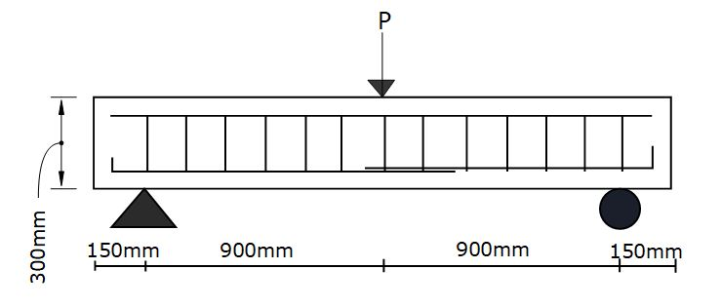

Figure 2(a): 3-point loading

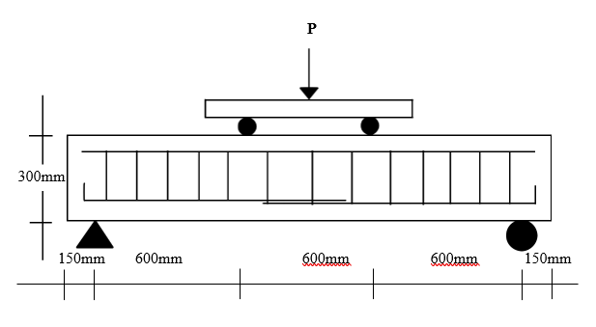

Figure 2(b): 4-point loading

Figure 2: Test setup for beams

**3.0 THEORETICAL ANALYSIS**

**3.1 Flexural Theory of beams**

The split tensile strength of the concrete calculated from the average applied load to the concrete cylinder using the formula:

$f_{t}= \frac{2P}{πLD}$

​

where $D$ and $L$ represent the diameter and length of the cylinder, respectively. Based on an average applied load of 288 kN, the tensile strength is determined to be 4.07 N/mm².

**3.1.1 Cracking Moments and Loads**

**Cracking Moments**

For the R.C. beam, cracking initiated as the concrete tensile strength was exceeded. Using a section of 150 mm by 300 mm, the cracking moment estimated from the formula:

$M_{cr}= \frac{F_{t}I}{y}$

​

where $M_{cr}$ is cracking moment, $f_{t}=$ split tensile strength of concrete, I = second moment of area of beam cross-section $(\frac{bD^{3}}{12})$, b = beam width and D = overall beam depth.

**3.1.2 Cracking Loads**

Using a section of 150 mm by 300 mm, the cracking moment is $P_{cr}= \frac{{4M}_{cr}}{L}$ ​ for 3-point loading; and $P_{cr}= \frac{{6M}_{cr}}{L}$ for 4-point loading, where $P_{cr}$ = cracking load and L = span of beam (1800mm). The corresponding cracking loads were 20.4 kN for 3-point loading, and 30.5 kN for 4-point loading.

**3.2 Flexural Theory of beams**

**3.2.1 Failure loads**

In examining the theoretical failure load of the beam, three possible failure modes are considered: steel yielding, concrete crushing, and shear failure.

***3.2.1.1 Theoretical failure load on the assumption that the steel yields first.***

When steel yields first, the moment of resistance ${(M}_{rs})$ is calculated using

$$M_{rs}= 0.8{7f}_{y}A_{s}×0.755d$$

where $f_{y}$ represents the tensile steel yield strength, $A_{s}$ is the area of steel reinforcement and $d$ is the effective depth. The governing failure loads based on steel yielding first resulted in failure loads of 35.78 kN and 53.67 kN for 3-point and 4-point loading, respectively.

***3.2.1.2*** ***Theoretical failure load on the assumption that concrete crushes first (or beam fails in compression).***

The moment of resistance ${(M}_{rc}$) of concrete in compression is calculated using

$M_{rc}=0.156f_{cu}bd^{2}+0.87f_{y}A_{s}(d- d_{1})$

where $f_{cu}$ = compressive strength of concrete, b = width of beam, d = effective depth of beam, d1 = depth of the compression steel bar.

Under this failure condition, the failure loads are 121.82 kN for 3-point loading and 182.73 kN for 4-point loading.

***3.2.1.3*** ***Theoretical failure load on the assumption that shear failure occurs first.***

Shear failure is evaluated based on the shear strength of concrete, calculated using [18]:

$V_{f}= \frac{0.87A_{sv}f_{y}}{s_{v}}d + υ_{c}bd$

where $A_{sv}$ ​ = cross-sectional area of links, $f_{y}$ = yield strength, $s_{v}$ ​ = spacing of the links, and $υ_{c}$ = concrete shear strength, b = width of beam, d = effective depth of beam. The governing failure mode results in a maximum shear force of 192.72 kN.

**4.0 TEST RESULTS**

**4.1 Cracking loads of Beams**

**Table 3** shows the theoretical and experimental cracking loads of beam subjected to monotonic loading for beams reinforced with mild steel bars milled from scrap metals. The theoretical cracking load for the beams averaged 5.30 times the experimental cracking load. It is observed from **Table 3** that beam C25/10D/20 produced the lowest cracking load of 2kN, followed by beams C25/10D/16, C25/15D/16, C25/15D/20 and C25/20D/20 with 4kN. The largest cracking load in the beams with lapped bars was 8kN in beams C25/10D/12, C25/15D/12 and this was the same in the control beams C25/B1/12, and C25/B1/20. With this observation it can be concluded that the reinforcing bar with diameter 12mm in beams C25/10D/12 and C25/15D/12 could sustain relatively high load before the initial crack appeared when subjected to loading, followed closely by C25/20D/12 and C25/20D/16 and their cracking loads were similar to beams without lapped bars. Beams with lapped bars C25/20D/12 and C25/20D/16 produced the same second highest cracking load of 6kN as control beam C25/B1/16. The trend appeared to indicate that smaller bar sizes lapped arrangement produced higher cracking load.

**4.2 Crack Pattern and Failure Modes**

In a simply supported beam subject to four-point loading, the middle third section of the span is subjected to equal magnitude of maximum bending and zero shear forces. In the case of three-point loading the beams experienced varying bending moments and constant shear from the support to the mid-span where maximum bending moment occurs. The first crack for all the test beams was found to appear within the middle third span where the maximum strain is occurred.

The general crack behavior of the R.C. beams with varying lap lengths under four-point (4PB) and three-point (3PB) loading is illustrated in **Figure 3**. The initial cracks for all the beams specimens appeared within the middle third span in the four-point loading and occurred near the central point of loading in the three-point loading where the maximum strain occurred. All three control beams (C25/B1/12, C25/B1/16 and C25/B1/ 20) had flexural-shear cracks that progressed at an angle due to the involvement of shear stress and propagated toward the load point as illustrated in **Figure 3**. The other beams that had varying lap lengths on the other hand developed few cracks (mostly two main vertical cracks with branches) that remained vertical and located closed to the loading points. Although all the beams had different crack lengths and crack numbers as presented in **Tables 3 and 4**, there was no significant difference of the influence of the reinforcement bar diameter and loading orientation on the cracking characteristics. The only significant difference in crack development and characteristics was the type of cracks which was different in the control beams without lapping and the other beams with lapping at varying lap lengths. While the control beams developed several cracks as both pure and flexural-shear only in the beams with lapped bars developed few cracks that are located near the applied constant moment region of the beams. In situations where the cracks in concrete were inclined, they were due to both shear and bending stresses and as a result they were classified as flexural-shear. Where the cracks were vertical, close to the loading points, and lapping section, even in the three-point loading beams, they could be described as pure bending cracks. In spite of the presence of shear and bending stresses, these few cracks under the load points in the beams with lapped bars propagated fast into the compression zone and led to concrete crushing and compression failure [19].

**C25/B1/12**

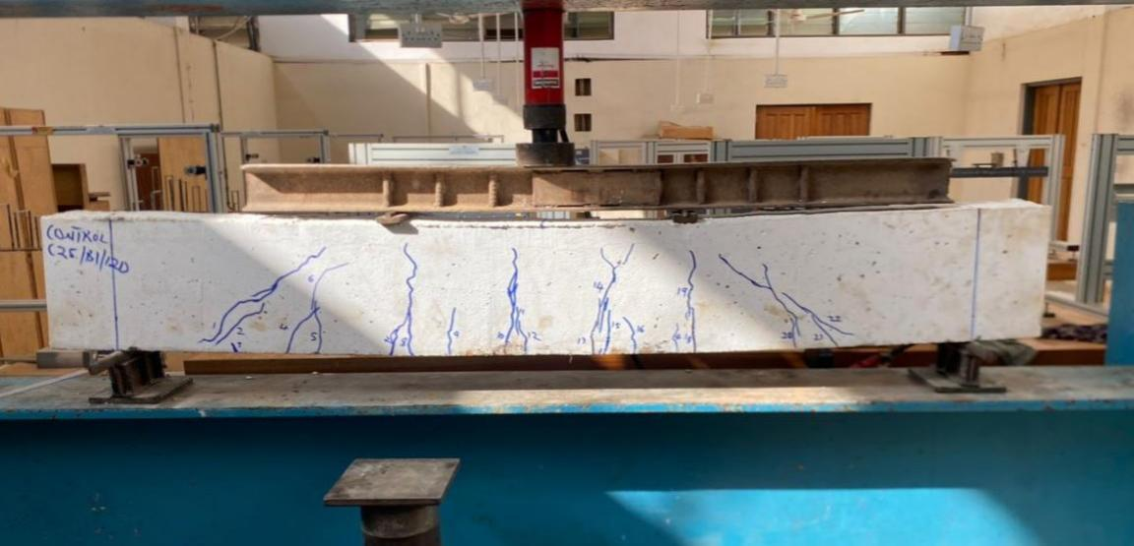

**C25/10D/12**

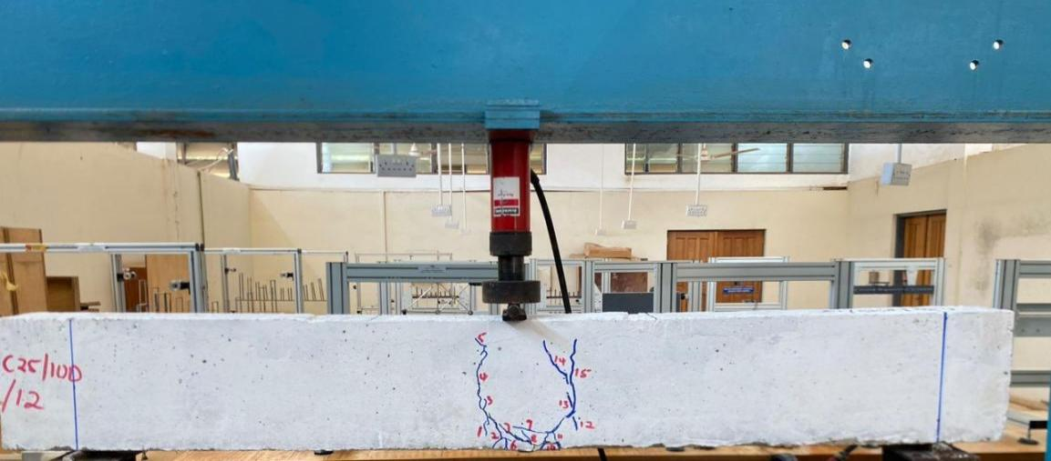

**C25/15D/12**

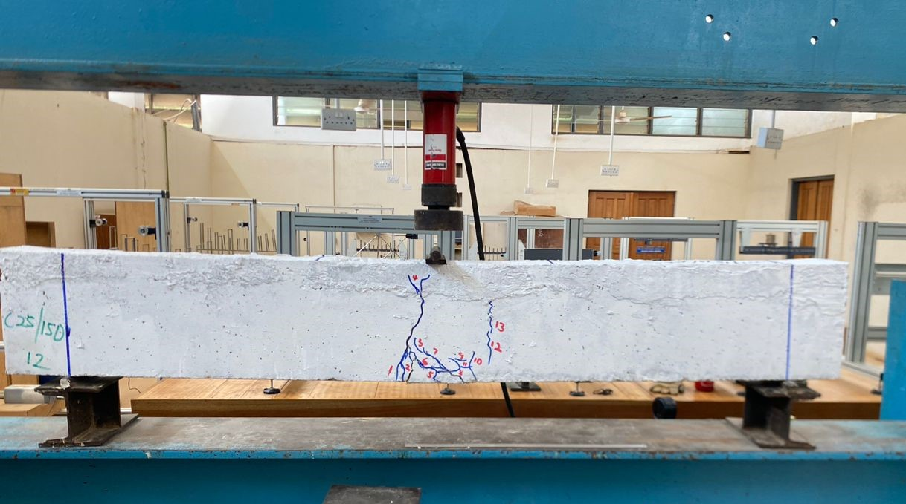

**C25/20D/12**

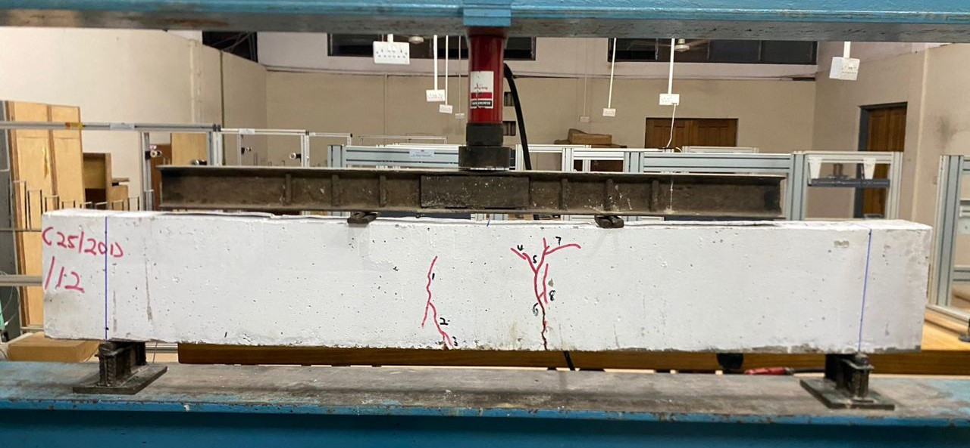

**C25/B1/16**

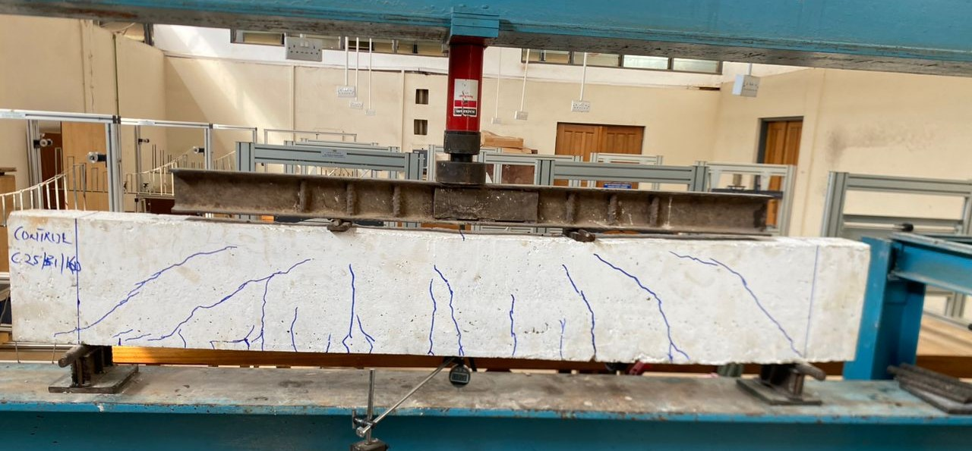

**C25/10D/16**

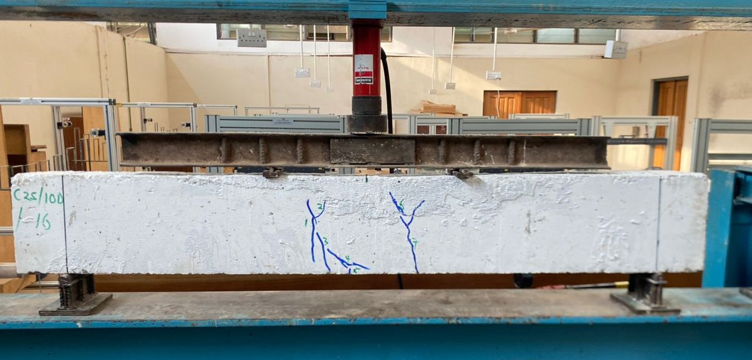

**C25/15D/16**

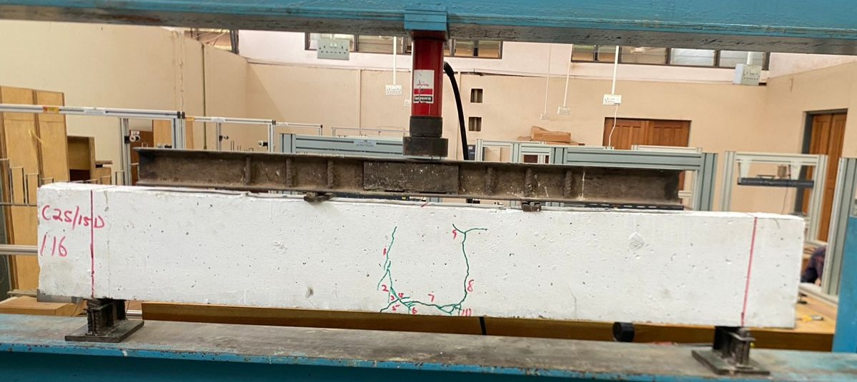

**C25/20D/16**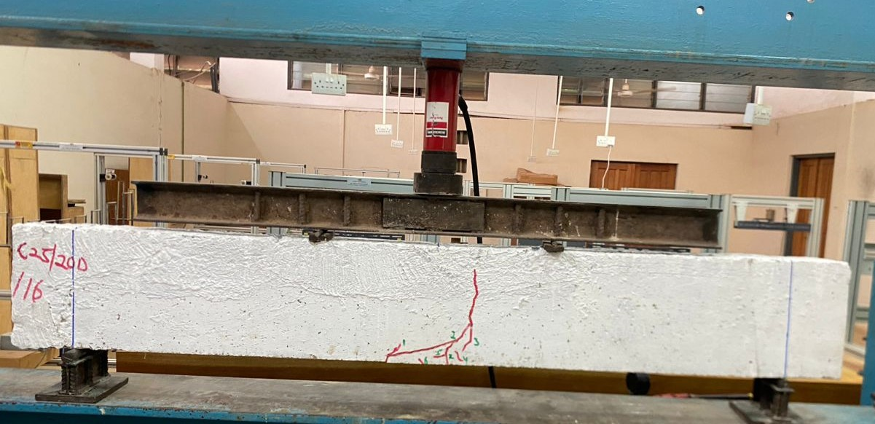

**C25/B1/20**

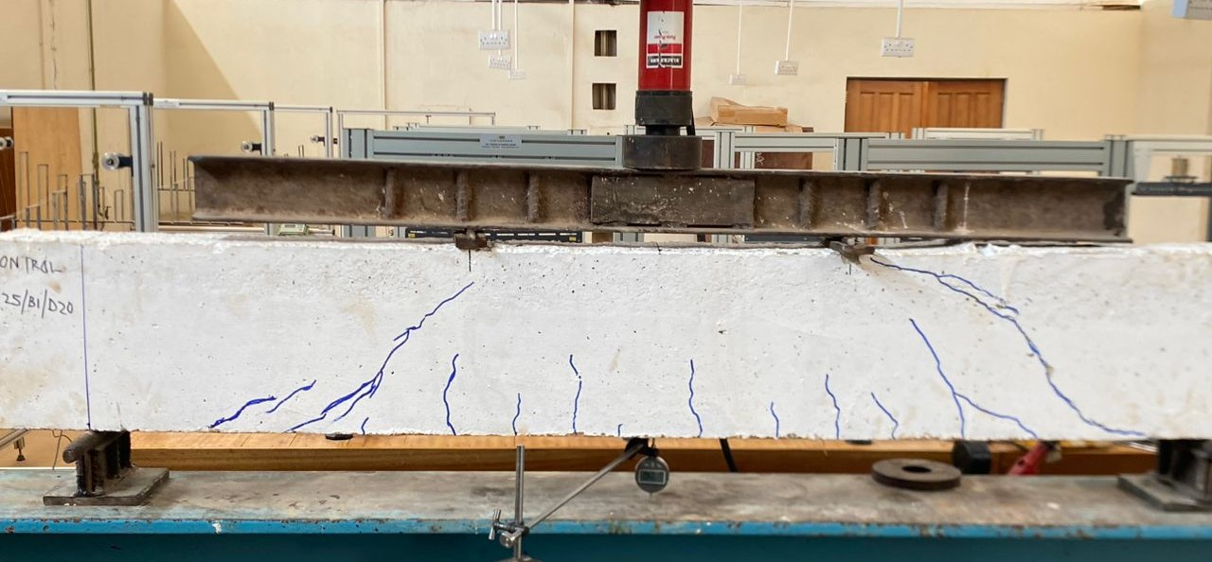

**C25/10D/20**

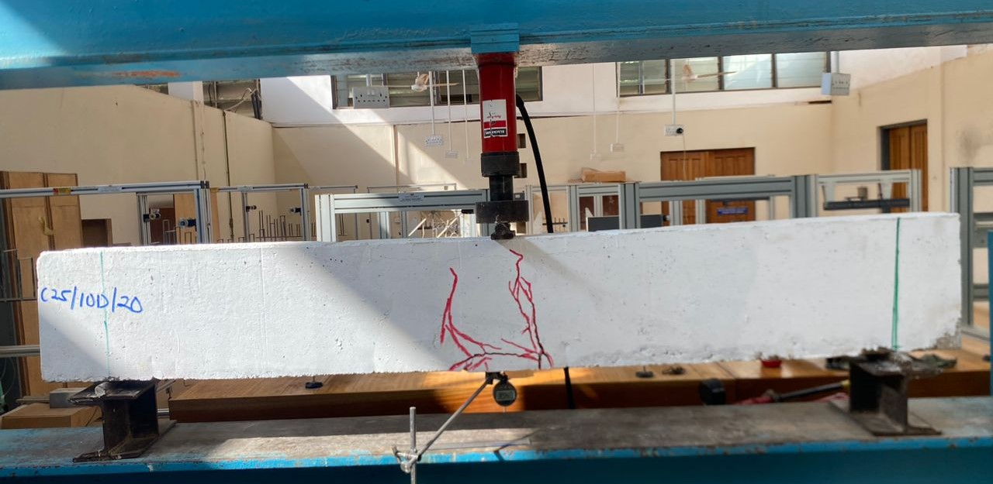

**C25/15D/20**

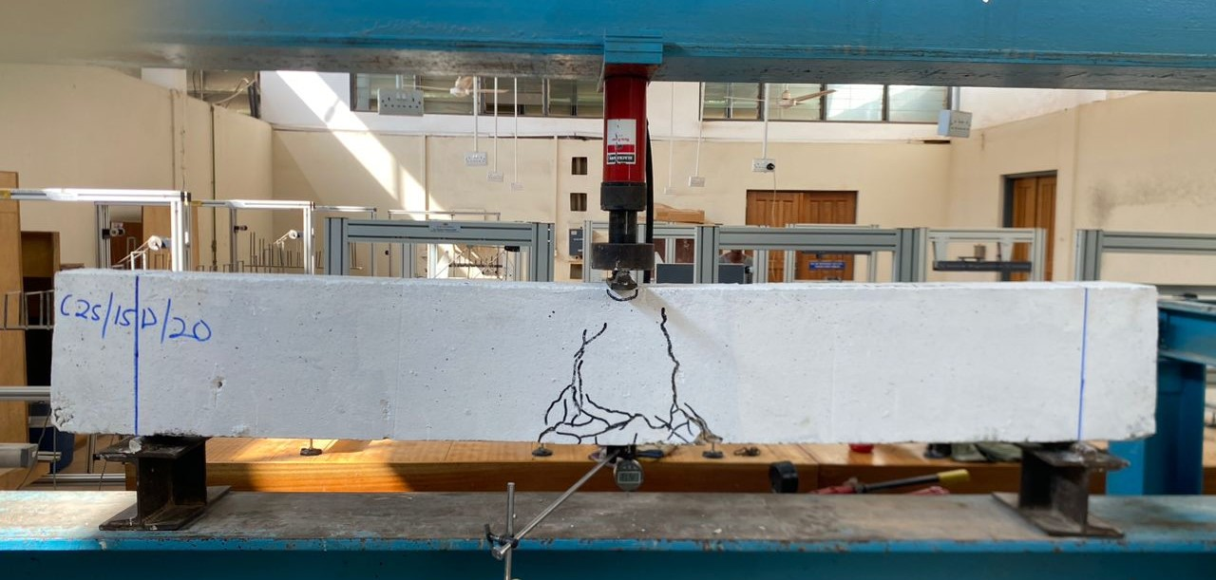

**C25/20D/20**

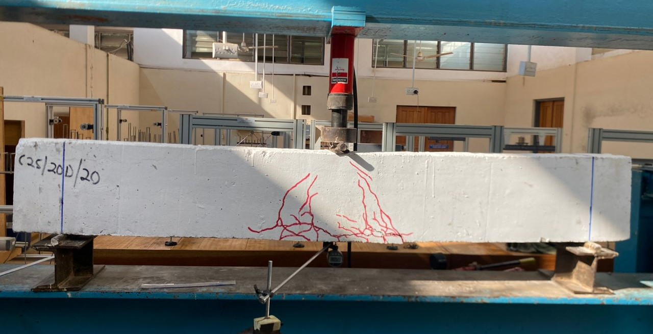

Figure 3: A picture of beams at failure after testing

**DISCUSSION**

**4.3 Load-Deflection Curves**

**Figure 4** shows the load-deflection curves of the test beams that were reinforced with mild steel bars milled from scrap metals. Beams: C25/10D/12, C25/15D/12, C25/10D/20, C25/15D/20 and C25/20D/20 were subjected to a three-point loading while beams C25/B1/12, C25/20D/12, C25/B1/16, C25/10D/16, C25/15D/16, C25/20D/16 and C25/B1/20 were subjected to a four-point loading and their details are presented in **Table 1**. Each beam was subjected to monotonic loading of 2kN increments and the mid-span-deflection at each load increment with the first crack load was recorded. As observed in the load-deflection curves prior to the cracking of the concrete beam, the slope of the curve was steep and approximately linear, characterizing elastic behaviour of the beam at this stage of early loading. Once flexural cracks developed, a change in the slope of the curves was observed and the curves remained fairly linear until the steel yielded in some of beams which was followed by inelastic and near plastic response before failure by yielding of steel followed by crushing of the concrete or diagonal shear (Figure 4).

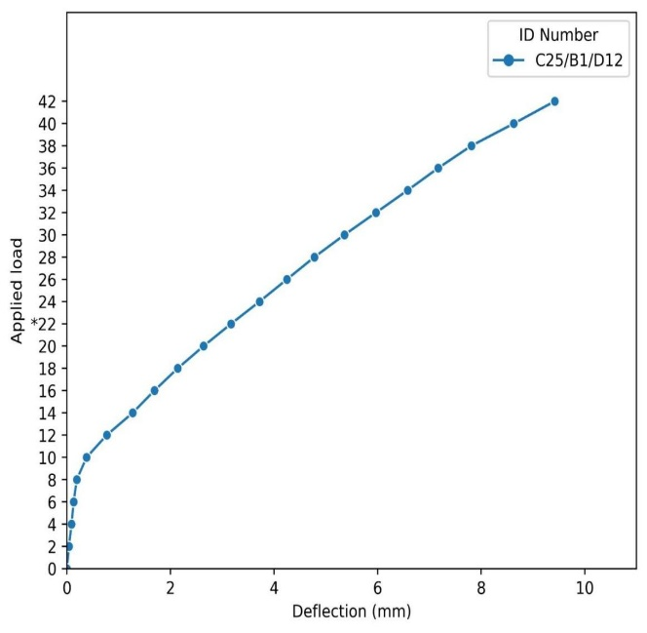

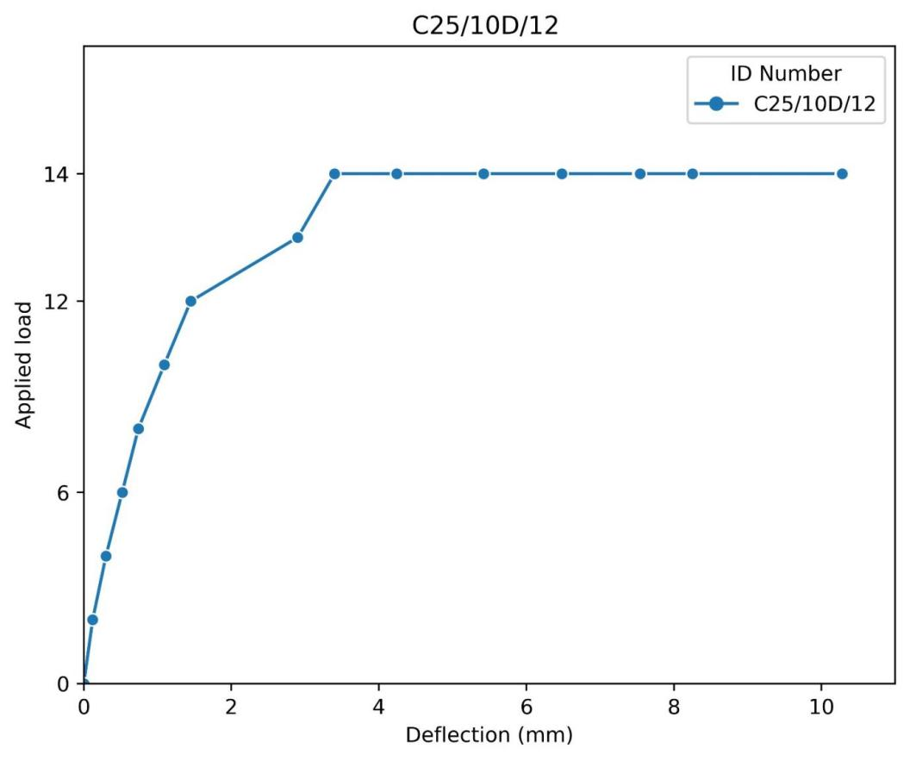

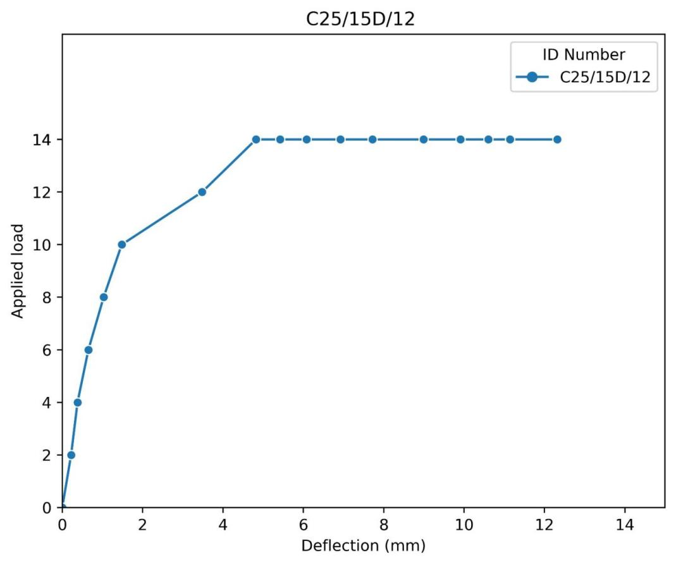

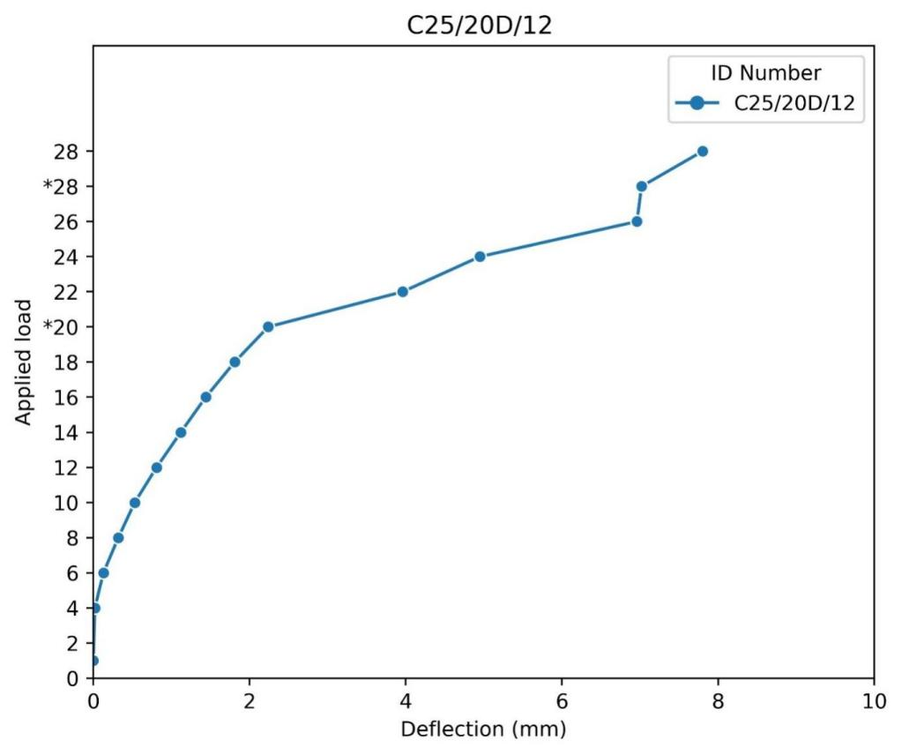

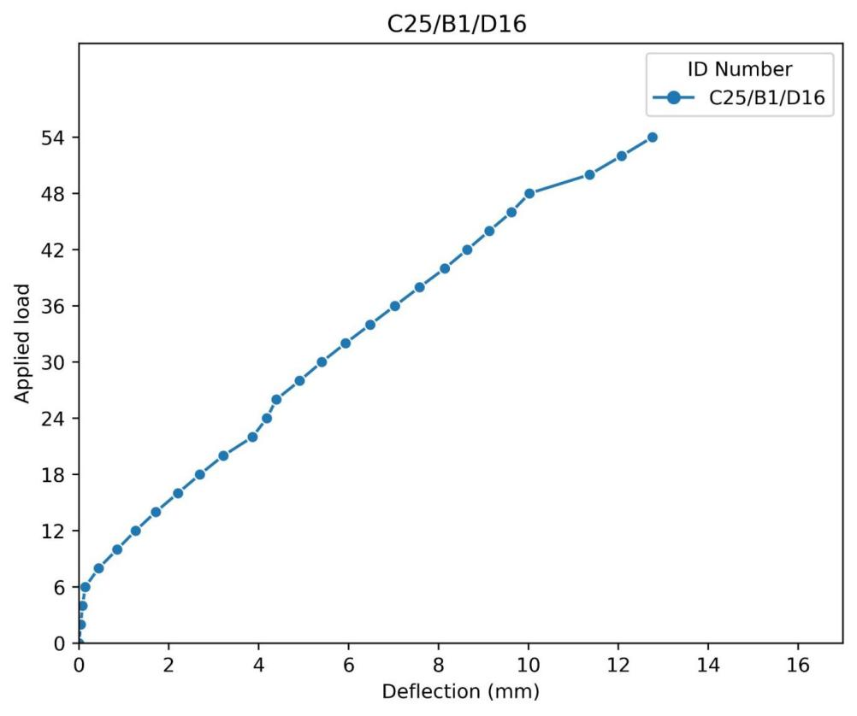

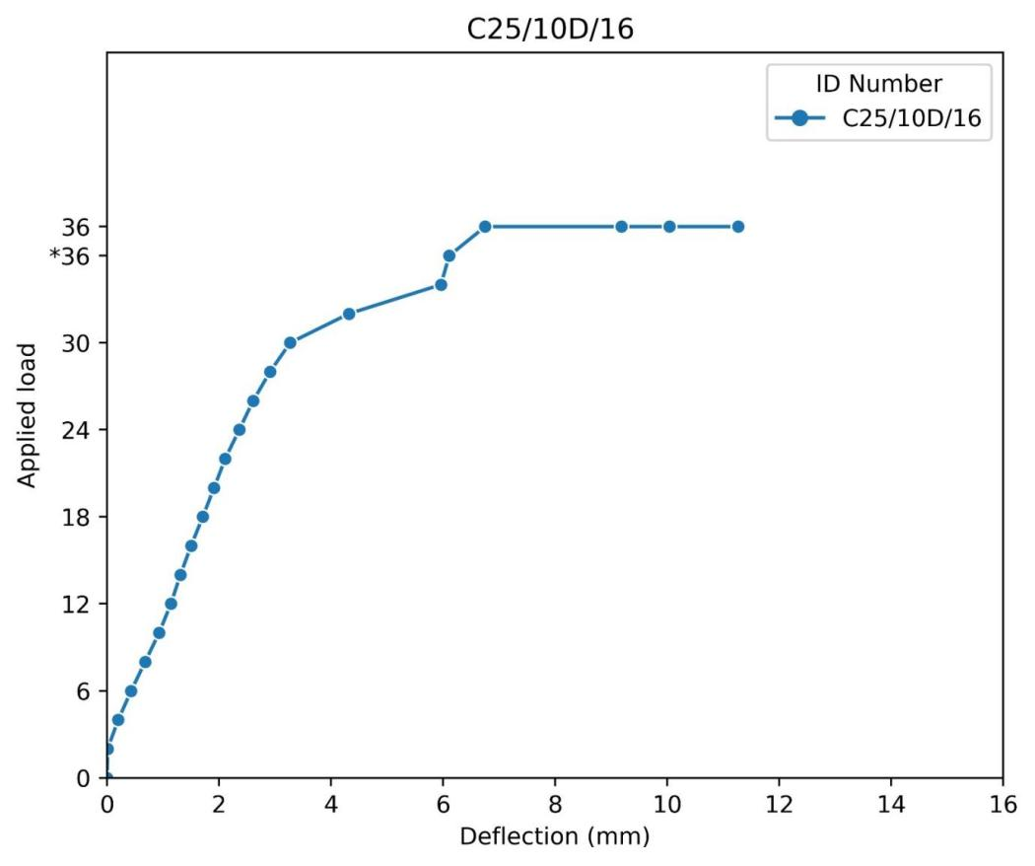

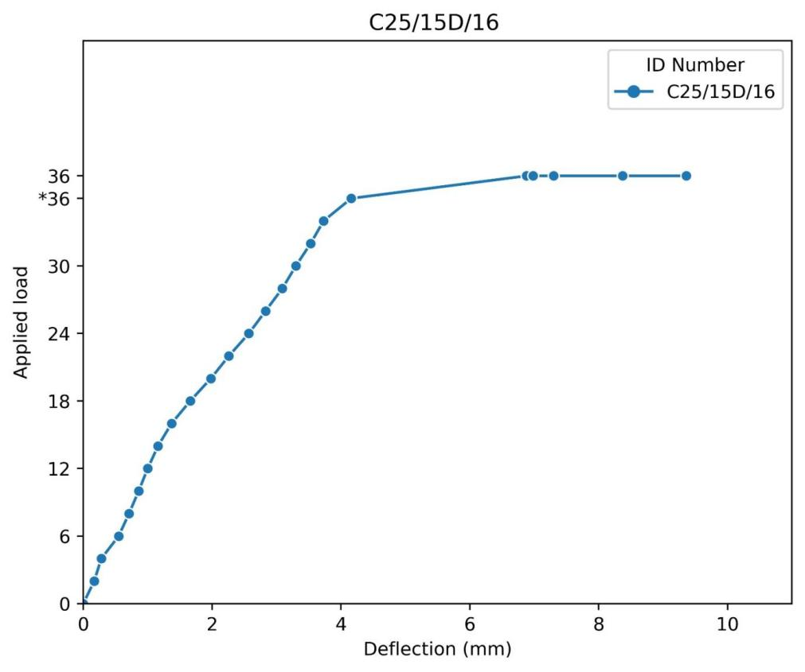

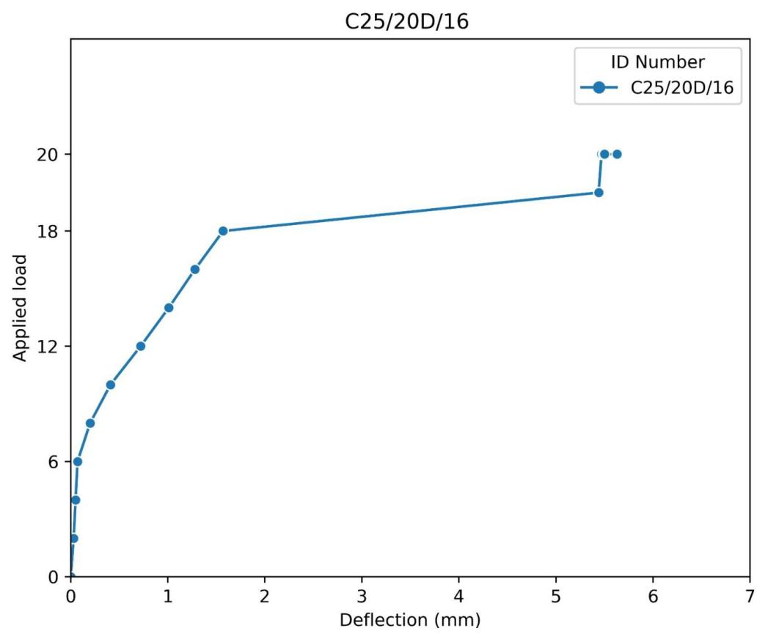

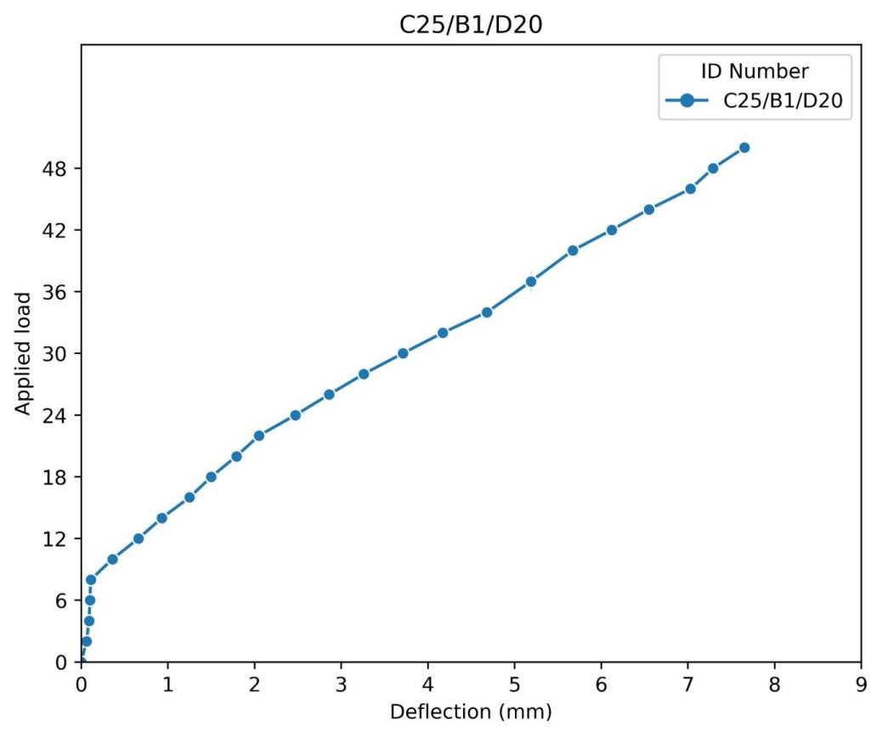

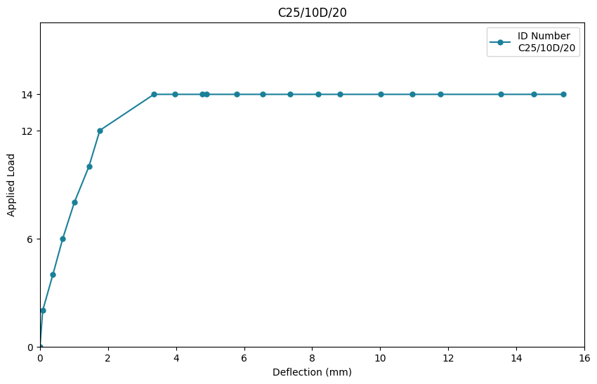

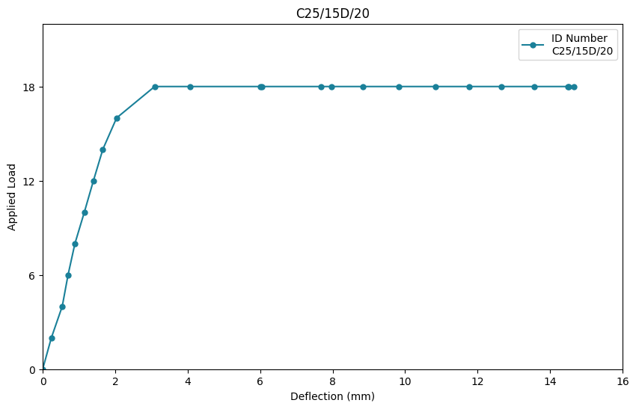

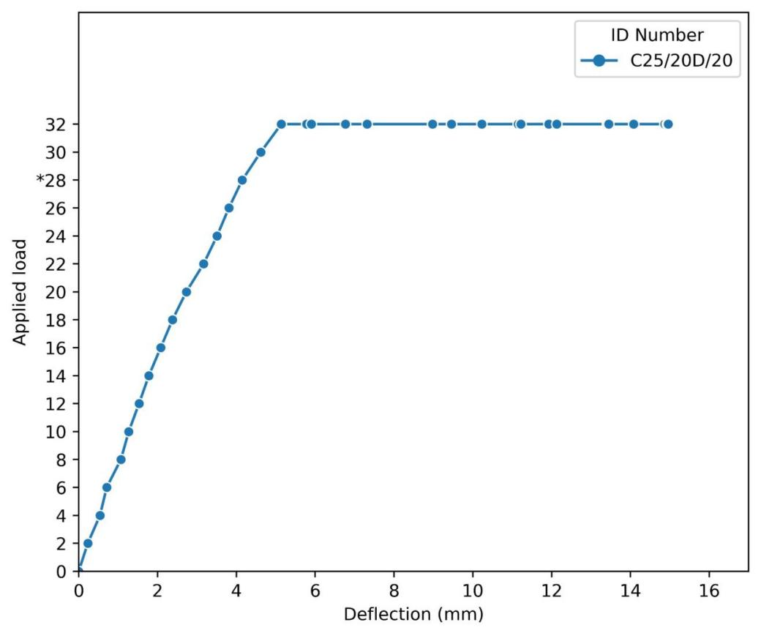

Figure 4: Load-Deflection curve for all beams

**4.4 LAP STRENGTH**

In terms of the failure loads of the beams, it was observed that the lapping of the reinforcing bars using different lap lengths had significant influence of the beam. From the test results shown in **Table 3**, the control beams without rebar lapping exhibited higher failure loads than beams reinforced with lapped bars. For example, considering the concrete beams reinforced with bars of diameter 20 mm, the failure load of beams C25/10D/20, C25/15D/20 and C25/20D/20, decreased when compared to control beam C25/B1/20. This also showed that as the lap length increased the lap strength increased as the decrease in the failure load relative to the control beam decreased with increase in lap length from 10D to 20D in beams C25/10D/20 and C25/20D/20 respectively. As it was also observed in previous studies [14,18], with the increase in the lap length there was better continuity in the tensile reinforcement and enhanced transfer of tensile stresses/forces between the lapped bars that helped improve the load carrying capacity of the beam.

With regard to the effect at varying diameters on the lap strength it can be observed from the experimental results that as the diameter of the reinforcing bars increased from 12 mm to 16 mm the load carrying capacity of the beams increased, but as the bar size increased from 16 mm to 20 mm, the load capacity decreased. Therefore, the best bar size for high load carrying capacity of the beams capacity among the three sizes is 16 mm. This might be due to increased brittleness in the steel bar from 16mm to 20mm as a result of the residual stresses on the bar ribs that locked into the steel bar [20].

The flexural strength of the beams evaluated on the basis of their stiffness as exhibited by their load-deflection curves shows that the control beams with no lapping were much stiffer than their counterpart lapped beams. In terms of the influence of the different lap lengths on the flexural strength it was observed that although the beam with lap length of 10D20 had the lowest value of maximum deflection among the beams with reinforcing bar diameter of 20 mm and expected to be the stiffest, it was the least stiff beam with stiffness value of 0.954KN/mm. Thus, in terms of the influence of the lapping lengths the stiffness of the C25/10D/20, C25/15D/20, and C25/20D/20 the stiffness values were 0.954KN/mm, 1.17KN/mm and 2.14KN/mm, respectively. In comparison to the control beam C25/B1/20, these values were 85.41%, 82.11% and 67.28% for the C25/10D/20, C25/15D/20, and C25/20D/20, respectively. This shows that increasing the lap length resulted in increased stiffness. This is because a longer lap length provided better anchorage and load transfer between the bars and concrete, enhancing the beam's stiffness and resistance to bending.

In terms of the reinforcing bar diameters, it was observed that there was no significant influence of the varying reinforcement diameters on the flexural strengths of the beams. This is consistent with observation in the previous studies [21]. These findings are consistent with prior studies on the flexural behavior of reinforced concrete beams under different conditions [22].

|  |  |  |  |  |  |  |  |  |  |
| --- | --- | --- | --- | --- | --- | --- | --- | --- | --- |
| **Beam ID** | **Theoretical cracking load, Pcr (kN)** | **Experimental cracking load, P'cr (kN)** | **Theoretical failure load (Pult) based on** | | | **Experimental failure load P'ult (kN)** | **P'cr/Pcr** | **P'ult/Pult** | **Number of cracks obtained at failure** |
| **Steel Yielding (kN)** | **Concrete Crushing (kN)** | **Shear Failure (kN)** |
| C25/B1/12 ^ | 30.5 | 8 | *53.67 | 182.73 | 192.72 | 42 | 0.30 | 0.783 | 22 |
| C25/10D/12 | 20.4 | 8 | *35.78 | 121.82 | 192.72 | 14 | 0.39 | 0.391 | 15 |
| C25/15D/12 | 20.4 | 8 | *35.78 | 121.82 | 192.72 | 14 | 0.39 | 0.391 | 13 |
| C25/20D/12 | 30.5 | 6 | *53.67 | 182.73 | 192.72 | 28 | 0.20 | 0.523 | 8 |
| C25/B1/16 ^ | 30.5 | 6 | *91.57 | 217.70 | 178.56 | 54 | 0.20 | 0.589 | 17 |
| C25/10D/16 | 30.5 | 4 | *91.57 | 217.70 | 178.56 | 36 | 0.13 | 0.393 | 7 |
| C25/15D/16 | 30.5 | 4 | *91.57 | 217.70 | 178.56 | 36 | 0.13 | 0.393 | 10 |
| C25/20D/16 | 30.5 | 6 | *91.57 | 217.70 | 178.56 | 20 | 0.20 | 0.218 | 7 |
| C25/B1/20 ^ | 30.5 | 8 | *149.97 | 276.83 | 186 | 50 | 0.30 | 0.333 | 13 |
| C25/10D/20 | 20.4 | 2 | *99.98 | 184.56 | 186 | 14 | 0.10 | 0.140 | 7 |
| C25/15D/20 | 20.4 | 4 | *99.98 | 184.56 | 186 | 18 | 0.20 | 0.180 | 8 |
| C25/20D/20 | 20.4 | 4 | *99.98 | 184.56 | 186 | 32 | 0.20 | 0.320 | 13 |

Table 3: Experimental vs Theoretical properties

*Governing failure mean on beam ^ Control Beams

Table 4: Details of cracks in beams

|  |  |  |  |
| --- | --- | --- | --- |
| **Beam ID** | **Longest Crack Length (mm)** | **Average Crack Length(mm)** | **Maximum Deflection(mm)** |
| C25/B1/12 | 340 | 134.20 | 9.42 |
| C25/10D/12 | 230 | 73.54 | 10.28 |
| C25/15D/12 | 270 | 79.75 | 12.32 |
| C25/20D/12 | 235 | 115.71 | 7.80 |
| C25/B1/16 | 435 | 147.89 | 12.76 |
| C25/10D/16 | 265 | 129.43 | 5.63 |
| C25/15D/16 | 290 | 121.88 | 9.36 |
| C25/20D/16 | 255 | 106.67 | 11.27 |
| C25/B1/20 | 475 | 146.72 | 7.65 |
| C25/10D/20 | 284 | 154 | 14.66 |
| C25/15D/20 | 255 | 130.44 | 15.44 |
| C25/20D/20 | 315 | 126.25 | 14.96 |

Table 5: Experimental versus FEM results

|  |  |  |  |  |  |  |  |
| --- | --- | --- | --- | --- | --- | --- | --- |
| Experimental Beam ID | FEM Beam ID | Experimental Cracking Load  (kN) | FEM Cracking Load  (kN) | Experimental Ultimate Load  (kN) | FEM Ultimate Load(kN) | Experimental Deflection  (mm) | FEM Deflection  (mm) |
| C25/B1/12 | B1/12 | 22 | 33 | 42 | 42 | 9.42 | 9.42 |
| C25/B1/16 | B1/16 | 24 | 29 | 54 | 63 | 12.76 | 7.65 |
| C25/B1/20 | B1/20 | 26 | 33.97 | 50 | 60 | 7.65 | 7.65 |

4.4 **Failure Loads**

Table 3 shows the theoretical and experimental failure loads of the beams under monotonic loading. The theoretical failure loads for beams C25/B1/D12, C25/10D/12, C25/15D/12, C25/20D/12, C25/B1/D16, C25/10D/16, C25/15D/16, C25/20D/16, C25/B1/D20, C25/10D/20, C25/15D/20, C25/20D/20 exceeded the experimental failure loads by 21.7%, 60.9%, 60.9%, 47.8%, 41%, 60.7%, 60.7%, 78.2%, 66.7%, 82%, 86%, and 68% respectively. The ratio of the experimental failure loads to the theoretical loads averaged 0.328 for the beams with lapped bars and 0.568 for beams without lapped bars. The difference in ratios between the two group of beams could be attributed to the effect of lapping. It is also observed from table 5 that the beams C25/10D/12, C25/15D/12, C25/10D/20 and C25/15D/20 had the failure load values appearing at a lower load value than the rest of the beams. At failure, all beams failed at different maximum load values ranging from 14kN to 54kN. From the table 3 it can be seen that lapping decreases the failure load, that is the capacity of the beam at the lapped position. For instance, C25/B1/12(control beam) had a higher load capacity than C25/10D/12, C25/15D/12 and C25/20D/12. With this observation it can be concluded that failure loads for all beams with laps were below the control beams. Again, the maximum deflection for all the beams with laps were observed to be lower than the control. Those with shorter lap length (10D) had the least deflection for all beams followed by (15D) and finally (20D).

**5.0 FINITE ELEMENT ANALYSIS**

The beams were modeled in ABAQUS using various theoretical approaches to simulate both three-point and four-point bending analysis of the behavior of reinforcing steel bars, ensuring reliable outcomes. The material models were developed based on their properties and the adopted theories, divided into two key components. The nonlinear behavior of concrete was modeled using the Concrete Damaged Plasticity Model (CDPM) available in the ABAQUS material library. In this study, the uniaxial compressive stress–strain relationship of concrete was modeled using as existing constitutive model adopted by Kent and Park [21] as shown in Fig.5 and presented in Eq 1.

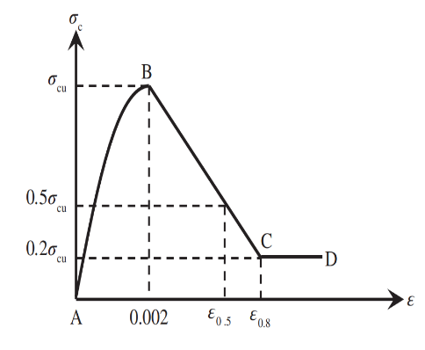

Fig 5: Constitutive model [17].

$σ_{c}= σ_{cu} \left[2\left(\frac{ε_{c}}{ε_{c}^{'}}\right)-{\left(\frac{ε_{c}}{ε_{c}^{'}}\right)}^{2}\right]$ (1)

where $σ_{c}, σ_{cu}, ε_{c}, ε_{c}^{'}$ are compressive stress, ultimate compressive stress, compressive strain and ultimate compressive strain respectively.

Apart from the uniaxial stress–strain data, the CDPM also required the damage variables dc and dt, which characterize the degradation of the elastic stiffness in compression and tension respectively. For simplicity, the model proposed by Lubliner et al. [23] as shown in Fig.6 is presented in Eq. 2 as follows:

$d_{c }=1-\frac{σ_{c}}{σ_{cu}}$

$d_{t }=1-\frac{σ_{t}}{σ_{t0}}$ (2)

where $σ_{t} and σ_{t0}$ tensile stress and ultimate tensile stress respectively

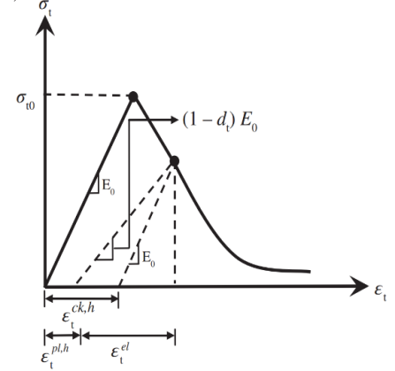

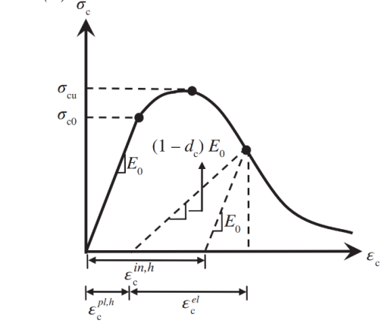

1. Compression b) tension

Fig 6: uniaxial behavior of concrete

The other CDPM parameters required to complete the model are dilation angle (ψ), eccentricity (ε), the ratio of initial equi biaxial compressive yield stress to initial compressive yield stress $(\frac{fbo}{fco}$) and the ratio of second stress invariant on the tensile meridian (k) and ultimate tensile strain. In this study, the values considered for ψ, ε, $(\frac{fbo}{fco}$), k and μ were 30◦, 0.1, 1.16, 0.67 and 0.0005 respectively. The beam components included steel, stirrups, and bearing plates, with material properties such as elastic and plastic behavior specified in the property field. For steel, the density, modulus of elasticity (E) and Poisson’s ratio (*v)* were taken as 7800 kg/m3, 200 GPa and 0.3 respectively. For concrete, the density and Poisson’s ratio (*v)* were taken as 2400 kg/m3 and 0.2 respectively.

The geometric and material properties of the FE models are the same as in the test. The 3D 8–node brick elements with reduced integration (C3D8R) was used to model both the steel tube and concrete components. The steel reinforcement bars were modeled using the 2–node truss element (T3D2). The embedded constraint was used to ensure perfect bond between the steel reinforcement bars and the concrete. Finer mesh sizes were used in the contact zones between the steel and concrete components as shown in Fig.7. the beams were subjected to four point bending test. The crack patterns are shown in Fig.8.

Similar to the current study's approach, previous research has utilized numerical modeling to predict the behavior of reinforced concrete elements with embedded features [24].

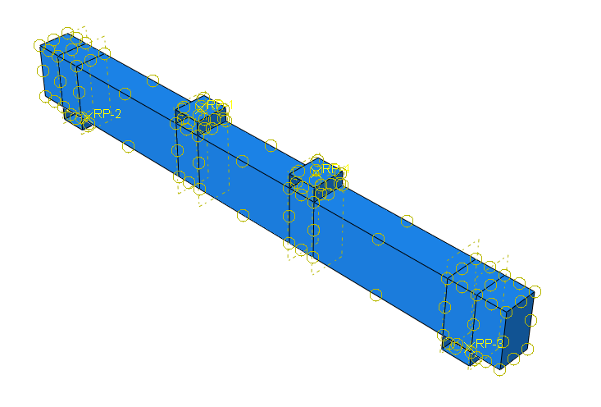

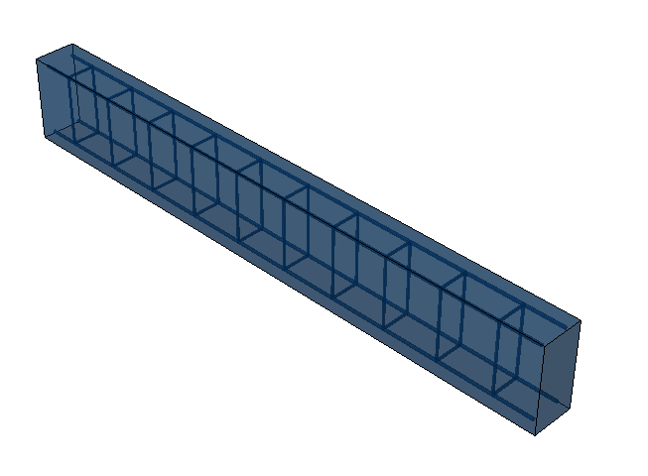

Fig 7b: Interactions of parts

Fig 7a: Assembled parts

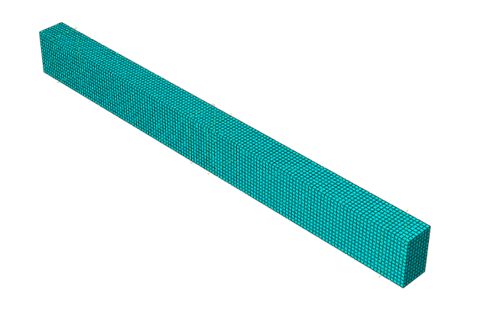

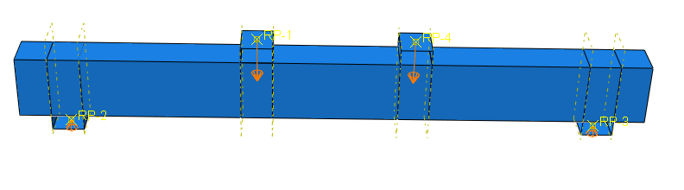

Fig 7d: Loads applied

Fig 7c: Mesh

Figure 7(a-d): Illustration of test beams modelled using ABAQUS software

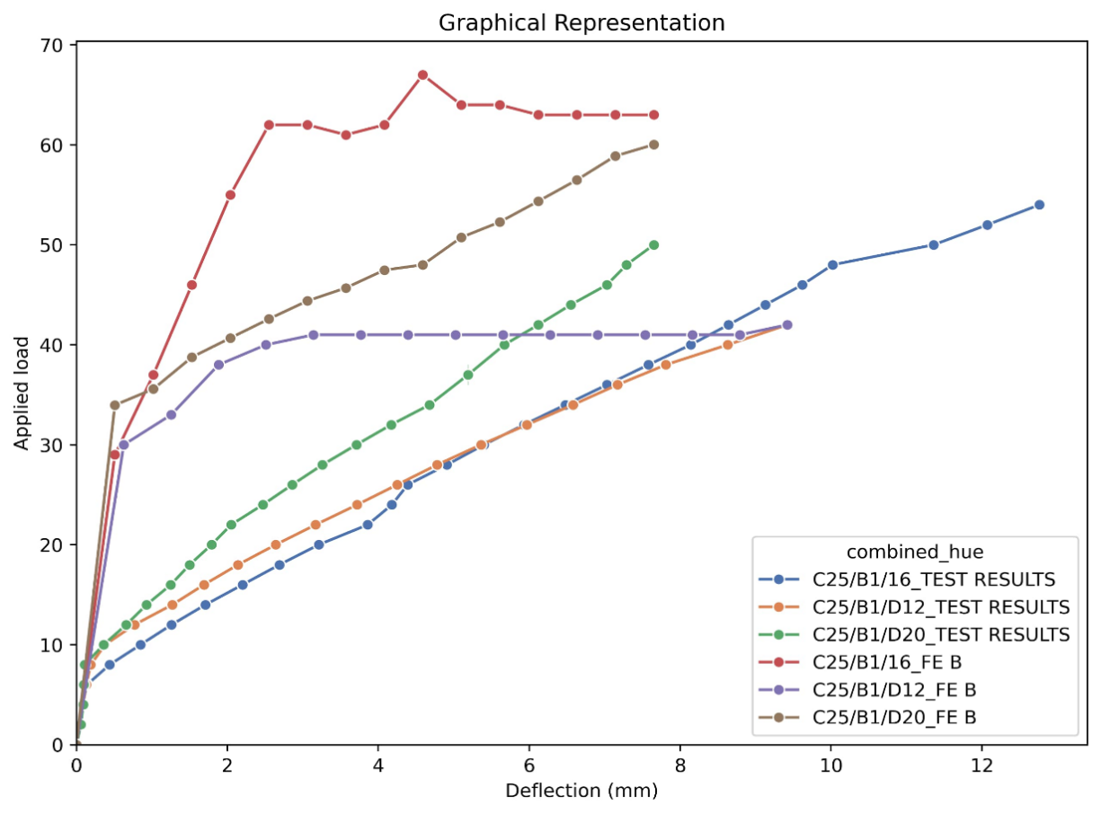

Figure 8: Experimental and FEM load-deflection curves of beams

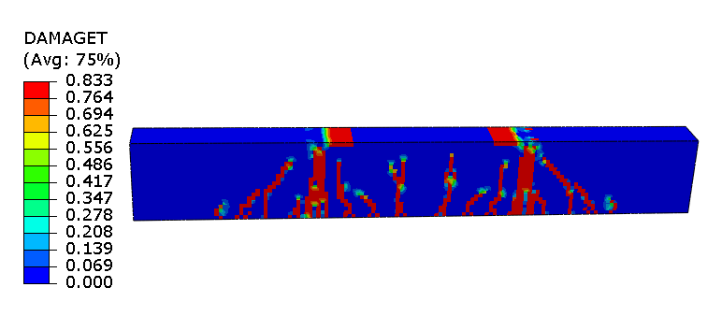

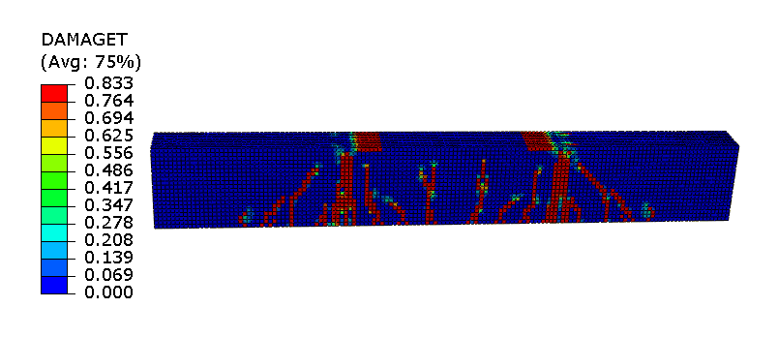

C25B116

C25B112

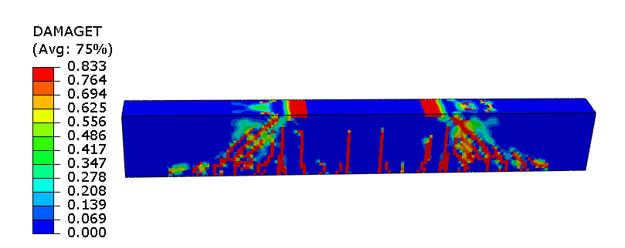

C25B120

Fig 9: Crack patterns of the beams by FEM

**5.1 Theoretical Results**

Clearly, there is a high degree of consistency of the numerical results with the experimental data, namely ultimate deflection, load bearing capacity and first crack load. The load-deflective curves of the numerical models are confirmed and validated by the experimental results. For the finite element method (FEM), B1/12 and B1/16 represent three-point load control beam (solid) and B1/20 represents the four-point load control beam (solid). The ultimate load for B1/12 and B1/16 subjected to the four-point load were 42kN and 54kN compared to 42kN and 63kN predicted by their corresponding FEM respectively. Their theoretical analysis was based on limit state design, that resulted to a failure load of 53.67kN and 91.57kN respectively and was governed by the yielding of the steel rebars (Table 3). Again, the maximum experimental test deflection of 9.42mm recorded for C25/B1/12, was the same as from FEM, but the 12.76mm recorded by beam C25/B1/16 was slightly larger in contrast to the 7.85mm predicted by the FEM.

As shown in Figure 8, the load-deflection curves in the FEM exhibit cracking loads of 33kN, 29kN and 33.97kN for beams B1/12, B1/16 and B1/20 respectively and are presented in Table 5. On the other hand, cracking loads of 8kN, 6kN and 8kN were obtained experimentally for the same beams. A noticeable trend is that, the FEM predicted higher cracking load values.

With reference to the ultimate loads that are shown in Table 5, the FEM predicted 42kN, 63kN and 60kN compared to 42kN, 54kN and 50kN from the experimental tests. Furthermore, from Table 5 the deflection values predicted by the FEM were slightly larger than values yielded by the experimental tests. These differences fell within an acceptable range, supporting the dependency of the FEM for further studies involving parameter adjustment. The cohesion between the experimental and numerical load-displacement results was quite impressive observing the curves [25].

The results of the finite element analysis using ABACUS, based on numerous theoretical considerations and iterative refinements have shown the accuracy and consistency between the numerical and experimental outcomes of load-deflection responses (Figure 8) and crack patterns in the beams (Figure 9).

**6.0 CONCLUSION**

The focus of this research was on assessing the lap strength of locally manufactured reinforcing bars milled from scrap metals in beam. The methodology was designed to take into account elements that influence the performance of lap strength, such as the lengths of lap and size of reinforcing bars. The test results showed that longer lap lengths result in greater lap strength, leading to an increased failure load. For instance, lap lengths of C25/10D/20, C25/15D/20, and C25/20D/20 corresponded to failure load values of 14 kN, 18 kN, and 32 kN, respectively. Beams with larger diameter bars, such as 16 mm and 20 mm, generally demonstrated higher ultimate loads and lower deflections when compared to beams with smaller 12 mm diameter bars under identical loading conditions and lap lengths. This increase in load-carrying capacity and stiffness of the larger reinforcing bars is attributed to the larger cross-sectional area and moment of inertia.

Failure modes observed in all beams were predominantly either flexural or shear failures. Flexural failures were the most frequent, often marked by visible flexural cracks and concrete crushing within the compression zone. Shear failures, while less common, were noticeable in some beams, which showed long, visible shear cracks before ultimately failing. Overall, ensuring an adequate lap length is essential for the smooth transfer of stress within the beam, allowing for a more gradual failure at the ultimate load. Smaller and insufficient lap lengths can lead to a premature and brittle failure.

Disclaimer (Artificial intelligence)

Option 1: AI was not used

Author(s) hereby declare that NO generative AI technologies such as Large Language Models

(ChatGPT, COPILOT, etc.) and text-to-image generators have been used during the writing or

editing of this manuscript.

**REFERENCES**

[1] A. S. Chahar and P. Pal, “Study on various properties of reinforced concrete – A review,” *Mater. Today Proc.*, vol. 65, pp. 597–602, Jan. 2022, doi: 10.1016/j.matpr.2022.03.193.

[2] G. Xu, L. Liu, H. Bao, Q. Wang, and J. Zhao, “Mechanical properties of steel corrosion products in reinforced concrete,” *Mater. Struct.*, vol. 50, no. 2, p. 115, Dec. 2016, doi: 10.1617/s11527-016-0985-3.

[3] C. K. Kankam and M. Adom-Asamoah, “Strength and ductility characteristics of

reinforcing steel bars milled from scrap metals,” *Mater. Des.*, vol. 23, no. 6, pp. 537–545,

Sep. 2002, doi: 10.1016/S0261-3069(02)00028-6.

[4] E. K. Banini and K. C. K. Kankam “Strength, Ductility and Chemical Properties of Reinforcing

Steel Bars in Ghana’s Building Construction Industry,” *J. Mater. Sci. Res. Rev.*, pp. 186–

203, Aug. 2022.

[5] G. Andoh, C. K. Kankam, F. Ohene-Coffie, E.S. Nanor, A.K. Kpo, K. Sarpong, F.A. Issifu

“Flexural Behavior of Reinforced Concrete Beams with Openings Created

by PVC Pipes: An Experimental and Numerical Study,” *Asian J. Adv. Res. Rep.*, vol. 19,

no. 1, pp. 252–269, Jan. 2025, doi: 10.9734/ajarr/2025/v19i1879.

[6] C. K. Kankam, “Bond strength of reinforcing steel bars milled from scrap metals,” *Mater. Des. - MATER Des.*, vol. 25, pp. 231–238, May 2004, doi: 10.1016/j.matdes.2003.09.011.

[7] S. Agudze, V. Akortia, C. K. Kankam, E. Biney, J. Quarm Junior, and E. Mansal, “Appraisal

of Structural Integrity Assessment Methodology and Reports of Existing RC Building

Structures in Ghana,” vol. 25, pp. 81–101, Oct. 2023, doi:

10.9734/JERR/2023/v25i101003.

[8] BS 8110-1 (1997). Structural use of concrete Part 1. Code of Practice for design and

construction. British Standard Institute 1997

[9] S. Assiamah, C. K. Kankam, E. K. Banini, S. Agyeman, and K. Adinkrah-Appiah,

“Standardization Issues in Africa: Bayesian analysis of physicogeometrical and

mechanical characteristics of rebars in Ghana’s construction industry,” *J. Build. Eng.*, vol.

73, p. 106835, Aug. 2023, doi: 10.1016/j.jobe.2023.106835.

[10] N. Connor, “Mild Steel | Density, Strength, Hardness, Melting Point,” Material Properties. Accessed: Aug. 29, 2024. [Online]. Available: https://material-properties.org/mild-steel-density-strength-hardness-melting-point/

[11] A. A. Joseph, “Assessment Of Mechanical Properties Of Reinforcing Steel Used In Construction Works At F.C.T, Abuja,” *Int. J. Eng. Res.*, vol. 2, no. 6, 2013.

[12] E. Boateng, C.K. Kankam, and A. K. Danso, “Models for Predicting Strength Reduction

Factors for Concrete that Utilizes Palm Kernel Shells and Waste Automobile Tires as

Aggregates,” *J. Eng. Res. Rep.*, vol. 24, pp. 44–53, Mar. 2023, doi:

10.9734/JERR/2023/v24i9842.

[13] Y. M. Karkarna, “Investigations into the ductility of lap joints in low-strength reinforced concrete beams”, Ph.D dissertation, School of Computing and Engineering, University of West London, London, U.K., Mar. 2023, viii + 211pp..

[14] H. Hwang, F. Yang, L. Zang, J. Baek, and G. Ma, “Effect of impact load on splice length

of reinforcing bars,” Int. J. Concr. Struct. Mater., vol. 14, art. no. 40, pp. 1–15, 2020. doi:

10.1186/s40069-020-00414-z

[15] C. A. Issa and A. Nasr, “An experimental study of welded splices of reinforcing bars,” *Build. Environ.*, vol. 41, no. 10, pp. 1394–1405, Oct. 2006, doi: 10.1016/j.buildenv.2005.05.025.

[16] P. Yalley, E. Appiah-Kubi, E. Osei-Tweneboah, and C.K Kankam, “Assessing the

Performance of Concrete Mixed with Different Water Sources within Small Scale Mining

Catchment Areas in Ghana,” vol. 7, pp. 31–45, May 2021.

[17] H. Singh, P. P. Singh Cheema, and P. Garg, Eds., “Types of Cracks in Concrete Beams and Their Causes Scribd., 5 pages, Dec. 28, 2019. [Online].

[18] U. Obinna, “Effect of Impact Load on Lap Length of Reinforcements in RC Structures - Structville.” Accessed: Oct. 22, 2024. [Online]. Available: https://structville.com/2020/09/effect-of-impact-load-on-lap-length-of-reinforcements-in-rc-structures.html

[19] B. O. Adeleke, S. J. Abbey, and A. O. Olubanwo, “Numerical Investigation of Tension Reinforcement Lap Length of Eurocode 2 Using a Four-Point Beam Loading System,” *Lat. Am. J. Solids Struct.*, vol. 16, p. e197, Jun. 2019, doi: 10.1590/1679-78255532.

[20] T. Robl, P. Hegele, C. Krempaszky, and E. Werner, “Residual Stresses in Ribbed Reinforcing Bars,” *Materials*, vol. 17, p. 26, Dec. 2023, doi: 10.3390/ma17010026.

[21] D. C. Kent and R. Park, “Flexural Members with Confined Concrete,” *J. Struct. Div.*, vol. 97, no. 7, Art. no. 7, Jul. 1971, doi: 10.1061/jsdeag.0002957.

[22] A. K. Nanda and J. Singh, “Relationship Between Compressive Strength and Split Tensile Strength for Sustainable Concrete—A Case Study,” in *Sustainable Development Through Engineering Innovations*, H. Singh, P.P. Singh Cheema and Garg, Eds., Singapore: Springer, 2021, pp. 733–740. doi: 10.1007/978-981-15-9554-7_65.

[23] J. Lubliner, J. Oliver, S. Oller, and E. Oñate, “A plastic-damage model for concrete,” *Int. J. Solids Struct.*, vol. 25, no. 3, pp. 299–326, Jan. 1989, doi: 10.1016/0020-7683(89)90050-4.

[24] F. Kwarteng, C. K. Kankam, J. O. Banahene, G. O. Boateng, and E. C. Mansal, “Predictive

Behaviour from Finite Element Analysis on PVC-Ducted Reinforced Concrete Column,”

*J. Eng. Res. Rep.*, vol. 26, no. 3, pp. 145–160, Mar. 2024, doi:

10.9734/jerr/2024/v26i31101.

[25] E. A. Ponle, O. B. Olatunde, & O. W. Awotunde, (2014). Mechanical properties of

reinforcing steel rods produced from recycled scraps. The International Journal of

Engineering and Science, 3(2), 14–34.