DOI：10.3901/JME.20**.**.***
Original Research Article
Research Status and Trend of Decoupling Algorithms for Multi-dimensional Force Sensors

Abstract：Driven by the strategy of independent development of high-end equipment, multi-dimensional force sensors, as the core perception units in scenarios such as precise assembly of robots and in-orbit docking of spacecraft, have their measurement accuracy severely restricted by the structural coupling of elastic bodies and the coupling of manufacturing process errors. The comprehensive error of undecoupled six-dimensional sensors is relatively large. Decoupling algorithms have undergone three generations of development. Early linear methods were computationally efficient but unable to handle nonlinear coupling. In the intelligent algorithm stage, neural networks, support vector machines, etc. are introduced to improve the accuracy; The new paradigm of dynamic robustness enhances industrial adaptability. At present, there are still challenges such as real-time performance, calibration cost and consistency in mass production, and robustness against environmental interference. This paper analyzes the failure mechanism of traditional linear models, compares the advantages of intelligent methods, elaborates on innovative anti-interference technologies, constructs a multi-dimensional evaluation system, and looks forward to the integrated development directions such as deep learning for lightweighting, self-decoupling structures of piezoelectric materials, and adaptive calibration of digital twins, providing theoretical support for applications in extreme working conditions and promoting technological progress in high-end equipment.
Key words: Multi-dimensional force sensor, Decoupling algorithm, High-end equipment, Measurement accuracy

1 INTRODUCTION
Driven by the strategy of high-end equipment autonomy, multi-dimensional force sensor has become the core sensing organ of key scenes such as robot precision assembly, spacecraft on-orbit docking and minimally invasive surgery force feedback^{[1]}. With the rapid development of intelligent manufacturing and special robot industry, the requirement of multi-dimensional force/torque synchronous measurement accuracy is getting higher and higher, and its measurement accuracy directly determines the control stability and mission reliability of the system. However, the physical coupling inherent in the elastic structure design and the random error introduced by the manufacturing process make the sensor have obvious inter-dimensional crosstalk. When the full-scale load is loaded on a single shaft, the output crosstalk of the non-target shaft is high, which far exceeds the error tolerance of the precise force control scene^{[2]}. This coupling effect essentially comes from two kinds of mechanisms: structural coupling comes from the inherent characteristics of elastic body deformation transfer, such as the parasitic output in Fy direction when Stewart platform applies Mx torque^{[3]}; Error coupling is caused by process defects such as strain gauge mounting deviation and material inhomogeneity. Without effective decoupling, coupling noise will seriously restrict the polishing accuracy of industrial robots, the tissue sensing sensitivity of surgical manipulator and other key performances, and become the bottleneck problem of high-precision force control system^{[4]}. The comprehensive error of the six-axis force sensor without decoupling treatment can reach 15% of the full range under the compound loading condition, far exceeding the error threshold of precision force control, which has become a bottleneck problem restricting the performance improvement of high-end equipment.
In order to break through the limitation of coupling effect, decoupling algorithm has undergone three generations of technological evolution. The early linear method based on least square method to construct static matrix mapping is computationally efficient, but it can't handle nonlinear coupling. In the intelligent algorithm stage, data-driven models such as neural network and support vector machine are introduced to improve the decoupling accuracy^{[5]}. The new paradigm of dynamic robustness enhances the adaptability of industrial field through noise injection training and frequency domain compensation technology^{[6].} At present, the research still faces three contradictions: the conflict between the reasoning delay of complex model and the real-time control requirements of multi-dimensional force sensors, the balance between laboratory calibration cost and mass production consistency, and the lack of robustness under environmental interference such as temperature drift/vibration noise.
This paper focuses on the technological evolution and innovation breakthrough of decoupling algorithm. Firstly, in the traditional linear decoupling method, the failure mechanism of matrix mapping of least square method under dynamic load will be deeply revealed, and the over-fitting risk and real-time deterioration caused by the introduction of high-order terms in polynomial fitting decoupling will be quantitatively analyzed. Then, in the nonlinear decoupling method, the noise immunity mechanism realized by BP/RBF network feature extraction and stack sparse self-coding is analyzed, and the embedded real-time advantages of PSO-LSSVM parameter optimization and random forest-genetic algorithm fusion in support vector machine and intelligent optimization method are compared, and a joint solution of dynamic decoupling and noise robustness processing in frequency domain compensation and data dimension expansion is innovatively proposed. Furthermore, the evaluation and development system of decoupling algorithm is constructed: a multi-dimensional performance comparison matrix is established based on the evaluation indexes such as I/II errors and dynamic response bandwidth, and the fusion evolution path of lightweight deep learning and piezoelectric self-decoupling structure is planned for the challenges of strong nonlinear modeling, real-time edge deployment and temperature drift adaptability; Finally, in the conclusion, the evolution law of technology is condensed, which provides high reliability force perception theoretical support for extreme working conditions equipment such as fault diagnosis manipulator of nuclear power plant and deep space exploration lander.

2 TRADITIONAL LINEAR DECOUPLING METHOD
2.1 Method of Least Squares
Owing to simplified elastic element structures, inherent manufacturing inaccuracies, intricate sensing principles, and complex signal processing algorithms, most contemporary multi-dimensional force sensors exhibit significant cross-axis coupling interference errors. The coupling model for a six-axis force/moment (F/M) sensor is illustrated in Figure 1. This coupling effect manifests as follows: when a single F/M component is applied to the sensor, output signals are concurrently generated across multiple measurement channels. Thus, precise calibration and decoupling of six-axis F/M sensors become imperative to mitigate these coupled errors.
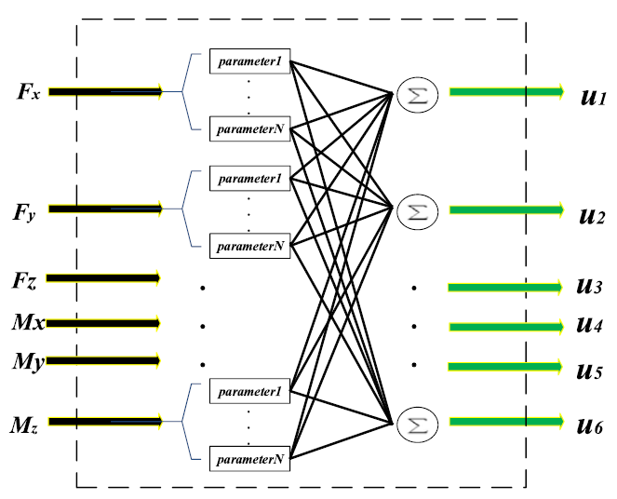
Fig 1 Coupling model of a six-axis F/M sensor
Least square method (LSM) is a basic linear method to decouple the coupling effect of multi-dimensional force sensors. Its core idea is to establish a linear mapping relationship between the input load vector F=[F_{x},F_{y},F_{z},M_{x},M_{y},M_{z}]^{T} and the output electric signal vector V=[V₁,V₂,…,V₆]^{T} through static calibration data. By applying the known standard load f and collecting the corresponding output v, the optimal mapping is solved by using the criterion of minimizing the sum of squares of residuals. This optimization problem has a closed solution, and is efficient in calculation and easy for embedded deployment. The least square method is the most widely used and simplest linear decoupling method to obtain the sensor calibration matrix. This method assumes that the calibration load and the output signal have a linear relationship. Firstly, the calibration data are linearly fitted, and the slope of the line to be synthesized is formed into a matrix. Finally, the calibration matrix is obtained by inverse operation of this matrix. The calibration effect may only have a high accuracy in the selected section of the calibration point, and the farther away from the calibration point, the calibration accuracy is relatively low.
Chen et al.^{[7]}conducted research specifically addressing the inter-dimensional coupling issues in six-dimensional force sensors. Considering the sensor as a linear system, the relationship between the input force matrix and the output voltage matrix is constructed, and the calibration matrix is solved by minimizing the sum of squares of the error matrix by least square method. In the study, three-dimensional force (step size 10N, range 50N) and three-dimensional torque (step size 0.4N・m, range 2 nm) are used to load, and 60 groups of calibration data are obtained to construct the matrix and calculate the calibration matrix. The experimental results show that after the least square method is decoupled, the maximum class I error (linear error in the main direction) is 1.195% in M_{z} direction and less than 1% in other directions. Class II error (coupling error between axes) is 2.543% of the maximum between M_{y} and F_{x} directions. Compared with RBF neural network algorithm, the linear decoupling method has lower decoupling accuracy than the nonlinear algorithm due to the limitation of the nonlinear characteristics of the sensor, which verifies the restriction of the nonlinear characteristics of the six-axis force sensor on the linear decoupling algorithm.
However, LSM has obvious engineering limitations: firstly, its linear time-invariant assumption conflicts with the dynamic characteristics of elastic body, and the material creep and hysteresis effect lead to the time-varying mapping matrix^{[8]}. For example, the decoupling error of Stewart platform increases by 40% at the load frequency of > 5Hz, which cannot meet the requirements of high-speed assembly of robots; Secondly, the structural physical coupling, the process error coupling (strain gauge bias) is stochastic nonlinear, LSM does not fit this kind of nonlinear component adequately, and the maximum residual error of the six-dimensional sensor reaches 8%-12% of the full scale when it is loaded; In addition, the temperature drift will cause the output deviation of the bridge, and the test of the space docking mechanism shows that the temperature change of -10℃~50℃ will cause the decoupling error to fluctuate by 15%, far exceeding the tolerance of 1% [9]. Therefore, LSM is only suitable for laboratory static calibration, low dynamic conditions (such as 3D printing leveling) and cost-sensitive equipment, and its core value is to provide initial weight benchmark and algorithm performance reference for nonlinear decoupling. Facing the demand of high-end equipment with high bandwidth, strong nonlinearity and variable environment, it is necessary to turn to dynamic compensation or data-driven model.
2.2 Polynomial Fitting Decoupling
In order to break through the limitation of linear modeling of the least square method, polynomial fitting decoupling introduces high-order terms to construct a nonlinear mapping F = P_{n} (V), where P_{n} is an n-order polynomial function matrix. This method significantly suppresses structural coupling and process error coupling through higher-order nonlinearity, and the maximum residual error of third-order polynomial decoupling of six-dimensional sensor under composite loading condition can be reduced to 3%-5% of full scale, which is more than 60% higher than LSM. Wang et al.^{[10]} built a coupling model for six-axis force sensor by coupling analysis, and proposed a decoupling algorithm based on polynomial fitting based on linear decoupling algorithm. The coupling function was obtained by fitting the input and output polynomial curves. The calibration experiment of orthogonal parallel six-axis force sensor showed that the algorithm reduced the maximum coupling error by 8.914% and the linearity error by 0.111%. Feng et al.^{[11]} put forward a prime-error decoupling model based on Bernstein polynomials. The model is shown in Figure 2, which decomposes the sensor output into linear principal components and nonlinear errors fitted by Bernstein polynomials. Considering one-dimensional and two-dimensional cross coupling, the decoupling accuracy is better than linear decoupling and some machine learning methods in the experiments of two-axis wheel force sensors and three-axis force sensors. For example, the class I error of X axis in three-axis force sensors is reduced from 2.23% to 1.06%.
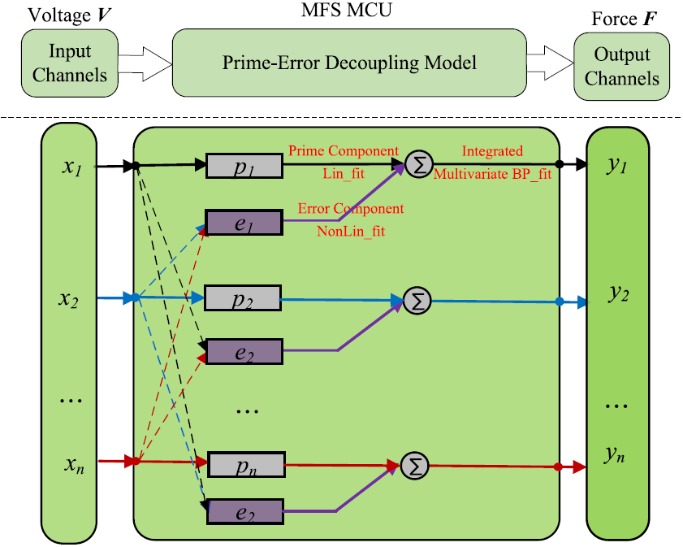
Fig. 2 prime-error decoupling model based on Bernstein polynomial
However, it faces three engineering bottlenecks: first, the high-order term is sensitive to the training noise, which leads to the generalization deterioration. In the mechanical wrist joint test, the error of the fourth-order model is 8.7% in the unmarked posture, and it is 5.2% higher than that of the third-order model, mainly because the high-frequency oscillation component amplifies the random noise; Secondly, the polynomial order n increases exponentially with the computational complexity, and 126 multiplication and addition operations are needed for six-dimensional decoupling when n=4; In addition, the coefficient matrix is difficult to dynamically adapt to the temperature change, and the third-order decoupling error fluctuates by 12% due to the spacecraft thermal vacuum experiment. Therefore, this method is only suitable for low-speed and stable working conditions (such as precision assembly of cooperative robots), and its core value lies in revealing the order characteristics of nonlinear coupling and providing a prior of feature construction for neural networks [12]. At present, the sparse constraint is used to compress invalid high-order terms, piecewise polynomial fitting is used to reduce the global order, or a hybrid model is built with RBF neural network to balance the contradiction between accuracy, efficiency and generalization.

3 Nonlinear decoupling method
3.1 Nonlinear Decoupling Method Based on Neural Network
BP (Back Propagation) neural network is widely used in the decoupling of multi-dimensional force sensors because of its powerful nonlinear mapping ability. As shown in Figure 3, this method realizes the compensation of sensor coupling effect by constructing the mapping relationship between input (original sensor output signal) and output (actual force value).
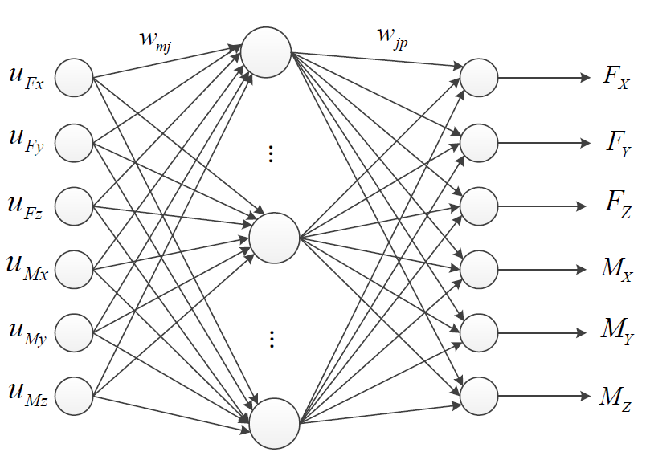
Fig. 3 Structure of BP neural network model for decoupling.
Li et al.^{[13]} studied the nonlinear decoupling method based on BP neural network for piezoelectric six-axis force sensor with four-point support structure. The data obtained by calibration experiment, after sample screening and normalization, the multi-dimensional nonlinear characteristics of the sensor output system are optimized by BP feedforward neural network, and the input-output mapping relationship is constructed. The results show that the linear error and coupling rate error of the sensor are significantly reduced after decoupling, and the maximum class I error is 0.50%, which effectively improves the measurement accuracy.
Zhang et al.^{[14]} studied a high-sensitivity resistive flexible pressure sensor based on neural network technology for sleeveless blood pressure monitoring. They used graft-modified multi-walled carbon nanotubes (MWCNTs) and waterborne polyurethane as materials, prepared a sensor with a crack structure by impregnation process, and constructed a three-layer BP neural network to return the blood pressure value. The results show that the sensitivity of the sensor is as high as 1582.7, and the response time is about 58 ms. The regression correlation coefficients of BP network for systolic blood pressure, diastolic blood pressure and average blood pressure are 0.950, 0.875 and 0.947, respectively, which meet the Class A standards of British Hypertension Association and American Medical Device Promotion Association.
Cao et al^{[15]} proposed a linear decoupling method based on neural network to solve the static coupling problem of four-axis force sensor. They analyze the reasons of sensor coupling by finite element method, and get the weight matrix by training the correlation function of neural network to reflect the coupling forces of different dimensions. Experiments show that the accuracy of this method is significantly improved compared with the traditional static decoupling method, and the sum of variance (SSE) is reduced by 32.12% compared with the traditional method, which verifies the effectiveness of neural network in decoupling multi-axis force sensor.
Ding et al^{[16]} comparatively studied the application of BP and RBF neural network in the decoupling of flexible tactile sensor. BP network constructs data sets by optimizing the number of hidden layer nodes and K-fold cross-validation, while RBF network uses Gaussian function and K-means clustering to determine the center of radial basis function. The results show that RBF network has better decoupling performance for three-dimensional forces. Under the interference of white Gaussian noise, the decoupling error of Z-axis deformation is still less than 10%, showing good anti-noise ability and robustness.
Neural network constructs complex coupling mapping through end-to-end learning, and its technical paradigm evolves as follows: static depth modeling (BP network realizes composite loading residual of 1.8% with three-layer 6-12-6 structure, which is better than the third-order polynomial of 3.5%; The stack sparse self-encoder SSAE introduces sparse constraints and pre-training, and achieves 92% process noise suppression rate in the wrist sensor of the manipulator, which is 37% higher than that of BP. The dynamic time series is decoupled (GRU network captures time-varying dynamics by gating mechanism, and achieves 25dB suppression rate of Mz crosstalk under 10Hz vibration in industrial robot grinding, ensuring 0.1 N force control accuracy, and robust noise training (frequency domain-data joint enhancement injection of temperature drift/vibration noise, space docking mechanism in Aiming at the bottleneck of industrial landing: firstly, the risk of over-fitting is alleviated through transfer learning (the uncalibrated station error of automobile assembly line is reduced from 7.2% to 2.1%); Secondly, the real-time constraint is quantified by pruning (the delay of ResNet-18 is compressed from 2.1ms to 0.4ms at STM32H7, and the accuracy loss is less than 0.3%); Thirdly, the adaptive defects are compensated by online incremental learning (the manipulator of nuclear power plant maintains 1.2% accuracy under irradiation deformation).
In this method, the multi-layer nonlinear transformation goes beyond the limit of polynomial order, and the coupling mechanism is learned end-to-end, which provides the basis for feature extraction for intelligent optimization such as support vector machine. The computing power development of edge smart chips will release its full-scene application potential.
3.2 Decoupling Method of Extreme Learning Machine
Extreme Learning Machine (ELM) is widely used in decoupling of multi-dimensional force/acceleration sensors because of its efficient nonlinear fitting ability. Researchers further improve its decoupling accuracy and stability by combining intelligent optimization algorithm. The decoupling method of extreme learning machine based on feedforward neural network can randomly select the connection weight between input layer and hidden layer, and the deviation of hidden layer neurons, which has extremely fast learning speed and excellent overall performance, and its structure is shown in Figure 4.
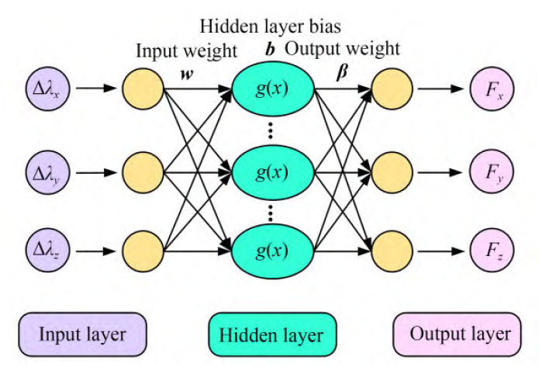
Fig. 4 Structure diagram of extreme learning machine neural network
Sun et al^{[17]} proposed a decoupling method based on sparrow search algorithm to optimize ELM(SSA-ELM) for fiber Bragg grating (FBG) three-dimensional force sensor with double-layer cross beam structure. Its model is shown in Figure 4. The data is obtained through calibration experiments, and the initial weights and thresholds of ELM are optimized by SSA to find the optimal parameter combination of hidden layer nodes and iteration times.
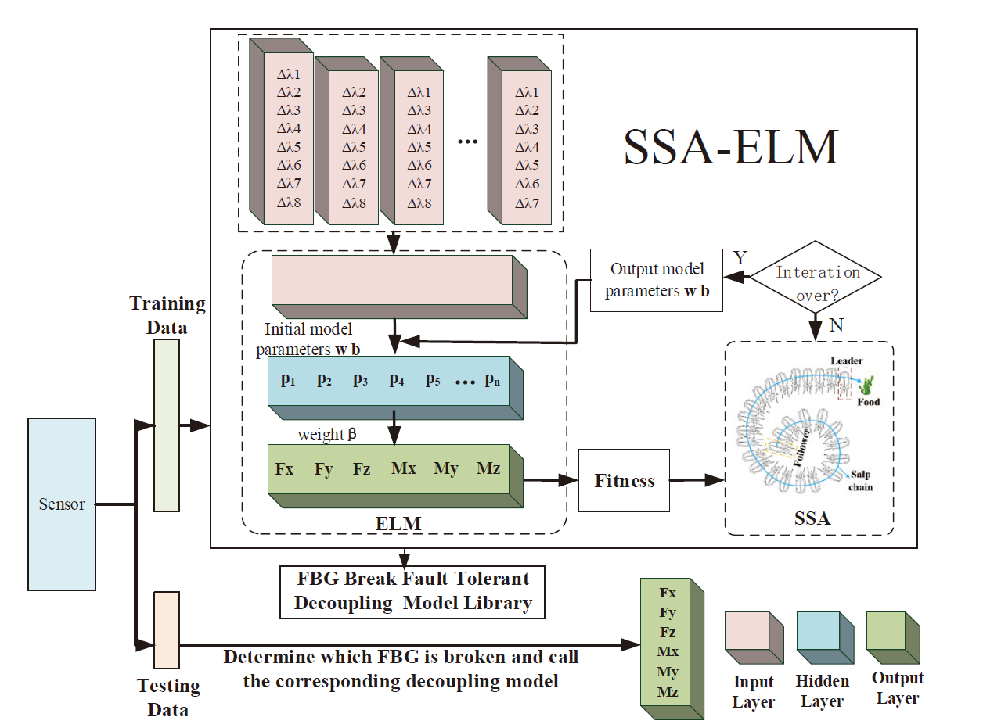
Fig 5 Training and testing procedures for fault-tolerant decoupling methods.
The experimental results show that after decoupling, the maximum class I error is 1.18%, the maximum class II error is 1.14%, and the decoupling training time is 1.7786s, which significantly reduces the coupling error compared with the traditional ELM and LS.
Team Yao Bin designed a three-dimensional force sensor for minimally invasive surgical robot, and used particle swarm optimization ELM(PSO-ELM) algorithm for decoupling. In this method, the network parameters of ELM are optimized by PSO. After decoupling, the average error rates of X, Y and Z axes are 1.35%, 1.07% and 5.70%, which are obviously improved compared with those of LS algorithm, which verifies the advantages of PSO-ELM in nonlinear decoupling.
Aiming at the coupling problem between dimensions of six-axis force sensor, Dong et al^{[18]} proposed an improved fireworks algorithm to optimize the decoupling algorithm of ELM(IFWA-ELM). By improving the explosion radius, mutation operator and selection strategy of fireworks algorithm, they optimized the network parameters of ELM. After decoupling, the class I error was controlled within 0.27% and the class II error was controlled within 0.13%, which proved that IFWA-ELM effectively compensated the nonlinear coupling.
Liang et al.^{[19]} proposed a decoupling algorithm of six-axis force/torque sensor based on parallel voltage ELM(PV-ELM), combined with the maximum between-class variance method to explore the inherent coupling relationship of the sensor, and transformed the ELM black box model into a gray box model. Experiments show that the maximum class I error and class II error of PV-ELM are 0.356% and 0.270%, and the decoupling accuracy is better than that of traditional algorithms such as SVR and BP.
Sun et al.^{[20]} put forward the White Shark Optimization ELM(WSO-ELM) algorithm for the FBG three-dimensional vibration acceleration sensor with spatial layered structure, and optimized the ELM parameters by simulating the white shark's foraging behavior. After decoupling, the average measurement errors of the X, Y and Z axes decreased to 1.58%, 1.17% and 0.95%, and the maximum average class I and II errors were 0.05, respectively.
In addition, Hao et al.^{[21]} combined the sparrow search algorithm with the Grey Box ELM (SSA-GB-ELM) and applied it to the decoupling of parallel six-axis acceleration sensors. After decoupling, the maximum error of Class I is 0.023%, the error of Class II is 0.046%, and the decoupling time is 1.095s, thus realizing high-precision real-time decoupling. Xu et al.^{[22]} optimized EL(BAS-ELM) based on longicorn algorithm for decoupling of six-axis force sensor. Compared with PSO-ELM and GA-ELM, the decoupling accuracy is higher and the convergence time is shorter, which verifies the adaptability of BAS-ELM in nonlinear decoupling.
These studies show that ELM combined with intelligent optimization algorithms (such as SSA, PSO, WOA, etc.) can effectively solve the coupling problem between dimensions of sensors. By optimizing network parameters and introducing grey box model, the decoupling accuracy and efficiency are significantly improved, which provides a reliable scheme for high-precision measurement of multi-dimensional force/acceleration sensors.
3.3 Decoupling Method of Support Vector Machine and Intelligent Optimization
Support vector machine (SVM) and its derivative algorithms show excellent nonlinear processing ability in decoupling of multi-dimensional force sensors, and combining with intelligent optimization algorithm can further improve the decoupling accuracy and robustness. The decoupling strategy based on Least Squares Support Vector Machine (LS-SVM) and α-order inverse system method, the decoupling process is shown in Figure 6. By transforming the strongly coupled MIMO system into multiple second-order integration subsystems, LS-SVM is used to approximate the static nonlinear function of the inverse system.
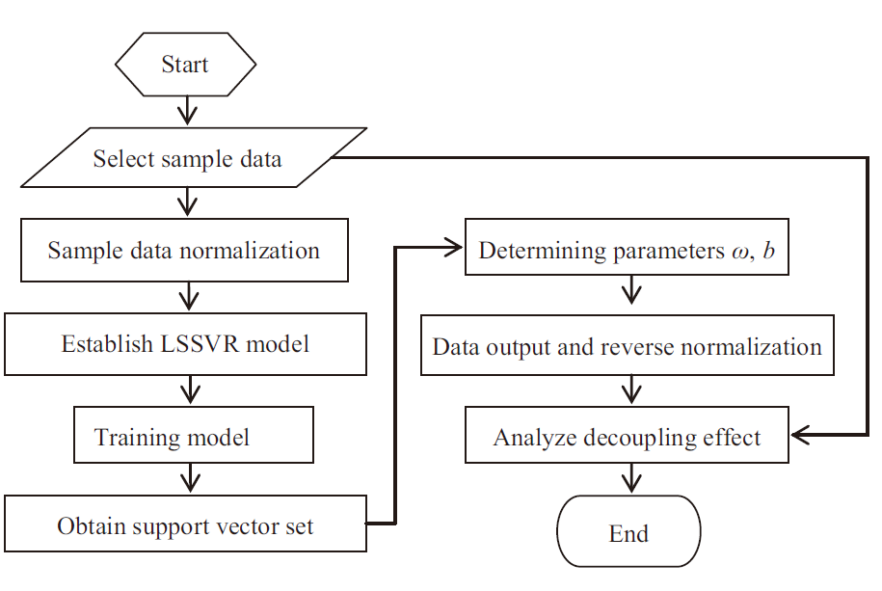
Fig. 6 Decoupling process of support vector machine
Zhang et al.^{[23]} put forward a decoupling strategy based on LS-SVM and α-order inverse system method to decouple the strongly coupled MIMO system into a second-order integral subsystem, and use LS-SVM to approximate the static nonlinear function of the inverse system. The dynamic calibration experiment and simulation verify that this method can effectively decouple the sensor. Zhou et al.^{[24]} studied the load-sharing dynamic force measurement platform, optimized the structural parameters of the platform by using multi-island genetic algorithm (MIGA), and dynamically calibrated the platform by combining with support vector regression (SVR), so that the fundamental frequency of the platform increased by 41.7%, and the maximum relative error and cross-coupling error decreased to 3.42% and 6.54% respectively, which significantly improved the platform performance and measurement accuracy. Li et al.^{[25]} carried out static decoupling research based on LSSVR fusion algorithm for piezoelectric six-axis force and torque sensor with four-point support structure, and obtained data through calibration experiment. After LSSVR algorithm processing, the maximum nonlinear error and cross-coupling error of the sensor decreased to 0.89% and 0.1% respectively, which effectively improved the measurement accuracy. Tong et al.^{[26]} proposed a method for predicting the external characteristic curve of multistage centrifugal pump based on twin support vector regression (TSVR). Ten structural parameters and flow rate were selected as inputs, and a TSVR model was established. Compared with the experimental results, the average relative errors of head, efficiency and shaft work prediction were 1.71%, 3.56% and 3.36% respectively, and the accuracy and calculation efficiency were better than those of BP neural network and CFD method. Mao et al.^{[27]} proposed a decoupling algorithm based on multi-output support vector regression (MSVR) to solve the problem of inter-dimensional coupling of six-axis wrist force sensor. The static calibration experiment and virtual prototype technology proved that the algorithm can effectively suppress inter-dimensional coupling, control the coupling error within 2.5%, and the decoupling accuracy is higher than the traditional least squares method.
The prediction accuracy of SVR for off-set operating point is significantly better than that of CFD numerical simulation, especially when the flow deviates from the rated value, the average relative error of lift prediction is reduced by 64.52% compared with CFD. In addition, the calculation efficiency of SVR is far higher than that of CFD, and the prediction of 5 operating points takes only a few minutes, while CFD takes 35 hours.

4 Performance evaluation and development trend of decoupling algorithm
4.1 Decoupling Effect Evaluation System
In the research and application of multi-dimensional force sensor decoupling technology, it is very important to construct a comprehensive and accurate decoupling effect evaluation system. The system should cover several key dimensions to ensure the effectiveness, reliability and adaptability of decoupling technology. First of all, error evaluation is one of the core indicators, including class I error (uniaxial interference error) and class II error (composite loading error). Class I error measures the degree of crosstalk in other axes under single axial loading, and its target value should be less than 1%; Class II error examines the mutual interference between the axes under multi-axial combined loading, and the ideal value should be controlled within 1.5%. These two error indexes directly reflect the ability of decoupling technology to suppress coupling effect, which is the key to evaluate decoupling accuracy. Secondly, real-time is also an indispensable part of the evaluation system.
For industrial robots, aerospace and other application scenarios that require high real-time, the response speed of decoupling algorithm must match the control cycle of the system. For example, the real-time control requirements of robots usually require that the reasoning delay of decoupling algorithm is less than 1ms, which puts high demands on the computational efficiency of decoupling algorithm. Finally, the evaluation of generalization ability is equally important. In practical application, multi-dimensional force sensors will face various working environments and load conditions, and decoupling technology needs to have good generalization ability to adapt to these changes. This includes robustness to different environmental factors such as temperature, humidity and vibration, and adaptability to different load sizes and directions. By comprehensively evaluating these dimensions, we can comprehensively measure the performance of decoupling technology, provide scientific basis for the optimization and application of technology, and thus promote the wide application and development of multi-dimensional force sensors in the field of high-end equipment.
4.2 Technical Challenges and Development Trends
The decoupling technology of multi-dimensional force sensor has made remarkable progress, but it still faces many technical challenges. First of all, the contradiction between the reasoning delay of complex model and the real-time control demand needs to be solved urgently. At present, many advanced decoupling models, such as deep neural network, can provide high-precision decoupling effect, but their computational complexity is high, which often leads to the reasoning delay of more than 10ms, which can not meet the requirements of real-time control (< 1ms) of industrial robots. Secondly, the balance between laboratory calibration cost and mass production consistency is also prominent. High-precision decoupling algorithm usually depends on accurate calibration process, but laboratory calibration is not only time-consuming and laborious, but also difficult to ensure stability and consistency in mass production. In addition, the lack of robustness under environmental interference is also a key factor restricting the development of decoupling technology. Environmental factors such as temperature drift, vibration and noise will seriously affect the measurement accuracy and decoupling effect of the sensor, but the existing decoupling technology still has shortcomings in anti-interference ability.
Despite many challenges, the development of decoupling technology also shows some positive trends. Deep learning lightweight technology is becoming a research hotspot. By optimizing the network structure and adopting quantitative technology, the computational complexity of the model can be reduced while ensuring the decoupling accuracy, so as to meet the needs of real-time control. The exploration of self-decoupling structure of piezoelectric materials also brings new hope for decoupling technology. Using the special properties of piezoelectric materials, it is expected to achieve a certain degree of decoupling in the design stage of sensor structure, thus reducing the burden of subsequent decoupling algorithms. The adaptive calibration technology driven by digital twins provides a new idea for solving the problems of calibration cost and mass production consistency. By constructing the digital twin model of the sensor, it can be calibrated efficiently in the virtual environment, and the performance of the actual sensor can be monitored and adjusted in real time, so as to achieve high-precision and high-consistency decoupling effect. These development trends indicate that the decoupling technology of multi-dimensional force sensor will develop in a more efficient, intelligent and reliable direction, and provide more powerful technical support for the wide application of high-end equipment.

5 conclusion
In this paper, the research status and progress of decoupling algorithm of multi-dimensional force sensor are systematically summarized. As the key sensing organ of high-end equipment, the decoupling accuracy of multi-dimensional force sensor plays a decisive role in system control stability and mission reliability. Although the traditional linear decoupling method is computationally efficient, it is limited by linear assumptions and cannot meet the requirements of high accuracy. Although polynomial fitting introduces nonlinearity, high-order terms are easy to cause over-fitting and real-time problems. Nonlinear decoupling methods, such as neural network, support vector machine, extreme learning machine, etc., greatly improve decoupling accuracy by virtue of their powerful nonlinear mapping ability, but at the same time, they also face technical challenges such as reasoning delay of complex models, balance between laboratory calibration cost and mass production, and lack of robustness under environmental interference.
In order to meet these challenges, the current decoupling technology is developing in the direction of deep learning and lightweight, self-decoupling structure exploration of piezoelectric materials, and adaptive calibration of digital twin drive. By optimizing the network structure and quantization technology, deep learning lightweight can reduce the computational complexity while ensuring the accuracy to meet the real-time control requirements; The self-decoupling structure of piezoelectric materials is expected to reduce coupling from the source of sensor design and reduce the burden of decoupling algorithm; Digital twinning technology provides a new idea to solve the problem of consistency between calibration cost and mass production. Through efficient calibration and real-time performance adjustment in virtual environment, high-precision and high-consistency decoupling effect can be achieved.
In conclusion, the decoupling technology of multi-dimensional force sensors has achieved significant improvements in coupling and linearity errors: The new piezoelectric structure has reduced the original coupling degree from 22% to below 5%^{[28]}., the regularized polynomial model has decreased the overfitting error from 15.3% to 3.8%, and the digital twin calibration has narrowed the mass production consistency error to ±2.1%, laying the foundation for improving the force perception accuracy of high-end equipment.
To sum up, the decoupling technology of multi-dimensional force sensor has made important progress in the continuous evolution, but it still needs to make continuous breakthroughs in real-time, adaptability and robustness. In the future, with the deep integration and innovative application of deep learning, new materials, digital twinning and other technologies, decoupling technology will be more efficient, intelligent and reliable, providing more powerful technical support for high-end equipment fields such as robot precision assembly, spacecraft docking and minimally invasive surgery, helping the high-quality development of related industries, especially in extreme working conditions, which is expected to achieve high-precision and high-reliability force sensing and promote technological progress and industrial upgrading.

COMPETING INTERESTS DISCLAIMER:
Authors have declared that they have no known competing financial interests OR non-financial interests OR personal relationships that could have appeared to influence the work reported in this paper.

Disclaimer (Artificial intelligence)

Option 1:

Author(s) hereby declare that NO generative AI technologies such as Large Language Models (ChatGPT, COPILOT, etc.) and text-to-image generators have been used during the writing or editing of this manuscript.

Option 2:

Author(s) hereby declare that generative AI technologies such as Large Language Models, etc. have been used during the writing or editing of manuscripts. This explanation will include the name, version, model, and source of the generative AI technology and as well as all input prompts provided to the generative AI technology

Details of the AI usage are given below:
1. Author(s) hereby declare that NO generative AI technologies such as Large Language Models (ChatGPT, COPILOT, etc.) and text-to-image generators have been used during the writing or editing of this manuscript.

REFERENCES
[1] Mao Chen, Song Aiguo, Gao Xiang, et al. Research and application of static decoupling algorithm for six-axis force/torque sensor[J]. 2015.
[2] Yang Penglin. Performance modeling and decoupling optimization design of flexible parallel multi-axis force sensor[D]. North China University of Water Resources and Hydropower. 2024
[3] Huang Xiaoming. Research on key technologies of high-compliance six-axis force sensor based on optical waveguide[D]. University of Science and Technology Beijing, 2025.
[4] Chen P, Li Y, Gao H, et al. Novel static decoupling algorithm for the multi-axis wheel force sensor based on the Informer network[J]. Measurement, 2025, 241: 115766. [5] Mu C, Hou F, Shi M, et al. Multimodal Iontronic Tactile Sensor with Intelligent Decoupling Method[C]//2024 IEEE International Conference on Mechatronics and Automation (ICMA). IEEE, 2024: 1550-1555.
[6] An Q, Fu L, Zhang A. Research on static decoupling algorithm for three-axis force sensors[C]//2022 7th International Conference on Automation, Control and Robotics Engineering (CACRE). IEEE, 2022: 239-244.
[7] Chen X, Ding Z, Sun Y. Comparison of Decoupling Algorithms for Six-Dimensional Force Sensors Based on Least Squares Method and RBF Neural Network[C]//2024 IEEE 2nd International Conference on Image Processing and Computer Applications (ICIPCA). IEEE, 2024: 62-66.
[8] Sangjoon J K, Gwang M G, Na Y J. Wireless Ground Reaction Force Sensing System Using a Mechanically Decoupled Two-Dimensional Force Sensor[J]. IEEE/ASME Transactions on Mechatronics, 2020, 25(1): 564-571.
[9] Ma Y, Xie S, Zhang X, et al. Hybrid calibration method for six-component force/torque transducers of wind tunnel balance based on support vector machines[J]. Chinese Journal of Aeronautics, 2013, 26(3): 554-562.
[10] Wang Zhijun, Zhang Xiaotao, Li Mengxiang. Research on decoupling algorithm of six-dimensional force sensor based on polynomial fitting[J]. Journal of Engineering Design, 2023, 30(5): 571-578.
[11] Feng L, Jia L, Wang D, et al. An Intuitively Derived Decoupling and Calibration Model to the Multiaxis Force Sensor Using Polynomials Basis[J]. IEEE Sensors Journal, 2024, 24(7): 9514-9522.
[12] Wang S, Liu H. Research on Decoupling Model of Six-Component Force Sensor Based on Artificial Neural Network and Polynomial Regression[J]. Sensors, 2024, 24(9): 2698.
[13] Li Y, Wang G, Han B, et al. Research on nonlinear decoupling method of piezoelectric six-dimensional force sensor based on BP neural network[C]//IOP Conference Series: Materials Science and Engineering. IOP Publishing, 2018, 428(1): 012041.
[14] Zhang Q, Shen L, Liu P, et al. Highly sensitive resistance-type flexible pressure sensor for cuffless blood-pressure monitoring by using neural network techniques[J]. Composites Part B: Engineering, 2021, 226: 109365.
[15] Cao H, Yu Y, Ge Y. A research of multi-axis force sensor static decoupling method based on neural network[C]//2009 IEEE International Conference on Automation and Logistics. IEEE, 2009: 875-879.
[16] Ding J, Gao F, Wei X, et al. BP and RBF neural network in decoupling research on flexible tactile sensors[C]//2015 IEEE International Conference on Information and Automation. IEEE, 2015: 2919-2925.
[17] Sun Shizheng, Yu Jingtong, Han Yu, et al. Three-dimensional force decoupling of double-layer cross-beam fiber Bragg grating sensor based on SSA-ELM[J]. Optics and Precision Engineering, 2022, 30(03):274-285.
[18] Dong Xiang, Xu Zijian, Cao Huibin, et al. Six-dimensional force sensor decoupling algorithm based on IFWA-ELM[J]. Journal of Sensor Technology, 2023, 36(12):1943-1951.
[19] Liang Q, Long J, Coppola G, et al. Novel decoupling algorithm based on parallel voltage extreme learning machine (PV-ELM) for six-axis F/M sensors[J]. Robotics and Computer-Integrated Manufacturing, 2019, 57: 303-314.
[20] Sun Shizheng, Wu Yufeng, He Jiang, et al. Nonlinear decoupling of spatial hierarchical structure FBG three-dimensional vibration acceleration sensor based on WOA-ELM[J]. Chinese Journal of Instrumentation, 2024, 45(7): 139-147.
[21] Hao Zhe, Yu Chunzhan, Zhang Jialin, et al. Nonlinear decoupling of parallel six-axis acceleration sensor based on SSA-GB-ELM[J]. Journal of Electronic Measurement and Instrumentation, 2023, 37(10): 106.
[22] Xu Jiaqi, Wu Wanneng, Sun Wei, et al. Optimization of extreme learning machine algorithm and its application in force information decoupling[J]. Journal of Sensor Technology, 2019, 32(10): 1487-1492.
[23] Jingzhu Z, Kai G, Cheng X. Decoupling Strategy of Multi-dimensional Force Sensor Based on LS-SVM and αth-order Inverse System Method[C]//2007 8th International Conference on Electronic Measurement and Instruments. IEEE, 2007: 4-378-4-381.
[24] Zhou C, Xia M, Li C, et al. Structural optimization and dynamic calibration for load sharing dynamic force measurement platform based on MIGA and SVR[J]. Measurement, 2023, 218: 113139.
[25] Li Y, Wang G, Yang X, et al. Research on static decoupling algorithm for piezoelectric six axis force/torque sensor based on LSSVR fusion algorithm[J]. Mechanical Systems and Signal Processing, 2018, 110: 509-520.
[26] Tong Zheming, Ma Xinhang. Prediction and design method of external characteristic curve of multi-stage centrifugal pump based on twin support vector regression[J]. Journal of Mechanical Engineering, 2024, 60(14): 364-377.
[27] Mao Chen, Gao Xiang, Xu Guozheng, et al. Static decoupling algorithm of six-dimensional wrist force sensor based on MSVR[J]. Journal of Data Acquisition & Processing/Shu Ju Cai Ji Yu Chu Li, 2019, 34(4).
[28] Yadav, M. (2020). A review on piezoelectric energy harvesting systems based on different mechanical structures. Int J Enhanced Res Sci Technol Eng, 9(1), 1-7.

