ANALYSIS OF BRICK BONDS – SYSTEMATIC REVIEW

ABSTRACT:

The need to address problems such as cracking and structural instability, enhance the effectiveness and quality of masonry construction, ensure adherence to building codes, as well as improve thermal performance, makes this brick bond research pertinent. One of the materials most frequently used in construction is masonry. Bricks are commonly used to construct a building's walls, and brickwork is the act of arranging bricks in different ways. The type of brick bond selected affects how bricks behave in masonry and, consequently, the overall strength of the construction. Bond strength is determined by several interconnected elements that can either directly or indirectly affect bond development, including unit surface absorption, pore structure, mortar composition, mortar water retentivity, and curing conditions. Two significant financial and environmental issues facing the brick industry are energy use and pollution. Stretcher Bond, Header Bond, Flemish Bond, English Bond, Stack Bond, Garden Wall Bond, Zigzag Bond, Raking Bond, Facing Bond, Scottish Bond, American Bond, and Rat Trap Bond are the twelve brick bonds used in the construction. The five most common types of bricklaying bonds are header, English, Flemish, stretcher, and running bonds. With its alternating layers of headers and stretchers, the English bond is regarded as the strongest type of brick bond. The majority of individuals concur that the weakest brick bond is the stack bond. Thematic analysis was employed in this investigation. For a brick wall to be stable and strong enough to support both vertical and horizontal loads, bonding is necessary. Although its primary function is to ensure the stability and strength of the brickwork, the brick bond can also influence the façade's design and lend a creative personality to a wall's visual appearance. The type of wall, use requirements, and other factors will all affect the bonding technique. For exterior walls, however, the metal tie approach is frequently recommended. Two benefits of this technology are its increased resistance to rain penetration and its ease of construction. Additionally, metal ties permit the facing and backing to move somewhat differently, which can lessen strain and keep the ties from shattering.

Keynotes: Bonds, Bond functions, Bricks, Construction, Metal ties,

- INTRODUCTION
Bricks are commonly used to construct a building's walls, and the process of combining bricks in various ways to form a structure is called brickwork [8]. The brick's overall absorption capacity is critical to its performance. The quantity of water extracted from the mortar to fill the clay brick's pores is known as absorption [14]. Bricks with a high absorption rate are susceptible to volume changes, which can lead to building cracking and structural damage. It would also cause cracking if the water inside the pores was frozen and then thawed [11]. Too little absorption is undesirable because rainwater, rather than being partially absorbed by the brick, tends to flow off quickly toward the joints and may make its way into the building, reducing the longevity of the mortar joints. The staggered nature of queen closers impacts the structural integrity of the English bond. Despite its beautiful appearance, the Flemish bond is beautiful in nature but difficult to construct and has less structural integrity for bearing loads [10].

A brick bond is a system for arranging bricks to create a structure like a wall, column, or sidewalk [1]. Bricks can be set in several ways, including longitudinally, width-wise, and upright. However, there are other varieties of brick bonds, but only a few are widely employed in the construction business. The Stretcher bond is the most frequent type of brick bond, in which bricks are put lengthwise with joints offset by half a brick per course [12]. This bond is frequently utilized as a front layer for buildings [16]. The Header bond is a pattern in which the brick's short end, or header, faces outwards. There are numerous brick patterns available, and which one to use is determined by the requirements. The type of bricks, local building styles, and other considerations all have a role in selecting a brick pattern. According to the laws of brick bonding, the bricks must be uniform in size and a good bond cannot be formed if the lap is not uniform. In alternate courses, the midline of the header should coincide with the centreline of the stretcher, either below or above it, and the use of brickbats should be discouraged, save in specific circumstances [13] [17].

- LITERATURE REVIEW

When it comes to masonry, the word bond can have three different meanings: Structural Bond: The process of interlocking or tying individual masonry pieces together to form a single structural unit [10]. Pattern Bond: The design created on the face of a wall by the mortar joints and masonry units. The pattern may be the product of the structural bond utilized, or it may be entirely decorative and unconnected to the structural bonding. The bonding of mortar to masonry units or reinforcing steel. Masonry walls can be structurally bonded in three ways: (1) by overlapping (interlocking) the masonry units, (2) by using metal ties implanted in connecting joints, and (3) by adhering grout to adjacent wythes of masonry. The overlapping bond is a variant of two basic bonding processes [15]. The first is called an English bond, and it comprises header and stretcher courses that alternate. The second type is a Flemish bond, which consists of alternating headers and stretchers in each course, with the headers and stretchers of the opposite course appearing in vertical lines. Stretchers set down the length of the wall to produce longitudinal bonding strength, whereas headers laid across the breadth of the wall bond the wall transversely [15].

Modern construction rules demand that masonry-bonded brick walls be bonded so that headers make up at least 4% of the wall surface, with no more than 24 inches (600mm) between consecutive headers vertically or horizontally. In both solid and cavity wall construction, metal ties are utilized to structurally join masonry walls [15]. Each 41/2 sq ft (0.42m2) of wall surface should have at least one metal tie installed. Ties on alternate courses should be staggered. The spacing between consecutive ties should not be greater than 24 inches (600mm) vertically or 36 inches (900mm) horizontally. Additional bonding ties should be placed around the perimeter of each aperture, no more than three feet (900mm) apart, and within 12 inches (300mm) of the opening itself. If ties less than 3/16 inch (4.7mm) in diameter are used, tie spacing should be decreased such that the tie area per square meter of wall does not fall below the above-mentioned limit [3] [11]. [15].

Grout is sometimes used to structurally bind solid and reinforced brick masonry walls. It is poured into the cavity or collar joint between the masonry withes [11]. The bonding process will be determined by the intended application, wall type, and other considerations. However, the metal tie approach is often preferred for outside walls. Some of the benefits of this technology are increased resistance to rain penetration and ease of building. Metal ties also allow for tiny differential movements of the facing and backing, which can reduce tension and prevent cracking. This Brick bond pattern spreads the weight, making buildings stronger. They keep everything stable and balanced. They make the structure appear good [16].

Structural bonds, such as English or Flemish, or variations of these, are frequently used to create patterns in the face of the wall; however, in the strict sense of the term, pattern refers to the change or varied arrangement of the brick texture or color used in the face, so it may be possible to secure many patterns using the same structural bond. Patterns can also be produced by the method of handling the mortar joint or by projecting or recessing certain [3][6].

Stretcher bond, also known as running bond, is the most often laid bond in the UK. The pattern is set so that the stretcher course is midway over the joints of the courses in the row below. While not exceptionally sturdy, it is a quick and cost-effective method of placing bricks. It was first used in 1631 and gained popularity in the late 18th century [3].
Fig 1: Stretcher Bond
Fig 2 Stretcher Bond

Stretcher bond is recommended for walls that require only half a brick's thickness, like partition walls and the outer leaf of cavity walls, or for decorative purposes in steel or reinforced concrete structures [15]. It's also a common choice for boundary walls, garden walls, and straight walls due to its simplicity and ease of construction. While versatile, it's not as strong as other bonds like English bonds, so it's important to consider the structural needs of the project. Considering economic implications as compared to bonds that use both headers and stretchers, stretcher bonds may be more affordable because they just require stretchers, or bricks arranged lengthwise. In terms of construction speed and ease of use, the stretcher bond's repeating pattern makes it comparatively simple and quick to install, especially for simple wall building. Although the stretcher bond is straightforward, it is not the most robust choice for walls that support loads [9] [10]. Other bonds, such as the English bond, might be better suitable under these circumstances. To make sure that any brickwork satisfies building codes and the project's particular structural needs, it is essential to get professional advice, particularly when employing stretcher bonds. Stretcher bond's repeating pattern makes it comparatively simple and quick to install, especially for simple wall building.

A header bond is a bricklaying technique that employs the ends of bricks, known as headers, to form a strong, thick wall. It's also called a heading bond. The header bond is identical to the stretcher bond, except it contains courses of headers. In header bonding, all bricks in each course are used as headers on the face of the walls [7] [14].
Fig 3 Header Bond

English bond is the oldest of brick bonding systems. It gained popularity in the 1450s and was the typical form of brickwork for British homes until the late 17th century. English bond brickwork features alternate courses of stretchers and headers. For instance, if the first row is a stretcher bond, then the second row should be a header bond, etc. This classic design is regarded as one of the strongest linkages and is widely employed in bridges and engineering projects. It needs more face bricks than other patterns [17]. It is worthwhile to note that a queen closer is a half-brick used in English bond brickwork that breaks the vertical joints in each header course, giving the wall a staggered pattern and increasing its stability and strength. However, it is placed next to the quoin header in each header course, which keeps the vertical mortar joints in adjacent courses from lining up and creating a weak spot in the wall. A staggered or overlapping pattern is produced by forcing the stretcher courses to shift by positioning a queen closer after the quoin header in each header course [11] [5]. The structural integrity of the English bond depends on this staggered pattern, which is accomplished using queen closers. It increases the wall's resistance to loads and stresses by preventing the formation of a straight line of weakness. It is also important to keep in mind that the queen closer is not at the corner itself, but rather next to the quoin header. Queen closers also help to maintain the face lap, which improves the connection overall, by permitting the stretchers in one course to overlap the headers in the course below. In English bond brickwork, the Arrangement of a queen closer in English bond brickwork is done longitudinally to break up the header courses' vertical connections. This arrangement, which comes after the first header brick, increases the wall's strength and stability by preventing the vertical joints in the stretcher courses from aligning. [1]. [4].
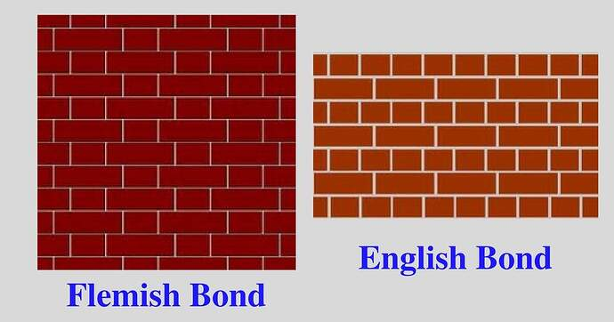
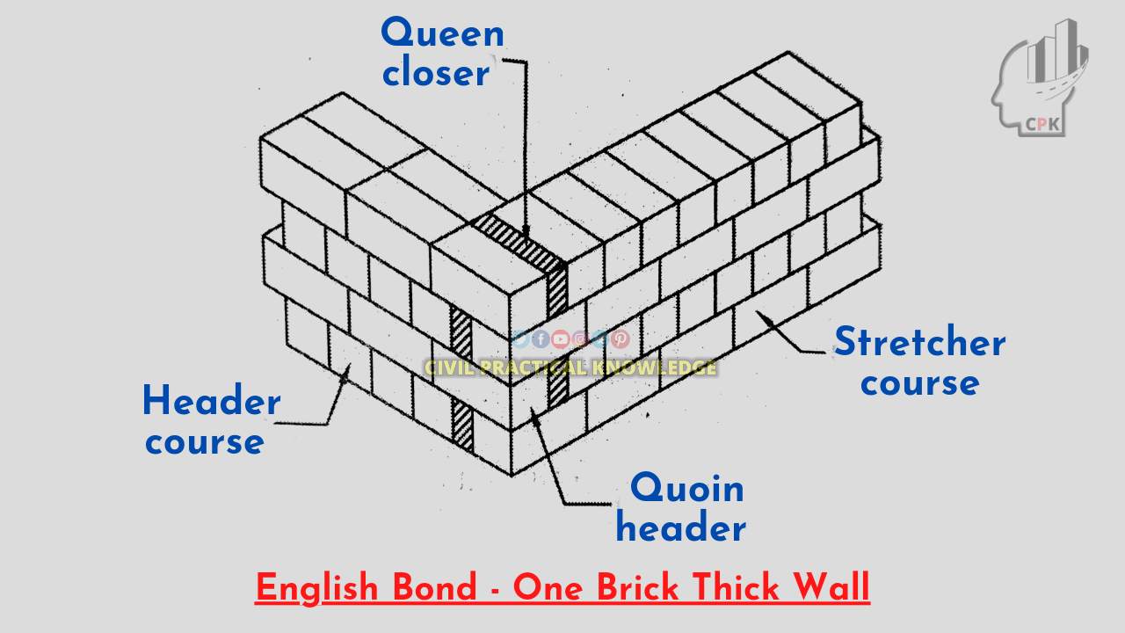
Fig 4 English Bond
Fig 5 Queen Closer

Another typical design is the Flemish bond, which involves alternating stretchers and headers in a single course. Flemish bond is aesthetically pleasing, but it is less durable than English bond for a load bearing wall construction. It is commonly used for walls that are two brick thick [12]. Flemish bond is a brickwork design in which stretchers and headers alternate between each course. It's a typical design commonly employed in Georgian buildings [2]. Although Flemish bond is preferred for its aesthetic appeal, its reliance on vertical mortar joints and possibility for less effective load distribution make it less appropriate for heavy loads than other bonds, such as English bond. Each course of Flemish bond consists of alternating stretcher and header bricks. Despite its beautiful appearance [6]. Flemish bond's construction can be more difficult to construct and cannot provide as much structural integrity for bearing heavy loads. Because of its harmonious and eye-catching alternating pattern of headers and stretchers, Flemish bond is a popular choice for decorative facades and walls where aesthetics is crucial. In load distribution, because of its overlapping header and stretcher design, English bond is renowned for its exceptional strength and capacity to distribute loads more efficiently. For load-bearing walls that must sustain a lot of weight and pressure, this makes it a better option. However, it is a popular choice for many classic structures due to its structural integrity and aesthetic appeal [10].

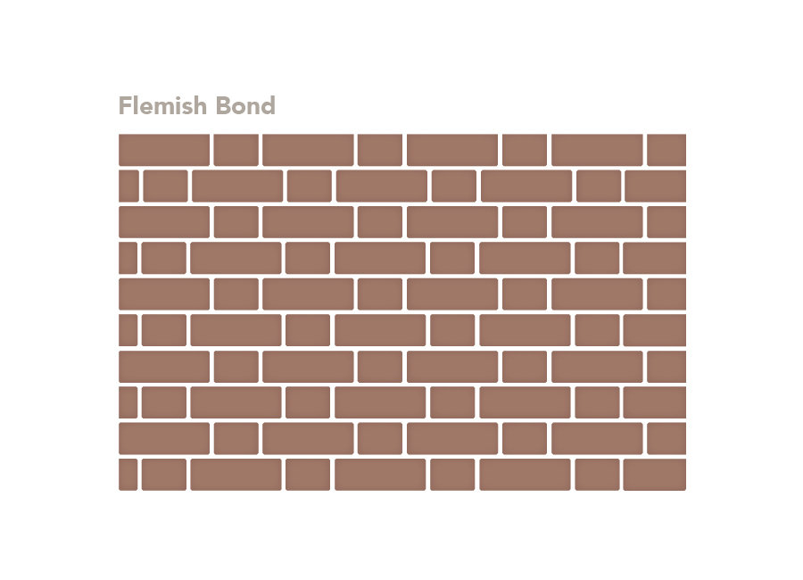
Header Brick
Stretcher Brick
Fig 6 Flemish Bond

In the stack bond pattern, bricks are put directly on top of one another, with all joints aligned. The bricks are placed vertically down the wall, resulting in less bonding; hence this brickwork pattern has less structural strength than others. This pattern is commonly used for decorative purposes [10].
Fig7 Stack Bond

English Garden Wall bond consists of three rows of stretchers and one row of headers. It is infrequently found on buildings outside of the north of the United Kingdom, where it is abundant, especially on the east coast. It was utilised beginning in the late 18th century and was occasionally used to build garden walls. It contains fewer facing bricks than English bond [13].
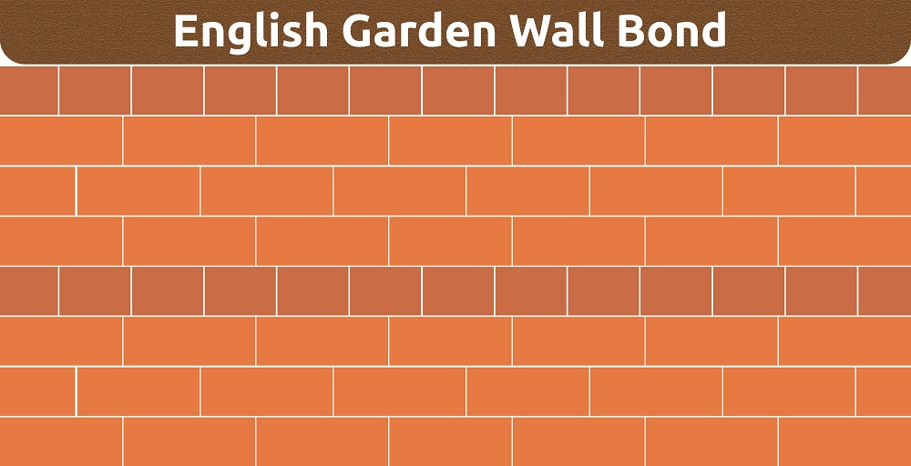
Fig8 English Garden Wall Bond

gharpedia.com

Flemish Garden Wall bond, also known as Sussex bond, consists of three stretchers and one header in each row. Ironically, this bond was rarely employed on garden walls in the past. It is most prevalent in West Sussex and Hampshire, where it can be found on up to 10% of historic structures [13] [15].
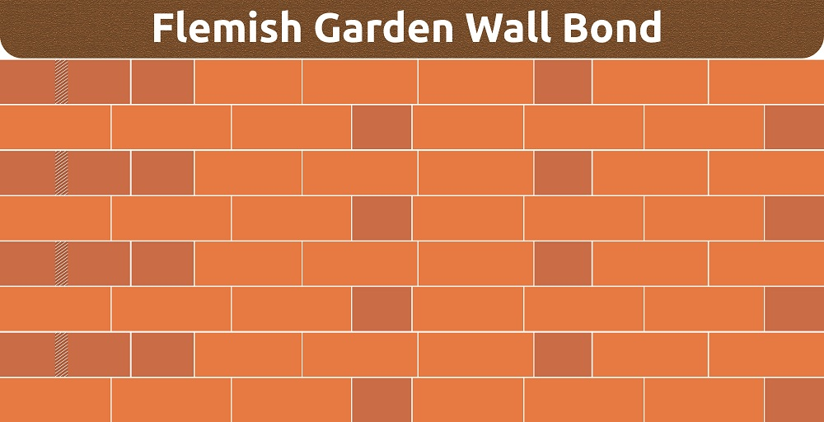
Fig 9 Flemish Garden Wall Bond

gharpedia.com

A ¹/3 Running Bond Pattern, also known as utility brick, offsets the second row of bricks by one-third of their width. The third row moves back and aligns with the first [1].
^{Fig 10 1}/3 Running Bond

The herringbone bond pattern is well-known for its complicated, interlocking design, which adds visual intrigue and texture to any outdoor location. This pattern uses rectangular 4x8 bricks arranged at 45-degree angles to create a sequence of V-shaped patterns [4]. Mark a 45-degree angle on the corner of one brick to indicate where the herringbone brick pattern should begin. Then, arrange nine bricks. Line align the brick's leading corners using a straightedge. Then, measure and record the distance between the 45-degree line and the straightedge [14].
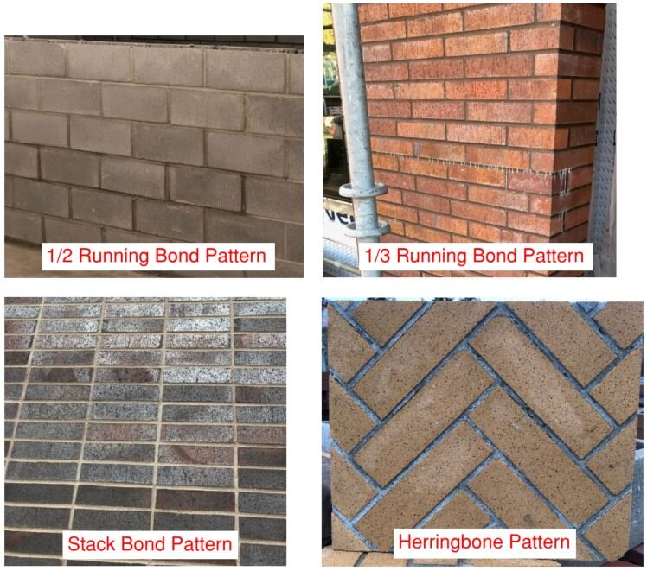
_{Fig 11 Herringbone Bond}

A zigzag bond, similar to the herringbone bond, is a brick-laying pattern that results in a zigzag pattern. It is frequently used for pavement, such as pathways and floors, however it is not commonly utilised for structural walls because to its strength limitations [8]. While both "zigzag bond" and "herringbone bond" refer to a brick-laying pattern creating a zigzag appearance, the key difference is that "herringbone bond" specifically describes a pattern where bricks are laid at a 45-degree angle in alternating directions, creating a more defined and geometric zigzag, whereas "zigzag bond" can refer to a more general zigzag pattern without the strict 45-degree angle specification [14].

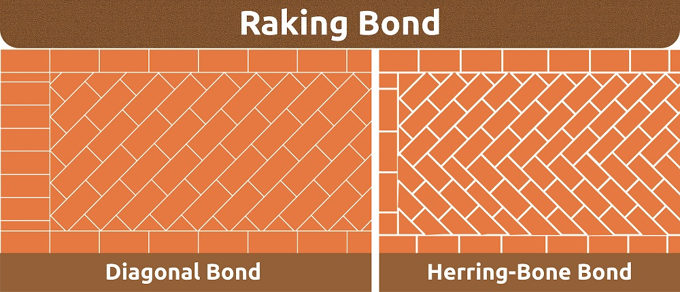
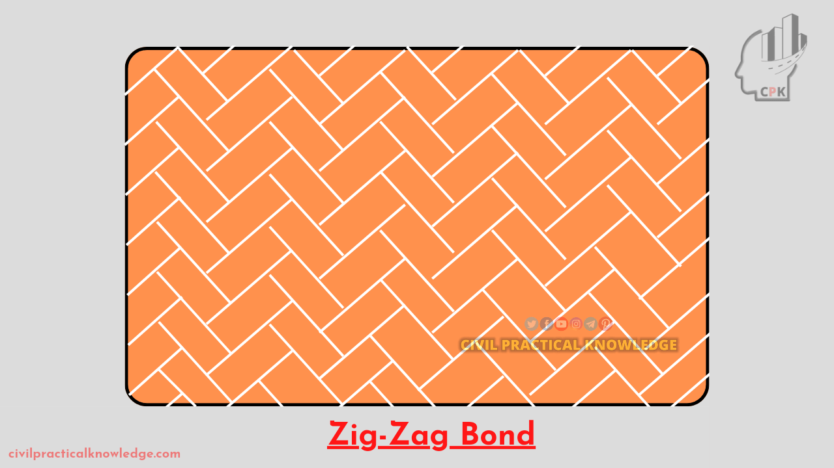
Diagonal Bond
Herringbone Bond
_{Fig 12 Zigzag Bond}
_{Fig 13 Raking Bond}

The Raking Bond bricks are arranged at an angle to form various diagonal designs. These patterns might be just decorative or improve the wall's stability. This bond pattern is made up of Herringbone Bond, which involves laying bricks diagonally in opposite directions to form a V shape that can provide significant strength while also being visually appealing. And Diagonal Bond, which adds diagonal layers of bricks to a wall, typically increases the strength of a mass wall or thick partition [11] [15].

Common bonds are sometimes known as American bonds. The main distinction between common bond and English bond brickwork is that English bond alternates courses of stretchers and headers in each row, whereas common bond primarily uses stretcher courses with occasional header courses inserted in every sixth rows as shown below, resulting in a less structurally robust pattern that is typically used for non-load bearing walls such as garden walls. In this case below, the headers are arranged at every sixth row [11] [8].

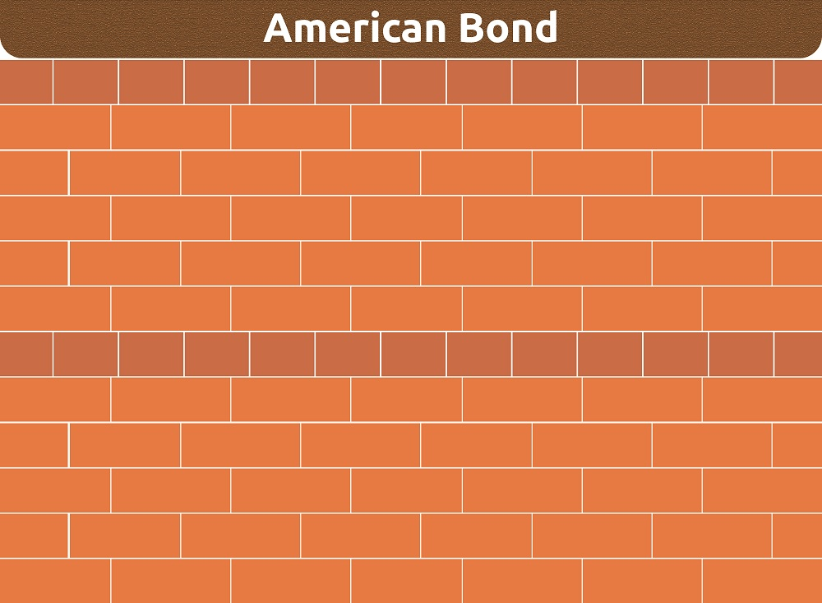
Fig 14 _{Common/American Bond}

A Scottish bond consists of numerous rows of stretchers followed by a row of headers, typically every sixth row, to create a strong wall with a distinct pattern. The American bond is similar, but it employs various stretcher courses before a header course, most likely every tenth row, depending on regional norms. The Scottish bond is a bricklaying pattern that is a variation of the American bond, or common bond. It is created by adding a header course every fifth, sixth, or seventh course [4][5].
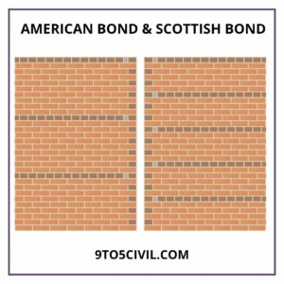
_{Fig 15 Scottish Bond}

Rat Trap Bond is a hollow wall pattern where bricks are put on their edges rather than flat. This creates a cavity within the wall that gives superior thermal insulation. It utilises fewer bricks, making it less expensive, but its construction is difficult and requires expert personnel [4][8].
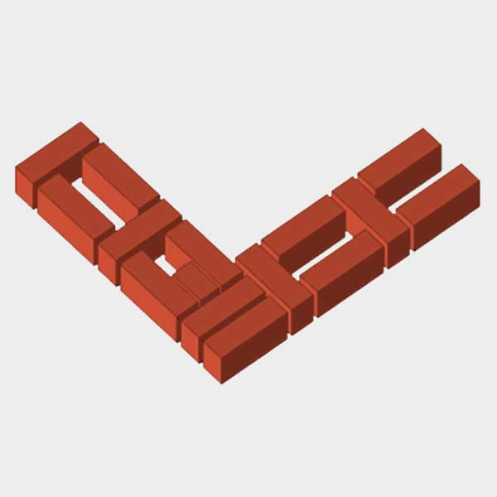
_{Fig 16 Rat Trap Bond}

This bond pattern is a brick masonry technique that includes vertically stacking bricks to form a cavity within the wall. The term refers to the hollow chamber, which resembles a rat trap [4][8].

In Monk Brick Bond, between the headers in each course, there are two stretchers. The connection between the two stretchers in the course below is in the centre of the headers [4].

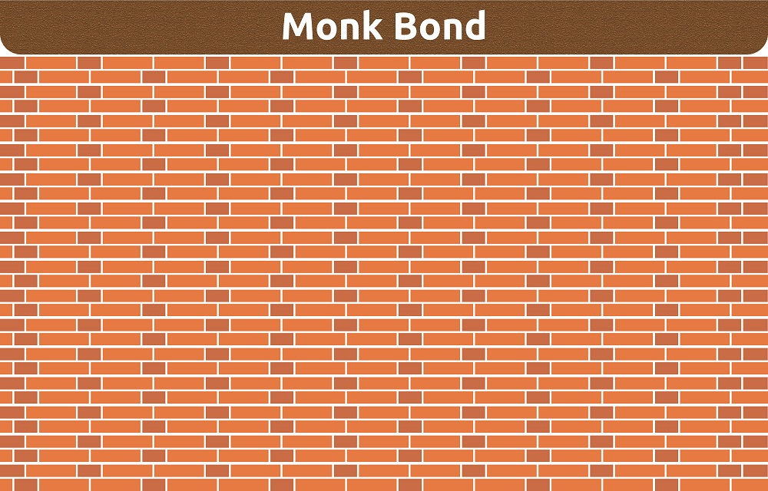
_{Fig 17 Monk Bond}

The Monk Bond brickwork method is a brick bonding pattern named from its relationship with mediaeval monastic buildings built by monks. The Monk Bond brickwork technology has a variety of applications in construction. It is frequently used in the restoration of historical structures, particularly those with monastery or mediaeval architectural forms, to preserve its authenticity and visual identity [6][9]. The Monk Bond is often used to build boundary and garden walls, where it provides strength, stability, and an appealing alternating pattern of stretchers and headers. The Monk Bond can also be used to produce decorative features in larger brickwork projects, such as arches or wall sections [9].

In a facing bond, the header course occurs only after multiple stretcher courses. It is widely used for constructing thick walls. Bonding the two differing thicknesses of the facing and backing walls can be quite useful. However, the number of joints between the facing and backing faces is not equal because to the uneven load distribution induced by the wide variety of thicknesses. This non-uniformity may also cause the masonry walls to settle unevenly [3].
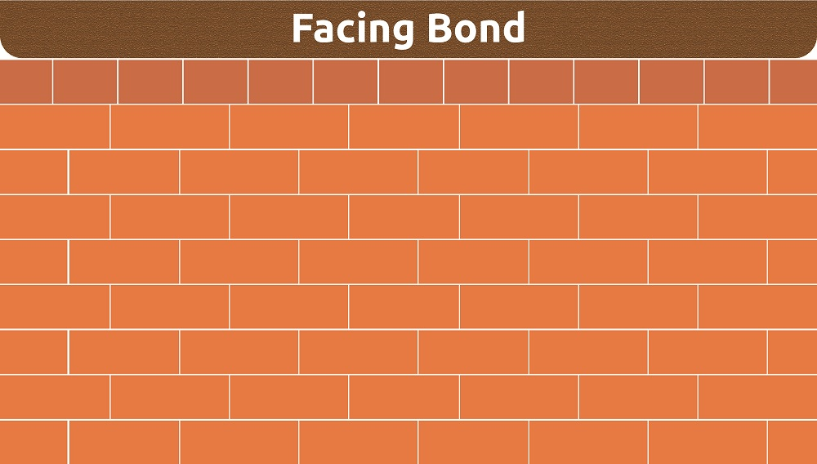
_{Fig 18 Facing Bond}

The pattern and texture of the wall are affected by how the mortar joints on the face of the wall are treated. The mortar has four functions: It binds the units together and plugs the spaces between them; it adjusts for dimensional irregularities in the units; it bonds to and so causes reinforcing steel to operate as an integral component of the wall; and it adds a decorative element to the wall surface by generating shadow or colour lines. Mortar joint finishes are divided into two categories: trowelled and tooled joints. In a trowelled joint, extra mortar is simply chopped off (struck) and completed with a trowel. In the tooled joint, a tool other than a trowel is utilised to compress and mould the mortar [11] [13].

A brick bond system is a specific arrangement of bricks relative to one another in which bricks are fixed in a special composition vertically, as well as lengthwise and transverse directions of the masonry construction. The behaviour of bricks in masonry is determined by the brick bond type chosen, and thus the structure's overall strength [12]. Many connected elements influence bond strength, including unit surface absorption, pore structure, mortar composition, mortar water retentivity, and curing conditions, as well as unit surface texture and craftsmanship [9]. The brick business faces significant environmental and cost challenges, particularly with energy usage and pollutants. The compressive strength of brick is crucial as an indicator of masonry strength; hence, brick strength has become an important need in brickwork design [2]. Surface qualities and suction are the most critical factors in determining bond capacity. The brick's total absorption capacity is also a significant factor in its performance. A high absorption rate makes bricks vulnerable to volume variations, which can cause cracking and structural damage in buildings [15]. It would also cause cracking if the water inside the pores was frozen and thawed repeatedly. Too little absorption is also undesirable because rainwater, rather than being partially absorbed by the brick, tends to flow off very quickly towards the joints and may make its way into the building, reducing the longevity of the mortar joints. The absorption is the amount of water that is drawn from the mortar to fill the pores in the clay brick [14]. For thousands of years, bricks have served as the foundation of architectural design and building. Bricks have developed but remain vital to building structures, ranging from sun-dried mud bricks in ancient Mesopotamia to high-strength concrete bricks in modern skyscrapers. While a brick may appear to be a simple component, its size can have a tremendous impact on a building's design and integrity. This article goes into the typical measurements of bricks in various countries across the world, examining how these standards meet differing aesthetic and structural needs [1].

- DATA AND SOURCES OF DATA

The primary data for this study was collected through a mixed research technique. The research objective is to undertake a thematic analysis of brick bonds. Peer review of online literature makes it easier to gather relevant and accurate data. This is more effective than other search engines. The qualitative and quantitative results of earlier investigations are merged and described. The literature review aids the gathering of existing data on the issue. To assure quality, this study only includes papers published in peer-reviewed books, journals, and articles. The Google search engine is also utilised for quick and direct data collection.

- RESULTS AND DISCUSSION
A typical brick may have a different meaning in a place like Sydney than in San Francisco or Shanghai. Bricks are typically small rectangular blocks that can be handled with one hand and used with mortar to make walls, pavements, and other architectural features. They are frequently made of clay or concrete and are valued for their durability, strength, and insulating properties.

There are two types of bricks: modular and non-modular. Modular bricks are designed to integrate mortar joints in their size specifications, resulting in uniform dimensions that simplify design and construction. Non-modular bricks can vary in size more dramatically and are less popular in modern buildings. They are frequently observed in historical or specialised applications.

The Standard brick dimensions were determined to vary depending on the region of application:
Bricks are widely available in a variety of sizes in the United States and Canada. The most popular categories are modular (3 ⁵/8 inches by 2¹/4 inches by 7⁵/8 inches) and utility (3⁵/8 inches by 3⁵/8 inches by 11⁵/8 inches). Norman bricks, another popular choice, measure 2¹/4 by 3⁵/8 by 11⁵/8 inches. These specifications serve to guarantee that bricks fit into typical house and commercial construction plans, hence supporting structural calculations and aesthetics.

In Europe, brick sizes are frequently measured in metric units, as opposed to imperial units used in North America. For example, in the United Kingdom, a standard brick measures 215 mm by 102.5 mm by 65 mm. These measurements differ slightly in different nations, such as Germany or Spain, reflecting local construction practices and historical influences. This variation in size highlights the need to modify building materials to local environmental circumstances and cultural preferences.

In Asia, Local resources, climate, and building techniques all have an impact on brick dimensions throughout Asia, particularly in India and China. A typical Indian brick measures 190 mm by 90 mm by 90 mm, which differs significantly from the normal Chinese dimensions of 240 mm by 115 mm by 53 mm. These sizes reflect the manual handling procedures that are still used in construction practices in these areas.

In Nepal, the typical brick measurement in Nepal is 240mm x 115mm x 57mm (length x depth x height), as defined by Nepal's National Building Code (NBC). Nepal's National Building Code (NBC 205: 1994) requires bricks to be rectangular, burned red, hand-formed or machine-made, and have a crushing strength of at least 3.5 N/mm². The greater the density and strength, the better they will be. The conventional brick dimension of 240 x 115 x 57 mm, with 10 mm horizontal and vertical mortar joints, is preferred. Tolerances of -10 mm in length, -5 mm in breadth, and ±3 mm in thickness are permitted for thick walls under Mandatory Rules of Thumb (MRT). The primary goal of Mandatory Rules of Thumb (MRT) in Nepal's National Building Code is to provide ready-to-use dimensions and details for various structural and non-structural elements for up to three-story reinforced concrete (RC), framed, ordinary residential buildings, which are commonly built by owner-builders in Nepal.

In Australia, standard bricks measure roughly 230 mm by 110 mm by 76 mm, which is slightly larger than many of its global counterparts. This size is intended to respond to Australia's specific climatic conditions, including changing climates and seismic activity considerations.

In the Middle East and Africa, The Middle East and Africa have a wide range of brick sizes, which are often determined by the special needs of the local environment. For example, larger brick sizes are prevalent in Egypt to give better insulation from the harsh sun and heat, yet brick measurements in South Africa are frequently similar to those found in European standards due to historical trade relations

In Bangladesh, the normal brick dimensions are 9¹/2 x 4¹/2 x 2³/4 inches (length, depth, and height).
The specialty bricks, such as bull nose (with a rounded edge), channel (with a groove), and coping (made for capping walls), vary in size and shape depending on the area of the brick. These bricks have specific uses in building aesthetics and usefulness, such as water direction or decorative finishes.

In terms of the Impact of Brick Size on Construction, the size of a brick determines not only a building's beauty but also its structural integrity and construction efficiency. Larger bricks minimise the number of joints and speed up the construction process, but they may be heavier and more difficult to handle. Smaller bricks, on the other hand, provide for more design flexibility and finer detail while requiring more care in placing.
Regarding future trends in Brick Production, as technology advances, so do brick-making techniques. Recent advancements include the production of lighter, more energy-efficient bricks as well as bricks constructed from recyclable materials. Such technologies reflect a rising emphasis on sustainability in the construction sector.

The investigation discovered that there are numerous types of bricks based on their dimensions (length, depth, and height):
● Modular Brick: The mortar thickness is added to the brick measurements. Modular brick dimensions: 194 x 92 x 57 mm (7⁵/8 × 3⁵/8 × 2¹⁄4 inches).
● Modular Economic Brick Dimensions: 194mm x 92mm x 92mm.
● Engineering brick is an effective solution for applications that require precise strength, porosity, and resistance to acids and gases. This brick is 194mm x 92mm x 71m (7⁵/8 × 3⁵/8 × 2³/4 inches). This brick comes in three sizes: Jumbo Modular (194mm x 92mm x 70mm), Jumbo Standard (203mm x 92mm x 70mm), and Jumbo Standard.
● Slim Jumbo Modular brick dimensions are 194mm x 76mm x 70mm. This brick comes in three sizes: King (244mm x 76mm x 67mm), Queen (244mm x 79mm x 70mm), and Closure (194mm x 92mm x 92mm).
● Norwegian brick dimensions: 295mm x 92mm x 71mm.
● Roman Brick Dimensions: 295mm x 92mm x 41mm.

● Norman: This brick is 295mm x 92mm x 57mm.
● Slim Jumbo Norman: This brick is 295mm x 79mm x 70mm.

The dimensions of the Monarch brick are 397mm x 92mm x 92mm.
● Double Monarch brick has dimensions of 397mm x 92mm x 194mm.
● Thru wall bricks come in three sizes: 397mm x 143mm x 92mm, 397mm x 194mm x 92mm, and 407mm x 194mm x 194mm.

● Danish Hand Mould: This brick is 194mm x 92mm x 57mm.
In addition to the numerous brick dimensions; global building agencies maintain a standard brick dimension. The normal brick size for working purposes is 225mm x 112.5mm x 75mm (length, depth, and height). This contains 10 mm mortar joints, and the actual brick measurement is 215 x 102.5 x 65 mm, as used in the United Kingdom.

Modern standard bricks in the US measure approximately 8 × 3⁵⁄8 × 2¹⁄4 inches (203mm × 92mm × 57mm) and are controlled by the American Society for Testing and Materials (ASTM). The most commonly used modular brick measures 7⁵⁄8 × 3⁵⁄8 × 2¹/4 inches (194mm × 92mm × 57mm). This modular brick of 7⁵⁄8 with a ³⁄8 mortar junction eases the computation of the number of bricks in a specific run.

In South Africa, the normal imperial size is 222mm long, 106mm wide and 73mm high, with a mass ranging from 3.0kg to 3.5kg.
Several considerations were considered when determining the final size. One of the most essential factors was ease of handling in relation to bricklaying speed, or making sure the brick wasn't too big to hold in one hand. Another important aspect was how the planned sizing would fit inside a 100mm module size. A module size is a specified manufacturing size that all building components should be made to fit, either individually or in multiples of 100mm. The advantages of sticking to this uniform module size include less scrap material generated from items that need to be cut on-site, less requirement for bespoke production, and the ability to streamline the range of product sizes kept in stock.

Although the new metric size did not conform to the 100mm module, it did fit within a 300mm module multiple (a preference indicated in BS 4011). The advantages of this were that the new size was not only consistent with metric block work, but it could also be utilised alongside imperial size bricks. When it comes to designing and building with brick, size counts. Because clay is such a versatile material, bricks may be manufactured in a variety of sizes. The most typical brickwork size in the UK is 215 x 102.5 x 65mm.

Brick dimensions influence a variety of factors, including how a building is planned, its overall aesthetic look, and how readily the bricks may be laid. Whatever brick size is chosen for a project, it is critical to consider these measurements during the design stage to avoid cutting and potential difficulties on site. The size of the bricks and mortar joints used will have a significant impact on the layout of the brickwork. It is critical that places such as window and door openings, brick piers, and so on are properly laid out, as varied brick sizes and mortar profiles will influence these components of a building.

The construction industry uses a variety of brick pointing types. The pointing ensures that mortar is correctly filled into the bed joints and perpends. Pointing is often done an hour or so after the bricks have been put, long enough for the mortar to solidify but not so long that it becomes unusable. If the un-pointed joints are not completely full, fill them with fresh mortar before tooling to the desired style.

- ANALYSIS OF RESULTS
  - Rules for Effective Bonding in Brick Masonry

Using the right type of brick bond pattern is necessary to constructing strong and cost-effective brick walls.

TABLE 1. Rules for Effective Bonding in Brick Masonry
Rule No. | Description
1 | All the bricks must be of the same size and shape.
2 | The same mortar thickness must be used between bricks, typically 10mm.
3 | Use the best laying pattern for the brick wall
4 | Avoid straight joints running down the wall. Overlap the bricks to reinforce the wall.
5 | Fill the gaps between bricks completely to keep water out of the wall and strengthen the wall.
6 | Close any end gaps with half or cut bricks to avoid leaving long, straight fractures.
7 | Use strong mortar (the paste) mixture that is powerful and long-lasting.
8 | Wet the bricks before using them to prevent them from absorbing too much water from the mortar.
9 | Ensure that the wall is straight up and horizontally level while building it.
10 | Maintain dry wall all through so that the mortar becomes exceptionally strong and durable over time.

  - Merits of using bricks

TABLE 2. Advantages of using bricks

S/No. | Merits | Description
1 | Resilience | Bricks are weather and age-resistant, able to withstand even the hardest conditions, including extreme maritime environments and cyclones, as well as wildfire-prone places. Bricks are also termite resistant because termites cannot consume them. If you build a full brick home with a steel roof frame on a concrete slab, your home will be termite resistant in all structural parts.
2 | Design Flexibility | Bricks are available in a variety of styles to accommodate any building project. Brick has always been a popular building material choice among architects and designers due to its architectural versatility, strong structural qualities, and detailed details. Whether you want to build a contemporary cliff-top hideaway, an inner-city living/work terrace, a school, an art gallery, or a heritage restoration project, there are bricks to suit any architectural style.
3 | Low Maintenance | Bricks do not require any maintenance. Unlike other building materials, bricks do not need to be painted, coated, or varnished to maintain their appearance and durability. Long-lasting brick is entirely weatherproof, even under extreme conditions like storms, and because bricks do not contain plant stuff, they are pest-resistant and will not degrade in hot or humid climates.
4 | Durability | Bricks are long-lasting. After it's built, your brick home is weatherproof and age-resistant, with minimal maintenance. Brick does not fatigue like other man-made materials, so you can have a sound mind as well as a sound home.
5 | Environmentally Friendly | Brick is a healthy and natural building material. Brick is sourced sustainably from the earth's natural and abundant materials, and it is 100% recyclable, allowing it to be utilised in renovations, new projects, or as landscaping mulch. Energy-efficient clay brick is designed to last generations with little upkeep.
6 | Fire Resistant Material | Bricks are fire retardant. Bricks are non-combustible and do not aid in the spread of fire, making them excellent for construction in wildfire-prone locations. Clay bricks often suffer little structural damage after a fire and can be reused as load bearing walls. However, bricks alone do not fireproof a building, unlike wood and plastic, which are flammable, and glass, which shatters in the heat. Building using brick provides a firm foundation for protecting the investment.
7 | Noise Cancelling | Bricks function as a sound barrier. Brick provides exceptional sound insulation, whether between rooms within a home or against outside noise. So, whether it's the garbage truck outside at 5 a.m. or your teen's drum kit at 11 p.m., you may enjoy more peace and quiet at home.
8 | Energy Efficient | Clay brick is inherently energy efficient and helps to keep your home cooler in the summer and warmer in the winter, thereby saving money on energy bills.
9 | As a Structural Unit | Clay bricks or burnt bricks are robust, hard, durable, and resistant to abrasion and fire, hence they are employed as a structural material in various projects.
10 | Aesthetic Unit/Surface Finish | Bricks can be used in varied colours, sizes, and orientations to create various surface designs.
11 | Affordable Investment | Brick exteriors account for less than 10% of the overall building cost. A brick home will frequently cut your insurance premiums and increase resale value. With almost no care, money is saved on repairs and upkeep over time, while receiving the benefits of brick.
12 | Weight | Bricks are lightweight; therefore, handling is quite easy.
13 | Recyclability | Bricks are recyclable and can be utilised for other project management, such as landscaping.

  - Demerits of using bricks
TABLE 3. Disadvantages of using bricks

S/No. | Demerits | Description
1 | Design limitations | Bricks come in standard shapes and colors, offering less design versatility compared to other options
2 | Moisture vulnerability | Porous bricks can absorb moisture in damp environments, leading to potential mold growth and damage if not properly treated.
3 | - Expense | Bricks are generally more expensive than other building materials like vinyl siding, increasing the overall construction cost.
4 | Skilled labor required | Properly laying bricks requires skilled masons, which can be challenging to find and may increase costs
5 | Cracking potential | Improper installation or structural stress can lead to cracks in brick walls.
6 | Labour intensive | Due to their weight, bricks require more labour to transport and install, adding to project costs.
7 | Time consumption | Using brick is time-consuming
8 | High seismic zones | Bricks cannot be used in high seismic and sensitive zones as they have less tensile strength
9 | Rough surfaces | Rough surfaces of bricks may cause mold growth if not properly cleaned
10 | Low tensile strength | If attention is paid to the strength and durability, brick proves to have Less tensile strength compared to stone masonry
11 | Color changes | The color of low-quality brick changes when exposed to the sun for a long period
12 | Cleaning Difficulty | Cleaning the brick walls is a very difficult task as they cannot be cleaned by a simple piece of cloth.
13 | Dampness | In the rainy season, brick absorbs the water, and there is a possibility of dampness

  - Standard face brick (house brick) dimensions
TABLE 4. Standard face brick (house brick) dimensions

Standard Brick Dimensions by geographical area
S/No. | Area | Metric in millimeter (mm) | Imperial in inches (in)
1 | South Africa | 222 x 106 x 73 | 8¾ x 4 x 3
2 | Russia | 250 x 120 x 65 | 10 x 4¾ x 2¹/2
3 | India | 228 x 107 x 69 | 9 x 4¼ x 2³/4
4 | Australia | 230 x 110 x 76 | 9 x 4¹/3 x 3
5 | Sweden | 250 x 120 x 62 | 10 x 4¾ x 2¹/2
6 | Romania | 240 x 115 x 63 | 9 x 4¼ x 2¹/2
7 | Denmark | 228 x 108 x 54 | 9 x 4¼ x 2¹/4
8 | United Kingdom | 215 x 102 x 65 | 8½ x 4 x 2¹/2
9 | Germany | 240 x 115 x 71 | 9 x 4¼ x 2³/4
10 | United States | 194 x 92 x 57 | 7⁵/8 x 3⁵/8 x 2¹/4
11 | Canada | 194 x 92 x 57 | 7⁵/8 x 3⁵/8 x 2¹/4

  - Coordinating size of bricks
Co-ordinating size
Working size

The coordinating dimensions are the physical space occupied by a brick plus the mortar necessary for one bed, one header face, and one stretcher face. The mortar thickness is usually 10mm. The working dimensions are the sizes at which manufacturers will attempt to create bricks. It has the precise manufacturing size of a brick. A brick's working and coordinating dimensions differ by 10mm (0.4"), which is compensated for by the layer of mortar into which the bricks are pressed when laying. The working dimensions are frequently referred to as the nominal size of a brick.

  - Brick bonds and their applications
TABLE 5. Brick bonds and their applications

S/No. | Bond Type | Application
1 | Stretcher Bond | While not exceptionally sturdy, it is a quick and cost-effective method of placing bricks. This bond is frequently used for walls where strength and beauty are not as important, such as garden walls and internal partitions.
2 | Flemish Bond | Flemish bond is aesthetically pleasing, but it is less durable than English bond for load-bearing wall construction. It is commonly used for walls that are two bricks thick. It is frequently used for decorative or high-quality brickwork, including facades and notable walls.
3 | English Bond | This classic pattern, known as the English bond, is regarded as one of the strongest ties and is widely utilised in bridge and engineering projects. It needs more face bricks than other patterns. It is widely employed in load-bearing walls and has an appealing appearance due to its alternating pattern.
4 | Garden Wall Bond | This pattern is similar to stretcher bond in that all bricks are laid as stretchers, but it also incorporates occasional headers for increased strength. It is commonly used for non-structural garden walls. Garden wall bonds, also known as common bonds, are appropriate for non-load-bearing walls such as garden walls that require structural integrity.
5 | Header Bond | The header bond is a bricklaying design in which bricks are laid with the short end, or header, facing outward. This connection produces a characteristic pattern of exposed headers on the surface of the wall. It is commonly used to make walls that are one-half brick thick, such as cavity walls and partitions.
6 | Stack Bond | Stack bond is a decorative bond in which all bricks are stacked directly on top of one another, without any overlapping. Because it lacks the structural solidity of other bonds, it is commonly utilised in modern or contemporary designs.
7 | Rat Trap Bond | The Rat Trap Bond, also known as the cavity wall bond, is a type of brick bond that has a number of vertical and horizontal cavities across the wall's thickness. It is termed "Rat Trap" because the cavities resemble the sections of a rat trap. This design offers thermal insulation and is energy efficient.
8 | Diagonal Bond | A diagonal brick bond, also known as a diagonal bond or diamond bond, is a bricklaying pattern in which bricks are placed at 45-degree angles to the wall's horizontal and vertical axes. This arrangement results in a striking diagonal or diamond-shaped pattern on the wall's surface. It is frequently used to create accent features on walls and floors.

- CONCLUSION

In brick masonry work, an English bond is made by laying one course of stretcher and another course of header above it, resulting in a pattern formed by alternating courses of stretcher and header. The queen closer is used to interrupt the continuity of vertical joints at the beginning and finish of a wall, following the first header in each heading course. A queen closer is a brick that has been cut lengthwise into two halves and is used at brick wall corners. English bond is among the strongest; however, it requires more face bricks than other bonds. The stretcher bond's shortcoming is that it cannot form an effective and strong bond with adjacent bricks in full-width, thick brick walls. To ensure the project's particular structural needs when employing stretcher bond, professional advice is required. Stretcher bond is more economical and ease of use in practice when compared with other types of bonds. They are only ideal for walls that are half a brick thick, such as partition walls. Walls built with stretcher bonds are not strong enough to stand alone in cases of lengthy span and height. This bond is commonly utilised as the outer facing in steel or reinforced concrete framed constructions, as well as the construction of cavity walls. Stretcher bond is used to produce half-brick walls, whereas header bond is used to construct full-brick walls. Flemish bond is one of the most durable types of brick bond for building construction. The demerits of utilising Flemish bond is that it is tough to create and requires a high level of ability to lay it perfectly because all vertical mortar joints must be lined vertically for the best results. Even though Flemish bonds look nicer, they are weaker than English bonds for load-bearing wall construction. So, if pointing is required for brick walls, the Flemish bond can be employed for the finest aesthetic view, whereas the English bond is better suited for plastered walls. Raking bond is a type of brick bond in which the bonding bricks are placed at any angle other than zero or ninety degrees. This configuration contributes to the longitudinal stability of thick walls erected in English bond. Diagonal Bond is best suited for walls with two to four brick thicknesses. In this sort of bond, the bricks are arranged end to end so that the extreme corners of the sequence remain in contact with the stretchers. Herringbone bond is best suited to walls that are at least four bricks thick. This form of bond is also widely utilised in brick paving. A Zig-Zag bond is extremely similar to herringbone bond; the main difference is that the bricks are set in a zig-zag pattern. It is widely used in brick-paved flooring.

AcknowledgEments

I do wish to appreciate my family members who assisted me with funding of this project. May God bless them abundantly. This fund assisted me in data collection and other miscellaneous activities. I also do appreciate their technical support that made this project a successful one.

CONFLICTS OF INTEREST
“The author(s) declare(s) that there is no conflict of interest regarding the publication of this paper.”

Funding Statement
The research and publication of this article was funded by the author.

REFERENCES

[1] Ahiwale, D.D., Kontoni, DP.N., Jadhav, A.V. et al. (2023). FEM analysis of the effect of various brick bond patterns on masonry walls under in-plane cyclic loading. Asian J Civ Eng 24, 2629–2643 (2023). https://doi.org/10.1007/s42107-023-00668-4

[2] Civil practical knowledge (2023). Types of bonds used in brick masonry

[3] Constructor. (2024). Civil Engineering Home. Types of Bonds in Brick Masonry Wall Construction. 2016. Available online: https://theconstructor.org/building/types-bonds-brick-masonry-flemish-english-wall/11616/ (accessed on 18 November 2024).

[4] Deepak, B. (2012). Sustainable dry interlocking block masonry construction. In Proceedings of the 15th
International Brick and Block Masonry Conference, Florianópolis, Brazil, 3 June 2012.

[5] El-adaway, I.; Breakah, T.; Khedr, S. (2012). Brick Masonry and Sustainable Construction. In Proceedings of the ICSDC 2011: Integrating Sustainability Practices in the Construction Industry, Kansas City, MO, USA, 18 January 2012; pp. 524–534.

[6] Evgeniy P., and Alina I. (2019). Prospects for the use of extraordinary brick bond types, E 3S Web of Conferences 164, 08004 (2020). 1 .mb0 bc os, 2019

[7] Freeda C., Mercy R. S., and Tensing D., (2018) Bond Strength of the Brick Masonry. International Journal of Architecture(IJA),4(1), 2018, pp. 22-28. http://www.iaeme.com/IJA/issues.asp?JType=IJA&VType=4&IType=1

[8] Khuzwayo, B.P; Walker, M., and Graham, B. (2023). Improving South African Masonry Construction Industry. African Journal of Inter/Multidisciplinary Studies 2023 | 5(1): 1-11 | DOI: https://doi.org/10.51415/ajims.v5i1.1064

[9] Kolawole, J. T., Oladimeji B. O, and Ademola J. O, (2020). Adhesive bond potential of compressed stabilised earth brick, Structures, Volume 23, 2020, Pages 812-820, https://doi.org/10.1016/j.istruc.2019.12.024.

[10] Nalumansi J., Mwesige G. (2012). Determining Productivity of Masons for both Stretcher and Header Bonding on Building Sites. 2nd International Conference on Advances in Engineering and Technology, Nagapattinam. Nagapattinam, 2012, pp. 339-345.

[11] Pavía, S.; Hanley, R. (2010). Flexural bond strength of natural hydraulic lime mortar and clay brick. Mater. Struct. 2010, 43, 913–922.

[12] Pugach, E. & Iumasheva, A. (2020). Prospects for the use of extraordinary brick bond types. E3S Web of Conferences. 164. 08004. 10.1051/e3sconf/202016408004.

[13] Rakesh, K.M.; Sanjay, S.J. (2017). Sustainability in Construction through Masonry Alternatives. Int. J. Innov. Res. Sci. Eng. Technol. 2017, 6, 12836–12844.

[14] Shah S, Arshad H, Farhan M, Raza SS, Khan MM, Imtiaz S, Shahzadi G, Qurashi MA, and Waseem M. (2019). Sustainable Brick Masonry Bond Design and Analysis: An Application of a Decision-Making Technique. Applied Sciences. 2019; 9(20):4313. https://doi.org/10.3390/app9204313

[15] Shrestha, J. & Pradhan, S, & Gautam, D. (2020). In-plane behavior of various brick bonds in masonry walls. Innovative Infrastructure Solutions. 5. 58. 10.1007/s41062-020-00306-x.

[16] Singh S.B. and Munjal P. (2017). Flexural response of engineered cementitious composite (ECC) faced masonry. Journal of Building Engineering, Volume: 9, Pages: 10-16
[17] Stott, P R; Smith, Z.; and Theron, E. (2023). Alleviating the problem of cracking of masonry buildings on expansive clay by building flexibility into the masonry. Journal of the South African Institution of Civil Engineering. J. S. Afr. Inst. Civ. Eng. vol.65 n.1. https://doi.org/10.17159/2309-8775/2023/v65n1a2

