***Original Research Article***

**A Comparison of OFDM Techniques in Massive MIMO on Data Throughput and Spectral Efficiency in Digital Wireless Communication Systems**

**ABSTRACT**

The exponential increase in wireless services necessitate development of advance technologies for wireless communication to enable massive machine-type communications (mMTC), enhanced mobile broadband (eMBB), ultra-reliable low-latency communications (URLLC), and optimized resource management to achieve a seamless 5G and 6G goals. Therefore, high spectral efficiency and data throughput becomes the major focus in designing a robust wireless communication systems. This study examine the performance of massive multiple input multiple output (mMIMO) communication systems using wavelet-order orthogonal frequency division multiplexing (W-OFDM) and Fast Fourier Transform orthogonal frequency division multiplexing (FFT-OFDM). A communication system based on W-OFDM Massive MIMO was modelled in a MATLAB software and its performance was compared with FFT- OFDM. Key performance metrics, specifically the data throughput and spectral efficiency were evaluated to assess the effectiveness and capabilities of the two systems. The simulation results indicates that at a bandwidth of 20 MHz, W-OFDM achieved up to 35% reduction in peak-to-average-power-ratio (PAPR) compared to the FFT-OFDM. Also, at a Beat Error Rate of 0.0001 ms, the Signal-Noise-Ratio (SNR) for FFT-OFDM is 9.00 dB while W-OFDM achieved SNR of 12.00dB at BER of 0.01ms. This translates to a 20% improvement in beat error rate (BER) performance under Rayleigh fading conditions. Also, the data throughput of W-OFDM mMIMO outperforms FFT-OFDM by 15%, making it a viable technology to realise high data rates and reliability. Conclusively, the analytical evaluation confirmed that W-OFDM mMIMO provides substantial benefits for improving spectral efficiency and high data rate in wireless communication systems, addressing the challenges of increased user demands for high throughput. This research suggests that this technology can play a critical role in the improvement in spectral efficiency and high data rate for future generation network.

**Keywords**: 5G network, W-OFDM, mMIMO, FFT-OFDM, wireless communication, cyclic prefix, data throughput, spectral efficiency.

**1. INTRODUCTION**

Wireless communications is a method of transmission of voice and data without the use of cable or wires. In place of a physical connection, data travels through electromagnetic signals broadcast from sending facilities to intermediate and end-user devices [1]. As predicted by Terré et al. [2] and Zhang, et al. [3], communication technology will continue to advance swiftly in order to connect people with machines and objects through an ever-increasing exchange of information and to facilitate a multitude of new services, such as vehicle-to-vehicle communication, smart factories, and high-quality communication services. To achieve high throughput, more channels are required for basics spectrum efficiency also known as bandwidth efficiency or spectral efficiency, this is the amount of data that can be sent to a given number of users in a second and still have an acceptable quality of service over a particular spectrum or bandwidth with the fewest possible transmission errors [4, 5]. Spectral efficiency in wireless communication measures how efficiently the available bandwidth is used to transmit data. It quantifies the rate of data transmission per unit bandwidth while maintaining reliable communication [6, 7]. Spectral efficiency is expressed in **bits per second per Hertz (bps/Hz).**

A Fast Fourier Transform (FFT) is an [algorithm](https://en.wikipedia.org/wiki/Algorithm) that computes the [Discrete Fourier Transform](https://en.wikipedia.org/wiki/Discrete_Fourier_Transform) (DFT) of a sequence, or its inverse (IDFT). [Fourier analysis](https://en.wikipedia.org/wiki/Fourier_analysis) converts a signal from its original domain (often time or space) to a representation in the [frequency domain](https://en.wikipedia.org/wiki/Frequency_domain) and vice versa [8, 9]. The DFT is obtained by decomposing a [sequence](https://en.wikipedia.org/wiki/Sequence) of values into components of different frequencies. This operation is useful in many fields, but computing it directly from the definition is often too slow to be practical. An FFT rapidly computes such transformations by [factorizing](https://en.wikipedia.org/wiki/Matrix_decomposition) the [DFT matrix](https://en.wikipedia.org/wiki/DFT_matrix) into a product of [sparse](https://en.wikipedia.org/wiki/Sparse_matrix) (mostly zero) factors. As a result, it manages to reduce the [complexity](https://en.wikipedia.org/wiki/Computational_complexity_theory) of computing the DFT fromO(n2), which arises if one simply applies the definition of DFT, to O(nlog⁡n), where *n* is the data size [10, 11]. The difference in speed can be enormous, especially for long data sets where *n* may be in the thousands or millions. In the presence of [round-off error](https://en.wikipedia.org/wiki/Round-off_error), many FFT algorithms are much more accurate than evaluating the DFT definition directly or indirectly. There are many different FFT algorithms based on a wide range of published theories, from simple [complex-number arithmetic](https://en.wikipedia.org/wiki/Complex_number) to [group theory](https://en.wikipedia.org/wiki/Group_theory) and [number theory](https://en.wikipedia.org/wiki/Number_theory) [8].

Orthogonal frequency-division multiplexing (OFDM) is a method of digital data modulation, whereby a single stream of data is divided into several separate sub-streams for transmission via multiple channels [12, 13]. It uses the principle of frequency division multiplexing (FDM), where the available bandwidth is divided into a set of sub-streams having separate frequency bands. When any signal is modulated by the sender, its sidebands spread out either side. A receiver can successfully demodulate the data only if it receives the whole signal. In case of FDM, guard bands are inserted so that interference between the signals, resulting in cross-talks, does not occur. However, since orthogonal signals are used in OFDM, no interference occurs between the signals even if their sidebands overlap. So, guard bands can be removed, thus saving bandwidth. The criteria that need to be maintained is that the carrier spacing should be equal to the reciprocal of the symbol period [14, 15].

Massive MIMO is a technology that uses many antennas to multiplex messages for various devices on each time frequency source. The radiated energy is directed towards the desired directions while simultaneously minimizing intra- and inter-cell interference [16]. In a Massive MIMO system, the number of antennas at the base station is far greater than the total number of devices per signaling resource [17]. Massive MIMO has been shown to preserve information rate and reduce base station radiated power by a factor proportional to the square root of the total number of deployed antennas, all while maintaining energy efficiency [18].

This current research aims at highlighting and comparing the effectiveness of W-OFDM massive MIMO over the FFT-OFDM technology for increasing the data throughput and spectral efficiency of the communication system. The study is significant because wavelets have proven to be advantageous in nearly every facet of digital wireless communication systems, encompassing data compression, transceiver design, source and channel coding, signal denoising, and channel modeling. The main characteristic of wavelets in these applications is their flexibility and ability to accurately characterize signals. With the addition of Massive MIMO (mMIMO) technology in this study, the wavelet transform also provides greater flexibility in creating the pulse's shape. These two technologies have significantly improved data throughput, low energy consumption, and spectral efficiency.

**1.2 Wavelet Transform Algorithm**

The Wavelet transform is a way of decomposing a signal of interest into a set of basis wave-forms, called wavelets, which thus provide a way to analyze the signal by examining the coefficients (or weights) of wavelets [19, 20]. This method is used in various applications and is becoming very popular among technologists, engineers and mathematicians alike. In most of the applications, the power of the transform comes from the fact that the basic functions of the transform are localized in time (or space) and frequency, and have different resolutions in these domains [8]. Different resolutions often correspond to the natural behavior of the process one wants to analyze, hence the power of the transform. These properties make wavelets and wavelet transform natural choices in fields as diverse as image synthesis, data compression, computer graphics and animation, human vision, radar, optics, astronomy, acoustics, seismology, nuclear engineering, biomedical engineering, magnetic resonance imaging, music, fractals, turbulence, and pure mathematics.

According to Jamin and Mahonen [8], wavelet transform has also been proposed as a possible analysis system when designing sophisticated digital wireless communication systems, with advantages such as transform flexibility, lower sensitivity to channel distortion and interference and better utilization of spectrum. Wavelets have found beneficial applicability in various aspects of wireless communication systems design including channel modeling, transceiver design, data representation, data compression, source and channel coding, interference mitigation, signal de-noising and energy efficient networking.

**1.3 Fast Fourier Transform Algorithm**

The best-known FFT algorithms depend upon the [factorization](https://en.wikipedia.org/wiki/Factorization) of *n*, but there are FFTs with O(nlog⁡n) complexity for all, even [prime](https://en.wikipedia.org/wiki/Prime), *n*. Many FFT algorithms depend only on the fact that  e−2πi/n is an nth [primitive root of unity](https://en.wikipedia.org/wiki/Primitive_root_of_unity), and thus can be applied to analogous transforms over any [finite field](https://en.wikipedia.org/wiki/Finite_field), such as [number-theoretic transforms](https://en.wikipedia.org/wiki/Number-theoretic_transform). Since the inverse DFT is the same as the DFT, but with the opposite sign in the exponent and a 1/*n* factor, any FFT algorithm can easily be adapted for it [21, 22].

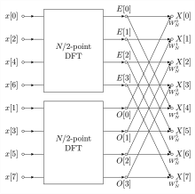

Chart 1: FFT Algorithm Structure [21]

**1.4 Spectral Efficiency $(η)$**

Spectral efficiency, or SE, is a measurement of how well a communication system uses the available bandwidth within a particular frequency band. It is commonly expressed in bits per second per hertz, or bps/Hz, and is used to compare the performance of multiple communication systems as well as evaluate a single system's performance under various conditions [23]. One approach to improving spectral efficiency is to apply more complex modulation schemes, such as quadrature amplitude modulation (QAM) or orthogonal frequency-division multiplexing (OFDM), which enable a communication system to transmit more bits per symbol [23]. Thus, in a massive MIMO system, spectral efficiency improves due to spatial multiplexing. Assuming Nt​ transmits antennas and Nr receive antennas, the channel can be modeled as a matrix H, and the capacity depends on the eigenvalues of H. Mathematically, spectral efficiency is expressed as:

$η=\sum_{k=0}^{\min{Nt,​ }Nr}{\log{(}}1+λi​⋅SNR)$ (1)

Where λi are the eigenvalues of the channel matrix HH H (Hermitian transpose times H).

**1.5 Data Throughput**

Data throughput can be increased by using multiple antennas (MIMO) at the transmitter and receiver to take advantage of the spatial diversity and multiplexing benefit. By adapting the modulation scheme in response to the channel state, the system can enhance throughput and more effectively handle changing channel circumstances [24, 25]. In a single-user MIMO system, the channel capacity (C) is given by:

$C=\sum_{i=1}^{N_{s}}{B.\log_{2}}\left(1+{SNR}_{i}\right)$ (2)

Where:

Ns​- Number of spatial streams (limited by the smaller of the number of transmit or receive antennas).

SNRi - Signal-to-noise ratio of the i-th stream.

With Massive MIMO, Ns increases significantly due to the large number of antennas, enabling simultaneous transmission to multiple users in the same frequency-time resource.

**1.6 Spectral Efficiency and Throughput**

As explained by Yusuf et al. [26], the spectral efficiency (SE) in bits/s/Hz for massive MIMO is greatly enhanced due to:

* Spatial multiplexing: Serving K users simultaneously, where K≤ M (number of base station antennas).
* Reduced interference: Due to highly directional beams.

For K users, the system throughput is:

$T=K.B.\log_{2 }\left(1+SINR\right)$ (3)

where:

* SINR - (Signal-to-Interference-plus-Noise Ratio) replaces SNR to account for interference.

Massive MIMO systems use beamforming to maximize SINR, ensuring that multiple users can coexist without degrading each other’s performance.

**2 METHOD**

The methods adopted in the study include the system channel model and linear processing using Zero Forcing Method with the help of MATLAB version R2018a and the HP ProBook 6550b version Laptop. The system design itself will be using the various power parameters.

**2.1 System Channel Model**

Since the MassiveMimo involves multiple antennas at the base station (BS) communicating simultaneously with multiple user equipment (UE). The channel model and linear processing schemes are the key components of this system's design and performance [26]. The channel between the BS and K users with M antennas at the BS can be represented as:

$H∈∁^{MXK}$ (4)

Where M is the number of BS antennas, K is the number of users, H= [h1,h2,……,hK], while hk∈CM×1 is the channel vector for user k

Since zero-forcing method is adopted, a small-scale fading is expected. Then the elements of **H** will typically experience Rayleigh fading and is presented a:

$H_{k}= \sim ∁N\left(O,β_{k}I_{M}\right)$ (5)

Where $∁$ N (0, βk) is the circularly symmetric complex Gaussian distribution while βk is the large-scale fading coefficient (path loss and shadowing).

**In uplink** (user to BS):

$y_{ul}=Hx+n$ (6)

Where: **yul**​ ∈CM×1 represents the received signal at the base station (BS), **X** ∈ CK×1 is the transmitted signal from users, while **n** ∈ CM×1 is the additive white Gaussian noise (AWGN).

**In downlink** (BS to user):

$y_{dl}=H^{T}Ws+n$ (7)

At the downlink, **ydl** ∈ CK×1 represents the received signal at users end, **W** ∈ CM×K is the Precoding matrix while **s** ∈ CK×1 - Transmitted symbols.

**2.2 Linear Processing**

Linear processing is employed to manage multi-user interference efficiently in both uplink and downlink. It includes:

**Uplink**

In the uplink, the BS applies a linear combining matrix $G∈∁^{KXM}$ to the received signal:

$\hat{S}=Gy_{ui}$ (8)

Where $S$- is the estimated signal vector

**Zero-Forcing (ZF):**

$G_{ZF}=\left(H^{H}H\right)-1H^{H}$ (9)

In addition, the uplink gross rate (in bit second) from the *kth* UE, where "gross" refers to, indicate that the overhead factors are not included. As earlier mentioned, the aim is to provide the same gross rate Rk-(ul) is R- for k=1,2…, K. This condition can be met if the uplink power allocation vector P (ul) is [P1(ul),P2(ul),….,Pk(ul)]T. This is presented in the equation 10 as:

$P^{(ul)}=σ^{2}{\left(D^{(ul)}\right)}^{-1}1_{k}$ (10)

where the (k, l) the element of $D^{(ul)}ϵC^{kxk}$ is

${\left[D^{(ul)}\right]}_{k,l}=\left\{\frac{{\left|g_{kh_{k}}^{H}\right|}^{2}}{\left(2^{R/B}-1\right){\left\|g_{k}\right\|}^{2}}-{\frac{\left|g_{kh_{l}}^{H}\right|}{{\left\|g_{k}\right\|}^{2}}}^{2}\right.$ For $k=l \& for k ≠ l$ (11)

According to Yusuf et al. [26], equation (10) is the direct computation of power allocation in ZF detection, the average uplink PA power (Watt) is given as the power consumption of the power amplifiers (PAs), which entails the radiated transmit power and the PA dissipation. This definition can be implemented using equation (9), this can be obtained in the equation as follows:

$P_{Ƭx}^{(ul)}= \frac{{Bζ}^{(ul)}}{η^{(ul)}}E\left\{1_{k}^{Ƭ}P^{(ul)}\right\}=σ^{2}\frac{{Bζ}^{(ul)}}{η^{(ul)}}E\left\{1_{k}^{Ƭ}{\left(D^{(ul)}\right)}^{-1}1_{k}\right\}$ (12)

where $0<η^{(ul)}≤1$ is the PA efficiency at the UEs. It can be observed that Ȓ cannot support any transmit power. In this scenario, the computation for $P^{(ul)}$ in equation (10) would give answers in negative powers, this can however be easily detected and also can be avoided by computing the spectral radius $D^{(ul)}$. This can only happen in interference-limited scenarios; this problem would not manifest if ZF is implemented under perfect CSI. Under these conditions, $P_{TX}^{(ul)}$ in equation (12) can be derived in closed form as presented in the following form.

In a situation where ZF detector is used with $M≥K+1$, the gross rate without losing the generality can be expressed as:

$Ȓ=B_{log\left(1+ρ^{(M-K)}\right)}$ (13)

Where ρ is a design parameter that is proportional to the received SINR. The PA power $P_{TX}^{(ul-ZF)}$ required to ensure that each UE encounters little or no loss in its gross rate in equation (12) is represented as:

$P_{TX}^{(ul-ZF)}= \frac{{Bζ}^{(ul)}}{η^{(ul)}}σ^{2}ρS_{x}K$ (14)

Where $S_{x}=E_{x\left(1-\left(X\right)\right)-1}$ accounts for user distribution and propagation environment under perfect CSI.

**2.3 System Design**

The system design of a communication system is crucial for optimizing spectral efficiency and data throughput. These two metrics are interconnected and measure the system's ability to transmit information efficiently.

**Spectral Efficiency** (SE) measures the amount of data transmitted per unit bandwidth (B) and is typically expressed in bits per second per Hz (bps/Hz).

The maximum achievable data rate (C) for a channel is given by the Shannon-Hartley theorem:

$C=B.\log_{2}\left(1+SNR\right)$ (15)

Where: C is the Channel capacity (bps), B the Bandwidth (Hz) and SNR is the signal-to-noise ratio. Hence the Spectral Efficiency is given by:

$SE= \frac{C}{B}=\log_{2} \left(1+SNR\right)$ (16)

**Data Throughput** (**T**)if bandwidth is equally shared in massiveMIMO, spatial multiplexing allows multiple users to share the same bandwidth without degrading throughput:

$T=K⋅SE⋅B$ (17)

Where: T is the throughput, K, the number of users, SE is the spectral efficiency and B is the total Bandwidth

**3 RESULTS**

**3.1 Parameters for Network Simulation**

The data used in this study is provided by International Telecommunication Union (ITU-R). They provided the standard equipment configurations for Massive MIMO technology employing Enhanced Mobile Broadband (eMBB) for dense metropolitan areas. This is to ensure that this study is aligned with the international benchmark. Also, this study used the radio frequency (RF) architecture, the beamforming technique, and multiple arrays of smart antennas at the transmitter and receiver sides to detect and send multiple signals simultaneously from multiple desired terminals. Wavelet-Massive MIMO technology is the focus of this research.

For the modeling and simulation of the 5G network using Massive MIMO system, it was executed by MATLAB. Both the graphs and analysis were generated from the analyzed data generated from the simulation.

Table 1: Network Simulation Parameter I

|  |
| --- |
| **Parameter Value** |
| Network layout (NL) 25  UE antenna height 1.5m  Inter-BS distance 200 m  Maximum BS transmit power 44dBm  Maximum UE distance 35m  Channel model BS antenna height 25m  Minimum UE distance 35m  Maximum UE transmit power 23dBm  UE dropping (K) 6 UEs in 200m x 200m area per BS  Carrier frequency 4 GHz  Transmission Bandwidth (B) 20 MHz |

(International Telecommunication Union (ITU), 2023

Table 2: Network Simulation Parameter II

|  |
| --- |
| **Parameter Value** |
| Backhaul Traffic Power (PBT) 0.25 W (Gbit/s)  Decoding power of data signals (PDEC) 0.8 W (Gbit/s)  Coding power of data signals (PCOD) 0.1 W (Gbit/s)  Circuit component power at UE (PUE) 0.1 W  Circuit component power at BS (PBS) 1 W  Local oscillator power at BSs (PSYN) 2 W  Fixed power consumption (PFIX) 18 W  PA efficiency at the UEs (𝞰(ul)) 0.3  PA efficiency at the BSs (𝞰(dl)) 0.39  Computational efficiency at the UE (LUE) 5 Gflops/W  Computational efficiency at the BS (LAS) 12.8 Gflops/W  Relative pilot lengths (τ(ul); τ(ul)) 1  Total noise power (Bσ2) -96 dBm  Channel coherence time (TC) 10 ms  Channel coherence bandwidth (BC) 180 KHz |

**3.2 Massive MIMO Simulation and Results**

Both Massive MIMO technologies (i.e W-OFDM and FFT-OFDM) were simulated over an urban channel with path loss component set at 3.75. The antenna arrays M was simulated over a range of values ranging from 6 to 96 i.e. minimum of 6 antenna elements for the lowest, the next is 12 antenna elements, and so on up to 96 antenna elements which was the set as the maximum value in the simulation. This implies that 16 different Massive MIMO antenna setups were achieved for each base station (BS). The M values are the same for both Uplink and Downlink setups. Each base station (BS) range is 200 meters and it was down for one square kilometer, resulting to 25 different BS was assumed to be a square (This was assumed for easy computation).The number of virtual set ups was 4, while the number of random realizations was 10. The number of user equipment (UE) was set at 6 users per base station (BS) as earlier stated, thereby making the total UE per square kilometer to 150. The minimum distance separating each UE was 35 meters. Other setup parameters are summarized in table 1 for the Massive MIMO simulation.

**3.3 Sum Spectral Efficiency**

The results gotten from the spectral efficiency of each cell within the simulated network for the Wavelet-OFDM Massive MIMO during the transmission of data to UEs are represented in Table 3. This average sum was resulted from the complex random realization during the simulation. Where each of the 25 network cells were subjected to different user equipment (UE) position and its spectral efficiencies taken, summed up then averaged for easy tabulation and for further evaluation. The values of spectral efficiency ranges from 4.9545 bits/s/Hz/cell, when M antenna element is at 6 to 31.4297 bits/s/Hz/cell when M antenna element is at 96.

The graphical representation of the sum spectral efficiency plotted against the number of different ranges of antenna elements within the simulation during the transmission of data to EUs and vice versa is illustrated in Figure 1. It is observed from Table 4 that the average sum SE is at its lowest value when the transmission antenna elements M is 6 then increases sharply when M is at 24, then a gradual growing curve when M is set at 30 up to 96.

Table 3: Network System Parameters for Massive MIMO Network Simulation

|  |
| --- |
| Parameter Value |
| Network Layout Square  Number of Network Cells 25  Cell Distance 200 meters  Range of Antenna per BS 10 to 100 antenna element  Number of UE’s per Cell 10  Channel gain per KM -148.1 Db  Pathloss Exponent 3.76  Shadow Fading 10  Bandwidth 20 MHZ  Receiver Noise power -94 dBm  Uplink Transmit Power 20 dBm  Downlink Transmit Power 20 dBm  Samples per Coherent Block 200  Pilot Reuse Factor 1 |

Table 4: Sum Spectral Efficiency for Wavelet-OFDM from MATLAB

|  |
| --- |
| Antenna (M) 6 12 18 24 30 36 |
| Average Sum SE 4.9545 7.7052 12.7273 16.0868 18.5372 20.4318  (bits/s/Hz/cell)  Antenna (M) 42 48 54 60 66 72  Average Sum SE 22.3452 23.6747 24.9464 25.9833 27.2498 28.1923  (bits/s/Hz/cell)  Antenna (M) 78 84 90 96  Average Sum SE 28.9088 30.1074 30.6088 31.4297  (bits/s/Hz/cell) |

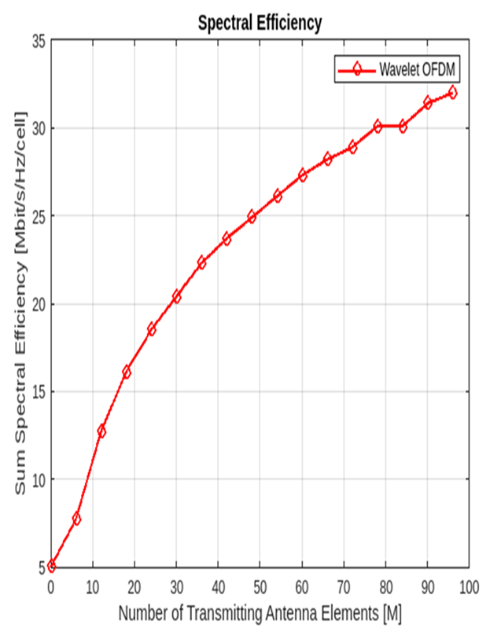

Fig. 1: Graph of Sum Spectral Efficiency against Number of Antenna Element in Wavelet-OFDM Massive MIMO Network

**3.4 Data Throughput**

Since the bandwidth and spectral efficiency of a given network determine its data throughput, it is necessary to simulate both the uplink and downlink spectral efficiencies, which yield the sum spectral efficiency, over a given bandwidth in order to determine the data throughput per network cell of each of the simulated networks. Table 6 presents the data throughput that was obtained from the simulation of the sum spectral efficiencies of each cell within the simulated network for Wavelet-OFDM Massive MIMO during reception of data to UEs and vice versa. This average sum was resulted from the complex random realizations during the simulation, where each of the 25 network cells was applied at different UE positions and the sum spectral efficiencies were taken, summed up then averaged within the specified bandwidth over the given carrier frequency. Figure 2 illustrates the graphical representation of the data throughput of the Wavelet- OFDM Massive MIMO network. This graph is a derivation of uplink and downlink average sum spectral efficiencies computed over the specified bandwidth for its throughput, which is plotted against the number of different ranges of antenna elements within the simulation during transmission and reception of data to UEs and vice versa.

Table 5: Network System Parameters for Massive MIMO Network Simulation

|  |
| --- |
| Parameter Value |
| Network Layout Square  Number of Network Cells 25  Cell Distance 200 meters  Range of Antenna per BS 10 to 100 antenna element  Number of UE’s per Cell 10  Channel gain per KM -148.1 Db  Pathloss Exponent 3.76  Shadow Fading 10  Bandwidth 20 MHZ  Receiver Noise power -94 dBm  Uplink Transmit Power 20 dBm  Downlink Transmit Power 20 dBm  Samples per Coherent Block 200  Pilot Reuse Factor 1 |

Table 6: The Data Throughput Simulated Data for Massive MIMO Network

|  |
| --- |
| Antenna (M) 6 12 18 24 30 36 |
| Data Throughput 99.0892 155.9041 254.545 321.7363 370.7445 408.6369  (bits/s/Hz/cell)  Antenna (M) 42 48 54 60 66 72  Average Sum SE 446.9050 473.4934 498.9270 519.6453 544.9964 553.8459  (bits/s/Hz/cell)  Antenna (M) 78 84 90 96  Average Sum SE 578.1755 602.1477 612.1751 628.5944  (bits/s/Hz/cell) |

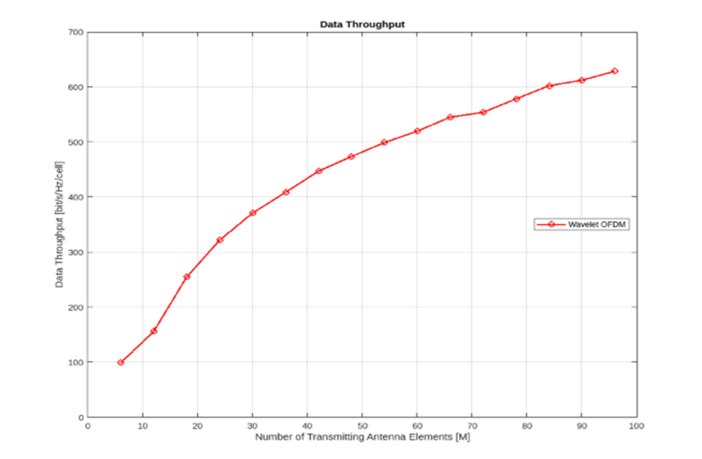

Fig. 2: Graph of Data Throughput for Massive MIMO Network

From Figure 2 and Table 6 the data throughput is at its lowest value 99.0892Mbit/s/cell when the antenna elements M is 6 then increases sharply to 321.7363Mbit/s/cell, when M is at 24, then a gradual growing curve at 370/7445Mbit/s/cell when M is set at 30 up to 628 5944Mbit/s/cell, when M is 96.

**3.5 Data Throughput Verses Spectral Efficiency**

The link between data throughput and spectral efficiency is examined in this section. This is to provide professionals with a visual display to aid in making informed decisions. The antenna, sum spectral efficiency, and data throughput of the Wavelet-OFDM Massive MIMO network simulations are characterized in Table 4. The data in this table is hybrid data that is used to plot the network's data throughput versus its spectral efficiency using a graphical form. The numbers listed for M antenna elements range from 6 to 96, for data throughput from 90.0892 Mbit/s/cell to 628.5944 Mbit/s/cell, and for spectral efficiency from 4.9545 bits/Hz/cell to 31.4297 bits/s/Hz/cell.

Figure 3 presents the graphical representation of the Data Throughput against Spectral Efficiency of the Wavelet-OFDM Massive MIMO network. This graph as it is already known is a derivation of the spectral efficiency per cell and data throughput for the network. Figure 4 is having a similar characteristic plot as a linear graph, where spectral efficiency value relationship with the data throughput is linear to each other. From this Figure 3 and Table 7, where the spectral efficiency is at its lowest value 4.9545 Mbit's/Hz/cell when the data throughput is 99.092 Mbit/s/cell then increases steadily to 31.4297 Mbit/s/Hz/cell, when the data throughput is 628.5944 Mbit/s/cell, hence the linearity, it is observed that there is a constant increase as both values increase.

Table 7: Data Throughput versus Spectral Efficiency Wavelet-OFDM

|  |
| --- |
| Antenna (M) 6 12 18 24 30 36 |
| SE (bits/s/Hz/cell) 4.9545 7.7952 12.7273 16.0868 18.5372 20.4318  Data Throughput 99.0892 155.9041 254.545 321.7363 370.7445 408.6369  (Mbits/s/cell)  Antenna (M) 42 48 54 60 66 72  SE (bits/s/Hz/cell) 22.3452 23.6747 24.9464 25.9833 27.2498 28.1923  Data Throughput 446.9050 473.4934 498.9270 519.6453 544.9964 563.8459  (Mbits/s/cell)  Antenna (M) 78 84 90 96  SE (bits/s/Hz/cell) 28.9088 30.1074 30.6088 31.4297  Data Throughput 578.1755 602.1477 612.1751 628.5944  (Mbits/s/cell) |

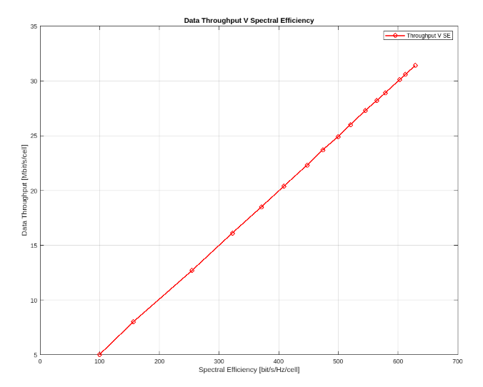

Fig. 3: Data Throughput versus Spectral Efficiency for Wavelet-OFDM

**3.6 Comparison of Wavelet-OFDM against FFT-OFDM Massive MIMO System**

In the simulation, during data transmission to UEs and vice versa, Figure 4 shows the graphical depiction of the comparison for a spectrum efficiency plotted against the member of various ranges of antenna elements. According to Figure 4, the average sum of the squared errors (SE) is at its minimum when the transmitting antenna elements (M) have a value of 6. It then rises quickly when M has a value of 24, and then gradually when M has a value of 30 up to 96. This is true for every scheme under comparison. The Wavelet-based Massive MIMO system outperformed all others on the graph, with the FFT-OFDM Massive MIMO setup performing the worst with a 20% cyclic prefix.

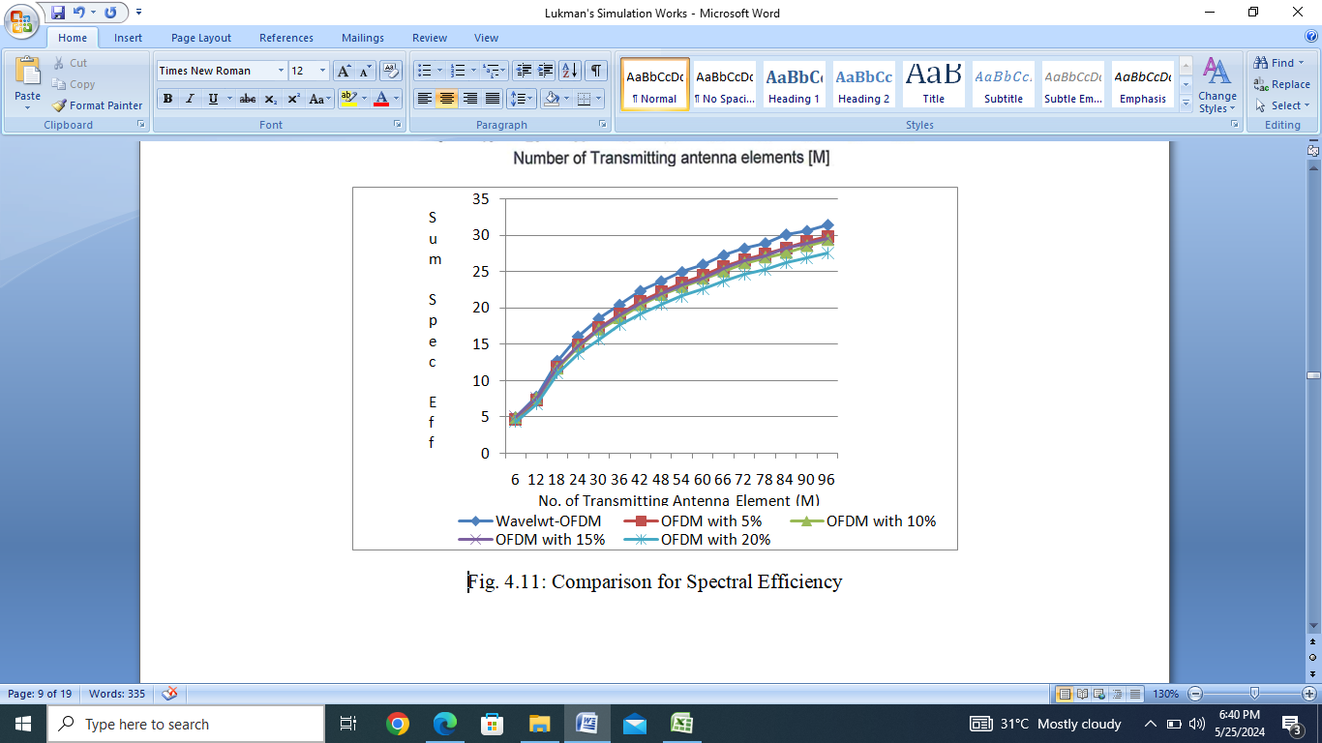

Fig. 4: Comparison for Spectral Efficiency

The data throughput for the comparison of Wavelet-OFDM and FFT-OFTD huge MIMO networks with varying levels of cyclic prefix (CP) applied to it is graphically represented in Figure 5. This graph, which is plotted against the number of different ranges of antenna elements within the simulation during data transmission and reception to UEs and vice versa, as it is previously mentioned, a derivation of the uplink and downlink average sum spectral efficiencies computed over the specified bandwidth for its throughput. From the Figure 5, it shows that the Wavelet Massive MIMO setup had the best performance on the graph, while the FFT-OFDM Massive MIMO setup with 20% cyclic prefix performed the worst.

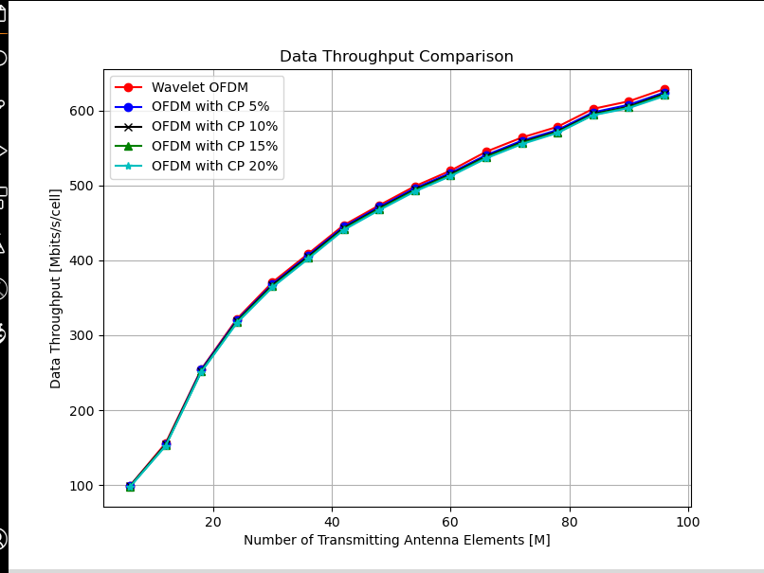

Fig. 5: Comparison for Data Throughput

**3.7 Data Throughput and Spectral Efficiency**

Data throughput and spectral efficiency are correlated in the sense that, the higher spectral efficiency typically translates into higher data throughput. The rate at which information is sent over a network is known as data throughput, and the effectiveness with which a particular spectrum is used for data transmission is known as spectral efficiency. Generally speaking, when the spectral efficiency is higher, more data can be transmitted in the same amount of time, resulting in increased data throughput. However, the actual data throughput is dependent on many other factors, such as the number of users accessing the network concurrently and the signal-to-noise ratio of the transmission device. Figure 6 shows that the Wavelet-based Massive MIMO system outperformed all others, with the FFT-OFDM Massive MIMO setup doing the worst with a 20% cyclic prefix. Therefore, this graph confirmed that Wavelet-OFDM would always perform better than FFT-based OFDM for any given bandwidth.

As expected, the Wavelet-based Massive MIMO setup performed best, while the FFT-OFDM Massive MIMO setup performed worst. However, at their respective antenna element number, M at 24 is the lowest, followed by M at 30, and M at 36 has the highest figure for all the schemes for the data throughput. This indicates that the data throughput increases as the number of antenna element increases.

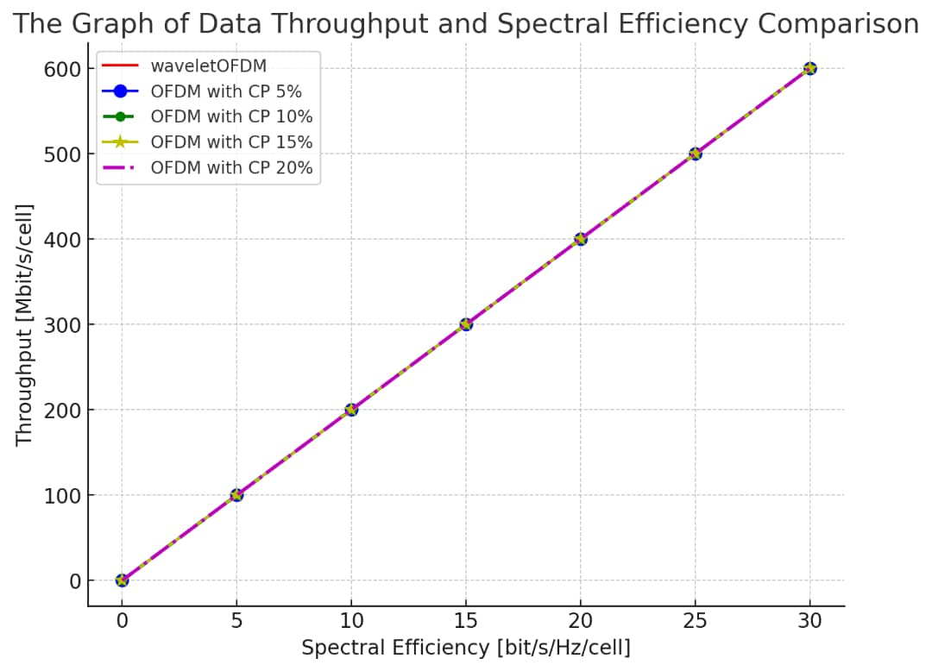

Fig. 6: Comparison of data throughput and spectral efficiency

Furthermore, the bar chart of the Massive MIMO networks' total data throughput for both technologies is shown in Figure 7. According to this graphic, the wavelet-OFDM technique outperformed all other technologies, with the 20% CP OFDM putting up a subpar performance and the 5%, 10%, and 15% CP OFDM doing fairly.

Fig. 7: Comparison of data throughput against antenna

**4 DISCUSSION OF RESULTS**

The spectral efficiency versus antenna numbers M graph is a right-side open parabola. This means that as the number of antenna M increases, the function initially accelerates slowly before speeding up quickly and eventually approaching a maximum value. The parabola opens to the right, with the vertex denoting the parabola's lowest point on the x-axis. This graph implies that the higher the number of antenna elements M, the higher the spectral efficiency of the communication systems. The overall mean value of the spectral efficiency gotten in this research is 22.05 Bit/Sec/Hz/Cell which is closely related to the works of; Boumard et al. [27], Guo [28] and that of Usama and Erol-Kantarci [29] who got their overall mean values at 21.55 bit/s/Hz, 22.03 bit/s/Hz and 21.99 bit/s/Hz respectively. The slight changes in the values are due majorly to the fact that they used frequency reuse and channel coding methods to improve the spectral efficiency through the MIMO antennas and the cell distance is 180meters instead of 200 meters in this research.

The graph of data throughput vs the antennas M shows a similar characteristic with that of spectral effiviency. Because these graphs are logistic or quadratic indicate that the data throughput and the energy efficiency of a Massive MIMO network have a direct relationship with the number of transmitting antenna elements M of the communication system. The overall mean value of the data throughput in this research is 441.83 bits/s/cell which corroborated the works of many researchers like; Yonis [30], Al-sharif et al. [31], Abrol [32] and so many other researchers with little deviations. For instance, Al Sharif et al. [31] got the overall data throughput mean value of 441,51bits/s and the reason for the deviation is that, they used advanced coding schemes and diversity techniques in polarization to migrate interference and thereby improve the throughput instead of wavelet orthogonal division multiplexing used in this research.

**5 CONCLUSION**

Conclusively, the comparison outcomes of W-OFDM mMIMO and FFT-OFDM for improving data rate and moderate energy consumption in communication systems shows encouraging results and a substantial potential for raising wireless network. The results of the study indicate that W-OFDM mMIMO may successfully meet the growing needs of contemporary communication environments for fast data rates and dependable connectivity. The simulation results provide important new information about W-OFDM mMIMO network performance characteristics. As the number of antenna components increases, there is significant improvement in spectral efficiency and data throughput.

Hence, the study's goals and objectives which included comparing a W-OFDM mMIMO with FFT-OFDM to determine the better technology for high spectral efficiency and improved data rate in communication system are accomplished. The relevant literature was reviewed, and any gaps were appropriately acknowledged. To close the gaps found in earlier studies, a W-OFDM Massive MIMO based communication system was created and simulated using MATLAB.

Disclaimer (Artificial intelligence)

Option 1:

Author(s) hereby declare that NO generative AI technologies such as Large Language Models (ChatGPT, COPILOT, etc.) and text-to-image generators have been used during the writing or editing of this manuscript.

**REFERENCES**

[1]. Chowdhury MZ, Shahjalal M, Ahmed S, Jang YM. 6G wireless communication systems: Applications, requirements, technologies, challenges, and research directions. IEEE Open Journal of the Communications Society. 2020:1(1):957-975.

[2]. Terré M, Pischella M, Vivier E. Wireless Telecommunication Systems. John Wiley & Sons. Journal of Clean Energy Technologies. 2013:2(3):12-15.

[3]. Zhang X, Li J, Zhou J, Zhang S, Wang J, Yuan Y, Liu J, Li J. Vehicle-to-Everything Communication in Intelligent Connected Vehicles: A Survey and Taxonomy. Automotive Innovation. 2025:1-33.

[4] Kopyltsov AV, Kravets AG, Abrahamyan GV, Katasonova GR, Sotnikov AD, Atayan AM. Algorithm of Estimation and Correction of Wireless Telecommunications Quality. In 2018 9th International Conference on Information, Intelligence, Systems and Applications (IISA). 2018:45(4):1299-1305.

[5]. Naraiah R, Tiwari M, Krishna P. Spectral efficiency improvement techniques in massive mimo for 5G communications. Turkish Journal of Computer and Mathematics Education. 2021:12(2):1457-1465.

[6]. Zhang L, Yang HC, Hasna MO. Generalized area spectral efficiency: An effective performance metric for green wireless communications. IEEE Transactions on Communications. 2014:62(2):747-757.

[7]. Dicandia FA, Genovesi S. Exploitation of triangular lattice arrays for improved spectral efficiency in massive MIMO 5G systems. IEEE Access. 2021:9(1):17530-17543.

[8]. Jamin A, Mahonen, P. Wavelet packet Modulation for Wireless Communications. Wireless Communications & Mobile Computing Journal, John Wiley and Sons Ltd. 2005:5(2):123-137.

[9]. Wahab MF, Gritti F, O'Haver TC. Discrete Fourier transform techniques for noise reduction and digital enhancement of analytical signals. TrAC Trends in Analytical Chemistry. 2021:143:116354.

[10]. Potts D, Steidl G, Tasche M. Fast Fourier transforms for nonequispaced data: A tutorial. Modern Sampling Theory: Mathematics and Applications, 2001:247-270.

[11]. Kanatov I, Kaplun D, Butusov D, Gulvanskii V, Sinitca A. One technique to enhance the resolution of discrete Fourier transform. Electronics. 2019:8(3):330.

[12]. Stuber GL, Barry JR, Mclaughlin SW, Li Y, Ingram MA, Pratt TG. Broadband MIMO-OFDM Wireless Communications. Proceedings of the IEEE. 2004:92(2):271-294.

[13]. Li J, Dang S, Wen M, Jiang XQ, Peng Y, Hai H. Layered orthogonal frequency division multiplexing with index modulation. IEEE Systems Journal. 2019:13(4):3793-3802.

[14]. Terry J, Heiskala J. OFDM wireless LANs: A Theoretical and Practical Guide. Sams publishing. International Journal of Engineering Sciences & Research Technology. 2002:40(3):4 -23.

[15]. Mahdavi M, Edfors O, Öwall V, Liu L. A low latency FFT/IFFT architecture for massive MIMO systems utilizing OFDM guard bands. IEEE Transactions on Circuits and Systems I: Regular Papers. 2019:66(7):2763-2774.

[16]. Chataut R, Akl R. Massive MIMO Systems for 5G and Beyond Networks—Overview, Recent Trends, Challenges, and Future Research Direction. Sensors. 2020:20(10):2753.

[17]. Marzetta TL. Noncooperative Cellular Wireless with Unlimited Numbers of Base Station Antennas. IEEE Transactions on Wireless Communications. 2010:9(11):3590-3600.

[18]. Ngo HQ, Larsson EG, Marzetta TL. Aspects of Favorable Propagation in Massive MIMO. In 2014 22nd European Signal Processing Conference (EUSIPCO). 2014:149(1):93-127.

[19]. Büssow R. An algorithm for the continuous Morlet wavelet transform. Mechanical Systems and Signal Processing. 2007:21(8):2970-2979.

[20]. Osadchiy A, Kamenev A, Saharov V, Chernyi S. (2021). Signal processing algorithm based on discrete wavelet transform. Designs. 2021:5(3):41.

[21]. Dongarra J, Gates M, Haidar A, Kurzak J, Luszczek P, Tomov S, Yamazaki I. The singular value decomposition: Anatomy of optimizing an algorithm for extreme scale. SIAM Review. 2018:60(4):808-865.

[22]. Wu S, Zhai Y, Liu J, Huang J, Jian Z, Dai H, Di S, Cappello F, Chen Z. Turbofft: Co-designed high-performance and fault-tolerant fast fourier transform on gpus. In Proceedings of the 30th ACM SIGPLAN Annual Symposium on Principles and Practice of Parallel Programming (pp. 70-84). 2025.

[23]. Hung T, Gezari S, Jones DO, Kirshner RP, Chornock R, Berger E, Neill JD. The GALEX Time Domain Survey. II. Wavelength-Dependent Variability of Active Galactic Nuclei in the PAN-STARRS1 Medium Deep Survey. The Astrophysical Journal. 2016:833(2):226.

[24]. Thomas YR, Picot M, Carer A, Berder O, Sentieys O, Barrière F. A Single Sediment-Microbial Fuel Cell Powering a Wireless Telecommunication System. Journal of Power Sources. 2013:2(4):703-708.

[25]. Nine MSZ, Kosar T. A two-phase dynamic throughput optimization model for Big Data transfers. IEEE Transactions on Parallel and Distributed Systems. 2020:32(2):269-280.

[26]. Yusuf SD, Egbebi LF, Loko AZ. Evaluation of Wavelet Orthogonal Frequency Division Multiplexing Massive MIMO (W-OFDM mMIMO) for Enhancing Spectral and Energy Efficiencies in Digital Wireless Communication System. Asian Journal of Advanced Research and Reports. 2024:18(12):225-240.

[27]. Boumard S, Harjula I, Kanstrén, Rantala SJ. Comparison of spectral and energy efficiency metrics using measurements in a LTE-A network. In 2018 Network Traffic Measurement and Analysis Conference (TMA) (pp. 1-8). IEEE. 2018.

[28]. Guo J. Energy Efficiency in Wireless Networking Protocols. Current issues in Wireless and Mobile Networking. Retrieved from http://www. cse. wustl. edu/~ jain/cse574-14/index. html. 2014.

[29]. Usama M, Erol-Kantarci M. A Survey on Recent Trends and Open Issues in Energy Efficiency of 5G. International Conference on Ubiquitous and Future Networks (ICUFN). 2019:19(14):3126.

[30]. Yonis AZ. Improving Energy Efficiency from Regular to Massive MIMO for 5G Cellular Networks. International Journal of Enhanced Research in Science, Technology & Engineering. 2017:6(8):36-48.

[31]. Al-sharif MH, Kelechi AH, Albreem MA, Chaudhry SA, Zia MS, Kim S. Sixth generation (6G) wireless networks: Vision, research activities, challenges and potential solutions. Symmetry. 2018:12(4):6-76.

[32]. Abrol S, Mehmani A, Kerman M, Meinrenken CJ, Culligan PJ. Data-enabled Building Energy Savings (DE BES). Proceedings of the IEEE. 2018:106(4):661-679.