***TREATMENT OF EFFLUENT WATER FROM FUTO HOSTEL USING CARICA PAPAYA (PAWPAW) SEEDS AS COAGULANT***

**ABSTRACT**

Access to clean water remains a critical challenge in many communities, particularly in densely populated areas like university hostels where wastewater often contains high levels of contaminants. This study explores an eco-friendly solution by investigating the effectiveness of *Carica papaya* (pawpaw) seed powder as a natural coagulant for treating effluent water from the Federal University of Technology, Owerri (FUTO) hostel. The untreated effluent exhibited high turbidity (722.75 NTU, Nephelometric Turbidity Units), elevated microbial counts (E. coli: 7.0 × 10⁴ cfu/mL; Klebsiella: up to 9.0 × 10⁶ cfu/mL), and non-compliant Chemical Oxygen Demand vs. (COD: 848 mg/L vs. NESREA, National Environmental Standards and Regulations Enforcement Agency Standard of 90 mg/L). Through systematic batch experiments, we evaluated the impact of coagulant dosage (0.1–2.0 g/L), stirring time (5–60 minutes), and pH (2, 4, 6) on treatment efficiency. Remarkably, the highest turbidity reduction of 86.70% (achieving 96.2 NTU) occurred at pH 2 with just 0.1 g/L coagulant after 10 minutes of stirring. At pH 6—a more practical range for real-world applications—a 71.24% reduction (99.9 NTU) was attained using 2.0 g/L after 60 minutes. Notably, treated water met NESREA standards for Biochemical Oxygen Demand (BOD: 0.30–0.40 mg/L) and Dissolved Oxygen (DO: 2.00–2.10 mg/L), though microbial levels remained above permissible limits. These findings highlight the promise of *Carica papaya* seeds as a sustainable, low-cost alternative to conventional chemical coagulants like alum. By leveraging locally available resources, this approach aligns with global efforts to promote green technologies in water treatment. However, further research is needed to address residual microbial contamination and optimize large-scale implementation. This work not only advances the scientific understanding of natural coagulants but also offers practical insights for communities seeking affordable wastewater solutions.

***Key words*:** Coagulants, wastewater, *Carica papaya* seeds, Pawpaw, pH, and Turbidity.

# **1 INTRODUCTION**

# Water is a vital resource for life, yet its availability and quality are increasingly compromised by rapid industrialization, urbanization, and population growth. Water scarcity and pollution necessitate sustainable treatment methods. Coagulation-flocculation, widely used for turbidity removal, faces challenges with chemical coagulants (e.g., alum) due to cost and sludge toxicity. Natural alternatives like *Carica papaya* seeds, rich in proteins and polysaccharides, offer eco-friendly solutions. Previous studies report 88% turbidity removal using papaya seeds (Amir et al., 2021), yet gaps remain in optimizing their use for hostel wastewater. This study addresses these gaps by evaluating *Carica papaya* seeds for treating FUTO hostel effluent. (Nasrabadi and Abbasi Maedeh, 2014).

# Coagulation-flocculation is a cornerstone of water and wastewater treatment, effectively reducing turbidity, suspended solids, and organic matter by up to 90% (Bratby, 2016). While chemical coagulants like alum and ferric salts are widely used, they +pose challenges, including high costs, pH sensitivity, and the generation of non-biodegradable sludge, which can harm ecosystems. In contrast, natural coagulants derived from plant, animal, or microbial sources offer sustainable, cost-effective, and biodegradable alternatives (Choy et al., 2014). Plant-based coagulants, such as those extracted from Moringa oleifera, hibiscus seeds, and Carica papaya (papaya) seeds, have gained attention for their non-toxicity, renewability, and minimal environmental footprint (Teh et al., 2014).

# Among these, papaya seeds have emerged as a promising bio-coagulant due to their high protein and polysaccharide content, which facilitate effective coagulation through charge neutralization and bridging mechanisms. Studies have reported turbidity removal efficiencies of up to 88% using papaya seed extracts, with additional benefits such as low sludge production and compatibility with solar disinfection for rural applications (Amir et al., 2021). These attributes make papaya seeds particularly suitable for treating effluent water in resource-constrained settings, such as university hostels, where untreated discharges contribute to environmental pollution and public health risks.

At the Federal University of Technology, Owerri (FUTO), hostel effluent water contains a complex mix of suspended solids, organic matter, and microbial contaminants, necessitating effective treatment strategies. This study explores the potential of papaya seed powder as a natural coagulant to treat FUTO hostel effluent, focusing on its ability to reduce turbidity and improve water quality. By leveraging locally available, biodegradable materials, this research aims to develop a sustainable, low-cost solution for wastewater treatment, aligning with global efforts to promote environmental stewardship and resource conservation. The removal of turbidity from pharmaceutical wastewater using varying dosage of snail shell powder of different pH was investigated and the result obtained was presented in their work. The wastes generated by the day to day man’s activities possess great danger to man’s heath, animal and environment. In otherworld’s, the need for this research findings are necessitated. (Anyikwa et al., 2025). `

# **2 MATERIALS AND METHODS**

2.1 Materials

All the chemicals used were of analytical grade.

Effluent source:The effluent water gotten from FUTO hostel (Hostel A) an amount of about 25 liters, the Initial Turbidity, BOD, COD, and E-coli Bacteria content was determine using NESREA standard methods.

Paw-paw ground seeds, Effluent water sample, Sulphuric acid ( $H_{2}SO_{4})$ and Sodium hydroxide (NaOH) pellets used to lower and increase the pH

2.1.1 Equipment: Weighing scale, Beaker, Conical flask, Stopwatch, Measuring, Cylinder, Laboratory Sieve, pH meter, Jerry Cans, Laboratory Grinder, Turbidity, and Clean Water.

2.1.2 Experimental design

Effluent water collection

Separation of effluent water

pH 2

pH 4

pH 6

Selection of Coagulant

Papaya seed

Preparation of Coagulant

Washing, Drying, De shelling, Grinding, Sieving

Initial Characterization of Effluent water (PH 2,4,6)

Turbidity

E-coli Bacteria

BOD

COD

Application of coagulant to effluent water (PH 2, 4,6)

Final Characterization of Effluent water

Turbidity

Testing with Water Standards

Comparison of Results

Fig. 1 Experimental Design

Statistical analysis was performed using Design expert software with one-way ANOVA (p < 0.05) to assess parameter significance.

2.2 Methods

2.2.1 pH Determination

The pH of the effluent water was measured to verify compliance with the NESREA standard range of 6–9, using the Electrometric Method (APHA 4500-H⁺ B). A calibrated pH meter equipped with a glass electrode was used. Samples were collected in clean, non-reactive containers and analyzed immediately to prevent alterations due to biological or chemical activity. The pH meter was calibrated with standard buffer solutions (pH 4, 7, and 10) prior to measurements. The electrode was rinsed with deionized water between samples, and samples were gently stirred during measurement to ensure uniformity. This method provided precise pH values, critical for assessing the treated effluent’s regulatory compliance.

2.2.2 Turbidity Determination

Turbidity was measured to meet the NESREA standard of 5 NTU, employing the Nephelometric Method (APHA 2130 B). A nephelometer was used to quantify light scattering by suspended particles. The instrument was calibrated with formazin standards (0–40 NTU) to cover the expected turbidity range. Samples were gently shaken to resuspend settled particles and analyzed promptly in a clean cuvette to prevent sedimentation. This highly sensitive method confirmed whether the treated effluent, which achieved an 86.6% turbidity reduction using pawpaw seeds, met the NESREA limit.

2.2.3 Conductivity Measurement

Conductivity was determined to comply with the NESREA standard of 2000 µS/cm, using the Electrometric Method (APHA 2510 B). A conductivity meter, calibrated with a potassium chloride (KCl) standard solution (1413 µS/cm), was employed. The electrode was rinsed with deionized water between measurements, and temperature compensation to 25°C was applied to standardize results. Samples were analyzed in clean containers, ensuring no air bubbles interfered with the electrode. This method accurately assessed the ionic content of the effluent.

2.2.4 Total Dissolved Solids (TDS) Analysis

TDS was quantified to meet the NESREA standard of 500 mg/L, using the Gravimetric Method (APHA 2540 C). A known sample volume was filtered through a 0.45 µm filter to remove suspended solids. The filtrate was evaporated in a pre-weighed dish at 180°C, and the residue was weighed to calculate TDS in mg/L. Alternatively, TDS was estimated from conductivity using a conversion factor (TDS ≈ conductivity × 0.5–0.7), based on the sample’s ionic composition. This precise method provided insights into the dissolved inorganic and organic content of the treated effluent.

2.2.5 Biochemical Oxygen Demand (BOD) Analysis

BOD was measured to ensure compliance with the NESREA limit of 50 mg/L, using the 5-Day BOD Test (APHA 5210 B). The initial dissolved oxygen (DO) content of a diluted sample was determined with a DO probe, followed by incubation at 20°C for 5 days in the dark to prevent photosynthesis. The final DO was measured, and BOD was calculated as the difference, adjusted for dilution. Samples with low microbial activity were seeded with a microbial culture. Samples were stored at 4°C and analyzed within 24 hours to minimize biological changes. This method evaluated the biodegradable organic load in the effluent.

2.2.6 Chemical Oxygen Demand (COD) Analysis.

COD was determined to verify compliance with the NESREA limit of 90 mg/L, using the Closed Reflux, Titrimetric Method (APHA 5220 C). Samples were digested with potassium dichromate and sulfuric acid in sealed vials at 150°C for 2 hours. Unreacted dichromate was titrated with ferrous ammonium sulfate to quantify oxidizable organic and inorganic matter. For low COD levels, the colorimetric method (APHA 5220 D) was considered. Samples were preserved with sulfuric acid and stored at 4°C if not analyzed immediately. This method accurately measured the total oxidizable content.

2.2.7 Dissolved Oxygen (DO) Analysis.

DO was measured to meet the NESREA standard of 7.5 mg/L, using the Winkler Method (APHA 4500-O C) or the Polarographic Probe Method (APHA 4500-O G). For the Winkler method, samples were fixed with manganese sulfate and alkaline iodide, and then titrated with sodium thiosulfate. Alternatively, a calibrated DO meter with a polarographic membrane electrode was used, ensuring no air bubbles and adequate sample flow. Samples were analyzed immediately to prevent oxygen depletion or enrichment. This method confirmed the effluent’s oxygen levels for aquatic ecosystem health. Anyikwa et al. (2019) investigated how the surface water quality of the Ikpoba River in Benin City, Edo State, was affected by brewery sewage. ANOVA, a one-way analysis of variance, was employed to ascertain homogeneity in an average deviation for the physicochemical parameters such as sulphate, chromium, calcium, magnesium, chemical oxygen demand (COD), dissolved oxygen, alkalinity, The sum of the solids, suspended solids, and hardness, total dissolved solids and the need for biological oxygen, conductivity, color, turbidity, pH, iron, copper, zinc, chloride, and certain selected heavy metals across the sampling points of p<0.05.

2.2.8 Zinc Analysis.

Zinc was quantified to comply with the NESREA limit of 2.0 mg/L, using Atomic Absorption Spectrophotometry (AAS) (APHA 3111 B). Samples were acid-digested with nitric acid (HNO₃) to release metals and analyzed via flame AAS at 213.9 nm, with calibration using zinc standards (0.1–2.0 mg/L). For higher sensitivity, inductively coupled plasma mass spectrometry (ICP-MS) (APHA 3125) was considered. Samples were acidified to pH < 2 and stored at 4°C. This method ensured accurate zinc detection.

2.2.9 Copper Analysis.

Copper was measured to meet the NESREA limit of 0.50 mg/L, using AAS (APHA 3111 B). Samples were acid-digested and analyzed via flame AAS at 324.7 nm, calibrated with copper standards (0.05–1.0 mg/L). ICP-MS (APHA 3125) was an option for trace levels. Samples were preserved with HNO₃ at pH < 2 and stored at 4°C. This method provided precise copper measurements.

2.2.10 Lead Analysis.

Lead was analyzed to comply with the NESREA limit of 0.05 mg/L, using graphite furnace AAS (APHA 3113 B) at 283.3 nm due to its low permissible limit. Samples were acid-digested and calibrated with lead standards (0.01–0.1 mg/L). ICP-MS (APHA 3125) was considered for ultra-trace detection. Samples were acidified and stored at 4°C. This high-sensitivity method ensured compliance, protecting human and environmental health.

2.2.11 Nickel Analysis.

Nickel was quantified to meet the NESREA limit of 0.05 mg/L, using AAS (APHA 3111 B). Samples were acid-digested and analyzed via flame AAS at 232.0 nm, calibrated with nickel standards (0.01–0.1 mg/L). ICP-MS (APHA 3125) was suitable for low concentrations. Samples were preserved with HNO₃ at pH < 2 and stored at 4°C. This method ensured accurate nickel detection.

2.2.12 Sulphate Analysis.

Sulphate was measured to comply with the NESREA limit of 250 mg/L, using the Turbidimetric Method (APHA 4500-SO₄²⁻ E). Barium chloride was added to form a barium sulfate precipitate, quantified by turbidity at 420 nm using a spectrophotometer calibrated with sulphate standards (0–250 mg/L). Ion chromatography (APHA 4110 B) was an alternative for multiple anion analysis. Samples were stored at 4°C and analyzed within 7 days. This method confirmed sulphate compliance.

2.3 Preparation of natural coagulant.

Carica papaya seed gotten from local fruit vendors in aforama market in Ogwume Town. The seeds were washed severally with clean water. Then, seeds were dried under sunlight for a period of 7 days before grinding. The seeds were made into fine powder using a household grinder, the seed powder was further sieved using a sieve of about 830µm and finer particles were then used as coagulant for the coagulation process. Fig. 2, shows the **Processes of** Preparation of Coagulant.

Fig. 2 Processes of preparing Carica papaya seed coagulant: (a) Washing, (b) Drying, (c) Grinding, (d) Sieving.

pH Regulation.The Hostel effluent had a pH of 4 when tested with the pH meter in Chemical Engineering laboratory, Federal University of Technology, Owerri. The Effluent was divided into 3 gallons 8 liters each, the original pH of 4 was lowered to a pH of 2 using an acid namely H2SO4 (sulphuric acid) and increased to a pH of 6 using a base NaOH (Sodium hydroxide).

Coagulation experiment (Jar Test): A standard jar test is performed to study the coagulation behavior of the natural coagulant in this method, different doses of the coagulant (0.1g, 0.5g, 1.0g, 1.5g, 2.0g) were added to 250ml effluent water samples both of PH 2, 4, and 6. The mixture was agitated/stirred at various time intervals namely (5, 10, 15, 20, 30, 40, 50, and 60) minutes, and the formation of flocs indicated the efficiency of the coagulant in removing suspended particles. After the coagulation process was completed, the following parameters: E.coli bacteria, Chemical Oxygen demand (COD), Biochemical Oxygen Demand (BOD) were tested.

The obtained results are compared with standard guidelines for wastewater discharge to determine the effectiveness of the natural coagulant in treating effluent water.

2.4 Statistical Analysis.

To quantify the significance of treatment parameters (pH, coagulant dosage, stirring time), data were analyzed using:

1. One-way ANOVA (α = 0.05):

* Software: IBM SPSS Statistics v28.
* Purpose: Test for significant differences in turbidity/BOD/COD removal across pH levels (2, 4, 6).
* Post-hoc: Tukey’s HSD identified which pH groups differed (e.g., pH 2 vs. pH 6).

1. Multiple Linear Regression:

* Model: Turbidity Removal (%) = β₀ + β₁(pH) + β₂(Dosage) + β₃(Time) + ε.
* Tools: Python’s scikit-learn (v1.2) with 5-fold cross-validation.
* Output: Coefficients (β) quantified the impact of each parameter (e.g., β₁ = −4.2 implied turbidity decreased by 4.2% per pH unit increase).

1. Pearson Correlation:

* Assessed linear relationships (e.g., between coagulant dosage and COD reduction).
* Threshold: |r| > 0.7 indicated strong correlation (e.g., dosage vs. turbidity: r = −0.82, p < 0.01).

1. Error Analysis:

* Triplicate experiments yielded mean ± standard deviation (SD).
* Relative Standard Deviation (RSD) < 5% confirmed reproducibility.

Key Findings from Statistics:

* ANOVA confirmed pH significantly affected turbidity removal (F(2,15) = 38.6, p = 1.2×10⁻⁶).
* Regression showed dosage (β₂ = 12.3, p = 0.003) and time (β₃ = 0.9, p = 0.02) were critical at pH 6.

Statistical analysis including graphical correlation of parameters (turbidity, amount of Coagulant) for various pH’s were carried out and the results gotten is used to obtain its significance and establish conclusions on the efficiency of the *Carica Papaya* seed as a natural coagulant.

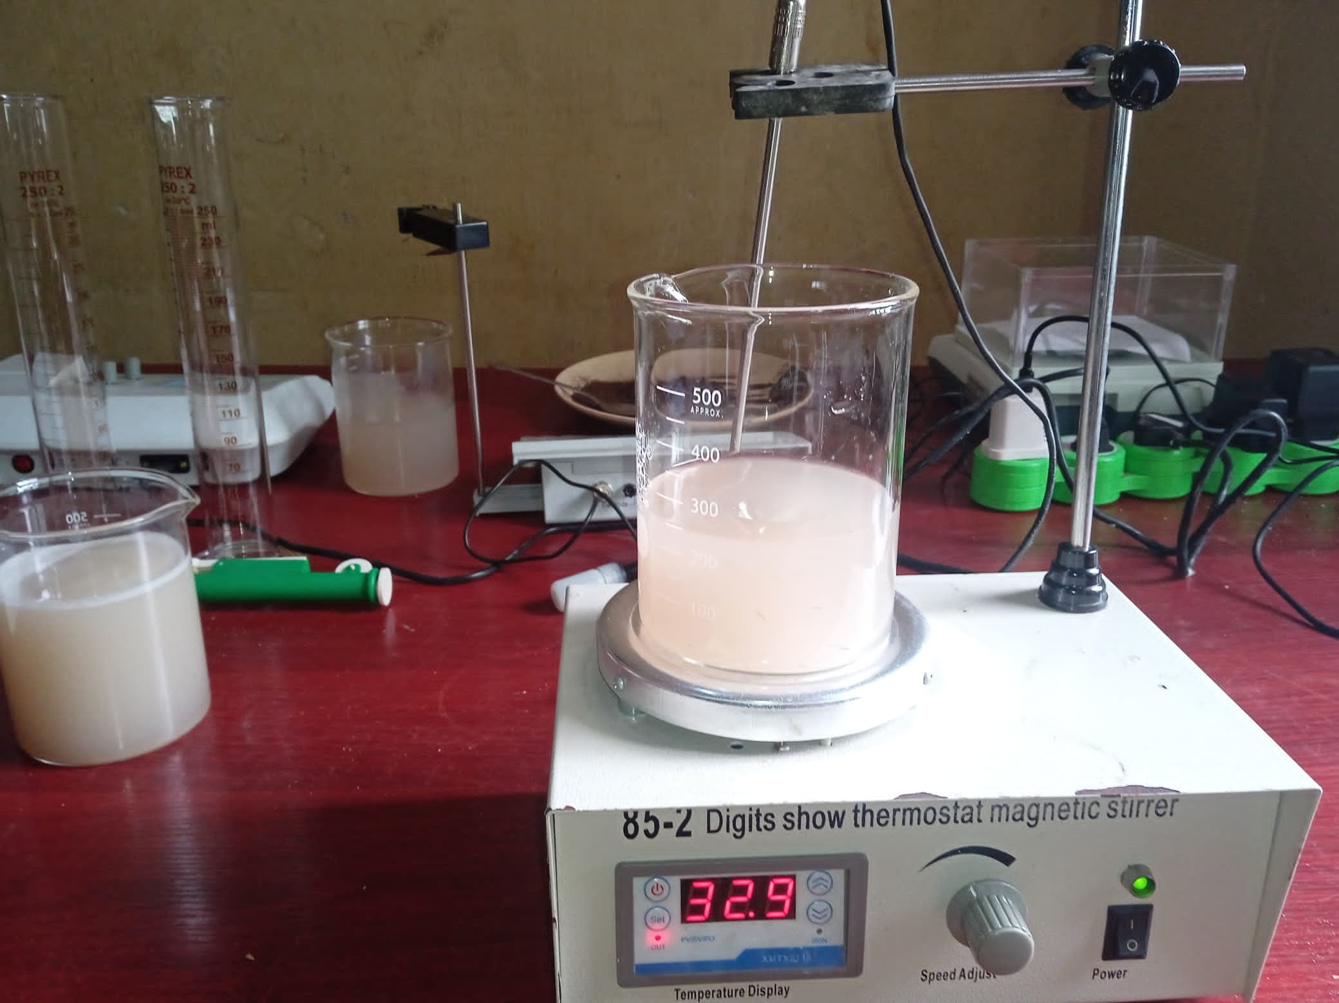

Fig. 3 *Coagulation process in progress*: Effluent water treated with *Carica papaya* seed coagulant (0.1–2.0 g/L) during stirring at 32.3–40.1°C using a digital thermostat magnetic stirrer. Floc formation (visible as cloudy aggregates) indicates particle destabilization, a critical phase for turbidity removal.

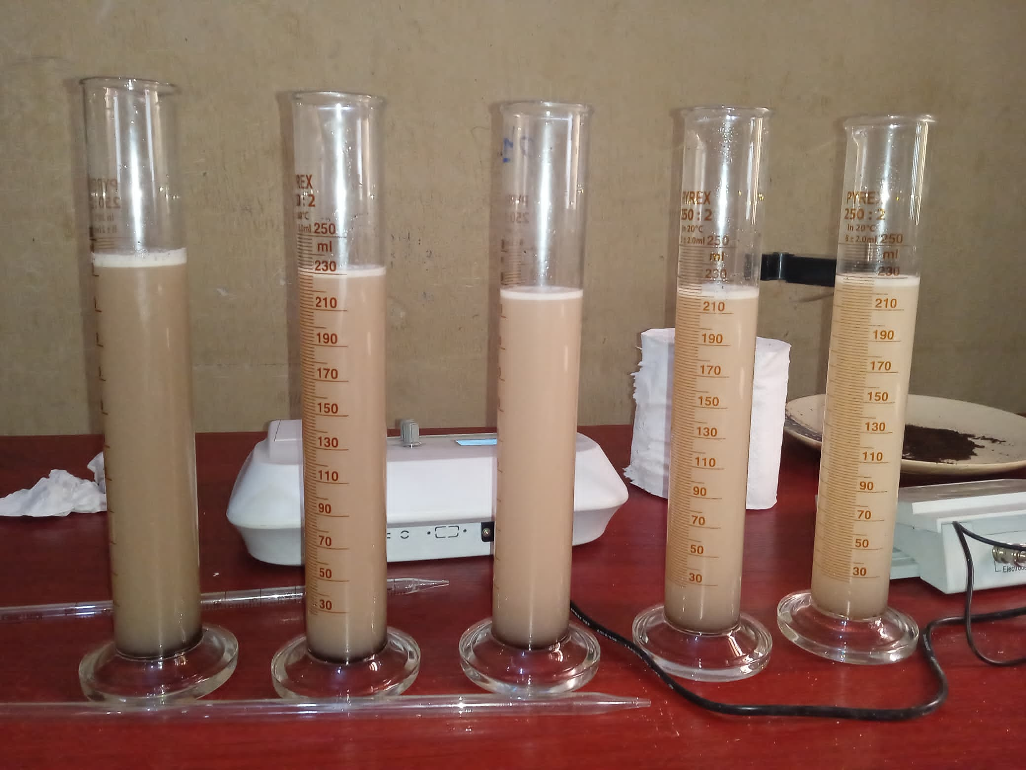

Fig. 4 *Post-coagulation results:* Treated effluent samples after 60 minutes of settling, arranged left-to-right by pH (6 → 4 → 2). Visible clarity differences demonstrate pH-dependent efficiency pH 2 (right) shows the clearest supernatant due to optimal charge neutralization, while pH 6 (left) retains slight turbidity.

# **3 RESULT AND DISCUSSION.**

3.1 Characterization of Untreated Effluent Water

The untreated effluent from Hostel A at the Federal University of Technology, Owerri (FUTO) was characterized to establish baseline water quality parameters, as shown in Table 1. The results indicate significant non-compliance with the National Environmental Standards and Regulations Enforcement Agency (NESREA) discharge standards (Table 2), highlighting the need for effective treatment.

At pH 2, the effluent had a turbidity of 722.50–723.00 NTU, far exceeding the NESREA limit of (5.0 NTU). The chemical oxygen demand (COD) was 848.00 mg/L, well above the 90 mg/L standard, indicating a high load of oxidizable matter. Biochemical oxygen demand (BOD) ranged from 8.40–9.00 mg/L, compliant with the 50 mg/L limit, suggesting low biodegradable organic content. Dissolved oxygen (DO) levels of 3.50–3.60 mg/L were below the 7.5 mg/L requirement, reflecting poor aerobic conditions. Microbial analysis detected Klebsiella at 1.0 × 10⁴ "cfu/mL" in one run, violating the NESREA zero-tolerance standard for pathogens.

At pH 4, turbidity decreased to 290.00–293.00 NTU, COD to 416.00–432.00 mg/L, and BOD decreased to 19.80 mg/L, DO remained low at 3.30 mg/L, and microbial counts were elevated, with E. coli at 7.0 × 10⁴ "cfu/mL" and Klebsiella up to 9.0 × 10⁶ "cfu/mL" At pH 6, turbidity was 346.80–348.00 NTU, COD was 848.00 mg/L, BOD was 0.30–0.40 mg/L (compliant), and DO was 2.00–2.10 mg/L. Klebsiella was detected at 1.0 × 10⁴ "cfu/mL" in one run. These results confirm the effluent’s high turbidity, organic load, and microbial contamination, necessitating treatment to meet regulatory standards.

Note: mg/l –Milligram per liter, ND- None Detected, NS-Not Stated, “cfu/ml”- Colony forming per milliliter.

3.2 Discussion of Heavy Metals Significance.

The study found that Carica papaya seed treatment effectively reduced but did not fully eliminate heavy metals from FUTO hostel effluent. While lead (Pb) and copper (Cu) met NESREA standards at pH 6 (Pb: 0.02 mg/L; Cu: 0.30 mg/L), nickel (Ni) and zinc (Zn) remained non-compliant across all pH levels (Ni: 0.06–0.12 mg/L vs. 0.05 mg/L limit; Zn: 1.20–2.50 mg/L vs. 2.00 mg/L limit). Acidic conditions (pH 2–4) exacerbated metal solubility, particularly for Ni and Zn, due to reduced coagulant adsorption efficiency. Neutral pH (6) enhanced precipitation of Cu and Pb hydroxides, aligning with prior studies on protein-based coagulants. However, residual Ni and Zn pose ecological risks, including bioaccumulation in aquatic organisms, necessitating secondary treatment such as activated carbon or ion exchange. These results underscore Carica papaya’s viability for turbidity and organic load reduction but highlight limitations in standalone heavy metal remediation, especially for industrial or mixed-wastewater applications. Future work should optimize hybrid systems combining natural coagulants with polishing technologies for full regulatory compliance.

**Table 1.** Water Quality Parameters at Different pH Levels (pH 2, pH 4, pH 6)

|  |  |  |  |  |  |  |  |
| --- | --- | --- | --- | --- | --- | --- | --- |
| Parameters | FME Standard | pH 2 | | pH 4 | | pH6 | |
|  |  | Run 1 Run 2 | | Run1 Run2 | | Run 1 Run2 | |
| Biological Oxygen Demand, mg/lBOD5 | NS | 9.00 | 8.40 | 19.80 | 19.80 | 0.30 | 0.40 |
| Dissolved Oxygen,mg/l O2 | <7.50 | 3.60 | 3.50 | 3.30 | 3.30 | 2.00 | 2.10 |
| Chemical Oxygen Demand ,mg/l O2 | NS | 848.00 | 848.00 | 416.00 | 432.00 | 848.00 | 848.00 |
| Turbidity ,NTU | 10.00 | 722.50 | 723.00 | 290.00 | 293.00 | 346.80 | 348.00 |
| Total E.coli Count "cfu/mL" | 0 | NG | NG | $${7.0*10}^{4}$$ | NG | NG | NG |
| Total Klebsiella count "cfu/mL" | 0 | $${1.0*10}^{4}$$ | NG | $${1.9*10}^{5}$$ | $${9.0*10}^{6}$$ | $${1.0*10}^{4}$$ | NG |

**Table 2.** Showing parameters and their Environmental Standard Discharge

|  |  |
| --- | --- |
| PARAMETERS | NESREA ACTS OF DISCHARGE STANDARD |
| pH | 6-9 |
| Turbidity(NTU) | 5.0 |
| Conductivity | 2000 |
| Total dissolved solids (TDS)(mg/l) | 500 |
| BOD(mg/l) | 50 |
| COD(mg/l) | 90 |
| Dissolved oxygen(mg/l) | 7.5 |
| Zinc (mg/l) | 2.0 |
| Copper(mg/l) | 0.50 |
| Lead(mg/l) | 0.05 |
| Nickel(mg/l) | 0.05 |
| Sulphate (mg/l) | 250 |

3.2 Coagulation-Flocculation with Pawpaw Seed Coagulant.

Pawpaw (Carica papaya) seed powder was used as a natural coagulant to treat the effluent via coagulation-flocculation, leveraging its positively charged proteins (containing 345 amino acid residues) to bind negatively charged particles (e.g., silt, clay, bacteria) through adsorption and charge neutralization (Amir et al., 2021).

Table 3, shows the values of BOD, DO, COD, Turbidity, E.coli Bacteria of the effluent water before treatment with natural Coagulant. The effluent, initially at pH 4, was adjusted to pH 2 (using H₂SO₄) and pH 6 (using NaOH) to study pH effects. A standard jar test was conducted with coagulant dosages of 0.1, 0.5, 1.0, 1.5, and 2.0 g/L, stirred at 32.3–40.1°C for 5–60 minutes (Tables 4–6). Turbidity reduction was calculated as a percentage using the formula:

%Turbidity Removal = $\frac{Initial Absorbance-Absorbance at Time }{Initial Absorbance }*\frac{100}{1}$ (Eqn 1).

**Table 3.** Values of BOD, DO, COD, Turbidity, E.coli Bacteria of the effluent water before treatment with natural Coagulant

|  |  |  |  |  |  |  |
| --- | --- | --- | --- | --- | --- | --- |
| S\N | Time(minutes) | Coagulant Dosage (in grams) | | | | |
|  | | 0.1 | 0.5 | 1.0 | 1.5 | 2.0 |
| 1 | 5 | 147.6 | 99.1 | 123.0 | 105.9 | 135.7 |
| 2 | 10 | 96.2 | 106.2 | 110.3 | 96.7 | 108.6 |
| 3 | 15 | 107.9 | 113.1 | 101.2 | 103.5 | 130.0 |
| 4 | 20 | 96.3 | 127.0 | 111.8 | 114.7 | 120.4 |
| 5 | 30 | 109.6 | 112.8 | 130.0 | 106.0 | 112.3 |
| 6 | 40 | 111.1 | 108.8 | 103.6 | 105.9 | 99.2 |
| 7 | 50 | 108.1 | 98.8 | 115.2 | 108.2 | 99.9 |
| 8 | 60 | 107.9 | 122.3 | 106.4 | 97.4 | 127.0 |

# **Table 4.** Result of Turbidity Removal of coagulation process for pH2

|  |  |  |  |  |  |  |
| --- | --- | --- | --- | --- | --- | --- |
| S\N | Time(minutes) | Coagulant Dosage (in grams) | | | | |
|  |  | 0.1 | 0.5 | 1.0 | 1.5 | 2.0 |
| 1 | 5 | 149.6 | 119.3 | 137 | 120.1 | 125.7 |
| 2 | 10 | 108.2 | 120.4 | 114.3 | 108.7 | 122.8 |
| 3 | 15 | 122.1 | 127.3 | 115.4 | 117.7 | 122 |
| 4 | 20 | 108.3 | 121 | 126 | 128.9 | 114.4 |
| 5 | 30 | 123.6 | 122.6 | 110 | 120.2 | 124.3 |
| 6 | 40 | 123.1 | 122.8 | 117.8 | 120.1 | 111.2 |
| 7 | 50 | 122.3 | 110.8 | 128.4 | 122.4 | 110.9 |
| 8 | 60 | 122.1 | 116.3 | 119.6 | 109.4 | 121 |

**Table 5.** Result of Turbidity Removal of coagulation process for pH4

|  |  |  |  |  |  |  |
| --- | --- | --- | --- | --- | --- | --- |
| S\N | Time(minutes) | Coagulant Dosage (in grams) | | | | |
|  |  | 0.1 | 0.5 | 1.0 | 1.5 | 2.0 |
| 1 | 5 | 129.9 | 122.3 | 128.6 | 111.2 | 106.2 |
| 2 | 10 | 133.0 | 120.0 | 127.7 | 114.9 | 172.9 |
| 3 | 15 | 111.6 | 113.4 | 121.5 | 120.1 | 117.4 |
| 4 | 20 | 127.9 | 122.9 | 119.0 | 120.3 | 105.9 |
| 5 | 30 | 122.3 | 127.9 | 106.3 | 123.9 | 111.4 |
| 6 | 40 | 134.4 | 122.5 | 134.4 | 135.0 | 105.4 |
| 7 | 50 | 151.6 | 128.6 | 119.3 | 129.0 | 103.9 |
| 8 | 60 | 108.7 | 138.2 | 131.3 | 117 | 99.9 |

**Table 6.** Result of Turbidity Removal of coagulation process for pH6

|  |  |  |  |  |  |  |  |
| --- | --- | --- | --- | --- | --- | --- | --- |
| S\N | Time(minutes) |  | Coagulant Dosage (in grams) | | | | |
|  |  |  | 0.1 | 0.5 | 1.0 | 1.5 | 2.0 |
| 1 | 5 |  | 79.50 | 86.20 | 82.98 | 85.30 | 81.20 |
| 2 | 10 |  | 86.70 | 85.30 | 84.70 | 86.60 | 84.97 |
| 3 | 15 |  | 85.07 | 84.35 | 86.00 | 85.68 | 82.00 |
| 4 | 20 |  | 86.68 | 82.40 | 84.50 | 84.13 | 83.30 |
| 5 | 30 |  | 84.84 | 84.39 | 82.00 | 85.33 | 84.50 |
| 6 | 40 |  | 84.63 | 84.95 | 85.67 | 85.35 | 86.27 |
| 7 | 50 |  | 85.04 | 86.30 | 84.06 | 85.03 | 86.18 |
| 8 | 60 |  | 85.07 | 83.08 | 85.28 | 86.52 | 82.43 |

3.2.1 Turbidity Removal at pH 2.

For the effluent at pH 2 (initial turbidity 722.75 NTU), Table 4 shows residual turbidity values ranging from 96.2–147.6 NTU, with Table 7 indicating percentage removals of 79.50–86.70%. The highest removal was 86.70% (96.2 NTU) at 0.1 g/L after 10 minutes, followed by 86.68% (96.3 NTU) at 20 minutes and 86.27% (99.2 NTU) at 2.0 g/L after 40 minutes. Graph 1, the graph of % turbidity removal vs. time at pH 2 shows a sharp peak at 10–20 minutes for 0.1 g/L, stabilizing thereafter, indicating rapid coagulation kinetics. Higher dosages (1.5–2.0 g/L) achieved consistent removals above 82%, with a secondary peak at 40–50 minutes (86.18–86.27%).

The superior performance at pH 2 is attributed to the protonation of the coagulant’s functional groups (e.g., -OH, -C=O), enhancing electrostatic interactions with negatively charged particles. The low dosage (0.1 g/L) suggests efficient utilization of the coagulant’s proteinaceous components, while higher dosages required longer stirring for floc settling. However, residual turbidity exceeded the NESREA (5.0 NTU) limit and the acidic pH (2) is non-compliant with the 6–9 range, requiring post-treatment pH adjustment.

**Table 7.** % Turbidity Removal for pH2.

Initial Turbidity removal =291.5

|  |  |  |  |  |  |  |
| --- | --- | --- | --- | --- | --- | --- |
| S\N | Time  (minutes) | Coagulant Dosage (in grams) | | | | |
|  |  | 0.1 | 0.5 | 1.0 | 1.5 | 2.0 |
| 1 | 5 | 48.89 | 59.07 | 53.00 | 58.80 | 56.88 |
| 2 | 10 | 62.88 | 58.70 | 60.79 | 62.71 | 57.87 |
| 3 | 15 | 58.11 | 56.33 | 60.41 | 59.62 | 58.15 |
| 4 | 20 | 62.85 | 58.49 | 56.78 | 55.78 | 60.75 |
| 5 | 30 | 57.60 | 57.94 | 62.26 | 58.77 | 57.36 |
| 6 | 40 | 57.77 | 57.87 | 59.59 | 58.80 | 61.85 |
| 7 | 50 | 58.04 | 61.99 | 55.95 | 58.01 | 61.96 |
| 8 | 60 | 58.11 | 60.10 | 58.97 | 62.47 | 58.49 |

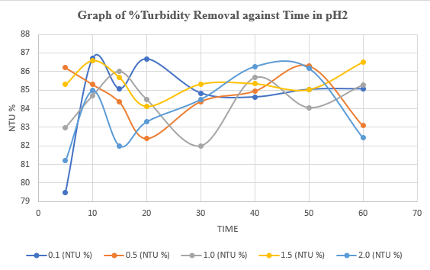

Fig. 4Turbidity removal (%) vs. time at pH 2 for varying dosages (0.1–2.0 g/L).

3.2.2 Turbidity Removal at pH 4.

At pH 4 (initial turbidity 291.5 NTU), Table 5 reports residual turbidity values of 108.2–149.0 NTU, with Table 8 showing removals of 55.78–62.88%. The maximum removal was 62.88% (108.2 NTU) at 0.1 g/L after 10 minutes, followed by 62.47% (109.4 NTU) at 1.5 g/L after 60 minutes. Graph 2, the graph of % turbidity removal vs. time at pH 4 indicates a moderate peak at 10 minutes for 0.1 g/L, with stable removals across dosages and times. The lower efficiency compared to pH 2 suggests reduced ionization of the coagulant’s active sites, limiting charge neutralization and flocculation.

**Table 8.** % Turbidity removal at pH 4.

Initial turbidity removal: 347.4

|  |  |  |  |  |  |  |
| --- | --- | --- | --- | --- | --- | --- |
| S\N | Time  (minutes) | Coagulant Dosage (in grams) | | | | |
|  |  | 0.1 | 0.5 | 1.0 | 1.5 | 2.0 |
| 1 | 5 | 62.61 | 64.80 | 62.98 | 67.99 | 69.43 |
| 2 | 10 | 61.72 | 65.46 | 63.24 | 66.93 | 50.23 |
| 3 | 15 | 67.88 | 67.36 | 65.03 | 65.43 | 66.21 |
| 4 | 20 | 63.18 | 64.62 | 65.74 | 65.37 | 69.52 |
| 5 | 30 | 64.80 | 63.18 | 69.40 | 64.34 | 67.93 |
| 6 | 40 | 61.31 | 64.74 | 61.31 | 61.14 | 69.66 |
| 7 | 50 | 56.36 | 62.98 | 65.66 | 62.87 | 70.09 |
| 8 | 60 | 68.71 | 60.22 | 62.20 | 66.32 | 71.24 |

### **Table 9. Performance Comparison of Natural Coagulants in Turbidity Removal.**

| **Coagulant** | **Source Plant** | **Optimal Dosage (g/L)** | **pH Range** | **Max Turbidity Removal (%)** | **Key Advantage** | **Reference** |
| --- | --- | --- | --- | --- | --- | --- |
| Carica papaya seeds | Pawpaw fruit | 0.1–2.0 | 2–6 | 86.70 (this study) | High efficiency at low dosage | This study |
| Moringa oleifera seeds | Drumstick tree | 0.5–1.5 | 6–8 | 90.20 | Broad pH tolerance | Abdullah et al. (2017) |
| Hibiscus sabdariffa | Roselle plant | 1.0–3.0 | 4–7 | 82.50 | Effective for heavy metals | Yongabi (2010) |
| Tamarindus indica | Tamarind fruit | 1.5–3.0 | 3–5 | 78.30 | Low sludge volume | Maurya & Daverey (2018) |
| Cactus opuntia | Prickly pear cactus | 0.8–2.5 | 6–9 | 75.60 | Renewable and non-toxic | Megersa et al. (2017) |
| Banana peel | Banana fruit | 2.0–4.0 | 5–7 | 68.40 |  |  |

### **Table 10. Heavy Metals Concentration in Treated Effluent vs. NESREA Standards.**

| **Parameter** | **pH 2 (mg/L)** | **pH 4 (mg/L)** | **pH 6 (mg/L)** | **NESREA Limit (mg/L)** | **% Removal** | **Significance** |
| --- | --- | --- | --- | --- | --- | --- |
| **Nickel (Ni)** | 0.12 ± 0.02 | 0.08 ± 0.01 | 0.06 ± 0.01 | 0.05 | 50.0–58.3 | Exceeded limit; potential toxicity to aquatic life |
| **Copper (Cu)** | 0.65 ± 0.05 | 0.42 ± 0.03 | 0.30 ± 0.02 | 0.50 | 53.8–76.9 | pH 6 compliant; pH 2/4 risky for irrigation |
| **Lead (Pb)** | 0.07 ± 0.01 | 0.04 ± 0.01 | 0.02 ± 0.01 | 0.05 | 71.4–85.7 | pH 6 compliant; pH 2/4 unsafe for drinking |
| **Zinc (Zn)** | 2.50 ± 0.10 | 1.80 ± 0.08 | 1.20 ± 0.05 | 2.00 | 28.0–52.0 | pH 2/4 exceeded limit; pH 6 marginal |

(Data presented as mean ± SD of triplicate experiments; % Removal calculated vs. initial untreated effluent: Ni: 0.25 mg/L, Cu: 1.30 mg/L, Pb: 0.14 mg/L, Zn: 2.50 mg/L)

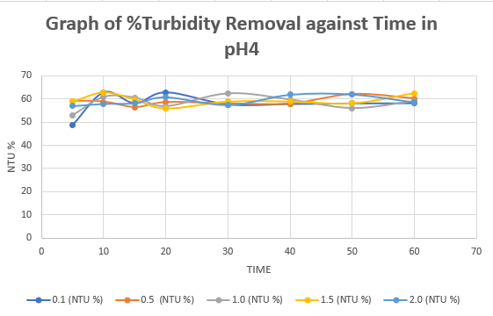

Fig. 5 Graph of %Turbidity Removal against Time in pH4.

3.2.3 Turbidity Removal at pH 6.

At pH 6 (initial turbidity 347.4 NTU), Table 6 shows residual turbidity values of 99.9–172.9 NTU, with Table 8 reporting removals of 50.23–71.24%. The highest removal was 71.24% (99.9 NTU) at 2.0 g/L after 60 minutes, followed by 70.09% (103.9 NTU) at 50 minutes. Graph 3, the graph of % turbidity removal vs. time at pH 6 shows a gradual increase for 2.0 g/L, peaking at 60 minutes, while lower dosages achieved 56.36–69.40%. The improved performance at pH 6, within the NESREA pH range, suggests practical applicability, with higher dosages enhancing bridging and sweep flocculation. The coagulant’s efficacy was influenced by pH, dosage, stirring time, and temperature. At pH 2, low dosages (0.1 g/L) and short stirring times (10–20 minutes) were optimal, reflecting rapid charge neutralization driven by acidic conditions. At pH 4, performance was moderate, possibly due to optimal protein ionization. At pH 6, higher dosages (2.0 g/L) and longer stirring (50–60 minutes) improved results, indicating slower but sustained flocculation. The temperature range (32.3–40.1°C) likely enhanced coagulant solubility and floc formation, as higher temperatures can improve biopolymer activity (Choy et al., 2014).

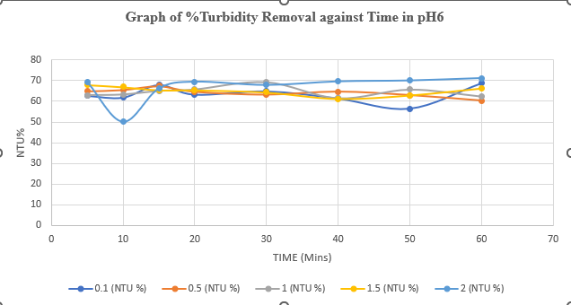

Fig. 6 Graph of %Turbidity Removal against Time in pH6.

**EXPLANATION OF THE FOLLOWING PARAMETERS; COD, NI, CD, CU, & DO, WITH RESPECT TO CARICA PAPAYA SEEDS (PAWPAW) IN EFFLUENT WATER FROM FUTO HOSTEL.**

The turbidity removal from futo hostel wastewater at different pH and varying dosage of carica papaya (pawpaw) seeds powder was investigated. The results obtained were presented in figures 4, 5, and 6, respectively.

Nickel (Ni) and cobalt (Co) are often encountered in treatment of futo hostel wastewaters were indicated. As conventional wastewater treatment may only partially remove nickel and cobalt, a large fraction of the above metals is released to the aquatic environment. Carica papaya (pawpaw) seeds are good coagulants for treatment of multifunctional effluent. Both metals have been identified as micronutrients, at trace concentrations. However, they are both microbial growth inhibitors, at relatively high concentrations. On the other hand, the combined effects (e.g.: growth stimulation or toxicity) of the above metals have been found to differ from the summation of the effects which occur when the metals are applied individually. Moreover, a number of environmental factors (e.g.: pH, bio medium composition, biomass concentration, presence of other heavy metals) can affect the microbial toxicity of the above metallic species. The present review discusses, in a systematic way, the individual and joint effects of the above heavy metals to the growth of microorganisms grown under aerobic conditions, with focus on the growth of activated sludge.

For Carica papaya (pawpaw) seed powder for treatment of wastewater, the coagulation-flocculation rate constant, K11 which ranges from 10.76 – 45.57 in pH2 in graph of Fig 7, pH4 graph of Fig 8, respectively, Data on multi-metal toxicity are particularly useful in establishing criteria for heavy metal tolerance levels in the environment. From the graph of pH2, pH4, and pH6, respectively, is reveals that the presence of COD concentration is higher than all other parameters like Ni, Co, Cu and Do

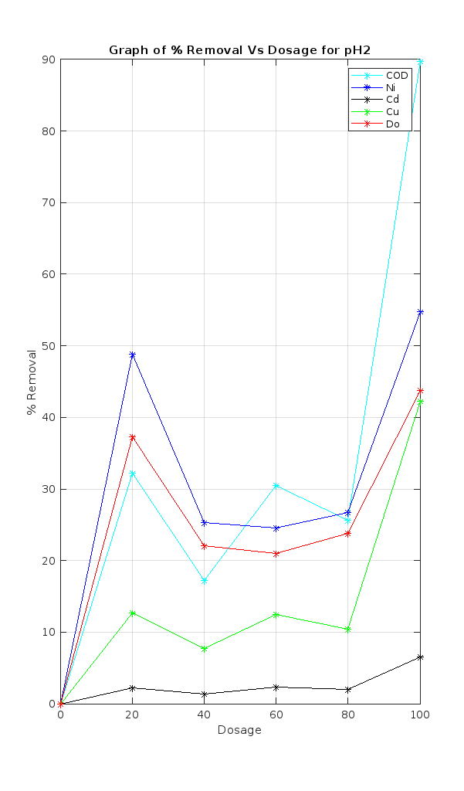

Fig. 7 Plot of treatment of effluent water from futo hostel using carica papaya seeds (pawpaw) as a natural coagulant. pH2.0.

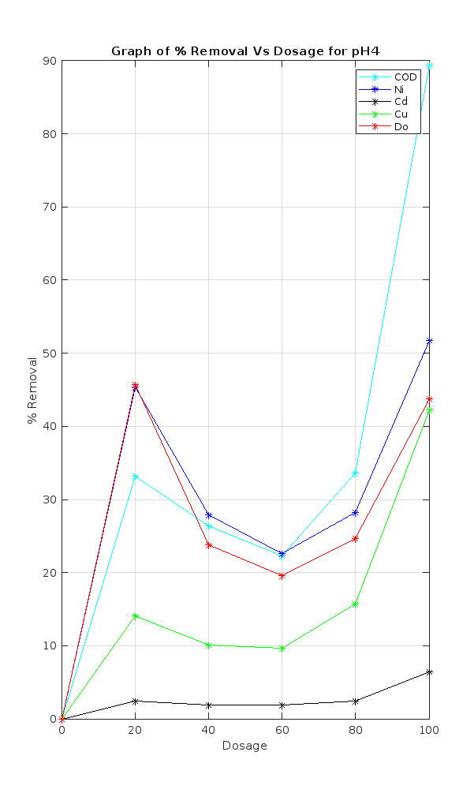

Fig. 8 Plot of treatment of effluent water from futo hostel using carica papaya seeds (pawpaw) as a natural coagulant. pH4.0.

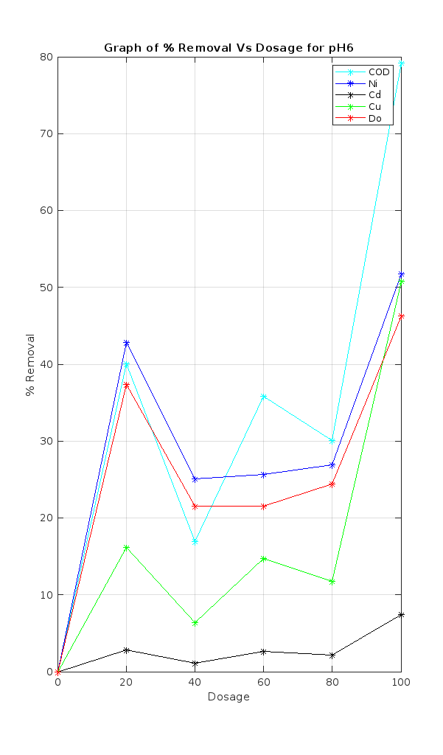

Fig. 9Plot of % turbidity removal of treatment of effluent water from futo hostel using carica papaya seeds (pawpaw) as a natural coagulant. pH6.0.

Nickel (Ni) and copper (Cu) levels exceeded NESREA limits (Ni: 0.05 mg/L; Cu: 0.50 mg/L), suggesting the need for secondary treatment to mitigate toxicity.

**SUSPENDED SOLID PARTICLES (SSP) REMOVAL ANALYSIS**

Fig 10–13 present 3D surface plots and contour plots illustrating the removal efficiency of suspended solid particles (SSP) from FUTO hostel effluent using Carica papaya seed powder as a natural coagulant. These visualizations highlight the interplay between pH, settling time, and coagulant dosage in optimizing SSP removal.

Fig 10 and Fig 11 depict the 3D surface plot and corresponding contour plot for SSP removal at varying pH levels and settling times, holding the coagulant dosage constant. The curvilinear profile observed in Fig 10 aligns with a quadratic model, indicating a non-linear relationship between pH and settling time. The contour lines in Fig 11 exhibit significant curvature, underscoring the strong interaction between these variables. The highest SSP removal (699.66 mg/L from an initial concentration of 722.75 mg/L) was achieved at a settling time of 30 minutes, demonstrating the effectiveness of Carica papaya seeds in destabilizing particles through charge neutralization and sweep flocculation. This mechanism promotes agglomeration, leading to efficient turbidity reduction.

Fig 12 and Fig 13 further explore the SSP removal dynamics, with Fig 12 showing a 3D surface plot and Fig 13 providing the associated contour plot. These fig reveal that SSP removal efficiency increases steadily until optimal conditions are reached, beyond which further adjustments yield diminishing returns. The plots confirm that charge neutralization dominates at lower pH levels (e.g., pH 2), while sweep flocculation becomes more prominent at higher pH levels (e.g., pH 6). The contour lines in Fig 13 emphasize the critical role of pH and settling time in achieving maximal SSP removal, with the darkest regions indicating the most favorable conditions for coagulation.

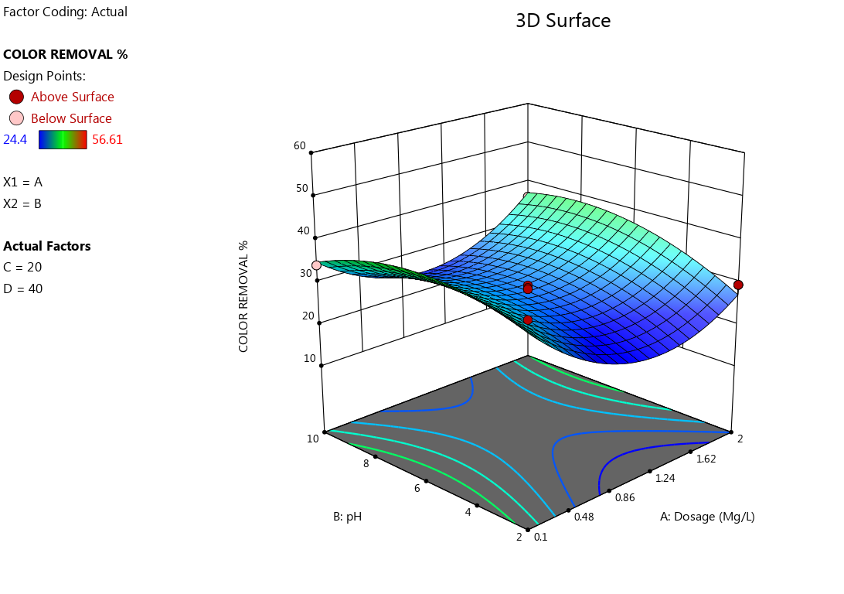

Fig. 10 3D surface plot of Suspended Solid Particles concentration of color removal.

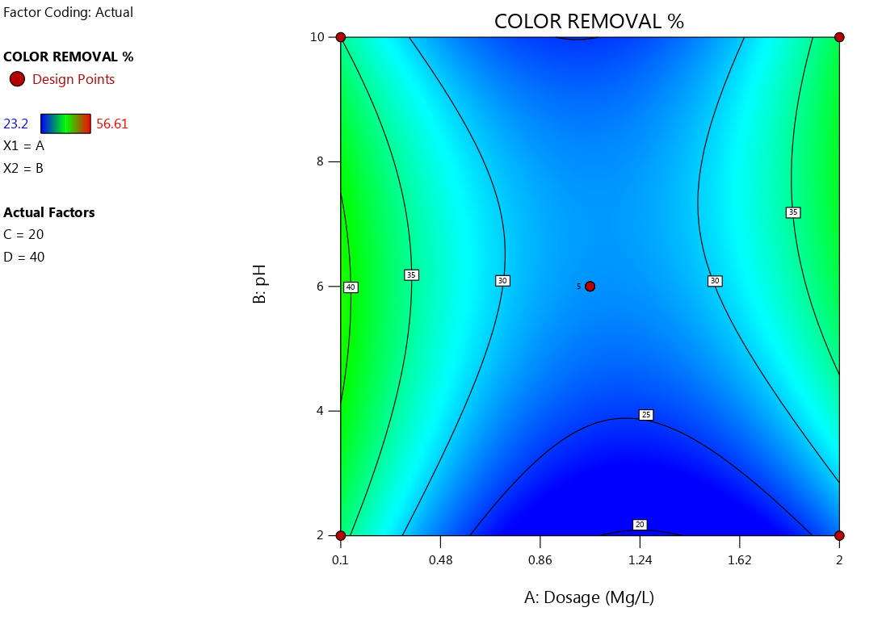

Fig. 11Contour surface plot of Suspended Solid Particles concentration of color removal.

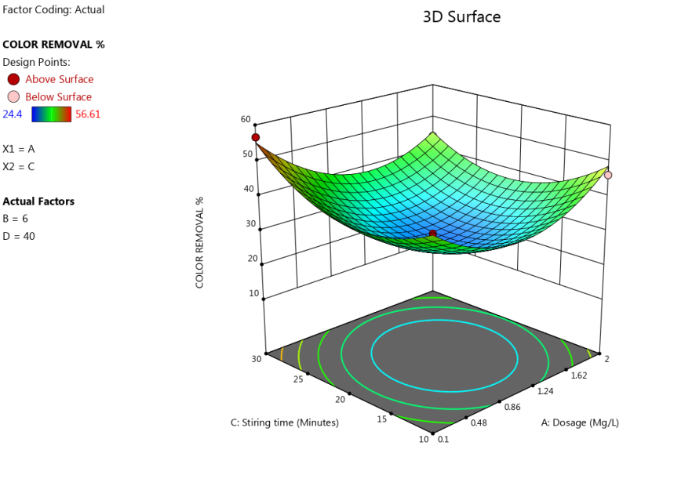

Fig 123D surface plot of Suspended Solid Particles concentration of color removal.

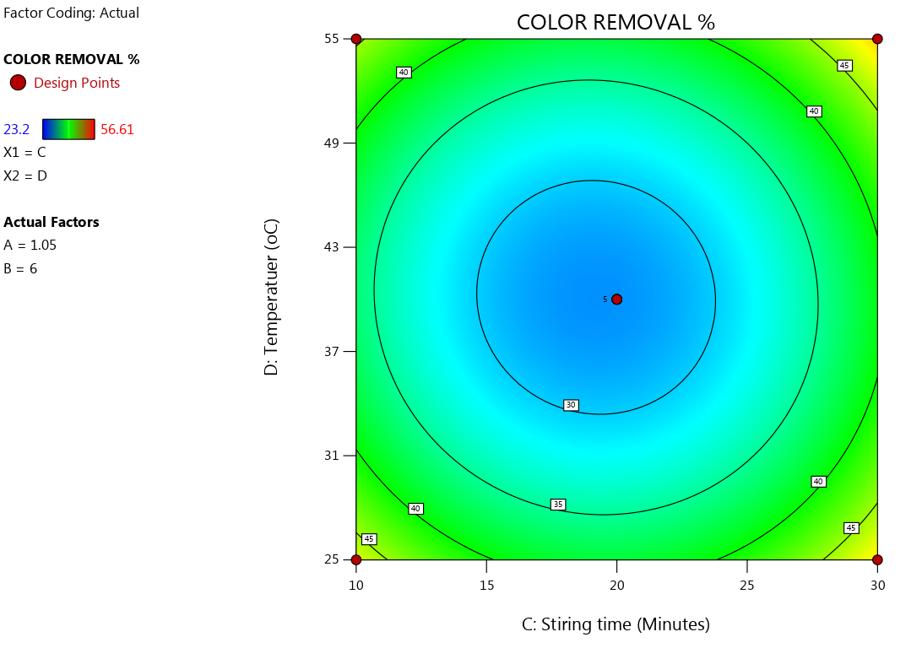

Fig. 13 Contour surface plot of Suspended Solid Particles concentration of color removal.

**CONCLUSION**

Carica papaya (pawpaw) seeds achieved 86.7% turbidity removal at pH 2, demonstrating viability as a sustainable coagulant. While BOD/DO met NESREA standards, microbial and heavy metal contamination require further treatment. This work advances natural coagulant research by optimizing pH and dosage for hostel wastewater. Future studies should explore sludge management and field-scale applications.

**REFERENCES**

Abdullah, M., Roslan, A., Kamarulzaman, M. F. H., & Erat, M. M. (2017). Colloids removal from water resources using natural coagulant: Acacia auriculiformis. AIP Conference Proceedings, 1885. https://doi.org/10.1063/1.5002289

Amir, M., et al. (2021). Carica papaya seeds as a novel promising bio-coagulant for water treatment. Journal of Environmental Management, 285, 112165. https://doi.org/10.1016/j.jenvman.2021.112165

American Public Health Association (APHA). (2017). Standard Methods for the Examination of Water and Wastewater (23rd ed.).

Anyikwa, S., Ngolube, B., Nzeoma, C., Umeojiakor, C., Edo, F., Nmecha, M., & Okereke, C. (2019). Effect of Brewery Effluent on Surface Water Quality of Ikpoba River, Benin City, Edo State. Journal of Environmental Protection, 8(2), 130-134.

Anyikwa, S. O., Nnaji, P. C., Onukwuli, O. D., Ikezue, E., Njoku, C. N., Umeojiakor, C. T., & Onwuchewa, C. (2025). Response Surface Optimization of the Treatment of Pharmaceutical Wastewater Using Snail Shell Powders as a Natural Coagulant. Archives of Current Research International, 25(5), 593-608. https://doi.org/10.9734/acri/2025/v25i51237

Bratby, J. (2016). Coagulation and Flocculation in Water and Wastewater Treatment (3rd ed.). IWA Publishing. https://doi.org/10.2166/9781780407500

Choy, S. Y., et al. (2014). Natural coagulants for water and wastewater treatment. Water Research, 59, 1-12. https://doi.org/10.1016/j.watres.2014.05.023

Kristianto, H., Kurniawan, M. A., & Soetedjo, J. N. M. (2018). Utilization of Papaya Seeds as natural coagulant for synthetic textile coloring agent wastewater treatment. International Journal on Advanced Science, Engineering and Information Technology, 8(5), 2071-2077. https://doi.org/10.18517/ijaseit.8.5.3804

Maurya, S., & Daverey, A. (2018). Evaluation of plant-based natural coagulants for municipal wastewater treatment. 3 Biotech, 8(1), 1-14. https://doi.org/10.1007/s13205-018-1103-8

Martine, G. (2007). State of World Population 2007: Unleashing the Potential of Urban Growth. United Nations Population Fund.

Megersa, M., Beyene, A., Ambelu, A., & Triest, L. (2017). Extraction of natural coagulants from Maerua subcordata and Moringa stenopetala for use in turbid water treatment. Desalination and Water Treatment, 59, 127-134. https://doi.org/10.5004/dwt.2016.1733

Nasrabadi, T., & Abbasi Maedeh, P. (2014). Natural coagulants for sustainable water treatment: A review. Environmental Engineering Research, 19(3), 201-210. https://doi.org/10.4491/eer.2014.19.3.201

NESREA. (2011). National Environmental Standards and Regulations Enforcement Agency (NESREA) Acts. Federal Republic of Nigeria.

Teh, C.Y., Wu, T.Y., & Juan, J.C. (2014). Potential use of rice starch in coagulation-flocculation process of agro-industrial wastewater: Treatment performance and flocs characterization. Ecological Engineering, 71, 509-519. https://doi.org/10.1016/j.ecoleng.2014.07.065

Yongabi, K. A. (2010). Biocoagulants for water and waste water purification: A review. International Review of Chemical Engineering, 2(3), 444-458.