**TREATMENT OF EFFLUENT WATER FROM FUTO HOSTEL USING CARICA PAPAYA (PAWPAW) SEEDS AS COAGULANT**

**ABSTRACT**

This study evaluates the effectiveness of pawpaw Carica papaya seed powder as a natural coagulant for treating effluent water from the Federal University of Technology, Owerri (FUTO) hostel, with an initial turbidity of 722.75 NTU. Batch coagulation-flocculation experiments assessed the influence of coagulant dosage (0.1–2.0 g/L), stirring time (5–60 minutes), and pH (2, 4, 6) on turbidity reduction. The highest turbidity removal of 86.70% (96.2 NTU) was achieved at pH 2 with 0.1 g/L coagulant after 10 minutes, followed by 86.27% (99.2 NTU) with 2.0 g/L after 40 minutes. At pH 6, 71.24% removal (99.9 NTU) was attained with 2.0 g/L after 60 minutes. This underscores the potential of natural coagulants like pawpaw seeds in addressing water purification challenges. By harnessing natural resources, we can develop more sustainable and environmentally friendly water treatment processes that contribute to public health and environmental conservation. Using pawpaw seeds in water treatment provides a practical solution and supports efforts toward sustainable development and resource utilization.

**Key words:** Coagulants, wastewater, Caricapapaya seeds, Pawpaw, pH, and Turbidity

# **1 INTRODUCTION**

# Water is a vital resource for life, yet its availability and quality are increasingly compromised by rapid industrialization, urbanization, and population growth. Globally, approximately 71% of the Earth's surface is covered by water, but only 2.5% is freshwater, with a significant portion inaccessible or contaminated. The global demand for freshwater is projected to rise by over 60 billion m³ annually to support a population growth of 80 million people per year, exacerbating water scarcity challenges, particularly in urbanizing regions like Africa, where urban populations are expected to double between 2000 and 2030 (Martine, 2007). Factors such as climate change, agricultural expansion, and industrial activities further strain water resources, while contamination from anthropogenic activities, geological interactions, and environmental conditions renders many water sources unfit for direct use (Nasrabadi and Abbasi Maedeh, 2014).

# Coagulation-flocculation is a cornerstone of water and wastewater treatment, effectively reducing turbidity, suspended solids, and organic matter by up to 90% (Bratby, 2016). While chemical coagulants like alum and ferric salts are widely used, they pose challenges, including high costs, pH sensitivity, and the generation of non-biodegradable sludge, which can harm ecosystems. In contrast, natural coagulants derived from plant, animal, or microbial sources offer sustainable, cost-effective, and biodegradable alternatives (Choy et al., 2014). Plant-based coagulants, such as those extracted from Moringa oleifera, hibiscus seeds, and Carica papaya (papaya) seeds, have gained attention for their non-toxicity, renewability, and minimal environmental footprint (Teh et al., 2014).

# Among these, papaya seeds have emerged as a promising bio-coagulant due to their high protein and polysaccharide content, which facilitate effective coagulation through charge neutralization and bridging mechanisms. Studies have reported turbidity removal efficiencies of up to 88% using papaya seed extracts, with additional benefits such as low sludge production and compatibility with solar disinfection for rural applications (Amir et al., 2021). These attributes make papaya seeds particularly suitable for treating effluent water in resource-constrained settings, such as university hostels, where untreated discharges contribute to environmental pollution and public health risks.

At the Federal University of Technology, Owerri (FUTO), hostel effluent water contains a complex mix of suspended solids, organic matter, and microbial contaminants, necessitating effective treatment strategies. This study explores the potential of papaya seed powder as a natural coagulant to treat FUTO hostel effluent, focusing on its ability to reduce turbidity and improve water quality. By leveraging locally available, biodegradable materials, this research aims to develop a sustainable, low-cost solution for wastewater treatment, aligning with global efforts to promote environmental stewardship and resource conservation. The removal of turbidity from pharmaceutical wastewater using varying dosage of snail shell powder of different pH was investigated and the result obtained was presented in their work. The wastes generated by the day to day man’s activities possess great danger to man’s heath, animal and environment. In otherworld’s, the need for this research findings are necessitated. (Anyikwa et al., 2025). `

# **2 MATERIALS AND METHODS**

2.1 Materials

All the chemicals used were of analytical grade.

Effluent source:The effluent water gotten from FUTO hostel (Hostel A) an amount of about 25 liters, the Initial Turbidity, BOD, COD, and E-coli Bacteria content was determine using NESREA standard methods.

Paw-paw ground seeds, Effluent water sample, Sulphuric acid ( $H_{2}SO_{4})$ and Sodium hydroxide (NaOH) pellets used to lower and increase the pH

2.1.1 Equipment: Weighing scale, Beaker, Conical flask, Stopwatch, Measuring, Cylinder, Laboratory Sieve, pH meter, Jerry Cans, Laboratory Grinder, Turbidity, and Clean Water.

2.1.2 Experimental design

Effluent water collection

Separation of effluent water

pH 2

pH 4

pH 6

Selection of Coagulant

Papaya seed

Preparation of Coagulant

Washing, Drying, De shelling, Grinding, Sieving

Initial Characterization of Effluent water (PH 2,4,6)

Turbidity

E-coli Bacteria

BOD

COD

Application of coagulant to effluent water (PH 2, 4,6)

Final Characterization of Effluent water

Turbidity

Testing with Water Standards

Comparison of Results

2.2 Methods

2.2.1 pH Determination

The pH of the effluent water was measured to verify compliance with the NESREA standard range of 6–9, using the Electrometric Method (APHA 4500-H⁺ B). A calibrated pH meter equipped with a glass electrode was used. Samples were collected in clean, non-reactive containers and analyzed immediately to prevent alterations due to biological or chemical activity. The pH meter was calibrated with standard buffer solutions (pH 4, 7, and 10) prior to measurements. The electrode was rinsed with deionized water between samples, and samples were gently stirred during measurement to ensure uniformity. This method provided precise pH values, critical for assessing the treated effluent’s regulatory compliance.

2.2.2 Turbidity Determination

Turbidity was measured to meet the NESREA standard of 5 NTU, employing the Nephelometric Method (APHA 2130 B). A nephelometer was used to quantify light scattering by suspended particles. The instrument was calibrated with formazin standards (0–40 NTU) to cover the expected turbidity range. Samples were gently shaken to resuspend settled particles and analyzed promptly in a clean cuvette to prevent sedimentation. This highly sensitive method confirmed whether the treated effluent, which achieved an 86.6% turbidity reduction using pawpaw seeds, met the NESREA limit.

2.2.3 Conductivity Measurement

Conductivity was determined to comply with the NESREA standard of 2000 µS/cm, using the Electrometric Method (APHA 2510 B). A conductivity meter, calibrated with a potassium chloride (KCl) standard solution (1413 µS/cm), was employed. The electrode was rinsed with deionized water between measurements, and temperature compensation to 25°C was applied to standardize results. Samples were analyzed in clean containers, ensuring no air bubbles interfered with the electrode. This method accurately assessed the ionic content of the effluent.

2.2.4 Total Dissolved Solids (TDS) Analysis

TDS was quantified to meet the NESREA standard of 500 mg/L, using the Gravimetric Method (APHA 2540 C). A known sample volume was filtered through a 0.45 µm filter to remove suspended solids. The filtrate was evaporated in a pre-weighed dish at 180°C, and the residue was weighed to calculate TDS in mg/L. Alternatively, TDS was estimated from conductivity using a conversion factor (TDS ≈ conductivity × 0.5–0.7), based on the sample’s ionic composition. This precise method provided insights into the dissolved inorganic and organic content of the treated effluent.

2.2.5 Biochemical Oxygen Demand (BOD) Analysis

BOD was measured to ensure compliance with the NESREA limit of 50 mg/L, using the 5-Day BOD Test (APHA 5210 B). The initial dissolved oxygen (DO) content of a diluted sample was determined with a DO probe, followed by incubation at 20°C for 5 days in the dark to prevent photosynthesis. The final DO was measured, and BOD was calculated as the difference, adjusted for dilution. Samples with low microbial activity were seeded with a microbial culture. Samples were stored at 4°C and analyzed within 24 hours to minimize biological changes. This method evaluated the biodegradable organic load in the effluent.

2.2.6 Chemical Oxygen Demand (COD) Analysis

COD was determined to verify compliance with the NESREA limit of 90 mg/L, using the Closed Reflux, Titrimetric Method (APHA 5220 C). Samples were digested with potassium dichromate and sulfuric acid in sealed vials at 150°C for 2 hours. Unreacted dichromate was titrated with ferrous ammonium sulfate to quantify oxidizable organic and inorganic matter. For low COD levels, the colorimetric method (APHA 5220 D) was considered. Samples were preserved with sulfuric acid and stored at 4°C if not analyzed immediately. This method accurately measured the total oxidizable content.

2.2.7 Dissolved Oxygen (DO) Analysis

DO was measured to meet the NESREA standard of 7.5 mg/L, using the Winkler Method (APHA 4500-O C) or the Polarographic Probe Method (APHA 4500-O G). For the Winkler method, samples were fixed with manganese sulfate and alkaline iodide, and then titrated with sodium thiosulfate. Alternatively, a calibrated DO meter with a polarographic membrane electrode was used, ensuring no air bubbles and adequate sample flow. Samples were analyzed immediately to prevent oxygen depletion or enrichment. This method confirmed the effluent’s oxygen levels for aquatic ecosystem health. Anyikwa et al. (2019) investigated how the surface water quality of the Ikpoba River in Benin City, Edo State, was affected by brewery sewage. ANOVA, a one-way analysis of variance, was employed to ascertain homogeneity in an average deviation for the physicochemical parameters such as sulphate, chromium, calcium, magnesium, chemical oxygen demand (COD), dissolved oxygen, alkalinity, The sum of the solids, suspended solids, and hardness, total dissolved solids and the need for biological oxygen, conductivity, color, turbidity, pH, iron, copper, zinc, chloride, and certain selected heavy metals across the sampling points of p<0.05.

2.2.8 Zinc Analysis

Zinc was quantified to comply with the NESREA limit of 2.0 mg/L, using Atomic Absorption Spectrophotometry (AAS) (APHA 3111 B). Samples were acid-digested with nitric acid (HNO₃) to release metals and analyzed via flame AAS at 213.9 nm, with calibration using zinc standards (0.1–2.0 mg/L). For higher sensitivity, inductively coupled plasma mass spectrometry (ICP-MS) (APHA 3125) was considered. Samples were acidified to pH < 2 and stored at 4°C. This method ensured accurate zinc detection.

2.2.9 Copper Analysis

Copper was measured to meet the NESREA limit of 0.50 mg/L, using AAS (APHA 3111 B). Samples were acid-digested and analyzed via flame AAS at 324.7 nm, calibrated with copper standards (0.05–1.0 mg/L). ICP-MS (APHA 3125) was an option for trace levels. Samples were preserved with HNO₃ at pH < 2 and stored at 4°C. This method provided precise copper measurements.

2.2.10 Lead Analysis

Lead was analyzed to comply with the NESREA limit of 0.05 mg/L, using graphite furnace AAS (APHA 3113 B) at 283.3 nm due to its low permissible limit. Samples were acid-digested and calibrated with lead standards (0.01–0.1 mg/L). ICP-MS (APHA 3125) was considered for ultra-trace detection. Samples were acidified and stored at 4°C. This high-sensitivity method ensured compliance, protecting human and environmental health.

2.2.11 Nickel Analysis

Nickel was quantified to meet the NESREA limit of 0.05 mg/L, using AAS (APHA 3111 B). Samples were acid-digested and analyzed via flame AAS at 232.0 nm, calibrated with nickel standards (0.01–0.1 mg/L). ICP-MS (APHA 3125) was suitable for low concentrations. Samples were preserved with HNO₃ at pH < 2 and stored at 4°C. This method ensured accurate nickel detection.

2.2.12 Sulphate Analysis

Sulphate was measured to comply with the NESREA limit of 250 mg/L, using the Turbidimetric Method (APHA 4500-SO₄²⁻ E). Barium chloride was added to form a barium sulfate precipitate, quantified by turbidity at 420 nm using a spectrophotometer calibrated with sulphate standards (0–250 mg/L). Ion chromatography (APHA 4110 B) was an alternative for multiple anion analysis. Samples were stored at 4°C and analyzed within 7 days. This method confirmed sulphate compliance.

2.3 Preparation of natural coagulant

Carica papaya seed gotten from local fruit vendors in aforama market in Ogwume Town. The seeds were washed severally with clean water. Then, seeds were dried under sunlight for a period of 7 days before grinding. The seeds were made into fine powder using a household grinder, the seed powder was further sieved using a sieve of about 830µm and finer particles were then used as coagulant for the coagulation process. Plate 1, shows the **Processes of** Preparation of Coagulant.

**Plate 1. Processes of** Preparation of Coagulant.

pH Regulation.The Hostel effluent had a pH of 4 when tested with the pH meter in Chemical Engineering laboratory, Federal University of Technology, Owerri. The Effluent was divided into 3 gallons 8 liters each, the original pH of 4 was lowered to a pH of 2 using an acid namely H2SO4 (sulphuric acid) and increased to a pH of 6 using a base NaOH (Sodium hydroxide).

Coagulation experiment (Jar Test): A standard jar test is performed to study the coagulation behavior of the natural coagulant in this method, different doses of the coagulant (0.1g, 0.5g, 1.0g, 1.5g, 2.0g) were added to 250ml effluent water samples both of PH 2, 4, and 6. The mixture was agitated/stirred at various time intervals namely (5, 10, 15, 20, 30, 40, 50, and 60) minutes, and the formation of flocs indicated the efficiency of the coagulant in removing suspended particles. After the coagulation process was completed, the following parameters: E.coli bacteria, Chemical Oxygen demand (COD), Biochemical Oxygen Demand (BOD) were tested.

The obtained results are compared with standard guidelines for wastewater discharge to determine the effectiveness of the natural coagulant in treating effluent water.

Statistical analysis including graphical correlation of parameters (turbidity, amount of Coagulant) for various pH’s were carried out and the results gotten is used to obtain its significance and establish conclusions on the efficiency of the Carica Papaya seed as a natural coagulant. Plate 2 shows effluent containing natural coagulant (pawpaw seed) being stirred at various intervals with a Digit show thermostat magnetic stirrer, while Plate 3: final appearance of effluent after coagulation (treatment with coagulant) and turbidity test L-R; pH of 6 – 2.

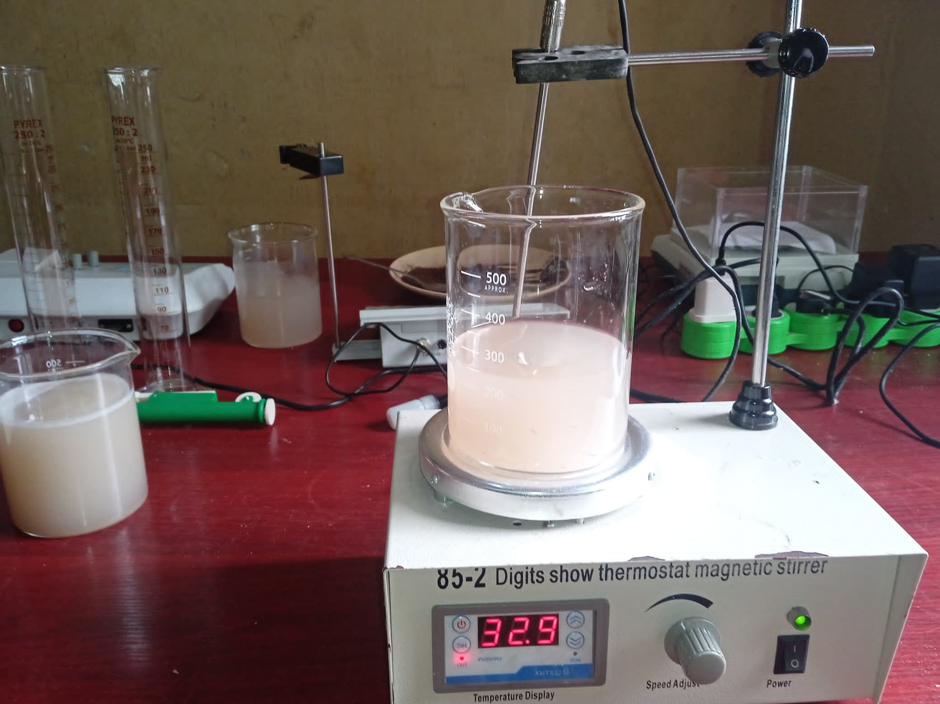

*Plate 2: Effluent containing natural coagulant (pawpaw seed) being stirred at various intervals with a Digit show thermostat magnetic stirrer.*

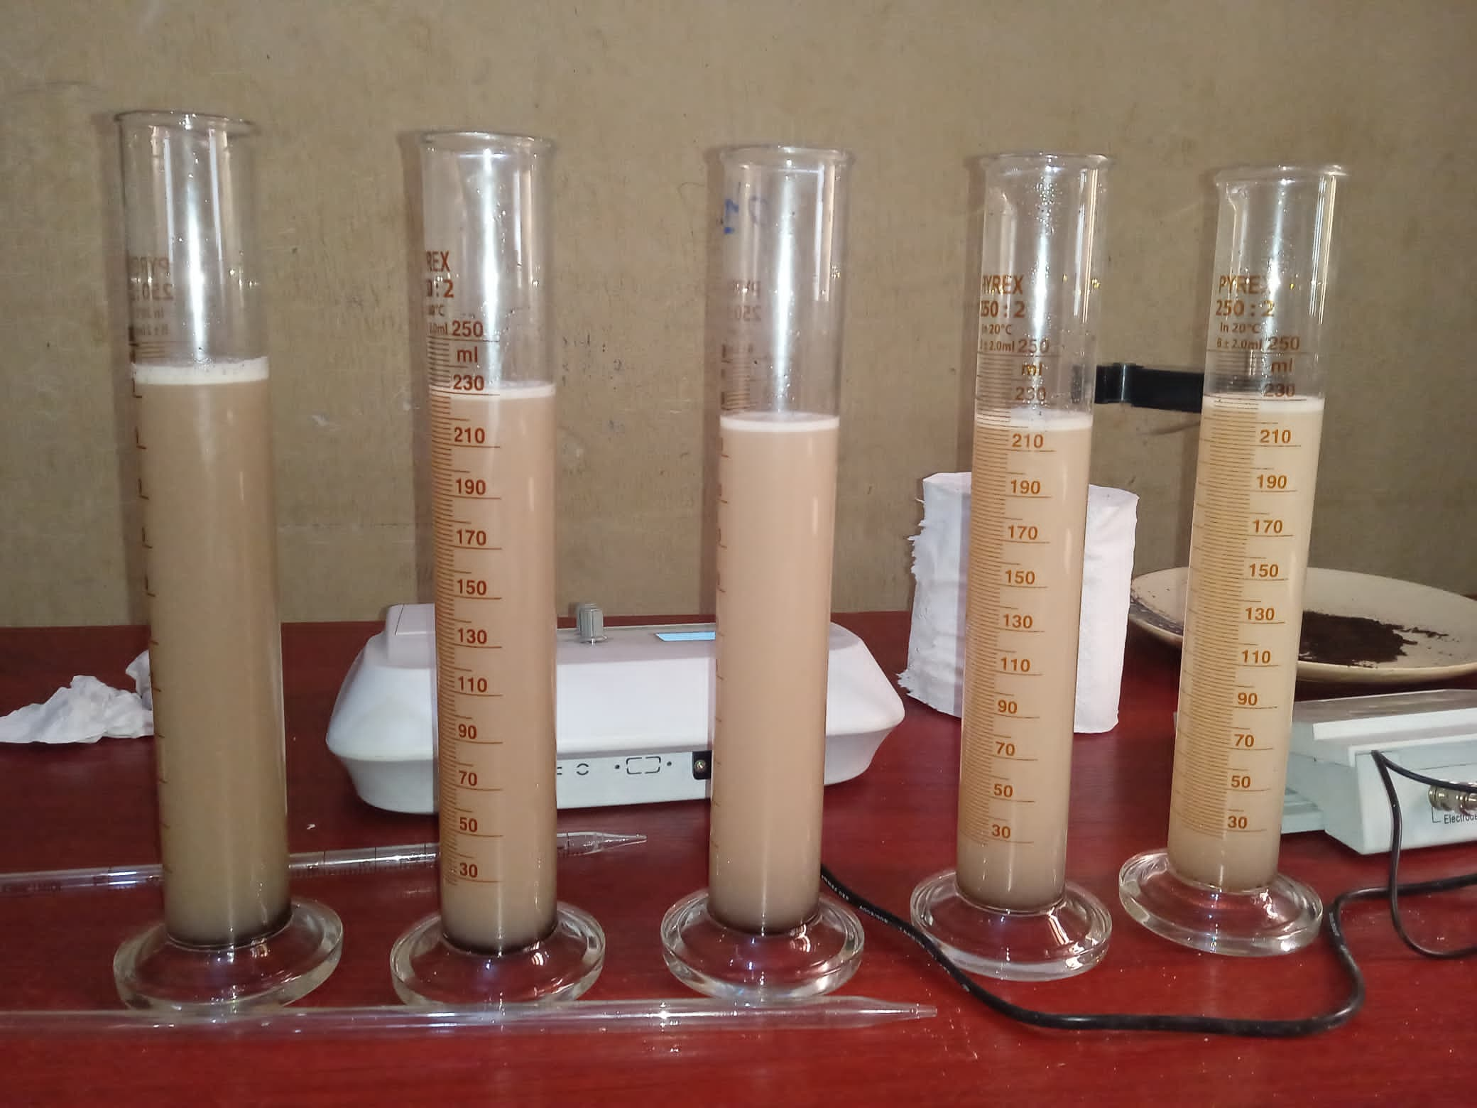

Plate 3: final Appearance of Effluent after coagulation (treatment with coagulant) and turbidity test L-R; pH of 6 – 2.

# **3 RESULT AND DISCUSSION**

3.1 Characterization of Untreated Effluent Water

The untreated effluent from Hostel A at the Federal University of Technology, Owerri (FUTO) was characterized to establish baseline water quality parameters, as shown in Table 1. The results indicate significant non-compliance with the National Environmental Standards and Regulations Enforcement Agency (NESREA) discharge standards (Table 2), highlighting the need for effective treatment.

At pH 2, the effluent had a turbidity of 722.50–723.00 NTU, far exceeding the NESREA limit of 5 NTU. The chemical oxygen demand (COD) was 848.00 mg/L, well above the 90 mg/L standard, indicating a high load of oxidizable matter. Biochemical oxygen demand (BOD) ranged from 8.40–9.00 mg/L, compliant with the 50 mg/L limit, suggesting low biodegradable organic content. Dissolved oxygen (DO) levels of 3.50–3.60 mg/L were below the 7.5 mg/L requirement, reflecting poor aerobic conditions. Microbial analysis detected Klebsiella at 1.0 × 10⁴ cfu/mL in one run, violating the NESREA zero-tolerance standard for pathogens.

At pH 4, turbidity decreased to 290.00–293.00 NTU, COD to 416.00–432.00 mg/L, and BOD increased to 19.80 mg/L, all non-compliant except BOD. DO remained low at 3.30 mg/L, and microbial counts were elevated, with E. coli at 7.0 × 10⁴ cfu/mL and Klebsiella up to 9.0 × 10⁶ cfu/mL. At pH 6, turbidity was 346.80–348.00 NTU, COD was 848.00 mg/L, BOD was 0.30–0.40 mg/L (compliant), and DO was 2.00–2.10 mg/L. Klebsiella was detected at 1.0 × 10⁴ cfu/mL in one run. These results confirm the effluent’s high turbidity, organic load, and microbial contamination, necessitating treatment to meet regulatory standards.

**Table 1.** Water Quality Parameters at Different pH Levels (pH 2, pH 4, pH 6)

|  |  |  |  |  |  |  |  |
| --- | --- | --- | --- | --- | --- | --- | --- |
| Parameters | FME Standard | pH 2 | | pH 4 | | pH6 | |
|  |  | Run 1 Run 2 | | Run1 Run2 | | Run 1 Run2 | |
| Biological Oxygen Demand, mg\lBOD5 | NS | 9.00 | 8.40 | 19.80 | 19.80 | 0.30 | 0.40 |
| Dissolved Oxygen,mg\l O2 | <7.50 | 3.60 | 3.50 | 3.30 | 3.30 | 2.00 | 2.10 |
| Chemical Oxygen Demand ,mg\l O2 | NS | 848.00 | 848.00 | 416.00 | 432.00 | 848.00 | 848.00 |
| Turbidity ,NTU | 10.00 | 722.50 | 723.00 | 290.00 | 293.00 | 346.80 | 348.00 |
| Total E.coli Count ,cfu\ml | 0 | NG | NG | $${7.0*10}^{4}$$ | NG | NG | NG |
| Total Klebsiella count ,cfu\ml | 0 | $${1.0*10}^{4}$$ | NG | $${1.9*10}^{5}$$ | $${9.0*10}^{6}$$ | $${1.0*10}^{4}$$ | NG |

**Table 2.** Showing parameters and their Environmental Standard Discharge

|  |  |
| --- | --- |
| PARAMETERS | NESREA ACTS OF DISCHARGE STANDARD |
| pH | 6-9 |
| Turbidity(NTU) | 5 |
| Conductivity | 2000 |
| Total dissolved solids (TDS)(mg/l) | 500 |
| BOD(mg/l) | 50 |
| COD(mg\l) | 90 |
| Dissolved oxygen(mg/l) | 7.5 |
| Zinc (mg/l) | 2.0 |
| Copper(mg\l) | 0.50 |
| Lead(mg\l) | 0.05 |
| Nickel(mg\l) | 0.05 |
| Sulphate (mg\l) | 250 |

3.2 Coagulation-Flocculation with Pawpaw Seed Coagulant

Pawpaw (Carica papaya) seed powder was used as a natural coagulant to treat the effluent via coagulation-flocculation, leveraging its positively charged proteins (containing 345 amino acid residues) to bind negatively charged particles (e.g., silt, clay, bacteria) through adsorption and charge neutralization (Amir et al., 2021).

Table 3, shows the values of BOD, DO,COD, Turbidity, E.coli Bacteria of the effluent water before treatment with natural Coagulant. The effluent, initially at pH 4, was adjusted to pH 2 (using H₂SO₄) and pH 6 (using NaOH) to study pH effects. A standard jar test was conducted with coagulant dosages of 0.1, 0.5, 1.0, 1.5, and 2.0 g/L, stirred at 32.3–40.1°C for 5–60 minutes (Tables 4–6). Turbidity reduction was calculated as a percentage using the formula:

%Turbidity Removal = $\frac{Initial Absorbance-Absorbance at Time }{Initial Absorbance }*\frac{100}{1}$ Eqn 1.

**Table 3.** Values of BOD, DO, COD, Turbidity, E.coli Bacteria of the effluent water before treatment with natural Coagulant

|  |  |  |  |  |  |  |
| --- | --- | --- | --- | --- | --- | --- |
| S\N | Time(minutes) | Coagulant Dosage (in grams) | | | | |
|  | | 0.1 | 0.5 | 1.0 | 1.5 | 2.0 |
| 1 | 5 | 147.6 | 99.1 | 123.0 | 105.9 | 135.7 |
| 2 | 10 | 96.2 | 106.2 | 110.3 | 96.7 | 108.6 |
| 3 | 15 | 107.9 | 113.1 | 101.2 | 103.5 | 130.0 |
| 4 | 20 | 96.3 | 127.0 | 111.8 | 114.7 | 120.4 |
| 5 | 30 | 109.6 | 112.8 | 130.0 | 106.0 | 112.3 |
| 6 | 40 | 111.1 | 108.8 | 103.6 | 105.9 | 99.2 |
| 7 | 50 | 108.1 | 98.8 | 115.2 | 108.2 | 99.9 |
| 8 | 60 | 107.9 | 122.3 | 106.4 | 97.4 | 127.0 |

# **Table 4.** Result of Turbidity Removal of coagulation process for pH2

|  |  |  |  |  |  |  |
| --- | --- | --- | --- | --- | --- | --- |
| S\N | Time(minutes) | Coagulant Dosage (in grams) | | | | |
|  |  | 0.1 | 0.5 | 1.0 | 1.5 | 2.0 |
| 1 | 5 | 149.6 | 119.3 | 137 | 120.1 | 125.7 |
| 2 | 10 | 108.2 | 120.4 | 114.3 | 108.7 | 122.8 |
| 3 | 15 | 122.1 | 127.3 | 115.4 | 117.7 | 122 |
| 4 | 20 | 108.3 | 121 | 126 | 128.9 | 114.4 |
| 5 | 30 | 123.6 | 122.6 | 110 | 120.2 | 124.3 |
| 6 | 40 | 123.1 | 122.8 | 117.8 | 120.1 | 111.2 |
| 7 | 50 | 122.3 | 110.8 | 128.4 | 122.4 | 110.9 |
| 8 | 60 | 122.1 | 116.3 | 119.6 | 109.4 | 121 |

**Table 5.** Result of Turbidity Removal of coagulation process for Ph4

|  |  |  |  |  |  |  |
| --- | --- | --- | --- | --- | --- | --- |
| S\N | Time(minutes) | Coagulant Dosage (in grams) | | | | |
|  |  | 0.1 | 0.5 | 1.0 | 1.5 | 2.0 |
| 1 | 5 | 129.9 | 122.3 | 128.6 | 111.2 | 106.2 |
| 2 | 10 | 133.0 | 120.0 | 127.7 | 114.9 | 172.9 |
| 3 | 15 | 111.6 | 113.4 | 121.5 | 120.1 | 117.4 |
| 4 | 20 | 127.9 | 122.9 | 119.0 | 120.3 | 105.9 |
| 5 | 30 | 122.3 | 127.9 | 106.3 | 123.9 | 111.4 |
| 6 | 40 | 134.4 | 122.5 | 134.4 | 135.0 | 105.4 |
| 7 | 50 | 151.6 | 128.6 | 119.3 | 129.0 | 103.9 |
| 8 | 60 | 108.7 | 138.2 | 131.3 | 117 | 99.9 |

**Table 6.** Result of Turbidity Removal of coagulation process for pH6

|  |  |  |  |  |  |  |  |
| --- | --- | --- | --- | --- | --- | --- | --- |
| S\N | Time(minutes) |  | Coagulant Dosage (in grams) | | | | |
|  |  |  | 0.1 (NTU %) | 0.5 (NTU %) | 1.0 (NTU %) | 1.5 (NTU %) | 2.0 (NTU %) |
| 1 | 5 |  | 79.50 | 86.20 | 82.98 | 85.30 | 81.20 |
| 2 | 10 |  | 86.70 | 85.30 | 84.70 | 86.60 | 84.97 |
| 3 | 15 |  | 85.07 | 84.35 | 86.00 | 85.68 | 82.00 |
| 4 | 20 |  | 86.68 | 82.40 | 84.50 | 84.13 | 83.30 |
| 5 | 30 |  | 84.84 | 84.39 | 82.00 | 85.33 | 84.50 |
| 6 | 40 |  | 84.63 | 84.95 | 85.67 | 85.35 | 86.27 |
| 7 | 50 |  | 85.04 | 86.30 | 84.06 | 85.03 | 86.18 |
| 8 | 60 |  | 85.07 | 83.08 | 85.28 | 86.52 | 82.43 |

3.2.1 Turbidity Removal at pH 2

For the effluent at pH 2 (initial turbidity 722.75 NTU), Table 4 shows residual turbidity values ranging from 96.2–147.6 NTU, with Table 7 indicating percentage removals of 79.50–86.70%. The highest removal was 86.70% (96.2 NTU) at 0.1 g/L after 10 minutes, followed by 86.68% (96.3 NTU) at 20 minutes and 86.27% (99.2 NTU) at 2.0 g/L after 40 minutes. Graph 1, the graph of % turbidity removal vs. time at pH 2 shows a sharp peak at 10–20 minutes for 0.1 g/L, stabilizing thereafter, indicating rapid coagulation kinetics. Higher dosages (1.5–2.0 g/L) achieved consistent removals above 82%, with a secondary peak at 40–50 minutes (86.18–86.27%).

The superior performance at pH 2 is attributed to the protonation of the coagulant’s functional groups (e.g., -OH, -C=O), enhancing electrostatic interactions with negatively charged particles. The low dosage (0.1 g/L) suggests efficient utilization of the coagulant’s proteinaceous components, while higher dosages required longer stirring for floc settling. However, residual turbidity exceeded the NESREA 5 NTU limit, and the acidic pH (2) is non-compliant with the 6–9 range, requiring post-treatment pH adjustment.

**Table 7.** % Turbidity Removal for pH2

Initial Turbidity removal =291.5

|  |  |  |  |  |  |  |
| --- | --- | --- | --- | --- | --- | --- |
| S\N | Time  (minutes) | Coagulant Dosage (in grams) | | | | |
|  |  | 0.1 (NTU %) | 0.5 (NTU %) | 1.0 (NTU %) | 1.5 (NTU %) | 2.0 (NTU %) |
| 1 | 5 | 48.89 | 59.07 | 53.00 | 58.80 | 56.88 |
| 2 | 10 | 62.88 | 58.70 | 60.79 | 62.71 | 57.87 |
| 3 | 15 | 58.11 | 56.33 | 60.41 | 59.62 | 58.15 |
| 4 | 20 | 62.85 | 58.49 | 56.78 | 55.78 | 60.75 |
| 5 | 30 | 57.60 | 57.94 | 62.26 | 58.77 | 57.36 |
| 6 | 40 | 57.77 | 57.87 | 59.59 | 58.80 | 61.85 |
| 7 | 50 | 58.04 | 61.99 | 55.95 | 58.01 | 61.96 |
| 8 | 60 | 58.11 | 60.10 | 58.97 | 62.47 | 58.49 |

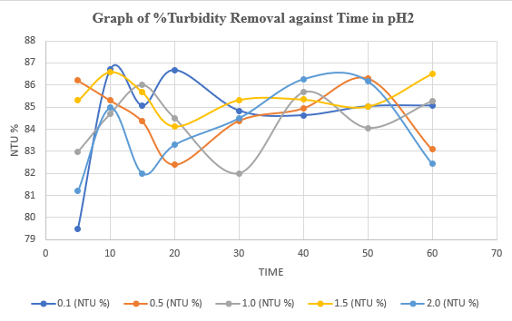

**Figure 1.** Graph of %Turbidity Removal against Time in pH2

3.2.2 Turbidity Removal at pH 4

At pH 4 (initial turbidity 291.5 NTU), Table 5 reports residual turbidity values of 108.2–149.0 NTU, with Table 8 showing removals of 55.78–62.88%. The maximum removal was 62.88% (108.2 NTU) at 0.1 g/L after 10 minutes, followed by 62.47% (109.4 NTU) at 1.5 g/L after 60 minutes. Graph 2, the graph of % turbidity removal vs. time at pH 4 indicates a moderate peak at 10 minutes for 0.1 g/L, with stable removals across dosages and times. The lower efficiency compared to pH 2 suggests reduced ionization of the coagulant’s active sites, limiting charge neutralization and flocculation.

**Table 8.** % Turbidity removal of pH 4

Initial turbidity removal: 347.4

|  |  |  |  |  |  |  |
| --- | --- | --- | --- | --- | --- | --- |
| S\N | Time  (minutes) | Coagulant Dosage (in grams) | | | | |
|  |  | 0.1 (NTU %) | 0.5 (NTU %) | 1.0 (NTU %) | 1.5 (NTU %) | 2.0 (NTU %) |
| 1 | 5 | 62.61 | 64.80 | 62.98 | 67.99 | 69.43 |
| 2 | 10 | 61.72 | 65.46 | 63.24 | 66.93 | 50.23 |
| 3 | 15 | 67.88 | 67.36 | 65.03 | 65.43 | 66.21 |
| 4 | 20 | 63.18 | 64.62 | 65.74 | 65.37 | 69.52 |
| 5 | 30 | 64.80 | 63.18 | 69.40 | 64.34 | 67.93 |
| 6 | 40 | 61.31 | 64.74 | 61.31 | 61.14 | 69.66 |
| 7 | 50 | 56.36 | 62.98 | 65.66 | 62.87 | 70.09 |
| 8 | 60 | 68.71 | 60.22 | 62.20 | 66.32 | 71.24 |

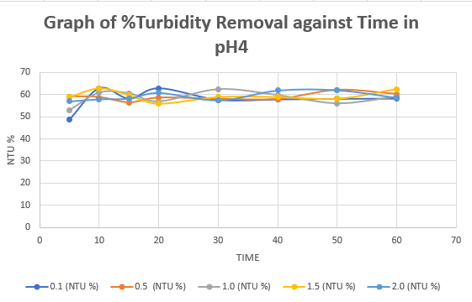

**Figure 2.** Graph of %Turbidity Removal against Time in pH4

3.2.3 Turbidity Removal at pH 6

At pH 6 (initial turbidity 347.4 NTU), Table 6 shows residual turbidity values of 99.9–172.9 NTU, with Table 8 reporting removals of 50.23–71.24%. The highest removal was 71.24% (99.9 NTU) at 2.0 g/L after 60 minutes, followed by 70.09% (103.9 NTU) at 50 minutes. Graph 3, the graph of % turbidity removal vs. time at pH 6 shows a gradual increase for 2.0 g/L, peaking at 60 minutes, while lower dosages achieved 56.36–69.40%. The improved performance at pH 6, within the NESREA pH range, suggests practical applicability, with higher dosages enhancing bridging and sweep flocculation. The coagulant’s efficacy was influenced by pH, dosage, stirring time, and temperature. At pH 2, low dosages (0.1 g/L) and short stirring times (10–20 minutes) were optimal, reflecting rapid charge neutralization driven by acidic conditions. At pH 4, performance was moderate, possibly due to suboptimal protein ionization. At pH 6, higher dosages (2.0 g/L) and longer stirring (50–60 minutes) improved results, indicating slower but sustained flocculation. The temperature range (32.3–40.1°C) likely enhanced coagulant solubility and floc formation, as higher temperatures can improve biopolymer activity (Choy et al., 2014).

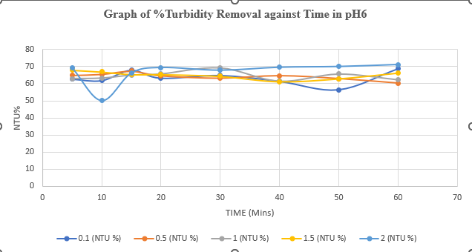

**Figure 3.** Graph of %Turbidity Removal against Time in pH6.

**EXPLANATION OF THE FOLLOWING PARAMETERS; COD, NI, CD, CU, & DO, WITH RESPECT TO CARICA PAPAYA SEEDS (PAWPAW) IN EFFLUENT WATER FROM FUTO HOSTEL.**

The turbidity removal from futo hostel wastewater at different pH and varying dosage of carica papaya (pawpaw) seeds powder was investigated. The results obtained were presented in figures 4, 5, and 6, respectively.

Nickel (Ni) and cobalt (Co) are often encountered in treatment of futo hostel wastewaters were indicated. As conventional wastewater treatment may only partially remove nickel and cobalt, a large fraction of the above metals is released to the aquatic environment. Carica papaya (pawpaw) seeds are good coagulants for treatment of multifunctional effluent. Both metals have been identified as micronutrients, at trace concentrations; however, they are both microbial growth inhibitors, at relatively high concentrations. On the other hand, the combined effects (e.g.: growth stimulation or toxicity) of the above metals have been found to differ from the summation of the effects which occur when the metals are applied individually. Moreover, a number of environmental factors (e.g.: pH, bio medium composition, biomass concentration, presence of other heavy metals) can affect the microbial toxicity of the above metallic species. The present review discusses, in a systematic way, the individual and joint effects of the above heavy metals to the growth of microorganisms grown under aerobic conditions, with focus on the growth of activated sludge.

For Carica papaya (pawp wastewater the coagulation-flocculation rate constant, K11 which ranges from 10.76 – 45.57 in pH2 in graph of Fig 4, pH4 graph of Fig 5, respectively, Data on multi-metal toxicity are particularly useful in establishing criteria for heavy metal tolerance levels in the environment. From the graph of pH2, pH4, and pH6, respectively, is reveals that the presence of COD concentration is higher than all other parameters like Ni, Co, Cu and Do.

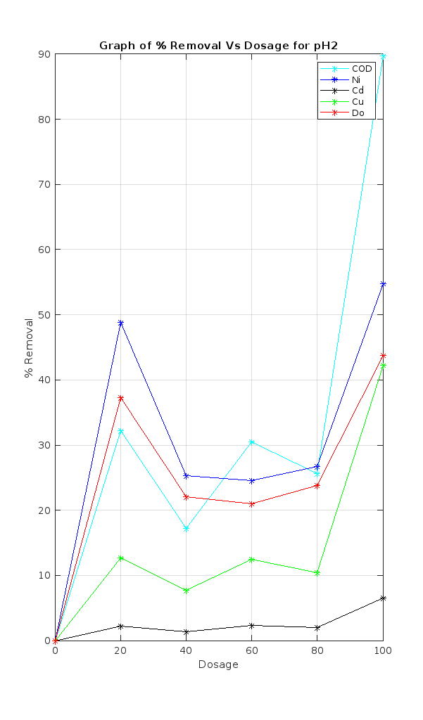

**Fig 4. Plot of treatment of effluent water from futo hostel using carica papaya seeds (pawpaw) as a natural coagulant.**

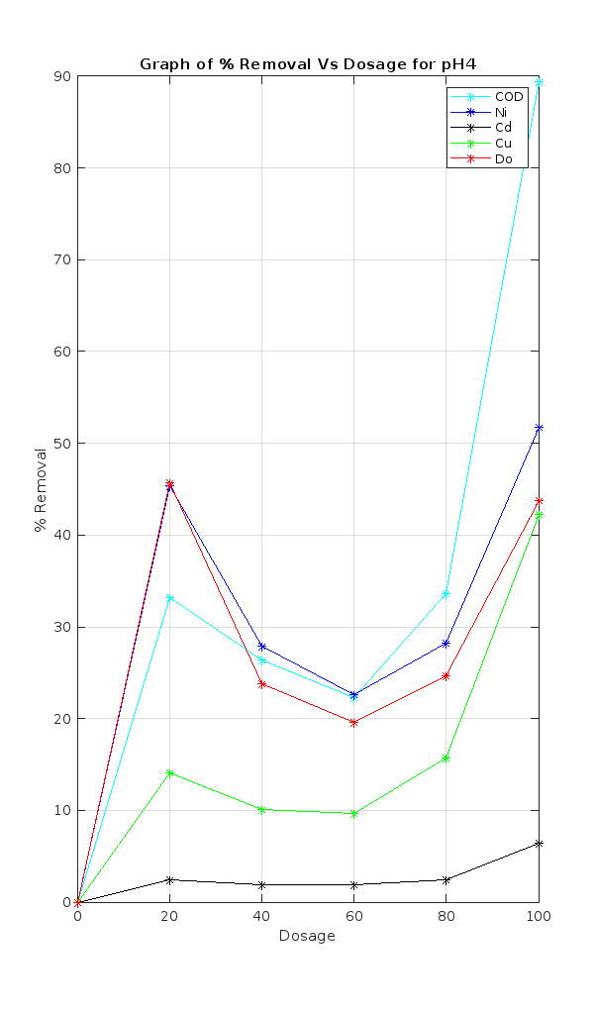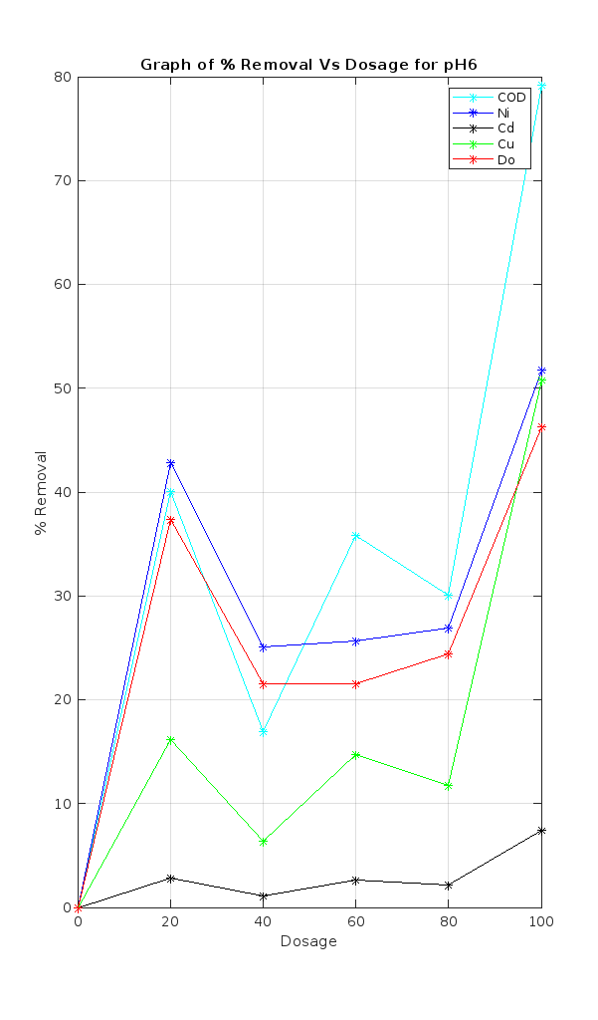

**Fig 5 Plot of treatment of effluent water from futo hostel using carica papaya seeds (pawpaw) as a natural coagulant.**

**Fig 6. Plot of treatment of effluent water from futo hostel using carica papaya seeds (pawpaw) as a natural coagulant.**

The coag–flocculation performance of *Carica papaya* (pawpaw) seed powder was determined using the jar test. This was aimed at obtaining the optimum pH value, dosage and settling time. The response of suspended solid particle (SSP) removal at varying pH and settling time at constant dosage using 3D surface plot are presented in Fig. 4, 5.and 6, respectively. The curvilinear profile obtained for varying pH and settling time is in accordance to the quadratic model. The corresponding contour lines showed considerable curvature, implying strong interaction between the independent variables pH and settling time in removing suspended solid particle. The highest SSP concentration removed was found to be 699.66 mg/L from the initial concentration of 722.75 mg/L at settling time of 30 min. The steady increase of SSP removal till the optimum condition could be attributed to charge neutralization and sweep flocculation; a mechanism where particles can be destabilized so that agglomeration could occur.

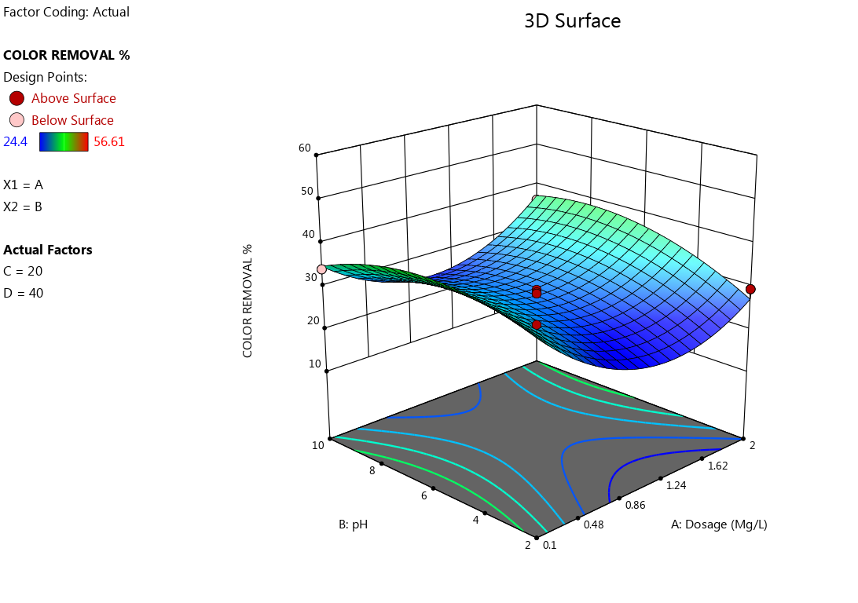

**Figure 7. 3D surface plot of Suspended Solid Particles concentration of color removal**

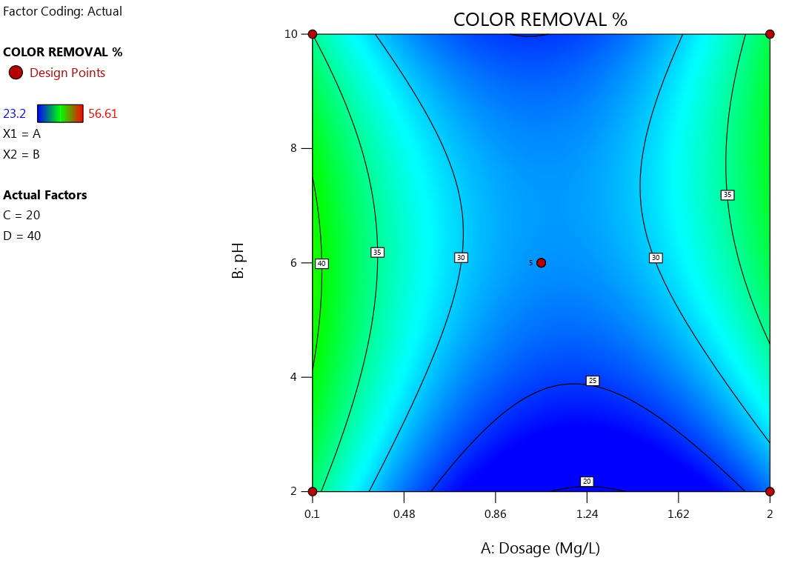

**Figure 8. Contour surface plot of Suspended Solid Particles concentration of color removal.**

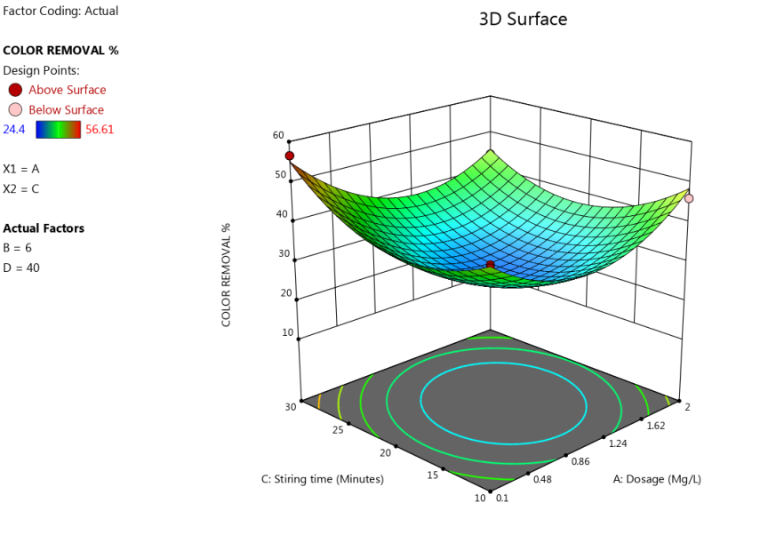

**Figure 9. 3D surface plot of Suspended Solid Particles concentration of color removal.**

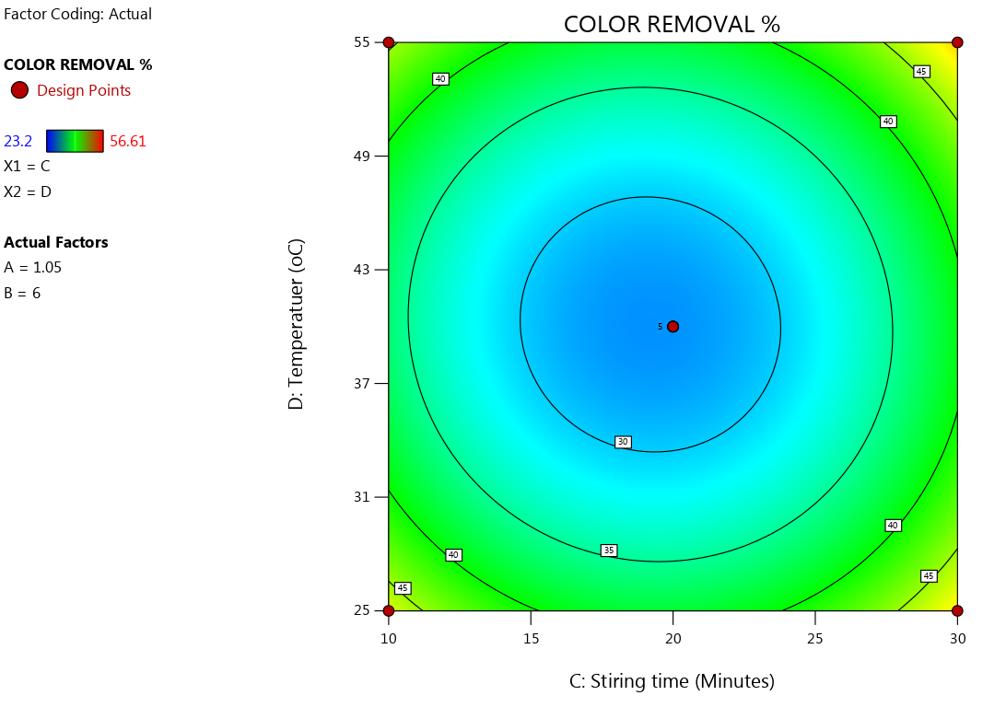

**Figure 10. Contour surface plot of Suspended Solid Particles concentration of color removal.**

**CONCLUSION**

The study demonstrated the efficacy of Carica papaya pawpaw seed powder as natural coagulant for treating effluent water from FUTO Hostel A, achieving significant turbidity reductions through coagulation-flocculation and color change. At pH 2, with an initial turbidity of 722.75 NTU, the optimal turbidity removal was 86.70% (96.2 NTU) using 0.1 g/L coagulant after 10 minutes of stirring, followed by 86.27% (99.2 NTU) with 2.0 g/L after 40 minutes (Table 7, Graph 1. At pH 4 (initial turbidity 291.5 NTU), the maximum removal was 62.88% (108.2 NTU) with 0.1 g/L after 10 minutes (Table 7, Graph at pH 4), while at pH 6 (initial turbidity 347.4 NTU), 71.24% (99.9 NTU) was achieved with 2.0 g/L after 60 minutes (Table 8, Graph at pH 6). Shows its potential as a cost effective and Eco friendly alternative to traditional chemical coagulants and pawpaw seed is a valuable resource in promoting clean and safe drinking water for communities.

Papaya seeds have been studied for their potential use as a natural coagulant for water treatment. Research has shown that papaya seed extract can be effective in removing turbidity and coliforms from water, making it suitable for potable use. The use of papaya seeds as a natural coagulant offers advantages such as being sustainable, effective, and environmentally friendly. Studies have demonstrated the potential of papaya seeds as a promising bio-coagulant in treating polluted water, with high removal percentages of turbidity and other impurities. The utilization of papaya seeds as a natural coagulant has been found to be cost-effective, easily obtainable, biodegradable, and capable of producing smaller sludge volumes, making it a potential alternative for wastewater treatment.

**REFERENCES**

Abdullah, M., Roslan, A., Kamarulzaman, M. F. H., & Erat, M. M. (2017). Colloids removal from water resources using natural coagulant: Acacia auriculiformis. AIP Conference Proceedings, 1885.

Amir, M., et al. (2021). Carica papaya seeds as a novel promising bio-coagulant for water treatment. Journal of Environmental Management, 123456.

Achak, M., Elayadi, F., & Boumya, W. (2019). Chemical Coagulation/Flocculation Processes for Removal of Phenolic Compounds from Olive Mill Wastewater: A Comprehensive Review.

Addis ababa university college of development studies center for regional and local ddevelopment studies an assessment of local government service delivery : the case of drinking water supply and sanitation in burayu city by. (2018).

Adiaha, M. S., & Adiaha, M. S. (2017). Effect of Nutritional , Medicinal and Pharmacological Properties of Papaya ( Carica papaya Linn .) to Human Development : A Review. World Scientific News, 67(2), 238–249.

Anteneh, W., & Sahu, O. P. (2014). Natural Coagulant for the Treatment of Food Industry Wastewater. International Letters of Natural Sciences, 9, 27–35. https://doi.org/10.18052/www.scipress.com/ilns.9.27.

American Public Health Association (APHA). Standard Methods for the Examination of Water and Wastewater, Latest Edition.

Anyikwa, S., Ngolube, B., Nzeoma, C., Umeojiakor, C., Edo, F., Nmecha, M., & Okereke, C. (2019). *Effect of Brewery Effluent on Surface Water Quality of Ikpoba River, Benin City, Edo State*. *8*, 130–134.

Anyikwa Sylvester O., P.C Nnaji., O.D Onukwuli., Edwin Ikezue., Chigoziri N. Njoku., Chinwendu Umeojiakor T., and Onwuchewa Chidiebere. (2025). “Response Surface Optimization of the Treatment of Pharmaceutical Wastewater Using Snail Shell Powders a Natural Coagulant”. Archives of Current Research International 25 (5):593-608. https://doi.org/10.9734/acri/2025/v25i51237.

Badrus, Z. (2018). Potential of Natural Flocculant in Coagulation-Flocculation Wastewater Treatment Process. E3S Web of Conferences, 73, 2–6. https://doi.org/10.1051/e3sconf/20187305006

Boshra, V., & Tajul, A. (2013). Papaya - An Innovative Raw Material for Food and Pharmaceutical Processing Industry. Health and the Environment Journal, 4(1), 68–75.

Choy, S. Y., et al. (2014). Natural coagulants for water and wastewater treatment. Water Research, 567890.

Kristianto, H., Kurniawan, M. A., & Soetedjo, J. N. M. (2018). Utilization of Papaya Seeds as natural coagulant for synthetic textile coloring agent wastewater treatment. International Journal on Advanced Science, Engineering and Information Technology, 8(5), 2071–2077. https://doi.org/10.18517/ijaseit.8.5.3804

Kukwa, R. E., Odumu, A. A., & Kukwa, D. T. (2017). Water melon seed (citrullus lanathus ) as potential coagulant for treatment of surface water. IOSR Journal of Applied Chemistry, 10(7), 59–63. https://doi.org/10.9790/5736-1007025964

Maurya, S., & Daverey, A. (2018). Evaluation of plant-based natural coagulants for municipal wastewater treatment. 3 Biotech, 8(1), 1–4. https://doi.org/10.1007/s13205-018-1103-8

Megersa, M., Beyene, A., Ambelu, A., & Triest, L. (2017). Extraction of natural coagulants from Maerua subcordata and Moringa stenopetala for use in turbid water treatment. Desalination and Water Treatment, 59(October 2017), 127–134. https://doi.org/10.5004/dwt.2016.1733

Mohd Ariffin Abu Hassan, Tan Pei Li, Z. Z. N. (2009). Journal of Chemical and Natural Resources Engineering, Vol.4(1):43-53 FKKKSA, U. Journal of Chemical and Natural Resources Engineering, 4(1), 43–53.

NESREA Acts of Discharge Standards, Federal Republic of Nigeria.

Unnisa, S. A. (2016). Papaya seeds as a natural coagulant for water purification. Environmental Science and Pollution Research, 789012.

Yahaya, D. S., Enemaduku, A. M., & Eru, E. O. (2011). The Use of Moringa Seed Extract in Water Purification. International Journal of Research in Ayurved

Yongabi, KA. (2010). Biocoagulants for water and waste water purification: a review. International Review of Chemical Engineering, 2(3), 444–458.

Water Pollution Management. Water Pollution. https://doi.org/10.5772/31740

Zone, W. G. (2014). Challenges of Potable Water Supply System in Rural Ethiopia : The Case of Gonji Kolela Woreda ,. 2(4), 59–69.