Original Research Article

An experimental investigation on the effect of different ultrasonic powers and temperatures on convective drying of fabric

.

# ABSTRACT

|  |
| --- |
| This study investigates the effects of ultrasonic power and temperature on fabric drying kinetics, energy consumption, and heat and mass transfer coefficients experimentally. The results indicated that the ultrasonic power and temperature could significantly improve the drying efficiency as the enhancement of moisture diffusion. The combination of 90 W ultrasonic power and 60 °C drying temperature yielded the best drying performance, which reduced drying time by 33.3% and increased effective moisture diffusivity by 48.8%. Meanwhile, the energy consumption was significantly decreased. The activation energy was also presented in this work. Additionally, the heat transfer coefficient remained relatively stable across different ultrasonic powers, while the mass transfer coefficient showed a noticeable increase. At the constant ultrasonic power, rising temperature led to a slight intensification of the heat transfer coefficient and a more pronounced increasement of the mass transfer coefficient. These findings highlight the synergistic interplay between elevated drying temperatures and ultrasonic powers in intensifying both heat and mass transfer processes. |

*Keywords: Fabric drying; ultrasound power effect; temperature effect; convective drying, mass transfer, convective heat transfer*

# 1. INTRODUCTION

With the rapid development of the textile industry, drying has become a key technology for improving production efficiency, product quality, and reducing energy consumption. Traditional drying methods, such as hot air drying and microwave drying (Li G, et al., 2025, Fu W, et al., 2019), are commonly employed in textile processing. However, these methods suffer from significant drawbacks, including long drying times, high energy consumption, and uneven drying, which limit improvements in production efficiency and fail to meet environmental sustainability requirements. As an effective alternative, ultrasound enhanced convective drying technology has proven to be a promising drying method. By utilizing mechanical and sponge effects, this method accelerates moisture removal, enhances energy efficiency, reduces both internal and external mass transfer resistance, and preserves the quality of the dried material (Li P and Chen Z, 2017, Szadzińska J, et al., 2019).

Ultrasound enhanced convective drying technology integrates ultrasonic vibrations into the traditional convective drying process. By exploiting the cavitation effect and vibration transmission of ultrasound, this technique accelerates moisture evaporation and enhances heat transfer both within and around the material, thereby improving drying efficiency. The influence of ultrasound on the microstructure of fabrics can increase their porosity and permeability, facilitating the migration of moisture from the fiber interior to the surface, and thus speeding up the drying process. Ultrasound enhanced convective drying has been extensively applied in the drying of fruits, vegetables, and food products, significantly reducing drying times (Zhang Y and Abatzoglou N, 2020).

In ultrasonic fabric drying, direct mechanical coupling between the piezoelectric transducer and the wet fabric causes moisture within the fabric to be ejected as fine droplets. Researchers at Oak Ridge National Laboratory developed a ultrasonic fabric drying technology to enhance the drying process (Dupuis ED, et al., 2019). Li and Chen employed ultrasonic power to improve fabric drying and observed a nonlinear relationship between ultrasonic power and drying rate (Li P and Chen Z, 2017). Fuente-Blanco et al.(de la Fuente-Blanco S, et al., 2006) conducted experimental research on the ultrasonic drying process of cylindrical carrots, using a high-power rectangular aluminum plate transducer. Their results indicated that, within the same drying time, higher ultrasonic power led to a greater dehydration rate of the sample. Sabarez et al. (Sabarez HT, et al., 2012) found a reduced energy consumption and increased production throughput after application of ultrasonic energy in hot air drying process of apples. Peng and Moghaddam (Peng C and Moghaddam S, 2020) studied fabric drying technology based on ultrasonic vibrations, experimentally analyzing the effects of different frequencies and powers on the drying process. The results indicated that the drying process could be divided into a nonlinear phase dominated by mechanical vibrations and a linear phase dominated by thermal evaporation. The Weibull model was found to more accurately describe the ultrasonic drying process. García-Pérez et al. (García-Pérez JV, et al., 2009) conducted a series of experimental and theoretical studies on ultrasonic-assisted convective drying of food materials. The findings revealed that increasing ultrasonic power, drying air velocity, and temperature all contributed to faster drying. By integrating these experimental results with theoretical models, they derived relationships between the various parameters and their effects on the mass transfer and heat transfer coefficients during the drying process.

However, most of the existing research focuses on food or agricultural products, with limited investigation into fabric drying. Moreover, few studies have systematically evaluated the combined effects of ultrasonic power and drying temperature on drying kinetics, heat and mass transfer coefficients, and energy consumption in textile materials.

To address these gaps, this study experimentally investigates the ultrasound-enhanced convective drying behavior of cotton fabric under varying ultrasonic power levels (0–90 W) and drying temperatures (30–60 °C). The drying kinetics, effective moisture diffusivity, heat and mass transfer coefficients, activation energy, and energy consumption are quantitatively analyzed under each condition. The results aim to reveal the mechanisms by which ultrasonic vibrations and thermal conditions jointly influence fabric drying, thereby providing both theoretical and practical insights for the development of energy-efficient drying technologies in the textile industry.

# 2. material and methods

## 2.1 Materials

Commercially available 100% cotton fabric was selected as the experimental material. The fabric was cut into square samples with dimensions of 100 × 100 mm and a nominal thickness of 1 mm. To ensure uniform and complete saturation, all samples were immersed in distilled water at room temperature for 24 hours. Excess surface water was gently removed using absorbent paper. The saturated samples were immediately sealed in airtight bags and stored in a refrigerated environment to minimize moisture loss prior to testing.

To determine the initial moisture content of the fabric, three wet samples were weighed and subsequently dried in an oven at 105°C for 24 hours. The initial moisture content of the wet fabric was determined to be 3.80 ± 0.01 g water/g fiber.

## 2.2 Experimental procedure

The experimental investigation of ultrasound enhanced convective drying of fabrics was conducted using the setup shown in Fig. 1. The experiments were performed at Shaanxi University of Science and Technology, China, during the period from January to March 2024.

The experimental system mainly consists of several key components, including an ultrasonic generator (THD-T1, China), an ultrasonic transducer (rated power: 100W, China), an ultrasonic vibration plate, a convection drying oven, a centrifugal fan (150FLJ7, China, flow rate accuracy ±5%), a PTC constant temperature heating module (China), a temperature control module (W141, China, control accuracy ±0.5 °C), a hot-wire anemometer (Testo 405i, Germany, velocity accuracy ±0.1 m/s), a wind speed control module, and electronic balance (HZF-A, America, 0.01 g accuracy,). Initially, the system was preheated at an air velocity of 5 m/s for 20 min to ensure uniform drying temperature throughout the chamber. After preheating, the wet samples were placed on the ultrasonic vibration plate inside the drying chamber, enabling the acoustic energy to be directly transmitted from the vibration plate to the fabric fiber samples. The ultrasonic generator was then activated, and drying experiments were carried out under different temperatures (30 °C, 40°C, 50 °C, and 60 °C) and ultrasonic power levels (0 W, 50 W, 70 W, and 90 W). The mass of the samples was periodically monitored until a constant mass was achieved. Throughout all experiments, the hot air velocity was consistently maintained at 5 m/s.

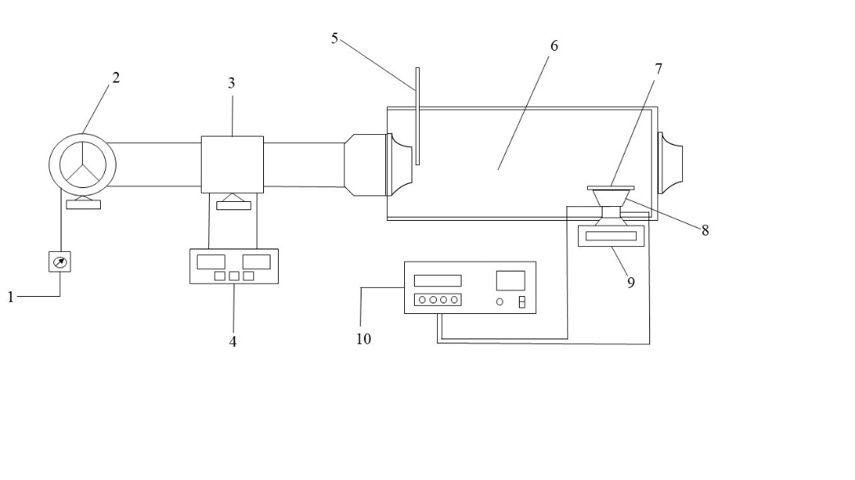

**Fig. 1 Schematic diagram of the fabric drying experimental setup. (1. Wind speed control module 2. Centrifugal fan 3. PTC heating module 4. Temperature control module 5. Hot-wire anemometer 6. Oven 7. Ultrasonic vibration plate 8. Ultrasonic transducer 9. Electronic balance 10. Ultrasonic generator)**

## 2.3 Moisture content and drying rate

The moisture content (*M*, g water/g fiber) of fibric at drying time *t* was calculated by using the following equations(Kushwah A, 2025).

 (1)

where *m*i is the mass of the fabric at drying time *t* (g); and *m*d is the mass of the completed dried fabric (g).

The drying rate (*DR*, g water/(g fiber·min)) of fabric at any time in the drying process was thus determined by Eq. (2)(Setyoningrum TM, et al., 2025).

 (2)

where *t*1 and *t*2 are the drying time (min), *M*t1 and *M*t2 are the moisture contents of fabric at drying time *t*1 and *t*2 (g water/g fiber).

## 2.4 Calculation of the effective moisture diffusivity and activation energy

The effective moisture diffusivity (*D*eff) for fabric drying can be determined from the relation of moisture ratio (MR) and drying time (t) with Eq.(3) (Hssaini L, et al., 2021).

 (3)

For convective drying of fabric, Eq.(4) is used to determine the activation energy(Nisha, et al., 2025).

 (4)

where *D*0 is the pre-exponential factor (m2/s), *E*a is the apparent activation energy (kJ/mol), *R* is the molar gas constant (J/mol K), and *T* is temperature (K).

For ultrasound enhanced convective drying of fabric, Eq.(5) is used to calculate the activation energy(Luka BS, et al., 2023).

 (5)

where *P*is the ultrasonic generator power (W); *m* is the mass of the sample (g).

## 2.5 Energy consumption

In the ultrasound enhanced convective drying system, the total energy consumption (*E*t), shown in Eq.(6), is the sum of the energy consumed by the ultrasonic generator (*E*us) and the energy consumed during the convective drying process (*E*cv) (Santos KC, et al., 2021).

 (6)

where A is the cross-sectional area of drying (m2); *v* is the air velocity (m/s); *ρ* is the ambient air density (kg/m3), *cp i*s the specific heat of air (J/(kg·K)), Δ*T* is the temperature increasement for heating the air (K), and *t* is drying time (s).

## 2.6 Heat and mass transfer coefficient

The dimensionless numbers are the most common tool for estimating most materials’ heat and mass transfer coefficients. The Nusselt and Sherwood correlations for laminar flow over flat plates were applied to estimate the ultrasound enhanced convective heat and mass transfer coefficients for fibric drying(Kumar A, et al., 2022).

# 3. results and discussion

## 3.1 Effect of ultrasonic power on fabric drying

Fig. 2 illustrates the effect of different ultrasonic powers on the drying process of fabric at 60 °C.

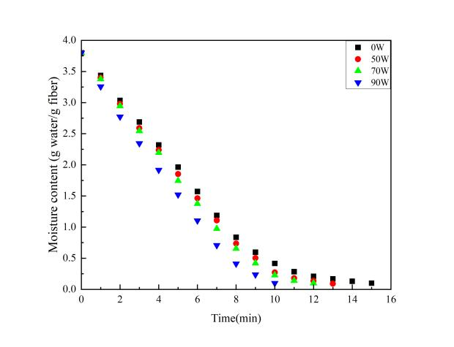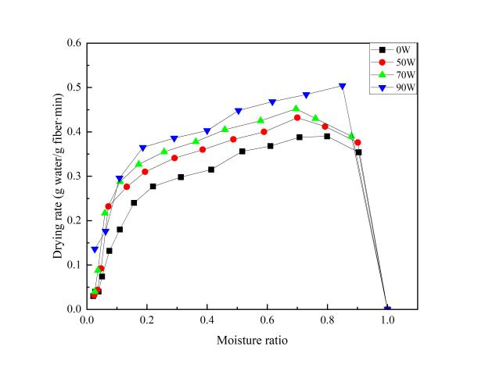

1. b).

**Fig. 2 Drying curves of fibric at different ultrasonic powers a). Moisture content vs. drying time; b). Drying rate vs. moisture ratio**

As drying time progresses, the overall moisture content of the fabric gradually decreases. Without ultrasonic enhancement, the time required to reach the same moisture content is the longest, at 15 min. With the application of ultrasound, the drying time is significantly reduced, and as the ultrasonic power increases from 50 W to 90 W, the drying time decreases from 13 min to 12 min and 10 min, respectively. Compared to drying without ultrasonic enhancement, the maximum drying time was reduced by 33.3%, indicating the higher ultrasonic power results in greater drying efficiency. This improvement is primarily attributed to the stronger mechanical vibrations and disturbances generated by higher power ultrasound, which significantly enhance heat and mass transfer on the surface of the material. Fig. 2(b) further shows that, under non-ultrasonic conditions, there are three distinct stages in the drying process: the acceleration period, the constant rate period, and the falling rate period. However, with the application of ultrasound, the constant rate phase disappears, leaving only a distinct acceleration phase and falling rate phase. During the acceleration phase, the drying rate increases monotonically, and the maximum drying rate significantly increases with higher ultrasonic power. Compared to non-ultrasonic conditions, the maximum drying rate increases by 42.4%, 10.5%, and 6.2% under ultrasonic powers of 50W, 70W, and 90W, respectively. This demonstrates that ultrasound enhances the efficiency of water migration and evaporation during the drying process, with particularly pronounced effects under high-power conditions.

## 3.2 Effect of drying temperature on fabric drying

Fig. 3 illustrates the effect of different temperatures on the drying process of fabric under the conditions of 90 W.

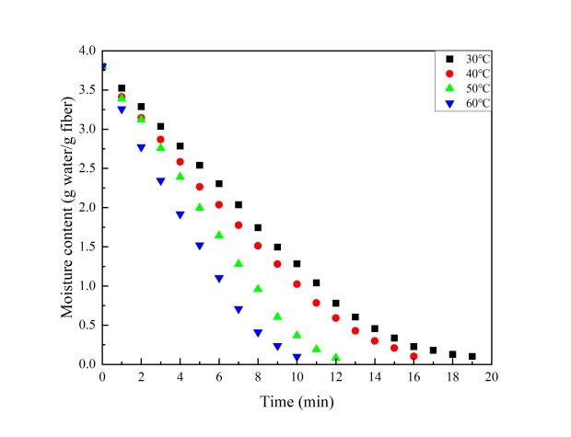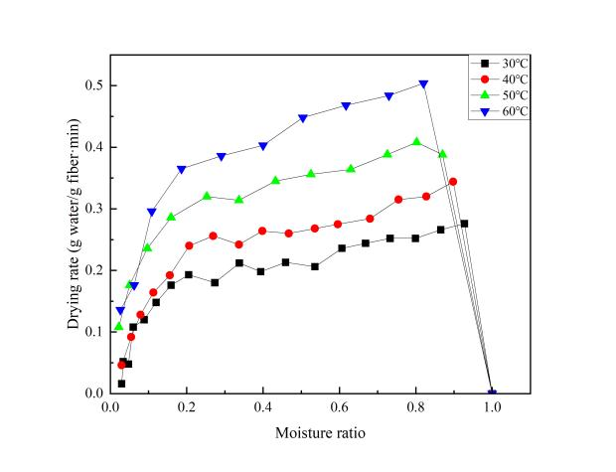

a). b).

**Fig. 3. Drying curves of fibric at different drying temperatures a). Moisture content vs. drying time; b). Drying rate vs. moisture ratio**

It can be observed that at all temperatures, the moisture content of the fabric gradually decreases as drying time increases. Higher temperatures significantly shorten the time required to reduce the moisture content of fabric to 0.1 g water/g fiber. For example, under the ultrasonic power of 90 W, the drying time was 19 min at 30 °C, 16 min at 40 °C, 12 min at 50 °C and 10 min at 60 °C. Similar results were obtained during fabric drying at other ultrasound intensities and without sonication. The positive effect of temperature on drying kinetics of agriproducts has also been extensively reported in other studies (Szadzińska J, et al., 2016, Corrêa JLG, et al., 2017). At 60 °C, the reduction in moisture content occurs significantly faster, indicating that higher drying temperatures enhance the heat transfer capacity of the air, accelerate moisture evaporation, and thereby significantly shorten the overall drying time. As shown in Fig. 3b, at 30 °C, in addition to the acceleration and falling rate periods, a constant rate period is observed. However, as the temperature increases, the constant rate period disappears. At 60°C, the peak drying rate is the highest, and the time to reach this peak is delayed. This demonstrates that higher temperatures accelerate surface moisture evaporation, delay the onset of the falling-rate period, and significantly increase the drying rate, further reduce the overall drying time.

## 3.3 Effective moisture diffusivity, activation energy and energy consumption of fabric drying

Table 1 presents the variation of effective moisture diffusivity, activation energy, and energy consumption under different ultrasonic powers and drying temperatures during fabric drying.

**Table 1. Variation with air temperature of effective moisture diffusivity,**

**activation energy and energy consumption of fabric drying**

|  |  |  |  |  |
| --- | --- | --- | --- | --- |
| **Temperature (**°C**)** | **Ultrasonic power(W)** | **Effective moisture diffusivity (**×10-10 **m2/s)** | **Activation energy** | **Energy consumption (MJ)** |
| 60 | 0 | 3.85 | 4.75 W/g | 7.68 |
| 60 | 50 | 4.95 | 6.70 |
| 60 | 70 | 5.26 | 6.19 |
| 60 | 90 | 5.73 | 5.17 |
| 30 | 90 | 3.24 | 16.73 kJ/mol | 2.77 |
| 40 | 90 | 3.91 | 4.35 |
| 50 | 90 | 4.89 | 4.81 |

At the drying temperature of 60°C, increasing the ultrasonic power from 0 W to 90 W led to a noticeable enhancement in effective moisture diffusivity from 3.85×10−10 m2/s to 5.73×10−10 m2/s, representing an increase of approximately 48.8%. Meanwhile, the total energy consumption decreased from 7.68 MJ to 5.17 MJ, indicating an energy saving of about 32.7%. This suggests that the application of ultrasound not only accelerates the internal moisture migration but also reduces the required thermal energy input for drying. When the ultrasonic power was maintained at 90 W and the drying temperature was varied from 30 °C to 60 °C, the effective moisture diffusivity continuously increased from 3.24×10−10 m2/s to 5.73×10−10 m2/s, indicating enhanced drying kinetics. However, the total energy consumption also increased from 2.77 MJ to 5.17 MJ, primarily due to the higher thermal input required at elevated temperatures.

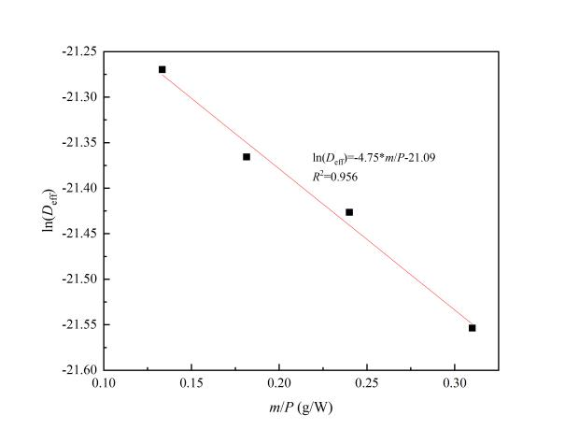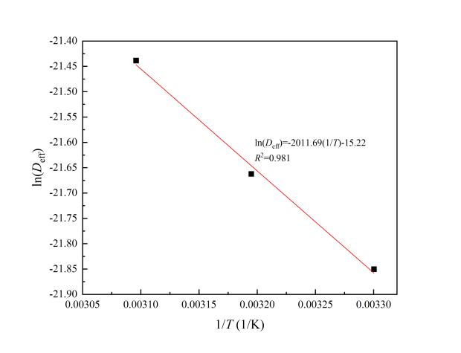

a). b).

**Fig. 4. a). Plot of In (*D*eff) versus *m*/*P*; b). Plot of In (*D*eff) versus 1/*T*.**

The activation energy for ultrasonic-enhanced convective drying was then calculated using Eq. (5). From the relationship between ln(*D*eff) and *m*/*P* for convective drying of fabric, as shown in Fig. 4a, the activation energy was determined to be 6.85 W/g.

For convective drying of fabric, the activation energy was calculated to be 16.73 kJ/mol from the relationship between ln(*D*eff) and 1/*T*, as shown in Fig. 4b.

## 3.4 Heat and mass transfer coefficients of fabric drying

**Table 2. The variation with drying ultrasonic power and temperature of heat and mass transfer coefficients of fabric drying**

|  |  |  |  |  |  |
| --- | --- | --- | --- | --- | --- |
| **Temperature (°C)** | **Ultrasonic power (W)** | **Nu** | **Sh** | ***h*t (W/(m2·K))** | ***h*m (**×10-5**m/s)** |
| 60 | 0 | 96.64 | 3751.63 | 27.16 | 1.67 |
| 60 | 50 | 96.64 | 3634.56 | 27.16 | 1.80 |
| 60 | 70 | 96.64 | 3561.71 | 27.16 | 1.87 |
| 60 | 90 | 96.64 | 3461.54 | 27.16 | 1.98 |
| 30 | 90 | 101.66 | 4152.20 | 26.31 | 1.35 |
| 40 | 90 | 99.90 | 3910.91 | 26.60 | 1.53 |
| 50 | 90 | 98.00 | 3639.09 | 26.98 | 1.78 |

At 60°C, as the ultrasonic power increased from 0 W to 90 W, the mass transfer coefficient showed a significant enhancement, rising from 1.67×10−5m/s to 1.98×10−5 m/s. This indicates that the increase in ultrasonic power substantially improved the mass transfer process. In contrast, the heat transfer coefficient remained constant at 27.16 W/(m²·K). When the ultrasonic power was fixed at 90 W, the heat transfer coefficient increased exhibited a slight increase with rising temperature, from 26.31 W/(m²·K) at 30°C to 27.16 W/(m²·K) at 60 °C. Meanwhile, the mass transfer coefficient experienced a more pronounced increase, from 1.35×10−5m/s at 30°C to 1.98×10−5 m/s at 60 °C. Overall, the synergistic effect of high temperature (60 °C) and high ultrasonic power (90 W) significantly accelerated the heat and mass transfer processes, highlighting these conditions as critical for optimizing the efficiency of fabric drying.

# 4. Conclusion

This study highlights the potential of ultrasound-enhanced convective drying as an efficient method for fabric dewatering. The integration of ultrasonic vibrations with traditional convective drying significantly improved drying performance by accelerating moisture transfer and reducing drying time. The results showed that increasing ultrasonic power to 90 W could reduce drying time by up to 33.3%, demonstrating the effectiveness of ultrasound in enhancing mass transfer. Additionally, higher drying temperatures further accelerated the drying process by increasing the vapor pressure gradient, thus promoting faster moisture evaporation. The combined effects of ultrasonic power and temperature exhibited a synergistic impact on drying efficiency. Moreover, the effective moisture diffusivity increased with both ultrasonic power and temperature, emphasizing enhanced moisture migration within the fabric.Notably, energy consumption decreased significantly with increasing ultrasonic power under the same temperature , indicating that ultrasonic energy input not only enhanced drying performance but also contributed to overall energy savings. Among the investigated conditions, the combination of 90 W ultrasonic power and 60 °C drying temperature achieved the best performance, characterized by the highest moisture diffusivity, the shortest drying time, and a 32.7% reduction in energy consumption compared to convective drying. The findings provide valuable insights into the mechanisms of ultrasound-enhanced convective drying and its practical implications for fabric drying applications. By demonstrating both enhanced drying kinetics and improved energy efficiency, this study lays the groundwork for the development of more sustainable and cost-effective drying technologies in the fabric industry.

# DISCLAIMER (ARTIFICIAL INTELLIGENCE)

Author(s) hereby declares that NO generative AI technologies such as Large Language Models (ChatGPT, COPILOT, etc.) and text-to-image generators have been used during the writing or editing of this manuscript.

**AcknowledgEments**

This work was sponsored by the Innovative Training Program for College Students of Shaanxi Province (China) under the contract number of S202310708103.

# References

[1] Li G., Chen L., Shu W., Lian S., & Chen H. (2025). A novel drying process for knitted fabrics based on heat-wet coupling model. *Applied Thermal Engineering*, 258, 124609.

[2] Fu W., Deng J., & Li X. (2019). Microwave drying of fabrics. *Journal of Microwave Power and Electromagnetic Energy*, 53(1), 12-23.

[3] Li P., & Chen Z. (2017). Experiment study on porous fiber drying enhancement with application of power ultrasound. *Applied Acoustics*, 127, 169-174.

[4] Szadzińska J., Łechtańska J., Pashminehazar R., Kharaghani A., & Tsotsas E. (2019.) Microwave- and ultrasound-assisted convective drying of raspberries: Drying kinetics and microstructural changes. *Drying Technology*, 37(1), 1-12.

[5] Zhang Y., & Abatzoglou N. (2020). Review: Fundamentals, applications and potentials of ultrasound-assisted drying. *Chemical Engineering Research and Design*, 154, 21-46.

[6] Dupuis E. D., Momen A. M., Patel V. K., & Shahab S. (2019). Electroelastic investigation of drying rate in the direct contact ultrasonic fabric dewatering process. *Applied Energy*, 235, 451-462.

[7] de la Fuente-Blanco S., Riera-Franco de Sarabia E., Acosta-Aparicio V. M., Blanco-Blanco A., & Gallego-Juárez J. A. (2006). Food drying process by power ultrasound. *Ultrasonics*, 44, e523-e527.

[8] Sabarez H. T., Gallego-Juarez J. A., & Riera E. (2012). Ultrasonic-Assisted Convective Drying of Apple Slices. *Drying Technology*, 30(9), 989-997.

[9] Peng C., & Moghaddam S. (2020). Experimental Evaluation and Kinetic Analysis of Direct-Contact Ultrasonic Fabric Drying Process. *Journal of Thermal Science and Engineering Applications*, 13(2), 021025.

[10] García-Pérez J. V., Cárcel J. A., Riera E., & Mulet A. (2009). Influence of the Applied Acoustic Energy on the Drying of Carrots and Lemon Peel. *Drying Technology*, 27(2), 281-287.

[11] Kushwah A. (2025). Drying kinetics, thermal performance, drying characteristic of different shaped potato samples: An experimental validation with mathematical model. *Solar Energy Materials and Solar Cells*, 290, 113689.

[12] Setyoningrum T. M., Kusuma H. S., Umamah S. H., Salsabila N. E., Darmokoesoemo H., & Amenaghawon A. N. (2025). Analysis of moisture content and drying kinetics model for drying of Cananga odorata flowers. *South African Journal of Chemical Engineering*, 52, 292-299.

[13] Hssaini L., Ouaabou R., Hanine H., Razouk R., & Idlimam A. (2021). Kinetics, energy efficiency and mathematical modeling of thin layer solar drying of figs (Ficus carica L.). *Scientific Reports*, 11(1), 21266.

[14] Nisha, Sharma N., & Mohite A. M. (2025). Effect of vacuum and through flow drying technique on mathematical modelling, functional properties, color degradation kinetics, and essential oil components of fish mint (Houttuynia cordata Thunb). *Food Physics*, 2, 100057.

[15] Luka B. S., Vihikwagh Q. M., Ngabea S. A., Mactony M. J., Zakka R., Yuguda T. K., & Adnouni M. (2023). Convective and microwave drying kinetics of white cabbage (Brassica oleracae var capitata L.): Mathematical modelling, thermodynamic properties, energy consumption and reconstitution kinetics. *Journal of Agriculture and Food Research*, 12, 100605.

[16] Santos K. C., Guedes J. S., Rojas M. L., Carvalho G. R., & Augusto P. E. D. (2021). Enhancing carrot convective drying by combining ethanol and ultrasound as pre-treatments: Effect on product structure, quality, energy consumption, drying and rehydration kinetics. *Ultrasonics Sonochemistry*, 70, 105304.

[17] Kumar A., Kandasamy P., Chakraborty I., & Hangshing L. (2022). Analysis of energy consumption, heat and mass transfer, drying kinetics and effective moisture diffusivity during foam-mat drying of mango in a convective hot-air dryer. *Biosystems Engineering*, 219, 85-102.

[18] Szadzińska J., Kowalski S. J., & Stasiak M. (2016). Microwave and ultrasound enhancement of convective drying of strawberries: Experimental and modeling efficiency. *International Journal of Heat and Mass Transfer*, 103, 1065-1074.

[19] Corrêa J. L. G., Rasia M. C., Mulet A., & Cárcel J. A. (2017). Influence of ultrasound application on both the osmotic pretreatment and subsequent convective drying of pineapple (Ananas comosus). *Innovative Food Science & Emerging Technologies*, 41, 284-291.