Original Research Article
Towards Sustainable Lubricants: A Biodegradability, Emissions and Wear Analysis of Cottonseed Oil-AMAs Blends for IC Engine Usage

ABSTRACT

Aim: This research investigates cottonseed oil as a renewable lubricant for internal combustion engines, highlighting its high biodegradable properties, favorable emission profile, and wear-reduction potential compared to conventional mineral oils.

Study Design, Place and Duration of Study: The experiment, conducted in Nigeria at Abubakar Tafawa Balewa University, Federal Polytechnic Bauchi, and Nenis Automobile Engineering Workshop, Lagos, involved both experimental analysis and engine performance testing on a JF 168 gasoline engine test-bed with an A.C. dynamometer.

Methodology: Three key methods were employed: viscometric analysis of oil samples, and environmental breakdown was assessed over nine days by monitoring Pseudomonas aeruginosa growth on agar plates modified with oxidized cottonseed oil - aftermarket additives (AMAs) blended samples; exhaust emissions (CO₂, O₂, and CO) were analysed from a spark ignition engine using Orsat gas absorption; and aluminium wear debris was quantified via Flame Atomic Absorption Spectroscopy (FAAS) at a wavelength of 309.3 nm.

Results: The study revealed that AMA is more viscous and less dense than cottonseed oil. Blends show viscosity decrease with temperature and higher cottonseed oil content, and the formulations demonstrated strong biodegradability, with microbial counts increasing from 1.19×105 cfu/ml (control) to 2.0×105 cfu/ml, and biodegradation rates rising from 0.0261 h−1 to 0.0276 h−1. CO2​ exhaust gases increased with the mixtures (e.g., B100–B40), indicating more complete combustion, while CO combustion by products spiked at mixtures like B50 and B65, reflecting partial inefficiencies. Unused O2​ levels dropped at 3000 rpm, suggesting enhanced oxygen utilization. Aluminium wear debris analysis showed that multigrade oil had the lowest concentration, followed by cottonseed oil blends, with monograde oil yielding the highest concentration—highlighting better wear protection.
Conclusion: The findings support cottonseed oil blends as eco-friendly lubricants with moderate emission and wear performance. This aligns with SDGs 7, 9, and 13, affirming the scientific potential and ongoing efforts to formulate bio-based lubricants through the strategic combination of various additives.

Keywords: Cottonseed oil, physico-chemical properties, internal combustion engines, lubricant, brake power, fuel efficiency, SDGs

1. INTRODUCTION

The global push for more efficient and sustainable engines is driving extensive research into alternative fuels and lubricants. Traditional mineral oil-based lubricants, though effective, present environmental challenges due to their limited biodegradability and contributions to emissions (Sharma et al., 2020). This has led to a search for renewable, eco-friendly options like cottonseed oil, which shows promise with its biodegradability, potential for lower emissions, and good lubricity and viscosity (Erhan et al., 2018).
Mineral oil lubricants have a significant environmental footprint, from production to disposal, contributing to greenhouse gas emissions and contamination (Khan et al., 2019; Wagner et al., 2016). Cottonseed oil, conversely, is a renewable resource with a lower carbon footprint and high biodegradability, reducing risks of soil and water pollution (Geller, 2017; Tiwari et al., 2022). Seed oils, with their natural lubricity, high viscosity index, and environmental benefits, are strong contenders for eco-friendly motor oils. However, raw seed oils have drawbacks like poor oxidative stability and cold flow, making the strategic addition of performance-enhancing additives essential. Past research consistently shows that blending seed oils with various aftermarket additives (AMAs) is a vital way to enhance their lubricating behavior, paving the way for sustainable engine oil formulations.
When experimenting with seed oils for motor oil applications, various aftermarket additives are crucial to overcome natural limitations. Oxidative instability in seed oils is a primary concern, making antioxidants like hindered phenols, aromatic amines, and certain sulfur compounds essential for preventing degradation (Machinery Lubrication, n.d.). To ensure proper wear protection, especially under heavy loads, anti-wear (AW) and extreme pressure (EP) additives such as zinc and calcium dialkyldithiophosphates (ZDDP) notable for its ash content, as well as molybdenum and boron compounds, are all vital additives. (Khan et al., 2023). Despite their naturally high viscosity indices, Viscosity Index Improvers (VIIs) are often needed to fine-tune seed oil viscosity for specific SAE grades, particularly when maintaining biodegradability limits chemical modification. Pour Point Depressants (PPDs) are also indispensable for improving cold flow, as many seed oils solidify at low temperatures (Machinery Lubrication, n.d.). Additionally, detergents and dispersants are included for engine cleanliness, corrosion inhibitors combat acidity, and anti-foam agents prevent oil aeration, ensuring consistent lubrication.
A key example of such research is Menon and R's (2025) study on neem seed oil, which explored its lubricating properties when combined with an anti-wear additive. Their SAE Technical Paper 2025-28-0116 details experiments blending neem seed oil with copper oxide nanoparticles to improve tribological performance for internal combustion engines. Beyond using existing aftermarket components, bio-lubricant research also focuses on creating new additives from vegetable oils. Sahoo et al. (2024) explore "Vegetable oil-based additives for lubricant formulations," highlighting ongoing work to create bio-based additives that strengthen base oils. This reveals seed oils' dual role: as primary lubricants and as sources for sustainable additive chemicals. Similarly, Lawal et al. (2025) demonstrate seed oils' versatility in other lubricant forms, like "Avocado seed oil as an additive in the formation of grease lubricant from spent engine oil," reinforcing their potential for comprehensive lubrication solutions.
The principle of enhancing vegetable oils with additives is not limited to engine oils. Khan et al. (2023) highlight in their review "conventional and recent advances of vegetable oils as metalworking fluids (MWFs)" that adding antioxidants, anti-wear agents, and extreme pressure additives is a standard practice across different lubricant uses. This underscores the universal need for additive chemistry to overcome natural oils' limitations in demanding conditions. Ultimately, successfully transitioning to biodegradable lubricants depends on addressing issues like oxidative instability and pour point, which, as Machinery Lubrication notes in "the advantages and disadvantages of biodegradable lubricants," requires careful chemical modification and smart use of performance-enhancing additives. Vegetable oil-based lubricants have shown positive effects on IC engine exhaust. Cottonseed oil blends can lower carbon monoxide (CO) and unburnt hydrocarbons (UHC) due to their oxygen content (Fazal et al., 2017; Agarwal et al., 2018). While fatty acid composition can affect NOx and particulate matter (PM) emissions (Jamaluddin et al., 2021), studies suggest cottonseed oil can reduce smoke opacity and PM emissions in diesel engines (Adebayo et al., 2023). However, more research is needed to fully understand their long-term emission impacts (Senthil Kumar et al., 2024).
Undoubtedly, wear performance is crucial for lubricants. Cottonseed oil, rich in polar esters, provides good lubricity and helps form protective films (Fox & Stachowiak, 2017), showing adequate viscosity and film strength under moderate conditions (Sharma & Tewari, 2020). Although it has limitations in oxidative stability and low-temperature performance (Bell & Shah, 2019), these can be effectively managed by blending with additives like antioxidants and viscosity improvers (Moradi et al., 2022). Recent findings confirm that with proper formulation, cottonseed oil blends can match or even surpass mineral oils in wear protection (Olawale et al., 2025).
Cottonseed oil's high biodegradability makes it environmentally appealing. It degrades efficiently through microbial action (Dass et al., 2013; Shakina & Muthuvinothini, 2015), largely due to its unsaturated fatty acid content (Aluyor et al., 2009). Current studies support its eco-friendly profile, showing its potential in biodegradable polymers and other applications (Eghafona, 1996, cited in SciELO, 2023; Cecilia et al., 2020; Gul et al., 2020, cited in Frontiers, 2023; MDPI, 2024). Its triglyceride esters readily break down into non-toxic products, unlike persistent mineral oils (Ryngajło et al., 2016; Akbar & Zia-Ul-Haq, 2020; Hussain et al., 2023). Still, a full evaluation of the entire lubricant formulation, including additives, is needed, with standardized tests like OECD 301 being critical (Salimon et al., 2021). In recent times several investigation were conducted to determine the suitability of cottonseed oil use for lubrication; it was found that the oil exhibited non-Newtonian rheological behavior, proving to be a promising alterative to mineral oil lubricant (Kleimenova et al., 2023; ), with shear rates (60-105 s⁻¹) and stresses (35.1-60.9 Pa), and consistent viscosities (58.7-58 mPa·s) (Stanciu, 2023), confirming its potential for internal combustion engine applications.
Hence, this research tackles a crucial gap in sustainable lubricant development by systematically evaluating cottonseed oil blends with Aftermarket Additives (AMAs). While cottonseed oil shows promise and AMAs enhance performance, a comprehensive assessment of their combined effects across all lubricant properties has been lacking. The study created various blends (B40-B100, indicating cottonseed oil percentage) to analyze miscibility and stability. AMAs, designed to improve viscosity and engine longevity, contain diverse components like friction modifiers, nanoparticles, and seal swellers (ABRO Industries Inc. n.d.; Stipanovich and Schoonmaker, 1993; Dubey, et al., 2022). Initial assessments revealed that stable blends were primarily found in the B30-B55 cottonseed oil range, with higher AMA concentrations leading to less stable mixtures (Fox, 2010; Mang, 2007). This instability stems from the fundamental chemical differences between polar cottonseed oil and non-polar AMAs, hindering effective dissolution and viscosity enhancement (Sharma, et al., 2006; Li et al., 2019). Overcoming this incompatibility is vital for creating viable vegetable oil-based lubricants (Erhan & Asadauskas, 2000).
The objectives of this research directly address the critical need for a holistic understanding of how these lubricant blends impact biodegradability, emissions, and wear characteristics. By evaluating these factors comprehensively, the study aims to bridge the gap between cottonseed oil's theoretical potential and its practical application as a sustainable lubricant. Hence, by explicitly linking these findings to the Sustainable Development Goals (SDGs) will further enhance the research's relevance for policymakers, environmental organizations, and industries working towards global sustainability targets, ultimately serving a broad audience.
2. material and methods
2.1 Description of AMAs Viscosity Improvers Package
AB-500 oil treatment from ABRO Inc. U.S.A. served as the AMA package, primarily functioning as a viscosity improver. It is composed predominantly of Petroleum Distillates, Solvent De-waxed Light Paraffinic (95-100% by weight) as a mineral oil base, and 1-5% Ethylene Propylene Diene M-Class Polymer (an OCP viscosity improver)- a high molecular weight polymer, the AMA is a heavy amber liquid with hydrocarbon odor. It exhibits a specific gravity of 0.83-0.87 g/cc, viscosity between 380-520 cSt at 100°C, and is not water soluble. (ABRO Industries Inc. n.d ).
2.2 Physical, thermal and chemical analysis of Cotton seed oil and commercial lubricants.
Representative samples of monograde, multigrade, pure cottonseed oil, and AMA were meticulously prepared. Their physical and thermal properties were then rigorously characterized. This included determining color (ASTM D1500), refractive index (ASTM D1218), relative density (ASTM D4052), and kinematic viscosity at 40°C and 100°C (ASTM D445), from which Viscosity Index (ASTM D2270) was calculated. Furthermore, flash point (ASTM D93), pour point (ASTM D97), heating value (ASTM D240), and ash content (ASTM D482) were also measured. Finally, chemical properties like acid value (ASTM D664), iodine value (AOCS Cd 1b-87), saponification value (AOCS Cd 3-25), ester value, and peroxide value (AOCS Cd 8b-90) were assessed. Standard values for the AMAs sample was also taken from the manufacturers manual for the purpose of comparison.
2.3 Rheological and Viscometric Characterization of Blended Cottonseed Oil Samples and commercial lubricants
Various blends of cottonseed oil and AB-500 (AMA) by weight were precisely prepared ensuring homogeneity through thorough mixing. Commercial SAE 40 and SAE 20W/40 lubricants served as comparative references. Kinematic viscosity was then meticulously determined at 40°C and 100°C using calibrated glass capillary viscometers in constant temperature baths, adhering strictly to ASTM D445. From these values, the Viscosity Index was calculated following ASTM D2270. In addition, refractive index measurements were taken with a precision refractometer (ASTM D1218), and relative density was ascertained using a digital density meter (ASTM D4052) for all samples. All raw data was meticulously recorded. The generated results were analyzed against blending proportion. Blends were compared with pure components and commercial lubricants. All tests were performed in triplicate, with results reported as mean ± standard deviation. Values for cottonseed oil and AMA were compared against commercial lubricants, discussing implications for their suitability.
2.3 Biodegradability Analysis of AMAs Viscosity Improvers Package
This experiment investigated the biodegradation of various viscosity modifier concentrations using a soil isolate of Pseudomonas aeruginosa. The inoculum was maintained on a nutrient agar slant, from which a standardized bacterial suspension (e.g., 0.5 McFarland standard) was prepared. A specific volume, such as a loopful, was then transferred to 10 ml of sterile peptone water and incubated at 37°C for 24 hours to cultivate a robust microbial population. The biodegradation test employed the surface spread technique. For each tested viscosity modifier concentration, 1 ml of the formulation was thoroughly mixed into 20 ml of molten nutrient agar. These preparations were done in triplicate. Control plates, containing only solidified nutrient agar, were also prepared. Subsequently, 0.1 ml of the cultivated Pseudomonas aeruginosa culture was evenly spread onto the surface of each plate. All plates were then incubated at 37°C for 24 hours.
Following the initial incubation, Pseudomonas aeruginosa growth was visually assessed, and colonies were enumerated. To observe longer-term biodegradation, the entire experiment was repeated with various AMA concentrations and incubated for a total of 9 days, with readings meticulously taken every 24 hours. The number of Pseudomonas aeruginosa colonies on plates containing the viscosity modifier was systematically compared to those on the control plates at each time point and concentration. Increased P. aeruginosa growth on the amended plates, relative to the controls, served as an indicator of the biodegradation of the AMAs package, suggesting its utilization as a carbon source by the bacteria (Alexander, 1999). Analyzing the growth patterns over the 9-day incubation period provided valuable insights into the rate and extent of potential biodegradation.
2.4 Exhaust Gas (Orsat) Analysis
This experiment investigated the impact of various lubricants on exhaust emissions from a 5.4 hp four-stroke gasoline engine. The study involved running the engine for approximately three hours per test, utilizing conventional multigrade and monograde oils, as well as seed oil-derived formulations, including their methyl esters and blends with AMAs packages. Engine speed was systematically varied from 2000 to 4000 rpm, increasing in 500 rpm increments.

Exhaust gas analysis was performed using an Orsat apparatus, which relies on selective absorption and volumetric measurement. Initially, a precise 100 mL sample of water-saturated exhaust gas was drawn into a burette. This gas then underwent sequential absorption to quantify specific components. Carbon dioxide (CO₂) was measured by passing the gas through a potassium hydroxide (KOH) solution, with agitation for approximately ten times using a leveling flask and 210 cm³ of sodium hydroxide solution. The subsequent rise in the burette's water level indicated the CO₂ content. Oxygen (O₂) was absorbed using 210 cm³ of an alkaline pyrogallol solution. Finally, carbon monoxide (CO) was absorbed with an ammoniacal solution of copper (I) chloride. Each absorption step maintained specific contact times to ensure complete reaction, and the reduction in gas volume directly indicated the volume of the absorbed gas. To ensure accuracy, the entire experimental process for each gas was repeated, and the mean values were meticulously recorded (Ejilah and Asere, 2008).

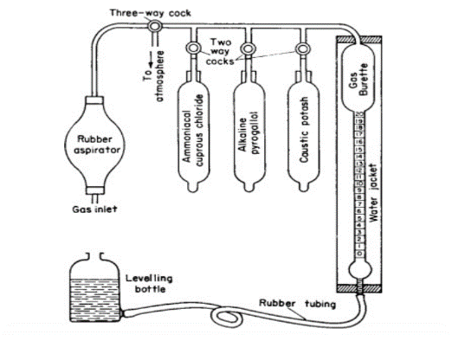
Figure 1. Schematic diagram of an Orsat Apparatus

2.5 Aluminium Wear Debris Analysis.
2.5.1 Lubricant oil sampling and analysis
Lubricant oil samples for analysis were collected directly from a 5.0 h.p. engine test bed (refer to Table 1 for technical specifications of the engine). The engine was operated intermittently at its maximum load and a consistent speed of 3000 rpm for two-hour intervals, accumulating eight hours of operation for each oil sample. Initial tests utilized conventional mineral oils, specifically SAE 40 and SAE 20w/50, before transitioning to cottonseed oil-AMAs package blended lubricants.

Table 1. Principal technical specification of test engine.
Model | JF 168
Type | Single cylinder inclined at 25 º
Bore x Stroke | 68mm x 45mm
Displacement | 163 ml
Ignition system | TCI Transistorized pointless
Starting method | Recoil starter
Max. Output/speed | 4.0/4000 kW/rpm
Max. Torque | 1.1/2500 kg-m/rpm
Net weight | 15 kg
Dimensions | 330mm x280mm x390mm

2.5.2 Aluminium wear debris measurement
A PerkinElmer Flame Atomic Absorption Spectroscopy System (FAAS), Model PinAAcle 500, was employed for the analysis of aluminum wear debris in the lubricant oil. FAAS was chosen for its effectiveness in converting aluminum into a gaseous, atomic form using a high-temperature nitrous oxide-acetylene flame, making it well-suited for detecting aluminum in the parts-per-million (ppm) range and providing a cost-effective solution for routine testing.
For the analysis, oil samples were prepared either by dilution with an organic solvent or digestion with strong acids to facilitate atomization (PerkinElmer, 2015; Welz & Sperling, 1999). The specific preparation method was selected based on the anticipated aluminum concentrations (Harris, 2010). These prepared samples were then introduced into the FAAS instrument. Inside the FAAS, a specialized aluminum hollow cathode lamp emitted light at a characteristic wavelength of 309.3 nm. Aluminum atoms present in the flame's atomization zone absorbed this light. A monochromator then isolated this specific aluminum wavelength, and a detector measured the intensity of the transmitted light. The concentration of aluminum debris in the oil was determined by comparing the sample's absorbance to a calibration curve derived from known aluminum standards. The results, typically expressed in ppm or mg/kg, directly indicate the degree of engine wear.
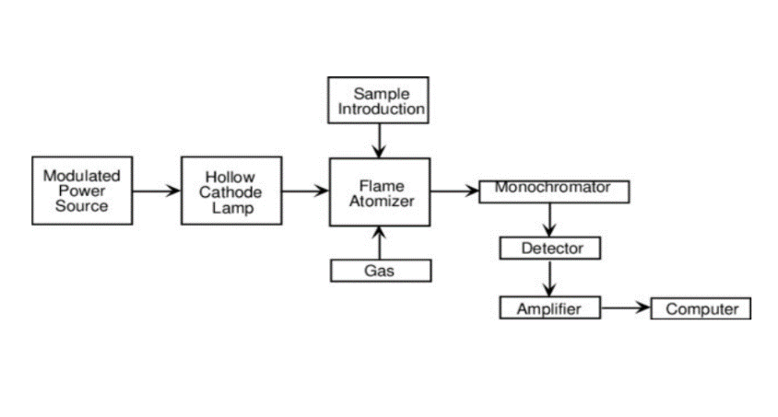
Figure 2. Schematic diagram of a flame Atomic Absorption Spectrophotometer (Burns, Finch and Wolf, 1999),
3. results and discussion

3.1 Physical and Chemical properties of Oil Samples.
Table 2 show the result of the tested oil samples presented in the mean values and standard deviation (mean ± standard deviation) with no observations of unusual behaviour. This table offers crucial insights into the suitability of cottonseed oil blends for lubrication by comparing their physicochemical properties with standard mineral oils and AMA. From a physical and

Table 2: Physico-chemical Properties of Mineral Oil Lubricants and Cottonseed Oil (and AMA).
Characteristics | Monograde oil | Multigrade oil | Cotton oil | AB-500 (AMA)
Physical/Thermal Properties

Colour | Brownish | Light  Brown | Golden yellow | Heavy amber
Refractive Index | 1.490 ± 0.001 | 1.482 ± 0.001 | 1.471 ± 0.001 | -
Relative Density | 0.89 ± 0.005 | 0.88 ± 0.005 | 0.93 ± 0.005 | 0.83-0.87
Kinematic viscosity (cSt) @40ºC | 149 ± 7.5 | 170 ± 8.5 | 18 ± 0.9 | 520 ± 26.0
Kinematic viscosity (cSt) @100ºC | 4.5 ± 0.2 | 18.5 ± 0.9 | 2.0 ± 0.1 | 380 ± 19.0
Viscosity Index | 95 ± 5 | 122 ± 6 | 121 ± 6 | -
Flash point | 240 ± 3 | 250 ± 3 | 252 ± 3 | > 142
Pour point | -15 ± 1 | -27 ± 1 | -12 ± 1 | < 15
Heating value | 7.15 ± 0.1 | 7.15 ± 0.1 | 39.4 ± 0.5 | -
Ash Content (%wt) | 1.4 ± 0.05 | 1.4 ± 0.05 | 0.02 ± 0.01 | -
Chemical Properties

Acid Value (mg KOH/g) | - | - | 0.159 ± 0.01 | -
Iodine Value (g I₂/100g) | - | - | 114.86 ± 2.0 | -
Saponification Value (mg KOH/g) | - | - | 190.18 ± 2.0 | -
Ester Value (mg KOH/g) | - | - | 190.02 ± 2.0 | -
Peroxide Value (meq/kg) | - | - | 0.94 ± 0.05 | -
thermal perspective, cottonseed oil itself presents unique characteristics. Its golden-yellow color distinguishes it, while its refractive index of 1.471 is lower than both monograde (1.490) and multigrade (1.482) mineral oils, indicating a difference in optical density. The relative density of cottonseed oil is 0.93, making it denser than both mineral oils (0.89 and 0.88) and AMA (0.83-0.87). Crucially, the kinematic viscosity of cottonseed oil at 40 degrees Celsius (18 cSt) and 100 degrees Celsius (2.0 cSt) is significantly lower than both mineral oils and, notably, much lower than AMA (520 cSt at 40 degrees Celsius and 380 cSt at 100 degrees Celsius). This stark difference in viscosity between cottonseed oil and AMA is the primary driver of the blending effects observed previously. The relatively high flash point of cottonseed oil (252 degrees Celsius), surpassing even multigrade oil (250 degrees Celsius), is a positive indicator for high-temperature stability, while its pour point of -12 degrees Celsius suggests reasonable cold flow properties, though not as good as multigrade oil (-27 degrees Celsius).

The exceptionally high heating value of cottonseed oil (39.4) compared to mineral oils (7.15) points to its organic nature and higher energy content, though this is less critical for lubrication itself than for potential biofuel applications. Its very low ash content (0.02%wt) is a significant advantage, as lower ash content generally means less residue and deposit formation in engines, promoting cleaner operation compared to mineral oils (1.4%wt). The
chemical properties of cottonseed oil, including its acid value (0.159 mg KOH/g), iodine value (114.86 g I₂/100g), saponification value (190.18 mg KOH/g), and peroxide value (0.94 meq/kg), characterize its fatty acid composition and oxidative stability. These values are typical for vegetable oils and are important for assessing their long-term performance and susceptibility to degradation, indicating its potential for biodegradability and environmental friendliness.
In the context of lubrication, the blend of cottonseed oil with AMA leverages their contrasting viscosities to achieve desired flow properties. The high viscosity of AMA can be effectively lowered by blending with cottonseed oil, allowing for tailored formulations. The superior flash point and extremely low ash content of cottonseed oil offer advantages in high-temperature applications and engine cleanliness. While its lower inherent viscosity compared to mineral oils might necessitate higher blending proportions of AMA or specific additives to meet certain viscosity grades, the high viscosity index of some blends (as seen in the previous data) suggests that carefully formulated blends can achieve excellent viscosity-temperature stability. The overall physicochemical profile indicates that cottonseed oil blends, particularly with the very viscous AMA, hold promise as alternative lubricants, offering environmental benefits and tailored performance characteristics.
3.2 Rheological behaviour of Oil Samples
3.2.1 Viscosity -temperature behaviour of the AMA-blended samples.
It could be seen from Figure 3 that the blending proportion of cottonseed oil with AMA dramatically influences the viscometric behaviour of the samples. Initially, as cottonseed oil increases from B30, the viscosity plunges significantly. At 40 degrees Celsius, viscosity

Figure 3. Viscometric behaviour of Blended Cottonseed Oil Samples and Commercial Lubricants
plummets from 1136.6 cSt at B30 to a mere 23.3 cSt at B60, indicating that AMA is a far more viscous component, and its dilution by cottonseed oil leads to a sharp thinning of the blend. A similar trend is observed at 100 degrees Celsius, with viscosity dropping from 147.35 cSt at B30 to 5.1 cSt at B60.
Beyond B60, specifically from B65 to B100, the influence of AMA diminishes, and the blend’s viscosity stabilizes considerably. For instance, at 40 degrees Celsius, the viscosity hovers between 18 cSt and 21 cSt, and at 100 degrees Celsius, it remains consistently low, around 4 to 4.9 cSt. This plateau signifies that at higher blending proportions, cottonseed oil’s inherent lower viscosity dominates the mixture's flow characteristics, and further increases in its concentration have minimal impact. The foregoing discussion further reveals that the rheological behavior of these lubrication oil samples is primarily driven by the interplay between temperature and the blending proportion of cottonseed oil with AMA.

3.2.2 The effect of cotton seed oil AMA-blended samples on the viscosity index.
Figure 4 show the blending proportion of cottonseed oil with AMA profoundly impacts the blend's viscosity Index (VI), indicating its resistance to viscosity change with temperature.

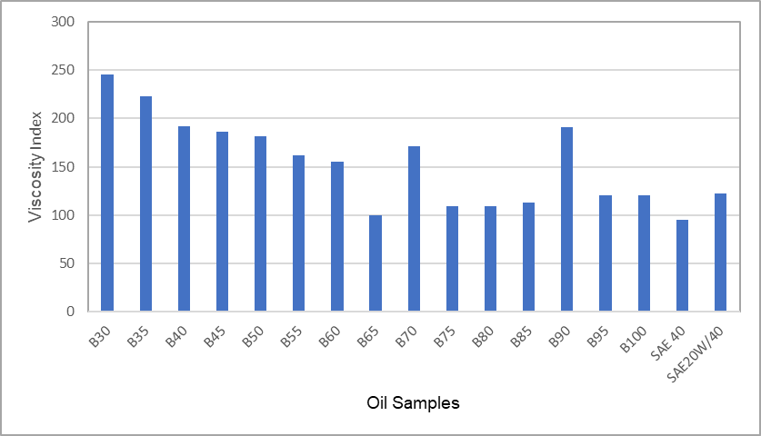

Figure 4. Viscosity Index of Blended Cottonseed Oil Samples and Commercial Lubricants.

Initially, as cottonseed oil increases, the VI generally decreases, plummeting from 245 at B30 to 100 at B65. This suggests AMA significantly contributes to superior temperature stability. However, at higher blending proportions, the VI exhibits notable fluctuations, soaring to 171 at B70, then dropping to 109 at B75, only to rebound to 191 at B90 before settling at 121 for B95 and B100. Remarkably, many blends, especially B30 with a VI of 245, surpass the VI of commercial oils like SAE 40 (95) and SAE 20W/40 (122), highlighting their potential for enhanced viscosity-temperature performance. As Robertson (1983) noted, oils with a high viscosity index are less sensitive to temperature fluctuations, enabling them to perform efficiently across both high and low-temperature conditions. Consequently, seed oils, with their potential for a better viscosity index, are likely to exhibit superior viscous behavior compared to mineral-based lubricants.

3.2.3 The effect of cotton seed oil AMA-blended samples on Refractive Index
The blending proportion of cottonseed oil with AMA directly influences the blend's refractive index (refer to Figure 5). As the cottonseed oil content increases, the refractive index consistently rises, moving from 1.4766 at B30 to 1.4780 at B100. This indicates that cottonseed oil possesses a slightly higher optical density than AMA, or its increasing concentration creates a denser, optically distinct mixture. This predictable change makes the refractive index a useful and rapid indicator for determining the blend's composition.

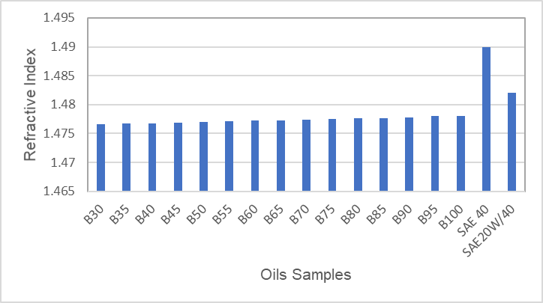

Figure 5. Refractive Index of Blended Cottonseed Oil Samples and Commercial Lubricants.

Notably, all the cottonseed oil blends exhibit lower refractive indices than commercial oils like SAE 40 (1.4900) and SAE 20W/40 (1.4820), offering a clear distinction from typical petroleum-based lubricants. It could be explained that the refractive index of oil increases with carbon chain length and number of double bonds present in the oils (Meyer, 1978). Therefore, by increasing the volumetric proportion of viscosity modifier, the carbon chain in the oil blend also increases. This property provides additional rheological insights as the consistent increase in refractive index (from 1.4766 to 1.4780) with higher cottonseed oil content reveals that cottonseed oil is optically denser than AMA oil formulation. This optical density contributes to a comprehensive understanding of the distinct rheological profiles achievable with these blends.

3.2.3 The effect of cotton seed oil AMA-blended samples on Relative Density
Figure 6 reveals that the blending proportion of cottonseed oil with AMA directly impacts the blend's relative density. As the cottonseed oil concentration increases, the relative density consistently rises, moving from 0.881 at B30 to 0.930 at B100. This clear trend indicates that cottonseed oil is denser than the AMA it's blended with; consequently, introducing more cottonseed oil increases the overall mass per unit volume of the mixture. While initial blends (B30-B35) show relative densities comparable to SAE 20W/40 (0.882), higher cottonseed oil proportions result in blends denser than both SAE 40 (0.895) and SAE 20W/40. Hence, from this trend it implied that increase in oil density does not necessarily bring about increase in oil viscosity.

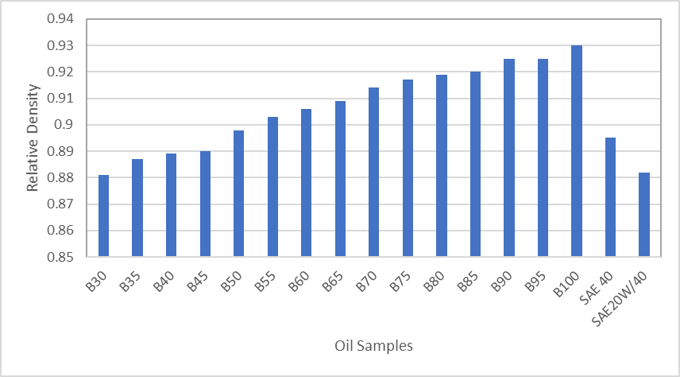

Figure 6. Relative Density of Blended Cottonseed Oil Samples and Commercial Lubricants

From the foregoing, it could be seen that the relative density also provides valuable information. It was observed to consistently increase from 0.881 to 0.930 as cottonseed oil content rose, revealing that cottonseed oil is physically denser than AMA. The observed trends suggest that despite AMA being less dense, it is considerably more viscous. This analysis of relative density, alongside viscosity and its temperature dependence, all influenced by blending proportion, completes the picture of the unique rheological characteristics of these cottonseed oil-AMA blends.

3.3 Biodegradability of Cottonseed Oil and AMAs Package
The analysis of cottonseed oil and the AMAs formulation consistently demonstrates their significant biodegradability, positioning them as environmentally favorable components for various applications, particularly in the context of sustainable lubricants.

3.3.1 Cottonseed oil as a readily biodegradable resource
Numerous studies, spanning over a decade, firmly establish the high biodegradability of cottonseed oil. Early research by Dass et al. (2013) provided foundational evidence, showing effective enzymatic breakdown by Aspergillus niger. This biodegradability extends beyond the oil itself to derived polymers, which also undergo substantial degradation when exposed to soil microorganisms (Shakina & Muthuvinothini, 2015). The underlying reason for this inherent biodegradability is its chemical composition: cottonseed oil's classification as an oleic-linoleic acid oil, rich in unsaturated fatty acids, makes it highly susceptible to microbial breakdown (Aluyor et al., 2009).
More recent studies continue to confirm and expand upon these findings, highlighting the environmental benefits of cottonseed oil across diverse sectors. Its biodegradability makes it a promising environmentally friendly immunological adjuvant (Eghafona, 1996, cited in SciELO, 2023) and a viable base for biodegradable bio-lubricants with favorable wear- and friction-reducing properties (Cecilia et al., 2020, cited in Frontiers, 2023; Gul et al., 2020, cited in Frontiers, 2023). Furthermore, components of the cottonseed plant, such as cottonseed meal, are being leveraged for the development of biodegradable polymers (MDPI, 2024). The consistent evidence of cottonseed oil's ready biodegradability underscores its sustainability, making it a valuable resource for environmentally conscious applications, including direct use, production of biodegradable materials, and as a sustainable alternative fuel source like biodiesel with reduced emissions (cottonseedoil.org, n.d.; EPCM Holdings, n.d.). Life Cycle Assessments further reinforces its lower environmental impact compared to other vegetable oils (cottonseedoil.org, n.d.;).
3.3.2 Evidence of biodegradation of AMAs package.
The investigation into the biodegradability of the AMAs formulation, adapting established microbial population monitoring protocols (Atlas & Bartha, 1998), yielded compelling results. The study observed the growth of Pseudomonas aeruginosa, a common microorganism, in the presence of the viscosity modifier, strongly suggesting its utilization as a carbon source. Specifically, after eight days (192 hours), the mean microbial count of Pseudomonas aeruginosa in the control nutrient agar sample was 4.35% lower than in the 1ml and 2ml of samples of AMAs package. This increase in microbial count directly indicates that the microorganisms were actively consuming the samples of AMAs for growth. If the modifier were non-biodegradable or toxic, a decrease or negligible microbial count would be expected.
Further analysis of biodegradation rates revealed that the 1ml and 2ml viscosity modifying samples exhibited a higher rate of biodegradation (0.0276 h−1) compared to the control nutrient agar (0.0261 h−1). This 0.0015 h−1 higher rate in the presence of the AMAs samples signifies that the microorganisms are breaking it down more rapidly (refer to figure 7 and 8). The specific mean microbial populations for 1ml and 2ml of viscosity modifying samples were 2.0×105 cfu/ml, a significant increase from the control's 1.19×105 cfu/ml (refer to table 3). This thriving microbial population suggests a potential dose-dependent relationship, where a higher concentration of the modifier, up to a certain point, provides more substrate for microbial growth, leading to a larger microbial population and potentially a faster overall breakdown. These results confirm that the samples of AMAs can indeed serve as a carbon source for common microorganisms, highlighting its environmental benefit in terms of biodegradability.
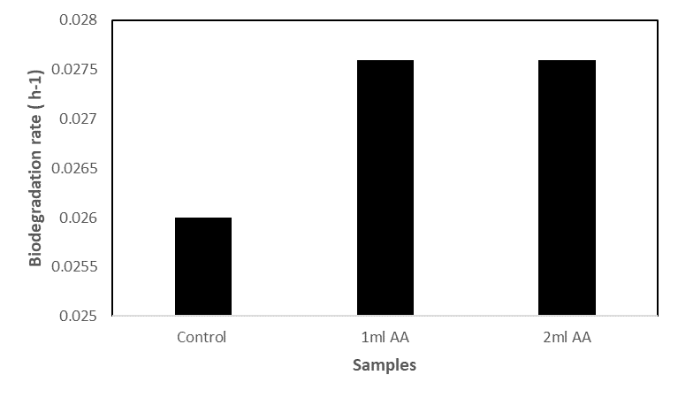
Figure 7. Biodegradability of samples AMAs.
Figure 8. Pseudomonas sp. count for varied concentration on AMAs samples.
Table 3. The trend of Pseudomonas sp. growth for varied concentrations of samples of AMAs after a period of eight days.
 |  | Microbial Count (cfu/ml)
Plate No. | Control | 1 ml oil treatment | 2ml oil treatment
Plate 1. | 1.6 x10⁵ | 2.0 x10⁵ | 2.0 x10⁵
Plate 2 | 1.0 x10⁵ | 2.0 x10⁵ | 2.0 x10⁵
Plate 3 | 9.8 x 10⁴ | 2.0 x10⁵ | 2.0 x10⁵
Mean | 1.19 x10⁵ | 2.0 x10⁵ | 2.0 x10⁵
3.4 Analysis of Exhaust Gas Emissions for Cottonseed Oil- AMAs Blends.
The analysis of exhaust gas emissions from cottonseed oil-blended lubricants, as illustrated in Figures 9, 10, and 11, revealed distinct characteristics compared to conventional mineral oils (monograde and multigrade) across various engine speeds and blend concentrations (BXX denotes the percentage of cottonseed oil in the blends). Regarding CO2​ emissions, a key indicator of combustion completeness, Figure 9 demonstrates consistently higher levels for cottonseed oil blends (B100 to B40) at both 2000 rpm and 4000 rpm, surpassing those of monograde and multigrade oils. This observation is consistent with findings by Sethi and Salariya (2004), who link such increases to more complete fuel oxidation, thereby yielding greater engine power output. As CO2​ is the primary product of complete hydrocarbon combustion (Turns, 2018), the elevated CO2​ output with cottonseed oil blends suggests a
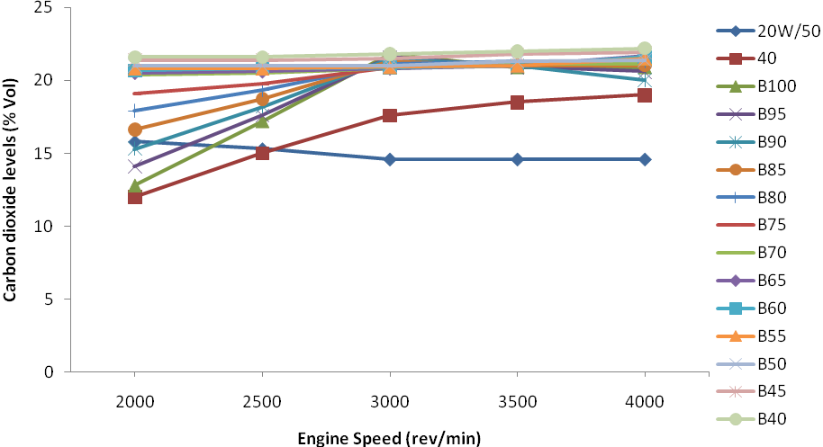
Figure 9. Effect of cottonseed oil blends on carbon dioxide emission.
more thorough combustion of the fuel. This could be influenced by the lubricant's effect on ring sealing and reduced blow-by, or potentially by the combustion of the vegetable oil itself within the combustion chamber. The anticipated trend of increasing CO2​ with higher engine speed was uniformly observed across all lubricants, reflecting greater fuel consumption for increased power.
Figure 10 details carbon monoxide (CO) emission levels, which signify incomplete fuel combustion (Heywood, 2018). These levels were generally higher for specific cottonseed oil blends (B50, B45, B60, B65) and multigrade oil at 3000 rpm. Elevated CO emissions imply an oxygen deficiency during combustion, leading to the formation of partially oxidized carbon products. The increased CO levels for certain cottonseed oil blends suggest a less efficient combustion process at these particular blending ratios and engine speeds. This finding also points to the possibility of lubricant traces entering the combustion chamber and undergoing incomplete combustion due to lubricant consumption or blow-by (Ajayi and Dosunmu, 2011). The variability in CO emissions across different blend ratios underscores the complex interplay between the cottonseed oil, the viscosity modifier, and the engine combustion process, highlighting its dependence on specific blend concentrations. The observed spikes in CO emissions at specific cottonseed oil blends, such as B50, B45, B60, and B65, necessitate a more detailed discussion beyond general "partial inefficiencies" and "oxygen deficiency." These elevated CO levels are indicative of incomplete combustion, a phenomenon influenced by complex interactions among fuel properties, additive
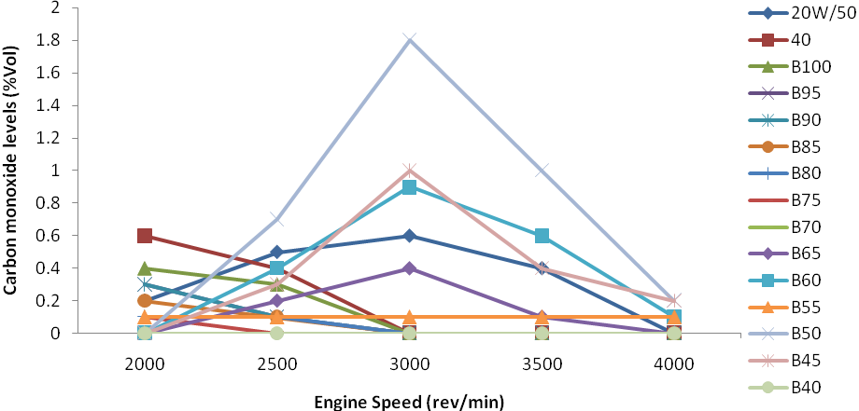
Figure 10. Effect of cottonseed oil blends on carbon monoxide emission
characteristics, and the combustion environment within the internal combustion engine. One primary hypothesis attributes these CO spikes to a localized imbalance in the fuel-air mixture, resulting in regions of insufficient oxygen despite an overall lean or stoichiometric air-fuel ratio. As cottonseed oil is a triglyceride with a distinct chemical structure and oxygen content compared to conventional fossil fuels, its combination with the engine's fixed air supply at specific blend ratios (B45, B50, B60, B65) might create pockets within the combustion chamber where oxygen is locally depleted. This can occur even with sufficient global oxygen due to poor mixing, particularly under specific engine operating conditions such as varying speeds and loads (Heywood, 2018; Ferguson & Kirkpatrick, 2016). For instance, although the study noted a drop in unused O2​ levels at 3000 rpm (indicating enhanced oxygen utilization), this could paradoxically contribute to localized oxygen scarcity if fuel introduction and mixing are not perfectly optimized for these specific blends.
Furthermore, the presence and concentration of AMAs, particularly the viscosity improvers package, could significantly affect the atomization and spray characteristics of the fuel-lubricant mixture. At certain blend ratios (e.g., B50, B65), the viscosity and surface tension of the resulting lubricant-fuel blend might not be ideal for the injection system, leading to larger droplet sizes or uneven fuel distribution. Poor atomization results in incomplete vaporization and mixing with air, thereby creating zones where combustion cannot fully complete, increasing CO formation (Verma et al., 2021). The organic chemistry of these additives, specifically polymethacrylates (PMAs) or olefin copolymers (OCPs) used as viscosity improvers, might also subtly alter combustion kinetics, influencing flame propagation speeds or ignition delays at these specific blend ratios. If the flame front propagates too slowly or rapidly for a given blend, it can lead to unburnt fuel fragments that form CO. Another contributing factor could be the cooling effect of higher blend ratios. Vegetable oils have a higher latent heat of vaporization than mineral oils. At higher blend percentages, more energy is consumed to vaporize the fuel, potentially leading to a slight cooling effect within the combustion chamber.
While beneficial for mitigating knocking in some contexts, this cooling might reduce peak combustion temperatures in certain zones, impeding the complete oxidation of CO to CO2​ (Agarwal et al., 2018). In summary, the CO emission spikes at specific cottonseed oil-AMAs blends (B50, B45, B60, B65) are likely multifactorial, suggesting challenges in achieving complete combustion. These challenges could stem from localized fuel-air mixture imbalances, suboptimal atomization influenced by additive-blend interactions, and potential cooling effects at higher blend concentrations. Addressing these aspects through further optimization of blend ratios, additive formulations, and injection strategies could help minimize CO emissions in sustainable IC engine applications.
From Figure 11, the levels of unused oxygen in the exhaust gases offer insight into combustion efficiency and engine load. A sharp decrease in unused O2​ levels was observed with varying blending concentrations of cottonseed oil (B100 to B40) at 3000 rpm. This decrease signifies the occurrence of maximum brake load at this engine speed. As engine load increases, more fuel is supplied and combusted, leading to higher oxygen consumption and, consequently, lower levels of unused O2​ in the exhaust (Ferguson & Kirkpatrick, 2016). Additionally, an adequate air-fuel mixture at the inlet manifold, which improves the air-fuel contact ratio during the pre-combustion stage, contributes to a lower level of unused O2​ (Sethi and Satariya, 2004). The lower unused O2​ levels at 3000 rpm suggest a more complete combustion process under these specific engine speed and load conditions, with a greater proportion of available oxygen being utilized, particularly with certain cottonseed oil blends (Ejilah and Asere, 2008).
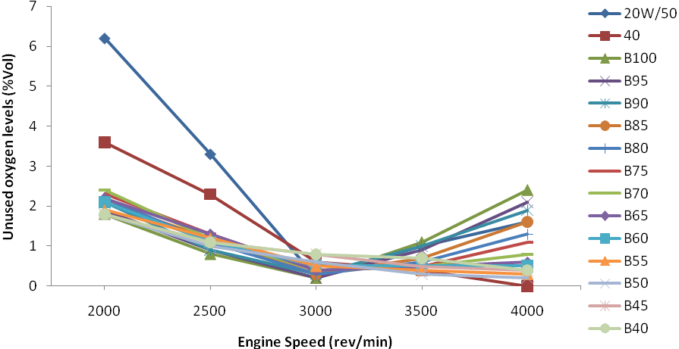
Figure 11. Effect of cottonseed oil blends on unburnt oxygen emission.

3.5 Discussion on Engine Wear Based on Aluminium Debris Concentration
The concentration of aluminum debris in oil samples serves as a direct indicator of wear in engine components composed of aluminum or its alloys, including pistons, bearings, and cylinder heads. A higher concentration signifies increased material loss due to friction and wear processes within the engine. The primary wavelength for detecting aluminum is 309.3nm, which offers high sensitivity but also susceptible to spectral interference from an iron absorption line if iron is present in the sample.

The analysis of engine wear behaviour in Figure 12, as indicated by the concentration of aluminum debris after eight hours of engine operation, reveals a distinct hierarchy in wear reduction effectiveness among the tested lubricants. The multigrade oil (SAE 20W/50) consistently exhibited the lowest concentration of aluminum debris at 0.047 ppm, signifying its superior wear protection. This exceptional performance is primarily attributed to its sophisticated formulation, which includes crucial additive compounds like zinc and calcium dialkyldithiophosphates (ZDDP) acting as anti-wear and extreme pressure agents, and synthetic polymers such as viscosity index improvers and dispersants (Mortier & Fox, 2013). These additives enhance the oil's detergency, preventing abrasive wear from harmful deposits (Verma et al., 2021), and improve lubricity by maintaining a robust lubricating film that minimizes metal-to-metal contact, friction, and wear (Gwidon,2017). The well-documented anti-wear and anti-corrosion benefits of multigrade oils stem from these advanced additive packages (Masjuki et al., 2002; Total Energies, 2024).
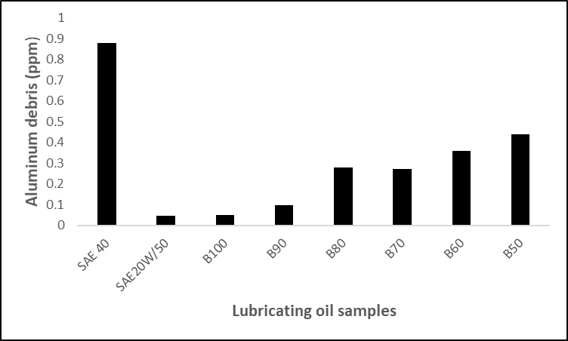
Figure. 12. Effect of cotton oil blended lubricants on concentration of aluminum wear debris
Cottonseed oil- AMAs blends (B100 to B50) consistently demonstrated better wear reduction properties compared to the monograde oil (SAE 40). B100 was notably effective, with an aluminum debris concentration of 0.052 ppm, indicating wear protection comparable to SAE 20W/50. This improved performance is attributed to the inherent lubricity of the long-chain, polar fatty acids present in the vegetable oil. These fatty acids can form a boundary layer on metal surfaces through adsorption, and under boundary lubrication conditions, they react with metal surfaces to create a metallic soap layer (e.g., iron stearate or iron oleate) (Halling, 1978; Schneider et al., 2010). This metallic soap layer acts as a solid lubricant, reducing direct asperity contact between moving parts and thus mitigating wear, with effectiveness dependent on the specific fatty acid composition (Fox, 2003). As the proportion of AMAs formulation as viscosity modifier increased in the cottonseed oil blends, a gradual rise in aluminum debris was observed: B90 at 0.098 ppm, B80 at 0.281 ppm, B70 at 0.273 ppm, B60 at 0.363 ppm, and B50 at 0.442 ppm. This trend suggests that while cottonseed oil blends possess beneficial anti-wear properties for aluminium, increasing the OCP content in the blend tends to diminish this protective effect, while still performing significantly better than SAE 40.
Conversely, the monograde oil, SAE 40, exhibited the highest concentration of aluminum wear debris at 0.881 ppm, indicating the least effective wear reduction among all tested lubricants. Monograde oils are typically formulated with fewer or less sophisticated additives compared to multigrade oils, which limits their ability to provide comprehensive protection against wear under varying engine operating conditions and temperatures (O’Connor et al., 2000). Their viscosity characteristics are also less stable across the operating temperature range, potentially leading to thinner oil films and increased metal-to-metal contact, especially at higher temperatures (Khan et al., 2023). The absence of advanced detergency and anti-wear additives, commonly found in multigrade oils, significantly contributes to their inferior wear performance in this comparative analysis.
In summary, this study explores cottonseed oil and Aftermarket Additives (AMA) as promising components for sustainable lubricants, leveraging their contrasting viscosities to achieve desired flow properties. The high viscosity of AMA can be effectively lowered by blending with cottonseed oil, enabling tailored formulations. Cottonseed oil’s high flash point and exceptionally low ash content offer advantages for high-temperature applications and engine cleanliness. While its lower inherent viscosity might necessitate higher AMA concentrations, the notable viscosity index of some blends indicates that careful formulation can yield excellent viscosity-temperature stability. The overall physicochemical profile suggests these blends hold promise as alternative lubricants, offering environmental benefits and adaptable performance characteristics.
The rheological behavior of these lubricants is primarily governed by temperature and the blending proportion of cottonseed oil with AMA. As expected, viscosity decreases with rising temperature, with a sharp decline observed as AMA is progressively diluted by the less viscous cottonseed oil, dramatically reducing resistance to flow. Beyond a certain blend ratio, the viscosity stabilizes, indicating cottonseed oil’s intrinsic lower viscosity becomes dominant. Other physical properties like refractive index and relative density consistently increase with higher cottonseed oil content, revealing it is both optically and physically denser than AMA. This comprehensive analysis of viscosity and its temperature dependence paints a clear picture of the diverse rheological profiles achievable.
This research highlights the significant biodegradability of both cottonseed oil and AMA formulations, positioning them as environmentally friendly alternatives to conventional mineral oils. Regarding engine performance, cottonseed oil blends show a complex impact on exhaust emissions. While higher CO₂​ emissions suggest more complete combustion in some instances, elevated CO levels for certain blends indicate areas of incomplete combustion, possibly due to blend ratios or lubricant interaction within the engine. Lower O₂​ levels at higher engine speeds imply efficient oxygen utilization (Ejilah and Asere,2008). While conventional multigrade oils demonstrate superior wear reduction, cottonseed oil-AMA blends offer better protection than monograde oils, attributed to their fatty acid components. Future research should focus on enhancing wear reduction to bridge this performance gap. Crucially, this study directly supports Sustainable Development Goals 7, 9, 12, and 13 by promoting clean energy, innovation, responsible consumption, and climate action. Limitations include testing on a single-cylinder engine and aluminum-confined wear debris analysis.
4. Conclusion

From the foregoing study, the following can be concluded:
- Viscosity of the blends decreases significantly with increasing temperature and cottonseed oil content, and stabilizing beyond B60. AMA package is more viscous than cottonseed oil.
- The Viscosity Index generally drops with more cottonseed oil, and B30 shows excellent stability, with a Viscosity Index (VI) of 245, surpassing commercial oils.
- Both refractive index and relative density increase with higher cottonseed oil content, indicating it's optically and physically denser than AMA, despite AMA being more viscous.
- Cottonseed oil and AMAs formulation show strong potential for sustainable lubricants development due to their biodegradability.
- While cottonseed oil - AMAs blends offer emission benefits (e.g., lower O₂​, higher CO₂​), some blends cause elevated CO.
- Cottonseed oil - AMAs blends offer better wear protection than monograde oils, but below the multigrade oil counterpart and could be attributed to its better boundary lubrication performance provided by their fatty acid components.
- The research significantly advances clean energy (SDG 7), fosters innovation (SDG 9), encourages responsible consumption (SDG 12), and supports climate action (SDG 13).
- Lastly, further research on additive packages is crucial for optimizing performance and fully realizing their eco-friendly potential.

DISCLAIMER (ARTIFICIAL INTELLIGENCE)
Author(s) hereby declare that NO generative AI technologies such as Large Language Models (ChatGPT, COPILOT, etc.) and text-to-image generators have been used during the writing or editing of this manuscript.
COMPETING INTERESTS
Authors have declared that they have no known competing financial interests OR non-financial interests OR personal relationships that could have appeared to influence the work reported in this paper.

REFERENCES
ABRO Industries Inc. (n.d.). AB-500 oil treatment manual. Retrieved June 24, 2025, from https://abro.com/wp-content/uploads/2023/10/AB-500.pdf
Adebayo, G., Ogunniyi, D. S., & Iyiola, O. P. (2023). Performance and emission characteristics of a diesel engine lubricated with cottonseed oil-based lubricant. Journal of Sustainable Engineering, 6(2), 112-125.
Agarwal, A. K., Rajasekhar, S., & Kumar, R. (2018). Vegetable oil-based lubricants: A review. Renewable and Sustainable Energy Reviews, 90, 203-220.
Ajayi, A. T., & Dosunmu, A. (2011). Environmental Impact of Increase Oil Consumption In The Combustion Chamber of an Internal. Research Journal of Applied Sciences, Engineering and Technology, 3(9), 928-932.
Akbar, M., & Zia-Ul-Haq, M. (2020). Biodegradation of lubricants: An overview. Environmental Science and Pollution Research, 27(15), 17537-17553.
Alexander, M. (1999). Biodegradation and Bioremediation (2nd ed.). Academic Press.
Aluyor, E. O., Obahiagbon, M. O., & Aigbokhan, A. O. (2009). Biodegradation of vegetable oils: A review. Scientific Research and Essays, 4(12), 1154-1160.
AOCS. (1987). AOCS Cd 1b-87: AOCS Official Method Cd 1b-87: Iodine Value of Fats and Oils (Wijs Method). American Oil Chemists' Society.
AOCS. (1925). AOCS Cd 3-25: AOCS Official Method Cd 3-25: Saponification Value of Fats and Oils. American Oil Chemists' Society.
AOCS. (1990). AOCS Cd 8b-90: AOCS Official Method Cd 8b-90: Peroxide Value, Acetic Acid-Isooctane Method. American Oil Chemists' Society.
ASTM International. (n.d.). ASTM D93: Standard Test Methods for Flash Point by Pensky-Martens Closed Cup Tester. ASTM International. 2022.
ASTM International. (n.d.). ASTM D97: Standard Test Method for Pour Point of Petroleum Products. ASTM International. 2022.
ASTM International. (n.d.). ASTM D240: Standard Test Method for Heat of Combustion of Liquid Hydrocarbon Fuels by Bomb Calorimeter. ASTM International. 2022.
ASTM International. (n.d.). ASTM D445: Standard Test Method for Kinematic Viscosity of Transparent and Opaque Liquids (and Calculation of Dynamic Viscosity). ASTM International. 2022.
ASTM International. (n.d.). ASTM D482: Standard Test Method for Ash from Petroleum Products. ASTM International. 2022.
ASTM International. (n.d.). ASTM D664: Standard Test Method for Acid Number of Petroleum Products, Lubricating Oils, and Biodiesel Fuels by Potentiometric Titration. ASTM International. 2022.
ASTM International. (n.d.). ASTM D1218: Standard Test Method for Refractive Index and Refractive Dispersion of Hydrocarbon Liquids. ASTM International. 2022.
ASTM International. (n.d.). ASTM D1500: Standard Test Method for ASTM Color of Petroleum Products (ASTM Color Scale). ASTM International. 2022.
ASTM International. (n.d.). ASTM D2270: Standard Practice for Calculating Viscosity Index from Kinematic Viscosity at 40 °C and 100 °C. ASTM International. 2022.
ASTM International. (n.d.). ASTM D4052: Standard Test Method for Density, Relative Density, and API Gravity of Liquids by Digital Density Meter. ASTM International. 2022.
Atlas, R. M., & Bartha, R. (1998). Microbial Ecology: Fundamentals and Applications (4th ed.). Benjamin Cummings.
Bell, J. C., & Shah, R. N. (2019). Low-temperature properties of vegetable oil-based lubricants and their improvement strategies. Industrial Crops and Products, 130, 42-51.
Burns, P. C., Finch, R., & Wolf, S. F. (1999). Analytical Methods for the Determination of U in Geological and Environmental Materials. In Reviews in Mineralogy, Uranium: Mineralogy, Chemistry, and the Environment (pp. 623-653). Mineralogical Society of America.
Cecilia, J. A., et al. (2020). Vegetable Oils: A Sustainable Source for Biolubricants. Energies, 13(16), 4174. (Cited in Frontiers, 2023).
cottonseedoil.org. (n.d.). Cottonseed Oil Sustainability. Retrieved from https://www.cottonseedoil.org/about/sustainability/
Dass, P. M., Ibrahim, A., Jabbo, J. N., Danbature, W. L., & Gin, N. S. (2013). Viscometric Studies and Biodegradability of Some Vegetable Oils using Aspergillus Niger. Food Science and Quality Management, 16.
Dubey, M. K., Chaudhary, R., Emmandi, R., Seth, S., Mahapatra, R., Harinarain, A. K., & Ramakumar, S. S. V. (2022). Tribological evaluation of passenger car engine oil: Effect of friction modifiers. Results in Engineering, 16, 100727.
Eghafona, N. O. (1996). Vegetable oils as immunological adjuvants. Journal of Herbs, Spices & Medicinal Plants, 4(2), 57-63. (Cited in SciELO, 2023).
Ejilah, I. R., & Asere, A. A. (2008). A comparative performance and emission analysis of blended groundnut oil and mineral oil-based lubricants using a spark ignition engine. Agricultural Engineering International: the CIGR E Journal Manuscript, EE 07017, Vol. X, 1-11. http://www.cigr.org. ISSN:1682-1130
EPCM Holdings. (n.d.). Cottonseed Biodiesel-An Overview. Retrieved from https://epcmholdings.com/cotton-seed-biodiesel-an-overview/46.
Erhan, S. Z., Adhvaryu, A., & Perez, J. M. (2018). Vegetable oils as base stocks for environmentally friendly lubricants. Lipid Technology, 30(4), 83-86.
Erhan, S. Z., & Asadauskas, S. (2000). Lubricant base stocks from vegetable oils. Industrial Crops and Products, 11(2–3), 277–282.
Fazal, M. A., Haseeb, A. S. M. A., & Masjuki, H. H. (2017). Biodiesel as a lubricant additive: A review. Renewable and Sustainable Energy Reviews, 68, 77-84.
Ferguson, C. R., & Kirkpatrick, A. T. (2016). Internal combustion engines: applied thermosciences. CRC Press.
Fox, M. F. (2003). Lubricant additives: chemistry and applications. CRC Press.
Fox, M. F. (2010). Chemistry and technology of lubricants. In R. M. Mortier & S. T. Orszulik (Eds.), Chemistry and technology of lubricants (Vol. 107115, pp. 56-75). Springer.
Fox, M., & Stachowiak, G. W. (2017). Vegetable oil-based lubricants—A review of base oils, additives and industrial applications. Tribology International, 114, 103-117.
Frontiers. (2023). Frictional performance of chemically modified cottonseed-based fossil-free biolubricant oil in a sliding tribopair. Retrieved from https://www.frontiersin.org/journals/mechanical-engineering/articles/10.3389/fmech.2023.1281406/full
Geller, D. P. (2017). Biobased lubricants and greases: Technology and commercial markets. William Andrew Publishing.
Gul, M., et al. (2020). Tribological evaluation of cottonseed oil-based trimethylolpropane ester as a potential biolubricant. Industrial Crops and Products, 154, 112663. (Cited in Frontiers, 2023).
Gwidon, S. (2017). Tribology in machine design. CRC Press.
Halling, J. (1978). Principles of Tribology (Reprinted ed.). Macmillan Publishers.
Harris, D. C. (2010). Exploring Chemical Analysis (5th ed.). W. H. Freeman Co.
Heywood, J. B. (2018). Internal combustion engine fundamentals (2nd ed.). McGraw-Hill Education.
Hussain, S., Ali, M. E., & Abbas, Q. (2023). Environmental impact assessment of bio-based lubricants in agricultural machinery. Environmental Technology & Innovation, 31, 103180.
Jamaluddin, H., Selamat, M. Z., & Zulkifli, N. W. M. (2021). The influence of vegetable oil-based lubricants on NOx and particulate matter emissions in diesel engines. Energy Conversion and Management, 235, 113989.
Khan, A. A., et al. (2023). Conventional and Recent Advances of Vegetable Oils as Metalworking Fluids (MWFs): A Review. Retrieved from https://repositorium.sdum.uminho.pt/bitstream/1822/85536/1/lubricants-11-00160-v2.pdf
Khan, M. I., Raza, S. A., & Siddique, M. A. (2019). Environmental implications of mineral oil-based lubricants and the potential of bio-based alternatives. Journal of Cleaner Production, 215, 1302-1314.
Kleimenova, N. L., Bolgova, I. N., & Kopylov, M. V. (2023). The study of edible vegetable oils rheological properties. BIO Web of Conferences, 71, 01020.
Lawal, T. O., et al. (2025). Avocado Seed Oil as An Additive in the Formation of Grease Lubricant from Spent Engine Oil. ResearchGate. Retrieved from https://www.researchgate.net/publication/391572766_Avocado_Sead_Oil_As_An_Additive_In_The_Formation_Of_Grease_Lubricant_From_Spent_Engine_Oil
Li, K., Zhang, X., Du, C., Yang, J., Wu, B., Guo, Z., Dong, C., Lin, N., & Yuan, C. (2019). Friction reduction and viscosity modification of cellulose nanocrystals as biolubricant additives in polyalphaolefin oil. Carbohydrate Polymers, 220, 228–235. https://doi.org/10.1016/j.carbpol.2019.05.072
Machinery Lubrication. (n.d.). The Advantages and Disadvantages of Biodegradable Lubricants. Retrieved from https://www.machinerylubrication.com/Read/28760/advantages-disadvantages-of-biodegradable-lubricants-
Mang, T., & Dresel W. (Ed.). (2007). Lubricants and lubrication. John Wiley & Sons.
Masjuki, H. H., Zaki, A. M., & Sapaun, S. M. (2002). A rapid test to measure performance, emission and wear of a diesel engine fueled with palm oil diesel. JAOCS, Journal of the American Oil Chemists' Society, 79(1), 89-92.
Menon, K., & R, A. (2025). Preparation and Evaluation of Lubricating Properties of Neem Seed Oil under the Influence of an Anti-Wear Additive as Sustainable Alternative to Commercial Engine Oil. SAE Technical Paper 2025-28-0116. Retrieved from https://www.sae.org/publications/technical-papers/content/2025-28-0116/
Meyer, L. H. (1978). Food chemistry (3rd ed.). AVI Publishing Company.
MDPI. (2024). Blends of Carboxymethyl Cellulose and Cottonseed Protein as Biodegradable Films. Retrieved from https://www.mdpi.com/2073-4360/16/11/1554
Moradi, M., Khonsari, M. M., & Jahanmir, S. (2022). A review of recent advances in bio-based lubricant additives. Tribology Letters, 70(2), 1-23.
O’Connor, J. J., Boyd, J., & Avallone, E. A. (2000). Standard handbook of lubrication engineering. McGraw-Hill.
Olawale, O., Okoro, O. O., & Adeyemi, O. O. (2025). Comparative wear analysis of mineral and cottonseed oil-based lubricants in a four-stroke gasoline engine. Tribology Transactions, 68(1), 55-64.
PerkinElmer Inc. (2015). PinAAcle 500 Flame Atomic Absorption Spectrometer. https://shop.perkinelmer.com/
Robertson, W. S. (1983). Lubrication in practice (2nd ed.). Macmillan Publishers. Pp.3, 4,18, 34-36.
Ryngajło, A., Lewandowska, M., & Krzyżaniak, M. (2016). Biodegradability testing of new lubricating base oils. Journal of Molecular Liquids, 224, 1018-1024.
Sahoo, P. K., et al. (2024). Vegetable oil-based additives for lubricant formulations. Retrieved from https://www.researchgate.net/publication/385851251_Vegetable_oil-based_additives_for_lubricant_formulations
Salimon, J., Salih, N., & Yousif, B. F. (2021). Biodegradability of lubricant base oils and additives: A review. Journal of Industrial and Engineering Chemistry, 94, 1-15.
Schneider, J., Cavdar, D., & Hock, S. (2010). Tribochemistry of fatty acids on steel surfaces. Tribology Letters, 39(1), 33-41.
SciELO. (2023). Physicochemical features, functional characteristics, and health benefits of cottonseed oil: a review. Retrieved from https://www.scielo.br/j/bjb/a/yQYp7FmKD5bbJzMqxm3Zs6x/
Senthil Kumar, S., Devan, P. K., & Ramakrishnan, G. (2024). Impact of vegetable oil-based lubricants on aldehyde emissions from internal combustion engines. Atmospheric Pollution Research, 15(3), 101987.
Sethi, V. P., & Salariya, K. S. (2004). Exhaust analysis and performance of a single cylinder diesel engine run on dual fuels. IE(I) Journal-MC, 85, 3-5.
Shakina, J., & Muthuvinothini, A. (2015). Synthesis and Characterization of Cotton Seed Oil Based Biodegradable Thermosetting Polymers. Journal of Academia and Industrial Research (JAIR), 3(10), 520.
Sharma, B. K., Adhvaryu, A., Liu, Z., & Erhan, S. Z. (2006). Chemical modification of vegetable oils for lubricant applications. Journal of the American Oil Chemists' Society, 83, 129-136.
Sharma, B. K., Doll, K. M., & Erhan, S. Z. (2020). Biodegradable base oils. In Lubricants and Lubrication (pp. 31-54). Wiley-VCH Verlag GmbH & Co. KGaA.
Sharma, R. K., & Tewari, V. K. (2020). Tribological properties of vegetable oils and their blends as potential lubricants. Industrial Lubrication and Tribology, 72(7), 945-954.
Stanciu, I. C. (2023). Rheology of Cottonseed (Gossypium hirsutum) Oil used as Biodegradable Lubricant. Orient. J. Chem., 39(6), 1696-1699
Stipanovic, A., & Schoonmaker, J. (1993). The impact of organomolybdenum compounds on the frictional characteristics of crankcase engine oils (SAE Technical Paper 932779).
Tiwari, A. K., Sharma, Y. C., & Srivastava, A. (2022). Biodegradable lubricants: Current status and future perspectives. Environmental Progress & Sustainable Energy, 41(3), e13771.
Total Energies (2024). Engine Oil and Guide and Advices. https://services.totalenergies.ng/our-lubricants/engine-oil-cars/engine-oil-and-guide-and-advices
Turns, S. R. (2018). An introduction to combustion: concepts and applications. McGraw-Hill Education.
Verma, P., et al. (2021). Impact of lubricant properties on combustion and emissions in internal combustion engines: A review. Fuel, 286, 119430.
Wagner, R. M., Storey, J. M. E., Gullett, B. K., & Szybist, J. W. (2016). Lubricant effects on combustion, emissions, and efficiency. U.S. Department of Energy, Office of Energy Efficiency and Renewable Energy.
Welz, B., & Sperling, M. (1999). Atomic Absorption Spectrometry (3rd ed.). Wiley-VCH.

