Measurement of Agricultural Resource Misallocation in China and Its Spatio-temporal Evolution Characteristics

ABSTRACT

Against the backdrop of China’s Rural Revitalization Strategy and deepening supply-side structural reforms in agriculture, the misallocation of agricultural production factors has emerged as a key constraint on high-quality agricultural development. This study constructs a comprehensive model to measure agricultural resource misallocation across capital, labor, and land inputs. Using panel data from 30 Chinese provinces between 2010 and 2023, and applying kernel density estimation, the study systematically quantifies the relative degree and spatiotemporal evolution of factor misallocation. The results reveal a systematically intensifying trend in capital misallocation, a labor misallocation trajectory characterized by “bimodal stabilization–ecological deterioration–marginal risk emergence,” and a land misallocation evolution following a “policy-driven improvement–structural rebound–regional polarization” three-stage pattern. Significant regional heterogeneity is observed: eastern China is marked by “external sensitivity and peri-urban rigidity,” central China shows a “three-phase evolution,” and western China exhibits “ecological constraint-driven polarization.” In response, the study proposes regionally adaptive, category-specific, and dynamically adjustable governance strategies, providing both theoretical insights and practical guidance for optimizing agricultural resource allocation and advancing agricultural modernization in China.

Keywords: Agricultural Resource Misallocation;Relative Distortion;Kernel Density Estimation

1 Introduction

Agriculture has long been the cornerstone of China's national economy. Over the past two decades, the sector has achieved significant economic growth and bountiful harvests, successfully ensuring national food security, increasing farmers’ incomes, and improving overall living standards. These achievements have been underpinned by substantial inputs of labor, capital, and land (Yang and Liu, 2023). However, as China enters a new stage of development, high-quality agricultural growth faces multiple challenges—including resource and environmental constraints, imperfect factor market structures, rural labor outflows, and low returns on agricultural capital—making it difficult to realize full sectoral development and exacerbating factor misallocation among agricultural producers (Lei et al., 2022; Liu et al., 2020).

Resource misallocation has become a critical impediment to China’s high-quality economic development. Inefficient resource allocation not only hampers the optimal flow of production factors but also adversely affects the sustainable and healthy development of the broader economy (Sun and Xu, 2024). In 2020, the Central Committee of the Communist Party of China and the State Council issued the "Opinions on Establishing a More Refined Mechanism for the Market-Based Allocation of Factors," calling for deepened reform of factor market allocation, improved autonomous and orderly factor mobility, and enhanced efficiency of resource allocation. In particular, advancing land market reforms, facilitating the smooth and rational flow of labor, and improving rural financial services are of strategic importance for promoting high-quality development of the agricultural sector, revitalizing rural industries, and modernizing agriculture and rural areas (Li et al., 2022). Therefore, addressing resource misallocation and optimizing allocation structures are not only intrinsic requirements for China's economic upgrade but also key driving forces and foundational supports for achieving high-quality economic growth (Yuan et al., 2024).

Existing domestic research on agricultural resource misallocation mainly focuses on individual or multiple production factors such as capital, labor, and land. Resource misallocation refers to the inefficient allocation of inputs due to market imperfections or policy distortions, resulting in suboptimal resource utilization (Liu & Yang, 2024). In agriculture, misallocation is evident in factors such as labor, land, capital, and technology (Zhou et al., 2022). Typical manifestations include the coexistence of surplus labor and shortages of skilled agricultural professionals, widespread land fragmentation and inefficient usage, and both underinvestment and overinvestment in capital (Xie, 2025). At the macro level, resource misallocation contributes to structural imbalances and low efficiency in factor utilization, thereby pushing the economy away from a general equilibrium of Pareto optimality. Among existing studies, capital misallocation has been a focal point in agricultural research. In the agricultural sector, factors such as policy (Zheng and Li, 2020), regional disparities (Yang and Zhu, 2024), urban-rural divisions (Wu, 2017), and firm- or industry-level characteristics (Lin and Chen, 2020) hinder the reallocation of land and labor to more productive uses, thereby perpetuating widespread misallocation. In recent years, the average level of human capital among Chinese workers has improved significantly. However, the output growth from human capital has not kept pace, with low allocation efficiency being considered a key factor (Ji and Lai, 2018). Meanwhile, land remains both a vital survival resource and a core element of economic development, playing a crucial role in the pursuit of high-quality growth (Liu et al., 2022). Estimates suggest that China’s agricultural sector suffers from severe land misallocation. If these inefficiencies were effectively corrected, total factor productivity (TFP) in agriculture could increase by more than 20% (Zhu et al., 2011). In summary, existing studies have laid a solid theoretical and empirical foundation for understanding resource misallocation, yet certain gaps remain. On one hand, most research focuses on regional or sectoral dimensions, while few studies explore temporal patterns or policy-driven effects. This study, therefore, uses data from 30 provinces and municipalities in China over the period 2010–2023, employing kernel density estimation to reveal the extent, trends, risks, and structural divergences in agricultural factor misallocation across regions, and to propose corresponding solutions and governance strategies.

2 Research Foundation
2.1 Research Methodology

Based on the theoretical frameworks of resource misallocation established by (Chen and Hu 2011) (Lei et al. 2022) (Wang and Huang 2022), this study develops a conceptual framework for analyzing factor misallocation in agricultural production. Relative distortion coefficients are employed to measure the agricultural capital misallocation index, agricultural labor misallocation index, and agricultural land misallocation index. The computational procedure is structured as follows:

First, theoretical model construction. Based on the assumption of multi-regional economic systems, the agricultural production function for each province is specified in Cobb-Douglas form.

Applying a natural logarithmic transformation to the original Cobb-Douglas production function, we establish a linear regression model:
$$\begin{aligned}Y_{it}=A_{it}K_{it}^{α_{K}}L_{it}^{α_{L}}M_{it}^{α_{M}}\#（1）\end{aligned}$$
Applying a natural logarithmic transformation to the original Cobb-Douglas production function, we establish a linear regression model:
$$\begin{aligned}\ln{Y_{it}}=\ln{A_{it}}+α_{K}\ln{K_{it}}+α_{L}\ln{L_{it}}+α_{M}\ln{M_{it}}+ε_{it}\#（2）\end{aligned}$$
In the model, $Y_{it}$ represents the agricultural gross output of region $i$ in period $t$. $A_{it}$ denotes the region's agricultural technology level. $K_{it}{、L_{it}、M}_{it}$ represent the inputs of capital, labor, and land factors, respectively. $α_{K}、α_{L}、α_{M}$ are the output elasticity coefficients of these factors, satisfying the constant returns to scale constraint $α_{K}+α_{L}+α_{M}=1$. $ε_{it}$ is the random error term.

Second, market distortion parameter settings. Considering the imperfectly competitive nature of factor markets, price distortion factors $τ_{it}^{k}$、$τ_{it}^{l}$、$τ_{it}^{m}$ are introduced to reflect the degree of price deviation for capital, labor, and land factors, respectively. Based on the profit maximization condition, the factor marginal output equilibrium equation is constructed:
$$\begin{aligned}P_{t}⋅MPK_{it}=\left(1+τ_{it}^{k}\right)P_{t}^{k}\#（3）\end{aligned}$$
$$\begin{aligned}P_{t}⋅MPL_{it}=\left(1+τ_{it}^{l}\right)P_{t}^{l}\#（4）\end{aligned}$$
$$\begin{aligned}P_{t}⋅MPM_{it}=\left(1+τ_{it}^{m}\right)P_{t}^{m}\#（5）\end{aligned}$$
In the equation, $τ_{it}^{k}$、$τ_{it}^{l}$、$τ_{it}^{m}$ represent the price distortion tax rates for the capital factor, labor factor, and land factor, respectively. $P_{t}$ refers to the national agricultural product market price in period $t$ (generally calculated using constant prices to eliminate the effects of inflation). $MPK_{it}$、$MPL_{it}$、$MPM_{it}$ represent the marginal output of capital, marginal output of labor, and marginal output of land in region $i$ during period $t$, respectively.

The degree of deviation of factor allocation from the optimal state is quantified using indicators such as the absolute distortion coefficient $γ_{it}^{k}=1/(1+τ_{it}^{k})$、$γ_{it}^{l}=1/(1+τ_{it}^{l})、γ_{it}^{m}=1/(1+τ_{it}^{m})$.

Third, relative mismatch index calculation. Establish the ratio between the actual share of factor inputs and the theoretically efficient share:
$$\begin{aligned}γ_{it}^{k}={\left(\frac{\frac{K_{it}}{K_{t}}}{s_{it}α_{K}}\right)}^{\frac{1}{1-α_{K}}}\#（6）\end{aligned}$$
$$\begin{aligned}γ_{it}^{l}={\left(\frac{\frac{L_{it}}{L_{t}}}{s_{it}α_{L}}\right)}^{\frac{1}{1-α_{L}}}\#（7）\end{aligned}$$
$$\begin{aligned}γ_{it}^{m}={\left(\frac{\frac{M_{it}}{M_{t}}}{s_{it}α_{M}}\right)}^{\frac{1}{1-α_{M}}}\#（8）\end{aligned}$$
Where $γ_{it}^{k}$、$γ_{it}^{l}、γ_{it}^{m}$ represent the relative distortion coefficients for agricultural capital, labor, and land in region $i$, respectively. $K_{it}/K_{t}$ represents the actual share of capital input in region $i$ during period $t$, $L_{it}/L_{t}$ represents the actual share of labor input in region $i$ during period $t$, $M_{it}/M_{t}$ represents the actual share of land input in region $i$ during period $t$, and $s_{it}$ represents the share of agricultural output in region $i$ during period $t$ in the national total output.

To facilitate empirical analysis, this paper converts the relative distortion coefficients into the Agricultural Factor Mismatch Index, finalized via a nonlinear transformation:
$$\begin{aligned}CAMIS_{it}=\left|\frac{1}{γ_{it}^{k}}-1\right|、LAMIS_{it}=\left|\frac{1}{γ_{it}^{l}}-1\right|、LDMIS_{it}=\left|\frac{1}{γ_{it}^{m}}-1\right|\#（9）\end{aligned}$$
In the equation, $CAMIS_{it}$、$LAMIS_{it}$、$LDMIS_{it}$ represent the Agricultural Capital Factor Relative Mismatch Index, Agricultural Labor Factor Relative Mismatch Index, and Agricultural Land Factor Relative Mismatch Index, respectively. These indices reflect the efficiency loss in resource allocation.When $γ_{it}^{k}$、$γ_{it}^{l}、γ_{it}^{m}$>1, it indicates an excess allocation of capital, labor, and land; conversely, it indicates an insufficient allocation. Furthermore, a smaller absolute value of the Agricultural Factor Mismatch Index signifies a lower degree of factor misallocation. Conversely, a larger numerical value of the Agricultural Factor Mismatch Index indicates a higher degree of factor misallocation.

Fourth, Data Standardization Processing.To ensure accuracy and reasonableness, this paper employs the GDP deflator to calculate the gross output value of agriculture, forestry, animal husbandry, and fishery in constant 2010 prices. The relevant indicators selected for the Agricultural Factor Mismatch Index are shown in the table below.

Table 1 Measurement Framework for Agricultural Factor Misallocation Indices
Indicator Type | Indicator Name | Unit
Capital Input | Agricultural Capital Stock | 100 million yuan
Labor input | Number of Employed Persons in the Primary Sector | 10,000 persons
Land input | Total Sown Area of Crops | Thousand hectares
Total Agricultural Output | Gross Output Value of Agriculture, Forestry, Animal Husbandry,and Fishery | 100 million yuan
Source:Created by author
For the calculation of agricultural capital stock, referring to (Li et al. 2014) research, the Perpetual Inventory Method (PIM) is adopted to compute the agricultural capital stock.
1. Base Period Capital Stock
$$\begin{aligned}K_{0}=\frac{I_{0}}{δ+g}\#（10）\end{aligned}$$
Among them, $K_{0}$ represents the agricultural capital stock in the base year; $I_{0}$ refers to the use of the total fixed asset investment in agriculture, forestry, animal husbandry, and fishery for that year to estimate the base year capital stock; $δ$ is the capital depreciation rate, which is set at 5.42% based on relevant studies; $g$ denotes the geometric average growth rate of the gross output value of agriculture, forestry, animal husbandry, and fishery.
- Current capital stock
$$\begin{aligned}K_{it}=\frac{I_{t}}{P_{it}}+\left(1-δ_{i}\right)K_{it-1}\#（11）\end{aligned}$$
In the equation,$K_{it}$ represents the total fixed asset investment in agriculture, forestry, animal husbandry, and fishery for region $i$ in period $t$;$P_{it}$ is the agricultural production materials price index for region $i$ in period $t$;$K_{it-1}$ denotes the capital stock of region $i$ in the previous period to period $t$.

2.2 Kernel Density Estimation Method

The kernel density function is a non-parametric estimation method that estimates the unknown probability density function by smoothing known data points, and is widely used in statistics. It works by applying a kernel function to each data point and summing them with weights to generate a smooth probability density curve, which can flexibly adapt to different data distributions.This paper applies the kernel density estimation method to study the distribution, location, extensibility, and polarization trends of new agricultural quality productivity forces and its three dimensions. It is used to describe the distribution and evolution patterns of regional absolute differences.Suppose $f\left(x\right)$ be the density function of China's new agricultural productive forces $x$:
$$\begin{aligned}f\left(x\right)=\frac{1}{Nh}\sum_{i=1}^{N}{ }K\left(\frac{X_{i}-x}{h}\right)\#（12）\end{aligned}$$
Here,$N$is the number of observations,$x$ represents the mean of the observations,$X_{i}$ denotes the independently and identically distributed observations ,$K$(·) is the kernel density function, and $h$ is the bandwidth. The larger the bandwidth, the higher the estimation accuracy. This paper uses the Gaussian kernel density function to estimate the distribution dynamics of new agricultural quality productivity forces nationwide and across the three major regions. The Gaussian kernel density function is:
$$\begin{aligned}K\left(x\right)=\frac{1}{\sqrt{2π}}exp\left(-\frac{x^{2}}{2}\right)\#（13）\end{aligned}$$
2.3 Data Sources

The empirical analysis in this study is based on balanced panel data from 30 provinces (autonomous regions and municipalities, excluding Hong Kong, Macao, and Taiwan) in China covering the period from 2010 to 2023. The sources of the indicator data are specified as follows: data used to estimate agricultural capital stock (gross fixed capital formation in the primary industry) are obtained from the *Historical Data of China’s Gross Domestic Product Accounting*; the number of employees in the primary industry is sourced from the statistical yearbooks of each province; and other relevant indicators are all drawn from the National Bureau of Statistics database.

3 Empirical Analysis
3.1 Spatiotemporal Analysis of the Misallocation of Agricultural Capital Factors
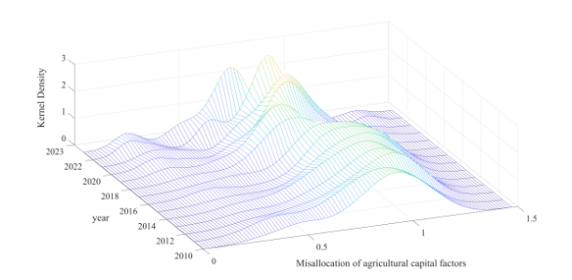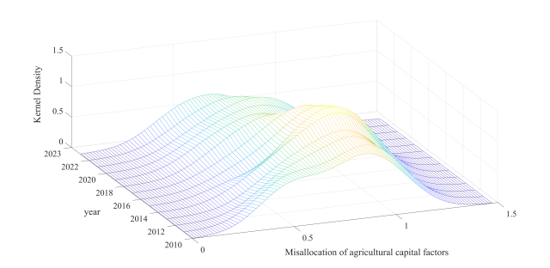
（a）National （b）Eastern region
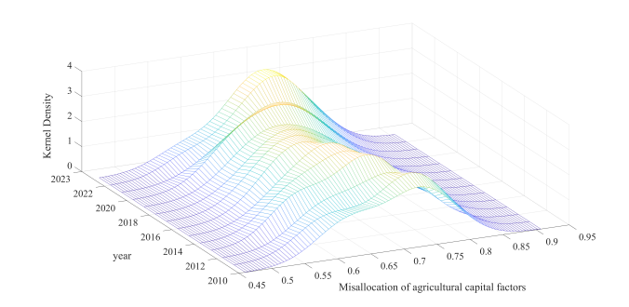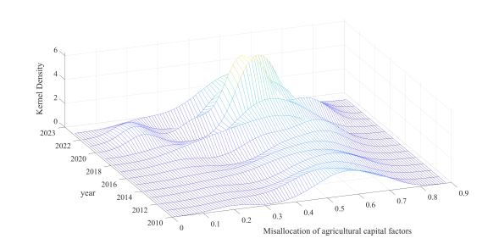
(c)Central region (d)Western region
Fig. 1. Spatio-temporal Evolution Trend of Agricultural Capital Misallocation
Source:Created by author

As shown in Figure 1(a), under the ongoing implementation of the Rural Revitalization Strategy and the deepening of supply-side structural reforms in agriculture, the efficiency of agricultural capital allocation has emerged as a critical factor constraining the progress of agricultural modernization. A dynamic kernel density estimation based on provincial panel data from 2010 to 2023 reveals three evolving contradictions in the misallocation of agricultural capital: First, the degree of misallocation shows a systemic worsening trend. Since 2012, the main peak of the kernel density has consistently shifted to the right—a sharp contrast to the “14th Five-Year Plan” goal of optimizing agricultural factor allocation—indicating that current policies have failed to curb the growing tendency toward capital misallocation. Second, the risk of misallocation is transforming into a systemic and widespread phenomenon. In 2023, the kernel density function exhibits a “high-peak, narrow-bandwidth” pattern: the main peak reaches its historical maximum, while the bandwidth narrows to its lowest level in the sample period. This indicates that agricultural capital misallocation has evolved from a localized and fragmented issue into a region-wide, high-intensity systemic risk that urgently requires top-level policy intervention. Third, structural divergence continues to intensify, with extreme misallocation risks becoming entrenched. All annual density functions exhibit significant rightward tails, and by 2023, these tails have extended further compared to earlier years. This suggests that deeply misallocated regions—such as large-scale agricultural zones in Northeast China and mountainous agricultural belts in the Southwest—are facing resource allocation bottlenecks, with potential risks spreading along the agricultural supply chain.

As shown in Figure 1(b), under the accelerating push for agricultural modernization in eastern China, capital misallocation in the region exhibits three distinct characteristics: "external sensitivity, suburban rigidity, and lagging coordination." During the early period of 2011–2016, the region displayed a bimodal distribution: the primary peak reflected moderate misallocation in facility agriculture zones around the Bohai Rim, while the secondary peak captured severe misallocation in suburban agricultural areas of the Yangtze River Delta, driven by soaring land costs. Notably, in 2014, the secondary peak surpassed the primary one for the first time, revealing a lag in policy response. From 2017 to 2022, the region entered a phase of systemic deterioration. The main peak first collapsed due to widespread environmental crackdowns, and then fluctuated sharply under external shocks. In 2020, the COVID-19 pandemic disrupted 38% of cold-chain logistics, forcing capital to accumulate at the production end, pushing the peak to a historical high. After 2023, a phase of structural correction began, highlighting persistent bottlenecks such as machinery idleness caused by land fragmentation in the Pearl River Delta and the crowding-out of on-farm investment by research and development capital in Hainan.

As shown in Figure 1(c), the misallocation of agricultural capital in central China follows a clear three-stage evolutionary pattern. During the single-peak concentration stage (2010–2016), the main peak of the kernel density function shifted steadily to the right, indicating a worsening degree of capital misallocation year by year. In 2014, the national “Sickle Bend” corn reduction policy led to a sharp surge in the peak density (reaching 0.72) in the Huang-Huai-Hai dry farming zone, due to delayed capital reallocation. Entering the bipolar differentiation stage, spatial heterogeneity became more pronounced: the main peak reflected moderate misallocation in the Jianghan Plain and Poyang Lake irrigation areas, while a newly emerged secondary peak indicated severe misallocation in the Wuling and Dabie mountain regions, driven by topographic constraints. This formed a distinct dual pattern of plains versus mountainous areas. Notably, the once-in-a-century drought in the Yangtze River Basin in 2022 exposed acute shortages in irrigation capital, causing the secondary peak to surpass the primary one for the first time. In the plateau diffusion stage, the shape of the density curve changed dramatically—its main peak dropped by 40% while its bandwidth significantly expanded, resulting in a low-peak, wide-base "plateau-like" distribution. This shift reflects the expansion of non-grain capital into grain production zones in peri-urban areas, with the Chang-Zhu-Tan urban agglomeration as a typical example. It signals a broadening of misallocation conflicts across diverse agricultural actors.

As shown in Figure 1(d), agricultural capital misallocation in western China follows an evolutionary trajectory characterized by "low-level stagnation, ecological divergence, and weak policy response." From 2010 to 2014, the kernel density remained persistently low, reflecting the chronic problem of insufficient capital investment in traditional agricultural areas. In 2018, a sudden bifurcation in the density distribution emerged. The primary peak represented mild misallocation in major grain-producing zones such as the Hetao Irrigation Area and the Chengdu Plain. Meanwhile, the secondary peak, concentrated in the high misallocation range of 0.7–0.8, indicated capital entrapment in ecologically constrained regions such as the Sanjiangyuan pasturelands and the terraced farming zones of Yunnan–Guizhou. During the COVID-19 pandemic in 2020, an anomalous improvement occurred: the main peak shifted leftward by 0.12 units to 0.38, benefiting from the “Western Livestock to Eastern Markets” supply stabilization policy, which improved capital utilization in ranching operations. However, in 2022, the secondary peak surpassed the primary in height, and the right tail further extended—signaling a worsening of capital misallocation in ecologically fragile zones such as the alpine pastoral areas of the Qinghai–Tibet Plateau and the karst mountain regions. Compared with other regions, the western region exhibits three pronounced weaknesses: the lowest peak values, the highest ecological sensitivity, and the fastest policy effect attenuation. This highlights the urgent need to establish a "dual-track governance" framework: implementing the "Oasis Agricultural Capital Efficiency Enhancement Plan" for major grain-producing zones, and launching the "Qinghai–Tibet Plateau Capital Reallocation Initiative" for ecologically fragile areas.

3.2 Spatiotemporal Evolution Characteristics of Agricultural Labor Factor Misallocation
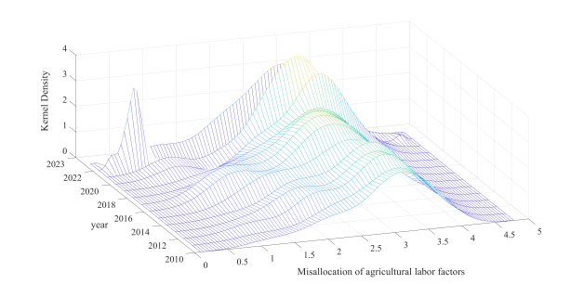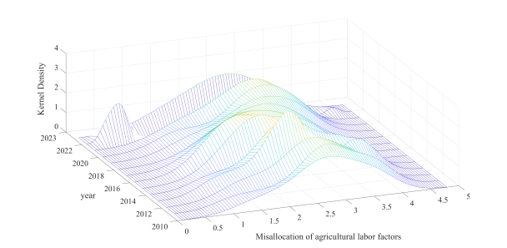
（a）National （b）Eastern region
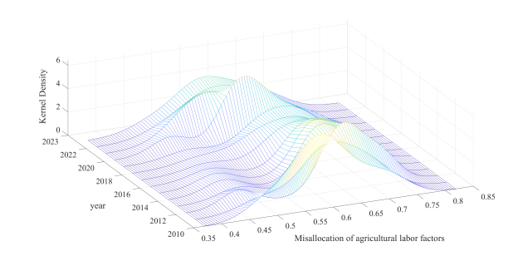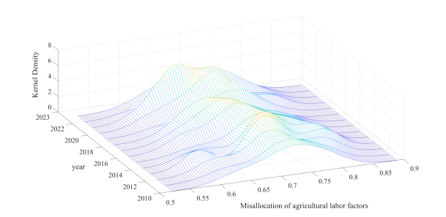
(c)Central region (d)Western region
Fig. 2. Spatio-temporal Evolution of Agricultural Labor Misallocation
Source:Created by author

As shown in Figure 2(a), the misallocation of agricultural labor across China follows an evolutionary trajectory characterized by "bimodal solidification, systemic deterioration, and the emergence of marginal risks." Between 2010 and 2014, a preliminary bimodal structure emerged. The 2014 household registration reform failed to dismantle the urban–rural dual structure, resulting in the continued coexistence of the two peaks. In 2018, the distance between the two peaks widened, highlighting the deepening urban–rural divide in labor allocation—indicating that the early phase of the Rural Revitalization Strategy failed to effectively stimulate local employment. The COVID-19 pandemic in 2020 led to an anomalous improvement, as returning rural migrants temporarily filled labor shortages during peak agricultural seasons. However, by 2022, the secondary peak overtook the primary in height, and its density surged to a historical high. This indicates that highly misallocated labor groups have become the dominant contradiction, exposing marginal regions—such as the Northeast black soil belt and the karst zones in Southwest China—to a dual trap of aging populations and low-skilled labor. A "dual-track urban–rural restructuring" mechanism is urgently needed: for the primary peak group, a “County Industrial Park Skill-Matching Program” should be implemented; for the secondary peak group, a “Local Empowerment Initiative for Silver-Age Labor” should be launched. In addition, a “Marginal Zone Anti-Relapse Capital Pool” should be established to mitigate the right-tail risks—responding directly to the urgent call in the 2023 No. 1 Central Document to “accelerate the bridging of rural human capital gaps.”

As shown in Figure 2(b), the misallocation of agricultural labor in eastern China follows a distinctive trajectory characterized by "growing pains from skill upgrading, mobility traps, and marginal group entrenchment." From 2014 to 2016, the main peak continuously shifted to the right, reflecting a passive misallocation in which low-skilled labor was pushed back into agriculture due to the displacement effects of smart manufacturing upgrades. The 2020 COVID-19 shock led to a bifurcated distribution, with the secondary peak surging to 4.5. This spike indicates deep misallocation among elderly suburban farmers who were unable to exit agricultural production due to stagnation in land transfer processes. By 2023, a paradox emerged, characterized by a leftward shift in the main peak to 2.0 and a simultaneous intensification of the right tail. This reflects a sharp contradiction between the outflow of skilled labor and the entrenchment of silver-aged laborers in the agricultural sector.

As shown in Figure 2(c), the misallocation of agricultural labor in central China follows a typical trajectory of “single-peak migration, bimodal segmentation, and plateau-like diffusion.” From 2010 to 2014, the main peak shifted continuously to the right, indicating an expansion of the "part-time farming, part-time working" population during rapid urbanization. In the Huang-Huai-Hai grain-producing region, the outflow of young and middle-aged labor intensified seasonal mismatches. In 2016, a distinct bimodal split emerged: the main peak (at 0.58) reflected moderate misallocation in the cash crop areas of the Jianghan Plain, while the secondary peak, concentrated in the high range of 0.75–0.80, revealed the “elderly agriculture trap” in the Wuling and Dabie mountain areas. By 2022, the distribution had evolved into a low-peak, wide-base “plateau” shape, signaling the spread of three major structural contradictions: labor shortages during peak seasons in major grain production zones; inefficient, aid-dependent employment in formerly impoverished counties; and labor retention issues due to insufficient industrial absorption capacity at the county level. A three-tier governance system is urgently needed: implement a “Smart Farming Service Platform” in the Huang-Huai-Hai region; launch a “Silver-Age Skills Renewal Program” in mountainous areas; and pilot a “Performance-Based Employment Subsidy” in formerly impoverished counties. These initiatives aim to resolve the compounding crisis of "seasonal underemployment and structural labor shortages" indicated by the plateau-like distribution in 2022.

As shown in Figure 2(d), agricultural labor misallocation in western China follows an evolutionary logic of “ecologically driven polarization, weak policy response, and entrenchment of marginal risks.” From 2014 to 2016, the main peak remained in the 0.65–0.70 range, indicating a persistent, routine misallocation under the traditional “semi-farming, semi-herding” model. In 2018, a sudden bimodal rupture emerged: the primary peak (0.60) reflected seasonal labor shortages in grain bases such as the Hetao Irrigation District and the Guanzhong Plain, while the secondary peak surged to 0.85, pointing to a dual dilemma of “lost herding + lost jobs” in areas like the Sanjiangyuan grazing ban zone and the Yunnan–Guizhou cropland-to-forest zone—producing the country’s sharpest ecology–livelihood conflict. By 2022 the bimodal pattern morphed into a “plateau with collapses,” exposing three diffuse risks: (i) language-skill barriers in ethnic minority areas, (ii) post-relocation support gaps, and (iii) shocks from seasonal migrant-labor surges. A “three-dimensional breakthrough” mechanism is urgently required: (1) launch a “Pastoral-to-Tourism Skill Revitalization Program” in ecological reserves; (2) deploy a “Bilingual Smart Agro-Service Platform” in ethnic regions; and (3) introduce “Seasonal Staggered-Employment Vouchers” to resolve core mismatches—directly addressing the bottom-line mandate in the National Rural Revitalization Administration’s 2023 “Ten Measures for Human-Capital Enhancement in Western China” to prevent large-scale relapse into poverty.

3.3 Spatiotemporal Evolution Analysis of Agricultural Land Factor Misallocation
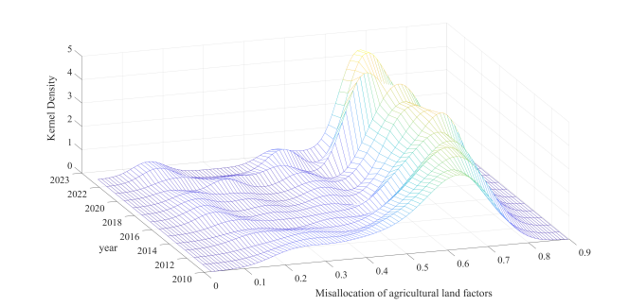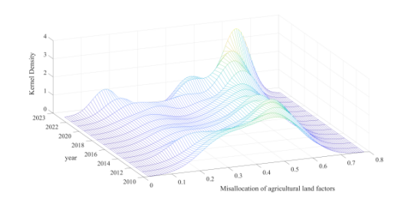
（a）National （b）Eastern region
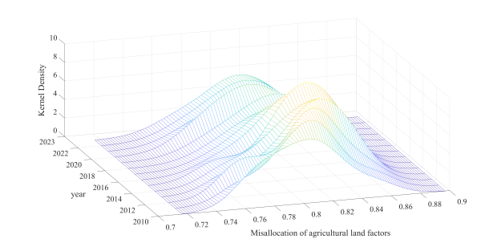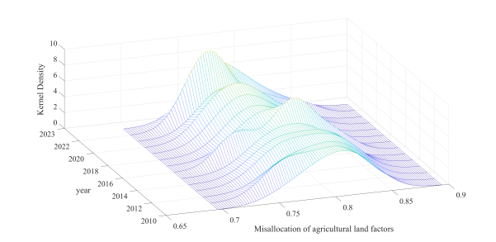
(c)Central region (d)Western region
Figure 3. Spatio-temporal Evolution Trend of Agricultural Land Misallocation
Source:Created by author

As shown in Figure 3(a), the misallocation of agricultural land in China has evolved through three distinct phases: “policy-driven improvement, structural rebound, and explicit regional polarization.” From 2016 to 2020, the main peak shifted steadily leftward, indicating that the “three rights separation” reform in rural land (reinforced by the 2018 revision of the Rural Land Contract Law) and the construction of high-standard farmland effectively alleviated allocation tensions. Between 2021 and 2023, a “V-shaped rebound” occurred: the main peak first shifted rightward to 0.45 due to intensified post-pandemic food security concerns, and later evolved into a bimodal distribution in 2023 as a result of growing heterogeneity among farm operators. By 2029, a paradoxical pattern of “main-peak steepening and right-tail rupture” emerges: the main peak surges to a historical high of 0.65, yet the right tail stretches as far as 0.85. This reflects three deep-rooted structural contradictions: over-concentration of large-scale farming in the Northeast black soil region; severe land fragmentation in Southwest mountainous areas; and hidden non-grain transitions in peri-urban zones. A three-tiered targeted governance system is urgently needed: (1) enforce a “black soil farming scale ceiling” in staple grain-producing zones (with pilot limits in the Songnen Plain); (2) promote “parcel integration securitization” in mountainous regions; and (3) establish “penetrative supervision” mechanisms for farmland use in peri-urban areas to monitor hidden non-grain conversions.

As shown in Figure 3(b), agricultural land misallocation in eastern China follows an evolutionary trajectory characterized by “peri-urban maladies dominance, policy shocks, and deepening capital differentiation.” A bimodal distribution initially emerged in 2016; In 2018, under the impact of the crackdown on illegal “greenhouse housing,” the primary peak sharply dropped to 1.8, while the secondary peak surged counterintuitively to 2.5, exposing a structural contradiction between “policy collateral damage on compliant actors” and “regulatory evasion by illicit capital.” By 2022, the distribution evolved into a unimodal pattern with a torn right tail—the main peak shifted rightward to 0.6, and density rebounded to 3.0, benefiting from improved allocation efficiency due to the integration of farmland transfer platforms. However, the right tail extended to the 1.2 range, directly indicating the “distortion of the three-rights separation” in the Pearl River Delta metropolitan area. By 2023, a reemergence of bimodal polarization was observed, marking three major forms of capital erosion: industrial and commercial capital locking land into non-grain uses; speculative arbitrage from collective-operational construction land entering the market; and covert encroachment on ecological land.

As shown in Figure 3(c), the misallocation of agricultural land in central China follows an evolutionary trajectory characterized by “plain–mountain dual fragmentation, policy efficacy decay, and structural capital erosion.” Between 2016 and 2018, an initial bimodal pattern emerged alongside severe misallocation caused by labor outflow. Under the 2020 pandemic-driven food security pressures, the main peak temporarily shifted leftward to 0.74, reflecting eased approvals for temporary farmland use that mitigated conflicts in the plains. However, the secondary peak moved counterintuitively rightward to 0.88, exposing structural shortcomings in mountainous areas where policy benefits failed to penetrate. By 2023, a sharp contrast emerged between a steepening main peak and a persistent secondary peak: the main peak density declined to 8.5 and shifted leftward to 0.72, while the secondary peak stubbornly remained high at 0.85, highlighting three deep-rooted contradictions: the distortion of “counter-leasing and re-contracting” in the plains; suspended historical land rights confirmation in mountainous areas; and the covert intensification of non-grain land use in peri-urban zones.

As shown in Figure 3(d), land factor misallocation in western China follows an evolutionary trajectory characterized by “ecologically constrained polarization, diminishing policy marginal returns, and systemic risk diffusion.” Between 2016 and 2018, a bimodal rupture pattern emerged alongside severe misallocation due to land parcel fragmentation. In 2020, pandemic-driven food security policies caused the main peak to temporarily shift leftward to 0.60; however, the secondary peak moved counterintuitively rightward to 0.88, exposing a structural shortcoming where policy benefits fail to penetrate ecologically sensitive zones. By 2023, the distribution evolved into a “plateau collapse” pattern, signaling the spread of three major risks: unresolved land ownership issues in ethnic minority regions and gaps in post-relocation support.

4 Conclusions and Implications

4.1 Conclusions

By constructing a measurement model of agricultural resource misallocation and using data from the National Bureau of Statistics for 30 Chinese provinces from 2010 to 2023, this study estimates the degree of interprovincial agricultural resource misallocation. Employing kernel density estimation, it analyzes the spatiotemporal evolution of misallocation in agricultural labor and land resources across provinces, yielding the following key findings:

Against the backdrop of the Rural Revitalization Strategy and supply-side structural reform in agriculture, this study measures the degree and spatiotemporal dynamics of agricultural resource misallocation in China. The results indicate a systematically intensifying trend of capital misallocation. Labor misallocation follows an evolutionary trajectory of “bimodal stabilization-ecological deterioration-marginal risk emergence,” while land misallocation exhibits a three-phase pattern of “policy-driven improvement-structural rebound-regional polarization.” The findings suggest that effectively addressing agricultural resource misallocation and improving the efficiency of capital allocation are crucial to advancing agricultural modernization. This requires developing tailored governance mechanisms and strategies based on the specific conditions of different regions and production factors. Current policies have not effectively curbed capital misallocation. To address this, it is essential to embrace the principle that “lucid waters and lush mountains are invaluable assets,” and implement a “Capital Efficiency Enhancement Program” for agriculture, a “Silver-Age Skills Renewal Initiative,” and pilot “Performance-Based Employment Subsidies.” These measures aim to mitigate the compound crisis of “seasonal underemployment and structural labor shortages.”

4.2 Implications

- Agricultural Capital Misallocation

Based on empirical findings of agricultural capital misallocation across eastern, central, and western China-characterized by “external sensitivity and suburban rigidity” in the east, “three-phase evolution” in the central region, and “ecological differentiation” in the west—this paper proposes region-specific policy recommendations aligned with regional disparities and evolutionary patterns. In the eastern region, policies should address the issue of idle agricultural machinery caused by land fragmentation in the Yangtze River Delta and Pearl River Delta by promoting a “plot consolidation + machinery sharing” model. Fiscal subsidies should be employed to channel capital toward intensive production sectors. Additionally, to improve the timeliness of policy responses, an agricultural capital emergency adjustment mechanism should be established to mitigate external shocks-such as the 2020 pandemic-induced cold chain disruptions that caused capital entrapment. Special-purpose loans should be used to address logistical shortfalls and better balance capital allocation between production and distribution. These measures can effectively resolve the dilemma of “external sensitivity and suburban rigidity” in eastern China. In central China, a “Cultivated Land Protection Compensation Fund” should be implemented in peri-urban areas such as the Chang-Zhu-Tan urban cluster to curb the encroachment of industrial and commercial capital on grain production. This would help reorient capital toward staple grain production and prevent the erosion of agricultural capital by non-grain sectors. To address capital adjustment lags resulting from the “Grain-for-Green” (Liandao Bay) policy—especially in dryland farming regions like the Huang-Huai-Hai Plain-a capital compensation mechanism should be introduced during policy transition periods, supported by targeted interest-subsidized loans to facilitate cropping structure transformation. These dual approaches would jointly alleviate the conflict between policy delays and structural divergence. The western region should implement a “Dual-Track Capital Support Plan.” In key grain-producing areas such as the Hetao Irrigation District, an “Oasis Agriculture Capital Enhancement Program” should be introduced to scale up efficient capital investments—such as water-saving irrigation-through low-interest loans. For ecologically fragile areas such as Sanjiangyuan and the Yunnan-Guizhou terraced regions, a “Special Fund for Ecological Compensation and Capital Reallocation” should be established to address capital misallocation arising from grazing bans and the resulting unemployment. Given the rapid decline in policy effectiveness in western regions, a “capital input–ecological output” linkage mechanism should be developed. Incorporating ecological outcomes into agricultural credit assessments would deter short-term speculative capital behavior and enhance policy sustainability. These measures aim to strike a balance between ecological constraints and capital scarcity to the greatest extent possible.

- Agricultural Land Misallocation

Given the spatiotemporal evolution of agricultural land misallocation across eastern, central, and western China-characterized by a three-phase progression of “policy-driven improvement-structural rebound-regional polarization” and intensifying regional heterogeneity-a policy framework based on “targeted governance, region-specific strategies, and dynamic adjustment” is urgently needed. In eastern China, land-use controls in peri-urban areas should be optimized. A combination of “cultivated land protection redlines” and a “negative list for non-grain conversion” should be delineated in the peri-urban zones of the Yangtze River Delta and Pearl River Delta, clearly stipulating that industrial and commercial capital entering rural areas must not alter the agricultural use of land. At the same time, a tolerance mechanism for policy implementation should be established alongside a “Policy Shock Compensation Fund.” Family farms and cooperatives facing short-term operational disruptions due to land rectification measures should be provided with low-interest loans, helping balance regulatory stringency with operational stability. These measures aim to address the issue of “peri-urban land dysfunction” and to regulate capital participation in land markets. To bridge the “plain–mountain dual divide” in central China, innovations in mountain land tenure confirmation and transfer mechanisms are needed. In regions such as the Wuling and Dabie Mountains, a combined approach of “historical rights tracing + digital confirmation” should be implemented by reconciling village-level records with satellite imagery to clarify ownership of fragmented plots. A “priority order for mountain land transfers” should be introduced to give precedence to collective farming by local households while restricting large-scale acquisitions by external capital. Policy enforcement in the plains should be strengthened. To address issues such as rent interception by village committees under the “reverse tenancy” model in the Huang-Huai-Hai Plain, blockchain-based oversight should be introduced to ensure that land transfer proceeds are directly distributed to farmers. Rental payments should be linked to grain production performance. In western China, land misallocation is strongly constrained by ecological factors, making it imperative to strike a balance between ecological protection and agricultural production needs. In regions such as Sanjiangyuan and the Yunnan-Guizhou reforested zones, an “Ecological Compensation for Operating Rights Swap” policy should be implemented. Farmers who voluntarily relinquish their operating rights to certain cultivated lands would receive ecological compensation, and the vacated land would be converted to ecological use under unified collective management. This would establish a coordinated mechanism between ecological compensation and land-use transformation. To resolve tenure disputes and relocation-related issues, bilingual land rights mediation committees should be established in ethnic minority areas such as Tibet and Yi regions. A combination of customary and statutory law should be used to clarify land ownership. For relocated communities, a coordinated plan integrating “land reclamation + industrial transition” should be adopted. The operating rights of reclaimed land should be transferred to agricultural enterprises, and the resulting income should be redistributed to benefit the relocated households.

- Agricultural Labor Misallocation

In light of the observed spatiotemporal evolution of agricultural labor misallocation—characterized by “skill upgrading pains” in the east, “seasonal shortages and structural differentiation” in the central region, and “ecological constraint-driven polarization” in the west—a governance framework based on “regional adaptation, demographic segmentation, and dynamic response” is urgently needed. In eastern China, a “skill–industry alignment” mechanism should be established. In manufacturing-intensive regions such as the Yangtze River Delta and Pearl River Delta, the government should subsidize enterprises to provide “agriculture–industry skill conversion training” for low-skilled workers, focusing on agricultural machinery operation and digital agriculture. This would facilitate their transition from industrial jobs to high-efficiency agriculture, reducing misallocation caused by passive labor reflows. To address the issue of elderly peri-urban farmers being reluctant to transfer land, a pilot model that combines “land transfer insurance + pension security” should be introduced. Farmers who transfer land would receive additional pension subsidies, while village collectives would coordinate large-scale farming operations. This approach helps reconcile the 2023 contradiction between the accumulation of elderly labor and the oversupply of skilled labor. In central China, the timely promotion of a “smart agricultural service platform” is necessary. In staple grain-producing areas like the Huang-Huai-Hai Plain, a digital platform combining “agricultural machinery sharing + labor dispatch” should be established. This platform would integrate fragmented farmer demand and use algorithms to match cross-regional machinery operators with peak-season jobs, alleviating seasonal mismatches. For areas like the Wuling and Dabie Mountains—trapped in an “aging agriculture dilemma”—a “Silver-Age Empowerment Program for Mountain Areas” should be implemented. This includes the establishment of mutual-aid cooperatives for elderly farmers, offering light agricultural machinery rentals and health services. A “time bank” system should also be introduced to encourage young returnees to support elderly farmers in exchange for future pension credits. In western China, an “ecological compensation–employment linkage mechanism” should be developed. In ecological protection zones such as Sanjiangyuan and Yunnan–Guizhou, a dual-role system of “forest ranger–agricultural technician” should be promoted. Herders would be trained to transition into ecological agriculture, simultaneously protecting the environment and ensuring livelihoods, thereby reducing labor redundancy caused by grazing bans. Furthermore, a “bilingual labor service network” should be established in ethnic minority regions such as Tibet and Yi areas. This includes forming a team of bilingual labor agents to disseminate agricultural technologies and job information in local languages. In relocated communities, “community factories + contract farming” should be developed in tandem to address employment stagnation following resettlement.

DISCLAIMER (ARTIFICIAL INTELLIGENCE)
The author declare that only generative Al tools (e.g., GPT)were used for translation purposes. No generative Al technologies were employed in the writing or editing of the other content in this manuscript.

COMPETING INTERESTS
Authors have declared that no competing interests exist.

COMPETING INTERESTS DISCLAIMER:
Authors have declared that they have no known competing financial interests OR non-financial interests OR personal relationships that could have appeared to influence the work reported in this paper.

REFERENCES

- Chen, Y., & Hu, W. (2011). Distortions, Misallocation and Losses: Theory and Application. China Economic Quarterly, 10(04), 1401-1422. DOI:10.13821/j.cnki.ceq.2011.04.010.
- Ji, W. W., & Lai, D. S. (2018). Human capital allocation and China’s innovation performance. Economic Perspectives, 11, 19-31.
- Li G C, Fan L X, & Feng Z. (2014). Capital Accumulation, Institutional Change,and Agricultural Growth: An Empirical Estimation of China's Agricultural Growth and Capital Stock from 1978 to 2011.Journal of Management World, (05), 67-79+92. DOI:10.19744/j.cnki.11-1235/f.2014.05.006.
- Lei, S. H., Tian X., & Wang, C. J. (2023). Spatial Effect Decomposition of Agricultural Resources Misallocation on Agricultural Green Production Efficiency. Areal Research and Development, 42 (02): 124-129+149.
- Lei, S. H., Qin, J. H., & Wang, C. J. (2022). Analysis on the Estimation, Space-Time Evolution Characteris-Tics and Factors of Chinese Agricultural Misallocation. Chinese Journal of Agricultural Resources and Regional Planning, 43(8), 83-94.
- Lin, G., & Chen, T. G. (2020). The Impact of Outward FDI on the Improvement of Resource Allocation Efficiency: Analysis Based on Agricultural Pro-cessing Industry. World Economy Studies, (07), 46-59+136. DOI: 10.13516/j.cnki.wes.2020.07.004.
- Liu, J. Z., Fang, Y. G., & Wang, R. R. (2020). Spatio-temporal evolution characteristics and driving mechanisms of agricultural multifunctions in Shandong province. Journal of Natural Resources, 35(12), 2901-2915.
- Li, S., Zhang, D., Xie, Y., & Yang, C. (2022). Analysis on the spatio-temporal evolution and influencing factors of China’s grain production. Environmental science and pollution research, 29(16), 23834-23846.
- Liu, G., & Yang, M. (2024). Characteristics of Spatial–Temporal Evolution of Sustainable Intensification of Cultivated Land Use and Analysis of Influencing Factors in China, 2001–2020. Sustainability, 16(23), 10679.
- Liu, S. Y., Xiong, X. F., Zhang, Y. H., & Guo, G. C. (2022). Land System and China’s Development Mode. China Industrial Economics, (1), 34-53. DOI: 10.3969/j.issn.1006-480X.2022.01.003.
- Sun, Y., & Xu, S. (2024). Measurement of Resource Mismatch Degree and Analysis of Its Change - Taking Liaoning Province as an Example. Productivity Research, (07), 54 - 59. DOI:10.19374/j.cnki.14-1145/f.2024.07.012.
- Wang, Y., & Huang, Y. (2022). Impact of Agricultural Resource Misallocation on Agricultural Eco-Efficiency: Evidence from 13 Major Grain Producing Areas in China. Ecological Economy, 38 (05): 129-137.
- Wu, L. (2017). Research on supply - side reform and agricultural resource allocation in China. Agricultural Economy, (08), 79-81.
- Xie, Y. Q. (2025). Resource Misallocation and Enhancement of Agricultural Green Total Factor Productivity. Journal of Shanxi University of Finance and Economics, 47(S1), 115-117.
- Yang, C. X., & Liu, W. B. (2023). Analysis of Agricultural Scienceand Technology Resource Mismatch Measurement and Space-time Evolution. Science Technology and Industry, 23(06), 7-15.
- Yang, Q., & Zhu, H. H. (2024). Analysis on Spatial Differences and Driving Factors of China’s Agricultural Resource Allocation Efficiency. Statistics & Decision, 40(05), 62-66. DOI: 10.13546/j.cnki.tjyjc.2024.05.011.
- Yuan, J., Huili, Y., Zhao, Z., Xu, J., Khan, N., Jiliang, M., & Huijie, Z. (2024). Assessing efficiency in sustainable allocation of agricultural scientific and technological talent: a spatial-temporal analysis in China. Frontiers in Sustainable Food Systems, 8, 1384734.
- Zheng, H. Y., & Li, G. C. (2020). The Impact of Urban-rural Biased Policy on Agricultural Resource Allocation Efficiency. Journal of Agrotechnical Economics, (07), 79-92. DOI: 10.13246/j.cnki.jae.2020.07.005.
- Zhu, X., Shi, Q. H., & Gai, Q. E. (2011). Misallocation and TFP in rural China. Economic Research Journal, 46(5), 86-98.
- Zhou, M., Sun, H., & Ke, N. (2022). The spatial and temporal evolution of coordination degree concerning china’s cultivated land green utilization efficiency and high-quality agricultural development. Land, 12(1), 127.

