Effect of Deep Tillage on Wheat Yield and Cost Economics under Rice-Wheat Cropping System in Haryana, India
ABSTRACT
Although the rice-wheat cropping system is one of the most widely utilized agricultural techniques in South Asia, it has difficulties because of soil compaction brought on by ongoing conventional plowing. Evaluation of the effects of conventional, rotary, conservation, and deep tillage techniques on wheat yield and financial feasibility was the goal of this study. Four tillage treatment i.e. conventional tillage, rotary tillage, conservation tillage, and deep tillage involving subsoiling were applied to the wheat variety during the 2022–2023 rabi season. Grain number, earhead length, plant height, number of tillers, and 1000-grain weight were all measured, as were machine performance metrics like fuel consumption and field efficiency. The benefit-cost (B:C) ratio, net returns, gross returns, and cultivation costs were among the economic factors that were examined. In comparison to other tillage techniques, the results showed that deep tillage greatly increased grain yield (59.18 q ha⁻¹) and straw yield (73.98 q ha⁻¹). However, the expense of cultivation also increased. The highest B:C ratio (2.47) was attained with conservation tillage because of lower input costs, albeit having a somewhat lower yield. Deep and conservation tillage both produced net returns that were higher than those of conventional and rotary techniques. In conclusion, by reducing soil compaction and promoting root development, deep tillage can significantly increase wheat productivity. Better economic efficiency is provided by conservation tillage in the interim. For rice-wheat systems, the results suggest a need-based selection of tillage strategies that balance cost-effectiveness and yield improvement for sustainable crop production.

Keywords: B:C ratio, crop yield, deep tillage, gross returns, net returns, tillage practices
- INTRODUCTION
Rice and wheat (Triticum aestivum L.) grown sequentially in an annual rotation constitute most widely utilized agricultural method in India. The rice-wheat cropping system is one of the world’s largest agricultural production systems, occupying 26 Mha of farmed area in the Indo-Gangetic Plains and in China. The Indo-Gangetic Plains are home to roughly 13 Mha of the rice-wheat system, of which roughly 10 Mha are in the Indian portion of IGP. The primary cereal crop in Chhattisgarh is rice, which grows on an area of 4.33 Mha and yields 9.24 MT and 21.3 q/ha. With a 0.259 MT and 8.22 q/ha production and productivity, wheat occupies 315 Mha of land. Maintaining the health of the soil in the rice-wheat cropping system greatly depends on nutrient management (Sahu et al. 2023).

The rice-wheat cropping system is pre-dominant in South Asia. Cropping practices have a huge impact on the physical and chemical characteristics of the soil, which in turn affects crop output (Ranamukhaarachchi and Begum 2005). High levels of nutrient extraction from soils are encouraged by intensive cropping without natural replenishing. Millions of people worldwide rely on the rice (Oryza sativa L.) wheat (Triticum aestivum L.) cropping system (RWCS) for basic foods, making it essential to global food security. Most of the world's technologically advanced countries use this cropping system extensively. In Asia, the Indo-Gangetic Plain, which spans approximately 13.5 million hectares (mha), is home to more than 85% of the RWCS used in South Asia. Over 85% of the RWCS used in South Asia is spread throughout the Indo-Gangetic Plains, covering nearly 13.5 million hectares (mha) area (Banjara et al., 2021 and Verma et al., 2025). About 76% of IGP is covered by India alone, which is divided among the states of West Bengal, Punjab, Haryana, Uttar Pradesh, and Bihar. Rice and wheat, the nation's prim India's cereal production has seen extraordinary growth, rising from 87.4 million tons (mt) in 1961 to 324.3 mt in 2019. In India, wheat has an area of 29.3 mha, a production of 103.6 mt, and a productivity of 3,533 kg ha-1, while rice occupies an area of approximately 43.8 mha, with a total production of 177.6 mt and a productivity of 4,057 kg ha-1. The nation has produced excess food grains in recent years thanks to improved mechanization and an integrated crop management strategy. Rice is consumed by over 70% of Indians, with the remaining population consuming it in combination with wheat or other grains. The cereal crops, were essential in reducing the discrepancy between the demand and supply of food grains (Verma et al. 2025).
Crop productivity may be restored through the use of green manure, particularly legumes in a cropping plan. Moreover, by regenerating the organic matter and fertility of these soils, the use of legumes in crop rotations safeguards the delicate soil surface. This would also aid in restoring the soils' original fertility (Ahmad et al., 2009). Due to extended use of the cereal-cereal cropping system, a decrease in the productivity of the Rice Wheat Cropping System (RWCS) land has been noted in recent years. Groundwater depletion, soil organic carbon status, diminishing soil fertility, and decreased factor productivity are all concerning. These data imply that RWCS has harmed the natural resource base's sustainability. The goal of implementing Resource Conservation Technologies (RCTs) in RCWS must be to reverse the trend of natural resource degradation in order to achieve higher productivity that is sustainable (Tiwari et al. 2022).
The poor soil properties also reduce their tolerance to abiotic stress, especially resistance against natural disasters (Wang et al., 2008, Wei et al., 2015). “Global soil degradation is being caused by soil compaction, which is becoming a severe issue reducing field agricultural yield. About 68 million hectares of land worldwide are affected by soil degradation brought on by compaction” (Flowers and Lal, 1998). The amount of pore space decreases and the soil density increases (Harris 1971), when soil is compressed by outside pressures. It is a densification and reduction of porosity, accompanied by modifications to the soil's structure, an increase in strength, and a decrease in hydraulic conductivity. When the soil is tilled while being highly damp, the soil particles are compressed and sheared. The bulk density of surface and subsurface soil is one soil physical characteristic that is consistently changed as a result of compaction. Tillage lowers production costs and decreases the occurrence of soil degradation in agricultural practices. In addition to water and soil temperature, slope and soil form, hydro-physical characteristics, soil texture, and compaction, irrigation water penetration in soil and the expansion of water storage in soil profile are dependent on the amount of water (Habaga, et al. 2022).
In some studies it was observed that, “after many years of no-tillage, the soils become compact with high bulk density which can adversely affect root growth. As a result, water and nutrient uptake by plant and crop yield also reduced” (Zou 2002, Boguzaset al., 2010, Cai et al., 2014, Shukla et al., 2021). Hill (1990) tested “soil strength, which is the important index of soil compaction, under long-term no-till system and found two to five times higher penetration resistances within the 0.16 m depth under continuous no-till cultivation compared to conventional plow tillage”. When it comes to grain loss, one of the most important agricultural procedures in the field is harvesting wheat harvests. Time, money, effort, and energy are all saved by using the right harvesting conditions and techniques. Wheat straw losses increased as a result of Egypt's widespread usage of combine harvesters for full wheat harvesting and threshing. To reduce the amount of wheat straw lost during the harvesting process, farmers use partial mechanization. Grain loss during harvesting can be decreased to as little as 2.35 percent by using a self-propelled reaper or mower. Additionally, using the binder device reduces bundling losses to 0.86% (Khater et al. 2023).
Deep tillage is the most effective ways to break up a plow pan in farming management(He et al., 2006, Qin et al., 2008b, Wang and Chen 2007, Bogunovic et al., 2018). Subsequently, sub soiling can minimize the effect of drought and lead to an increase in crop yield adjusting the proportion of solid, liquid, and gas of soil, improving the structure and characteristics of top soil (Gao & Li, 1995, Mohanty et al., 2007, Dhaliwal et al., 2022). Deep tillage also considerably improves crop yield (Evans et al., 1996, Abu-Hamdeh 2003, Wang et al., 2008, Sidhu and Duiker, 2006).). Wang et al., 2004 found that “in comparison with traditional tillage, subsoiling technique caused an increase in winter wheat yield by 703.6 kg ha⁻¹ (18.8%) and water use efficiency was also increased by 16.8%”. He et al., 2006 studied “the suitability of annual subsoiling and suggested that it was not necessary to conduct subsoiling every year in no-tillage fields”. Akinci et al., 2004 established that “subsoiling treatments created statistically significant effects on the soil resistance compared with control plots where subsoiling was not applied”. Gao and Li, 1995 also indicated that “subsoiling reduced soil bulk density by 0.1 Mg m⁻³ and increased water content by 11.2 per cent to a depth of 0–50 cm compared with traditional tillage”. In conservation tillage for row crop planting, subsoiler tines are frequently used during semi-deep operations down to a depth of 50 cm. Agricultural tractors will find it difficult to pull these tools, particularly multi-tine ones, which require drawbar work and a high power range. Energy waste from interactions between dirt and tractor wheels is the most significant aspect in drawbar work, ranging from 20% to 55% (Askari et al. 2021).
Most of the studies were targeted on the variations of plant roots and yield, lacking quantitative estimations on soil water conservation. In India, till today limited research has been conducted and there is a urgent need to study the impacts of different tillage machineries water use efficiency, root morphology and grain yield of wheat. The aim of this study will be to characterize the effects of subsoil tillage on wheat and thereby provide useful guidance for soil management coupled with appropriate machinery operations for sustainable crop production in the Northern region of India.

- MATERIALS AND METHODS
The experimental study was planned and conducted during rabi (winter season) of the year 2022-23. The materials and methods used for the study have been presented under the following subheadings:
  - General description of the experimental site
  - Crop parameters
  - Machine performance parameters
  - Economic parameters
2.1 General description of the experimental site
2.1.1 Climate and rainfall
The region has a semi arid climate, with hot and dry spell in April to June to wet summer spell in July to September and a cool and dry winter spell in October to March. The total rainfall received during the experimental period was 18.7 mm. The daily rainfall, PAN evaporation, maximum and minimum temperature, relative humidity and wind speed during crop season (November 22, 2022 to April 10, 2023) are plotted in Fig.1.
Fig.1: Mean weekly values of weather parameters during rabi 2022-23
2.1.2 Description of soil
The representative soil samples were collected from five randomly selected places of the experimental field. Samples were collected from 15 cm plough depth. Texture analysis of the soil was carried out with the International pipette method (Piper, 1950) using sodium hex meta phosphate as dispersing agent. The texture classes were determined using the triangular textural diagram of USDA. The soil testing was done in the soil testing laboratory of College of Agriculture, CCS HAU, Hisar. The soil texture at the experimental site was classified as sandy loam (sand 67.6%, silt 11.1%, clay 21.3%) in texture, non-saline (EC 0.56 dS m⁻¹), alkaline in reaction (pH 8.0), low in available N (170.2 kg ha⁻¹), medium in available P (14.6 kg ha⁻¹) and high in available K (311.8 kg ha⁻¹).

Table 1. Details of tillage practices
Treatment | Description | Plot size (m²)
T1 | Straw chopper (1) + Harrowing (2) + Cultivator (1) + Planker (1) + Seed drill | 1007.5
T2 | Straw chopper (1) + Rotavator (2) + Seed drill | 1007.5
T3 | Straw chopper (1) + Zero till drill | 1007.5
T4 | Straw chopper (1) + Sub soiler (2) + Rotavator (1) + Seed drill | 1007.5
2.2 Crop parameters
The wheat variety (WH-1124) was used for the experiment. The agronomical practices as mentioned in package of practice of rabi crops of CCS HAU, Hisar was followed throughout the crop season.
2.2.1 Number of tillers per m² (no.)
The number of tillers per m² area at three locations in each treatment were counted after 15, 30, 45 days after sowing (DAS) and at harvest.
2.2.2 Plant height (cm)
The height of plant was measured from three locations in each replication. Height of plant was recorded with the help of a meter rod after 15, 30, 75 days after sowing (DAS) and at harvest of the crop.
2.2.3 Earhead length (cm)
The ear head length in cm was measured randomly at three locations in each treatment at the time of harvesting of crop.
2.2.4 Number of grains per earhead (no.)
The ear heads selected for length measurement were considered for counting number of grains per ear head.
2.2.5 1000-grain weight (gm)
Weight of 1000-grain was recorded at 12 per cent moisture content after harvesting in gm.
2.2.6 Grain yield (q ha⁻¹)
The crop was harvested manual in 1x1 m² area from 3 locations in each treatment and harvested manually and grain yield was recorded in q ha⁻¹.
2.2.7 Straw yield (q ha⁻¹)
The straw yield in q ha⁻¹ was recorded by taking samples of 1x1 m² area from 3 locations in each treatment.

2.3 Machine performance parameters
During the field experiment tractor along with straw chopper, harrow, cultivator, rotavator, planker, sub soiler, seed drill and zero till drill were used among different treatments. The various parameters related to performance of these machines were noted as given below.
2.3.1 Width of machine (m)
The width of a machine was measured in meter by using measuring tape.
2.3.2 Speed of operation (km h⁻¹)
A distance of 20 m was measured and marked by two poles and stop watch was used to note the time taken for traveling the marked distance. The forward speed of different machines was calculated in km h⁻¹ by using the formula:
S = $\frac{D }{T}×3.6$ | … (1)
Where,
S = Speed of operation, km h^{–1}
D = Distance, 20 m
T = Time needed to cover 20 m distance, s
3.6 = Constant
2.3.3 Field capacity (ha h^{–1})
It is the ratio of the actual area covered by the machine to the total time taken to cover that area. For measuring the field capacity, the time taken for each plot was noted using a stop watch, and the field capacity was calculated by using formula:
Field capacity (ha h^{–1}) = $\frac{Area covered in square metre ×3600}{Time taken in seconds×10000}$ | … (2)
2.3.4 Field efficiency (%)
It is the ratio of actual field capacity to theoretical field capacity usually expressed in percentage. Formula used for calculation of field efficiency was:
Field efficiency (%) = $\frac{Actual field capacity }{Theoretical field capacity}×100$ | … (3)
2.3.5 Fuel consumption (l h⁻¹)
A volume flow meter (Aqua Metro VZO 4, Swiss made) having least count of 1.0 ml was installed between the diesel tank and fuel filters of tractor to measure the fuel consumption of the tractor. By pass fuel from the filters and injectors was returned down from stream of flow meter instead of returning to the fuel tank. Thus all the fuel passing through the flow meter was consumed by the tractor engine. Fuel meter gives volume of fuel passed through the meter for a particular time which was recorded with the help of a stop watch.

2.4 Economic parameters
2.4.1 Cost of operation (Rs.)
The total cost of operation of machines was determined as the sum of the fixed and variable cost. The fixed costs include depreciation, interest on investment, insurance, tax and shelter; whereas the variable cost includes fuel, oil, repair and maintenance and required labour for operation of different machines. The cost of operation was calculated in Rs h⁻¹ and converted into area basis by dividing it with field capacity of the machines and expressed in Rs ha⁻¹. The details of cost of operation of different machines used in the study were given in Annexure I-III. The cost of seed, fertilizer, weed control, irrigation, harvesting and threshing were kept constant in all the treatments.
2.4.2 Gross return (Rs ha⁻¹)
Gross return was calculated by multiplying the grain yield (q ha⁻¹) by wheat price (Rs 2125 q⁻¹ & straw yield (q ha⁻¹) by straw price (Rs 650 q⁻¹) and adding both in terms of Rs ha⁻¹.
2.4.3 Net returns (Rs ha⁻¹)
Net returns (Rs ha⁻¹) were worked out by subtracting the total cost of cultivation of each tillage treatment from the gross income of the respective treatment.

2.4.4 Benefit: Cost ratio
It is the ratio of gross return to cost of cultivation. The B:C ratio must be more than unity for a project investment to be considered worthwhile. The B:C ratio was calculated as:
Benefit: cost ratio =$\frac{ Gross return, Rs {ha}^{-1}}{ Cost of cultivation, Rs{ ha}^{-1}}$ | … (4)

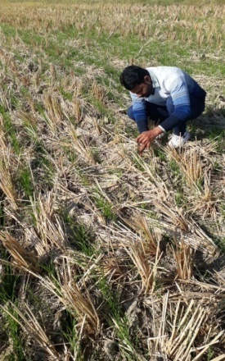 | 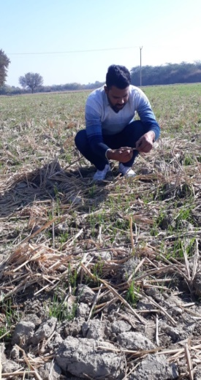 |  | 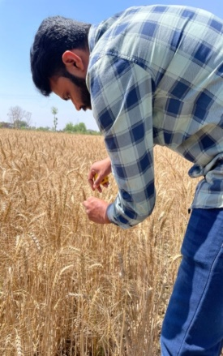
Fig. 2: Measurement of plant height after 15 days of sowing and at harvest stage
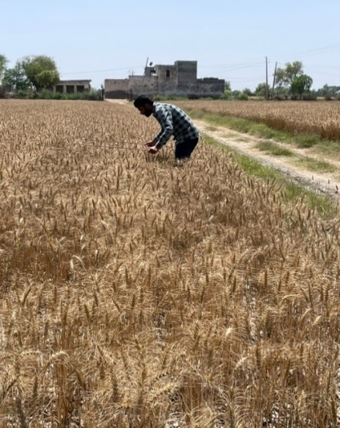 |  | 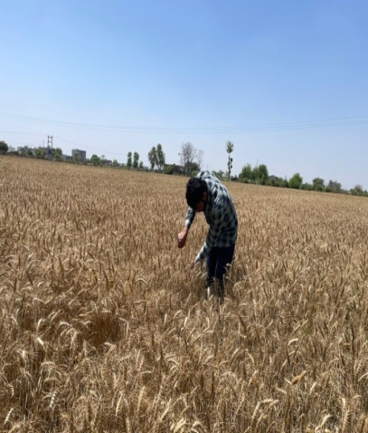
Fig.3: Measurement of no. of plants in 1m⁻² and length of earhead (cm)

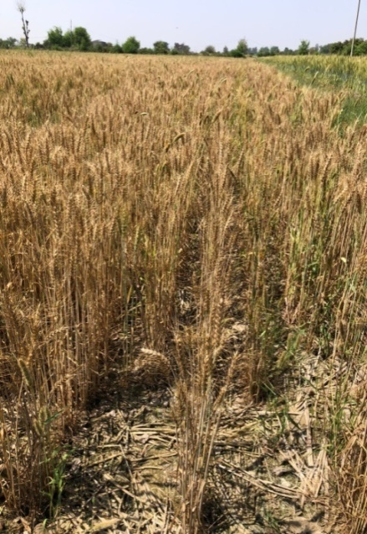 | 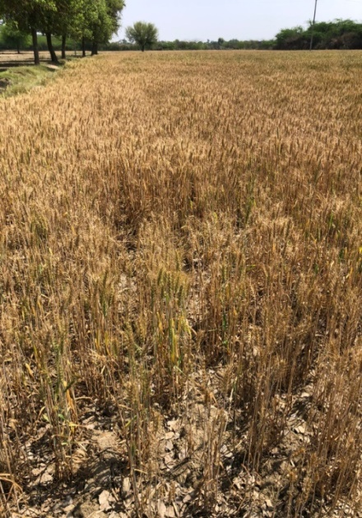
Conservation tillage | Conventional tillage
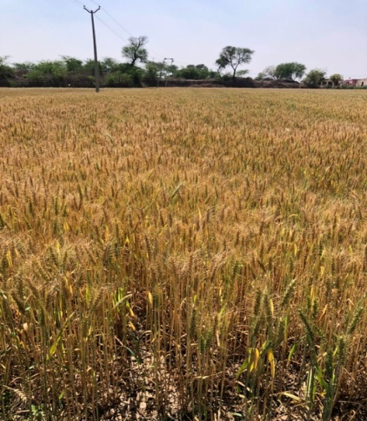 | 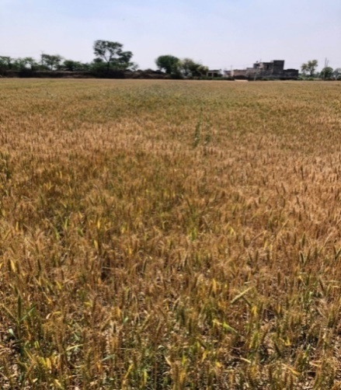
Deep tillage | Rotary tillage
Fig. 4: Crop stand under different tillage practices

- RESULTS AND DISCUSSION
The observed results are tabulated and analyzed and presented under following headings and sub-headings:
  - Crop parameters
  - Machine performance parameters
  - Economic parameters
3.1 Crop parameters
3.1.1 Effect of different tillage practices on growth parameters
The effect of different tillage practices on growth parameters are shown in Fig.5 and Fig.6. The number of plants m⁻² at 15 DAS in conventional (72) rotary (73) and deep tillage (73) practice was statically at par with each other, however, the conservation tillage (70) has significantly lower plant population. At 30 DAS, the plant population m⁻² of deep tillage (95) was significantly higher than all other treatments. The plant population of conventional (94) and rotary tillage (94) was same but significantly higher than conservation tillage (92). At 45 DAS, the plant population m⁻² of rotary (154), conservation (154) and deep tillage (155) was as par with each other and significantly higher than conventional tillage practice (152). The number of plants m⁻² at harvest under deep tillage practice (290) was significantly higher than conventional (275) and rotary tillage (280) practice and at par with conservation tillage (288) practices. The plant population of conservation tillage was also significantly higher than rotary and conventional tillage practice. The plant population of conventional tillage practice was also significantly lower than rotary tillage practice. The number of plants m⁻² under deep tillage practice was 5.5 and 3.6 per cent higher than conventional and rotary tillage practice. The higher plant population in deep tillage practice might be due to improvement in soil physical properties and more availability of water and nutrients to the plants. Imran et al., 2013 also observed 1.94 and 2.4 per cent higher plant population in deep tillage practice as compared to conventional and conservation tillage practice. The number of plants m⁻² under conservation tillage practice was 4.7 and 2.8 per cent higher than conventional and rotary tillage practice at harvest stage. Kumar et al., 2013 observed that conservation tillage resulted in 3.7 per cent higher plant population as compared to conventional tillage practice in wheat crop. Similarly, Singh et al., 2008 and Saharawat et al., 2010 also reported 15 per cent higher effective tiller in conservation tillage as compared to conventional practice.
The plant height of conventional, rotary and conservation tillage practices after 15 DAS was 4.6 cm, which was significantly lower than deep tillage (4.8 cm) practice. Similar trend was observed after 30 DAS. At 75 DAS, the plant height of deep tillage (46.3 cm) practice was significantly higher than other tillage treatments. The plant height of conservation tillage practice (45.1 cm) was also significantly higher than conventional and rotary tillage practice. The plant height of rotary tillage practice (44.8 cm) was also significantly higher than conventional (43.7 cm) tillage practice. Similar trend was observed at harvesting time. At harvesting time, the plant height in deep tillage practice (82.4 cm) was significantly higher than conventional (76.9 cm), rotary (78.3 cm) and conservation tillage (79.2 cm) practices. The plant height of conservation tillage practice was significantly higher than conventional and rotary tillage practice. The plant height of rotary tillage practice was also significantly higher than conventional tillage practice. The plant height of deep tillage practice was 7.2, 5.3 and 4.0 per cent higher than conventional, rotary and conservation tillage practice. The higher plant height in deep tillage practice might be due to more availability of water and nutrients to the plant especially in deeper soil layers. Chandra et al., 2017 also observed 11.7 and 14.7 per cent higher plant height in deep tillage practice as compared to conservation and rotary tillage practice. The plant height of conservation tillage practice (79.2 cm) was also significantly higher than conventional and rotary tillage practice. The plant height of conservation tillage practice was 2.9 and 1.1 per cent higher than conventional and rotary tillage practice. The plant height of rotary tillage practice was also significantly higher (1.8 per cent) than conventional tillage practice.
Fig. 5: Effect of different tillage practices on plant population (no. of tillers in 1m²)

Fig. 6: Effect of different tillage practices on plant height (cm) of the crop
3.1.2 Effect of different tillage practices on yield and yield attributes
The effect of different tillage practices on yield and yield attributing characteristics are presented in Table 2. The length of earhead was significantly higher in deep tillage practice (11.98 cm) as compared to conventional and rotary tillage practice. The deep tillage practice has 3.1 per cent higher earhead length as compared to conventional (11.62 cm) and rotary tillage practice (11.50 cm) and at par with conservation tillage (11.90 cm) practice. Chandra et al., 2017 also observed higher ear head length in case of deep tillage practice (9.6 cm), which was 4.7 and 10.3 per cent higher than conservation tillage and rotary tillage practice. The length of earhead in conservation tillage practice was also significantly higher than conventional and rotary tillage practice. The conservation tillage practice has 2.4 and 3.5 per cent higher earhead length as compared to conventional and rotary tillage practice. Pandey et al., 2019 also observed 4.71 per cent higher earhead length in conservation tillage as compared to conventional tillage practice in wheat. The earhead length of conventional tillage practice was also significantly higher than rotary tillage practice.
The number of grains per earhead was also significantly higher in deep tillage (49) practice as compared to conservation tillage (48) and conventional and rotary tillage practice (47). The conservation tillage practice also has significantly higher grains over conventional and rotary tillage practice. The conventional and rotary tillage practice have same number of grains per earhead. Meena et al., 2011 also observed non-significant effect of different tillage treatments on number of grains per earhead in wheat crop.
The 1000 grain weight of deep tillage practice (41.65 g) was significantly higher than other tillage practices. The deep tillage practice has 4.0, 3.1 and 1.5 per cent higher 1000 grain weight as compared to conventional (40.05 g), rotary tillage (40.25 g) and conservation tillage (41.02 g) practice, respectively. Dhaliwal et al., 2022 also observed 3.3 per cent higher 1000 grain weight in deep tillage treatment as compared to conventional tillage practices. The conservation tillage practices have also significant higher 1000 grain weight (41.02 g) than conventional and rotary tillage practice. The conservation tillage practice has 2.4 and 1.9 per cent higher 1000 grain weight as compared to conventional and rotary tillage practice. The difference in 1000 grain weight among conventional and rotary tillage practices was non-significant.
The yield of deep tillage practice (59.18 q ha⁻¹) was significantly higher than conventional (51.76 q ha⁻¹), rotary tillage practice (52.97 q ha⁻¹) and conservation tillage (56.70 q ha⁻¹) practice, mainly because of breakage of hard pan in 15-30 cm soil layer, which improves soil physical properties through reduction in bulk density and soil strength. The yield of deep tillage was also attributed to higher number of effective tillers m⁻² area. Shahzad et al., 2016 also observed similar trend. It may also improve root development (Mosaddeghi et al.,2009) and moisture content in deeper layers, which has a great impact on the crop’s potential capacity for nutrient absorption and water uptake which in turn affects the crop growth and yields (Doussan et al., 2006). Meena et al., 2011 also observed that deep tillage practice resulted in higher wheat grain yield of 9 and 12 per cent as compared to conventional and rotary tillage practice. The yield of deep tillage was also 4.4 per cent higher than conservation tillage practice (56.70 q ha⁻¹). Dhaliwal et al., 2022 also observed higher grain yield of wheat (53.9q ha⁻¹) in deep tillage treatment as compared to conventional tillage practices (49.0 q ha⁻¹). The grain yield of conservation tillage practice (56.70q ha⁻¹) was also significantly higher than conventional and rotary tillage practice. The conservation tillage practice has 9 and 7 per cent higher grain yield as compared to conventional and rotary tillage practice. Kumar et al., 2013 observed that conservation tillage practice resulted in higher grain yield (44.9 q ha⁻¹), which was 9.7 and 5.8 per cent as compared to conventional and rotary tillage practice.

The straw yield under deep tillage practice (73.98 q ha⁻¹) was also significantly higher than other tillage practices. The straw yield of deep tillage practice was 19.1, 16.4 and 8.7 per cent higher than conventional (62.11 q ha⁻¹), rotary (63.56 q ha⁻¹) and conservation tillage (68.04 q ha⁻¹) practice, respectively. The higher straw yield in deep tillage practice was mainly because of better crop growth parameters (effective tillers and plant height).
Table 2: Effect of different treatments on yield and yield attributes
Parameters | T1 | T2 | T3 | T4
Effective tillers at maturity (no. m⁻²) | 275 | 280 | 288 | 290
Length of earhead (cm) | 11.62 | 11.50 | 11.90 | 11.98
No. of grains per ear head (no.) | 47 | 47 | 48 | 49
Test weight (1000 grains), g | 40.05 | 40.25 | 41.02 | 41.65
Grain yield (q ha⁻¹) | 51.76 | 52.97 | 56.70 | 59.18
Straw yield (q ha⁻¹) | 62.11 | 63.56 | 68.04 | 73.98

3.2 Machine performance parameters
The performances of different machines used in the study are presented in Table 3. The field capacity of straw chopper, harrow, cultivator, rotavator, subsoiler, seed drill, planker and zero drill was found to be 1.00, 0.67, 1.00, 0.40, 0.26, 0.55, 1.46 and 0.55ha h⁻¹, respectively. The field capacity of planker was highest (1.46 ha h⁻¹), whereas lowest field capacity was observed in case of subsoiler (0.26 ha h⁻¹). Kumar et al., 2013 also observed similar results and found that field capacity of harrow, planker, cultivator, zero drill and rotavator was 1.14, 0.50, 0.89, 1.68 and 2.42 h ha⁻¹, respectively.
The fuel consumption of sub soiler was highest (7 l h⁻¹) followed by rotavator (6.3 l h⁻¹), harrow (4.8 l h⁻¹), cultivator (4.2 l h⁻¹), seed drill and zero drill (3.5 l h⁻¹), straw chopper (2.5 l h⁻¹) and planker (2 l h⁻¹), respectively. Kumar et al., 2013 also observed similar results and found that harrow, planker, cultivator, zero drill and rotavator resulted in fuel consumption of 6.82, 5.23, 8.18, 3.48 and 6.11 l h⁻¹, respectively.
The field efficiency of straw chopper, harrow, cultivator, rotavator, sub soiler, seed drill, planker and zero drill was found to be 79,74,79,75,74,70,75 and 70 per cent, respectively. The results are in line with Kumar et al., 2013 for wheat sowing in rice wheat cropping system.

Table 3: Field performance of different implements
Parameters | Name of the implement
 | Straw  chopper | Harrow | Cultivator | Rotavator | Sub  soiler | Seed  drill | Planker | Zero  drill
Width of machine, m | 2.1 | 1.8 | 2.1 | 2.1 | 1.4 | 2.6 | 3.0 | 2.6
Speed of operation, km h⁻¹ | 6.0 | 5.0 | 6.0 | 2.5 | 2.5 | 3.0 | 6.5 | 3.0
Fuel consumption,l h⁻¹ | 2.5 | 4.8 | 4.2 | 6.3 | 7.0 | 3.5 | 2.5 | 3.5
Field capacity, ha h⁻¹ | 1.00 | 0.67 | 1.00 | 0.40 | 0.26 | 0.55 | 1.46 | 0.55
Field efficiency, % | 79 | 74 | 79 | 75 | 74 | 70 | 75 | 70
3.3 Economic parameters
The economics of wheat cultivation under different tillage practices were calculated and presented in Table 4. The cost of cultivation of deep tillage (Rs 73596 ha⁻²) practice was higher than all other tillage practices. The deep tillage practice was 9.3, 7.0 and 14.7 per cent costlier than conventional (Rs 67343 ha⁻²), rotary (Rs 68769 ha⁻²) and conservation tillage (Rs 64139 ha⁻²) practice. The cost of cultivation of conservation tillage (Rs 64139 ha⁻¹) was lowest. The cost of agronomical practices was kept constant among all the tillage practices (Rs. 62500 ha⁻¹). Kumar et al., 2013 also observed that zero tillage practice resulted in cost saving of 13.3 and 2.2 per cent as compared to conventional and rotary tillage practice.
The Gross return was highest in deep tillage practice (Rs. 167335ha⁻¹) followed by conservation tillage (Rs. 158477ha⁻¹), rotary tillage (Rs. 148049ha⁻¹) and conventional tillage (Rs. 144668 ha⁻¹). The deep tillage treatment gives 15.7, 13.0 and 5.6 per cent higher gross returns over conventional, rotary and conservation tillage practice.
The net returns of deep tillage practice were Rs. 93739 ha⁻¹, which was almost as par with conservation tillage practice (Rs. 94338ha⁻¹). The net returns of deep and conservation tillage practice was significant over conventional and rotary tillage practice. These tillage practices give 21.0 and 18.2 per cent higher net returns over conventional and rotary tillage practice. Similar result was observed by Saharawat et al., 2010, Gathala et al., 2011a and Jat et al., 2011b in wheat cultivation by conservation agricultural technologies in comparison to conventional and rotary tillage practice. The lowest net return (Rs. 77325ha⁻¹) was obtained in conventional tillage practice. Imran et al., 2013 observed that conservation tillage practice resulted in 23.3 per cent higher net returns as compared to conventional practice. Similarly, Kumar et al., 2013 revealed that conservation tillage practice resulted in 12.8 per cent higher net returns as compared to rotary tillage practice.
The maximum B:C ratio was observed in conservation tillage (2.47) followed by deep tillage (2.27). The conventional and rotary tillage both having B:C ratio of 2.15. Imran et al., 2013 also observed higher B:C ratio in conservation tillage practice (2.75) as compared to conventional (2.34) and deep tillage practice (2.37). The results of B: C ratio was more than unity which indicated that wheat cultivation with different tillage practice is economically viable. The conservation tillage practice was most economically viable option as compared to other tillage practices.
Table 4: Effect of different tillage treatments on economics of wheat
Parameters | T1 | T2 | T3 | T4
Cost of cultivation, Rs ha⁻¹ | 67343 | 68769 | 64139 | 73596
Gross return, Rs ha⁻¹ | 144668 | 148049 | 158477 | 167335
Net return, Rs ha⁻¹ | 77325 | 79280 | 94338 | 93739
Benefit cost ratio | 2.15 | 2.15 | 2.47 | 2.27

- CONCLUSION
The grain yield of deep tillage practice (59.18 q ha⁻¹) was significantly higher than conservation (56.70 q ha⁻¹), conventional (51.76 q ha⁻¹) and rotary (52.97 q ha⁻¹) tillage practices. The straw yield of deep tillage practice (73.98 q ha⁻¹) was significantly higher than conservation (68.04 q ha⁻¹), conventional (62.11 q ha⁻¹) and rotary (63.56 q ha⁻¹) tillage practices. The grain and straw yield of conservation tillage practice was also significantly higher than conventional and rotary tillage practices. The cost of cultivation of conservation tillage practice (Rs. 64139 ha⁻¹) was minimum, followed by conventional tillage (Rs. 67343 ha⁻¹), rotary tillage (Rs. 68769 ha⁻¹) and deep tillage (Rs. 73596 ha⁻¹) practice. The deep tillage practice gives higher gross returns (Rs. 167335 ha⁻¹) as compared to conservation (Rs. 158477 ha⁻¹), rotary (Rs. 148049 ha⁻¹) and conventional tillage (Rs. 144668 ha⁻¹) practice. The conservation tillage practice gives higher net returns (Rs. 94338 ha⁻¹) as compared to deep (Rs. 93739 ha⁻¹), rotary (Rs. 79280 ha⁻¹) and conventional tillage (Rs. 77325 ha⁻¹) practice. The B:C ratio of conservation tillage (2.47) practice was higher as compared to deep tillage (2.27) practice mainly because of lower cost of cultivation.
- Future Perspective
In order to better understand the long-term consequences of various tillage techniques across a range of agro-ecological zones, future research should build on the findings of this study by concentrating on multi-season and multi-location trials. The effects of tillage techniques on soil biological health, carbon sequestration, and water-use efficiency in the face of changing climate conditions must also be evaluated. Furthermore, combining sub-soil tillage with conservation techniques and precision agriculture tools may open up new possibilities for increasing yield while maintaining soil integrity. In the rice-wheat cropping regions, these initiatives would help create farming systems that are more robust to climate change and sustainable.
Disclaimer (Artificial intelligence)
Author(s) hereby declare that NO generative AI technologies such as Large Language Models (ChatGPT, COPILOT, etc.) and text-to-image generators have been used during the writing or editing of this manuscript.

REFERENCES
Abo-Habaga, M. M., Ismail, Z. E., & Okasha, M. H. (2022). Effect of tillage systems on a soil moisture content and crops productivity. Journal of Soil Sciences and Agricultural Engineering, 13(7), 231-235.

Abu-Hamdeh, N.H. (2003) Compaction and subsoiling effects on corn growth and soil bulk density. Soil Science Society of America Journal, 67(4), 1213-1219.
Ahmed, N., Hassan, F.U. & Belford, R. (2009) Effect of soil compaction in the sub-humid cropping environment in Pakistan on uptake of NPK and grain yield in wheat (Triticum aestivum). Field Crops Research, 110(1), 54–60.
Akinci, I., Cakir, E., Topakci, M., Canakci, M. & Inan, O. (2004) The effect of subsoiling on soil resistance and cotton yield. Soil and Tillage Research, 77(2), 203-210.
Askari, M., Abbaspour-Gilandeh, Y., Taghinezhad, E., El Shal, A. M., Hegazy, R., & Okasha, M. (2021). Applying the response surface methodology (RSM) approach to predict the tractive performance of an agricultural tractor during semi-deep tillage. Agriculture, 11(11), 1043.)
Bogužas, V., Kairytė, A. & Jodaugienė, D. (2010) Soil physical properties and earthworms as affected by soil tillage systems, straw and green manure management. Zemdirbyste-Agriculture, 97(3), 3-14.
Cai, H., Ma, W., Zhang, X., Ping, J., Yan, X., Liu, J. & Ren, J. (2014) Effect of subsoil tillage depth on nutrient accumulation, root distribution, and grain yield in spring maize. The Crop Journal, 2(5), 297-307
Chandra, A., Guru, S. K. & Thakur, T. C. (2017) Impact of different tillage practices on soil biochemical parameters, root and shoot growth and yield attributes of winter wheat. Journal of Pharmacognosy and Phytochemistry, 6(5), 1915-1922.
Dhaliwal, J., Kahlon, M.S. & Kukal, S.S. (2022) Deep tillage and irrigation impacts on crop productivity of wheat in north-west India. Journal of Soil and Water Conservation, 21(1), 41-48.
Doussan, C., Pierret, A., Garrigues, E. & Pages, L. (2006) Water uptake by plant roots: II–modelling of water transfer in the soil root-system with explicit account of flow within the root system–comparison with experiments. Plant and Soil, 283, 99-117.
Evans, S.D., Lindstrom, M.J., Voorhees, W.B., Moncrief, J.F. & Nelson, G.A. (1996) Effect of subsoiling and subsequent tillage on soil bulk density, soil moisture, and corn yield. Soil and Tillage Research, 38(1-2), 35-46.
Flowers, M.D. & Lal, R. (1998) Axle load and tillage effects on soil physical properties and soybean grain yield on a mollic ochraqualf in North-West Ohio. Soil and Tillage Research, 48(1-2), 21-35.
Gao, H.W. & Li, H.W. (1995) A testing study of dryland subsoiling. Agricultural Research in Arid Areas, 4, 126-133 (in Chinese).
Gathala, M. Ladha, J.K. Balyan, V. Saharawat , Y.S. Kumar, V. Sharma, P.K. Sharma , S. & Pathak, H. (2011a) Tillage and crop establishment affects sustainability of South Asian rice wheat system. American Society of Agronomy Journal, 103, 1-10.
Harris, W.L. (1971) The soil compaction process. Compaction of Agricultural Soils, 9-44.
He, J., Li, H.W. & Gao, H.W. (2006) Subsoiling effect and economic benefit under conservation tillage mode in northern china. Transcations of the CSAE, 22, 62-67 (in Chinese).
Hill, R.L. (1990) Long‐term conventional and no‐tillage effects on selected soil physical properties. Soil Science Society of America Journal, 54(1), 161-166.
Imran, A., Shafi, J., Akbar, N., Ahmad, W., Ali, M. & Tariq, S. (2013) Response of wheat (Triticum aestivum) cultivars to different tillage practices grown under rice-wheat cropping system. Universal Journal of plant science, 1(4), 125-131.
Jat, M.L. Saharawat, Y.S. & Gupta R.K. (2011b) Conservation agricultural in cereal systems of South Asia: nutrient management perspectives. Karnataka Journal of Agricultural Sciences, 24, 100-105.
Khater, A., Fouda, O., El-Termezy, G., El-Tantawy, M., El-Beba, A., Sabry, H., & Okasha, M. (2023). Modification of the rice combine harvester for cutting and binding wheat crop. Journal of Agriculture and Food Research, 14, 100738.
Kumar, V., Saharawat, Y. S., Gathala, M. K., Jat, A. S., Singh, S. K., Chaudhary, N., & Jat, M. L. (2013). Effect of different tillage and seeding methods on energy use efficiency and productivity of wheat in the Indo-Gangetic Plains. Field Crops Research, 142, 1-8.
Meena, H.M., Sharma, S.K. & Meena, M.C. (2011) Effect of tillage and mulch practices on wheat yield, yield attributes and nitrogen use efficiency in vertisols of Madhya Pradesh. Journal of Soil and Water Conservation, 10(4), 294-298.
Mohanty, M., Bandyopadhyay, K.K., Painuli, D.K., Ghosh, P.K., Misra, A.K. & Hati, K.M. (2007) Water transmission characteristics of a Vertisol and water use efficiency of rainfed soybean under subsoiling and manuring. Soil and Tillage Research, 93(2), 420-428.

Mosaddeghi, M.R., Mahboubi, A.A. & Safadoust, A. (2009) Short-term effects of tillage and manure on some soil physical properties and maize root growth in a sandy loam soil in western Iran. Soil and Tillage Research, 104, 173-179.
Pandey, B.P. & Kandel, T.P. (2019) Growth and yield response of wheat to tillage, rice residue and weed management under rice-wheat cropping system. Global Journal of Agricultural and Allied Sciences, 1(1), 43-48.
Ranamukhaarachchi, S.L. & Begum, M.M.R.S.N. (2005) Soil fertility and land productivity under different cropping systems in highlands and medium highlands of Chandina sub-district, Bangladesh. Asia-Pacific Journal of Rural Development, 15(1), 63-76.
Saharawat, Y.S., Singh, B., Malik, R.K., Ladha, J.K., Gathala, M.K., Jat, M.L. & Kumar, V. (2010) Evaluation of alternative tillage and crop establishment methods in a rice wheat rotation in North Western IGP. Field crop Research, 116, 260-267.
Sahu, D., Banwasi, R., Shrivastava, L. K., Chowdhury, T., Jatav, G., & Kumar, H. (2023). Performance of nano-DAP under rice-wheat cropping system in vertisol of Chhattisgarh, India. Int. J. Environ. Clim, 13(9), 2864-2875.
Shahzad, M., Farooq, M., Jabran, K., Yasir, T.A. & Hussain, M. (2016) Influence of various tillage practices on soil physical properties and wheat performance in different wheat-based cropping systems. International Journal of Agriculture & Biology, 18(4), 821-829.
Shukla, S.K., Jaiswal, V.P., Sharma, L., Pathak, A.D., Singh, A.K., Gupta, R. & Tiwari, R. (2021) Subsoiling affecting soil quality parameters and sugarcane yield in multiratooning system in subtropical India. Communications in Soil Science and Plant Analysis, 52(18), 2125-2144.
Sidhu, D. & Duiker, S.W. (2006) Soil compaction in conservation tillage: Crop impacts. Agronomy Journal, 98(5), 1257-1264.
Singh, Y., Brar, N.K., Humphreys, E., Singh, B., Nayyar, A. & Timsina, J. (2008) Yield and nitrogen use efficiency of permanent bed rice-wheat systems in north-west India: effect of N fertilization, mulching and crop establishment method. In: Humphreys, E., Roth, C.H. (Eds.), Permanent Beds and Rice – Residue Management for Rice – Wheat System of Indo- Gengetic Plain. ACIAR Proc. 127, 62-97 www.aciar.gov.au/publication/term/18.
Tiwari, H., Naresh, R. K., Debangshi, U., Roy, S., Reddy, B. R., Vismaya, G. U., ... & Singh, A. (2022). Improving resource utilization efficiency and productivity in rice-wheat cropping system through cutting edge technologies: An overview. International Journal of Plant & Soil Science, 34(23), 420-435.
Verma, S. K., Singh, S. B., Rajpoot, S. K., Bhushan, C., Vaheed, M., Shrivastava, S., ... & Jaysawal, P. K. (2025). A Review on Drawbacks of Rice-Wheat Cropping System: Opportunities and Challenges in North-Western Indo-Gangetic Plains. Journal of Advances in Biology & Biotechnology, 28(6), 170-183.
Wang, L.C., Ma, H. & Zheng, J.Y. (2008) Research on rational plough layer construction of spring maize soil in northest China, Journal of Maize Sciences, 16, 13-17 (in chinese with english abstract).
Wei, Y., Wu, X. & Cai, C. (2015) Splash erosion of clay–sand mixtures and its relationship with soil physical properties: The effects of particle size distribution on soil structure. Catena, 135, 254-262.
Zou, G.X. (2002) The effects of no-tillage and rotation periods on erosion. Scientific and Technical Information of Soil and Water Conservation, 4, 7-8 (in Chinese).
Annexure-I
Calculations of cost of operation of different implements used in the experiment
Implements | Initial cost  (Rs) | Salvage cost  (Rs) | Service life  (yrs) | Annual use  (h) | Interest rate per year  (%) | Operator wages per day  (Rs) | Diesel rate  (Rs l⁻¹)
Tractor | 700000 | 70000 | 10 | 1000 | 8 | 400 | 88
Straw chopper | 30000 | 3000 | 8 | 500 | 8 | 400 | 88
Harrow | 60000 | 6000 | 8 | 800 | 8 | 400 | 88
Cultivator | 45000 | 4500 | 8 | 800 | 8 | 400 | 88
Planker | 10000 | 1000 | 8 | 800 | 8 | 400 | 88
Rotavator | 110000 | 11000 | 8 | 850 | 8 | 400 | 88
Sub soiler | 18000 | 1800 | 8 | 450 | 8 | 400 | 88
Zero drill | 55000 | 5500 | 8 | 800 | 8 | 400 | 88
Seed drill | 55000 | 5500 | 8 | 800 | 8 | 400 | 88

Annexure-II
Calculations of cost of operation of different implements used in the experiment (Fixed cost)
Implement | Depreciation  Cost (Rs) | Interest  (Rs) | Insurance  (Rs) | Housing  (Rs) | Total fixed cost  (Rs)
Tractor | 63 | 30.8 | 14 | 7 | 164.8
Straw chopper | 6.75 | 2.64 | 0.60 | 0.30 | 10.29
Harrow | 8.44 | 3.30 | 1.20 | 0.60 | 13.54
Cultivator | 6.33 | 2.48 | 0.90 | 0.45 | 10.15
Planker | 1.41 | 0.55 | 0.20 | 0.10 | 2.26
Rotavator | 14.56 | 5.69 | 2.20 | 1.10 | 23.550
Sub soiler | 4.50 | 1.76 | 0.36 | 0.18 | 6.80
Zero till drill | 7.73 | 3.03 | 1.10 | 0.55 | 62.41
Seed dril | 7.73 | 3.03 | 1.10 | 0.55 | 62.41

Annexure-III
Calculations of cost of operation of different implements used in the experiment (variable cost and total cost of operation)
Implement | Fuel Consumed  (l h⁻¹) | Fuel Cost,  Rs h⁻¹ | Lubrication Cost,  Rs h⁻¹ | Repair & maintenance cost  Rs h⁻¹ | Total Variable Cost,  Rs h⁻¹ | Total operating cost  Rs h⁻¹ | Field capacity,  ha h⁻¹ | Cost of operation, Rs ha⁻¹
Tractor |  |  |  | 70
Straw chopper | 2.50 | 220.00 | 66.00 | 6.00 | 298.50 | 308.79 | 1.00 | 308.79
Harrow | 4.80 | 422.40 | 126.72 | 7.50 | 563.92 | 577.46 | 0.67 | 861.88
Cultivator | 4.20 | 369.60 | 110.88 | 5.60 | 494.68 | 504.83 | 1.00 | 504.83
Planker | 2.50 | 220.00 | 66.00 | 1.25 | 298.50 | 300.76 | 1.46 | 205.99
Rotavator | 6.30 | 554.40 | 166.32 | 12.94 | 737.02 | 760.57 | 0.40 | 1901.43
Sub soiler | 7.00 | 616 | 184.80 | 4.00 | 817.8 | 824.60 | 0.20 | 4123.00
Zero drill | 3.50 | 308 | 92.40 | 6.80 | 413.9 | 476.31 | 0.55 | 866.02
Seed drill | 3.50 | 308 | 92.40 | 6.80 | 413.9 | 476.31 | 0.55 | 866.02

