**Identification of high-yielding genotypes through multivariate analysis in Small Cardamom [*Elattaria cardamomum* (L.) Maton]**

**ABSTRACT:**

|  |
| --- |
| A field experiment was conducted to evaluate the variability among 20 high-yielding small cardamom accessions, including the widely recognized "Green Gold" variety. The study comprised hybrids, breeding lines, and seedling selections, all chosen for their exceptional yield potential. The trial was carried out over four years at the Cardamom Research Station of Kerala Agricultural University, using a randomized block design (RBD). Analysis of ten yield-contributing traits revealed significant genetic diversity among the accessions at the 1% probability level. Among the genotypes, PS 27 recorded the highest fresh weight, whereas Pl. No. 14 registered the highest dry weight, indicating an excellent dry recovery percentage. PS 27 also showed superior performance in capsule volume, with Pl. No. 19 and HY 9 exhibit comparable results. HY 9 recorded the highest weight for 100 capsules, further highlighting the bold capsule characteristics of PS 27. PS 3 had the maximum seed count, followed by PS 27, while Pl. No. 14 showed superior performance in most traits, except for the 100-capsule weight. The results highlighted PS 27 and Pl.No. 14 as promising candidates for breeding programs targeting yield improvement in cardamom. Cluster analysis grouped the accessions into three clusters based on 75% genetic similarity, with Cluster II comprising the majority of genotypes, whereas PS 27 was uniquely placed in Cluster III. Pl.No. 14 and Green Gold were grouped in Cluster I, reflecting their superior yield and morphological traits. The first four principal components explained 82.5% of the total variation, underscoring the potential of morphologically diverse genotypes to strengthen breeding strategies for small cardamom. |

*Keywords:* Small cardamom, genetic diversity, cluster analysis, yield traits, Principal Component Analysis

1. INTRODUCTION

Small cardamom (Elettaria cardamomum [L.] Maton), a species within the Zingiberaceae family, stands out as one of the most valuable spice crops in India. The state of Kerala, often termed the "Spice Bowl of India," holds a prominent position in the cultivation of spices, particularly cardamom and black pepper, both of which significantly bolster the country's export revenues. Cardamom is indigenous to the lush evergreen forests of the southern Western Ghats and grows best in the Cardamom Hill Reserves (CHR), located in southern India. It thrives at altitudes ranging from 800 to 1300 meters above sea level, where it is grown as an understory crop beneath the shade of forest trees (Hrideek *et al*., 2015).

Being a cross-pollinated crop propagated through both seeds and vegetative suckers, cardamom displays a high degree of genetic diversity. However, evolving environmental conditions in the Cardamom Hill Reserves (CHR) highlight the need for the development of robust and adaptable varieties. To address these challenges, it is essential to identify genotypes that possess favorable traits, supported by adequate variability in key economic attributes, to ensure their effective integration into breeding efforts (Prasath & Venugopal, 2004). The morphological traits of cardamom germplasm exhibit a wide range of variability (Abraham & Tulasidas, 1958).

A repository of 195 distinct cardamom accessions has been maintained at the Cardamom Research Station in Pampadumpara to enable significant research. Exploring the genetic diversity within this superior germplasm is crucial for identifying promising lines that possess specific desirable traits (Ali *et al*., 2008) and for selecting genetically distinct parents. Genetic variation among parental lines plays a vital role in exploiting transgressive segregation in breeding efforts and deriving heterosis in progeny (Joshi *et al*., 2004).

Cluster analysis and Principal Component Analysis (PCA) are commonly employed techniques for assessing genetic diversity, as they provide valuable information on genetic relationships and variability. These approaches have proven essential in analyzing family linkages and distinguishing distinct clusters among various accessions (Rogers, 1972). The current study aimed to evaluate and quantify the variability among high-yielding cardamom accessions, identify superior genotypes with enhanced yield potential, and examine character associations to support targeted breeding efforts.

2.materials and methods

**2.1 Experimental genetic accessions**

A total of 21 cardamom accessions, including hybrids, advanced breeding lines, plant selections, nursery seedling selections, and farmer varieties, were used in the study. These accessions were obtained from an ex-situ field gene bank maintained at the Cardamom Research Station of Kerala Agricultural University, Pampadumpara. The selection was based on the observed seedling vigour. Comprehensive details of the accessions are presented in Table 1.

**Table 1.** List of cardamom [*E. cardamamom* (L.)Maton] germplasm accessions

|  |  |  |
| --- | --- | --- |
| **Sl.No** | **Accession** | **Remarks** |
| 1. | Pl. No. 10 | Plant selection from commercial plantation of CRS, Pampadumpara |
| 2. | Pl.No. 19 | Plant selection from commercial plantation of CRS, Pampadumpara |
| 3. | PPK 2 | *Vazhukka*, selection form green gold. Extra-long panicle but small capsules, land races identified from farmer’s field |
| 4. | BEP 1 | *Vazhukka*, close internodes, land races identified from farmer’s field |
| 5. | PS 27 | *Malabar*, pale green-coloured capsules, plant selection from commercial plantation of CRS, Pampadumpara |
| 6. | BEP 2 | *Vazhukka*, light green-coloured capsules, four panicles per tiller, selection from farmer’s field |
| 7. | PL.No. 1 | *Vazhukka*, plant selection from commercial plantation of CRS, Pampadumpara |
| 8. | NS 25 | *Malabar*, nursery seedling selection based on vigour |
| 9. | HY 9 | *Malabar*, selection from F1s of cross between PV1&Clone 57 |
| 10. | NS 18 | *Vazhukka*, nursery seedling selection |
| 11. | HY 6 | *Malabar*, long panicle, more internodal distance, selection from F1s of cross between PV1&Clone 57 |
| 12. | PS 3 | *Malabar*, green-coloured large round capsules, plant selection from commercial plantation of CRS, Pampadumpara |
| 13. | PS 34 | Plant selection from commercial plantation of CRS, Pampadumpara |
| 14. | PL.No. 4 | *Vazhukka*, plant selection from commercial plantation of CRS, Pampadumpara |
| 15. | NS 50 | *Vazhukka*, nursery seedling selection based on vigour |
| 16. | Pl.No. 14 | *Vazhukka*, round bold capsules, plant selection from commercial plantation of CRS, Pampadumpara |
| 17. | NS 20 | *Malabar*, nursery seedling selection based on vigour |
| 18. | NS 34 | *Vazhukka*, nursery seedling selection based on vigour |
| 19. | NS 29 | *Vazhukka*, nursery seedling selection based on vigour |
| 20. | NS 24 | *Vazhukka*, nursery seedling selection based on vigour |
| 21. | GG | *Vazhukka*, fertilizer responsive high yielding variety, popular farmer variety known as green gold |

**2. 2 Germplasm characterization**

The research was carried out at the experimental farm of the Cardamom Research Station in Pampadumpara, located in Idukki district, Kerala. This site lies at an elevation of 1100 meters above mean sea level, positioned at 9°51′0″ N latitude and 76°56′24″ E longitude. The soil in the area is categorized as forest loam, with a pH ranging between 5 and 6.

The experiment was laid out in a randomized block design (RBD) with three replications. Each plot contained 12 plants, planted at a spacing of 3 x 3 m. The variety "Green Gold" served as the check. All recommended agronomic practices prescribed by Kerala Agricultural University were followed consistently during the study. The germplasm accessions were evaluated based on ten traits related to yield and yield components. The characterization was carried out following the IPGRI descriptor guidelines for *E. cardamomum*.

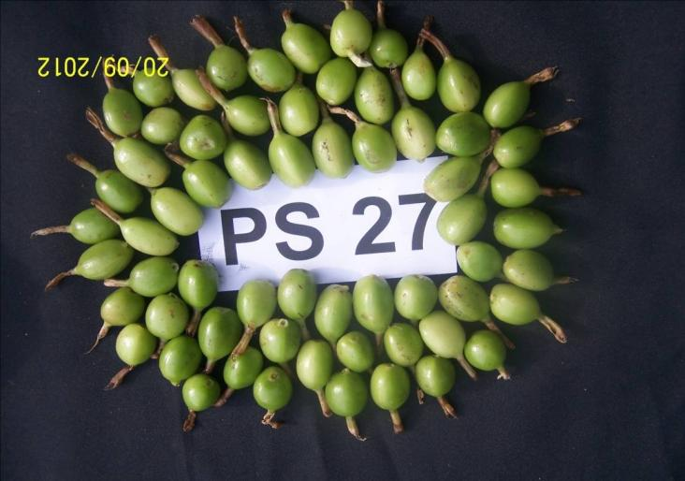 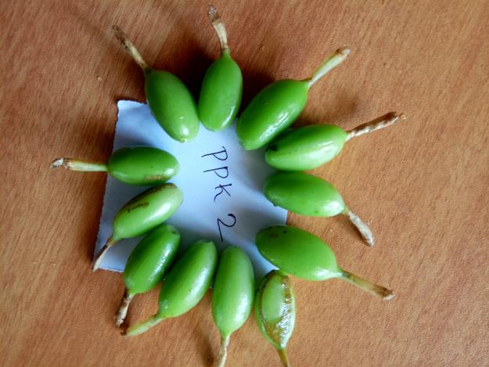

**Fig.1.** Capsules of PS 27 and PPK 2

**2.3 Data analysis**

A pooled analysis of yield and its contributing traits was carried out using data collected over four-year period. The recorded trait data were analyzed using multivariate statistical techniques. To determine the extent of variability among the landraces and varieties, analysis of variance (ANOVA) was performed with the help of the statistical software GRAPES. Cluster analysis and principal component analysis (PCA) were utilized to examine the grouping patterns and interrelationships among the cardamom genotypes. For cluster analysis, a distance matrix was created using Euclidean dissimilarity coefficients calculated for each pair of genotypes. PCA was conducted using a correlation matrix derived from the quantitative traits to identify the principal components responsible for the observed variation. Both cluster analysis and PCA were carried out using Minitab 18 software. Additionally, correlation coefficients were calculated to determine associations among different traits.

1. ReSULTS And discussion
   1. **General Variability among different accessions**

Significant differences (at the 1% probability level) were found among the genotypes for all ten yield attributing traits (Table 2). Among the evaluated accessions, PS 27 exhibited the highest fresh capsule weight (5185 g per plant), with Pl.No. 14 following closely; both were statistically on par. Notably, the trend was reversed for dry capsule weight, as Pl.No. 14 showed a superior dry recovery percentage.

**Table 2: Variability in cardamom accessions based on different morphological traits**

|  |  |  |  |  |  |  |  |  |  |  |  |
| --- | --- | --- | --- | --- | --- | --- | --- | --- | --- | --- | --- |
| Sl.No | Accession | Fresh yield (g/plant) | Dry yield (g/plant) | 100 capsule volume (ml) | 100 capsule weight (g) | Seed number | Plant height (cm) | Number of tillers/clump | Number of panicles/clump | Panicle length | Racemes/panicle |
| 1. | Pl. No. 10 | 4266.7a | 784.75ab | 153.3ef | 85cde | 16fg | 252.5cd | 39f | 44ghi | 60.3efg | 18.25fgh |
| 2. | Pl.No. 19 | 3273.5cdef | 601.33defgh | 176.0abcd | 87.5abcd | 19.2bcde | 297.5a | 48.5cde | 45fgh | 63.25def | 18.25fgh |
| 3. | PPK 2 | 4164.2abcd | 839.87bc | 121.8h | 63.5f | 15.5g | 232.5de | 43ef | 50.25cdef | 62.625def | 17.25ghi |
| 4. | BEP 1 | 2716.7f | 485.59gh | 179.3abc | 87.7abcd | 17.12efg | 237.5d | 48.25cde | 45fgh | 71.95c | 19cdefg |
| 5. | PS 27 | 5185 abc | 926.25bcd | 193.2a | 96ab | 22.2ab | 242.5d | 57.25a | 47efg | 55.45gh | 15.5i |
| 6. | BEP 2 | 2778.3ef | 477.37gh | 159.3def | 79.7de | 15.2g | 256bcd | 45.25ef | 39.5i | 84.45ab | 21abc |
| 7. | PL.No. 1 | 4151.7abcd | 729.05bcde | 155.2ef | 76.7e | 18.8cdef | 295a | 54.25abc | 54cd | 83.45ab | 20.75bcd |
| 8. | NS 25 | 2640.3f | 491.72fgh | 162.3cdef | 78.5de | 20.7abc | 197.5f | 39.5f | 49.5cdef | 54.1h | 15.25i |
| 9. | HY 9 | 4201.7abcd | 774.5bcd | 186.0ab | 97.5a | 21.3abc | 242.5d | 53abcd | 52.5cd | 66.1cde | 16.75hi |
| 10 | NS 18 | 3035def | 548.09efgh | 178.3abc | 92.7abc | 17.2efg | 237.5d | 54abc | 53.5cd | 59.35fgh | 20.75bcd |
| 11. | HY 6 | 4246.7abc | 697.81cde | 176.7abcd | 87.7abcd | 21.2abc | 237.5d | 46.75de | 50cdef | 61.7def | 18.75defgh |
| 12. | PS 3 | 2198.7f | 426.53gh | 161.8cdef | 80.2de | 22.5a | 290a | 55.5ab | 46.5efg | 81.825ab | 20.5cde |
| 13. | PS 34 | 3120cdef | 591.32defgh | 144.8fg | 76.8e | 20.5abcd | 250d | 55.5ab | 40hi | 70.675c | 18.25fgh |
| 14. | PL.No. 4 | 2486.3f | 458.8gh | 133.5gh | 66f | 17.2efg | 285ab | 46.25e | 46.5efg | 86.125ab | 19.25cdefg |
| 15. | NS 50 | 2973.3ef | 621.64defg | 168.3bcde | 86bcde | 21.5abc | 232.5de | 57a | 60.25a | 80b | 19cdefg |
| 16. | Pl.No. 14 | 4700ab | 1116a | 178.3abc | 86.7bcde | 20.3abcd | 282.5abc | 54abc | 59.5ab | 87.33a | 22.75ab |
| 17. | NS 20 | 2727f | 479.66gh | 176.0abcd | 88.5abcd | 17.5defg | 227.5def | 45ef | 51.25cde | 58.08fgh | 20.25cdef |
| 18. | NS 34 | 3908.3bcde | 686.99cdef | 181.5ab | 83.5cde | 21.6abc | 227.5def | 53abcd | 48.75defg | 66.825cd | 20.5cde |
| 19. | NS 29 | 2345f | 419.63h | 120.0h | 66f | 19.5abcde | 205ef | 45.5ef | 43.75ghi | 53.525h | 18.5efgh |
| 20. | NS 24 | 2583.3f | 479.32gh | 176.8abcd | 92.7abc | 16.8efg | 205ef | 49.25bcde | 45.75fg | 58.825fgh | 18gh |
| 21. | GG | 4566.7ab | 825.87bc | 175.2abcd | 80.7de | 19.6 abcde | 255bcd | 56.5a | 54.75bc | 82.5ab | 23a |
|  | CD (1%) | 1565.82 | 265.260 | 24.37 | 13.45 | 4.23 |  |  |  |  |  |

PS 27 (Fig. 1) exhibited the highest 100-capsule volume, and was statistically on par with Pl.No. 19, BEP 1, HY 9, NS 18, HY 6, NS 20, Pl.No. 14, and NS 24. The maximum 100-capsule weight was recorded in HY 9, with PS 27 ranking next, highlighting the notable capsule boldness of PS 27 in comparison to the other genotypes.

PS 3 recorded the highest seed count per capsule (22.5), with PS 27 ranking next. NS 50 showed the maximum number of panicles per clump, a value statistically similar to that of Pl.No. 14. The longest panicle length was noted in Pl.No. 14 (87.33 cm), followed by Pl.No. 4, BEP 2, Pl.No. 1, and PS 3, all of which exhibited statistically on par values.

Except for 100-capsule weight, Pl.No. 14 excelled in the majority of evaluated traits, with PS 27 closely trailing. The results highlight Pl.No. 14 and PS 27 (Fig. 2) as superior genotypes, making them suitable for inclusion in future breeding initiatives focused on enhancing yield potential.

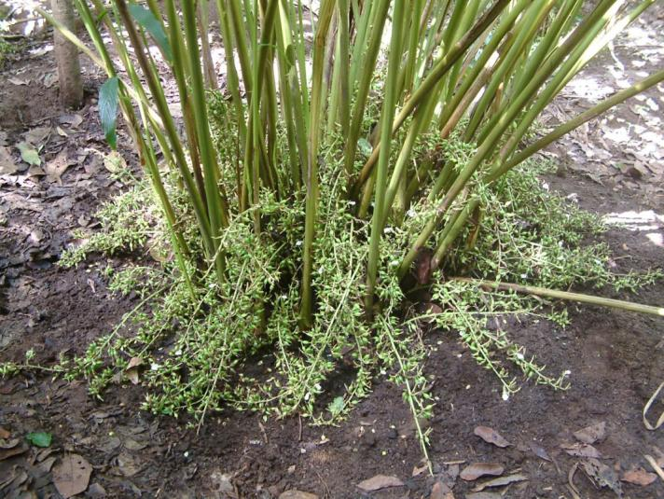 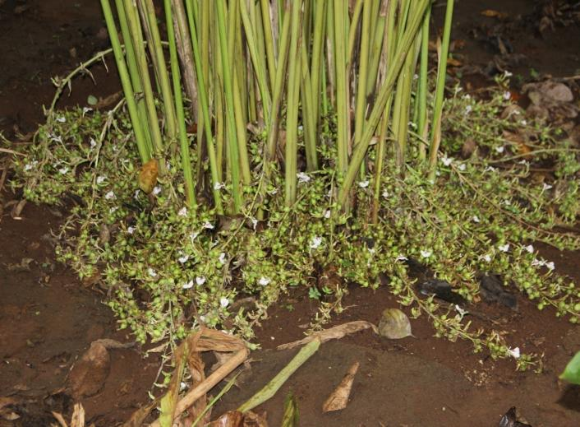

**Fig. 2.** Basal region of plants showing the panicles and orientation in Pl.No. 14 and PS 27

**3.2. Principal component analysis**

Principal component analysis (PCA) and cluster analysis serve as essential methodologies for assessing genetic diversity, enabling the identification of relative differences among accessions (Shajitha et al., 2015). In this study, PCA was employed to examine the extent of variation and distribution trends among small cardamom accessions. The principal factor analysis was performed using the principal component (PC) method for factor extraction, emphasizing key morphological traits that played a major role in phenotypic diversity. The selection of parental lines was primarily based on the contribution of specific traits to overall divergence.

PCA revealed the primary contributors to total variation at distinct points. Eigenvalues were utilized to determine the number of major principal components explaining variability. Differentiation among populations was observed across various axes of divergence, accounting for the overall variation. The first principal component (PC1) explained the highest proportion of variability (35.0%), followed by PC2 (23.4%), PC3 (14.2%), and PC4 (9.9%). Together, the first four principal components accounted for 82.5% of the total variation among the studied accessions (Table 3).

All evaluated traits showed a positive influence on PC1. In contrast, fresh weight, dry weight, 100-capsule volume, 100-capsule weight, and seed number demonstrated negative contributions to PC2, underscoring the complex contributions of these traits to the phenotypic variability observed among the accessions.

**Table 3. Principal components of the 10 quantitative traits in cardamom genotypes**

|  |  |  |  |  |
| --- | --- | --- | --- | --- |
|  | PC1 | PC2 | PC3 | PC4 |
| Eigenvalue | 3.4951 | 2.3436 | 1.4232 | 0.9894 |
| Proportion | 0.350 | 0.234 | 0.142 | 0.099 |
| Cumulative | 0.350 | 0.584 | 0.726 | 0.825 |
|  | Eigen vector | | | |
|  |  |  |  |  |
| Variable | PC1 | PC2 | PC3 | PC4 |
| Fresh yield (g/plant) | 0.368 | -0.117 | 0.548 | 0.051 |
| Dry yield (g/plant) | 0.387 | -0.041 | 0.557 | 0.016 |
| 100 capsule volume (ml) | 0.360 | -0.319 | -0.318 | 0.348 |
| 100 capsule weight (g) | 0.295 | -0.399 | -0.292 | 0.400 |
| Seed number | 0.279 | -0.175 | -0.223 | -0.709 |
| Plant height (cm) | 0.218 | 0.435 | -0.007 | 0.069 |
| Number of tillers/clump | 0.400 | 0.078 | -0.315 | -0.310 |
| Number of panicles/clump | 0.355 | 0.022 | 0.097 | -0.085 |
| Panicle length (cm) | 0.208 | 0.544 | -0.126 | 0.008 |
| Racemes/panicle | 0.207 | 0.448 | -0.170 | 0.324 |



**Fig. 3.** PCA scatter plot showing distribution pattern of the cardamom genotypes assayed

To visualize the distribution of cardamom accessions, the first two principal components were plotted on a scatter plot (Fig. 3), providing an informative representation of the genotypes. Genotypes PS 27, Pl.No. 4, Pl.No. 14, and NS 25 exhibited the greatest divergence based on the scatter plot. These genotypes, with their significant variability, are ideal candidates for hybridization programs and are expected to produce highly heterogenic crosses. Morphologically diverse genotypes identified through this analysis can serve as valuable resources for future breeding programs aimed at enhancing yield and other desirable traits.

**3.3. Cluster analysis**

Cluster analysis is an effective approach for assessing family relationships among genotypes (Mellingers, 1972). Unlike cluster analysis, which assigns each germplasm line to a single cluster, principal component analysis (PCA) offers the advantage of accounting variability across multiple components. In the present study, the gene bank accessions were classified into three distinct clusters at a 75% genetic similarity, reflecting the extent of variability among the accessions and their phenotypic performance (Table 4).

**Table 4: Inter-cluster variation in cardamombased on different morphological traits**

|  |  |  |  |  |
| --- | --- | --- | --- | --- |
| Variable | Cluster 1 | Cluster 2 | Cluster 3 | Grand centroid |
| Fresh yield (g/plant) | 4275.75 | 2736.78 | 5185.00 | 3441.35 |
| Dry yield (g/plant) | 806.85 | 506.75 | 926.25 | 641.05 |
| 100 capsule volume (ml) | 166.00 | 161.37 | 193.20 | 164.65 |
| 100 capsule weight (g) | 82.66 | 81.86 | 96.00 | 82.84 |
| Seed number (nos.) | 19.29 | 18.74 | 22.20 | 19.12 |
| Plant height (cm) | 253.13 | 243.38 | 242.50 | 247.05 |
| Number of tillers/clump | 49.94 | 49.13 | 57.25 | 49.82 |
| Number of panicles/ clump | 51.72 | 47.21 | 47.00 | 48.92 |
| Panicle length (cm) | 71.35 | 68.51 | 55.45 | 68.97 |
| Racemes/panicle | 19.75 | 19.00 | 15.50 | 19.12 |

Cluster I comprised Pl.No. 10, HY 9, HY 6, Pl.No. 1, PPK 2, NS 34, Pl.No. 14, and Green Gold (GG). Cluster II included the largest number of genotypes, while PS 27 uniquely formed Cluster III. Pl.No. 14 and Green Gold, included in Cluster I, demonstrated their superiority in yield and morphological similarity. The maximum inter-cluster distance was observed between Clusters II and III, indicating significant genetic diversity.

The mean cluster values indicated substantial variation among the traits studied. Cluster III recorded the highest values for fresh yield, dry yield, 100-capsule volume, 100-capsule weight, seed count, and tiller number per clump. Meanwhile, Cluster I showed high mean values for traits such as plant height, panicle length, and the number of racemes per panicle.



**Fig. 4.** Phenogram illustrating the clustering pattern of cardamom [Elettaria cardamomum (L.) Maton] accessions based on morphological traits.

No clear relationship between the collection source and the clustering pattern was observed. Instead, the clustering primarily reflected groupings based on quantitative traits, a pattern that was further supported by the PCA results. The distinct clustering of genotypes indicates a high degree of genetic diversity among the germplasm accessions examined.

**3.4. Association of different yield and yield attributing characters**

The small cardamom genotypes examined in this study exhibited significant positive correlations among various quantitative traits (Table 5).

**Table 5. Association of different traits in cardamombased on correlation coefficients**

**Correlation Matrix**

|  |  |  |  |  |  |  |  |  |  |  |
| --- | --- | --- | --- | --- | --- | --- | --- | --- | --- | --- |
|  | Fresh yield (g/plant) | Dry yield (g/plant) | 100 capsule volume (ml) | 100 capsule weight (g) | Seed number | Plant height  (m) | Number of tillers/clump | Number of panicles/clump | Panicle length (m) | Racemes/panicle |
| Fresh yield (g/plant) | 1.000 |  |  |  |  |  |  |  |  |  |
| Dry yield (g/plant) | **0.931\*** | 1.000 |  |  |  |  |  |  |  |  |
| 100 capsule volume (ml) | 0.337 | 0.266 | 1.000 |  |  |  |  |  |  |  |
| 100 capsule weight (g) | 0.281 | 0.222 | **0.923\*** | 1.000 |  |  |  |  |  |  |
| Seed number | -0.011 | -0.087 | **0.438\*** | 0.334 | 1.000 |  |  |  |  |  |
| Plant height (m) | 0.191 | 0.246 | 0.002 | -0.077 | 0.069 | 1.000 |  |  |  |  |
| Number of tillers/clump | -0.093 | -0.143 | 0.253 | 0.235 | **0.561\*** | 0.201 | 1.000 |  |  |  |
| Number of panicles/clump | 0.370 | 0.490* | 0.313 | 0.226 | 0.263 | 0.068 | 0.245 | 1.000 |  |  |
| Panicle length (cm) | 0.019 | 0.142 | -0.050 | -0.221 | -0.027 | **0.683\*** | 0.236 | 0.251 | 1.000 |  |
| Racemes/panicle | 0.025 | 0.107 | 0.096 | -0.069 | -0.197 | **0.443\*** | 0.191 | 0.310 | **0.669\*** | 1.000 |

The evaluation of small cardamom genotypes in the present research revealed noteworthy positive correlations among several quantitative traits, offering valuable insights for trait-based selection in breeding programs. Akhila et al. (2017) and Senthil Kumar et al. (2018) also mentioned considerable variability among small cardamom genotypes in terms of morphological traits and these traits are crucial for recognizing favorable characteristics in parent lines selected for use in breeding programs. Fresh yield showed a strong positive correlation with dry yield, while traits such as 100-capsule volume, 100-capsule weight, and seed number were also significantly and positively interrelated. Moreover, seed number exhibited a positive correlation with the number of tillers per clump. These results indicate that selecting for these traits concurrently may enhance the development of high-yielding varieties. Similar findings were reported by Backiyarani et al. (2002), who noted that most traits, except 100-capsule weight, were significantly correlated with yield per clump.

A significant positive correlation was observed among plant height, panicle length, and the number of racemes per panicle, suggesting that taller plants are likely to produce more panicles. This relationship implies that increased plant height may lead to greater accumulation of photosynthates, thereby enhancing overall yield. Comparable results were documented by Backiyarani et al. (2000) and Senthil Kumar et al (2018). These correlated traits offer valuable insights for focusing on crop improvement in cardamom.

Traits that make the greatest contribution to genetic divergence should be given priority when selecting cluster type for further evaluation and identifying suitable parent lines for hybridization (Jagadev et al. 1991)

These findings emphasize the importance of multivariate trait analysis and correlation studies in understanding trait interdependencies, which ultimately facilitate the development of superior cardamom varieties tailored for yield maximization.

**4. CONCLUSION**

This research investigated intra-specific variation in cardamom with an emphasis on yield and yield-associated traits, uncovering considerable genetic diversity among the studied germplasm accessions. PS 27 and Plant No. 14 emerged as superior genotypes compared to the commonly cultivated Njallani Green Gold. It is concluded that traits associated with both vegetative and reproductive stages provide valuable insights for analysing phenotypic diversity in cardamom. Among the accessions analyzed, PS 27, Plant No. 14, Plant No. 4, and NS 25 stood out as genetically distinct. Additionally, most yield-related traits showed positive correlations with both fresh and dry yields. The genetic diversity insights from this study are valuable for identifying diverse parental lines and strengthening cardamom breeding efforts in Indian cardamom.

**Disclaimer (Artificial intelligence)**

We hereby declare that generative AI technology such as Large Language Model (ChatGPT) have been used during the editing of manuscripts.

Details of the AI usage are given below:

1. Chat GPT 3.5 Free version

References

1. Abraham P & Tulasidas G, 1958. South lndian cardamom and their agricultural value. lCAR Tech. Bull. 79: 1-27.
2. Akhila P R, Radhakrishnan V V, Pradipkumar K & Mohanan K V ,2017. Assessment of variability and performance of new landraces of small cardamom (*Elettaria cardamomum* (L.) Maton). J. Plant. Crops 45: 43–48.
3. Ali Y, Atta BM, Akhter J, Monneveux P & Lateef Z, 2008. Genetic variability, association and diversity studies in wheat (*Triticum aestivum* L.) germplasm. Pak. J. Bot. 40 (5): 2087-2097.
4. Al-jibouri HA, Miller PA & Robinson HF, 1958. Genotypic environmental variances and co-variances in upland cotton cross of inter specific origin. Agron. J. 50: 633-636.
5. Avadhani KK, Venkatesh J & Khan MM, 1993. Studies on character association in cardamom. Current Research. 22 (618) :91-92.
6. Backiyarani S, Murugan M, Josephrajkumar A & Sainamole Kurian P, 2000. Association of yield and yield components in small cardamom. Proceedings of the 12th Kerala Science Congress, 27-29 January 2000, Idukki (pp.494 - 496).
7. Backiyarani S, SainamoIe Kurian P, Josephrajkumar A & Murugan M, 2002. Evaluation of high yielding accessions of small cardamom (*Elettaria cardamomum* (L.) Maton). for suitability in the high ranges of Idukki District. J. Spices Aromat. Crops. 11 (2): 93-96.
8. Hrideek TK, Radhakrishnan VV, Kuruvilla KM & Mohanan KV, 2015. A study on variability of elite landraces of small cardamom (*Elettaria cardamomum* (L.) Maton). Indian J. Plant Genet. Resour. 28(3): 311–316.
9. Jagadev PN, Shamal KM & Lenka L, 1991. Genetic divergence in rape mustard. Indian j. Genet. Plant breed.51:465-466.
10. Joshi BK, Mudwari A, Bhatta MR & Ferrara GO, 2004. Genetic diversity in Nepalese wheat cultivars based on agro-morphological traits and coefficients of parentage. Nepal Agric. Res. J. 5: 7-17.
11. Mellingers JS, 1972. Measures of genetic similarity and genetic distance studies in genetics. VII univ.Tex. Publ.27: 145- 153.
12. Miniraj N, Murugan M & Carmel Rani Joseph, 2000. Evaluation of cardamom (*Elettaria cardamomum* (L.)Maton) germplasm. J. Spices Arom. Crops 9: 55–56
13. Mukhtar MS, Rahman M & Zafar Y, 2002. Assessment of genetic diversity among wheat (*Triticum aestivum* L.) cultivars from a range of localities across Pakistan using random amplified polymorphic DNA (RAPD) analysis. Euphytica. 128: 417p.
14. Prasath D & Venugopal VA, 2004. Genetic diversity and conservation of cardamom (*Elettaria cardamomum* (L.) Maton) in India. Plant Genetic Resources Newsletter, 2004. No. 138: 55-60.
15. Ravendran PN & Madhusoodanan KJ, 2002. Cardamom – the genus *Elettaria.* Taylor and Francis, CRC press, London, pp 1-10.
16. Rogers JS,1972. Measures of Genetic Similarity and Genetic Distance. In: Studies in Genetics VII, University of Texas Publication 7213, Austin, pp 145-153.
17. Senthil Kumar R, Sharon A, Biju C N & Ankegowda S J, 2018. Characterization of genotypes of small cardamom (*Elettaria cardamomum* (L.) Maton) for yield parameters and disease resistance. J. Plant. Crops 46: 143–146.
18. Shajitha P, Sivasamy M, Gajalakshmi K, Baghyalakshmi K & Vikas VK, 2015. Genetic divergence of bread wheat genotypes based on cluster and principal component analysis for breeding strategies, biochem. Cell. Arch.15 (2): 445-449.
19. Sharon A, Biju C N, Ankegowda S J, Shivakumar M S, Senthil Kumar R, Peeran M F, 2020. Screening small cardamom (*Elettaria cardamomum* Maton) field gene bank accessions for phenotypic characters, yield potential and disease resistance. J. Plant. Crops Vol. 29 (2): 105-112.
20. Zaman MR, Paul DNR, Kabir MS, Mahbub MAA & Bhuiya MAA, 2005. Assessment of Character Contribution to the Divergence for some Rice Varieties. Asian J. Plant Sci. 4(4) :388- 391.