**Influence of Cutting Maturity and Growth Regulator on vegetative growth and Flowering in *Hydrangea macrophylla* under Subtropical Pot Culture**

**ABSTRACT**

This study investigated the effects of cutting maturity, growth regulator concentration, and growing media on vegetative and floral traits of *Hydrangea macrophylla* L. under subtropical pot culture in Bhubaneswar, Odisha. Uniformly rooted softwood, semi-hardwood, and hardwood cuttings were transplanted into pots and grown under 75% shade net conditions. Treatments included different levels of Indole-3-butyric acid (IBA) and growing media (sand, perlite, vermiculite, soilrite). Softwood cuttings consistently exhibited superior performance in plant height (18.51 cm), leaf area (130.15 cm²), flower head diameter (14.08 cm), and earliest flower bud initiation (43.57 days). They also recorded maximum flower longevity (97.85 days). Hardwood cuttings produced more leaves at 45 and 60 days after planting, especially under control and IBA 250 PPM, but showed delayed flowering. Growth regulators had mixed effects, with control and IBA 250 PPM outperforming IBA 500 PPM in most traits. Perlite was the most effective medium for shoot elongation and leaf production. These results suggest that softwood cuttings combined with low IBA concentrations and well-drained media like perlite enhance ornamental performance in *Hydrangea macrophylla* under subtropical conditions.

**Keywords:** *Hydrangea macrophylla, cutting maturity, IBA, flowering, vegetative growth, softwood cuttings, pot culture, subtropical climate*

**1. INTRODUCTION**

Shrubs form an integral component of ornamental horticulture, valued for their aesthetic foliage and seasonal floral display. Among them, *Hydrangea macrophylla* L., commonly referred to as the "queen of flowering shrubs", is widely appreciated for its large, colorful, and long-lasting flower heads. Flowering is a very important trait in ornamental plants which determines their ornamental value (Liu et al., 2023). Native to temperate climates, hydrangeas have shown promising adaptability in certain subtropical and mid-elevation regions of India, including Bhubaneswar, where their winter flowering behavior under potted culture is increasingly being explored.

Successful propagation of Hydrangea macrophylla depends on the maturity of the cutting material, with juvenile (softwood) tissues generally showing higher rooting percentages and faster transition to flowering than more lignified cuttings (Bowden, 2022). In *Cordyline terminalis*, Jena *et al*., 2025, studied that use of growth regulators lead to profuse formation of rooting and shoot growth.

However, limited information is available regarding how different cutting maturities influence vegetative and reproductive parameters in container-grown *Hydrangea macrophylla* under subtropical lowland conditions. Understanding these responses is essential for standardizing pot culture techniques and optimizing flower quality and longevity for landscape or commercial use. Jena *et al*., 2025 studied that to restore environmental degradation and limit the use of chemical fertilizer, study of bioenzymes using semi-hardwood cuttings of Cordyline is essential.

The present investigation was undertaken to assess the influence of softwood, semi-hardwood, and hardwood cuttings on plant growth and flowering performance of *Hydrangea macrophylla* under shade net conditions in Bhubaneswar, Odisha.

**2. METHODOLOGY**

**2.1. Experimental Site**

The experiment was conducted at the Department of Floriculture and Landscaping, College of Agriculture, Odisha University of Agriculture and Technology (OUAT), Bhubaneswar, India. The location experiences a humid subtropical climate, with mild winter temperatures that support winter flowering in container-grown ornamental shrubs.

**2.2. Plant Material and Treatments**

Uniformly rooted cuttings of *Hydrangea macrophylla* obtained from a previous propagation trial were used. Three types of cuttings based on maturity were evaluated:

T₁: Softwood cuttings

T₂: Semi-hardwood cuttings

T₃: Hardwood cuttings

Each treatment was replicated seven times, with one plant per pot per replication. The experiment was laid out in a Completely Randomized Block Design (CRBD).

**2.3. Potting and Media**

Rooted cuttings were transplanted into 30 cm earthen pots containing a standardized potting mixture of Soil: FYM: Sand in 2:1:1 ratio. Proper drainage was ensured by placing broken earthen pot pieces at the bottom. Pots were pre-filled and lightly watered two days before planting.

**2.4. Aftercare and Maintenance**

All pots were placed under a 75% agro shade net and maintained uniformly. Daily watering was done with a rose cane in the morning. Hand weeding was conducted at 15-day intervals to maintain a weed-free growing environment.

**2.5. Fertilization**

A basal fertilizer mixture was prepared by mixing 10 kg soil with 50 g each of urea (N), single super phosphate (P), and muriate of potash (K). A 20 g portion of this mixture was applied to each pot at 20 days after transplanting. The rest 30g was used for measuring vegetative maturity stage of cuttings using growth regulators.

**2.6. Staking**

To support the developing plants and flower heads, staking was done using wooden sticks after visible bud emergence. Plants were tied gently to avoid damage to developing inflorescences.

**2.7. Observations Recorded**

The following parameters were recorded at flowering stage:

* Plant height (cm)
* Number of branches per plant
* Number of leaves per plant
* Leaf area (cm²) of the 3rd leaf from the apex taken and measured using leaf area meter
* Days to flower bud initiation (DAT)
* Number of flower heads per plant
* Average number of florets per head
* Flower head diameter (cm)
* Flower life (days till turning green)

**2.8. Statistical Analysis**

Data were subjected to analysis of variance (ANOVA) using CRBD. Mean comparisons were performed using the Critical Difference (CD) at 5% level of significance. Percentage data were angularly transformed before analysis wherever necessary.

**3. RESULTS AND DISCUSSION**

**3.1. Plant Height and Branching at Flowering**

Significant differences were observed in plant height at flowering across different cutting types (Table 1). Plants raised from softwood cuttings attained the greatest height (18.51 cm), which was significantly higher than those from semi-hardwood (13.78 cm) and hardwood cuttings (14.85 cm). The enhanced vertical growth in softwood cuttings is likely due to their juvenile physiological state, which supports rapid cell division and shoot elongation. Similar trends have been reported by Bhattacharjee et al. (1986, who noted better shoot development in juvenile tissues. Branch production followed a similar pattern. Softwood cuttings produced significantly more branches (2.28 per plant) than semi-hardwood and hardwood cuttings (1.42 each). This could be attributed to the presence of active axillary buds and higher meristematic activity in younger tissues. Softwood‐derived plants attained greater height and larger leaf area compared to hardwood cuttings (Table 1). Likewise, extended floral longevity in softwood treatments aligns with previous reports on Hydrangea pot culture under shade nets [Guo et al.1995, Lopez et al. 2011).

**Table 1. Plant height at flowering (cm), number of branches appeared at flowering and number of leaves at flowering**

|  |  |  |  |
| --- | --- | --- | --- |
| **Treatments** | **Plant height at flowering (cm)** | **Number of branches appeared at flowering** | **Number of leaves at flowering** |
| T1 (Softwood cutting) | 18.51 | 2.28 | 17.00 |
| T2 (Semi hardwood cutting) | 13.78 | 1.42 | 16.14 |
| T3 (Hardwood cutting) | 14.85 | 1.42 | 20.57 |
| ‘F’ Test | * | * | NS |
| SE(M)± | 1.07 | 0.23 | 1.33 |
| CD at 5% | 3.18 | 0.69 | - |

* = Significant at 5% level. ** = Significant at 1% level.

**3.2. Leaf Traits**

No significant differences were observed in the total number of leaves per plant, though hardwood cuttings showed a slightly higher mean leaf count (20.57), followed by softwood (17.00) and semi-hardwood cuttings (16.14). However, leaf area of the third apical leaf differed significantly. Plants from softwood cuttings recorded the largest leaf area (130.15 cm²), while hardwood and semi-hardwood cuttings exhibited significantly lower values (81.00 cm² and 73.82 cm², respectively). The larger leaf area may contribute to higher photosynthetic efficiency and better floral development.

**Table 2. Leaf area of 3rd leaf at flowering (sq.cm), days taken for flower bud formation and flower head diameter (cm)**

|  |  |  |  |
| --- | --- | --- | --- |
| **Treatments** | **Leaf area of 3rd leaf at flowering (sq.cm)** | **Days taken for flower bud formation (days after transplanting)** | **Flower head diameter (cm)** |
| T1 (Softwood cutting) | 130.15 | 43.57 | 14.08 |
| T2 (Semi hardwood cutting) | 73.82 | 65.35 | 9.32 |
| T3 (Hardwood cutting) | 81.00 | 56.02 | 11.72 |
| ‘F’ Test | ** | ** | * |
| SE(M)± | 9.79 | 1.23 | 1.05 |
| CD at 5% | 29.01 | 3.66 | 3.12 |

* = Significant at 5% level. ** = Significant at 1% level.

**3.3 Number of leaves per cutting at 45 days after planting**

Observations on number of leaves per cuttingwere recorded at 45 days after planting and the data so obtained were statistically analyzed and presented in Table-3.

From the Table-6 it was found that the type of cuttings exhibited significant difference for production of leaves. Highest number of leaves were produced in hardwood cuttings (10.33) followed by semi hardwood cuttings (8.52) and softwood cuttings (4.28). Growth regulator treatments also exhibited significant difference between treatments. Highest number of leaves were produced under control (8.91) followed by IBA 250 ppm (8.30) and IBA 500 ppm (6.74). Control and IBA 250 ppm remained at par. Similarly, IBA 250 ppm and IBA 500 ppm remained at par. No significant difference was observed for media treatments. However, highest number of leaves was observed with perlite (9.04) followed by sand (8.37) and vermiculite (8.07). Soilrite produced lowest number of leaves (6.62).

The interaction of type of cutting and growth regulator exhibited no significant difference for leaf production. However, highest number of leaves was produced under hardwood cuttings × control (11.16) followed by hardwood cuttings × IBA 250 ppm (10.66) and semi hardwood cuttings × control (10.66). The lowest number of leaves was produced in softwood cuttings × control (4.91). Significant difference for leaf production was observed for cutting × media treatments. Hardwood cuttings × vermiculite produced highest number of leaves (12.11) and this remained at par with hardwood cuttings × sand (10.66), hardwood cuttings × perlite (10.55) and semi hardwood cuttings × perlite (9.77). Softwood cuttings × vermiculite produced the lowest number of leaves (3.00) which remained at par with Softwood cuttings × all the media. No significant difference was observed for growth regulator × media. However, highest number of leaves was recorded in IBA 250 ppm × perlite (10.22) followed by control × vermiculite (9.89) and control × perlite (9.44). Lowest number of leaves were produced under IBA 500 ppm × vermiculite (4.89) followed by IBA 500 ppm × soilrite (5.89).

**Table 3. Effect of types of cutting, growth regulator and media on number of leaves per cutting at 45 days after planting**

|  |  |  |  |  |  |  |  |
| --- | --- | --- | --- | --- | --- | --- | --- |
| **Type of cuttings** | **IBA Concentration (ppm)** | **Media** | | | |  |  |
| **Sand** | **Perlite** | **Vermiculite** | **Soilrite** | **Mean** | **Grand mean** |
| Softwood cuttings | IBA 500 ppm | 8.67 | 7.00 | 2.67 | 2.33 | **5.16** |  |
| IBA 250 ppm | 8.00 | 8.00 | 2.33 | 2.67 | **5.25** |  |
| IBA 0ppm (control) | 5.00 | 5.33 | 4.00 | 5.33 | **4.91** |  |
| **Mean** | **5.16** | **5.08** | **3.00** | **3.44** |  | **4.28** |
| Semi  hardwood cuttings | IBA 500 ppm | 7.67 | 6.67 | 2.67 | 6.67 | **5.92** |  |
| IBA 250 ppm | 6.00 | 11.33 | 12.00 | 6.67 | **9.00** |  |
| IBA 0ppm (control) | 8.00 | 11.33 | 11.33 | 12.00 | **10.66** |  |
| **Mean** | **7.22** | **9.77** | **8.66** | **8.44** |  | **8.52** |
| Hardwood cuttings | IBA 500 ppm | 10.00 | 8.67 | 9.33 | 8.67 | **9.16** |  |
| IBA 250 ppm | 11.33 | 11.33 | 12.67 | 7.33 | **10.66** |  |
| IBA 0ppm (control) | 10.67 | 11.67 | 14.33 | 8.00 | **11.16** |  |
| **Mean** | **10.66** | **10.55** | **12.11** | **8.00** |  | **10.33** |
| IBA 500 ppm | | 8.78 | 7.44 | 4.89 | 5.89 |  | 6.74 |
| IBA 250 ppm | | 8.44 | 10.22 | 9.00 | 6.22 |  | 8.30 |
| IBA 0ppm (control) | | 7.89 | 9.44 | 9.89 | 8.44 |  | 8.91 |
| **Grand Mean** | | **8.37** | **9.04** | **8.07** | **6.62** |  |  |

|  |  |  |  |
| --- | --- | --- | --- |
| **Effects** | **‘F’ Test** | **SE(M)±** | **CD at 5%** |
| Types of cuttings | ** | 0.59 | 1.67 |
| Growth regulator concentration (ppm) | * | 0.59 | 1.67 |
| Media | NS | - | - |
| **Interaction** |  |  |  |
| Cuttings × Growth regulator conc. | NS | - | - |
| Cutting × Media | ** | 1.18 | 3.33 |
| Growth regulator conc. × Media | NS | - | - |
| Cutting × Growth regulator conc. × Media | NS | - | - |

* = Significant at 5% level. ** = Significant at 1% level.

No significant difference was observed due to interaction treatments of type of cuttings × growth regulator × media. However, the highest number of leaves was recorded in hardwood cuttings × control × vermiculite (14.33) followed by hardwood cuttings × IBA 250 ppm × vermiculite (12.67) and semi hardwood cuttings × IBA 250 ppm × vermiculite (12.0). The lowest was under softwood cuttings IBA 500 ppm × soilrite (2.33), softwood cuttings IBA 500 ppm × vermiculite (2.67) and softwood cuttings IBA 250 ppm × soilrite (2.67).

**3.4. Number of leaves per cutting at 60 days after planting**

Observations on number of leaves per cutting were recorded at 60 days after planting and the data so obtained were statistically analyzed and presented in Table-4.

From the Table-4 it was found that the data showed significant difference for production of leaves at 60 days due to treatments under type of cuttings. Hardwood cuttings produced highest number of leaves per cutting (12.69) which remained at par with semi hardwood cuttings (11.08). These two remained at par and softwood cuttings produced significantly the lowest number of leaves (7.13). Growth regulator concentration also exhibited significant difference for leaf production at 60 days. Control produced (11.63) highest leaves followed by IBA 250 ppm (11.08). These two remained at par. The lowest number of leaves was produced under IBA 500 ppm (8.19). Media treatments exhibited significant difference for production of leaves per cutting at 60 days. The highest number of leaves was produced under perlite (11.85) which was at par with sand (11.36). Soilrite significantly produced lowest number of leaves (8.7) which was at par with vermiculite (9.29).

Cuttings × growth regulator interaction exhibited no significant difference. However, highest number of leaves was produced by hardwood cuttings × control (14.08) followed by hardwood cuttings × IBA 250 ppm (13.75) and semi hardwood cuttings × control (13.08). The lowest number of leaves was produced under softwood cuttings × IBA 500 ppm (6.5). Type of cuttings × media interactions exhibited significant difference. The highest number of leaves was produced with hardwood cuttings × vermiculite (14.89) followed by hardwood cuttings × sand (13.33) and semi hardwood cuttings × perlite (13.0), hardwood cuttings × perlite (12.44) and these treatments were at par. The lowest number of leaves was produced under softwood cuttings × vermiculite (4.0). No significant difference was observed for growth regulator × media interactions. However, the highest number of leaves was produced under IBA 250 ppm × perlite (12.89) followed by control × perlite (12.56) and IBA 250 ppm × sand (12.0). The lowest number of leaves was produced under IBA 500 ppm × vermiculite (5.78).

**Table 4. Effect of types of cutting, growth regulator and media on number of leaves per cutting at 60 days after planting**

|  |  |  |  |  |  |  |  |
| --- | --- | --- | --- | --- | --- | --- | --- |
| **Type of cuttings** | **IBA Concentration (ppm)** | **Media** | | | |  |  |
| **Sand** | **Perlite** | **Vermiculite** | **Soilrite** | **Mean** | **Grand mean** |
| Softwood cuttings | IBA 500 ppm | 11.33 | 9.67 | 2.67 | 2.33 | **6.5** |  |
| IBA 250 ppm | 12.00 | 11.67 | 2.33 | 2.67 | **7.16** |  |
| IBA 0ppm (control) | 8.67 | 9.00 | 4.00 | 9.33 | **7.75** |  |
| **Mean** | **10.66** | **10.11** | **3.00** | **4.77** |  | **7.13** |
| Semi  hardwood cuttings | IBA 500 ppm | 10.33 | 10.67 | 3.00 | 7.33 | **7.83** |  |
| IBA 250 ppm | 8.67 | 14.33 | 14.67 | 11.67 | **12.33** |  |
| IBA 0ppm (control) | 11.33 | 14.00 | 12.33 | 14.67 | **13.08** |  |
| **Mean** | **10.11** | **13.00** | **10.00** | **11.22** |  | **11.08** |
| Hardwood cuttings | IBA 500 ppm | 11.00 | 10.00 | 11.67 | 8.33 | **10.25** |  |
| IBA 250 ppm | 15.33 | 12.67 | 15.67 | 11.33 | **13.75** |  |
| IBA 0ppm (control) | 13.67 | 14.67 | 17.33 | 10.67 | **14.08** |  |
| **Mean** | **13.33** | **12.44** | **14.89** | **10.11** |  | **12.69** |
| IBA 500 ppm | | 10.89 | 10.11 | 5.78 | 6.00 |  | 8.19 |
| IBA 250 ppm | | 12.00 | 12.89 | 10.89 | 8.56 |  | 11.08 |
| IBA 0ppm (control) | | 11.22 | 12.56 | 11.22 | 11.56 |  | 11.63 |
| **Grand Mean** | | **11.36** | **11.85** | **9.29** | **8.7** |  |  |

|  |  |  |  |
| --- | --- | --- | --- |
| **Effects** | **‘F’ Test** | **SE(M)±** | **CD at 5%** |
| Types of cuttings | ** | 0.60 | 1.69 |
| Growth regulator concentration (ppm) | ** | 0.60 | 1.69 |
| Media | ** | 0.69 | 1.95 |
| **Interaction** |  |  |  |
| Cuttings × Growth regulator conc. | NS | - | - |
| Cutting × Media | ** | 1.19 | 3.37 |
| Growth regulator conc. × Media | NS | - | - |
| Cutting × Growth regulator conc. × Media | NS | - | - |

* = Significant at 5% level. ** = Significant at 1% level.

No significant difference was observed for interaction treatments of type of cuttings × growth regulator × media. The highest number of leaves was recorded under hardwood cuttings × control × vermiculite (17.33) followed by hardwood cuttings × IBA 250 ppm × vermiculite (15.67) and hardwood cuttings × IBA 250 ppm × sand (15.33) followed by semi hardwood cuttings × IBA 250 ppm × vermiculite (14.67) and semi hardwood cuttings × IBA 250 ppm × perlite (14.33). The lowest number of leaves was produced under softwood cuttings × IBA 250 ppm × vermiculite (2.33) followed by softwood cuttings × IBA 500 ppm × vermiculite (2.67).

Normally in propagation through stem cuttings few leaves are maintained in both softwood cuttings and semi hardwood cuttings and leaves were removed in hardwood cuttings, the reason is the softwood cuttings and semi hardwood cuttings had a greater imbibing power of water than hardwood cuttings. In hydrangea leaves are of larger size therefore it is not desirable to maintain the leaves in the cuttings. Wherever possible a little portion of leaf were maintained and only the effect of buds and leaves on formation of adventitious roots in stem has been reported by Duhamel du monceau (1758). Lek (1925) reported that sprouting of buds promote the development of roots just below the buds and base of cuttings. Therefore, it is believed that hormone-like substances form in the developing buds and transported to phloem to the base of the cuttings where they stimulate root formation.

Considering this data on new leaf production observations at 45 and 60 DAP were recorded. Type of cuttings had a significant effect on leaf production. Hardwood cuttings at these two stages had higher number of leaves production (10.33 and 12.69), the softwood cutting produced lesser number of leaves that is (4.28 and 7.13). However semi hard wood cuttings produce moderate number of leaves (8.52 to 11.08). Media have no significant effect at early stage but later on type of cuttings $×$ growth regulator $×$ media significantly help to increase the number of leaf production per cutting. The type of cutting primarily influences the production of leaves. Hardwood cuttings quickly produce the leaf as they had good amount of carbohydrate with them.

However, semi hardwood cuttings also produced a greater number of leaves. Asregard to the effect of growth regulator treatment highest number of leaves produced under hard wood cuttings (9.80), IBA 250 ppm (8.30), IBA 500 ppm (6.74) at 45 DAP and same trend was maintained in control (11.63), IBA 250 ppm (11.08) and IBA 500 ppm (8.19) at 60 DAP. So, it can be concluded that IBA had no effect on leaf production at the both stages rather it antagonizes the leaf production. The production at 45 DAP was (9.04, 8.37, 8.07 and 6.62) respectively under perlite, sand, vermiculate and soilrite and the trend was also same at 60 DAP being (11.85, 11.36, 9.29 and 8.70) respectively perlite, sand, vermiculite and soilrite. Perlite and sand proved to be best medium as regard to the bud break and leaf production and the maintenance of better environment for the development of bud break and leaf production as compare to vermiculite and soilrite. During the course of investigation, it was observed that soilrite is not well drained compare to others. Among the interaction type of cuttings $×$ media had a significant result at 45DAP, hardwood cuttings $×$ vermiculite (12.11) produced highest number of leaves and the trend was same at 60 DAP (14.89). Hardwood cuttings $×$ control $×$ vermiculite produce (14.33) number of leaves being the highest among the treatments and the same was observed at 60 DAP with 17.33 number of leaves in this treatment. Softwood cuttings produce lesser number of leaves because of the poor carbohydrates present in it. As softwood cuttings contain leaves at the time of collection, their propagation under misting has been successful and standardized.

**3.5. Length of the new growth (cm) at 45 days after planting**

Observations on length of the new growthwere recorded at 45 days after planting and the data so obtained were statistically analyzed and presented in Table-5.

From the Table-5the types of cuttings exhibited significant difference as regarding to length of the new growth of cuttings at 45 DAP. The length was height in softwood cuttings (4.36cm) followed by hardwood cuttings (3.10cm) and semi hardwood cuttings (2.06cm). All treatments differed significantly from each other. Growth regulator treatments revealed a significant difference. IBA 500 ppm produced the smallest shoot length (2.54cm) whereas control produced the highest shoot length (3.53cm), it remained at par with IBA 250 ppm (3.44cm). Media treatments also exhibited significant difference. Vermiculite (2.78cm) and soilrite (2.39cm) remained at par whereas sand (3.61cm) and perlite (3.90cm) remained at par. The highest shoot length observed in perlite (3.90cm) and the lowest was in soilrite (2.39cm).

Significant difference was observed into type of cuttings × growth regulators. The highest was observed with softwood cuttings × control (5.77cm) followed by softwood cuttings × IBA 250 ppm (4.57cm). These two also differ significantly. The shoot length was the lowest in semi hardwood cuttings × IBA 500 ppm (1.70cm), semi hardwood cuttings × IBA 250 ppm(2.16cm), semi hardwood cuttings × control(2.31cm) and hardwood cuttings × control (2.53cm) remained at par. Type of cuttings × media interactions exhibited significant difference at some point. The highest was with softwood cuttings × perlite (6.3cm) and it remained at par with softwood cuttings × sand (5.92cm). These two were significantly higher than rest of the treatments. The lowest shoot length at 45 DAP was observed with softwood cuttings × perlite (1.68cm). These remained at par with softwood cuttings × soilrite (2.51cm), softwood cuttings × vermiculite (2.72cm), semi hardwood cuttings × sand (2.22cm), semi hardwood cuttings × vermiculite (2.18cm), semi hardwood cuttings × soilrite (2.16cm) and hardwood cuttings × soilrite (2.51 cm). Growth regulator × media interactions also recorded significant difference. The highest was recorded with IBA 250 ppm × perlite (4.71cm) followed by control× sand (4.70cm) and these two remained at par. The lowest was observed with IBA 250 ppm × soilrite (1.92cm).

**Table 5. Effect of types of cutting, growth regulator and media on length of the new growth (cm) at 45 days after planting**

|  |  |  |  |  |  |  |  |
| --- | --- | --- | --- | --- | --- | --- | --- |
| **Type of cuttings** | **IBA Concentration (ppm)** | **Media** | | | |  |  |
| **Sand** | **Perlite** | **Vermiculite** | **Soilrite** | **Mean** | **Grand mean** |
| Softwood cuttings | IBA 500 ppm | 2.90 | 4.03 | 2.13 | 1.90 | **2.74** |  |
| IBA 250 ppm | 6.47 | 7.90 | 2.40 | 1.53 | **4.57** |  |
| IBA 0ppm (control) | 8.40 | 6.97 | 3.63 | 4.10 | **5.77** |  |
| **Mean** | **5.92** | **6.3** | **2.72** | **2.51** |  | **4.36** |
| Semi  hardwood cuttings | IBA 500 ppm | 2.07 | 1.50 | 1.63 | 1.63 | **1.70** |  |
| IBA 250 ppm | 1.87 | 2.17 | 3.10 | 1.53 | **2.16** |  |
| IBA 0ppm (control) | 2.73 | 1.37 | 1.83 | 3.33 | **2.31** |  |
| **Mean** | **2.22** | **1.68** | **2.18** | **2.16** |  | **2.06** |
| Hardwood cuttings | IBA 500 ppm | 2.20 | 4.10 | 3.33 | 3.13 | **3.19** |  |
| IBA 250 ppm | 2.97 | 4.07 | 4.63 | 2.70 | **3.59** |  |
| IBA 0ppm (control) | 2.97 | 3.07 | 2.40 | 1.70 | **2.53** |  |
| **Mean** | **2.71** | **3.74** | **3.45** | **2.51** |  | **3.10** |
| IBA 500 ppm | | 2.39 | 3.12 | 2.37 | 2.22 |  | 2.54 |
| IBA 250 ppm | | 3.77 | 4.71 | 3.38 | 1.92 |  | 3.44 |
| IBA 0ppm (control) | | 4.70 | 3.80 | 2.62 | 3.04 |  | 3.53 |
| **Grand Mean** | | **3.61** | **3.90** | **2.78** | **2.39** |  |  |

|  |  |  |  |
| --- | --- | --- | --- |
| **Effects** | **‘F’ Test** | **SE(M)±** | **CD at 5%** |
| Types of cuttings | ** | 0.17 | 0.49 |
| Growth regulator concentration (ppm) | ** | 0.17 | 0.49 |
| Media | ** | 0.20 | 0.56 |
| **Interaction** |  |  |  |
| Cuttings × Growth regulator conc. | ** | 0.30 | 0.84 |
| Cutting × Media | ** | 0.34 | 0.97 |
| Growth regulator conc. × Media | ** | 0.34 | 0.97 |
| Cutting × Growth regulator conc. × Media | * | 0.60 | 1.69 |

* = Significant at 5% level. ** = Significant at 1% level.

The interaction of type of cuttings × growth regulator × media exhibited significant difference at 5% level. The highest shoot length was observed in softwood cuttings × control × sand (8.40cm) followed by softwood cuttings × IBA250 ppm × perlite (7.90cm). The lowest was observed with semi hardwood cuttings × IBA 500 ppm × perlite (1.50cm) followed by semi hardwood cuttings × IBA 250 ppm × soilrite (1.53 cm), softwood cuttings × IBA 250 ppm × soilrite (1.53cm) and these treatments remained at par.

**3.6. Length of the new growth (cm) at 60 days after planting**

Observations on length of the new growth were recorded at 60 days after planting and the data so obtained were statistically analyzed and presented in Table-6.

From the Table-6 it was observedthe type of cuttings differ significantly for producing length of new shoots at 60 DAP. The highest was with softwood cuttings (5.55cm) followed by hardwood cuttings (4.67cm) and the lowest was semi hardwood cuttings (3.29cm). Growth regulators influence the new growth at 60DAP which was significantly higher in control (4.97cm) and remained at par with IBA 250 ppm (4.72cm). IBA 500 ppm produced smaller shoot length (3.71cm). When different medias among themselves were compared the highest shoot length was observed under perlite (5.55cm) followed by sand (5.41 cm), these two remained at par. The lowest shoot length was observed with soilrite (3.61cm) which remained at par with vermiculite (3.72 cm).

Type of cuttings × growth regulator interaction exhibited significant difference. The highest shoot length was under softwood cuttings × control (7.30cm) which differ significantly from rest of the treatments. However, the highest shoot length was recorded in softwood cuttings × IBA 250 ppm (5.55cm) followed by hardwood cuttings × IBA 250 ppm (5.27cm). These three remained at par. The lowest was observed under semi hardwood cuttings × IBA 500 ppm (2.79cm). Type of cutting × media interaction revealed significant difference. The highest was with softwood cuttings × perlite (8.18cm) which remained at par with softwood cuttings × sand (7.75cm) and these two were significant at higher side as compared to rest other type of cuttings × media treatments. The lowest shoot length was observed in semi hardwood cutting × vermiculite (2.93cm) followed by softwood cuttings × soilrite (2.94cm). No significant difference was observed for growth regulators × media interactions. The highest shoot length was produced with IBA 250 ppm × perlite (6.49cm) and the lowest was with IBA 500 ppm × soilrite (2.94cm).

**Table 6. Effect of types of cutting, growth regulator and media on length of the new growth (cm) at 60 days after planting**

|  |  |  |  |  |  |  |  |
| --- | --- | --- | --- | --- | --- | --- | --- |
| **Type of cuttings** | **IBA Concentration (ppm)** | **Media** | | | |  |  |
| **Sand** | **Perlite** | **Vermiculite** | **Soilrite** | **Mean** | **Grand mean** |
| Softwood cuttings | IBA 500 ppm | 4.57 | 6.03 | 2.13 | 1.90 | **3.65** |  |
| IBA 250 ppm | 8.47 | 9.83 | 2.40 | 1.53 | **5.55** |  |
| IBA 0ppm (control) | 10.23 | 8.70 | 4.87 | 5.40 | **7.3** |  |
| **Mean** | **7.75** | **8.18** | **3.13** | **2.94** |  | **5.5** |
| Semi  hardwood cuttings | IBA 500 ppm | 3.73 | 3.20 | 1.63 | 2.63 | **2.79** |  |
| IBA 250 ppm | 3.63 | 3.57 | 3.73 | 2.43 | **3.34** |  |
| IBA 0ppm (control) | 4.30 | 2.70 | 3.43 | 4.57 | **3.75** |  |
| **Mean** | **3.88** | **3.15** | **2.93** | **3.21** |  | **3.29** |
| Hardwood cuttings | IBA 500 ppm | 4.13 | 5.27 | 5.10 | 4.30 | **4.7** |  |
| IBA 250 ppm | 4.87 | 6.07 | 6.50 | 3.67 | **5.27** |  |
| IBA 0ppm (control) | 4.80 | 4.67 | 3.70 | 2.37 | **3.88** |  |
| **Mean** | **4.6** | **5.33** | **5.1** | **3.44** |  | **4.61** |
| IBA 500 ppm | | 4.14 | 4.83 | 2.96 | 2.94 |  | 3.71 |
| IBA 250 ppm | | 5.66 | 6.49 | 4.21 | 2.54 |  | 4.72 |
| IBA 0ppm (control) | | 6.44 | 5.36 | 4.00 | 4.11 |  | 4.97 |
| **Grand Mean** | | **5.41** | **5.55** | **3.72** | **3.61** |  |  |

|  |  |  |  |
| --- | --- | --- | --- |
| **Effects** | **‘F’ Test** | **SE(M)±** | **CD at 5%** |
| Types of cuttings | ** | 0.24 | 0.68 |
| Growth regulator concentration (ppm) | ** | 0.24 | 0.68 |
| Media | ** | 0.28 | 0.78 |
| **Interaction** |  |  |  |
| Cuttings × Growth regulator conc. | ** | 0.24 | 1.17 |
| Cutting × Media | ** | 0.48 | 1.36 |
| Growth regulator conc. × Media | NS | - | - |
| Cutting × Growth regulator conc. × Media | NS | - | - |

* = Significant at 5% level. ** = Significant at 1% level.

Type of cuttings × growth regulators × media interaction treatments did not exhibit any significant difference among themselves. However, the highest was with softwood cuttings × control × sand (10.22cm) followed by softwood cuttings× IBA 250 ppm × perlite (9.83cm), softwood cuttings × control × perlite (8.70 cm) and softwood cuttings × IBA 250 ppm × sand (8.47cm). The lowest shoot length was observed with semi hardwood cuttings × IBA 500 ppm × vermiculite (1.63cm).

The new growth developed in the cuttings after planting gave an indication for better rooting. The result recorded at 45 and 60 DAP revealed significant effect of type of cuttings $×$ growth regulator $×$ media. Although for interaction significant results can obtained for all treatments but in later stage no significant results were obtained for growth regulator $×$ media and type of cuttings $×$ growth regulator interactions. At the both stages softwood cuttings produced longer new growth due to extension of their original growth that is (4.36cm) at 45 DAP and (5.5cm) at 60 DAP. Whereas the length of new growth was lesser in both semi hardwood cuttings and hardwood cuttings. Control treatment has got better effect on length of the new growth (3.53cm and 4.97cm) respectively higher in 45 DAP and 60 DAP. The length of new growth was significantly highest in perlite at 45 and 60 DAP respectively (3.90cm and 5.55cm). Among the type of cuttings $×$ growth regulator interaction softwood cuttings $×$ control produce largest new growth both at 45 and 60 DAP (5.77 and 7.30cm). Extension of new growth was effective under softwood cuttings whereas it was low in all remaining treatments. Among growth regulator × media interaction new growth rate under IBA 250 ppm $×$ perlite had highest shoot length (4.71cm) at 45 DAP and (6.49cm) at 60 DAP. This indicates the effectiveness of perlite as the media. Among type of cuttings softwood cuttings $×$ perlite produce largest new growth both at 45 and 60 DAP respectively (6.30 and 8.18cm). Softwood cuttings $×$ IBA 250 ppm $×$ perlite had the highest length of the new growth (7.9cm) and (9.83cm) respectively at 45 DAP and 60 DAP. In cuttings after planting, new growth and bud development along with leaf depend on the type of cutting in the beginning, but subsequently the development of new growth depends on development of formation of roots and their subsequent development. High concentrations of auxins like IBA may inhibit shoot elongation despite stimulating root initiation (De Klerk *et al*., 1999). Cutting success is influenced by the interaction of genotype, physiological condition, and environment (Leakey *et al*., 2005). In many cuttings buds may develop but they may not help for root formation, carbohydrates translocation forms the leaves are important for root development. However, the strong root promoting effects of leaf and buds are probably due to other more direct factors. (Hudson *et al.* 1997).

**3.7 Flower Bud Initiation and Development**

The earliest flower bud formation was observed in plants raised from softwood cuttings (43.57 days after transplanting), significantly earlier than in hardwood (56.02 days) and semi-hardwood cuttings (65.35 days).

Flower head diameter also varied significantly, with softwood cuttings producing the largest blooms (14.08 cm), followed by hardwood (11.72 cm) and semi-hardwood cuttings (9.32 cm). This supports the hypothesis that early vegetative vigor promotes superior floral development.

**3.8. Floral Output and Longevity**

While number of florets per head and number of flower heads per plant did not differ significantly, softwood cuttings produced more florets per head (434.14) compared to hardwood (344.42) and semi-hardwood (308.71). Interestingly, hardwood cuttings produced the highest number of flower heads per plant (1.71), although statistically non-significant. This may be due to higher branching in mature tissues, but with reduced flower quality. Among various media, perlite and sand mixtures were found optimal for early shoot growth and rooting in ornamental potted plants (Kumar *et al*., 2021)

Flower head longevity, measured as days until color change from pink to green, showed a significant difference. Flowers from softwood cuttings maintained original color for the longest duration (97.85 days), followed by hardwood (95.71 days) and semi-hardwood (89.28 days). The extended floral life in softwood-derived plants is a key trait for ornamental value and cut flower potential. Sahoo *et al*., 2025 studied that use of IBA lead to development of rooting in Chrysanthemum.

**Table 7. Number of florets per head, number of flower heads per plant at flowering and flower head life**

|  |  |  |  |
| --- | --- | --- | --- |
| **Treatments** | **Number of florets per head** | **Number of flower heads per plant at flowering** | **Flower head life**  **(Days till tuning green colour)** |
| T1 (Softwood cutting) | 434.14 | 1.28 | 97.85 |
| T2 (Semi hardwood cutting) | 308.71 | 1.28 | 89.28 |
| T3 (Hardwood cutting) | 344.42 | 1.71 | 95.71 |
| ‘F’ Test | NS | NS | * |
| SE(M)± | 39.4 | 0.22 | 2.15 |
| CD at 5% | - | - | 6.40 |

* = Significant at 5% level. ** = Significant at 1% level.

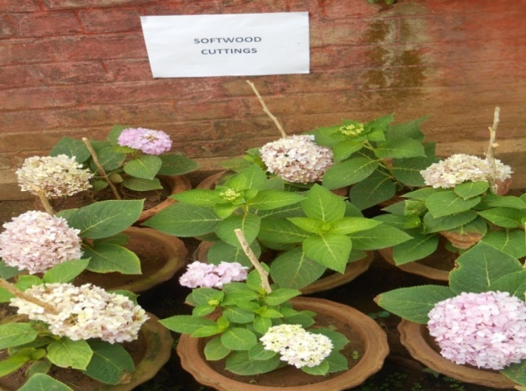

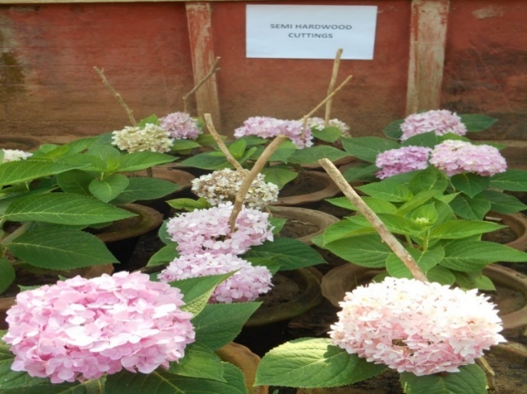

**Fig.1.b: Plants grown out of Semi-hardwood cuttings**

**Fig.1.a: Plants grown out of Soft-wood cuttings**

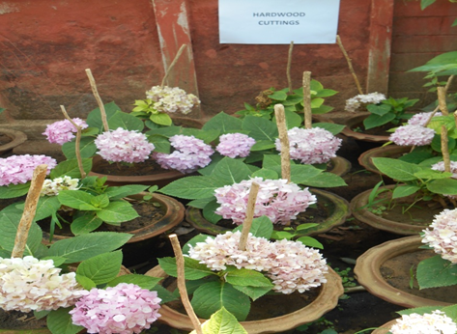

**Fig. 1.c: Plants grown out of hardwood cutting**

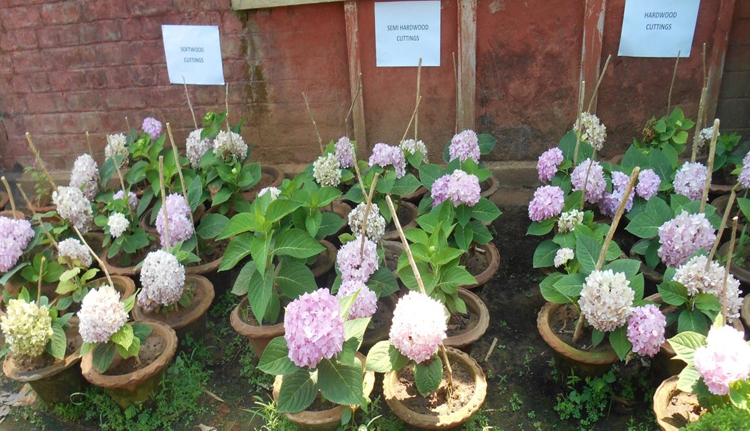

**Fig. 2: General view of the potted cuttings at flowering**

**3.5. Summary of Findings**

Overall, softwood cuttings resulted in the most desirable combination of traits: early flowering, larger flower heads, greater leaf area, and extended flower longevity. These results validate the role of cutting maturity in determining subsequent plant performance. Juvenile tissues retain superior regenerative and physiological capacities, making them ideal for both propagation and ornamental display purposes.

**4. CONCLUSION**

The maturity of stem cuttings has a pronounced effect on the vegetative and floral development of *Hydrangea macrophylla* grown under subtropical pot culture. Among the three types tested, softwood cuttings demonstrated superior performance across most growth and reproductive parameters, including greater plant height, increased branching, larger leaf area, earlier flower bud initiation, larger flower head diameter, and prolonged flower life. These outcomes highlight the physiological advantages of juvenile plant tissues in terms of both vegetative vigor and floral quality.

Although hardwood cuttings showed marginally higher flower head numbers, the overall quality and longevity of blooms from softwood-derived plants make them more suitable for ornamental and potential commercial use. The findings of this study provide practical recommendations for nursery managers and floriculture practitioners seeking to optimize *Hydrangea macrophylla* production in containers under warm winter climates. Future studies may explore seasonal influences or integrate microbial inoculants to further enhance flowering performance and stress resilience. The findings may be directly applied by floriculture nurseries in warm sub-tropical climates to enhance quality and reduce production time in *Hydrangea macrophylla* pot culture

**Disclaimer (Artificial intelligence)**

Author(s) hereby declares that NO generative AI technologies such as Large Language Models (ChatGPT, COPILOT, etc.) and text-to-image generators have been used during the writing or editing of this manuscript.

**5. REFERENCES**

Bhattacharjee SK, Rani A, Singh N. Standardization of propagation of Hibiscus rosa-sinensis Linn. from stem cuttings. Indian Journal of Horticulture. 1986;43(3–4):235–241.

Bowden, A. T. (2022). *Non-traditional adjuvants and methods for applying root-promoting compounds in commercial cutting propagation*. Mississippi State University.

De Klerk, G. J., Van der Krieken, W., & De Jong, J. C. (1999). The formation of adventitious roots: new concepts, new possibilities. In Vitro Cellular & Developmental Biology - Plant, 35(3), 189–199.<https://doi.org/10.1007/s11627-999-0031-y>

Du Monceau, H. L. D. (1758). *La Physique Des Arbres Où Il Est Traité De L'Anatomie Des Plantes Et De L'Economie Végétale: Pour servir d'Introduction au Traité complet des Bois & des Forests; Avec Une Dissertation Sur L'Utilité des Méthodes de Botanique Et une Explication des termes propres à cette Science et qui sont en usage pour l'exploitation des Bois et des Forêts* (Vol. 2). Guerin & Delatour.

Hudson, M. K., Elkington, S. R., Lyon, J. G., Marchenko, V. A., Roth, I., Temerin, M., ... & Wygant, J. R. (1997). Simulations of radiation belt formation during storm sudden commencements. *Journal of Geophysical Research: Space Physics*, *102*(A7), 14087-14102.

Jena, S. S., Tripathy, L., Beura, S., Dash, S. K., Maharana, K., & Jena, P. (2025). *In vitro* Optimization of Protocol for Micropropagation in Cordyline [*Cordyline terminalis* (L.) Kunth]. *Journal of Advances in Biology & Biotechnology*, ***28***(6), 880–912. <https://doi.org/10.9734/jabb/2025/v28i62449>

Jena, S. S., Tripathy, L., Maharana, K., & Jena, P. (2025). Bioenzyme-mediated growth enhancement in Cordyline (Cordyline terminalis): A developmental study. *Plant Cell Biotechnology and Molecular Biology*, ***26***(7-8), 116-132.

Sahoo, T. T., Maharana, K., Beura, S., & Jena, S. S. (2025). Effect of Indole-3-butyric Acid, Aspirin and Natural Plant Extracts on Rooting of Chrysanthemum (*Dendranthema grandiflora* L.) cv. Flirt. *Asian Journal of Research in Biochemistry*, ***15***(4), 30–50. <https://doi.org/10.9734/ajrb/2025/v15i4405>

van der Lek, H. A. A. (1925). *Over de wortelvorming van houtige stekken* (No. 1). H. Veenman & Zonen.

Liu, Y., Lyu, T., & Lyu, Y. (2023). Study on the flower induction mechanism of Hydrangea macrophylla. International journal of molecular sciences, 24(9), 7691.