**Development, evaluation and diversity analysis of high biomass multi-cut forage pearl millet composite varieties for green fodder yield and its contributing traits**

**Abstract**

Evaluation of the high biomass forage pearl millet parental lines and the creation of the first cycle high biomass multi-cut forage pearl millet composite were the two main goals of the current study. A parental evaluation experiment and a composite varieties evaluation along with check experiment were both carried out. The first experiment was carried out during Kharif 2024, when all parents were planted in a single row with a spacing of 60 cm and 2 m length. Data on twelve morphological features was gathered for the parents. Two recently created composite varieties and commercial check wonderleaf were planted in eight rows, each measuring two meters in length and sixty centimeters apart, during the summer of 2025. Four of the eight rows were employed to collect data, and the remaining four rows were used to cut green fodder. Based on the regrowth state of each of the three entrants, a total of four cuts were made. For varietal trial data were collected on six quantitative traits. Parental diversity was analyzed using GRAPES and NCSS 2025 software, while varieties were identified based on mean data. Two parents from each of the two varieties, HBFCVP4 and HBFCVP7 of HBFCV-1 were discovered to be extremely diverse, while HBFCVP9 and HBFCVP14 were determined to be extremely diverse parents of HBFCV-2. Among the two newly developed varieties, High Biomass Forage Composite Variety-1-C1 was found promising for green fodder yield (20.6 t ha-1) (HBFCV-1-C1). This study concludes that four parental lines can be further utilized for development of single cross forage hybrids and identified variety can be directly promoted for second cycle of random mating or half sibs of these F1s can be used directly for line development of forage pearl millet.

1. **Introduction**

Pearl millet fodder demand in India is significant, driven by the country's large livestock population and the crop's drought-tolerant nature. The demand for fodder is expected to rise by 25% by 2030, making pearl millet a vital crop for meeting this demand. India faces a significant fodder deficit, which poses a serious challenge to the livestock sector and overall agricultural economy. The country is a deficit in fodder. The ICAR- Indian Grassland and Fodder Research Institute (IGFRI), Jhansi has estimated that there is deficit of 11.24%, 23.4 % and 28.9% in green fodder, dry fodder and concentrates respectively. The genetic heterogeneity of composites can contribute to their adaptability and stability of performance across various environments. Composites, especially those used for developing hybrid parents, have the potential to accelerate genetic gains for yield and other desirable traits in hybrids. Composites can be specifically developed to improve particular traits like drought tolerance, disease resistance, or nutritional quality. This allows breeders to focus selection efforts on those desired characteristics (Yadav *et al*. 2013). In essence, first-cycle composites provide the raw genetic material and a foundation for the subsequent development of improved open-pollinated varieties and hybrid parents, contributing significantly to advancements in pearl millet breeding (Govindaraj *et al*. 2019). The first cycle composite serves as the starting point, possessing a broad genetic base and high genetic variability (Rattunde *et al*. 1993). Based on reviews, the purpose of this research was to identify diverse high biomass forage parents and to recombine them to broaden the genetic base of forage breeding material. This article describes the characterization of new forage lines and strategies for their introgression of genes of interest into the commercial variety (Sharma *et al*. 2020).

1. **Methodology**

**2.1 Development of cycle 1 high biomass multi-cut forage pearl millet composites**

A cycle 1 composites in pearl millet were developed through a process involving random mating of selected parental lines. Total sixteen high biomass parental lines (8 lines each composite) were selected for developing the high biomass multi-cut forage composites (Table 1). These lines were planted during *kharif* 2024 for phenotypic evaluation. Each parent was planted as one row each with 2m length and 60 cm row to row spacing. Recommended dose of fertilizer and agronomic practices were followed for best agronomic performance of parental lines and data were recorded for twelve morphological traits *viz.,* Basal pigmentation, Plant height (cm), Number of tillers, Stem girth (cm), Number of leaves, Leaf length (cm), Leaf width (cm), Panicle length (cm), Panicle girth (cm), Blast, Downy Mildew and Rust score (Table 2 and 4). All parental lines of each composite varieties were random mated during kharif season of 2024 at Foragen Seeds R&D Farm, Hyderabad (Latitude 17.66 and Longitude 78.45) and harvested the seeds from the randomly mated plants. These seeds represent the Cycle 1 (C1) bulk of the composite.

**2.2 Evaluation of cycle 1 high biomass multi-cut forage pearl millet composites**

All sixteen first cycle random mated F1s (8 from each) were harvested and bulked the equal quantity of seed for evaluation. Bulk seed of each first cycle (C1) composites were planted with 8 rows each along with our commercial fodder hybrid Wonderleaf for comparison, however, 4 rows used for observation and 4 rows for collecting the multi-cut data. Plot size was 2m row length, 60 cm spacing and un-replicated. Data were collected on quantitative traits *viz.* Days to 50% flowering, Plant height (cm), Panicle length (cm), Number of leaves, GFY: Green fodder yield (t/ha) and Plant population (Table 4).

**2.3 Statistical analysis**

These parental lines underwent basic statistical analysis for knowing the variability among the selected parental lines (Table 2 and 4). Clustering of both composite parental lines were done using software, NCSS 2025, v25.0.2 by Group Average (Unweighted Pair-Group) clustering method.

**Table 1: Parentage of high biomass composite variety-1 and 2 (HBFCV-1-C1 and HBFCV-2-C1)**

|  |  |  |  |
| --- | --- | --- | --- |
| **Varieties** | **Parent code** | **Source** | **Pedigree** |
| **HBFCV-1-C1** | **HBFCVP1** | Foragen Seeds | K2024-FVP-1 |
| **HBFCVP2** | Foragen Seeds | K2024-FV1P-2 |
| **HBFCVP3** | Foragen Seeds | K2024-FV1P-3 |
| **HBFCVP4** | Foragen Seeds | K2024-FV1P-4 |
| **HBFCVP5** | Foragen Seeds | K2024-FV1P-5 |
| **HBFCVP6** | Foragen Seeds | K2024-FV1P-6 |
| **HBFCVP7** | Foragen Seeds | K2024-FV1P-7 |
| **HBFCVP8** | Foragen Seeds | K2024-FV1P-8 |
| **HBFCV-2-C1** | **HBFCVP9** | Foragen Seeds | K2024-FVP-9 |
| **HBFCVP10** | Foragen Seeds | K2024-FVP-10 |
| **HBFCVP11** | Foragen Seeds | K2024-FVP-11 |
| **HBFCVP12** | Foragen Seeds | K2024-FVP-12 |
| **HBFCVP13** | Foragen Seeds | K2024-FVP-13 |
| **HBFCVP14** | Foragen Seeds | K2024-FVP-14 |
| **HBFCVP15** | Foragen Seeds | K2024-FVP-15 |
| **HBFCVP16** | Foragen Seeds | K2024-FVP-16 |

**\*HBFCVP-**High Biomass Forage Composite Variety Parent numbers

**3. Result and discussion**

**3.1 Basic statistics**

The result of basic statistical analysis *viz*., maximum, minimum, mean, standard error of mean (SEM) and coefficient of variation (CV) for all traits indicated the existence of diversity among the all the parents involved in both high biomass multi-cut forage pearl millet composite varieties were highly diverse and were free from blast, downy mildew and rust diseases (Table 3 and 5). Among the traits of both the composite varieties, number of tillers, panicle length and panicle girth were recorded high variation, while leaf length recorded lowest variation. The range of variation observed for these traits provided great opportunity to utilize these parental lines for composite variety development.

**3.2 Cluster analysis**

The hierarchical clustering pattern of parental lines of high biomass multi-cut forage pearl millet composite varieties based on Mahalanobis squared Euclidean distance matrix obtained from quantitative data using Ward method is depicted in figure 1 and 2. These significant differences reveals the diverse genetic composition of the composite comprising of dissimilar parents (Nehra *et al*. 2016). Clustering pattern among high biomass multi-cut forage pearl millet composite varieties-1 parents grouping showed cluster I & II was large group consisting of 3 lines each, however cluster III & IV having one line each. For high biomass multi-cut forage pearl millet composite varieties-2 parents, cluster I, II and III were having 2 lines each and cluster IV and V having one line each. Based on phenotypic data, the initial assessment of breeding material to choose strong parents for a hybridization program is quick, easy, and may be thought of as a universal method for determining genetic diversity among genetically different lines. Likewise, Pearl millet genetic material was grouped according to quantitative data by Shanmuganathan *et al*., (2006), Vidhyadhar and Devi (2007), Govindaraj *et al*., (2011), Drabo *et al*., (2013), Sathya *et al*., (2013), Upadhyaya *et al*., (2013), Sankar *et al*., (2014), Chaudhary *et al*., (2015), Kumar *et al*., (2015) and Radhika Ramya *et al*. (2017).

**3.3 Principal component analysis**

Tables 6 and 7 as well as Figure 3 and 4 displayed the findings of the main component analysis for total green fodder yield and associated characteristics across pooled environments. When combined, the three main components of the high biomass composite variety-1 parents, each with an eigenvalue greater than one, explained 86.7% of the variability. In a similar vein, the first three components of high biomass composite variety-2 parents indicated 86.6%. For the parents of both composite varieties, the percentage variability explained for PC1, PC2, and PC3 was 35.0, 31.4, 20.3 and 36.6, 26.9, and 23.25, respectively. With high positive loadings for traits like leaf length and leaf width, the first principal component of the high biomass composite variety-1 parent data explains the most variation in the dataset. This suggests that the traits have a significant impact on the overall variation. The high biomass composite variety-2 parent data also explains the most variation with high positive loadings for traits like number of tillers, leaf length, and leaf width.

The first two principal components for the high biomass composite variety-1 parent data are represented by the two primary axes of the PCA biplot, Dim1 (36.6%) and Dim2 (36.9%). Similarly, the first two principal components for high biomass composite variety-2 parent data are represented by the two primary axes, Dim1 (35.0%) and Dim2 (31.4%). The trait contributions to the primary components are shown by the arrows. The association is stronger when the arrow is longer. Dim 1 is substantially positively correlated with the number of tillers, while Dim 2 is more strongly correlated with panicle girth. The most significant characteristics influencing the overall variation in the data were found using principal component analysis. Three principal components were found to account for 86% of the overall variability in the both varietal parent’s data set when associated factors were broken down into independent components. While leaf length was crucial for the second component, characteristics including the number of tillers, panicle length, and panicle girth significantly influenced the first component. Strong reliability with research on fodder pearl millet by Gupta *et al*. 2022 and Khandelwal *et al*. 2023 is explained by the results of this study. Patterns seen in earlier pearl millet research are reflected in the identification of important characteristics that affect yield and quality, such as plant height, dry fodder production, and productive tillers.

**Table 2: Quantitative traits of parents involved in development of high biomass composite variety-1 (C1)**

|  |  |  |  |  |  |  |  |  |  |  |  |  |
| --- | --- | --- | --- | --- | --- | --- | --- | --- | --- | --- | --- | --- |
| **Parents Code** | **BP** | **PH** | **NOT** | **SG** | **NOL** | **LL** | **LW** | **PL** | **PG** | **Blast** | **DM** | **Rust** |
| **HBFCVP1** | Purple | 255 | 6 | 1.48 | 5 | 61.1 | 2.0 | 27 | 1.1 | Blast resistant | DM resistant | Rust free |
| **HBFCVP2** | Green | 235 | 4 | 1.04 | 8 | 45.0 | 3.5 | 35 | 1.3 | Blast resistant | DM resistant | Rust free |
| **HBFCVP3** | Green | 248 | 5 | 1.1 | 7 | 42.0 | 3.0 | 33 | 1.4 | Blast resistant | DM resistant | Rust free |
| **HBFCVP4** | Purple | 285 | 9 | 1.28 | 10 | 47.0 | 2.0 | 30 | 2.0 | Blast resistant | DM resistant | Rust free |
| **HBFCVP5** | Purple | 255 | 8 | 1.07 | 6 | 58.0 | 3.0 | 16 | 1.0 | Blast resistant | DM resistant | Rust free |
| **HBFCVP6** | Purple | 255 | 8 | 1.07 | 6 | 58.0 | 3.0 | 16 | 1.0 | Blast resistant | DM resistant | Rust free |
| **HBFCVP7** | Purple | 190 | 7 | 1.53 | 5 | 61.1 | 5.0 | 35 | 1.7 | Blast resistant | DM resistant | Rust free |
| **HBFCVP8** | Purple | 250 | 6 | 1.2 | 9 | 55.5 | 3.5 | 35 | 1.3 | Blast resistant | DM resistant | Rust free |

HBFCVP: High biomass forage composite variety parent numbers; BP: Basal pigmentation; PH: Plant height (cm); NOT: Number of tillers; SG: Stem girth (cm); NOL: Number of leaves; LL: Leaf length (cm); LW: Leaf width (cm); PL: Panicle length (cm); PG: Panicle girth (cm), Blast, Downy Mildew and Rust score.

**Table 3: Summary Statistics for quantitative traits of high biomass composite variety-1 (C1)**

|  |  |  |  |  |  |  |  |  |
| --- | --- | --- | --- | --- | --- | --- | --- | --- |
| **Measures** | **PH** | **NOT** | **SG** | **NOL** | **LL** | **LW** | **PL** | **PG** |
| **Min** | 190 | 4 | 1.04 | 5 | 42 | 2 | 16 | 1 |
| **Max** | 285 | 9 | 1.53 | 10 | 61.1 | 5 | 35 | 2 |
| **Mean** | 246.62 | 6.62 | 1.22 | 7 | 53.46 | 3.12 | 28.38 | 1.35 |
| **SE.mean** | 9.48 | 0.6 | 0.07 | 0.65 | 2.7 | 0.34 | 2.88 | 0.12 |
| **Var** | 719.7 | 2.84 | 0.04 | 3.43 | 58.11 | 0.91 | 66.27 | 0.12 |
| **Std.dev** | 26.83 | 1.69 | 0.19 | 1.85 | 7.62 | 0.95 | 8.14 | 0.35 |
| **Coef.var** | 0.11 | 0.25 | 0.16 | 0.26 | 0.14 | 0.31 | 0.29 | 0.26 |

PH: Plant height (cm); NOT: Number of tillers; SG: Stem girth (cm); NOL: Number of leaves; LL: Leaf length (cm); LW: Leaf width (cm); PL: Panicle length (cm); and PG: Panicle girth (cm)

**Table 4: Quantitative traits of parent involved in development of high biomass composite variety-2 (C1)**

|  |  |  |  |  |  |  |  |  |  |  |  |  |
| --- | --- | --- | --- | --- | --- | --- | --- | --- | --- | --- | --- | --- |
| **Parents Code** | **BP** | **PH** | **NOT** | **SG** | **NOL** | **LL** | **LW** | **PL** | **PG** | **Blast** | **DM** | **Rust** |
| **HBFCVP9** | Purple | 285 | 5 | 0.9 | 6 | 60 | 3.0 | 30 | 2.8 | Blast resistant | DM resistant | Rust free |
| **HBFCVP10** | Green | 200 | 5 | 1.3 | 5 | 50 | 4.0 | 35 | 2.1 | Blast resistant | DM resistant | Rust free |
| **HBFCVP11** | Green | 200 | 5 | 1.3 | 5 | 50 | 4.0 | 35 | 2.1 | Blast resistant | DM resistant | Rust free |
| **HBFCVP12** | Purple | 205 | 8 | 0.8 | 6 | 58 | 3.0 | 30 | 1.6 | Blast resistant | DM resistant | Rust free |
| **HBFCVP13** | Purple | 205 | 8 | 0.8 | 6 | 58 | 3.0 | 30 | 1.6 | Blast resistant | DM resistant | Rust free |
| **HBFCVP14** | Purple | 240 | 8 | 1.7 | 6 | 70 | 5.1 | 17 | 1.7 | Blast resistant | DM resistant | Rust free |
| **HBFCVP15** | Purple | 160 | 6 | 1.2 | 6 | 62 | 4.0 | 43 | 2.3 | Blast resistant | DM resistant | Rust free |
| **HBFCVP16** | Purple | 70 | 10 | 1.2 | 6 | 60 | 4.0 | 38 | 1.7 | Blast resistant | DM resistant | Rust free |

HBFCVP: High biomass forage composite variety parent numbers; BP: Basal pigmentation; PH: Plant height (cm); NOT: Number of tillers; SG: Stem girth (cm); NOL: Number of leaves; LL: Leaf length (cm); LW: Leaf width (cm); PL: Panicle length (cm); PG: Panicle girth (cm).

**Table 5: Summary Statistics for quantitative traits of high biomass composite variety-2 (C1)**

|  |  |  |  |  |  |  |  |  |
| --- | --- | --- | --- | --- | --- | --- | --- | --- |
| **Measures** | **PH** | **NOT** | **SG** | **NOL** | **LL** | **LW** | **PL** | **PG** |
| **Min** | 70 | 5 | 0.85 | 5 | 50 | 3 | 17 | 1.6 |
| **Max** | 285 | 10 | 1.73 | 6 | 70 | 5.1 | 43 | 2.8 |
| **Mean** | 195.62 | 6.88 | 1.18 | 5.75 | 58.5 | 3.76 | 32.25 | 1.99 |
| **SE.mean** | 22.05 | 0.67 | 0.11 | 0.16 | 2.29 | 0.26 | 2.71 | 0.15 |
| **Var** | 3888.84 | 3.55 | 0.09 | 0.21 | 42 | 0.54 | 58.79 | 0.18 |
| **Std.dev** | 62.36 | 1.89 | 0.3 | 0.46 | 6.48 | 0.73 | 7.67 | 0.42 |
| **Coef.var** | 0.32 | 0.27 | 0.25 | 0.08 | 0.11 | 0.19 | 0.24 | 0.21 |

PH: Plant height (cm); NOT: Number of tillers; SG: Stem girth (cm); NOL: Number of leaves; LL: Leaf length (cm); LW: Leaf width (cm); PL: Panicle length (cm); and PG: Panicle girth (cm)



**Fig 1.** Dendrogram showing the clustering pattern of eight parental lines of pearl millet of high biomass multi-cut forage composite variety-1 (HBBFCV-1).



**Fig 2.** Dendrogram showing the clustering pattern of eight parental lines of pearl millet of high biomass multi-cut forage composite variety-2 (HBBFCV-2).

**Table 6: The eigen values, per cent variation and per cent cumulative variation for eight Principal Components (PCs) and factor loading between PCs and traits studied in high biomass composite variety-1 parents**

|  |  |  |  |  |  |  |  |  |
| --- | --- | --- | --- | --- | --- | --- | --- | --- |
| **Principal components** | **PC1** | **PC2** | **PC3** | **PC4** | **PC5** | **PC6** | **PC7** | **PC8** |
| **Eigen value** | 2.8 | 2.5 | 1.6 | 0.8 | 0.3 | 0.0 | 0.0 | 0.0 |
| **% of variance** | 35.0 | 31.4 | 20.3 | 9.4 | 3.8 | 0.1 | 0.0 | 0.0 |
| **% cumulative variance** | 35.0 | 66.4 | 86.7 | 96.1 | 99.9 | 100.0 | 100.0 | 0.0 |
| **Factor Loading** |  |  |  |  |  |  |  |  |
| **Plant height** | -0.55 | 0.17 | -0.13 | 0.21 | -0.15 | -0.48 | 0.23 | -0.55 |
| **Number of tillers** | -0.12 | 0.33 | -0.57 | -0.47 | 0.08 | -0.36 | -0.10 | 0.43 |
| **Stem girth** | 0.35 | -0.06 | -0.54 | 0.49 | 0.00 | -0.08 | -0.54 | -0.22 |
| **Number of leaves** | -0.44 | -0.34 | -0.13 | -0.22 | -0.63 | 0.31 | -0.37 | 0.02 |
| **Leaf length** | 0.37 | 0.41 | -0.23 | 0.06 | -0.61 | 0.24 | 0.46 | -0.03 |
| **Leaf width** | 0.46 | -0.21 | 0.13 | -0.59 | -0.16 | -0.35 | -0.10 | -0.48 |
| **Panicle length** | 0.12 | -0.59 | -0.04 | 0.26 | -0.25 | -0.48 | 0.32 | 0.42 |
| **Panicle girth** | -0.06 | -0.43 | -0.54 | -0.17 | 0.35 | 0.36 | 0.43 | -0.25 |

**Table 7: The eigen values, per cent variation and per cent cumulative variation for eight Principal Components (PCs) and factor loading between PCs and traits studied in high biomass composite variety-2 parents**

|  |  |  |  |  |  |  |  |  |
| --- | --- | --- | --- | --- | --- | --- | --- | --- |
| **Principal components** | **PC1** | **PC2** | **PC3** | **PC4** | **PC5** | **PC6** | **PC7** | **PC8** |
| **Eigen value** | 2.93 | 2.16 | 1.86 | 0.96 | 0.09 | 0.00 | 0.00 | 0.00 |
| **% of variance** | 36.61 | 26.94 | 23.25 | 12.05 | 1.15 | 0.00 | 0.00 | 0.00 |
| **% cumulative variance** | 36.61 | 63.55 | 86.80 | 98.85 | 100.00 | 100.00 | 100.00 | 0.00 |
| **Factor Loading** |  |  |  |  |  |  |  |  |
| **Plant height** | -0.16 | 0.24 | -0.63 | 0.23 | -0.26 | 0.19 | 0.58 | -0.17 |
| **Number of tillers** | 0.48 | -0.33 | 0.16 | 0.11 | 0.52 | 0.09 | 0.53 | -0.27 |
| **Stem girth** | 0.26 | 0.58 | 0.21 | -0.13 | 0.04 | 0.69 | -0.17 | -0.22 |
| **Number of leaves** | 0.36 | -0.35 | -0.33 | -0.39 | -0.16 | 0.38 | 0.01 | 0.56 |
| **Leaf length** | 0.48 | 0.04 | -0.31 | -0.38 | -0.24 | -0.39 | -0.21 | -0.52 |
| **Leaf width** | 0.29 | 0.53 | 0.25 | -0.13 | -0.09 | -0.41 | 0.41 | 0.45 |
| **Panicle length** | -0.30 | -0.24 | 0.44 | -0.49 | -0.44 | 0.13 | 0.38 | -0.24 |
| **Panicle girth** | -0.38 | 0.18 | -0.25 | -0.61 | 0.62 | -0.06 | 0.07 | 0.00 |

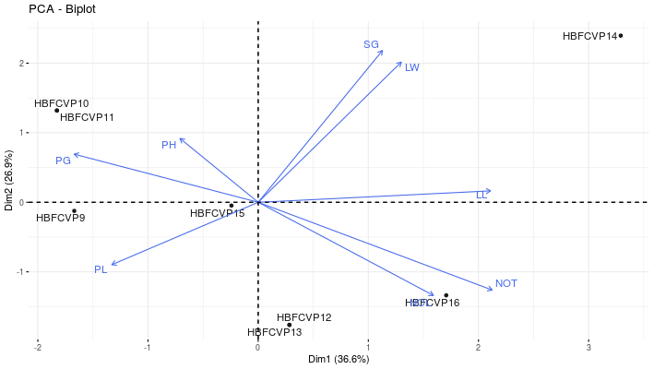

**Figure 3:** Principal component analysis (PCA) biplot showing trait distribution for high biomass forage composite variety-1

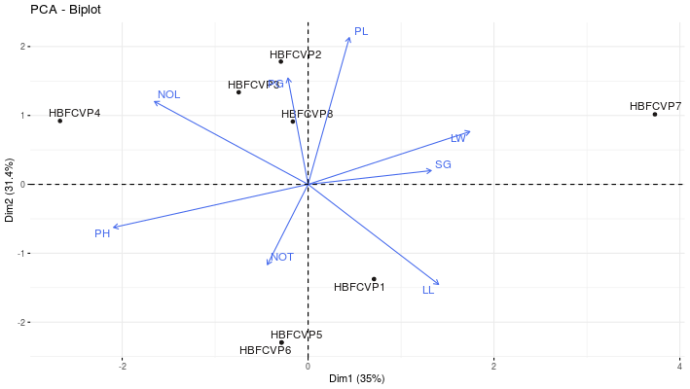

**Figure 4:** Principal component analysis (PCA) biplot showing trait distribution for high biomass forage composite variety-2

**3.4 Varietal performance with commercial check wonderleaf**

The multi-cut performance of newly developed first cycle high biomass forage pearl millet varieties presented in Table 8. Among two, High Biomass Forage Composite Variety-1 (HBFV-1-C1) was top yielded over check wonderleaf. Compare to cuts, first cut green fodder yield of both the varieties and check was higher at 50 days, whereas 2nd cut green fodder yield of both varieties was less compare to wonderleaf but in 3rd cut green fodder yield of check was drastically reduced. So, this fluctuation in green fodder yield reveals that we further need to investigate these varieties with more number of commercial checks with different agronomic practices in target ecologies. This composite variety was having highest plant height, more number of leaves, 4-5 tillers, non-lodging, broad leaves, late flowering, thick and brown and green stem with rust resistance. So, we can explore this composite to next cycle advancement. Also, we can use half sibs for line development directly.

**Table 8: Multi-cut performance of newly developed high biomass forage composite varieties with check Wonderleaf during summer 2024**

|  |  |  |  |  |  |  |  |  |  |
| --- | --- | --- | --- | --- | --- | --- | --- | --- | --- |
| **Varieties & check** | **DFF** | **PH** | **PL** | **NOT** | **NOL** | **MGFY** | **Pl.P** | **Rank** | **Morphological traits** |
| High Biomass Forage Composite Variety-1 (HBFV-1-C1) | 63 | 249 | 25.6 | 4 | 9 | **20.6** | 60 | 1 | Bristled, Thick stem, broad leaves, pale green-green leaves, conical head, excellent exertion, purple glume, late. |
| High Biomass Forage Composite Variety-2 (HBFV-2-C1) | 58 | 247 | 28.0 | 6 | 8 | **19.0** | 62 | 3 | Conical, long thick head, non-bristled, green glumes, hairy & non hairy plants (more non-hairy plants), medium broad leaves. |
| Wonderleaf | 55 | 221 | 26.6 | 6 | 8 | **20.9** | 67 | 2 | Tall, medium flowering, medium thick-thin stem tillering, medium thick conical heads, lower leaves dried, narrow leaves |

DFF: Days to 50% flowering; PH: Plant height (cm); PL: Panicle length (cm); NOL: Number of leaves; MGFY: Mean Green fodder yield (t/ha); Pl.P: Plant population.

**# Cuts:** 1st cut at 50 days, 2nd cut at 22 days, 3rd cut at 16 days and 4th cut at 12 days. All cuts did were based on regrowth.

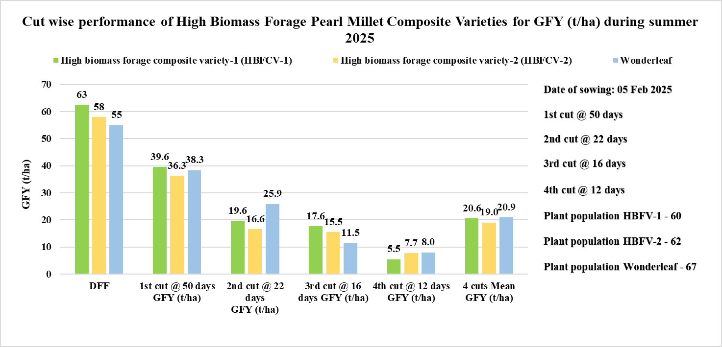

**Graph 1: Cut wise performance of High Biomass Forage Pearl Millet Composite Varieties for GFY (t/ha) during summer 2025**

**Plate 1: Performance of HBFCV-1 (CI), HBFCV-2 (C2) and Wonderleaf at 50 days**

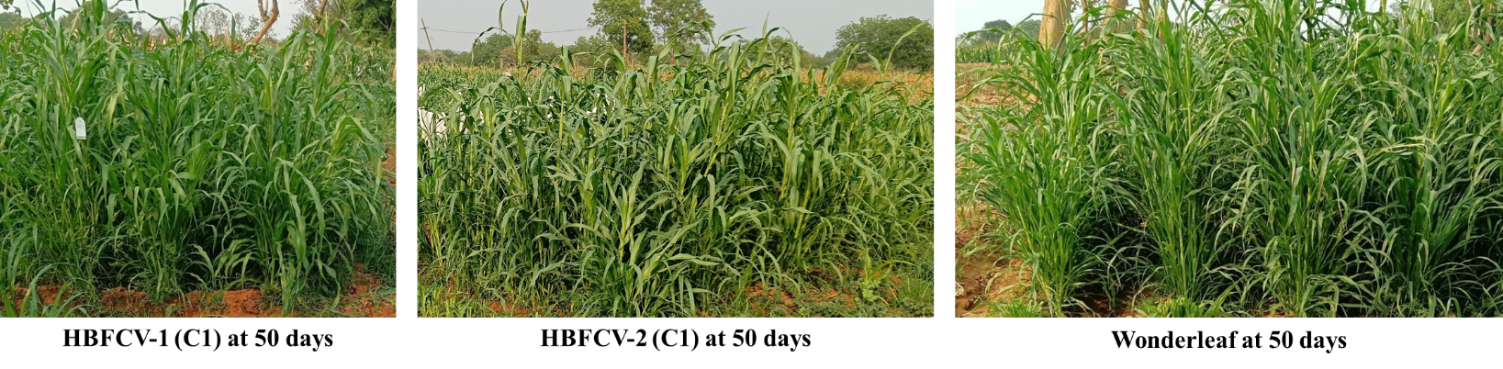

**4. Conclusion:**

The present research concluded that the parental lines involved in the development of high biomass forage composite varieties were highly diverse and these parental lines can be exploited for development of forage pearl millet hybrids. Also, the variety, HBFCV-1 was performed well at R&D station. So, this variety will be promoted for next cycle and half sib of this cycle 1 random mated F1s will be utilized for development of high fodder yielding lines.

**Consent:** All authors read, reviewed, agreed and approved the final manuscript. Note-All authors agreed that-Written informed consent was obtained from all participants prior to publish/enrolment.

**Ethical approval:** This article does not contain any studies with human participants or animals performed by any of the authors. Ethical Committee Approval Number: Nil

**COMPETING INTERESTS DISCLAIMER:**

Authors have declared that they have no known competing financial interests OR non-financial interests OR personal relationships that could have appeared to influence the work reported in this paper.

Disclaimer (Artificial intelligence)

Author(s) hereby declare that NO generative AI technologies such as Large Language Models (ChatGPT, COPILOT, etc.) and text-to-image generators have been used during the writing or editing of this manuscript.

**5. Referrences**

Mamta Nehra, Mukesh Kumar, Dev Vart, Rajesh Kumar Sharma and Mukesh Choudhary DUS characterization and diversity assessment in pearl millet inbreds. 2017. *Electronic Journal of Plant Breeding*, 7 4, 925-933.

Shanmuganathan, Murugappan & Gopalan, A & Mohanraj, K. (2006). Genetic variability and multivariate analysis in pearl millet (*Pennisetum glaucum* (L.) R. Br.) germplasm for dual purpose. *Journal of Agricultural Sciences*. 2. 10.4038/jas.v2i1.8115.

Vidyadhar, B., P Chand. S L Devi, I., M V S Reddy, and D.Ramachandraiah, (2004). Variability and correlation analysis for the yield attributes in pearl millet (*Pennisetum glaucum* (L.) R. Br.) germplasm. In: 3rd National seminar on millet research and development – Future policy options in India. (Eds). Y.K. Sharma and I.S. Khairwal, Jodhupur, India, pp. 12.

Govindaraj, Mahalingam & Selvi, Basil & Rajarathinam, S & Vetri, Sumathi. (2011). Genetic variability and heritability of grain yield components and grain mineral concentration in India's pearl millet (*Pennisetum glaucum* (L) R. Br.) accessions. *African Journal of Food, Agriculture, Nutrition and Development.* 11. 10.4314/ajfand.v11i3.66627.

Drabo, I., Zangre, G.R., Sawadogo, M. and Ouedraogo, M. 2013. Genetic variability and estimates of genetic parameters in Burkina faso’s pearl millet landraces. *International Journal of Agriculture and Forestry* 3(7): 367-373. DOI: 5923/j.ijaf.20130307.17

Sathya M, Vinodhana NK, Sumathi P. Hierarchial clustering of pearl millet (*Pennisetum glaucum* (L.) R.Br) inbreeds for morpho-physiological traits. IJCMAS. 2013; 2(12): 647-52.

Upadhyaya, H. D., Reddy, K. N., Ahmed, M. I., Kumar, V., Gumma, M. K., & Ramachandran, S. (2016). Geographical distribution of traits and diversity in the world collection of pearl millet [*Pennisetum glaucum* (L.) R. Br., synonym: *Cenchrus americanus* (L.) Morrone] landraces conserved at the ICRISAT genebank. Genetic Resources and Crop Evolution, 64(6), 1365–1381. doi:10.1007/s10722-016-0442-8.

Sankar SM, Satyavathi CT, Singh SP, Singh MP, Bharadwaj C, Barthakur S. Genetic diversity analysis for high temperature stress tolerance in pearl millet [*Pennisetum glaucum* (L.) R. Br]. *Indian Journal of Plant Physiology*. 2014; 19(4):324-329.

Chaudhary S, Sagar P, Hooda BK, Arya RK. Multivariate analysis of pearl millet data to delineate genetic variation. *Forage Research*. 2015; 40 (4):201-208.

Kumar R, Verma U, Malik V, Vart D. Multivariate analysis for selection of diverse genotypes in pearl millet germplasm*, Forage Research. 2015; 41(2):73-77.*

Radhika Ramya A, Ahamed ML, Srivastava RK. Genetic diversity analysis among inbred lines of pearl millet (*Pennisetum glaucum* (L.) R. Br.) based on grain yield and yield component characters. *International Journal of Current Microbiology and Applied Science*. 6 (6), 2240-2250.

Khandelwal, vikas. (2023). Multivariate Analysis in Pearl Millet Parental Lines for Diversity Estimation and Association Study of Yield Contributing Traits for Genetic Improvement of Hybrids: Diversity analysis of pearl millet. *Annals of Arid Zone*, 62(1), 65-75. <https://doi.org/10.59512/aaz.2023.62.1.7>.

Yadav, O.P. and Rai, K.N. (2013) Genetic Improvement of Pearl Millet in India. *Agricultural Research*, 2, 275-292. <http://dx.doi.org/10.1007/s40003-013-0089-z>.

Govindaraj, M., Rai, K. N., Cherian, B., Pfeiffer, W. H., Kanatti, A., & Shivade, H. (2019). Breeding Biofortified Pearl Millet Varieties and Hybrids to Enhance Millet Markets for Human Nutrition. *Agriculture*, 9(5), 106.Doi: 10.3390/agriculture 9050106.

Rattunde, H F W and Wrrcombe, J R (1993) Recurrent Selection for Increased Grain Yield and Resistance to Downy Mildew in Pearl Millet. *Plant Breeding*, 110 (1). pp. 63-72. ISSN 1439-0523.

Sharma, S., Sharma, R., Govindaraj, M., Mahala, R. S., Satyavathi, C. T., Srivastava, R. K., & Kilian, B. (2021). Harnessing wild relatives of pearl millet for germplasm enhancement: Challenges and opportunities. *Crop Science*, 61(1), 177-200.