**Morphological Characterization of Pebrine Spore Using Scanning Electron Microscopy**

**ABSTRACT**

The silkworm, *Bombyx mori* L. is susceptible to infection of various pathogenic organisms. Pebrine, one of the deadliest disease of silkworm caused by highly virulent microsporidian parasite, *Nosema bombycis*. Several strains and species of microsporidians have since been isolated from different regions. The primary objective of this study is to assess morphology and dimensions of pebrine spores using scanning electron microscopy (SEM) collected from different locations in Magadi taluk of Mysore seed area. The results revealed that the spores were ovo-cylindrical in shape with slight depression. On an average, the length × width measurements of these spores was 4.33 ± 0.03 × 2.13 ± 0.02 µm, closely resembled with *Nosema* sp. Lbms strain which measures 4.36 × 2.14 µm and also has a slight depression.

Key words: Pebrine spores, Mysore seed area, silkworm and SEM analysis,

**INTRODUCTION**

Silkworm, *Bombyx mori* L*.* a lepidopteran insect has marvellous ability to produce silk is considered as the most elegant textile. Owing to its unparalleled grandeur, natural sheen, high absorbance, light weight, soft touch and high durability. Worldwide silk is known as ‘Queen of Textiles’ (Vishaka and Narayanaswamy, 2018).

Mulberry silkworm, *B. mori is* the primary producer of commercial silk and domesticated for many centuries. Continuous indoor rearing of silkworms has rendered to lose its natural ability to withstand adverse climatic conditions resulting in infections causing crop loss or low yield leading to low silk productivity. Mulberry silkworm *Bombyx mori* L. is susceptible to number of diseases like flacherie, grasserie, pebrine and muscardine (Manakani *et al*., 2017). Silkworm diseases are highly contagious and the causative agents get easily dispersed leading to outbreak of diseases (Selvakumar *et al.,* 2005). Among all the diseases pebrine is the deadliest disease caused by microsporidian parasite, *Nosema bombycis* Nageli. The name pebrine was coined by De Quadrefagues (1860) because of pepper like spots on the diseased larvae in advanced stage of infection (Bhat and Nataraju, 2005).

By the end of 19th century, *N. bombycis* alone was found as causative agent of microsporidiosis in silkworm untill further research work revealed that there are several other microsporidia belonging to different genera *viz.,* *Nosema*, *Pleistophora, Thelohania, Vairomorpha and Leptomonas* spp.causing microsporidiosis in silkworm. The nature of transovarial transmission differs with different microsporidian strains infecting silkworms *viz.,* *Nosema* sp, (NIS-001, NIS-M11, NIS-M14, NIK-2r and NIK-3h), *Vairimorpha* sp. (NIS-M12 and NIK-4m), *Microsporidium* sp. (NIS-M25), *Pleistophora* sp. (NIS-M27), *Thelohania* sp. These microsporidians differ in their spore morphology, virulence, site of infection and nature of transmission (Hyslis *et al.,* 2006).

A burning problem in the field is the increasing number of different microsporidians that are being encountered in silkworm crops (Rao *et al.,* 2007). Several strains and species of microsporidia have since been isolated from the infected silkworms and the disease is becoming increasingly more and more complex (Bhat *et al*., 2009).

Even though the fight against pebrine has continued for more than a century, the loss due to the disease has not been completely eliminated (Chakrabarty *et al.,* 2012). During the year 2020-21 pebrine disease resurfaced in Magadi which was noticed by the state Department of Sericulture, GoK, Magadi taluk of Mysore seed area, Karnataka. With this background, the research problem entitled “Morphological characterization of pebrine spores using scanning electron microscopy**”** was formulated. The primary objective of this study is to assess morphology and dimensions of pebrine spores using scanning electron microscopy (SEM).

**MATERIAL AND METHODS**

Pebrine infected samples were collected from two government model grianages (Magadi and Kuduru) and farmers’ field (Soluru, Kuduru and Kalya hoblies).

**Isolation and purification of pebrine spores**

The pure microsporidia spores were extracted from infected moths by crushing them in a domestic mixer for 2 minutes by adding 4ml of 0.6 per cent of K2CO3 solution in the ratio of 1:4 (larvae: ml). Later, the homogenate was transferred into a beaker and allowed to settle for 3-5 minutes. The liquid was filtered through double layered fine mesh plastic strainer and the filtered liquid was centrifuged at 3000 rpm for 3 minutes. The supernatant was discarded and sediment was dispersed in a few drops of 2 per cent KOH solution over a cyclomixer. The spore solution was then added to a discontinuous sucrose gradient (25%, 50%, 75%, and 100% v/v, each at 5 mL volume in a 50-mL falcon) and centrifuged at 20,000 g for 40 min twice. Eventually, pure spores were placed between 75% and 100% sucrose levels, were obtained and suspended in distilled water and counted using hemocytometer under a phase-contrast light microscope. (Rahul *et al.,* 2021; Moharrami *et al*., 2022)

**Scanning Electron Microscopy (SEM)**

Pebrine spore samples were examined under a scanning electron microscope (SEM) at the Central Instrumentation Facility (CIF) of the University of Agricultural Sciences, Bangalore, located in GKVK, Bengaluru.

A homocytometer was used to count the spores and appropriate dilutions were then prepared on metal paper according to the standard protocol. Subsequently, initial stabilization of purified spores was conducted using glutraldehyde (2.5%) and phosphate buffer. The pellets were dehydrated through different grades of ethanol. One drop of each of the dehydrated samples was placed on the upper surface of the foil, dried, and fixed using osmium tetraoxide (2%). Eventually, the sample was held between the coating and the metallic copper stud using a silver-based paint. The copper stud was then placed in a vacuum evaporator that was connected to a high electrical voltage (20 kV) to place the gold vapor coating on the copper stud sample at 300°C. Imaging was performed using the FeSEM field emission microscope and all samples were observed (Moharrami *et al*., 2022).

The morphological data obtained from SEM of pebrine spores including length, width and shape was compared with the already exsiting morphological data of different microsporidian strains (Kawarabata, 2003; Singh and Saratchandra, 2003; Bhat *et al.,* 2009).

**RESULTS**

The pebrine spores obtained from the infected samples were isolated and subjected to SEM analysis for morphological characterization.

**Table 1: Shape and size of pebrine spores isolated from Government model grainage,**  **Magadi**

|  |  |  |  |
| --- | --- | --- | --- |
| **Sl. No.** | **Spore shape** | **Spore size** | |
| **Length (µm)** | **Width (µm)** |
| **1** | Ovo- cyclindrical | 4.31 | 2.14 |
| **2** | Ovo- cyclindrical | 4.30 | 2.13 |
| **3** | Ovo- cyclindrical | 4.29 | 2.12 |
| **4** | Ovo- cyclindrical | 4.32 | 2.15 |
| **5** | Ovo- cyclindrical | 4.35 | 2.10 |
| **Mean ± SD** |  | 4.31 ± 0.02 | 2.12 ± 0.01 |

The data in Table 1 shows the spore shape and size of pebrine spores isolated from Government Model Grainage, Magadi in Magadi taluk of Mysore seed area. The spores were ovo-cylindrical in shape with slight depression. The length × width measurements of different spores was ranged from 4.29 × 2.12 µm to 4.35 × 2.10 µm. On an average, the length × width measurements of these spores was 4.31 ± 0.02 × 2.12 ± 0.01 µm (Plate 1).

**Table 2: Shape and size of pebrine spores isolated from Government model grainage,**  **Kuduru**

|  |  |  |  |
| --- | --- | --- | --- |
| **Sl. No.** | **Spore shape** | **Spore size** | |
| **Length (µm)** | **Width (µm)** |
| **1** | Ovo- cyclindrical | 4.35 | 2.16 |
| **2** | Ovo- cyclindrical | 4.33 | 2.14 |
| **3** | Ovo- cyclindrical | 4.36 | 2.17 |
| **4** | Ovo- cyclindrical | 4.34 | 2.15 |
| **5** | Ovo- cyclindrical | 4.37 | 2.13 |
| **Mean ± SD** |  | 4.35 ± 0.01 | 2.15 ± 0.01 |

The data in Table 2 shows the spore shape and size of pebrine spores isolated from Government model grainage, Kuduru in Magadi taluk of Mysore seed area. The spores were ovo-cylindrical in shape with slight depression. The length × width measurements of different spores was ranged from 4.33 × 2.14 µm to 4.37 × 2.13 µm. On an average, the length × width measurements of these spores was 4.35 ± 0.01 × 2.15 ± 0.01 µm (Plate 1).

**Table 3: Shape and size of pebrine spores isolated from farmers’ field, Soluru hobli**

|  |  |  |  |
| --- | --- | --- | --- |
| **Sl. No.** | **Spore shape** | **Spore size** | |
| **Length (µm)** | **Width (µm)** |
| **1** | Ovo- cyclindrical | 4.33 | 2.15 |
| **2** | Ovo- cyclindrical | 4.36 | 2.13 |
| **3** | Ovo- cyclindrical | 4.31 | 2.12 |
| **4** | Ovo- cyclindrical | 4.33 | 2.10 |
| **5** | Ovo- cyclindrical | 4.34 | 2.15 |
| **Mean ± SD** |  | 4.33 ± 0.01 | 2.13 ± 0.01 |

The data in Table 3 shows the spore shape and size of pebrine spores isolated from farmers’ field, Soluru hobli in Magadi taluk of Mysore seed area. The spores were ovo-cylindrical in shape with slight depression. The length × width measurements of different spores was ranged from 4.33 × 2.14 µm to 4.37 × 2.13 µm. On an average, the length × width measurements of these spores was 4.35 ± 0.01 × 2.15 ± 0.01 µm (Plate 1).

**Table 4: Shape and size of pebrine spores isolated from farmers’ field, Kuduru hobli**

|  |  |  |  |
| --- | --- | --- | --- |
| **Sl. No.** | **Spore shape** | **Spore size** | |
| **Length (µm)** | **Width (µm)** |
| **1** | Ovo- cyclindrical | 4.30 | 2.12 |
| **2** | Ovo- cyclindrical | 4.33 | 2.15 |
| **3** | Ovo- cyclindrical | 4.34 | 2.13 |
| **4** | Ovo- cyclindrical | 4.36 | 2.11 |
| **5** | Ovo- cyclindrical | 4.31 | 2.14 |
| **Mean ± SD** |  | 4.32 ± 0.02 | 2.13 ± 0.01 |

The data in Table 4 shows the spore shape and size of pebrine spores isolated from farmers’ field, Kuduru hobli in Magadi taluk of Mysore seed area. The spores were ovo-cylindrical in shape with slight depression. The length × width measurements of different spores was ranged from 4.30 × 2.12 µm to 4.36 × 2.11 µm. On an average, the length × width measurements of these spores was 4.32 ± 0.02 × 2.13 ± 0.01 µm (Plate 1).

**Table 5: Shape and size of pebrine spores isolated from farmers’ field, Kalya hobli**

|  |  |  |  |
| --- | --- | --- | --- |
| **Sl. No.** | **Spore shape** | **Spore size** | |
| **Length (µm)** | **Width (µm)** |
| **1** | Ovo- cyclindrical | 4.34 | 2.14 |
| **2** | Ovo- cyclindrical | 4.33 | 2.13 |
| **3** | Ovo- cyclindrical | 4.32 | 2.12 |
| **4** | Ovo- cyclindrical | 4.35 | 2.15 |
| **5** | Ovo- cyclindrical | 4.36 | 2.16 |
| **Mean ± SD** |  | 4.32 ± 0.02 | 2.14 ± 0.04 |

The data in Table 5 shows the spore shape and size of pebrine spores isolated from farmers’ field, Kuduru hobli in Magadi taluk of Mysore seed area. The spores were ovo-cylindrical in shape with slight depression. The length × width measurements of different spores was ranged from 4.32 × 2.12 µm to 4.36 × 2.16 µm. On an average, the length × width measurements of these spores was 4.32 ± 0.02 × 2.14 ± 0.04 µm (Plate 1).

**Table 6: Shape and size of pebrine spores isolated from different places in Magadi taluk of Mysore seed area**

|  |  |  |  |
| --- | --- | --- | --- |
| **Place of collection** | **Spore shape** | **Spore size (µm)** | |
| **Length**  **(Mean ± SD)** | **Width**  **(Mean ± SD)** |
| **Government model grainage, Magadi** | Ovo- cyclindrical | 4.31 ± 0.02 | 2.12 ± 0.01 |
| **Government model grainage, Kuduru** | Ovo- cyclindrical | 4.35 ± 0.01 | 2.15 ± 0.01 |
| **Farmers’ field, Soluru hobli** | Ovo- cyclindrical | 4.33 ± 0.01 | 2.13 ± 0.01 |
| **Farmers’ field, Kuduru hobli** | Ovo- cyclindrical | 4.32 ± 0.02 | 2.13 ± 0.01 |
| **Farmers’ field, Kalya hobli** | Ovo- cyclindrical | 4.34 ± 0.01 | 2.14 ± 0.04 |
| **Mean ± SD** |  | 4.33 ± 0.01 | 2.13 ± 0.01 |

The data in Table 6 shows the spore shape and size of different pebrine spores isolated from Magadi taluk of Mysore seed area. The spores appeared as ovo-cylindrical in shape with slight depression. The length × width measurements of different spores was ranged from 4.31 ± 0.02 × 2.12 ± 0.03 µm to 4.35 ± 0.05 × 2.15 ± 0.01 µm. On an average, the length × width measurements of these spores was 4.33 ± 0.03 × 2.13 ± 0.02 µm.

**DISCUSSION**

Kawarabata, (2003), Singh and Saratchandra, (2003) and Bhat *et al.* (2009) have reported the spore shape and size of various microsporidian strains infecting mulberry silkworm, *B. mori.* The spore form of *N.bombycis, Nosema* sp. M11, *Pleistophora* sp*.*NIS-M27, Thelohania sp. NIS-M32, NIK2r, NIK4m, NIK-Cc, NIK-1Cpy, NIK-1Dp were oval where as *Vairomorpha* sp. NIS-M12, *Nosema* sp. M12, *Nosema* sp. Lbms**,** NIK-5hm, NIK-1pr and NIK-1So were ovo-cylindrical. They also reported on length × width of various microsporidian strains infecting mulberry silkworm, *B. mori* as 3.8 × 2.6 µm in *N.bombycis,* 3.9 × 1.9 µm in *Nosema* sp. M11, 2.5 × 1.3 µm in *Pleistophora* sp*.* NIS-M27*,* 3.4 × 1.7 in *Thelohania* sp. NIS-M32, 3.6 × 2.8 µm in NIK2r, *5.0* × 3.1 µm in NIK4m, *4.60* × 2.77 µm in NIK-Cc, 4.96 × 2.85 µm in NIK-1Cpy, 4.27 × 2.79 µm in NIK-1Dp,4.5 × 2.0 µm in *Nosema* sp. M12, 4.36 × 2.14 µm in *Nosema* sp. Lbms, 5.0 × 3.1 µm in NIK-5hm, 5.41 × 2.85 µm in NIK-1pr and 5.26 × 2.61 µm in NIK-1So. Maximiano *et al.* 2020 reported that the spores obtained from a diseased larva of silkworm showed spore morphologies with highly varying sizes, ranging from 1.67 to 4.2 µm in length and 0.99-2.48 µm in width. The spores isolated from silk gland of silkworm showed larger dimensions of 4.2±0.35 µm×2.48±0.34 µm.

On comparing the shape and size of pebrine spores isolated from Magadi taluk of Mysore seed area with the previously reported shape and size of various microsporidian strains (Kawarabata 2003; Singh and Saratchandra, 2003; Bhat *et al.* 2009; Maximiano *et al.* 2020), the spores from the current study were ovo-cylindrical in shape with slight depression, the mean length of 4.33 ± 0.01 µm and width of 2.13 ± 0.01 µm (Table 6). It resembles the spore of *Nosema* sp. Lbms strain which also has a slight depression and measures 4.36 × 2.14 µm.

(Bhat and Nataraju, 2004) reported that the microsporidian spore isolated from Lamerin breed (Lbms) of the silkworm, *B. mori*, was found to be different in spore size (length 4.36 ± 0.06 µm, width 2.14 ± 0.01 µm) and shape (ovo-cylindrical with slight depression) from standard strain *N. bombycis* (length 3.08 ± 0.21 µm, width 2.01 ± 0.05 µm and oval shape).

Many of microsporidian strains live in the gut harmlessly, however the NIK-4m was highly pathogenic to the silkworm and causes acute disease by cyst formation on the gut surface (Ananthalakshmi *et al*., 1994). *N. bombycis* and NIK-2r are equally virulent while NIK-3h is comparatively lower in its pathogenicity (Fujiwara, 1993). The microsporidian spores (NIK-5hm) isolated from haemocytes of the silkworm are highly pathogenic while microsporidia Lbms isolated from Lamerin breed of the silkworm was low in pathogenicity (Selvakumar *et al.,* 2005; Bhat and Nataraju, 2006). The microsporidia isolated from butterflies cause low pathogenicity to silkworm when inoculated through feed compared to *N. bombycis* (Kishore *et al.,* 1994). Chitra *et al*. (1975) reported that one of the isolated strains of *N. bombycis* infects only the midgut cells which is less virulent than the normal strain which infects all tissues of the host.

Bhat and Nataraju (2005) studied the mode of transmission of a newly discovered microsporidian strain (Lbms) and its effect on fecundity and hatching in silkworm, *B. mori* L.

* Peroral inoculation of microsporidian spore (Lbms) to zero day of IVinstar larvae at dosage of 1×10 5 spores / ml resulted in no larval and pupal mortality prior to adult eclosion. Hundred per cent of adults were obtained in all the breeds and the percentage of infection was low at moth stage which was 41.2 per cent, 41.4 per cent and 48 per cent in Lamerin, Pure Mysore and CSR2 breeds, respectively. The result indicated that Lbms was less infective to all three silkworm breeds tested compared to *N. bombycis.*
* Further, the same authors found the microsporidian (Lbms) infective to all susceptible tissues of silkworm but infection level in all the tissues was very low compared to *N. bombycis* indicating low rate of proliferation and low infectivity
* The fecundity and hatchability was not significantly affected by infection with microsporidian (Lbms) compared to *N. bombycis* infection in all the three breeds (Lamerin, Pure Mysore and CSR2)
* The microsporidian strain Lbms could transmit infection (61.33 ± 5.10 per cent) transovarially to the Fl progeny through eggs whereas *N. bombycis* was transovarially transmitted at 100 per cent level in all the three breeds (Lamerin, Pure Mysore and CSR2)

The pebrine spores isolated from Magadi taluk of Mysore seed area closely resembled microsporidian strain Lbms which is characterized by low virulence and non-expression of symptoms.

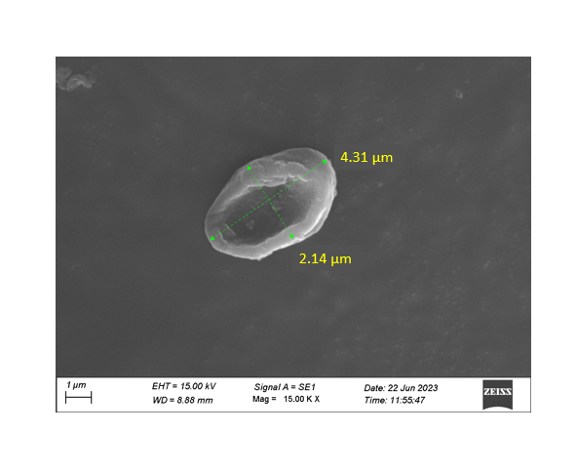 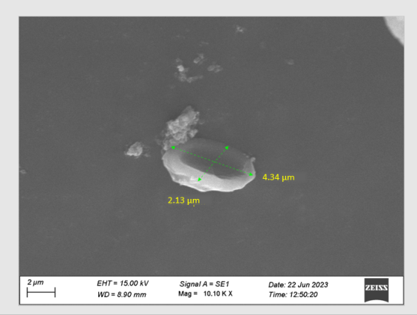

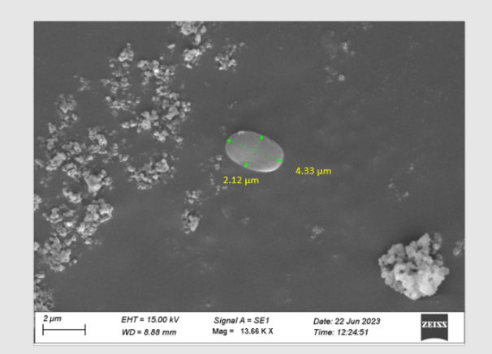 

a. Government Model Grainage, Magadi b. Government Model Grainage, Kuduru

c. Soluru hobli

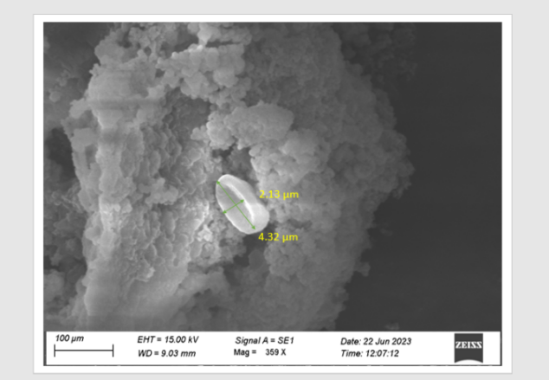 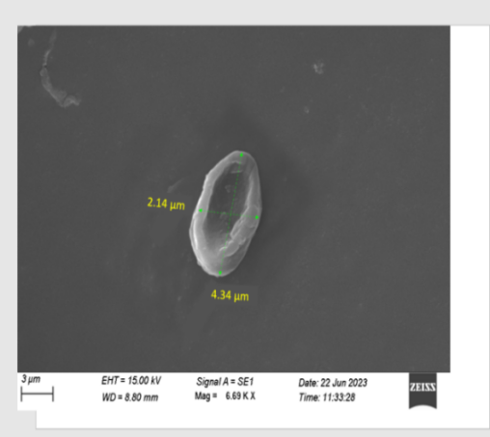

d. Kuduru hobli

e. Kalya hobli

**Plate 1: SEM photographs of pebrine spores collected from different regions in Magadi taluk of Mysore seed area**

**Conclusion**

The pebrine spores isolated from Magadi taluk of Mysore seed area were ovocylindrical in shape with slight depression, the mean length × width was 4.33 ± 0.01 × 2.13 ± 0.01 µm. On comparing this isolate with the previously reported shape and size of various microsporidian strains, it morphologically resembles the spore of *Nosema* *sp*. Lbms strain which also has a slight depression and measures 4.36 × 2.14 µm. But further molecular charecterization of pebrine isolate collected from Magadi taluk of Mysore seed area to confirm the strain.

**Future trends:** The pebrine spores isolated from various sites within the Magadi taluk seed area of Mysore were morphologically characterized using scanning electron microscopy (SEM). To confirm the specific strain of *Nosema sp*., further molecular characterization is required. These analyses will support the development and implementation of effective prevention and control strategies, ultimately ensuring sustainable larval development and optimized cocoon productivity.

**Disclaimer (Artificial intelligence)**

Option 1:

Author(s) hereby declare that NO generative AI technologies such as Large Language Models (ChatGPT, COPILOT, etc.) and text-to-image generators have been used during the writing or editing of this manuscript.

Option 2:

Author(s) hereby declare that generative AI technologies such as Large Language Models, etc. have been used during the writing or editing of manuscripts. This explanation will include the name, version, model, and source of the generative AI technology and as well as all input prompts provided to the generative AI technology

Details of the AI usage are given below:

1.

2.

3.

**REFERENCES**

ANANTHALAKSHMI, K. V. V., FUJIWARA, T. AND DATTA, R. K., 1994, First report on the isolation of three microsporidians (*Nosema* spp.) from the silkworm *Bombyx mori* L. in India. *Indian J. Seric.,* **33:** 146-148.

BHAT, S. A. AND NATARAJU, B., 2005, Mode of transmission of a newly discovered microsporidian and its effect on fecundity and hatching in silkworm, *Bombyx mori* L. *Int. J. Indust. Entomol*., **2(**10): 81-86.

BHAT, S. A., BASHIR, I. AND KAMILI, A. S., 2009, Microsporidiosis of silkworm, *Bombyx mori* L. (Lepidoptera: Bombycidae): A review. *Afr. J. Agric. Res.*, **4**(13): 1519-1523.

BHAT, S. A. AND NATARAJU, B., 2006, Studies on the pathogenicity of a microsporidian isolate (Lbms) to the silkworm, *Bombyx mori* L. New Strategies in Research and Development of Sericulture-Indian Perspective”, p. 60.

CHAKRABARTY, S., SAHA, A. K., MANNA, B. AND BINDROO, B. B., 2012, Light and electron microscopy of *Nosema ricini* (Microsporidia: Nosematidae), the causal pathogen of pebrine disease in eri silkworm. *Appl. Biol. Res.,* **14**(1): 1-14.

CHITRA, C. N., KARANTH, C. K. AND VASANTHARJAN, V. N., 1975, Diseases of mulberry silkworm, *Bombyx mori* L. *J. Sci. Indus. Res*., **34**: 386-410.

FUJIWARA, T., 1993, *Comprehensive report on the silkworm disease control*. A report on Bivoltine Sericulture Technology Development in India. Central Silk Board, Bangalore, India. p. 110.

HYSLIS, M., PILARSKA, D. K., OBARNIK, M., VAVRA, J., SOLTER, L. F., WESER LINDE, A. AND MCMANUS, M. L., 2006, *Nosema chysorrhoea* (Microsporidia) isolated from brown tail moth, *Euproctis chysorrhoea* L. (Lepidoptera: Lymantriidae) in Bulgaria. Characterisation and phylogenetic relations. *J. Invertebr. Pathol.*, **91**: 105-114.

KAWARABATA, T., 2003, Biology of microsporidians infecting the silkworm, *Bombyx mori* L. in Japan. J. Insect Biotechnol., **72**: 1-32.

KISHORE, S., BAIG, M., NATARAJU, B., BALAVENKATASUBBAIAH, M., SIVAPRASAD, V., IYENGAR, M. N. S. AND DATTA, R. K., 1994, Cross infectivity of microsporidians isolated from lepidopteran insects to silkworm, *Bombyx mori* L. *Indian J. Seric*., **33**(2): 126-130.

MANKANI, M., DORESWAMY, C., BANUPRAKASH, K. G. AND BHASKAR R. N., 2017, Relative performance of silkworm Breeds *Bombyx mori* L. to late larval flacherie as influenced by light intensity. *Mysore J. Agric. Sci*., **51** (1): 93-97.

MAXIMIANO, C. C., AIRI, F., OUMI, N., KAZUHIRO, I., LIDIA, M. F. AND CHISA, Y., 2020, Identification and characterization of three microsporidian genera concurrently infecting a silkworm, *Bombyx mori*, in Brazil*. J. Invertebr. Pathol*., **177**:1-36.

MOHARRAMI, M., BAGHERI, M. AND NEMATOLLAHIAN, S., 2022, Detection and characterization of *Nosema bombycis* using TEM and SEM techniques. *Arch Razi Inst*., **77**(4): 1473-1480.

RAO, S. N., NATH, B. S., BHUVANESWARI, G. AND URS, S. R., 2007, Genetic diversity and phylogenetic relationships among microsporidia infecting the silkworm, *Bombyx mori*, using random amplification of polymorphic DNA. Morphological and ultrastructural characterization. *J. Invertebr. Pathol*., **96**(3): 193-204.

RAHUL, K., MANJUNATHA, G. R. AND SIVAPRASAD, V., 2021, Pebrine monitoring methods in sericulture. *Methods in Microbiology*, Academic Press., **49**: 79-96.

SELVAKUMAR, T., RAO, P. S., DANDIN, S. B., BALAVENKATASUBBAIAH, M., CHANDRASEKHARAN, K., SHARMA, S. D., NATARAJU, B. AND THIAGARAJAN, V., 2005, Isolation of a new microsporidian sp. (NIK-5hm) forming spores within the haemocytes of silkworm, *Bombyx. mori* L. *Int. J. Indust. Entomol*.,**11**(1): 63-66.

SINGH, T. AND SARATCHANDRA, B., 2003, Microsporidian disease of the silkworm, *Bombyx mori* L. (Lepidoptera: Bombycidae). *Int. J. Indust. Entomol*.,**6**(1): 1-9.

VISHAKA, G. V. AND NARAYANASWAMY, T. K., 2018, Protocol for extraction of silkworm (*Bombyx mori* L.) pupal residue bio soft descent (SPRBD) and its properties. *Mysore J. Agric. Sci*., **52** (4): 744-754.