**Marketing Constraints in the Potato Supply Chain: Perspectives from Stakeholders in Haryana**

**Abstract**

In India potato marketing is remarkably impeded by severe constraints. Thus, this study was planned to identify various problems faced by the producers and different marketing functionaries in the supply chain of potato. Multistage random sampling technique was used to select respondents for the study viz. 200 farmers, 10 of each commission agent and wholesalers; 14 retailers and 6 super markets from Kurukshetra and Yamuna Nagar districts of Haryana state. Henry and Garrett ranking technique was used to determine various constraints. Among all the identified constraints, the major problems faced by farmers were high price fluctuation, lack of storage facilities and non-availability of proper market information with a mean score of 69.71, 69.61 and 67.25 respectively. From market intermediaries’ point of view, the major problems were higher rate of commission charges and inadequate market infrastructure with a mean score of 70.80 and 69.23. The study pointed out the role of awareness generation, price incentives and better infrastructure facilities to the potato growers for encouraging them to emerging potato supply chains that could enhance the farmer’s returns. The study suggests that, the farmer should get guaranteed prices of potato, and better marketing facilities should be provided by the government. Various government and non-government organizations are taking many measures to resolve the infrastructure barriers in the marketing process, but there is still a gap, thus more such efforts are required. The study will benefit the policy makers, agribusiness planners and various stakeholders that are involved in the supply chain of potato marketing.

**Key Words:** Marketing,Supply Chain, farmer, wholesaler, retailer.

**Introduction**

Potato (*Solanum Tuberosum*) is the most important staple crop in India and cash crop cultivated in most areas of the world and is considered a major food crop in India (Bajracharya 2017). Uttar Pradesh ranks first in terms of production of potato with the production of 14.7 million tonnes in year 2020-21 from overall production of 51.6 million tonnes. West Bengal ranks second, Bihar ranks third, Gujrat ranks fourth, Madhya Pradesh ranks fifth and Punjab ranks sixth in the production of potato with an average production of 2.8 million tonnes and constitutes 5.5 per cent to the country overall production (Indiastat.com, 2021).

As Indian economy depends on agriculture there is a need to formulate proper supply chain models which may play crucial role in enhancing the shelf life and in turn minimize the losses and wastages in fruits and vegetables, increase in farmer income. The production and marketing of vegetable sector is still unorganized and to support the entrepreneurs agro-processing measures, phytosanitary measures and extension services should be provided (Glover et al., 2017). Fruit and vegetable sector is identified as the low margin sector in organized retail format. Product quality and grading aspects plays an important role in the growth of the retail sector (Ravi and Prasad, 2020). Supply chain of fruits and vegetables is indulged in the issues of post-harvest losses and wastages. The major constraints in the supply chain of potato marketing are poor cold chain infrastructure, higher packaging costs, poor distribution quality, and weak linkages in supply chain, poor road infrastructure, and dependencies on intermediaries which directly inhibit the growth and development of vegetable sector (Negi and Anand, 2015). A well-established supply chain could provide huge opportunities for agribusiness and development of rural sector in vegetable sector. As vegetables are seasonal and perishable; there are not adequate storage and transportation facilities, supply chain could be made efficient by minimizing the chain length and improving the cold chain facilities (Pujari, 2016). Indian products are generally rejected in the international markets and the supply chain also has not developed in the past decades. Stable prices, certainty of market place and adequate market information majorly influence the supply chain performance. (Naik and Suresh, 2018).

Potato marketing in India is enormously hampered by severe constraints. Thus, the present study was carried out to determine various constraints that are encountered by various stakeholders involved in the process of marketing of Potato in Haryana state of India.

**Methodology**

The marketing channels of vegetables were scrutinized by selecting a random sample of intermediaries such as wholesalers, commission agents, retailers, supermarkets in Kurukshetra and Yamuna Nagar districts of Haryana state. Five wholesaler and five commission agents from each district and fourteen retailers and six super markets from both districts were selected using convenience sampling in the study area. A sample of 200 farmers was also recorded for the present study with the help of survey schedule.

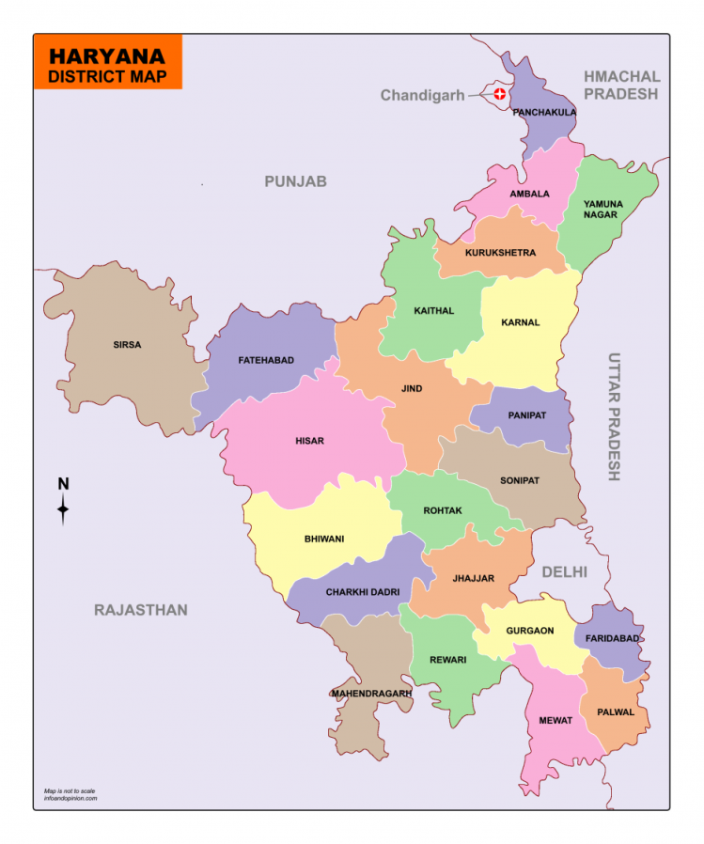

**Fig. 1.0 Map of study area**

Measurement of predictable variable of constraints in the potato production was done as part of the study. Multistage purposive sampling was done where four blocks were selected in the study area and the villages were selected randomly from each block. The potato growers were randomly asked about the constraints faced by them in the marketing of potato. Later, ranking was given by the farmers to the constraints faced by them. The main focus of the study was to determine the constraints faced by the potato growers in the marketing process in the study area. A list of sixteen constraints was made in the survey schedule and major eight constraints were ranked by the farmers.

Thus, assigned ranks by the individual farmers were counted into percent position value by using the formula:

**Percentage position = 100(Rij – 0.5)/Nj**

Where, Rij = Rank given for ith item of jth individual

Nj = Number of items ranked by jth individual

The per cent position was converted into scores by referring the Garrett’s ranking table. Mean scores were calculated by dividing the total score by the number of respondents. Overall ranking was obtained by assigning ranks in the descending order of the mean score.

**Results**

**1. Constraints encountered by the farmers in marketing of potato**

Most of the farmers realized price fluctuations as the major constraint in the study area as the farmers were not able to sell their produce at fair prices in the market as the prices of potatoes were changed based on the demand and supplies as well as season; and ranked it first with a mean score of 69.76. Due to the lack of supportive storage facilities, the farmers were not able to store their produce even for a few days. The perishable nature of potato was the main reason for which the farmers give second rank to the lack of storage facilities and ranked it second with a mean score of 69.61. The flow of proper market information regarding prices prevailing in the market for their produce was observed as the third major constraint in marketing of potato with a mean score of 67.25. Majority of farmers sold their produce through commission agents and then the produce passes through wholesalers, retailers and then to the final consumer. Majority of farmers were having some type of financial obligations with the wholesalers and it was the main reason that they do not sell them directly to the consumers and were not able to get remunerative prices due to the presence of large number of middlemen in the supply chain. That’s why it was given the fourth rank with a mean score of 67.10 among the other major constraints encountered by the farmers in marketing of potato. The other important constraints identified in the study area were inadequate market infrastructure, shortage of labor for post-harvest operations, delay in sale and payment; and lack of accommodation facilities with a mean score of 64.18, 63.53, 62.39 and 58.33 respectively.

**Table: 1.0 - Constraints encountered by farmer in marketing of potato in Haryana**

|  |  |  |
| --- | --- | --- |
| **Constraints** | **Mean** | **Ranking** |
| Price fluctuations | 69.76 | 1 |
| Lack of storage facility | 69.61 | 2 |
| Non availability of proper market information | 67.25 | 3 |
| Large number of middlemen | 67.10 | 4 |
| Inadequate market infrastructure | 64.18 | 5 |
| Shortage of labor for post-harvest operations | 63.53 | 6 |
| Delay in sale and payment of produce | 62.39 | 7 |
| Lack of accommodation facilities | 58.55 | 8 |

**Fig. 2.0: Constraints encountered by farmer in marketing of potato in Haryana**

**2. Constraints in the marketing of potato faced by the wholesalers in Haryana**

Constraint analysis of marketing of potato by the wholesalers is presented in the Table 2.0. Higher rate of commission charges with a mean score of 70.80 was ranked as a major constraint identified by the wholesaler in marketing of potato. At that time the farmers are not able to keep their produce at accurate space and place as in the peak season a large number of farmers arrive at the market yard and it create big problems for them. So inadequate market infrastructure was identified as the second most important constraint by the wholesalers in the marketing process with a mean score of 69.23. The quality of the produce that arrives in the market was not observed good by the wholesalers and obstructs in obtaining the best market prices by them and was given as the third major constraint encountered by them. The price fluctuations was observed as fourth major marketing constraint with a mean score of 64.14, lack of availability of market information is observed as fifth marketing constraint with a mean score of 62.42, higher marketing costs as sixth rank with a mean score of 62.23, large number of middlemen as seventh rank with a mean score of 60.90 and high market fees with a mean score of 89.38 as eighth major marketing constraint as the wholesalers have to pay one per cent market fees and one per cent HRDF to the market when they buys the produce from the market committee.

**Table: 2.0 - Constraints encountered by wholesaler in marketing of potato in Haryana**

|  |  |  |
| --- | --- | --- |
| **Constraints** | **Mean** | **Ranking** |
| Higher rate of commission charges | 70.80 | 1 |
| Inadequate market infrastructure | 69.23 | 2 |
| Lack of quality produce | 65.00 | 3 |
| Price fluctuations | 64.14 | 4 |
| Lack of availability of market information | 62.42 | 5 |
| Higher marketing costs | 62.23 | 6 |
| Large number of middlemen | 60.90 | 7 |
| High Market Fee | 59.38 | 8 |

**Fig. 3.0: Constraints encountered by wholesaler in marketing of potato in Haryana**

**3.** **Constraints in the marketing of potato faced by the retailers and super markets in Haryana**

In case of retailers almost similar constraints were identified compared to wholesalers and lack of quality produce was given the first rank among other marketing constraint in marketing of potato with a mean score of 70.52 followed by higher rate of commission charges as the quality of the produce which arrives in the market was low and degraded. This directly influences the prices of the produce in the market. The agencies or intermediaries who buy produce from vegetable market have to pay five per cent commission charges of the produce to the market and was identified as second major marketing constraint with a mean score of 68.57. As we know vegetable are seasonal in nature and their demand and supply changes with respect to the season. So, price of the produce was also affected by this prospect and price fluctuations was ranked third by the retailers with a mean score of 65.28. The retailers have to pay more prices of the produce when the number of intermediaries in the market rises. Similar results were reported by Pandit (2003).

**Table: 3.0 - Constraints encountered by retailers in marketing of potato in Haryana**

|  |  |  |
| --- | --- | --- |
| **Constraints** | **Mean** | **Ranking** |
| Lack of quality produce | 70.52 | 1 |
| Higher rate of commission charges | 68.57 | 2 |
| Price fluctuations | 65.28 | 3 |
| Large number of middlemen | 64.76 | 4 |
| More spoilage losses | 64.09 | 5 |
| High market fees | 61.09 | 6 |
| Lack of availability of market information | 60.76 | 7 |
| Packaging problem | 59.04 | 8 |

**Fig. 4.0: Constraints encountered by retailer in marketing of potato in Haryana**

This is the main reason that large number of middlemen is given fourth rank by the retailers with a mean score of 64.76. More spoilage loss is given fifth rank with a mean score of 64.09. Retailers have to pay one per cent market fees of the produce to the market and one percent HRDF of the produce to the market. It contributes to a high amount of marketing cost to the retailers and that’s the main reason it is given the sixth most important constraint in the marketing of potato with a mean score of 61.09. The other marketing constraints identified are lack of availability of market information with a mean score of 60.76 and packaging problem observed as eighth major marketing constraint encountered by the retailers with a mean score of 59.04.

**Conclusion**

The study revealed that farmers have to face the price fluctuations problems in the market when they sold their produce and was the most important problem faced by the respondents. The farmers were not able to store their produce due to lack of accurate cold storage facilities and that’s the reason the farmer in Haryana does not store the potato and directly sold their produce without waiting for the best prices in the market. The availability of proper market information was also a major marketing problem encountered by the respondent farmers and was the third major constraint in the marketing of potato. The involvement of large number of middlemen was encountered by the farmers and the level of profits received by them is minimized in terms of producer’s share in consumer’s rupee and was the fourth major constraint in the marketing of potato. The farmers faced a lot of problems when they arrive at the market for selling their produce in terms of proper sheds where they could place their produce and protect it from unfavorable environmental conditions and was the fifth major marketing problem. The availability of labor for post-harvest operations, delay in sale and payment of produce, and lack of accommodation facilities were some other major constraints that were observed by the farmers in the study area. The wholesalers have to pay high commission charges and market fees to the market when they buy from the market. The low quality of produce is also very low observed by the wholesalers and the problem of price fluctuations were other problems faced by the wholesaler. The retailers also faced problems regarding the availability of quality produce in the market. The retailers have to pay one per cent market fees, one per cent HRDF and five per cent commission charges of the produce when they buy from market and are considered as the major marketing constraints faced by them. Organizing farmers into larger producer groups can benefit the entire supply chain. These groups will then be better placed in terms of collective pre and post-harvest management, reduced transaction costs and higher bargaining power. Marketing facilities may be created near the production point center and government should formulate policies regarding direct procurement of the produce from farmers which will lead to increased returns to farmers on account of bypassing of numerous intermediaries in the supply chain of potato.

Disclaimer (Artificial intelligence)

Author(s) hereby declare that NO generative AI technologies such as Large Language Models (ChatGPT, COPILOT, etc.) and text-to-image generators have been used during the writing or editing of this manuscript.

**References**

Anonymous 2021 www.indiastat.com

Bajracharya M and Sapkota M 2017. Profitability and productivity of potato (Solanum tuberosum) in Baglung district, Nepal. Agric Food Secur 6:47 https://doi.org/10.1186/s40066-017-0125-5.

Glover, M. K., Obubuafo, J., Agyeman-Duah, M. O., Doku, G. D. and Glover, E. K. (2017). Constraints associated with the marketing channel of lettuce and cabbage trade in Ghana. Journal of Agriculture and Sustainability, 10(2), 116-143.

Naik, G. and Suresh, D. N. (2018). Challenges of creating sustainable agri-retail supply chains. IIMB Management Review, 30(3), 270-282.

Negi, S. and Anand, N. (2015). Issues and challenges in the supply chain of fruits and vegetables in India. International Journal of Managing Value and Supply Chain, 6(2), 47-62.

Pandit, A., Rana, R. K. and Sharma, H. C. (2003). Problems of potato marketing in India. Indian Journal of Agricultural Marketing, 17, 79-91.

Pujari, B. (2016). Challenges and solutions in the supply chain of Indian vegetable market: A review. International Journal of Research Science and Management, 3(7), 38-43.

Ravi, S. S. and Prasad, M. V. R. (2020). Challenges and innovations in fruits and vegetable operations in Indian retail industry. International Journal of Recent Technology and Engineering, 8(6), 2597-2603.

Yadav, R., Kumari, A., & Kunwar, N. (2018). Diversified Utilization of Potato and Marketing Constraint Faced by Farm Women in Potato Production. Asian Journal of Agricultural Extension, Economics & Sociology, 24(2), 1–5. https://doi.org/10.9734/AJAEES/2018/40293