**Assessment of trend in area, production and productivity of potato in Hassan district of Karnataka, India**

**ABSTRACT**

The present analysis was undertaken to estimate the growth and instability of area, production and productivity of potato in Hassan district and Karnataka state. Potato in Hassan District is primarily grown in the Kharif season under rainfed conditions. Hassan district is the major potato growing district with the total area of 9995 ha and production of 68921 tonnes with the productivity of 6.89 t/ha. (Anonymous, 2023). The Compound Annual Growth rate and Cuddy Della Vella Index was used to estimate growth of instability of Potato. The secondary data on the area, production and productivity of potatoes in Karnataka was collected from 2013 to 2022. While data specific to the Hassan district was gathered from 2001 to 2023. The area and production of potato in Karnataka showed a significant negative compound growth rate of 5.96 per cent and 3.0 per cent per annum respectively, while productivity exhibited a positive compound growth rate of 3.14 per cent per annum. The growth rate of area under potato in the Hassan district was declined at a rate of 8.88 per cent per annum, Further, the growth rates of production and productivity showed a decreased at rate of 8.95 per cent per annum and 0.94 per cent per annum respectively. The negative growth rates in area and production of potato may be attributed by the unavailability of quality potato seed tubers, limited availability of irrigation facilities, susceptibility to diseases and pests, limited market access and price fluctuations, and adverse climatic conditions. To increase productivity, farmers need to adopt quality potato seed tubers as well as high yielding varieties which are resistant to pest and diseases combined with proper irrigation facilities.

***Keywords:*** Potato, compound annual growth rate, instability index, coefficient of variation

1. **INTRODUCTION**

Potato (*Solanum tuberosum L.*) is the world's most important vegetable crop and the third most important food crop after rice and wheat. As per FAOSTAT data (2021), India ranks second in global potato production with 54.23 million tonnes, behind China (94.36 million tonnes). In 2023-24, India cultivated potatoes on 23.26 lakh hectares, producing 56.76 million tonnes with a yield of 24.40 t/ha. Karnataka is a key potato-growing state in peninsular India, covering 23,290 ha with a production of 3,50,110 tonnes and a yield of 15.04 t/ha. Hassan is the top potato-producing district and a major contributor, along with Kolar, Chikkaballapur, Chikkamagaluru, and Belgaum. Potatoes are mainly grown in the *kharif* season under rainfed conditions, with varieties like Kufri Chandramukhi, Kufri Himalini, Fc5, and Kufri Sindhuri. Potato in Hassan District is primarily grown in the Kharif season under rainfed conditions. Hassan district is the major potato growing district with the total area of 9995 ha and production of 68921 tonnes with the productivity of 6.89 t/ha. (Anonymous, 2023)

However, potato cultivation in Hassan district faces several significant challenges such as unavailability of quality potato seed, which hampers crop productivity and yield. Additionally, there is a notable lack of technical know-how regarding advanced potato production technologies among farmers, further affecting efficiency and output. The high cost of potato cultivation adds financial strain, while the dependence on only a few potato varieties limits genetic diversity and resilience. This situation is exacerbated by the crop's susceptibility to diseases and pests, which can lead to significant losses.

Despite these issues, the potato industry in India has strong domestic and international demand. Increased productivity through modern farming techniques, better crop management, and value-added products like processed foods can boost profitability. Government policies, subsidies, and private investment, including contract farming, can enhance production, improve infrastructure, and support farmers. Strengthening potato farming is crucial for the economic well-being of farmers, food security, employment generation, and agricultural sustainability.

1. **METHODOLOGY**

Hassan district of Karnataka was purposively chosen as the study area because, it has the larger area under potato cultivation in the district. The secondary data on the area, production and productivity of potatoes in Karnataka was collected from 2013 to 2022.While data specific to the Hassan district was gathered from 2001 to 2023. Additionally, the data specific to the Hassan and Arakalgud taluks were gathered from 2014-15 to 2023-24. These data sets, obtained from the Department of Economics and Statistics (DES) and the Department of Horticulture, Hassan district. The data was analyzed using various statistical tools.

1. Descriptive statistics
2. Compound Annual Growth Rate

The growth in area, production and productivity of potato in Hassan district was calculated by using growth function. Compound annual growth rate were worked out for a period from 2001-02 to 2023-24 for Hassan district, 2013-14 to 2022-23 for Karnataka state and 2014-15 to 2023-24 for Hassan and Arakalgud taluks.

The Compound growths were computed by using the exponential function of the form.

Yt = ABt eut-------------------------------(1)

Where Yt = Area/ production/ productivity of potato during time t

A = Constant/ intercept indicating Y in the base year t

t = Time period

ut= Error term

B = 1+g where, g = growth rate.

CAGR= {Antilog(b)-1}*100

where,

b= regression coefficient

1. Instability analysis (Cuddy Della

Valle Index)

CDVI $=CV *\sqrt{1-adjusted R2}$

where,

CV= Coefficient of Variation

The ranges of CDVI are given as follows:

Low instability= 0-15

Medium instability= 15-30

High instability = >30

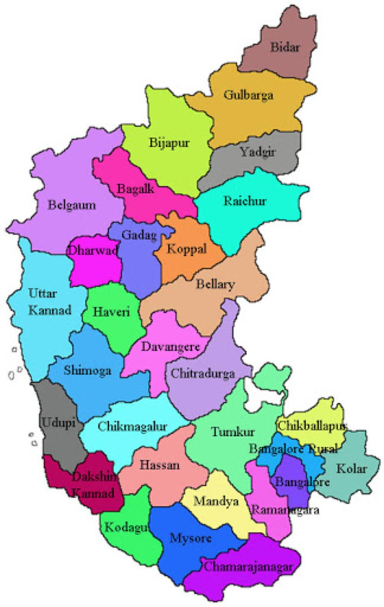

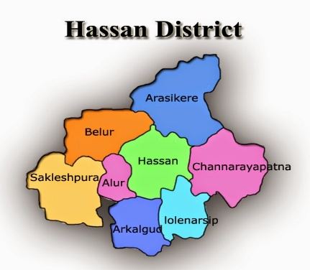

**Fig. 1: Map showing the study area**

**3. RESULTS AND DISCUSSION**

**3.1 Trends in area, production and productivity of potato in Karnataka (2013-14 to 2022-23)**

The production performance of potato was analysed using the data from 2013-14 to 2022-23. The analysis of potato production in Karnataka using the data from 2013-14 to 2022-23 revealed several key trends as presented in table 1. The production of potato showed a significant negative annual growth rate of three per cent. In contrast, the area under potato cultivation decreased at a rate of 5.96 per cent per annum, while productivity exhibited a positive annual growth rate of 3.14 per cent. However, these growth rates for area and productivity were found to be non-significant. The reduction in potato cultivation area may be due to farmers shifting to more profitable crops, climate issues like water scarcity, or land conversion for non-agricultural use. Meanwhile, the slight increase in productivity could be attributed to improved farming practices or technological advancements. These results are in line with a study conducted by Devi (2023).

**Table 1 : Trends in area, production and productivity of potato in Karnataka (2013-14 to 2022-23)**

|  |  |  |  |
| --- | --- | --- | --- |
| **Particulars** | **Area (ha)** | **Production ( t)** | **Productivity (t/ha)** |
| CAGR (%) | -5.96NS | -3.00*** | 3.14NS |
| SD | 6762.38 | 51462.41 | 1.786 |
| Mean | 30054 | 274987 | 9 |
| Coefficient of Variation (%) | 22.50 | 18.71 | 19.06 |
| Cuddy-Della Valle Index | 12.60 | 17.38 | 18.09 |

*** indicates significant at one per cent level of probability,NS-indicates non-significant

**Fig 2: Line graph presents the trends in area, production and productivity of Potato in Karnataka (2013-14 to 2022-23)**

In Table 1 and fig 2, the estimates of Cuddy-Della Valle Index revealed that, the potato growing area showed a low variability (12.60 %) compared to potatoes production (17.38 %) and productivity (18.09 %) showed moderate variability. However, this variability caused by unstable weather patterns or fluctuating economic conditions.

**3. 2 Trends in area, production and productivity of potato in Hassan district (2001-02 to 2023-24)**

The production performance of potato in Hassan district was analysed using the data from 2001-02 to 2023-24 revealed several key trends over the study period. The area under potato cultivation showed a significant negative annual growth rate of 8.88 per cent. The production of potato cultivation decreased at a rate of 8.95 per cent per annum, while productivity exhibited a negative annual growth rate of 0.946 per cent. However, these growth rates for production and productivity were found to be non-significant.

The variability analysis based on the Cuddy-Della Valle Index (CDVI) revealed significant fluctuations in Hassan district's potato cultivation. The area under potato cultivation exhibited high variability with a CDVI value of 46.65 per cent. Similarly, potato productivity (47.08 %) and production (46.82 %) also showed a high degree of variability, indicating erratic trends during the study period (Table 2 and fig 2).

**Fig 3: Line graph presents the rrends in area, production and productivity of Potato in Hassan district of Karnataka (2001-02 to 2023-24)**

The results are similar to a study conducted by Dileshwari *et al.* (2022) on analysis of growth rate in area, production and productivity of major spices in Raigarh district and Chhattisgarh state, who reported that, the area of ginger in Raigarh district was found positive highly significant at 7.15 per cent and production was found positive not-significant at 0.12 per cent, also the productivity was found negative and highly significant at 1.32 per cent.

**Table 2: Trends in area, production and productivity of potato in Hassan district (2001-02 to 2023-24)**

|  |  |  |  |
| --- | --- | --- | --- |
| **Particulars** | **Area (ha)** | **Production ( t)** | **Productivity (t/ha)** |
| CAGR (%) | -8.88*** | -8.95NS | -0.946NS |
| SD | 17464.6 | 102685.38 | 3.30 |
| Mean | 25375 | 155866.65 | 7.13 |
| Coefficient of Variation (%) | 68.82 | 65.88 | 46.23 |
| Cuddy-Della Valle Index | 46.65 | 47.08 | 46.82 |

*** indicates significant at one per cent level of probability. NS-indicates non-significant

**3.3 Trend in area, production and productivity of potato in Hassan taluk (2014-15 to 2023-24)**

The production performance of potato in Hassan taluk was analysed using the data from 2014-15 to 2023-24 which revealed several key trends over the study period. From table 3 and figure 4 shows the data of area and production under potato cultivation showed a significant negative annual growth rate of 9.79 per cent and 13.00 per cent, respectively. In contrast, productivity exhibited a negative annual growth rate of 3.55 per cent but found to be non-significant.

The variability analysis based on the Cuddy-Della Valle Index (CDVI) revealed significant fluctuations in Hassan taluk's potato cultivation. The potato production exhibited high variability with a CDVI value of 45.98 per cent whereas, area under potato cultivation high variability with CDVI value of 39.93 per cent. The productivity of potato crop shows medium variability with CDVI value of 17.62 per cent.

The negative growth rates and high variability in potato cultivation in Hassan taluk from 2014-15 to 2023-24 can be attributed to factors like unpredictable weather and climate change, which affected crop yields. Frequent pest and disease outbreaks, especially late blight, may have caused significant losses. Economic challenges, such as price volatility and rising input costs, discouraged investment in potato farming. Additionally, soil fertility issues due to continuous cultivation without proper crop rotation, along with limited access to quality seeds and inputs, further impacted productivity, leading to the observed fluctuations in area and production.

**Table 3: Trends in area, production and productivity of potato in Hassan taluk (2014-15 to 2023-24)**

|  |  |  |  |
| --- | --- | --- | --- |
| **Particulars** | **Area (ha)** | **Production ( t)** | **Productivity (t/ha)** |
| CAGR (%) | -9.79*** | -13.00*** | -3.55NS |
| SD | 3331.207 | 41099.92 | 1.97 |
| Mean | 6719.364 | 66542.27 | 9.69 |
| Coefficient of Variation (%) | 49.57 | 61.76 | 20.35 |
| Cuddy-Della Valle Index | 39.93 | 45.98 | 17.62 |

*** indicates significant at one per cent level of probability. NS- indicates non-significant

**Fig 4:** Line graph presents the **trends in area, production and productivity of potato in Hassan taluk (2014-15 to 2023-24)**

**3.4 Trend in area, production and productivity of potato in Arakalgud taluk (2014-15 to 2023-24)**

The production performance of potato in Arakalgud taluk was analysed using the data from 2014-15 to 2023-24 revealed several key trends over the study period. From the table 4 and figure 5 shows, the area and production under potato cultivation showed a significant negative annual growth rate of 5.91 per cent and 9.60 per cent, respectively. In contrast, productivity exhibited a negative annual growth rate of 3.92 per cent but found to be non-significant.

The variability analysis based on the Cuddy-Della Valle Index (CDVI) revealed significant fluctuations in Arakalgud taluk's potato cultivation. The potato production and area under potato cultivation exhibited high variability with a CDVI value of 31.98 per cent and 31.43 per cent whereas, the productivity of potato crop shows high variability with CDVI value of 30.02 per cent.

The negative growth rates and high variability in potato production in Arakalgud taluk from 2014-15 to 2023-24 can be attributed to factors like climate change, soil health degradation, and pest and disease pressure. Market fluctuations and high input costs also affected farmers' decisions to cultivate potatoes. These challenges led to significant fluctuations in area, production, and productivity, as indicated by the Cuddy-Della Valle Index.

**Table 4: Trends in area, production and productivity of potato in Arakalgud taluk (2014-15 to 2023-24)**

|  |  |  |  |
| --- | --- | --- | --- |
| **Particulars** | **Area (ha)** | **Production ( t)** | **Productivity (t/ha)** |
| CAGR (%) | -5.91*** | -9.60*** | -3.92NS |
| SD | 555.32 | 6454.40 | 3.89 |
| Mean | 1700.82 | 16965.88 | 8.28 |
| Coefficient of Variation (%) | 32.65 | 38.04 | 47.01 |
| Cuddy-Della Valle Index | 31.43 | 31.98 | 30.02 |

*** indicates significant at one per cent level of probability. NS-indicates non-significant

**Fig 5: Line graph presents the trends in area, production and productivity of potato in Arakalgud taluk (2014-15 to 2023-24)**

1. **CONCLUSION**

The results revealed that, significant negative compound annual growth rates were found in the production and area under potato in Karnataka and Hassan district respectively. Growth rate of productivity of potato was positive in Karnataka and negative for Hassan district but found to be non-significant. Area under potato was more stable than production and productivity in Karnataka.

Potato growers confront numerous challenges in production and marketing, including high labor costs, a high incidence of pests and diseases, irregular rainfall patterns, a low price for products, and price variations. The main problem with the potato growers in the study area was crop loss due to heavy rainfall and late blight disease. This induced farmer to shift from potato cultivation to other crops like maize and finger millet. So, compensation may be given to the affected potato farmers in order to increase area under potato and promote potato production. Creating awareness among the farmers to take up potato crop insurance to protect against financial losses arising from unforeseen act which is beyond their control.

**Disclaimer (Artificial intelligence)**

Author(s) hereby declare that generative AI technologies such as Large Language Models, etc. have been used during the writing or editing of manuscripts. This explanation will include the name, version, model, and source of the generative AI technology and as well as all input prompts provided to the generative AI technology

Details of the AI usage are given below:

1. Chatgpt

2.Google scholar

3.

**REFERENCES**

ANONYMOUS, 2023, Directorate of economics & statistics, DAC & FW (DES). 2023, Agricultural statistics at a glance. Department of agriculture, cooperation and farmers welfare, ministry of agriculture and farmers welfare. Government of India.

ANONYMOUS, 2024, Department of Horticulture, Potato crop statistics, Hassan district.

BHAJANTRI, S., 2011, Production, processing and marketing of potato in Karnataka -An economic analysis*. MBA.* (*Agri.*) *Thesis* (*Unpub.*), Univ. Agric. Sci., Bangalore.

CUDDY, J. AND DELLA, V. P., 1978. Measuring the instability of time series data. *Oxford Bul. Econ. and Stat.*, **40** (10): 79-84.

DEVI, P., 2023, Value chain analysis of potato in Hassan district of Karnataka. *MBA.* (*Agri.*) *Thesis* (*Unpub.*), Univ. Agric. Sci., Bangalore.

DILESHWARI., JAIN, B. C. AND DRONAK, KUMAR, SAHU., 2022, An analysis of growth rate in area, production and productivity of major spices in Raigarh district and Chhattisgarh state. *The Pharma Inno. J.*, **11** (8): 949-954.

JOSE, C. T. AND JAYASEKHAR, S., 2008, The growth trends in area, production and productivity of ginger in India. *Agric. Situ. in India.*, **65** (1):135-140.

NABI, T. AND BAGALKOTI, S. T., 2017, Growth in area, production and productivity of horticultural crops in Karnataka. *Int. J. of Man. and Dev. Stu.*, **6** (3): 17-29.

NAGABHUSHANA, K., 2007, Farming performance of potato cultivators of Hassan district in Karnataka. *M.Sc. (Agri.). Thesis (Unpub)*, Acharya N. G. Ranga Agricultural University, Hyderabad, India.

PYNBIANGLANG, K., DEVARANI, L. AND RAMSINGH., 2023, Growth performance of potato in India vis-à-vis North East India. *Indian J. of Ext. Edu.,* **59** (1): 37-41.

RANI, S. AND PRASOON, M., 2013, Analysis of potato production performance and yield variability in India. *Potato Journal*, **40**(1): 38-44.

ROHINI, A. V., POKHARKAR, V. G. AND YADAV, D. B., 2022, Growth and instability of area, production and productivity of acid lime in India and Maharastra. *The Pharma Inno. J.,* **11** (5): 101-105.

SHILPA, C. N. AND NANJAPPA, D., 2010, Knowledge and adoption behaviour of potato growers in Hassan District of Karnataka. *M.Sc. (Agri) Thesis (Unpub.),* Univ. Agric. Sci., Bangalore.

SOOD, S., SINGH, H. AND SETHI, D., 2019, Growth performance and instability of pulses in the state of Rajasthan. *Indian Journal of Agricultural Research*, **54** (5): 1-5.