**Innovation and Improvement in Weeding Technology: A review**

**Abstract**

Weed control is vital in agriculture, as weeds can reduce crop yields by 30–40%. Common weeding methods include manual, chemical, mechanical, and precision techniques. Manual tools such as khurpi, grubber, spade, wheel hoe, and push-pull weeders provide high weeding efficiency (72–99%) but are labor-intensive, time-consuming, and offer very low field capacity (0.001–0.033 ha/h). Chemical weeding is widely adopted due to its cost-effectiveness but has drawbacks like environmental pollution, food safety risks, and ecological imbalance due to overuse. With rising demand for toxicant-free and organic food, mechanical weed control is gaining importance. It enhances soil aeration, improves water retention, suppresses weeds, and is safe for crops. Mechanized tools such as tractor-operated finger weeders, torsion weeders, ECO weeders, flame weeders, and harrows are increasingly used for inter- and intra-row weeding, especially in crops with wider spacing. Technological advancements have led to automated and precision weeding systems using sensors, microcontrollers, and computing technologies for intelligent field operations. These systems reduce labor dependency, minimize physical strain, and improve efficiency. Sensor-based tools and automation enhance weed control through targeted action. Future technologies include remote sensing, multispectral and hyperspectral imaging, and robotics, which ensure precise, environmentally safe agrochemical applications. Integrated weed management combining automation and sustainability offers a comprehensive, eco-friendly approach to modern weed control challenges

**Keywords:** Weeding technology, Inter and intra row weeder, Power weeder, Automation.

# Introduction

By 2050, there will be nine billion people on the planet. The world's food production needs to rise by 70% to 100% in order to supply the food needs of this population [1]. As food demands rise as a result of the growing global population, the efficiency of current agricultural practices will be called into question. Yield reduction is caused by a number of factors, including climate change, water scarcity, excessive use of pesticides, fertilizers, weedicides, and insecticides, which reduces soil fertility, and improper weeding practices. The biggest yield loss among all the factors is caused by poor weed control.

In essence, weeds are plants that are deemed abnormal because they impede human activities and well-being [2]. Weeds compete with crops for the same resources in a crop production system, such as water, nutrients, sunlight, and space, which eventually lowers the yield of the crops under cultivation. Strong competition from hostile weeds significantly reduces crop yields and adds to crop production costs because of weed control. Numerous factors, such as weed density, the time of emergence, the type of crop being grown, and the particular weed species, influence the amount of yield loss attributable to weeds [3, 4]. The biggest threat on a global level is weeds, which have the potential to cause 34% of losses, while animal pests and diseases are relatively less significant, causing 18% and 16% of losses, respectively [5].Weeds are thought to reduce agricultural yield and economic losses by 5% on average in the majority of developed countries, but this number increases to 10% in developing countries and a significant 25% in underdeveloped countries like India [5]. For kharif and Rabi crops, respectively, weed control costs in India are Rs. 6000/hm2 (33% total production cost) and Rs. 4000/hm2 (22% total production cost), according to Yaduraju and Mishra [6]. An estimated 1100 Crore INR is lost in grain crop yields each year in India as a result of weeds [7]. Weeds decreased crop yield by roughly 65%, depending on the crop, weed species level, plant types, and management techniques [8, 9]. For weeding operations, 560 workers were needed per hectare per hour. Sincetraditional weed control techniques still result in an average yield loss of 15%–20%, weed control remains crucial for effective crop loss management and high-quality crop production [10, 11]. Depending on the particular weed species and how they interact with the crop; the amount of yield reduction brought on by weed competition varies significantly (Table 1).

Applying technical expertise, weeding ensures that a specific weed population in an agricultural field survives [12,13]. Numerous techniques, including mechanical, chemical, and manual methods, are used to control weeds in both intra-row and inter-row crops [14] (Figure 1). Hand weeding is a time-consuming, expensive, and labor-intensive process [15]. Since different weeders are made for specific crops, mechanical weed control uses a variety of weeders, each of which has special characteristics [16].The environment and human operators are both harmed by chemical weeding [17]. While there are a number of intra-row weed control techniques, such as soil steaming, laser radiation, and flame [18, 19], their efficacy is restricted to specific plant and soil conditions. Additionally, they require steam and flame-generation systems which are more costly and fuel-intensive [20, 21].

Table 1 Reduction in crop yield of various crops due to weeds

|  |  |  |
| --- | --- | --- |
| Name of crop | Yield reduction/% | Reference |
| Direct seeded paddy | 45-90 | [22] |
| Transplanted paddy | 15-38 | [22] |
| Maize | 28-93 | [22-24] |
| Sorghum | 6-40 | [22] |
| Finger millet | 26-27 | [25] |
| Red gram | 20-47 | [22] |
| Soybean | 40-60 | [22,26] |
| Wheat | 26-38 | [27-31] |
| Oat | 29-38 | [30] |
| Lucerne | 50-90 | [32] |
| Chickpea | 15-25 | [30] |
| Lentil | 20-30 | [30] |
| Pea | 20-30 | [30] |
| Mustard | 15-30 | [30] |
| Linseed | 30-40 | [30] |
| Safflower | 35-60 | [30] |
| Groundnut | 20-50 | [31] |
| Sesame | 50-75 | [31] |
| Sunflower | 30-64 | [31] |
| Castor | 15-25 | [31] |
| Cotton | 74-96.5 | [33] |
| Niger | 20-33 | [31] |
| Jute | 58-70 | [34] |
| Coriander | 20-50 | [35] |
| Sugarcane | 40-67 | [36] |
| Egyptian clover | 30-40 | [31] |
| Brinjal | 49-90 | [37] |
| Tapioca | 40-50 | [38] |

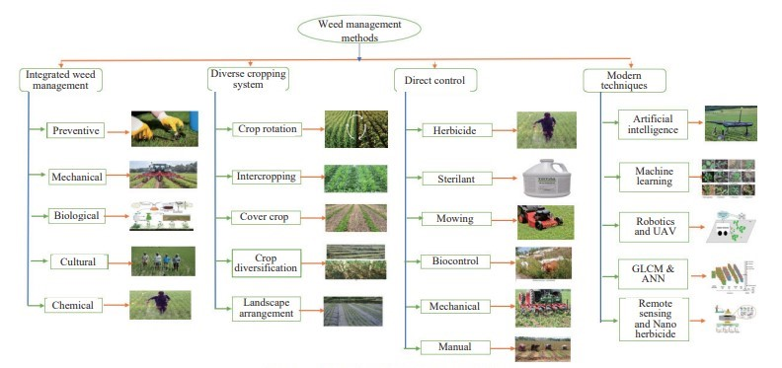

Figure 1    Types of weeding techniques

Due to the physical force involved in weeding, weeds are cut or removed using mechanical, animal, or manual strength. One or both of these methods are applied, depending on the kind of crop and weed. Hand weeding, hand hoeing, digging, mowing, cutting, tillage, burning, intercropping, and mulching are the primary physical weed control techniques [23]. In India, weeds are mostly controlled by hand or with small hand tools. Because it doesn't leave any chemical or herbicide residue on crops, the physical method is currently the most efficient and quick way to control weeds.

In order to control weeds, agricultural automation technology is also growing globally. India is currently dealing with two significant issues. The first is to use conventional methods to supply food to such a large population at a reasonable cost. Second, there is a need to look for alternate options because human resources are scarce during crucial times and labor wages for agricultural operations are rising daily. These two significant issues can be resolved in the coming years by precision weed control methods like robotics, sensors, microcontrollers, and vision-based UAVs [23].

# Weed control methods

Weed control methods include manual, mechanical, and chemical weeding, precision weeding, and robotics.

## Conventional weed control methods

### Manual weeding

Weeding is usually carried out with local hand tools, which is very labor-intensive[42]. Weeds are pulled by hand when using the manual method[43,44] . The manual weeder takes longer to cover the gap between crops and has a smaller working width. It was discovered that a tractor-drawn cultivator worked well for weeding crops with large row spacing.

In the past, farmers would simply use their hands to pull weeds. When compared to alternative techniques, manual weeding is expensive, time-consuming, labor-intensive, tedious, and inefficient [45]. This approach has been discontinued because it exposes employees to health risks and requires them to bend for a longer duration of time [46–49]. Only 65% to 85% of weeds are successfully removed using the hand weeding method because of missed weeds or human error [50]. Additionally, it has been claimed that using long-treated hoes would harm the crops and leave some weeds in the field [51]. A push-pull weeder was created and assessed by Tewari et al. [46] (Figure 2a). Additionally, Figure 2b shows the results of tests conducted on five different types of blades: straight flat, straight flat with serrated edge, five tines, sweep type, and double plough type blade.Each blade had a cut width of 20 cm, a cutting angle of 20°, and a sharpness angle of 15°. All other blades are inferior to the straight flat blade. In a groundnut field, Goel et al. [52] created and ergonomically tested a manual weeder that, when compared to other weeders like wheel finger weeders, wheel hoes, and traditional weeding, had the highest performance index (3689.74), the lowest plant damage rate (2.46% to 7.96%), and the lowest energy consumption rate (8.34 to 40.05 kJ/min) at 11.63% moisture content. The various manual weeders and their performance metrics are shown in Table 2.

Table 2 Manual weeding tool

|  |  |  |  |  |  |
| --- | --- | --- | --- | --- | --- |
| Tools | Width of cut/mm | Field capacity /hm2.h-1 | Weeding efficiency /% | Work rate/ man-h.hm-2 | Energy requirement/ MJ.hm-2 |
| Khurpi | 80 | 0.001-0.002 | 92-99 | 300-500 | 567.62 |
| Gruber | - | 0.004-0.008 | 82-96 | 109 | 212.62 |
| Spade | 220 | 0.002 | 75.7-92 | 120-126 | 326.62 |
| Wheel hoe | 230 | 0.008-0.009 | 72-94 | 86 | 167.30 |
| Push-pull type weeder | 150-250 | 0.026-0.033 | 80-90 | 100-125 | 140.5 |

(Source: [10])

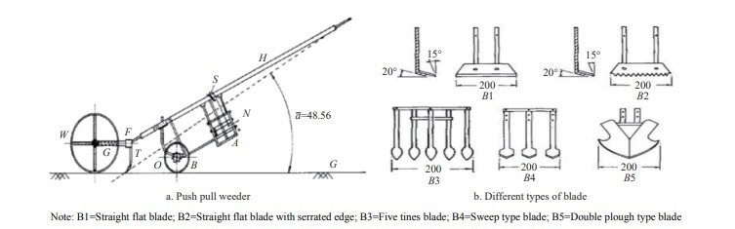

Figure 2    Manual operated push-pull weeder and different types of blades

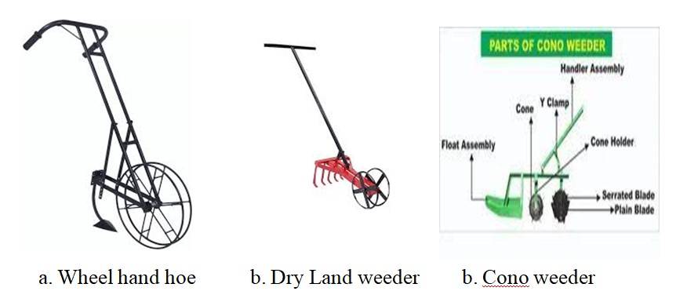

Image .1 Manual operated push-pull weeder

### Animal Drawn weeders

For small-scale farmers, animal-drawn weeders are a very useful tool, particularly in regions where using mechanized farming equipment is not financially possible. Farmers who might not have the funds to purchase machinery can now easily use these cutting-edge devices because they are made to be pulled by draft animals like donkeys or oxen. These weeders are made with movable blades or tines that efficiently pull weeds that proliferate in between crop rows, giving the plants the room and nourishment they require to flourish. According to research, an area of 0.4 to 0.6 hectares can be covered by animal-drawn weeders in a single day.Compared to conventional hand-weeding techniques, which usually only enable farmers to manage 0.1 to 0.2 hectares per day, this efficiency is in sharp contrast. Farmers can save a great deal of time and effort by using animal-drawn equipment, which significantly increases coverage while requiring less manual labor. Additionally, employing these weeders reduces weeding time by roughly 60 to 70% while simultaneously increasing productivity. The efficiency of farm operations is increased as a result of the time savings, which free up farmers to concentrate on other crucial duties. Furthermore, better soil aeration is encouraged by animal-drawn weeders, which is essential for sustaining robust crop growth. Stronger root systems are produced by better soil, which promotes plant growth and increased yields.Animal-drawn weeders are a great way to increase agricultural productivity because of their adaptability and affordability, especially in developing nations where resources may be scarce. Farmers can increase crop yields and reduce labor costs by using this sustainable approach to weed control, improving their overall standard of living and promoting community food security.

### Chemical weeding

The chemical method applies herbicides to kill weeds. The use of herbicides has significantly increased since 1944. Chemical methods are an effective way to manage weeds, but in inter-row crops, these methods create problems for crops [53]. Farmers have been using herbicides more and more since the "Green Revolution" to control weeds and increase revenue. Herbicides have improved weed control through repeated applications, contributed to solving labor shortages during peak agricultural seasons, and offered a viable substitute for physical weeding techniques, which often proven inadequate. Most of the time, farmers accept mechanical or manual weed control methods because chemical methods have a negative impact on the environment and are harmful to human and animal health [17] .The management of diseases, pests, and weeds depends heavily on the use of pesticides and efficient plant protection devices, which distribute, spread, and deposit recommended chemical doses on the desired target [54].According to Choudhury et al. [55], and herbicides are used on over 10% of the country's total agricultural land. In India, the use of herbicides for weed control makes up 20% of all pesticide applications.

## Mechanical weeding

One of the most crucial techniques for managing weeds is mechanical control. Despite being one of the more traditional weed control strategies, it has become more inventive in recent years due to technological advancements. Weeding by machine has a number of benefits over chemical weeding, including the slow growth of weeds and the absence of negative effects on plant growth. The function of mechanical inter-row weeders is to eradicate weeds entirely or in part [56]. To perform tasks like weed cutting, uprooting, and soil burying, a variety of mechanical weeders have been developed. When these weeding tools were first being developed, draft animals like buffaloes and bullocks were usually used to pull them. Tractors are now the main source of power, though, as a result of the shift over time [57].Farmers who would rather not use herbicides are the ones who use mechanical weed control the most. This strategy uses inter-row weeding, which focuses on and eliminates weeds without harming the crop from the areas between crop rows. When crops are just starting to grow, the benefits of mechanical weed control are most noticeable. Tractors and cultivators have the potential to harm crop foliage in the later stages of crop growth. This is due to the fact that their ground clearance is frequently lower than that of the crop plants that are growing [45]. Aside from the tractor's draft, no additional power source was required for the development and operation of the basket weeder [58].This ground-driven tool has round, rectangular baskets that effectively remove weeds from the top soil layer while causing the least amount of soil disturbance possible in the crop rows. It km/h. Pandey [64] designed and developed an e-powered inter-row weeder which consisted of a battery (24 V, 24 Ah), DC motor with speed controller, drive wheel, weeding unit (drum and tool), main frame, transport wheel, and handle. Various mechanical weeders that can effectively remove inter-row weeds at different speeds and depths with their effectiveness are presented in Table 3.

Table 3 Inter-row weeders and their performance parameters

|  |  |  |  |  |
| --- | --- | --- | --- | --- |
| Tools | Depth of cut, mm | Field capacity/ hm2.h-1 | Weeding efficiency, % | Speed of operation/ km.h-1 |
| Rotary weeder | 40-50 | 0.24-0.50 | 61-87 | 2.0-4.0 |
| Sweep cultivator | 20-40 | 0.54 | 84-94 | 2.0-4.0 |
| Chemical weeding | On surface | 2.00-5.00 | 90 | 2.9-9.7 |
| Self-propelled rotary power weeder | 20-50 | 0.08-0.09 | 91-95 | 1.3-2.5 |
| E-powered inter-row weeder | 45 | 0.049 | 91.68 | 3.0 |

Picture 1 : Power Weeder Classifiacation type1

Picture 2: Weeder classified with their implement

## Power weeder for inter-row weeding

The power weeder is a compact, light-weight machine powered by either petrol or diesel engines that is used to remove weeds but also keeps the soil surface loose, ensuring better soil aeration and water holding capacity[65]. This machine's primary function is to inter-cultivate or de-weed rows of various plantation, horticultural, and agricultural crops, including fruits, vegetables, sugarcane, paddy, and others. The invention of the power weeder has the potential to decrease operating costs, drudgery brought on by farm workers' constant posture changes, and the amount of time spent weeding in general. A one-hectare area can be covered in 10 man-hours with a power weeder, whereas 167 man-hours are needed for manual weeding of the maize crop [66].The manual weeder takes longer to cover the space between crops and has a limited working width. When it came to weeding large rows of crops, tractor-drawn cultivators were tested and found to be effective [44]. The rotary type of weeder removes weeds from the soil by disturbing their roots and more precisely stirring the soil. Keeping the soil loose for adequate aeration is another benefit of doing this. Rotating power weeders have the main benefit of improved field performance and reduced draft requirements due to the power used for the rotary weeder blades.The depth and width of cut, effective field capacity, and weeding efficiency, plant damage, and cost of operation of different developed weeders are listed in Table 4.

Table 4 Performance evaluations carried out by different studies for different rotary power weeders

|  |  |  |  |  |  |  |  |
| --- | --- | --- | --- | --- | --- | --- | --- |
| Power source | Width of cut/ mm | Depth of cut / mm | Type of blade | Field capacity / hm2.h-1 | Weed efficiency /% | Plant damage / % | Coast of operation / rs.hm-2 |
| 5.5 hp diesel | 66 | - | L-type | 0.0347 | 98.74 | 0.94 | 3878 |
| Solar panel (battery 12V 12A) | 350 | 30 | - | 0.12 | 90.24 | 7.40 | - |
| 5 hp Diesel engine | 600 | 50 | L-shape | 0.09 | 80.12 | 2.9 | 1733 |
| SPV powering system capacity(20 Ah) | 200, 250,300 | 30-70 | Plane blade | 0.06 | 83 | 2-3 | 3607 |
| 1.03 KW engine | 120 to 180 | 40-50 | Rotary blade | 0.0257 | 61.53 | Nill | 3823 |
| 160 W solar panel | 240 | 35 | - | 0.021 | 88.03 | 1.96 | - |
| 5 HP Diesel engine | 100 | 80 | L-type | 0.19 | 94 | - | 970 |
| 4 kW air-cooled diesel engine | 400 | 53,46, 50 | L-shape | 0.092, 0.080, 0.096 | 96, 94, 97 | 1.6, 2.8, 1.9 | 589 |

(Source: [62, 65, 68, 69, 70, 71, 72, 73])

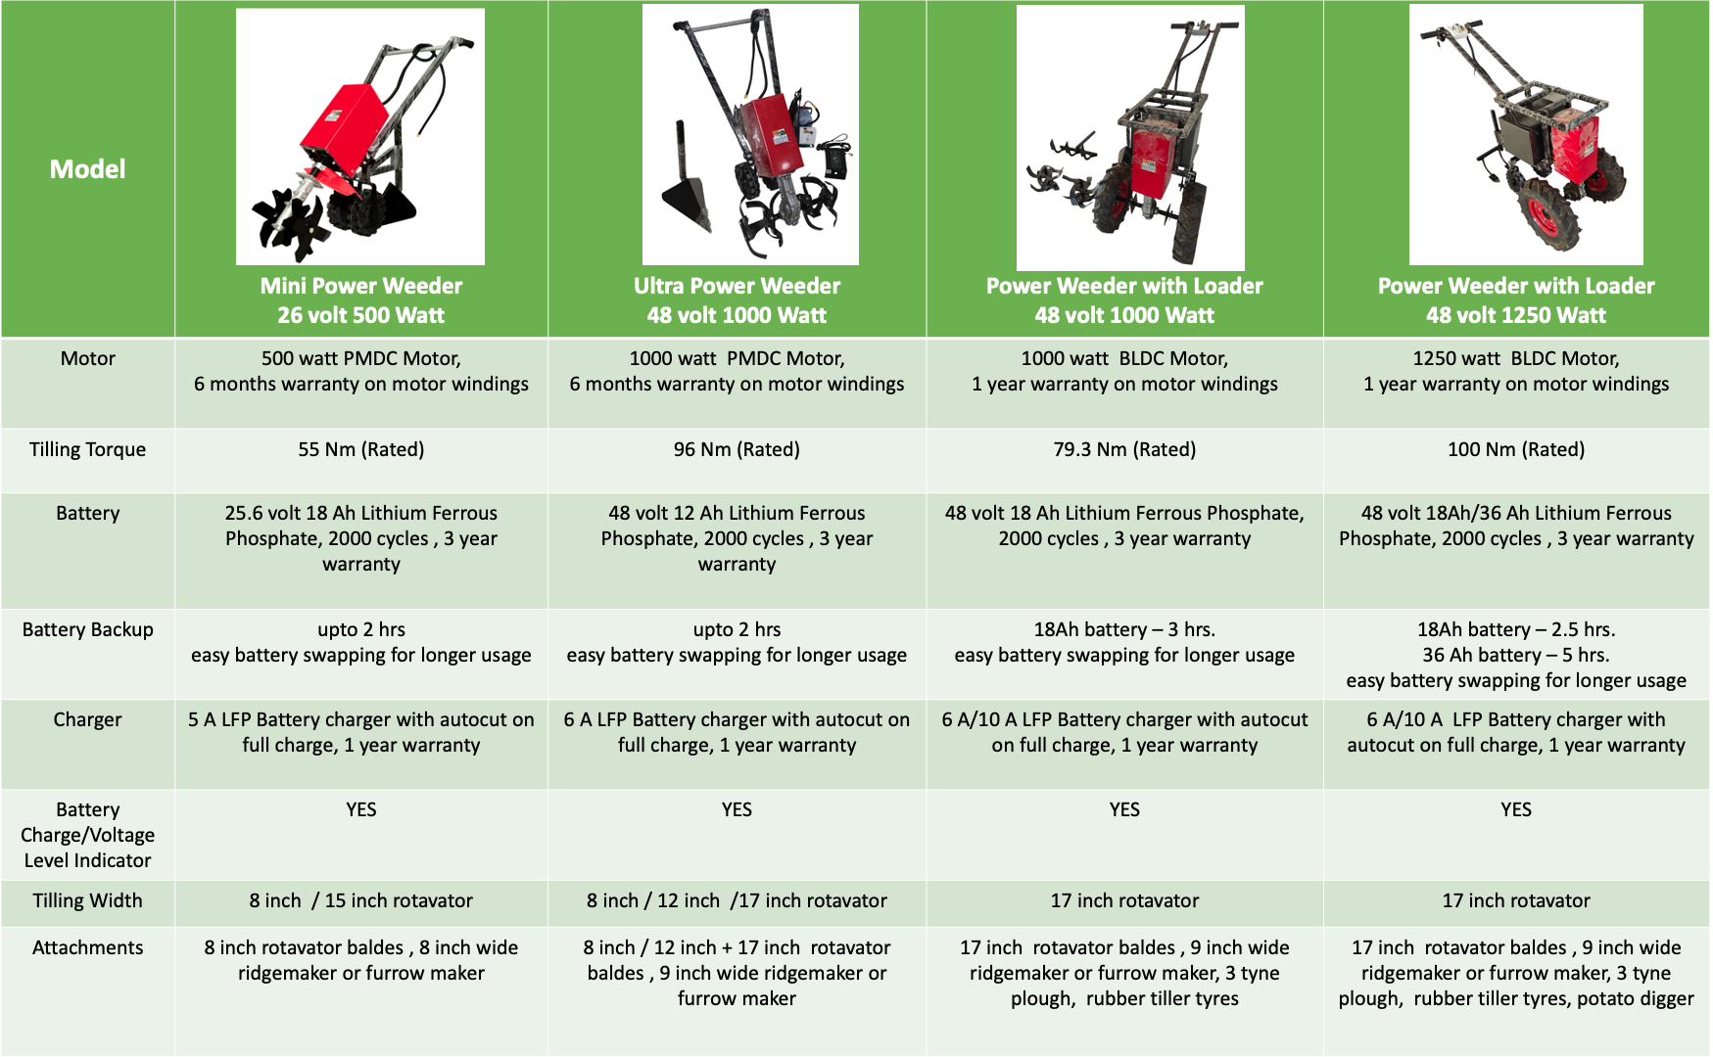

Picture 3: Classification of Model of power weeders

# Mechanical weeding in intra-row crops

Weeds in intra-row crops remain uncontrolled even after mechanical weeders were used to eradicate them from inter-row crops. Therefore, intra-row weeders have occasionally been developed and designed. The working width and speed of the spring-tine harrow weeder were 6 to 24 cm and 6 to 8 km/h, respectively [74]. Crop and weed height, growth phase differences, operation duration, forward speed, tine angle, and weed composition were the main factors influencing weed-crop interaction [75]. A manually operated brush weeder with flexible nylon or fiberglass brushes that rotate on a vertical or horizontal axis was created by Kouwenhoven [74] (Figure 3a).To prevent crop damage, a guard is provided. The torsion weeder is a device that is typically used in conjunction with additional inter-row cultivation blades to control weeds between vegetable rows [48]. The two fast segments of the developed torsion weeder were able to work closely together and parallel to the soil surface because it was made up of two spring tines attached to a rigid frame that was angled backward or downward inside a row (Figure 3b). Within the rows, the weeds are suppressed by the tines. However, any steering error damages the primary crop and reduces yield. Because it must also run at comparatively low forward speeds, the work has a very low operating capacity [48, 76 and 77].The basic mechanical intra-row weeder known as a finger weeder is composed of two sets of blunted metal cones driven by vertically oriented metal tines. The rubber spikes on the cones, also called weeder fingers, are horizontally pointing outward while the crop row is between them (Figure 3c). When thoere are long stem residues on the ground or the soil is compacted or incrusted, the finger weeder does nt do well [48]. Small weeds near fingers were pulled using a rubber finger that was penetrated into the soil surface (Table 5).

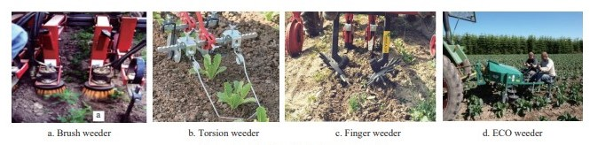

Figure 3    Mechanical intra-row weeders

Table 5 Field performance of intra-row weeding weeders

|  |  |  |  |  |  |
| --- | --- | --- | --- | --- | --- |
| Device | Depth of operation/ mm | Field capacity/ hm2.h-1 | Weeding efficiency/ % | Speed of operation /km.h-1 | Cost of operation Rs.hm- |
| Finger weeder | 10-40 | 0.30-0.60 | 55-60 | 4.8-9.6 | 7000-7500 |
| Torsion weeder | 10-50 | 0.10-1.40 | 60-80 | 6.4-8.1 | 4000-4500 |
| ECO weeder | 25-50 | 0.05-0.15 | 60-80 | 0.8-2.4 | 9000-9500 |
| Flame weeder | 25-50 | 0.05-0.15 | 60-80 | 0.8-2.4 | 16000-16500 |

(Source: [48, 78-82])

Table 6 Effect on speed of inter-/intra-row weeding

|  |  |  |  |
| --- | --- | --- | --- |
| Device | Depth of operation / mm | Speed of operation / km.h-1 | Weeding efficiency / % |
| Brush weeder | 20-30 | <3.50 | 60-80 |
| Harrow | 20-30 | 7.00 | 70-80 |
| Hoe ridger | 25-40 | 7.00 | 80-90 |
| Sensor base vertical axis Rotor weeder | 20-60 | 1.00-2.58 | 75-90 |

ECO weeder is a tractor-operated three-point hitch implement which is used to remove weeds within intra-rows (Figure 3d). The tractor's PTO was utilized to run the ECO weeder's weeding unit. When compared to manual weeding, the developed ECO weeder can cut weeding expenses by up to 60%. Tables 5 and 6 present the field performance of intra row weeding tools and the impact of speed on weed control, respectively. A mechanical inter- and intra-row weeding system was created by Chandel et al. [78] and tested on field crops. For intra-row tine weeders, the ideal rotary speed-to-forward speed ratio was 0.8:1.3. This resulted in a weed mortality rate of 88.4% (8.5% buried and 79.9% uprooted), reduced plant damage (<6%), and a field capacity of 0.22-0.26 hm2 /h at the suggested speed of 0.50-0.56 m/s.

Table 7 Projection for Farm Mechanization in India

|  |  |  |  |  |  |  |  |
| --- | --- | --- | --- | --- | --- | --- | --- |
| Year | Agricultural Workers (millions) | Draft Animals (millions) | Tractors (millions) | Power Tillers (millions) | Diesel Engines (millions) | Electric Motors (millions) | Power (kW/ha) |
| 2010 | 250 | 50 | 4.0 | 200 | 6.8 | 21 | 1.8 |
| 2020 | 300 | 30 | 5.0 | 300 | 7.3 | 30 | 2.5 |
| 2030 | 340 | 20 | 6.0 | 400 | 7.8 | 35 | 3.5 |
| 2040 | 350 | 10 | 7.0 | 500 | 8.5 | 40 | 4.5 |

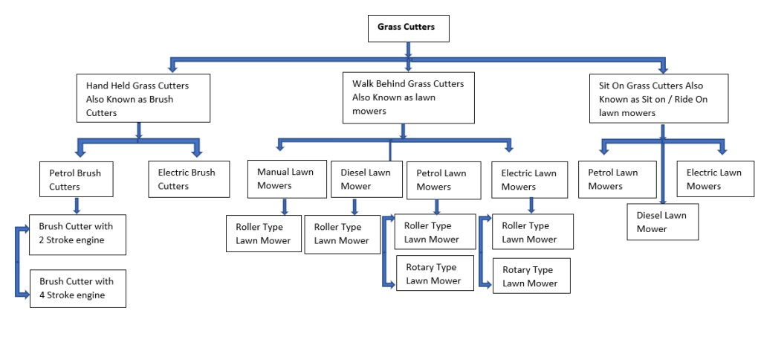

Chart 1: Classification of grass cutters

# Autonomous weeding

# 4.1 Autonomous weeding in Inter-row crops

Robotics in weed control is bringing agriculture closer to the next stage of efficiency, sustainability, and accuracy. Developing a weeding technique that uses fewer herbicides requires robotics. Modern weed robot designs necessitate real-time image detection via multi- and hyper spectral sensors because early weed identification and control are crucial.  
 Robotic arms and self-driving cars are examples of advanced sensor technology that is revolutionizing conventional weed control strategies. Despite being one of the most difficult tasks, weed control in inter row crops will become completely autonomous in the future due to a labor shortage and rising labor wages [83]. According to Merfield [84], every mechanical weeding task is unique and calls for different weeders and equipment adjustments. Some autonomous robots that require little to no modification will be needed for weed control in the near future.

Table 8 Autonomous weeding robots in row crops

|  |  |  |  |  |  |  |
| --- | --- | --- | --- | --- | --- | --- |
| Name | Country | Scope | Method | Sensor | Mechanism | Weeding efficiency /% |
| Tertill | USA | Pearl millet | Mechanical | Capacitive | Weeding Whacking | 54 to 75 |
| Boni Rob | Germany | Sugar beet | Mechanical | RGB, NIR, Ultrasonic | - | - |
| Field Robot | Malaysia | Cucumber | Mechanical | Ultrasonic | - | 95 |
| Agribot II | Australia | cauliflower, broccoli | Mechanical | RGB | Sliding | 96 |
| Plant and weed Identifier Robot | Germany | Rice | Mechanical | Sensor module | - | 84-99 |
| Agribot | India | - | Mechanical | Camera | - | 99.47 |
| Mobile Robot | Turkey | - | Mechanical | Web scam | - | - |
| Weed Robot | Japan | Paddy | Mechanical | GPS sensor | - | - |
| Weed Robot | Japan | Paddy | Mechanical | Capacitive | - | - |
| Laser Weeding Robot | China | Corn | Mechanical | Camera | Track Tensioning Mechanism | 88.94 |

(Source: [85, 86, 87, 88, 89, 90, 91, 92, 93 95])

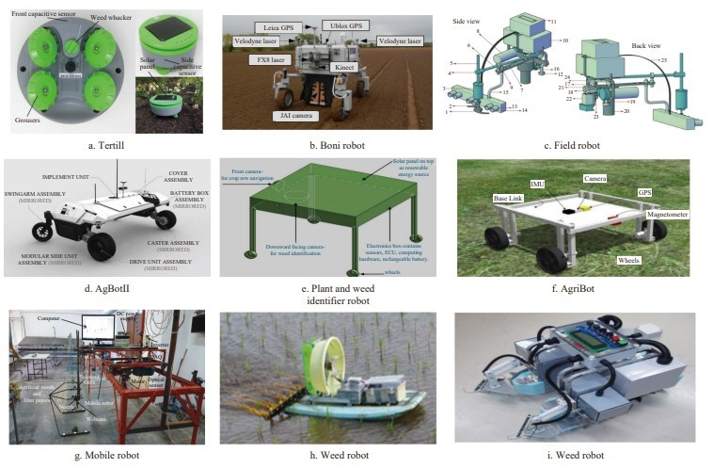



Figure 4    Autonomous robots for weeding operation in inter-row crops

The autonomous, solar-powered Tertill weeding robot for home gardens was just released and put on the market by Franklin Robotics (Billerica, MA) (Figure 4a). With capacitive sensors on both sides to detect and steer clear of obstacles like massive crops and walls, respectively, it functions similarly to a Roomma (iRobot, Bedford, MA) home vacuum cleaner. With this robot, a complex, bulky, and energy-intensive camera or GPS-guided detection system is no longer necessary. In order to detect and identify weeds, an additional capacitive sensor was placed on the bottom side of the Tertill in order to activate the weed whacking mechanism. Tertill's effectiveness ranged from 54% to 75% when using a weed whacker and from 16% to 29% when not [85].The BoniRob, an agricultural robot, was utilized in sugar beet fields throughout the entire season (Figure 4b) [86]. The monorail, chassis, ball bearing, wheels, arms, blade, and adjusting mechanism are the primary components of a field robot (Figure 4c). When the field robot stopped in between two rows of cucumber plants, an ultrasonic sensor was used to scan for weeds and determine the distance between weeds and the blade arm. The arm and blade motors receive the signal to begin rotation [87]. The modular side unit, implement unit, swing arms, drive units, battery boxes, caster assembly, and external covers are the primary parts of a weeding robot. AgBot-II's power unit consists of a custom motor, a gearbox, and an emergency brake in the 14-wheel hub (Figure 4d). Within the intended speed range of 1.38-2.77 m/s, an energy-efficient accessibility requires a 5 kW electric motor operating at 48 VDC with 75%-85% efficiency. A camera was mounted in front of AGBot-II, facing downward, at a height that covered a 1 m field of view [88].

Using on shape design software, Shah et al. [89] created a conceptual model of a plant and weed identification robot that is used in rice row crops spaced 0.25 meters apart (Figure 4e). The breadth and height can be changed based on the stage of plant growth. This robot is able to recognize the leaves in their early stages of development. In order to supply a renewable energy source for robot movement, a solar panel was also installed above the electronic box. Following weed identification, an algorithm shows the weed's location in relation to the image frame and the robotic platform's real-world coordinates. AGRIBOT is a four-wheeled, autonomous agricultural robot prototype model that can steer a skid and perform a variety of tasks, including crop and weed monitoring and classification. [90] (Figure 4f). Using machine vision, Ozluoymak et al. [91] created, planned, and executed a performance assessment of target-oriented weed control (Figure 4g). A remote-controlled weeding robot that uses a body board to float on the water's surface was created by Uchida and Funaki et al. [92]. For stirring paddy fields, a chain was mounted to the back side of the robot (Figure 4h). Sori et al.[93] studied the performance of a weeding robot in wet paddy field (Figure 4i). The field capacity of the developed robot was 1.0-1.5 acres in 3 h at a speed of 20 m/min with a single charge.

## Automated technology for intra-row weeding

Automation could help separate crop plants from weeds and remove the weeds precisely using a mechanical device without causing harm to the crop plants or requiring human intervention [96]. Automation incorporates important technological advancements such as mapping, in-row precision weed control, detection and identification, and guiding [50]. It reduces operator stress by reducing the need for operators to constantly maneuver agricultural machinery. Its goal is to reduce resources and increase efficiency through the use of electrical hardware, sensors, actuators, and software [97].Image processing techniques and vision systems have placed a great deal of importance on weed detection based on plant characteristics and visual structure (Figure 5a). A vision computer a guidance system can identify the precise location of a device, the offset distance from the crop's center line, the margins of the ridges, and the center of the seed line. A machine vision guiding system was created by Slaughter et al. [98] that uses continuous color segmentation of direct-seeded crops in seed lines in cases where the crop is absent because of poor germination. They used two cameras, and the system was put through a field test at 16 km/h. The RMS position errors varied from 4.2 mm when there were no weeds to 12 mm when there were.

Higher accuracy is needed to control weeds within intra-rows [101], and various weed guidance systems have been developed to agricultural management. Astrand and Baerveldt [104] created a fully autonomous movable agricultural robot (Figure 5b) using a framework that has two cameras: one for weed rows and one for crop rows. The first camera is a grey scale camera. A robotic weeding device for transplanted lettuce was created by Balsco et al. [105] and uses a high-voltage electric current (15 kV electrical current discharge) to get rid of weeds (Figure 5c). Two vision-based devices were employed, one to locate the electrical probe to remove the weeds and the other to identify them based on size. Zuydam [106] assessed the differential global positioning system (DGPS) device for the real-time kinematics (RTK)  satellite-based guidance of an instrument along a previously stored electronic area map. Griepentrog et al. [107] created a weeder for intra-row operation that used an RTK base and crop seed maps created at the time of sowing to get rid of the weeds (Figure 5d). The electro-hydraulic motor of the rotary weeder rotates its eight tines along cycloid curves. The rotary tine cultivator, sometimes referred to as the cycloid hoe, can be guided between crop rows using RTK-GPS [108].

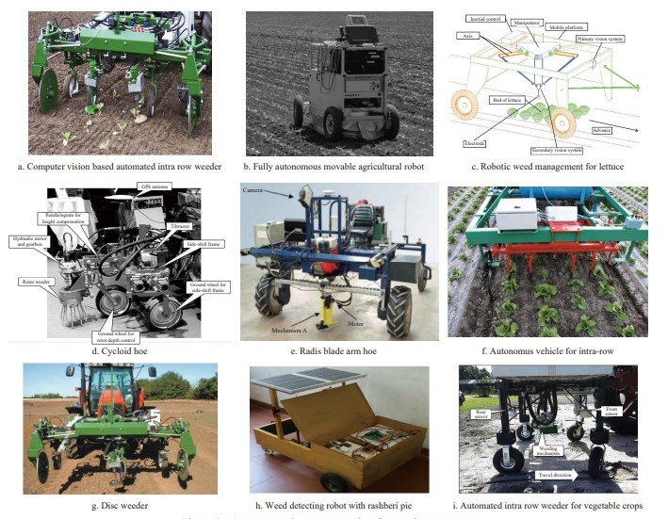

Figure 5   Autonomous intra-row weeders for weeding

The spinning arm removes intra-row weeds when there are no plants present by entering the intra row space through an air pressure chamber. With blades fixed on a pivoting arm, Radis Mechanism created an intra-row weed control system (Figure 5e). The position of the disc is controlled by light sensors that identify the plants. Bakker [116] assessed performance at a speed of 5 km/h, and only 20 mm of weeds were removed. A weeding system that identified plants using computer vision was assessed by Tillett et al. [99]. To prevent crop damage during weeding, the automatic intra row weeder included a rotating half-circle disc (Figure 5f). In the middle position of the weeder, a digital camera was mounted for both forward and downward viewing. A different cutting-edge inter-and intra-row mechanical weeder may work at 1.2 m/s when transplanting intra-row spacing [118] (Figure 5g). When it comes to weeding within and between rows, it possesses reciprocating blades and duck foot. By combining a Raspberry Pi computer with the appropriate input-output components, including cameras, micro-lights, and motors, with an electric device, Sujaritha et al. [119] created a robot that can detect weeds (Figure 5h). Raspbian operating devices and Python programming were used to create the weed detection system. The developed robot prototype could distinguish between nine different types of weeds and the sugarcane plantation.

The soil bin laboratory test of the intra-row weeding method used a number of parameters, including plant spacing conditions, forward speed, depth of operation, and type of soil compaction. Higher forward speeds and closer plant spacing significantly increased plant damage. The overall operational efficiency ranged from 80% to 96% when evaluated using different plant spacing. The accuracy of intra-row weeding systems and different sensor-guided systems are shown in Table 8. For vegetable crops, Saber [127] created an automated mechanical intra-row weed control device (Figure 5i). Rather than sliding in and out sideways, the weeding mechanism moves upward and downward. The upward and downward movement reduces wear on the pinch-roller rubber and enhances weed control performance.

Table 9 Sensor-guided system for intra-row weeding operations

|  |  |  |  |
| --- | --- | --- | --- |
| Machine | Guidance type | Accuracy / Limitation | Reference |
| Hoe | Laser guidance steering system Ultrasonic Real-Time  Kinematic  (RTK) | ± 6 99% over range 0.1-10 m ± 20 mm and ± 60 mm | [101, 106, 110, 121, 122] |
| Cycloid hoe | Hydraulic side-shift device | Geo positioning,  expensive maintenance | [113] |
| Field robot or Autonomous weeder | Machine vision guidance system | ± 12 mm and ± 45 mm | [50, 118, 123,124] |
| Vertical rotating disc weeder | Rotating disc with cut-out sector | Angular error < 10° | [80] |
| Rotating disc type | Infrared | Error of identifying plant  weed | [113, 114, 115] |
| Radius moving time | Light sensor | Error due to natural light  interference | [116, 117] |

The introduction of autonomous robots capable of performing various agricultural tasks has led to much research on the roboticization of the agricultural environment. Traditional weeding techniques have been revolutionized, including by the use of robotics and sensors. Robotic weeding can reduce herbicide consumption by 5%–10% compared to blanket spraying [128]. As robots become more affordable and sophisticated, their ability to eradicate weeds will increase.

Table 10 Comparative study of manual, mechanical and automated weeders

|  |  |  |  |
| --- | --- | --- | --- |
| Criteria | **Manual Weeders** | **Mechanical Weeders** | **Automated Weeders** |
| **Labor Requirement** | High (requires manual labor) | Moderate (requires machine operation, but less manual labor) | Low (automatic operation, minimal human intervention) |
| **Efficiency** | Low (time-consuming and labor-intensive) | Moderate (faster than manual but requires supervision) | High (precise, quick, and requires minimal supervision) |
| **Cost** | Low (initial cost) | Moderate (cost of machinery and maintenance) | High (expensive machinery and technology) |
| **Energy Source** | Human-powered (no fuel required) | Fuel-powered (e.g., gasoline, diesel, or electric) | Fuel/electric-powered (depends on the technology) |
| **Precision** | Low (depends on the skill of the operator) | Moderate (can be precise, but affected by operator skill) | Very High (automated systems use sensors for precision) |
| **Environmental Impact** | High (manual labor can lead to soil compaction, erosion) | Moderate (depends on machinery type, some may cause soil compaction) | Low (designed to minimize soil disturbance and use ecofriendly methods) |
| **Adaptability to Field Conditions** | High (works well in varied field conditions) | Moderate (works well in fields with less complex terrains) | High (advanced sensors and systems allow adaptation to different field conditions) |
| **Weed Type Effectiveness** | Variable (depends on the type of weeds and manual effort) | Good (effective against a range of weed types) | Very High (can target specific weeds using AI and sensors) |
| **Speed of Operation** | Slow (limited by manual labor capacity) | Moderate (depends on machinery capacity) | Very High (machines operate continuously and quickly) |
| **Maintenance** | Minimal (only for tools) | Moderate (requires regular machine maintenance) | High (requires upkeep of automated systems and software updates) |
| **Training Requirements** | None (simple tools, requires only basic training) | Moderate (requires knowledge of machinery use) | High (requires technical training to operate and maintain automated systems) |
| **Labor Cost** | High (manual labor is costly over time) | Moderate (operator costs) | Low (minimal labor after setup) |
| **Flexibility** | High (can be used in small, confined areas) | Moderate (works well in large, open fields) | High (can be programmed to work in various field types) |

# Precision weeding

Pesticide spraying is the most widely used technique for controlling weeds, despite the fact that it negatively affects the ecosystem [129]. Therefore, it is imperative to create a weeding technique that uses fewer pesticides. By combining sensors, information systems, and management, precision agriculture [130] has the potential to increase agricultural productivity while reducing environmental impact. Smart farming technologies like smart sensors, remote sensing, UAVs, satellites, internet of things (IoT) technology, etc., are becoming more and more common in modern agriculture to help increase agricultural productivity and lower waste and expenses [131] (Figure 6). Sensing-related variable rate technology (VRT) offers a practical means of preserving the environment and boosting precision farming's financial gains [132]. This technique uses a sprayer in conjunction with a variable rate control system to apply fertilizer, pesticides, or herbicides. Maps or sensors with different rates may serve as the foundation for the application [133].

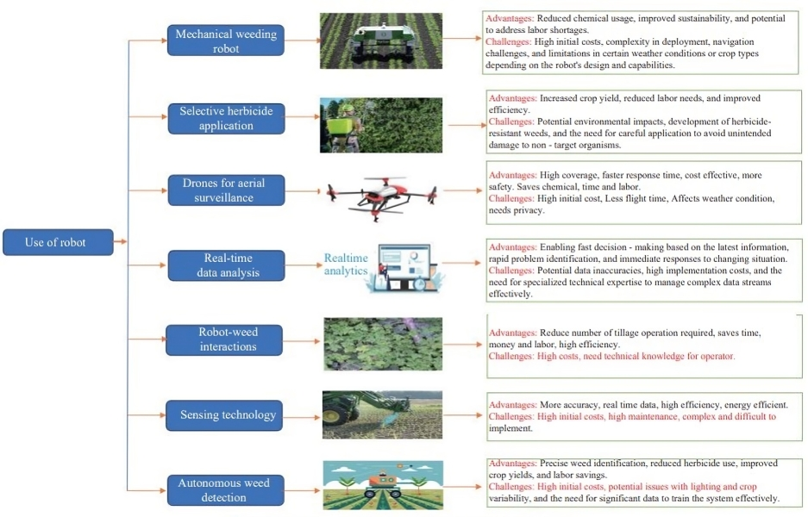

Fig 6    Different precision weed management techniques

Weed control techniques can be greatly enhanced by the use of precision farming technologies. Weed control technology must continuously advance to keep up with weed growth and adaptability because weeds are a persistent problem [134]. Numerous techniques for detecting weeds have been researched since the turn of the century. The most cost-effective way to provide maps of weed presence over large areas, such as a farm or a wide area encompassing multiple farms, may be through remote sensing. Satellites and manned or unmanned aerial vehicles are two methods of gathering data for remote sensing. Large-scale crop yield monitoring and area surveying are both made easier by satellite-based remote sensing. High-resolution imaging is required for these operations, which is normally obtained through closer inspections made with manned or unmanned aircraft or ground vehicles [135].

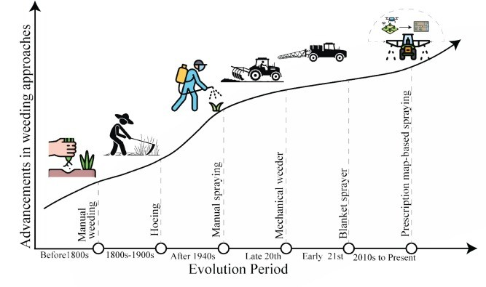

Fig 7: Advancements in weeding approaches

# Conclusion

Mechanical weeding has seen a lot of innovation over the previous few decades, but more is needed to develop and use precision agricultural technology for mechanical weeding in India. There are presently no commercial approaches available to effectively control intra-row weeds, and the accuracy of the tool’s lateral positioning in intra row is restricted to the guidance system. The challenges for dynamic synchronization of electronic control, The farming community, particularly the rural poor, will benefit from improved socioeconomic standing. Manual weeding will reduce labor and promote gender equality, freeing up time for rural women and adolescents to pursue other lucrative occupations such as sericulture and beekeeping.

The study mentioned above led to the following conclusions:

1) By raising output and lowering weeding expenses, farmers can significantly increase their income.

2) Weeds are currently controlled in India using a variety of techniques, including mechanical, chemical, and manual methods, which may be best avoided given their individual drawbacks, as previously mentioned.

3) Time and money can be saved and drudgery can be decreased with the use of precision weed control techniques.

4) New technologies like sensors, microcontrollers, computer vision, robotics, and unmanned aerial vehicles (UAVs) have recently made managing weeds much simpler. This has led to a rise in food production by lowering labor costs, using fewer chemicals, operating on schedule, and posing fewer health and environmental risks.

# Future recommendations

One of the biggest challenges in intensive farming practices and large production areas is non-chemical weed control. In order to manage weeds sustainably, an integrated approach that combines Physical, mechanical, cultural, and agronomic methods are required. The Green Revolution's emphasis on intensive agriculture led to a number of secondary and tertiary problems, such as soil and water contamination and pesticide resistance. In India, the main objectives of agricultural research and development are now nutrition, food safety, and diet diversity rather than food security. Herbicide-based weed control seems sensible for mono cropping, but it falls short of what consumers want when they want safe food. Agronomical methods and instruments for non-chemical weed control may improve food quality and environmental health. Sustainable agriculture techniques based on cropping systems, like conservation agriculture, are essential for reducing the limitations and issues of weed competition in farming. Examples of cutting-edge tools and concepts that can support sustainable agriculture include robotics, UAVs, multispectral and hyper spectral cameras, and remote sensing. In an environmentally responsible way, a significant decrease in pesticide use may enhance agricultural output, food safety, and the standard of living for both producers and consumers.

Disclaimer (Artificial intelligence)

Option 1:

Author(s) hereby declare that NO generative AI technologies such as Large Language Models (ChatGPT, COPILOT, etc.) and text-to-image generators have been used during the writing or editing of this manuscript.

1. NO generative AI technologies are used

Option 2:

Author(s) hereby declare that generative AI technologies such as Large Language Models, etc. have been used during the writing or editing of manuscripts. This explanation will include the name, version, model, and source of the generative AI technology and as well as all input prompts provided to the generative AI technology

Details of the AI usage are given below:

1.

2.

3.

# REFERENCES

[1] FAO Food and Agricultural Organization of the United States. FAO 2023 Available: https://doi.org/10.4060/cc7724en. Accessed on [2024-09- 15].

[2] Sharma G, Shrestha S, Kunwar S, Tseng T. Crop- diversification for improved weed management: A review. Agriculture, 2021; 11(5): 461. doi: 10.3390/agriculture11050461.

[3] Chauhan B S. Grand challenges in weed management. Front Agron, 2020; 1. doi: 10.3389/fagro.2019.00003.

[3] Fahad S, Hussain S, Chauhan B S, Saud S, Wu C, Hassan S, et al. Weed Growth and Crop Yield Loss in Wheat as Influenced by Row Spacing and Weed Emergence Times. Crop Prot, 2015; 71: 101–108.

[5] Oerke E C. Crop losses to pests. J. Agric. Sci, 2006; 144: 31–43.

[6] Yaduraju N T, Mishra J S. Smart weed management: A small step towards doubling farmers’ income. Indian Journal of Weed Science, 2018; 50(1): 1–5.

[7] Gharde Y, Singh P K, Dubey R P, Gupta P K. Assessment of yield and economic losses in agriculture due to weeds in India. Crop Prot, 2018; 107: 12–18.

[8] Devojee B, Meena S S, Sharma A K, Agarwal C. Development of portable knapsack power weeder. International Journal of Agricultural Engineering, 2018; 11(1): 35–40.

[9] Raut, M. B., Wagh, S. P., & Gawde, G. V. Review paper on power weeder. International Journal of Scientific Development and Research, 2019; 4(3): 375–377.

[10] Chethan C R, Singh P K, Dubey R P, Mishra J S, Choudhary V K, Pawar D V, et al. Precision weed management techniques: A smarter way to manage the weeds. Intensive Agriculture, 2022; 56: 4–8.

[11] Jayan P R, Sathyanathan N. Aquatic weed classification, environmental effects and the management technologies for its effective control in Kerala, India. Int J Agric & Biol Eng, 2012; 5(1): 76–90.

[12] Ghersa C M, Benech- Arnold R L, Satorre E H, Martýnez- Ghersa M A. Advances in weed management strategies. Field Crops Research, 2000; 67(2): 95–104.

[13] Jacob J T, Guo X. Effects of irrigation and weed-control methods on growth of weed and rice. Int J Agric & Biol Eng, 2014; 7(5): 22–33.

[14] Rao N A, Nagamani A. Integrated weed management in India–Revisited. Indian Journal of Weed Science, 2010; 42(3-4): 123–135.

[15] Thorat D S, Sahoo P K, Dipankar De, Iquebal M A. Design and development of ridge profile power weeder. Journal of Agricultural Engineering, 2014; 51(4): 7–13.

[16] Kumar S P, Tewari V K, Mehta C R, Chethan C R, Chandel A, Pareek C M, et al. Mechanical weed management technology to manage inter- and intra-row weeds in agroecosystems: A review. Indian Journal of Weed Science, 2022; 54(3): 220–232.

[17] Olaoye J O, Adekanye T A. Development and evaluation of a rotary power weeder. In: Tillage for agricultural productivity and environmental sustainability conference held in Ilorin, Nigeria, 2013; pp.129–141.

[18] Raffaelli M, Martelloni L, Frasconi C, Fontanelli M, Peruzzi A. Development of machines for flaming weed control on hard surfaces. Applied Engineering in Agriculture, 2013; 29(5): 663–673.

[19] Fontanelli M, Frasconi C, Martelloni L, Pirchio M, Raffaelli M, Peruzzi A. Innovative strategies and machines for physical weed control in organic and integrated vegetable crops. Chemical Engineering & Technology, 2015; 44: 211–216.

[20] Melander B, Kristensen J K. Soil steaming on weed seedling emergence under the influence of soil type, soil moisture, soil structure and heat duration. Annals of Applied Biology, 2011; 158: 194–203.

[21] Marx C, Barcikowski S, Hustedt M, Haferkamp H, Rath T. Design and application of a weed damage model for laser–based weed control. Biosystems Engineering, 2012; 113(1): 48–57.

[22] Priyadarshini A, Dash S, Jena J, Kusumavathi K, Pattnaik P, Holderbaum W. Review of the cutting edge technologies for weed control in field crops. Int J Agric & Biol Eng, 2024; 17(5): 44–57.

[23] Singh R. Weed management in major kharif and rabi crops. National Training on Advances in Weed Management. 2014; 31–40.

[24] Malviya A, Singh B. Weed dynamics, productivity and economics of maize as affected by integrated weed management under rainfed condition. Indian J. Agronomy, 2007; 52(4): 321–24.

[25] Pradhan A, Rajput A S, Thakur A. Effect of weed management practices on finger millet under rainfed conditions. Indian Journal of Weed Science. 2012; 44: 115–117.

[26] Jha A K, Soni M. Weed management by sowing methods and herbicides in soybean. Indian J. Weed Science, 2013; 45: 250–252.

[27] Das T K. Weed science: basics and application. New Delhi: Jain Brothers Pub. 2008; 901p.

[28] Verma S K, Singh S B. Enhancing of wheat production through appropriate agronomic management. Indian Farming, 2008; 58(5): 15–18.

[29] Das T K, Tuti M D, Sharma R, Paul T, Mirja P R. Weed management research in India: An overview. Indian Journal of Agronomy, 2012; 57(3): 148–156.

[30] Kewat M L Improved weed management in Rabi crops. National Training on Advances in Weed Management, 2014; 22–25.

[31] Rathore S S, Chaudhary D R, Vaisya L K, Shekhawat K, Bhatt B P. Schoenite and Potasium Sulphate: indigenous potassic fertilizer for rainfed groundnut (Arachis hypogea L.). Indian J Tradit Know, 2014; 13(1): 222–226.

[32] Revathi P, Suneetha K B, Devi, Madhavi M. Effect of integrated weed management practices on weed dynamics and weed control efficiency in lucerne. Indian Journal of Weed Science, 2012; 44(1): 46–49.

[33] Ayyadurai P, Poonguzhalan R. Critical period of crop-weed competition in zero-till cotton. Indian Journal of Weed Science. 2011; 43(3–4): 228–230.

[34] Ghorai A K, Chowdhury H, Kumar M, Kumar S. Technology for weed management in jute. Indian Farming, 2013; 63(6): 12–14.

[35] Yadav S S, Chaudhary I, Yadav R L Heshwa G L. Growth and yield of coriander as influenced by weed management and nitrogen levels. Indian J. Agronomy, 2013; 58(4): 597–602.

[36] Chauhan R S, Srivastava S N. Influence of weed management practices on weed growth and yield of sugarcane. Indian Journal of Weed Science, 2002; 34(3–4): 318–319.

[37] Kunti, Sharma, G, Singh A P. Weed management practices on growth and yield of winter season brinjal under Chhattisgarh plain conditions. Indian Journal of Weed Science, 2012; 44(1): 18–20.

[38] Prameela P, Menon M V, John P S, Abraham C T. Evaluation of pre emergence herbicides for cost-effective weed control in tapioca. Indian Journal of Weed Science, 2012; 44(1): 58–59.

[39] Gnanavel I. Eco-friendly weed control options for sustainable agriculture. Sci Int, 2015; 3: 37–47.

[40] Esposito M, Crimaldi M, Cirillo V. Drone and sensor technology for sustainable weed management: A review. Chem Biol Technol Agric, 2021; 8(18): 2–11. doi: 10.1186 /s40538-021-00217-8.

[41] Christensen S, Søgaard H T, Kudsk P, Nørremark M, Lund I, Nadimi E S, et al. Site-specific weed control technologies. Weed Res, 2009; 49: 233–241.

[42] Sirmour A, Verma A. Design and development of single row power weeder for rice. Journal of Crop and Weed, 2018; 14(1): 163–169.

[43] Tabatabaekoloor R, Pasha H Y, and Hashemi J. Comparison of efficiencies and costs of different weed control methods in paddy production in Iran. Int J Agric & Biol Eng, 2012; 5(2): 28–33.

[44] Verma A, Guru P K. Development and evaluation of cultivator cum seed drill. Ecology Environment and Conservation, 2015; 21(3): 1359–1364.

[45] Jiao J K, Wang Z M, Luo H W, Chen G L, Liu H L, Guan J J, et al. Development of a mechanical weeder and experiment on the growth, yield and quality of rice. Int J Agric & Biol Eng, 2022; 15(3): 92–99.

[46] Tewari V K, Datta R K, Murthy A S R. Field performance of weeding blades of a manually operated push–pull weeder. Journal of Agricultural Engineering Research, 1993; 55: 129–141.

[47] Tewari V K, Kumar A, Nare B, Kumar S P, Tyagi A. Microcontroller based roller contact type herbicide applicator for weed control under row crops. Computers and Electronics in Agriculture, 2014; 104: 40–45.

[48] Weide R Y V D, Bleeker P O, Achten V T J M, Lotz L A P, Fogelberg F, Melander B. Innovation in mechanical weed control in crop rows. Weed Research, 2008; 48(3): 215–224

[49] Chandel A K, Tewari V K, Kumar S P, Nare B, Agarwal A. On–the–go position sensing and controller predicated contact–type weed eradicator. Current Science, 2018; 114(7): 1485–1494.

[50] Slaughter D, Giles D, Downey D. Autonomous robotic weed control systems, A review. Computers and Electronics in Agriculture. 2008; 61(1): 63–78.

[51] Gianessi L P, Reigner N P. The value of herbicides in US crop production. Weed Technology, 2007; 21(2): 559–566.

[52] Goel A K, Behera D, Behera B K, Mohanty S K, Nanda S K. Development and ergonomic evaluation of manually operated weeder for dry land crops. Agricultural Engineering International: CIGR Journal, 2008; 10: 1–11.

[53] Suresh K R, Durairaj N S, Marimuthu S, Muthamilselvan M. Weed characters and indices of transplanted rice as influenced by different weed management practices. International Journal of Agriculture Sciences, 2016; 8(51): 2221–2223.

[54] Jyoti B, Mani I, Kumar K, Khura T K. Electrostatic induction spray charging system for pesticide application in agriculture. Indian Journal of Agricultural Sciences, 2020; 90(7): 1245–1249.

[55] Choudhury P P, Ghosh D, Sanyal A, Sharma D. Herbicide use in agriculture: An Indian perspective. ISWS Golden Jubilee International Conference, Directorate of Weed Research, Jabalpur, India, 2018; 238–264.

[56] Wang J W, Tao G X, Liu Y J, Pan Z W, Zhang C F. Field experimental study on pullout forces of rice seedlings and barnyard grasses for mechanical weed control in paddy field. Int J Agric & Biol Eng, 2014; 7(6): 1–7.

[57] Gianessi L P, Sankula S. The value of herbicides in US crop production. Washington D. C.: National Center of Food and Agricultural Policy. 2003.

[58] Bowman G. Steel in the Field: A Farmer’s Guide to Weed Management Tools. Sustainable Agriculture Network Handbook Series (USA). No. 2, 1997.

[59] Anonymous. Tractor drawn three row rotary weeder. Coordinating Cell, AICRP on farm implements and machinery, CIAE, Bhopal, Extension Bulletin No. CIAE/ FIM/2006/61. 2006.

[60] Sutthiwaree P, Yang M. The rice production situation and mechanization level in the north region of Thailand: Chiang Rai Province. In ASABE Annual International Meeting, 2015; pp.49–56.

[61] Pannacci E, Lattanzi B, Tei F. Non–chemical weed management strategies in minor crops: A review. Crop Protection, 2017; 96: 44–58.

[62] Kumari S, Mehta A K, Meena S S. Development and performance evaluation of solar operated power weeder. International Research Journal of Engineering and Technology, 2019; 6(7): 1340–1343.

[63] Dixit A, Manes G S, Chandel R. Comparative performance evaluation of weeders for cotton crop. Journal of the Institution of Engineers, 2011; 92: 1–4.

[64] Pandey H S, Tiwari G S, Sharma A K. Design and development of an e-powered inter row weeder for small farm mechanization. Journal of Scientific & Industrial Research, 2023; 82: 671–682.

[65] Kachhot A R, Dulawat M S, Vadher A L. Development of solar operated walking type power weeder. Agricultural Science and Green Energy, 2021; 2(2): 30–41.

[66] Dixit J, Syed I. Field evaluation of power weeder for rainfed crops in Kashmir valley. Agricultural Mechanization In Asia, Africa, and Latin America, 2008; 39: 53–56.

[67] Veerangouda M, Sushilendra, Anantachar M. Performance evaluation of weeders in cotton. Karnataka Journal of Agricultural Sciences. 2010; 23: 732–736.

[68] Gatkal N R, Rani V, Pannu R, Naresh, Jain M. Performance and economical evaluation of two row self-propelled narrow crop rotary weeder for managing weeds in mustard crop. Indian Journal of Weed Science, 2022; 54(3): 272–278.

[69] Sahu G, Raheman H. Development of a solar energy operated weeder for wetland paddy crop. Journal of Renewable Energy and Environment, 2022; 9(2): 1–11.

[70] Dhruwe N K, Sahu S, Raghuwanshi V, Nishad P K. Field performance evaluation of L-shaped blade rotary tiller cum inter row weeder. International Journal of Agricultural Engineering, 2018; 11(1): 64–72.

[71] Chandel N S, Tripathi H, Tewari V K. Evaluation and adopt ion scope of rotary power weeder for weed management in vegetable crops. International Journal of Bio-resource and Stress Management, 2015; 6(4): 513–516.

[72] Mohan S S, Sanjana G, Avinash D, Rohitha M, Kumar D A. Performance evaluation of power weeder in sugarcane crop. Current Journal of Applied Science and Technology, 2020; 39(38): 70–81.

[73] Guru P K, Patel S P, Nayak A K, Kumar A, Lal B, Gautam P. Development, and evaluation of power operated weeder in rice. Oryza, 2018; 55(2): 317–323.

[74] Kouwenhoven J K. Intra–row mechanical weed control– possibilities and problems. Soil & Tillage Research, 1997; 41: 87–104.

[75] Rasmussen J. Selectivity–an important parameter on establishing the optimum harrowing technique for weed control in growing cereals. In: Proceedings EWRS Symposium, Integrated Weed Management in Cereals, Helsinki. 1990; pp.197–204.

[76] Bleeker P, Weide R, Kurstjens D. Experiences and experiments with new intra–row weeders. In: Proceedings of the 5th EWRS workshop on Physical Weed Control, Pisa, Italy: European Weed Research Society, 2002.

[77] Melander B, Jorgensen M H, Elsgaard L. Recent results in the development of band steaming for intra–row weed control. In: Abstracts 6th EWRS Workshop on Physical and Cultural Weed Control, 2004; 21p.

[78] Chandelm N S, Chandel A K, Roul A K, Solanke K R, Mehta C R. An integrated inter–and intra–row weeding system for row crops. Crop Protection, 2021; 145: 105642.

[79] Dedousis A. An investigation into the design of precision weeding mechanisms for inter or intra-row weed control. Doctoral thesis, School of Applied Sciences, Cranfield University, 2007; pp.2–16.

[80] Dedousis A P, Godwin R J, O’Dogherty M J, Tillett N D, Grundy A C. Inter and intra-row mechanical weed control with rotating discs. In: Precision Agriculture, Wageningen Academic Publishers, 2006; pp.493– 498.

[81] Anonymous. ECO weeder. Hillside Cultivator Company, LLC, 2011. Available: http://www.hillsidecultivator.com/?page_id=39. Accessed on [2024-08-15].

[82] Ahmad M T. Development of an automated mechanical intra- row weeder for vegetable crops. Agricultural engineering MS thesis, Iowa State University and Agricultural University, Denmark. 2012.

[83] Yan J, Zhang W G, Liu Y, Pan W, Hou X Y, Liu Z Y. Autonomous trajectory tracking control method for an agricultural robotic vehicle. Int J Agric & Biol Eng, 2024; 17(1): 215–224.

[84] Merfield C. Organic weed management: A practical guide. Available at: https://researcharchive.lincoln.ac.nz/.bitstream/handle/10182/4902/ Merfield_organic_weed. pdf?sequence=1&isAllowed=y Accessed on [2021-08-18]

[85] Sanchez J, Gallandt E R. Functionality and efficacy of Franklin Robotics’ Tertill robotic weeder. Weed Technol, 2020; 35(1): 166–70. doi: 10.1017/wet.2020.94.

[86] Chebrolu N, Lottes P, Schaefer A, Winterhalter W, Burgard W, Stachniss C. Agricultural robot dataset for plant classification, localization and mapping on sugar beet fields. Int J Robot Res, 2017; 36: 1045–1052.

[87] Heravi A, Ahmad D, Hameed I A, Shamshiri R R, Balasundram S K, Yamin M. Development of a field robot platform for mechanical weed control in greenhouse cultivation of cucumber. Agricultural Robot, 2018. doi: 10.5772/intechopen.80935.

[88] Bawden O, Kulk J, Russell R, McCool C, English A, Dayoub F. Robot for weed species plant-specific management. J Field Robot, 2017; 34(6): 1179–99.

[89] Shah T M, Nasika D P B, Otterpohl R. Plant and weed identifier robot as an agroecological tool using artificial neural networks for image identification. Agriculture, 2021; 11(3): 222.

[90] Patel D, Gandhi M, Shankaranarayanan H, Darji A D. Design of an autonomous agriculture robot for real time weed detection using CNN. arXiv: 2211.12077, 2022; 1–20. doi: 10.48550/arXiv.2211.12077.

[91] Ozluoymak O B, Bolat A, Bayat A, Guzel E. Design, development, and evaluation of a target-oriented weed control system using machine vision. Turk J Agric, 2019; 43: 164–17.

[92] Uchida H, Funaki T. Development of a remote-control type weeding machine with stirring chains for a paddy field. In: Proceedings of the 22nd International Conference on Climbing and Walking Robots and Support Technologies for Mobile Machines (CLAWAR). Kuala Lumpur: CLAWAR Association Ltd. 2019; pp.61–68. doi: 10.13180/clawar.2019.26-28.08.30.

[93] Sori H, Inoue H, Hatta H, Ando Y. Effect for a paddy weeding robot in wet rice culture. J Robot Mechatronic, 2018; 30(2): 198–205.

[94] Gollakota A, Srinivas M B. AgriBot - A Multipurpose agricultural robot. Annual IEEE India Conference, Hyderabad, 2011; 1–4.

[95] Zhu H, Zhang Y, Mu D, Bai L, Zhuang H, Li H. YOLOX-based blue laser weeding robot in corn field. Frontiers in Plant Science, 2022; 13: 1017803.

[96] Bakker T. An autonomous robot for weed control: design, navigation and control. PhD thesis, Wageningen: Wageningen University, 2009.

[97] Kocher M F, Smith M B, Grisso R D, Bashford L L. Performance tests of three–point mounted implement guidance systems: I. Procedure. American Society of Agricultural Engineers St. Joseph Michigan, 2009; 16(6): 595– 603.

[98] Slaughter D C, Chen P, Curley R G. Vision guided precision cultivation. Precision Agriculture, 1999; 1(2): 199–217.

[99] Tillett N D, Hague T, Grundy A C, Dedousis A P. Mechanical within–row weed control for transplanted crops using computer vision. Biosystems Engineering, 2008; 99(2): 171–178.

[100] Sogaard H T, Olsen H J. Determination of crop rows by image analysis without segmentation. Computers and Electronics in Agriculture, 2003; 38(2): 141–158.

[101] Tillett N D. Automatic guidance sensors for agricultural field machines: A review. Journal of Agricultural Engineering Research, 1991; 50: 167–187.

[102] Sukefeld M, Gerhards R, Kuhbauch W, Site–specific weed control from weed recording to herbicide application. In: Proceedings of the 20th German Conference on Weed Biology and Weed Control, Stuttgart– Hohenheim, Germany, 2000; pp.14–16.

[103] Guerrero J M, Ruz J J, Pajares G. Crop rows and weeds detection in maize fields applying a computer vision system based on geometry. Computers and Electronics in Agriculture, 2017; 142: 461–472.

[104] Astrand B, Baerveldt A. An agricultural mobile robot with vision–based perception for mechanical weed control. Autonomous Robots, 2002; 13: 21–35.

[105] Blasco J, Aleixos N, Roger J M, Rabatel G, Moltó E. Automation and emerging technologies: Robotic weed control using machine vision. Biosystems Engineering, 2002; 83(2): 149–157.

[106] Zuydam R P. Centimetre-precision guidance of agricultural implements in the open field by means of real time kinematic DGPS. In: Proceedings of the Fourth International Conference on Precision Agriculture, St. Paul, Minnesota, USA, July 19- 22, 1999; pp.1023–1034.

[107] Griepentrog H W, Nørremark M, Nielsen J. Autonomous intra–row rotor weeding based on GPS. In: Proceedings of the CIGR World Congress Agricultural Engineering for a Better World, Bonn, Germany, 2006; 37: 17.

[108] Norremark M, Griepentrog H W, Nielsen J, Soegaard H T. The development and assessment of the accuracy of an autonomous GPS–based system for intra row mechanical weed control in row crops. Biosystems Engineering, 2008; 101: 396–410.

[109] Griepentrog H W, Gulhom H T, Nielsen J. First field results from intra–row rotor weeding. In: Proceedings of the 7th European Weed Research Society Workshop on Physical and Cultural Weed Control, Salem, Germany, 2007.

[110] Zuydam R P, Sonneveld C. Test of an automatic precision guidance system for cultivation implements. Journal of Agricultural Engineering Research, 1994; 59: 239–243.

[111] Andersen H J. Tracking furrow with laser. United States Patent application publication. Publication No. US 2003/ 002/0007. 2003.

[112] Kise M, Zhang Q, Mas F R. A stereovision–based crop row detection method for tractor–automated guidance. Biosystems Engineering, 2005; 90(4): 357–367.

[113] Cavalieri A, Janssen S, Smithnson A, Buisman T. Economic viability of weeding strategies in organically grown sugar beets. KVL The Royal Veterinary and Agricultural University, Denmark, 2001.

[114] Bontsema J, Van Asselt C J, Lempens P W J, Van Straten G. Intra–row weed control: a mechatronics approach. IFAC Proceedings, 1998; 31(12): 93–97.

[115] Jones P A, Blair A M, Orson J H. The effect of different types of physical damage to four weed species. In: Proceedings of the Brighton Crop Protection Conference–Weeds, 1995; Vol. 2.

[116] Bakker T. Autonomous weeding literature review. SCO Report 03–01 Wageningen University Systems and Control Group, 2003.

[117] Bleeker P. First experiments with intra–row weed control with a camera. In: Proceedings of the Spatial and dynamic weed measurements and innovative weeding technologies, Bygholm, Denmark: European Weed Research Society. 2005.

[118] Home M. An investigation into the design of cultivation systems for inter–and intra–row weed control. Eng. Doctoral thesis, Cranfield University, Silsoe, 2003.

[119] Sujaritha M, Annadurai S, Kumar S, Sharan J, Mahesh S K. Weed detecting robot in sugarcane fields using fuzzy real time classifier. Computers and Electronics in Agriculture, 2017; 134: 160–171.

[120] Jakasania R G, Yadav R, Rudani M R. Performance evaluation of intra row weeder in soil bin. International Journal of Current Microbiology Applied Science, 2019; 8(6): 2781–2785.

[121] Kumar S P, Tewari V K, Chandel A K, Mehta C R, Nare B, Chethan C R, Mundhada K, Shrivastava P, Gupta C, Hota S. A fuzzy logic algorithm derived mechatronic concept prototype for crop damage avoidance during eco– friendly eradication of intra–row weeds. Artificial Intelligence in Agriculture, 2020; 4: 116–126.

[122] Buick R. RTK base station networks driving adoption of GPS±1-inch automated steering among crop growers. RTK network white paper, Westminster, Colo., Trimble Agricultural Division, 2007.

[123] Keicher R, Seufert H. Automatic guidance for agricultural vehicles in Europe. Computers and Electronics in Agriculture, 2000; 25(1-2): 169–194.

[124] Lee W S, Slaughter D C, Giles D K. Robotic weed control system for tomatoes. Precision Agriculture, 1999; 1: 95–113.

[125] Kumar S P, Tewari V K, Chandel A K, Mehta C R, Nare B, Chethan C R, et al. Sonar sensor based intra row weeding prototype for row crops. World Journal of Agriculture and Soil Science, 2019; 3(4): 1–3.

[126] Kumar S P, Tewari V K, Chethan C R, Mehta C R, Nare B, Chandel A K. Development of non–powered self– propelling vertical axis inter row rotary weeder. Indian Journal of Weed Science, 2019; 51(3): 284–289.

[127] Saber M N. Development of an automated mechanical weed control system for intra-row weeds in vegetable row crops. A dissertation presented to the Graduate School of the University of Florida in partial fulfillment of the requirements for the degree of doctor of philosophy, University of Florida. 2014; 115p.

[128] Shamshiri R R, Weltzien C, Hameed I A, Yule I J, Grift T E, Balasundram S K, et al. Research and development in agricultural robotics: A perspective of digital farming. Int J Agric & Biol Eng, 2018; 11(4): 1–14.

[129] Rani L, Thapa K, Kanojia N, Sharma N, Singh S, Grewal A S, et al. An extensive review on the consequences of chemical pesticides on human health and environment. Journal of Cleaner Production, 2021; 283: 124657.

[130] Zhu N Y, Liu X, Liu Z Q, Hu K, Wang Y K, Tan J L, et al Deep learning for smart agriculture: concepts, tools, applications and opportunities. Int J Agric & Biol Eng, 2018; 11(4): 32–44.

[131] Monteiro A, Santos S, Gonçalves P. Precision agriculture for crop and livestock farming-brief review. Animals, 2021; 11(8): 2345.

[132] Dammer K H, Wartenberg G. Sensor-based weed detection and application of variable herbicide rates in real time. Crop. Prot, 2007; 26(3): 270–277. DOI: 10.1016/j. cropro. 2005.08.018.n.

[133] Lima A, Mendes K. Variable rate application of herbicides for weed management in pre- and postemergence. In Kourti A, Mendes K F, Eds. Pests, weeds and diseases in agricultural crop and animal husbandry production. Dimitrios Kontogiannatos; Intech Open: London, UK, 2020. doi: 10.5772/intechopen.93558.

[134] Westwood J, Charudattan R, Duke S, Fennimore S, Marrone P, Slaughter D, et al. Weed management in 2050: Perspectives on the Future of Weed Science. Weed Sci, 2018; 66(3): 275–285.

[135] Burgos N R, Rouse C E, Singh V, Salas-Perez R, Bagavathiannan M. Technological advances for weed management. In Chandrasena N, Rao A N, Eds. APWSS 50th Anniversary Celebratory; Asian-Pacific Weed Science Society (APWSS) Publication: Honolulu, HI, USA. 2017. 65–79.