**Development of Ergonomically Designed Self-Propelled Planter for NEH Region**

**Abstract**

In narrow terraces of North Eastern Hilly Region use of tractor operated planters and other conventional planter is not feasible. Due to the uneven topography and smaller size of terraces, machines made for the plain regions are not suited for use in the hills. Line sowing is almost non-existent in hill farming due to a lack of a suitable sowing device. Therefore, a lightweight self-propelled planter is required for timely operation with less drudgery in terraced terrain with a vertical interval more than 1 m.The developed machine was consisted of frame, furrow opener, seed box, seed metering plate, engine, power transmission system, seed tube, drive wheel, support wheel and handle. The cost of the developed planter was assessed to be ₹ 32314.00 and the operational cost was observed to be ₹ 192.65 per hour, payback period, break-even point and benefit-cost ratio were obtained to be 2-year, 50 h. yr-1 and 5.70. The self-propelled planter was precise in operation, ergonomically comfortable and cost effective.

**Keywords:** Planter, Hilly region, Ergonomics and Vertical plate type seed metering mechanism

1. **Introduction**

Mechanization of agricultural operations has played a crucial role in effective and timely completion of field operations in plain regions, but it has largely gone unnoticed in hilly region. The majority of fields in the hills and mountains are in shape of small, and varying size terraces, and farmers mostly use manual and bullock power (Singh and Vatsa, 2007). Machines developed for the plains are unsuitable for the hills, owing to geography and the amount of land holdings.

The weight of the prime mover utilized in the hill region must be between 100 and 110 kg, which may be lifted by one or two persons from one terrace to another (Singh and Vatsa, 2007). Thus, a lightweight self-propelled farm equipment’s and machines are necessary to complete crucial farm operations (tillage, sowing/planting, weeding and harvesting) with less drudgery in terraced terrain with a considerable vertical interval between terraces. Traditional farming is dependent on human and animals involving lot of drudgery. Therefore, capabilities and anthropometric dimensions of the operators must be taken while designing the farm equipment and work stations. This would reduce the human energy requirement to operate the tool/equipment without affecting its performance adversely. Seeds are typically broadcasted and sown in line in India's North Eastern Hill (NEH) Region (either sowing the seeds behind the country plough or manual dibbling using khurpi). These methods take a long time, are labor expensive, and are difficult to maintain the recommended seed rate. Although number of planters or self-propelled planters have been developed for planting seeds such as blackgram, information on the development of an ergonomically designed self-propelled planter with an electronic seed metering system suitable for terraces of India’s NEH region could not be found. To deal with the above challenges and to increase precision of seed metering mechanism for a better crop productivity, the best substitute is the development of electronic-seed metering system for the existing self-propelled planter. In this region, precise seed planting is a major challenge and is truly an inter-disciplinary problem.

1. **Materials and Methods**

**Table 1 Description of the developed planter**

|  |  |  |  |
| --- | --- | --- | --- |
| **Sl. No.** | **Name of components** | **Material used** | **Size** |
| 1 | Main frame | MS square pipe | 950 $×$ 40 $×$ 40 $×$ 3 mm |
| 2 | Engine | - | 2.1 HP |
| 3 | Gear box | Cast iron | 130 $×$ 60 $×$ 120 mm (50:1 speed reduction ratio) |
| 4 | Seed Hopper | Plastic | 200 $×$ 200 $×$ 185 mm |
| 5 | Seed metering plate (Vertical plate type) | 3D printer filament | 1.75 Ø mm |
| 6 | Seed metering plate shaft | Aluminium | 10 Ø $×$ 320 mm |
| 7 | Furrow opener | MS flat | 310 $×$ 40 $×$ 5 mm |
| 8 | Drive wheel | MS flat | 200 Ø $×$ 120 $×$ 4 mm |
| 9 | Support wheel | MS flat | 200 Ø $×$ 40 $×$ 3 mm |
| 10 | Drive wheel shaft | MS rod | 20 Ø $×$ 700 mm |
| 11 | Sprockets | High grade cast iron | One 30 teeth and one 15 teeth |
| 12 | Chain | Steel | 670 mm |
| 13 | Seed delivery tube | Plastic tube | 700 mm |
| 14 | Handle | GI pipe | 2100 $×$ 2 $×$ 25 Ø mm |

**2.1 General design consideration of self-propelled planter**

1. Low-cost machine so that small farmers can afford it
2. Simplicity in construction
3. Ease of operation and adjustment
4. Uniform placement of seed
5. Lightweight and ease of operation and transportation
6. Proper covering of the seed in the field
7. Safety and operator’s comfort
8. Use of easily available material for fabrication of the planter
9. Size of land holding

**2.2 Design of main frame**

Due to induced draught, a self-propelled planter was subjected to twisting and bending. As a result, the frame's design was based on the stress it generated.

Assumptions:

1. Width of furrow opener = 3.5 cm
2. Depth of furrow opener = 5 cm
3. Soil resistance = 0.8 kg cm-2

Cross sectional area of furrow opener = 17.5 cm2

Two furrow openers are to be arranged in different bar. The design is based on the total stress produced in the bar.

Draft per furrow opener = 14 kg

Total draft from two furrow opener = 28 kg

Maximum load was calculated considering factor of safety as 2.

Therefore, total draft on tool bar = 56 kg

Torque on the square bar = Draft (kg) $×$ ground clearance (cm)

Ground clearance = 20 cm

Torque = 1120 kg cm = 109.83 Nm

Bending moment is created in addition to torque. The largest bending moment will be near the middle of the frame, which was designed as a basic supported beam. As a result, for a basic supported beam, the maximum bending moment can be calculated using equation 1 (Kumar, *et al*. 2014).

$M_{max} =\frac{WL}{4}$… (1)

Where,

W = Total weight on frame

L = Length of frame

Mmax = 980 kg cm = 96.10 Nm

Equivalent torque due to torsion and bending moment is given as (Verma, 2004) could be calculated using equation 2.

$Te =\sqrt{M^{2}+T^{2}}$… (2)

Where,

Te = equivalent torque

M = maximum bending moment

T = torque

Therefore, Te = 145.93 Nm

The maximum shear stress developed at the center of the toolbar frame could be calculated using equation 3.

$\frac{S_{s}}{Y}= \frac{T_{e}}{I}$… (3)

Where,

Ss = shear stress at any section

Y = distance of the section from neutral axis

Te = equivalent torque produced

I = polar moment of inertia

Considering ultimate stress of M S square material = 360 N/mm2

Therefore, design stress = 180 N/mm2 = Ss

For square section, polar moment of inertia can be calculated using equation 4.

$I =\frac{a^{4}- b^{4}}{12}$… (4)

Where,

a = outer side

b = inner side

$$Y =\frac{a}{2}$$

$$Z =\frac{I}{Y}= \frac{a^{4}- b^{4}}{6a}$$

Therefore,

$\frac{a^{4}- b^{4}}{6a}=$ 810.93 mm

Using a = 40 mm as a starting point, the following equation for b, resulted into b = 39.21 mm.

Accordingly, a mild steel square pipe with a diameter of 40 mm x 40 mm was employed to construct the frame.

Mainframe of the planter (650 mm $×$ 300 mm) was fabricated using a mild steel square section of size 40 mm $×$ 40 mm $×$ 3 mm (Fig.1).

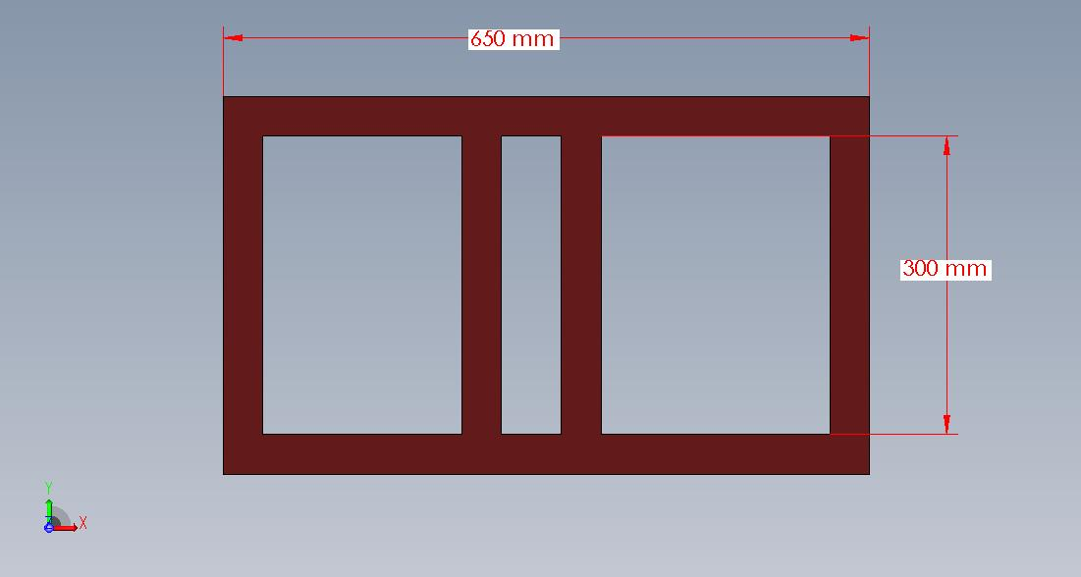

**Fig. 1:** Frame of the planter

**2.3 Seed metering mechanism**

Vertical plate type seed metering mechanism was used for the metering of the seed. The detailed diagram of the vertical plate is given in Fig.2.

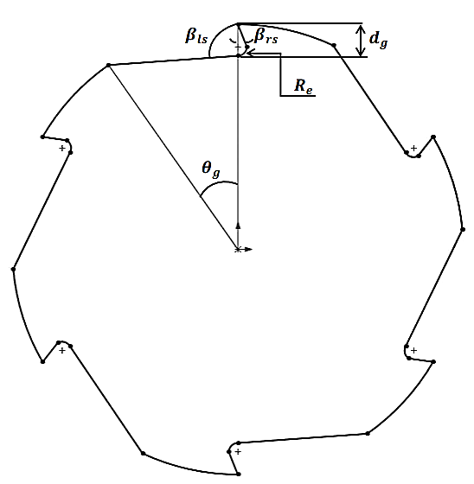

**Fig. 2:** Vertical plate seed metering Plate. dg =Depth of the groove,θg= Opening angle of the groove, βIs = Left side angle of the groove, βrs= Right side angle of the groove, Re = Radius of curvature of the groove

**2.4 Design of furrow opener**

Furrow openers open the soil where seeds metered out and falling through the chute will be dropped into and covered. Soil type, soil condition and depth of planting was considered for designing furrow openers (Ani *et al.* 2016). The depth of placement at which seed is placed in the soil depends on the crop variety and the soil moisture level.

As revealed from review, shovel type furrow openers were well suited for the stony and root infested field. Therefore, shovel type furrow opener was used. Furrow opener having single pointed shovel was taken in the design of self-propelled planter. The main aim is to open the furrow having 2-5 cm depth and 3.5 cm width so that the blackgram seeds can be placed at 2 to 5 cm depth and 3.5 cm width of furrow.

**Selection of standard tine of furrow opener**

The width and thickness of the tine was calculated as follows. A single pointed shovel was fitted with tine as cutting tool. The tine was made of mild steel flat plate having carbon content from 0.15 to 0.25 per cent (Verma, 2005) of size 40 $×$ 5 mm and two was made of M S sheet.

The furrow cross sectional area = 5 $×$ 3.5 = 17.5 cm2

The soil resistance = 0.8 kg cm-2

Soil resistance exerted at the tip of each furrow opener/tine = 17.5 $×$ 0.8 =14 kg

Now taking a factor of safety of three for MS tine the total draft exerted on the opener will be 42 kgf.

Bending moment (M) = Draft (kgf) $×$ ground clearance of tyne (cm)

42 $×$ 20 = 840 kgf-cm.

The section modulus of the tine was computed from the classical flexure formula (Verma *et al.,* 2007) as given in equation 5.

$δ$ = $\frac{MC}{I}$… (5)

Where,

$δ$ = Bending stress, kgf/cm2

M = Bending moment, kgf-cm.

C = Distance from natural axis to the point at which stress is determined, cm and

I = Moment of inertia of the rectangular section, mm4.

The section modulus axis was computed by using the equation 6.

$Z= \frac{I}{C}$… (6)

From the equation 5 and 6,

$Z= \frac{M}{δ}$… (7)

Assuming a bending stress equal to 1000 kgf/cm2, (Verma *et al.* 2007).

= = 0.84 cm3

Take, b = 4 cm size flat M.S

t = thickness of flat M.S

section modulus of the furrow opener, was calculated by using the equation 8 (Verma *et al.* 2007).

$Z= \frac{1}{6}×t×b^{2}$… (8)

0.94 = $\frac{1}{6}×t × {\left(4\right)}^{2}$

t = 3.53 mm = 5mm

Therefore, the cross-section of the tine will be b $×$ t = 40 5 mm2

The maximum deflection of the tine was calculated using equation 9.

$Y_{max}= \frac{{Dl}^{3}}{3EI}$… (9)

Where,

Ymax = Deflection produced due to loading, mm.

D = Draft force, kgf,

l = Length of the tine, mm,

E = Modulus of elasticity = 2104 kg mm-2 (for mild steel) and

I = Moment of inertia was calculated by the using equation 10.

$I= \frac{{tb}^{2}}{12}$… (10)

= = 667 mm4

Therefore,

Ymax =

Ymax = 8.3 mm

The tine of the furrow opener was exposed first to bending due to soil resistance. The soil resistance (Fx) is horizontal and acts in the axis of symmetry of hoe. The soil resistance was assumed to be 3 to 5 times higher actual average soil resistance (Pk) offered by the particular soil (Fig. 3).

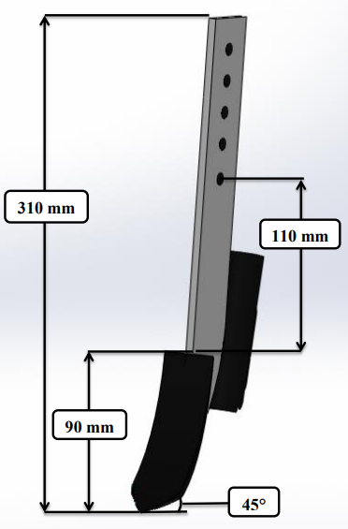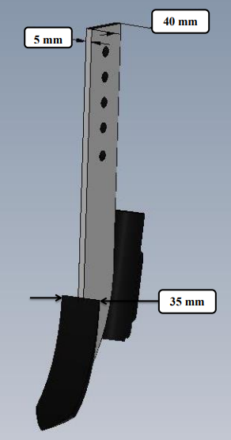

**Fig.3** Furrow opener

The value of the actual average soil resistance was calculated using equation 11 (Varshney *et al.* 2004):

$F_{x }=a w_{w}⍴_{k}$… (11)

Where,

a = working depth of the furrow opener, cm

ww = working width of the furrow opener, cm

Pk = specific soil resistance, kg cm-2

Fx = 5 3.5 .8 $×$ 9.8 = 137.2 N

The soil resistance is assumed to be 3 to 5 times higher than actual average soil resistance (Fx). Draft at the tip of tine was calculated using equation 3.36 (D) = 137.2 $×$ 3 = 411.6 N

Stress, causing the tine to bend was calculated using equation 12 (Nare *et al.* 2014):

$σ = \frac{6 D(L+ a)}{t b^{2}}× {10}^{4}$... (12)

Where,

$σ$ = stress causing bending of tine, Pascal

D = draft at the tip of tine, N

L = length of the tine, cm

$σ$ = 771.7 $× {10}^{5}$ Pa

Now, Torsional stress acting on the tine when turning the opener inside the soil at headland was calculated using equation 13.

$τ= \frac{9D_{t}\left(W_{w}\right)}{8× {b t}^{2}}× {10}^{4}$… (13)

Where,

Ww = working width of furrow opener, cm

$τ=$ 162.0 $×{10}^{5}$ Pa

Then, combined stress was calculated using equation 14.

$δ= \sqrt{σ^{2}+{4τ}^{2}}$… (14)

$δ=$ 788.52 $× {10}^{5}$ Pa

The factor of safety has been taken 2 times more than that of the actual stress,

Therefore, the stress = 788.52 $× {10}^{5} ×2$ = 1577.04 $× {10}^{5}$ Pa

The allowable stress of flat mild steel is 350 MPa (Varshney *et al.* 2004) which is more than the designed stress. Hence, a mild steel of dimension (L $×$ W $×$ T) of 31.0 cm $×$ 4.0 cm $×$ 0.5 cm had been taken for furrow openers.

**2.5 Transport wheel**

One transport wheel of 20 cm diameter made up of 4.0 cm x 0.3 cm MS flat and 0.8 cm diameter spokes were fitted at the axle of the transport wheel (Fig. 4). A shaft of 2.5 cm diameter supported by MS flat (4 cm x 0.6 cm) of length 13 cm was attached to the wheel in perpendicular direction, which was used for transport of the planter.

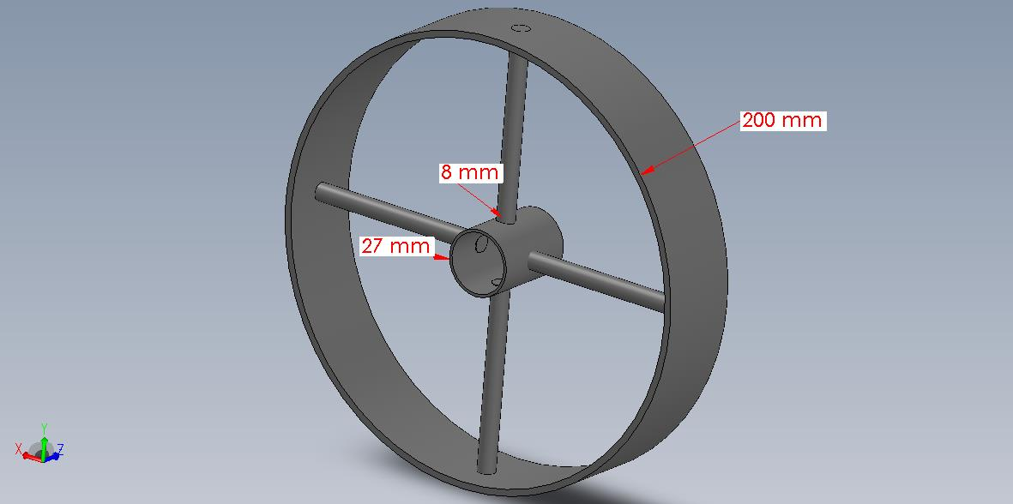

**Fig.4** Support wheel

**2.6 Power source (Petrol Engine)**

A 1.57 kW petrol engine (Honda GXH50) with recoil starter was used for self-propelled planter (Fig. 5). The engine was selected on the basis of draft and power requirement of the planter and was fixed on the frame with the help of nut bolts.

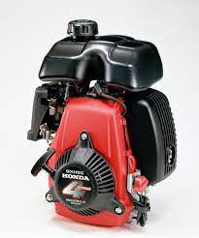

**Fig. 5** Petrol Engine

**2.7 Gear box**

A gear box with speed reduction ratio of 50:1 was used (Fig. 6). The gear box used in this machine works in forward direction only. It was attached to engine with the help of centrifugal clutch at one end and the other end with the drive wheels.

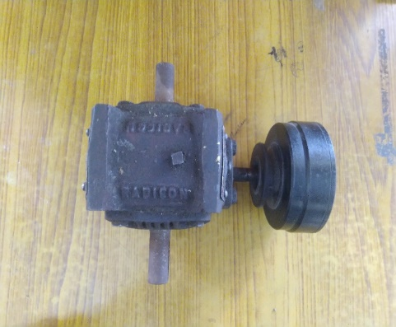

**Fig. 6** Gear box

**2.8 Selection and design of drive wheel**

The drive wheel should be positive power transmission device to provide motion to the self-propelled planter. Invariably chain and sprockets are considered most appropriate devices. The power derived from the wheel can be calculated using principles of soil mechanics. In this case the rigid wheel with pegs was used in the planter due to its of low cost, low maintenance, better gripping and longer life.

In addition, this type of wheel suitable for use under wet or sticky soils, where plain, lugged or even pneumatic wheels fail to work. Mild steel sheet measuring 120 mm broad and 4 mm thick was used to build two 200 mm diameter driving wheels. There were eight mild steel round spokes with an 8 mm diameter offered. To reduce slip, eleven 20 mm high lugs were welded at regular intervals at a 25 $°$ angle to the rotating axis (Fig. 7). The motion of a given point on the wheel follows a cycloid path. The pegs enter the ground vertically and leave the surface upwards. Hence, soil coming in contact with the peg was pushed downward but not taken upwards.

The diameter of the drive wheel was calculated using equation 15.

$D= \frac{n×p}{π}$… (15)

Where,

D = Diameter of the drive wheel, cm

n = No. of seeds dropped in one revolution, and

p = Plant to plant distance, cm

Using values of n and p as 6 and 10 in equation 3.40 value of D was estimated as 19.10 (20 cm).

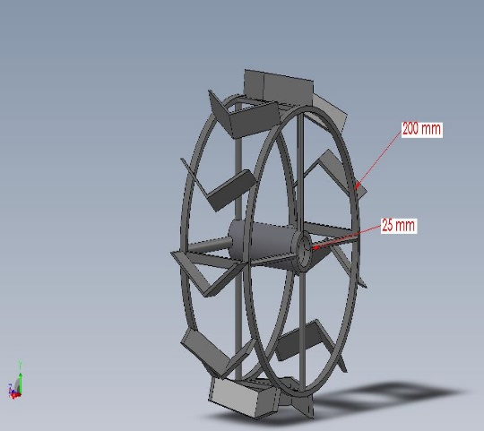

**Fig. 7** Drive wheel

**2.9 Design of chain**

The chains are mostly used to transmit motion and power from one shaft to another, when the center distance between the shaft is short. In order to obtain a constant velocity ratio, chain drive is mostly preferred.

The length of chain (L) attached from drive wheel to gearbox through follower sprocket the center-to-center distance between two sprocket is maintained at 220 mm.

The length of the chain was calculated using equation 16 (BIS: 15530: 2004).

$M=\frac{2C}{P} +\frac{N1 +N2}{2} +{\left(\frac{N2-N1}{2Pπ}\right)}^{2}$… (16)

Where,

M = Number of chain link,

C = Center to center distance between two sprockets,

N1 = Number of teeth on bigger sprocket, 30

N2 = Number of teeth on smaller sprocket, 15

P = Chain pitch, mm.

$$M =\frac{2×220}{10}+\frac{30+15}{2}+{\left(\frac{15-30}{2×10π}\right)}^{2}$$

= 67

Chain length was calculated using equation 17.

$L=M×P$... (17)

= 67 $×10$

= 670 mm

Average chain velocity was calculated using equation 18 (Kurtz *et al*., 1984).

$V_{av}= \frac{n ×p ×rpm}{60×1000}$… (18)

$V_{av}= \frac{15 ×10×90}{60×1000}$ = 0.225 m s-1

Where,

Vav = Average chain velocity, m s-1

n = The driving sprocket no. of teeth, 15

rpm = Maximum revolution of the driving sprocket, 90 rpm

The total load (force) on the driving side of the chain was calculated using equation 20 to 22 (Sharma and Mukesh, 2010).

$F_{T}=F+F_{C}+F_{f}$… (19)

Where,

FT = The total force, N

F = The force due to power transmission, N

Ff = Frictional force, N

FC = Centrifugal force on the chain, N

$F= \frac{P}{V_{av}}$… (20)

$F= \frac{119}{0.225}$

F = 528.88 N

$F_{C}= \frac{W ×{\left(V_{av}\right)}^{2}}{g}$ ` ... (21)

= $\frac{4.8 × {.225}^{2}}{9.81}$

FC = 0.024 N

$F_{f}= W × kf ×Cc$... (22)

= 4.8 $×$ 2 $×$.22

$F_{f}$ = 2.11 N

Where,

Cc = Nominal center to center distance between the sprocket, 0.22m

P = Power at the planter/ power to be transmitted, 119w = .16hp

Kf = Friction factor = 4 for horizontal drive, 2 for inclined drive and 1 for vertical drive Since the sprocket are inclined aligned, kf = 2 (Norton, 2005)

W = Weight of the chain, 4.8 N/ .67m (measured)

g = Gravitational acceleration 9.81m s-2 (Norton, 2005).

Thus,

$$F_{T}=528.88 +0.024 +2.11$$

FT = 531 N

According to ANSI standard, the minimum tensile strength of the chain is 3470N. To avoid breakage or failure of the chain, the safety factor should be more than one. Checking safety factor, using equation 23 Sf (Sharma and Mukesh, 2010).

Sf = … (23)

= $\frac{3470}{531}$ = 7

7, the value is greater than unity. It is safe.

**2.10 Design of shaft for drive wheel**

Considering total load imposed on machine 35 kg and length of the shaft 70 cm.

The shaft is subjected to a twisting and bending moment than maximum shear stress theory or Guests theory was used for designing the shaft (Fig. 8) (Khurmi and Gupta, 2014).

If shaft is made of ductile material the maximum shear stress theory was used to design the shaft by using the equation 24.

$τ_{max}=\frac{1}{2}\sqrt{{\left(σb\right)}^{2}+4τ^{2}}$... (24)

Where,

$τ_{max}$ = maximum shear stress, N mm-2

= bending stress (tensile or compressive) induced due to bending moment, N-mm

$τ$ = shear stress induced due to twisting moment, N-mm

Maximum shear stress, ( $τ_{max}$) was calculated using equation 25.

$\left(τ_{max}\right)= \frac{τ_{u}}{F S}$… (25)

Where,

u = ultimate shear stress, N/mm-2, 500Mpa (for mild steel)

F S = factor of safety (considering 2).

The shaft is subjected to a bending moment than the maximum stress was calculated using equation 26.

$σb$ = $\frac{M}{I} ×Y$ or $\frac{Mb}{\frac{π}{64}d^{4}}×\frac{d}{2}$… (26)

Where,

Mb = bending moment of drive wheel shaft in N-mm,

= 209 $×$ 700

= 146300 N-mm

I = moment of inertia of cross-sectional area of the shaft about the rotation,

Y = distance from neutral axis to the outer most fibre,

d = diameter of the shaft in mm.

The shaft is subjected to a torsional moment than the maximum stress was calculated using equation 27.

$τ= \frac{Mt}{I}×Y$ or $\frac{Mt}{\frac{π}{32}d^{4}}×\frac{d}{2}$… (27)

Where,

Mt = torsional moment in N-mm

Torsional moment can be calculated using equation 28 from the power of Engine.

$P= \frac{2 π N Mt}{60×{10}^{6}}$… (28)

Where,

P = power of engine, 1.57 Kw,

N = rpm of drive wheel, 45

Mt = 333334 N-mm

Substituting the values of $τ$ and $σb$ in Equation (1), we have

d3 = 19.50 mm

Therefore, the selected diameter of shaft d = 20mm

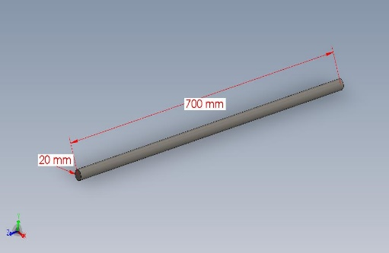

**Fig. 8** Shaft for drive wheel

**2.11 Hopper**

Planters have small seed hoppers for each row (Singh, *et al.* 2014). The hopper can have a trapezoidal, rectangular, triangular, or cylindrical cross-section. The basic consideration in choosing the shape of the hopper was that each hopper should carry the desired amount of seed and the seed should flow freely towards the hopper's outlet. The size, shape, test weight, and coefficient of friction of the seed govern the former, while the angle of repose governs the later. In light of these considerations, a trapezoidal hopper was chosen (Fig. 9), and its volume was calculated using equation 29.

Considering Trapezoidal seed box with following dimensions:

a = Bottom width of seed box, 7 cm,

b = Top width of seed box, 20 cm,

l = Length of seed box, 20 cm,

h = Height of seed box, 18.5 cm,

The volume of seed box (VS) was calculated using equation 29.

$V_{s}= \frac{\left(a+b\right)}{2}×h×l$… (29)

= 4995 cm3

Each hopper could thus hold 4.995kg of Blackgram.

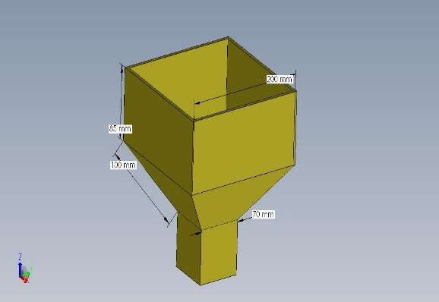

**Fig. 9** Seed box

**2.12 Seed tube**

Seed tubes were made of transparent plastic pipe fitted between different seed outlet of metering system and furrow opener boot pipes. The time of fall of the seed through a tube is affected by the size and type of tube by the striking and bouncing of seeds against the wall of the seed tube. Transparent smooth surface plastic tubes of 25 mm diameter and 2 mm thick were selected for the planter to avoid any seed clogging and to ensure smooth seed flow.

**2.13 Design of handle**

The handle was designed according to anthropometric dimensions of Sikkim workers. Relevant anthropometric dimensions under standing position and hand-related dimensions of workers are given in Table 2 and Table 3 and shown in Fig. 10 and 11respectively. 5th to 95th percentile values are taken for design to satisfy 90 per cent user population. 5th percentile data are taken where reach is the requirement while 95th percentile data are taken for the requirement of space (Singh *et al.* 2019).

**Table 2 Anthropometric dimensions considered for designing height of handle**

|  |  |  |
| --- | --- | --- |
| **S. No.** | **Parameters (mm)** | **Percentile score adopted** |
| **1** | Acromial height | 95th |
| **2** | Elbow height | 5th |
| **3** | Bideltoid breadth | 95th |

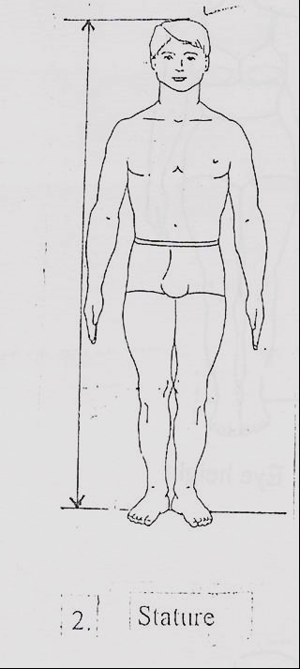

**Fig. 10** Anthropometric measurements in standing posture

**Table 3 Anthropometric dimensions considered for designing grip of handle**

|  |  |  |
| --- | --- | --- |
| **S. No.** | **Parameters (mm)** | **Percentile score adopted** |
| **1** | Inside grip diameter | 5th |
| **2** | Middle finger palm grip diameter | 95th |
| **3** | Hand length | 5th |

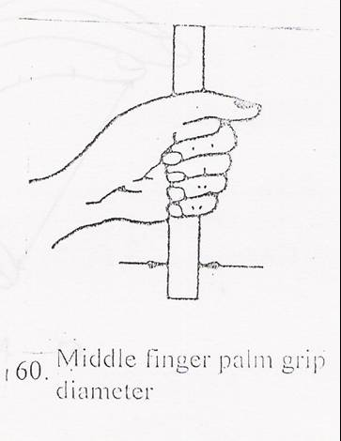

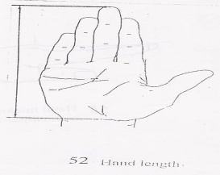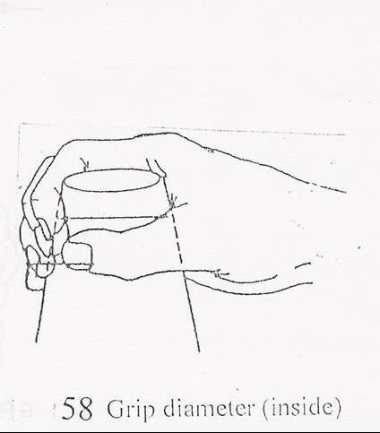

**Fig. 11** Measurement of relevant hand dimensions

1. **Results and Discussion**

**3.1 Machine performance**

During field evaluation of the developed planter various machine performance parameters such as depth of furrow for seed placement, seed germination, theoretical, actual field capacity, field machine index and fuel consumption rate were determined and summarized in Table 4.

It is evident from Table 4 those average values of depth of furrow for seed placement, seed germination (%) under laboratory condition, theoretical field capacity, actual field capacity, field machine index and fuel consumption rate were estimated as Machine performance data 32.2 mm, 91.6%, 0.038 ha h-1, 0.024 ha h-1, 77.19% and 0.71 l h-1respectively.

**Table 4 Machine performance data self-propelled planter for planting of blackgram in terraces**

|  |  |  |  |  |
| --- | --- | --- | --- | --- |
| **S. No.** | **Machine parameters** | **Min.** | **Max.** | **Average** |
|  | Depth of furrow for seed placement, mm | 18 | 48 | 32.2 |
|  | Theoretical field capacity, ha h-1 | 0.025 | 0.051 | 0.038 |
|  | Actual field capacity, ha h-1 | 0.021 | 0.026 | 0.024 |
|  | Field machine index, % | 76.6 | 77.8 | 77.19 |
|  | Fuel consumption rate, l/h | 0.68 | 0.76 | 0.71 |

The detailed view and design diagram of the developed planter is shown in Figure 12. As per design consideration the machine components were designed and fabricated successfully.The cost of the developed machine was estimated to be ₹ 32314.00 and the operational cost was observed to be ₹ 192.65 per hour.During the field testing, the developed planter gave satisfactory results. Specification of the developed planter is given in Table 5.

**Table 5 Specification of developed planter**

|  |  |
| --- | --- |
| **Part/Parameter** | **Specification** |
| Engine power | 1.57 kW, 4500 rpm |
| Gear box speed reduction ratio | 50:1 |
| Seed metering | Vertical plate type (100 mm Ø) |
| Overall size, L $×$ W $×$ H | 650 $×$ 320 $×$ 740 mm |
| Number of rows | 2 |
| Row spacing | 300 mm |
| Plant spacing | 100 mm |
| Type of furrow opener | Single pointed shovel type |
| Weight of the planter, kg | 35 |
| Capacity of the battery, h | 3 hours and 21 minutes |

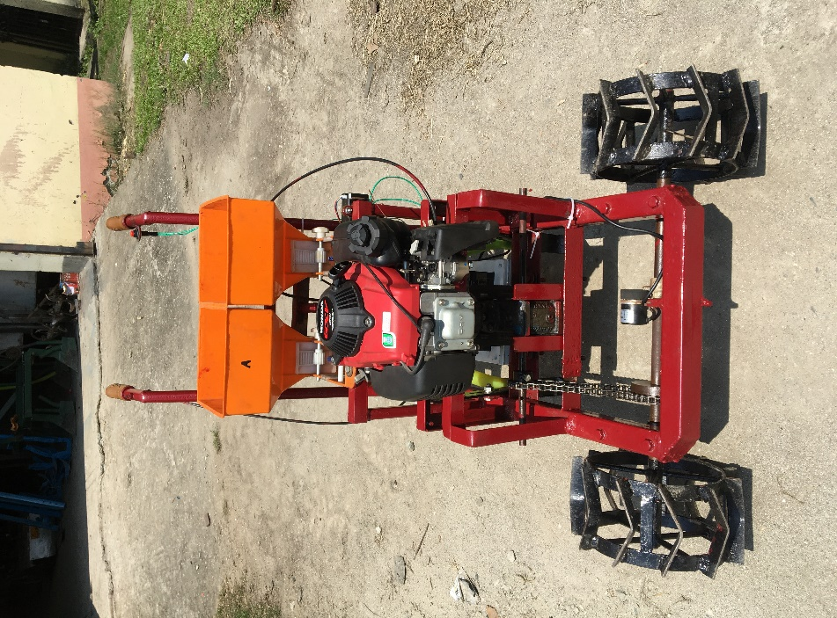

**Fig. 12:** View of developed machine

1. **Conclusions**

Developed self-propelled planter was tested in the field at the Namin village Gangtok, Sikkim. The developed planter works satisfactory.

**Disclaimer (Artificial intelligence)**

**Option 1:**

**Author(s) hereby declare that NO generative AI technologies such as Large Language Models (ChatGPT, COPILOT, etc.) and text-to-image generators have been used during the writing or editing of this manuscript.**

**Option 2:**

**Author(s) hereby declare that generative AI technologies such as Large Language Models, etc. have been used during the writing or editing of manuscripts. This explanation will include the name, version, model, and source of the generative AI technology and as well as all input prompts provided to the generative AI technology**

**Details of the AI usage are given below:**

**1.**

**2.**

**3.**

**References**

Ani, O.A., Uzoejinwa, B.B., and Anochili, N.F. (2016). Design, construction and evaluation of a vertical plate maize seed planter for gardens and small holder farmers. *Nigerian Journal of Technology (NIJOTECH)*., 35: 647-655.

IS 15530: 2004. Test code for conveyor chains, attachment and sprockets-specification, Bureau of Indian Standard, Manak Bhawan, New Delhi, India.

Khurmi, R.S., and Gupta, J.K. (2014). A Text book of machine design. 1st edition. Eurasia publishing house pvt. ltd., New Delhi,Pp.759-774.

Kumar, S., Mishra, B. P., Patel, S. K., and Dave, A. K. (2014). Design and development of a power tiller operated seed-cum-ferti till-drill machine. *African Journal of Agricultural Research*, 9(51), 3776-3781.

Kurtz, G., Thompson, L. and Clwar, P. (1984): Design of agricultural machinery. John Willey and Sons, Singapore, pp 245 - 255.

Nare, B., Naik, R.K., Shrivastava, A.K., and Prakash, A. (2014). Design, development and evaluation of self-propelled garlic (*Allium sativum* L.) clove planter*. Agricultural mechanization in asia, africa, and latin America*., 45(2): 74-79.

Norton, M.L. (2005). Design of machinery: An introduction to the synthesis and analysis of mechanisms and machines, Mc-Graw-Hill, Inc., New York,3rd ed.

Sharma, D. N. and Mukesh S (2010). Farm machinery design principles and problems, second edition. Jain brothers. Pp. 55-190.

Singh, H. J., De, D., Sahoo, P. K., and Iquebal, M. A. (2014). Development and evaluation of self-propelled multicrop planter for hill agriculture. *Journal of Agricultural Engineering*, 51(2), 1-8.

Singh, S. and Vatsa, D.K. (2007). Development and Evaluation of a light weight power tiller operated seed drill for hilly region. *Agricultural Mechanization in Asia, Africa and Latin America*, 38(2): 45-47.

Singh, S. P., Singh, M. K., Singh, M. K., and Ekka, U. (2019). Ergonomics for gender friendly farm equipment to enhance better human-machine interaction. *RASSA Journal of Science for Society*, *1*(1&2), 54-59.

Varshney, A.C., Tiwari, P.S., Suresh, N. and Mehta, C.R. (2004). Data Book for Agricultural Machinery Design. Bhopal, Pp.50-241.

Verma, A. K., Dewangan, M. L., Singh, V. V., and Das, V. (2007).Mechanical consideration for design and development of furrow openers for seed cum fertilizer drill. *Agricultural Mechanization in Asia, Africa and Latin America*, *38*(2): 74.

Verma, A.K. (2004). Design and Development of Seed Cum Fertilizer Drill from Mechanical and Ergonomics Consideration. Ph.D. Thesis, Submitted to Pt. Ravishankar Shukla University, Raipur (CG) India.

Verma, B.B. (2005). Design, development and testing of animal drawn tillage cart. M. Tech. Thesis, Submitted to Indira Gandhi Krishi Vishwavidyalaya, Raipur (CG) India.