***Minireview Article***

**The Sudden Collapse of Cancer Cells: Exploring Tumor Lysis Syndrome Through a Molecular and Therapeutic Lens**

**Abstract**

Tumor Lysis Syndrome (TLS) is an acute oncologic emergency triggered by the rapid destruction of malignant cells, resulting in a cascade of metabolic derangements including hyperuricemia, hyperkalemia, hyperphosphatemia, and hypocalcemia. This review synthesizes contemporary understanding of TLS from molecular to clinical and translational perspectives. It examines TLS pathophysiology, focusing on intracellular release of nucleic acids and ions that overwhelm clearance mechanisms, precipitating acute kidney injury, cardiac arrhythmias, seizures, and multiorgan failure. This catabolic cascade also provokes systemic inflammatory responses (akin to cytokine release syndrome), further compounding endothelial dysfunction and organ injury. Both therapy-induced and spontaneous TLS are considered, highlighting risk factors including high tumor burden, elevated lactate dehydrogenase (LDH), proliferative indices, and oncogenic alterations that predispose to rapid lysis. Additionally, targeted therapies and immunotherapies have also broadened TLS contexts, underscoring vigilance. Management strategies include aggressive hydration, hypouricemic agents, and innovative therapies. Future directions include personalized prophylaxis guided by tumor genomics, novel targeted interventions to modulate tumor metabolism, and multidisciplinary research. Early recognition and tailored intervention remain paramount to mitigate the complexity and lethality of TLS in affected patients.

1. **Introduction**

Tumor lysis syndrome is an oncologic emergency defined by an acute release of intracellular contents to systemic circulation after a brisk destruction of malignant cells and is most frequently induced by cytotoxic chemotherapy. TLS is most frequently associated with hematological malignancies such as acute leukemias and high-grade lymphomas but is increasingly reported with bulky aggressive solid cancers. Based on recent clinical evidence, TLS is most frequently evident in non-Hodgkin lymphoma (~30%), followed by acute myeloid leukemia (~19%), acute lymphoblastic leukemia (~13%), and certain high-burden solid cancers (~20%) [(1)](https://www.zotero.org/google-docs/?lheHU5). Sex is not definitively predictive but is not an absolute predictor either. Known predisposing factors include male gender and old age (>65 years), elevated premorbid levels of uric acid or lactate dehydrogenase (LDH), underlying renal insufficiency, and dehydration status [(2)](https://www.zotero.org/google-docs/?AkgLXX). For purposes of clinical management, existing guidelines stratify TLS risk for each individual on a spectrum of low (<1%), intermediate (1–5%), and high (>5%) based on tumor or leukemia type and histology and laboratory evidence of impending TLS. High-risk categories are frequent for those with end-stage or aggressive lymphomas such as Burkitt lymphoma and for those with acute leukemias with white cell counts >100×10⁹ or for those with bulky diffuse large B-cell lymphomas. Those with slow-growing cancers such as CLL or MM would be of low risk [(1,3)](https://www.zotero.org/google-docs/?ECq7jC).

TLS occurs when rapidly disintegrating tumor cells release intracellular ions, nucleic acids, proteins, and their byproducts into the bloodstream, ultimately triggering TLS. These metabolites, including hyperuricemia, hyperkalemia, hyperphosphatemia, hypocalcemia, and uremia, disrupt the body's natural balance mechanisms [(4)](https://www.zotero.org/google-docs/?tUGRpY). These abnormalities lead to severe complications such as kidney failure, cardiac arrhythmias, and neurological issues, notably convulsions and seizures [(5)](https://www.zotero.org/google-docs/?R6w0Hx). TLS can manifest spontaneously, even before the commencement of cancer treatment; however, it frequently emerges within the initial week of initiating therapy. The likelihood of its occurrence is influenced by the specific cancer type the patient is diagnosed with, and the presence of larger tumors or extensive metastases increases the risk of TLS development. These acute metabolic derangements show the restricted tolerance of the body to the abrupt biochemical load from rapid tumor cell lysis, especially in cancers with higher proliferative and cell-turnover rates. A systemic understanding of these derangements necessitates a broader perspective based on cancer cell metabolism and systemic stress from metabolic dysregulation. In our previous work, we explored the impacts of metabolic overload, driven by elevated glucose metabolism and disturbed glycolytic pathways, on cancer cell survival and therapeutic outcomes [(6)](https://www.zotero.org/google-docs/?FRucuQ). These are crucial insights into the metabolic instability found in Tumor Lysis Syndrome.

Notably, TLS is most observed in cases of acute leukemias characterized by elevated white cell counts at diagnosis and diffuse non-Hodgkin lymphomas of the Burkitt type. This association is largely attributed to the propensity of tumors with substantial burden, rapid cell turnover, and heightened sensitivity to chemotherapeutic agents to trigger TLS [(7)](https://www.zotero.org/google-docs/?JyJ8cT). Tumor Lysis Syndrome (TLS) is not restricted to individuals undergoing conventional chemotherapy; it can also manifest in patients receiving treatments such as steroids, hormonal therapy, targeted therapy, or radiation therapy [(8)](https://www.zotero.org/google-docs/?BK7Hru).

1. **Pathophysiology**

The cancer cell lysis occurs spontaneously or because of the cancer treatment, which results in the release of a large number of intracellular components into the bloodstream, including a large amount of potassium, phosphate, and nucleic acids, by the breakage of the plasma membrane of the cancer cells. The amount of these intracellular contents rises faster than the kidney can remove them, which leads to various complications such as kidney failure, cardiac arrhythmias, metabolic acidosis, and seizures. This causes tumor lysis syndrome. The pathophysiology of the tumor lysis syndrome is demonstrated in Figure 1.

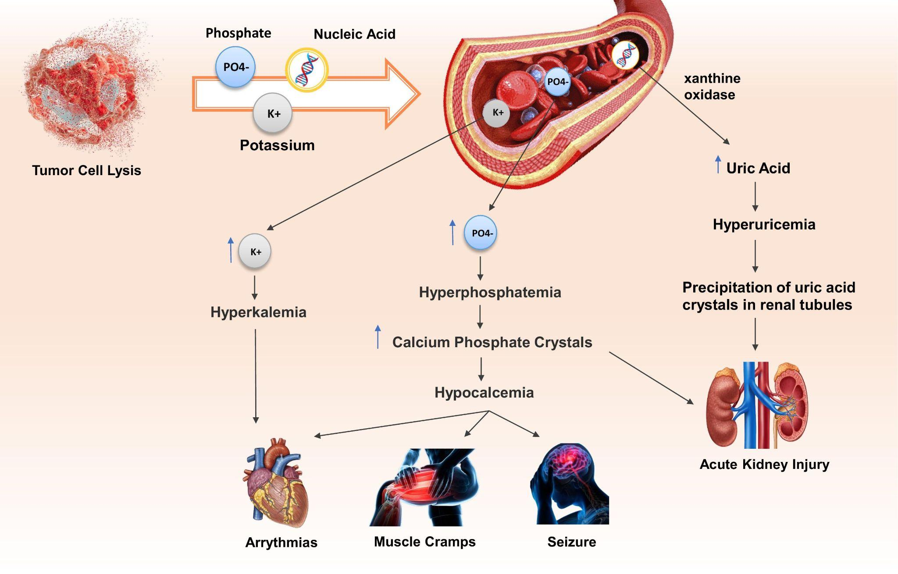

**Figure 1**: Pathophysiology of tumor lysis syndrome.

2.1 Hyperuricemia

In patients with tumor lysis syndrome (TLS), hyperuricemia is a frequent complication. The rapid cell turnover of tumor cells, which results in a greater production of uric acid, is the mechanism underlying hyperuricemia in TLS. Purines, which are found in DNA and RNA, are metabolized into uric acid as a byproduct. Huge quantities of purines are released into the bloodstream during the rapid destruction of tumor cells, and these purines are later converted into uric acid. The purine pathway starts with adenosine monophosphate (AMP), where AMP is processed to inosine monophosphate (IMP) as well as adenosine by an enzyme called AMP deaminase. Adenosine is then processed to inosine by the enzyme adenosine deaminase (ADA). IMP can be reprocessed into inosine. Inosine undergoes another reaction to form hypoxanthine with the help of an enzyme called purine nucleoside phosphorylase. The hypoxanthine is then metabolized by xanthine oxidase to xanthine, which can be further processed to uric acid via the xanthine oxidase enzyme [(9)](https://www.zotero.org/google-docs/?TOWv3W). Most mammals have uricase, an enzyme that oxidizes uric acid into the easily excreted metabolite allantoin, which is water-soluble. Compared to uric acid, allantoin is five to ten times more soluble. A missense mutation has rendered urate oxidase inhuman, but pharmacologic urate oxidase is available and is used to treat and prevent hyperuricemia. The marked overproduction and overexcretion of uric acid in TLS can lead to crystal precipitation and deposition in the renal tubules, resulting in renal vasoconstriction, compromised glomerular filtration, reduced urine output, impaired autoregulation (impaired blood flow to organs), decreased renal flow, and inflammation, resulting in acute kidney injury [(10)](https://www.zotero.org/google-docs/?MPrgUL). The pathway is explained in the figure given below. Purine metabolism and the site of action of allopurinol, febuxostat, and rasburicase are demonstrated in Figure 2

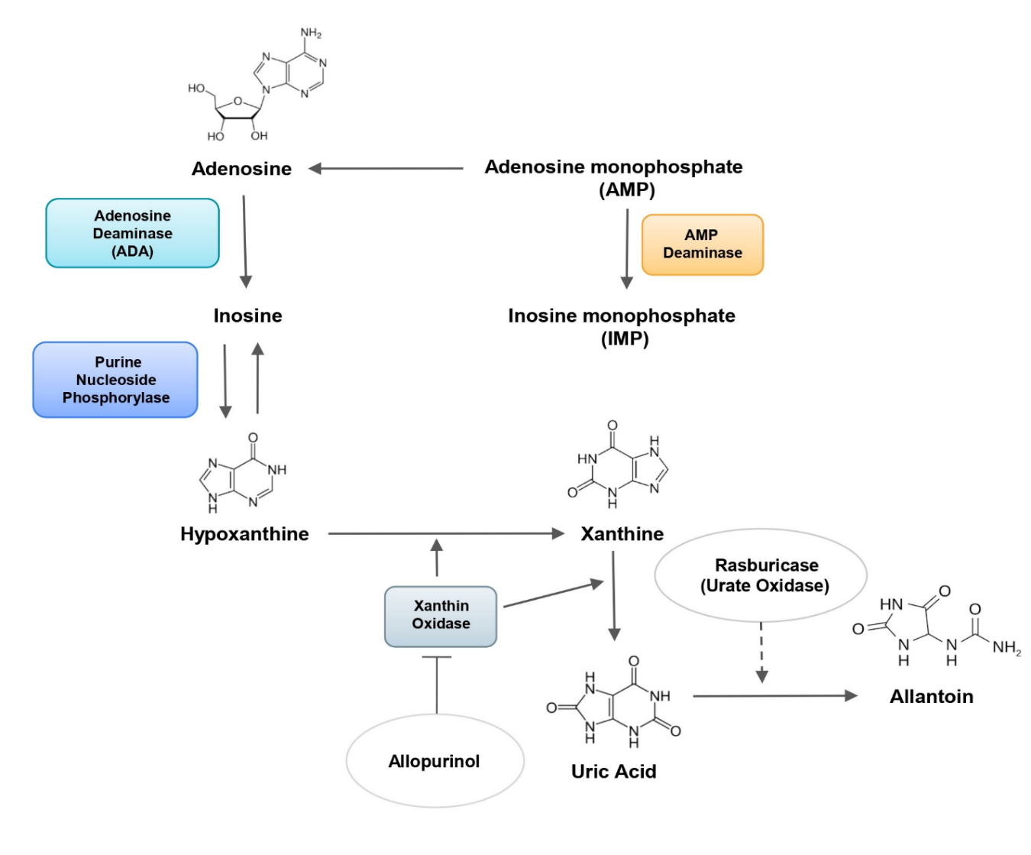

**Figure 2:** Purine metabolism and site of action of hypouricemic agents

2.2 Hyperkalemia

Hyperkalemia, or an abnormally high level of potassium in the blood, is a common manifestation of TLS. They start to show up 6 to 72 hours after chemotherapy starts. There is a huge load of potassium intracellularly which can be as high as 120 meq/L [(11)](https://www.zotero.org/google-docs/?OoxT7u). Numerous cells are killed during TLS, releasing potassium from the intracellular environment into the bloodstream. The typical homeostatic processes that control serum potassium levels may be overwhelmed by this abrupt increase in potassium. Ineffective potassium excretion by the kidneys can also result in hyperkalemia. Renal failure, a common TLS consequence, can cause this in TLS patients. Decreased potassium excretion and potassium retention in the body can be caused by decreased urine production, compromised renal function and transcellular potassium shift [(12)](https://www.zotero.org/google-docs/?l5we26).

2.3 Hyperphosphatemia and Hypocalcemia

One of the hallmarks of TLS is hyperphosphatemia. Although phosphate is a necessary part of cellular metabolism, excessive concentrations can be hazardous to the body. The actions of parathyroid hormone (PTH), vitamin D, and fibroblast growth factor 23 (FGF-23) normally maintain the serum phosphate concentration within a specific range. While FGF-23 inhibits phosphate reabsorption and induces urine excretion, PTH promotes the reabsorption of phosphate by the renal tubules. Increased intestinal absorption of calcium and phosphate and altered renal phosphate excretion are both effects of vitamin D [(13)](https://www.zotero.org/google-docs/?vKbHHP). In TLS, the massive release of intracellular phosphate leads to an increase in the serum phosphate concentration, which makes it difficult for the body to handle. This hyperphosphatemia can cause several pathological effects, including: secondary hypocalcemia (the elevated serum phosphate binds to calcium, forming insoluble calcium phosphate crystals that precipitate in soft tissues and bones, leading to hypocalcemia); acute kidney injury (by the formation of calcium phosphate crystals in renal tubules); and endothelial dysfunction (by inducing oxidative stress and inflammation).

Hypocalcemia is another common feature of TLS. Calcium is a vital electrolyte that is required for many cellular processes, including muscle contraction and nerve function. Hypocalcemia in TLS occurs due to a combination of factors. First, the high levels of serum phosphate in TLS can lead to the formation of calcium phosphate crystals, which can bind to and remove calcium from the bloodstream. Additionally, the rapid release of intracellular potassium and nucleic acids can lead to an influx of hydrogen ions into the bloodstream, which can lead to an increase in the acidity of the blood. This acidosis can then lead to increased calcium binding to albumin, making it unavailable for use by the body. Low calcium levels can cause muscle cramps, tetany, seizures, and cardiac arrhythmias [(14)](https://www.zotero.org/google-docs/?h1jPHA).

**3. Clinical Features and Risk Factors**

As discussed earlier the identification of the syndrome is very crucial for implementing the prophylactic treatment and for preventing the mortality among the cancer patients. The clinical features of TLS are directly linked to the metabolic abnormalities that are observed in this disorder, which include hyperuricemia, hyperkalaemia, hyperphosphatemia, hypocalcaemia, and uraemia. Therefore, these abnormalities can be identified by the clinical manifestations. For example the hypocalcemia caused by TLS may have common symptoms such as prolonged QT intervals, paresthesia, muscle spasms, cramps, tetany, circumoral numbness, seizures and alteration of mental status [(14)](https://www.zotero.org/google-docs/?5epllK). Hyperkalemia is associated with Muscle fatigue, deadly cardiac arrhythmias, ECG abnormalities and renal dysfunction [(15)](https://www.zotero.org/google-docs/?Y8vFmk). In severe acute phosphatemia, the clinical manifestations arise from hypocalcemia caused by the formation of insoluble calcium phosphate salts: musculoskeletal weakness, tetany and increased neuromuscular excitability. At the central nervous system level seizures and cognitive impairment may develop [(16)](https://www.zotero.org/google-docs/?zXS1t7).

 Meanwhile, as a direct result of hyperuricemia, uric acid crystals precipitate out of the renal tubules. The main complaints associated with hyperuricemia are gout and uric acid nephrolithiasis, which are followed by clinical manifestations such as swollen joints, flank pain, hematuria, nausea or vomiting, and colicky pain [(17)](https://www.zotero.org/google-docs/?CUU2j5). These symptoms should be closely monitored in patients receiving chemotherapy, especially those who are in the high-risk category of developing TLS [(18)](https://www.zotero.org/google-docs/?BQUmj8). Tumor Lysis Syndrome (TLS) most commonly arises in patients with malignancies characterized by rapid proliferation and a substantial tumor burden. Elevated serum levels of lactate dehydrogenase (LDH), a marker of tumor aggressiveness and high cellular turnover, are frequently observed in these individuals and serve as a significant predictor of TLS. Hematologic malignancies, particularly acute lymphoblastic leukemia (ALL), often present with markedly elevated white blood cell counts, further amplifying the risk. Additionally, pre-treatment hyperuricemia can predispose patients to uric acid nephropathy once cytotoxic therapy is initiated. Underlying renal dysfunction or existing kidney disease significantly impairs the clearance of metabolic byproducts, thereby exacerbating the risk of TLS. Pre-existing electrolyte disturbances, such as hyperkalemia, hyperphosphatemia, or hypocalcemia can intensify metabolic derangements once cell lysis begins. Importantly, the initiation of chemotherapy, radiation, or targeted therapies often serves as the precipitating trigger, rapidly inducing tumor cell death and the subsequent release of intracellular contents into the circulation. Identifying these high-risk features prior to the initiation of therapy is essential for timely prophylactic interventions and optimal patient outcomes.

We have categorized the tumors based on the risk of developing tumor lysis syndrome into high-risk, intermediate-risk, and low-risk tumors [(1)](https://www.zotero.org/google-docs/?HA2KDe). It is also important that the clinician differentiate TLS from other causes of acute kidney injury, such as autoimmune kidney disease, use of certain medications that are nephrotoxic, urinary tract obstruction, and untreated systemic diseases such as liver disease or heart disease.

**4. Diagnosis and Classification**

The diagnosis of tumor lysis syndrome (TLS) is established through a combination of clinical symptoms and laboratory findings. One of the most widely recognized diagnostic approaches is the Cairo–Bishop classification, which was developed to address the limitations of an earlier system proposed by Hande and Garrow. Their original classification was based on a retrospective review of 102 patients with intermediate- to high-grade non-Hodgkin’s lymphoma and introduced the concepts of laboratory TLS (LTLS) and clinical TLS (CTLS). Despite its utility, the Hande–Garrow model lacked key features such as severity stratification, broad tumor applicability, and sufficient clinical precision [(2,19)](https://www.zotero.org/google-docs/?2NpZO6).

To overcome these shortcomings, Cairo and Bishop refined the criteria to enhance its relevance in diverse oncological settings. Their revised classification clearly differentiates LTLS, defined by specific biochemical disturbances, from CTLS, which includes laboratory abnormalities along with clinical complications such as acute kidney injury, cardiac arrhythmias, or seizures. This modification has since become the preferred diagnostic framework for TLS in both clinical practice and research [(4)](https://www.zotero.org/google-docs/?jAciA2). The criteria are summarized in Table 1.

|  |  |
| --- | --- |
| **Criterion** | **Cairo–Bishop Threshold** |
| Uric acid | ≥8.0 mg/dL (≥476 μmol/L) or ≥25% increase from baseline |
| Potassium (serum K⁺) | ≥6.0 mmol/L or ≥25% increase |
| Phosphate (serum PO₄³⁻) | ≥4.5 mg/dL (≥1.45 mmol/L) or ≥25% increase |
| Calcium (serum Ca²⁺) | ≤7.0 mg/dL (≤1.75 mmol/L) or ≥25% decrease |
| Laboratory TLS | ≥2 of above abnormalities within 3 days before to 7 days after therapy |
| Clinical TLS | Laboratory TLS plus ≥1 of: creatinine >1.5×ULN; seizure; cardiac arrhythmia or sudden death |

Table 1. Cairo–Bishop diagnostic criteria for TLS  
Reproduced with permission from Cairo MS and Bishop M, Tumour lysis syndrome: new therapeutic strategies and classification, British Journal of Haematology. Wiley. License number: 6046001503603.

**Molecular Signatures and Biomarkers of TLS**

Early recognition of tumor lysis risk increasingly depends on molecular markers. Urate transporters, such as URAT1 (SLC22A12), play a key role in modulating hyperuricemia by regulating tubular uric acid reabsorption [(17)](https://www.zotero.org/google-docs/?54dnoY). Genetic variations or pharmacologic inhibition of these transporters can influence urate accumulation during TLS. Serum lactate dehydrogenase (LDH) remains a reliable surrogate for tumor burden and turnover, with elevated levels strongly correlating with TLS risk. While total LDH is commonly used, isozyme profiling, particularly LDH-3 and LDH-4, often elevated in lymphoid malignancies, may offer insights into tumor origin, though its clinical utility is still under evaluation [(20)](https://www.zotero.org/google-docs/?ddNele). The massive tumor breakdown also triggers an inflammatory cascade. High interleukin-6 (IL-6) levels, observed in nearly all TLS cases, along with elevated TNF-α, IL-8, and IL-10, contribute to capillary leakage and acute kidney injury, potentially serving as early biochemical red flags [(21)](https://www.zotero.org/google-docs/?ArwXSD). Novel biomarkers, including circulating tumor DNA and γH2AX (indicative of DNA damage), are under active investigation. Incorporating such serum and urinary biomarkers into risk models may enable proactive TLS management in high-risk patients [(22)](https://www.zotero.org/google-docs/?acUmGJ).

**Current and Emerging Therapies**

Management of tumor lysis syndrome (TLS) hinges on early intervention with uric acid–lowering agents, supported by vigilant monitoring and fluid therapy. The two primary pharmacological options are allopurinol and rasburicase, each with distinct mechanisms and indications [(23)](https://www.zotero.org/google-docs/?88eaFQ). Allopurinol works by inhibiting xanthine oxidase, thereby reducing the production of uric acid from purine metabolism. It is most effective when initiated prior to chemotherapy, particularly in patients with lower baseline uric acid levels [(1)](https://www.zotero.org/google-docs/?xxiotc). However, its action is preventive rather than therapeutic, it does not reduce pre-existing uric acid, and can lead to xanthine accumulation, posing a risk of crystal-induced renal injury. Known adverse effects include hypersensitivity reactions, which may be severe in individuals with certain genetic predispositions.

Rasburicase, by contrast, is an enzymatic agent that rapidly converts uric acid into allantoin, a more soluble metabolite readily eliminated by the kidneys. It is especially useful in patients already experiencing TLS or those at high risk, such as individuals with underlying renal impairment or a large tumor burden. Clinical studies have consistently demonstrated rasburicase’s superior efficacy in rapidly lowering serum uric acid levels compared to allopurinol [(24)](https://www.zotero.org/google-docs/?94uqXm). However, its high cost and the risk of hemolysis in patients with glucose-6-phosphate dehydrogenase (G6PD) deficiency, due to oxidative stress caused by the drug, are important limitations. An additional option under investigation is febuxostat, a non-purine xanthine oxidase inhibitor. Unlike allopurinol, febuxostat is metabolized in the liver, making it potentially safer for patients with renal dysfunction [(25)](https://www.zotero.org/google-docs/?MEkoSn). It also carries a lower likelihood of hypersensitivity reactions. While its use in TLS is not yet backed by large randomized trials, it may be considered in cases where allopurinol is contraindicated.

Beyond pharmacological measures, supportive care plays a vital role in TLS prevention and management. Adequate intravenous hydration, typically ranging from 2 to 3 liters per square meter per day, is critical to maintaining renal perfusion and enhancing urinary excretion of uric acid and electrolytes. Diuretics may be used judiciously if fluid overload is a concern, provided hydration status is sufficient. Urate-lowering therapy should be administered in parallel: rasburicase is preferred for treating established hyperuricemia, while allopurinol may be continued in moderate-risk cases [(20)](https://www.zotero.org/google-docs/?w5AN8h).

Electrolyte abnormalities must be managed promptly. Hyperkalemia requires immediate treatment with interventions such as insulin-glucose infusions, beta-agonists, sodium bicarbonate, or calcium administration to stabilize cardiac membranes [(26)](https://www.zotero.org/google-docs/?XqQ0L4). Hyperphosphatemia can be managed through phosphate binders and dietary modifications, while hypocalcemia is treated only when symptomatic, due to the risk of calcium-phosphate precipitation [(16)](https://www.zotero.org/google-docs/?64lwif). If severe renal dysfunction or unmanageable electrolyte imbalances occur, renal replacement therapy, including dialysis, may be necessary. Common indications include persistent oliguria or anuria, severe fluid overload, refractory hyperkalemia, and symptomatic disturbances in calcium or phosphate levels [(27,28)](https://www.zotero.org/google-docs/?esfuF5).

**6. TLS in Immunotherapy and Targeted therapy**

With the advent of potent immunotherapies and molecularly targeted treatments, Tumor Lysis Syndrome (TLS) has re-emerged as a clinically significant complication, particularly in patients with high disease burden. CAR T-cell therapies, especially those directed against B-cell maturation antigen (BCMA) in multiple myeloma and CD19 in chronic lymphocytic leukemia (CLL), have been associated with notable TLS incidence. In a clinical cohort of relapsed or refractory multiple myeloma patients receiving BCMA-targeted CAR T cells, TLS occurred in approximately 17% of cases, typically manifesting around eight days post-infusion [(29)](https://www.zotero.org/google-docs/?q05TvQ). All patients who developed TLS also experienced cytokine release syndrome (CRS), with a majority presenting severe (grade 3–4) forms. Similarly, earlier studies using CD19 CAR T cells in CLL reported TLS in around 14% of patients. These findings highlight that high tumor burden and rapid immune-mediated cytotoxicity, often accompanied by CRS, are critical risk factors, warranting close biochemical and clinical surveillance [(30,31)](https://www.zotero.org/google-docs/?mOR8fn).

Among targeted therapies, venetoclax, a selective BCL-2 inhibitor used in hematologic malignancies such as CLL and AML, has a well-documented TLS risk due to its potent pro-apoptotic effect [(32)](https://www.zotero.org/google-docs/?Xl5uIa). Early clinical trials reported fatal TLS events, especially when rapid dose initiation protocols were employed. Consequently, a structured 5-week dose escalation strategy with concurrent hydration and urate-lowering therapy (typically allopurinol) is now standard. Real-world data support the effectiveness of this approach: in a large series involving 297 CLL patients treated with venetoclax, clinical TLS occurred in just 2.7% of cases, with one fatality and one dialysis-requiring episode. Laboratory TLS was observed in 5.7% [(33)](https://www.zotero.org/google-docs/?8sipf5). In AML, TLS is comparatively rare; for example, the VIALE-A trial evaluating azacitidine plus venetoclax reported only three laboratory TLS events and no clinical cases. Nonetheless, isolated reports of TLS in AML and even multiple myeloma suggest that risk persists, particularly in settings of aggressive disease biology or large tumor burden [(34)](https://www.zotero.org/google-docs/?VYUipi). Collectively, these observations underscore the need for proactive TLS risk assessment and tailored prophylaxis in patients undergoing immunotherapy or targeted treatment regimens.

**7. Future Direction**

Looking ahead, advanced analytics and artificial intelligence hold significant promise for improving risk stratification in Tumor Lysis Syndrome (TLS). Recent research has demonstrated the utility of machine learning algorithms, such as CatBoost and LASSO-based models, that leverage baseline clinical and laboratory parameters to predict TLS risk, particularly in patients with acute leukemia. For instance, in a pediatric acute lymphoblastic leukemia cohort, a CatBoost model achieved an area under the curve (AUC) of approximately 0.832, while a LASSO-derived nomogram incorporating variables such as white blood cell count, electrolyte levels, and organ function markers reported an AUC near 0.824 [(35,36)](https://www.zotero.org/google-docs/?TNODb3). These predictive tools could potentially be integrated into clinical workflows, such as electronic health record systems or mobile-based applications, to flag high-risk individuals in real time and support proactive intervention. The addition of multi-omic data and longitudinal lab trends may further refine prediction accuracy. Simultaneously, precision medicine is reshaping TLS prophylaxis, with risk-adapted strategies gaining traction. For example, in chronic lymphocytic leukemia, venetoclax is introduced through a gradual dose escalation protocol alongside close monitoring to reduce TLS incidence [(37)](https://www.zotero.org/google-docs/?5cl9Gk). Future directions also include tailoring preventive measures based on pharmacogenomics and tumor-specific characteristics, such as screening for HLA variants to avoid hypersensitivity reactions or customizing uric acid-lowering therapy based on genetic predispositions.

**Conclusion**

Tumor Lysis Syndrome represents a critical tipping point where the effectiveness of cancer treatments collides with the dangers of rapid tumor breakdown. As our understanding of the underlying molecular events continues to grow, so does our ability to recognize and manage TLS across a wide range of therapies, from traditional chemotherapy to cutting-edge immunotherapies. The destruction of cancer cells, while often a sign of treatment success, brings with it serious risks that demand early attention and careful monitoring. By embracing advances like genomics, AI-based risk assessment, and personalized treatment strategies, we can move from reacting to crises toward preventing them. In this delicate space between healing and harm, the future of TLS care depends on innovation, foresight, and strong collaboration across disciplines.

**Declaration of competing interest**

The authors declare that they have no known competing financial interests or personal relationships that could have appeared to influence the work reported in this paper.

Disclaimer (Artificial intelligence)

Option 1:

Author(s) hereby declare that NO generative AI technologies such as Large Language Models (ChatGPT, manuscript.

Option 2:

Author(s) hereby declare that generative AI technologies such as Large Language Models, etc. have been used during the writing or editing of manuscripts. This explanation will include the name, version, model, and source of the generative AI technology and as well as all input prompts provided to the generative AI technology

Details of the AI usage are given below:

1.

2.

3.

I declare that no artificial intelligence was used in preparation of this manuscript.

**Reference**

[1. Adeyinka A, Bashir K. Tumor Lysis Syndrome. In: StatPearls [Internet]. Treasure Island (FL): StatPearls Publishing; 2023 [cited 2023 May 11]. Available from: http://www.ncbi.nlm.nih.gov/books/NBK518985/](https://www.zotero.org/google-docs/?R3ORkq)

[2. Lupușoru G, Ailincăi I, Frățilă G, Ungureanu O, Andronesi A, Lupușoru M, et al. Tumor Lysis Syndrome: An Endless Challenge in Onco-Nephrology. Biomedicines [Internet]. 2022 Apr 28 [cited 2023 Apr 28];10(5):1012. Available from: https://www.mdpi.com/2227-9059/10/5/1012](https://www.zotero.org/google-docs/?R3ORkq)

[3. Bozkurt S, Genc DB, Vural S. Laboratory and clinical features of tumor lysis syndrome in children with non-Hodgkin lymphoma and evaluation of long-term renal functions in survivors. BMC Pediatr [Internet]. 2024 Jan 31 [cited 2025 Jul 5];24(1):85. Available from: https://bmcpediatr.biomedcentral.com/articles/10.1186/s12887-024-04549-w](https://www.zotero.org/google-docs/?R3ORkq)

[4. Cairo MS, Bishop M. Tumour lysis syndrome: new therapeutic strategies and classification. Br J Haematol [Internet]. 2004 [cited 2023 Apr 22];127(1):3–11. Available from: https://onlinelibrary.wiley.com/doi/abs/10.1111/j.1365-2141.2004.05094.x](https://www.zotero.org/google-docs/?R3ORkq)

[5. Ñamendys-Silva SA, Arredondo-Armenta JM, Plata-Menchaca EP, Guevara-García H, García-Guillén FJ, Rivero-Sigarroa E, et al. Tumor lysis syndrome in the emergency department: challenges and solutions. Open Access Emerg Med [Internet]. 2015 Aug [cited 2023 Apr 25];39. Available from: http://www.dovepress.com/tumor-lysis-syndrome-in-the-emergency-department-challenges-and-soluti-peer-reviewed-article-OAEM](https://www.zotero.org/google-docs/?R3ORkq)

[6. Anil A, Raheja R, Gibu D, Raj AS, Spurthi S. Uncovering the Links Between Dietary Sugar and Cancer: A Narrative Review Exploring the Impact of Dietary Sugar and Fasting on Cancer Risk and Prevention. Cureus [Internet]. 2024 Aug 21 [cited 2025 Jul 6]; Available from: https://www.cureus.com/articles/259861-uncovering-the-links-between-dietary-sugar-and-cancer-a-narrative-review-exploring-the-impact-of-dietary-sugar-and-fasting-on-cancer-risk-and-prevention](https://www.zotero.org/google-docs/?R3ORkq)

[7. Will A, Tholouli E. The clinical management of tumour lysis syndrome in haematological malignancies. Br J Haematol [Internet]. 2011 [cited 2023 Apr 23];154(1):3–13. Available from: https://onlinelibrary.wiley.com/doi/abs/10.1111/j.1365-2141.2011.08697.x](https://www.zotero.org/google-docs/?R3ORkq)

[8. Jeha S. Tumor lysis syndrome. Semin Hematol [Internet]. 2001 Oct [cited 2023 Nov 4];38:4–8. Available from: https://linkinghub.elsevier.com/retrieve/pii/S003719630190037X](https://www.zotero.org/google-docs/?R3ORkq)

[9. Williams SM, Killeen AA. Tumor Lysis Syndrome. Arch Pathol Lab Med [Internet]. 2019 Mar 1 [cited 2023 Apr 29];143(3):386–93. Available from: http://meridian.allenpress.com/aplm/article/143/3/386/9241/Tumor-Lysis-Syndrome](https://www.zotero.org/google-docs/?R3ORkq)

[10. Maiuolo J, Oppedisano F, Gratteri S, Muscoli C, Mollace V. Regulation of uric acid metabolism and excretion. Int J Cardiol [Internet]. 2016 Jun [cited 2023 Apr 30];213:8–14. Available from: https://linkinghub.elsevier.com/retrieve/pii/S0167527315303429](https://www.zotero.org/google-docs/?R3ORkq)

[11. Cividalli G, Nathan DG. Sodium and Potassium Concentration and Transmembrane Fluxes in Leukocytes. Blood [Internet]. 1974 Jun 1 [cited 2023 May 8];43(6):861–9. Available from: https://ashpublications.org/blood/article/43/6/861/40441/Sodium-and-Potassium-Concentration-and](https://www.zotero.org/google-docs/?R3ORkq)

[12. Evans KJ, Greenberg A. Hyperkalemia: A Review. J Intensive Care Med [Internet]. 2005 Sep [cited 2023 Jun 2];20(5):272–90. Available from: http://journals.sagepub.com/doi/10.1177/0885066605278969](https://www.zotero.org/google-docs/?R3ORkq)

[13. Geddes RF, Finch NC, Syme HM, Elliott J. The role of phosphorus in the pathophysiology of chronic kidney disease: Role of phosphorus in the pathophysiology of CKD. J Vet Emerg Crit Care [Internet]. 2013 Mar [cited 2023 May 9];23(2):122–33. Available from: https://onlinelibrary.wiley.com/doi/10.1111/vec.12032](https://www.zotero.org/google-docs/?R3ORkq)

[14. Davidson MB, Thakkar S, Hix JK, Bhandarkar ND, Wong A, Schreiber MJ. Pathophysiology, clinical consequences, and treatment of tumor lysis syndrome. Am J Med [Internet]. 2004 Apr [cited 2023 May 9];116(8):546–54. Available from: https://linkinghub.elsevier.com/retrieve/pii/S0002934303007253](https://www.zotero.org/google-docs/?R3ORkq)

[15. Parham WA, Mehdirad AA, Biermann KM, Fredman CS. Hyperkalemia Revisited. Tex Heart Inst J [Internet]. 2006 [cited 2023 Apr 25];33(1):40–7. Available from: https://www.ncbi.nlm.nih.gov/pmc/articles/PMC1413606/](https://www.zotero.org/google-docs/?R3ORkq)

[16. García Martín A, Varsavsky M, Cortés Berdonces M, Ávila Rubio V, Alhambra Expósito MR, Novo Rodríguez C, et al. Phosphate disorders and the clinical management of hypophosphatemia and hyperphosphatemia. Endocrinol Diabetes Nutr Engl Ed [Internet]. 2020 Mar [cited 2023 Apr 26];67(3):205–15. Available from: https://linkinghub.elsevier.com/retrieve/pii/S2530018020300330](https://www.zotero.org/google-docs/?R3ORkq)

[17. George C, Minter DA. Hyperuricemia. In: StatPearls [Internet]. Treasure Island (FL): StatPearls Publishing; 2023 [cited 2023 Jun 2]. Available from: http://www.ncbi.nlm.nih.gov/books/NBK459218/](https://www.zotero.org/google-docs/?R3ORkq)

[18. Howard SC, Jones DP, Pui CH. The Tumor Lysis Syndrome. N Engl J Med [Internet]. 2011 May 12 [cited 2023 Apr 20];364(19):1844–54. Available from: http://www.nejm.org/doi/10.1056/NEJMra0904569](https://www.zotero.org/google-docs/?R3ORkq)

[19. Wilson FP, Berns JS. Tumor Lysis Syndrome: New Challenges and Recent Advances. Adv Chronic Kidney Dis [Internet]. 2014 Jan [cited 2025 Jun 6];21(1):18–26. Available from: https://linkinghub.elsevier.com/retrieve/pii/S1548559513000931](https://www.zotero.org/google-docs/?R3ORkq)

[20. Puri I, Sharma D, Gunturu KS, Ahmed AA. Diagnosis and management of tumor lysis syndrome. J Community Hosp Intern Med Perspect [Internet]. 2020 May 3 [cited 2025 Jun 6];10(3):269–72. Available from: https://www.tandfonline.com/doi/full/10.1080/20009666.2020.1761185](https://www.zotero.org/google-docs/?R3ORkq)

[21. Findakly D, Luther RD, Wang J. Tumor Lysis Syndrome in Solid Tumors: A Comprehensive Literature Review, New Insights, and Novel Strategies to Improve Outcomes. Cureus [Internet]. 2020 May 29 [cited 2025 Jun 6]; Available from: https://www.cureus.com/articles/33194-tumor-lysis-syndrome-in-solid-tumors-a-comprehensive-literature-review-new-insights-and-novel-strategies-to-improve-outcomes](https://www.zotero.org/google-docs/?R3ORkq)

[22. Joseph A, Zafrani L. How I Treat Tumor Lysis Syndrome. Clin J Am Soc Nephrol [Internet]. 2023 Dec [cited 2025 Jun 6];18(12):1634–6. Available from: https://journals.lww.com/10.2215/CJN.0000000000000331](https://www.zotero.org/google-docs/?R3ORkq)

[23. Alshehri W, Aljohani A, Alhasani R, Alshammari A, Alhamoud JA, Alruwaili A, et al. Role of Hypouricemic Agents in Tumor Lysis Syndrome: A Meta-Analysis. J Pharm Res Int [Internet]. 2021 Jun 25 [cited 2025 Jul 5];183–96. Available from: https://journaljpri.com/index.php/JPRI/article/view/2610](https://www.zotero.org/google-docs/?R3ORkq)

[24. Martens KL, Khalighi PR, Li S, White AA, Silgard E, Frieze D, et al. Comparative effectiveness of rasburicase versus allopurinol for cancer patients with renal dysfunction and hyperuricemia. Leuk Res [Internet]. 2020 Feb [cited 2025 Jun 6];89:106298. Available from: https://linkinghub.elsevier.com/retrieve/pii/S0145212620300035](https://www.zotero.org/google-docs/?R3ORkq)

[25. Lee JS, Won J, Kwon OC, Lee SS, Oh JS, Kim YG, et al. Hepatic Safety of Febuxostat Compared with Allopurinol in Gout Patients with Fatty Liver Disease. J Rheumatol [Internet]. 2019 May [cited 2025 Jun 6];46(5):527–31. Available from: http://www.jrheum.org/lookup/doi/10.3899/jrheum.180761](https://www.zotero.org/google-docs/?R3ORkq)

[26. Rafique Z, Chouihed T, Mebazaa A, Frank Peacock W. Current treatment and unmet needs of hyperkalaemia in the emergency department. Eur Heart J Suppl [Internet]. 2019 Feb 1 [cited 2025 Jun 6];21(Supplement_A):A12–9. Available from: https://academic.oup.com/eurheartjsupp/article/21/Supplement_A/A12/5364194](https://www.zotero.org/google-docs/?R3ORkq)

[27. McGregor T, Jones S. Fluid and electrolyte problems in renal dysfunction. Anaesth Intensive Care Med [Internet]. 2021 Jul [cited 2025 Jun 6];22(7):406–9. Available from: https://linkinghub.elsevier.com/retrieve/pii/S1472029921001181](https://www.zotero.org/google-docs/?R3ORkq)

[28. Pi J, Kang Y, Smith M, Earl M, Norigian Z, McBride A. A review in the treatment of oncologic emergencies. J Oncol Pharm Pract [Internet]. 2016 Aug [cited 2025 Jun 6];22(4):625–38. Available from: https://journals.sagepub.com/doi/10.1177/1078155215605661](https://www.zotero.org/google-docs/?R3ORkq)

[29. Zhang Q, Zu C, Jing R, Feng Y, Zhang Y, Zhang M, et al. Incidence, clinical characteristics and prognosis of tumor lysis syndrome following B-cell maturation antigen-targeted chimeric antigen receptor-T cell therapy in relapsed/refractory multiple myeloma. Front Immunol [Internet]. 2023 May 4 [cited 2025 Jun 6];14:1125357. Available from: https://www.frontiersin.org/articles/10.3389/fimmu.2023.1125357/full](https://www.zotero.org/google-docs/?R3ORkq)

[30. Levstek L, Janžič L, Ihan A, Kopitar AN. Biomarkers for prediction of CAR T therapy outcomes: current and future perspectives. Front Immunol [Internet]. 2024 Mar 15 [cited 2025 Jun 6];15:1378944. Available from: https://www.frontiersin.org/articles/10.3389/fimmu.2024.1378944/full](https://www.zotero.org/google-docs/?R3ORkq)

[31. Chhabra N, Kennedy J. A Review of Cancer Immunotherapy Toxicity II: Adoptive Cellular Therapies, Kinase Inhibitors, Monoclonal Antibodies, and Oncolytic Viruses. J Med Toxicol [Internet]. 2022 Jan [cited 2025 Jun 6];18(1):43–55. Available from: https://link.springer.com/10.1007/s13181-021-00835-6](https://www.zotero.org/google-docs/?R3ORkq)

[32. Anderson MA, Walewska R, Hackett F, Kater AP, Montegaard J, O’Brien S, et al. Venetoclax Initiation in Chronic Lymphocytic Leukemia: International Insights and Innovative Approaches for Optimal Patient Care. Cancers [Internet]. 2024 Feb 28 [cited 2025 Jun 6];16(5):980. Available from: https://www.mdpi.com/2072-6694/16/5/980](https://www.zotero.org/google-docs/?R3ORkq)

[33. Roeker LE, Fox CP, Eyre TA, Brander DM, Allan JN, Schuster SJ, et al. Tumor Lysis, Adverse Events, and Dose Adjustments in 297 Venetoclax-Treated CLL Patients in Routine Clinical Practice. Clin Cancer Res [Internet]. 2019 Jul 15 [cited 2025 Jun 6];25(14):4264–70. Available from: https://aacrjournals.org/clincancerres/article/25/14/4264/81666/Tumor-Lysis-Adverse-Events-and-Dose-Adjustments-in](https://www.zotero.org/google-docs/?R3ORkq)

[34. Diao S, Nichols ED, DiNardo C, Konopleva M, Ning J, Qiao W, et al. Incidence of tumor lysis syndrome in patients with acute myeloid leukemia undergoing low‐intensity induction with venetoclax. Am J Hematol [Internet]. 2021 Mar [cited 2025 Jun 6];96(3). Available from: https://onlinelibrary.wiley.com/doi/10.1002/ajh.26060](https://www.zotero.org/google-docs/?R3ORkq)

[35. Xiao Y, Xiao L, Zhang Y, Xu X, Guan X, Guo Y, et al. Prediction of tumor lysis syndrome in childhood acute lymphoblastic leukemia based on machine learning models: a retrospective study. Front Oncol [Internet]. 2024 Mar 7 [cited 2025 Jun 6];14:1337295. Available from: https://www.frontiersin.org/articles/10.3389/fonc.2024.1337295/full](https://www.zotero.org/google-docs/?R3ORkq)

[36. Xiao Y, Xiao L, Xu X, Guan X, Guo Y, Shen Y, et al. Development and validation of a predictive model for tumor lysis syndrome in childhood acute lymphoblastic leukemia. Leuk Res [Internet]. 2024 Nov [cited 2025 Jun 6];146:107587. Available from: https://linkinghub.elsevier.com/retrieve/pii/S014521262400153X](https://www.zotero.org/google-docs/?R3ORkq)

[37. Gribben JG. Practical management of tumour lysis syndrome in venetoclax‐treated patients with chronic lymphocytic leukaemia. Br J Haematol [Internet]. 2020 Mar [cited 2025 Jun 6];188(6):844–51. Available from: https://onlinelibrary.wiley.com/doi/10.1111/bjh.16345](https://www.zotero.org/google-docs/?R3ORkq)