**Artificial Intelligence and Machine Learning in Personalized Medicine: Emerging Technologies and Applications**

**Abstract**

Personalized medicine is a revolutionary paradigm shift in the health sector, to customize medical decisions and initiatives to the distinct biological and contextual peculiarities of individual patients. This approach differs from the generalized strategies of traditional medicine, which can enhance patient outcomes and minimize adverse effects. The incorporation of machine learning and Artificial Intelligence is very crucial in the improvement of personalized medicine, which facilitates the productive extraction of practical findings from complex and multifaceted datasets in healthcare. This review gives a comprehensive overview of how AI and ML have and can transform personalized medicine by improving diagnostics, maximizing therapy plans, predicting disease risks, and identifying novel therapeutic targets. It scrutinizes the rudimentary concepts of AI and ML, and their various uses in oncology, cardiology, pharmacogenomics, and rare disease diagnosis, and the critical role of robust data infrastructures. Moreover, the review discusses the ethical, legal, and regulatory challenges, which include algorithmic bias and data privacy, and also discusses current trends in limitations such as data heterogeneity and model interpretability. Conclusively, we emphasize the future directions and the importance of interdisciplinary collaboration in overcoming these challenges and completely recognize the hope personalized medicine presents.

Keywords: Personalized medicine, biomedical science, Artificial Intelligence, Machine Learning, oncology

### ****1. Introduction****

Personalized medicine is also known as precision medicine, and it has been formed to transform conventional paradigms of healthcare by customizing medical decisions, practices, and interventions to the individual’s peculiarities(1). It is a patient-centric method that considers genomic, epigenomic, environmental, and lifestyle data to facilitate the specificity and potency of diagnosis, treatment, and prevention(2). The advancement of biomedical science has brought about the complexity, volume, and availability of health data, fostering an urgent need for advanced computational tools capable of meaningful data extraction from this avalanche of information(3).

Artificial Intelligence (AI) and Machine Learning (ML) have evolved as a cornerstone of this said transformation(4). AI consists of a series of computational techniques that are designed to model intelligent human behavior, while ML algorithms can learn and improve from data without being rigorously programmed(5). These are unique tools adapted to recognize non-linear patterns, predict outcomes, and maximize decision-making in ways that are far beyond the conventional statistical models(6).

When it comes to personalized medicine, AI and ML has been taken adavantage of to decode complex genomic signatures, predict therapeutic responses, categorize the risk of disease and enhance real-time clinical decision support(7). Its applications ramges from oncology and pharmacogenomics to digital diagnostics and multi-omics data integration which demonstrates the scope and transformative potential these technologies has(8).

This review gives an elaborate and narrative exploration of the incorporation of AI and ML into the progression and implementation of personalized medicine. It extracts basic concepts, highlights current and emerging applications, examines the infrastructural and ethical considerations, and highlights future directions(9). By navigating the intersection between computational intelligence and precision healthcare, we were able to give insights into how AI is capable of shaping the future of medical science and improving patient outcomes(10).

### ****2. Foundations of Artificial Intelligence and Machine Learning in Healthcare****

Artificial Intelligence (AI)is a set of technologies that have been fashioned to mimic human cognitive functions such as the ability to learn, reason, solve problems, and make decisions(11). In this wide scope, Machine Learning (ML) can be referred to as a subset of AI that requires the development of algorithms which is capable of learning from data patterns and improving performance over time without the need for rigorous programming(12). In the healthcare sector, a large amount of heterogeneous and high-dimensional data is generated daily from genomic sequences and electronic health records (EHRs) to radiologic images and continuous data streams from devices that are wearable devices. The use of AI and ML is unmatched and paramount to deriving practical insights(13).

ML techniques are mainly classified into supervised, unsupervised, and reinforcement learning paradigms. **Supervised learning** has the potential to coach algorithms on labeled datasets, it is mostly used in predictive analytics and the diagnosis of disease(14). For example, models can learn to predict the probability of cardiovascular events based on structured clinical data. Contrary to **unsupervised learning**, which identifies hidden structures in datasets that are not labelled, making it unstable for discovering subtypes of disease, patient stratification, and phenotype clustering(15). A less common applied technique is **reinforcement learning**, but it seems to be gaining traction for maximizing treatment policies over the years via trial-and-error approaches(16).

A subset of ML is **deep learning,** which is dependent on artificial neural networks, and can transform the analysis of medical images. A technique that has particularly demonstrated human-level performance in interpreting radiologic, dermatologic, and histopathologic images is the Convolutional Neural Networks (CNNs). Likewise, **Natural Language Processing (NLP)** techniques allow the extraction and interpretation of meaningful data from unstructured clinical texts, such as physician notes, discharge summaries, and pathology reports(17).

Moreover, incorporating **multi-modal data** combining genomics, imaging, laboratory values, and real-time sensor data needs classy algorithms that is able to handle dimensional complexity and maintain interpretability(18). While these foundations continue to emerge, implementing them successfully articulate developing robust data infrastructures, algorithm transparency, and clinical unification frameworks(19).

To appreciate the transformative impact of these foundational technologies on personalized medicine and their ability to bridge the gap between data abundance and clinical precision, it is paramount to understand them(20). Figure 1 and 2 gives an overview of AI/ML techniques and their roles in both everyday life and personalized medicine.

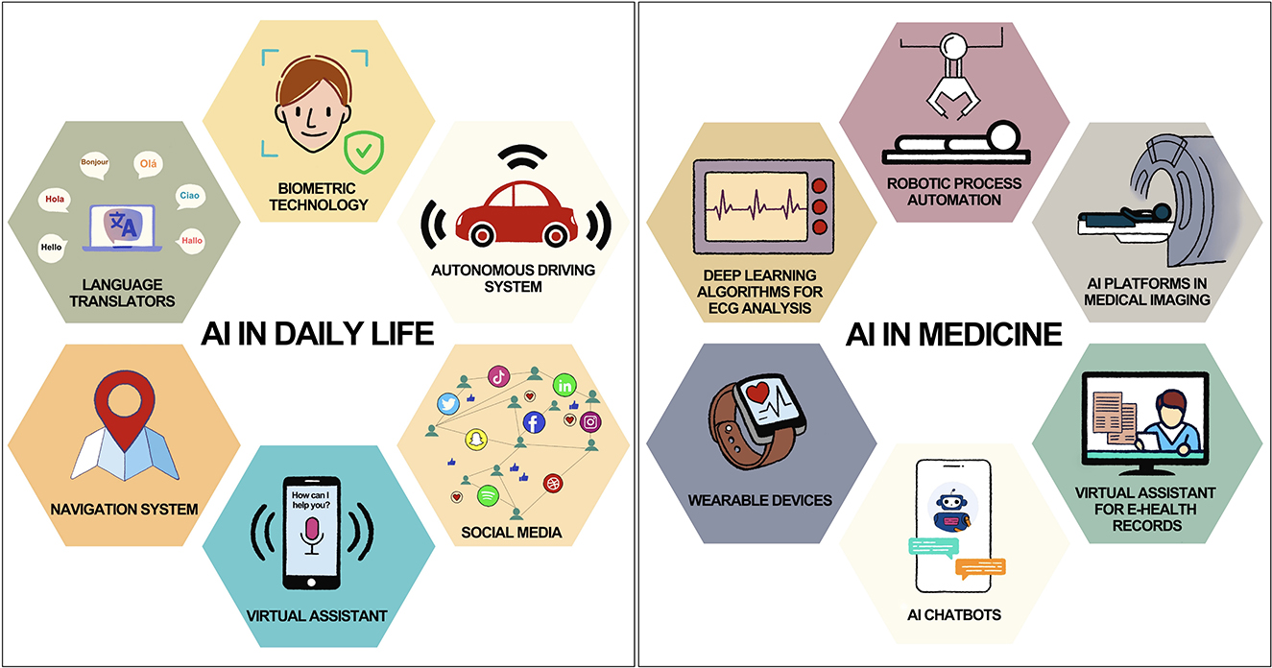

**Figure 1**. Common applications of AI in daily life and medicine Gokul et al., 2023). Artificial intelligence in clinical medicine: Catalyzing a sustainable global healthcare paradigm. Frontiers in Artificial Intelligence, 6, Article 1227091. <https://doi.org/10.3389/frai.2023.1227091>

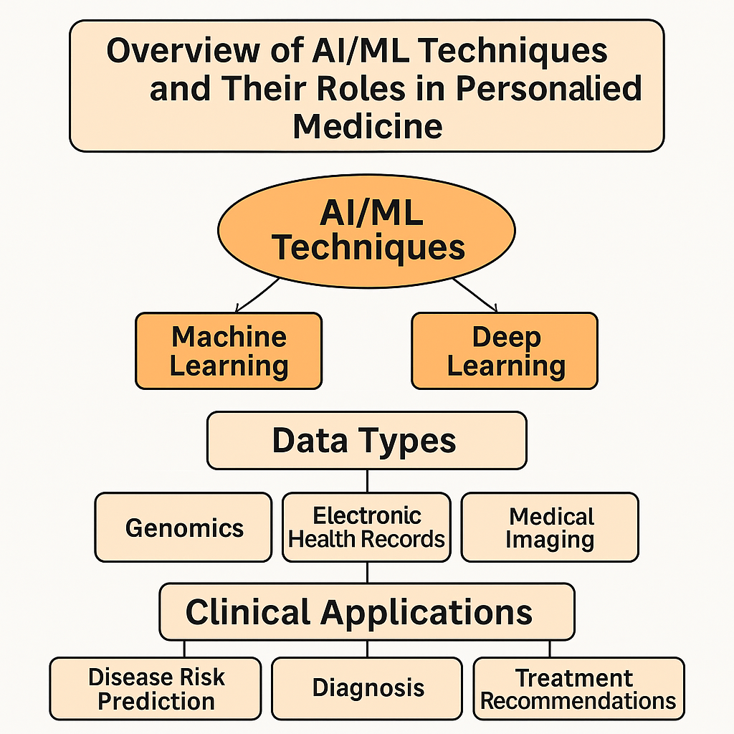

**Chart 1 : A** flow chart showing AI branches, data types, and clinical applications

### ****3. Applications in Personalized Medicine****

The integration of Artificial Intelligence (AI) and Machine Learning (ML) into personalized medicine is reshaping clinical workflows, enhancing diagnostic precision, and enabling more individualized therapeutic interventions. These applications span diverse domains, ranging from genomics and pharmacogenomics to diagnostics and clinical decision support. The following subsections highlight key use cases that illustrate the transformative role of AI and ML in advancing precision healthcare(21).

#### ****3.1 Genomics and Precision Oncology****

AI technologies have revolutionized the interpretation of genomic data, particularly in oncology, where they assist in identifying oncogenic mutations, predicting variant pathogenicity, and mapping the mutational landscape of tumors(22). Deep learning tools such as **DeepVariant**, developed by Google, convert raw sequencing data into highly accurate variant calls. **IBM Watson Genomics**, another example, integrates genomic sequencing with scientific literature to generate clinically actionable insights, helping oncologists tailor therapies based on a tumor's molecular profile(23). Platforms that are AI-driven can resist and relapse in treatment, and also further support personalized care in cancer treatment(24).

#### ****3.2 Pharmacogenomics and Drug Response Prediction****

The ability to anticipate individual variability in drug metabolism and response is the cornerstone of personalized medicine(25). To predict drug efficacy and adverse reactions, ML algorithms are important to analyze complex genomic and phenotypic datasets(26). For example, polymorphisms in the **CYP2C9** and **VKORC1** genes majorly disrupt the metabolism of warfarin(27). AI models that are trained on genetic and clinical parameters give room to enable real-time optimization of warfarin dosing, minimizing the risk of thrombotic events. Like models are evolving for psychotropic medications, antihypertensives, and chemotherapeutic agents, which facilitates a safer and effective prescription(28).

#### ****3.3 Predictive Analytics and Risk Stratification****

AI-based predictive models have proved to be of utmost importance in categorizing patients by disease risk(29). Conventional tools like the **Framingham Risk Score** have been enhanced by ML approaches that incorporate a broader array of features, including socio-demographic, lifestyle, genomic, and imaging data(30). For long-term illnesses, including heart disease, type 2 diabetes, and chronic kidney disease, these models enhance risk prediction. Additionally, AI systems can update risk profiles continuously using data from wearable devices, allowing for early intervention and dynamic disease tracking(31).

#### ****3.4 AI in Diagnostics and Imaging****

AI, especially deep learning, has shown impressive results in picture identification jobs in diagnostics(32). The ability of Convolutional Neural Networks (CNNs) to identify lung nodules, breast cancer, melanoma, and diabetic retinopathy from radiologic and histopathologic images is on par with or better than that of human specialists(33). These algorithms examine data at the pixel level, spot minute patterns that are frequently missed by the naked eye, and produce probabilistic results to aid in clinical judgment. AI technologies are also being utilized in pathology to find lymph node metastases with high sensitivity and specificity, grade tumors, and evaluate mitotic activity(32).

#### ****3.5 Clinical Decision Support Systems (CDSS)****

Electronic health records (EHRs) are progressively incorporating AI-enhanced clinical decision support systems to inform therapeutic, prognostic, and diagnostic choices. These systems create evidence-based suggestions by processing patient-specific data in real-time and comparing it to extensive clinical databases.For example, AI-powered CDSS can flag potential drug interactions, suggest diagnostic investigations for rare diseases, or recommend personalized treatment pathways based on clinical guidelines and prior outcomes. As these systems evolve, they are becoming indispensable tools for augmenting clinician expertise and reducing diagnostic errors(34). The diverse applications of AI underscore its role in enabling truly personalized healthcare across domains as describe in Table 1

### ****Table 1: Summary of AI Applications in Personalized Medicine****

| **Application Area** | **AI/ML Tool Used** | **Data Type** | **Clinical Utility** |
| --- | --- | --- | --- |
| Oncology | DeepVariant | Genomic data | Variant calling, mutation detection |
| Oncology | IBM Watson Genomics | Genomic + literature databases | Targeted therapy selection, resistance prediction |
| Pharmacogenomics | XGBoost | Genotype & drug response data | Personalized dosing (e.g., warfarin) |
| Risk Stratification | Random Forest, Logistic Regression | EHR + lifestyle + genomic data | Cardiovascular and diabetes risk prediction |
| Imaging Diagnostics | Convolutional Neural Networks (CNNs) | Radiologic & histopathologic images | Automated detection of cancer, diabetic retinopathy |
| Clinical Decision Support | Decision Trees, NLP models | EHR + clinical guidelines + lab reports | Personalized recommendations for diagnosis and treatment |
| Rare Disease Diagnosis | NLP-based systems | Unstructured clinical notes | Symptom extraction and differential diagnosis generation |
| Chronic Disease Monitoring | Recurrent Neural Networks (RNNs) | Wearable sensor data + EHRs | Real-time patient monitoring and intervention planning |

### ****4. Data Integration and Infrastructure****

The successful application of Artificial Intelligence (AI) and Machine Learning (ML) in personalized medicine is predicated on the availability, accessibility, and harmonization of high-quality, high-volume data(35). Given the complexity and variability of healthcare data, integrating disparate sources—ranging from structured data such as laboratory results, vital signs, and medication records, to unstructured data like clinical narratives, imaging studies, and genomic sequences—presents both a technical and operational challenge(36).

A fundamental requirement for effective AI deployment is a **robust data architecture** capable of ingesting, standardizing, and synchronizing multimodal datasets across different health information systems(32). However, the lack of **interoperability** among electronic health record (EHR) platforms and data silos within healthcare institutions often impedes comprehensive data integration(37). Efforts such as the development of common data models (e.g., OMOP, HL7 FHIR standards) aim to overcome these barriers, yet adoption remains inconsistent across settings and geographies(38).

Federated learning is one of the most promising innovations addressing data privacy and fragmentation(39). Federated learning not only improves data diversity and algorithmic robustness, but it also fosters stakeholder trust by addressing ethical and legal concerns associated with centralized data storage(12). This decentralized model enables AI algorithms to be trained across multiple institutions without transferring sensitive patient data, thereby maintaining confidentiality and meeting regulatory compliance standards like HIPAA and GDPR(40).

The computational infrastructure needed to support large-scale AI applications is just as important. The adoption of cloud-based platforms, graphics processing units (GPUs), and real-time analytics engines allows huge datasets to be processed at unprecedented speed and scale(41). These technologies are critical for deep learning model training, complex workflow execution, and incorporating AI-driven insights into point-of-care clinical decision support systems. Furthermore, scalable infrastructure allows for ongoing model development using streaming data, ensuring that AI systems stay adaptable to changing clinical scenarios(41).

As personalized medicine continues to mature, investment in integrated data ecosystems and scalable digital infrastructure will be essential to unlocking the full potential of AI in delivering precise, efficient, and ethically sound healthcare solutions(7). The architecture of federated learning in personalized medicine is illustrated in **Figure** 2, demonstrating how decentralized AI models collaboratively train without compromising patient data privacy.

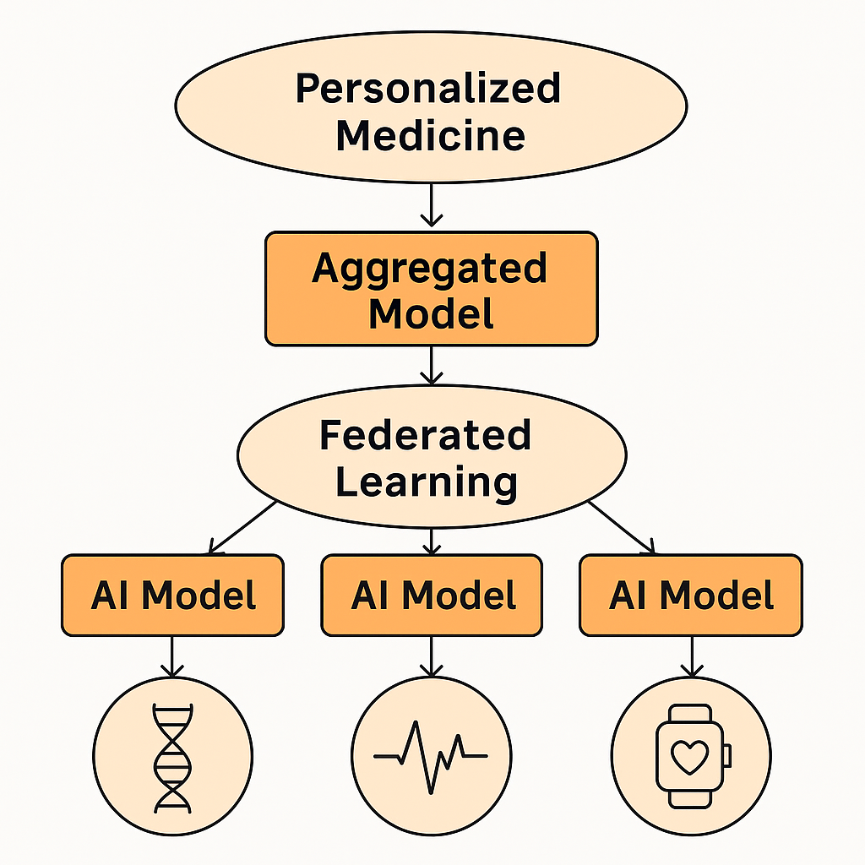

**Figure 2**: Federated learning framework in AI-driven personalized medicine. Local AI models are trained on individual data sources (e.g., genomics, ECGs, wearables) and contribute to a central aggregated model without transferring raw data, enabling privacy-preserving, distributed learning.

### ****5. Ethical, Legal, and Social Implications****

The integration of Artificial Intelligence (AI) and Machine Learning (ML) into personalized medicine offers transformative potential, but it also raises a host of ethical, legal, and social challenges that must be proactively addressed(42). Among the most pressing concerns are **bias, fairness, transparency,** and **patient privacy.**

AI models trained on imbalanced or non-representative datasets risk propagating or even amplifying existing healthcare disparities(43). A well-cited example involves dermatologic AI systems developed using predominantly light-skinned images, which have demonstrated significantly reduced diagnostic accuracy in individuals with darker skin tones(44). The ethical application of AI depends on making sure that training data reflects the diversity of real-world populations, as such biases not only undermine clinical effectiveness but also give rise to grave concerns about social justice and health equity(45).

**Explainable AI (XAI)** has evolved to tackle the problem of **model opacity**. XAI techniques makes complex algorithmic decisions more readable, to help clinicians understand how specific outputs are gotten(46). This is majorly important to enhance clinician trust and facilitate responsible decision-making, especially in high-stakes medical contexts where the lives of patient are prone to risk(47).

AI in healthcare still has a somewhat undeveloped legal environment. Liability issues are not well defined, particularly when AI systems offer suggestions that are autonomous or semi-autonomous. Determining responsibility amongst developers, institutions, and physicians if an AI-driven decision causes harm is still controversial(48).

Furthermore, in the era of artificial intelligence, informed consent goes beyond traditional patient agreements. Patients need to be informed about the ways in which their data will be used, especially when it comes to data reuse, algorithm updates, or model retraining(41). In the end, addressing ELSI concerns is not ancillary but rather essential to the responsible advancement of AI in personalized medicine. As technology advances, ethical governance, regulatory oversight, and stakeholder engagement must also change(49).

### ****6. Challenges and Limitations****

While the incorporation of Artificial Intelligence (AI) and Machine Learning (ML) into customized medicine ushers in a new era of individualized care, its execution is fraught with difficulties and constraints(50,51). One of the most significant is the issue of low generalizability. AI models are frequently trained on datasets with little variation in terms of ethnicity, age, gender, socioeconomic level, or geographic origin. As a result, when applied to underrepresented communities, these models may underperform or give biased results, worsening already-existing healthcare inequities(52).

The regulatory environment surrounding AI in healthcare is also lacking; existing frameworks are unable to keep up with the rapid advancements in technology, which leads to uncertainty regarding approval procedures, liability, and post-deployment surveillance(53). Regulatory bodies are just starting to take into account adaptive models that change in response to new data, but precise guidelines for dynamic validation and clinical accountability are still elusive(54).

Clinical adoption of AI technology is further hampered by the complexity of many models and the perceived lack of transparency. Many high-performing algorithms behave as “black boxes,” allowing limited visibility into how predictions are formed(52). This lack of interpretability presents serious issues in therapeutic settings, when decisions need to be clear, understandable, and justified, especially when patient safety is involved. Even though explainable AI (XAI) has great potential, its development and uptake are still in their infancy(55).

Furthermore, model validation and reproducibility present significant obstacles. Algorithms frequently demonstrate great accuracy in controlled environments or single-institution research, but these results do not repeat across various clinical contexts. Data quality, healthcare workflows, coding procedures, and infrastructure all contribute to this variability(56).

Maintaining AI performance also necessitates ongoing model monitoring and updates, which involve technical, ethical, and logistical concerns. Without routine re-training using up-to-date data, even the most robust models risk obsolescence or degradation in performance(57).

To truly integrate AI into the fabric of personalized medicine, these limitations must be addressed through inclusive data practices, regulatory reform, interdisciplinary collaboration, and ongoing investment in interpretability and infrastructure(40,50).

**7. Future Prospects and Roadmap**

The future of precision medicine is poised for a transformative leap, driven by rapid advancements in artificial intelligence (AI), data science, and biotechnology(25). Emerging trends such as multi-omics integration—encompassing genomics, proteomics, transcriptomics, metabolomics, and more—are enabling a more holistic understanding of human biology(58). When combined with high-resolution data from wearables, biosensors, and electronic health records, AI algorithms can construct dynamic, patient-specific models that enhance disease prediction, progression monitoring, and therapeutic response forecasting(59). Emerging innovations in precision medicine are illustrated in Figure 1, which highlights key trends such as multi-omics integration, digital twins, wearable biosensors, and the convergence of AI with systems biology.

One particularly promising development is the creation of digital twins—virtual replicas of individual patients that simulate physiological processes in real time(60). These models can be used to test interventions virtually before applying them in the real world, thereby reducing risk and accelerating drug development. AI-powered clinical trials will further optimize trial design, recruitment, and outcome assessment, making trials more adaptive, efficient, and inclusive(61).

The integration of AI with systems biology holds the potential to shift the focus from treatment to prevention, enabling truly personalized and proactive healthcare(41). Global collaborations across academic institutions, healthcare systems, and industry players will be essential to scale these innovations. Equally crucial is the inclusion of diverse populations in data sets to ensure equity and generalizability of AI-driven solutions(51). As summarized in *Table 1*, the future of AI-driven precision medicine is shaped by several interlinked innovations, each contributing unique value to personalized healthcare delivery.

However, the deployment of AI in precision medicine must be approached with caution. Ethical considerations such as patient privacy, data security, algorithmic transparency, and bias mitigation are imperative. Clinically, AI models must undergo rigorous validation and meet regulatory standards to gain acceptance and ensure patient safety(53).

In sum, the roadmap to realizing the full potential of AI in precision medicine requires a multidisciplinary, patient-centric approach(50). By aligning technological innovation with ethical integrity and clinical relevance, the field can move toward delivering predictive, preventive, personalized, and participatory healthcare for all(62).

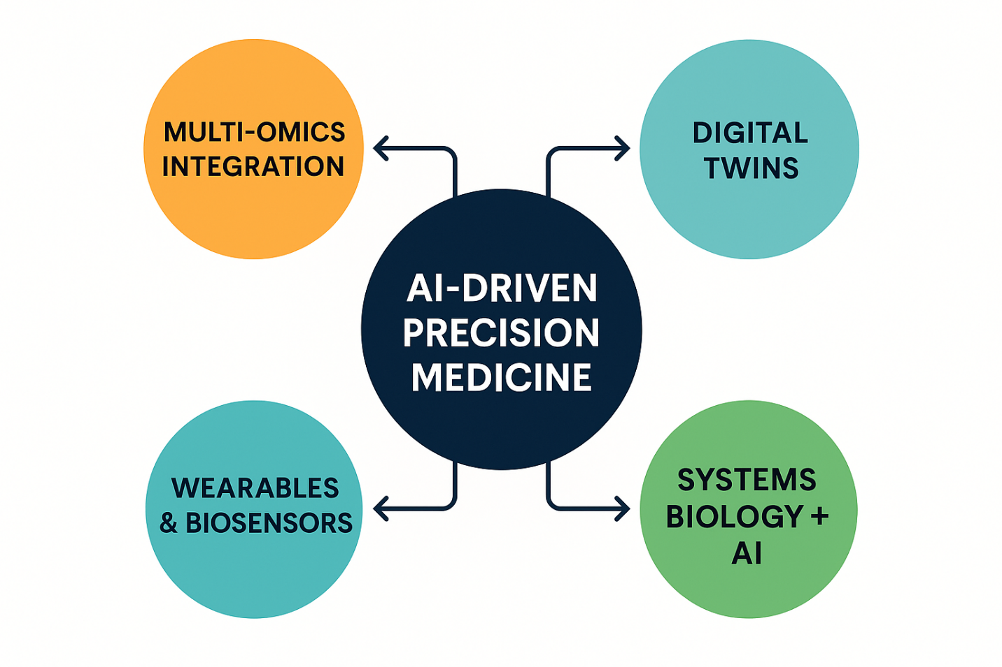

**Figure 3**: Key emerging trends in AI-driven precision medicine, illustrating the integration of technologies that collectively enhance predictive, preventive, and personalized healthcare strategies

**Table 2**: Overview of key emerging trends in AI-driven precision medicine, detailing their descriptions and potential impacts on healthcare outcomes.

| **Trend** | **Description** | **Potential Impact** |
| --- | --- | --- |
| **Multi-Omics Integration** | Combines genomic, proteomic, transcriptomic, and metabolomic data | Enables comprehensive biological profiling for precision diagnosis |
| **Digital Twins** | Virtual replicas of individual patients that simulate physiological responses | Facilitates personalized treatment planning and risk-free testing |
| **AI-Powered Clinical Trials** | Uses AI to optimize trial design, patient selection, and adaptive methodologies | Increases trial efficiency, reduces costs, and improves inclusivity. |
| **Wearables & Biosensors** | Collects real-time health data such as vitals and activity levels | Enhances disease prediction and supports continuous monitoring |
| **Systems Biology + AI** | Model complex biological networks to predict responses and interventions | Shifts focus from treatment to prevention and early intervention |
| **Inclusive Data Representation** | Ensures diverse population data is used in model training | Reduces bias and improves applicability across demographics |

**8. Conclusion**  
Artificial intelligence and machine learning are rapidly transforming the landscape of personalized medicine, offering unprecedented capabilities in data integration, pattern recognition, and individualized care. Their applications span the spectrum—from multi-omics analysis and diagnostic imaging to predictive analytics and clinical decision support—ushering in a new era of precision healthcare. However, these advancements are accompanied by critical challenges, including data privacy concerns, algorithmic bias, and the need for rigorous clinical validation. Moving forward, the responsible integration of AI into healthcare systems will depend on sustained interdisciplinary collaboration, robust ethical governance, and a commitment to inclusivity in data representation and deployment. This review underscores the transformative potential of AI while calling for a patient-centered, transparent, and equitable approach to ensure its benefits are realized across diverse populations and clinical settings.

Disclaimer (Artificial intelligence)

Option 1:

Author(s) hereby declare that NO generative AI technologies such as Large Language Models (ChatGPT, manuscript.

Option 2:

Author(s) hereby declare that generative AI technologies such as Large Language Models, etc. have been used during the writing or editing of manuscripts. This explanation will include the name, version, model, and source of the generative AI technology and as well as all input prompts provided to the generative AI technology

Details of the AI usage are given below:

1.

2.

3.

REFERENCES

1. Goetz LH, Schork NJ. Personalized Medicine: Motivation, Challenges and Progress. Fertil Steril. 2018 Jun;109(6):952–63.

2. Lawal OP, Ahmed NK, Ilesanmi TA, Anthony GI, Nwosu SN, Ogungbemiro FO, et al. The Impact of Antimicrobial Resistance on Cancer Treatment: A Systematic Review of Current Evidence and Future Directions. Asian Journal of Research in Medical and Pharmaceutical Sciences. 2024 Sep 16;13(4):9–27.

3. Stanton LW. Computational Biology: Transforming Biomedical Research and Healthcare. Stem Cell Research and Regenerative Medicine. 2024 Jun 28;7(3):212–4.

4. Jones LD, Golan D, Hanna SA, Ramachandran M. Artificial intelligence, machine learning and the evolution of healthcare. Bone Joint Res. 2018 May 5;7(3):223–5.

5. Xu Y, Liu X, Cao X, Huang C, Liu E, Qian S, et al. Artificial intelligence: A powerful paradigm for scientific research. Innovation (Camb). 2021 Oct 28;2(4):100179.

6. Eloranta S, Boman M. Predictive models for clinical decision making: Deep dives in practical machine learning. J Intern Med. 2022 Aug;292(2):278–95.

7. Alowais SA, Alghamdi SS, Alsuhebany N, Alqahtani T, Alshaya AI, Almohareb SN, et al. Revolutionizing healthcare: the role of artificial intelligence in clinical practice. BMC Med Educ. 2023 Sep 22;23:689.

8. Subramanian I, Verma S, Kumar S, Jere A, Anamika K. Multi-omics Data Integration, Interpretation, and Its Application. Bioinform Biol Insights. 2020 Jan 31;14:1177932219899051.

9. Okafor CE, Egwuatu EC, Owosagba VA, Njei T, Adeyemi BI, Onuche PUO, et al. From Bench to Bedside: Medicinal Chemistry Strategies in the Development of Kinase Inhibitors for Cancer Therapy. Journal of Cancer and Tumor International. 2025 May 10;15(2):79–96.

10. Maleki Varnosfaderani S, Forouzanfar M. The Role of AI in Hospitals and Clinics: Transforming Healthcare in the 21st Century. Bioengineering. 2024 Apr;11(4):337.

11. Hassani H, Silva ES, Unger S, TajMazinani M, Mac Feely S. Artificial Intelligence (AI) or Intelligence Augmentation (IA): What Is the Future? AI. 2020 Jun;1(2):143–55.

12. Lawal OP, Egwuatu EC, Akanbi KO, Orobator ET, Eweje OZ, Omotayo EO, et al. Fighting Resistance With Data: Leveraging Digital Surveillance to Address Antibiotic Misuse in Nigeria. Path of Science. 2025 Mar 31;11(3):1009–17.

13. Varnosfaderani SM, Forouzanfar M. The Role of AI in Hospitals and Clinics: Transforming Healthcare in the 21st Century. Bioengineering. 2024 Mar 29;11(4):337.

14. Razzaq K, Shah M. Machine Learning and Deep Learning Paradigms: From Techniques to Practical Applications and Research Frontiers. Computers. 2025 Mar;14(3):93.

15. Hu Y, Yan H, Liu M, Gao J, Xie L, Zhang C, et al. Detecting cardiovascular diseases using unsupervised machine learning clustering based on electronic medical records. BMC Medical Research Methodology. 2024 Dec 19;24(1):309.

16. Jayaraman P, Desman J, Sabounchi M, Nadkarni GN, Sakhuja A. A Primer on Reinforcement Learning in Medicine for Clinicians. NPJ Digit Med. 2024 Nov 26;7:337.

17. Olthof AW, van Ooijen PMA, Cornelissen LJ. Deep Learning-Based Natural Language Processing in Radiology: The Impact of Report Complexity, Disease Prevalence, Dataset Size, and Algorithm Type on Model Performance. J Med Syst. 2021;45(10):91.

18. National Subsea Centre [Internet]. [cited 2025 May 5]. Expert Insight: The Benefits of Multi-Modality Data Fusion. Available from: https://www.nationalsubseacentre.com/news-events/news/2024/april/expert-insight-the-benefits-of-multi-modality-data-fusion/

19. Almeman A. The digital transformation in pharmacy: embracing online platforms and the cosmeceutical paradigm shift. Journal of Health, Population and Nutrition. 2024 May 8;43(1):60.

20. Seyhan AA, Carini C. Are innovation and new technologies in precision medicine paving a new era in patients centric care? Journal of Translational Medicine. 2019 Apr 5;17(1):114.

21. Bekbolatova M, Mayer J, Ong CW, Toma M. Transformative Potential of AI in Healthcare: Definitions, Applications, and Navigating the Ethical Landscape and Public Perspectives. Healthcare (Basel). 2024 Jan 5;12(2):125.

22. Xu J, Yang P, Xue S, Sharma B, Sanchez-Martin M, Wang F, et al. Translating cancer genomics into precision medicine with artificial intelligence: applications, challenges and future perspectives. Hum Genet. 2019;138(2):109–24.

23. O’Connor O, McVeigh TP. Increasing use of artificial intelligence in genomic medicine for cancer care- the promise and potential pitfalls. BJC Rep. 2025 Apr 1;3(1):1–7.

24. Liao J, Li X, Gan Y, Han S, Rong P, Wang W, et al. Artificial intelligence assists precision medicine in cancer treatment. Front Oncol. 2023 Jan 4;12:998222.

25. Enabling technologies for personalized and precision medicine - PMC [Internet]. [cited 2025 May 5]. Available from: https://pmc.ncbi.nlm.nih.gov/articles/PMC7924935/

26. Abul-Husn NS, Kenny EE. Personalized medicine and the power of electronic health records. Cell. 2019 Mar 21;177(1):58–69.

27. Ma G, As S, G Ștefănescu, Gg B, Cm G, A B, et al. State-of-the-Art Review on Immersive Virtual Reality Interventions for Colonoscopy-Induced Anxiety and Pain. Journal of clinical medicine [Internet]. 2022 Mar 17 [cited 2025 Jul 3];11(6). Available from: https://pubmed.ncbi.nlm.nih.gov/35329993/

28. Fung E, Patsopoulos NA, Belknap SM, O’Rourke DJ, Robb JF, Anderson JL, et al. Effect of Genetic Variants, Especially CYP2C9 and VKORC1, on the Pharmacology of Warfarin. Semin Thromb Hemost. 2012 Nov;38(8):893–904.

29. Stafie CS, Sufaru IG, Ghiciuc CM, Stafie II, Sufaru EC, Solomon SM, et al. Exploring the Intersection of Artificial Intelligence and Clinical Healthcare: A Multidisciplinary Review. Diagnostics (Basel). 2023 Jun 7;13(12):1995.

30. Cheng CH, Lee BJ, Nfor ON, Hsiao CH, Huang YC, Liaw YP. Using machine learning-based algorithms to construct cardiovascular risk prediction models for Taiwanese adults based on traditional and novel risk factors. BMC Medical Informatics and Decision Making. 2024 Jul 22;24(1):199.

31. Guan Z, Li H, Liu R, Cai C, Liu Y, Li J, et al. Artificial intelligence in diabetes management: Advancements, opportunities, and challenges. Cell Rep Med. 2023 Oct 2;4(10):101213.

32. Lawal O, Elechi K, Adekunle F, Farinde O, Kolapo T, Igbokwe C, et al. A Review on Artificial Intelligence and Point-of-Care Diagnostics to Combat Antimicrobial Resistance in Resource-Limited Healthcare Settings like Nigeria: Review Article. Journal of Pharma Insights and Research. 2025 Apr 5;3(2):166–75.

33. Ramesh P, Gayathri PV, Chandrika M, Kalyan DP. A Review Article On The Artificial Intelligence [Ai] In Tumour Detection [Oncology]. IJPS Journal [Internet]. 2024 Jul 11 [cited 2025 May 5]; Available from: https://www.ijpsjournal.com/article/A+Review+Article+On+The+Artificial+Intelligence+Ai+In+Tumour+Detection+Oncology++

34. Alanazi A. Clinicians’ Views on Using Artificial Intelligence in Healthcare: Opportunities, Challenges, and Beyond. Cureus. 15(9):e45255.

35. Serrano DR, Luciano FC, Anaya BJ, Ongoren B, Kara A, Molina G, et al. Artificial Intelligence (AI) Applications in Drug Discovery and Drug Delivery: Revolutionizing Personalized Medicine. Pharmaceutics. 2024 Oct 14;16(10):1328.

36. Maleki Varnosfaderani S, Forouzanfar M. The Role of AI in Hospitals and Clinics: Transforming Healthcare in the 21st Century. Bioengineering (Basel). 2024 Mar 29;11(4):337.

37. Lawal OP, Adedayo OA, Dorcas SI, Akanbi OO, Okafor BC, Kanu I, et al. Biomarkers for Tuberculosis Diagnosis and Monitoring: A Review of Translational Progress. Asian Journal of Microbiology and Biotechnology. 2025 May 20;10(1):115–30.

38. Torab-Miandoab A, Samad-Soltani T, Jodati A, Rezaei-Hachesu P. Interoperability of heterogeneous health information systems: a systematic literature review. BMC Med Inform Decis Mak. 2023 Jan 24;23:18.

39. Lawal O, Oyebamiji HO, Kelenna IJ, Chioma FJ, Oyefeso E, Adeyemi BI, et al. A Review on Usage of Digital Health Literacy to Combat Antibiotic Misuse and Misinformation in Nigeria: Review Article. Journal of Pharma Insights and Research. 2025 Apr 5;3(2):258–69.

40. Williamson SM, Prybutok V. Balancing Privacy and Progress: A Review of Privacy Challenges, Systemic Oversight, and Patient Perceptions in AI-Driven Healthcare. Applied Sciences. 2024 Jan;14(2):675.

41. Maleki Varnosfaderani S, Forouzanfar M. The Role of AI in Hospitals and Clinics: Transforming Healthcare in the 21st Century. Bioengineering (Basel). 2024 Mar 29;11(4):337.

42. Harishbhai Tilala M, Kumar Chenchala P, Choppadandi A, Kaur J, Naguri S, Saoji R, et al. Ethical Considerations in the Use of Artificial Intelligence and Machine Learning in Health Care: A Comprehensive Review. Cureus. 16(6):e62443.

43. Norori N, Hu Q, Aellen FM, Faraci FD, Tzovara A. Addressing bias in big data and AI for health care: A call for open science. Patterns (N Y). 2021 Oct 8;2(10):100347.

44. Rezk E, Eltorki M, El-Dakhakhni W. Improving Skin Color Diversity in Cancer Detection: Deep Learning Approach. JMIR Dermatol. 2022 Aug 19;5(3):e39143.

45. Chen IY, Pierson E, Rose S, Joshi S, Ferryman K, Ghassemi M. Ethical Machine Learning in Healthcare. Annu Rev Biomed Data Sci. 2021 Jul;4:123–44.

46. Lawal OP, Igwe EP, Olosunde A, Chisom EP, Okeh DU, Olowookere AK, et al. Integrating Real-Time Data and Machine Learning in Predicting Infectious Disease Outbreaks: Enhancing Response Strategies in Sub-Saharan Africa. Asian Journal of Microbiology and Biotechnology. 2025 May;10(1):147–63.

47. Antoniadi AM, Du Y, Guendouz Y, Wei L, Mazo C, Becker BA, et al. Current Challenges and Future Opportunities for XAI in Machine Learning-Based Clinical Decision Support Systems: A Systematic Review. Applied Sciences. 2021 Jan;11(11):5088.

48. Cestonaro C, Delicati A, Marcante B, Caenazzo L, Tozzo P. Defining medical liability when artificial intelligence is applied on diagnostic algorithms: a systematic review. Front Med (Lausanne). 2023 Nov 27;10:1305756.

49. Zhang J, Zhang Z ming. Ethics and governance of trustworthy medical artificial intelligence. BMC Medical Informatics and Decision Making. 2023 Jan 13;23(1):7.

50. Johnson KB, Wei W, Weeraratne D, Frisse ME, Misulis K, Rhee K, et al. Precision Medicine, AI, and the Future of Personalized Health Care. Clin Transl Sci. 2021 Jan;14(1):86–93.

51. Bajwa J, Munir U, Nori A, Williams B. Artificial intelligence in healthcare: transforming the practice of medicine. Future Healthc J. 2021 Jul;8(2):e188–94.

52. Arora A, Alderman JE, Palmer J, Ganapathi S, Laws E, McCradden MD, et al. The value of standards for health datasets in artificial intelligence-based applications. Nat Med. 2023;29(11):2929–38.

53. Mennella C, Maniscalco U, De Pietro G, Esposito M. Ethical and regulatory challenges of AI technologies in healthcare: A narrative review. Heliyon. 2024 Feb 15;10(4):e26297.

54. Alowais SA, Alghamdi SS, Alsuhebany N, Alqahtani T, Alshaya AI, Almohareb SN, et al. Revolutionizing healthcare: the role of artificial intelligence in clinical practice. BMC Med Educ. 2023 Sep 22;23:689.

55. Orobator E, Nnodumele C, Tsegay N, Onyekwelu P, Odenigbo A, Ugbor MJ, et al. Applications of Artificial Intelligence in Plant-Based Anticancer Drug Discovery and Development: Review Article. Journal of Pharma Insights and Research. 2025 Apr 5;3(2):203–10.

56. Deniz-Garcia A, Fabelo H, Rodriguez-Almeida AJ, Zamora-Zamorano G, Castro-Fernandez M, Alberiche Ruano M del P, et al. Quality, Usability, and Effectiveness of mHealth Apps and the Role of Artificial Intelligence: Current Scenario and Challenges. J Med Internet Res. 2023 May 4;25:e44030.

57. Perifanis NA, Kitsios F. Investigating the Influence of Artificial Intelligence on Business Value in the Digital Era of Strategy: A Literature Review. Information. 2023 Feb;14(2):85.

58. Dai X, Shen L. Advances and Trends in Omics Technology Development. Front Med (Lausanne). 2022 Jul 1;9:911861.

59. Shajari S, Kuruvinashetti K, Komeili A, Sundararaj U. The Emergence of AI-Based Wearable Sensors for Digital Health Technology: A Review. Sensors (Basel). 2023 Nov 29;23(23):9498.

60. Onwuemelem LA, Orobator ET, Onyedum NN, Chibueze ES, Kanu I, Christopher AA, et al. Molecular Mechanisms of Clonal Hematopoiesis in Age-Related Cardiovascular Disease and Hematologic Malignancies: Review Article. Journal of Pharma Insights and Research. 2025 Apr 5;3(2):358–72.

61. Kamel Boulos MN, Zhang P. Digital Twins: From Personalised Medicine to Precision Public Health. J Pers Med. 2021 Jul 29;11(8):745.

62. Stoumpos AI, Kitsios F, Talias MA. Digital Transformation in Healthcare: Technology Acceptance and Its Applications. Int J Environ Res Public Health. 2023 Feb 15;20(4):3407.