**Review Article**

**Decoding Tumor Heterogeneity Through Multi-Omics: Insights into Cancer Evolution, microenvironment and Therapy Resistance.**

### Abstract

Background: The existence of genetically, epigenetically, and phenotypically distinct cell populations inside and between tumors is known as tumor heterogeneity, and it is one of the main barriers to effective cancer treatment. This intricacy affects the likelihood of metastasis, therapeutic resistance, and disease recurrence, rendering single-omics methods and conventional diagnostics inadequate for whole-tumor profiling. As a result, multi-omics methods, which incorporate data from multiple biological layers, such as transcriptomics, proteomics, metabolomics, genomes, and epigenomics, have emerged as powerful tools for thoroughly examining intra- and inter-tumoral complexity.

Methods: A comprehensive literature synthesis was conducted, emphasizing high-impact studies that illustrate technological innovation and translational impact in multi-omics applications. Key case studies in glioblastoma, non-small cell lung cancer, and breast cancer are highlighted to demonstrate real-world clinical relevance.

Aims and objectives: This paper explores the ways in which integrated multi-omics has transformed our understanding of clonal dynamics, tumor growth, and resistance mechanisms while charting a path toward precision oncology.

Key Insights: The latest methods, such as single-cell multi-omics, spatial transcriptomics, and proteogenomics, were examined, along with computational frameworks including network-based models, probabilistic inference algorithms, and AI-driven tools that make it easier to integrate high-dimensional data. Along with discussing new technologies like in vivo biosensors, organoid-based modeling, and point-of-care omics, the function of the tumor microenvironment, lineage tracing, and liquid biopsies in monitoring the real-time progression of tumors was also discussed. Translational hurdles, including cost, complexity, and ethical issues were addressed while highlighting the importance of equity and worldwide access.

Conclusion: Multi-omics has great promise for truly personalized oncology by providing the integrated insights required for dynamic monitoring, predictive diagnosis, and tailored therapy design in future cancer care.

Keywords: Heterogeneity, Multi-omics, Therapy Resistance, Tumor Microenvironment, Personalized Oncology

**Introduction**

Cancer is a multifaceted disease with significant tumor heterogeneity rather than a single illness.

This heterogeneity can be viewed in three ways: spatially (differences between primary and metastatic sites or between regions within a tumor), temporally (evolution over time and under therapeutic pressure), and biologically (difference at the genetic, epigenetic, transcriptomic, proteomic, and metabolic levels) (MacDonald et al., 2025). The tumor microenvironment (TME), composed of stromal, immunological, and endothelial cells, further complicates the situation by altering cellular signaling, immune evasion, and resistance mechanisms. According to growing evidence, this multilayered heterogeneity plays a significant role in the disease's progression, metastasis, and most importantly, therapy resistance (Biray Avci et al., 2024). Even among malignancies that are histologically comparable, this diversity is clinically associated with poor survival outcomes, high rates of treatment failure, and tumor recurrence (Melariri et al., 2023).

Conventional approaches to tumor research, often based on bulk sequencing and single-omics datasets, have helped to better understand oncogenesis and driver mutations. The small but important distinctions between individual cells and molecular layers are often obscured by these methods. Bulk measurements, which often average out signals from several subpopulations, mask rare clones that may lead to resistance or relapse. In addition, single-omics studies, whether transcriptomic, proteomic, or genomic, fail to capture the complex connections that drive the development of cancer (G. Sun et al., 2021). In order to adequately evaluate tumor complexity, multi-omics integration is necessary. This method simultaneously analyzes and synthesizes data from multiple biological domains, such as transcriptomics (gene expression), proteomics (protein abundance and variations), metabolomics (metabolic fluxes), genomics (DNA mutations), and epigenomics (chromatin modifications). Combining these datasets can reveal non-linear relationships and causal pathways that are not apparent when examined as distinct layers. Crucially, multi-omics methods offer a dynamic, system-level viewpoint on tumor progression, adaptive resistance, and microenvironmental crosstalk, offering significant prospects for precision oncology development (Hayes et al., 2024). In an effort to provide a comprehensive overview of the state of the art on tumor heterogeneity, this review focuses on how multi-omics technologies and integrative analytics are transforming our knowledge of cancer biology. We examine therapeutic applications, give typical case studies, talk about current problems and possible directions for the field, and delve into methodological developments (Chen et al., 2023a).

### 2. Understanding Tumor Heterogeneity

Tumor heterogeneity refers to the significant biological variability observed both within individual tumors and among different tumors. This variability poses a major challenge for effective cancer diagnosis and treatment. Intra-tumoral heterogeneity specifically describes the differences in cancer cells found within a single tumor mass. This often includes variations in genetic, epigenetic, transcriptomic, and phenotypic profiles among different subclones (Proietto et al., 2023). Inter-tumoral heterogeneity, on the other hand, describes the diversity seen amongst tumors of the same histological subtype, whether within a single patient or between patients with comparable diagnoses. These types of heterogeneity are responsible for differences in tumor behavior, treatment response, and disease prognosis (Ramón y Cajal et al., 2020b). Multiple layers of variation drive tumor heterogeneity at the molecular level. A tumor's overall mutational load is influenced by genetic heterogeneity, which is frequently the consequence of continuous clonal evolution and is defined by changes in somatic mutations, copy number variations, and chromosomal rearrangements (Folorunsho, Sanmori, et al., 2025). Without changing the DNA sequence, epigenetic heterogeneity, which includes differences in histone modifications and DNA methylation patterns, affects gene expression and can be quite responsive to environmental stiMULTI (Dentro et al., 2021). The variety of gene expression profiles, impacted by both internal and external causes, is reflected in transcriptomic variations. Comparably, metabolic heterogeneity represents unique metabolic dependencies and adaptations that support tumor growth under various microenvironmental conditions, whereas proteomic heterogeneity results from differences in protein expression, post-translational modifications, and signaling pathway activation (Ortmayr et al., 2019). Tumor heterogeneity arises from several key factors. Clonal diversity is driven by random mutations and genomic instability. The tumor microenvironment (TME), comprising immune cells, fibroblasts, endothelial cells, and extracellular matrix components, affects tumor cell behavior through paracrine signaling and immunoediting. Resistant clones can evade immune surveillance by reducing interferon signaling or deleting antigens. Additionally, treatment pressures favor the proliferation of these resistant subclones (Marusyk & Polyak, 2010). Tumor heterogeneity has been outlined by three conceptual models. According to Nowell's original description of the clonal evolution concept, tumor development is the consequence of clones with favorable mutations being selected one after the other. According to the cancer stem cell theory, there is a hierarchical structure in place, and heterogeneity and treatment resistance are driven by stem-like cells (Lawal et al., 2024). Finally, according to the Big Bang hypothesis, neutral evolution is widespread since most mutations take place early in the neoplastic process, and there are not many selective pressures after that. It is possible for these models to function simultaneously in various tumor situations, and they are not exclusive. As illustrated in Figure 1 below, tumor heterogeneity encompasses several molecular levels, ranging from the genome to the metabolome, each of which adds to the complexity of the cancer's phenotype and response to treatment (R. Sun et al., 2018).

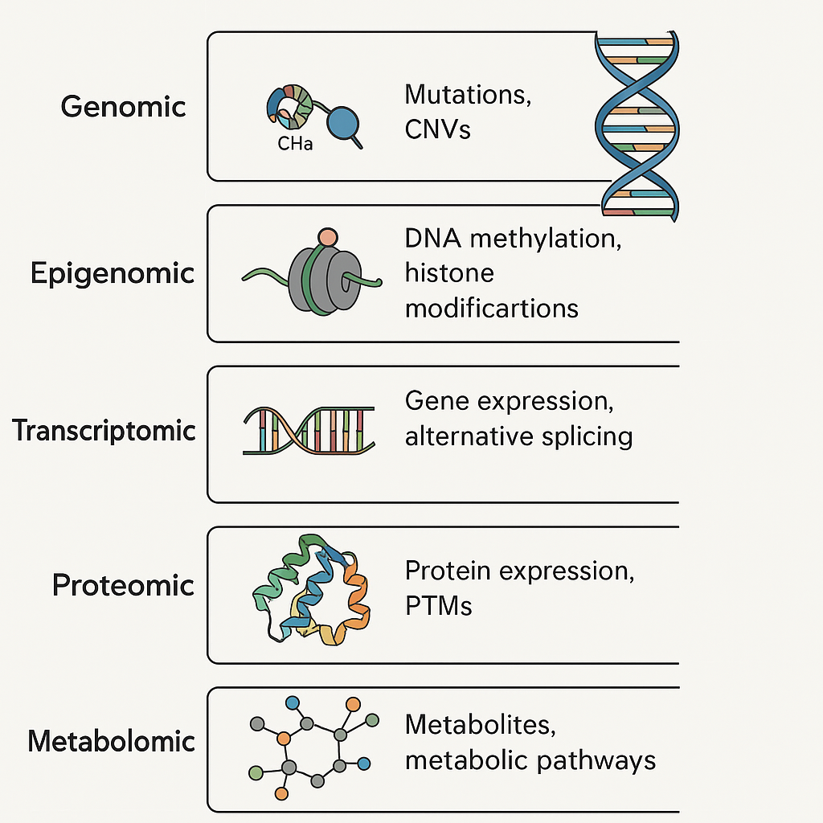

**Figure 1. Layers of Tumor Heterogeneity: From Genome to Metabolome**. This diagram depicts the hierarchical layers of genomic, epigenomic, transcriptomic, proteomic, and metabolomic that contribute to tumor heterogeneity. DNA methylation and histone modifications, RNA expression dynamics, protein post-translational modifications (PTMs), metabolite profiles, and mutations and copy number variations (CNVs) at the DNA level are all examples of the unique molecular processes that are contained inside each layer. These levels work together to influence tumor behavior, evolution, and responsiveness to treatment (Li et al., 2023). Histopathologic and proteogenomic heterogeneity reveals features of clear cell renal cell carcinoma aggressiveness. Cancer Cell, 41(1), 139-163.e17. https://doi.org/10.1016/j.ccell.2022.12.001)

### 3. Multi-Omics Approaches: An Integrated Lens

Analytical techniques that go beyond the constraints of single-omics profiling are required due to the multifaceted complexity of cancer. To present a thorough molecular picture of malignancies, multi-omics involves the systematic integration of data from several biological layers, from the genome to the metabolome. Multi-omics integration can be defined by two main strategies: vertical integration, which connects various layers across the molecular cascade (e.g., DNA mutations influencing RNA expression and downstream protein activity), and horizontal integration, which combines data from the same omics level but different platforms or modalities (e.g., bulk RNA-seq with single-cell RNA-seq to capture population and cellular resolution). The latter approach offers a systems biology perspective (Cai et al., 2022). Understanding tumor biology is supported by the distinct contributions of each omics layer. Single-nucleotide variations (SNVs), copy number variations (CNVs), and structural rearrangements are aspects of the fundamental mutational architecture that are captured by genomics. The patterns of clonal evolution and oncogenic drivers are identified by this layer (Ortega-Batista et al., 2025). Heritable but reversible changes like DNA methylation, histone modifications, and chromatin accessibility are revealed by epigenomics, and techniques like ATAC-seq shed light on the regulatory environment and transcriptional potential of tumor cells. With single-cell RNA-seq (scRNA-seq) collecting cell-specific expression and isoform variety, revealing subclonal states and plasticity, and bulk RNA-seq providing averaged profiles, transcriptomics represents dynamic gene expression programs (Carter & Zhao, 2021). This knowledge is further enhanced by proteomics, which measures protein abundance, post-translational modifications (PTMs), and signaling network dynamics, usually using methods based on mass spectrometry. The direct impact of proteins on cellular function and pharmacological targets makes this layer crucial. Metabolomics, the last layer of the omics cascade, records metabolic fluxes and rewiring processes, such as the Warburg effect and modifications in the metabolism of lipids and amino acids that support tumor growth and survival in stressful situations (Birhanu, 2023). It takes advanced computational frameworks to integrate such complex datasets. In order to identify functional modules and regulatory hubs, network-based techniques, such as multi-layered or multiplex networks, map interactions across omics layers. Particularly in high-dimensional, sparse datasets, machine learning and artificial intelligence facilitate feature selection, pattern recognition, and predictive modeling. Probabilistic and unsupervised techniques for identifying latent structures and shared variation across datasets are provided by Bayesian frameworks and matrix factorization techniques (e.g., iCluster, MOFA). When combined, these integrative approaches provide a potent toolkit for revealing the emergent characteristics of malignancies and advancing precision oncology (Wörheide et al., 2021). The integrated multi-omics pathway used for thorough tumor profiling, from sample collection to data integration and computational modeling, is simplified in Figure 2.

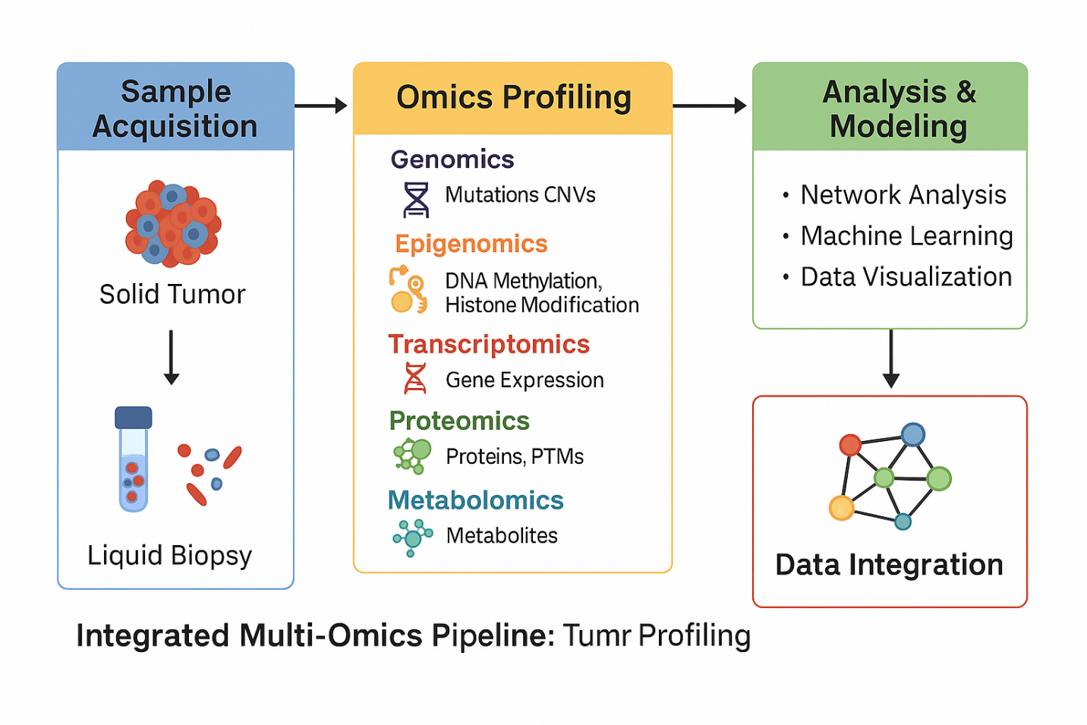**Figure 2. Integrated Multi-Omics Pipeline for Tumor Profiling**. This flowchart illustrates the multi-step pipeline for integrated tumor profiling using multi-omics approaches. The process begins with sample acquisition from solid tumors or liquid biopsies, followed by omics profiling across multiple layers: genomics (mutations, CNVs), epigenomics (DNA methylation, histone modifications), transcriptomics (gene expression), proteomics (proteins, PTMs), and metabolomics (metabolites). These diverse data types are then subjected to computational analysis and modeling, including network analysis, machine learning, and data visualization. Finally, data integration frameworks synthesize insights across omics layers to enable a systems-level view of tumor biology. (Heo et al., 2021) Integrative Multi-Omics Approaches in Cancer Research: From Biological Networks to Clinical Subtypes. Molecules and Cells, 44(7), 433–443. https://doi.org/10.14348/molcells.2021.0042

Below is a concise overview of the core omics layers, associated technologies, and their respective biological contributions to tumor profiling is presented in Table 1. It highlights how each dimension of molecular data enhances our understanding of cancer complexity and therapeutic response. This table provides an overview of the major omics layers involved in multi-omics studies, genomics, epigenomics, transcriptomics, proteomics, and metabolomics, alongside the primary technologies used to interrogate each layer. It also highlights the specific biological processes captured and the critical insights each layer contributes to understanding tumor heterogeneity, evolution, and therapy resistance (Menyhárt & Győrffy, 2021),

**Table 1. Summary of Omics Layers, Representative Technologies, and Key Biological Insights in Tumor Profiling.**

| **Omics Layer** | **Representative Technologies** | **Biological Focus** | **Key Insights** |
| --- | --- | --- | --- |
| **Genomics** | Whole-genome sequencing (WGS), whole-exome sequencing (WES), and ctDNA | DNA mutations, copy number variations (CNVs), structural variants | Identifies driver mutations, clonal architectures, and resistance-associated alterations |
| **Epigenomics** | Bisulfite sequencing, ChIP-seq, ATAC-seq | DNA methylation, histone modifications, chromatin accessibility | Reveals regulatory plasticity, enhancer hijacking, epigenetic reprogramming |
| **Transcriptomics** | Bulk RNA-seq, scRNA-seq, spatial transcriptomics | Gene expression, alternative splicing, isoform usage | Captures cell states, lineage transitions, and immune activation/exclusion signatures |
| **Proteomics** | Mass spectrometry, reverse-phase protein arrays, phospho-proteomics | Protein abundance, post-translational modifications (PTMs) | Uncovers active signaling cascades, resistance networks, and proteogenomic biomarkers |
| **Metabolomics** | LC-MS, GC-MS, NMR spectroscopy | Metabolic fluxes, energy pathways, and redox state | Reveals tumor-specific metabolic rewiring and adaptation under therapy |

### 4. Technological Platforms Enabling Multi-Omics

Recent developments in high-throughput technology have transformed our ability to analyze tumor heterogeneity using multi-omics, providing previously unheard-of resolution in molecular, temporal, and geographic dimensions. The integration of genotype, epigenotype, phenotype, and microenvironmental context is supported by these platforms (Lee et al., 2021). At the resolution of individual cells, single-cell multi-omics technologies enable the simultaneous investigation of many molecular modalities. Single-cell assay for transposase-accessible chromatin sequencing (scATAC-seq) provides chromatin accessibility landscapes across different cell populations, whereas single-cell RNA sequencing (scRNA-seq) offers insights into transcriptional variation. By concurrently assessing surface protein abundance and transcriptomes, CITE-seq (Cellular Indexing of Transcriptomes and Epitopes by Sequencing) improves phenotypic characterization. More comprehensive techniques like scNMT-seq provide holistic perspectives of the regulatory mechanisms influencing cellular identity and plasticity in malignancies by simultaneously profiling transcriptomes, chromatin accessibility, and DNA methylation (Kim & Takahashi, 2025). A crucial spatial component is added to tumor profiling by spatial omics platforms. Spatial transcriptomics preserves the contextual link between tumor cells and the surrounding milieu by enabling mapping of gene expression in situ within tissue architecture. Numerous proteins can be detected simultaneously in intact tissue sections using methods like imaging mass cytometry and multiplexed immunofluorescence, which makes high-dimensional cellular phenotyping and microenvironmental mapping easier (Jin et al., 2024). Figure 3 illustrates the state of the art in terms of single-cell and spatial multi-omics platforms, which allow for fine-scale resolution of microenvironmental and tumor complexity.

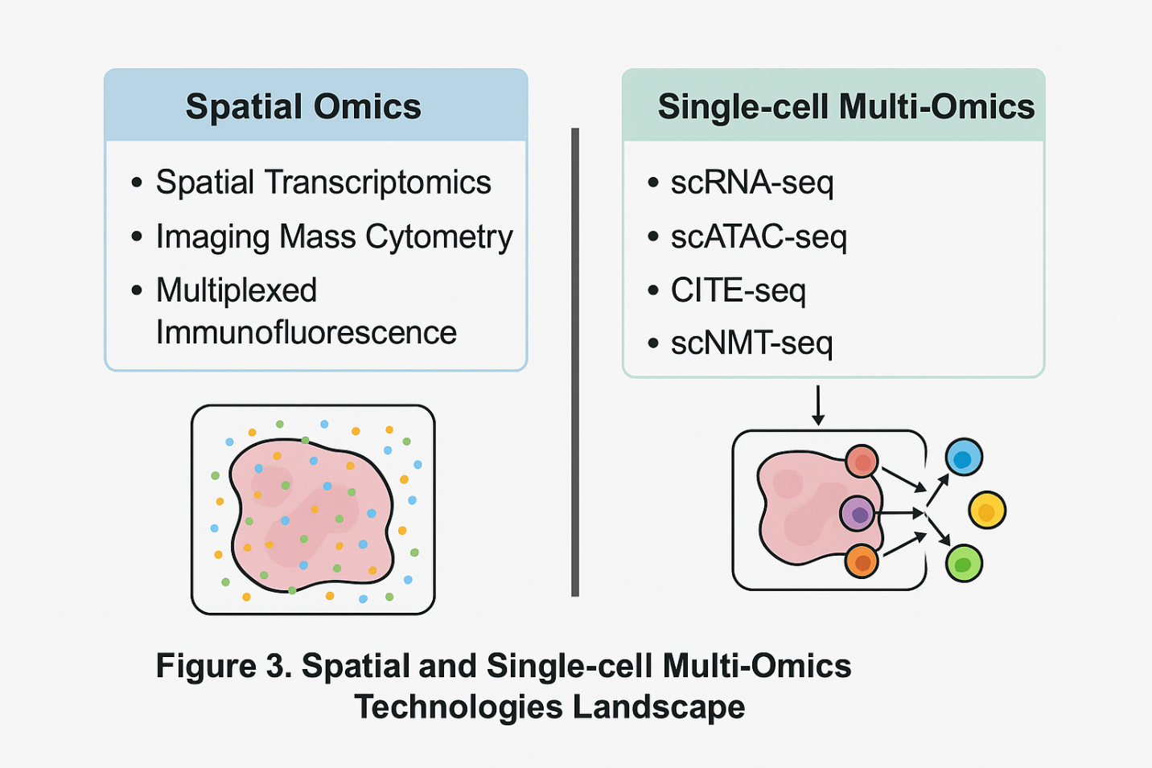

**Figure 3. Spatial and Single-cell Multi-Omics Technologies Landscape**. This figure highlights the functions of important technologies in single-cell multi-omics and spatial omics in addressing tumor heterogeneity by classifying and contrasting them. The localization of molecular characteristics inside intact tissue architecture is made possible by spatial omics techniques, including multiplexed immunofluorescence, imaging mass cytometry, and spatial transcriptomics. Single-cell methods, such as scRNA-seq, scATAC-seq, CITE-seq, and scNMT-seq, on the other hand, isolate individual cells for deep molecular profiling, concurrently recording surface protein, transcriptional, and epigenetic information. When combined, these methods enable high-resolution analysis of tumor cell states, lineage hierarchies, and interactions with the microenvironment. (Zhang et al., 2025). Application of spatial and single-cell omics in tumor immunotherapy biomarkers. *LabMed Discovery*, 100076. https://doi.org/10.1016/j.lmd.2025.100076.

In order to resolve structural variants, repetitive areas, and epigenetic alterations, third-generation sequencing technologies like Oxford Nanopore and Pacific Biosciences (PacBio) offer long-read sequencing capabilities that get beyond the drawbacks of short-read platforms. These methods are especially useful for identifying base alterations like 5-methylcytosine without bisulfite conversion, complicated rearrangements, and oncogenic fusions (Satam et al., 2023a). By combining mass spectrometry-based proteomic data with genomic or transcriptomic information, proteogenomics fills the gap between proteomics and genomics. It can be used to discover neoantigens, measure the expression of mutant proteins, and describe signaling cascades that are important for drug targeting. This method has proved crucial in improving treatment approaches for conditions including colorectal and breast cancer (Sheynkman et al., 2016). It takes strong computational platforms to manage the amount and complexity of multi-omics data. Biomarker identification, batch correction, data integration, dimensionality reduction, and cell-cell interaction modeling are all supported by tools like MOFA (Multi-Omics Factor Analysis), Seurat v4, Harmony, Liger, CellPhoneDB, and iCluster. The analysis of intricate, high-dimensional datasets is powered by these bioinformatics tools, which provide mechanistic insights and translational applications in oncology (Saliba et al., 2024).

### 5. Tracking Tumor Evolution Using Multi-Omics

To predict treatment resistance and the course of the disease, it is crucial to comprehend the evolutionary dynamics of tumors. When used longitudinally, multi-omics techniques offer a potent framework for documenting the geographical and temporal trajectories of tumor progression. It is possible to reconstruct clonal architecture and identify subclonal expansions that occur prior to relapse by doing a temporal study of clonal dynamics by repeated sampling over time. Circulating free DNA (cfDNA), circulating tumor DNA (ctDNA), and tumor-derived exosomes are examples of liquid biopsies that provide a minimally invasive way to track the progression of tumors over time. These biopsies can record both genomic changes and dynamic transcriptomic or proteomic variations (Zhang & Wang, 2025). Case studies of various tumor types demonstrate how multi-omics can be used to decipher evolutionary pathways. Mechanisms of resistance to HER2-targeted therapy, including compensatory PI3K/AKT pathway activation and epigenetic remodeling, have been identified in HER2-positive breast cancer by integrated investigations that combine genomic profiling, transcriptome changes, and proteomic reprogramming (Roszkowska, 2024). Multi-omics analysis of serial tumor samples in glioblastoma has revealed that IDH1 mutations, which were previously believed to be early and stable occurrences, might change under the influence of treatment, producing genetically distinct subclones that aid in recurrence. Another classic example is non-small cell lung cancer (NSCLC), where EGFR-mutant tumors treated with tyrosine kinase inhibitors (TKIs) frequently develop secondary resistance mutations (e.g., T790M, C797S) (Garrett et al., 2021). These mutations can be identified by serial ctDNA sequencing and validated by proteomic signaling analysis, which helps guide real-time therapy adjustments. Real-world instances of tumor progression and treatment resistance, as shown by multi-omics profiling in lung, brain, and breast malignancies, are shown in Figure 4.

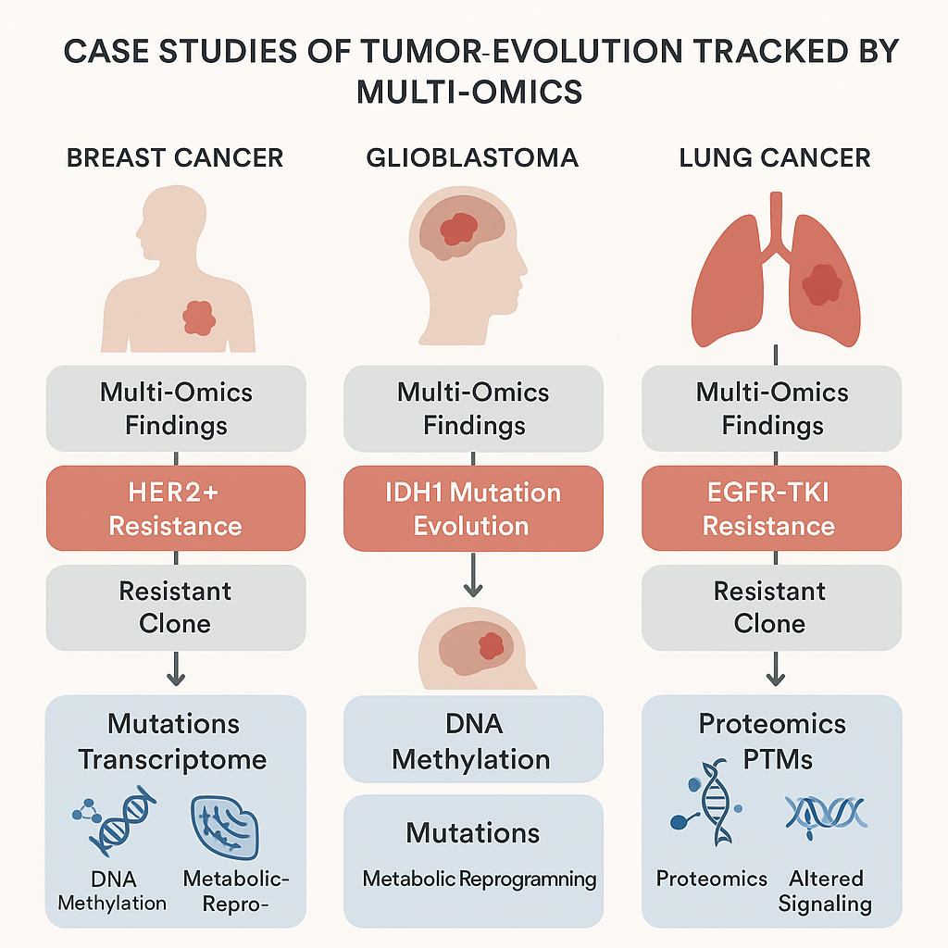

**Figure 4. Case Studies of Tumor Evolution Tracked by Multi-Omics**. Breast cancer, glioblastoma, and lung cancer are the three main cancer types for which this infographic provides three helpful illustrations of how multi-omics methods have revealed the molecular evolution of drug resistance. Clonal selection and metabolic reprogramming in resistant clones were identified in HER2+ breast cancer by means of comprehensive transcriptome and methylation analysis. The development of IDH1 mutations and the corresponding epigenetic reprogramming in glioblastoma was monitored by longitudinal multi-omics profiling. EGFR-TKI resistance was shown in lung cancer by serial liquid biopsies and proteomics, which also highlighted changes in post-translational modifications and bypass signaling pathways. The effectiveness of multi-layered profiling in tracking clonal dynamics and resistance mechanisms throughout time is demonstrated by these case studies. (Malta, et al., 2024) The Epigenetic Evolution of Glioma Is Determined by the IDH1 Mutation Status and Treatment Regimen. Cancer Research, 84(5), 741–756. https://doi.org/10.1158/0008-5472.CAN-23-2093.

A growing number of lineage tracing techniques are being used to rebuild the lineage links among changing tumor subpopulations. Natural lineage markers can be found in copy number evolution and mitochondrial mutation patterns, whereas synthetic tracking of clonal descent can be achieved by techniques like CRISPR barcoding. From multi-region or multi-timepoint omics data, clonal hierarchies and ancestral links are inferred using phylogenetic reconstruction techniques (Yang et al., 2022). These initiatives are aided by a variety of bioinformatics technologies. By reconstructing clonal evolution from bulk and single-cell genomic data, PhyloWGS, CloneFinder, SciClone, and MACHINA allow the inference of tumor phylogenies and evolutionary bottlenecks. Unmatched resolution into how cancers adapt, resist, and re-emerge is provided by these integrative technologies when used on longitudinal multi-omics datasets. This information is crucial for the planning and development of adaptive therapeutic approaches (Sandmann et al., 2023).

### 6. Mechanisms of Therapy Resistance Uncovered by Multi-Omics

Therapy resistance is still an important challenge in the treatment of cancer, even with advancements in immunotherapy and targeted medicines. Resistance may be acquired, emerging in reaction to therapeutic pressure, or intrinsic, resulting from underlying changes that render a patient insensitive to therapy. By analyzing tumors at several molecular levels, multi-omics techniques offer a thorough framework for revealing the complex and dynamic character of these resistance mechanisms (Garg et al., 2024). Resistance frequently arises at the genetic level as a result of secondary mutations that change drug-binding sites or reactivate downstream pathways. The EGFR T790M mutation in non-small cell lung cancer, which results in resistance to first-generation EGFR inhibitors, is a well-known example. Targeted treatments are ineffectual since bypass signaling is also driven by gene amplifications, such as MET or ERBB2, in different malignancies (Leonetti et al., 2019). Through chromatin remodeling, histone modification, and enhancer hijacking, epigenomic modifications play a major role in resistance. Without changing the underlying DNA sequence, these occurrences may result in the silencing of tumor suppressor genes or the reactivation of carcinogenic pathways (Onwuemelem et al., 2025). The small-cell transformation of EGFR-mutant lung tumors during TKI treatment demonstrates how this flexibility promotes phenotypic switching and cellular dedifferentiation (Gu et al., 2024). Functional adaptations that are not identifiable at the transcriptome or genomic levels are revealed by proteomics. Escape from inhibition is often mediated through post-translational modifications (PTMs) and activation of compensatory signaling pathways, such as PI3K/AKT or MAPK reactivation. Reactivation of the MAPK pathway through different RAF isoforms or upstream RTKs is a typical mechanism of BRAF inhibitor resistance in melanoma (Hu et al., 2025). Through improved nutritional flexibility and stress tolerance, metabolic rewiring promotes resistance. In order to withstand oxidative stress brought on by drugs, tumors can increase glycolysis, glutaminolysis, and antioxidant pathways. In cancers lacking BRCA1/2, for example, resistance to PARP inhibitors may result from either alternative DNA repair mechanisms driven by altered metabolism or regained redox equilibrium (Schiliro & Firestein, 2021). The necessity of multi-omics to comprehend the tumor-immune environment is highlighted by immunotherapy resistance. Immune escape is facilitated by mechanisms like epigenetic silencing of antigen-presentation machinery, loss of interferon-γ signaling, and downregulation of MHC class I. Tumor-intrinsic mutations, stromal remodeling, and immune cell depletion work together to compromise immune checkpoint inhibition, according to multi-omics research(Sari & Rock, 2023). Multi-omics reveals the intricate, frequently non-linear processes causing resistance by combining genomic, epigenomic, proteomic, and metabolomic information. This information informs the creation of logical combination medicines and effective treatment plans(Chen et al., 2023b).

### 7. Role of Tumor Microenvironment and Multi-Omics Dissection

Tumor microenvironment (TME) influences immune surveillance, treatment response, and the course of cancer. The TME functions as a physical and physiological niche that promotes tumor heterogeneity and resilience. It is made up of a dynamic network of endothelial and stromal elements, cancer-associated fibroblasts (CAFs), myeloid-derived suppressor cells, and tumor-infiltrating lymphocytes (TILs). The complex cell-cell interactions inside the TME may be decoded using multi-omics technologies, especially when spatially resolved. This reveals the paracrine signaling, immunosuppressive networks, and stromal regulation that underpin tumor adaptability (El-Tanani et al., 2024). The TME's physical and functional variability has been shown using spatially-resolved multi-omics perspectives. Multiplexed imaging platforms and spatial transcriptomics are two examples of technologies that enable the mapping of cellular niches, the identification of metabolic zonation, hypoxia gradients, and immunological exclusion zones (Jing et al., 2025). For instance, hypoxic tumor cores frequently show downregulated antigen presentation and elevated glycolytic gene expression, which are spatially limited and undetectable to bulk profiling(Folorunsho, Ajayi, et al., 2025). The response to treatment is significantly impacted by these geographical patterns, particularly with regard to immunotherapies and anti-angiogenic medicines (Estephan et al., 2025). The microbiome has become an essential facilitator of tumor behavior and immune reactivity, independent of host-derived variables. By producing metabolites and educating the immune system, gut microbiota can affect T cell priming and systemic inflammation (Graham & Xavier, 2023). According to recent data, intratumoral bacteria that live inside cancer cells or the stromal compartment may also alter drug metabolism, resistance mechanisms, and local immunological tone. Certain microbial profiles linked to response to checkpoint inhibitors and chemotherapies have been identified by multi-omics profiling that combines 16S rRNA sequencing, metagenomics, and host transcriptomics (M. Wang et al., 2023). The TME actively contributes to treatment resistance in a number of ways. Stromal shielding, which is made by fibroblasts and ECM components and comprises physical and metabolic barriers, prevents drug penetration and immune cell trafficking. Although hypoxia-induced signaling promotes metabolic rewiring and epithelial-mesenchymal transition, cytokine networks (such as TGF-β and IL-6) reorganize immune cells toward suppressive phenotypes, enhancing stress survival. To investigate these complex interactions, sophisticated methods including as STARMAP, CODEX, MERFISH, and CellCHAT have been developed (Yuan et al., 2023). By combining spatial resolution, multiplexing, and computational modeling, these systems decode the functional topography of the TME, map ligand-receptor interactions, and reconstruct cell communication networks. Such understanding is necessary to design context-specific medicines that increase anti-tumor immunity and break down stromal barriers (Armingol et al., 2022).

### 8. Multi-Omics and Precision Oncology: Clinical Applications

Precision medicine is changing due to the incorporation of multi-omics into clinical oncology, which makes stratified treatment strategies based on thorough molecular profiling possible. Multi-omics enables the discovery of multi-modal biomarkers for prognosis, treatment stratification, and response prediction by examining tumors across genomic, transcriptomic, epigenomic, proteomic, and metabolomic levels (Molla & Bitew, 2024). These composite signatures, in contrast to conventional single-gene biomarkers, provide more reliable and practically useful insights by taking into consideration the functional interactions between several molecular determinants. Multi-omics biomarker discovery has revealed predictive and prognostic markers that go beyond individual modalities (Okafor et al., 2025). For example, coupled proteogenomic signatures in breast cancer have improved the classification of HER2-negative subgroups with unique treatment vulnerabilities, and combined DNA methylation and transcriptome profiles can identify immunological subtypes in colorectal cancer (Aerqin et al., 2022). Integrative biomarkers are essential for risk assessment and therapy selection across all cancer types. By combining exome sequencing with immunopeptidomics, multi-omics allows for the identification of tumor-specific neoantigens, altered peptides that arise from non-synonymous mutations, facilitating the discovery of therapeutic targets. Furthermore, integrating genomic and transcriptomic data helps map synthetic lethality networks and identifies context-dependent vulnerabilities in tumors with specific genetic mutations, such as the use of PARP inhibitors in BRCA-mutated cancers (Naffaa et al., 2025). Clinical trials are increasingly using multi-omics classifiers to improve patient stratification. Multi-layered molecular data is used in trials like as NCI-MATCH and I-PREDICT to match patients with targeted medicines according to their distinct tumor characteristics. These initiatives highlight the increasing awareness of molecular complexity in medication development and clinical decision-making (Teleanu et al., 2025). A sensitive, non-invasive technique for identifying subclinical disease and new resistance clones for minimal residual disease (MRD) and medication resistance monitoring is provided by the integration of liquid biopsy technology with transcriptome and epigenomic profiling. This dynamic monitoring may help with early intervention and adaptive treatment change (Pandey & Yadav, 2025). There are many obstacles in the way of the therapeutic application of multi-omics, notwithstanding its revolutionary promise. Widespread adoption is restricted by high prices, computational complexity, difficulties integrating data, and regulatory uncertainty (Wu & Xie, 2025). Furthermore, to guarantee reproducibility and usefulness in practical contexts, it is critically necessary to standardize procedures, validate in sizable cohorts, and create clinically interpretable algorithms. Resolving these issues is essential to integrating multi-omics into standard oncologic treatment (Rozera et al., 2025).

## 9. Multi-Omics Technologies Used for Guiding Precision Cancer Therapies

A notable multi-omics program is MASTER (Molecularly Aided Stratification for Tumor Eradication Research; ClinicalTrials.gov: NCT05852522), which directs precision cancer treatment. The German Cancer Research Center (DKFZ), the National Center for Tumor Diseases (NCT), and the German Cancer Consortium (DKTK) collaborate to form MASTER, a coordinated precision oncology network that was established in 2012 (Teleanu et al., 2025a). A central diagnostic pipeline that combines ex vivo drug sensitivity testing, DNA methylation profiling, RNA sequencing (RNA-seq), whole-genome or whole-exome sequencing (WGS/WES), and proteome profiling is its main characteristic. This approach allows MASTER to customize clinical decisions for patients with rare cancers or young individuals facing challenging common malignancies. The following sections will cover the strengths and limitations of these technologies and share experiences with MASTER (Masucci et al., 2024).

1. **Whole-Genome/Exome and RNA Sequencing**

DNA-based gene panel analysis and targeted RNA sequencing for fusion gene detection have significantly advanced precision oncology and is now essential in molecular cancer diagnostics (Ji et al., 2025). This has led to the integration of targeted therapies as first-line treatments for various solid tumors, such as hormone receptor-positive breast cancer and non-small cell lung cancer. With this method, MASTER can customize clinical choices for patients with uncommon tumors or those who were diagnosed with difficult common cancers at an early age(Masoud & Pagès, 2017). The advantages and disadvantages of various technologies, as well as the MASTER experience, will be covered in the parts that follow. Research on broad profiling techniques such as RNA sequencing (RNA-seq), whole-genome sequencing (WGS), and whole-exome sequencing (WES) has advanced our knowledge of cancer therapy (Satam et al., 2023a). Although it is currently unknown how incorporating these methods into clinical practice will affect overall survival, they have benefits over targeted RNA assays and conventional gene panel sequencing. WGS and WES are capable of detecting structural variations (SVs), viral DNA, tumor mutational burden (TMB), microsatellite instability (MSI), copy number changes, minor insertions/deletions (indels), and single-nucleotide variants (SNVs). Furthermore, the intratumoral immune landscape can be analyzed using RNA-seq deconvolution, improving the usage of immune checkpoint inhibitors (Satam et al., 2023b). Treatment recommendations based on RNA-based biomarkers were made for 47% of the cases from the first 1310 patients analyzed in the MASTER program, primarily in the tyrosine kinase and immune evasion baskets. In contrast, somatic copy number alterations and SNVs guided treatment in 25.5% and 13.2% of the cases, respectively (Shohdy et al., 2024). In contrast, only 3.7% of individuals had gene fusions, and 8.7% had composite biomarkers. These results highlight how, particularly for uncommon malignancies, RNA-seq can greatly increase the number of actionable targets. According to the Canadian Personalized OncoGenomics Initiative, 25% of 570 patients with advanced or metastatic cancer who had RNA-seq and WGS were treated exclusively using RNA expression data (Tsang et al., 2021). It is anticipated that RNA-seq will become even more valuable as antibody-mediated immunotherapies evolve further, allowing for the identification of new tumor antigens and hastening the creation of next-generation therapeutics. WGS or WES provides important insights into tumor heterogeneity and the molecular basis of cancer growth and therapy resistance, in addition to its direct therapeutic uses(Xie et al., 2023). Different genetic characteristics were found at every stage of the disease in comprehensive research that included 7108 genomes from primary, treatment-naive tumors and late-stage, treated tumors. In particular, metastatic tumors showed increased SVs, decreased intratumor heterogeneity, and increased genomic instability differences seen in over half of the 23 cancer types analyzed. Increased ploidy and TP53 mutations, two indicators of genomic instability, were linked to this increase in SVs (Zhong et al., 2023). It's interesting to note that there were only minor changes in the overall driver landscape between primary and metastatic illness. Nonetheless, at the metastatic stage, some cancer types displayed enrichment of resistance-related driver genes (e.g., ESR1 mutations in HR-positive breast cancer or androgen receptor amplification in prostate cancer). Three genes TP53, CDKN2A, and TERT were consistently enriched across a variety of cancer types, highlighting their wide-ranging involvement in carcinogenesis (Razavi et al., 2018).

1. **DNA Methylation Profiling**

The diagnostic value of DNA methylome analysis is another significant advantage of broad molecular profiling in clinical practice, particularly for uncommon tumors such as sarcomas and cancers of the central nervous system, where genome-wide methylation patterns aid in the classification of tumor subtypes (Park et al., 2023). Molecular data led to pathologic re-evaluation for about 3% of patients in a recent retrospective examination of over 3000 cases from the MASTER cohort; expert pathology review verified up to 90% of these findings (Teleanu et al., 2025b). Cancer of unknown origin (20%) and different sarcomas (50%) were the most common presenting diagnoses. In 62% of the cases, gene fusions led to a diagnosis; in nine of these cases, a desmoplastic small cell round tumor was found, with EWSR1::WT1 being the most significant (Gonzalez et al., 2024). Just expression or methylation patterns prompted diagnostic re-evaluation in almost 10% of the instances. These discoveries draw attention to the intricacy of some entities' diagnosis and emphasize how crucial it is to use all available data layers to improve diagnoses and direct treatment (Mio & Damante, 2022). Additionally, DNA methylation profiling can be very helpful in identifying the probable tumor type or tissue of origin in cases of carcinoma of uncertain source. Moreover, abnormal methylation patterns can be used as indicators for different disease subtypes and as possible targets for treatment. GISTs with succinate dehydrogenase (SDH) impairment, for example, show unique hypermethylation patterns that set them apart from classical GIST, and some GIST instances have also been found to silence SDHC by promoter hypermethylation (Zhu et al., 2024). Furthermore, MGMT promoter hypermethylation, which codes for O6-methylguanine-DNA methyltransferase, is employed as a biomarker of MGMT silencing, which is associated with decreased glioblastoma response to temozolomide. In more recent times, MGMT silencing has also surfaced as a possible prognostic indicator for pancreatic and biliary tract malignancies (Goh et al., 2021).

1. **(Phospho)Proteomic Profiling**

Dysregulated lipid or protein kinase signaling pathways are essential for the growth, survival, and advancement of many cancers. Kinase inhibitors are, therefore, one of the most important molecularly focused treatments for cancer. Most patients do not have such highly actionable changes, even while some biomarker–drug combinations (such as those associated with NTRK fusions or BRAF V600E mutations) elicit deep responses(Bhullar et al., 2018). To make matters more complicated, patients may respond differently to targeted treatments even if they have the same actionable biomarker and tumor type. It is difficult to identify which changes actually promote tumor growth and confer resistance because the majority of advanced tumors exhibit a wide range of genomic and transcriptomic characteristics, many of which are poorly understood (Passaro et al., 2024). This disparity between genotype and phenotype, which is probably caused by the context-dependent carcinogenicity of different mutations as well as nongenetic causes, highlights the urgent need to advance beyond molecular diagnostics that are solely focused on the genome. The functional status of the proteome at the main site of therapeutic intervention can be captured by comprehensive phosphoproteome analysis of tumor tissue, which presents a promising method of bridging the genotype-phenotype gap (Feng et al., 2018). Recent proteogenomic analyses of more than 1000 untreated tumors from over ten different cancer types by the Clinical Proteomic Tumor Analysis Consortium demonstrated that combining genomic information with (phospho)proteomics can identify molecular subtypes that share oncogenic pathways and may be especially responsive to targeted treatments that target these pathways (Vasaikar et al., 2019). Several preclinical investigations have demonstrated the better efficacy of co-tailoring kinase inhibitor medicines using integrative inferred kinase activity scoring. We demonstrated for the first time in the MASTER program that comprehensive phosphoproteome profiling is both practical and informative in a prospective, real-world molecular tumor board (MTB) setting (Vallés-Martí et al., 2024). We discovered that about 40% of advanced cancers have nongenetic activity by methodically examining aberrant receptor tyrosine kinase activity in over 1200 tumor tissues. In addition to highlighting the significance of functionally interpreting genetic anomalies within the larger context of individual tumor biology, this study emphasizes the significance of kinase activity assessment in a patient-specific way(Muneer et al., 2025). Approximately 8000 proteins and 30,000 phosphopeptides can be quantified in single biopsy specimens thanks to recent advances in mass spectrometry, but this deeper exploration of the phosphoproteome also reveals the limited biological annotation of proteins and phosphopeptides, which complicates our understanding of tumor-specific signaling pathways and limits the full potential of such data. To enable precise molecular subtyping through phosphoproteomics and match these subtypes with appropriate therapies, more research is required to improve the functional annotation of the phosphoproteome and better characterize the target landscape of kinase inhibitors (Muneer et al., 2025). Finally, incorporating longitudinal phosphoproteome profiling into clinical trials will be crucial for identifying predictive biomarkers of therapeutic response .

1. **Drug Sensitivity Profiling**

Genetic methods like RNA-seq and WGS/WES give a static picture of the genomic landscape of the tumor and might not account for changes in tumor dependency brought on by therapy (Zhao et al., 2019). There is increasing interest in using extra data layers that look at therapeutic response in tumor models taken from patients in order to overcome this constraint. Tumor cells taken from surgery or biopsies can be used directly for these functional tests, or they can be expanded into long-term three-dimensional organoids or spheroids. By doing this, they provide further data that can improve patient classification and help with treatment decisions (Liu et al., 2023). According to preliminary research, drug screening in living biobanks made from expandable tumor models acquired from patients may reveal new therapeutic targets and weaknesses(Folorunsho & Okyere, 2025). Functional genomic approaches, on the other hand, allow for the systematic modulation of gene expression, exposing possible therapeutic opportunities and liabilities particular to subgroups. These developments emphasize how crucial it is to combine molecular and functional data in order to more accurately classify patients into therapy groups that may be put into action (Liu et al., 2023). Our knowledge of tumor dependencies is greatly enhanced by functional testing, which identifies dynamic interactions and weaknesses that molecular profiling alone could miss. This knowledge is especially helpful for uncommon malignancies, as purely molecular techniques may be hampered by small patient cohorts and significant tumor heterogeneity (El‐Deiry et al., 2019). For example, a recent work by (Al Shihabi et al., 2024 ) showed that medication sensitivity testing may be performed within a week of tumor removal using short-term sarcoma cultures grown in Matrigel, giving clinicians fast, useful information for therapeutic decision-making. Functional profile can reveal additional therapeutic dependencies, particularly when standard therapies fail or resistance develops, according to similar work in more widely used cancer models. By evaluating several therapies or combinations at the same time, high-throughput in vitro screening techniques can help patients with few treatment options by identifying new therapeutic targets, helping to prioritize medication regimens, and clarifying resistance mechanisms (Plana et al., 2022). Half of the patients in the EXALT1 trial (NCT03096821), which was carried out in patients with advanced hematologic malignancies, saw significant clinical benefit, including exceptional responders, demonstrating the clinical viability and effectiveness of therapy selection informed by drug response profiling. Building on these findings, the EXALT2 trial will include an interdisciplinary tumor board to discuss treatment recommendations and prospectively compare standard-of-care approaches, genomic profiling, and functional testing in patients with relapsed or refractory hematologic malignancies. The development and expansion of these techniques will be critical to the future of functional patient stratification (Kornauth et al., 2022).

**11. Challenges and Limitations of Multi-Omics Integration**

Notwithstanding its enormous potential, a number of technical, computational, biological, and ethical obstacles must be carefully overcome before multi-omics integration in cancer research and clinical practice may reach its full potential (Magro et al., 2024a). Technically speaking, problems including inconsistent sample preparation methods, protein and nucleic acid deterioration, and the identification of low-abundance molecules can jeopardize data quality and cross-omics layer comparability. Results are frequently distorted by batch effects and platform-specific biases, necessitating rigorous quality control and normalization processes (Lou & Therkildsen, 2022). The computational issues are especially important since omics data is diverse, with varying noise levels, scales, and distributions. There are still no standardized procedures for preprocessing, integrating, and interpreting data, which makes it difficult for studies to be repeated. Furthermore, it is possible that the majority of current algorithms do not translate well to multi-modal environments because they were designed (Magro et al., 2024b). An additional level of complexity arises in the understanding of biology. Using observational information to infer causal links between molecular alterations and phenotypic outcomes is intrinsically challenging. Furthermore, multi-omics data sometimes have insufficient temporal resolution, which makes it challenging to discern between initial events and subsequent consequences in treatment resistance and tumor growth (Clarke et al., 2020). Privacy and ethical issues are also quite important. Because multi-omics datasets are naturally recognizable, they raise important questions about patient permission, data sharing, and handling incidental findings that may have therapeutic significance. It is crucial to have transparent governance structures and strong anonymization techniques (Chiruvella & Guddati, 2021). Last but not least, one of the biggest obstacles is still the scalability of multi-omics platforms in low- and middle-income (LMIC) nations. The requirement for specialist staff, high expenses, and limited infrastructure restricts access and global equity in cancer research. Strategic investment in local capacity building and affordable, decentralized omics solutions will be necessary to address these inequities (Nacis et al., 2024).

### 10. Future Perspectives and Innovations

The future of multi-omics in oncology is poised to be shaped by breakthroughs in technology, data science, and global collaboration, with a common objective of improving precision cancer care more predictive, preventive, and equitable (Luo et al., 2025). New technologies are pushing the limits of what can be measured and understood. Tools driven by artificial intelligence (AI), including AlphaFold for protein structure prediction and massive language models for biological sequence interpretation, are transforming our capacity to quickly and accurately process omics data (Lateef Junaid, 2025). Nanoscale spatial-omics, on the other hand, is improving subcellular resolution and enabling fine-grained mapping of molecular events in tissue microenvironments. Real-time multi-omics monitoring in vivo biosensors are a promising development for dynamic illness tracking and therapy response evaluation (R. Wang et al., 2025). With the advent of point-of-care sequencing platforms and ultra-rapid diagnostics, the goal of real-time omics in clinical practice is becoming more and more realistic. This is because it allows for immediate molecular profiling to inform treatment decisions that are time-sensitive, especially in low-resource or oncology emergencies (Satam et al., 2023b). Synthetic multi-omics models, like multi-layered omics profiling and patient-derived organoids combined with CRISPR gene editing, are developing strong platforms for in vitro drug response testing, tumor evolution modeling, and therapeutic regimen personalization. Initiatives centered on accessibility and equity are essential to ensuring global inclusion (Zhu et al., 2025). In low- and middle-income countries (LMICs), initiatives like H3Africa and the Pan-Cancer Analysis of Whole Genomes (PCAWG) collaboration are democratizing access to omics technology and promoting capacity-building (Shaffer et al., 2019). Through the promotion of open-access data, local biobanking, and infrastructure development, these cooperative initiatives seek to lessen inequities in cancer research and outcomes. The future of multi-omics in precision oncology will ultimately be determined by the meeting point of clinical integration, technical innovation, and international collaboration (Gueye et al., 2024).

### 11. Conclusion

In order to understand the deep complexity of tumor heterogeneity, multi-omics techniques have become indispensable instruments, providing hitherto unheard-of insights into the molecular, geographical, and temporal dynamics of cancer. A systems-level knowledge of cancer evolution, therapeutic resistance, and tumor-immune interactions is made possible by multi-omics, which integrates data from the genomic, epigenomic, transcriptomic, proteomic, and metabolomic levels. This is not possible with single-layer analysis.Multi-omics' capacity to figure out clonal trajectories, spot actionable weaknesses, and track resistance mechanisms places it at the forefront of next-generation precision oncology. These technologies are changing the field of patient classification, therapeutic target selection, and biomarker discovery with the goal of providing genuinely customized treatment based on the distinct molecular composition of every tumor. Interdisciplinary cooperation, a strong bioinformatics infrastructure, and close attention to accessibility, ethical, and legal issues, especially in settings with limited resources, are necessary to fulfill this promise. It will be necessary to invest in scalable, affordable platforms and fair international initiatives. Multi-omics integration into standard clinical procedures is not only possible but also inevitable as new technologies and AI-powered analytics develop further. Offering more accurate, flexible, and fair ways to combat cancer, this paradigm shift has the potential to completely transform cancer care.

Disclaimer (Artificial intelligence)

Option 1:

Author(s) hereby declare that NO generative AI technologies such as Large Language Models (ChatGPT, manuscript.

Option 2:

Author(s) hereby declare that generative AI technologies such as Large Language Models, etc. have been used during the writing or editing of manuscripts. This explanation will include the name, version, model, and source of the generative AI technology and as well as all input prompts provided to the generative AI technology

Details of the AI usage are given below:

1.

2.

3.

Option 1.

REFRENCES

Aerqin, Q., Wang, Z.-T., Wu, K.-M., He, X.-Y., Dong, Q., & Yu, J.-T. (2022). Omics-based biomarkers discovery for Alzheimer’s disease. *Cellular and Molecular Life Sciences: CMLS*, *79*(12), 585. https://doi.org/10.1007/s00018-022-04614-6

Altorki, N. K., Markowitz, G. J., Gao, D., Port, J. L., Saxena, A., Stiles, B., McGraw, T., & Mittal, V. (2019). The lung microenvironment: An important regulator of tumour growth and metastasis. *Nature Reviews. Cancer*, *19*(1), 9–31. https://doi.org/10.1038/s41568-018-0081-9

Armingol, E., Baghdassarian, H. M., Martino, C., Perez-Lopez, A., Aamodt, C., Knight, R., & Lewis, N. E. (2022). Context-aware deconvolution of cell–cell communication with Tensor-cell2cell. *Nature Communications*, *13*, 3665. https://doi.org/10.1038/s41467-022-31369-2

Biray Avci, C., Goker Bagca, B., Nikanfar, M., Takanlou, L. S., Takanlou, M. S., & Nourazarian, A. (2024). Tumor microenvironment and cancer metastasis: Molecular mechanisms and therapeutic implications. *Frontiers in Pharmacology*, *15*, 1442888. https://doi.org/10.3389/fphar.2024.1442888

Birhanu, A. G. (2023). Mass spectrometry-based proteomics as an emerging tool in clinical laboratories. *Clinical Proteomics*, *20*, 32. https://doi.org/10.1186/s12014-023-09424-x

Cai, Z., Poulos, R. C., Liu, J., & Zhong, Q. (2022). Machine learning for multi-omics data integration in cancer. *iScience*, *25*(2), 103798. https://doi.org/10.1016/j.isci.2022.103798

Carter, B., & Zhao, K. (2021). The epigenetic basis of cellular heterogeneity. *Nature Reviews. Genetics*, *22*(4), 235–250. https://doi.org/10.1038/s41576-020-00300-0

Chen, C., Wang, J., Pan, D., Wang, X., Xu, Y., Yan, J., Wang, L., Yang, X., Yang, M., & Liu, G. (2023a). Applications of multi‐omics analysis in human diseases. *MedComm*, *4*(4), e315. https://doi.org/10.1002/mco2.315

Chen, C., Wang, J., Pan, D., Wang, X., Xu, Y., Yan, J., Wang, L., Yang, X., Yang, M., & Liu, G. (2023b). Applications of multi‐omics analysis in human diseases. *MedComm*, *4*(4), e315. https://doi.org/10.1002/mco2.315

Chiruvella, V., & Guddati, A. K. (2021). Ethical Issues in Patient Data Ownership. *Interactive Journal of Medical Research*, *10*(2), e22269. https://doi.org/10.2196/22269

Clarke, R., Kraikivski, P., Jones, B. C., Sevigny, C. M., Sengupta, S., & Wang, Y. (2020). A Systems Biology Approach to Discovering Pathway Signaling Dysregulation in Metastasis. *Cancer Metastasis Reviews*, *39*(3), 903–918. https://doi.org/10.1007/s10555-020-09921-7

Dentro, S. C., Leshchiner, I., Haase, K., Tarabichi, M., Wintersinger, J., Deshwar, A. G., Yu, K., Rubanova, Y., Macintyre, G., Demeulemeester, J., Vázquez-García, I., Kleinheinz, K., Livitz, D. G., Malikic, S., Donmez, N., Sengupta, S., Anur, P., Jolly, C., Cmero, M., … Van Loo, P. (2021). Characterizing genetic intra-tumor heterogeneity across 2,658 human cancer genomes. *Cell*, *184*(8), 2239-2254.e39. https://doi.org/10.1016/j.cell.2021.03.009

El-Tanani, M., Rabbani, S. A., Babiker, R., Rangraze, I., Kapre, S., Palakurthi, S. S., Alnuqaydan, A. M., Aljabali, A. A., Rizzo, M., El-Tanani, Y., & Tambuwala, M. M. (2024). Unraveling the tumor microenvironment: Insights into cancer metastasis and therapeutic strategies. *Cancer Letters*, *591*, 216894. https://doi.org/10.1016/j.canlet.2024.216894

Estephan, H., Tailor, A., Parker, R., Kreamer, M., Papandreou, I., Campo, L., Easton, A., Moon, E. J., Denko, N. C., Ternette, N., Hammond, E. M., & Giaccia, A. J. (2025). Hypoxia promotes tumor immune evasion by suppressing MHC-I expression and antigen presentation. *The EMBO Journal*, *44*(3), 903–922. https://doi.org/10.1038/s44318-024-00319-7

Garg, P., Malhotra, J., Kulkarni, P., Horne, D., Salgia, R., & Singhal, S. S. (2024). Emerging Therapeutic Strategies to Overcome Drug Resistance in Cancer Cells. *Cancers*, *16*(13), 2478. https://doi.org/10.3390/cancers16132478

Garrett, M., Fujii, Y., Osaka, N., Ito, D., Hirota, Y., & Sasaki, A. T. (2021). Emerging Roles of Wild-type and Mutant IDH1 in Growth, Metabolism and Therapeutics of Glioma. In W. Debinski (Ed.), *Gliomas*. Exon Publications. http://www.ncbi.nlm.nih.gov/books/NBK570701/

Graham, D. B., & Xavier, R. J. (2023). Conditioning of the immune system by the microbiome. *Trends in Immunology*, *44*(7), 499–511. https://doi.org/10.1016/j.it.2023.05.002

Gu, M., Ren, B., Fang, Y., Ren, J., Liu, X., Wang, X., Zhou, F., Xiao, R., Luo, X., You, L., & Zhao, Y. (2024). Epigenetic regulation in cancer. *MedComm*, *5*(2), e495. https://doi.org/10.1002/mco2.495

Gueye, A., Maroun, B., Zimur, A., Berkovits, T., & Tan, S. M. (2024). The future of collaborative precision oncology approaches in sub-Saharan Africa: Learnings from around the globe. *Frontiers in Oncology*, *14*, 1426558. https://doi.org/10.3389/fonc.2024.1426558

Hayes, C. N., Nakahara, H., Ono, A., Tsuge, M., & Oka, S. (2024). From Omics to Multi-Omics: A Review of Advantages and Tradeoffs. *Genes*, *15*(12), 1551. https://doi.org/10.3390/genes15121551

Hu, S., Xu, J., Cui, W., Jin, H., Wang, X., & Maimaitiyiming, Y. (2025). Post-Translational Modifications in Multiple Myeloma: Mechanisms of Drug Resistance and Therapeutic Opportunities. *Biomolecules*, *15*(5), Article 5. https://doi.org/10.3390/biom15050702

Jin, Y., Zuo, Y., Li, G., Liu, W., Pan, Y., Fan, T., Fu, X., Yao, X., & Peng, Y. (2024). Advances in spatial transcriptomics and its applications in cancer research. *Molecular Cancer*, *23*, 129. https://doi.org/10.1186/s12943-024-02040-9

Jing, S., Wang, H., Lin, P., Yuan, J., Tang, Z., & Li, H. (2025). Quantifying and interpreting biologically meaningful spatial signatures within tumor microenvironments. *NPJ Precision Oncology*, *9*, 68. https://doi.org/10.1038/s41698-025-00857-1

Kim, Y. J., & Takahashi, K. (2025). Emerging technologies of single-cell multi-omics. *Haematologica*, *110*(6), 1269–1277. https://doi.org/10.3324/haematol.2022.282557

Lateef Junaid, M. A. (2025). Artificial intelligence driven innovations in biochemistry: A review of emerging research frontiers. *Biomolecules and Biomedicine*, *25*(4), 739–750. https://doi.org/10.17305/bb.2024.11537

Lawal, O. P., Ahmed, N. K., Ilesanmi, T. A., Anthony, G. I., Nwosu, S. N., Ogungbemiro, F. O., Olaide, Z., Adeniyi, M. M., Okoye, U. L., Olufunmilayo, A. M., Christopher, A. A., & Oseghale, I. D. (2024). The Impact of Antimicrobial Resistance on Cancer Treatment: A Systematic Review of Current Evidence and Future Directions. *Asian Journal of Research in Medical and Pharmaceutical Sciences*, *13*(4), 9–27. https://doi.org/10.9734/ajrimps/2024/v13i4270

Lee, D., Park, Y., & Kim, S. (2021). Towards multi-omics characterization of tumor heterogeneity: A comprehensive review of statistical and machine learning approaches. *Briefings in Bioinformatics*, *22*(3), bbaa188. https://doi.org/10.1093/bib/bbaa188

Leonetti, A., Sharma, S., Minari, R., Perego, P., Giovannetti, E., & Tiseo, M. (2019). Resistance mechanisms to osimertinib in EGFR-mutated non-small cell lung cancer. *British Journal of Cancer*, *121*(9), 725–737. https://doi.org/10.1038/s41416-019-0573-8

Li, Y., Lih, T.-S. M., Dhanasekaran, S. M., Mannan, R., Chen, L., Cieslik, M., Wu, Y., Lu, R. J.-H., Clark, D. J., Kołodziejczak, I., Hong, R., Chen, S., Zhao, Y., Chugh, S., Caravan, W., Naser Al Deen, N., Hosseini, N., Newton, C. J., Krug, K., … Zhang, Z. (2023). Histopathologic and proteogenomic heterogeneity reveals features of clear cell renal cell carcinoma aggressiveness. *Cancer Cell*, *41*(1), 139-163.e17. https://doi.org/10.1016/j.ccell.2022.12.001

Lou, R. N., & Therkildsen, N. O. (2022). Batch effects in population genomic studies with low-coverage whole genome sequencing data: Causes, detection and mitigation. *Molecular Ecology Resources*, *22*(5), 1678–1692. https://doi.org/10.1111/1755-0998.13559

Luo, Y., Li, Y., Fang, M., Wang, S., Shao, L., Zou, R., Dong, D., Liu, Z., Wei, J., & Tian, J. (2025). Multi-omics synergy in oncology: Unraveling the complex interplay of radiomic, genoproteomic, and pathological data. *Intelligent Oncology*, *1*(1), 17–30. https://doi.org/10.1016/j.intonc.2024.10.003

MacDonald, W. J., Purcell, C., Pinho-Schwermann, M., Stubbs, N. M., Srinivasan, P. R., & El-Deiry, W. S. (2025). Heterogeneity in Cancer. *Cancers*, *17*(3), 441. https://doi.org/10.3390/cancers17030441

Magro, D., Venezia, M., & Rita Balistreri, C. (2024a). The omics technologies and liquid biopsies: Advantages, limitations, applications. *Medicine in Omics*, *11*, 100039. https://doi.org/10.1016/j.meomic.2024.100039

Magro, D., Venezia, M., & Rita Balistreri, C. (2024b). The omics technologies and liquid biopsies: Advantages, limitations, applications. *Medicine in Omics*, *11*, 100039. https://doi.org/10.1016/j.meomic.2024.100039

Marusyk, A., & Polyak, K. (2010). Tumor heterogeneity: Causes and consequences. *Biochimica et Biophysica Acta*, *1805*(1), 105. https://doi.org/10.1016/j.bbcan.2009.11.002

Melariri, H., Els, T., Oyedele, O., Suttle, T. K., Bermosky, K. T., De Freitas, A., Murtaza, A., Moosajee, M., & Melariri, P. E. (2023). Prevalence of locoregional recurrence and survival post-treatment of head and neck cancers in Africa: A systematic review and meta-analysis. *eClinicalMedicine*, *59*, 101964. https://doi.org/10.1016/j.eclinm.2023.101964

Menyhárt, O., & Győrffy, B. (2021). Multi-omics approaches in cancer research with applications in tumor subtyping, prognosis, and diagnosis. *Computational and Structural Biotechnology Journal*, *19*, 949–960. https://doi.org/10.1016/j.csbj.2021.01.009

Molla, G., & Bitew, M. (2024). Revolutionizing Personalized Medicine: Synergy with Multi-Omics Data Generation, Main Hurdles, and Future Perspectives. *Biomedicines*, *12*(12), 2750. https://doi.org/10.3390/biomedicines12122750

Nacis, J. S., Kamande, P., Toni, A. T., Mudibo, E., Musyimi, R., Popluechai, S., Dailey-Chwalibóg, T., Voskuijl, W., Dable-Tupas, G., Shahid, A. S. M. S. B., Bascos, N. A., Afroze, F., Chisti, M. J., Singa, B., Ngari, M., Tigoi, C., Mhango, G., Freitag, H., Potani, I., … Gonzales, G. B. (2024). Barriers and enablers to the effective implementation of omics research in low- and middle-income countries. *Nature Biotechnology*, *42*(6), 988–991. https://doi.org/10.1038/s41587-024-02274-4

Naffaa, M. M., Al-Ewaidat, O. A., Gogia, S., & Begiashvili, V. (2025). Neoantigen-based immunotherapy: Advancing precision medicine in cancer and glioblastoma treatment through discovery and innovation. *Exploration of Targeted Anti-Tumor Therapy*, *6*, 1002313. https://doi.org/10.37349/etat.2025.1002313

Okafor, C. E., Egwuatu, E. C., Owosagba, V. A., Njei, T., Adeyemi, B. I., Onuche, P. U. O., Adams, A., Ugwuja, C. B., Chibueze, E. S., & Lawal, O. P. (2025). From Bench to Bedside: Medicinal Chemistry Strategies in the Development of Kinase Inhibitors for Cancer Therapy. *Journal of Cancer and Tumor International*, *15*(2), 79–96. https://doi.org/10.9734/jcti/2025/v15i2294

Onwuemelem, L. A., Orobator, E. T., Onyedum, N. N., Chibueze, E. S., Kanu, I., Christopher, A. A., Lawal, O., & Ben-Anioke, B. (2025). Molecular Mechanisms of Clonal Hematopoiesis in Age-Related Cardiovascular Disease and Hematologic Malignancies: Review Article. *Journal of Pharma Insights and Research*, *3*(2), Article 2. https://doi.org/10.69613/gexxbw35

Ortega-Batista, A., Jaén-Alvarado, Y., Moreno-Labrador, D., Gómez, N., García, G., & Guerrero, E. N. (2025). Single-Cell Sequencing: Genomic and Transcriptomic Approaches in Cancer Cell Biology. *International Journal of Molecular Sciences*, *26*(5), Article 5. https://doi.org/10.3390/ijms26052074

Ortmayr, K., Dubuis, S., & Zampieri, M. (2019). Metabolic profiling of cancer cells reveals genome-wide crosstalk between transcriptional regulators and metabolism. *Nature Communications*, *10*(1), 1841. https://doi.org/10.1038/s41467-019-09695-9

Pandey, S., & Yadav, P. (2025). Liquid biopsy in cancer management: Integrating diagnostics and clinical applications. *Practical Laboratory Medicine*, *43*, e00446. https://doi.org/10.1016/j.plabm.2024.e00446

Proietto, M., Crippa, M., Damiani, C., Pasquale, V., Sacco, E., Vanoni, M., & Gilardi, M. (2023). Tumor heterogeneity: Preclinical models, emerging technologies, and future applications. *Frontiers in Oncology*, *13*, 1164535. https://doi.org/10.3389/fonc.2023.1164535

Ramón y Cajal, S., Sesé, M., Capdevila, C., Aasen, T., De Mattos-Arruda, L., Diaz-Cano, S. J., Hernández-Losa, J., & Castellví, J. (2020a). Clinical implications of intratumor heterogeneity: Challenges and opportunities. *Journal of Molecular Medicine (Berlin, Germany)*, *98*(2), 161–177. https://doi.org/10.1007/s00109-020-01874-2

Ramón y Cajal, S., Sesé, M., Capdevila, C., Aasen, T., De Mattos-Arruda, L., Diaz-Cano, S. J., Hernández-Losa, J., & Castellví, J. (2020b). Clinical implications of intratumor heterogeneity: Challenges and opportunities. *Journal of Molecular Medicine (Berlin, Germany)*, *98*(2), 161–177. https://doi.org/10.1007/s00109-020-01874-2

Roszkowska, M. (2024). Multilevel Mechanisms of Cancer Drug Resistance. *International Journal of Molecular Sciences*, *25*(22), Article 22. https://doi.org/10.3390/ijms252212402

Rozera, T., Pasolli, E., Segata, N., & Ianiro, G. (2025). Machine Learning and Artificial Intelligence in the Multi-Omics Approach to Gut Microbiota. *Gastroenterology*. https://doi.org/10.1053/j.gastro.2025.02.035

Saliba, A., Du, Y., Feng, T., & Garmire, L. (2024). Multi-Omics Integration in Nephrology: Advances, Challenges, and Future Directions. *Seminars in Nephrology*, *44*(6), 151584. https://doi.org/10.1016/j.semnephrol.2025.151584

Sari, G., & Rock, K. L. (2023). TUMOR IMMUNE EVASION THROUGH LOSS OF MHC CLASS I ANTIGEN PRESENTATION. *Current Opinion in Immunology*, *83*, 102329. https://doi.org/10.1016/j.coi.2023.102329

Satam, H., Joshi, K., Mangrolia, U., Waghoo, S., Zaidi, G., Rawool, S., Thakare, R. P., Banday, S., Mishra, A. K., Das, G., & Malonia, S. K. (2023a). Next-Generation Sequencing Technology: Current Trends and Advancements. *Biology*, *12*(7), 997. https://doi.org/10.3390/biology12070997

Satam, H., Joshi, K., Mangrolia, U., Waghoo, S., Zaidi, G., Rawool, S., Thakare, R. P., Banday, S., Mishra, A. K., Das, G., & Malonia, S. K. (2023b). Next-Generation Sequencing Technology: Current Trends and Advancements. *Biology*, *12*(7), 997. https://doi.org/10.3390/biology12070997

Schiliro, C., & Firestein, B. L. (2021). Mechanisms of Metabolic Reprogramming in Cancer Cells Supporting Enhanced Growth and Proliferation. *Cells*, *10*(5), 1056. https://doi.org/10.3390/cells10051056

Shaffer, J. G., Mather, F. J., Wele, M., Li, J., Tangara, C. O., Kassogue, Y., Srivastav, S. K., Thiero, O., Diakite, M., Sangare, M., Dabitao, D., Toure, M., Djimde, A. A., Traore, S., Diakite, B., Coulibaly, M. B., Liu, Y., Lacey, M., Lefante, J. J., … Doumbia, S. O. (2019). Expanding Research Capacity in Sub-Saharan Africa Through Informatics, Bioinformatics, and Data Science Training Programs in Mali. *Frontiers in Genetics*, *10*. https://doi.org/10.3389/fgene.2019.00331

Sheynkman, G. M., Shortreed, M. R., Cesnik, A. J., & Smith, L. M. (2016). Proteogenomics: Integrating Next-Generation Sequencing and Mass Spectrometry to Characterize Human Proteomic Variation. *Annual Review of Analytical Chemistry (Palo Alto, Calif.)*, *9*(1), 521–545. https://doi.org/10.1146/annurev-anchem-071015-041722

Sun, G., Li, Z., Rong, D., Zhang, H., Shi, X., Yang, W., Zheng, W., Sun, G., Wu, F., Cao, H., Tang, W., & Sun, Y. (2021). Single-cell RNA sequencing in cancer: Applications, advances, and emerging challenges. *Molecular Therapy Oncolytics*, *21*, 183–206. https://doi.org/10.1016/j.omto.2021.04.001

Sun, R., Hu, Z., & Curtis, C. (2018). Big Bang Tumor Growth and Clonal Evolution. *Cold Spring Harbor Perspectives in Medicine*, *8*(5), a028381. https://doi.org/10.1101/cshperspect.a028381

Teleanu, M.-V., Schneider, A., Ball, C. R., Leber, M. F., Stange, C., Krieghoff-Henning, E., Beck, K., Heilig, C. E., Kreutzfeldt, S., Kuster, B., Lipka, D. B., & Fröhling, S. (2025). Celebrating Ulrik Ringborg: Multi-Omics-Based Patient Stratification for Precision Cancer Treatment. *Biomolecules*, *15*(5), 693. https://doi.org/10.3390/biom15050693

Wang, M., Yu, F., & Li, P. (2023). Intratumor microbiota in cancer pathogenesis and immunity: From mechanisms of action to therapeutic opportunities. *Frontiers in Immunology*, *14*. https://doi.org/10.3389/fimmu.2023.1269054

Wang, R., Hastings, W. J., Saliba, J. G., Bao, D., Huang, Y., Maity, S., Kamal Ahmad, O. M., Hu, L., Wang, S., Fan, J., & Ning, B. (2025). Applications of Nanotechnology for Spatial Omics: Biological Structures and Functions at Nanoscale Resolution. *ACS Nano*, *19*(1), 73–100. https://doi.org/10.1021/acsnano.4c11505

Wörheide, M. A., Krumsiek, J., Kastenmüller, G., & Arnold, M. (2021). Multi-omics integration in biomedical research – A metabolomics-centric review. *Analytica Chimica Acta*, *1141*, 144–162. https://doi.org/10.1016/j.aca.2020.10.038

Wu, Y., & Xie, L. (2025). AI-driven multi-omics integration for multi-scale predictive modeling of genotype-environment-phenotype relationships. *Computational and Structural Biotechnology Journal*, *27*, 265–277. https://doi.org/10.1016/j.csbj.2024.12.030

Yuan, Z., Li, Y., Zhang, S., Wang, X., Dou, H., Yu, X., Zhang, Z., Yang, S., & Xiao, M. (2023). Extracellular matrix remodeling in tumor progression and immune escape: From mechanisms to treatments. *Molecular Cancer*, *22*, 48. https://doi.org/10.1186/s12943-023-01744-8

Zhang, Y., & Wang, W. (2025). Advances in tumor subclone formation and mechanisms of growth and invasion. *Journal of Translational Medicine*, *23*, 461. https://doi.org/10.1186/s12967-025-06486-3

Zhu, Z., Shen, J., Ho, P. C.-L., Hu, Y., Ma, Z., & Wang, L. (2025). Transforming cancer treatment: Integrating patient-derived organoids and CRISPR screening for precision medicine. *Frontiers in Pharmacology*, *16*. <https://doi.org/10.3389/fphar.2025.1563198>

Al Shihabi, A., Tebon, P. J., Nguyen, H. T. L., Chantharasamee, J., Sartini, S., Davarifar, A., Jensen, A. Y., Diaz-Infante, M., Cox, H., Gonzalez, A. E., Norris, S., Sperry, J., Nakashima, J., Tavanaie, N., Winata, H., Fitz-Gibbon, S. T., Yamaguchi, T. N., Jeong, J. H., Dry, S., … Soragni, A. (2024). The landscape of drug sensitivity and resistance in sarcoma. *Cell Stem Cell*, *31*(10), 1524-1542.e4. https://doi.org/10.1016/j.stem.2024.08.010

Bhullar, K. S., Lagarón, N. O., McGowan, E. M., Parmar, I., Jha, A., Hubbard, B. P., & Rupasinghe, H. P. V. (2018). Kinase-targeted cancer therapies: Progress, challenges and future directions. *Molecular Cancer*, *17*, 48. https://doi.org/10.1186/s12943-018-0804-2

El‐Deiry, W. S., Goldberg, R. M., Lenz, H., Shields, A. F., Gibney, G. T., Tan, A. R., Brown, J., Eisenberg, B., Heath, E. I., Phuphanich, S., Kim, E., Brenner, A. J., & Marshall, J. L. (2019). The current state of molecular testing in the treatment of patients with solid tumors, 2019. *Ca*, *69*(4), 305–343. https://doi.org/10.3322/caac.21560

Feng, Y., Spezia, M., Huang, S., Yuan, C., Zeng, Z., Zhang, L., Ji, X., Liu, W., Huang, B., Luo, W., Liu, B., Lei, Y., Du, S., Vuppalapati, A., Luu, H. H., Haydon, R. C., He, T.-C., & Ren, G. (2018). Breast cancer development and progression: Risk factors, cancer stem cells, signaling pathways, genomics, and molecular pathogenesis. *Genes & Diseases*, *5*(2), 77–106. https://doi.org/10.1016/j.gendis.2018.05.001

Folorunsho, S., Ajayi, V., Sanmori, M., Suleiman, M., Abdullateef, R., & Abdulganiyu, A. (2025). Access to and Utilization of Dental Care Services by Older Adults in Nigeria: Barriers and Facilitators. *Special Care in Dentistry*, *45*(3), e70040. https://doi.org/10.1111/scd.70040

Folorunsho, S., & Okyere, M. (2025). The impact of neglect, physical, and financial abuse on mental health among older adults: A systematic review. *Aging & Mental Health*, *29*(4), 567–577. https://doi.org/10.1080/13607863.2024.2436468

Folorunsho, S., Sanmori, M., & Suleiman, M. (2025). The role of formal social networks in mitigating age-related mental stress among older Nigerians living in poverty: Insights from social capital theory. *Cambridge Prisms: Global Mental Health*, *12*, e56. https://doi.org/10.1017/gmh.2025.10012

Goh, W. C., Murali, R., Shamsuddin, S., Idris, B., Idris, Z., Ahmad, F., Goh, W. C., Murali, R., Shamsuddin, S., Idris, B., Idris, Z., & Ahmad, F. (2021). Potential of epigenetic biomarker O6-methylguanine-DNA methyltransferase gene in glioma. *Gulhane Medical Journal*. https://doi.org/10.4274/gulhane.galenos.2021.1595

Gonzalez, J., Ocejo, S., Iribarren, M., Abreu, A., Bahmad, H. F., & Poppiti, R. (2024). Desmoplastic Small Round Cell Tumors of the Gastrointestinal Tract. *Cancers*, *16*(23), 4101. https://doi.org/10.3390/cancers16234101

Ji, G., Yao, Q., Ren, M., Bai, Q., Zhu, X., & Zhou, X. (2025). An accurate DNA and RNA based targeted sequencing assay for clinical detection of gene fusions in solid tumors. *Scientific Reports*, *15*(1), 7223. https://doi.org/10.1038/s41598-025-91640-6

Kornauth, C., Pemovska, T., Vladimer, G. I., Bayer, G., Bergmann, M., Eder, S., Eichner, R., Erl, M., Esterbauer, H., Exner, R., Felsleitner-Hauer, V., Forte, M., Gaiger, A., Geissler, K., Greinix, H. T., Gstöttner, W., Hacker, M., Hartmann, B. L., Hauswirth, A. W., … Staber, P. B. (2022). Functional Precision Medicine Provides Clinical Benefit in Advanced Aggressive Hematologic Cancers and Identifies Exceptional Responders. *Cancer Discovery*, *12*(2), 372–387. https://doi.org/10.1158/2159-8290.CD-21-0538

Liu, Y., Wu, W., Cai, C., Zhang, H., Shen, H., & Han, Y. (2023). Patient-derived xenograft models in cancer therapy: Technologies and applications. *Signal Transduction and Targeted Therapy*, *8*, 160. https://doi.org/10.1038/s41392-023-01419-2

Masoud, V., & Pagès, G. (2017). Targeted therapies in breast cancer: New challenges to fight against resistance. *World Journal of Clinical Oncology*, *8*(2), 120–134. https://doi.org/10.5306/wjco.v8.i2.120

Masucci, M., Karlsson, C., Blomqvist, L., & Ernberg, I. (2024). Bridging the Divide: A Review on the Implementation of Personalized Cancer Medicine. *Journal of Personalized Medicine*, *14*(6), 561. https://doi.org/10.3390/jpm14060561

Mio, C., & Damante, G. (2022). Challenges in promoter methylation analysis in the new era of translational oncology: A focus on liquid biopsy. *Biochimica et Biophysica Acta (BBA) - Molecular Basis of Disease*, *1868*(6), 166390. https://doi.org/10.1016/j.bbadis.2022.166390

Muneer, G., Chen, C., & Chen, Y. (2025). Advancements in Global Phosphoproteomics Profiling: Overcoming Challenges in Sensitivity and Quantification. *Proteomics*, *25*(1–2), e202400087. https://doi.org/10.1002/pmic.202400087

Park, J. W., Lee, K., Kim, E. E., Kim, S.-I., & Park, S.-H. (2023). Brain Tumor Classification by Methylation Profile. *Journal of Korean Medical Science*, *38*(43), e356. https://doi.org/10.3346/jkms.2023.38.e356

Passaro, A., Al Bakir, M., Hamilton, E. G., Diehn, M., André, F., Roy-Chowdhuri, S., Mountzios, G., Witsuba, I., Swanton, C., & Peters, S. (2024). Cancer Biomarkers—Emerging Trends and Clinical Implications for personalized treatment. *Cell*, *187*(7), 1617–1635. https://doi.org/10.1016/j.cell.2024.02.041

Plana, D., Palmer, A. C., & Sorger, P. K. (2022). Independent Drug Action in Combination Therapy: Implications for Precision Oncology. *Cancer Discovery*, *12*(3), 606–624. https://doi.org/10.1158/2159-8290.CD-21-0212

Razavi, P., Chang, M. T., Xu, G., Bandlamudi, C., Ross, D. S., Vasan, N., Cai, Y., Bielski, C. M., Donoghue, M. T. A., Jonsson, P., Penson, A., Shen, R., Pareja, F., Kundra, R., Middha, S., Cheng, M. L., Zehir, A., Kandoth, C., Patel, R., … Baselga, J. (2018). The Genomic Landscape of Endocrine-Resistant Advanced Breast Cancers. *Cancer Cell*, *34*(3), 427-438.e6. https://doi.org/10.1016/j.ccell.2018.08.008

Satam, H., Joshi, K., Mangrolia, U., Waghoo, S., Zaidi, G., Rawool, S., Thakare, R. P., Banday, S., Mishra, A. K., Das, G., & Malonia, S. K. (2023a). Next-Generation Sequencing Technology: Current Trends and Advancements. *Biology*, *12*(7), 997. https://doi.org/10.3390/biology12070997

Satam, H., Joshi, K., Mangrolia, U., Waghoo, S., Zaidi, G., Rawool, S., Thakare, R. P., Banday, S., Mishra, A. K., Das, G., & Malonia, S. K. (2023b). Next-Generation Sequencing Technology: Current Trends and Advancements. *Biology*, *12*(7), 997. https://doi.org/10.3390/biology12070997

Shohdy, K. S., Pillai, M., Abbas, K. S., Allison, J., Waddell, T., Darlington, E., Mohammad, S., Hood, S., Atkinson, S., Simpson, K., Morgan, D., Nathan, P., Kilgour, E., Dive, C., & Thistlethwaite, F. (2024). Immune biomarker evaluation of sequential tyrosine kinase inhibitor and nivolumab monotherapies in renal cell carcinoma: The phase I TRIBE trial. *Immuno-Oncology Technology*, *22*, 100712. https://doi.org/10.1016/j.iotech.2024.100712

Teleanu, M.-V., Schneider, A., Ball, C. R., Leber, M. F., Stange, C., Krieghoff-Henning, E., Beck, K., Heilig, C. E., Kreutzfeldt, S., Kuster, B., Lipka, D. B., & Fröhling, S. (2025a). Celebrating Ulrik Ringborg: Multi-Omics-Based Patient Stratification for Precision Cancer Treatment. *Biomolecules*, *15*(5), 693. https://doi.org/10.3390/biom15050693

Teleanu, M.-V., Schneider, A., Ball, C. R., Leber, M. F., Stange, C., Krieghoff-Henning, E., Beck, K., Heilig, C. E., Kreutzfeldt, S., Kuster, B., Lipka, D. B., & Fröhling, S. (2025b). Celebrating Ulrik Ringborg: Multi-Omics-Based Patient Stratification for Precision Cancer Treatment. *Biomolecules*, *15*(5), 693. https://doi.org/10.3390/biom15050693

Tsang, E. S., Grisdale, C. J., Pleasance, E., Topham, J. T., Mungall, K., Reisle, C., Choo, C., Carreira, M., Bowlby, R., Karasinska, J. M., MacMillan, D., Williamson, L. M., Chuah, E., Moore, R. A., Mungall, A. J., Zhao, Y., Tessier-Cloutier, B., Ng, T., Sun, S., … Loree, J. M. (2021). Uncovering Clinically Relevant Gene Fusions with Integrated Genomic and Transcriptomic Profiling of Metastatic Cancers. *Clinical Cancer Research: An Official Journal of the American Association for Cancer Research*, *27*(2), 522–531. https://doi.org/10.1158/1078-0432.CCR-20-1900

Vallés-Martí, A., de Goeij-de Haas, R. R., Henneman, A. A., Piersma, S. R., Pham, T. V., Knol, J. C., Verheij, J., Dijk, F., Halfwerk, H., Giovannetti, E., Jiménez, C. R., & Bijlsma, M. F. (2024). Kinase activities in pancreatic ductal adenocarcinoma with prognostic and therapeutic avenues. *Molecular Oncology*, *18*(8), 2020–2041. https://doi.org/10.1002/1878-0261.13625

Vasaikar, S., Huang, C., Wang, X., Petyuk, V. A., Savage, S. R., Wen, B., Dou, Y., Zhang, Y., Shi, Z., Arshad, O. A., Gritsenko, M. A., Zimmerman, L. J., McDermott, J. E., Clauss, T. R., Moore, R. J., Zhao, R., Monroe, M. E., Wang, Y.-T., Chambers, M. C., … Zhang, B. (2019). Proteogenomic analysis of human colon cancer reveals new therapeutic opportunities. *Cell*, *177*(4), 1035-1049.e19. https://doi.org/10.1016/j.cell.2019.03.030

Xie, N., Shen, G., Gao, W., Huang, Z., Huang, C., & Fu, L. (2023). Neoantigens: Promising targets for cancer therapy. *Signal Transduction and Targeted Therapy*, *8*(1), 9. https://doi.org/10.1038/s41392-022-01270-x

Zhao, E. Y., Jones, M., & Jones, S. J. M. (2019). Whole-Genome Sequencing in Cancer. *Cold Spring Harbor Perspectives in Medicine*, *9*(3), a034579. https://doi.org/10.1101/cshperspect.a034579

Zhong, L., Zhao, Z., & Zhang, X. (2023). Genetic differences between primary and metastatic cancer: A pan-cancer whole-genome comparison study. *Signal Transduction and Targeted Therapy*, *8*, 363. https://doi.org/10.1038/s41392-023-01596-0

Zhu, J., Yang, Y., Li, L., Tang, J., & Zhang, R. (2024). DNA methylation profiles in cancer: Functions, therapy, and beyond. *Cancer Biology & Medicine*, *21*(2), 111–116. https://doi.org/10.20892/j.issn.2095-3941.2023.0403