**Histomorphology Architecture and Weight Changes Following Long Term Exposure to Marijuana (*Cannabis sativa*) Smoke on the Liver of Wistar Rats**

**Abstract**

Smoking is a practice in which a substance such as, tobacco, marijuana or cannabis is burned and the smoke tasted or inhaled. This study was carried out to assess the effects of marijuana (*Cannabis* *sativa*) smoke on the weight and the histomorphological architecture on the liver of wistar rats. Fifty (50) male wistar rats with weights ranging from 170-250g divided into five groups A-E of ten (10) rats each were used for the study. The rats in the control groups (A and B) were exposed to normal air and smoke from cigarette wrapper respectively, while the rats in groups C, D, and E were exposed to smoke from a completely burnt 1.0g marijuana (*Cannabis* *sativa*) wrapped with 0.5g of cigarette wrapper once/day, twice/day and thrice/day respectively. The duration of exposure in all the groups was for seven and fourteen days for acute and chronic respectively. The animals were then anesthetized, sacrificed and the livers were obtained from each animal and transferred directly to 10% formal saline for histopathological analysis using Haematoxylin and Eosin (H&E) stain. The weights were also taken at baseline and during the treatment. The results showed that there was a significant increase (p<0.05) in the body weight of wistar rats treated with marijuana (*Cannabis* *sativa*) (group C, D and E) when compared with control rats (A and B). In the liver tissue of the rats in the control groups (A and B), the histological profile of the livers was preserved, whereas in groups C, D and E the histological outline of the liver tissues obtained revealed disruptive characteristics such as distortion with inflammatory cell, mild sinusoidal congestion and moderate portals congestion and basophilic hepatocytes. Data obtained from this study show that exposure to the smoke extract of marijuana (*Cannabis sativa*) on the liver have deleterious effects on the cytoarchitecture of these organs in wistar rats. This therefore indicates that Cannabis sativa and its constituents are possible hepatotoxic substances.

**Keywords:** Marijuana, *Cannabis* *sativa*, Smoke, Liver, Histomorphological Architecture,

**Introduction**

*Cannabis sativa* plants' dried leaves and blossoms are referred to as marijuana, sometimes called "pot," "grass," "weed," "hemp," and "blow and puff" (Taiwo *et al*., 2021; Longoria *et al*., 2022). The Cannabaceae family includes the annual plant *Cannabis sativa*. Throughout recorded history, people have grown this herb for food, seed oil, and industrial fiber. The herb has long been utilized by people as a medication, a drug, and a spiritual aid. Depending on its intended use, different parts of the plant are collected. When used in this way, *Cannabis sativa* products are smoked, vaped, or taken orally (Imran *et al*., 2023). *Cannabis sativa* is still the most commonly used illegal natural plant, even though it is illegal in many nations, including Nigeria (Ejime *et al*., 2022). A significant minority and, in certain cases, the majority of young adults use cannabis in numerous societies around the world (Connor *et al*., 2021). About 60 of the more than 400 chemical components found in *Cannabis sativa* are cannabinoids. Delta-9-tetrahydrocannabinol was the first to be identified and was primarily in charge of the plant's psychotropic qualities (Černe, 2020). Perceptual alterations, strong laughter, talkativeness, relaxation, and mild euphoria are among the subjective effects of cannabis and its primary psychoactive ingredient, delta-9-tetrahydrocannabinol (Δ9-THC) (Wolfe *et al*., 2020; Le *et al*., 2022). Cannabis usage, however, can also have negative consequences, such as paranoia and memory loss (Freeman *et al*., 2015; Kroon *et al*., 2021). According to Hammond *et al*. (2020) and Schlag *et al*. (2021), long-term cannabis use can result in dependence, and stopping it can cause affective withdrawal symptoms like increased anxiety, irritability, aggression, a strong desire for cannabis, trouble sleeping, and physical complaints (Millea, 2020; Cooke *et al*., 2021; Adams *et al*., 2022).

Smoking is the act of burning a material, like tobacco or marijuana, and then tasting or inhaling the smoke. Since burning releases the active ingredients in medicines like nicotine and makes them available for absorption through the lungs, it is mostly used as a method of administration for recreational drug use. In order to create trances and spiritual enlightenment, it might be used into ceremonies (Akintaro, 2015). Smoking is caused by a number of factors, such as a lack of knowledge about the negative effects of smoking, appealing tobacco advertisements, the large number of smokers, the rebelliousness and immaturity of young people, a lack of mature judgment, a lack of laws to regulate smoking, addiction, unhealthy consumption beliefs, and the use of tobacco for enjoyment and social interaction (Xiong *et al*., 2020).

The effects of *Cannabis sativa* manifest in a matter of seconds and become noticeable and full in a few minutes, with a typical duration of two to three hours (Okobi *et al*., 2022; Śmiarowska *et al*., 2022). Users of marijuana (*Cannabis* *sativa*) typically smoke the drug in hand-rolled cigarettes known as joints, among other names. Other methods of smoking it include using bongs, which are water pipes (Stella *et al*., 2021). Additionally, it is used to make tea and occasionally combined with meals (Ejime *et al*., 2022).

Numerous high-volume biochemical reactions, including the production and breakdown of tiny and complex molecules, occur in the liver, an essential organ found in vertebrates. Many of these reactions are required for regular vital processes (Coman *et al*., 2021; Castera & Cusi, 2023). These include the metabolism of carbohydrates, amino acids, proteins, fats, detoxification, drug metabolism, bile secretion and excretion, clotting factor synthesis (I, II, V, VII, IX, X), hormone synthesis, phagocytotic activity, glucose storage, vitamin A, D, B12, copper, and iron (Coman *et al*., 2021).

Only a small percentage of the cannabis plant, specifically the flowering tops and some of the leaves, contain delta-9-tetrahydrocannabinol (THC), the active element in cannabis (Imran *et al*., 2023). Following inhalation, delta-9-tetrahydrocannabinol is quickly absorbed and circulated. The first metabolism occurs in the liver and lungs, where it is converted to the more powerful and readily translatable 11-hydroxy-tetrahydrocannabinol. 11-hydroxy-tetrahydrocannabinol undergoes further metabolism in the liver, where it is changed into a variety of inactive metabolites. These include 11-nor-carboxydelta-9-tetrahydrocannabinol, which is seen in large amounts in plasma and urine minutes after smoking (Černe, 2020).

One possible side effect of using different illegal substances is hepatotoxicity, which may result from the way the chemicals are metabolized in the liver (Ahmed *et al*., 2022). Over the past ten years, there has been a significant increase in the use of marijuana (*Cannabis sativa*) by young people in the form of cigarettes made from dried leaves, flowers, and stalks of female *Cannabis sativa* plants (Connor *et al*., 2021). *Cannabis sativa*, or marijuana, contains cannabinoids that have become important mediators in a number of pathophysiological disorders over the last 20 years. Additionally, both the number of people using marijuana (*Cannabis sativa*) and the long-term health effects of using it have dramatically increased in recent years. A certain level of liver impairment may result from the effects of cannabis and its ingredients on specific hepatic enzymes (Haktanır *et al*., 2025). Hepatic morphologic and enzymatic changes are linked to cannabinoids, which may be hepatotoxic drugs. According to research, it raises the activity of ALP in both human smokers and injected rats, and this will rise as the dose and duration of use increase. However, the levels of ALT and AST rise initially and then fall with time (Nwonuma *et al*., 2021). Additionally, it has been found that the mean GGT activity and alkaline phosphatase (ALP) activity of marijuana (*Cannabis sativa*) users were 86.6% and 121.7% higher, respectively, than those of the control group and the non-smokers, respectively (Barré *et al*., 2020). Thus, the purpose of this study is to illustrate how long-term exposure to marijuana (*Cannabis sativa*) smoke affects the liver of Wistar rats in terms of histomorphology architecture and weight alterations.

**Study Area**

The study was conducted at Ambrose Alli University in Ekpoma, Edo State's Esan-West Local Government Area. The town, which has an estimated population of 125,842, is situated at latitude 60.75IN and longitude 60.13IE. The majority of the residents are farmers, civil servants, and students.

**Study Design**

Both experimental and observational study designs were used in this investigation. For a duration of 14 days, fifty (50) adult male wistar rats were used in this investigation (7 days for acute and 14 days for chronic).

**Experimental Animals**

After being purchased from the laboratory animal house at the College of Medicine, Ambrose Alli University Ekpoma, Edo State, fifty (50) male wistar rats weighing between 170 and 250 grams were moved to the Experimental Laboratory Health Affairs Ventures, Ekpoma, where they were given two (2) weeks to acclimate. To avoid contamination, they were housed in wire mesh cages with tripods that kept the animal and its waste apart. Rats were given growers' mash and unlimited water during the acclimation phase. The study was carried out in compliance with the European Community's rules (EEC Directive of 1986; 86/609/EEC), which contain internationally recognized standards for the use and care of laboratory animals.

**Substance Preparation**

The Nigeria Drug Law Enforcement Agencies (NDLEA), Benin Command, Benin, Edo State, Nigeria, provided the sample of *Cannabis sativa* (marijuana), which was botanically identified and verified at the Botany Department's Herbarium at Ambrose Alli University, Ekpoma. It was allowed to air dry in a typical laboratory setting. In accordance with Dubey *et al*.'s (2023) technique, 1.0 g of dried marijuana (*Cannabis sativa*) was wrapped in 0.5 g of sterilized wrapper and burned to create the smoke extract for animal exposure.

**Experimental Design**

Five groups (A, B, C, D, and E) of ten (10) rats each were created by random assignment. Following Massányi *et al*.'s (2020) methodology, they were put in closed glass chambers that were about 0.1 m² in volume (37 x 54 x 30 cm) and had a 2 cm opening on the top surface.

Group A (Control rats): Where not exposed to marijuana (*Cannabis* *sativa*) smoke.

Group B: exposed to smoke of burnt 0.5g of marijuana (*Cannabis* *sativa*) wrapped with 0.5g of sterilized wrapper for 5 minutes once per day

Group C: exposed to smoke of burnt 1.0g marijuana (*Cannabis* *sativa*) wrapped with 0.5g of sterilized wrapper for 5 minutes once per day (9.00am)

Group D: exposed to smoke of burnt 1.0g marijuana (*Cannabis* *sativa*) wrapped with 0.5g of sterilized wrapper for 5 minutes twice per day (9.00am, 1.00pm)

Group E: exposed to smoke of burnt 1.0g marijuana (*Cannabis* *sativa*) wrapped with 0.5g of sterilized wrapper for 5 minutes thrice per day (9.00am, 1.00pm and 5.00pm).

**Animal Sacrifice**

Following their anesthesia with chloroform, the animals were slaughtered in two stages: after day 7 for acute and after day 14 for chronic. The organs of interest (liver) were exposed by gently dissecting their anterior thoraco-abdominal cavities in the midline while they were supine on the dissection board. Before undergoing additional histological treatment and analysis, the livers were placed in 10% formol saline to fix for at least 72 hours. Animals' baseline and pre-sacrifice body weights were also recorded.

**Histological Protocol**

In accordance with the processing schedule utilized at AAU, Ekpoma, Edo State, the tissues were processed using an automatic tissue processor. Using a normal histology approach, the tissues from the fixed plastic cassette were automatically treated in 10% formalin. A light microscope was utilized to examine the slides, and photomicrographs were taken (as used in AAU, Ekpoma).

**Microscopy and Photomicroscopy**

The organs' well-stained sections were examined for pathological alterations using a Swift binocular microscope that has an integrated illumination system. The photomicroscope was used to take pictures of the slides.

**Method of Data Analysis**

SPSS (version 20) was then used to statistically analyze the collected data. ANOVA was used to compare the test groups' values with the control group's values at a 95% confidence level. The mean± standard error of mean (SEM) was used to depict the values.

**Results**

Table 1 shows the body weight (g) of control rats (A and B) and test rats (C, D and E) at baseline, acute and chronic phases. The mean±SD weight of group A, B, C, D and E at baseline were 223.40±9.61g, 226.70±6.52g, 223.80±7.87g, 226.50±5.72g and 225.40±6.96g respectively. There was no significant difference (p>0.05) in the body weight among the groups at the baseline. The mean±SD weight of group A, B, C, D and E at acute phase were 227.00±7.42g, 230.10±9.86g, 240.00±25.06g, 246.30±7.76g and 248.90±4.23g respectively. There was a significant increase in the body weight of wistar rats treated with marijuana (*Cannabis* *sativa*) (group C, D and E) when compared with control rats (A and B). The mean±SD weight of group A, B, C, D and E at chronic phase were 230.80±6.60g, 235.00±7.96g, 247.20±25.36g, 253.20±7.44g and 259.40±4.33g respectively. There was a significant increase in the body weight of wistar rats treated with marijuana (*Cannabis* *sativa*) (group C, D and E) when compared with control rats (A and B).

Table 2 showed the effects of marijuana (*Cannabis* *sativa*) smoke on the histology of the liver. An acute phase, the animals in group A and B (control groups) showed normal hepatic cytoarchitecture. Distortion with inflammatory cell was observed in few of the animals in group C while all animals in group D and E showed distortion of inflammatory cell. Animals in group D and E showed mild sinusoidal congestion and the effect was more in group E animals. Moderate portals congestion and basophilic hepatocytes was observed only in group E animals. In chronic phase, the animals in group A and B (control groups) showed normal hepatic cytoarchitecture. Distortion with inflammatory cell was seen in all the group treated with marijuana (*Cannabis* *sativa*), mild sinusoidal congestion was observed in group D and E while moderate portals congestion and basophilic hepatocytes was observed in group E only.

**Table 1: Body Weight at Baseline, Acute Phase and Chronic Phase of Wistar Rats Fed with Marijuana (*Cannabis* *sativa*) and Control Rats**

|  |  |  |  |  |  |  |  |
| --- | --- | --- | --- | --- | --- | --- | --- |
| **Phases** | **Group A**  **Mean±SD**  **weight (g)** | **Group B**  **Mean±SD**  **weight (g)** | **Group C**  **Mean±SD**  **weight (g)** | **Group D**  **Mean±SD**  **weight (g)** | **Group E**  **Mean±SD**  **weight (g)** | **F-value** | **p-value** |
| **Baseline** | 223.40±9.61a | 226.70±6.52a | 223.80±7.87a | 226.50±5.72a | 225.40±6.96a | 0.418 | 0.698 |
| **Acute Phase** | 227.00±7.42a | 230.10±9.86a | 240.00±25.06b | 246.30±7.76b | 250.90±4.23b | 5.805 | 0.004 |
| **Chronic Phase** | 230.80±6.60a | 235.00±7.96a | 247.20±25.36b | 253.20±7.44b | 259.40±4.33b | 7.892 | 0.001 |

**Table 2: The Histological Effects of *Cannabis sativa* on the Liver of Wistar Rats**

|  |  |  |  |  |  |  |  |  |  |  |  |  |  |  |  |  |  |  |  |  |  |  |  |  |  |  |
| --- | --- | --- | --- | --- | --- | --- | --- | --- | --- | --- | --- | --- | --- | --- | --- | --- | --- | --- | --- | --- | --- | --- | --- | --- | --- | --- |
| **Duration** | **Microscopical**  **Observation** | **Group A** | | | | | **Group B** | | | | | **Group C** | | | | | **Group D** | | | | | **Group E** | | | | |
| **Acute**  **(7 Days)** | **Animals** | **1** | **2** | **3** | **4** | **5** | **1** | **2** | **3** | **4** | **5** | **1** | **2** | **3** | **4** | **5** | **1** | **2** | **3** | **4** | **5** | **1** | **2** | **3** | **4** | **5** |
| Normal hepatic cytoarchitecture | + | + | + | + | * | + | + | + | + | + | + | + |  |  |  |  |  |  |  |  |  |  |  |  |  |
| Distortion with inflammatory cell |  |  |  |  |  |  |  |  |  |  | - | - | + | + | / | ++ | ++ | ++ | ++ | ++ | ++ | ++ | ++ | ++ | ++ |
| Mild sinusoidal congestion |  |  |  |  |  |  |  |  |  |  |  |  |  |  |  | - | + | + | + | + | ++ | ++ | ++ | ++ | ++ |
| Moderate portals congestion and basophilic hepatocytes |  |  |  |  |  |  |  |  |  |  |  |  |  |  |  |  |  |  |  |  | + | ++ | ++ | ++ | ++ |
| **Chronic**  **(14 Days)** | Normal hepatic cytoarchitecture | + | + | + | + | + | + | + | + | + | + |  |  |  |  |  |  |  |  |  |  |  |  |  |  |  |
| Distortion with inflammatory cell |  |  |  |  |  |  |  |  |  |  | + | + | + | + | + | + | + | + | + | + | + | + | + | + | + |
| Mild sinusoidal congestion |  |  |  |  |  |  |  |  |  |  |  |  |  |  |  | + | + | + | + | + | + | + | + | + | + |
| Moderate portals congestion and basophilic hepatocytes |  |  |  |  |  |  |  |  |  |  |  |  |  |  |  |  |  |  |  |  | + | ++ | ++ | ++ | ++ |

**KEYS: + = present (mild), - = absent, ++ = moderately present, * = Escaped, /= Dead**

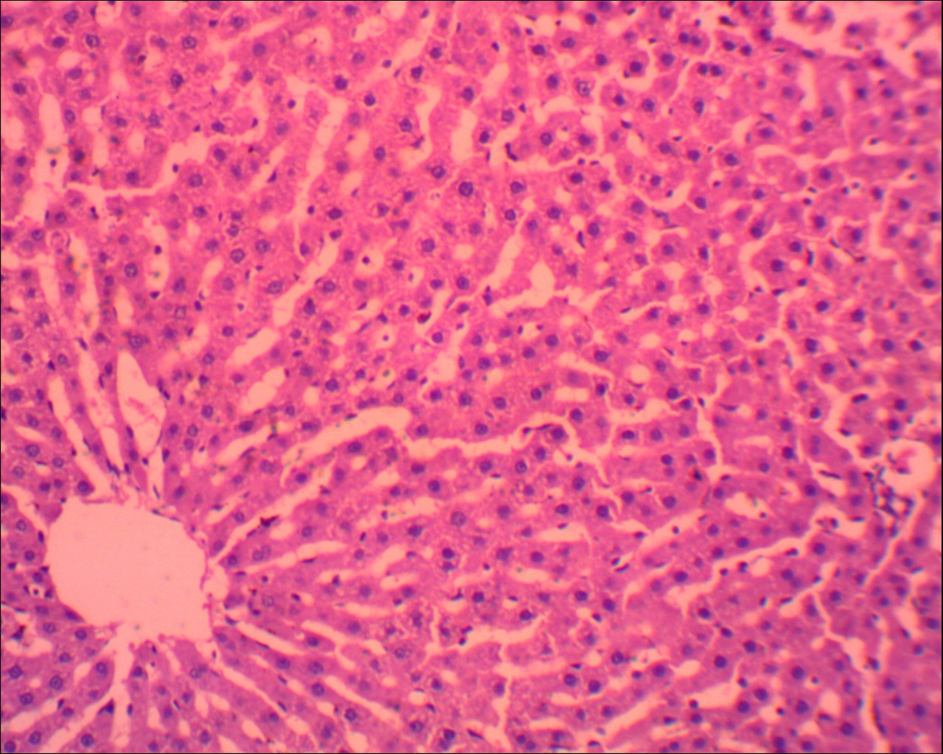**Histomorphology Observations in the Liver**

**Figure 1: GROUP A: Control rat liver composed of hepatocytes (thin white arrow) and sinusoids (thin black arrow) and central vein (thick black arrow). (H&E x 400)**

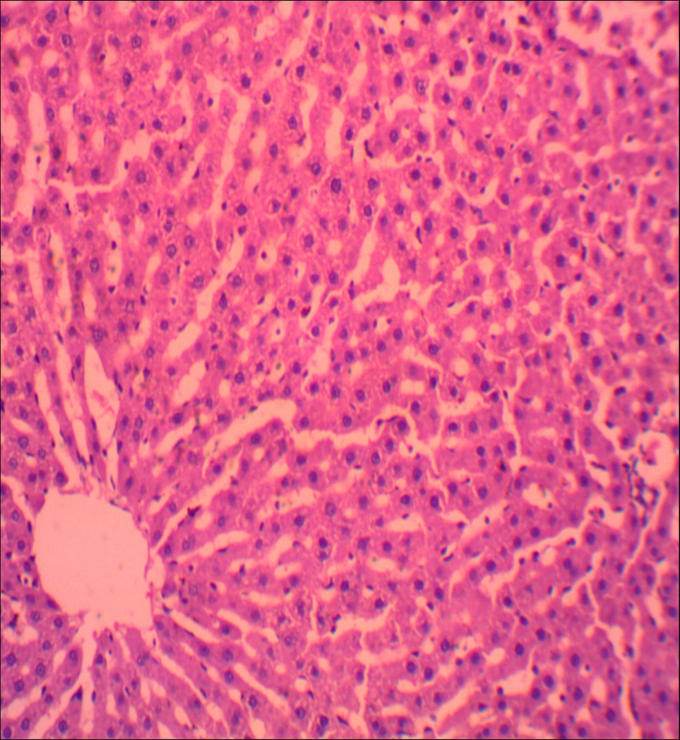

**Figure 2: Group B: Control rat liver composed of hepatocytes (thin white arrow) and sinusoids (thin black arrow) and central vein (thick black arrow). (H&E x 400)**

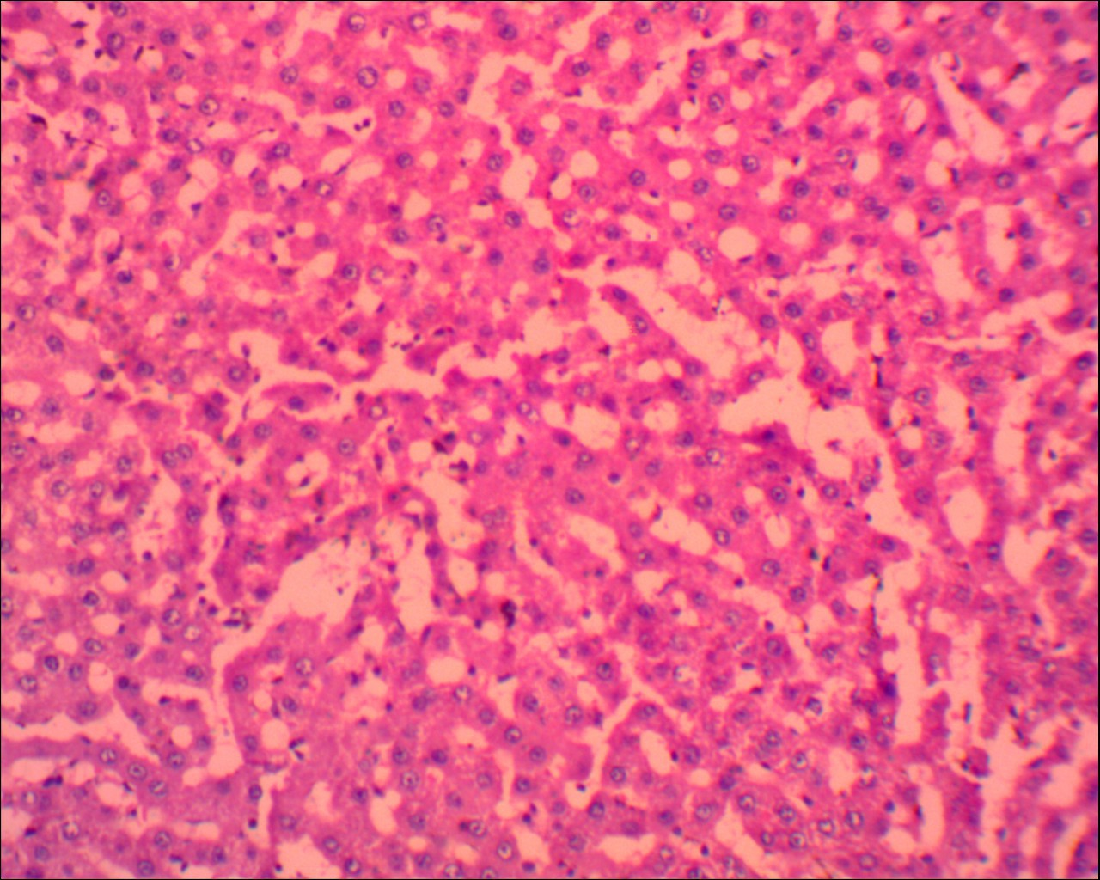

**Figure 3: GROUP C: Rat liver treated with Marijuana (*Cannabis* *sativa*) showing normal hepatocytes (black arrow) and sinusoids (white arrow) (H&E x400)**

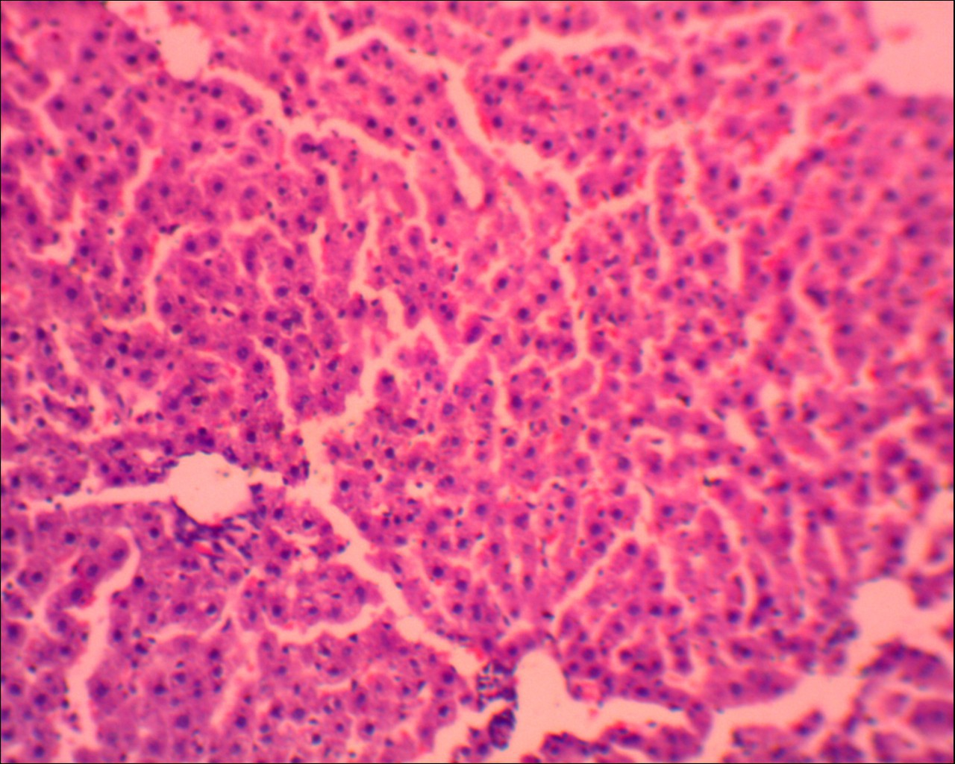

**Figure 4: GROUP D: Rat liver treated with Marijuana (*Cannabis* *sativa*) showing mild tissue sinusoidal congestion (black arrow) and basophilic hepatocytes (white arrow) (H&E, X400)**

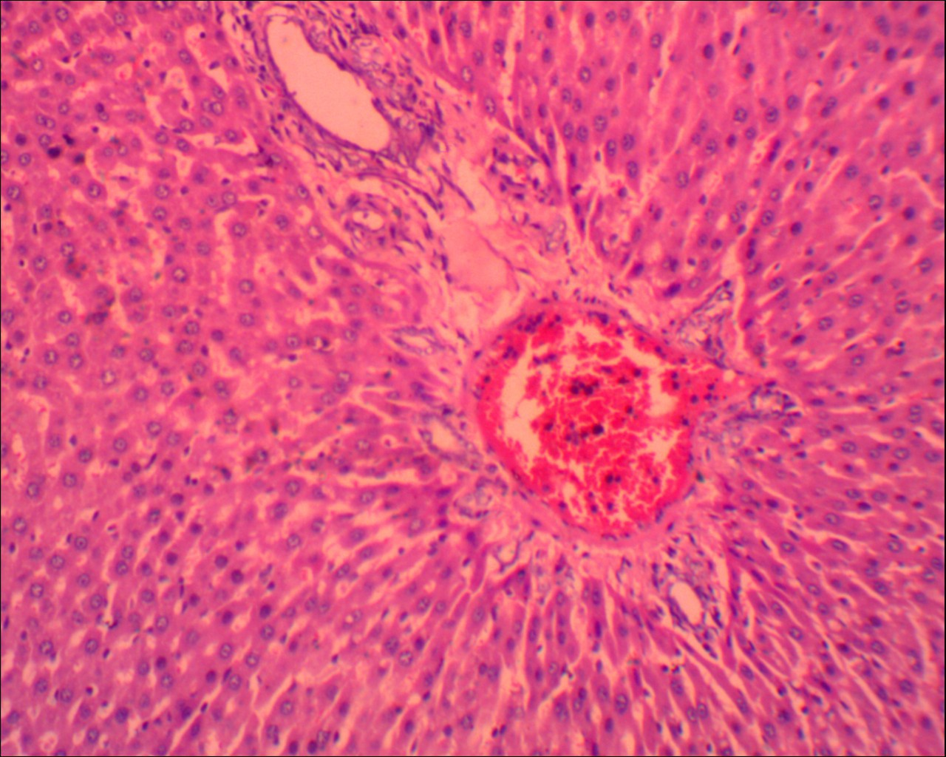

**Figure 5: GROUP E: Rat liver treated with Marijuana (*Cannabis* *sativa*) showing moderate portal congestion (black arrow) and basophilic hepatocytes (white arrow) (H&E, X400).**

**Discussion**

The effects of cannabis on the body's organs are the subject of numerous scientific discussions. The purpose of this study was to evaluate how marijuana (*Cannabis sativa*) affected the weight and liver of wistar rats. When compared to control rats, the results of this study indicated that wistar rats treated with marijuana (*Cannabis sativa*) had higher body weights (Table 1). This was consistent with the findings of Richard *et al*. (2020) and Goodpaster (2025), who found that rats fed marijuana (*Cannabis sativa*) gained weight in their respective investigations. Since marijuana (*Cannabis sativa*) and its various chemical constituents (cannabinoids) as well as substances generated internally that activate cannabinoid receptors (endocannabinoids) seem to have particular effects on the regulation of feeding behavior, the increase in body weight has been ascribed to these factors (Goodpaster, 2025). According to Dörnyei *et al*. (2023), endocannabinoids have a wide range of ubiquitous modifying activities, including the regulation of body weight, and are significant biomediators and metabolic regulators in mammalian physiology. DiPatrizio (2021) also noted that activation of the mammalian cannabinoid system's CB1 receptors specifically enhances food craving and enjoyment and encourages the storage of energy as fat in adipose tissues, which may be the cause of the weight gain seen in this study.

Comparing the liver sections from animals in groups C, D, and E to those from animals in groups A and B reveals clearly different histological patterns. Among the histological abnormalities observed in the liver sections of animals treated with cannabis are distortion with inflammatory cells, mild sinusoidal congestion, moderate portal congestion, and basophilic hepatocytes. This was in line with the findings of Ejime *et al*. (2022) and El Ghachi *et al*. (2025). Ejime *et al*. (2022) noted degeneration and disruption of the hepatocytes and cells lining the bile ducts with central portal vein occlusions in cannabis-treated animals, while El Ghachi *et al*. (2025) reported that the livers of animals treated with cannabis showed significant histological damage with increased infiltration of inflammatory cells in pericentral areas, necrotic cells, pyknotic nuclei, marginated chromatin in some nuclei and giant cells, cytoplasmic vacuolation, and fatty changes of hepatocytes with sinusoidal dilatation and congestion. The liver's physiological and biochemical functions will probably be compromised in conjunction with these histological anomalies. It is well recognized that hepatocytes are crucial to liver function. One of the primary sources of energy for the body's use, they usually contain glycogen and use the processes of glycolysis, glycogenesis, and gluconeogenesis to keep blood glucose levels stable (Gartner, 2020; Lowe *et al*., 2023). The liver may not operate properly as a result of the microanatomical deterioration in the hepatocytes' integrity shown in this study.

The results of this study also demonstrated that, in comparison to control rats, the body weight of the Wistar rats treated with marijuana (*Cannabis sativa*) increased significantly (p<0.05). This was consistent with research by Amaza *et al*. (2013) and Sansone and Sansone (2014), who found that rats fed marijuana gained weight in their various trials. Endocannabinoids, which are compounds produced within the body that activate cannabinoid receptors, and marijuana's several chemical components, known as cannabinoids, have been linked to the increase in body weight. These substances appear to have unique effects on the control of feeding behavior. Endocannabinoids are key mediators and metabolic regulators in mammalian physiology, according to Vemuri *et al*. (2008) and Hasan (2023). They have a wide range of modifying effects, including controlling body weight. According to Kirkham (2008), activation of the mammalian cannabinoid system's CB1 receptors specifically enhances food craving and enjoyment and encourages the storage of energy as fat in adipose tissues, which could be the cause of the weight gain seen in this study.

**Conclusion**

Smoking marijuana (*Cannabis sativa*) has detrimental and frequently fatal impacts on human health. The results of this study demonstrate that wistar rats' liver cytoarchitecture is negatively impacted when exposed to marijuana smoke extract (*Cannabis sativa*). Consequently, this suggests that *Cannabis sativa* and its components may be hepatotoxic. Given these effects on the histological integrity of the organ under study in these rats, we advise that everyone, especially our young people who have developed a cannabis addiction, be made aware of the risks associated with cannabis use. We also advise against the indiscriminate cultivation and use of cannabis due to the detrimental effects it had on the organs under study in the treated animals in this study. Additionally, more research should be conducted to ascertain the mechanism of the histological change caused by marijuana (*Cannabis sativa*) on this essential organ.

**Conflict of Interest**

The authors declare no conflicts of interest. The authors alone are responsible for the content and the writing of the paper.

**Ethical Approval**

Ethical permission for the use of marijuana and wistar rats for this study was obtained from the Research and Ethics Committee of Ambrose Alli University, Ekpoma. The study was conducted according to the protocol approval of the ethical review committees.

Disclaimer (Artificial intelligence)

Option 1: Author(s) hereby declare that NO generative AI technologies such as Large Language Models (ChatGPT, COPILOT, etc.) and text-to-image generators have been used during the writing or editing of this manuscript.

**Reference**

Adams, Z. W., Marriott, B. R., Hulvershorn, L. A., & Hinckley, J. (2022). Treatment of adolescent cannabis use disorders. *Child and adolescent psychiatric clinics of North America*, *32*(1), 141.

Ahmed, S. T., Alam, A., Hassan, A., Kamal, S., & Mahmood, M. (2022). Acute Liver Failure Caused by Synthetic Marijuana Use. *American Journal of Therapeutics*, *29*(6), e769-e771.

Akintaro O. A. (2015): The Menace of Tobacco Smoking among Nigerian Adolescents. *Developing Country Studies*. 5(15): 11-15

Amaza DS, Maidugu FA, Zirahei JV, Numan AI, Mari H. The effect of *Cannabis sativa* leaves aqueous extract on the cerebral cortex in albino rats. *J Dent Med Sci.* 2013;6(2):53-58.

Barré, T., Nishimwe, M. L., Protopopescu, C., Marcellin, F., Carrat, F., Dorival, C., ... & ANRS/AFEF Hepather study group. (2020). Cannabis use is associated with a lower risk of diabetes in chronic hepatitis C‐infected patients (ANRS CO22 Hepather cohort). *Journal of Viral Hepatitis*, *27*(12), 1473-1483.

Castera, L., & Cusi, K. (2023). Diabetes and cirrhosis: current concepts on diagnosis and management. *Hepatology*, *77*(6), 2128-2146.

Černe, K. (2020). Toxicological properties of Δ9-tetrahydrocannabinol and cannabidiol. *Archives of Industrial Hygiene and Toxicology*, *71*(1), 1.

Coman, L. I., Coman, O. A., Bădărău, I. A., Păunescu, H., & Ciocîrlan, M. (2021). Association between liver cirrhosis and diabetes mellitus: a review on hepatic outcomes. *Journal of clinical medicine*, *10*(2), 262.

Connor, J. P., Stjepanović, D., Le Foll, B., Hoch, E., Budney, A. J., & Hall, W. D. (2021). Cannabis use and cannabis use disorder. *Nature Reviews Disease Primers*, *7*(1), 16.

Cooke, M. E., Gilman, J. M., Lamberth, E., Rychik, N., Tervo-Clemmens, B., Evins, A. E., & Schuster, R. M. (2021). Assessing changes in symptoms of depression and anxiety during four weeks of cannabis abstinence among adolescents. *Frontiers in psychiatry*, *12*, 689957.

DiPatrizio, N. V. (2021). Endocannabinoids and the gut-brain control of food intake and obesity. *Nutrients*, *13*(4), 1214.

Dörnyei, G., Vass, Z., Juhász, C. B., Nádasy, G. L., Hunyady, L., & Szekeres, M. (2023). Role of the endocannabinoid system in metabolic control processes and in the pathogenesis of metabolic syndrome: an update. *Biomedicines*, *11*(2), 306.

Dubey, R. K., Shukla, S., Hussain, Z., & Tasin, M. (2023). A Systematic Review of the Pharmacological and Phytochemical Profiles of Madagascar periwinkle as Potential Dietary Supplement. *Chinese Journal of Applied Physiology*, e20230002.

Ejime, A. C., Chukwuebuka, N. B., Azuka, E. P., Ejiro, O. P., Michael, A. E., Elias, D. T. M., ... & Ebuwa, E. I. (2022). Sperm Quality and Testicular Histological Changes in Wistar rats treated with Cannabis sativa Ethanolic Extract. *NeuroQuantology*, *20*(15), 5228-5236.

El Ghachi, H., Oukhrib, M., Aziz, F., Benrazzouk, K., Gamrani, H., Soulimani, R., & Boukhzar, L. (2025). Exploring the Phytochemical and Toxicological Profile of Moroccan Cannabis Sativa L. Leaves Extract: Behavioral, Histological, and Oxidative Stress Assessments. *Journal of Ethnopharmacology*, 120058.

Freeman, D., Dunn, G., Murray, R.M., Evans, N., Lister, R. and Antley, A. (2015): How Cannabis Causes Paranoia: Using the Intravenous Administration of 9-Tetrahydrocannabinol (THC) to Identify Key Cognitive Mechanisms Leading to Paranoia. *Schizophrenia bulletin*. 41: 391–399.

Gartner, L. P. (2020). *Textbook of histology e-book: Textbook of histology e-book*. Elsevier Health Sciences.

Goodpaster, K. P. (2025). Cannabis, Weight, and Weight-Related Behaviors. *Current Obesity Reports*, *14*(1), 1-9.

Haktanır, A. E., Atalay, F. Ö., Ayyıldız, T., Balaban, S., & Dolar, M. E. (2025). Hepatic Expression of Endocannabinoid Receptors (CB1 and CB2) in Patients with Non-Alcoholic Steatohepatitis and Its Relationship with Metabolic Syndrome. *Uludağ Üniversitesi Tıp Fakültesi Dergisi*, *50*(3), 381-389.

Hammond, C. J., Shirk, S. D., Foster, D. W., Potenza, N. B., Kraus, S. W., Mayes, L. C., ... & Potenza, M. N. (2020). Cannabis use, problem-gambling severity, and psychiatric disorders: Data from the National Epidemiological Survey on Alcohol and Related Conditions. *Psychology of Addictive Behaviors*, *34*(1), 230.

Hasan KM. (2023). *Cannabis Unveiled: An Exploration of Marijuana’s History, Active Compounds, Effects, Benefits, and Risks on Human Health.* *Subst Abuse.* ;17:11782218231182553.

Imran, S., Beenish, H., Anjum, K., & Zaid, H. (2023). A Comparative Histological Study of Effects of Cigarette and Shisha Smoke on Lungs of Mice. *Pakistan Journal of Medical & Health Sciences*, *17*(06), 137-137.

Kirkham T. (2008). Endocannabinoids and the neurochemistry of gluttony. *J Neuroendocrinol.* 20(9):1099-1100.

Kroon, E., Kuhns, L., & Cousijn, J. (2021). The short-term and long-term effects of cannabis on cognition: recent advances in the field. *Current Opinion in Psychology*, *38*, 49-55.

Le, A., Han, B. H., & Palamar, J. J. (2022). Underreporting of past-year cannabis use on a national survey by people who smoke blunts. *Substance abuse*, *43*(1), 349-355.

Longoria, V., Parcel, H., Toma, B., Minhas, A., & Zeine, R. (2022). Neurological benefits, clinical challenges, and neuropathologic promise of medical marijuana: A systematic review of cannabinoid effects in multiple sclerosis and experimental models of demyelination. *Biomedicines*, *10*(3), 539.

Lowe, J. S., Anderson, P. G., & Anderson, S. I. (2023). *Stevens & Lowe's Human Histology-E-Book: Stevens & Lowe's Human Histology-E-Book*. Elsevier Health Sciences.

Massányi, P., Massányi, M., Madeddu, R., Stawarz, R., & Lukáč, N. (2020). Effects of cadmium, lead, and mercury on the structure and function of reproductive organs. *Toxics*, *8*(4), 94.

Millea, T. P. (2020). Smoke and Mirrors: The Recreational Marijuana Debate. *The Linacre Quarterly*, *87*(3), 254-258.

Nwonuma, C. O., Osemwegie, O. O., Irokanulo, E. O., Alejolowo, O. O., Kayode, O. T., Olaolu, T. D., ... & Ojo, O. A. (2021). Comparative effects of combined use of alcohol with cannabis and tobacco on testicular function in rats. *Toxicology research*, *10*(4), 761-770.

Okobi O.E., Iyevhobu K.O., Nwanguma A.N., Akinsola Z., Onyechi N.P., Ajibowo A.O., Odedina J. (2022). Effects of Marijuana on Weight Changes, Physical Observation and Histology on the Kidney of Wistar Rats. *International Journal of Healthcare and Medical Sciences, 8*(4), 49-56.

Richard, Z., Sunday, A. S., Umana, U. E., Sadeeq, A. A., & Adamu, P. P. (2020). Effect of n-butanol extract of Cannabis sativa L. extract on the cerebral cortex of adult Wistar rats. *African Journal of Cellular Pathology*, *12*(2), 6-15.

Sansone RA, Sansone LA. (2014). Marijuana and body weight. *Innov Clin Neurosci.* ;11(7-8):50-54.

Schlag, A. K., Hindocha, C., Zafar, R., Nutt, D. J., & Curran, H. V. (2021). Cannabis based medicines and cannabis dependence: A critical review of issues and evidence. *Journal of Psychopharmacology*, *35*(7), 773-785.

Śmiarowska, M., Białecka, M., & Machoy-Mokrzyńska, A. (2022). Cannabis and cannabinoids: Pharmacology and therapeutic potential. *Neurologia i neurochirurgia polska*, *56*(1), 4-13.

Stella, B., Baratta, F., Della Pepa, C., Arpicco, S., Gastaldi, D., & Dosio, F. (2021). Cannabinoid formulations and delivery systems: current and future options to treat pain. *Drugs*, *81*, 1513-1557.

Taiwo, O. A., Dosumu, O. A., Ugbaja, R. N., Rotimi, S. O., Owolabi, O. P., & Ojo, O. A. (2021). Oral administration of marijuana produces alterations in serotonin 5-hydroxytryptamine receptor 3A gene (HTR3A) and electrolyte imbalances in brain of male Wistar rats. *Molecular Biology Research Communications*, *10*(1), 5.

Vemuri VK, Janero DR, Makriyannis A. (2008). Pharmacotherapeutic targeting of the endocannabinoid signaling system: drugs for obesity and the metabolic syndrome. *Physiol Behav.* ;93(0):671-686.

Wolfe, D., Corace, K., Rice, D., Smith, A., Kanji, S., Conn, D., ... & Hutton, B. (2020). Effects of medical and non-medical cannabis use in older adults: protocol for a scoping review. *BMJ Open*, *10*(2), e034301.

Xiong, P. S., Xiong, M. J., Liu, Z. X., & Liu, Y. (2020). Prevalence of smoking among adolescents in China: an updated systematic review and meta-analysis. *Public health*, *182*, 26-31.