THE RISE OF INGESTIBLE SENSORS: TRANSFORMING THE FUTURE OF HEALTHCARE

ABSTRACT
The healthcare industry is constantly evolving with new innovations and technologies being introduced every day. One such technology that is gaining popularity and attention is smart pills. A smart pill is a complex product with several components working together to monitor the oral administration of a drug. Digital pills can significantly improve disease diagnoses, enable real-time monitoring, improve targeted drug delivery, and promote patient compliance. The healthcare sector is undergoing a transformation with the advent of ingestible sensors, which offer promising opportunities to advance gastroenterology research. These ingestible sensors can travel through the gastrointestinal tract and aid in the diagnosis of various diseases. The global market for digital pills and ingestible sensors is experiencing significant growth, driven by the increasing prevalence of chronic diseases, the need for remote health monitoring, and advancements in technology, with projections reaching USD 3.29 billion by 2033. So, smart pills are expected to become increasingly prevalent in the future, with ongoing research and development focused on improving their accuracy, safety, and accessibility. This breakthrough opens the door to personalised and preventative treatment by offering vital information into gastrointestinal health, medication adherence, and disease diagnosis.This Review presents a comprehensive overview of the current and emerging smart pills.

KEYWORDS: smart pills, new innovations,technology, ingestible sensors, global market, healthcare

INTRODUCTION
In the modern world, the advancement of digital health instruments is closely linked to the advancement of the healthcare system.Digital technologies are linked to the future of global health, according to the WHO global strategy. The advent of digitalization was intended to support global security, promote health, and offer services to the most vulnerable segments of society [1,2]. In order to interpret gastrointestinal tract physiology in both health and disease, it is crucial to comprehend the anatomy and function of the gastrointestinal tract.[3,4] Therefore, ingestible sensors are crucial to digital health solutions.Pharmacotherapy monitoring may benefit from the use of indigestible sensors. Software found on tablets and smartphones can be used to operate these ingestible sensors. Medication can be given to the patient once the severity of the illness has been monitored.As a result, it can reduce patient complaints [5,6]. In the areas of mental health and behavioral changes, including schizophrenia, bipolar I disorder, attention deficit and hyperactivity disorder, drug misuse, smoking, pain, sleeplessness, and many more, digital tablets increase therapy adherence and effectiveness. Additionally, scientists are working to create edible medicines to treat a number of illnesses, including diabetes, hepatitis C, AIDS, cancer, tuberculosis, and heart problems. Additionally, it can be used to track the use of opioid medications by patients following surgery and in other situations where the patient's behavior may make admittance difficult (geriatrics, neurological illnesses, etc.) [7,8,9].
Digital sensors that resemble pills and carry out sensing tasks inside the human body are known as ingestion sensors. Smart pills are ingestible capsules with mechanical or electronic components that pass through the gastrointestinal (GI) tract for a variety of uses, such as surgery, sampling, diagnosis, or treatment.[10,11] The ability of smart tablets to monitor stomach pH was first reported in 1965.[12] Research on the drug absorption of smart pills on the gastrointestinal tract was published in 1982 [13]. Later, in 2000, the capsule endoscope (CE) was created. [14] There have been numerous reports of ingestible sensors being used in recent years. [15] The US Food and Drug Administration (US FDA) authorized the first digital pill in November 2017: Aripirazole (Abilify MyCite), produced by Otsuka Pharmaceutical. Doctors can use it to keep an eye on patients with mental illnesses as they take their medications.[16]By 2033, the worldwide market for ingestible sensors and digital pills is projected to reach USD 3.29 billion. [17]These capsules can serve as a platform to advance our knowledge of gastrointestinal pathophysiology, offer novel gastrointestinal and systemic therapeutic delivery methods, and minimally invasively gather tissue and other samples for further examination. [18,19]As a result, it might offer greater patient compliance than the traditional therapy approach.

ADVANTAGES^{[20]}
- It is safe to ingest on repeat occasion.
- It is easy to administered.
- It can be used to precisely diagnose digestive disorders.
- After administration patient can do his/her daily activities. It does not required for bowel preparation or sedation.
- It may reduce the carbon foot print.
DISADVANTAGES^{[21]}
- It is expensive for manufacturing.
- It can experience regulatory hurdles as the process is complex.
- It may be obstructed by Bowel.
- It may raises ethical concern regarding data privacy and security.
Table 1: HISTORY
YEAR | SENSOR NAME | PURPOSE
1957 | Swallowable Electronic Capsule | A swallowable electronic capsule that uses radiofrequency (RF) transmission to measure interior temperature and pressure was initially described by Jacobson and Mackay [22,23].
1968 | Ingestible Telemetric Temperature Pill | First reported were devices specifically designed to measure core body temperature [24,25].
2017 | Abilify MyCite | The first indigestible medication authorized by the US FDA, Abilify MyCite, is used to treat depression in adults, schizophrenia, and manic and mixed episodes linked to bipolar I illness [26,27].
2020 | Proteus Digital Health's | A study was conducted to improve adherence to HIV therapy using an ingestible sensor device, which consists of a wearable patch and a sensor tablet [28,29].
2023 | Ingestible vitals-monitoring pill | To improve adherence to HIV therapy, a study used an ingestible sensor device that consists of a wearable patch and a sensor tablet [30,31].
2024 | Ingestible sensor platform utilizing gastric acid battery | An ingestible sensor device with the ability to assess core body temperature and other vital signs was proposed by a study using a gastric acid battery for everyday healthcare [32,33].
MATERIALS REQUIRED
Materials required for ingestible sensors are :
- Power supplies
- Telecommunication
- Microcontrollers and processors
- Power switches
- Cladding
- Sensors

1) Power Supplies
For ingestible devices, silver oxide batteries in coin cell shapes are frequently chosen due to their stability and safety in both basic (colon) and acidic (stomach) environments [34]. However, because lithium ion batteries have the potential to raise the pH of gastric juice and have harmful consequences, they are not advised. Additionally, because zinc air batteries do not allow oxygen to circulate through the body, they are not advised [35].
2) Telecommunication
Real-time monitoring of physiological parameters including pH, temperature, and pressure in the GI tract is made possible by these sensors' ability to record and transmit biological data.In general, communications often use commercial transmitter chips [36].It may be essential in the future for tasks including gathering tissue or luminal contents samples for investigation, delivering drugs to certain GI tract locations, and determining if patients are taking their prescriptions as directed [37].
3) Micro controllers and Processor
A microcontroller [38] is a small integrated circuit that is used in embedded systems to control a particular function. On a single chip, a typical microcontroller consists of a CPU, memory, and input/output (I/O) peripherals.It uses its I/O peripherals to send and receive data, then processes that data to carry out its assigned responsibilities. Microcontrollers can control the functions of artificial kidneys, hearts, and other organs in medical settings. Additionally, it may play a crucial role in how prosthetic devices operate [39].
- Power Switches
Before being employed, ingestible devices are typically turned on using magnetic reed switches [40, 41].

5) Cladding
The cladding acts as a barrier to shield the electronics and other parts of the sensor from the basic and acidic environment of the digestive tract.Therefore, the cladding materials need to be strong, chemical resistant, and biocompatible [42, 43].

6) Sensors
Ingestable sensors are crucial for gathering physiological information about the body, such as temperature and pH, which can be used to diagnose a number of GI tract illnesses and digestive disorders [44, 45].

MECHANISM OF ACTION
The sensor can be consumed by the patient. Later, when the sensor comes into contact with an acidic or basic environment, it gets triggered. It is activated by the electrical current that drives the sensor or by a chemical reaction.[46]
Additionally, a signal (such as a magnetic field, radiofrequency, or other type of data) is produced by the wearable ingestible sensor and sent to the wearable receiver.The signal is picked up by the wearable receiver, which then sends the information to a cloud-based server or another device for analysis (e.g., time of drug consumption, location in the digestive tract, physiological characteristics) [47,48].

SENSOR USED TO DIAGONISE SOME HUMAN ORGANS
- ORAL CAVITY
We are aware that the mouth cavity contains a variety of microorganisms, including viruses, fungus, and bacteria.[49] Therefore, oral wearing sensors can be used to identify these microorganisms. Both infections linked to oral illnesses and other physical conditions as well as helpful bacteria can be detected by these sensors [50].
Wearable sensor technology is the foundation of oral wearable sensors. It can be applied to food consumption, salivary biochemical monitoring, and dental disease monitoring. The identified information can be sent wirelessly to networks and smartphones in the area. It might be beneficial for the development of intelligent medicine and mobile healthcare in day-to-day living [51]. Examples include saliva and oral cavity examination point-of-care sensing systems.

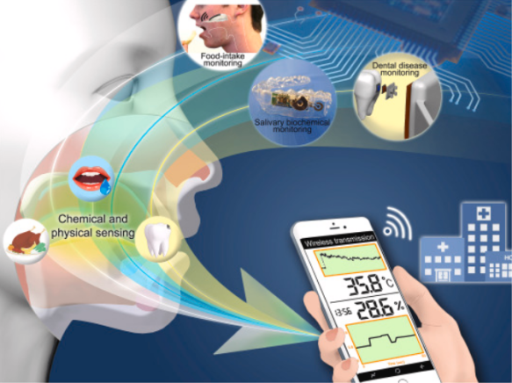 | 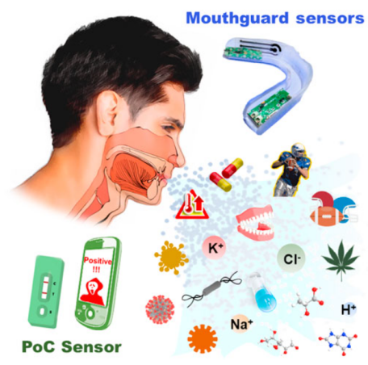
Fig 1(a): Oral wearable sensors | Fig 1(b): PoC sensors for saliva analysis

- OESOPHAGUS
Bravo Test is another name for the wireless pH esophageal test.A tiny capsule that is affixed to the esophagus during an endoscopy is used in the Bravo test. It is employed to quantify acid reflux and provide diagnoses for disorders such as GERD [52,53].A battery-free, portable, and ingestible sensor pill called NFCapsule is utilized to identify eosinophilic esophagitis. The NFCapsule reader determines the pill's resonance characteristics. It continuously checks the tablet. It transforms the data into an estimated bio-impedance after passing through the esophagus [54].

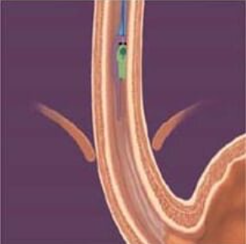 | 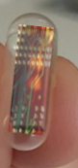
Fig 2(a) :wireless pH Esophageal Test | Fig 2(b) :NFCapsule

- STOMACH
At Ulm University, Boris Mizaikoff and his colleagues created a miniature breath sensor. It was created with Helicobacter pylori detection in mind. They have developed a breath sensor for H. pylori by utilizing mid-infrared (MIR) light. It is too little to be affixed to a mobile phone [55]. Specific human IgG antibodies against H. pylori were successfully measured quantitatively [56]. An immunosensor based on laser-induced fluorescence in the serum sample makes up this device.A luminol-based ternary electrochemiluminescence (ECL) nanosphere biosensor was created to detect H. pylori DNA [57].
The Jell-O-like pill is an edible sensor created by MIT engineers [58]. It swiftly swells to the size of a soft, squishy ping-pong ball when it reaches the stomach, where it can remain for a long time.The novel tablet is composed of two kinds of hydrogels, which are jelly-like combinations of water and polymers.
To aid in the triage of patients with suspected UGIB, a new bleeding sensor system [59] (PillSense; EnteraSense, Galway, Ireland) was created.A single-use, minimally intrusive tool for detecting gastrointestinal blood is the SOS capsule. The existence of UGIB is assessed by looking for blood in the stomach.[60]
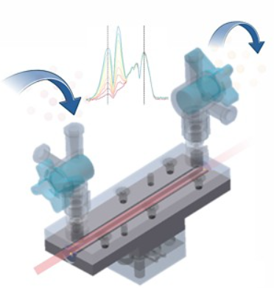 | 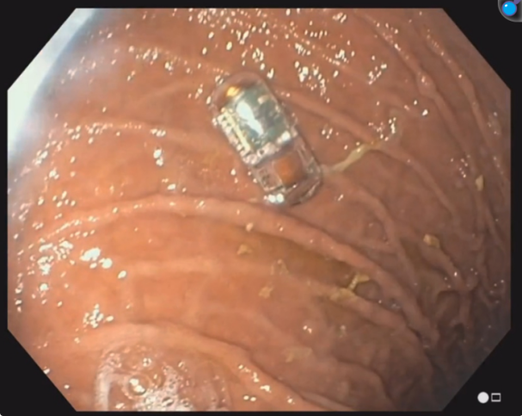
Fig 3(a): Mini breath sensor | Fig 3(b): swallowed optical sensor capsule visualized in the stomach
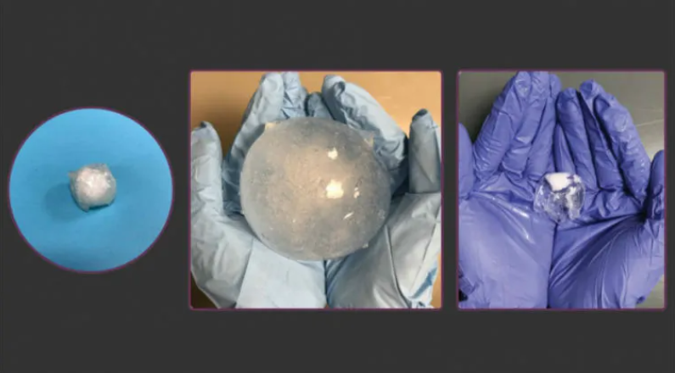
Fig 3(b): New pill to monitor stomach ulcers, cancers, or other conditions for up to a month

- SMALL INTESTINE
A cutting-edge method for inspecting the small intestine is capsule endoscopy. A jelly-bean-sized camera capsule that captures many digital images of the small intestine is given to the patient to ingest [61].Crohn's disease, other types of inflammatory bowel disease (IBD), ulcerative colitis, gastric hemorrhage, celiac disease, colon polyps, and colon and rectal cancer can all be diagnosed with PillCam [62].

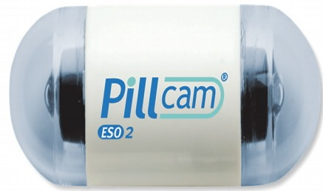
Fig 4: PillCam ESO2® (Given Imaging Ltd., Yoqneam, Israel) capsule

- LARGE INTESTINE (COLON)
Mascarenhas et al. created an AI technique based on a convolutional neural network (CNN) architecture. With an overall accuracy of 95.3%, it can automatically identify increased lesions in pictures for the purpose of screening for colon tumors [63,64].

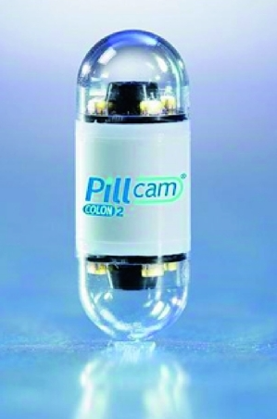
Fig 5: PillCam colon 2. Size: 31 mm × 11 mm

OTHER SENSORS

- Ingestible telemetric temperature pill
It has been determined that the gastrointestinal temperature, as determined by ingestible temperature capsules, is a reliable proxy for the core body temperature. Temperature capsule devices are simple to use in field settings, wireless, and comparatively noninvasive.
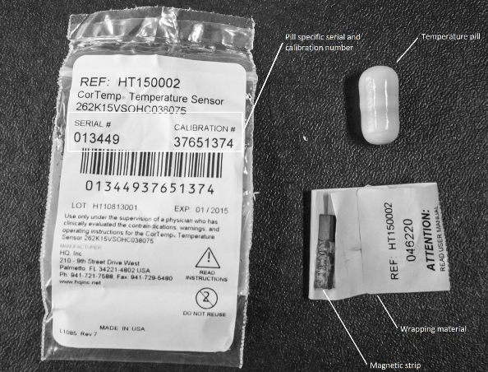 | 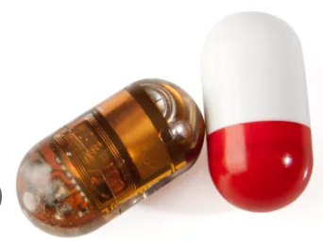
Fig 6(a): Ingestible telemetric temperature pill | Fig 6(b): Pill Measures Body Temperature

Packing material and an indigestible telemetric temperature tablet [65, 66]. The wrapping material, which displays the temperature pill's unique serial number and calibration number, is visible on the left. The magnetic stripe and the temperature pill are visible on the right. The battery is turned on in this instance since the temperature pill is not in touch with the magnetic stripe. Among the marketed goods on the market are: BodyCap e-Celsius Performance Electronic Pill, RF (Radio Frequency) measuring capsule [67]

Pressure sensors
Both healthy and gastroparetic patients' gastrointestinal tract contractile frequency is tracked using pressure sensors, which have a measurement range of 0 to 350 mm Hg [68,69]. However, because pressure sensor data is derived from both transthoracic respiratory-related movement and abdominal/body movement, it is challenging to interpret. It matters that the device's location cannot be sub-localized (antrum vs. body vs. fundus of stomach, for example). For instance, it may be helpful to be able to distinguish between fundus and antral motility when evaluating suspected gastric dysmotility [70,71].Pigs were used to test for acute abdominal compartment syndrome using an indigestible microelectromechanical system (PressureDOT, 10 mm × 13 mm) [72]. However, people can take advantage of this.

Gas sensors
In the stomach, gases are useful indicators [73].An innovative ingestible device is the Atmo gas-sensing capsule (Atmo Biosciences, Box Hill, Australia). It can measure the concentrations of carbon dioxide and hydrogen using a volatile organic compound sensor, a multi-gas detector, and thermal conductivity detectors. Additionally, it analyzes antennae efficiency, temperature, and capsule orientation [74,75].At 434 MHz, measurements are sent from the capsule to a patient-worn data receiver. From there, they are transferred to a distant server using a mobile device application, where they are analyzed and reviewed through a web portal. In healthy subjects, it has been shown to reliably assess the major gastrointestinal landmarks. A pilot research was conducted on slow transit constipation and gastroparesis. Larger experiments also confirmed its validity [76].Gas profile analysis may also make it possible to characterize other physiological processes, such as small intestinal bacterial overgrowth (SIBO) and colonic fermentation [77].A prototype capsule system for the detection of hydrogen sulfide was recently created [78].

4. Microbiological‐based sensors
Certain analytes in the lumen of the gastrointestinal system can be found using genetically modified probiotic sensor bacteria. The inner chamber of the Ingestible Micro-Bio-Electronic Device (IMBED), which contains genetically modified probiotic E. coli Nissle 1917 [79,80], is separated from the luminal space by a semi-permeable membrane.It has been used to detect heme and other biomarkers, including acyl-homoserine lactone and tetrathionate, which assesses inflammation. A biosensing panel for nitric oxide, hydrogen peroxide, thiosulfate, and tetrathionate has been developed further and is contained in a device that has been sufficiently reduced in size to be safely consumed orally [81].Recent preliminary investigations on small intestine bacterial overgrowth have described a unique sensing method that uses fluorometric signals to monitor bacterial numbers.[82]

5. pH MONITORING SYSTEM
Several gastrointestinal system components were evaluated using a pH monitoring device [83]. It covers everything from caecal fermentation in the large intestine to the distal oesophagus in the assessment of gastroesophageal reflux. One of the more recent developments that makes use of a wireless system to increase patient compliance and prolong the duration of monitoring is the Bravo pH capsule system (Bravo™, Medtronic, Shoreview, MN). Both patient acceptance and diagnostic accuracy may be enhanced by these modifications.The BRAVO® pH test determines the esophageal acidity (pH). This aids medical professionals in the diagnosis of GERD.

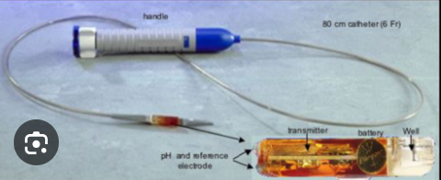
Fig 7: The Bravo pH capsule system
A pH sensor serves as the main sensor in the SmartPill® WMC monitoring system [84,85].The pH of the gastrointestinal tract can be predicted using the pH capsule method. During the shift from the stomach's acidic environment to the duodenum's bicarbonate-rich environment, there is a sudden and prolonged increase in pH (pH 5.9–6.8). Additionally, it was noted that the generation of weak acids, including short-chain fatty acids, from the fermentation of carbohydrates is caused by the sudden drop in pH from the alkaline ileum (pH ~7.3–7.7) to the acidic caecum/proximal ascending colon (pH 5.8–6.7) [86,87,88].In 2006, the FDA authorized the WMC to assess colonic transit durations and gastric emptying in cases of suspected gastroparesis and slow-transit constipation, respectively. With less proof, it has also been used to assess colonic fermentation in the colon [89,90,91]. Because of its limitations, WMC manufacture was stopped [92].Its low cost led to the development of an alternate ingestible pH-sensing capsule. [93].
Reactive oxygen species can be measured using electrochemical sensors. To aid in locating the capsule inside the digestive system, it can be used in conjunction with a pH sensor [94].In cases like inflammatory bowel disease, it has been suggested as a substitute biomarker for measuring inflammation.

MEDICATION MONITORING PILLS
Digital or smart pills, also referred to as medication monitoring sensing pills [95]. These are made with built-in sensors that monitor drug intake and compliance, sending information to patients or healthcare professionals using wearable technology or smartphone apps. For instance:The drug-device combo product Abilify MyCite (sensor-equipped aripiprazole tablets) enables digital medicine consumption tracking.Proteus Digital Health has created a drug adherence tracking system that includes wearable patches, mobile apps, and ingestion sensors.Conditions for which digital tablets may be beneficial include:mental illnesses such as major depressive disorder, bipolar disorder, and schizophrenia.chronic conditions such as cancer, HIV/AIDS, and diabetes.conditions including opioid use following surgery and TB when adherence is crucial.[96]

 | 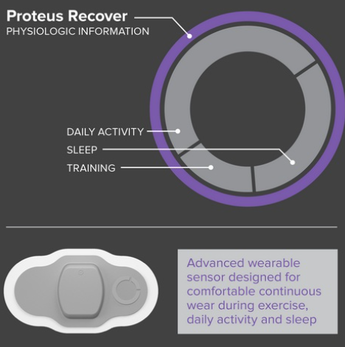
Fig 8(a) :Abilify MyCite Pills | Fig 8(b) :Ingestible sensor pill

List of key players in Ingestible Sensors Market[97]
- Otsuka Holdings Co., Ltd.
- Medtronic
- CapsoVision
- etectRx
- CapsoVision, Inc.
- H.Q., Inc.
- Proteus Digital Health
- IntroMedic
- JINSHAN Science & Technology
FUTURE CHALLENGES
The idea of swallowing a sensor with all of its electrical components is still a psychological hurdle, and ingestion-friendly sensors are still a relatively new idea. The gadget needs to be secure both when being used and when not. Additionally, it needs to adhere to ISO's criteria (ISO 10993, ISO 62304, and IEC 60601). Patient compliance and ease of use are essential. The wide geographic localization of the gastrointestinal tract is the extent of current devices. Electronic ingestible devices have substantial initial development expenses. Additionally, environmentally acceptable disposal methods should be taken into account [98,99].

CONCLUSION
The healthcare industry has undergone a change thanks to ingestion sensors. It presents intriguing opportunities to advance gastroenterological study. An indigestible sensor can enter the gastrointestinal tract and aid in the diagnosis of the illness. One of the main advantages of an indigestible tablet is that it remains stable in both basic and acidic environments. It can also be sent to a specified location. It offers patient cooperation and is simple to use. Recent advancements have enhanced patient compliance and enabled prolonged monitoring through wireless system. The field of gastroenterology can make use of this technology.[100,101]
It can be applied to customized medications. It can be applied to food consumption, salivary biochemical monitoring, and dental disease monitoring. It might help progress intelligent medicine and mobile healthcare in day-to-day living. Technological innovations like deep thinking, machine learning, artificial neural networks, and artificial intelligence could be applied in this area to benefit humanity.[102]

CONFLICTS OF INTEREST
The author declares that there are no conflicts of interest regarding the publication of this article.

COMPETING INTERESTS DISCLAIMER
Authors hereby declare that NO generative AI technologies such as Large Language Models (ChatGPT, COPILOT, etc.) and text-to-image generators have been used during the writing or editing of this manuscript.

REFERENCES
- Global Strategy on Digital Health 2020–2025. World Health Organization; Geneva, Switzerland: 2021.
- Yeung AWK, Torkamani A, Butte AJ, Glicksberg BS, et al. The promise of digital healthcare technologies. Front Public Health. 2023 ; 26(11):1196596.
- Kalantar‐zadeh K, Ha N, Ou JZ, Berean KJ. Ingestible sensors. ACS Sens. 2017;2(4): 468-483.
- Liao DH, Zhao JB, Gregersen H. Gastrointestinal tract modelling in health and disease. World J Gastroenterol. 2009 Jan 14;15(2):169-76.
- Manjula T. , Nirosha C. , Nandhini D. , Kokila M. , Revathi V., An Comprehensive Review Of Ingestible Sensor, Int. J. of Pharm. Sci., 2024;2(8): 3224-3229.
- Litvinova O, Klager E, Tzvetkov NT, Kimberger O, et al. Digital Pills with Ingestible Sensors: Patent Landscape Analysis. Pharmaceuticals (Basel). 2022 Aug 19;15(8):1025.
- Yang SY, Sencadas V, You SS, Jia NZ, Srinivasan SS, Huang HW, Ahmed AE, Liang JY, Traverso G. Powering Implantable and Ingestible Electronics. Adv Funct Mater. 2021; 26;31(44):2009289.
- Knights J., Heidary Z., Cochran J.M. Detection of Behavioral Anomalies in Medication Adherence Patterns Among Patients With Serious Mental Illness Engaged With a Digital Medicine System. JMIR Ment. Health. 2020;7:e21378.
- Chai P.R., Carreiro S., Innes B.J., Rosen R.K., O’Cleirigh C., Mayer K.H., Boyer E.W. Digital Pills to Measure Opioid Ingestion Patterns in Emergency Department Patients With Acute Fracture Pain: A Pilot Study. J. Med. Internet Res. 2017;19:e19.
- Chai P.R., Vaz C., Goodman G.R., Albrechta H., Huang H., Rosen R.K., Boyer E.W., Mayer K.H., O’Cleirigh C. Ingestible electronic sensors to measure instantaneous medication adherence: A narrative review. Digit. Health.2022;8:205520762210831.
- Sideri K, Cockbain J, Van Biesen W, De Hert M, Decruyenaere J, Sterckx S. Digital pills for the remote monitoring of medication intake: a stakeholder analysis and assessment of marketing approval and patent granting policies. J Law Biosci. 2022; 18;9(2):lsac029.
- Miley, D. et al. Video capsule endoscopy and ingestible electronics: emerging trends in sensors, circuits, materials, telemetry, optics, and rapid reading software. Adv. Devices Instrum. 2021, 9854040 (2021).
- Kalantar-Zadeh, K., Ha, N., Ou, J. Z. & Berean, K. J. Ingestible sensors. ACS Sensors 2, 468–483 (2017).
- Beardslee, L. A. et al. Ingestible sensors and sensing systems for minimally invasive diagnosis and monitoring: the next frontier in minimally invasive screening. ACS Sensors 5, 891–910 (2020).
- Cummins G , 'Smart pills for gastrointestinal diagnostics and therapy', Advanced Drug Delivery Reviews, 2021;l(177): 113931.
- Browning, K. N. & Travagli, R. A. Central nervous system control of gastrointestinal motility and secretion and modulation of gastrointestinal functions. Compr. Physiol.2014; 4:1339.
- Vallejos X, Wu C. Digital Medicine: Innovative Drug-Device Combination as New Measure of Medication Adherence. J Pharm Technol. 2017 ;33(4):137-139.
- Mandsberg, N. K., Christfort, J. F., Kamguyan, K., Boisen, A., & Srivastava, S. K. Orally ingestible medical devices for gut engineering. Advanced Drug Delivery Reviews, 2020;165-166, 142-154.
- G. Cummins,Smart pills for gastrointestinal diagnostics and therapy, Advanced Drug Delivery Reviews,Volume 177,2021,113931.
- Steiger C, Abramson A, Nadeau P, Chandrakasan A P, Langer R and Traverso G Ingestible electronics for diagnostics and therapy Nat. Rev. Mater. 2019;4:83–98.
- Kalantar‐zadeh K, Ha N, Ou JZ, Berean KJ. Ingestible sensors. ACS Sens. 2017;2(4):468–483.
- Hafezi H,Robertson TL, Moon GD,Au-Yeung KY,Zdedlick MJ,Savage GM. An ingestible sensor for measuring medication adherence. IEEE Trans biomed Eng.Jan 2015.
- Pan G, Wang L. Swallowable wireless capsule endoscopy: progress and technical challenges. Gastroenterol Res Pract. 2012;2012:841691.
- Ulkuhan Guler, Devdip Sen, Ian M. Costanzo, Tuna B. Tufan, Lawrance Rhein,Sensors for Neonatal Monitoring,Editor(s): Roger Narayan,Encyclopedia of Sensors and Biosensors (1st ed.),Elsevier,2023: 423-448.
- Yuce, Mehmet & Dissanayake, Tharaka. Easy-to-Swallow Wireless Telemetry. Microwave Magazine, IEEE. 2012;13:90-101.
- Salma Abdelmoteleb, Jayant Totlani, Salma Ramadan and Mohamed Salem, et al., Schizophrenia management: Systematic review of current medications and Phase 3 agents (2008–2024),Neuroscience Applied, 2025;4:105507.
- Caliendo Tina and Hilas Olga.The Promise and Pitfalls of Digital Medication.US Pharm. 2019;44(7):22-24.
- Goodman GR, Vaz C, Albrechta H, Boyer EW, Mayer KH, O'Cleirigh C, Chai PR. Ingestible Electronic Sensors for Monitoring Real-time Adherence to HIV Pre exposure Prophylaxis and Antiretroviral Therapy. Curr HIV/AIDS Rep. 2022;19(5):433-445.
- Brothers J, Hosek S, Keckler K, et al. The ATEAM study: Advances in technology to enhance PrEP adherence monitoring (ATEAM) among young men who have sex with men. Clin Transl Sci. 2022;15:2947-2957.
- Giovanni Traverso, Victor Finomore, James Mahoney, Justin Kupec, et al.First-in-human trial of an ingestible vitals-monitoring pill,Device,2023;1(5):100125.
- Kartik Kumar, Michael R Loebinger, Saira Ghafur. The role of wirelessly observed therapy in improving treatment adherence, Future Healthcare Journal, 2022,9(2) : 179-182.
- Cao, Q., Deng, R., Pan, Y. et al. Robotic wireless capsule endoscopy: recent advances and upcoming technologies. Nat Commun (2024);15:4597 .
- Yoshida Shinya, Miyaguchi Hiroshi and Nakamura Tsutomu. Development of Ingestible Thermometer with Built-in Coil Antenna Charged by Gastric Acid Battery and Demonstration of Long-Time in vivo Telemetry.2021;9:102368-102377.
- Yang SY, Sencadas V, You SS, Jia NZ, Srinivasan SS, Huang HW, Ahmed AE, Liang JY, Traverso G. Powering Implantable and Ingestible Electronics. Adv Funct Mater. 2021; 26:31(44):2009289.
- Ramy Ghanim, Anika Kaushik, Jihoon Park, Alex Abramson,Communication protocols integrating wearables, ingestibles, and implantables for closed-loop therapies, Device,2023; 1(3)100092.
- Xu, Z., Hao, Y., Luo, A. et al. Technologies and applications in wireless biosensors for real-time health monitoring. Med-X 2, 24 (2024).
- Lino-Ramirez Carlos, Zamudio-Rodriguez V. Manuel, Ochoa-López Verónica del Rocio, Muñoz-López Gerardo,Chapter 14 - Wireless Sensor Networks Applications for Monitoring Environmental Variables Using Evolutionary Algorithms,
- Editor(s): Miguel Wister, Pablo Pancardo, Francisco Acosta, José Adán Hernández,In Intelligent Data-Centric Systems,Intelligent Data Sensing and Processing for Health and Well-Being Applications,Academic Press,2018;257-281.
- Paul Regtien, Edwin Dertien,1 - Introduction,Editor(s): Paul Regtien, Edwin Dertien,Sensors for Mechatronics (Second Edition),Elsevier,2018;1-22.
- Jean-Philippe Vasseur, Adam Dunkels,Chapter 11 - Smart Object Hardware and Software,Editor(s): Jean-Philippe Vasseur, Adam Dunkels,Interconnecting Smart Objects with IP,Morgan Kaufmann,2010; 119-145.
- Hosseini, Ensieh S.,Dervin, Saoirse,Ganguly Priyanka,Dahiya, Ravinder. Biodegradable Materials for Sustainable Health Monitoring Devices.American Chemical Society. 2021;4(1):163-194.
- Day, S., Dry Reed Relays and Mercury Wetted Relays, in The Engineers’ Relay Handbook, (6th Ed., 17.1 – 17.20), Electronic Components & Materials Assoc., Arlington VA, 2006.
- Verdiana Marchianò, Angelo Tricase, Alessandra Cimino and Blanca Cassano, et al.Inside out: Exploring edible biocatalytic biosensors for health monitoring, Bioelectrochemistry, 2025;161:108830.
- Kabir, S.F., Sikdar, P.P., Haque, B. et al. Cellulose-based hydrogel materials: chemistry, properties and their prospective applications. Prog Biomater 2018;7: 153–174.
- De la Paz E, Maganti NH, Trifonov A, Jeerapan I, Mahato K, Yin L, Sonsa-Ard T, Ma N, Jung W, Burns R, Zarrinpar A, Wang J, Mercier PP. A self-powered ingestible wireless biosensing system for real-time in situ monitoring of gastrointestinal tract metabolites. Nat Commun. 2022 ;13(1):7405.
- Shajari S, Kuruvinashetti K, Komeili A, Sundararaj U. The Emergence of AI-Based Wearable Sensors for Digital Health Technology: A Review. Sensors (Basel). 2023;23(23):9498.
- Kourosh Kalantar-zadeh, NamHa, Jian Zhen Ou, and Kyle J. Berean. “Ingestible Sensor”. ACS Sens. 2017, 2, 468−483.
- Baranwal J, Barse B, Gatto G, Broncova G, Kumar A. Electrochemical Sensors and Their Applications: A Review. Chemosensors. 2022; 10(9):363.
- Deo PN, Deshmukh R. Oral microbiome: Unveiling the fundamentals. J Oral Maxillofac Pathol. 2019;23(1):122-128.
- Yuanfang Li, Hao Tang, Ying Liu, Yancong Qiao, Hongqi Xia, Jianhua Zhou,Oral wearable sensors: Health management based on the oral cavity,Biosensors and Bioelectronics: X,Volume 10,2022, 100135, 1370.
- Chochanon Moonla, Don Hui Lee,Dinesh Rokaya and Natcha Rasitanon, et al. Review—Lab-in-a-Mouth and Advanced Point-of-Care Sensing Systems: Detecting Bioinformation from the Oral Cavity and Saliva ECS Sensors Plus, 2022 ;(1): 021603.
- Lawenko RM, Lee YY. Evaluation of Gastroesophageal Reflux Disease Using the Bravo Capsule pH System. J Neurogastroenterol Motil. 2016;22(1):25-30.
- Peter Aberg, Ingrid Nicander, Johan Hansson, Paul Geladi, Ulf Holmgren, and Stig Ollmar. 2004. Skin cancer identification using multifrequency electrical impedance-a potential screening tool. IEEE transactions on biomedical engineering 51, 122004; 2097-2102.
- Fehmi Ates, Elif Saritas Yuksel, Tina Higginbotham and James C Slaughter,. 2015. Mucosal impedance discriminates GERD from non-GERD conditions. Gastroenterology .2015;148(2): 334-343.
- Louisa Dalton. “A mini breath sensor can detect ulcer-causing bacteria”.C&en Chemicals and Engineering news, 2025, 1-2.
- Jimbo, Hikaru & Miki, Norihisa. (2008). Gastric-fluid-utilizing micro battery for micro medical devices. Sensors and Actuators B: Chemical. 134. 219-224.
- Kirti Saxena, Nidhi Chauhan, Utkarsh Jain,Advances in diagnosis of Helicobacter pylori through biosensors: Point of care devices,Analytical Biochemistry,Volume 630,2021,114325.
- Xinyue Liu, Christoph Steiger, Shaoting Lin and German Alberto Parada, et al., Ingestible hydrogel device. Nature Communications| (2019)10:493.
- Tala Mahmoud, Mohammad Alqaisieh, Karl Akiki, Kristin Lescalleet, Andrew C. Storm,A novel bedside swallowed optical sensor for detection of upper GI bleeding, VideoGIE, 2022;7(12): 423-426.
- Bajer L, Ryou M, C Thompson C, Drastich P. Novel upper gastrointestinal bleeding sensor capsule: a first human feasibility and safety trial. Clin Endosc. 2024;57(2):203-208.
- Liangpunsakul S, Chadalawada V, Rex DK, Maglinte D, Lappas J. Wireless capsule endoscopy detects small bowel ulcers in patients with normal results from state of the art enteroclysis. Am J Gastroenterol. 2003 Jun;98(6):1295-8.
- Adler SN, Metzger YC. PillCam COLON capsule endoscopy: recent advances and new insights. Therap Adv Gastroenterol. 2011 Jul;4(4):265-8.
- Joana Mota,Maria João Almeida, Francisco Mendes and Miguel Martins et al.”A Comprehensive Review of Artificial Intelligence and Colon Capsule Endoscopy: Opportunities and Challenges” Diagnostics 2024;14(18):2072.
- Mascarenhas M, Afonso J, Ribeiro T, Cardoso H, Andrade P, Ferreira JPS, Saraiva MM, Macedo G. Performance of a Deep Learning System for Automatic Diagnosis of Protruding Lesions in Colon Capsule Endoscopy. Diagnostics (Basel). 2022; 12,12(6):1445.
- Bongers CC, Hopman MT, Eijsvogels TM. Using an Ingestible Telemetric Temperature Pill to Assess Gastrointestinal Temperature During Exercise. J Vis Exp. 2015; 7(104): 53258.
- Thomas A. Mayer, Aaron R. Caldwell, Catherine O'Brien,Agreement of telemetric temperature capsules ingested 48 hours apart,Journal of Thermal Biology,2022;108:103271.
- Thwaites PA, Yao CK, Halmos EP,Muir JG, Burgell RE, Berean KJ, et al. Review article: Current status and future directions of ingestible electronic devices in gastroenterology. Aliment Pharmacol Ther. 2024;59:459–474.
- Hasler WL. The use of SmartPill for gastric monitoring. Expert Rev Gastroenterol Hepatol. 2014;8(6):587–600.
- Kloetzer L, Chey WD, McCallum RW, Koch KL, Wo JM, Sitrin M, et al. Motility of the antroduodenum in healthy and gastroparetics characterized by wireless motility capsule. Neurogastroenterol Motil. 2010;22(5):527–533 e117.
- 106. Liao C‐H, Cheng C‐T, Chen C‐C, Jow UM, Chen CH, Lai YL, et al. An ingestible electronics for continuous and real‐time intraabdominal pressure monitoring. J Pers Med. 2020;11(1):12.
- Kalantar‐Zadeh K, Berean KJ, Burgell RE, Muir JG, Gibson PR. Intestinal gases: influence on gut disorders and the role of dietary manipulations. Nat Rev Gastroenterol Hepatol. 2019;16(12):733–747.
- Kalantar‐Zadeh K, Berean KJ, Ha N, Chrimes AF, Xu K, Grando D, et al. A human pilot trial of ingestible electronic capsules capable of sensing different gases in the gut. Nat Electron. 2018;1(1):79–87.
- Ou JZ, Yao CK, Rotbart A, Muir JG, Gibson PR, Kalantar‐zadeh K. Human intestinal gas measurement systems: in vitro fermentation and gas capsules. Trends Biotechnol. 2015; 33(4):208–213.
- Zhou J, Berean K, Pedersen H, Thwaites PA, Gibson PR, Burgell R, et al. Ingestible gas‐sensing capsule for whole gut transit: prospective comparison with wireless pH‐motility capsule (SmartPill) in gastroparesis and chronic constipation. Gastroenterology. 2023;164(6), S–629.
- Shah A, Sahu S, Pederse H, Chrimes A, John J, Singh M, et al. Small intestinal bacterial overgrowth as assessed by an ingestible gas‐sensing device: a prospective comparison to both aspirate and breath testing. Gastroenterology. 2023;164:S55.
- Stine JM, Ruland KL, Beardslee LA, Levy JA, Abianeh H, Botasini S, et al. Miniaturized capsule system towards real‐time electrochemical detection of H2S in the gastrointestinal tract. Adv Healthc Mater. 2023:2302897.
- Mimee M, Nadeau P, Hayward A, Carim S, Flanagan S, Jerger L, et al. An ingestible bacterial‐electronic system to monitor gastrointestinal health. Science. 2018; 360 (6391):915–918.
- Thwaites PA, Yao CK, Halmos EP, Muir JG, Burgell RE, Berean KJ, Kalantar-Zadeh K, Gibson PR. Review article: Current status and future directions of ingestible electronic devices in gastroenterology. Aliment Pharmacol Ther. 2024 Feb;59(4):459-474.
- M.A. Kwiatek, J.E. Pandolfino,The Bravo™ pH capsule system,Digestive and Liver Disease,2008;40(3):156-160.
- Kuo B, McCallum RW, Koch KL, Sitrin MD, Wo JM, Chey WD, et al. Comparison of gastric emptying of a nondigestible capsule to a radio‐labelled meal in healthy and gastroparetic subjects. Aliment Pharmacol Ther. 2008;27(2):186–196.
- Mimee Mark, Nadeau Phillip, Hayward Alison and Carim Sean et al. An ingestible bacterial-electronic system to monitor gastrointestinal health. Science. 2018;360:915-918.
- Dukowicz AC, Lacy BE, Levine GM. Small intestinal bacterial overgrowth: a comprehensive review. Gastroenterol Hepatol (N Y). 2007;3(2):112-22.
- Rao SS, Kuo B, McCallum RW, Chey WD, DiBaise J, Hasler WL, et al. Investigation of colonic and whole‐gut transit with wireless motility capsule and radiopaque markers in constipation. Clin Gastroenterol Hepatol. 2009;7(5):537–544.
- Maqbool S, Parkman HP, Friedenberg FK. Wireless capsule motility: comparison of the SmartPill GI monitoring system with scintigraphy for measuring whole gut transit. Dig Dis Sci. 2009;54(10):2167–2174.
- Filipe MI. Mucins and gastrointestinal malignancy. A new approach to the interpretation of biopsies. Acta Med Port. 1979;1(3):351–365.
- Cummings JH, Macfarlane GT. The control and consequences of bacterial fermentation in the human colon. J Appl Bacteriol. 1991;70(6):443–459.
- Gibson GR, Macfarlane GT, Cummings JH. Sulphate reducing bacteria and hydrogen metabolism in the human large intestine. Gut. 1993;34(4):437–439.
- Mikolajczyk AE, Watson S, Surma BL, Rubin DT. Assessment of tandem measurements of pH and Total gut transit time in healthy volunteers. Clin Transl Gastroenterol. 2015; 6:e100.
- Farmer AD, Mohammed SD, Dukes GE, Scott SM, Hobson AR. Caecal pH is a biomarker of excessive colonic fermentation. World J Gastroenterol. 2014;20(17):5000–5007.
- Farmer AD, Ruffle JK, Hobson AR. Linaclotide increases cecal pH, accelerates colonic transit, and increases colonic motility in irritable bowel syndrome with constipation. Neurogastroenterol Motil. 2019;31(2):e13492.
- Ringel‐Kulka T, Choi CH, Temas D, Kim A, Maier DM, Scott K, et al. Altered colonic bacterial fermentation as a potential pathophysiological factor in irritable bowel syndrome. Am J Gastroenterol. 2015;110(9):1339–1346.
- Colin W. Howden, Rohit Loomba, A Message From the Editors, Alimentary Pharmacology & TherapeuticsAlimentary Pharmacology & TherapeuticsAlimentary Pharmacology and Therapeutics,2025; 61(1):4-5.
- Asci C, Sharma A, Del‐Rio‐Ruiz R, Sonkusale S. Ingestible pH sensing device for gastrointestinal health monitoring based on thread‐based electrochemical sensors. Microchim Acta. 2023;190(10):385.
- Gopalakrishnan S, Thomas R, Sedaghat S, Krishnakumar A, Khan S, Meyer T, et al. Smart capsule for monitoring inflammation profile throughout the gastrointestinal tract. Biosens Bioelectron X. 2023;14:1–10.
- Sideri K, Cockbain J, Van Biesen W, De Hert M, Decruyenaere J, Sterckx S. Digital pills for the remote monitoring of medication intake: a stakeholder analysis and assessment of marketing approval and patent granting policies. J Law Biosci. 2022 18;9(2):lsac029.
- De Miguel Beriain I, Morla González M. 'Digital pills' for mental diseases: an ethical and social analysis of the issues behind the concept. J Law Biosci. 2020 Jul 27;7(1):lsaa040.
- https://www.mordorintelligence.com/industry-reports/ingestible-sensors- market/companies Updated 19/3/2025. Accessed 19/3/2025.
- Thwaites PA, Yao CK, Halmos EP, Muir JG, Burgell RE, Berean KJ, Kalantar-Zadeh K, Gibson PR. Review article: Current status and future directions of ingestible electronic devices in gastroenterology. Aliment Pharmacol Ther. 2024 Feb;59(4):459-474.
- Min J, Yang Y, Wu Z, Gao W. Robotics in the gut. Adv Therap. 2020;3(4):1900125.
- Wang Y., Shen J., Handschuh-Wang S. and Qiu M., et al. Microrobots for Targeted Delivery and Therapy in Digestive System. ACS Nano. 2022; 17(1), 27-50.
- Hu C., Wang L., Liu S. and Sheng X.,et al. Recent Development of Implantable Chemical Sensors Utilizing Flexible and Biodegradable Materials for Biomedical Applications. ACS Nano. 2024;18:3969-3995.
- Verma A, Inslicht SS, Bhargava A. Gut-Brain Axis: Role of Microbiome, Metabolomics, Hormones, and Stress in Mental Health Disorders. Cells. 2024; 13(17):1436.

