**Tadalafil-Inducedhisto Morphological and Biochemical Alterations In The Prostate And Heart Of Male Wistar Rats**

**ABSTRACT**

This study aims After a period of 14 days of acclimatization, twenty (20) healthy male albino rats were randomly allocated to four groups, control group(takes water only), low dose group (2.5mg/kg bw of tadalafil), medium dose group (5mg/kg. b.w of tadalafil) and high dose group which takes (10mg/kg b.w of tadalafil) The rats were subjected to tadalafil oral administration for twenty-eight consecutive days. The impact of the tadalafil on antioxidant enzymes activities of the prostate and heart homogenized tissue. All data in the table were expressed as mean ± standard deviation(SD), p-values for antioxidative stress markers analysis(SOD 0.25 ± 0.04, CAT1.22 ± 0.25, and MDA0.33 ± 0.07) were statistically significant at p<0.05), while the impact on the hormonal activities shows statistically significant dose-dependent effects of the substance on (PSA0.19 ± 0.02, testosterone7.46 ± 0.11, and tyrosinase-related protein 1 4.01 ± 0.15 (TRP1) level were all statistically significant at p<0.05 cut off mark to measure the level of significance

The histology shows that they were no significant changes in the histological structure of the prostate and heart tissues when given high dose with no indication of degeneration in the tissues. In summary, the study posits that owing to the regular and controlled use of tadalfil, it was efficacious in the treatment of erectile dysfunction while irregular and over use can results in some biochemical and hormonal changes in the prostate and heart of the rats.

**Keywords: Tadalafil, Troponin-1, prostate, heart, erectile dysfunction, antioxidative markers**

# INTRODUCTION

Erectile dysfunction is the inability to achieve or maintain an adequate erection for sexual activity. It affects a significant number of men on occasion (Yafi *et al.,* 2016). It is an issue that affects 35% of men over 60 and 50% of men over 70, respectively, in achieving and maintaining an erection strong enough for satisfying sexual performance (Najari and Kashanian, 2016). Male erection dysfunction can be attributed to two main factors: the reflex erection, which is triggered by direct contact with the penile shaft and is controlled by the lower spinal cord and peripheral nerves, and the psychogenic erection, which is triggered by erotic or emotional stimuli and activates the limbic system of the brain. Both of these erection mechanisms can be treated with therapy (Yafi *et al.,* 2016). ED is treated with oral medication, intracavernous injections, topical and intraurethral pharmacotherapy, vacuum erection devices, and penile prosthesis implantation in addition to addressing the underlying conditions that cause ED (Saleh *et al.,* 2015). PDE5 inhibitors are among the most often utilised first-line therapies for ED due to their well-established safety, convenience, and effectiveness profiles. PDE5 inhibitors have the ability to slow down the breakdown of cyclic guanosine monophosphate, which relaxes smooth muscle and increases blood flow, both of which contribute to penile erection (Peng *et al.,* 2017, Huang and Lie, 2013).

Tadalafil is a selective inhibitor of phosphodiesterase type 5 (PDE5) that has a half-life of 17.5 hours and is quickly absorbed (La Vignera *et al.,* 2017). In 2003, the long-acting, selective PDEI tadalafil was introduced. The longest duration of action in its class, tadalafil has a 20-minute start and should be taken 30 minutes before sexual activity. Its maximum duration of action is 72 hours. After taking tadalafil for 30 minutes, 52% of patients are able to have effective sex (Evans and Hill, 2015). Tadalafil's lengthy half-life and efficient steady-state serum concentration make it the perfect medication to use every day (Ma *et al.,* 2020). Tadalafil works by causing the muscles in the prostate and bladder to relax as well as by boosting blood flow to the penis during intercourse (Gonzalez-Cadavid and Rajfer, 2019). It is licenced to treat erectile dysfunction and symptoms of prostatic hyperplasia in the lower urinary tract (Christie and Oostema, 2016). Tadalafil may help limit the development of smooth muscle cells in BPH, which may shrink the prostate and relieve the structural blockage that causes the disease's symptoms related to urination

The human prostate gland is a pyramid-shaped structure that sits beneath the bladder, with the base touching the bladder and the peak (which corresponds to the pyramid's apex) contacting the penile urethra (Ittmann, 2018). The adult prostate is a compound tubular-alveolar gland found in most mammals (Aaron *et al.,* 2016). The prostate is situated in front of the rectum, beneath the bladder. The prostatic urethra, which serves as the passageway for urine flow from the bladder, is surrounded by the prostate. A typical prostate weighs between 15 and 20 grammes (Ittmann, 2018). Benign prostatic hyperplasia (BPH), prostate cancer, and prostatitis are the three main causes of morbidity that originate from it (Aaron *et al.,* 2016). As such, it deserves greater attention than one might anticipate for such a large organ. The form, expression of genes, surface antigens, and relative location within glandular aci have all been used to suggest the different types of prostate cells ( Henry *et al.,* 2018). Following these criteria, the concept that the prostate glands have three distinct types of epithelial cells emerged: neuroendocrine (NE), luminal, and basal ( Henry *et al.*, 2018). The proliferation of stromal and epithelial components in the prostate's periurethral transitional zone is the histological hallmark of benign prostatic hyperplasia (BPH). Increases in urethral resistance, which result in bladder outlet obstruction (BOO) and typical lower urinary tract symptoms (LUTS), may or may not accompany the development of prostatic hyperplasia (Olesovsky and Kapoor, 2016). Recently, tadalafil, an inhibitor of phosphodiesterase type 5 (PDE5), which has been widely approved as a once-daily and/or on-demand treatment for ED, was given approval to treat BPH-LUTS (5 mg once-daily) in all of the US, the EU, and several Asian countries (Yokoyama *et al.,* 2015).

The heart is a muscular organ located in the centre of the chest, behind the sternum (Carter *et al.,* 2023). It has four chambers: the two top chambers are termed the right and left atria, while the two lower chambers are called the right and left ventricles (Saxton *et al.,* 2023). The right atrium and ventricle are frequently referred to as the "right heart," while the left atrium and ventricle together comprise the "left heart” (Hussain and Burns, 2023). The superior and inferior vena cavae supply the right atrium with deoxygenated blood from the entire body, with the exception of the lungs (the systemic circulation) (Rehman and Rehman, 2023). In addition, the coronary sinus empties deoxygenated blood from the heart muscle into the right atrium (Tucker *et al.,* 2023). As a result, the right atrium serves as a collection point for deoxygenated blood. Blood then travels through the tricuspid valve and into the right ventricle, the right heart's main pumping chamber (Rehman and Rehman, 2023).

The pulmonary artery receives blood from the right ventricle and delivers it to the lungs for oxygenation (Saxton *et al.,* 2023). The blood travels through the right ventricular outflow tract, the pulmonic valve, and the pulmonary artery (Ogobuiro *et al.,* 2023). Blood oxygenates in the lungs during its passage through the capillaries, where it is sufficiently near to the oxygen found in the lung's alveoli. The four pulmonary veins—two in each lung—collect this oxygenated blood (Ogobuiro *et al.,* 2023).

**METHODOLOGY**

## **Study area**

The research was carried out at the animal house of the department of anatomy, Olabisi Onabanjo University of teaching hospital, Sagamu, Ogun state.

**Experimental animal/housing condition**

Twenty (20) Wistar rats were procured from Olabisi Onabanjo University of teaching hospital, Animal house, Sagamu Ogun state and were acclimatized before taken to the research site. They were kept under a very conducive and hygienic condition, under a 12 hours light -12 hours dark lighting cycle. Pelletized feeds were purchased under hygienic and nutritional condition and fed to the rats with clean water and their beddings were changed daily according to the National Research Council's guidelines for laboratory animal care.

**Experimental design**

Mohammed *et al.,* (2018) design was used with modifications. Twenty rats were divided into four groups (A–D) of five rats each. Group A as the control group while group B-D were administered tadalafil with varying dose. Tadalafil administration and feeding continued for 28 days, after which the rats were sacrificed by cervical dislocation, and their prostate and heart were collected for analysis. Data collected from biochemical and hormonal analysis were statistically analyzed using one-way ANOVA, with significance set at p<0.05.

**Exposure set-up**

At the end of the acclimatization period, the rats were selected, weighed and were physically accessed. The animals were randomly selected, tagged \to permit individual identification and kept in a well-ventilated plastic cage of 40×60×20 with a bedding of cleaned wood shavings. They were administered tadalafil drug daily for 4 weeks. During the experimental period the animals were given pelleted feeds and clean water.

**Preparation of drug**

20mg/kg of tadalafil drug was dissolved in 10ml of distilled water

**Administration of drug**

* The control group; received distilled water only
* B; received 2.5mg/kg body weight tadalafil orally for 4 weeks.
* C; received 5mg/kg body weight tadalafil orally for 4 weeks.
* D; received 10mg/kg body weight tadalafil orally for 4 weeks.

**Sample Collection and Analysis**

At the completion of the administration period, experimental animals were sacrificed by cervical dislocation, with blood samples taken from the retro-orbital plexus and tissue fixed in freshly prepared 10% neutral buffered formalin.

**Processing Schedule**

Tissue samples were processed using standard histological methods. They were passed through different alcohol grades, xylene, and molten paraffin wax before being sectioned at 5nm using a rotary microtome. The sections were prepared on slides, de-waxed, and stored for staining.

**Staining Procedures**

Sections were stained using the Haematoxylin and Eosin (H&E) technique, Periodic Acid Schiff (PAS) and Masson trichrome staining techniques. Photomicrographs were taken under a bright-field digital microscope (10-40x magnification objective used), was used to take the photomicrographs.

**Data Analysis**

For statistical analysis, data were analyzed by both one-way(for weight analysis) and two-way analysis of variance (ANOVA) (acetaminophen consumption analysis) using GraphPad Prism (version 8.1) software. The results were expressed as mean standard deviation and Statistical significance was considered at a 95% confidence interval (P<0.05).

## **RESULT**

Results of analysis

**RESULTS FOR ANTIOXIDATIVE STRESS MARKERS**

Table 1: Analysis of variance showing mean differences in parameters across groups

|  |  |  |  |  |  |  |
| --- | --- | --- | --- | --- | --- | --- |
| Parameters | Control | Low dose | Medium dose | High dose | ANOVA | |
| Mean ± SD | | | | F | *p*-value |
| CATALSE | 3.41±1.94 | 2.46±1.41 | 2.06±0.91 | 1.22±0.25 | 3.979 | **0.018** |
| SOD | 0.56±0.08 | 0.41±0.08 | 0.37±0.03 | 0.25±0.04 | 35.157 | **<0.001** |
| MDA | 0.15±0.03 | 0.21±0.01 | 0.29±0.04 | 0.33±0.07 | 25.991 | **<0.001** |

* *p*-value <0.05 is significant, SD: Standard Deviation

Table 1 above indicate that administration of the substance caused significant dose-dependent alterations in oxidative stress markers. Catalase activity decreased progressively from the control group (3.41 ± 1.94) to the high-dose group (1.22 ± 0.25), with a statistically significant difference observed (F = 3.979, p = 0.018). Similarly, Superoxide Dismutase (SOD) activity declined significantly from 0.56 ± 0.08 in the control to 0.25 ± 0.04 in the high-dose group (F = 35.157, p < 0.001). In contrast, Malondialdehyde (MDA) levels, a marker of lipid peroxidation, increased significantly with dose, rising from 0.15 ± 0.03 in the control to 0.33 ± 0.07 in the high-dose group (F = 25.991, p < 0.001).

**RESULTS FOR HORMONAL ASSAYS**

Table 2: Analysis of variance showing mean differences in parameters across groups

|  |  |  |  |  |  |  |
| --- | --- | --- | --- | --- | --- | --- |
|  | Control | Low dose | Medium dose | High dose | ANOVA | |
| Mean±SD | | | | F | *p*-value |
| PSA | 0.27±0.02 | 0.33±0.02 | 0.37±0.01 | 0.19±0.02 | 86.792 | <0.001 |
| Testosterone | 2.58±0.10 | 2.75±0.12 | 3.69±0.11 | 7.46±0.11 | 1761.359 | <0.001 |
| TRP1 | 1.54±0.17 | 2.30±0.16 | 2.77±0.12 | 4.01±0.15 | 187.97 | <0.001 |

* *p*-value <0.05 is significant, SD: Standard Deviation

Table 2 above show statistically significant dose-dependent effects of the substance on prostate-specific antigen (PSA), testosterone, and tyrosinase-related protein 1 (TRP1) levels. PSA levels increased from the control (0.27 ± 0.02) to the medium dose (0.37 ± 0.01) but decreased at the high dose (0.19 ± 0.02), with the change being statistically significant (F = 86.792, p < 0.001). Testosterone levels increased consistently across doses, from 2.58 ± 0.10 in the control to 7.46 ± 0.11 in the high-dose group, indicating a strong, dose-dependent increase (F = 1761.359, p < 0.001). Similarly, TRP1 levels significantly increased with dose, from 1.54 ± 0.17 in the control to 4.01 ± 0.15 at high dose (F = 187.97, p < 0.001).

**HISTOLOGY RESULTS**

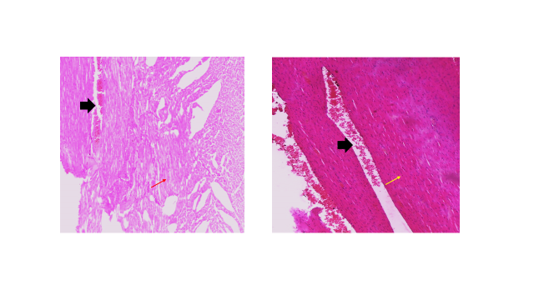

PLATE 1: Control section of the heart tissue showing heart muscles in which the fibres are arranged in synctium, no abnormalites detected, blood vessels(black thck arrow) and cardiac muscles(red thin arrow)

Section of heart tissues from test group. Note the heart muscles tissues in which The fibres are arranged in syncytium, dilated blood vessels(black thck arrow) and cardiac muscles(yellow thin arrow). H and E X400

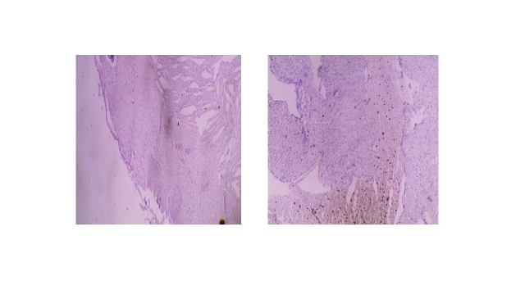

PLATE 2: Control section of the heart tissue showing muscle fibres, there are no indication of glycogen, mucopolysacharides and degenerative changes.

Section of the heart tissue from test group. Note the muscle fibres which are poorly stained, there are no indication of glycogen, mucopolysacharides and degenerative changes. PAS X 400

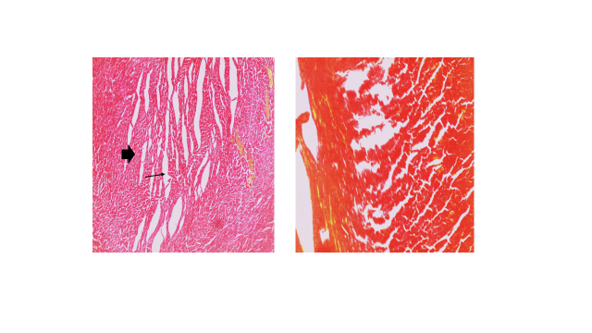

PLATE 3: Control section of heart tissiue showing muscles fibres which stained red. nucleus and collagen fibres not demonstrated. Masson’s Trichrome stain x400

Section of heart tissiue of Albino rats from test group. Note the muscles fibres which stained red. nucleus and collagen fibres not demonstrated. Masson’s Trichrome stain x400

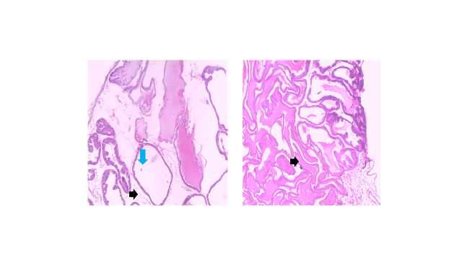

PLATE 4: Control sections of prostatic tissues of Albino rats. Note the acini( blue arrow) that are seprated by fibrous stroma (black arrow). the glands are lined by cuboidal epithelium with centrally located nuclei. stain is satisfactory. H and E X400

sections of Albino rat show prostatic tissues from test group. Note the acini that are seprated by fibrous stroma. the glands are lined by cuboidal epithelium with centrally located nuclei.No indication of degenerative changes. H and E X400

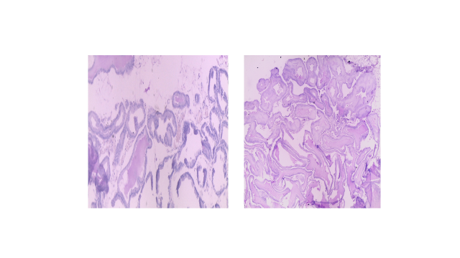

PLATE 5: Control section show poorly stained prostatic tissues. no amyloid, abnormal protein, polysaccharide or collagen deposits demonstrated. PAS X400

section of Albino rat prostatic tissue from test group. Note the poorly stained prostatic tissues. no amyloid, abnormal protein, polysaccharide or collagen deposits demonstrated. PAS X400

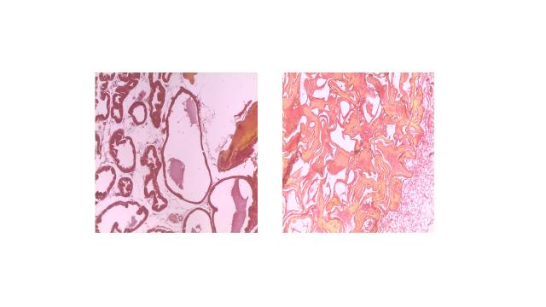PLATE 6 :Control section of stained prostatic tissue of Albino rat. collagen not demonstrated, Masson’s trichrome x400

Tissue section of the prostate of Albino rat from the test group. Note the poorly stained prostatic tissue, collagen not demonstrated. Masson’s Trichrome x 400

**DISCUSSION**

The present study evaluated the Histomorphological and biochemical effects of Tadalafil on prostate and heart tissues of adult albino rats exposed to low dose (2.5mg/kg), medium dose (5mg/kg) and high dose (10mg/kg) daily over a 28-day period. The findings from this investigation revealed statistically significant alterations in the oxidative stress markers (malondialdehyde, superoxide dismutase, catalase) or hormonal assays (Prostate specific antigen, testosterone and Troponin 1). Additionally, histopathological assessment using hematoxylin and eosin (H&E), Periodic acid–Schiff (PAS), and Masson’s trichrome staining techniques did not demonstrate any observable pathological lesions or structural changes in prostate and heart tissues.

The measured level of MDA, a biomarker of lipid peroxidation in this study, shows significant increase in other groups when compared to the control. This correlates with earlier studies that reported increased oxidative stress seen by the significant rise in MDA levels with a significant decrease in SOD and CAT levels following tadalafil administration (Sahib, 2016), which means the increase in both tissues that the oxidative stress damage is overwhelming the drug’s protective effect. While the measured level of SOD and CAT in the study shows significant decrease in other groups compared to control group. This means that decrease in the SOD and CAT of heart and prostate tissues are likely due to the improved blood flow to the prostate tissue and upregulation of antioxidant enzymes in the heart tissues especially during ischemia reperfusion injury.

After the biochemical analyses, hormonal assays such as testosterone, prostate specific antigens (PSA) and troponin 1 (TRP-1) were carried out. It shows significant increase in the level of testosterone and troponin 1 in groups treated with high does of tadalfil compared to the control group while they was a significant decrease in level of PSA in groups with high dose compared to the control group, this has also been reported by various studies (Gerald *et al.,* 2022). The increase in the testosterone levels are likely due to the blood flow to the testes and reducing oxidative stress which may enhance the leydig’s cell function which is responsible for testosterone production. It may also be due to the reduce of testosterone imbalance and lower inflammation in men with benign prostatic hyperplasia (BPH). Increase in the troponin 1 maybe due to an underlying cardiac event but it’s not necessarily due to the drug effects. While decrease in PSA level may be due to the reduce in prostate inflammation.

Histological evaluation revealed preserved prostate and heart architecture in all groups. There were no signs of damage or inflammation in any of the exposed animals. H&E of the heart tissues shows control section of heart muscles in which the fibres are arranged in synctium, no abnormalites detected and staining is satisfactory same with the test group of the heart . While the control section of the prostate H&E shows the glands are lined by cuboidal epithelium with centrally located nuclei. stain is satisfactory same with the test group with no indication of degeneration. PAS of the heart tissues shows control section of the muscle fibres which are poorly stained, there are no indication of glycogen, mucopolysacharides and degenerative changes same with the test group. While the control section of the prostate show poorly stained prostatic tissues, no amyloid, abnormal protein, polysaccharide or collagen deposits demonstrated same with the test groups. Masson’s trichrome of the heart tissues shows control section of muscles fibres which stained red. nucleus and collagen fibres not demonstrated same with the test group. While the control section of stained prostatic tissue of Albino rat shows normal cell with collagen not demonstrated same with the test group but poorly stained. This means that there’s no significant damage to the prostate and heart histological structures.

Although the lack of statistically significant biochemical or histological changes might appear inconclusive, it is important to interpret these findings within the framework of dose-response toxicology. Toxic effects are often dose-dependent and influenced by several factors, including exposure duration, individual susceptibility, and the capacity of detoxification systems. The body’s enzymatic antioxidant defenses, such as SOD and CAT, may have successfully mitigated low-level oxidative stress in this experimental setting. It is worth noting that while the findings suggest that high dose of tadalafi toxicity under the conditions of this study, may include the possibility of subtle biochemical and hormonal changes captured by the selected biomarkers. Future studies with extended exposure periods, higher tadalafil dose concentrations, or more sensitive molecular analyses such as gene expression profiling of inflammatory or oxidative stress-related genes may yield deeper insights into the early biochemical effects of Tadalafil.

**CONCLUSION**

This study investigated the Histomorphological and biochemical effects of tadalafil on Wistar rats over varying dosage. While changes in oxidative and hormonal markers (MDA, SOD, CAT, PSA, TRP-1 and testosterone) were statistically significant. Histological findings suggest there’s no significant damage to the prostate and heart histological structures.

**Ethical Approval:** Ethical approval was obtained from Ethical committee of Research of the Faculty of Applied health sciences of Edo state University, Iyahmo.

**COMPETING INTERESTS DISCLAIMER:**

Authors have declared that they have no known competing financial interests OR non-financial interests OR personal relationships that could have appeared to influence the work reported in this paper.

Disclaimer (Artificial intelligence)

Option 1:

Author(s) hereby declare that NO generative AI technologies such as Large Language Models (ChatGPT, COPILOT, etc.) and text-to-image generators have been used during the writing or editing of this manuscript.

Option 2:

Author(s) hereby declare that generative AI technologies such as Large Language Models, etc. have been used during the writing or editing of manuscripts. This explanation will include the name, version, model, and source of the generative AI technology and as well as all input prompts provided to the generative AI technology

Details of the AI usage are given below:

1. the authors disclaim any use of CHATGPT for this study

2. No Use of AI for this study

3. authors hereby declare that NO use of large language models or any known AI used for this study

# REFERENCES

Aaron, L., Franco, O. E., & Hayward, S. W. (2016). Review of Prostate Anatomy and Embryology and the Etiology of Benign Prostatic Hyperplasia. *The Urologic clinics of North America*, 43(3), 279–288.

Barnes, H., Brown, Z., Burns, A., & Williams, T. (2019). Phosphodiesterase 5 inhibitors for pulmonary hypertension. The Cochrane database of systematic reviews, 1(1), CD012621.

Carter YM, Wehrle CJ, Mahajan K (Aug 8, 2023). Anatomy, Thorax, Heart Anomalous Left Coronary Artery. Treasure Island (FL):.. StatPearls Publishing; StatPearls [Internet].

Evans JD, Hill SR (2015) A comparison of the available phosphodiesterase-5 inhibitors in the treatment of erectile dysfunction: a focus on avanafil. *Patient Prefer Adherence* 9:1159–1164

Fahmy G, Hess J. (2024 Jan). Treasure Island (FL): StatPearls Publishing; Tadalafil In: StatPearls

Galiè N, Brundage BH, Ghofrani HA, Oudiz RJ, Simonneau G, Safdar Z, Shapiro S, White RJ, Chan M, Beardsworth A, Frumkin L, Barst RJ. (2009), Pulmonary Arterial Hypertension and Response to Tadalafil (PHIRST) Study Group. Tadalafil therapy for pulmonary arterial hypertension. *Circulation*. 09;119(22):2894-903.

Gonzalez-Cadavid NF, Rajfer J (2019). The two phases of the clinical validation of preclinical translational mechanistic research on PDE5 inhibitors since Viagra's advent. A personal perspective. *Int J Impot Res.* Mar;31(2):57-60.

Hatzimouratidis K (2014). A review of the use of tadalafil in the treatment of benign prostatic hyperplasia in men with and without erectile dysfunction. *Ther Adv Urol*. Aug;6(4):135-47.

Henry, G. H., Malewska, A., Joseph, D. B., Malladi, V. S., Lee, J., Torrealba, J., Mauck, R. J., Gahan, J. C., Raj, G. V., Roehrborn, C. G., Hon, G. C., MacConmara, M. P., Reese, J. C., Hutchinson, R. C., Vezina, C. M., & Strand, D. W. (2018). A Cellular Anatomy of the Normal Adult Human Prostate and Prostatic Urethra. *Cell reports*, 25(12), 3530–3542.e5.

Huang SA, Lie JD (2013). Phosphodiesterase-5 (PDE5) inhibitors in the management of erectile dysfunction. P T;38:407-419

Hussain A, Burns B (Jul 30, 2023). Anatomy, Thorax, Wall. Treasure Island (FL):. StatPearls Publishing; StatPearls [Internet].

Ittmann M. (2018). Anatomy and Histology of the Human and Murine Prostate. *Cold Spring Harbor perspectives in medicine*, 8(5), a030346.

Kayalioglu G, Altay B, Uyaroglu FG, Bademkiran F, Uludag B, Ertekin C (2008). Morphology and innervation of the human cremaster muscle in relation to its function. *Anat Rec (Hoboken)*;291(7):790-6.

La Vignera, Sandro, Condorelli, Rosita A., Mongioi, Laura M., Calogero, Aldo E., (2017). Chronic Administration of Tadalafil Improves the Symptoms of Patients with Amicrobic MAGI: An Open Study, *International Journal of Endocrinology*, 3848545, 7 pages.

Ma, J., Liu, Z., Wu, J., Zhou, Z., Zhang, X., Cui, Y., & Lin, C. (2020). Role of application of tadalafil 5 mg once-daily (≥6 months) in men with erectile dysfunction from six randomized controlled trials. T*ranslational andrology and urology*, 9(3), 1405–1414.

Najari B.B., Kashanian J.A (2016). Erectile Dysfunction. *JAMA*;316: 1838.

National Center for Biotechnology Information (2024). PubChem Compound Summary for CID 110635, Tadalafil.

Obukohwo, O. M., Kingsley, N. E., Rume, R. A., & Victor, E. (2021). The concept of male reproductive anatomy. *In IntechOpen eBooks*.

Ogobuiro I, Wehrle CJ, Tuma F (Jul 24, 2023). Anatomy, Thorax, Heart Coronary Arteries. Treasure Island (FL): StatPearls Publishing; StatPearls [Internet].

Olesovsky, C., & Kapoor, A. (2016). Evidence for the efficacy and safety of tadalafil and finasteride in combination for the treatment of lower urinary tract symptoms and erectile dysfunction in men with benign prostatic hyperplasia. *Therapeutic advances in urology*, 8(4), 257–271.

Peng, Z., Yang, L., Dong, Q., Wei, Q., Liu, L., & Yang, B. (2017). Efficacy and Safety of Tadalafil Once-a-Day versus Tadalafil On-Demand in Patients with Erectile Dysfunction: A Systematic Review and Meta-Analyses. *Urologia internationalis,* 99(3), 343–352.

Rahman, T., Al-Ruweidi, M. K. a. A., Sumon, M. S. I., Kamal, R. Y., Chowdhury, M. E. H., & Yalcin, H. C. (2023). Deep learning Technique for congenital heart disease detection using Stacking-Based CNN-LSTM models from Fetal Echocardiogram: a pilot study. *IEEE Access, 11*, 110375–110390.

Rehman I, Rehman A. Anatomy, Thorax, Heart. (2023). In: StatPearls [Internet]. Treasure Island (FL): StatPearls Publishing;

Saleh A, Abboudi H, Ghazal-Aswad M, Mayer EK, Vale JA (2015). Management of erectile dysfunction post-radical prostatectomy. *Res Rep Urol*;7:19-33.

Saxton A, Chaudhry R, Manna B (Jul 24, 2023). Anatomy, Thorax, Heart Right Coronary Arteries. Treasure Island (FL):. StatPearls Publishing; StatPearls [Internet].

Shalet SM (2009). Normal testicular function and spermatogenesis. Pediatr Blood Cancer. Aug;53(2):285-8.

Titi-Lartey OA, Khan YS (2023 Apr 24). Embryology, Testicle. Treasure Island (FL): StatPearls Publishing; In: StatPearls [Internet].

Tiwana MS, Leslie SW (2023 Apr 15). Anatomy, Abdomen and Pelvis: Testes. Treasure Island (FL): StatPearls Publishing; In: StatPearls.

Tsili AC, Sofikitis N, Stiliara E, Argyropoulou MI (2019). MRI of testicular malignancies. *Abdom Radiol (NY)*;44(3):1070-1082.

Tucker WD, Weber C, Burns B (Jul 24, 2023). Anatomy, Thorax, Heart Pulmonary Arteries. Treasure Island (FL): StatPearls Publishing; StatPearls [Internet].

Ulloa-Aguirre A, Reiter E, Crépieux P (2018). FSH Receptor Signaling: Complexity of Interactions and Signal Diversity. Endocrinology. Aug 01;159(8):3020-3035.

Villapalos-García G, Zubiaur P, Marián-Revilla C, Soria-Chacartegui P, Navares-Gómez M, Mejía-Abril G, Rodríguez-Lopez A, González-Iglesias E, Martín-Vílchez S, Román M, Ochoa D, Abad-Santos F (2023). Food Administration and Not Genetic Variants Causes Pharmacokinetic Variability of Tadalafil and Finasteride. *J Pers Med.* Oct 31;13(11)

Yafi, F., Jenkins, L., Albersen, M. (2016). Erectile dysfunction. *Nat Rev Dis Primers* 2, 16003.

Yang Y, Workman S, Wilson M (2018). The molecular pathways underlying early gonadal development. *J Mol Endocrinol.*

Yokoyama, O., Igawa, Y., Takeda, M., Yamaguchi, T., Murakami, M., & Viktrup, L. (2015). Tadalafil for lower urinary tract symptoms secondary to benign prostatic hyperplasia: a review of clinical data in Asian men and an update on the mechanism of action. *Therapeutic advances in urology*, 7(5), 249–264.