**REVISITING ENDODONTIC PROTOCOLS IN THE WAKE OF COVID -19- A REVIEW ARTICLE**

**ABSTRACT-**

**BACKGROUND** - The emergence of the COVID-19 pandemic has significantly impacted dental practice, particularly in the field of endodontics, where aerosol-generating procedures pose a heightened risk of viral transmission.

**OBJECTIVE** - This review article aims to comprehensively evaluate the current COVID-19 protocols relevant to endodontic practice, emphasizing infection control strategies, personal protective equipment (PPE) usage, patient triaging, clinic disinfection, and treatment modifications. Emphasis is placed on evidence-based recommendations issued by global health authorities and dental associations to ensure the safety of both patients and dental healthcare professionals. The review also highlights innovations such as teledentistry for remote consultations, minimally invasive endodontic procedures, and rubber dam isolation to reduce viral exposure.

**CONCLUSION**- This review highlights key strategies which includes pre appointment screening , use of high efficiency PPE kits , rubber dam as well as isolation and retraction strategies including four – handed dentistry. By analyzing the evolution of safety protocols from the onset of the pandemic to the post-vaccination phase, this article serves as a guide for resilient and adaptive endodontic care during public health emergencies.

**Keywords:**

COVID-19, Endodontics, Aerosol-generating procedures, Infection control, Personal protective equipment (PPE), Teledentistry, Dental protocols, Rubber dam isolation, Patient triage, Pandemic dentistry.

**INTRODUCTION**

“There is an emergency in China, but it has not yet become a global health emergency- WHO is following this outbreak every minute of every day”, said Dr Tedros Ghebreyesus, Director-General of WHO, on Jan 23.1

It is said that the 2019 n-COV, which presents as COVID-19, is the most significant worldwide health emergency of our time. In addition to cholera, smallpox, influenza, and bubonic plague, COVID-19 is the most recent disease to be designated as a pandemic by the WHO.2 A seafood and wet animal wholesale market in Wuhan, Hubei Province, China, was epidemiologically connected to clusters of patients with pneumonia of unclear etiology that were reported by a number of local health facilities in late December 2019 (Ciotti et al., 2020).3 The China CDC sent a fast reaction team on December 31, 2019, to work with Wuhan municipal and Hubei province health officials to carry out an epidemiologic and etiologic investigation.3

In late December 2019, Wuhan City became the epicentre of an emergency pneumonia outbreak. From Wuhan, the pneumonia infection has quickly spread to the majority of other provinces and 24 other nations.2, 3 The global pneumonia outbreak prompted the World Health Organization to declare a public health emergency of international concern on January 30, 2020.4 The first clinical data from people from Wuhan, China who were verified to have 2019-nCoV infection was released on January 24. The severity of the sickness is alarming: four patients needed breathing, five had significant heart injury, six patients died, and nearly a third developed acute respiratory distress syndrome necessitating intensive care.

Encased positive stranded RNA viruses, or coronaviruses, are members of the family Coronaviridae, the order Nidovirales, and the subfamily Coronoviridae.5 Based on their genomic architecture and evolutionary links, this subfamily is divided into **four genera:** **Alpha, Beta, Gamma, and Delta coronaviruses.** Only mammals are infected by alpha and beta coronaviruses. Although several of the gamma and delta coronaviruses can infect mammals, they primarily infect birds. 6  
A variety of respiratory viruses that can cause respiratory failure and exhibit mild to severe symptoms are included in the definition of coronavirus. The term alludes to the virus's microscopic appearance, which is distinguished by the presence of crown-like pointed features on its surface.7 Originally known as 2019-nCoV, the new coronavirus was formally known as SARSCoV-2 (Lamers & Haagmans, 2022).

As of February 26, 34 nations have identified COVID-19, with 2,700 fatalities and 80,239 laboratory-confirmed cases.8  
Sputum production, headache, hemoptysis, and diarrhea were less prevalent clinical symptoms among patients with the new viral pneumonia than fever, cough, and myalgia or lethargy with abnormal chest CT. In addition to diarrhea, nausea, vomiting, abdominal pain, and other gastrointestinal symptoms, COVID-19 patients frequently experienced fever, exhaustion, dry cough, nasal congestion, runny nose, and other respiratory symptoms. Acute respiratory distress syndrome (ARDS), septic shock, metabolic acidosis, coagulation malfunction, or even mortality may be present in some patients who have developed severe pneumonia.

Furthermore, SARS-CoV-2 vertical transmission has not yet been reported, and neonatal illness has been thought to happen very infrequently. It was therefore questioned whether children would be less vulnerable to this new infectious disease.   
This virus is distinct and very dangerous due to its high pathogenicity and transmissibility. The virus can spread through respiratory droplets, coughing, sneezing, and contact-transmission.  
The danger of virus transmission between patients and dental professionals can be regarded as considerable due to the differences in dental procedures and environments (Ardavan Parhizkar et al., 2019). Saliva is one of the main ways that the corona virus spreads, which puts the dental community at serious risk(Susan,2020).

**TRANSMISSION RISK FACTORS IN OPERATORY**

In a dental office, the virus can ***spread*** in the following ways:

* Person to person - respiratory droplets
* Face to face communication
* Direct contact
* Directly or indirectly through saliva
* Contact with contaminated instruments & environmental surfaces
* Poor respiratory hygiene & etiquettes
* Inadequate sterilization protocols

The virus is known to have a surface stability of over 72 hours and an aerosol viability of over 3 hours, which makes it particularly likely to spread in a dental context (Na Zhu, 2019). The inability to totally stop the formation of aerosols is the biggest worry in dentistry, and since the COVID-19 virus is highly contagious through these droplets, strict precautions must be made to prevent dental clinics from becoming the site of infections.   
Therefore, it is crucial that dental practices follow stringent and efficient infection control procedures, especially for dentistry clinics located in COVID-19-affected areas (Stefania Cantore, 2019).

The amount of medical and dental care was drastically reduced, to only urgent and non-delayed care. This was feasible during the first outbreak, but as the virus expanded unchecked, it became essential to develop ways to treat patients while guaranteeing the maximum level of safety for both patients and dental office employees. In light of this, numerous infection control measures were proposed by international health organizations.

**ORAL MANIFESTATIONS IN COVID 19 DISEASE:**

**Dysgeusia** is the first recognized oral symptom of covid19 reported in 38% of patients mostly female with mild and moderate severity of infection.

**Enanthema** refers to an ulcer or eruption on a mucous secreting surface such as inside the mouth. These are very common in viral diseases for example dengue, ebola, herpangina, human herpes virus (HHV) infection & measles. They can manifest as apthous like ulclers, koplik’s spots, petechiae, papulovesicular or maculopapular lesions, some may even appear as red or white patches.

**Apthous like lesions** – increase levels of TNF-α in covid 19 patients leads to chemotaxis of neutrophils to the oral mucosa and development of apthous like lesions. Stress and immunosuppression secondary to Covid 19 infection is another possibility for the occurrence of these lesions.

**Ulcerative and erosive lesions** – painful lesions with irregular borders on the tongue, hard palate and labial mucosa most often appeared after a latency period of 4 to 7 days. The etiology of these lesions can be attributed to drug eruptions (NSAID), vasculitis or thrombotic vasculopathy secondary to covid 19.

**White/red plaque** – on the dorsum of the tongue, gingiva and palate were frequently seen in patients with covid19. Long term antibiotic therapy, deterioration of general health and decline in oral health practices lead to development of candidiasis.

**Petechiae** – was reported on the lower lip, palate and oro-pharynx mucosa. Thrombocytopenia due to covid19 or the prescribed drugs were the possible causes of petechiae.15

**IMPLICATIONS IN CONSERVATIVE AND ENDODONTICS TREATMENT**

**INDIAN ENDODONTIC SOCIETY** has formulated and compiled basic guidelines for its fellow members safety and protection. It is categorized under four major points that **includes personal care, patient care, clinical and operatory care and laboratory care.**

1. **PERSONAL CARE PROTOCOL**
2. All elective procedures and asymptomatic treatments must to be postponed.   
    Proper PPE (Personal Protective Equipment) donning and doffing procedures should be carried out.
3. **Please consult the schematic instruction provided as it is very important to dispose of the discarded PPE without contaminating it.**   
   • **Gown:** Make wearing a full-coverage gown which should be disposable mandatory in your clinical practise . It should cover the arms up to the wrist, the knee, and the neck.   
    **•Respirators or masks:**1. The use of appropriate respiratory protection is critical aspect of infection control in enodontics as the aerosol generating procedures are common . A surgical mask with **three layers** provides barrier against large respiratory droplets, but these masks are not helpful against airbone particles.   
   2. The preferred N-95 respirator filters >95% of airbone particles . and is recommened for all endodontic procedures. It is best to double-check that the mask is securely fastened in the middle of the head and neck and fits snugly over the face and under the chin. Verify the patency of the filter if a respirator is fitted.

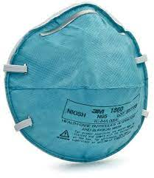

Fig 1- **N95 Respirator Mask**

* **Goggles and Face Shield:** During endodontic procedures , especially those which produce aerosol , splattering on face , mucous membranes of eye are portals of entry for spread of infection . Hence it is advised to place goggles and face shields over the face and eye after proper disinfecting the goggles/face shield regularly.

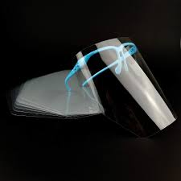

Fig 2- **Protective Face Shield**

* Gloves: Gloves are fundamental protection and barriers serving as primary barriers between clinicans hands and potential sources of infection .Nitrile / Surgical grade gloves should be preferred over normal diagnostic gloves in operatory . Avoid using the non-sterile examination gloves as the packaging can also be source of infections. Whenever feasible, wear two pairs of gloves; the inner pair should be a contrasting color to make it easier to spot any unintentional rips on the outer pair. Gloves should be worn long enough to cover the gown's wrists. When wearing gloves, the WHO advises against using an alcohol-based hand sanitizer.

c. Everyone operating and helping must wear full disposable personal protective equipment (PPE) when performing any treatments that produce splatter or aerosol (Cook, 2020). Isolation of rubber dams should be required.

d. Strict fumigation must be carried out following any treatment that involves splatters or aerosols in your operatory.   
  
e. You can add 0.5% hydrogen peroxide or 2.5% sodium hypochlorite to the dental chair's water reservoir in order to enhance sterlisation proocols.

f. **Digital payment methods** should be encouraged as it reduces the chances of person to person contact , improves transaction transparency , offers quicker and more hygienic billing protocols. Automated billing and e-receipts help reducing need of printed invoices, further lowering transmission risks.   
g. It can be communicated in advance, or even better, a notice stating that PPEs are being used for the patient's safety due to additional precautions, which would result in additional expenses; treatment for each procedure would increase by 10 to 15%, etc. h)Patients will feel more confident knowing that dental clinics act as barriers rather than as sources of infection as a result of this information.  
i) Conduct routine personal health evaluations and, in the event that you have any symptoms, notify the authorities and enter self-quarantine right away.

1. **PATIENT CARE PROTOCOL**

1. All patients should provide strict written informed consent, screening, and undertaking about COVID and other disorders in general. You may find a lot of basic consent forms online. Even people with no symptoms should be carefully screened, examined and educated about broader protocol trends in denstistry.   
2. Remember that the patient might not be providing an accurate account of their medical history or may not be aware of their illness. Every patient needs to be regarded as a possible carrier of COVID-19 who does not exhibit any symptoms.   
3. Following a laboratory test confirming recovery, keeping records and also treat newly recovered patients as possible virus carriers.

4. It is crucial to keep accurate records, addresses, and contact information.   
5. The clinic assistants should also be provided with the appropriate safety gear and trained in taking a patient's medical history and performing a basic examination, ideally with the use of a non-contact thermal scanner.   
6. The patient should be escorted to the hand wash station outside the main entrance upon arrival at the dental setup, where they will be able to wash their hands under the guidance of a designated hand wash helper. Before being brought to the reception, it is best to have the patient wear a protective garment with foot coverings and cover his face with a mask.

7. A non-contact thermometer must be used to take the patient's temperature at reception. The reception area and the patient must be kept at least "six feet" apart. In addition to the receptionist, the reception team must include a dentist. Before the patient arrives at the dental clinic, the endodontist must make sure that he or she conducts a phone chat with each patient, including a brief medical history. He or she is responsible for making sure that the patient only ever attends the dentist by appointment, to the greatest extent feasible. If endodontic and conservative dental care can wait, give patients

8. With thorough instructions for at-home care and any necessary medication. If pharmacologic pain management is necessary, ibuprofen should be avoided. Emergency dental care may be given utilizing the proper engineering controls, work procedures, and infection control procedures if the patient is afebrile (temperature < 100.4˚F) and otherwise shows no signs of COVID-19.

All elective treatment operations, including as crowns, veneers, inlays, onlays, etc., should be postponed by the endodontist, who should only do basic and emergency procedures. Ask the patient to keep their hands in their pockets or not touch anything else until they are seated in the dentist chair after requiring them to wash their hands with soap or hand sanitizer.

9. The patient must be made to do a pre-procedural mouth rinse using Betadine or 1% Hydrogen peroxide/ 2% w/v Povidone-Iodine mouth wash for at least 15 seconds, just before treatment is initiated and also after the procedure is over.

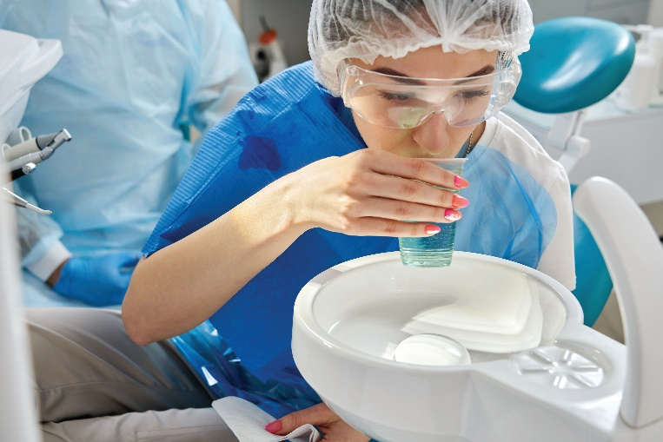

**Fig 3- The Patient do a pre-procedural mouth rinse**

1. Before the treatment begins, patients should also be covered with a full-length drape, with their hands tucked in, a head hat, goggles, and a disposable disinfecting face wipe or Betadine solution applied to the immediate extraoral area.
2. The best defense against the creation of aerosols will be rubber dams and proper instruction in their use.
3. The assistant is to make sure that all surfaces that the patient or aerosolized particles may have come into contact with are cleaned and sprayed with surface disinfectant once the patient exits the dental chair. After each patient's treatment is finished, the PPE must be disposed of in accordance with established procedures.
4. Promote few follow-up appointments- teledentistry should be encouraged if need be.
5. Instruct and motivate patients to use digital channels to pay their costs and to carry out contactless transacions.
6. If you notice anything concerning about the patient's condition while they are there, don't be afraid to report it to the appropriate authorities.
7. To reduce the spread of aerosols, high vacuum extra oral suctions combined with high speed saliva ejectors ought to be required.
8. To lessen the excessive salivation and gag reaction linked to intraoral radiography, extraoral radiographs should be used and intraoral imaging should be limited.
9. **CLINICAL AND OPERATORY PROTOCOL**

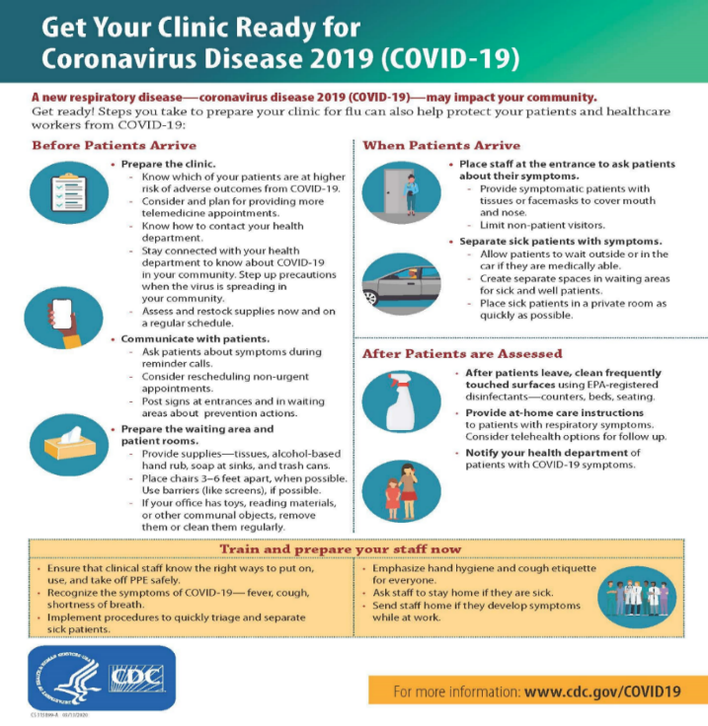

**Fig 4- The Clinical and Operatory Protocol**

1. **LABORATORY PROTOCOL**
2. 1. Until this pandemic is over, the lab technician should, at most, stop providing any services that involve direct patient contact.   
   2. Work in the lab should be conducted strictly, with as few staff as possible.   
   3. Laboratory staff members ought to be dressed in full PPE, just as clinical staff members.   
   4. There is evidence that dental impressions, casts, dental prostheses, or appliances may provide a risk of COVID-19 transmission. Additionally, the virus can remain active for several hours or even days on a variety of lab surfaces, such as cardboard and plastic.

So, it is of paramount importance that these should be thoroughly disinfected prior to handling both at the clinic or operatory, on acceptance of the work at the lab and prior to delivery.

5. Disinfectants that contain viricidal compounds that are effective against enveloped viruses—including COVID-19—must be used in labs. Among other things, hydrogen peroxide, sodium hypochlorite, and isopropyl alcohol can be the active components in these agents. Together with the other agents, soap use should be considered an adjunct.   
6. If using a spray, apply the product straight onto the area that needs to be cleaned. When using a disinfectant-soaked wipe, it's crucial to completely wipe the area that needs to be cleaned. In all situations, it is crucial to make sure that the entire surface that has to be cleaned has been covered. It is better to let the disinfectant evaporate as opposed to removing it with a wet cloth unless otherwise indicated. Ensure disinfection of models, casts, trays, with at least 70 % isopropyl alcohol-based solutions.

7. Use a solution based on sodium hypochlorite to disinfect sinks, floors, and tables/platforms.   
8. Every lab worker, without exception, should follow the correct infection control procedures, which include donning personal protective equipment (PPE) such as a mask, gloves, safety glasses, and protective clothing.   
9. The mask, protective clothing, and eyewear worn in the laboratory must remain in the laboratory and not be removed. These must be cleaned, cleansed, and disinfected daily, kept in the lab, and those that need to be thrown away must be disposed of properly.

10. When not wearing gloves, hand sanitizers should be used frequently and put at strategic locations throughout the lab. Wear gloves when handling all lab equipment and clinic transfers, such as castings or impressions.   
11. After each case, hands should be completely cleaned with soap and water, and hands should not be touched to the face in the lab. Hand washing is essential to following conventional precautions.   
12. It is imperative that all lab workers and technicians observe social distancing as much as possible while they are working or sitting and keep a minimum of six feet between one another.

13. The delivery/pickup person who collects the impression from the dentist must adhere to stringent hygienic procedures if he works in the lab. When traveling, he should always wear gloves and a mask. If at all possible, the delivery person should deliver the model or impression to the recipient at the entryway and avoid entering the lab. The material must be disinfected once all packets holding models and other materials have been disposed of with extreme caution.   
14. All employees must be monitored for signs of COVID-19 on a regular basis, and they must be strictly instructed to stay at home if they experience any of the following symptoms: cough, fever, cold symptoms, including runny or congested nose, or breathing difficulties.

15. Observe that a high vacuum suction is used to remove any flints or shards while using the trimmers and buff without wearing personal protective equipment.   
16. Urge the clinics to switch to digital platforms and, whenever feasible, employ intraoral scanners in place of standard impressions.   
17. Every dental prosthesis entering and leaving the laboratory needs to be completely cleaned. In order to reduce fomite based viral transmissions , strict sterilization protocols should be carried out for prosthetic appliances such as crowns , bridges temporary restorations. Prosthetic items must be thoroughly cleaned of visible debris and disinfected using agents such as 0.5% sodium hypochlorite, 70% isopropyl alcohol, or glutaraldehyde-based solutions, depending on material compatibility. For items received from dental laboratories, sealed packaging and a disinfection certificate were recommended to ensure safety. It is advised that impressions and try-in prosthetics be disinfected before transport to the lab and again upon return to the clinic.  
  
18. Make sure the dental lab is regularly fumigated. Fumigation of the dental laboratory is a critical infection control measure, particularly emphasized during the COVID-19 pandemic to maintain a sterile working environment. Dental labs are high-risk areas due to the handling of contaminated impressions, prostheses, and instruments that may carry infectious agents. Fumigation, or environmental decontamination using gaseous disinfectants, was recommended as a periodic protocol—especially in laboratories with high patient turnover or suspected contamination. Agents commonly used for fumigation include formaldehyde gas, hydrogen peroxide vapor (HPV), and chlorine dioxide, which are effective against a broad spectrum of pathogens, including SARS-CoV-2. Before fumigation, the lab must be sealed airtight, and all electronic devices and materials covered or removed if sensitive to chemicals. After exposure (usually 4–6 hours), aeration and neutralization steps must be followed before re-entry. In addition to daily surface disinfection, scheduled fumigation (weekly or bi-weekly) helped ensure comprehensive sterilization of air and inaccessible surfaces. Fumigation was often supplemented with the use of HEPA filters, UV-C irradiation, and adequate ventilation to maintain a low microbial load. This measure significantly minimized cross-contamination risk between lab personnel, clinical staff, and patients during the pandemic and continues to be part of enhanced biosafety protocols in modern dental practices.

**CONCLUSION**

Prior to the turn of the century, the novel coronavirus, which belongs to a viral family, was believed to be rather benign. However, it has now caused a public health emergency of global significance. The widespread spread of SARS COV 2 over the world makes it more likely that oral health care providers will treat this segment of the population, according to the 140th coronavirus situation report released by the WHO on June 8, 2020. It is anticipated that the diseases would continue to exist in the community as a milder, less aggressive infection. In order to disrupt the chains of transmission through the public as well as in dentistry clinics and hospitals, this calls for strict surveillance to identify, isolate, test, and treat every case.

In order to combat the constant threats posed by newly developing viruses, outbreaks such as this one underscore the significance of good public health initiatives.   
Dental professionals must be completely aware of 2019n-CoV spreading modalities, how to identify patients with this infection, and most importantly, self-protection considerations. This is because the nature of dental treatments and the potential for aerosol production during such procedures make dentistry one of the most dangerous occupations in the world. In the current situation, it is imperative that dental procedures designated as emergency by the WHO be prioritized and that all dental procedures be postponed until the outbreak enters a recession.

It is anticipated that in the future, pathogen transmission will lead to the development of infectious diseases more frequently due to patients' longer life expectancies, improved health care that causes more diseases to become chronic, and the increased virulence of microorganisms (resistance). As a result, it is the responsibility of health care professionals to protect the public and uphold high standards of care and infection control.   
Because their patients are so afraid that they are unwilling to leave their homes and enter the dental office, dental hygienists, dentists, and dental practice owners are currently searching desperately for innovative methods to think.

The need for dental organizations to adopt telemedicine and mobile dentistry in order to adjust to a changing society has never been more clear. Ironically, the American Mobile Dentistry Alliance—the country's professional association for mobile doctors and mobile organizations—was established during the first week of March, which also happened to be the first annual National Mobile Dentistry Conference. Together with these two tools, mobile clinicians can now take advantage of cutting-edge goods and services.   
It is impossible to overstate the use of digital technology in public health emergencies for surveillance, diagnosis, treatment, and self-management assistance.

To improve their health care system's ability to respond to the COVID-19 pandemic, governments, health organizations, and healthcare practitioners are strongly encouraged to promptly and logically harness the power of digital health platforms.   
Making well-informed healthcare judgments and educating the public are crucial in preventing panic and advancing our patients' health and wellbeing during these trying times. The immediate and long-term effects of COVID-19 as well as other upcoming health care requirements can be significantly impacted by a deliberate, coordinated approach that makes use of current expertise and strong enterprise-grade technologies.

**RECENT UPDATE-2020-2023**

A systematic review done by **Chaudhary et al in year 2021** primarily focuses on triage , aerosol management states that only emergency endodontic treatment protocols to be carried out while rest patients were guided for teledentistry and prescribed medications17. Another study conducted by **Ravazi et al in 2020** to analyse the effects of air purification , door condition , particle size on the temporal concentration distribution of particles.19 Their study concluded that it takes 95 mins for 0.5 micro-meteparticles to settle down . hence particle transmission to rest of room takes place even if the particle concentration in the generation zones comes back to ground level. Hence protocols for sterilization should be made mandatory in all fields of dentistry.

**FUTURE PERSPECTIVE**

The COVID-19 pandemic has transformed endodontic practice, compelling clinicians to adopt stringent infection control measures. As the world transitions into a post-pandemic era, several trends and innovations are expected to reshape the future of infection control in endodontics such as integration of Smart and Contactless Technologies, Advancement in Aerosol-Free Techniques, Enhanced PPE and Sustainable Materials, Improved Air Management Systems.

**Permanent Shift Toward Digital Dentistry:**

The adoption of intraoral scanners, CAD/CAM workflows, and teledentistry will continue to grow, reducing reliance on physical impressions and in-person consultations. This promotes better infection control and enhances patient convenience.

**Development of Updated Global Guidelines:**

Regulatory bodies are expected to release dynamic, evidence-based protocols that can be rapidly adapted for future infectious outbreaks. These may include real-time risk assessment tools and standardized PPE tiers for various dental procedures.

**Ongoing Training and Simulation-Based Education:**

Regular infection control simulations, virtual reality training, and online certification programs will be integrated into continuing dental education to keep professionals prepared for future public health challenges.

**Proactive Patient Communication and Consent:**

Practices will increasingly emphasize transparent infection control policies, digital consent forms, and real-time updates for patients to build trust and enhance compliance with safety protocols.The evolution of infection control in endodontics will likely persist well beyond the pandemic, integrating new technologies, sustainable practices, and smarter clinical designs. The COVID-19 experience has highlighted the importance of preparedness, and future directions will focus not only on containing infection but also on creating resilient, safe, and patient-centered endodontic environments.

**Disclaimer (Artificial intelligence)**

Option 1:

Author(s) hereby declare that NO generative AI technologies such as Large Language Models (ChatGPT, COPILOT, etc.) and text-to-image generators have been used during the writing or editing of this manuscript.

**REFERENCES**

1. “Emerging understandings of 2019-ncov”; The Lancet Vol 395 February 1, 2020 Pg. 311
2. Susan H. Davide. “Coronavirus Transmission in the Dental Setting”; The Journal of Multidisciplinary Care, June 2020
3. Na Zhu, Dingyu Zhang. “A Novel Coronavirus from Patients with Pneumonia in China, 2019”; The New England Journal of Medicine 2020;382:727-33.
4. Richman DD, Whitley RJ et al. “Clinical Virology”. John Wiley & Sons, 2016.
5. Woo, P. C. et al. “Discovery of seven novel mammalian and avian coronaviruses in the genus delta coronavirus supports bat coronaviruses as the gene source of alphacoronavirus and beta coronavirus and avian coronaviruses as the gene source of gamma coronavirus and delta coronavirus”. J. Virol. 86, 3995–4008 (2012).
6. Su S, Wong G, Shi W, et al. “Epidemiology, genetic recombination, and pathogenesis of coronaviruses”. Trends Microbiol 2016; 24:490-502.
7. Peng X, Xu X et al. “Transmission routes of 2019-ncov and controls in dental practice”. Int J Oral Sci. 12(1):9.
8. L. Meng, F. Hua. “Coronavirus Disease 2019 (COVID-19): Emerging and Future Challenges for Dental and Oral Medicine”; Journal of Dental Research 2020, Vol. 99(5) 481 –487
9. Dewald Schoeman and Burtram C. Fielding. “Coronavirus envelope protein: current knowledge”; Schoeman and Fielding Virology Journal (2019) 16:69
10. Stefania Cantore, Andrea Ballini. “Coronavirus Disease 2019 (COVID-19) Pandemic Burst and Its Relevant Consequences in Dental Practice; The Open Dentistry Journal 14(1):111-112 · April 2020 Indian Dental Association’s Preventive Guidelines for Dental Professionals on the Coronavirus Threat.
11. Muhammad Adeel Ahmed, Rizwan Jouhar et al. “Fear and Practice Modiﬁcations among Dentists to Combat Novel Coronavirus Disease (COVID-19) Outbreak”; Int. J. Environ. Res. Public Health 2020, 17, 2821
12. The workers who face the greatest coronavirus risk. The New York Times (New York) 2020 March 15.
13. Ardavan Parhizkar, Sayna Shamszadeh et al. “Dental Considerations After the Outbreak of 2019 Novel Coronavirus Disease: A Review of Literature”; Arch Clin Infect Dis. In Press: e103257. Ciccarese G, Drago F, Boatti M, Porro A, Muzic SI, Parodi A. Oral erosions and petechiae during SARS‐CoV‐2 infection. Journal of medical virology. 2020 Jun 24
14. Ciotti, M., Ciccozzi, M., Terrinoni, A., Jiang, W. C., Wang, C. B., & Bernardini, S. (2020). The COVID-19 pandemic. Critical reviews in clinical laboratory sciences, 57(6), 365-388.
15. Lamers, M. M., & Haagmans, B. L. (2022). SARS-CoV-2 pathogenesis. Nature reviews microbiology, 20(5), 270-284.
16. Cook, T. M. (2020). Personal protective equipment during the coronavirus disease (COVID) 2019 pandemic–a narrative review. Anaesthesia, 75(7), 920-927.
17. Chaudhary FA, et al. Provision of Endodontic Treatment in Dentistry amid COVID‑19: A Systematic Review and Clinical Recommendations. J Endod. 2021; (includes literature up to Nov 2020)
18. Ates AA, Alomari T, Bhardwaj A, Tabnjh A, Gambarini G. Recommendations for Managing Endodontic Emergencies during Coronavirus Disease 2019 Outbreak. J Endod. 2020;47(2).
19. Ravazi M, Butt Z, Lin MHE, et al. In situ Measurement of Airborne Particle Concentration in a Real Dental Office: Implications for Disease Transmission. Preprint/Quantitative study; 2022