Effectiveness of Different Surgical Techniques in the Removal of Odontogenic Cysts: A Narrative Review

ABSTRACT: Odontogenic cysts are pathological cavities lined with epithelium and derived from odontogenic tissues, frequently encountered in dental practice. Their varied etiopathogenesis, overlapping clinical and radiographic features, and potential for recurrence represent significant challenges in clinical decision-making for dental surgeons. This review evaluates the effectiveness of different surgical techniques for treating odontogenic cysts, aiming to assist clinicians in selecting the most appropriate approach for each lesion type. A narrative literature review was conducted using the PubMed and SciELO databases, resulting in the inclusion of 32 relevant studies. The choice of technique was found to depend on factors such as cyst type and location, lesion size, patient age, and proximity to vital anatomical structures. Simple enucleation is indicated for small, well-defined lesions; marsupialization is useful for large or hard-to-access cysts; combined techniques are recommended when there is a risk of fracture; and segmental resection is reserved for aggressive or recurrent lesions. The study underscores the need for future research using standardized methodologies, as heterogeneity in surgical indications and study designs remains a major limitation. No single surgical technique proved universally superior, reinforcing the importance of individualized assessment and accurate diagnosis for therapeutic success.

Keywords: Odontogenic Cyst. Enucleation. Marsupialization. Surgical Removal.

- INTRODUCTION
A cyst can be defined as a cavity filled with fluid or soft-consistency material (Hupp et al., 2009). However, the definition of an odontogenic cyst goes further, as it features a cystic epithelial lining derived from odontogenic tissues originating from the odontogenesis process (Franklin et al., 2021). Due to the high rate of cellular proliferation and intense mitotic activity during dental embryogenesis, cellular alterations may occur, leading to the later development of a specific type or variant of odontogenic cyst. Nevertheless, this etiopathogenic hypothesis is still not fully clarified or substantiated in the literature (Hupp et al., 2009).
According to the current classification proposed by the WHO (World Health Organization), odontogenic cysts can be classified based on their origin, whether developmental or inflammation-associated (Tolentino et al., 2018). Thus, we have the so-called developmental odontogenic cysts: dentigerous cyst, eruption cyst, gingival cyst of the newborn, gingival cyst of the adult, lateral periodontal cyst, calcifying odontogenic cyst, glandular odontogenic cyst, and odontogenic keratocyst. Another group comprises cysts associated with inflammation: periapical and/or radicular cysts, and buccal bifurcation cysts (Dioguardi et al., 2024).
Understanding the characteristics inherent to each type of odontogenic cyst should be a core competency for dental surgeons aiming to make accurate diagnoses and treatment plans (Franklin et al., 2021). According to Santosh et al. (2020), the similarity between the clinical features and radiographic findings of different types of odontogenic cysts may lead to diagnostic errors, since these lesions often share morphological characteristics and imaging patterns that hinder precise differentiation. This directly impacts decision-making regarding the most effective and appropriate surgical technique for treatment.
The removal of odontogenic cysts through surgical techniques is an essential practice in dentistry, aimed at preventing complications and restoring patients' oral health. The main objective of the therapeutic approach is the eradication of the pathological lesion, ensuring its complete removal and the elimination of any cells that could proliferate and lead to recurrence (Silva et al., 2019).
Therefore, the aim of this study was to conduct a narrative literature review, seeking to clarify and guide dental surgeons in selecting the best and most effective therapeutic approach for each clinical case, highlighting the most appropriate surgical interventions. Additionally, as a secondary objective, this review aims to present a brief overview of each type of oral cystic lesion of odontogenic origin, addressing their etiopathogenesis, clinical characteristics, and radiographic features.
- LITERATURE REVIEW
Various surgical methods are employed, each adapted to the individual characteristics of the cyst, considering its origin, composition, and the histopathology of the epithelial lining. Careful evaluation of the surgical techniques is of utmost importance to minimize any damage or sequelae the patient may suffer. Therefore, any major ablative procedure depends on prior analysis of a histopathological examination report, aiming to select the most appropriate technique and preserve as much healthy tissue and adjacent anatomical structures as possible (Silva et al., 2019).
Simple enucleation, for instance, is a conventional approach involving the complete removal of the cyst and its capsule without rupture, through direct surgical access. This removal is made possible by a layer of fibrous connective tissue between the epithelial component (lining the inner layer of the cyst) and the bony wall of the cystic cavity, allowing for en bloc removal, which helps reduce the risk of recurrence (Soares et al., 2021).
Marsupialization, in turn, is another technique that consists of creating an opening in the cyst wall to allow drainage and gradual reduction of its size before complete removal. This process enables thickening of the cyst wall and bone regeneration, which facilitates a future enucleation. At that point, noble structures and the rigidity of the gnathic bones will be compatible with a more extensive and aggressive intervention, without increasing the risk of complications or adverse events such as bone fracture (Soares et al., 2021).
The combination of both techniques is often used when immediate enucleation could cause damage to neurovascular structures or vital regions such as the maxillary sinus and nasal cavity floor (Al-Moraissi et al., 2016). For this reason, marsupialization helps thicken the cystic lining, making en bloc removal easier, and promotes increased structural rigidity of the bone since, after intracystic decompression, surrounding bone regeneration occurs (Winters et al., 2023). After this initial healing phase, enucleation can then be performed with fewer complications (Spivakovsky et al., 2019).
Segmental resection is indicated for larger cysts or those that extend into surrounding tissues, involving removal of a portion of the adjacent bone (Araújo et al., 2018). Additionally, techniques such as enucleation with curettage are somewhat more aggressive, as after cyst removal, peripheral bone wear must be performed using spherical surgical burs to break down any daughter cysts or satellite cells that could proliferate and cause lesion recurrence (Oliveira et al., 2020).
Another adjunctive method that complements enucleation is the application of Carnoy's solution, a chemical compound made from a mixture of chloroform, absolute ethanol, glacial acetic acid, and ferric chloride, which acts to eliminate epithelial remnants (Freitas et al., 2015). This technique is particularly indicated for odontogenic keratocysts due to their aggressiveness and rapid cellular proliferation, as well as for odontogenic cysts previously treated with enucleation but that have recurred, likely due to residual fragments left in the cavity (Freitas et al., 2015).
Decompression is also a viable alternative for the treatment of odontogenic cysts, as it is a simple procedure that allows drainage of the cystic content, helping to reduce intracystic pressure, which can lead to lesion resolution (Vasconcelos et al., 2014; Tugnait et al., 2002).
These surgical approaches, based on solid clinical principles, have demonstrated effectiveness in resolving these pathologies, contributing to the restoration of oral health, function, rehabilitation, and overall patient well-being. The clinical and radiographic characteristics inherent to each type of odontogenic cyst are exemplified and summarized in Table 1.

Table 1. Odontogenic cysts
Cyst | Clinical Characteristics | Radiographic Characteristics | Illustrative Image
Dentigerous | Associated with unerupted teeth, pain, bone expansion, pathological migration (El Gaouzi Rajae et al., 2021). | Radiolucency surrounding the crown of an unerupted tooth, delimited by the cementoenamel junction (Ghandou et al., 2018). | 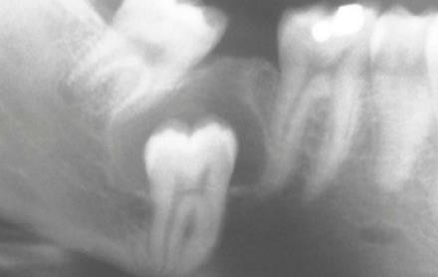  Source: Neville et al. (2016).
Eruption | Painless gingival swelling. Translucent or bluish coloration. Cystic fluctuating consistency (Seward et al., 1973). | No significant radiographic changes (Counts et al., 2001). | 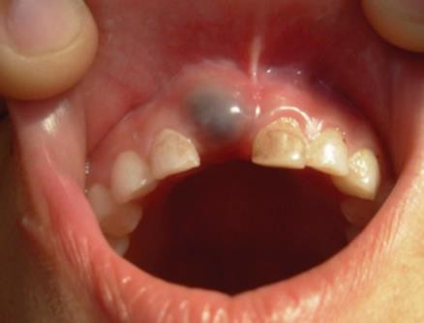  Source: Nagaveni et al. (2001).
Newborn | Whitish papules, isolated or multiple. Three millimeters in diameter, located on the alveolar ridge. More commonly found in the maxilla (Singh et al., 2012). | No significant radiographic changes (Bilodeau et al., 2021). | 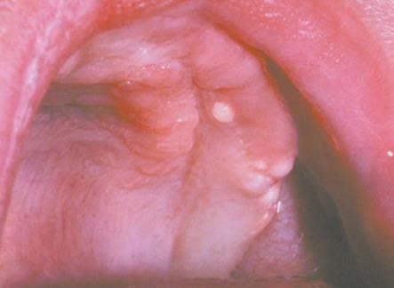  Source: Neville et al. (2016).
Adult Gingival | Nodular, dome-shaped lesion smaller than 1 cm. Firm consistency on palpation, painless, translucent or bluish coloration (Scully et al., 2015; Viveiros et al., 2019). | No radiographic changes in most cases, but cup-shaped resorption after removal may be observed (Richman et al., 2020; Wagner et al., 2015). | 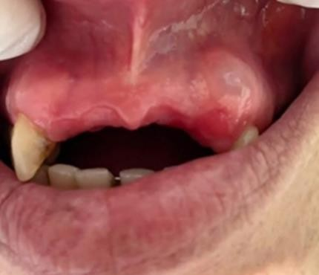  Source: Mota et al. (2023).
 | Asymptomatic and usually detected incidentally on routine radiographs (Chrcanovic et al., 2019). | Well-circumscribed radiolucent area on the lateral aspect of the root. The botryoid variant may appear as a radiolucent cluster (Chrcanovic et al., 2019). | 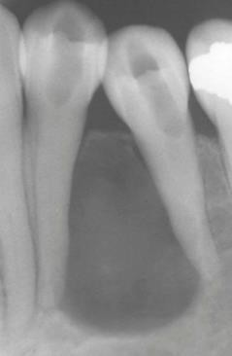  Source: Neville et al. (2016).
  Lateral Periodontal
Calcifying | Edema in the anterior region of the jaws, more common in adults over the 3rd decade of life (Dutra et al., 2017; el-naggar et al., 2017) | Well-defined unilocular or multilocular radiolucent region, possibly with radiopaque foci inside (Yoshiura et al., 1998;Sheikh et al., 2017; Buchner et al., 1991) | 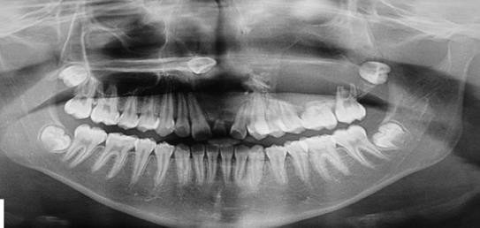  Source: Santana et al. (2021)
Glandular | Large tissue expansion, may be associated with pain and paresthesia (Cano et al., 2012) | Unilocular or multilocular radiolucent area with well-defined cortical margins, usually in the anterior mandible (França et al., 2019.) | 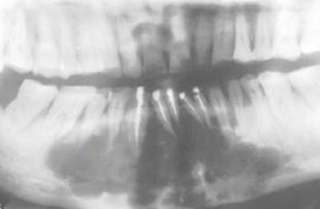  Source: Neville et al. (2016).
Keratocyst | Asymptomatic and does not usually cause noticeable bone expansion. Larger lesions may cause pain, swelling, purulent drainage, and displacement or divergence of teeth (Waldron et al., 2009). | Radiolucent area, unilocular or multilocular, with well-defined margins. Growth pattern is predominantly anteroposterior (Winters et al., 2023) | 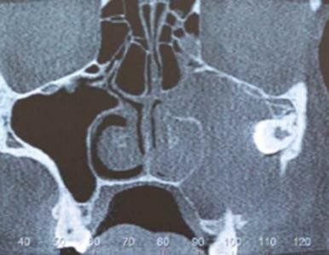  Source: Brancher et al. (2020).
Radicular | Mobility, root resorption, displacement of adjacent teeth; patient may feel pain when teeth are infected (Irfan et al., 2007). | Radiolucent area at the apex of a non-vital tooth or with necrotic pulp, with a well-defined radiopaque border (Pekiner et al., 2012). | 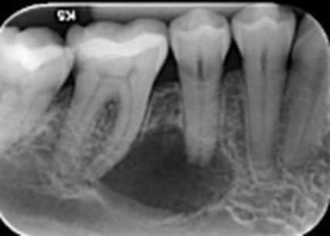  Source: Oliveira et al. (2018).
Buccal Bifurcation | Buccal tenderness, swelling, pus discharge, and increased periodontal pocket depth (Lima et al., 2019). | Well-circumscribed unilocular hypodense region affecting the buccal bifurcation and the root of the involved tooth (Lima et al., 2019). | 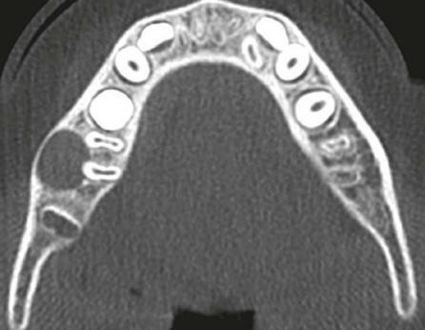  Source: Neville et al. (2016).

- METHODOLOGY
The guiding question for this narrative review was: “What is the effectiveness of different surgical techniques in the removal of odontogenic cysts?” Its main objective was to compare the effectiveness of the different surgical techniques used for the removal of odontogenic cysts, as well as to identify their respective advantages and disadvantages.

3.1 Eligibility Criteria

3.1.1 Inclusion Criteria
Studies that compared different surgical techniques for cyst removal, reviews on the origin and development of odontogenic cysts, clinical case reports and therapeutic approaches, randomized clinical trials, and systematic reviews with or without meta-analysis were included in this review. No restrictions were placed on language, year of publication, or publication status.

3.1.2 Exclusion Criteria

The exclusion criteria encompassed studies involving cysts of non-odontogenic origin, those unrelated to the topic, or those that diverged from the main objective of the review. Additionally, conference abstracts, letters to the editor, studies involving therapeutic approaches outside the scope of dental surgeons, and non-surgical treatment modalities were excluded from the analysis.

3.2 Databases
The scientific databases used for data collection and analysis were PubMed (via MEDLINE) and the Scientific Electronic Library Online (SciELO). The keywords used were: Odontogenic Cyst, Enucleation, Marsupialization, Removal Surgery, with or without combinations, as shown in Table 2. After database searches, the articles were imported into Microsoft Word™ 365 (Microsoft™ Ltd, Redmond, WA, USA) and organized into a table where duplicates were manually removed by reviewers AJS and RCM. In cases of disagreement, a third reviewer (JCRG) was consulted.
The keyword combination strategy was developed with the intention of promoting the widest possible screening of relevant studies while minimizing the inclusion of articles discussing other types of cysts affecting the jaw and facial bones (such as epidermoid, sebaceous, and mucous cysts), as these are beyond the scope of this work (Table 2).
Additionally, the goal was to maximize records that provided effective comparisons of surgical techniques specifically focused on odontogenic cysts.

Table 2. Search Strategy
Database | Search Strategy
PubMed (via MEDLINE) | (Odontogenic cyst AND Enucleation) OR (Odontogenic cyst AND Marsupialization) OR (Odontogenic cyst AND Removal sugery) OR (Enucleation  OR Marsupialization)
SciELO | (Odontogenic cyst AND Enucleation) OR (Odontogenic cyst AND Enucleation) OR (Odontogenic cyst AND Removal sugery) OR (Enucleation OR  Marsupialization)

3.3 Data Collection and Extraction Process
After study selection and initial analysis, reviewers AJS and RCM conducted a calibration exercise to validate the information contained in each study (title and abstract). Any situation that hindered the continuity of the analysis was resolved through discussion. In the event of persistent disagreement, a third reviewer (JCRG) was consulted for a final decision.
The initial search phase identified a total of 96 studies across the two selected databases. After removing duplicates, 85 studies remained for title and abstract screening. Following this step, 32 studies were selected based on the established eligibility criteria. The study selection process is summarized in a flowchart (Figure 1).

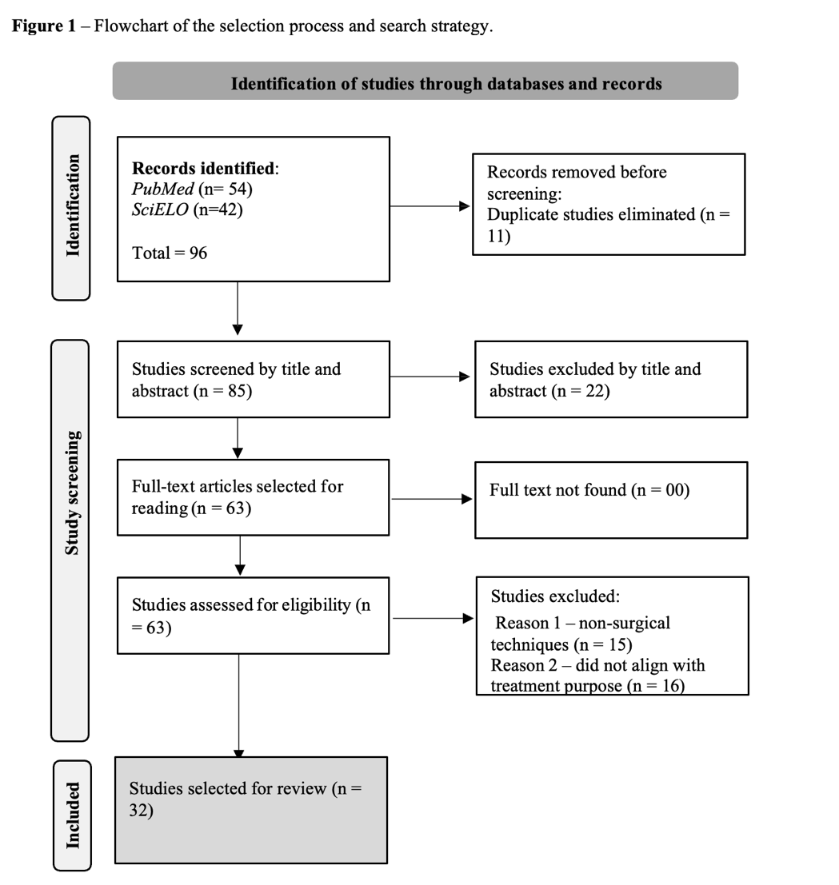

- RESULTS
The summary of the articles included in this review is presented in Table 3.
Table 3. Summary of results according to surgical technique and conclusion of each article.
Type of cyst | Author and year of publication | Study type | Surgical Technique | Conclusion
Dentigerous | Vázquez et al. (2024) | Systematic review without meta-analysis | Marsupialization and decompression | Successful treatment without recurrence
Dentigerous | Caliento et al. (2013) | Case report | Decompression + enucleation | Successful treatment without recurrence
Dentigerous | El Gaouzi Rajae et al.  (2021) | Case report | Enucleation | Successful treatment without recurrence
Gingival cyst of the newborn | Ortiz et al. (2023) | Case report | Monitoring, spontaneous regression | Successful treatment without recurrence
Gingival cyst of the adult | Mota et al. (2023) | Case report | Conservative surgical excision | Successful treatment without recurrence
Gingival cyst of the adult | Chrcanovic et al. (2019) | Systematic review without meta-analysis | Conservative surgical excision | Successful treatment without recurrence
Eruption cyst | Nagaveni et al. (2011) | Literature review and case report | Monitoring/conservative surgical intervention only in cases of pain, infection, or aesthetic concern. | Successful treatment without recurrence
Eruption cyst | Navas et al. (2010) | Case report | Monitoring | Successful treatment without recurrence
Periodontal | Chrcanovic et al. (2019) | Systematic review without meta-analysis | Conservative surgical excision | Successful treatment without recurrence
Glandular | Oliveira et al. (2020) | Case report | Marsupialization + enucleation with peripheral ostectomy | Successful treatment without recurrence
Glandular | Cano et al. (2012) | Case report | Simple enucleation and enucleation with curettage | Successful treatment without recurrence
Glandular | França et al. (2019) | Case report | Mandibular block resection with iliac crest bone graft and titanium plate | Successful treatment, but with increased morbidity and decreased patient quality of life due to rehabilitation difficulty
Calcifying | Ghorbani et al., 2025 | Case report | Enucleation | Successful treatment without recurrence
Calcifying | Santana et al., 2021 | Case report | Enucleation | Successful treatment without recurrence
Calcifying | Vizuete-Bolaños et al., 2022 | Systematic review and case report | Enucleation | Successful treatment without recurrence
Calcifying | de Arruda et al., 2018 | Literature review | Enucleation | Successful treatment without recurrence

Type of cyst | Author and year of publication | Study type | Surgical technique | Conclusion
Keratocyst | Winters et al. (2023) | Meta-analysis | Marsupialization followed by delayed enucleation with Carnoy’s solution | Successful treatment without recurrence
Keratocyst | Dioguardi et al. (2024) | Systematic review without meta-analysis | Enucleation with Carnoy’s | Successful treatment without recurrence
Keratocyst | Slusarenko da Silva et al. (2019) | Systematic review with meta-analysis | Marsupialization followed by delayed enucleation | Successful treatment without recurrence
Keratocyst | de Castro et al. (2018) | Systematic review with meta-analysis | Marsupialization followed by delayed enucleation | Successful treatment without recurrence
Keratocyst | Spivakovsky et al. (2019) | Case report | Marsupialization followed by delayed enucleation | Successful treatment without recurrence
Keratocyst | Blanas et al. (2000) | Systematic review without meta-analysis | Block resection | Successful treatment without recurrence; increased morbidity and worse quality of life
Keratocyst | Oginni et al. (2023) | Systematic review without meta-analysis | Algorithm developed did not suggest a specific technique but recommended individualized analysis for each case | Individualized analysis for each patient
Keratocyst | Al-Moraissi et al. (2016) | Systematic review with meta-analysis | Marsupialization followed by delayed enucleation | Successful treatment without recurrence
Keratocyst | Kaczmarzyk et al. (2012) | Systematic review without meta-analysis | Resection and enucleation with peripheral ostectomy combined with Carnoy’s solution | Successful treatment without recurrence; increased morbidity and worse quality of life
Keratocyst | Brancher et al. (2020) | Case report | Decompression followed by delayed enucleation | Successful treatment without recurrence
Keratocyst | Freitas et al. (2015) | Case report | Enucleation with curettage and Carnoy’s solution | Successful treatment without recurrence
Keratocyst | Stoelinga et al. (2023) | Literature review | Enucleation with Carnoy’s solution | Successful treatment without recurrence
Keratocyst | Walsh et al. (2022) | Case report | Marsupialization + block resection with Carnoy’s solution | Successful treatment without recurrence; increased morbidity and worse quality of life
Radicular | Deshmukh et al. (2014) | Case report | Enucleation | Successful treatment without recurrence
Radicular | Kocyigit et al. (2012) | Comparative study |  | Successful treatment without recurrence
  Enucleation by
  piezo surgery
Buccal bifurcation | Lima et al. (2019) | Systematic review and case report | Enucleation | Successful treatment without recurrence
As shown in Table 3, there are multiple possible surgical approaches for treating the same type of odontogenic cyst. This therapeutic multiplicity is justified by the presence of clinical and anatomical variables that cannot be accurately predicted, such as the extent of the lesion, its location, and the size of the cystic capsule (Oginni et al., 2022). Thus, the combination of these factors directly influences both treatment choice and patient prognosis (Santosh et al., 2020).
Given this, it is essential that the dental surgeon conducts a thorough anamnesis, along with the request for appropriate complementary examinations, in order to support clinical decision-making (Al-Moraissi et al., 2023). The goal should be to select the therapeutic approach that provides the best possible outcome, minimizing risks of morbidity and recurrence, and, when indicated, integrating a plan for functional and aesthetic rehabilitation (Hupp et al., 2009).
Simple enucleation was mentioned on seven occasions as a standalone treatment for odontogenic cysts (Deshmukh et al., 2014; de Arruda et al., 2018; Lima et al., 2019; Santana et al., 2021; Rajae et al., 2021; Vizuete-Bolaños et al., 2022; Ghorbani et al., 2025). On the other hand, marsupialization was never indicated as an isolated technique, always being combined with other therapeutic approaches. This is due to its limitation in not allowing complete removal of the cystic capsule, functioning primarily to decompress the lesion and promote subsequent bone regeneration (Dioguardi et al., 2024).
The combination of marsupialization followed by enucleation was reported four times among the different types of odontogenic cysts (Al-Moraissi et al., 2016; de Castro et al., 2018; Silva et al., 2019; Spivakovsky et al., 2019). More complex techniques, such as isolated block resection, were cited once (Blanas et al., 2000), and enucleation with irrigation using Carnoy’s solution was also reported once (Stoelinga et al., 2023).
Other invasive techniques were reported only once: marsupialization + block resection with application of Carnoy’s solution (Walsh et al., 2022); enucleation with bone curettage and application of Carnoy’s solution (Freitas et al., 2015); and resection and enucleation with peripheral osteotomy combined with application of Carnoy’s solution (Kaczmarzyk et al., 2012).
Only the odontogenic keratocyst and the glandular odontogenic cyst were indicated for enucleation followed by bone curettage or peripheral osteotomy (Freitas et al., 2015; Oliveira et al., 2020). The neonatal odontogenic cyst, in turn, did not present any indication for surgical intervention (Ortiz et al., 2023). The eruption cyst is generally managed expectantly (clinical monitoring); however, in cases of symptoms such as pain, infection, or aesthetic impairment, conservative excision may be indicated (Nagaveni et al., 2011).
Regarding the gingival cyst of the adult and the lateral periodontal cyst, due to their low aggressiveness and limited expansive potential, conservative surgical excision has proven sufficient for effective resolution of these lesions (Chrcanovic et al., 2019).
- DISCUSSION
Odontogenic cysts are commonly encountered in the daily practice of dental surgeons (El Gaouzi Rajae et al., 2021). These are disorders that affect the gnathic bones, resulting in pathologies of developmental or inflammatory origin. The surgical removal of odontogenic cysts is a fundamental practice in dentistry, aimed at preventing possible complications and restoring the oral health of patients (Franklin et al., 2021). Various techniques are applied according to the morphological, anatomical, and behavioral characteristics of each lesion.
Simple enucleation, for example, is a traditional method that involves the complete removal of the cyst and its capsule through direct surgical access (Soares et al., 2021). Marsupialization, in turn, consists of opening the cyst wall to promote drainage of its contents and a consequent progressive reduction in volume, and it may be used as a preliminary step to complete enucleation (Soares et al., 2021). In cases of extensive lesions or those involving adjacent structures, segmental resection becomes more viable, requiring the removal of part of the surrounding bone (Araújo et al., 2018).
Other approaches such as enucleation associated with bone curettage and decompression techniques are also viable therapeutic alternatives, especially when aiming to reduce surgical aggressiveness or preserve vital structures (Tugnait et al., 2002; Vasconcelos et al., 2014). These procedures, grounded in well-established clinical principles, have proven effective in managing odontogenic cystic pathologies, promoting both functional and aesthetic recovery, as well as contributing significantly to the overall well-being of patients.
According to a study by Cobo-Vázquez et al. (2024), which conducted a systematic review to evaluate the effectiveness of conservative treatment of dentigerous cysts in pediatric patients, with a focus on the eruption of associated permanent teeth, marsupialization and decompression are good conservative alternatives when the goal is to preserve the tooth and allow for natural eruption. However, factors such as lesion location, size, patient age, and the developmental stage of the involved tooth directly influence treatment success. In the study by Caliento et al. (2013), the recommended approach differed, as the authors advocated decompression followed by enucleation as the treatment modality for these cases.
Other authors (Caliento et al., 2013; Cobo-Vázquez et al., 2024) strongly emphasize surgical planning and lesion assessment based on criteria such as size, extent, anatomical location, proximity to vital structures, and the importance of the tooth involved in the patient’s occlusion. Rajae et al. (2021) support the findings of Caliento et al. (2013) and reinforce the importance of individualized surgical planning based on risk criteria for total enucleation, adding that marsupialization is an appropriate choice for larger dentigerous cysts or those involving vital structures.
In the case of the gingival cyst of the newborn, the therapeutic modality of choice according to Ortiz et al. (2023) is observation, as the lesion tends to regress spontaneously within the first three months of life. This occurs because, after rupture of the cystic lining, the cyst epithelium fuses with the oral epithelium and its contents are released, enabling self-resolution.
Chrcanovic et al. (2019) and Mota et al. (2023) report conservative surgical removal as the protocol of choice for treating the adult gingival cyst and lateral periodontal cyst. These two cysts share some clinical similarities; however, the adult gingival cyst affects only soft tissue, while the lateral periodontal cyst presents radiolucency on radiographic examination due to its involvement with hard tissue (Neville et al., 2016). Both cysts have a mild aggressive nature, and conservative surgical excision has proven effective. However, the botryoid cyst variant exhibits distinct radiographic, clinical, and histological features and has a more destructive behavior toward periodontal tissues, with a higher recurrence rate of approximately 21.7% (Chrcanovic et al., 2019).
The chosen treatment for this case, aimed at complete lesion removal and minimizing the risk of recurrence, is enucleation followed by bone curettage or peripheral ostectomy to eliminate any residual daughter or satellite cells that could evolve into a new lesion (Chrcanovic et al., 2019).
There is consensus among authors (Navas et al., 2010; Nagaveni et al., 2011) regarding the treatment of choice for the eruption cyst, with both recommending observation and monitoring, as this cyst typically resolves spontaneously upon tooth eruption. However, Nagaveni et al. (2011) also suggest the possibility of conservative surgical intervention in specific cases where aesthetic compromise, pain, infection, or delayed eruption is present.
Regarding the glandular odontogenic cyst, due to its rarity, aggressiveness, and high recurrence potential (Cano et al., 2012), three studies (Cano et al., 2012; França et al., 2019; Oliveira et al., 2020) agree on the need for thorough diagnostic assessment, including radiographs and CT scans, to evaluate proximity to vital structures, lesion extent, location, and size. These criteria guided their therapeutic decisions.
In the study by Oliveira et al. (2020), the authors opted for marsupialization followed by delayed enucleation and peripheral ostectomy, justified by the close contact of the lesion with the inferior alveolar nerve. Immediate simple enucleation could have resulted in nerve damage and subsequent paresthesia. However, as cited in the article, marsupialization enables decompression of the cystic capsule, promoting bone regeneration and facilitating a more conservative enucleation.
Conversely, Cano et al. (2012) suggested immediate simple enucleation combined with peripheral ostectomy. Given the aggressive nature of the cyst, the study by França et al. (2019) presented a more extensive and severe case, with signs of significant mobility, root resorption, and a large multilocular lesion with cortical bone expansion. In this scenario, due to the extensive tissue destruction caused by the cyst, the authors chose an extremely invasive and aggressive approach: mandibular resection with iliac crest bone grafting followed by rehabilitation with a titanium plate. Both authors agree on the necessity of long-term follow-up to monitor for recurrence, although none of the studies reported recurrence in their cases.
The choice of the ideal therapeutic modality for the treatment of Calcifying Odontogenic Cyst (COC) is greatly influenced by the clinical, radiographic, and histopathological characteristics of the lesion, as well as the patient profile and the extent of bone involvement (de Arruda et al., 2018; Santana et al., 2021; Bolaños et al., 2022; Ghorbani et al., 2025). In the reviewed literature, there is no absolute consensus on a standard surgical approach, with treatment decisions being primarily based on the individualization of each case.
In the study conducted by de Arruda et al. (2018), the authors analyzed a large sample of 268 cases of COC, demonstrating that, despite the variable clinical behavior, most lesions were treated with simple surgical enucleation, which was considered effective in cases where the lesion did not compromise vital structures and had well-defined borders. This approach offers advantages such as reduced morbidity and preservation of adjacent tissues. However, in cases of aggressive or extensive lesions, the risk of recurrence is considerable.
In the study by Bolaños et al. (2022), which presented the association of COC with compound odontoma, enucleation was also the chosen therapeutic modality in most reviewed cases, reinforcing the applicability of this technique for well-delimited lesions. The main justification for this choice was the low recurrence rate observed, especially when accompanied by proper removal of the pathological content. Nevertheless, early diagnosis and lesion size remain decisive factors for the success of the conservative approach.
On the other hand, Santana et al. (2021) reported a case of a large COC located in the posterior maxilla, whose size initially justified a conservative approach through decompression, followed later by enucleation. This strategy allowed for lesion volume reduction, minimizing the risk of surgical complications, and preserving bone and anatomical structures. The main disadvantage of this two-step approach is the prolonged treatment duration and the need for strict clinical follow-up. Ghorbani et al. (2025) reinforced the effectiveness of simple enucleation as a surgical technique for treating COC after a definitive histopathological diagnosis. Enucleation proved to be effective for well-defined lesions, with satisfactory postoperative recovery, although, as emphasized by the authors (de Arruda et al., 2018; Santana et al., 2021; Bolaños et al., 2022; Ghorbani et al., 2025), long-term follow-up is essential to reduce the risk of recurrence.
According to the meta-analysis by Al-Moraissi et al. (2023), enucleation associated with adjuvant therapies, such as Carnoy's solution or cryotherapy, in the treatment of odontogenic keratocysts (OKCs), shows significantly lower recurrence rates than simple enucleation alone. The main advantage of this approach is the elimination of residual cells that may be responsible for recurrence. However, the use of chemical agents or physical adjuncts may increase local morbidity, delay bone regeneration, and potentially damage adjacent structures.
Conversely, marsupialization, a more conservative technique, was highlighted in the studies by de Castro et al. (2018) and Dioguardi et al. (2024) as a valid option for extensive lesions, promoting cystic volume reduction before secondary enucleation. This approach favors the preservation of important anatomical structures, reducing surgical morbidity and allowing for faster rehabilitation. However, the downside is a longer treatment duration, the need for prolonged follow-up, and the risk of intraoral infection. Silva et al. (2019) showed that the combination of marsupialization followed by enucleation yields better outcomes than either technique alone, with intermediate recurrence rates.
In comparison, more radical techniques, such as segmental resection or procedures like Le Fort I osteotomy (Brancher et al., 2020), are reserved for extensive, multilocular, or recurrent lesions in OKCs. The advantage of these approaches lies in near-complete disease control, with recurrence rates below 5% (Blanas et al., 2000; Oginni et al., 2023). However, their biological cost is high, as they create large bone defects, require grafts, and demand complex prosthetic rehabilitation, severely impacting patients’ quality of life. Kaczmarzyk et al. (2012) emphasized conservative procedures such as simple enucleation, which tend to show recurrence rates between 17% and 56%, whereas more aggressive approaches reduce these figures to below 10%. Still, the balance between surgical aggressiveness and functional preservation is critical for therapeutic decision-making.
Regarding postoperative quality of life, Ribeiro-Júnior et al. (2017) highlighted that conservative techniques are superior in terms of maintaining masticatory function and facial aesthetics, facilitating social reintegration and simplifying rehabilitation processes. High-morbidity surgical techniques, though effective for disease eradication, often require complex reconstructive procedures, increasing treatment time and costs.
Spivakovsky et al. (2018) emphasized that the ideal treatment for lesions such as OKCs must be individualized, considering lesion size, patient age, anatomical location, and functional expectations. Conservative methods such as marsupialization may be preferred for large lesions in young patients, while enucleation with adjuvants is indicated for smaller or more aggressive lesions. It is also important to note that early or late recurrence is an intrinsic feature of OKCs due to the presence of residual odontogenic epithelial rests.
The systematic review on OKCs conducted by Al-Moraissi et al. (2016) found that isolated marsupialization has higher recurrence rates compared to enucleation with adjuvants, supporting the combined use of techniques.
Freitas et al. (2015) emphasized that the choice of surgical technique must also consider the possibility of functional and aesthetic rehabilitation, a crucial aspect of long-term quality of life. Mutilating surgeries, although effective, should be reserved for extreme cases where preservation is not feasible.
Deshmukh et al. (2014) presented a case differentiating a true radicular cyst from a pocket radicular cyst, noting that the latter is typically treated endodontically because its capsule is open and in direct contact with the root foramen. Histopathological analysis confirmed a true radicular cyst, meaning the cystic cavity was entirely enclosed by epithelium. Radiographic analysis showed no involvement of vital structures, so the authors chose simple enucleation of the lesion and extraction of the associated tooth. Follow-up showed bone regeneration without recurrence.
In the study by Kocyigit et al. (2012), piezosurgery was compared with conventional surgery in the enucleation of radicular cysts, aiming to assess efficacy and complications associated with each technique. Evaluation criteria included intraoperative bleeding, soft tissue damage, handling complexity, cyst lining perforation, and procedure duration. Results showed that the piezosurgery group had no significant complications, although the surgery took longer than expected. In contrast, the conventional surgery group experienced intraoperative bleeding, cyst lining perforation, incomplete enucleation, postoperative bleeding, and recurrence. Piezosurgery, characterized by ultrasonic microvibrations, allows for precise bone cuts with minimal damage to adjacent tissues. This technique proved to be more conservative and with fewer risks of complications and adverse events compared to conventional surgery, as noted by Deshmukh et al. (2014).
In the study by Lima et al. (2019), a case of buccal bifurcation cyst (BBC) associated with a partially erupted lower right first molar was reported. The chosen treatment approach was surgical enucleation of the lesion while preserving the involved tooth. This conservative surgical intervention was justified by the inflammatory and self-limiting nature of BBC, which favors lesion resolution without the need for tooth extraction.
Among the advantages of this approach are the maintenance of masticatory function, preservation of the dental arch, and the minimization of psychosocial impacts due to early permanent tooth loss in young patients. Additionally, the literature reviewed by the authors reaffirms the effectiveness of isolated enucleation, showing low recurrence rates and good postoperative bone regeneration. However, this therapeutic strategy requires an accurate diagnosis supported by clinical, radiographic, and histopathological exams to avoid inadequate treatment. Furthermore, long-term postoperative follow-up is essential to monitor bone healing and detect early signs of recurrence. The study highlights the need for future research with standardized methodologies, as heterogeneity in surgical indications and study designs remains a major limitation.
- CONCLUSION
The choice of the most effective surgical technique for each type of Odontogenic Cyst must be individualized, taking into account a well-structured anamnesis and the use of complementary exams such as radiographs, CT scans, blood tests, and histopathological analysis. Consequently, a thorough evaluation of these exams will guide the dental surgeon in selecting the technique with the highest success rate and the lowest recurrence and morbidity rates, aiming, whenever possible, for a more conservative approach that allows for better recovery and rehabilitation of the patient.
Due to the wide variability among Odontogenic Cysts and the potential for overlapping features between them, selecting a single surgical technique often becomes unfeasible. Several factors—such as the lesion’s extent, location, distribution, size, and proximity to vital structures—hinder the standardization of studies attempting to determine the best technique for each case, highlighting the need for further research with rigorous methodologies.
Disclaimer (Artificial intelligence)
Option 1:
Author(s) hereby declare that NO generative AI technologies such as Large Language Models (ChatGPT, COPILOT, etc.) and text-to-image generators have been used during the writing or editing of this manuscript.

REFERENCES
AL-MORAISSI EA, KAUR A, GOMEZ RS, ELLIS E 3rd. Effectiveness of different treatments for odontogenic keratocyst: a network meta-analysis. Int J Oral Maxillofac Surg. 2023 Jan;52(1):32-43. DOI: 10.1016/j.ijom.2022.09.004. Epub 2022 Sep 21.

AL-MORAISSI EA, DAHAN AA, ALWADEAI MS, OGINNI FO, AL-JAMALI JM, ALKHUTARI AS, AL-TAIRI NH, ALMAWERI AA, AL-SANABANJ JS. What surgical treatment has the lowest recurrence rate following the management of keratocystic odontogenic tumor? A large systematic review and meta-analysis. J Craniomaxillofac Surg. 2017 Jan;45(1):131-144. DOI: 10.1016/j.jcms.2016.10.013. Epub 2016 Oct 31.

AL-KHUDHAIR, B. et al. Bilateral dentigerous cysts and ectopic teeth in the maxillary sinuses: a case report and literature review. International Journal of Surgery Case Reports, v. 55, p. 117–120, 2019.

ANDERSON, R. A. Eruption cysts: a retrograde study. Journal of Dentistry for Children, v. 57, p. 124–127, 1990.

ARAÚJO, L. B.; CABRAL, L. A.; MENEZES, A. M. Ressecção segmentar de cistos odontogênicos: relato de caso. Revista Brasileira de Odontologia, v. 75, n. 2, p. 99–102, 2018.

BILODEAU, E. A.; COLLINS, B. M. Odontogenic cysts and neoplasms. Surgical Pathology Clinics, v. 10, n. 1, p. 177–222, 2017.

BILODEAU, E. A.; HUNTER, K. D. Odontogenic and developmental oral lesions in pediatric patients. Head and Neck Pathology, v. 15, n. 1, p. 71–84, 2021.

BHASKAR, S. N.; LASKIN, D. Gingival cysts: report of three cases. Oral Surgery, Oral Medicine, Oral Pathology, v. 8, n. 8, p. 803–807, 1955.

BLANAS N, FREUND B, SCHWARTZ M, FURST IM. Systematic review of the treatment and prognosis of the odontogenic keratocyst. Oral Surg Oral Med Oral Pathol Oral Radiol Endod. 2000 Nov;90(5):553-8. DOI: 10.1067/moe.2000.110814. PMID: 11077375.

BODNER, L. Cystic lesions of the jaws in children. International Journal of Pediatric Otorhinolaryngology, v. 62, p. 25–29, 2002.

BOJ, J. R.; GARCIA-GODOY, F. Multiple eruption cysts: report of case. Journal of Dentistry for Children, v. 67, p. 282–284, 2000.

BRANCHER, G. Q. B et al . Removal of Odontogenic Keratocyst in Maxilla Through the Le Fort I Osteotomy. Int. J. Odontostomat., Temuco, v. 14, n. 2, p. 249-256, jun. 2020.

BUCHNER, A. The central (intraosseous) calcifying odontogenic cyst: an analysis of 215 cases. Journal of Oral and Maxillofacial Surgery, v. 49, n. 4, p. 330–339, 1991.

CALIENTO, R., MANNARINO, F. S., & Hochuli-Vieira, E. (2013). Cisto dentígero: modalidades de tratamento. Revista De Odontologia Da UNESP, 42(6), 458–462.

CANO J, BENITO DM, MONTÁNS J, Rodríguez-Vázquez JF, CAMPO J, COLMENERO
C. Glandular odontogenic cyst: two high-risk cases treated with conservative approaches. J Craniomaxillofac Surg. 2012 Jul;40(5):e131-6. DOI: 10.1016/j.jcms.2011.07.005. Epub 2011 Aug 23.

COBO-VÁZQUEZ C, FERNÁNDEZ-GUTIÉRREZ L, PÉREZ-FERNÁNDEZ B, SÁNCHEZ-LABRADOR L, MARTÍNEZ-RODRÍGUEZ N, MARTÍNEZ-GONZÁLEZ JM, MENIZ-GARCÍA C. Effectiveness of conservative treatment of dentigerous cyst in the pediatric patient: A systematic review. J Stomatol Oral Maxillofac Surg. 2024 Oct 13;126(4):102115. DOI: 10.1016/j.jormas.2024.102115.

CHRCANOVIC, B. R.; GOMEZ, R. S. Gingival cyst of the adult, lateral periodontal cyst, and botryoid odontogenic cyst: an updated systematic review. Oral Diseases, v. 25, n. 1, p. 26– 33, 2019.

CHRCANOVIC BR, GOMEZ RS. Recurrence probability for keratocystic odontogenic tumors: An analysis of 6427 cases. J Craniomaxillofac Surg. 2017 Feb;45(2):244-251.DOI: 10.1016/j.jcms.2016.11.010. Epub 2016 Nov 19. PMID: 28011178.

COUNTS, A. L. et al. An aggressive dentigerous cyst in a seven-year-old child. ASDC Journal of Dentistry for Children, v. 68, p. 268–271, 2001.

DAS, S.; DAS, A. K. A review of pediatric oral biopsies from a surgical pathology service in a dental school. Pediatric Dentistry, v. 15, n. 3, p. 208–211, 1993.

DA SILVA, L. P. et al. Epidemiologic study of odontogenic and non-odontogenic cysts in children and adolescents of a Brazilian population. Medicina Oral Patología Oral y Cirugía Bucal, v. 23, n. 1, p. e49–e53, 2018.

de ARRUDA JAA, SCHUCH LF, ABREU LG, SILVA LVO, MONTEIRO JLG, PINHO RF, SILVA LP, de SOUSA SC, de ANDRADE BAB, ROMANACH MJ, de Qc LOURENÇO S, BATISTA AC, de MENDONÇA EF, MARTINS MD, RADOS PV, RIVEIRO ER, de SOUZA LB, PINHEIRO MDG, GOMES APN, VASCONSELOS ACU, SOBRAL APV,
MESQUITA RA. A multicentre study of 268 cases of calcifying odontogenic cysts and a literature review. Oral Dis. 2018 Oct;24(7):1282-1293. DOI: 10.1111/odi.12906. Epub 2018 Jun 29. PMID: 29856507.

de CASTRO MS, CAIXETA CA, de CARLI ML, Ribeiro Júnior NV, MIYAZAWA M, PEREIRA AAC, SPERANDINO FF, HANEMANN JAC. Conservative surgical treatments for nonsyndromic odontogenic keratocysts: a systematic review and meta-analysis. Clin Oral Investig. 2018 Jun;22(5):2089-2101. DOI: 10.1007/s00784-017-2315-8. Epub 2017 Dec 20.

DIAZ de ORITIZ LE, MENDEZ MD. Palatal and Gingival Cysts of the Newborn. 2023 Mar 24. In: StatPearls [Internet]. Treasure Island (FL): StatPearls Publishing; 2025 Jan–. PMID: 29630229.

DIOGUARDI M, QUARTA C, SOVERETO D, CALORO GA, Ballini A, AIUTO R, MARTELLA A, Lo MUZIO L, Di CONSOLA M. Factors and management techniques in odontogenic keratocysts: a systematic review. Eur J Med Res. 2024 May 15;29(1):287. DOI: 10.1186/s40001-024-01854-z.

DUHAN, R. et al. Dentigerous cyst in maxillary sinus region: a rare case report and outline of clinical management for pediatric dentists. IOSR Journal of Dental and Medical Sciences, v. 14, n. 8, p. 84–88, 2015.

DUTRA, S. N. et al. Immunoexpression of Wnt/β-catenin signaling pathway proteins in ameloblastoma and calcifying cystic odontogenic tumor. Journal of Clinical and Experimental Dentistry, v. 9, n. 1, p. e136–e140, 2017.

EL GAOUZI, R. et al. Dentigerous cyst: enucleation or marsupialization? (A case report). Pan African Medical Journal, v. 40, n. 149, 2021. DOI: 10.11604/pamj.2021.40.149.28645.

EL-NAGGAR, A. K. et al. The fourth edition of the head and neck World Health Organization blue book: editors’ perspectives. Human Pathology, v. 66, p. 10–12, 2017.

FRANÇA GM, FREITAS CTS, ALMEIDA LF, MOREIRA LC, GOMES PP, GALVÃO HC. Glandular odontogenic cyst: report of an unusual case in the posterior mandible. J Bras Patol Med Lab [Internet]. 2019Nov;55(6):683–92. Available from: https://doi.org/10.5935/1676- 2444.20190061

FRANKLIN, J. R. B. et al. Epidemiological evaluation of jaw cysts according to the new WHO classification: a 30-year retrospective analysis. Brazilian Oral Research, v. 35, p. e129, 2021.

FREGNANI, E. R. et al. Calcifying odontogenic cyst: clinicopathological features and immunohistochemical profile of 10 cases. Journal of Oral Pathology and Medicine, v. 32, p. 163–170, 2003.

FROMM, A. Epstein’s pearls, Bohn’s nodules and inclusion-cysts of the oral cavity. Journal of Dentistry for Children, v. 34, n. 4, p. 275–287, 1967.

GHANDOUR, L.; BAHMAD, H. F.; BOU-ASSI, S. Conservative treatment of dentigerous cyst by marsupialization: a case report and review of the literature. Case Reports in Dentistry, v. 2018, Article ID 7621363.

GIBSON, G. M. Case report: a large radicular cyst involving the entire maxillary sinus. General Dentistry, v. 50, p. 80–81, 2001.

GIUNTA, J. L. Gingival cysts in the adult. Journal of Periodontology, v. 73, n. 7, p. 827– 831, 2002.
GHORBANI F, AMIRI MA, FARAHMAND MM, AFZOUN S, PAKNAHAD M. Calcifying Odontogenic Cyst in Posterior Maxilla: A Case Report. J Dent (Shiraz). 2025 Mar 1;26(1):88-94. DOI: 10.30476/dentjods.2024.102636.2375. PMID: 40092548; PMCID: PMC11909402.

HUNTER, R. B. et al. Bilateral odontogenic keratocysts of the maxillary sinus. American Journal of Otolaryngology, v. 17, n. 4, p. 269–271, 1996.

IRANI, S.; FOROUGHI, F. Histologic variants of calcifying odontogenic cyst: a study of 52 cases. Journal of Contemporary Dental Practice, v. 18, n. 8, p. 688–694, 2017.

IRFAN, M. et al. Big radicular cyst in a 12 year old girl: a case report. International Medical Journal, v. 6, p. C5, 2007.

JONES, A. V.; CRAIG, G. T.; FRANKLIN, C. D. Range and demographics of odontogenic cysts diagnosed in a UK population over a 30-year period. Journal of Oral Pathology and Medicine, v. 35, n. 8, p. 500–507, 2006.

KAZMARZYK T, MOJSA I, STYPULKOWSKA J. A systematic review of the recurrence rate for keratocystic odontogenic tumour in relation to treatment modalities. Int J Oral Maxillofac Surg. 2012 Jun;41(6):756-67. DOI: 10.1016/j.ijom.2012.02.008. Epub 2012 Mar 23. PMID: 22445416.

KRISHNAMURTHY, V. et al. Radicular cyst masquerading as a multilocular radiolucency. Quintessence International, v. 44, p. 71–73, 2013.

LEDESMA-MONTES, C. et al. International collaborative study on ghost cell odontogenic tumours. Journal of Oral Pathology and Medicine, v. 37, p. 302–308, 2008.

LETYCIA MARIA LOPES DE OLIVEIRA,GABRIELLA MENDES,OLIVEIRA,SERGIO VITORINO CARDOSO,FLAVIANA SOARES ROCHA,JOÃO CÉSAR GUIMARÃES HENRIQUES. GLANDULAR ODONTOGENIC CYST SURGICAL TREATMENT BY MARSUPIALIZATION AND ENUCLEATION: CASE REPORT; Rev Odontol Bras Central 2020; 29(88): 69-72 72 DOI: 10.36065/robrac.v29i88.1262

LEWIS, D. M. Bohn’s nodules, Epstein’s pearls, and gingival cysts of the newborn: a new etiology and classification. Journal of Oklahoma Dental Association, v. 101, n. 3, p. 32–33, 2010.

LIMA, I. F. P. et al. RANK, RANKL, and OPG in Dentigerous Cyst, Odontogenic Keratocyst, and Ameloblastoma: A Meta-Analysis. Brazilian Dental Journal, v. 32, n. 1, p. 16–25, 2021.

MADRAS, J.; LAPOINTE, H. Keratocystic odontogenic tumour: reclassification of the odontogenic keratocyst from cyst to tumour. Journal of the Canadian Dental Association, v. 74, n. 2, p. 165–165h, 2008.

MARINI, R. et al. Unusual symptomatic inclusion cysts in a newborn: a case report. Journal of Medical Case Reports, v. 8, p. 314, 2014.

MOTA, M. E. et al. Gingival cyst of the adult. Autopsy and Case Reports, v. 13, p. e2023454, 2023.

NAAVENI, N B; UMASHANKARA, K V1; RADHIKA, N B2; MAJ Satisha, T S3. Eruption cyst: A literature review and four case reports. Indian Journal of Dental Research 22(1):p 148-151, Jan–Feb 2011. | DOI: 10.4103/0970-9290.79982

NAVAS, R. M. A.; MENDOZA, M. G. M. Congenital eruption cyst. Pediatric Dermatology, v. 27, n. 6, p. 671–672, 2010.

NEVILLE, B. W. et al. Patologia Oral e Maxilofacial. 4. ed. Rio de Janeiro: Elsevier, 2016.

OGINNI FO, ALASSERI N., et al. An evidence-based surgical algorithm for management of odontogenic keratocyst. Oral Maxillofac Surg. 2023 Jun;27(2):201-212. DOI: 10.1007/s10006-022-01064-z. Epub 2022 Apr 27. PMID: 35476304.

RAJAE, El Gaouzi; KARIMA, El Harti. Dentigerous cyst: enucleation or marsupialization?(a case report). Pan African Medical Journal, v. 40, 2021.

RIBEIRO-JÚNIOR, O., BORBA, A. M., ALVES, C. A. F., GOUVEIA, M. M. DE ., DEBONI, M. C. Z., & NACLÉRIO-HOMEM, M. DA G.. (2017). Reclassification and treatment of odontogenic keratocysts: A cohort study. Brazilian Oral Research, 31, e98. https://doi.org/10.1590/1807- 3107bor-2017.vol31.0098.

SANTANA, L. A. M. et al.. Large calcifying odontogenic cyst in the posterior maxilla. Jornal Brasileiro de Patologia e Medicina Laboratorial, v. 57, p. e3062021,2021.

SANTOSH, A. B. R. Odontogenic cysts. Dental Clinics, v. 64, n. 1, p. 105–119, 2020.
SCULLY, C.; MALAMOS, D. Clinical Challenges Q&A: Swelling in the anterior gingivae. Diagnosis: gingival cyst. Dental Update, v. 42, n. 10, p. 981–982, 2015.

SEWARD, M. E. Eruption cyst: an analysis of its clinical features. Journal of Oral Surgery, v. 31, p. 31–35, 1973.

SHEAR, M. Cysts of the oral and maxillofacial regions. 3. ed. Boston: Wright, 1992.

SILVA, Yuri Slusarenko da. Eficácia da cirurgia conservadora na diminuição da recidiva do queratocisto odontogênico e do ameloblastoma sólido convencional/multicístico. 2019. 160 f. Tese (Doutorado em Cirurgia e Traumatologia Buco-Maxilo-Facial) – Faculdade de Odontologia, Universidade de São Paulo, São Paulo, 2019.

SLUSARENKO DA SILVA Y, STOELINGA PJW, NACLÉRIO-HOMEM MDG. Recurrence of nonsyndromic odontogenic keratocyst after marsupialization and delayed enucleation vs. enucleation alone: a systematic review and meta-analysis. Oral Maxillofac Surg. 2019 Mar;23(1):1-11. DOI: 10.1007/s10006-018-0737-3. Epub 2018 Nov 29. PMID: 30498866.

SPIVAKOVSKY S. Surgical treatments for nonsyndromic odontogenic keratocysts. Evid Based Dent. 2018 Jun;19(2):55-56. DOI: 10.1038/sj.ebd.6401309. PMID: 29930360.
STOELINGA PJW, GRILLO R, DA SILVA YS. How reliable are follow-up studies on odontogenic keratocysts? Int J Oral Maxillofac Surg. 2023 Nov;52(11):1156-1161. doi: 10.1016/j.ijom.2023.03.016. Epub 2023 Apr 17. PMID: 37076356.
TOLENTINO, E. de S. Nova classificação da OMS para tumores odontogênicos: o que mudou? Revista da Faculdade de Odontologia - UPF, v. 23, n. 1, 2018. Disponível em: https://doi.org/10.5335/rfo.v23i1.7905. Acesso em: 13 abr. 2025.

VIZUETE-BOLAÑOS MX, SALGADO-CHAVARRIA F, RAMÍREZ-MARTÍNEZ CM, RAMOS-NIETO JJ, VAZQUEZ-DÁVALOS NM. Compound odontoma associated with a calcifying odontogenic cyst. Case report and systematic review. J Stomatol Oral Maxillofac Surg. 2022 Jun;123(3):e97- e105. doi: 10.1016/j.jormas.2021.10.008. Epub 2021 Oct 21. PMID: 34687949.

WAGNER, V. P. et al. Gingival cysts of adults: retrospective analysis from two centers in South Brazil and a review of the literature. Journal of the International Academy of Periodontology, v. 17, n. 1, p. 14–19, 2015.

WALDRON, C. A. Cistos e tumores odontogênicos. In: NEVILLE, B. W. et al. Patologia Oral e Maxilofacial. Rio de Janeiro: Elsevier, 2009. p. 679–742.

YOSHIURA, K. et al. Computed tomographic features of calcifying odontogenic cysts. Dentomaxillofacial Radiology, v. 27, p. 12–16, 1998.

ZACHARIADES, N.; PAPANICOLAOU, S.; TRIANTAFYLLOU, D. Odontogenic keratocysts: review of the literature and report of sixteen cases. Journal of Oral and Maxillofacial Surgery, v. 43, n. 3, p. 177–182, 1985.

