**A Case Report on Buteyko Breathing Technique and Deep Breathing Exercises for Enhancing Cardiac and Pulmonary Outcomes Post-CABG**

**Abstract:** Background: Coronary Artery Bypass Grafting (CABG) is a common surgery for coronary artery disease (CAD), with postoperative pulmonary complications affecting 30–60% of patients. This study evaluates its effectiveness in enhancing LVEF and breath-holding time in CABG patients.

Materials and Method: A combination of deep breathing exercises and gentle limb movements was implemented in post operated CABG patient in MG Hospital Jaipur in an upright, supported seated position. The Buteyko breathing technique, involving gentle inhalation, soft exhalation, and breath-holding during exhalation, was also practiced to maintain partial lung emptiness. Breath-hold duration was recorded until the first urge to breathe, followed by nasal inhalation. This supervised intervention was performed for 20 minutes daily over seven days. Breath-hold duration was monitored daily, and ejection fraction (EF) was assessed on postoperative days 1st and 7th to evaluate the technique's impact.

Results: Significant improvements were observed in ejection fraction (EF), breath-hold duration, vital signs, Visual Analogue Scale (VAS) scores, and lung efficiency (via incentive spirometry). The combined use of the Buteyko breathing technique (BBT) and deep breathing exercises demonstrated marked effectiveness in enhancing early postoperative outcomes in an early post-operative CABG patient.

Conclusion: The Buteyko breathing technique and deep breathing exercises significantly enhanced respiratory mechanics, oxygen utilization, lung expansion, leading to improved ejection fraction (EF) and breath-hold duration. This combination demonstrated effectiveness in reducing postoperative pulmonary complications and supporting early recovery and functional outcomes in an early post-operative CABG patients.

**Key words:** Buteyko Breathing technique, Deep breathing, Ejection fraction, Breath holding time, Coronary artery bypass grafting, Coronary artery disease.

# Introduction

Coronary artery disease (CAD) remains a significant global health challenge, contributing to disability and mortality. In India, it is one of the leading causes of death, with key risk factors such as smoking, dyslipidemia, hypertension, diabetes, obesity, sedentary lifestyle, psychological stress, and inadequate nutrition accounting for over 90% of cases. This growing burden has led to approximately 140,000 coronary artery bypass graft (CABG) surgeries performed annually, highlighting the importance of cardiac interventions in CAD management1. Coronary artery disease (CAD) is the leading cause of death worldwide, responsible for ~16% of all deaths (WHO, 2023). India accounts for ~60% of the world’s cardiac disease burden, with CAD being the most prevalent. Prevalence in India: ~54.5 million people suffer from CAD (Indian Heart Association, 2023). Mortality Rate: CAD causes ~2.8 million deaths/year in India (~28% of all deaths).

The Buteyko breathing technique (BBT), based on breath control and breath-holding, aims to restore diaphragmatic breathing, offering benefits such as symptom relief, improved breath control, and enhanced oxygen delivery. Utilizing measures like control pause (CP), BBT has shown positive effects on bronchial asthma symptoms and peak expiratory flow rate (PEFR)1. Originally developed in the 1950s, BBT has recently gained recognition outside Russia and is now widely practiced in Europe, Australia, New Zealand, and the USA. Scientific studies support its physiological principles, with Osborne et al. demonstrating that stable mild asthmatic patients have significantly lower resting CO₂ levels than healthy controls¹,⁶. Although, Deep breathing exercises complement non-invasive therapies, positively influencing conditions such as insomnia, cardiac autonomic function, depression, anxiety, hypertension, and lung diseases. By balancing physiological functions, such as consciousness unconsciousness and sympathetic-parasympathetic system activity—these exercises promote relaxation and recovery. Regular practice has been found to reduce insomnia, with Chien et al. confirming that cognitive behavioral intervention combined with breathing relaxation enhances sleep quality and heart rate variability in patients with major depression. Additionally, deep breathing exercises play a crucial role in preventing postoperative pulmonary complications following cardiac surgery².

Globally, CAD is the leading cause of mortality, with premature cardiovascular-related deaths in India increasing by 59%, from 23.2 million in 1990 to 37 million in 2010. The primary cause of myocardial ischemia is atherosclerosis in epicardial coronary arteries, which impairs myocardial perfusion, reduces ventricular systolic function, and decreases overall functional capacity. As a result, revascularization surgeries have become more common, with CABG accounting for over 60% of all procedures and approximately 25,000 surgeries performed annually. By creating alternative pathways for blood flow, CABG restores cardiac function and alleviates myocardial ischemia³,⁴.

National guidelines strongly recommend cardiac rehabilitation (CR) after CABG. U.S. surveys describe CR as a structured program incorporating medical assessment, monitored exercise training, and counseling for heart disease patients³,⁴. Left ventricular ejection fraction (LVEF), a well-established clinical indicator of myocardial contractility and prognosis in acute myocardial infarction, plays a crucial role in determining long-term outcomes. As the core component of cardiac rehabilitation, exercise training significantly aids in secondary prevention of CAD³,⁴. As Postoperative pulmonary complications (PPCs) occur in 30–60% of CABG patients and are a major contributor to morbidity, mortality, and prolonged hospitalization⁵. The Breath-holding time serves as a reliable indicator of optimal lung expansion, oxygenation, and the absence of pulmonary complications, making it an essential parameter in post-CABG recovery⁵.

## **Case Presentation**

**Patient Information**

A 61-year-old male patient admitted in the CTVS dept. of Mahatma Gandhi Hospital, Jaipur, Rajasthan presented with a history of chronic asthma for 15–20 years. The patient had experienced an asthma exacerbation, characterized by shortness of breath, sputum production, and cough 15–20 days prior to surgery. Additionally, he had a 3–4year history of type 2 diabetes mellitus (T2DM), managed with Glimepiride, Metformin for 15–20 years, and a long-standing history of hypertension. Notably, there was no reported history of chest or limb pain.

**Diagnostic Investigations & Interpretation**

**Preoperatively**, A 2D-Echo showed, the patient had **ejection fraction (EF) of 33%**, grade 1 left ventricular (LV) systolic dysfunction at rest, hypokinetic distal septum and LV apex, trivial tricuspid regurgitation (TR)., leading to diagnoses of coronary artery disease (CAD) and dilated cardiomyopathy (DCMP).

Post-left ventricular angiography, the patient was found to have significant arterial occlusions, including 90% stenosis of the right coronary artery (RCA), 80% stenosis of the left circumflex artery (LCX), 95% stenosis of the left anterior descending artery (LAD), 95% stenosis of the first obtuse marginal artery (OM1), and 90% stenosis of the posterior descending artery (PDA), and Troponin I was positive in preoperative investigations.

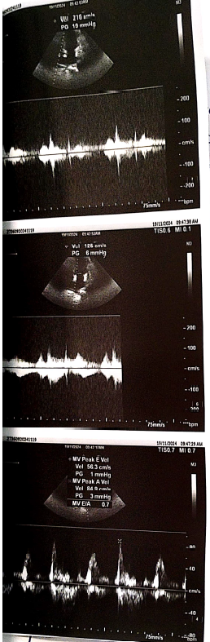

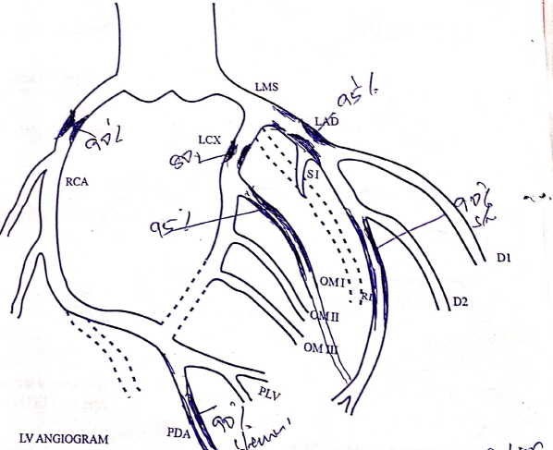

Fig.1 LV Angiography

ECG shows Sinus Rhythm with a prolonged QT interval. These findings confirmed a diagnosis of coronary artery disease (CAD) with critical triple-vessel disease.

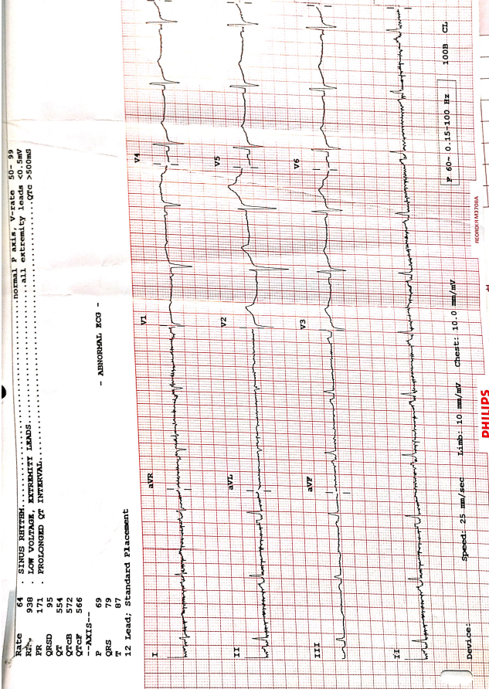

Fig.2. Pre-operative ECG of patient showed prolonged QT interval.

The patient underwent **on-pump coronary artery bypass grafting (CABG)**, with grafting performed as follows:

* Right saphenous vein graft (RSVG) to the posterior left branch (PLB) and PDA
* Left mammary artery (LMA) to the LAD.

A physiotherapist attended the patient in CVTS ICU on POD 1st ; he was on four liters of oxygen support via a simple face mask. He was anxious, nervous, and restless and complained of difficulty in breathing and pain over the suture site. On inspection, the central line, femoral line, foley catheter, and retro sternal drains were in situ.

**Postoperative assessment** included evaluation of vitals, ejection fraction, visual analogue scale (VAS) for pain, arterial blood gas (ABG) analysis, breathing pattern, New York Heart Association (NYHA) functional classification, presence of audible wheeze, chest shape, respiratory muscle use, tracheal position, symmetry of chest expansion, percussion findings, vocal fremitus, auscultation of breath sounds, chest X-ray interpretation, and incentive spirometry readings.

|  |  |  |  |  |  |  |  |  |
| --- | --- | --- | --- | --- | --- | --- | --- | --- |
| **DAYS** | **0** | **1** | **2** | **3** | **4** | **5** | **6** | **7** |
| ***HR*** |  |  |  |  |  |  |  |  |
| ***RR*** |  |  |  |  |  |  |  |  |
| ***BP*** |  |  |  |  |  |  |  |  |
| ***SPO2*** |  |  |  |  |  |  |  |  |
| ***TEMERATURE*** |  |  |  |  |  |  |  |  |
| ***EF*** |  |  |  |  |  |  |  |  |
| ***O2 SUPPORT*** |  |  |  |  |  |  |  |  |
| ***VISIUAL ANALOGUE PAIN SCALE (1-10)*** |  |  |  |  |  |  |  |  |
| ***BREATHING PATTERN*** |  |  |  |  |  |  |  |  |
| ***NYHA GRADE*** |  |  |  |  |  |  |  |  |
| ***AUDIBLE WHEEZE*** |  |  |  |  |  |  |  |  |
| ***BREATH HOLDING TIME DURATION*** |  |  |  |  |  |  |  |  |
| ***CHEST SHAPE*** |  |  |  |  |  |  |  |  |
| ***RESPIRATORY MUSCLE USE (WHICH)*** |  |  |  |  |  |  |  |  |
| ***POSITION OF TRACHEA*** |  |  |  |  |  |  |  |  |
| ***CHEST EXPANSION SYMMETRY*** |  |  |  |  |  |  |  |  |
| ***PERCUSSION*** |  |  |  |  |  |  |  |  |
| ***VOCAL FERMITIS*** |  |  |  |  |  |  |  |  |
| ***AUSCULTATION SOUNDS*** |  |  |  |  |  |  |  |  |
| ***CHEST XRAY FINDINGS*** |  |  |  |  |  |  |  |  |
| ***INCENTIVE SPITOMETER*** |  |  |  |  |  |  |  |  |

TABLE 1. Physiotherapy assessment table.

**Physiotherapy assessment done on postoperative day 1,** Upon assessment Pain on **VAS scale** was 7/10, **EF**=33%, Spirometric evaluation revealed **lung efficiency** with an inspiratory capacity of 600 cc and an equivalent expiratory volume, and the **breath holding time duration** was of 3 seconds. Also the patient exhibited an thoraco-abdominal breathing pattern and was classified as NYHA Grade 3. No audible wheeze was present, and the chest shape was observed to be normal. Accessory muscle use involved the sternocleidomastoid (SCM) and scalene muscles. The tracheal position was central. Chest expansion symmetry was reduced. Percussion revealed a dull sound over the middle lobe of the lung bilaterally. Vocal fremitus was decreased over the middle lobe bilaterally. Auscultation findings included fine crackles bilaterally in the middle lobes and reduced air entry in the lower lobes, bilaterally. Chest X-ray findings indicated a blunted costophrenic (CP) angle on the left lung.

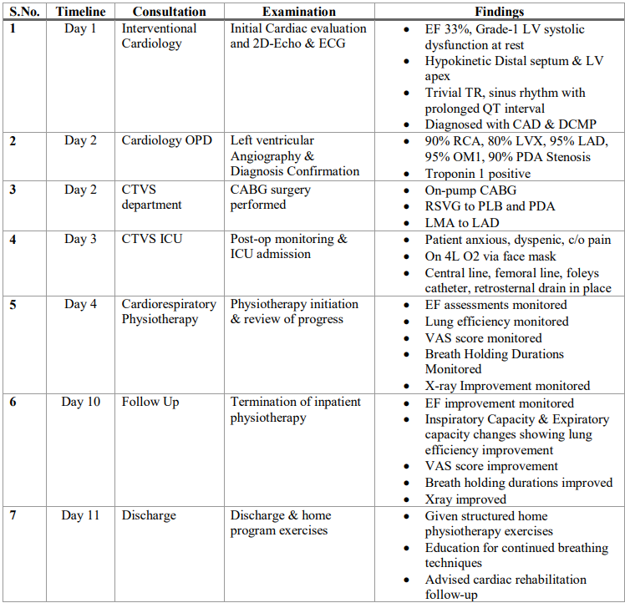TABLE 2. Timeline of Events with their findings and treatment given.

( EF – Ejection Fraction, LV – Left Ventricle, TR – Tricuspid Regurgitation, CAD – Coronary Artery Disease, DCMP – Dilated Cardiomyopathy, RCA – Right Coronary Artery, LCX – Left Circumflex Artery, LAD – Left Anterior Descending Artery, OM1 – First Obtuse Marginal Artery, PDA – Posterior Descending Artery, ECG – Electrocardiogram, CABG – Coronary Artery Bypass Grafting, RSVG – Right Saphenous Vein Graft, PLB – Posterior Left Branch, LMA – Left Mammary Artery, NYHA – New York Heart Association (Functional Classification), OPD – Outpatient Department)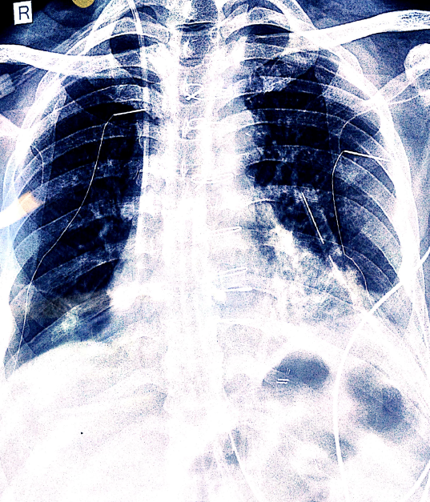

Fig.3. Post-operative day 1 chest X-Ray, sternal wires and blunt left CP angle.

**Therapeutic Interventions**

Following the post-operative assessment on Day 1, the patient underwent a structured physiotherapy intervention, incorporating the **Buteyko breathing technique and deep breathing** exercises for a duration of seven days. Throughout this period, daily physiotherapy assessments were conducted, including evaluations of ejection fraction (EF) and breath-holding duration, to monitor progressive improvements in respiratory function and cardiac efficiency. The assessments continued until post-operative Day 7, aiming to quantify the extent of improvement and reduction in post-operative pulmonary complications. This systematic approach allowed for the evaluation of pulmonary function recovery, emphasizing the role of targeted respiratory interventions in enhancing lung expansion, oxygenation, and overall post-CABG rehabilitation outcomes.

**Post-operative assessment was done on 7th Day of physiotherapy treatment,** Upon assessment Pain on **VAS scale** was 2/10, **EF**=35-40%, Spirometric evaluation revealed **lung efficiency** with an inspiratory capacity of 1200 cc and an expiratory capacity of 900cc, and the **breath holding time duration** was of 15 seconds.

Also the patient demonstrated an abdominal-thoracic breathing pattern and was classified as NYHA Grade I. No audible wheeze was detected, and the chest shape appeared normal. Examination of accessory muscle usage indicated involvement of the scalene muscle, while the tracheal position remained central.Respiratory assessment revealed increased chest expansion symmetry. Percussion findings indicated the absence of a dull sound over the middle lobe, and vocal fremitus was increased in the same region. Auscultation revealed mild fine crackles bilaterally in the middle lobes, with increased air entry in the lower lobes.Radiographic findings from the chest X-ray showed a normal costophrenic (CP) angle in the left lung.

These findings highlight the patient's pulmonary status post-CABG surgery, reflecting the impact of physiotherapy interventions on respiratory function and recovery.

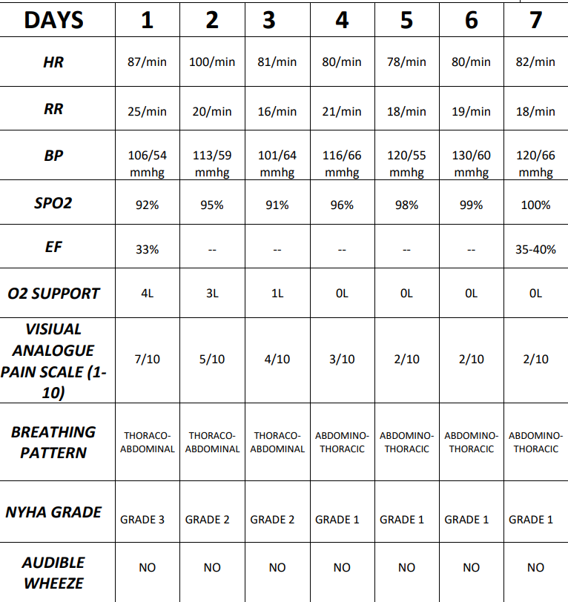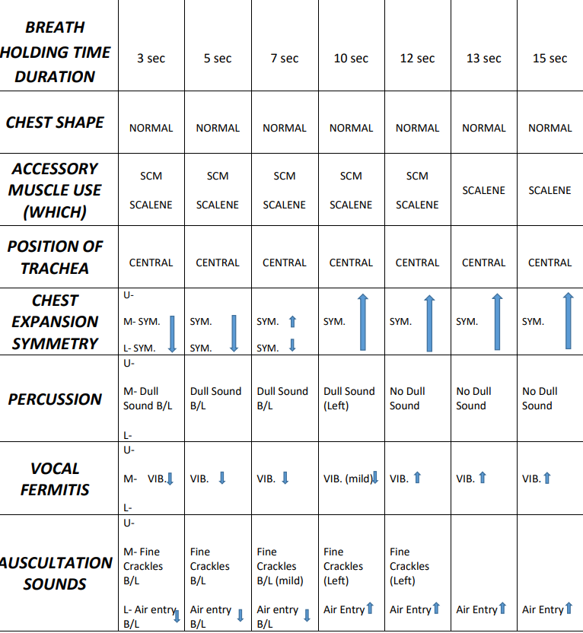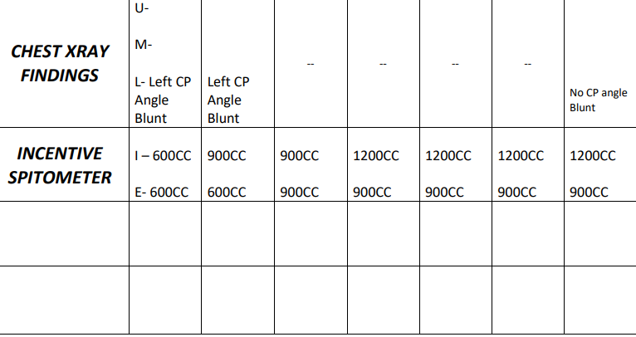

TABLE 3. Timeline of Assessments with their findings from POD1- POD7.

**Methodology**

* Deep breathing exercises, combined with gentle movements of the upper and lower limbs, were initiated. The patient was placed in an upright position in a chair, with shoulders relaxed and their lower back supported against the chair’s backrest.2 Each session consisting of 10 deep breaths with a few seconds pause between each set2.
* The Buteyko breathing technique was introduced, where the patient was instructed to perform a gentle inhalation followed by a soft exhalation1.
* During the exhalation phase, the patient held their nose, maintaining a state of partial lung emptiness without excessive depletion1. The duration, measured in seconds, during which the patient could comfortably sustain the **breath-hold** until the **initial urge to breathe was noted**, was recorded. After the breath-holding phase, the patient released their nose and inhaled through it. This sequence was repeated multiple times under guidance. for 10-15 minutes with 30 sec of rest after every 3 breath holding duration, where the breath holding duration was noted5.
* Total protocol duration: 7 days1.
* Total time for each exercise session: 20 minutes1.
* Frequency: 1 time per day1.

**Results**

Significant improvements were observed in **ejection fraction (EF) and breath-holding time duration, with additional notable positive changes in vital signs, Visual Analogue Scale (VAS) scores, and lung efficiency as assessed by the incentive spirometer**. The combined implementation of the Buteyko breathing technique (BBT) and deep breathing exercises proved highly effective in achieving these outcomes in the early postoperative period of an on-pump CABG patient.

The Buteyko breathing technique, through its controlled breathing and emphasis on breath-hold optimization, contributed to improved respiratory mechanics and enhanced oxygen utilization. Deep breathing exercises, coupled with gentle limb movements, played a critical role in promoting better lung expansion, mobilizing secretions, and enhancing overall pulmonary function.

Together, these interventions synergistically facilitated improvements in EF, highlighting their potential to enhance cardiac output and ventricular function during the critical recovery phase. The progressive increase in breath-holding time duration further demonstrated better respiratory efficiency and reduced post-surgical pulmonary complications. These results underscore the effectiveness of combining targeted respiratory exercises for early recovery and improved functional outcomes in postoperative on-pump CABG patients.

The results of this study, are presented in table format, documenting the progressive changes observed from post-operative Day 1 to Day 7 during the ongoing physiotherapy protocol. The table systematically illustrates the impact of the Buteyko breathing technique and deep breathing exercises on ejection fraction (EF), breath-holding time, and other key respiratory parameters, highlighting the gradual improvements over the seven-day intervention period, and reducing Post-Pulmonary Complications (PPCs)5.

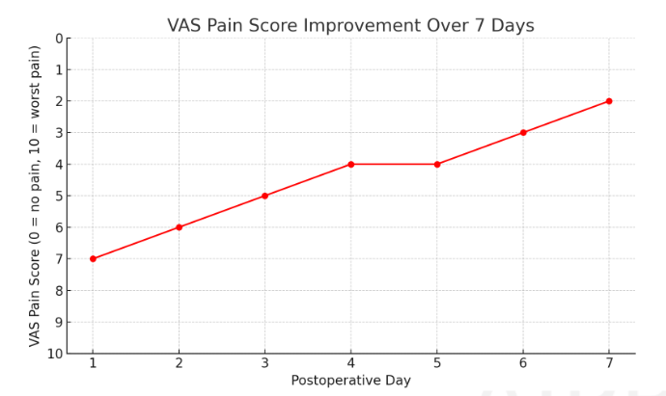

Fig.4. VAS (Visual Analog Scale) pain score graph showing an improvement from 7/10 on Day 1 to 2/10 by Day 7. The pain level consistently decreases, indicating effective pain management and recovery.

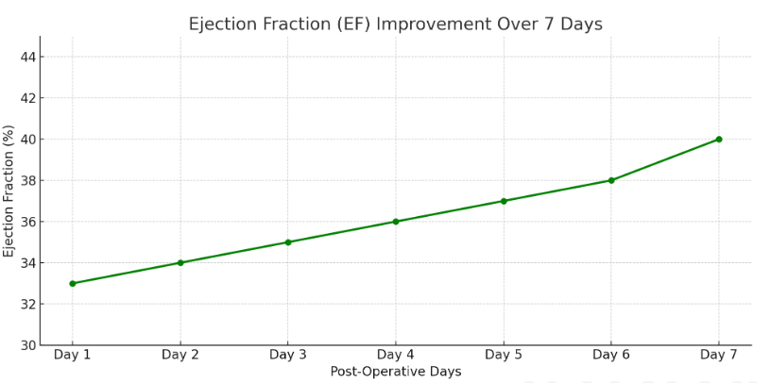

Fig.5. Improvement in Ejection Fraction (EF) from 33% on Day 1 to 40% on Day 7, demonstrating progressive cardiac function recovery during the physiotherapy rehabilitation period.

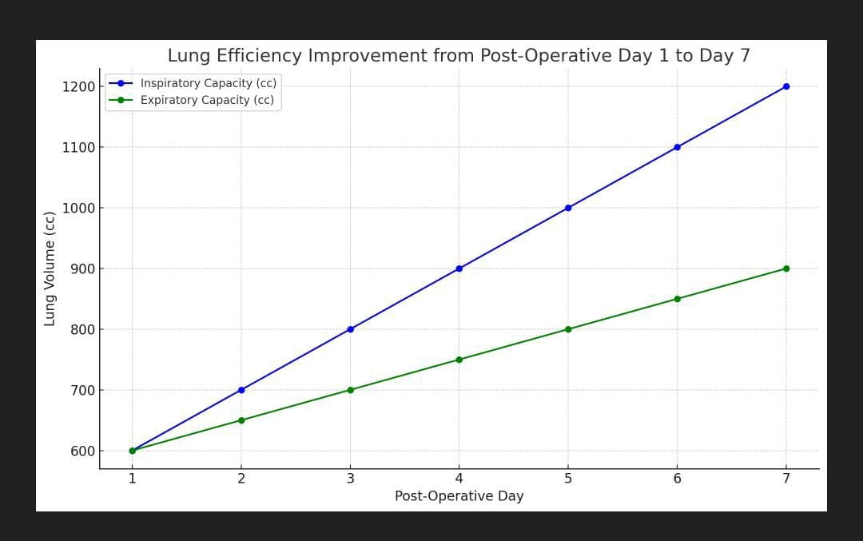

Fig.6. Improvement in Lung Efficiency from inspiratory capacity of 600cc to 1200cc and expiratory capacity of 600cc to 900cc from POD 1 to day 7.

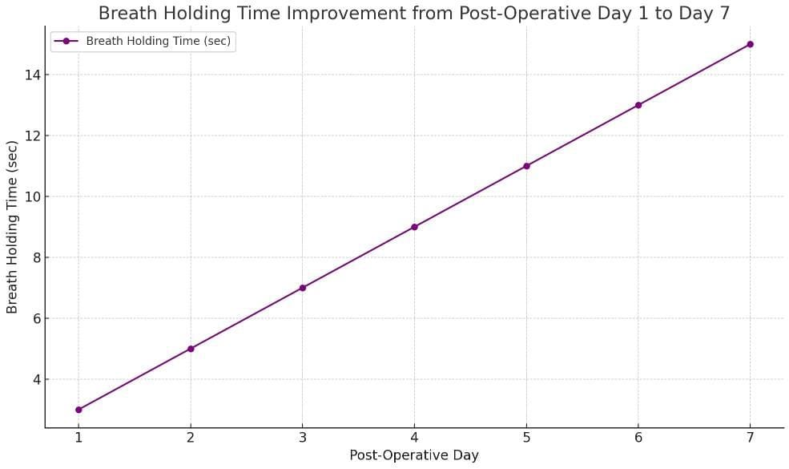

Fig.7 Breath holding time graph improvement from 3 to 15 sec from POD 1 to day 7.

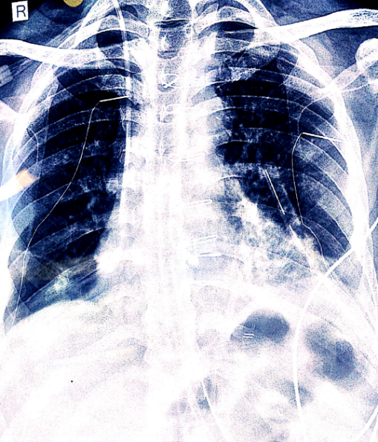

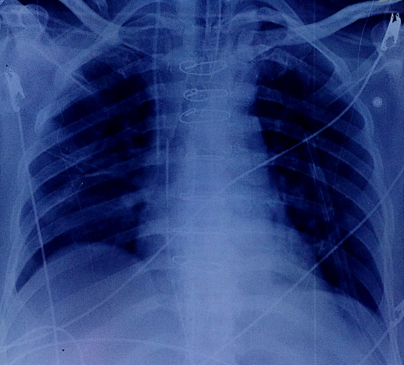

Fig.8 X-Ray Comparison POD 1 & 7.

**Discussion**

The postoperative phase following Coronary Artery Bypass Graft (CABG) surgery presents a critical period where patients are susceptible to various complications, including pulmonary dysfunction, reduced functional capacity, and impaired left ventricular ejection fraction (LVEF)3.As highlighted in multiple studies, integrating targeted respiratory therapies such as the Buteyko breathing technique and deep breathing exercises into post-CABG rehabilitation protocols has shown significant potential in enhancing patient recovery1. Result of this case study also found significant improvement in pain, Ejection fraction, breath holding time duration & pulmonary efficiency after one week of physiotherapy invention comprises of Buteyko breathing technique, deep breathing exercises and gentle limb Active range of motion exercise.

**Pulmonary Function and Postoperative Complications:**

Pulmonary complications, including atelectasis, pneumonia, and reduced lung expansion, are common concerns following CABG surgery, with incidence rates ranging between 30% and 60%1. Evidence suggests that deep breathing exercises and incentive spirometry play a fundamental role in mitigating these complications by improving lung compliance, enhancing ventilation-perfusion matching, and promoting airway clearance2. The Buteyko breathing technique, known for optimizing breath control and reducing hyperventilation, further aids in efficient gas exchange and oxygen utilization, which is crucial for early postoperative recovery1,5. Studies have demonstrated that these techniques prevent the decline in pulmonary function and reduce post-pulmonary complications, ultimately contributing to better postoperative outcomes1.Findings of above mentioned studies also supports the results of the present case study in which breathing patterns, chest expansion symmetry, auscultation sound & chest X-ray were improved and no post pulmonary complications were found.

**Cardiac Function and Rehabilitation:**

Functional capacity and LVEF serve as critical indicators of cardiac recovery in post-CABG patients. Structured cardiac rehabilitation programs, whether home-based or center-based, have demonstrated efficacy in improving these parameters3,4. The integration of deep breathing exercises into cardiac rehabilitation protocols has been associated with significant improvements in breath-holding time and chest expansion, suggesting enhanced diaphragmatic strength and endurance2,5. Additionally, studies indicate that the Buteyko breathing technique contributes to autonomic stability and improved cardiac efficiency, supporting its role as a complementary intervention in post-CABG rehabilitation. Deep breathing exercises have an obvious impact on preventing further postoperative pulmonary problems in cardiac surgery. Scientific evidence indicated that deep breathing can facilitate the oxygen transfer to cells and reduce lung problems that may occur after operations2. In our case study the cardiac efficiency was also improved in same pattern as achieved in findings of above mentioned studies.

The observed improvement in **left ventricular ejection fraction (LVEF)** following the Buteyko breathing technique (BBT) and deep breathing exercises can be attributed to several interconnected physiological mechanisms:

1. Enhanced Myocardial Oxygenation & Reduced Cardiac Workload

* Improved Oxygen Delivery: BBT emphasizes controlled, diaphragmatic breathing, which enhances alveolar ventilation and systemic oxygenation. Better oxygen saturation (SpO₂) ensures optimal myocardial oxygen supply, reducing ischemic stress on the heart.
* Decreased Sympathetic Overdrive: Slow, rhythmic breathing activates the parasympathetic nervous system, lowering heart rate and blood pressure. This reduces cardiac afterload and myocardial oxygen demand, allowing better ventricular filling and contractility.

2. Optimization of Intrathoracic Pressure & Venous Return

* Negative Intrathoracic Pressure: Deep inhalation during BBT increases negative intrathoracic pressure, improving venous return (preload) and enhancing stroke volume via the Frank-Starling mechanism.
* Controlled Exhalation & Breath-Holding: Prolonged exhalation phases prevent excessive positive intrathoracic pressure, avoiding impedance of venous return. Breath-holding at low lung volumes may also stimulate hypoxic pulmonary vasoconstriction, improving ventilation-perfusion (V/Q) matching.

3. Reduction in Pulmonary Congestion & Left Ventricular Afterload

* Decreased Pulmonary Stiffness: Post-CABG patients often have pulmonary congestion due to fluid overload and inflammation. BBT promotes lymphatic drainage and alveolar recruitment, reducing pulmonary resistance and, consequently, left ventricular afterload.
* Baroreflex Modulation: Slow breathing enhances baroreceptor sensitivity, improving autonomic balance and reducing pathological ventricular remodeling.

4. Improved Respiratory Efficiency & Diaphragmatic Function

* Strengthened Respiratory Muscles: BBT enhances diaphragmatic endurance, reducing the work of breathing and preventing respiratory fatigue-induced cardiac strain.
* Better CO₂ Tolerance: BBT increases carbon dioxide retention (mild hypercapnia), promoting Bohr effect-mediated oxygen release to tissues, including the myocardium.

**Future Directions and Recommendations:**

While the existing body of research underscores the benefits of the Buteyko breathing technique and deep breathing exercises in post-CABG rehabilitation, further large-scale randomized controlled trials are needed to establish standardized protocols and long-term efficacy1,2,6. Future studies should explore the combined effects of these breathing techniques with structured exercise rehabilitation to determine optimal intervention strategies. Additionally, investigating the impact of these techniques on specific subgroups of CABG patients, such as those with pre-existing pulmonary conditions along with sleep disorder & depression could provide deeper insights into their applicability.

Given the demonstrated benefits of targeted respiratory therapies in improving pulmonary function, cardiac efficiency, their integration into standard post-CABG rehabilitation protocols is strongly recommended. Developing structured guidelines that incorporate Buteyko breathing and deep breathing exercises into both hospital-based and home-based recovery programs may further enhance patient outcomes and reduce postoperative complications1,2,6.

**Conclusion**

The integration of the Buteyko breathing technique and deep breathing exercises proved highly effective in the early postoperative recovery of on-pump CABG patients. By optimizing breathing patterns and enhancing breath-hold control, the Buteyko technique improved respiratory mechanics, oxygen utilization, and autonomic regulation, thereby reducing postoperative hypoxemia and promoting stability. Deep breathing exercises, combined with gentle limb movements, facilitated lung expansion, improved ventilation-perfusion matching, and mobilized pulmonary secretions, effectively reducing the risk of post-surgical atelectasis and enhancing pulmonary compliance. This synergistic application significantly improved ejection fraction (EF), a key marker of cardiac performance, while the progressive increase in breath-holding time indicated enhanced respiratory efficiency and diaphragmatic function. Additionally, positive changes in vital signs, VAS scores, and lung efficiency further validated the effectiveness of these interventions.

These findings underscore the importance of incorporating evidence-based respiratory therapies like the Buteyko breathing technique and deep breathing exercises into postoperative rehabilitation protocols for CABG patients. Their implementation can accelerate recovery, reduce complications, and improve overall functional outcomes in the critical early postoperative period.

Disclaimer (Artificial intelligence)

Option 1:

Author(s) hereby declare that NO generative AI technologies such as Large Language Models (ChatGPT, COPILOT, etc.) and text-to-image generators have been used during the writing or editing of this manuscript.

Option 2:

Author(s) hereby declare that generative AI technologies such as Large Language Models, etc. have been used during the writing or editing of manuscripts. This explanation will include the name, version, model, and source of the generative AI technology and as well as all input prompts provided to the generative AI technology

Details of the AI usage are given below:

1. Usage of AI in preparing the graphs of outcome measure results.

2. Usage of AI in making the paragraphs look more professional.

# References

1. Mavkar SS, Shukla MP. Effect of Buteyko Breathing Technique as an Adjunct to Routine Physiotherapy on Pulmonary Functions in Patients Undergoing Off-pump Coronary Artery Bypass Surgery: A Randomized Controlled Trial. Indian J Crit Care Med. 2024 Mar;28(3):280-285. doi: 10.5005/jp-journals-10071-24655. PMID: 38477002; PMCID: PMC10926028.
2. Ghorbani A, Hajizadeh F, Sheykhi MR, Mohammad Poor Asl A. The Effects of Deep-Breathing Exercises on Postoperative Sleep Duration and Quality in Patients Undergoing Coronary Artery Bypass Graft (CABG): a Randomized Clinical Trial. J Caring Sci. 2018 Dec 1;8(4):219-224. doi: 10.15171/jcs.2019.031. PMID: 31915624; PMCID: PMC6942648.
3. Mujeeb KF, Kazi A. Efficacy of Home Versus Centre-Based Cardiac Rehabilitation in Improving Functional Capacity and Left Ventricular Ejection Fraction in Coronary Artery Bypass Graft (CABG) Patients. Indian Journal of Public Health Research & Development. 2020 May 18;11(5):165-71.
4. Haddadzadeh MH, Maiya AG, Padmakumar R, Shad B, Mirbolouk F. Effect of exercise-based cardiac rehabilitation on ejection fraction in coronary artery disease patients: a randomized controlled trial. Heart Views. 2011 Apr;12(2):51-7. doi: 10.4103/1995-705X.86013. PMID: 22121461; PMCID: PMC3221192.
5. Hennawi WB, Fallatah AA, Alzahrani AM, Nasseeb AO, Maddawi EJ, Alghamdi MA, Alqarni FA, Alsayedali HA. Effect of Incentive Spirometer on Breathing Holding Time After Coronary Artery Bypass Graft. Journal for ReAttach Therapy and Developmental Diversities. 2023 Aug 29;6(10s (2)):1461-6.
6. Bruton A, Lewith GT. The Buteyko breathing technique for asthma: a review. Complement Ther Med. 2005 Mar;13(1):41-6. doi: 10.1016/j.ctim.2005.01.003. Epub 2005 Apr 18. PMID: 15907677.
7. Jain MJ, YaDaV VD, VarDhan V. Affirmative Outcome after Modified Cardiopulmonary Rehabilitation in Postpump Syndrome with Reduced Ejection Fraction following Coronary Artery Bypass Graft. Journal of Clinical & Diagnostic Research. 2022 Oct 1;16(10).
8. Nikhade DN, Vardhan V. Effect of breather device on respiratory muscle strength and quality of life in coronary artery bypass grafting patients: A randomised control trial protocol. F1000Research. 2023 Nov 17;12:1480.
9. Subramanian VH, Arora RD. Study of the effect of Buteyko breathing technique in patients with hypertension–a case series. Journal of Society of Indian Physiotherapists. 2020 Feb;4(1):14-5.
10. Jain, M., Vardhan, V., Yadav, V., & Harjpal, P. (2021). Efficacy of Buteyko Breathing Technique on Anxiety, Depression, and Self-efficacy in Coronary Artery Bypass Graft Surgery Patients: A Protocol for Randomized Clinical Trial. Journal of Pharmaceutical Research International.