# Clinical Success of MTA Apical Barrier in a Tooth with Open Apex: Two Case Reports and Literature Perspective

**ABSTRACT**

Open apices in non-vital immature teeth present a significant endodontic challenge. The lack of apical constriction compromises the ability to establish an effective apical seal, complicating obturation and increasing the risk of periapical pathology. Various techniques have evolved, including apexification using calcium hydroxide, and the use of biocompatible materials such as mineral trioxide aggregate (MTA) and Biodentine for apical barrier formation. This case report highlights the successful management of a non-vital maxillary central incisor with an open apex using MTA apical barrier technique, providing clinical and radiographic healing.

**Keywords: Open apex, apexification, mineral trioxide aggregate, apical barrier, immature tooth.**

## INTRODUCTION

An open apex results from the cessation of root development due to pulp necrosis in immature permanent teeth, often caused by trauma or caries¹. Managing such cases is complex due to the absence of an apical stop, which impedes proper condensation of root filling material and apical seal formation². Historically, apexification using long-term calcium hydroxide was the mainstay of treatment³. However, calcium hydroxide has drawbacks including prolonged treatment duration and increased risk of root fracture⁴. Contemporary approaches favor one-visit apexification using materials such as mineral trioxide aggregate (MTA), which offers excellent biocompatibility, sealing ability, and induction of hard tissue formation⁵. MTA reduces treatment time and enhances prognosis, especially in young patients where compliance can be variable⁶. This report presents the clinical management of a maxillary incisor with an open apex treated with MTA apical barrier technique.

Blunder buss canals referred to as Absence of sufficient root development to provide a conical taper to the canal as referred by **Franklein S. Weine in the year 1972** . Due to trauma or carious exposure, the pulp undergoes necrosis, dentin formation ceases and root growth is arrested. The resultant immature root will have an apical opening that is very large. This is called an open

apex, also referred to previously as a blunderbuss canal defined by **Thomas R.Pittford,1989.** This case report signifies the use of MTA as an apical barrier for open apex root canal cases for apexogensis.

## PULP INJURY IN TEETH WITH DEVELOPING ROOTS

Hertwig epithelial root sheath is sensitive to trauma which effects increases the vascularity and cellularity. Complete destruction of Hertwig’s epithelial root sheath results in cessation of normal root development. Hertwigs epithelial sheath (HERS)forms from the outer and inner enamel epithelium. HERS is responsible for responsible for determining shape of the root or roots. Important role of Hertwig’s epithelial root sheath in continued root development after pulpal injury hence every effort should be made to maintain its viability. Unfortunately traumatic injuries to young permanent teeth and are said to affect 30% of children. The majority of these incidents occur before root formation.

### Hard tissue can be formed by :

🠶 Cementoblasts -apical region

🠶 Fibroblasts of the dental follicle

🠶 Periodontal ligament that undergo differentiation after the injury to become hard tissue producing cells.

## CAUSES OF OPEN APICES

### Incomplete development

* The open apex typically occurs when the pulp undergoes necrosis as a result of caries or trauma, before root growth and development are complete.
* The normal crown /root ratio is compromised and may cause mobility.
* It becomes difficult to achieve an apical seal with conventional root canal filling.

### An open apex can also occasionally form in a mature apex as a result of following :

* Extensive apical resorption due to orthodontic treatment,
* Periapical pathosis
* Trauma
* Root end resection during periradicular surgery
* Over-instrumentation

### These can be of two configurations :

* **Non-blunderbuss-** The walls of the canal may be parallel to slightly convergent as the canal exits the root. The apex, therefore can be broad (cylinder shaped) or tapered (convergent)
* **Blunderbuss-** The word ‘blunderbuss’ basically refers to an 18th century weapon with a short and wide barrel. It derives its origin from the Dutch word ‘DONDERBUS’ which means ‘thunder gun’. The walls of the canal are divergent and flaring, more especially in the buccolingual direction. The apex is funnel shaped and typically wider than the coronal aspect of the canal.

## PROBLEMS ASSOCIATED WITH INCOMPLETE RHIZOGENESIS

* Large open apices- convergent, parallel, divergent
* Thin dentinal walls- which are susceptible to fracture before, during or after treatment
* Frequent periapical lesions - with or without associated apical resorption
* Short roots - thus compromising crown-root ratio
* Fractures of crown - compromising esthetics especially in the anterior region - necessitating post endodontic
* Rehabilitation of both crown and root

## TREATMENT PROTOCOLS

Treatment is based on the vitality of the pulp.

* If the immature tooth has vital pulp, exhibiting reversible pulpitis, then physiological root end development or **apexogenesis** is attempted.
* On the other hand if irreversible pulpitis is present or pulp is necrotic, then root end closure or **apexification** is induced.

## CASE REPORT-1

A 14-year-old boy reported to our clinic with a history of prior impact of trauma 2 years before his initial visit. He reported with no pain and only discolored tooth in the upper front tooth since 3 weeks . No spontaneous pain was reported by the patient. Clinical examination showed slight discoloration , chipped enamel and tenderness on percussion of maxillary left central incisor (tooth 21). The tooth was non-responsive to pulp vitality tests. Periapical radiograph revealed an incompletely formed root with divergent canal walls and an open apex. This confirmed the diagnosis of pulp necrosis with open apex. The patient’s medical history was noncontributory. After informed consent, access cavity was prepared under rubber dam isolation. Working length was determined using a 40- h file and reconfirmed radiographically. Canal was gently debrided using saline and 3.5% sodium hypochlorite ,followed by only circumferential filing in order to avoid mechanical shaping to prevent thinning of dentinal walls⁷. Calcium hydroxide was placed as an intracanal medicament for one week to ensure disinfection⁸ of the root canal.

At next appointment after 1 week , canal was irrigated well with 2.5.% NaOCl in order to remove calcium hydroxide and dried. No discharge noticed and the canal was ready for obturation .Mineral trioxide aggregate (MTA Angelus) was mixed and delivered using MTA carrier to form an apical plug of 4 mm. A wet cotton pellet was placed, and the cavity sealed with temporary cement. After 24 hours, MTA set was confirmed using a hand instrument on the set MTA. The canal was backfilled with thermoplasticized gutta-percha and resin-based sealer⁹. Composite resin was used to restore access cavity.

The case demonstrated successful management using the MTA apical barrier technique.

**CASE REPORT 1 - OPEN APEX WRT 11**

FIG. 1- MTA PLUG

FIG. 2- PRE OPERATIVE TOOTH FRACTURED WRT 11 & 21 FIG. 3- POST OPERATIVE ESTHETIC BUILD UP

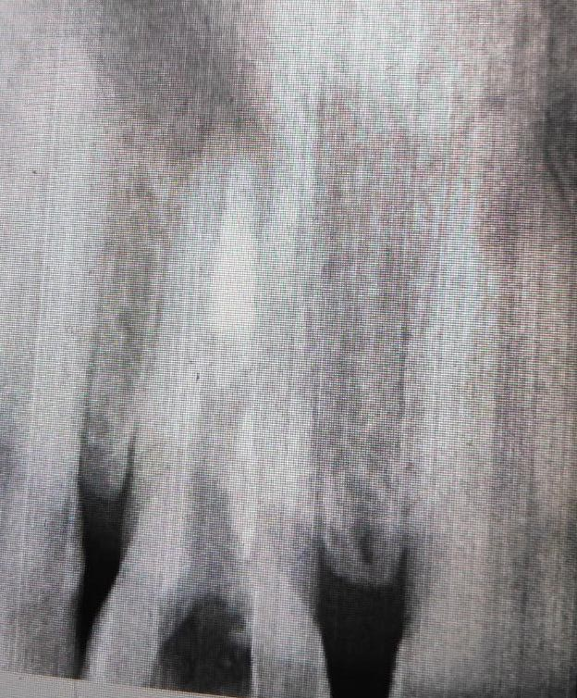

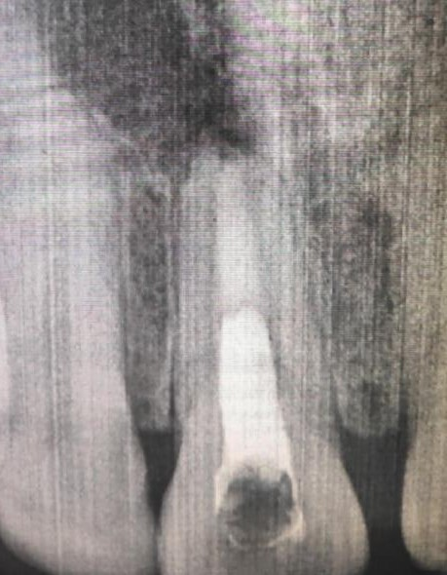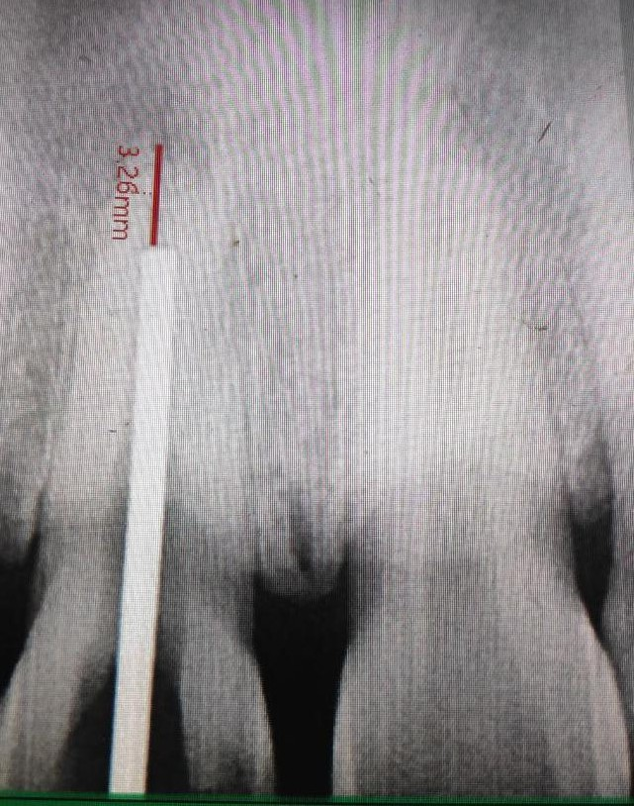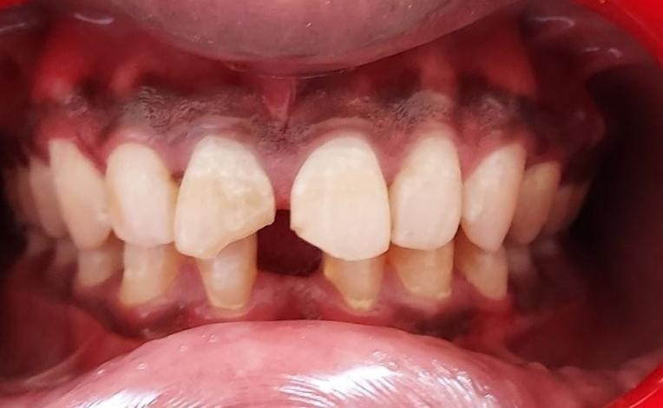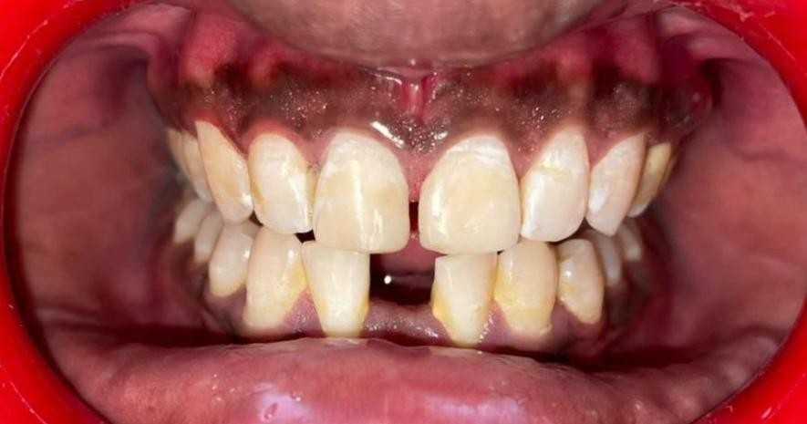

**CASE REPORT 2**

A 21- year old male patient presented to our clinic with intra oral swelling , pain on the front maxillary region in between both the central incisors since 1 week. The patients parents reported with trauma 5 years back while playing in the ground . No significant history of pus discharge , swelling , bleeding or pain in past 5 years. On clinical examination intra oral sinus tract was present along with small swelling wrt – tooth number – 21. On percussion tooth was tender and radiographic evaluation revealed blunderbuss canal, small periapical radiolucency and PDL widening wrt 21.

Endodontic therapy was performed in 21 under local anesthesia under rubber dam isolation. Upon access opening, pulpal necrosis was verified , slight purulent pus discharge noticed. Working length confirmed with 80- Hedstorm file ( DENSPLY-, MAILLEFER, BALLAIGUES, SWITZERLAND ). Biomechanical preparation done with circumferential filing and copious irrigation done with 2.5% NaOCl. Ca hydroxide was placed in the entire canal after drying with paper points an sealed with zinc oxide and eugenol cement for 1 week.

Patient was recalled after 1 week where he reported to be completely asymptomatic. The canal as dried and rinsed with 2.5% NaOCl to remove all the Calcium hydroxide from canal. To achieve an apical seal in the blunderbuss canal, the central incisor- 21 , MTA mixture (ProRoot MTA; Dentsply Tulsa Dental Specialties, Tulsa, OK, USA) was made and placed with an MTA carrier (Dovgan MTA Carrier 0.9 mm bendable, Quality Aspirators, TX, USA) in the apical area upto 5 mm in length which was re-evaluated with the help of radiograph. The mixture was well adapted to the inner walls with help of No. 70- hand plugger and a cotton pellet soaked with sterile water was placed in the canal and sealed with temporary cavit. After 4 days , the set of the MTA was re confirmed with hand file followed by gutta percha obturation and esthetic composite restoration .

# CASE REPORT 2- BLUNDER BUSS CANAL WITH OPEN APEX WRT 21

FIG. 4-PRE OPERATIVE WORKING LENGTH RAIOGRAPH

FIG. 5- MTA PLUG

FIG 6- ESTHETI RESTORATION

FIG. 7- **FOLLOW-UP AFTER 1 YEAR** WITH APICAL BARRIER FORMATION

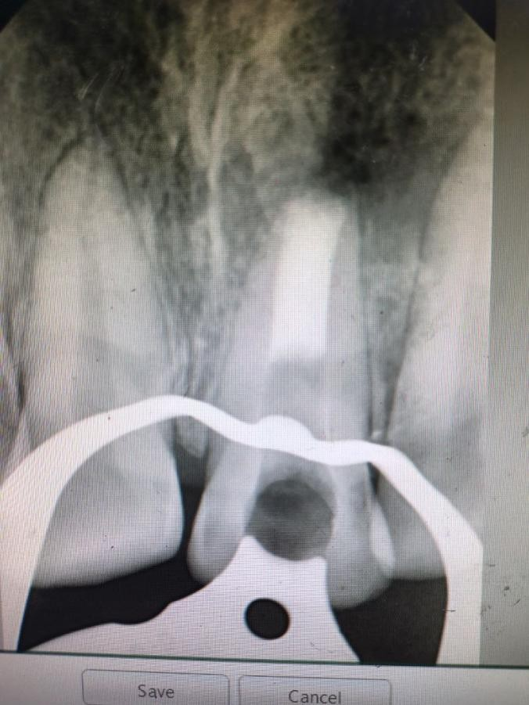

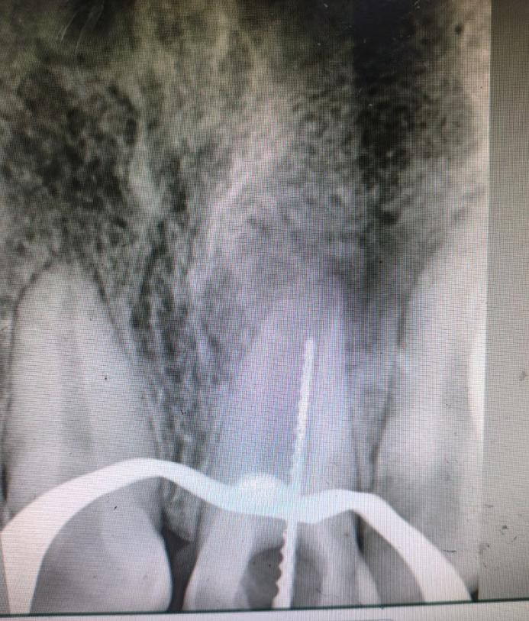

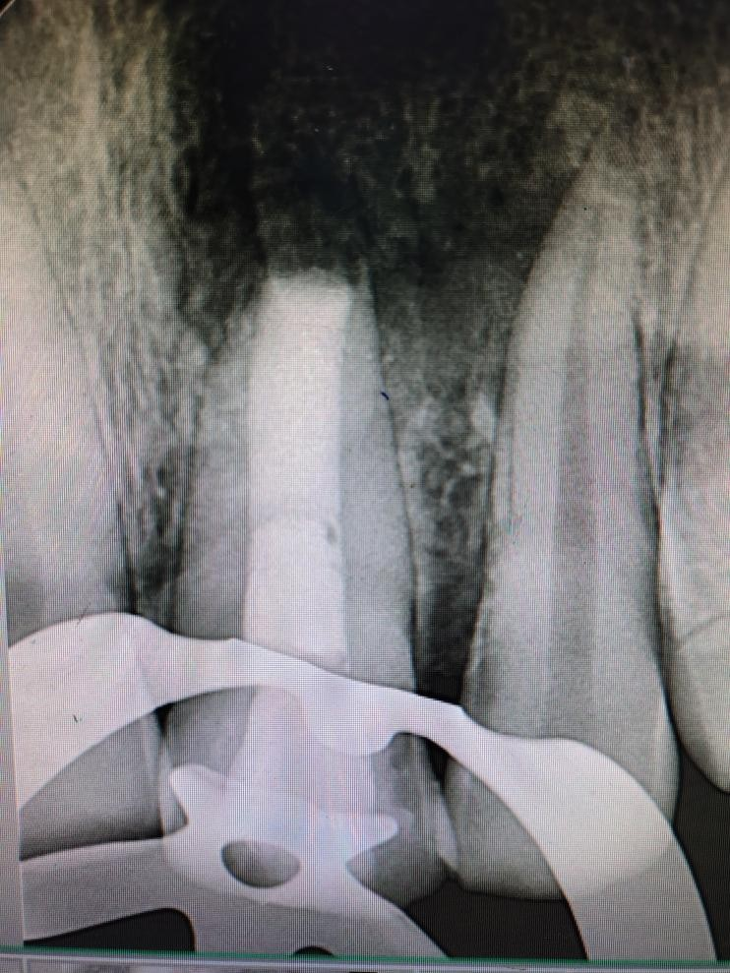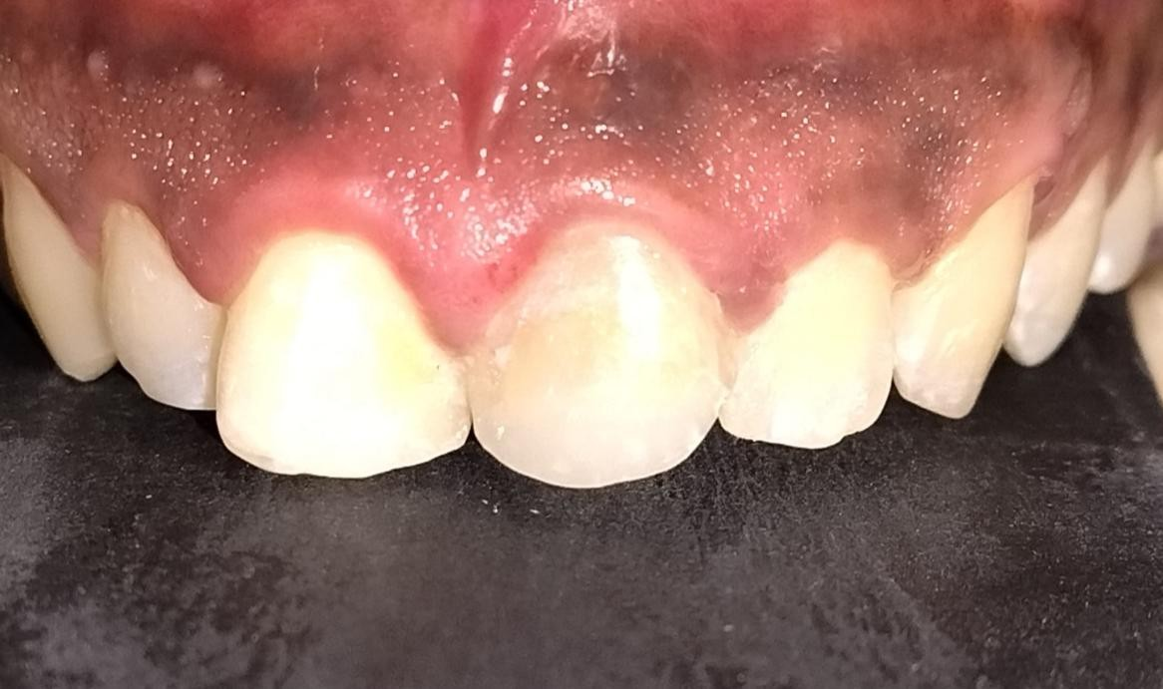

## DISCUSSION

In anatomy, the apical foramen is the opening at the A**pex** of the **root** of a **tooth**, through which the nerve and blood vessels that supply the dental pulp pass. Thus it represents the junction of the pulp and the periodontal tissue. The anatomy of the apical foramen changes with age as root formation is yet to be completed when the tooth erupt. The completion of root development and closure of the apex occurs up to three years after eruption but sometimes the root apex remains open, which is known as Immature Permanent Teeth With Immature Root Apex Formation. The aetiology of pulp necrosis in immature permanent teeth can include caries , Trauma , Presence of the dental anomalies, Dens invaginatus , Dens evaginatus. Trauma or caries in immature permanent teeth often leads to pulpal damage, interrupting root development and increasing the risk of fractures due to shorter roots with thin walls. Open apices pose a unique challenge in endodontics due to the inability to create an apical stop¹⁰. Traditional approaches like calcium hydroxide apexification or mineral trioxide aggregate (MTA) apexification have shown success in controlling infection and creating an apical seal.

The traditional calcium hydroxide apexification requires multiple appointments over 6–24 months and risks cervical fracture due to prolonged exposure¹¹. (MTA) in apexification has shown accelerated success outcome due to greater frequency of dentin bridge formation, thicker as well as less porous dentin and also less inflammation as compared to calcium hydroxide. One-visit apexification using MTA has revolutionized treatment by allowing formation of an artificial apical barrier that enables effective obturation¹². MTA is a calcium silicate-based cement with excellent sealing ability, biocompatibility, and the ability to set in moist conditions¹³. It induces cytokine release from bone cells and promotes cementogenesis¹⁴. In this case, MTA allowed predictable closure of the apex and successful healing, aligning with literature reports of high success rates¹⁵ as it induces the proliferation of undifferentiated cells to form dentin- bridge. **Mineral trioxide aggregate (MTA)** was introduced as an alternative to traditional materials for the repair of root perforations, pulp-capping and as a retrograde root filling due to its superior biocompatibilty and ability to seal the root canal system.

Alternatives such as Biodentine and bioceramic materials have also shown promise in apexification and root-end sealing¹⁶. However, MTA remains the most researched and clinically validated material for open apex management¹⁷. Care must be taken during placement to avoid extrusion into periapical tissues, which can provoke inflammatory reactions in some cases. ¹⁸ Irrigation protocols must be conservative in immature teeth. Overzealous instrumentation or high concentration irrigants may weaken dentin and cause transportation¹⁹. Gentle debridement with

calcium hydroxide disinfection remains essential to reduce microbial load prior to barrier placement. ²⁰

Few researches have proved MTA that when placed in direct contact with human dental pulp cells ( DPCS ) differentiated into odontoblast like cells whereas others also stated that MTA stimulates proliferation of cementoblasts, osteoblasts and fibrocblast cells.21 Many invitro studies proved that MTA after 24 hours upregulated the expression of type I collagen as well as osteocalcin . The way cells interact with substances for apexogenesis, apical surgery, and root perforation and resorption repair may be crucial to the recovery of wounded tissues. Multipotent mesenchymal stem cell migration and invasion are necessary for the intricate process of bone and periodontal healing and regeneration, which requires the coordination of several distinct stages . One of the most crucial steps in the activation of tissue repair should likely be the ability of MTA to regulate cell migration.22-23 MTA has been demonstrated to promote cementoblast adhesion, growth, and mineralized matrix formation gene and protein expression.24

The present case reports confirms the apical barrier formation after placement of MTA in open apex case with a follow up of 1 year. This clearly states that MTA can be used as an apical plug as it has proved to be very effective in stimulating regeneration of apical barrier in open apex cases which is also in accordance with many studies done by various authors.

**UPDATED OVERVIEW: MTA APEXIFICATION IN ENDODONTICS (2024–2025)**

The latest research (2024–2025) on Mineral Trioxide Aggregate (MTA) used for apexification, particularly in immature teeth with blunderbuss canals.

### Microleakage Study (BMC Oral Health, Sep 2024)21

An in vitro study comparing MTA and Biodentine apical plugs showed that while MTA had moderate microleakage, Biodentine performed better, indicating a tighter apical seal. This suggests Biodentine may be superior in sealing ability in open apex cases.

### Modified MTA Materials (BMC Oral Health, Mar 2024)22

Systematic reviews indicate that adding 2.5% Na₂HPO₄ or 5% CaCl₂ can shorten MTA setting time without compromising biocompatibility. Higher concentrations may affect strength or increase toxicity.

### Long-term Clinical Outcomes (Australian Endodontic Journal)23

A 17–20 year follow-up of MTA apexification cases showed excellent long-term outcomes including sustained function and periapical healing, reinforcing the durability of MTA.

### Systematic Reviews & Meta-analyses22

Meta-analyses confirm that MTA creates apical barriers significantly faster than calcium hydroxide and has comparable or better clinical success. Bioceramic alternatives such as EndoSequence are also effective but MTA remains the gold standard.

**Table 1-Key Takeaways**

|  |  |  |
| --- | --- | --- |
| Aspect | What’s New | Clinical Relevance |
| Sealing Ability | Biodentine may outperform MTA in microleakage tests | Consider Biodentine for tighter seal in open apices |
| Modified MTA | Additives reduce set time without toxicity | Faster apical barrier in fewer visits |

|  |  |  |
| --- | --- | --- |
| Success Rates | MTA yields faster barrier  formation vs Ca(OH)₂ | Shorter treatment time, better compliance |
| Durability | Proven success up to 20 years | Supports long-term reliability of MTA |

## CONCLUSION

Management of non-vital teeth with open apices requires a strategic and biologically sound approach. The use of MTA as an apical barrier enables a predictable, single-visit apexification with excellent healing outcomes. This case reaffirms the clinical efficacy of MTA in managing immature teeth, ensuring preservation and long-term function.

MTA offers reliability in achieving apical closure, while regenerative approaches, particularly with PRF, show promise for enhanced tissue regeneration. Further studies are needed to determine long-term success and establish definitive guidelines.

Management of immature teeth with large blunderbuss canals presents a clinical challenge due to the absence of an apical constriction, making obturation and periapical healing unpredictable. Mineral Trioxide Aggregate (MTA) has proven to be an ideal material for apexification in such cases, owing to its excellent biocompatibility, sealing ability, and capacity to induce hard tissue formation. In teeth with wide open apices, MTA facilitates the formation of an artificial apical barrier, allowing for predictable obturation and periapical repair. Clinical and radiographic outcomes have consistently demonstrated successful healing and apical closure with MTA, making it a reliable and efficient option in managing blunderbuss canals. However, proper case selection, canal disinfection, and controlled placement of MTA are essential for optimal results.

|  |  |  |  |  |  |
| --- | --- | --- | --- | --- | --- |
| **Aspect** | | **What’s New** | | **Clinical Relevance** | |
| **Sealing ability** | | MTA provides effective seal, but Biodentine may be superior in microleakage tests. | | Consider Biodentine for tighter seal | |
| **Modified MTA** | | Additives like Na₂HPO₄ & CaCl₂ can shorten set-time without compromising safety | | Faster barrier formation in single visits | |
| **Success &** | | MTA still matches or exceeds Ca(OH)₂ in outcomes, | | Quicker, patient-friendly | |
| **Aspect** | | What’s New | | Clinical Relevance | |
| **efficiency** | | with significantly faster barrier formation | | treatment | |
| **Long-term durability**  Table 2- Different aspects of Mineral Trioxide Aggregate (MTA)and its clinical relevance | | Case reports show sustained success up to 20 years | | Strong evidence for lasting outcomes | |

SUMMARY

* MTA seals, sets fast, and yields reliable long-term results.
* Biodentine may outperform MTA in sealing ability—especially in wide-open ("blunderbuss") canals.
* Chemical modification of MTA (e.g., with CaCl₂ or Na₂HPO₄) offers faster setting while

retaining safety.

* MTA continues to be a **top-tier apexification agent in 2025**, balancing speed, safety, and durability.

Consent

As per international standards or university standards, patient(s) written consent has been collected and preserved by the author(s).

**Disclaimer (Artificial intelligence)**

Option 1:

Author(s) hereby declare that NO generative AI technologies such as Large Language Models (ChatGPT, COPILOT, etc.) and text-to-image generators have been used during the writing or editingof this manuscript.

Option 2:

Author(s) hereby declare that generative AI technologies such as Large Language Models, etc. have been used during the writing or editing of manuscripts. This explanation will include the name, version, model, and source of the generative AI technology and as well as all input prompts provided to the generative AI technology

Details of the AI usage are given below:

1.

2.

3.

## REFERENCES

1. Andreasen JO, Farik B, Munksgaard EC. Long-term calcium hydroxide as a root canal dressing may increase risk of root fracture. Dent Traumatol. 2002;18(3):134–137.
2. Cvek M. Prognosis of luxated non-vital maxillary incisors treated with calcium hydroxide and filled with gutta-percha. Endod Dent Traumatol. 1992;8(2):45–55.
3. Teerawatvatin V, Kongsrichareon K. Apexification of a non-vital immature permanent tooth with the use of mineral trioxide aggregate (MTA) as an apical root canal filling material: a case report;25(1):73–82. <https://www.dent.cmu.ac.th/cmdj/frontend/web/?r=site/viewarticle&id=471>
4. Andreasen JO. Experimental dental traumatology: development of a model for external root resorption. *Endod Dent Traumatol.* 1987;3(6):269–87.(https://doi.org/10.1111/j.1600-9657.1987.tb00636.x)
5. Torabinejad M, Chivian N. Clinical applications of MTA. J Endod. 1999;25(3):197–205.
6. Pace R, Giuliani V, Pini Prato L, Baccetti T, Pagavino G. Apical plug technique using MTA: results from a 13-year follow-up. J Endod. 2007;33(10):1327–1330.
7. Hachmeister DR, Schindler WG, Walker WA, Thomas DD. The sealing ability and retention characteristics of mineral trioxide aggregate in a model of apexification. J Endod. 2002;28(5):386–390.
8. Law AS. Considerations for regeneration procedures. J Endod. 2013;39(3):S44–S56.
9. Simon S, Rilliard F, Berdal A, Machtou P. The use of mineral trioxide aggregate in one-visit apexification treatment: a prospective study. *Int Endod J.* 2007;40(3):186–97. (https://doi.org/10.1111/j.1365-2591.2007.01214.x)
10. Witherspoon DE. Vital pulp therapy with new materials: new directions and treatment perspectives—permanent teeth. J Endod. 2008;34(7 Suppl):S25–S28.
11. Felippe MC, Felippe WT, Rocha MJ. The effect of mineral trioxide aggregate on the apexification and periapical healing of teeth with incomplete root formation. Int Endod J. 2006;39(1):2–9.
12. Witherspoon DE, Ham K. One-visit apexification: technique for inducing root-end barrier formation in apical closures. *Dent Traumatol.* 2001;17(6):302–309.
13. Parirokh M, Torabinejad M. Mineral trioxide aggregate: a comprehensive literature review –

Part I. Chemical, physical, and antibacterial properties. J Endod. 2010;36(1):16–27.

1. Nair PN, Duncan HF, Pitt Ford TR, Luder HU. Histological, ultrastructural and quantitative investigations on the response of healthy human pulps to experimental capping with MTA. Int Endod J. 2008;41(2):128–150.
2. El Meligy OA, Avery DR. Comparison of apexification with MTA and calcium hydroxide. Pediatr Dent. 2006;28(3):248–253.
3. Nowicka A, Lipski M, Parafiniuk M, et al. Response of human dental pulp capped with Biodentine and mineral trioxide aggregate. Clin Oral Investig. 2013;17(6):1339–1343.
4. Duggal M, Tong HJ, Al‑Ansary M, Twati W, Day PF, Nazzal H. Interventions for the endodontic management of non‑vital traumatised immature permanent anterior teeth in children and adolescents: a systematic review of the evidence and guidelines of the European Academy of Paediatric Dentistry. *Eur Arch Paediatr Dent.* 2017;18(3):139–51. doi:10.1007/s40368‑017‑0289‑5 ([pubmed.ncbi.nlm.nih.gov](https://pubmed.ncbi.nlm.nih.gov/28508244/?utm_source=chatgpt.com))
5. Shabahang S, Torabinejad M. Treatment of teeth with open apices using mineral trioxide aggregate. Pract Proced Aesthet Dent. 2000;12(3):315–320.
6. Estivalet MS, de Araújo LP, Immich F, et al. Bioactivity potential of bioceramic‑based root canal sealers: a scoping review. *Life (Basel).* 2022;12(11):1853 .(10.3390/life12111853 ([mdpi.com](https://www.mdpi.com/2075-1729/12/11/1853?utm_source=chatgpt.com))
7. Roy M, Bailwad SA, Bhatnagar A, et al. Evaluation of microleakage of mineral trioxide aggregate and biodentine as apical barriers in simulated young permanent teeth. *BMC Oral Health.* 2024;24(1):1100. doi:10.1186/s12903-024-04817-2 ([bmcoralhealth.biomedcentral.com](https://bmcoralhealth.biomedcentral.com/articles/10.1186/s12903-024-04817-2?utm_source=chatgpt.com))
8. Paranjpe A, Zhang H, Johnson JD. Effects of mineral trioxide aggregate on human dental pulp cells after pulp-capping procedures. J Endod 2010;36:1042-1047.
9. Polimeni G, Xiropaidis AV, Wikejso UM. Biology and principles of periodontal wound healing/regeneration. Periodontol 2000; 2006;41:30-47.
10. Schindeler A, McDonald MM, Bokko P, Little DG. Bone remodeling during fracture repair: the cellular picture. Semin Cell Dev Biol 2008;19:459-466.
11. Thomson TS, Berry JE, Somerman MJ, Kirkwood KL. Cementoblasts maintain expression of osteocalcin in the presence of mineral trioxide aggregate. J Endod 2003;29:407-412.
12. Bolhari B, Noori F, Assadian H, Raee A, Ghabraei S, Shamshiri AR, Heboyan A, Bolhari G. The effect of three additives on properties of mineral trioxide aggregate cements: a systematic review and meta‑analysis of in vitro studies. *BMC Oral Health.* 2024;24(1):335. doi:10.1186/s12903‑024‑04103‑1