**Management of the Canalis Sinuosus (CS) in Anterior Maxillary Implantology: A Minimally Invasive Case Report**

**Abstract**

**Background:** The lack of knowledge on the existence of Canalis Sinuosus (CS) has shown that many cases of implant failure in the anterior maxillary region still occur, in which patients and implantologists end up reporting more pronounced bleeding during surgery, postoperative pain that does not go away with analgesics, and also paresthesia.

**Aims:** We present a case report demonstrating an innovative surgical technique for managing the Canalis Sinuosus (CS) during dental implant placement in the anterior maxilla, focusing on minimizing complications through a minimally invasive approach.

**Presentation of the Case:** A 55-year-old female with a mobile maxillary left lateral incisor and radiographic evidence of CS underwent extraction, curettage, anti-microbial photodynamic therapy (aPDT), and immediate implant placement using bone expanders. Bone reconstruction was performed with xenogeneic biomaterial, L-PRF, I-PRF, and a collagen membrane.

**Discussion:** Postoperative CBCT scans at eight months showed the CS in close proximity to the implant, but without encroachment, and the patient reported no sensory changes or pain. Successful osseointegration allowed for prosthetic rehabilitation. Conclusion: This case underscores that a thorough understanding of CS anatomy and minimally invasive techniques, like bone expanders, can facilitate successful implant placement in the anterior maxilla, even with anatomical variations, minimizing complications and enhancing patient satisfaction. No adverse events in the transoperative period were observed. There was no excessive bleeding, pain or paresthesia in the postoperative period either. After eight months of surgery, the reopening and provisional prosthetic procedures were performed and no abnormal symptoms were observed during the soft tissue healing period. With the prostheses finished and functioning, the patients were highly satisfied in terms of final aesthetic outcomes.

**Conclusion:** This report highlights the importance of considering CS anatomy in surgical planning and suggests that minimally invasive techniques can improve patient outcomes in complex cases. Further studies are needed to validate the long-term efficacy of this technique in a larger patient population.

**Keywords**: Tooth Complications; Canalis Sinuosus; Bone Expansion Technique; Dental Implant;

**1 Introduction**

Awareness of the anatomical structures before any surgical procedure is essential for safe and satisfactory outcomes of dental treatments. The placement of dental implants should follow a thorough evaluation of the area of interest, in which the configuration of these structures is assessed and possible anatomical variations are identified (Shintaku et al., 2020). The Canalis Sinuosus (CS) is a tortuous bone channel which originates from the posterior infraorbital foramen and courses in an anterolateral direction to the anterior wall of the nasal antrum below the orbital margin. Then, it sharply runs downward along the pyriform apertures tracing an “S” and moving downwards again issuing into the palatine mucosa through an accessory foramen (Rosano et al., 2021; Samunahmetoglu, & Kurt, 2023). The canalis sinuosus was first described by Jones in 1939 as being a nervous vascular bundle located 25 mm posterior to the infraorbital foramen (1;2). It extends from the inferior orbital cortex downwardly and medially towards the anterior wall of the maxillary sinus and contouring the nasal

fossa laterally. In the lower region of the CS, it is common to observe accessory canals (AC) bifurcated towards the regions of nasal fossa floor and premaxilla, reaching the palatal region of the incisors and canines and, less frequently, the buccal region of these teeth (2).

However, CS is a little-known structure detected in 66.5% to 88% of patients, and it can be considered an anatomical structure rather than an anatomical variation (3;4;5). As periapical and panoramic radiographs are inaccurate in detecting CS, cone beam computed tomography (CBCT) becomes an important tool in detecting this structure for surgical planning in implant dentistry and avoiding iatrogenic causes during such procedures (6).

In some cases, it is common to see radiographic images mimicking apical lesions at the apex of upper incisors, canines or external resorption processes (7).

The lack of knowledge on the existence of CS has shown that many cases of implant failure in the anterior maxillary region still occur, in which patients and implantologists end up reporting more pronounced bleeding during surgery, postoperative pain that does not go away with analgesics, and also paresthesia. Upon closer examination of the CBCT, one can identify the presence of CS and the removal of the implants becomes necessary as no other procedure is capable of reversing the established condition, either by compressing or sectioning the nerve/vessel (9;10).

The objective of this case report was to demonstrate an alternative treatment in a patient with CS

by means of osseointegrated implants and rotary burs for bone expansion.

**2 Presentation of Case**

The clinical case was approved by the Research Ethics Committee of the University of Santo Amaro according to protocol number CAAE09095619000000081. A 55-year-old female patient, M.O. presented at the dental office with the main complaint of mobility of maxillary left lateral incisor (tooth #10). On clinical examination, a grayish coloration was observed in the cervical region, with neither pain nor secretion. (Figure 1).

The radiographic examination was performed by using the panoramic technique and cone beam computed tomography (CBCT). It revealed previously root canal treatment and an extensive apical lesion. Also, the buccal aspect of the cervical margin exhibited reduced thickness, and there was evidence of bone resorption in the mid-apical region. (Figure 2)

In the parasagittal and sagittal/oblique views, the presence of CS was radiographically evidenced in the path from the floor of the nasal fossa, surrounding the root of the tooth at the palatal region and emerging apically at the medianpalatine suture to the tooth #10.

After evaluating the clinical and radiographic findings, the proposed treatment plan was the extraction of tooth #10, curettage of the endo-perio lesion associated with anti-microbial photodynamic therapy (aPDT), followed by placement of an implant and the provision of an adhesive prosthesis as an immediate restoration on same day. Simultaneously, reconstruction of the bone defect using particulate xenogeneic biomaterial associated with fibrin rich in platelets and leukocytes (L-PRF) and fibrin rich in platelets injectable (I-PRF) membranes, and a collagen membrane. The patient agreed to participate in this clinical case and the patient read and signed the informed consent form.

Initially, Peripheral blood was collected in six 10-ml collection tubes (BD Vacutainer® Serum) for L-PRF preparation and two 9-ml collection tubes (Vacuette ® Tube, Greiner Bio-one) for I-PRF preparation. The tubes were centrifuged in a centrifuge (Kasvi®) according to a centrifugation protocol, that is, 2700 rpm for 3 minutes to obtain the I-PRF and 2700 rpm for 12 minutes to obtain the L-PRF membrane. Respectively, 3mL of the supernatant was pipetted and stored in a sterile syring and the clots were removed from the tubes with sterile tweezers and pressed into a metal case to produce the L-PRF membranes.

In the first surgical procedure, Articaine® 100 (DFL®) was used for anesthesia of the vestibule fornix region and of the entire palatine region between maxillary left central incisor and canine. Next, removal of all tissues allowed visualization and successful atraumatic extraction of the tooth #10, thus

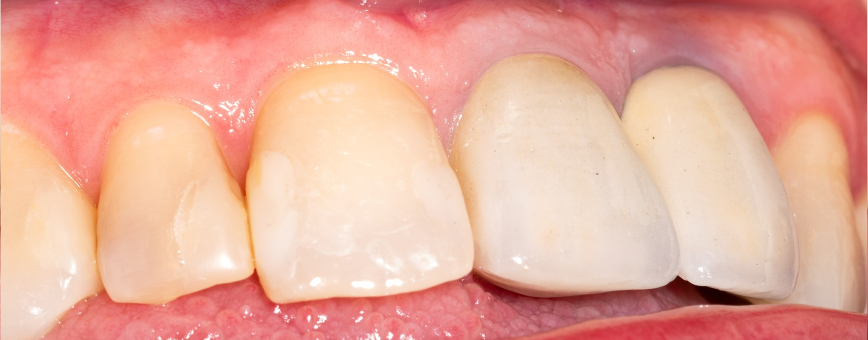

Figure 1: Clinical examination (tooth #10)

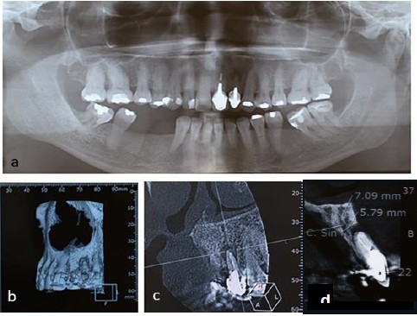

Figure 2: (a) Panoramic x-ray. (b) 3D reconstruction showing bone defect. (c)

parasagittal view tomographic slices. (d) Canalis Sinuosus

preserving the cervical buccal surface of the extracted tooth. After curettage of the apical lesion, the continuity solution on the buccal surface was evidenced. (Figure 3)

After curettage of the entire socket, aPDT was performed with application of methylene blue

0.01% (CHIMIOLUX® 1, DMC®) to both socket and region of continuity solution buccally for 5 minutes. Next, the entire region was irrigated with saline solution 0.9% before irradiation with laser (Laser Duo® MMO®) at a low power of 9J.

For insertion of the implant, a set of rotary expanders (Bone Expander®, Maximus®) was used in which the initial drilling was performed with a cutter of 1.3 mm in diameter, followed by the use of stepped reamers in sequences of 1.6 mm, 1.8 mm, 2.0 mm, 2.3 mm, 2.5 mm, 2.8 mm, 3.0 mm and

3.3 mm according to length of the implant on a clockwise direction at 600 rpm.

Thus, no osteotomy was performed as the bone at the site was compressed only, leaving the region denser and reducing the risk of injuring the CS. (Figure 4)

The implant of 3.5mm diameter x 13mm length (Black Fix Profile, TitaniumFix®) was placed with an insertion torque of 45 Ncm. The bone defect was reconstructed with 0.5 cc of particulated xenogeneic biomaterial (Bio-Oss® Large, Geistlich® Pharma) associated with L-PRF and I-PRF, covered with a collagen membrane (Bio Gide®, Geistlich® Pharma) and LPRF membranes and sutured with 4.0 nylon thread (ETHICONTM). A provisional adhesive prosthesis was also placed.

The patient was medicated with amoxicillin 875mg and Clavulanate 125mg, every 12 hours for 7 days, dipyrone 500mg every 6 hous for 2 days and 0.12% chlorhexidine digluconate as mouth rinse twice a day for 7 days. No complications as swellling, pain, numbness, nasal discharges and bleeding were observed in the postoperative follow-up, and the suture was removed after 10 days. After eight months, a new CBCT scan was performed and showed proximity of the CS to the implant, but without invading it. Also, from the immediate postoperative period until the time of the new exam, the patient did not report any sensory changes or pain related to the implant. (Figure 5).

Prosthetic rehabilitation including the second surgical procedure was performed. An incision was made on the crest of the ridge and thus the covering screw of the implant was removed. A short prosthetic abutment 3.6mm of diameter and 2.0 mm of length (Universal Link – Titanium Fix®) was placed and temporary crown was made on the abutment. After 15 days, [Rest of text from Section 2 is cut off in the provided content, but the abstract and discussion cover the successful outcome.]

**3 Discussion**

The anatomical variations of the CS can eventually prevent a surgical approach in the region. The present clinical case showed it is very important to know the anatomy of the structure called canalis sinuosus for correctly planning a successful surgical rehabilitation with osseointegrated implants.

In the literature, there are several studies describing the presence of CS and indicating its trajectory and prevalence (1;12;13). Clinical cases are also referred, in which problems arising from

the non-observance of this important structure caused excessive bleeding during surgery, postoperative pain and paresthesia. When the patient reports all these symptoms, a second CBCT exam usually shows the presence of CS. The treatment involves removing the implant, or even burial of the implant, thus preventing a possible remission of the symptoms (2;14).

Aoki et al. (2019), in a study of 200 CBCT images, found that 66.5% of the patients had CS in which 45.86% were unilateral and 54.14% bilateral, with a higher prevalence in males. This high rate of CS justifies designating it as an anatomical structure (5). The lack of knowledge on this structure by most implantologists and the lack of alternatives to rehabilitation treatment with dental implants in the presence of CS gave us the opportunity to present a clinical case with a satisfactory result.

Volberg & Mordanov (2019) described a clinical case in which extraction of tooth #10 was determined after surgical planning for implant placement. Due to the extensive bone defect in the buccal region, guided bone regeneration was performed. Abnormal bleeding was not observed during the transoperative period. However, after a few hours of the procedure, the patient reported pain and paresthesia in the

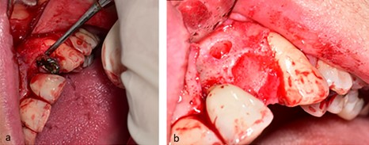

Figure 3: (a) Extraction with preservation of the buccal wall. (b) Aspect of the apical lesion after curettage of the granulation tissue.

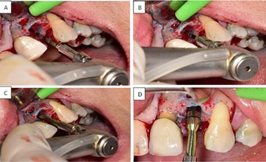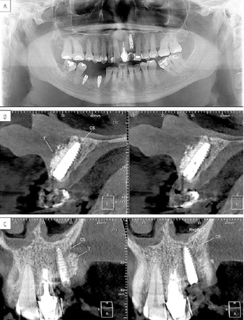

Figure 5: CBCT images (a) Panoramic view ˆ . (b) Cross-sectional view. (c)

Coronal section view.

left region of the maxilla. The location of the pain and paresthesia were concentrated around the upper left canine, palate and nasal region and not in the vicinity of the implant inserted. The use of analgesics, tranquilizers and neurotropic agents was ineffective. A CBCT was performed, and the presence of CS was detected, with a diameter of Ø2.3 mm and two branches, one with Ø1.9 mm in the palatal region and another with Ø0.7mm in the buccal region of tooth #10. The implant was removed, and both pain and paresthesia disappeared (14).

Arruda et al. (2017) described another clinical case in which the patient reported paresthesia in the region of the upper right lip for 22 months, coinciding with the insertion of an implant in the region of tooth #7. CBCT revealed the presence of CS and two neurologists pointed out that the trauma to the CS was irreversible. Based on the dentist’s opinion, the patient decided not to undergo another surgery (2).

Shelley (2019) reported a clinical case of a 49-year-old patient whose tooth #9 was missing. Surgical treatment was not performed because CBCT showed the presence of CS, and it was decided that such structure would be inevitably injured by using the conventional technique. Thus, an adhesive prosthesis was chosen (10).

Leven & Sood (2018) reported case of a 32-year-old woman complaining of pain in the regions of teeth #7 and #8. Clinically, it was observed that a possible occlusal trauma due to premature contact with an antagonist could be the cause of pain. There was a history of trauma in this region, with a crown fracture in tooth #8. At the time, the tooth was endodontically treated and a crown was made. No alteration was detected in the tooth after periapical radiography, but a radiolucent area was observed in the apical region of tooth #7. CBCT revealed the presence of CS whose path passed through the apical part of tooth #7, thus either periapical lesion or external root resorption was discarded. As a treatment, it was decided to replace the crown of tooth #8 and consequently eliminate the premature contact in protrusion (15).

In this report, the presence of CS was also evidenced on CBCT exam. Then with the knowledge of the existence of this anatomical structure, including the possible problems caused by trauma, it was decided for a surgical approach with insertion of an osseointegrated implant and guided bone regeneration at the site of the bone defect. Immediate placement implants in extraction socket has been proposed to preventing soft tissue collapse and preserving the contour of the gingival margin at aesthetic zone. Furthemore, less invasive approach bone expander drills were used only for osteotomy in the initial drilling and then for bone expansion. In this way, the chance of injury to the vascular-nervous bundle is extremely reduced, thus allowing the implant to be inserted safely. This technique requires low rotation of the drills, up to 600 rpm. This is another important factor that allows precise control of the surgical act.

No adverse events in the transoperative period were observed. There was no excessive bleeding, pain or paresthesia in the postoperative period either. After eight months of surgery, the reopening and provisional prosthetic procedures were performed and no abnormal symptoms were observed during the soft tissue healing period. With the prostheses finished and functioning, the patients was highly satisfied in terms of final aesthetic outcomes and did not reported no unpleasant event at all.

**4 Conclusion**

In our clinical study, it was evidenced that the anatomical knowledge of the structure called canalis sinuosus is very important for a correct surgical planning. The anatomical variations of CS can eventually prevent a surgical approach. However, even if the CS path is close to the space occupied by the implant, we believe that one of the solutions is to resort to an approach requiring no excessive osteotomy, such as the use of expanders, so that a rehabilitation treatment with implants can be offered to the patient.

**Consent**

Patient accepted the treatment plan, and written informed consent was obtained from the patient.

**Ethical Approval**

The clinical case was approved by the Research Ethics Committee of the University of Santo Amaro according to protocol number CAAE09095619000000081

**Disclaimer (Artificial intelligence)**

Option 1:

Author(s) hereby declare that NO generative AI technologies such as Large Language Models (ChatGPT, COPILOT, etc.) and text-to-image generators have been used during the writing or editing of this manuscript.

Option 2:

Author(s) hereby declare that generative AI technologies such as Large Language Models, etc. have been used during the writing or editing of manuscripts. This explanation will include the name, version, model, and source of the generative AI technology and as well as all input prompts provided to the generative AI technology

Details of the AI usage are given below:

1.

2.

3.

**Abbreviations**

Canalis sinuosus (CS) Accessory canals (AC)

Cone beam computed tomography (CBCT) Anti-microbial photodynamic therapy (aPDT) Fibrin rich in platelets and leukocytes (L-PRF) Fibrin rich in platelets injectable (I-PRF)

Disclaimer (Artificial intelligence)

Option 1:

Author(s) hereby declare that NO generative AI technologies such as Large Language Models (ChatGPT, COPILOT, etc.) and text-to-image generators have been used during the writing or editing of this manuscript.

Option 2:

Author(s) hereby declare that generative AI technologies such as Large Language Models, etc. have been used during the writing or editing of manuscripts. This explanation will include the name, version, model, and source of the generative AI technology and as well as all input prompts provided to the generative AI technology

Details of the AI usage are given below:

1.

2.

3.

**References**

[1]Jones FW. The anterior superior alveolar nerve and vessels. J Anat. 1939;73(Pt 4):583-91.

[2]Arruda JA, Silva P, Silva L,

A´ lvares P, Silva L, Zavanelli R, et al. Dental Implant in the

Canalis Sinuosus: A Case Report and Review of the Literature. Case Reports in Dentistry.

2017;2017:1–5.

[3]Wanzeler AMV, Marinho CG, Junior SMA, Manzi FR, Tuji FM. Anatomical study of the canalis sinuosus in 100 cone beam computed tomography examinations. Oral Maxillofac Surg. marc¸ o de 2015;19(1):49–53.

[4]Lopes dos Santos G, Ikuta CRS, Salzedas LMP, Miyahara GI, Tjioe KC. Canalis sinuosus : An Anatomic Repair that May Prevent Success of Dental Implants in Anterior Maxilla. Journal of Prosthodontics. dezembro de 2020;29(9):751–5.

[5]Aoki R, Massuda M, Zenni LTV, Fernandes KS. Canalis sinuosus: anatomical variation or structure? Surg Radiol Anat. janeiro de 2020;42(1):69–74.

[6]Ac¸ ar G. Computed tomography evaluation of the morphometry and variations of the infraorbital canal relating to endoscopic surgery. :9.

[7]Guimar

a˜ es VSN, Dantas LL, Gonzalez J, Rebello IMCR, Neves FS. Canalis Sinuosos

mimetizando reabsorc¸ a˜ o radicular: relato de caso. J Health Biol Sci. 27 de junho de

2019;7(3):320.

[8]Ruiz Garc ´ıa De Chaco´ n VE, Mayanga Becerra JM. Canalis sinuosus: reporte de cuatro casos y revisio´ n de la literatura. Rev Estomatol Herediana. 28 de junho de 2017;27(1):39.

[9]

Shintaku, W. H., Ferreira, C. F., & de Souza Venturin, J. (2020). Invasion of the canalis sinuosus by dental implants: A report of 3 cases. Imaging Science in Dentistry, 50(4), 353.

[10]Shelley A, Tinning J, Yates J, Horner K. Potential neurovascular damage as a result of dental implant placement in the anterior maxilla. Br Dent J. maio de 2019;226(9):657–61.

[11]Ferlin R, Pagin BSC, Yaed

u´ RYF. Evaluation of canalis sinuosus in individuals with cleft lip and

palate: a cross-sectional study using cone beam computed tomography. Oral Maxillofac Surg. setembro de 2021;25(3):337–43.

[12]Ferlin R, Pagin BSC, Yaed

u´ RYF. Canalis sinuosus: a systematic review of the literature. Oral

Surgery, Oral Medicine, Oral Pathology and Oral Radiology. junho de 2019;127(6):545–51.

[13]Marzook HAM, Elgendy AA, Darweesh FA. New accessory palatine canals and foramina in cone-beam computed tomography. Folia Morphol. 2021;80(4):9.

[14]Volberg R, Mordanov O. Canalis Sinuosus Damage after Immediate Dental Implant Placement in the Esthetic Zone. Case Reports in Dentistry. 17 de dezembro de 2019;2019:1–5.

[15]Leven AJ, Sood B. Pathosis or Additional Maxillary Neurovascular Channel? A Case Report.

Journal of Endodontics. junho de 2018;44(6):1048–51.

16. Rosano, G., Testori, T., Clauser, T., & Del Fabbro, M. (2021). Management of a neurological lesion involving Canalis Sinuosus: A case report. Clinical Implant Dentistry and Related Research, 23(1), 149-155.

Samunahmetoglu, E., & Kurt, M. H. (2023). Assessment of Canalis Sinuosus located in maxillary anterior region by using cone beam computed tomography: a retrospective study. BMC Medical Imaging, 23(1), 46.